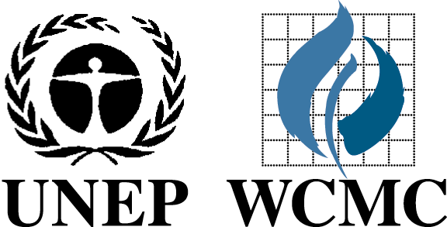

UNEP-WCMC data made available through the Conservation Geoportal to mark the International Day for Biological Diversity on 22nd May 2007

Produced by National Geographic, UNEP-WCMC, ESRI, The Nature Conservancy and other leading conservation organisations, the Conservation Geoportal is a free online catalogue to discover, view and share conservation maps and data. It was created to help catalogue, evaluate and distribute the wealth of maps and geographic information system data scattered across thousands of organisations and individuals worldwide.

To mark the 2007 International Day for Biological Diversity on 22nd May, UNEP-WCMC has published metadata on many of its key datasets and interactive map services on the Conservation Geoportal. This information is freely available to all users, so anyone can now find, view and bring biodiversity and ecosystem data from UNEP-WCMC together online with that of other organisations. Where datasets are not available for download the metadata records contain the contact information for requesting it.

The Conservation Geoportal can be used to discover what information is available from UNEP-WCMC on the following:

- Protected Areas of the World
- Marine and coastal ecosystems
- Terrestrial ecosystems
- Taxonomic distribution
- Data from the Millennium Ecosystem Assessment

The full list of data now freely available from UNEP-WCMC can be found at:
http://www.conservationmaps.org/Portal/ptk?command=openchannel&channel=266

The Conservation Geoportal was created to make data and information concerning the conservation of biological diversity available according to the principles of the Conservation Commons regarding Open Access, Mutual Benefit and Rights and Responsibilities.

For further information on the biodiversity spatial data held by UNEP-WCMC either visit the Conservation Geoportal or contact spatial.analysis@unep-wcmc.org.

www.unep-wcmc.org
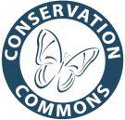

www.conservationmaps.org

www.conservationcommons.org

