 |  | CBD
 |  |  |  | Distr.  GENERAL  UNEP/CBD/ABS/CB-IAC/1/2  12 August 2015  ENGLISH ONLY
INFORMAL ADVISORY COMMITTEE ON CAPACITY-BUILDING FOR THE IMPLEMENTATION OF THE NAGOYA PROTOCOL
First meeting
Montreal, 15-17 September 2015

Status and SCOPE of capacity-building and development INITIATIVES supportING the implementation of the Nagoya Protocol on Access and Benefit sharing
Note by the Executive Secretary

I. INTRODUCTION
- At its first meeting, the Conference of the Parties serving as the meeting of the Parties to the Nagoya Protocol on Access and Benefit-sharing (COP-MOP) adopted a strategic framework for capacity-building and development to support the implementation of the Nagoya Protocol (decision NP-1/8). The COP-MOP also established an informal advisory committee (IAC) to provide advice to the Executive Secretary on matters of relevance to the assessment of the effectiveness of the strategic framework. One of the specific tasks of the informal advisory committee, as stipulated in its terms of reference contained in annex II of decision NP-1/8, is “stocktaking of the capacity-building and development initiatives being implemented by Parties and various organizations with a view to identifying gaps in the implementation of the strategic framework.”
- Since the adoption of the Nagoya Protocol in 2010, a number of access and benefit-sharing (ABS) capacity-building and development initiatives (activities, projects and programmes) have been undertaken or initiated to support its ratification and implementation. Some of the initiatives have provided or are providing direct support for country-level activities. Other initiatives are supporting global or region-wide activities (such as training, information-sharing or development of capacity-building tools and resources), meant to broadly support or benefit all governments and stakeholders.
- Examples of capacity-building initiatives intended to provide broad support include the following:
- The CBD Secretariat, with funding from various sources, including the Governments of Japan, the Republic of Korea, Norway and Spain, as well as the European Union and others, has carried out a number of training activities and developed various tools aimed to develop the capacity of countries to ratify and implement the Protocol. A summary table of the capacity-building activities organized by the Secretariat since COP-10 is presented in annex 1. Furthermore, with support from the Japan Biodiversity Fund, the Secretariat and the International Development Law Organization (IDLO) are developing learning materials and will conduct four training courses for national lawyers and policymakers to support the development of national ABS legal frameworks. The Secretariat also executed the UNEP-GEF Capacity Building for the Early Entry into Force of the Nagoya Protocol from 2011-2014, through which an ABS information kit as well as factsheets and policy briefs on the Nagoya Protocol were produced and a number of awareness-raising workshops and briefings were carried out;
  - The ABS Capacity Development Initiative (ABS Initiative), a multi-donor programme hosted by the German Agency for International Cooperation (GIZ), has since 2006 supported a number of global and region-wide capacity-building activities on ABS in Africa, the Caribbean and the Pacific, including training courses and workshops on various topics, and development of ABS capacity-building tools and resources. While activities of the ABS Initiative initially supported the negotiations that led to the adoption of the Nagoya Protocol and capacity-building activities on ABS in general, since 2010 it has focussed its efforts on supporting the ratification and implementation of the Nagoya Protocol through various activities. Some of the global activities include South-South dialogues on ABS implementation such as those organized in January 2014 in Cape Town, South Africa, and in August 2014 in Goa, India; ABS Business Dialogue Forums such as the one organized in Copenhagen in 2012; the tandem workshop for national focal points of the Nagoya Protocol and the International Treaty on Plant Genetic Resources for Food and Agriculture (ITPGRFA); as well as the development of technical guidance on mutually supportive implementation of the ITPGRFA and the Nagoya Protocol at national level. A key focus of its new programme 2015-2020 will be to provide direct support to a few countries as further examined in section II;
  - There are also initiatives that aim to build the capacity of specific stakeholder groups to ensure that their activities are consistent with, and supportive of, the Nagoya Protocol. For example:
    - Botanic Gardens Conservation International (BGCI), in collaboration with the Royal Botanic Gardens Kew, has created a number of learning modules on access and benefit-sharing, mostly targeted to those working in botanic gardens;
    - The Global Environment Facility (GEF) Small Grants Programme, implemented by United Nations Development Programme (UNDP), is supporting local communities and civil society organizations in various countries, including Benin, Cameroon, Niger, and Vanuatu, to build their awareness and capacity to contribute to the implementation of the Protocol, including through activities such as development of biocultural community protocols, documentation of traditional knowledge and training in the negotiation of ABS agreements. Similar proposals are under discussion in Cook Islands, Fiji, Micronesia (Federated States of), Saint Lucia, Samoa and South Africa;
    - The proposed project entitled: “Impact Investment in Support of the Implementation of the Nagoya Protocol”, will support small and medium enterprises in Latin America and Caribbean that are engaged with nature based products to sustainably valorize genetic resources. The project will be implemented by the Inter-American Development Bank (IADB), in collaboration with the EcoEnterprises Fund and the Union of Ethical Biotrade (UEBT) with non-grant funding from the GEF and co-financing from other sources;
- Examples of some of the capacity-building tools and resources developed through the above, and similar, initiatives are contained in the compilation made available in information document UNEP/CBD/ABS/CB-IAC/1/INF/1.
- The present document focuses on capacity-building initiatives (activities, projects and programmes) completed or initiated after the adoption of the Nagoya Protocol in 2010 that are providing, or have provided, direct support for country-level activities contributing to the ratification and implementation of the Nagoya Protocol. Section II analyses the current status, geographic and thematic coverage, duration and size of those initiatives, and identifies overlaps and gaps that may need to be addressed. Section III provides an overview of the various agencies implementing and/or executing the capacity-building and development initiatives. The last section outlines possible options for addressing the gaps and suggestions for enhancing coordination, synergies and complementarity among ABS capacity-building initiatives.
- The information used in the analysis was collected from various sources; including the project identification forms (PIFs) or project documents available in the project database of the GEF. The Secretariat also invited organizations involved in ABS capacity-building to update information about their initiatives and, wherever possible, to provide copies of the project documents or PIFs. The analysis is based on the information made available as of 15 July 2015. It is noted that for some of the initiatives key information, such as the start and end dates and the actual budget, was missing or not readily available.
II. CURRENT STATUS AND SCOPE OF ACCESS AND BENEFIT-SHARING CAPACITY-BUILDING AND DEVELOPMENT INITIATIVES PROVIDING SUPPORT FOR COUNTRY-LEVEL ACTIVITIES
- This section describes the current status, coverage, size and duration of capacity-building initiatives that have provided or are providing direct support to countries to enable them to ratify and/or implement the Nagoya Protocol. It also includes an analysis of the major overlaps and gaps in the geographic and thematic coverage of the initiatives.
A. Status of the initiatives
- According to the information available, since 2010 at least 67 ABS capacity-building and development initiatives (projects and programmes) have directly supported the ratification and implementation of the Nagoya Protocol. Of these, 10 projects (15 per cent) have been completed; 39 projects (58 per cent) are ongoing, 14 projects (21 per cent) are approved, and 4 (6 per cent) are proposed (see figure 1 below).
B. Geographic coverage of the initiatives
- In terms of geographic coverage, there are currently 54 national projects, 11 regional/subregional projects and 2 global projects and programmes supporting country-level activities. The African region has the largest number of projects (26 projects – 22 national projects and 4 subregional projects), followed by Asia and the Pacific with 20 projects (17 national and 3 subregional projects), then Latin America and the Caribbean (GRULAC) with 18 projects (15 national and 3 subregional projects) and lastly the Central and Eastern European (CEE) region with 1 regional project covering three countries (Armenia, Azerbaijan and Georgia) but only Georgia has requested support for a component on ABS as part of the project (see figure 4 below). The list of all projects providing direct support to countries is provided in annex 2.

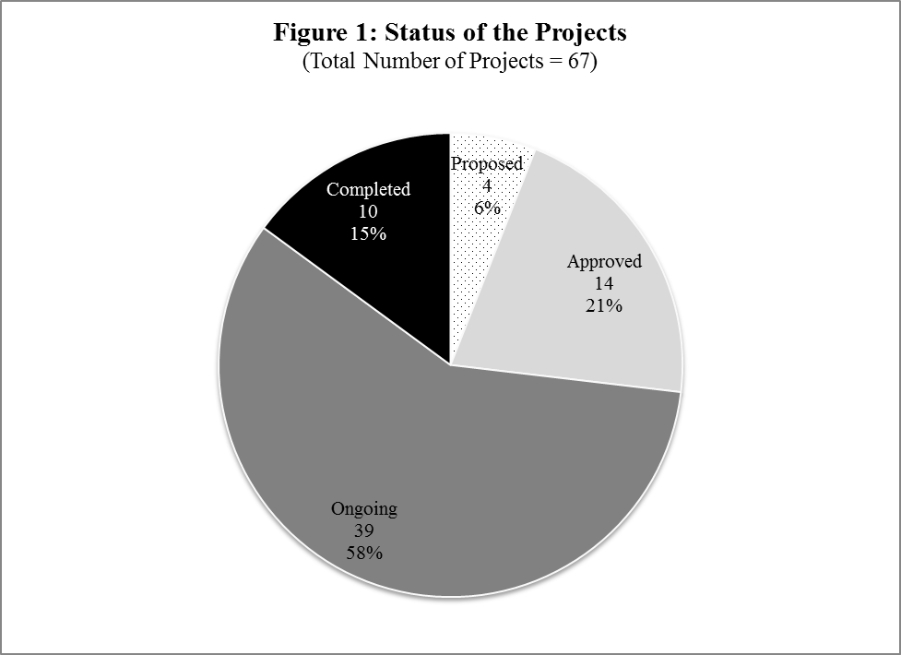

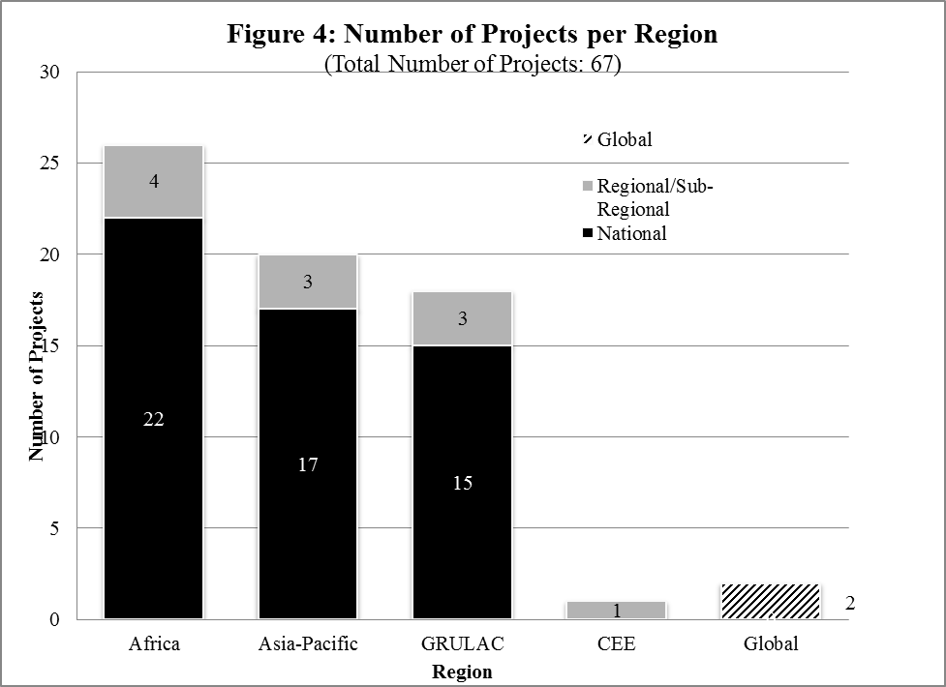
- The 11 regional/subregional projects are distributed as follows:
  - The African region had one project implemented by the United Nations Environment Programme (UNEP) (completed);
  - Central African Forests Commission (COMIFAC) subregion has one project by UNEP/GEF (ongoing) and another 1 project by GIZ/ABS Initiative (ongoing);
  - Bioversity International/ABS Initiative are implementing one subregional project in Benin and Madagascar (ongoing);
  - Southeast Asia, i.e. the Association of Southeast Asian Nations (ASEAN) has one project by UNEP and the ASEAN Centre for Biodiversity (ACB) (completed) and one other new project by UNEP/ACB funded by the China Trust Fund (ongoing);
  - The Pacific subregion has one project by UNEP and the Secretariat of the Pacific Regional Environment Programme (SPREP) (approved);
  - The Caribbean subregion has one project by UNEP/IUCN (approved);
  - Latin America and the Caribbean has one project by UNEP/IUCN (completed); one project covering the Central American Integration System (SICA) countries by GIZ (ongoing);
  - The Central and Eastern Europe region has one regional project implemented by GIZ, although only one country (Georgia) out of three has requested support for ABS.
- The global initiatives providing direct support for country-level activities are:
  - The UNDP/GEF project entitled: “Strengthening Human Resources, Legal Frameworks and Institutional Capacities to Implement the Nagoya Protocol” (approved), which will support 25 countries;
  - The UNEP-GEF Global Support for the Entry into Force of the Nagoya Protocol (Ongoing), supporting 20 countries from different regions;
  - The ABS Capacity Development Initiative.
- The tables in annex 2 list all the projects providing direct ABS capacity-building support to each country.
Identified gaps and overlaps
- Based on the information available, it is apparent that there are gaps in the geographic coverage by the current ABS capacity-building and development initiatives. In terms of regional coverage, the CEE region is the most under-covered. Of the 23 countries in the region, only 4 countries, i.e. Albania, Belarus, Bosnia and Herzegovina and Georgia (17 per cent) have support from at least one project. Georgia has ABS activities supported by a subregional biodiversity project funded by GIZ through a small ABS component; Belarus and Bosnia and Herzegovina benefited from the UNEP-GEF Global Project to support the Entry into Force of the Protocol; and Albania and Belarus are to receive support from the new UNDP-GEF global project (see table 4 in annex 2). The other 19 countries or 73 per cent are so far not covered by any ABS capacity-building project.
- The Asia-Pacific region, particularly the Asian subregion, is also generally under-served by the existing projects. Of the 56 countries in the region, 36 countries (including all the 14 Pacific and 22 Asian countries) have country-level activities supported either through a national project or one of the regional or global projects (see annex 2, table 2). Based on information gathered, currently 20 countries (all in the Asia subregion) or 36 per cent of the countries in the entire region are not covered by any ABS capacity development project.
- Both Africa and GRULAC regions are relatively well covered by the existing capacity-building projects. In Africa, at least 41 countries (or 76 per cent) have received direct support for country-level activities through one or more of the national, regional/subregional or global projects (see annex 2, table 1). Currently, 13 countries (24 per cent), do not have a national ABS project and have not received direct support for country-level activities from a regional/subregional or global capacity-building project. In GRULAC, of the 33 countries in region, only 8 countries (or 24 per cent) do not have a national project or a regional/subregional or global project providing direct support for country-level activities (see annex 2, table 3).
- It is noted that although the countries mentioned above have not received direct project support for country-level activities, some of them have taken part in, or benefited from global and regional/subregion-wide activities. For example, representatives from some of those countries have participated in global, regional or subregional capacity-building activities, such the Pan-African ABS workshops and ABS training course organized by ABS Initiative in collaboration with the University of Cape Town and with IDLO.
- Available data also shows that there is overlap in the geographic coverage of a number of projects which has resulted in some countries receiving support from multiple projects while others have little or no support. For example, a few countries in Africa (including Cameroon, Gabon, Kenya, Madagascar, Morocco, Rwanda and South Africa), Asia and the Pacific (Malaysia, Micronesia, Mongolia, Myanmar, Samoa, Timor-Leste and Viet Nam); and GRULAC (Colombia, Costa Rica, Dominican Republic, Ecuador, Nicaragua, Panama and Peru) have received or are receiving support from three or more projects (see tables 1, 2 and 3 in annex 2).
- In cases where there is more than one ABS project in a given country, it is important for the capacity-building providers and the countries concerned to effectively coordinate their efforts to ensure that activities of the various projects complement each other and do not result in duplication and inefficiencies in the use of resources. On the other hand, however, it would be important to minimize situations whereby capacity development support is over-concentrated in specific countries and regions when others have very little or no support at all in order to ensure broad and equitable support for the implementation of the Protocol globally.
C. Duration and size of the initiatives
- The number, size (budget) and duration of projects together provide information that may provide a general indication of the level of support available to a country or region. The previous subsection has analysed the extent of geographic coverage in terms of the number of the ABS projects implemented since 2010. This subsection provides an analysis of the size and duration of the projects for which data was available. Information on the core budgets (in United States dollars) and duration (in months) of the individual projects are provided in annex 2.
- With regard to the duration, an analysis of 67 projects for which information is available shows that the duration of most projects (54 projects or 81 per cent) is between 3 and 5 years. Ten projects (15 per cent) have duration of up to 2 years and 3 projects (4 per cent) are 5 years or more (see Fig. 2 below).
- In terms of size (based on the core budget), an analysis of 50 national, regional and subregional projects for which information was available, shows that the majority of projects (i.e. 25 projects or 50 per cent) are medium-sized, i.e. US$ 500,000 to 2,000,000); 21 projects (42 per cent) are large-sized (US$ 2,000,000 and above, i.e. and 4 projects (8 per cent) are small-sized, i.e. US$ 500,000 and below (see figure 3 below).
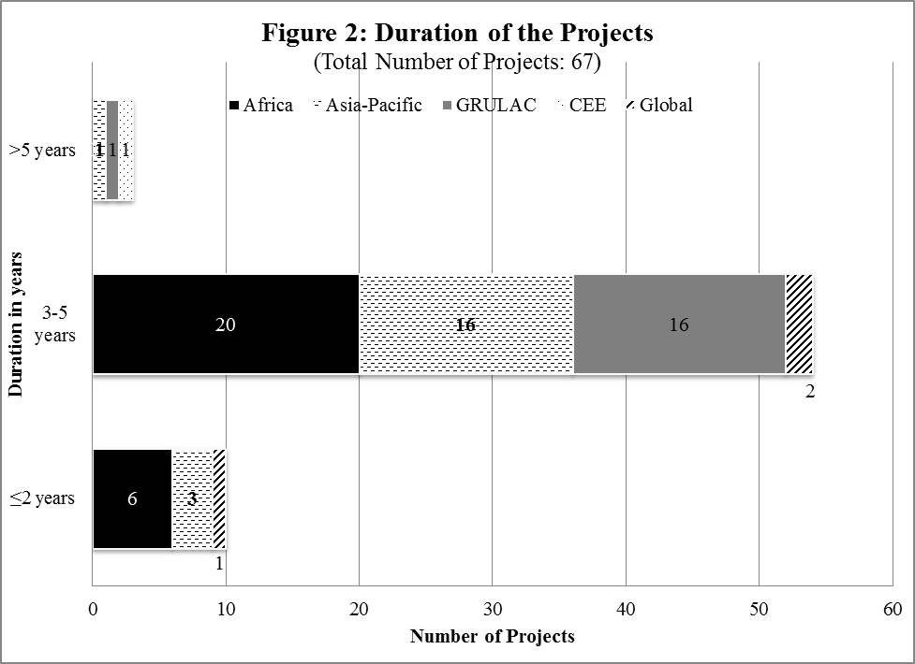

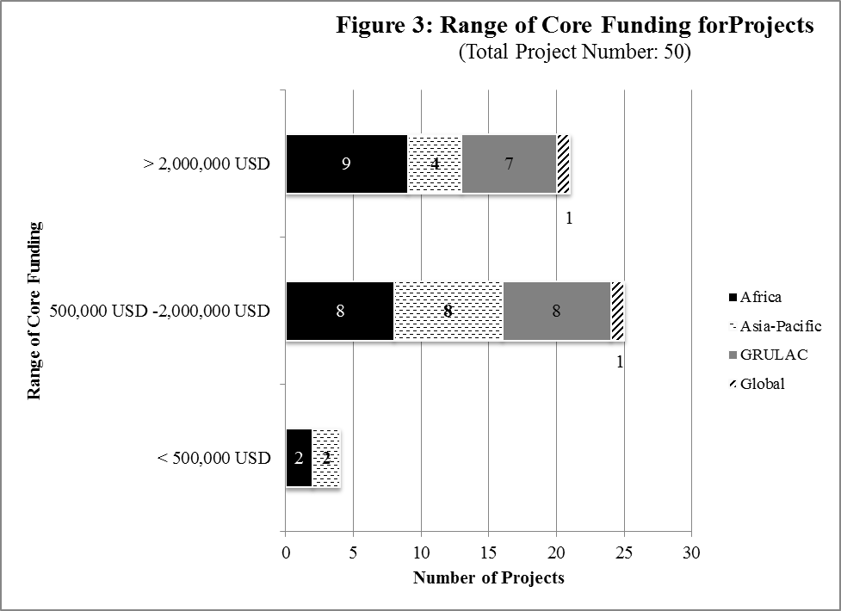
- A further analysis of the 34 national projects for which the actual core budget figures were available also shows similar trend. According to that set of information, most national projects (i.e. 18 projects or 53 per cent) are medium-sized; 14 projects (41 per cent) are large-sized (US$ 2,000,000 and above, i.e. and 2 projects (6 per cent) are small-sized (see figure 3b below).
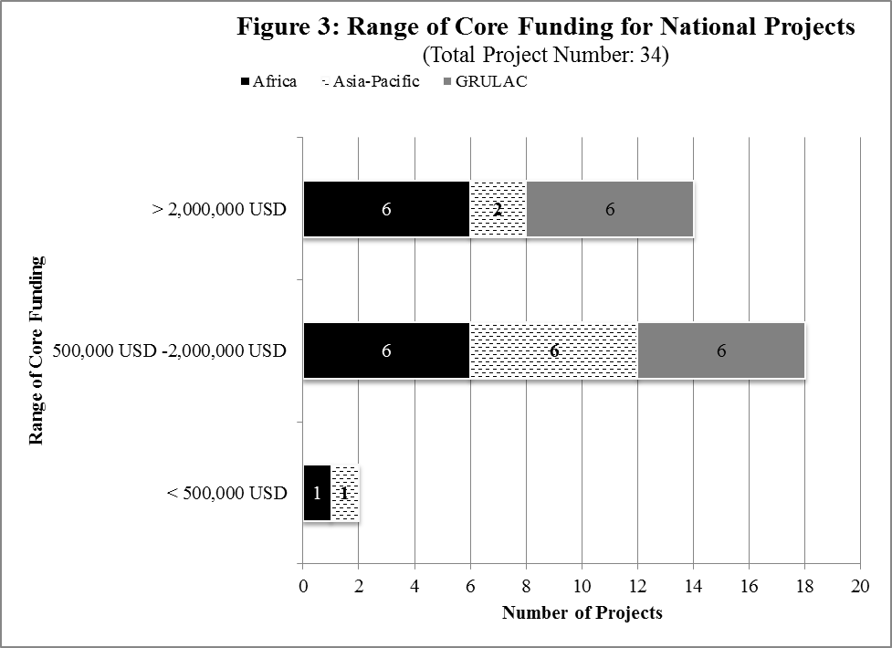
D. Thematic coverage of the initiatives
- With regard to the thematic coverage, the 67 known capacity-building initiatives address the five key areas of the strategic framework as follows (see figure 5 below):
  - The majority of projects (53 projects or 88 per cent) support Key Area 2 (i.e. development, implementation and enforcement of ABS domestic legislative, administrative or policy measures);
  - A total of 54 projects (or 88 per cent) support Key Area 1 (developing capacity for ratification, implementation and compliance with the Protocol, including general measures/activities such as public awareness-raising, information-sharing and resource mobilization);
  - At least 42 projects (or 63 per cent) support Key Area 4 (developing the capacity of indigenous and local communities (ILCs) and relevant stakeholders, including the business sector and the research community to, inter alia, participate effectively in the Protocol processes, negotiate mutually agreed terms (MAT), develop community protocols and other tools in relation to associated traditional knowledge, and to understand and deal with other ABS issues in general);
  - At least 40 projects (or 60 per cent) support Key Area 5 (i.e. development of the countries’ endogenous research capabilities to add value to their own genetic resources); and
  - Lastly, 32 projects (or 48 per cent) support Key Area 3 (i.e. capacity to negotiate MAT), including training in the negotiation of MAT, development of tools such as model contractual clauses to provide guidance, and development and implementation of pilot ABS agreements).
- The above data shows that while existing capacity development initiatives cover all the five key areas of the strategic framework fairly evenly, the main focus has been on areas 1 and 2. This is perhaps because the priority of many countries has been to ratify/accede to the Protocol and to put in place and/or amend access and benefit-sharing legislative, administrative or policy measures in order to implement their obligations under the Protocol, and thus contribute to the achievement of Aichi Target 16, i.e. by 2015, the Nagoya Protocol is in force and operational, consistent with national legislation.
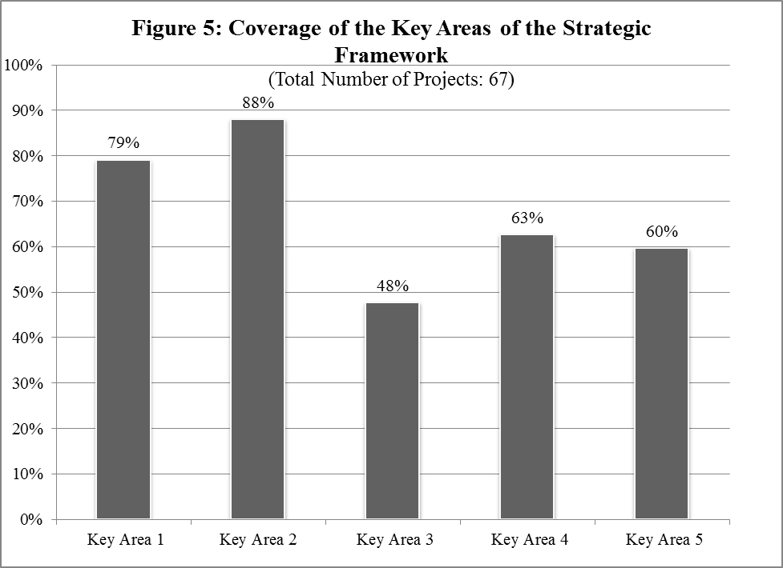
- A further detailed analysis of the key areas covered was possible for 36 projects for which project documents or project identification forms (PIFs) were available. This analysis shows that the specific measures/activities listed below are currently supported by the largest number of projects in the following order (see table 1 below):
  - Development or amendment of ABS legal/regulatory frameworks (75 per cent of the projects);
  - Raising awareness of the importance of genetic resources (GR) and traditional knowledge (TK) associated with genetic resources, and related ABS issues (72 per cent)
  - Establishment of institutional arrangements and administrative systems (67 per cent);
  - Undertaking research and development on genetic resource/bioprospecting (56 per cent);
  - Implementation and enforcement ABS measures/compliance (56 per cent);
  - Facilitation of information sharing, including participation in Access and Benefit-Sharing Clearing-House (47 per cent);
  - Development of infrastructure for research, e.g. research laboratories and databases of genetic resources (42 per cent);
  - Development of capacity to negotiate and implement ABS agreements (39 per cent);
  - Strengthening the general capacity of ILCs and relevant stakeholders, including the business sector and the research community in relation to ABS (36 per cent);
  - Development of national policy frameworks on ABS (33 per cent);
  - Strengthening the capacities of ILCs and stakeholders to negotiate MAT (33 per cent);
  - Managing traditional knowledge associated with genetic resources, including development of strategies and systems for recording, inventorying and protecting of associated TK (31 per cent).
- The analysis also shows that the following measures/activities are currently supported by the least number of projects and may need further attention:
  - Developing the capacity for valuation of genetic resources and associated traditional knowledge (currently covered by 6 per cent of the projects);
  - Mobilization of resources for the implementation of the Protocol (currently covered by 11 per cent of the projects);
  - Promoting better understanding of business models in relation to the utilization of genetic resources (currently covered by 14 per cent of the projects).
Table 1: Number and percentage of projects supporting specific measures under the Key Areas

Key Area and the associated measures | No. of projects | Percentage (%)
Key Area 1: Capacity to implement, and to comply with the obligations of, the Protocol
- Ratification and accession | 9 | 25%
- Awareness raising | 26 | 72%
- Information sharing (including participation in ABS Clearing-House) | 17 | 47%
- Resource mobilization for the implementation of the Protocol | 4 | 11%
Key Area 2: Capacity to develop, implement and enforce domestic legislative, administrative or policy measures on ABS
- Developing a policy framework on ABS | 12 | 33%
- Developing or amending ABS legal / regulatory framework | 27 | 75%
- Establishing institutional arrangements and administrative systems | 24 | 67%
- Implementation and enforcement (compliance) | 20 | 56%
Key Area 3: Capacity to negotiate mutually agreed terms (MAT) | 18 | 50%
- Developing capacity to negotiate / implement ABS agreements | 14 | 39%
- Developing/providing tools to facilitate negotiation of MAT | 8 | 22%
- Promoting understanding of business models regarding utilization of GR | 5 | 14%
Key Area 4: Capacity needs and priorities of indigenous and local communities and relevant stakeholders, including the business sector and the research community
- Strengthening general capacity of ILC and stakeholders in relation to ABS | 13 | 36%
- Strengthening capacities of ILCs and stakeholders to participate in ABS processes | 10 | 28%
- Strengthening capacities of ILCs and stakeholders to negotiate MAT | 12 | 33%
- Developing/providing tools to support ILCs MAT negotiation | 7 | 19%
- Managing TK/developing strategies and systems for recording, inventorying and protecting of TK | 11 | 31%
Key Area 5: Capacity of countries to develop their endogenous research capabilities to add value to their own genetic resources (GR)
- Developing capacity for valuation of GR and TK | 2 | 6%
- Undertaking research and development (bioprospecting) | 20 | 56%
- Technology transfer (including equipment, know-how, training, etc.) | 6 | 17%
- Development of infrastructure for research (e.g. databases) | 15 | 42%
- Most of the measures currently supported by at least 30 per cent of the projects are among the priorities identified in appendix 1 of the strategic framework for action in the short-term (i.e. three to five years).
iII. ORGANIZATIONS SUPPORTING THE IMPLEMENTATION AND/OR EXECUTION OF ACCESS AND BENEFIT-SHARING CAPACITY-BUILDING INITIATIVES
- Currently, 52 per cent of the ABS capacity-building projects (35 projects) are or have been funded by the GEF. To date, the GEF has invested over $60 million and leveraged $120 million in co-financing for at least 35 projects. Most of the GEF-funded projects have been implemented by UNDP (13 projects or 16 per cent of all the ABS projects) and UNEP (16 projects or 24 per cent). In addition, about 8 per cent of the projects are also implemented by UNEP in collaboration with other partners including the International Union for Conservation of Nature, IUCN (4 per cent), ACB (3 per cent) and SPREP (1 per cent) and the ABS Initiative (1 per cent).
- The ABS Capacity Development Initiative supports more than 21 per cent of ABS capacity development projects, mainly in Africa, the Caribbean, and the Pacific. The ABS Initiative also collaborates with and supports the implementation of 7 projects funded by BMZ (10 per cent) that have ABS components.
- In addition, 8 other projects funded by GIZ (12 per cent) and 1 project funded by BMZ and executed by the German Development Bank, KfW (1 per cent) have components contributing to ABS capacity development and implementation of the Nagoya Protocol in general.
- The number of projects implemented by various organizations in the different regions is presented in table 2 below.
Table 2: Number of projects implemented/executed by various organizations in each region
Organization | Africa | Asia-Pacific | GRULAC | CEE | Global | No. of Projects | Percentage
UNDP | 7 | 2 | 3 | - | 1 | 13 | 16%
UNEP | 3 | 6 | 6 | - | 1 | 16 | 24%
UNEP/IUCN | - | 1 | 2 | - | - | 3 | 4%
UNEP/ACB | - | 2 | - | - | - | 2 | 3%
UNEP/SPREP | - | 1 | - | - | - | 1 | 1%
Inter-American Development Bank | - | - | 1 | - | - | 1 | 1%
ABS Initiative | 7 | 5 | 2 | - | - | 14 | 21%
ABS Initiative/GIZ | 7 | - | - | - | - | 7 | 10%
Bioversity International/ Darwin Initiatives | 1 | - | - | - | - | 1 | 1%
GIZ | - | 3 | 4 | 1 | 0 | 8 | 12%
KfW | 1 | - | - | - | - | 1 | 1%
Total | 26 | 20 | 18 | 1 | 2 | 67 | 100%

- Table 2 above shows that currently UNDP, UNEP and the ABS Initiative are implementing the largest number of the ABS capacity-building initiatives. From the information available, it is also apparent that more organizations need to be identified and encouraged to get involved in the implementation of capacity-building initiatives to support the implementation of the Nagoya Protocol.
IV. OPTIONS FOR ADDRESSING GAPS AND OVERLAPS IN THE COVERAGE OF ACCESS AND BENEFIT-SHARING CAPACITY-BUILDING INITIATIVES AND FOR ENHANCING SYNERGIES AND COMPLEMENTARITY AMONG THEM
- The previous two sections have highlighted gaps, overlaps and coordination challenges that may need urgent attention. For example, the following have been noted:
  - The CEE region is currently under-covered; the region has only 1 regional/subregional project and only two countries in the region (Albania and Belarus) are to be included in the new UNDP-GEF global project currently under development;
  - The Asian subregion is also generally under-served by the existing projects; based on information gathered more than 24 countries in the subregion have not received any direct capacity development support at country level whether through a national, subregional or global project;
  - There are overlaps in the geographic coverage of a few projects which have resulted in some countries benefiting from multiple projects while others have received little or no support at all. Also some countries have two or more national projects supported by different organizations;
  - While all the five key areas of the strategic framework are fairly evenly covered by the existing projects and most measures identified in the strategic framework as priorities for action in the short-term (i.e. three to five years) under the key areas, such as the development of national ABS regulatory frameworks are being addressed, further attention may be need to address measures/activities related to valuation of genetic resources and associated traditional knowledge, understanding of business models and mobilization of resources for the implementation of the Protocol;
  - Currently relatively few organizations are supporting the implementation of ABS capacity development initiatives.
- There is a need to address the above gaps and overlaps. The IAC is one of the mechanisms through which possible solutions could be discussed and promoted. As part of the discussions to address existing gaps, overlaps and related challenges, the first meeting of the IAC may wish to consider the following questions:
  - How to improve exchange of information on ABS capacity-building initiatives and tools? Timely exchange of information about completed, ongoing, and planned capacity-building projects and activities could play an important role in helping to identify and addressing gaps and overlaps in the coverage of capacity-building initiatives. As well, exchange of information on capacity-building tools could also help minimize duplication of existing materials and resources and identification gaps in terms of their content and coverage. The sharing of such information through the ABS Clearing-House could also multiply the impact and visibility of the already developed initiative and tools. Options for facilitating such exchange and action could include:
    - Registration and regular update of ABS capacity-building initiatives and opportunities and tools in the ABS Clearing-House information by Parties and ABS capacity development providers with a view to create a capacity-building database that become a reliable “one-stop” source of information on all ABS capacity-building and development initiatives and tools;
    - Preparation, on the basis of the information made available in the ABS Clearing-House capacity-building database, of a comprehensive analysis of the status, scope and trends of ABS capacity-building initiatives and tools, including an analysis of the overlaps and gaps in their coverage;
    - Encouraging capacity development providers to take into account the results of the analyses and make effort to address any overlaps and gaps identified;
  - How to improve coordination and collaboration during the design of capacity-building projects? Improved coordination and collaboration among capacity development providers and recipient countries during the design of capacity-building projects could also help to identify and address gaps as well as potential overlaps at an early stage. Possible steps in this respect could include:
    - Conducting needs assessments and gap analysis prior to the development of new projects. In order to ensure that project development is country-driven and avoid duplication and overlaps between projects covering the same country, recipient countries need to have a clear overview of their capacity-building needs for implementing the Protocol;
    - Enhancing coordination among capacity-building providers in capacity stock-taking, needs assessments and gaps analysis processes can also help to identify and addressing gaps and potential overlaps at an early stage;
    - Sharing of capacity stock-taking, needs assessments tools or adoption of common approaches and formats can facilitate this process; and/or
    - Development of joint projects can increase efficiencies among capacity development providers.
  - How to improve coordination and sharing of experiences and lessons learned in the implementation of capacity-building projects? Improved coordination and sharing of experience and lessons learned among organizations providing capacity-building support during the implementation stage could also help to minimize overlap and duplication of efforts when these activities are carried out in the same region, and ensure that various activities of different organizations are synchronized and complementary. Furthermore, sharing of experience will allow capacity-building providers to learn from each other as experiences with implementation are acquired, and thus, increase the impact and sustainability of project as well as create efficiencies in the use of resources. The following questions could provide a basis for the discussions on this issue:
    - How are lessons learned and experience acquired through capacity-building projects being documented?
    - How could lessons learned and experience acquired in the implementation of capacity-building projects be shared and used by others more effectively?
    - How could the Access and Benefit-sharing Clearing-house be used to facilitate the documentation and sharing of experiences and lessons learned among Parties and relevant organizations to support the implementation of the Nagoya Protocol?
  - How to engage more capacity-building providers? The IAC may wish to discuss ways and means of identifying, engaging and encouraging more organizations, including other GEF agencies, regional development banks and members of the Aichi Biodiversity Targets Task Force, to get involved in supporting the development and implementation of ABS capacity-building initiatives to help address the gaps identified.
  - How to further foster regional approaches and initiatives? Another solution could be to further promote the development of regional and subregional capacity-building approaches and initiatives especially in situations where countries have common needs and priorities. Experience from existing regional and subregional initiatives shows that such initiatives help to foster collaboration and coordination among the participating countries and capacity development providers, promote synergies and pooling of resources and may also help to address gaps or imbalance in the geographic coverage of capacity-building support.

Annex 1
List of capacity-building activities organized by the Secretariat since 2010

Date(s) and venue | Title of the activity
12 October 2014, Pyeongchang, Republic of Korea | Capacity-building workshop on the Access and Benefit-Sharing Clearing-House
9 - 13 June 2014, Kampala, Uganda | Regional Capacity-building Workshop on the Nagoya Protocol on Access and Benefit-sharing for Africa
1 - 5 June 2014, Dubai, United Arab Emirates | Sub-regional Capacity-building Workshop on the Nagoya Protocol on Access and Benefit-sharing for West Asia and North Africa
19 - 22 May 2014, Georgetown, Guyana | Sub-regional Capacity-building Workshop on the Nagoya Protocol for the Caribbean
31 March - 4 April 2014, Minsk, Belarus | Sub-regional Capacity-building Workshop on the Nagoya Protocol for Central and Eastern Europe and Central Asia
24 - 28 March 2014, Montevideo, Uruguay | Regional Capacity-building Workshop for Latin America on Nagoya Protocol on Access and Benefit-sharing
23 February 2014, Pyeongchang, Republic of Korea | ABS Clearing-House Capacity-building Workshop
3 - 7 December 2013, Chennai, India | Sub-regional Capacity-building Workshop on the Nagoya Protocol for East, South and South-East Asia
25 - 29 November 2013, Suva, Fiji | Sub-regional Capacity-building Workshop on the Nagoya Protocol for the Pacific (organized in collaboration with the ABS Initiative)
9 - 10 April 2013, Amman, Jordan | Regional Capacity-building Workshop on the Nagoya Protocol on Access and Benefit-sharing for Middle East region and Djibouti, Libya, Mauritania (in collaboration with UNEP)
11 - 13 December 2012, Budapest, Hungary | Regional Capacity-building Workshop on the Nagoya Protocol on ABS for Central and Eastern Europe and Central Asia
17 - 18 August 2012, Asunción, Paraguay | Regional Workshop for Indigenous and Local Community Trainers of the Latin American and the Caribbean Region on Articles 8(j), 10(c), and related provisions of the CBD and Nagoya Protocol on ABS
30 June - 1 July 2012, New Delhi, India | Third Joint SCBD-ITPGRFA Capacity-building Workshop on Access and Benefit-sharing
29 - 30 October 2011, Montreal, Canada | Second Joint SCBD-ITPGRFA Capacity-building Workshop on Access and Benefit-sharing
4 - 5 June 2011, Montreal, Canada | First Joint SCBD-ITPGRFA Capacity-building Workshop on Access and Benefit-sharing
16 - 18 March 2011, Georgetown, Guyana | Latin American and Caribbean Indigenous and Local Community Capacity-building Workshop on the CBD including issues relevant to Article 8(j), Traditional Knowledge and ABS

Annex 2
Access and benefit-sharing capacity-building projects supporting various countries

This annex contains only projects, completed or initiated after the adoption of the Nagoya Protocol in 2010, which have provided or are providing direct support for country-level activities contributing to the implementation of the Nagoya Protocol. Information about the projects was compiled from various sources including the project documents and PIFs available in the GEF project database. In addition, the Secretariat invited various implementing and executing organizations involved in ABS capacity building to provide and/or update information about their projects.

Table 1: Africa

Country | Type of project | Status | Duration (months) | Core funding (USD) | Core funding source | Implementing / executing agency | Title of project
- Algeria | National | Ongoing | 42 | 4,459,080 | BMZ | GIZ / ABS Initiative | Programme “Gouvernance Environnementale et Biodiversité”
- Algeria | National | Approved | 48 | 1,940,000 | GEFTF | UNDP | Developing a National Strategy and Legal Institutional Framework on Access to Genetic Resources and Related Benefit Sharing and TK in line with the CBD and its NP
- Angola | Global (20) | Ongoing | 36 | 1,000,000 | NPIF | UNEP | Global Support for Ratification and for the Entry into Force of the NP on ABS
- Benin | National | Ongoing | 36 | See ABS Initiative Global budget | ABS Initiative donors | ABS Initiative | Support of Implementation of National ABS Roadmap
- Benin | Regional (2) | Ongoing | 36 | 450,502 | DFID / Darwin Initiative | Bioversity International / ABS Initiative | Mutually Supportive Implementation of the Nagoya Protocol and Plant Treaty
- Botswana | Global (25) | Approved | 60 | 12,000,000 | GEFTF | UNDP | Strengthening Human Resources, Legal Frameworks and Institutional Capacities to Implement the NP
- Burkina Faso | Global (20) | Ongoing | 36 | 1,000,000 | NPIF | UNEP | Global Support for Ratification and for the Entry into Force of the NP on ABS
- Burundi | Subregional (10) | Ongoing | 24 | 5,016,465 | BMZ | GIZ / ABS Initiative | Regional Support for the Central Africa Forests Commission (COMIFAC)
- Burundi | Subregional (10) | Ongoing | 36 | 1,762,557 | NPIF | UNEP | Ratification and Implementation of the NP for the Member Countries of the Central African Forests Commission (COMIFAC)
- Cameroon | Regional (6) | Completed | 36 | 1,177,300 | GEFTF | UNEP / ABS Initiative | Supporting the Development and Implementation of ABS Policies in Africa
- Cameroon | Subregional (10) | Ongoing | 24 | 5,016,465 | BMZ | GIZ / ABS Initiative | Regional Support for the Central Africa Forests Commission (COMIFAC)
- Cameroon | Subregional (10) | Ongoing | 36 | 1,762,557 | NPIF | UNEP | Ratification and Implementation of the NP for the Member Countries of the Central African Forests Commission (COMIFAC)
- Cameroon | National | Approved | 36 | 900,000 | NPIF | UNDP | A Bottom Up Approach on ABS: Community Level Capacity Development for Successful Engagement in ABS Value Chains in Cameroon (Echinops giganteus)
- Central African Republic | Subregional (10) | Ongoing | 24 | 5,016,465 | BMZ | GIZ | Regional Support for the Central Africa Forests Commission (COMIFAC)
- Central African Republic | Subregional (10) | Ongoing | 36 | 1,762,557 | NPIF | UNEP | Ratification and Implementation of the NP for the Member Countries of the Central African Forests Commission (COMIFAC)
- Chad | Subregional (10) | Ongoing | 36 | 1,762,557 | NPIF | UNEP | Ratification and Implementation of the NP for the Member Countries of the Central African Forests Commission (COMIFAC)
- Chad | Subregional (10) | Ongoing | 24 | 5,016,465 | BMZ | GIZ | Regional Support for the Central Africa Forests Commission (COMIFAC)
- Comoros | Global (25) | Approved | 60 | 12,000,000 | GEFTF | UNDP | Strengthening Human Resources, Legal Frameworks and Institutional Capacities to Implement the NP
- Congo | Subregional (10) | Ongoing | 24 | 5,016,465 | BMZ | GIZ | Regional Support for the Central Africa Forests Commission (COMIFAC)
- Congo | Subregional (10) | Ongoing | 36 | 1,762,557 | NPIF | UNEP | Ratification and Implementation of the NP for the Member Countries of the Central African Forests Commission (COMIFAC)
- Congo Democratic Republic of the | Subregional (10) | Ongoing | 24 | 5,016,465 | BMZ | GIZ / ABS Initiative | Regional Support for the Central Africa Forests Commission (COMIFAC)
- Congo Democratic Republic of the | Subregional (10) | Ongoing | 36 | 1,762,557 | NPIF | UNEP | Ratification and Implementation of the NP for the Member Countries of the Central African Forests Commission (COMIFAC)
- Cote d’Ivoire | Global (20) | Ongoing | 36 | 1,000,000 | NPIF | UNEP | Global Support for Ratification and for the Entry into Force of the NP on ABS
- Cote d’Ivoire | National | Completed | 24 | see ABS Initiative (Global) | ABS Initiative donors | ABS Initiative | Support for Developing ABS Policy and Regulations for Protected Areas
- Djibouti | Global (20) | Ongoing | 36 | 1,000,000 | NPIF | UNEP | Global Support for Ratification and for the Entry into Force of the NP on ABS
- Egypt | Global (25) | Approved | 60 | 12,000,000 | GEFTF | UNDP | Strengthening Human Resources, Legal Frameworks and Institutional Capacities to Implement the NP
- Equatorial Guinea | Subregional (10) | Ongoing | 24 | 5,016,465 | BMZ | GIZ | Regional Support for the Central Africa Forests Commission (COMIFAC)
- Equatorial Guinea | Subregional (10) | Ongoing | 36 | 1,762,557 | NPIF | UNEP | Ratification and Implementation of the NP for the Member Countries of the Central African Forests Commission (COMIFAC)
- Ethiopia | Global (25) | Approved | 60 | 12,000,000 | GEFTF | UNDP | Strengthening Human Resources, Legal Frameworks and Institutional Capacities to Implement the NP
- Ethiopia | National | Ongoing | 48 | 2,047,000 | GEFTF | UNEP | Capacity Building for ABS and Conservation and Sustainable Use of Medicinal Plants
- Gabon | National | Approved | 36 | 863,242 | NPIF | UNEP | Implementation of National Strategy and Action Plan on Access to Genetic Resources and The Fair and Equitable Sharing of Benefits Accruing From Their Utilization
- Gabon | Subregional (10) | Ongoing | 36 | 1,762,557 | NPIF | UNEP | Ratification and Implementation of the NP for the Member Countries of the Central African Forests Commission (COMIFAC)
- Gabon | Subregional (10) | Ongoing | 24 | 5,016,465 | BMZ | GIZ | Regional Support for the Central Africa Forests Commission (COMIFAC)
- Guinea Bissau | Global (20) | Ongoing | 36 | 1,000,000 | NPIF | UNEP | Global Support for Ratification and for the Entry into Force of the NP on ABS
- Kenya | Global (25) | Approved | 60 | 12,000,000 | GEFTF | UNDP | Strengthening Human Resources, Legal Frameworks and Institutional Capacities to Implement the NP
- Kenya | National | Ongoing | 48 | 913,000 | NPIF | UNEP | Developing the Microbial Biotechnology Industry from Kenya's Soda Lakes in line with the NP
- Kenya | Regional (6) | Completed | 24 | 1,177,300 | GEFTF | UNEP / ABS Initiative | Supporting the Development and Implementation of ABS Policies in Africa
- Kenya | National | Ongoing | 36 | see ABS Initiative (Global) | ABS Initiative donors | ABS Initiative | Support of Implementation of National ABS Roadmap
- Lesotho | Global (20) | Ongoing | 36 | 1,000,000 | NPIF | UNEP | Global Support for Ratification and for the Entry into Force of the NP on ABS
- Liberia | Global (20) | Ongoing | 36 | 1,000,000 | NPIF | UNEP | Global Support for Ratification and for the Entry into Force of the NP on ABS
- Liberia | National | Completed | 36 | see ABS Initiative (Global) | ABS Initiative donors | ABS Initiative | Support for Developing ABS Regulatory Framework
- Madagascar | National | Ongoing | 24 | 13,377,240 | BMZ | GIZ / ABS Initiative | Programme d’Appui à la Gestion de l’Environnement (PAGE)
- Madagascar | Regional (2) | Ongoing | 36 | 450,502 | DFID / Darwin Initiative | Bioversity International / ABS Initiative | Mutually supportive implementation of the Nagoya Protocol and Plant Treaty
- Madagascar | Regional (6) | Completed | 24 | 1,177,300 | GEFTF | UNEP / ABS Initiative | Supporting the Development and Implementation of ABS Policies in Africa
- Malawi | Global (20) | Ongoing | 36 | 1,000,000 | NPIF | UNEP | Global Support for Ratification and for the Entry into Force of the NP on ABS
- Malawi | National | Completed | 36 | see ABS Initiative (Global) | ABS Initiative donors | ABS Initiative | Support for Developing ABS Regulatory Framework and Establishing ABS Compliant Value Chains
- Mauritania | Global (20) | Ongoing | 36 | 1,000,000 | NPIF | UNEP | Global Support for Ratification and for the Entry into Force of the NP on ABS
- Morocco | National | Ongoing | 42 | 6,688,620 | BMZ | GIZ / ABS Initiative | Programme Adaptation au Changement Climatique et Valorisation de la Biodiversité (ACCN)
- Morocco | National | Ongoing | 36 | 812,786 | GEFTF | UNDP | Developing a National Framework on ABS of Genetic Resources and TK as a Strategy to Contribute to the Conservation and Sustainable Use of Biodiversity in Morocco
- Morocco | National | Approved | 36 | 5,238,512 | BMZ | GIZ / ABS Initiative | Environmental and Climate Change Governance
- Mozambique | National | Completed | 18 | 175,200 | GEFTF | UNEP | Development of the National Clearing House Mechanism- and Capacity Assessment for ABS and Taxonomy (previously titled " Updating of the NBSAP, Development of the NCHM"
- Mozambique | Regional (6) | Completed | 24 | 1,177,300 | GEFTF | UNEP / ABS Initiative | Supporting the Development and Implementation of ABS Policies in Africa
- Namibia | National | Ongoing | 36 | 5,796,804 | BMZ | GIZ / ABS Initiative | Biodiversity Management and Climate Change (BMCC)
- Namibia | National | Proposed | 36 | 8,918,160 | BMZ | KfW | Establishment of a Research and Development Facility on Indigenous Biological Resources, while promoting Access and Benefit Sharing and BioTrade in Namibia and SADC
- Namibia | National | Approved | 36 | 7,802,039 | BMZ | GIZ /ABS Initiative | Biodiversity Management and Climate Change II (BMCC II)
- Niger | Global (20) | Ongoing | 36 | 1,000,000 | NPIF | UNEP | Global Support for Ratification and for the Entry into Force of the NP on ABS
- Nigeria | Global (20) | Ongoing | 36 | 1,000,000 | NPIF | UNEP | Global Support for Ratification and for the Entry into Force of the NP on ABS
- Rwanda | Global (25) | Approved | 60 | 12,000,000 | GEFTF | UNDP | Strengthening Human Resources, Legal Frameworks and Institutional Capacities to Implement the NP
- Rwanda | Subregional (10) | Ongoing | 24 | 5,016,465 | BMZ | GIZ | Regional support for the Central Africa Forests Commission (COMIFAC)
- Rwanda | Subregional (10) | Ongoing | 36 | 1,762,557 | NPIF | UNEP | Ratification and Implementation of the NP for the Member Countries of the Central African Forests Commission (COMIFAC)
- Sao Tome and Principe | Subregional (10) | Ongoing | 24 | 5,016,465 | BMZ | GIZ | Regional Support for the Central Africa Forests Commission (COMIFAC)
- Sao Tome and Principe | Subregional (10) | Ongoing | 36 | 1,762,557 | NPIF | UNEP | Ratification and Implementation of the NP for the Member Countries of the Central African Forests Commission (COMIFAC)
- Senegal | Regional (6) | Completed | 24 | 1,177,300 | GEFTF | UNEP / ABS Initiative | Supporting the Development and Implementation of ABS Policies in Africa
- Seychelles | Global (25) | Approved | 60 | 12,000,000 | GEFTF | UNDP | Strengthening Human Resources, Legal Frameworks and Institutional Capacities to Implement the NP
- Sierra Leone | Global (20) | Ongoing | 36 | 1,000,000 | NPIF | UNEP | Global Support for Ratification and for the Entry into Force of the NP on ABS
- South Africa | Global (25) | Approved | 60 | 12,000,000 | GEFTF | UNDP | Strengthening Human Resources, Legal Frameworks and Institutional Capacities to Implement the NP
- South Africa | National | Ongoing | 36 | see ABS Initiative (Global) | ABS Initiative donors | ABS Initiative | Support of Implementation of National ABS Roadmap
- South Africa | Regional (6) | Completed | 24 | 1,177,300 | GEFTF | UNEP / ABS Initiative | Supporting the Development and Implementation of ABS Policies in Africa
- Sudan | Global (25) | Approved | 60 | 12,000,000 | GEFTF | UNDP | Strengthening Human Resources, Legal Frameworks and Institutional Capacities to Implement the NP
- Swaziland | Global (20) | Ongoing | 36 | 1,000,000 | NPIF | UNEP | Global Support for Ratification and for the Entry into Force of the NP on ABS
- Togo | Global (20) | Ongoing | 36 | 1,000,000 | NPIF | UNEP | Global Support for Ratification and for the Entry into Force of the NP on ABS
- Uganda | Global (20) | Ongoing | 36 | 1,000,000 | NPIF | UNEP | Global Support for Ratification and for the Entry into Force of the NP on ABS
- Uganda | National | Ongoing | 36 | see ABS Initiative (Global) | ABS Initiative donors | ABS Initiative | Support of implementation of national ABS roadmap
- Uganda | National | Proposed | 48 | 1,521,233 | GEFTF | UNEP | Institutional Capacity strengthening for Implementation of the Nagoya Protocol and Information, Education and Awareness on Access to Genetic Resources and Benefit Sharing
- Zimbabwe | Global (20) | Ongoing | 36 | 1,000,000 | NPIF | UNEP | Global Support for Ratification and for the Entry into Force of the NP on ABS

Note: So far, 13 African countries have not received direct capacity-building support on ABS, namely: Cabo Verde, Eritrea, Gambia, Ghana, Libya, Mali, Mauritius, Somalia, South Sudan, Swaziland, the United Republic of Tanzania, Tunisia and Zambia.

Table 2: Asia and the Pacific

Country | Type of project | Status | Duration (months) | Core funding (USD) | Core funding source | Implementing / executing agency | Title of project
- Bhutan | National | Ongoing | 48 | 1,000,000 | NPIF | UNDP | Implementing the NP on Access to Genetic Resources and Benefit Sharing in Bhutan
- Brunei Darussalam | Subregional (11) | Completed | 36 | 750,000 | GEFTF | UNEP / ACB | Building Capacity for Regionally Harmonized National Processes for Implementation CBD Provisions
- Brunei Darussalam | Subregional (12) | Ongoing | 22 | 300,000 | China Trust Fund | UNEP / ACB | Support for Ratification and Implementation of the Nagoya Protocol on Access and Benefit Sharing in ASEAN Countries
- Cambodia | Subregional (11) | Completed | 36 | 750,000 | GEFTF | UNEP / ACB | Building Capacity for Regionally Harmonized National Processes for Implementation CBD Provisions
- Cambodia | Subregional (12) | Ongoing | 22 | 300,000 | China Trust Fund | UNEP / ACB | Support for Ratification and Implementation of the Nagoya Protocol on Access and Benefit Sharing in ASEAN Countries
- China | National | Approved | 60 | 4,436,210 | GEFTF | UNDP | Developing and Implementing the National Framework on ABS of Genetic Resources and Associated TK
- China | Subregional (12) | Ongoing | 22 | 300,000 | China Trust Fund | UNEP / ACB | Support for Ratification and Implementation of the Nagoya Protocol on Access and Benefit Sharing in ASEAN Countries
- Cook Islands | National | Ongoing | 48 | 930,137 | NPIF | UNDP | Strengthening the Implementation of the NP on Access of Genetic Resources and Benefit Sharing in the Cook Islands
- Cook Islands | National | Ongoing | 36 | see ABS Initiative (Global) | ABS CDI donors | ABS Initiative | Support of Developing a National ABS Roadmap
- Fiji | National | Ongoing | 36 | 970,000 | NPIF | UNDP | Discovering Nature-Based Products and Building Capacities for the Application of the NP on Access to Genetic Resources and Benefit Sharing
- India | Global (25) | Approved | 60 | 12,000,000 | GEFTF | UNDP | Strengthening Human Resources, Legal Frameworks and Institutional Capacities to Implement the NP
- India | National | Completed | 24 | 3,561,000 | GEFTF | UNEP | Strengthening the Implementation of the Biological Diversity Acts and Rules with Focus on its ABS Provisions
- India | National | Approved | 36 | 3,901,019 | BMZ | GIZ | Capacity Development of Statuary Institutions for the Effective Implementation of ABS Mechanisms in India – Component of the Indo-German Biodiversity Program
- Indonesia | Subregional (11) | Completed | 36 | 750,000 | GEFTF | UNEP / ACB | Building Capacity for Regionally Harmonized National Processes for Implementation CBD Provisions
- Indonesia | Subregional (12) | Ongoing | 22 | 300,000 | China Trust Fund | UNEP / ACB | Support for Ratification and Implementation of the Nagoya Protocol on Access and Benefit Sharing in ASEAN Countries
- Jordan | Global (25) | Approved | 60 | 12,000,000 | GEFTF | UNDP | Strengthening Human Resources, Legal Frameworks and Institutional Capacities to Implement the NP
- Kazakhstan | Global (20) | Ongoing | 36 | 1,000,000 | NPIF | UNEP | Global Support for Ratification and for the Entry into Force of the NP on ABS
- Kazakhstan | Global (25) | Approved | 60 | 12,000,000 | GEFTF | UNDP | Strengthening Human Resources, Legal Frameworks and Institutional Capacities to Implement the NP
- Kiribati | Subregional (12) | Approved | 36 | 1,762,557 | NPIF | UNEP / SPREP | Ratification and Implementation of the NP in the Countries of the Pacific Region
- Kyrgyzstan | Global (20) | Ongoing | 36 | 1,000,000 | NPIF | UNEP | Global Support for Ratification and for the Entry into Force of the NP on ABS
- Lao People’s Democratic Republic | Subregional (11) | Completed | 36 | 750,000 | GEFTF | UNEP / ACB | Building Capacity for Regionally Harmonized National Processes for Implementation CBD Provisions
- Lao People’s Democratic Republic | Subregional (12) | Ongoing | 22 | 300,000 | China Trust Fund | UNEP / ACB | Support for Ratification and Implementation of the Nagoya Protocol on Access and Benefit Sharing in ASEAN Countries
- Malaysia | National | Ongoing | 48 | 1,970,000 | GEFTF | UNDP | Developing and Implementing a National ABS Framework
- Malaysia | Subregional (11) | Completed | 36 | 750,000 | GEFTF | UNEP / ACB | Building Capacity for Regionally Harmonized National Processes for Implementation CBD Provisions
- Malaysia | Subregional (12) | Ongoing | 22 | 300,000 | China Trust Fund | UNEP / ACB | Support for Ratification and Implementation of the Nagoya Protocol on Access and Benefit Sharing in ASEAN Countries
- Marshall Islands | Subregional (12) | Approved | 36 | 1,762,557 | NPIF | UNEP / SPREP | Ratification and Implementation of the NP in the Countries of the Pacific Region
- Micronesia (Federated States of) | Global (25) | Approved | 60 | 12,000,000 | GEFTF | UNDP | Strengthening Human Resources, Legal Frameworks and Institutional Capacities to Implement the NP
- Micronesia (Federated States of) | Subregional (12) | Approved | 36 | 1,762,557 | NPIF | UNEP / SPREP | Ratification and Implementation of the NP in the Countries of the Pacific Region
- Micronesia (Federated States of) | National | Ongoing | 60 | see ABS Initiative (Global) | ABS CDI donors | ABS Initiative | Support of Developing State Level and Federal ABS Policies
- Mongolia | Global (25) | Approved | 60 | 12,000,000 | GEFTF | UNDP | Strengthening Human Resources, Legal Frameworks and Institutional Capacities to Implement the NP
- Mongolia | National | Ongoing | 72 | 891,816 | BMZ | GIZ | Biodiversity and the Adaptation of Key Forest Ecosystems to Climate Change
- Mongolia | National | Approved | 36 | 3,901,019 | BMZ | GIZ | Biodiversity in Mongolia
- Myanmar | Global (25) | Approved | 60 | 12,000,000 | GEFTF | UNDP | Strengthening Human Resources, Legal Frameworks and Institutional Capacities to Implement the NP
- Myanmar | Subregional (11) | Completed | 36 | 750,000 | GEFTF | UNEP / ACB | Building Capacity for Regionally Harmonized National Processes for Implementation CBD Provisions
- Myanmar | Subregional (12) | Ongoing | 22 | 300,000 | China Trust Fund | UNEP / ACB | Support for Ratification and Implementation of the Nagoya Protocol on Access and Benefit Sharing in ASEAN Countries
- Nauru | Subregional (12) | Approved | 36 | 1,762,557 | NPIF | UNEP / SPREP | Ratification and Implementation of the NP in the Countries of the Pacific Region
- Niue | Subregional (12) | Approved | 36 | 1,762,557 | NPIF | UNEP / SPREP | Ratification and Implementation of the NP in the Countries of the Pacific Region
- Pakistan | National | Completed | 12 | 35,000 | GEF | UNEP / IUCN | Development of a National Clearing House Mechanism, Capacity Assessment for ABS, Preservation of Traditional Knowledge and In situ/Ex situ conservation in Pakistan
- Palau | Subregional (12) | Approved | 36 | 1,762,557 | NPIF | UNEP / SPREP | Ratification and Implementation of the NP in the Countries of the Pacific Region
- Palau | National | Ongoing | 48 | see ABS Initiative (Global) | ABS CDI donors | ABS Initiative | Support of Implementation of National ABS Roadmap as well as State Level and Federal ABS Policies
- Papua New Guinea | Subregional (12) | Approved | 36 | 1,762,557 | NPIF | UNEP / SPREP | Ratification and Implementation of the NP in the Countries of the Pacific Region
- Philippines | Subregional (11) | Completed | 36 | 750,000 | GEFTF | UNEP / ACB | Building Capacity for Regionally Harmonized National Processes for Implementation CBD Provisions
- Philippines | Subregional (12) | Ongoing | 22 | 300,000 | China Trust Fund | UNEP / ACB | Support for Ratification and Implementation of the Nagoya Protocol on Access and Benefit Sharing in ASEAN Countries
- Samoa | Global (25) | Approved | 60 | 12,000,000 | GEFTF | UNDP | Strengthening Human Resources, Legal Frameworks and Institutional Capacities to Implement the NP
- Samoa | Subregional (12) | Approved | 36 | 1,762,557 | NPIF | UNEP / SPREP | Ratification and Implementation of the NP in the Countries of the Pacific Region
- Samoa | National | Ongoing | 36 | see ABS Initiative (Global) | ABS CDI donors | ABS Initiative | Support of Developing of National ABS Roadmap and Regulations
- Singapore | Subregional (11) | Completed | 36 | 750,000 | GEFTF | UNEP / ACB | Building Capacity for Regionally Harmonized National Processes for Implementation CBD Provisions
- Singapore | Subregional (12) | Ongoing | 22 | 300,000 | China Trust Fund | UNEP / ACB | Support for Ratification and Implementation of the Nagoya Protocol on Access and Benefit Sharing in ASEAN Countries
- Solomon Islands | Subregional (12) | Approved | 36 | 1,762,557 | NPIF | UNEP / SPREP | Ratification and Implementation of the NP in the Countries of the Pacific Region
- Tajikistan | Global (25) | Approved | 60 | 12,000,000 | GEFTF | UNDP | Strengthening Human Resources, Legal Frameworks and Institutional Capacities to Implement the NP
- Thailand | Subregional (11) | Completed | 36 | 750,000 | GEFTF | UNEP / ACB | Building Capacity for Regionally Harmonized National Processes for Implementation CBD Provisions
- Thailand | Subregional (12) | Ongoing | 22 | 300,000 | China Trust Fund | UNEP / ACB | Support for Ratification and Implementation of the Nagoya Protocol on Access and Benefit Sharing in ASEAN Countries
- Timor-Leste | National | Proposed | 48 | 1,500,000 | GEFTF | UNEP | Strengthening and Applying an Access and Benefit Sharing (ABS) Regime in Timor-Leste
- Timor-Leste | Subregional (11) | Completed | 36 | 750,000 | GEFTF | UNEP / ACB | Building Capacity for Regionally Harmonized National Processes for Implementation CBD Provisions
- Timor-Leste | Subregional (12) | Ongoing | 22 | 300,000 | China Trust Fund | UNEP / ACB | Support for Ratification and Implementation of the Nagoya Protocol on Access and Benefit Sharing in ASEAN Countries
- Tonga | Subregional (12) | Approved | 36 | 1,762,557 | NPIF | UNEP / SPREP | Ratification and Implementation of the NP in the Countries of the Pacific Region
- Tuvalu | Subregional (12) | Approved | 36 | 1,762,557 | NPIF | UNEP / SPREP | Ratification and Implementation of the NP in the Countries of the Pacific Region
- Vanuatu | Subregional (12) | Approved | 36 | 1,762,557 | NPIF | UNEP / SPREP | Ratification and Implementation of the NP in the Countries of the Pacific Region
- Vanuatu | National | Ongoing | 48 | see ABS Initiative (Global) | ABS CDI donors | ABS Initiative | Support of Development and Implementation of National ABS Roadmap
- Viet Nam | National | Ongoing | 36 | 2,000,000 | GEFTF | UNDP | Capacity Building for the Ratification and Implementation of the NP on ABS
- Viet Nam | Subregional (11) | Completed | 36 | 750,000 | GEFTF | UNEP / ACB | Building Capacity for Regionally Harmonized National Processes for Implementation CBD Provisions
- Viet Nam | Subregional (12) | Ongoing | 22 | 300,000 | China Trust Fund | UNEP / ACB | Support for Ratification and Implementation of the Nagoya Protocol on Access and Benefit Sharing in ASEAN Countries

Note: The following 20 countries in the Asia-Pacific region so far have no ABS capacity-building projects: Afghanistan, Bahrain, Bangladesh, Cyprus, Democratic People’s Republic of Korea, Iran (Islamic Republic of), Iraq, Kuwait, Lebanon, Maldives, Nepal, Oman, Qatar, Saudi Arabia, Sri Lanka, Syrian Arab Republic, Turkmenistan, United Arab Emirates, Uzbekistan and Yemen.

Table 3: Latin America and the Caribbean

Country | Type of project | Status | Duration (months) | Core funding (USD) | Core funding source | Implementing / executing agency | Title of project
- Antigua and Barbuda | Subregional (8) | Approved | 36 | 1,826,000 | GEFTF | UNEP / IUCN | Advancing the Nagoya Protocol in Countries of the Caribbean Region
- Argentina | National | Approved | 36 | 908,904 | NPIF | UNDP | Promoting the Application of the NP on ABS
- Bahamas | National | Approved | 36 | 1,900,000 | GEFTF | UNEP | Strengthening ABS in the Bahamas
- Bahamas | National | Ongoing | 36 | see ABS Initiative (Global) | ABS CDI donors | ABS Initiative | Support of Implementation of National ABS Roadmap
- Barbados | Subregional (8) | Approved | 36 | 1,826,000 | GEFTF | UNEP / IUCN | Advancing the Nagoya Protocol in Countries of the Caribbean Region
- Belize | Subregional (8) | Ongoing | 60 | 5,573,850 | BMZ | GIZ | Promotion of Economic Potentials of Biodiversity in an Equitable and Sustainable Way for the Implementation of the Nagoya Protocol on ABS in Central America
- Brazil | National | Approved | 60 | 4,401,931 | GEFTF | IADB | Capacity Building and Institutional Strengthening on the National Framework for ABS under the NP
- Colombia | Global (25) | Approved | 60 | 12,000,000 | GEFTF | UNDP | Strengthening Human Resources, Legal Frameworks and Institutional Capacities to Implement the NP
- Colombia | National | Ongoing | 36 | 980,000 | NPIF | UNDP | The Development and Production of Natural Dyes in the Choco Region of Colombia for the Food, Cosmetics, and Personal Care Industries Under the Provisions of the NP
- Colombia | Subregional (8) | Completed | 36 | 850,000 | GEFTF | UNEP / IUCN | Strengthening the Implementation of ABS Regimes in Latin America and the Caribbean
- Costa Rica | National | Ongoing | 36 | 979,566 | NPIF | UNDP | Promoting the Application of the NP through the Development of Nature-based Products, Benefit-sharing and Biodiversity Conservation
- Costa Rica | Subregional (8) | Ongoing | 60 | 5,573,850 | BMZ | GIZ | Promotion of Economic Potentials of Biodiversity in an Equitable and Sustainable Way for the Implementation of the Nagoya Protocol on ABS in Central America
- Costa Rica | Subregional (8) | Completed | 36 | 850,000 | GEFTF | UNEP / IUCN | Strengthening the Implementation of ABS Regimes in Latin America and the Caribbean
- Cuba | Subregional (8) | Completed | 36 | 850,000 | GEFTF | UNEP / IUCN | Strengthening the Implementation of ABS Regimes in Latin America and the Caribbean
- Dominican Republic | Global (25) | Approved | 60 | 12,000,000 | GEFTF | UNDP | Strengthening Human Resources, Legal Frameworks and Institutional Capacities to Implement the NP
- Dominican Republic | Subregional (8) | Ongoing | 60 | 5,573,850 | BMZ | GIZ | Promotion of Economic Potentials of Biodiversity in an Equitable and Sustainable Way for the Implementation of the Nagoya Protocol on ABS in Central America
- Dominican Republic | Subregional (8) | Completed | 36 | 850,000 | GEFTF | UNEP / IUCN | Strengthening the Implementation of ABS Regimes in Latin America and the Caribbean
- Ecuador | Global (25) | Approved | 60 | 12,000,000 | GEFTF | UNDP | Strengthening Human Resources, Legal Frameworks and Institutional Capacities to Implement the NP
- Ecuador | National | Ongoing | 36 | 8,918,160 | BMZ | GIZ | Climate, Biodiversity and Sustainable Development (ProCamBío)
- Ecuador | National | Ongoing | 60 | 2,726,908 | GEFTF | UNDP | Conservation of Ecuadorian Amphibian Diversity and Sustainable Use of its Genetic Resources
- Ecuador | Subregional (8) | Completed | 36 | 850,000 | GEFTF | UNEP / IUCN | Strengthening the Implementation of ABS Regimes in Latin America and the Caribbean
- El Salvador | Subregional (8) | Ongoing | 60 | 5,573,850 | BMZ | GIZ | Promotion of Economic Potentials of Biodiversity in an Equitable and Sustainable Way for the Implementation of the Nagoya Protocol on ABS in Central America
- Grenada | Subregional (8) | Approved | 36 | 1,826,000 | GEFTF | UNEP / IUCN | Advancing the Nagoya Protocol in Countries of the Caribbean Region
- Guatemala | National | Ongoing | 48 | 874,500 | GEFTF | UNEP | ABS and Protection of TK to Promote Biodiversity Conservation and Sustainable Use
- Guatemala | Subregional (8) | Ongoing | 60 | 5,573,850 | BMZ | GIZ | Promotion of Economic Potentials of Biodiversity in an Equitable and Sustainable Way for the Implementation of the Nagoya Protocol on ABS in Central America
- Guyana | Subregional (8) | Approved | 36 | 1,826,000 | GEFTF | UNEP / IUCN | Advancing the Nagoya Protocol in Countries of the Caribbean Region
- Guyana | Subregional (8) | Completed | 36 | 850,000 | GEFTF | UNEP / IUCN | Strengthening the Implementation of ABS Regimes in Latin America and the Caribbean
- Guyana | National | Completed | 24 | see ABS Initiative (Global) | ABS CDI donors | ABS Initiative | Support of Implementation of National ABS Roadmap
- Honduras | Global (25) | Approved | 60 | 12,000,000 | GEFTF | UNDP | Strengthening Human Resources, Legal Frameworks and Institutional Capacities to Implement the NP
- Honduras | Subregional (8) | Ongoing | 60 | 5,573,850 | BMZ | GIZ | Promotion of Economic Potentials of Biodiversity in an Equitable and Sustainable Way for the Implementation of the Nagoya Protocol on ABS in Central America
- Jamaica | Subregional (8) | Approved | 36 | 1,826,000 | GEFTF | UNEP / IUCN | Advancing the Nagoya Protocol in Countries of the Caribbean Region
- Mexico | National | Ongoing | 64 | 6,688,620 | BMZ | GIZ | Fair and Equitable Sharing of the Benefits Arising from the Utilization and Management of Biological Diversity
- Mexico | National | Approved | 36 | 2,283,105 | GEFTF | UNDP | Strengthening the National Capacities for the Implementation of the NP on Access to Genetic Resources and the Fair and Equitable Sharing of Benefits Arising from their Utilization to the Convention on Biodiversity
- Nicaragua | Subregional (8) | Ongoing | 60 | 5,573,850 | BMZ | GIZ | Promotion of Economic Potentials of Biodiversity in an Equitable and Sustainable Way for the Implementation of the Nagoya Protocol on ABS in Central America
- Panama | Global (25) | Approved | 60 | 12,000,000 | GEFTF | UNDP | Strengthening Human Resources, Legal Frameworks and Institutional Capacities to Implement the NP
- Panama | National | Ongoing | 36 | 1,000,000 | NPIF | UNDP | Promoting the Application of the NP on Access to Genetic Resources and Benefit Sharing in Panama
- Panama | Subregional (8) | Ongoing | 60 | 5,573,850 | BMZ | GIZ | Promotion of Economic Potentials of Biodiversity in an Equitable and Sustainable Way for the Implementation of the Nagoya Protocol on ABS in Central America
- Panama | Subregional (8) | Completed | 36 | 850,000 | GEFTF | UNEP / IUCN | Strengthening the Implementation of ABS Regimes in Latin America and the Caribbean
- Peru | National | Ongoing | 36 | 1,672,155 | BMZ | GIZ | Contribution to the Environmental Targets of Peru
- Peru | National | Ongoing | 48 | 2,290,000 | GEFTF | UNEP | Effective Implementation of the Access and Benefit Sharing and Traditional Knowledge Regime in Peru in accordance with the Nagoya Protocol
- Peru | Subregional (8) | Completed | 36 | 850,000 | GEFTF | UNEP / IUCN | Strengthening the Implementation of ABS Regimes in Latin America and the Caribbean
- Saint Kitts and Nevis | Subregional (8) | Approved | 36 | 1,826,000 | GEFTF | UNEP / IUCN | Advancing the Nagoya Protocol in Countries of the Caribbean Region
- Saint Lucia | Subregional (8) | Approved | 36 | 1,826,000 | GEFTF | UNEP / IUCN | Advancing the Nagoya Protocol in Countries of the Caribbean Region
- Trinidad and Tobago | Subregional (8) | Approved | 36 | 1,826,000 | GEFTF | UNEP / IUCN | Advancing the Nagoya Protocol in Countries of the Caribbean Region
- Uruguay | Global (25) | Approved | 60 | 12,000,000 | GEFTF | UNDP | Strengthening Human Resources, Legal Frameworks and Institutional Capacities to Implement the NP

Note: The following 8 countries in the GRULAC region (24 per cent) have so far not received direct capacity-building support from any national, regional/subregional or global project: Bolivia; Chile; Dominica; Haiti; Paraguay; Saint Vincent and the Grenadines; Suriname; and Venezuela.

Table 4: Central and Eastern Europe

Country | Type of project | Status | Duration (months) | Core funding (USD) | Core funding source | Implementing executing agency | Title of project
- Albania | Global (25) | Approved | 60 | 12,000,000 | GEFTF | UNDP | Strengthening Human Resources, Legal Frameworks and Institutional Capacities to Implement the NP
- Belarus | Global (20) | Ongoing | 36 | 1,000,000 | NPIF | UNEP | Global Support for Ratification and for the Entry into Force of the NP on ABS
- Belarus | Global (25) | Approved | 60 | 12,000,000 | GEFTF | UNDP | Strengthening Human Resources, Legal Frameworks and Institutional Capacities to Implement the NP
- Bosnia and Herzegovina | Global (20) | Ongoing | 36 | 1,000,000 | NPIF | UNEP | Global Support for Ratification and for the Entry into Force of the NP on ABS
- Georgia | Subregional (3) | Ongoing | 108 | 22,960,917 | BMZ | GIZ | Sustainable Management of Biodiversity in the South Caucasus (a Component of the Environmental Protection Program in Armenia, Azerbaijan and Georgia)

Note: The following 19 CEE countries (73 per cent) have no ABS project: Armenia, Azerbaijan, Bulgaria, Croatia, Czech Republic, Estonia, Hungary, Latvia, Lithuania, The former Yugoslav Republic of Macedonia, Montenegro, Poland, Republic of Moldova, Romania, Russian Federation, Serbia, Slovakia, Slovenia and Ukraine.

__________

The principal donors of the ABS Initiative are: the Governments of Germany, Norway, Denmark and France, the European Union and the Institut de la Francophonie pour le développement durable. Details about the ABS Initiative can be accessed at: http://www.abs-initiative.info/.
See details at: http://www.abs-initiative.info/countries-and-regions/global/india/second-abs-dialogue-on-key-challenges-and-practical-ways-forward-for-the-implementation-of-the-nagoya-protocol/.
See details at: https://www.bgci.org/resources/abs_learning/.
This project will potentially cover the 19 Latin American countries: Argentina, Bolivia, Brazil, Chile, Colombia, Costa Rica, Cuba, Dominican Republic, Ecuador, El Salvador, Guatemala, Honduras, Mexico, Nicaragua, Panama, Paraguay, Peru, Uruguay and Venezuela.
The GEF project database can be accessed online at: https://www.thegef.org/gef/project_list.
Donors use different terminology to reflect the status of projects. For the purposes of this analysis, the status of projects has been categorized as follows: proposed, approved, ongoing or completed. “Proposed” refers to projects for which concepts or PIFs have been developed but not yet submitted to donors or are submitted but not yet accepted/approved by donors. “Approved” refers to projects whose concepts/PIFs have, in principle, been accepted by donors and are under development/being elaborated into full project documents. “Ongoing” refers to projects that are under implementation.
This refers to BMZ-funded projects with components on ABS that are executed by the ABS Initiative.
SICA Member States are Guatemala, El Salvador, Honduras, Nicaragua, Costa Rica and Panama.
The 25 countries participating in this project are Dominican Republic, Colombia, Honduras Panama, Ecuador, Uruguay, India, Kazakhstan, Micronesia (Federated States of), Mongolia, Myanmar, Samoa, Botswana, Ethiopia, Kenya, Seychelles, Comoros, Rwanda, South Africa, Albania, Belarus, Egypt, Jordan, Sudan, and Tajikistan.
The 20 participating countries are Angola, Burkina Faso, Belarus, Bosnia and Herzegovina, Cote d’Ivoire, Djibouti, Guinea Bissau, Kazakhstan, Kyrgyzstan, Lesotho, Liberia, Malawi, Mauritania, Niger, Nigeria, Sierra Leone, Swaziland, Togo, Uganda, and Zimbabwe.
See details at: http://www.abs-initiative.info/.
The CEE countries with no ABS project support are Armenia, Azerbaijan, Bulgaria, Croatia, Czech Republic, Estonia, Hungary, Latvia, Lithuania, The former Yugoslav Republic of Macedonia, Montenegro, Poland, Republic of Moldova, Romania, Russian Federation, Serbia, Slovakia, Slovenia and Ukraine. It is noted that some of these countries (including Bulgaria, Croatia, Czech Republic, Estonia, Hungary, Latvia, Lithuania, Romania, Slovakia and Slovenia) are Member States of the European Union and may not require direct capacity-building support.
The following 20 countries in the Asia-Pacific region have no ABS capacity-building projects: Afghanistan; Bahrain; Bangladesh; Cyprus; Democratic People's Republic of Korea; Iran; Iraq; Kuwait; Lebanon; Maldives; Nepal; Oman; Qatar; Saudi Arabia; Sri Lanka; Syrian Arab Republic; Turkmenistan; United Arab Emirates; Uzbekistan; and Yemen.
The 13 African countries with no national project or direct support from a regional/subregional project are: Cabo Verde; Eritrea; Gambia; Ghana; Libya; Mali; Mauritius; Somalia; South Sudan; Swaziland; Tanzania (United Republic of); Tunisia; and Zambia.
The GRULAC countries with no ABS project are: Bolivia, Chile, Dominica, Haiti, Paraguay, Saint Vincent and the Grenadines, Suriname and Venezuela.
Amounts originally provided in euros or pounds sterling (GBP) were converted to United States dollars (US$) based on the exchange rate of 13 July 2015 (i.e. EUR 1 = US$ US$ 1.11477 and GBP 1 = US$ US$ 1.55077).
Actual budget figures for 17 projects, including national projects receiving direct support from the ABS Initiative, were not readily available. It is noted that the analysis is based on the core budgets and not the total budgets of the projects, which in some cases includes co-financing equal to or more than the core funding.
It was not possible to obtain information about the level of funding available for each country but such information would be useful.
The percentages are based on 36 projects for which project documents or PIFs were available.
This includes taking stock of existing domestic ABS measures and developing regional model legislation.
This includes mapping of relevant actors and establishment of mechanisms for domestic interagency coordination.
Including promotion of compliance with domestic legislation or regulatory requirements and compliance with MAT and enhancing the contribution of ABS activities to the conservation and sustainable use of biological diversity.
Including through training and negotiation/implementation of pilot ABS agreements.
Including model sectoral and cross-sectoral contractual clauses.
This includes developing minimum requirements for MAT, community protocols in relation to access to TK and model contractual clauses for benefit-sharing arising from the utilization of TK.
Further information can be obtained from the GEF project database: https://www.thegef.org/gef/project_list.
This refers only to projects implemented by UNEP and directly executed by national government agencies.
The Secretariat has prepared some two draft common formats for facilitating the exchange of information on (a) ABS capacity-building initiatives and opportunities and (b) capacity-building tools and resources, through the ABS Clearing-House. These are made available as information documents UNEP/CBD/ABS/CB-IAC/1/INF/3 and UNEP/CBD/ABS/CB-IAC/1/INF/4.
For example, UNDP has developed an elaborate ABS Score Card for assessing and tracking the country ABS capacity needs, which other partners could adapt/modify and use.
The GEF project database can be accessed online on the GEF Website under https://www.thegef.org/gef/project_list.
Number in brackets refers to the number of countries which are covered by the respective regional/sub-regional or global projects.
Different donors use different terminology to reflect the status of projects. For the purposes of this analysis, the status of projects has been categorized as follows: proposed, approved, ongoing or completed. Proposed refers to projects that have been conceived, i.e. project concepts (or Project Identification Forms, PIFs) have been developed or are being developed but not yet formally submitted to donors or are submitted but not yet accepted/approved by donors. Approved refers to projects whose project concepts/PIFs have, in principle, been accepted by donors and are under development/being elaborated into full project documents. Ongoing refers to projects that are under implementation.
The amount provided under this column corresponds to the core funding for each respective project (national, regional or global). In instances where regional and global projects are listed under the participating countries, the amount indicated is for the entire project meant to support all the countries involved and not just for that one country. Therefore, in trying to estimate the amount of support available to a given country, the number of countries covered by the regional or global project need to be taken into account. In addition, for some of the regional or global projects, a portion of the budget may be directed to global or region-wide activities and not directly to country-level activities. Amounts originally provided in EUR or GBP have been converted to US$ US$ based on the exchange rate of 13 July 2015 (i.e. EUR 1 = US$ US$ 1.11477 and GBP 1 = US$ US$ 1.55077).
The 20 countries that have benefited from this project are: Angola, Armenia, Burkina Faso, Belarus, Bosnia and Herzegovina, Cote d’Ivoire, Djibouti, Guinea Bissau, Kazakhstan, Kyrgyzstan, Lesotho, Malawi, Mauritania, Niger, Nigeria, Sierra Leone, Swaziland, Togo, Uganda and Zimbabwe.
The global budget of the ABS Capacity-development Initiative since 2010 is in the amount of 20 175 000 Euros. In countries where direct national support is provided by the ABS Initiative through the global budget, support is budgeted with up to 160,000 US$ per country per year. Actual costs depend on the country specific activities.
The principal donors of the ABS Capacity Development Initiative (ABS Initiative) are: the Governments of Germany, Norway, Denmark and France, the European Union and the Institut de la Francophonie pour le développement durable. For details see http://www.abs-initiative.info/about-us/donors.
The two countries participating in this project are: Benin and Madagascar.
All the 25 countries to benefit from this project are: Albania, Belarus, Botswana, Colombia, Comoros, Dominican Republic, Ecuador, Egypt, Ethiopia, Honduras, India, Jordan, Kazakhstan, Kenya, Micronesia (Federated States of), Mongolia, Myanmar, Panama, Rwanda, Samoa, Seychelles, South Africa, Sudan, Tajikistan and Uruguay.
The 10 COMIFAC countries supported by this project are: Burundi, Cameroon, Central African Republic, Chad, Congo, Democratic Republic of Congo, Gabon, Equatorial Guinea, Rwanda, and Sao Tome and Principe.
The 6 countries that benefited from this project are: Cameroon, Kenya, Madagascar, Mozambique, Senegal and South Africa.
The principal donors of the ABS Capacity Development Initiative (ABS Initiative) are: the Governments of Germany, Norway, Denmark and France, The EU and the Institut de la Francophonie pour le développement durable - see details at: http://www.abs-initiative.info/about-us/donors.
The principal donors of the ABS Capacity Development Initiative (ABS Initiative) are: the Governments of Germany, Norway, Denmark and France, the European Union and the Institut de la Francophonie pour le développement durable. For details, see http://www.abs-initiative.info/about-us/donors.
Ibid.
The 11 countries that benefited from this project are: Brunei, Cambodia, Indonesia, Lao People’s Democratic Republic, Malaysia, Myanmar, Philippines, Singapore, Thailand, Timor-Leste and Viet Nam.
The 12 countries participating in this project are: Brunei Darussalam, Cambodia, China, Indonesia, Lao People’s Democratic Republic, Malaysia, Myanmar, Philippines, Singapore, Thailand, Timor-Leste and Viet Nam.
The 12 countries that are to benefit from this project are: Kiribati, Marshall Islands, Micronesia (Federated States of), Nauru, Niue, Palau, Papua New Guinea, Samoa, Solomon Islands, Tonga, Tuvalu and Vanuatu.
The budget refers only to the ABS allocation.
The eight countries participating in this project are: Antigua and Barbuda, Barbados, Grenada, Guyana, Jamaica, Saint Kitts and Nevis, Saint Lucia, and Trinidad and Tobago.
The eight countries participating in this project are the member States of the Central American Integration System (SICA): Belize, Costa Rica, Dominican Republic, El Salvador, Guatemala, Honduras, Nicaragua and Panama.
The eight countries that benefited from this project are: Colombia, Costa Rica, Cuba, Dominican Republic, Ecuador, Guyana, Panama and Peru.
The budget refers only to the ABS allocation.
The three countries participating in this subregional project are Armenia, Azerbaijan and Georgia.
Support for ratification and implementation of the Nagoya Protocol at the national level is provided upon request as part of a regional programme. So far, only Georgia has requested support for NP implementation. This is the total budget of the project covering three countries (Armenia, Azerbaijan and Georgia) and other components in addition to the ABS component.

