 |  | CBD
 |  | Distr.  GENERAL  UNEP/CBD/ABS/GTLE/1/2  6 November 2008  ORIGINAL: ENGLISH  AND SPANISH
GROUP OF TECHNICAL AND LEGAL EXPERTS ON CONCEPTS, TERMS, WORKING DEFINITIONS AND SECTORAL APPROACHES IN THE CONTEXT OF THE INTERNATIONAL REGIME ON ACCESS AND BENEFIT-SHARING
Windhoek, 2-5 December 2008

COMPILATION OF SUBMISSIONS BY PARTIES, INTERNATIONAL ORGANIZATIONS, INDIGENOUS AND LOCAL COMMUNITIES AND STAKEHOLDERS ON CONCEPTS, TERMS, WORKING DEFINITIONS AND SECTORAL APPROACHES
Note by the Executive Secretary
INTRODUCTION
- In its decision IX/12, paragraph 11, the Conference of the Parties decided, inter alia, to establish a group of technical and legal experts to further examine the issue of concepts, terms, working definitions and sectoral approaches in order to assist the Ad Hoc Open-ended Working Group on Access and Benefit-sharing in the elaboration and negotiation of the international regime on access and benefit-sharing.
- In the same decision, the Conference of the Parties requested the Expert Group to provide legal and technical advice, including, where appropriate, options and/or scenarios. The terms of reference for the Group, set out in annex II B to the decision, are as follows:
“The Group of Technical Experts will address the following questions:
(a) What are the different ways of understanding biological resources, genetic resources, derivatives and products and what are the implications of each understanding for the development of the main components of the international regime on access and benefit-sharing, including in relation to sectoral and subsectoral activities and in relation to commercial and non-commercial research?
(b) Identify different forms of utilization of genetic resources in relation to sectoral and subsectoral activities in the context of Article 15, paragraph 7, of the Convention;
(c) Identify and describe sector specific characteristics of access and benefit-sharing arrangements and to identify the differences, if any, between approaches in sectors;
(d) What are the range of options and approaches for taking these different characteristics into account and that may bring coherence to access and benefit-sharing related practices in different sectors?”
- In paragraph 15 of decision IX/12, the Conference of the Parties invited Parties, Governments, international organizations, indigenous and local communities and relevant stakeholders to provide information and views related to the issues to be addressed by each expert group six weeks prior to the convening of each group.
- Further to that request, notification 2008-104 of 18 August 2008 was sent to Parties, Governments, international organizations, indigenous and local communities and relevant stakeholders and a reminder notification was sent on 23 September 2008.
- The present document provides a compilation of submissions provided by Parties, Governments, international organizations and relevant stakeholders on concept, terms, working definitions and sectoral approaches. The contributions have been reproduced in the form and language in which they were received. In addition, contributions provided in a language other than English have been translated into English.

CONTENTS
Page
I. SUBMISSIONS FROM PARTIES 3
COLOMBIA 4
EUROPEAN COMMUNITY AND ITS MEMBER STATES 13
MEXICO 22
NIGERIA 32
NORWAY 33
SWITZERLAND 35
II. SUBMISSIONs FROM NON-PARTIES 44
UNITED STATES OF AMERICA 45
III. SUBMISSIONS FROM International Organizations, non-governmental organizations and stakeholders 63
ACCESS AND BENEFIT SHARING ALLIANCE (ABSA) 64
BIOTECHNOLOGY INDUSTRY ORGANIZATION (BIO) 69
EUROPEAN SEED ASSOCIATION (ESA) 91
INTERNATIONAL CHAMBER OF COMMERCE (ICC) 92
INTERNATIONAL ORGANISATION FOR BIOLOGICAL CONTROL (IOBC), INTERNATIONAL BIOCONTROL MANUFACTURERS ASSOCIATION (IBMA) AND AFRICAN INSECT SCIENCE FOR FOOD AND HEALTH (ICIPE) 109
INTERNATIONAL SEED FEDERATION (ISF) 112
INTERNATIONAL UNION FOR PROTECTION OF NEW VARIETIES OF PLANTS (UPOV) 113
MR. GEOFF BURTON, PRINCIPAL CONSULTANT GENETIC RESOURCES MANAGEMENT & INTERNATIONAL CO-OPERATION, JEAN SHANNON & ASSOCIATES PTY LTD AND VISITING SENIOR FELLOW, UNITED NATIONS UNIVERSITY INSTITUTE OF ADVANCED STUDIES 119

I. SUBMISSIONS FROM PARTIES

COLOMBIA

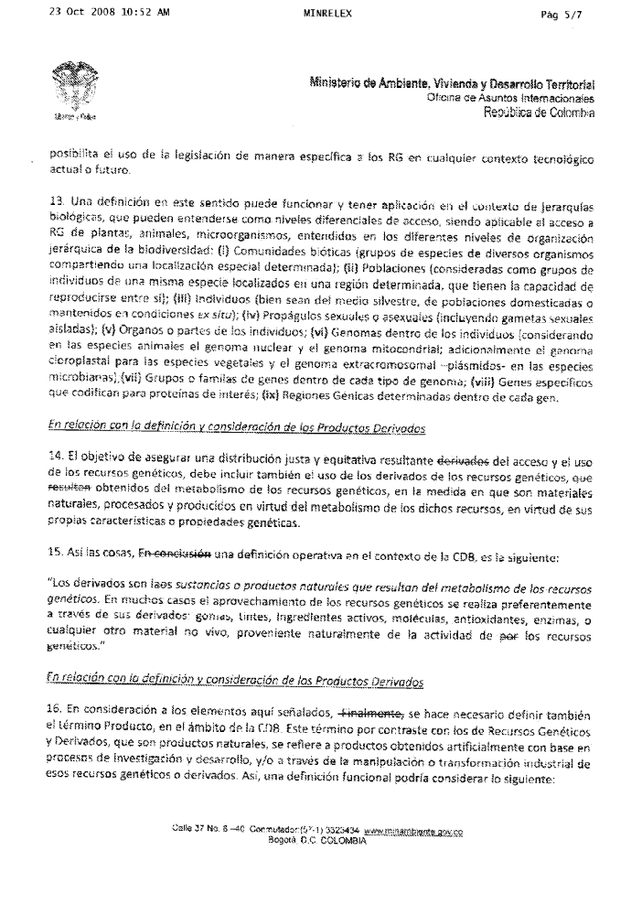
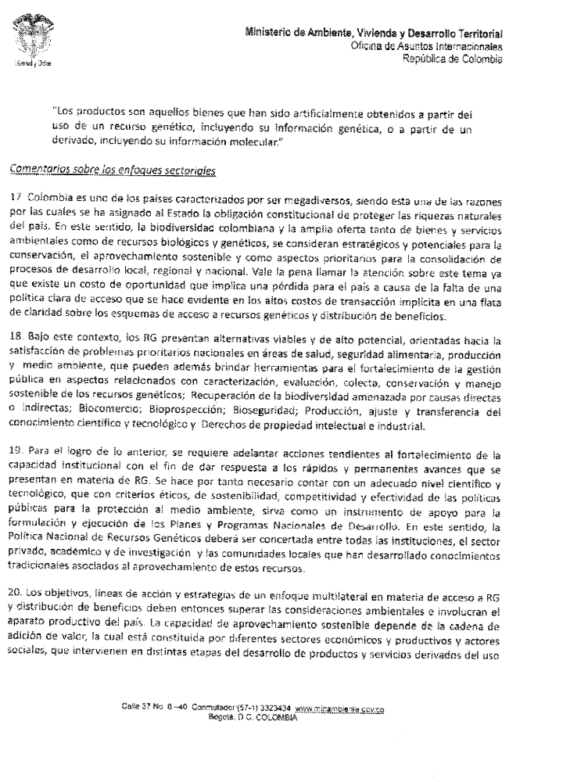
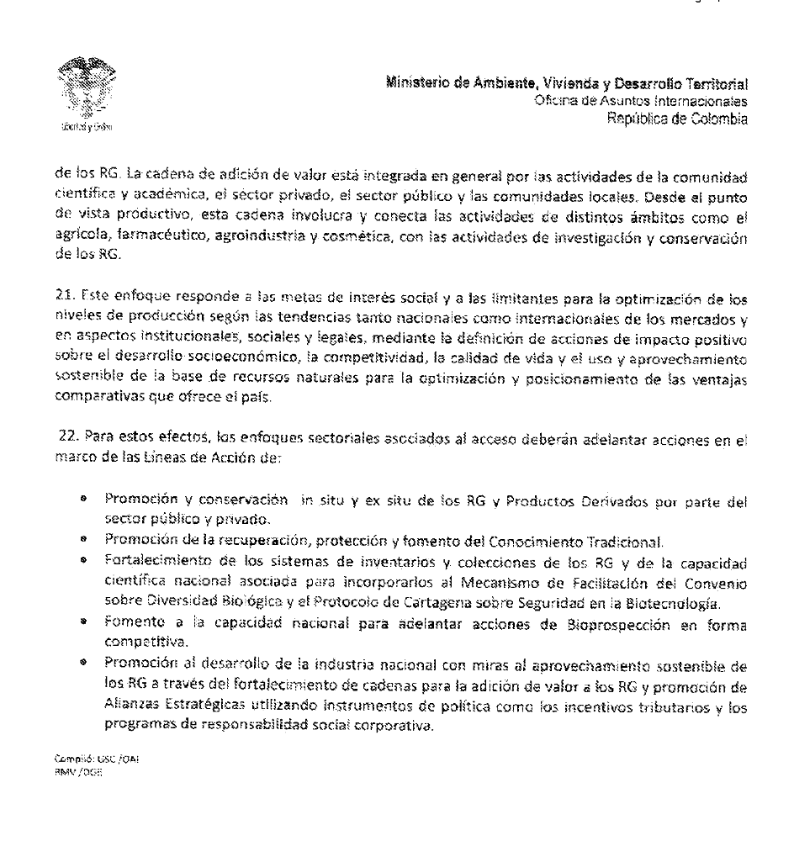

ENGLISH TRANSLATION

SCBD NOTIFICATION SCBD/SEL/OJ/VN/GD/64650
Group of Legal and Technical Experts on Concepts, Terms, Working Definitions and Sectoral Approaches

In response to the Secretariat’s request through notification SCBD/SEL/OJ/VN/GD/64650, Colombia wishes to submit the following comments for the Expert Group’s consideration

With regard to the definition of genetic resources
- A definition of genetic resources is essential to clearly set the scope of any regime on access and benefit sharing established under the Convention on Biological Diversity.
- Such a definition must has to therefore meet two requirements: a) be scientifically sound, and b) be operational, in order to be able to achieve the objective of ensuring fair and equitable sharing of benefits by the countries, communities or agents that provide genetic resources or the biological resources that contain them and through which genetic resources are accessed that provide access to genetic resources.
- The definition of “genetic resources” adopted by the CBD is essentially correct, but it is necessary to avoid misinterpretations that limit, without justification, the CBD’s scope, thereby reducing benefit-sharing opportunities.
- If we take the CBD definitions word for word, according to the definition:
“Genetic resources” are genetic material (any material of plant, animal, microbial or other origin containing functional units of heredity) of actual or potential value.
- In practical terms, genetic resources are any biological material, or material of biological origin, that can be reproduced in order to use genetic traits of actual or potential interest.
- This fact is clearly expressed in the CBD’s definition of genetic material. The definition establishes that a) genetic material is any biological material (of plant, animal, microbial, microbiological or other origin); and b) always containing functional units of heredity, which are the basic mechanism for reproducing genetic traits of actual or potential interest.
- What is not possible is the interpretation whereby Genetic Resources are exclusively units of functional heredity. This reductionist interpretation raises a number of problems. Scientifically speaking, it could reduce the scope to nucleic acids. Such a view is contradicted by practical experience, which shows that genetic resources have been isolated and manipulated from time immemorial, independently from the isolation and direct manipulation of said nucleic acids. Although nucleic acids are a sine qua non condition, they are not sufficient to obtain genetic material.
- Furthermore, this reductionist interpretation would mean that most genetic material, or biological material containing genetic resources usually provided as the basis for are the basis of making use of any genetic trait or property specific to biodiversity, would be excluded from the fair and equitable sharing remuneration of benefits arising from access to said materials and their use. This would prevent the implementation of the CBD’s objectives.
- There is a variety of biological material containing functional units of heredity and very diverse techniques can be used to take advantage of said material. The techniques include: domestication and ancestral selection, conventional genetic enhancement, and modern biotechnology procedures, including recombinant DNA. The various types of material include: complete organisms or parts thereof, seeds, pollen, spores, semen, ovules, embryos, tissue, cells, and nucleic acids, among others.
- It should be pointed out, however, that likening or equating Genetic Resource (GR) and Biological Resource (BR) could lead to practical difficulties when it comes to implementing the mechanisms and instruments designed for their use. For example, in Colombia’s case, each type of resource (Genetic and Biological) has its own administrative system, regulatory system, handling and control mechanisms, and even different property regimes.
- Therefore, in order to consider a proposal that will make it possible to account for GR and BR while maintaining the defined characteristics of each, we propose to adjust the definition as set out below (so as to retain the possibility of access to genetic resources through the various levels of hierarchical organisation of Biological Diversity, while reiterating the elements considered to be patterns of heredity/inheritability of genetic traits or properties of actual or potential interest):

Genetic Resources: “DNA and RNA molecules, together with the inheritable properties or traits that are characteristic of them, and that have actual or potential value or use”
- A definition along those lines is justifiable insofar as it makes it possible, without departing from the definitions in the CBD, to create a closer match between the technical concept and current scientific progress, thereby removing genetic/biological ambiguities. This would apply to access to Genetic Resources that can be derived from the use of any level of the hierarchical organisation of biodiversity. It also makes it possible to use legislation specifically for GR in any current or future technological context.
- Such a definition could work and be applied in the context of biological hierarchies, which can be seen as different levels of access, applicable to access to the GR of plants, animals and micro-organisms belonging to the various levels of hierarchical organisation of biodiversity: (i) Biotic communities (groups of species of various organisms that share a specific, defined location); (ii) Populations (considered to be groups of individuals of a same species located in a given region, that have the capacity to reproduce among themselves); (iii) Individuals (either in the wild, as part of domesticated populations, or maintained in ex situ conditions); (iv) Sexual or asexual propagules (including isolated sexual gametes); (v) Organs or parts of individuals; (vi) Genomes within individuals (taking into consideration the nuclear genome and mitochondrial genome for animal species, as well as the chloroplast genome for plant species and extrachromosomal genome –plasmids– for microbial species); (vii) Groups or families of genes within each type of genome; (viii) specific genes codified for proteins of interest; (ix) Given genic regions within each gene.

With regard to the definition and consideration of derivatives
- The objective of ensuring the fair and equitable sharing of benefits arising derived from access to and the use of genetic resources must also include the use of derivatives of genetic resources obtained that result from the metabolism of genetic resources, insofar as they are natural materials, processed and produced by the metabolism of said resources, in accordance with their own genetic properties or characteristics.
- Given this, in conclusion a definition that would work within the context of the CBD would read as follows:

“Derivatives are the substances or products arising from the genetic resources’ metabolism. In many cases, the use of genetic resources first takes place through their derivatives: gums, dyes, active ingredients, molecules, antioxidants, enzymes or any other non-living material generated naturally by the activity of the genetic resources.

With regard to the definition and consideration of Derivative Products
- Given the points raised here, finally, it is also necessary to define the term Product within the context of the CBD. As opposed to Genetic Resources and Derivatives, which are natural substances, Products in this sense are products that are obtained artificially, based on research and development, or through the industrial processing or manipulation of said genetic resources or derivatives. A working definition could therefore be:

“Products are goods that have been obtained artificially, based on the use of a genetic resource, including its genetic information, or based on a derivative, including its molecular information.”

Comments on the sector approaches
- Colombia has the characteristic of being a megadiverse country, which is why the state has been given the constitutional obligation to protect the country’s natural wealth. In this respect, Colombian biodiversity and the vast supply of environmental goods and services, as well as genetic and biological resources, are seen as being strategic, as having the potential for conservation and sustainable use, and as being priority aspects for consolidating national, regional and local development processes. It is worth drawing attention to this issue, seeing as there are opportunity costs that represent a loss for the country due to a clear policy for access. This is evident in the high transaction costs linked to a lack of clarity with regard to regimes for access to genetic resources and sharing of benefits.
- In this context, GR are viable alternatives that show great potential for solving national priority issues in the areas of health care, food safety, production and the environments. They can furthermore provide tools for strengthening public administration of aspects linked to characterisation, evaluation, collection, conservation and sustainable management of genetic resources; recovering biodiversity under direct or indirect threat; Biotrade; Bioprospecting, Biosafety; Production; the adaptation and transfer of scientific and technological knowledge, and intellectual and industrial property rights.
- Achieving the above will require action aimed at strengthening institutional capacity so as to deal with rapid and permanent advances with regard to GR. It is therefore necessary to have a proper level science and technology that, in conjunction with ethical criteria for sustainability, competitiveness, and efficient public policies for environmental protection, can be used as a tool to support the creation and implementation of National Development Plans and Programs. The National Policy for Genetic Resources must therefore be a concerted effort by all institutions, the private sector, the academic and research sectors, and local communities that have developed traditional knowledge associated with the use of said resources.
- The objectives, lines of action and strategies of a multilateral approach to GR access and benefit sharing must consequently go beyond environmental considerations and involve the country’s production apparatus. The capacity for sustainable use depends on the value-added chain, which is composed of various economic and production sectors, as well as social stakeholders, which are involved in the various steps of develop of products and services derived from the use of GR. The value added chain generally includes activities by the scientific and research sector, the private sector, the public sector and local communities. From the perspective of production, this chain involves and connects activities in different areas, such as agriculture, pharmaceuticals, agri-food and cosmetics, with GR research and conservation activities.
- This approach meets social interest goals, with limitations on optimizing levels of production imposed by both national and international market trends, as well as by institutional, social and legal aspects through the definition of actions with a positive impact on socioeconomic development, competitiveness, quality of life, and the sustainable use of the natural resource base to optimize and position the country’s comparative advantages.
- To this end, the sector approaches linked to access must involve steps, as part of the Lines of Action, aimed at:
- In situ and ex situ conservation of GR, Derivatives and Products by the public and private sectors;
- Fostering the recovery, protection and promotion of Traditional Knowledge;
- Strengthening GR inventory systems and collections, and strengthening associated scientific knowledge, to include them in the Convention on Biological Diversity’s clearing-house Mechanism, as well as the Cartagena Protocol on Biosafety;
- Building national capacity to carry out competitive bioprospecting activities;
- Promoting the development of national industry with a view to sustainable use of GR by strengthening value-added chains for GR, and fostering strategic alliances through policy instruments, such as tax incentives and corporate social responsibility programmes.

EUROPEAN COMMUNITY AND ITS MEMBER STATES

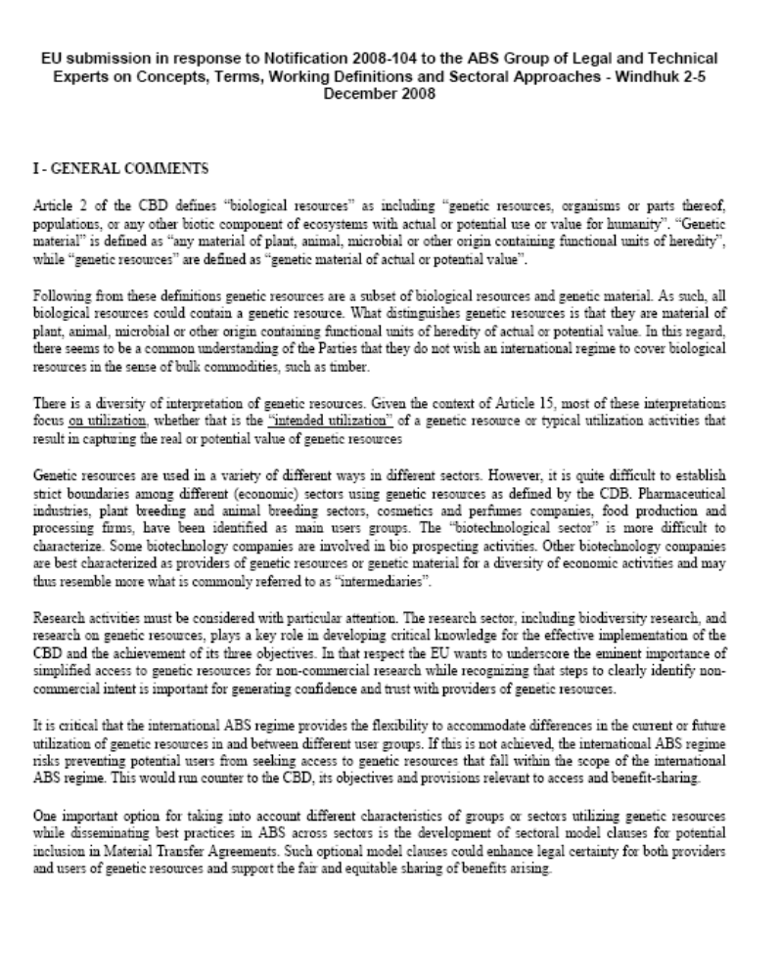

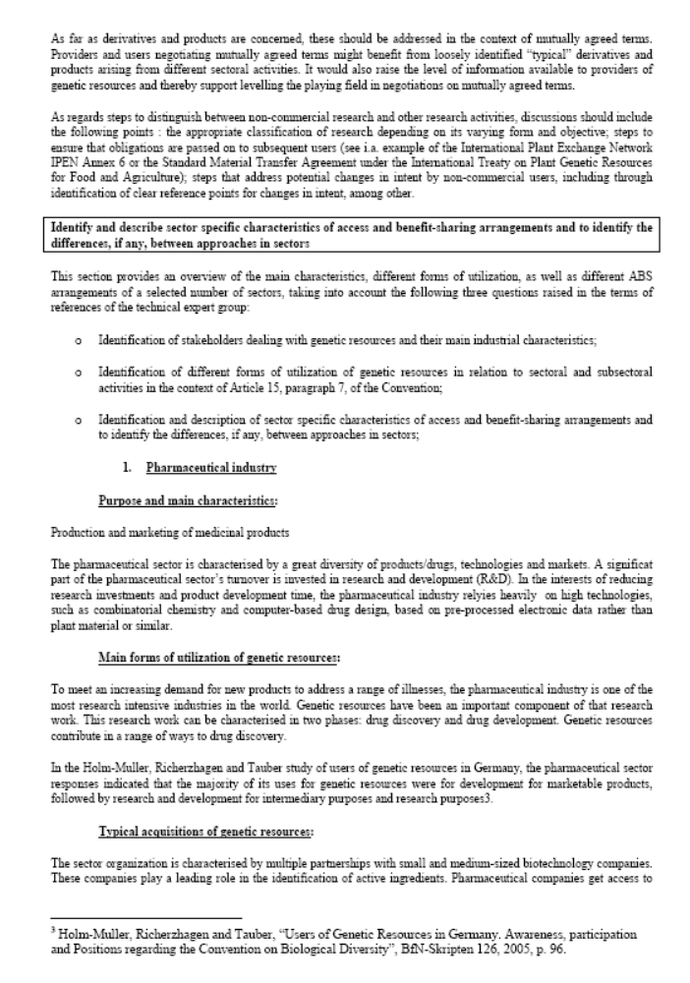

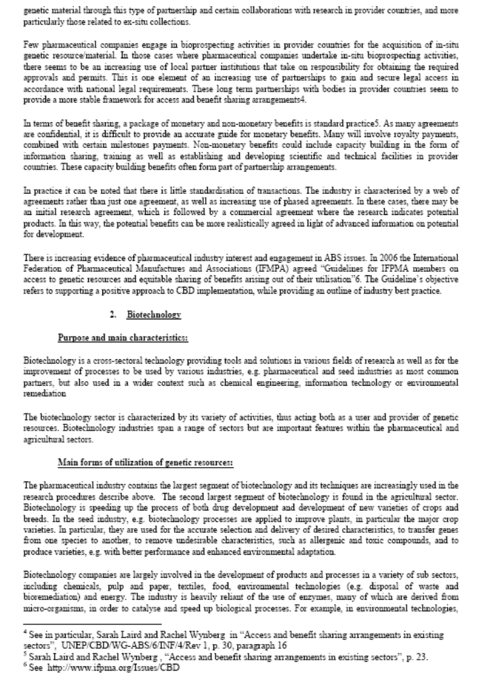

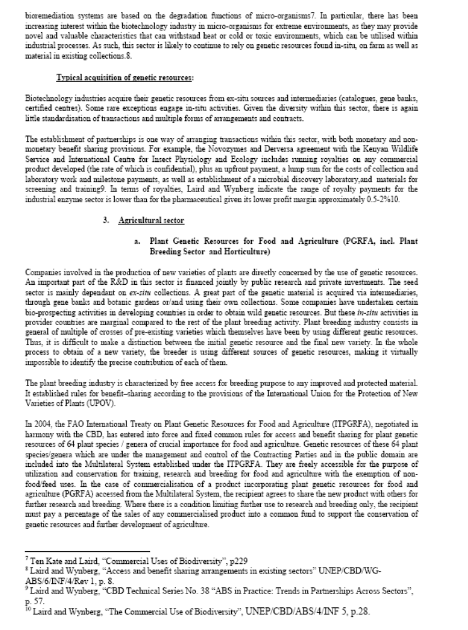

MEXICO

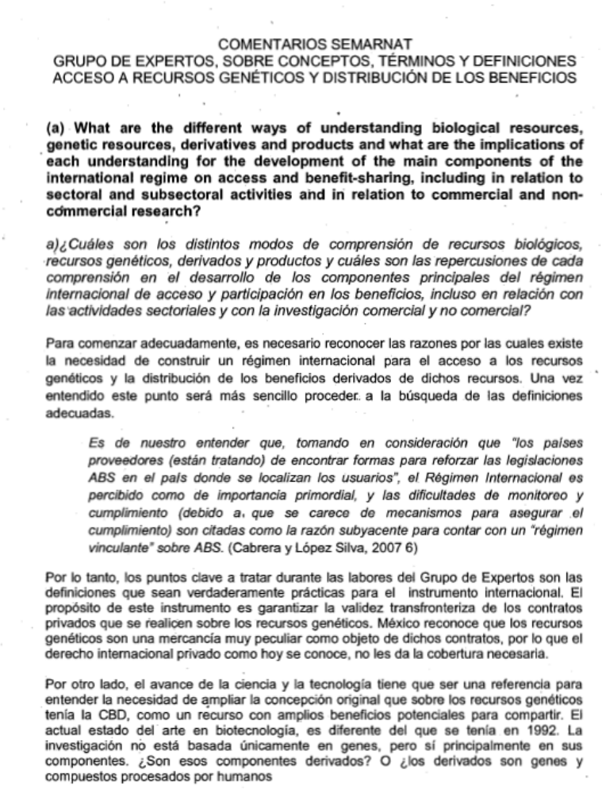

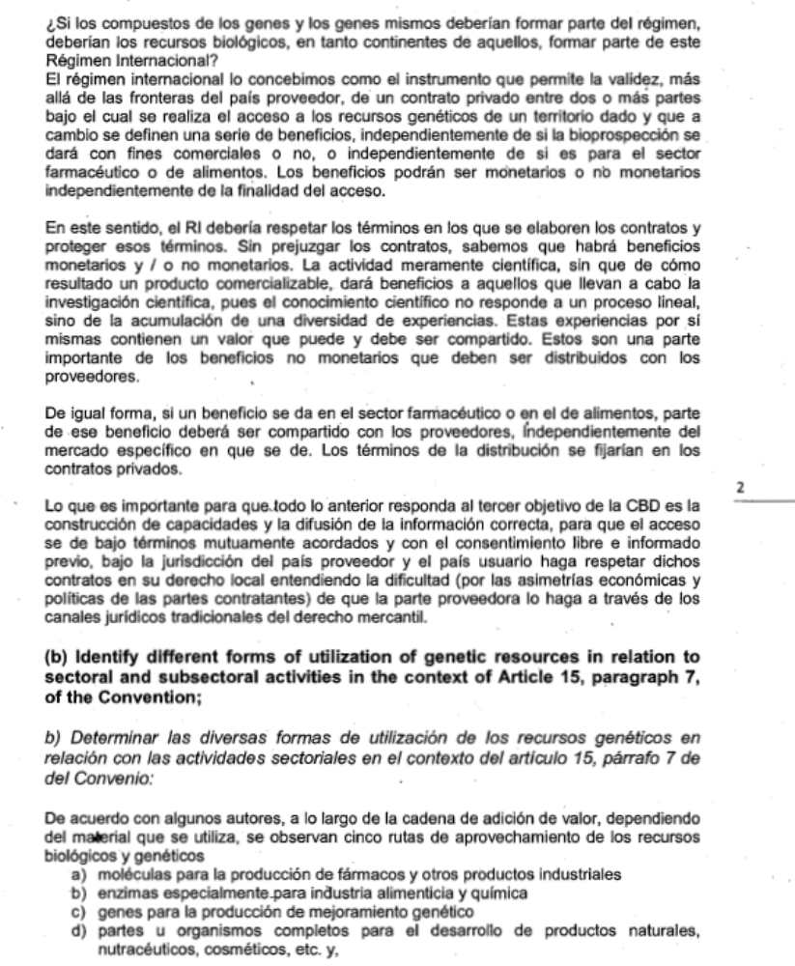

ENGLISH TRANSLATION

SEMARNAT COMMENTS
EXPERT GROUP ON CONCEPTS, TERMS AND DEFINITIONS
ACCESS TO GENETIC RESOURCES AND BENEFIT SHARING
- What are the different ways of understanding biological resources, derivatives and products, and what are the implications of each understanding for the development of the main components of the international regime on access and benefit-sharing, including in relation to sectoral and subsectoral activities and in relation to commercial and non-commercial research?
In order to begin properly, we must recognize why it is necessary to create an international regime on access and benefit-sharing. Once this is understood, it will be easier to find the appropriate definitions.
As we understand it, taking into account that “provider countries (are trying) to find ways of strengthening ABS legislation in countries where users are located”, the International Regime is considered to be of the utmost importance, and monitoring and compliance problems (caused by the lack of mechanisms to ensure compliance) are given as the underlying reason for having a “binding ABS regime”. (Cabrera and López Silva, 2007 6)
The key points to be addressed by the Working Group therefore consist of finding definitions that are truly practical for the international regime. The purpose of this instrument is to guarantee the transboundary validity of private contracts regarding genetic resources. Mexico acknowledges that genetic resources are very special merchandise under such contracts, which is why they are not adequately covered by private international law in its current form.
Furthermore, scientific and technological advances must be a reference point for understanding the need to broaden the CBD’s original concept of genetic resources as being a resource with vast potential benefits to be shared. The current state of the art in biotechnology is very different today than it was in 1992. Research is not only based on genes, but mainly on the components of genes. Are these components derivatives? Or: are derivatives genes and compounds processed by humans?
If gene compounds and genes themselves should be included under the regime, should biological resources also be included, seeing as they contain gene compounds and genes?
We see the international regime as a tool that will make it possible to validate, beyond the borders of provider countries, a private contract between two or more parties for access to the genetic resources of a given territory, in exchange for which a series of benefits are defined, regardless of whether bioprospecting is for commercial purposes, or for the food or pharmaceutical sector. Benefits may be monetary or non-monetary, depending on the purpose of access.
In this respect, the IR must observe the terms set out in contracts and protect those terms. Without prejudging said contracts, we know that monetary and/or non-monetary benefits will exist. Purely scientific activity, which may not result in a marketable product, will generate benefits for those doing the scientific research, because scientific knowledge does not follow a linear process, but is rather the accumulation of a variety of experiences. These experiences are a significant part of the non-monetary benefits that must be shared with providers.
Similarly, if benefits arise in the pharmaceutical or food sector, some of said benefit should be shared with providers, regardless of the market in which those benefits occur. The terms for benefit-sharing would be set out in the private contracts.
There must be capacity-building and dissemination of accurate information for all of the above to match the CBD’s third objective, and for access to take place under mutually agreed terms, with free prior informed consent, under the jurisdiction of the provider country, with the user country ensuring the observance of such contracts under local law, given the difficulty (due to economic and political asymmetry in contracting parties) involved in having the provider party enforce contracts using traditional commercial law channels.
- Identify different forms of utilization of genetic resources in relation to sectoral and subsectoral activities in the context of Article 15, paragraph 7, of the Convention;
According to certain authors, throughout the value added chain, depending on the material used, there are five ways of taking advantage of biological and genetic resources:
- molecules for the production of pharmaceuticals and other industrial products
- enzymes, especially for the food and chemical industries
- genes, for genetic production and improvement
- parts of or entire organisms for the development of natural, homeopathic, cosmetic and other products
- information for new markets, such as biocomputing, genomics, etc.
As mentioned in the first point of this document, it is not clear why there should be sector differences when dealing with access or benefit sharing.
Access, once it has taken place, makes it possible to use the material as indicated by subsequent research. The research can lead to unexpected uses, and changes of sector, as well as of intermediate and end user. In principle, contracts must cover these possibilities, as well as the possibility that scientific use might end up being commercial, unless prior informed consent is obtained from the provider once again, using mutually agreed terms. in such a case,
commercial use could also be expressly prohibited. All of these options exist, and must be understood when creating the international regime. There are so many potential variations that IR cannot be case-based, but must rather have general guidelines. In this respect, it must be very clear that in the presence of benefits, be they tangible or intangible, there must be sharing of said benefits through monetary or non-monetary means.
c) Identify and describe sector-specific characteristics of access and benefit-sharing arrangements and to identify the differences, if any, between approaches in sectors;
According to Casas, 2004, four main social groups can be identified as the main agents in the value added chain when it comes to the use of biological and genetic resources:
The scientific community
Ethnic groups and local communities
Private enterprise and
The public sector
The sectors that use genetic resources have been identified as being:
The pharmaceutical industry
Botanical medicine
Plant breeding
Horticulture
Biotechnology and sectors linked to Health, Industry and Agriculture
Pest Control
The cosmetics and personal hygiene industry
Fishing, fish geoplasma, genetic resources from the seabed in continental waters
Bioremediation
Each of these sectors has its own dynamic and specific characteristics, particularly with regard to the “products” obtained or “arising” from access to genetic resources. It is therefore highly likely that the non-monetary benefit aspect will vary according to the sector using the genetic resources. The monetary aspect of benefits will surely be covered by contracts through more conventional and uniform clauses, regardless of the user sector.
With regard to indigenous and local communities, genetic resource use is more a matter of using certain genetically-determined characteristics of specimens, than of using the genetic resources and their derivatives as such. These uses are linked mainly to: traditional medicine (herb lore), gastronomy, gathering, and seed banks. For the most part, activities in this sector fall under the primary sector of the economy (hunting, gathering and fishing). This sector tends to engage in direct use of the ecosystems they inhabit, and their relationship with resources is intimately linked to their beliefs and spiritual life. It is important to mention that these resources are associated with a vast amount of traditional knowledge and cultural practices that determine a given resource’s function through holistic understanding.
The characteristics of indigenous and local communities, which are substantially different from the other sectors, are basically rooted in their holistic understanding of reality; in the secularisation of thought and in socio-political as well as spiritual practice. Access to resources is direct in the ecosystem, through gathering, and is linked to inherited knowledge about techniques and procedures, as well as the places and times for gathering. The benefits of use are also direct, in the form of health care, food and clothing, and species maintenance (biodiversity) through the gathering, for example, of seeds for planting. Unlike other sectors, benefits are not sought mainly for monetary gain, and it is not a matter of gains in the industrial or capital sense. Once again, the difference in perspective is that the indigenous sector sees reality as a whole, and not as being fragmented, which is the view of non-indigenous society.
It is basically this chasm between the market view and the indigenous world view that makes it so difficult to design the international regime. The application of property rights and the attendant commercialisation of all goods and services in modern society does not correspond to the traditional ways and customs of many indigenous groups. Lack of effective dialogue on ABS has, on multiple occasions, led to the polarization of views during talks.
(d) what are the range of options and approaches for taking these different characteristics into account, and that may bring coherence to access and benefit-sharing related practices in different sectors?
The equitable sharing of benefits depends on the type of access to and use of genetic resources. “A legislative point of view states that the main trigger activities for benefit sharing are access to genetic resources” and “use of genetic resources”, and that both concepts are connected.
It should be stressed that the minimum conditions to be observed must involve mutually agreed terms, based on prior informed consent between the provider and the user of genetic resources and associated traditional knowledge.
Benefit sharing has caused confusion for all types of use, because many countries propose that use for scientific purposes be treated differently. It has been acknowledged that material transfer notices, which can occur many times a year given the nature of modern scientific research, should not be subject to prior authorization by a relevant authority or by providers, but should take place more freely. It is worth considering this, seeing as it is very valid point, and should not affect the purpose of the IR, under which benefits must first exist in order to be shared. Any potential lack of monitoring could be remedied by holding a single legal entity responsible during the period of said transfers, regardless of who holds the tangible and intangible elements covered by the contract.
More flexible treatment upon access is also being requested, with fewer requirements for the scientific community. The fact is that there should be little red tape surrounding access for all potential users seeking legal access, simply to fight biopiracy, but with the necessary minimum conditions to guarantee, as much as possible, the equitable sharing of potential benefits.
Furthermore, universities around the world are very closely linked to private funding, with contracts for the use of technological innovations that have marketing potential by the companies that support the research leading to said innovations. In other words, there is a very thin and permeable line between research done in “non-profit” organisations and commercial research. It is therefore neither particularly appropriate nor justified to differentiate between these two types of use when it comes to access requirements. Accordingly, exclusively with regard to “benefits”, there should be no doubt that if scientific activity yields benefits, said benefits should be included under the IR as commercial bioprospecting.
The definitive use of benefits should ideally be for the conservation and sustainable use of biodiversity, consistent with the Convention itself. However, it is rightfully argued that the benefits shall be used according to provider priorities, primarily in accordance with PIC and MAT.
It is important to take into account that benefits based on MAT can range widely, from an initial payment to a percentage amount for leasing the product developed using the resources; even moreso if there is associated traditional knowledge. It is also important to mention the origin of the resource.
References:
Cabrera Medaglia, Jorge and Christian López Silva (2007). Addressing the Problems of Access: Protecting Sources, While Giving Users Certainty. IUCN, Gland, Switzerland. xiv + 77pp.

T.R. Young 2004 “Genetic Resources” and “Use of Genetic Resources”. International Workshop of Experts on Access and Benefit-Sharing (Cuernavaca, Mexico, 2004)

NIGERIA

NIGERIA’S VIEW ON CBD NOTIFICATION 2008-104-ACCESS AND BENEFIT SHARING

(a)
Question i): What are the different ways of understanding biological resources, derivatives and products?
Answer: i) The different ways are: physical identification of any part or whole of organisms their Compositions , their Uses, materials thereof and items/material that can be derived as a result of processing and manufacturing using an organism(s).
Question ii): What are the different ways of understanding genetic resources derivatives and products?
Answer: ii) Identification of the Compositions (hereditary Materials living and dead) of any part or whole of organisms and their Uses, materials thereof and items/material that can be derived as a result of processing and manufacturing using hereditary Materials living and dead.
Question iii): What are the implications of each understanding for the development of the main components of the international regime on access and benefit-sharing, including in relation to sectoral and subsectoral activities and in relation to commercial and non-commercial research?
Answer: iii) The implication is that Biological Resources, Genetic Resources, derivatives and products have to be identified, standards created for the regulation of access to each and to have common regime to reduce conflicting views.

(b)
Question: Identify different forms of utilization of genetic resources in relation to sectoral and subsectoral activities in the context of Article 15, paragraph 7, of the Convention;
Answer: Some of the forms of utilization of genetic resource sectorally are: Pharmaceutics, Scientific/Technological Research, food processing and Derivatives Production of ingredients. In all cases equitable and fair benefit sharing arrangements should be put in place in accordance with National regulation.
(c)
Question: Identify and describe sector specific characteristics of access and benefit-sharing arrangements and to identify the differences, if any, between approaches in sectors;
Answer: Pharmaceutics: The acquisition of Biological Resources for the purpose of pharmaceutics will require benefit sharing arrangement of providing jobs, technological transfer, Sharing of accruable profit.
Scientific/Technological Research: Establishment of Research Institute within area of location of biological resources and training of indigenous/local communities to make them employable in the research institute. Identify other benefits that will involve the elites, local people to meet their peculiar needs.

(d)
Question: What are the range of options and approaches for taking these different characteristics into account and that may bring coherence to access and benefit-sharing related practices in different sectors?
Answer: Some of the range of options and approaches include having meetings and dialogue with local people who are directly involved in the location of biological resources, local government, policy makers, relevant government institutions and other relevant stakeholders. There should be holistic regulatory and administrative framework in place.

NORWAY

SWITZERLAND

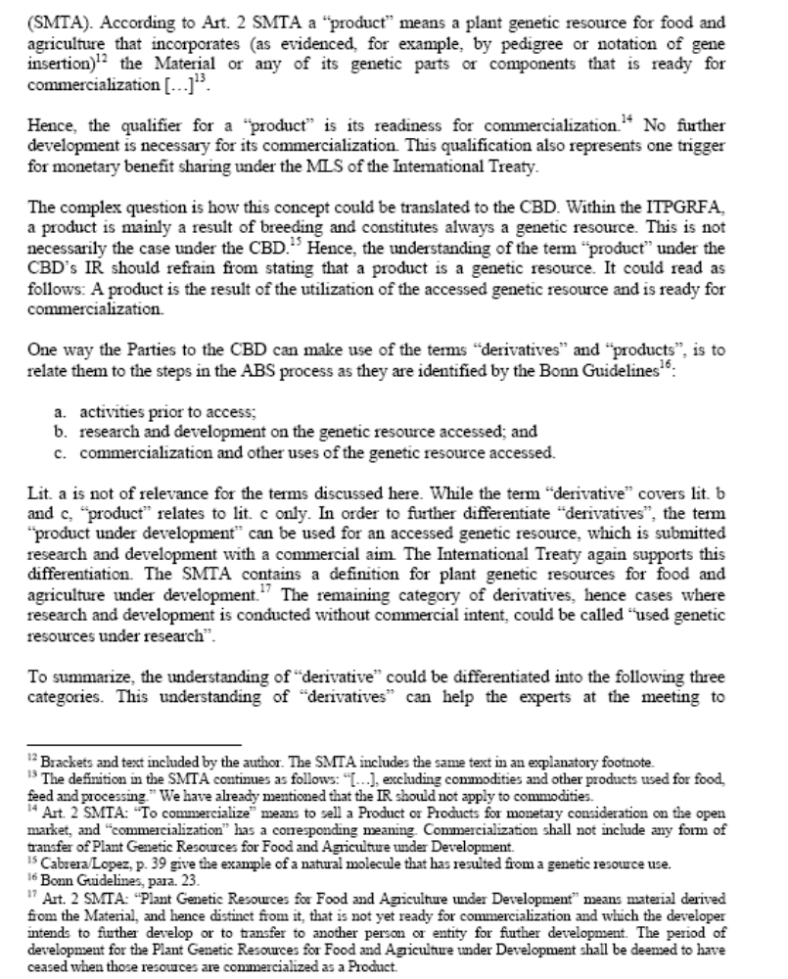

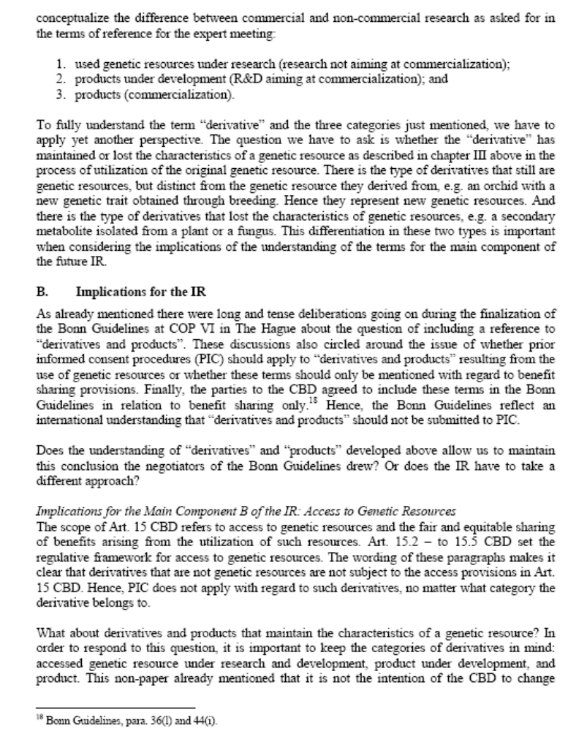

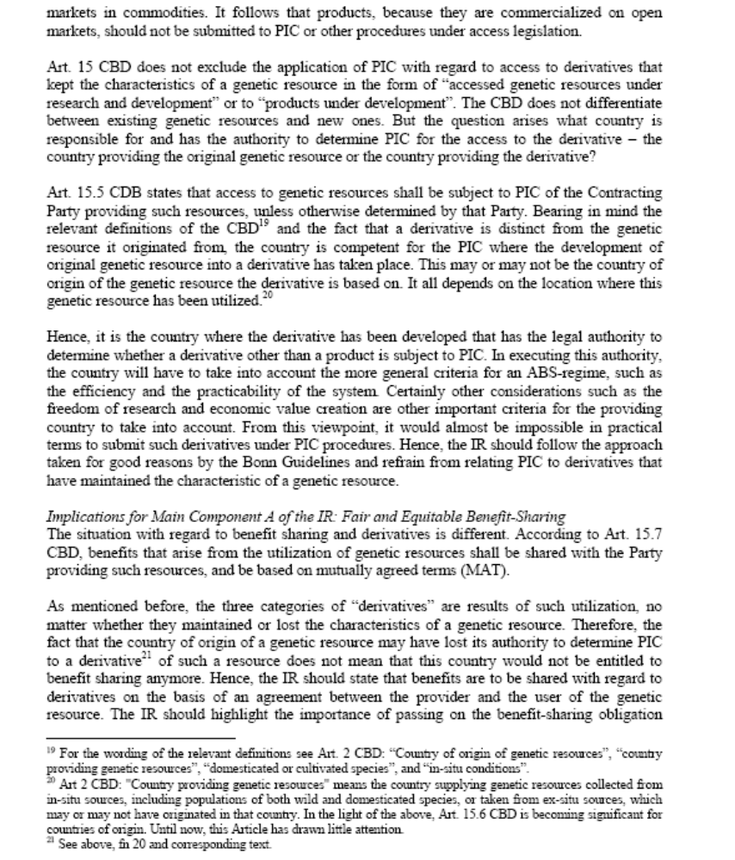

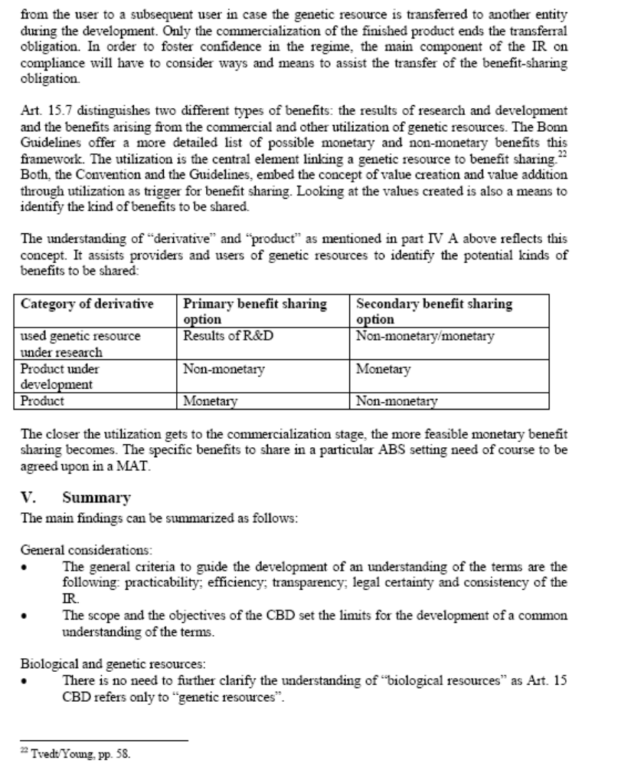

II. SUBMISSIONs FROM NON-PARTIES

UNITED STATES OF AMERICA

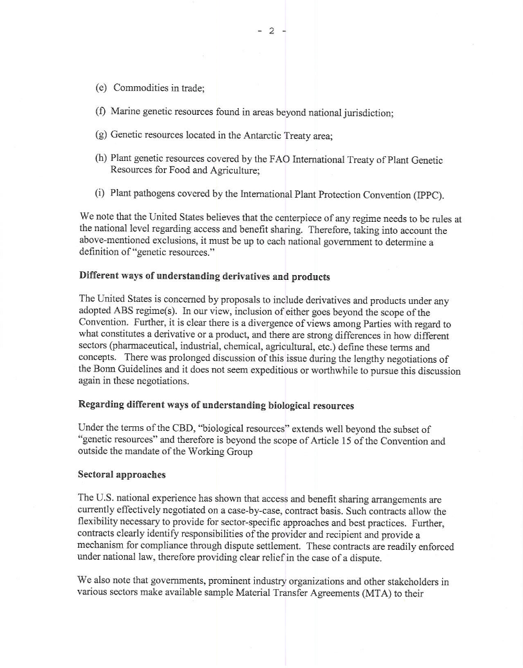

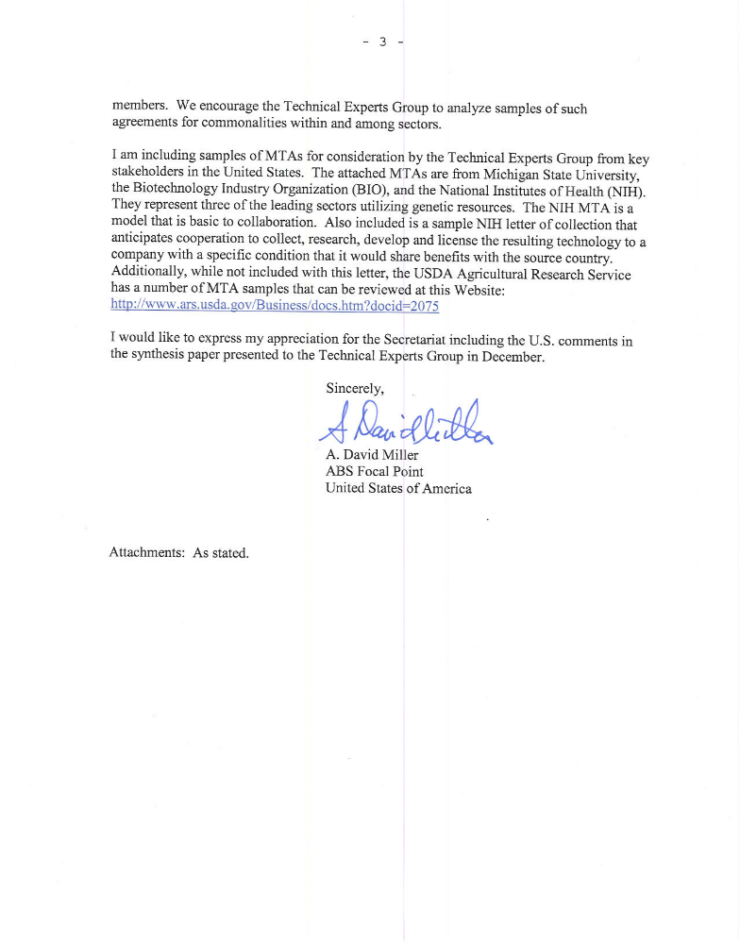

Please note that the “Suggested Model Material Transfer Agreement” of the Biotechnology Industry Organization (BIO), also submitted by BIO, is available from page 80 to 90.

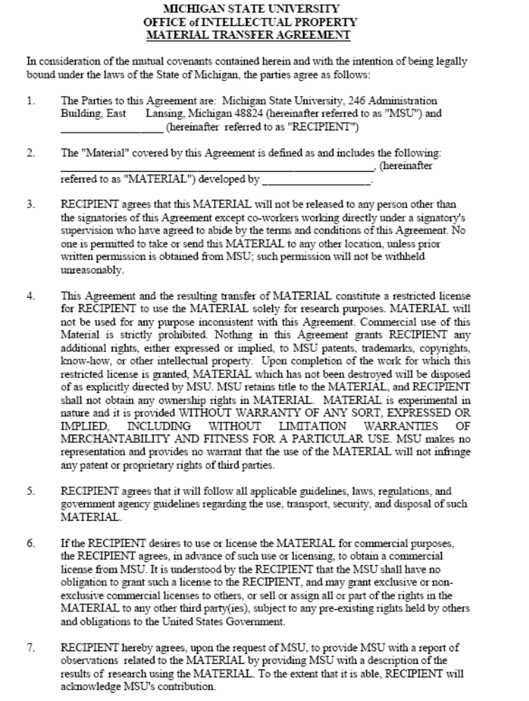

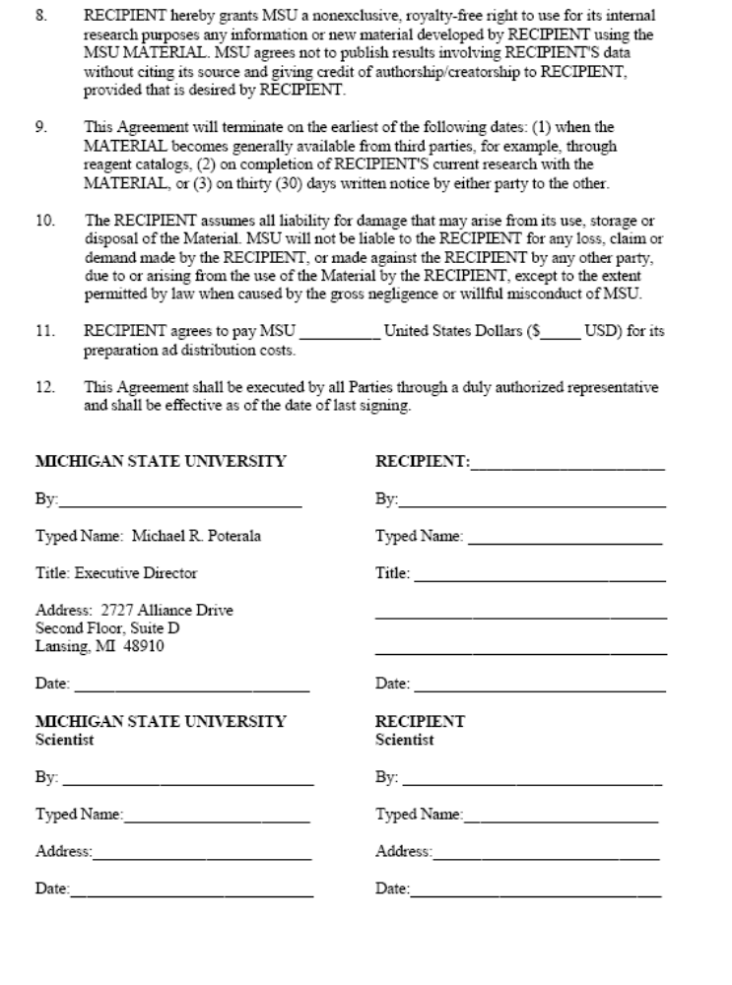

LETTER OF COLLECTION

Agreement Between
[Source Country Organization, SCO]
and the
Developmental Therapeutics Program
Division of Cancer Treatment and Diagnosis
National Cancer Institute
The Developmental Therapeutics Program (DTP), Division of Cancer Treatment and Diagnosis (“DCTD”), National Cancer Institute (NCI) is currently investigating plants, micro-organisms, and marine macro-organisms as potential sources of novel anticancer drugs. The DTP is the drug discovery program of the NCI which is an Institute of the National Institutes of Health (NIH), an arm of the Department of Health and Human Services (DHHS) of the United States Government. While investigating the potential of natural products in drug discovery and development, NCI wishes to promote the conservation and sustainable utility of biological diversity, and recognizes the need to compensate [Source Country, SC] organizations and peoples in the event of commercialization of a drug developed from an organism collected within their country’s borders.
As part of the drug discovery program, DTP has contracts with various organizations for the collection of plants, micro-organisms and marine macro-organisms worldwide. DTP has an interest in investigating plants, micro-organisms and marine macro-organisms from [Source Country], and wishes to collaborate with the [Source Country Government (SCG) or Source Country Organization(s) (SCO)] as appropriate in this investigation. The collection of plants, micro-organisms and marine macro-organisms will be within the framework of the collection contract between the NCI and the NCI Contractor [Contractor] which will collaborate with the appropriate agency in the [SCG or SCO]. The NCI will make sincere efforts to transfer knowledge, expertise, and technology related to drug discovery and development to the [appropriate Source Country Organization (SCO] in [Source Country] as the agent appointed by the [SCG or SCO], subject to the provision of mutually acceptable guarantees for the protection of intellectual property associated with any patented technology. The [SCG or SCO], in turn, desires to collaborate closely with the DTP/NCI in pursuit of the investigation of its plants, micro-organisms and marine macro-organisms, subject to the conditions and stipulations of this agreement.
A. The role of DTP, DCTD, NCI in the collaboration will include the following:
1) DTP/NCI will screen the extracts of all plants, micro-organisms and marine macro-organisms provided from [Source Country] for anticancer activity, and will provide the test results to [SCO] on an annual basis. Such results will be channeled via Contractor.
2) The parties will keep the test results and subsequently-developed data confidential until approved for publication by the parties. Before either party submits a paper or abstract containing test results for publication, the other party shall have 60 days to review and, as necessary file a sole or joint patent application in accordance with Article 6.
3) Any extracts exhibiting significant activity will be further studied by bioassay-guided fractionation in order to isolate the pure compounds(s) responsible for the observed activity. Since the relevant bioassays are only available at DTP/NCI, such fractionation will be carried out in DTP/NCI laboratories. A suitably qualified scientist designated by [SCO] may participate in this process subject to the terms stated in Article 4. In addition, in the course of the contract period, DTP/NCI will assist the [SCO], thereby assisting the [Source Country], to develop the capacity to undertake drug discovery and development, including capabilities for the screening and isolation of active compounds from plants, micro-organisms and marine organisms.
4) Subject to the provision that suitable laboratory space and other necessary resources are available, DTP/NCI agrees to invite a senior technician or scientist designated by [SCO] to work in the laboratories of DTP/NCI or, if the parties agree, in laboratories using technology which would be useful in furthering work under this agreement. The duration of such visits would not exceed one year except by prior agreement between [SCO] and DTP/NCI. The designated visiting scientist(s) will be subject to provisions usually governing Guest Researchers at NIH. Salary and other conditions of exchange will be negotiated in good faith. Costs and other conditions of visits will also be negotiated in good faith prior to the arrival of the visiting scientist(s).
5) In the event of the isolation of a promising agent from a plant, micro-organism or marine macro-organism collected in [Source Country], further development of the agent will be undertaken by DTP/NCI in collaboration with [SCO]. Once an active agent is approved by the DTP/NCI for preclinical development, [SCO] and the DTP/NCI will discuss participation by SCO scientists in the development of the specific agent.
The DTP/NCI will make a sincere effort to transfer any knowledge, expertise, and technology developed during such collaboration in the discovery and development process to [SCO], subject to the provision of mutually acceptable guarantees for the protection of intellectual property associated with any patented technology.
6) DTP/NCI/NIH will, as appropriate, seek patent protection on all inventions developed under this agreement by DTP/NCI employees alone or by DTP/NCI and [SCG or SCO] employees jointly, and will seek appropriate protection abroad, including in [Source Country], if appropriate. All resulting patent applications and patents shall be assigned to the U.S. Department of Health and Human Services and managed by NIH. Under current NIH policy, all inventors of such assigned patents may receive royalties in accordance with said NIH policy for any royalty-bearing license(s) for these patent(s).
7) All licenses granted on any patents resulting from this collaboration shall contain a clause referring to this agreement and shall indicate that the licensee has been apprised of this agreement.
8) Should an agent derived from an organism collected under the terms of this agreement eventually be licensed to a pharmaceutical company for production and marketing, DTP/NCI will request that NIH/OTT require the successful licensee to negotiate and enter into agreement(s) with the appropriate [SCG] agency(ies) or [SCO] within twelve (12) months from the execution of said license. This agreement(s) will address the concern on the part of the [SCG or SCO] that pertinent agencies, institutions and/or persons receive royalties and other forms of compensation, as appropriate.
9) The terms of Article 8 shall apply equally to inventions directed to a direct isolate from a natural product material, a product structurally based upon an isolate from the natural product material, a synthetic material for which the natural product material provided a key development lead, or a method of synthesis or use of any aforementioned isolate, product or material; though the percentage of royalties negotiated as payment might vary depending upon the relationship of the marketed drug to the originally isolated product. It is understood that the eventual development of a drug to the stage of marketing is a long term process which may require 10-15 years.
10) In obtaining licensees, the DTP/NCI/NIH will require the license applicant to seek as its first source of supply the natural products from [Source Country]. If no appropriate licensee is found that will use natural products available from [Source Country], or if the [SCG] or [SCO] as appropriate, or its suppliers cannot provide adequate amounts of raw materials at a mutually agreeable fair price, the licensee will be required to pay to the [SCG] or [SCO] as appropriate, compensation (to be negotiated) to be used for expenses associated with cultivation of medicinal organisms that are endangered or for other appropriate conservation measures. These terms will also apply in the event that the licensee begins to market a synthetic material for which a material from [Source Country] provided a key development lead.
11) Article 10 shall not apply to organisms which are freely available from different countries (i.e., common weeds, agricultural crops, ornamental plants, fouling organisms) unless information indicating a particular use of the organism (e.g., medicinal, pesticidal) was provided by local residents to guide the collection of such an organism from [Source Country], or unless other justification acceptable to both the [SCG or SCO] and the DTP/NCI is provided. In the case where an organism is freely available from different countries, but a phenotype producing an active agent is found only in [Source Country], Article 10 shall apply.
12) DTP/NCI will test any pure compounds independently submitted by the [SCG or SCO] scientists for antitumor activity, provided such compounds have not been tested previously in the DTP/NCI screens. If significant antitumor activity is detected, further development of the compound may, as appropriate, be undertaken by DTP/NCI in consultation with the [SCG or SCO].
Should an NCI/NIH patent on an agent derived from the submitted compound(s) eventually be licensed to a pharmaceutical company for production and marketing, DTP/NCI will request that NIH/OTT require the successful licensee to negotiate and enter into agreement(s) with the appropriate [SCG agency(ies) or SCO] within twelve (12) months from the execution of said license. This agreement will address the concern on the part of the [SCG or SCO] that pertinent agencies, institutions and/or persons receive royalties and other forms of compensation, as appropriate.
13) DTP/NCI may send selected samples to other organizations for investigation of their anti-cancer, anti-HIV or other therapeutic potential. Such samples will be restricted to those collected by NCI contractors unless specifically authorized by the [SCG or SCO]. Any organization receiving samples must agree to compensate the [SCG or SCO] and individuals, as appropriate, in the same fashion as described in Articles 8-10 above, notwithstanding anything to the contrary in Article 11.
B. The role of the Source Country Government ("SCG") or Source Country Organization(s) ("SCO") in the collaboration will include the following:
1) The appropriate agency in [SCG or SCO] will collaborate with Contractor in the collection of plants, micro-organisms and marine macro-organisms, and will work with Contractor to arrange the necessary permits to ensure the timely collection and export of materials to DTP/NCI.
2) Should the appropriate agency in [SCG or SCO] have any knowledge of the medicinal use of any plants, micro-organisms and marine macro-organisms by the local population or traditional healers, this information will be used to guide the collection of plants, micro-organisms or marine macro-organisms on a priority basis where possible. Details of the methods of administration (e.g., hot infusion, etc.) used by the traditional healers will be provided where applicable to enable suitable extracts to be made. All such information will be kept confidential by DTP/NCI until both parties agree to publication.
The permission of the traditional healer or community will be sought before publication of their information, and proper acknowledgment will be made of their contribution.
3) The appropriate agency in [SCG or SCO] and Contractor will collaborate in the provision of further quantities of active raw material if required for development studies.
4) In the event of large amounts of raw material being required for production, the appropriate agency of the [SCG or SCO] and Contractor will investigate the mass propagation of the material in [Source Country]. Consideration should also be given to sustainable harvest of the material while conserving the biological diversity of the region, and involvement of the local population in the planning and implementation stages.
5) [SCG or SCG] and SCO scientists and their collaborators may screen additional samples of the same raw materials for other biological activities and develop them for such purposes independently of this agreement.
This agreement shall be valid as of the date of the final authorized signature below for an initial period of five (5) years, after which it can be renewed by mutual agreement. It may be amended at any time subject to the written agreement of both parties. Copies of such amendments will be kept on file at both of the addresses indicated below.
For the National Cancer Institute: For [SCI] or [SCO]:

_______________________ __________________________
John E. Niederhuber, M.D. Name (typed):
Director, National Cancer Institute Title:

_______________________ __________________________
Date Date

mailing and contact address: mailing and contact address:

Technology Transfer Branch
National Cancer Institute at Frederick
Fairview Center, Suite 500
1003 - W. 7th Street
Frederick, Maryland 21701-8512 U.S.A.
Telephone: 301-846-5465
Facsimile: 301-846-6820

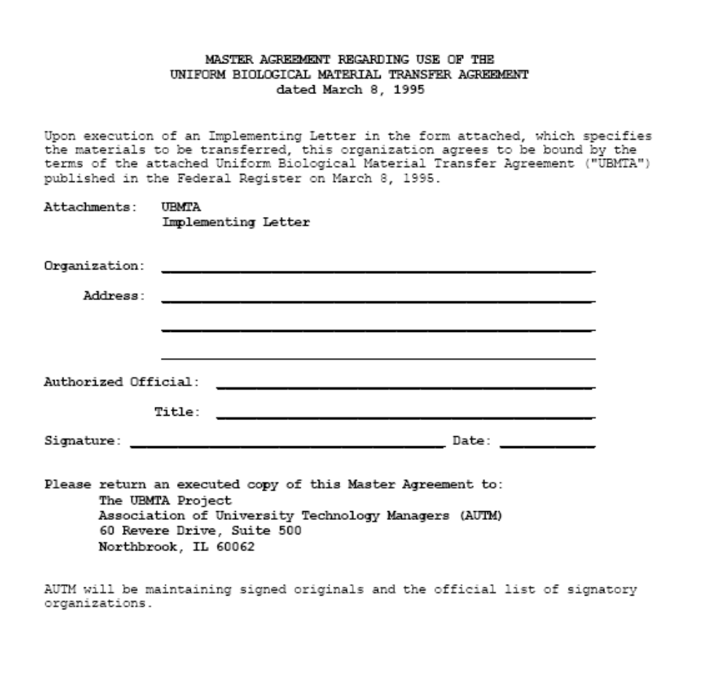

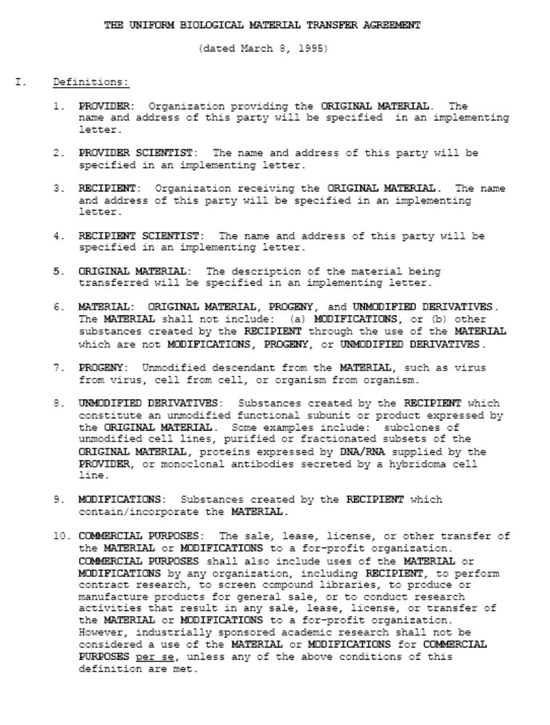

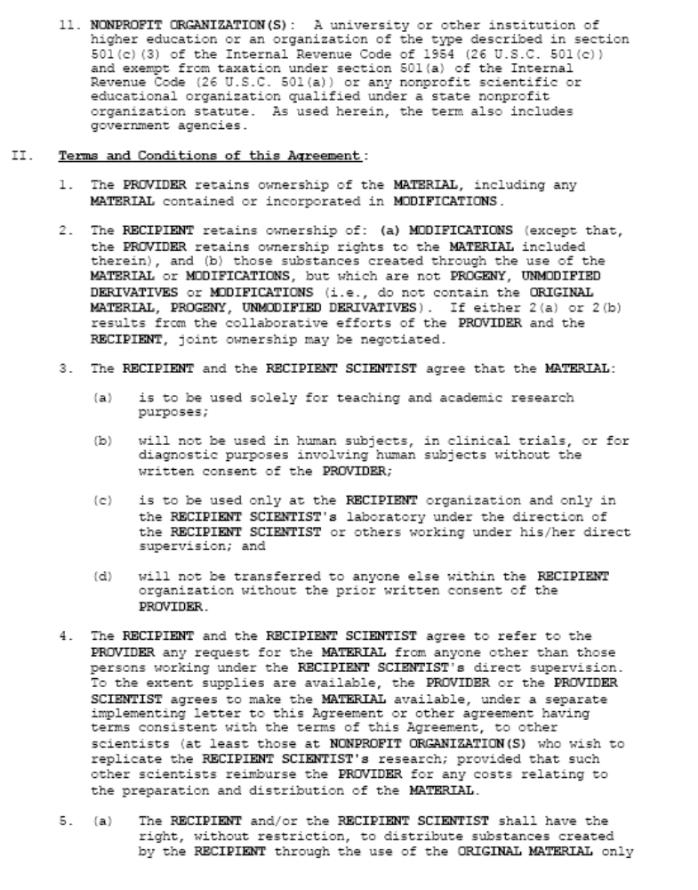

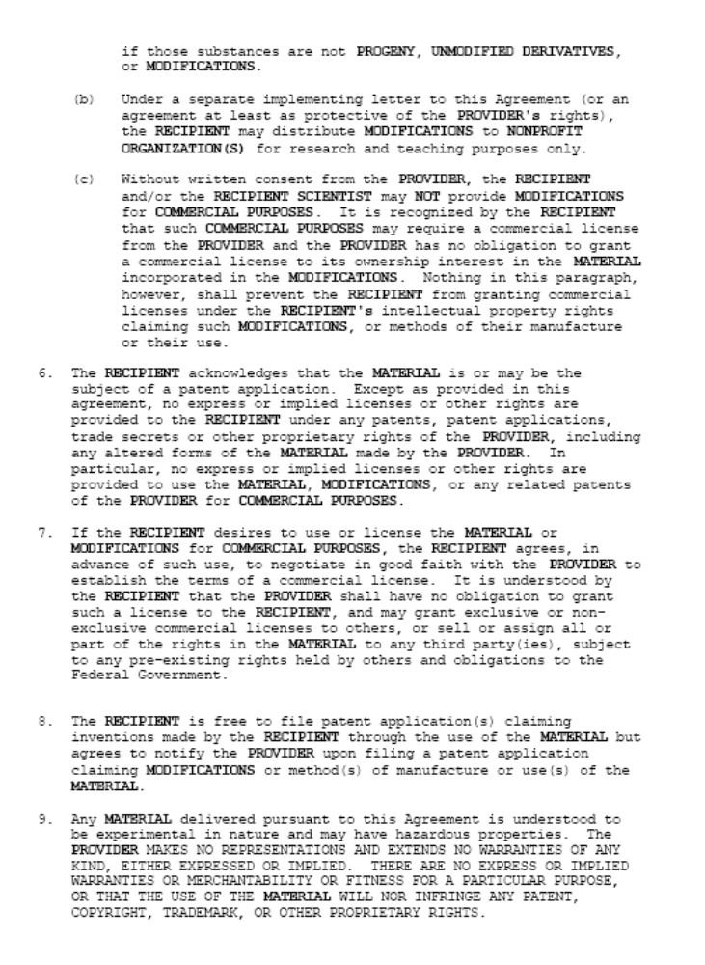

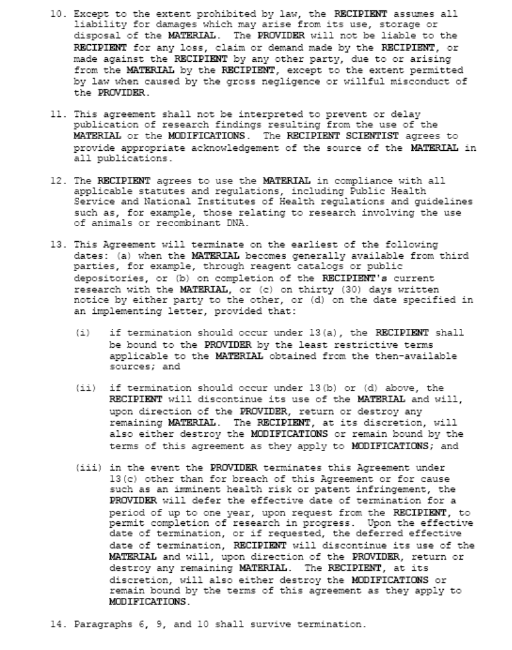

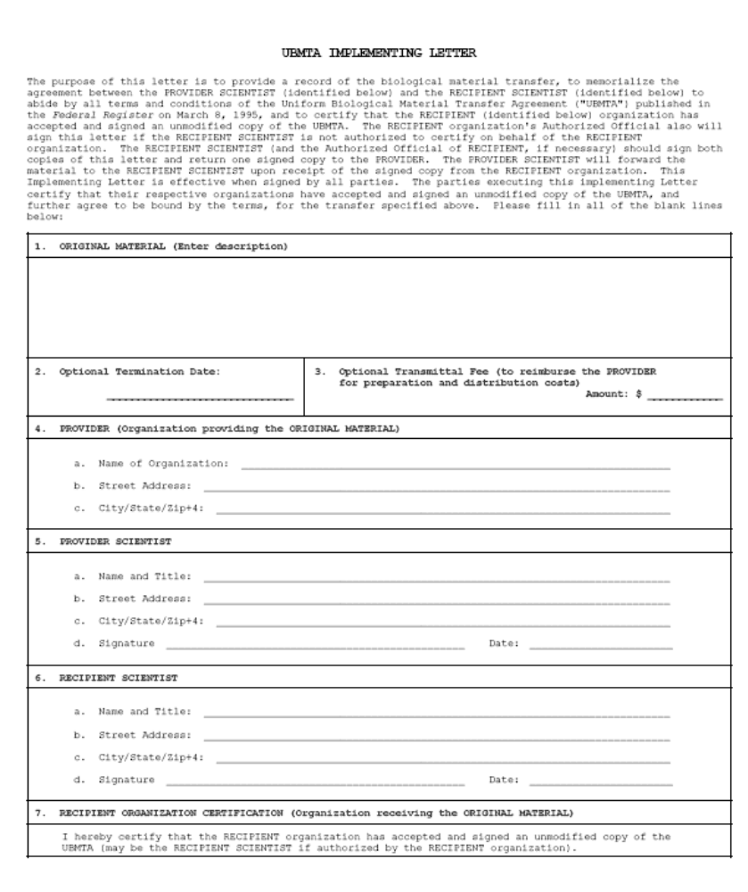

III. SUBMISSIONS FROM International Organizations, non-governmental organizations and stakeholders

ACCESS AND BENEFIT SHARING ALLIANCE (ABSA)

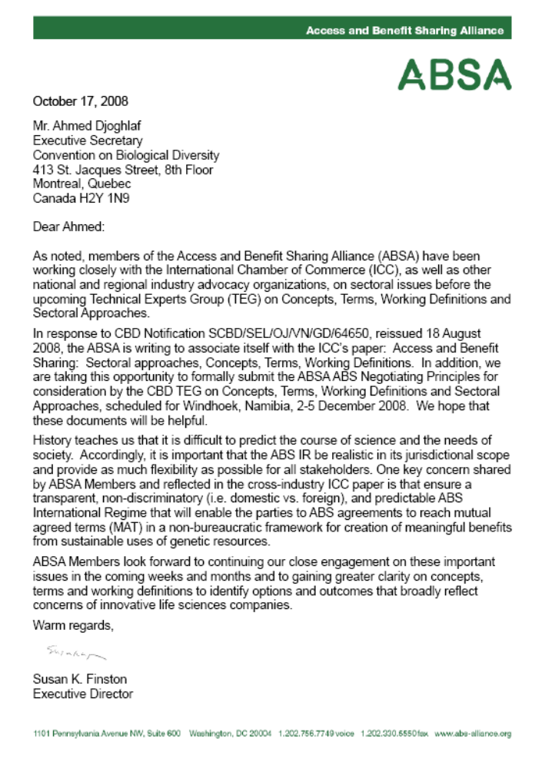

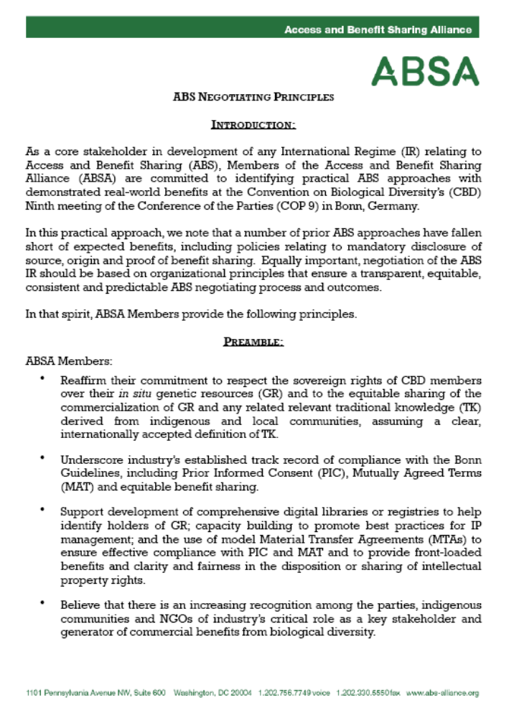

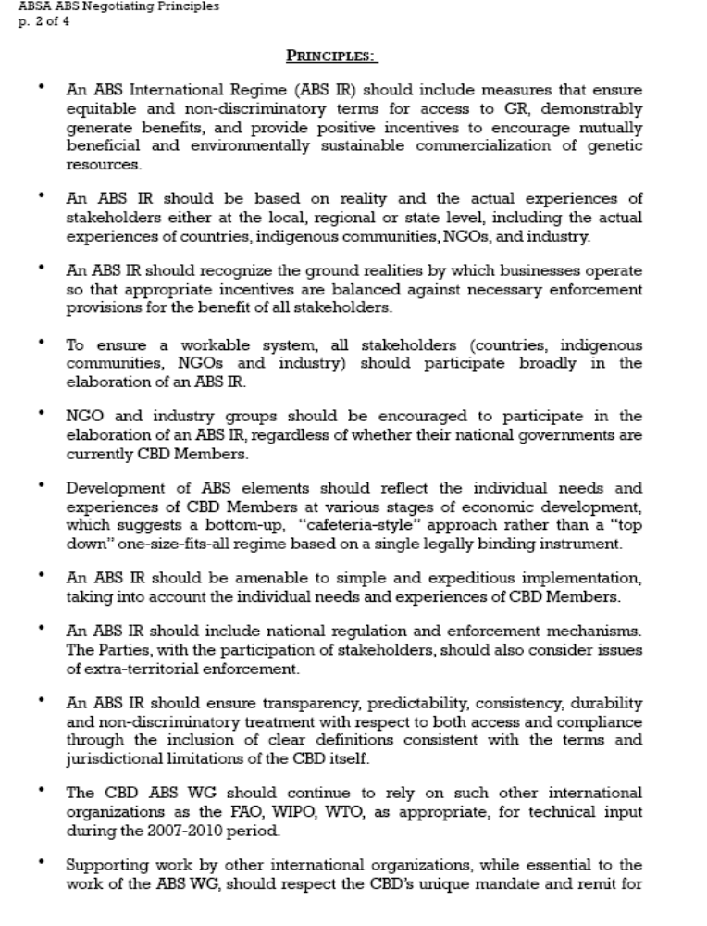

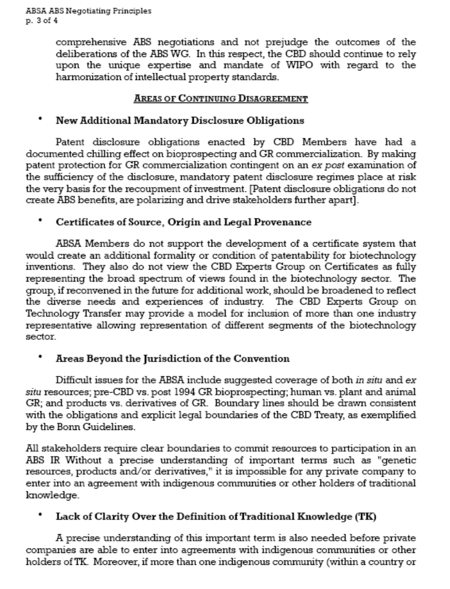

BIOTECHNOLOGY INDUSTRY ORGANIZATION (BIO)

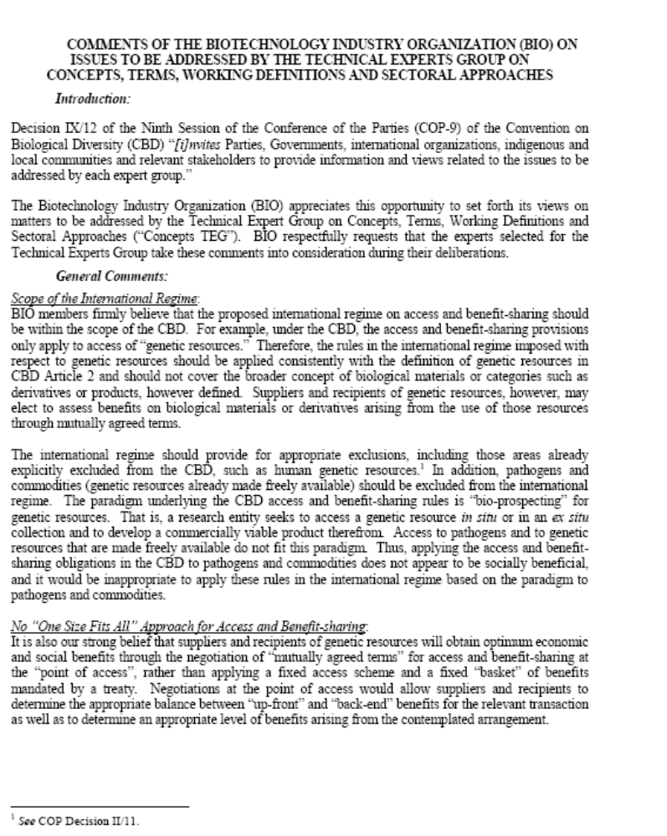

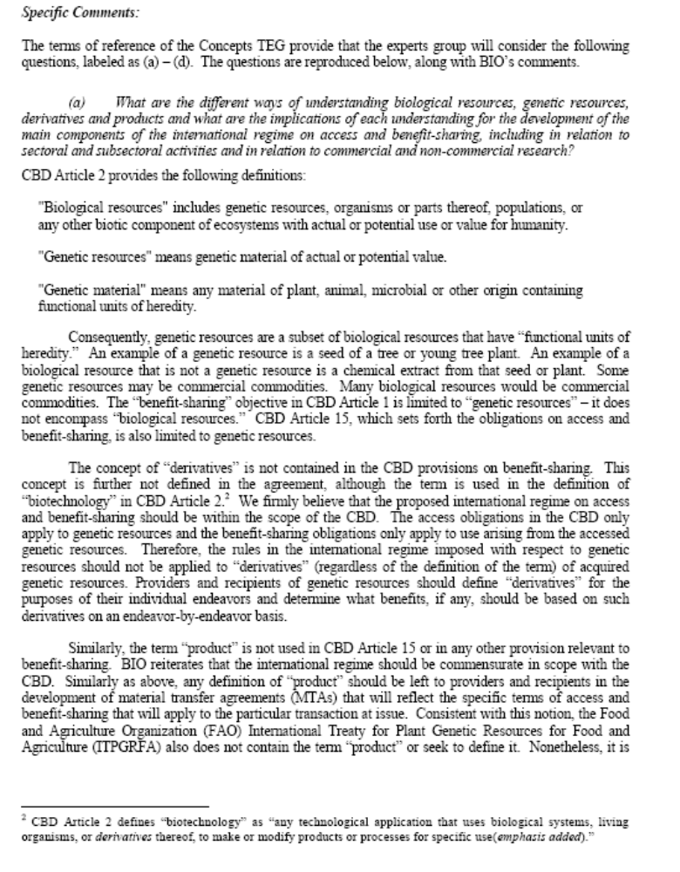

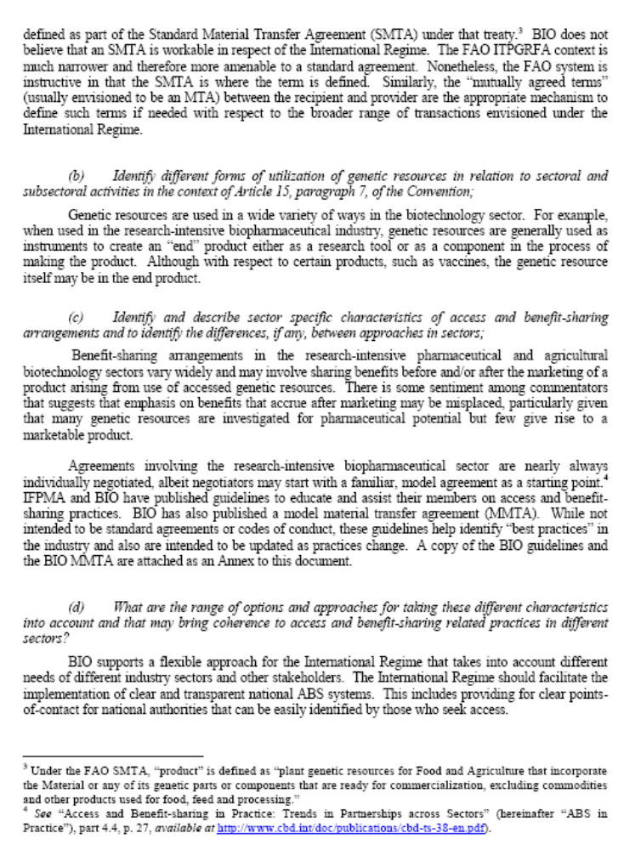

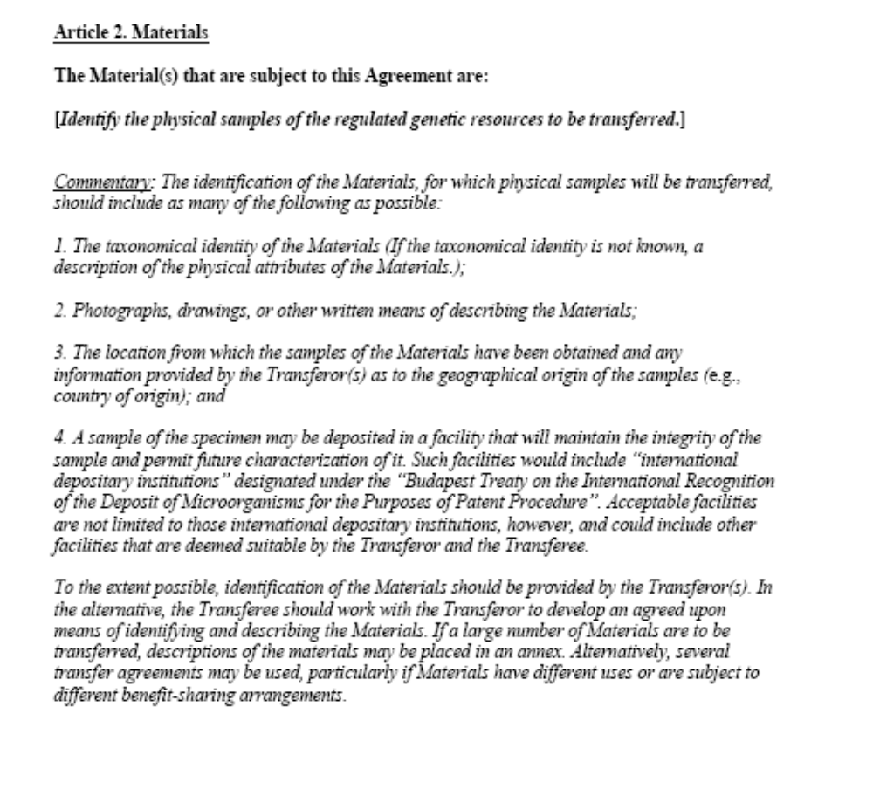

EUROPEAN SEED ASSOCIATION (ESA)

From: Isabelle Klopstein [mailto:IsabelleKlopstein@euroseeds.org]
Sent: Tuesday, October 21, 2008 11:54 AM
To: secretariat
Cc: Garlich von Essen
Subject: ESA supports to ICC submission for TEG on Sectoral Approach

To:

Secretariat of the Convention on Biological diversity
att. Mr Ahmed Djoghlaf, Executive Secretary
Montreal, Canada
Via e-mail: secretariat@cbd.org

Dear Mr. Ahmed Djoghlaf,

In view of the meeting of the TEG on Concepts, Terms, Working Definitions and Sectoral to be held on 2-5 December 2008 in Namibia, ESA European Seed Association would like to state its full support for the submission from ICC (International Chamber of Commerce) “Access and Benefit Sharing: Sectoral approaches, Concepts, Terms, Working Definitions” (n° 450/1041) and associated documents as sent last Friday to the CBD Secretariat.

In addition, ESA will continue to work on a specific position of the plant breeding sector for submission to the 7th meeting of the Ad Hoc Open-ended Working Group on Access and Benefit-Sharing.

Yours sincerely,

Isabelle Klopstein
Legal Advisor
-------------------------------------------------
ESA European Seed Association
Rue du Luxembourg 23
1000 Brussels
Belgium
Phone: +32 (0) 2 743 28 68
Website: www.euroseeds.org

INTERNATIONAL CHAMBER OF COMMERCE (ICC)

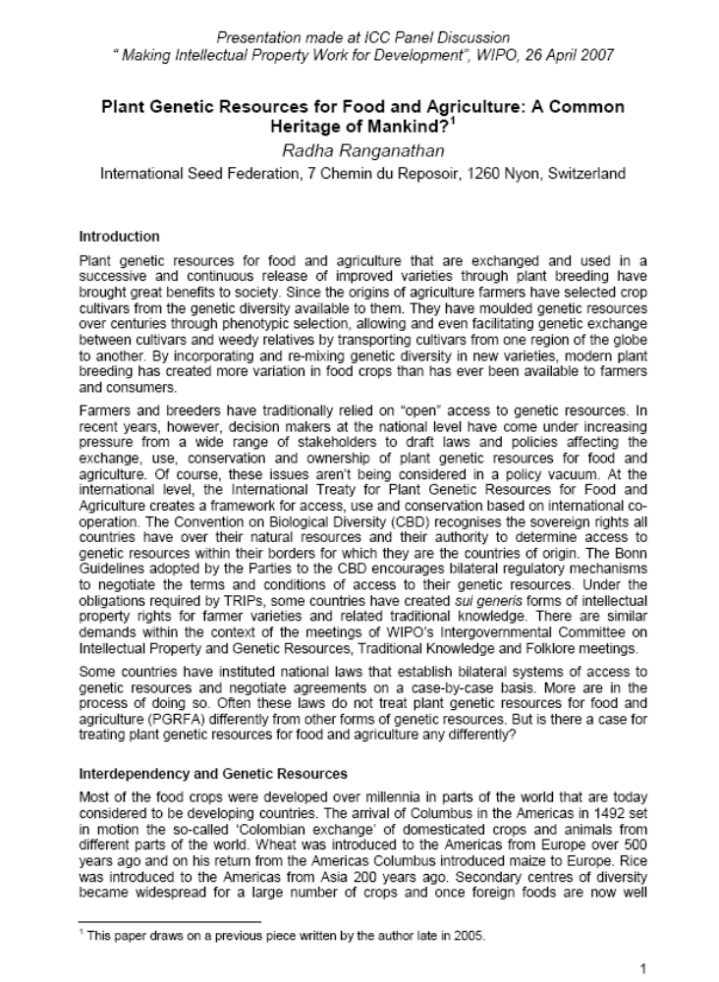

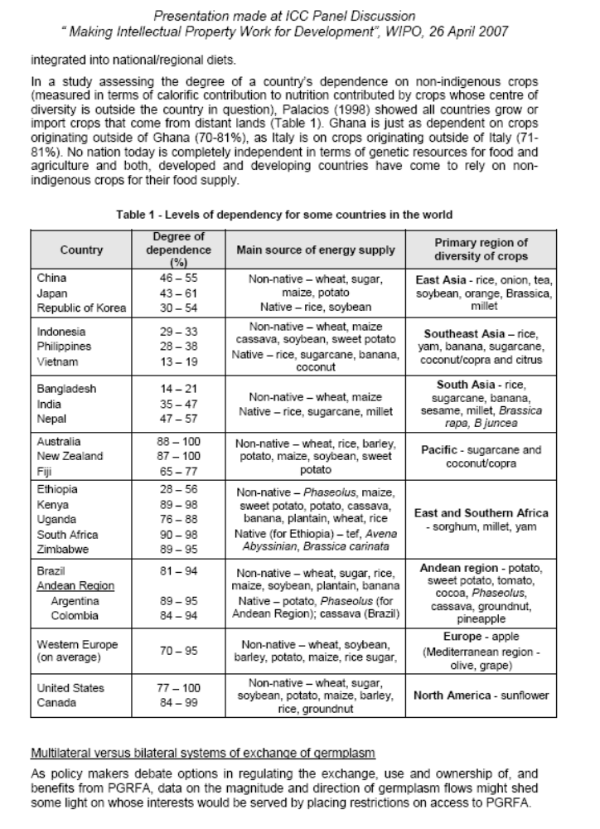

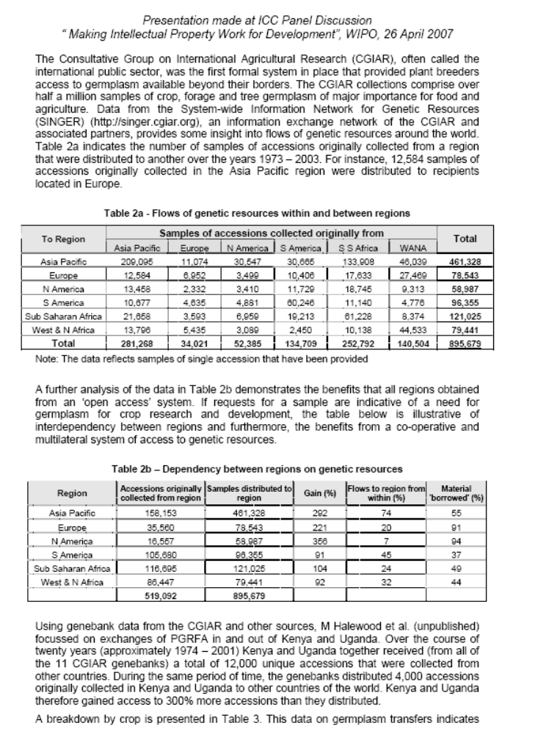

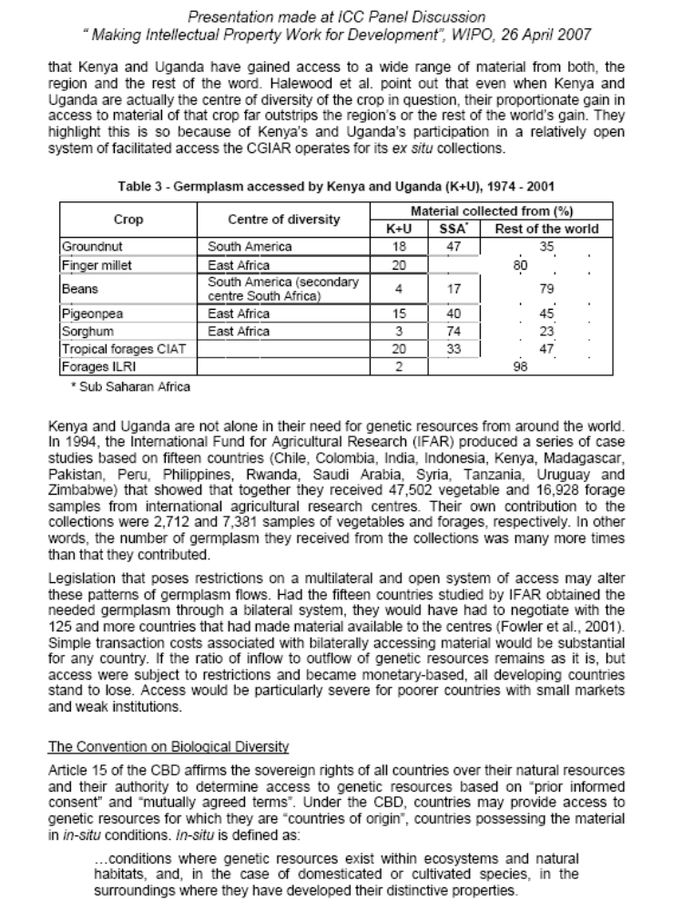

INTERNATIONAL ORGANISATION FOR BIOLOGICAL CONTROL (IOBC), INTERNATIONAL BIOCONTROL MANUFACTURERS ASSOCIATION (IBMA) AND AFRICAN INSECT SCIENCE FOR FOOD AND HEALTH (ICIPE)

Dear Executive Secretary, Mr Ahmed Djoghlaf

As a preparation for the next ABS AHTEC meeting held in Windhoek Namibia on the 2-5 December 2008, you called for a submission of views on the terms of reference in the Para 11 of Decision IX/12.

On behalf of the IOBC-Global, the organization representing more than 2000 biocontrol researchers and practitioners (International Organisation for Biological Control), the IBMA, representing 150 companies in this area (International Biocontrol Manufacturers Association), and icipe, an international research centre working on Biocontrol in Africa and for Africa, I would like to submit our views.

Do allow me to use your template of questions and annex them to this letter, as well as the contact persons.

Yours sincerely



Dr. Fabian Haas
icipe Nairobi

Annex I
Views on Para 11 of Decision IX/12
(a) What are the different ways of understanding biological resources, genetic resources, derivatives and products and what are the implications of each understanding for the development of the main components of the international regime on access and benefit-sharing, including in relation to sectoral and subsectoral activities and in relation to commercial and non-commercial research?
In Classical Biological Control the whole organism is used as a natural enemy of the targeted pest. This organism is released into a new environment where it is expected to get establish. It then becomes a new component of the biodiversity. The organism and its action, i.e. the suppression of a pest, thus become a public good, serving everybody, every farmer and every person in its range for free and no body/company receives any continued monetary benefit from its existence and actions as contemplated in the scope of the current national access and benefit s sharing regimes, or in the on-going negotiations.. Classical Biological Control programmes are supported through national or international initiatives in which donors, national administration and universities/research centres work closely together during the whole process.
In case of Inoculative Biological Control an organism is most often released to confined environments (e.g. greenhouses) and controls/kills the pest for a certain time but usually does not become established. Therefore long-term control requires the continued and repeated release of the organism, to be supplied by an institution.
In both cases, however, the organism is not genetically modified, IPRs,as contemplated in the current national access and benefit sharing regimes and biosafety (Cartagena Protocol) issues are therefore not involved, and the organism remains available in its natural (and new) environment to all possible users (other biocontrol firms, local people, and scientists) and uses. What is usually charged for where commercialization of the organism occurs, is for the mass rearing and handling of the organism on its premises.
Further, the natural enemy is in neither case not continually extracted from nature and no genes or substances are isolated and used independently, neither is the organism genetically modified. Therefore, no Intellectual Property Rights are granted nor infringed, and derivatives do not occur.
With regard to the natural population it should be stressed that the organism is not continually extracted from nature, since once released it will build up a new independent population, and in case of Inoculative Biological Control, the company mass rears the organism producing the high number necessary for effective release.
Since the organism is used as a whole, no genes or substances are isolated, which are used directly or could be used for other products. So the issues of derivates do not apply here.
In Biological Control the organism is seen as whole, as a biological resource, and not reduced to genes.
(b) Identify different forms of utilization of genetic resources in relation to sectoral and subsectoral activities in the context of Article 15, paragraph 7, of the Convention;
Because it does not generate income to companies, Classical Biological Control is usually implemented and conducted through cooperation between research institutes from several countries, often on several continents, and donors. The results and techniques are published in reports to donors and scientific contributions and become thus available to everybody. The cooperation increases the scientific and administrative capacities to deal with future pests.
Inoculative Biological Control stimulates the research in ecology and biology of the species involved. As the organisms themselves are not protected by IPR, all biocontrol companies can mass rear the organism for commercial use. Prices drop through competition between companies offering the same organisms. The natural population is not affected despite this use.
(c) Identify and describe sector specific characteristics of access and benefit-sharing arrangements and to identify the differences, if any, between approaches in sectors;
Specific to this sector is that is deals with Invasive Alien Species brought from their natural range to new areas. So, allowing biological control is very much along the lines of CBD’s call for cooperation, managing IAS and preventing damage to biodiversity in other countries through an invasive alien species. It also affirms the principle that biodiversity is of common heritage to mankind.
Specific to the sector of biocontrol is the access to a –compared to the natural population- minute number of specimens of the wild population of the natural enemy. The biocontrol agent is then mass reared and released without modifying its genetic material, thus no patents can be granted.
Specific to this sector is that natural enemies become established as new elements of the local biodiversity and become a public good, with costs for nobody but benefits for all.
Specific to this sector is the very strong aspect of cooperation amongst scientist and donors across continents and countries, and the publication of the results in freely accessible media. Even in the case of companies, the result of their research work, i.e. the finding of a natural enemy of a pest organism, becomes immediately public knowledge when the company starts marketing. Anybody can start using the same organism for the same purpose.
(d) What are the ranges of options and approaches for taking these different characteristics into account and that may bring coherence to access and benefit-sharing related practices in different sectors?
The current practice could be molded into a SMTA (Standard Material Transfer Agreement) which is capturing the aforementioned customs and restricting the activities to exactly the uses common in biological control.
At this point it should also be noted that the sector of biocontrol is already regulated under the roof of the FAO and IPPC to minimize the risks related to introduction of new species. So, ABS would actually add to these requirements.
The biocontrol community is also in favour of the MLS found under the ITPGRFA or ‘The Plant Treaty’, as it is colloquially called. This treaty is appealing because it has a ‘commons approach’ for access and distribution of benefits while allowing simple and easy access to biodiversity components.
Annex II
Contact Persons (alphabetic to organization)
Ms Johannette Klapwijk  Head of Invertebrate Biocontrol Agents  IBMA - International Biocontrol Manufacturers Association  www.ibma.ch  jklapwijk@koppert.nl  Phone +31 105 140 471 | Prof. Dr. Jacques Brodeur  President of the  IOBC – International Organisation of Biological Control  www.entomology.wisc.edu/iobc/nrs.htm  Institute de recherche en biologie vegetale  4101 rue Sherbrooke  Montreal  Canada H1X 2B2  jacques.brodeur@umontreal.ca  Phone: +1 514 872 4563
Dr. Fabian Haas
Head of Biosystemtic Support Unit
icipe – African Insect Science for Food and Health
www.icipe.org
Kasarani, Duduville Campus
Nairobi 30772-00100
Kenya
fhaas@icipe.org
Phone +254 728 132 868

INTERNATIONAL SEED FEDERATION (ISF)

ISF Position on Access to Plant Genetic Resources for Research and Breeding
(Oct 2008)

Plant genetic resources are used for very diverse purposes such as pharmaceutical products, cosmetics and plant breeding. Consequently, any regime on access and benefit sharing (ABS) for such plant genetic resources must take into account the specificity of each sector of users.
Since the beginning of agriculture and horticulture farmers have selected cultivars from the genetic diversity available to them. Over centuries they moulded these genetic resources through phenotypic selection, facilitated genetic exchange between cultivars and their weedy relatives, and transported their cultivars from one region of the globe to another. By incorporating and recombining genetic diversity available worldwide into new varieties, modern plant breeding has created, and continues to create, more variation in crops than has ever been available to growers and consumers.
All countries are strongly dependent on each other for plant genetic resources. Each country grows or imports numerous crops whose centres of diversity lie outside its national boundary making it inherently dependent on multiple foreign genetic resources. The widespread use of plant genetic resources, historically based on open access, is evident in the ancestry of individual varieties.
Access to genetic resources used in plant breeding is best facilitated through a multilateral approach that recognises and takes into consideration this dependency between countries. Public research institutions and small breeding companies in developing countries, those who access an overwhelming majority of plant genetic resources from gene banks, are particularly at risk of being unable to negotiate bilateral agreements. A multilateral system and standard terms of access would also encourage the sustainable use and conservation of plant genetic resources.
The CBD is debating a certificate of origin, source or legal provenance that would be required to guarantee benefit sharing once genetic resources had left the provider country. ISF is not in favour of such a certificate, as neither its need nor true value has been demonstrated. The complex parentage of genetic resources used for plant breeding and the continuous recombination of genes render its implementation impractical.
ISF believes that the Multilateral System (MLS) of the FAO International Treaty on Plant Genetic Resources for Food and Agriculture (the “Treaty”) is the right approach for ABS of genetic resources used in plant breeding programs. ISF strongly recommends that all plant genetic resources used regularly in plant breeding programs be brought into the MLS of the Treaty.
For plant genetic resources used in plant breeding that are not in the MLS of the Treaty, ISF supports a sectoral approach in CBD’s International Regime on ABS. They should be accessed through an MLS-like system using a standard Material Transfer Agreement. Benefit sharing provisions should take into consideration the specificities of the plant-breeding sector.

INTERNATIONAL UNION FOR PROTECTION OF NEW VARIETIES OF PLANTS (UPOV)

MR. GEOFF BURTON, PRINCIPAL CONSULTANT GENETIC RESOURCES MANAGEMENT & INTERNATIONAL CO-OPERATION, JEAN SHANNON & ASSOCIATES PTY LTD AND VISITING SENIOR FELLOW, UNITED NATIONS UNIVERSITY INSTITUTE OF ADVANCED STUDIES
Cover Sheet

Submission of Views in Accordance with SCBD Notification: SCBD/SEL/OJ/VN/GD64650.

Subject: Access and Benefit-sharing: Group of Legal and Technical Experts on Concepts, Terms, Working Definitions, and Sectoral Approaches

Author: Mr Geoff Burton, Principal Consultant Genetic Resources Management
& International Co-operation, Jean Shannon & Associates Pty Ltd and Visiting Senior Fellow, United Nations University Institute of Advanced Studies.

___________________________________
Submission by: Geoff Burton, Principal Consultant Genetic Resources Management
& International Co-operation, Jean Shannon & Associates Pty Ltd and
Visiting Senior Fellow, United Nations University Institute of Advanced Studies.

Understanding Access to Biological Resources, Genetic Resources and its relationship to Derivatives and Products

The Problem
The Convention on Biological Diversity does not define access to biological resources or genetic resources nor does it clarify the relationship between biological resources, genetic resources and their derivatives and products. This has lead to concerns that the application of the Convention is flawed. This concern in turn leads to consistent calls for the inclusion of derivatives and products in the development an international regime on Access and Benefit-sharing.

Such calls have been resisted by other Parties in the belief that national law implementing the terms of the Convention and developed in accordance with Convention’s Bonn Guidelines, are sufficient to provide legal certainty and to promote the fair and equitable sharing of benefits from the utilisation of genetic resources. Moreover, it has been argued that inclusion of derivatives would expand the scope of any regime so as to make it unworkable.

This latter view is commonly held among developed countries and particularly by those whose common law heritage has given them confidence in the regulation of commerce by contracts - within an over arching legal framework. The historic experience of many developing countries does not provide them with the same confidence and countries with a civil law tradition often find themselves more comfortable with a clear and explicit expression of terms, rights and obligations.

The continuing nature of this concern about ‘derivatives’ and ‘products’ is most recently demonstrated in annex I to COP9 decision IX/12 The International Regime. Here, references to the terms ‘derivatives’ and to ‘products’ are included as bracketed text in the paragraph setting out the Regime’s Objective, in Option 1 under Scope, and are continued in Options 4 and 6. Option 7 under Scope calls for the clarification of the term “utilization of genetic resources”. This may be interpreted as an indirect call for the issue of derivatives and products to be resolved.

Progress?
This seeming impasse is showing signs of breaking with the scope for flexibility at the national level being recognised in 2007.
This recognition was reflected in the agreed position adopted by the Group of Technical Experts on An Internationally Recognised Certificate of Origin/Source/Legal Provenance in its report to the 5th Meeting of the Ad Hoc Open Ended Working Group on Access and Benefit-Sharing / where they said:
“The Group considered that the sovereign rights of Parties over their natural resources allowed them to regulate access and to determine the range of genetic resources and associated traditional knowledge that could be covered, providing flexibility to the Parties and avoiding the need to harmonize national access legislation and thereby significantly reducing implementation costs. This may also allow Parties to include derivatives in the national system if they so wish. It was felt that some harmonization of user measures and checkpoints may be necessary.”
While flexibility at the national level is welcome, it does not resolve the need for consistency in any international regime.
Linking Purpose to Use of Resources
The Convention defines the terms Biological resources and Genetic resources but it does not define access to resources. The opportunity to do so opens the door to providing clarity about what resources are to be obtained and for what purpose. In doing so, providing such a definition it is one way in which the concerns about the limitations of the existing definitions of biological and genetic resources may be addressed.
For example, in 2005 Australia adopted the following definition of ‘access’ in its national ABS legislation:
“access to biological resources means the taking of biological resources of native species for research and development on any genetic resources, or biochemical compounds, comprising or contained in the biological resources (other than an activity mentioned in subregulation (3)).”/
In this instance the scope of the definition is initially wide with the reference to ‘taking biological resources’ but is then narrowed by the reference to ‘native species” and by “for research and development” and then is made specific by reference to ‘genetic resources and biochemical compounds’ found within the biological resources.
Another plain words definition of Access can be found in the United Nations University Institute of Advanced Studies Pocket Guide (to) Access to Genetic Resources, Benefit Sharing and Bioprospecting. It defines ‘Access’ as:
“Access to genetic resources means to obtain samples of biological and/or genetic material from areas within national jurisdiction for purposes of research on conservation, commercial application or industrial use”/
The inclusion of a reference to biochemical compounds in the first definition ensures that any and all parts (derivatives) found within a biological resource are covered even if the material obtained no longer contains any genetic material of functional heredity. The second definition addresses this issue by including biological resources - which necessarily includes any, and all, of its constituent components.
Does such an pragmatic approach also cover ‘products’? Yes. By linking the grant of access to a defined purpose (scientific research and development or commercial application or industrial use) any product of the research and development process comes within the benefit sharing provisions of the system. This is consistent with the express intention at CBD Articles 15(7) and 19(2) to secure and promote fair and equitable benefit sharing.
At the same time, this type of approach ensures that commodity harvesting involving fishing, forestry, and other uses of biological resources including traditional indigenous and local community uses are not wrongfully included.
Other approaches to resolving ‘Derivatives’
The CBD defines ‘Genetic material’ as:
“… any material of plant, animal, microbial or other origin containing functional units of heredity.”
And goes on to define ‘Genetic resources’ as:
‘… genetic material of actual or potential value.’
In circumstances where benefits arising from biotechnologies are no longer based simply on the genetic material of organisms but rather on the proteins produced by genes (Proteomics and Metabolics) or from the interaction of genes or from the interaction of RNA and DNA within an organism, or indeed, from proteins that are the consequence of the symbiotic interactions of organisms, it is clear that a more inclusive a working definition of ‘genetic resources’ may be useful.
Such a working definition should be sufficiently broad as to capture advances in biotechnology. Moreover, it ought cover biological processes as well as physical content. There are various ways of expressing this: For example a working definition might provide that:
‘Genetic resources’:
‘… are genetic material of actual or potential value, including its constituent components, biological processes and products engendered, produced, supported or otherwise involving the material.’
The principal of any such working definition is that it captures the products of genes, and the interactive processes involved as well as the genes themselves. The inclusion of processes is both physical (in so far as it involves collecting something live) and abstract, in so far as it involves recognition that value lies in the knowledge of the operation of genes, their metabolic processes and their interactions with living and non-living biological components.
Such a working definition can add greater clarity to national ABS law. Where a consensus on specific wording can be reached it can make a significant contribution to bilateral, regional and international common practice.
Accordingly, the adoption of a practical definition of access that encompasses the concerns of developing countries can remove a significant obstacle to the development of a successful international regime.

Authority for a working definition
The CBD recognises that countries have national sovereignty over their resources. This authority is quoted at Article 15 (1) as the basis for its access and benefit sharing provisions. While the CBD sets out standards and responsibilities for Parties it does not prevent additional action in furtherance of the objectives of the Convention. With this in mind the development of useful working definitions is a valuable contribution to the international regime.
-----

/ See COP9 decision IX/12, annex 1.
/ See page 7 paragraph 10, UNEP/CBD/WG-ABS/5/7
/ See environment protection and biodiversity conservation regulations 2000: part 8a access to biological resources in Commonwealth areas <http://www.comlaw.gov.au/comlaw/legislation/legislativeinstrumentcompilation1.nsf/0/6762c4f433643bdaca25728800075f3c?opendocument>
/ This UNU IAS report was prepared by Balakrishna Pisupati and published by the UNU IAS in 2007
/ Proteomics may be regarded as the study of proteins expressed by genes within an organism, with applications in the understanding of disease and in drug development while Metabolomics may be understood as the study of cell metabolism and involving the measurement of the metabolites of low molecular weight in an organism's cells at a specific time under specific environmental conditions.
/ See CBD Article 3
/ See CBD Article 1

