 |  | CBD
 |  |  |  | Distr.  GENERAL  UNEP/CBD/ABS/EM-CH/1/3/Add.1  7 April 2011  ORIGINAL: ENGLISH AND SPANISH
EXPERT MEETING ON THE MODALITIES OF OPERATION OF THE ACCESS AND BENEFIT-SHARING CLEARING-HOUSE
Montreal, 11-14 April 2011
COMPILATION OF SUBMISSIONS provided by Parties, international organizations, indigenous and local community organizations and relevant stakeholders on THE modalities of operation of the Access and Benefit-sharing Clearing-House
Note by the Executive Secretary
Addendum

SUBMISSION FROM mexico
- The Secretariat is circulating herewith, as an addendum to the original compilation of submissions on the modalities of operation of the Access and Benefit-sharing Clearing-House, a submission from Mexico.
- The contribution has been reproduced in the form and language in which it was received by the Secretariat. An English translation of the original submission is also being provided.

MEXICO
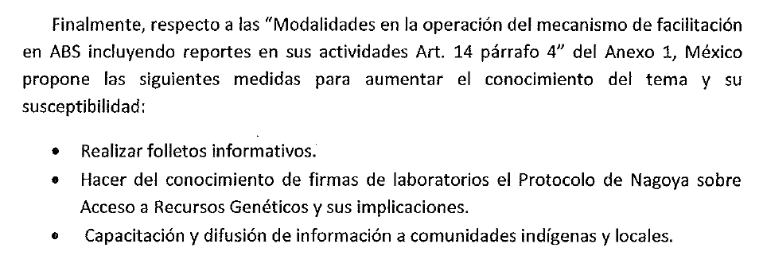

English translation:

Finally, in relation to the “Modalities of operation of the ABS Clearing-House, including reports on its activities, Article 14, paragraph 4” of Annex 1, Mexico suggests the following measures to increase knowledge and awareness in this area:

- Development of information brochures.
- Making laboratory companies aware of the Nagoya Protocol on Access and Benefit-Sharing and its implications.
- Training and dissemination of information among indigenous and local communities.
-----

