 |  | CBD
 |  |  | Distr.  GENERAL  UNEP/CBD/NP/COP-MOP/2/INF/11  22 November 2016  ENGLISH ONLY
CONFERENCE OF THE PARTIES TO THE CONVENTION ON BIOLOGICAL DIVERSITY SERVING AS THE MEETING OF THE PARTIES TO THE NAGOYA PROTOCOL ON ACCESS TO GENETIC RESOURCES AND THE FAIR AND EQUITABLE SHARING OF BENEFITS ARISING FROM THEIR UTILIZATION
Second meeting
Cancun, Mexico, 4–17 December 2016
Item 8 of the provisional agenda*

EXECUTIVE SUMMARY OF THE ABS BONN WORKSHOP

“A WORKSHOP ON ACCESS AND BENEFIT SHARING: BENEFIT SHARING FROM ACADEMIC RESEARCH”

Note by the Executive Secretary
The Executive Secretary is circulating herewith, for the information of participants in the second meeting of the Conference of the Parties serving as the meeting of the Parties to the Nagoya Protocol on Access to Genetic Resources and the Fair and Equitable Sharing of Benefits Arising from their Utilization, the report of the Bonn Workshop “A workshop on Access and Benefit Sharing: Benefit Sharing from Academic Research” organized by the Institute of Food and Resources Economics, University of Bonn, at the Zoological Research Museum Alexander Koening, Bonn, from 2 to 3 July 2015.
- The document is being circulated in the form and language in which it was received by the Secretariat.

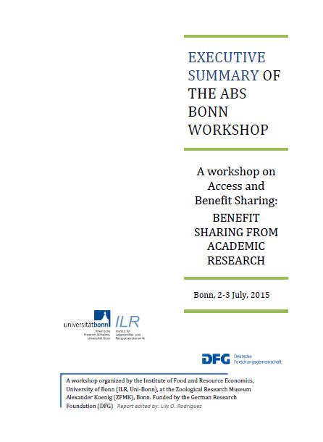
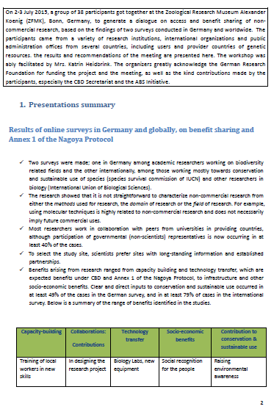
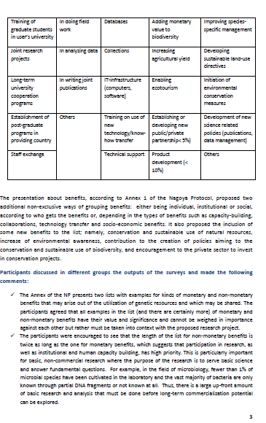
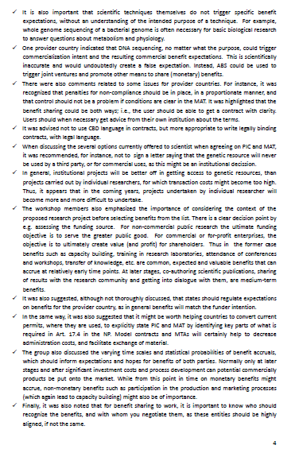
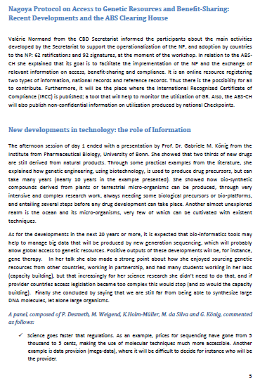
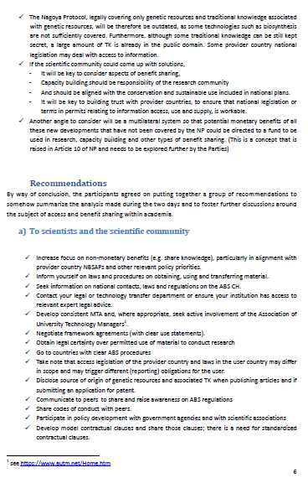
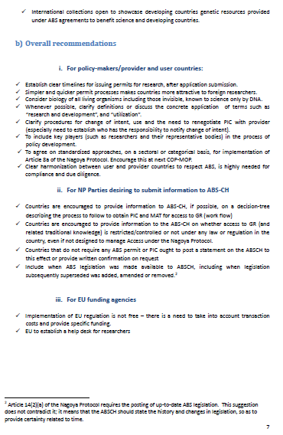
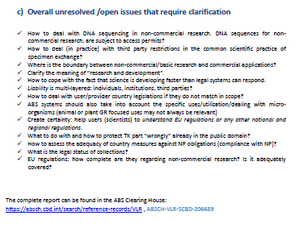

* UNEP/CBD/NP/COP-MOP/2/1/Rev.1.

