 |  |  | CBD
 |  | CONVENTION ON  BIOLOGICAL DIVERSITY |  |  | Distr.  GENERAL  UNEP/CBD/BS/TE-18.2a/INF/1  27 February 2002  ORIGINAL: ENGLISH/FRENCH/SPANISH
MEETING OF TECHNICAL EXPERTS ON THE REQUIREMENTS OF PARAGRAPH 2 (a) OF ARTICLE 18 OF THE CARTAGENA PROTOCOL ON BIOSAFETY
Montreal, 18-20 March 2002

Compilation of views and relevant information on the requirements of paragraph 2 (a) of Article 18 of the Cartagena Protocol on Biosafety
CONTENTS

Submitting Page

ARGENTINA 2
AUSTRALIA 4
CANADA 6
CZECH REPUBLIC 10
EQUATORIAL GUINEA 13
EUROPEAN UNION 13
KOREA (REPUBLIC OF) 18
NORWAY 19
ROMANIA 20
SLOVENIA 20
SWITZERLAND 21
TUNISIA 22
UNITED STATES OF AMERICA 22
VIET NAM 23
Submitting organization Page

International Grain Trade Coalition (IGTC) 24
ARGENTINA [5 February 2002]
[SUBMISSION: ENGLISH]

Answer from Argentina to the points of view and relevant information regarding the requirements of each elements included in paragraph 2 a) of Article 18 of the Biosafety Protocol and the appropriate implementation of the requirement contained in the first sentence of that paragraph (paragraph 4, recommendation 2/10).

ARTICLE 18. HANDLING, TRANSPORTATION, PACKAGING AND IDENTIFICATION

Argentina is a large producer of genetically modified organisms and the adoption of biotechnology by Argentine farmers has led both to a substantial decrease in costs and to an increase in crop productivity. For this reason, we consider that it should be clearly stated that the purpose of this Protocol is to ensure the transfer, handling and use of Living Modified Organisms (LMOs) which may have adverse effects on the conservation and sustainable use of biological diversity, preventing these requirements from becoming restrictions or barriers for the transboundary movements of commodities and products.

A - With reference to the first sentence in paragraph 2 a) of Article 18,

"Each party shall take measures to require that the documentation accompanying Living Modified Organisms that are intended for direct use as food or feed, or for processing, clearly identifies that their "may contain" living modified organisms and are not intended for intentional introduction into the environment, as well as a contact point for further information”.

Argentina considers that:

The term “commodity" defines those products that are produced in bulk and which are not specialized. They are commonly available elements which are undifferentiated since they are not considered as unique. Agricultural commodities include grains (such as corn, wheat and rice) and oilseeds (such as rapeseed and soybeans). Every year, billions of tons of agricultural commodities are shipped all around the world and practically every country in the earth is to a certain extent both an importer and an exporter of commodities.

The current international systems for the handling of commodities are complex due to the huge quantities, quality grades and products that are handled, and also to the number of importers and exporters that are involved. However, the basic structure of the commodities handling system is similar for all countries and commodities. All the way through, from the farm to the export elevator (and the import by a purchasing country), the basic purpose of the system is the same: to collect, commingle, store and transport large quantities of commodities.

From the point of view of producers and consumers, the strength of the current system for commodities lies in its capacity to provide a steady supply of low cost agricultural products to countries all around the world. In addition to the benefits associated with the provision of cheap bulky products, the currents mechanisms for commercial transactions involving commodities are also appropriately established and understood.

In addition to the buyer and the seller, the transport of commodities frequently includes many parties - such as exporters, freighters and shipowners - which may not be involved in the transaction (itself). Therefore, the processes established for all the transport, many of which have been institutionalized, lead to a higher efficiency, lower transaction costs and less delays

With reference to documentation used for commodities trade and due to the nature of the commercial transactions involving commodities, it is widely known that grain shipments are accompanied by different types of documents.

In view of this, Argentina considers that the commercial invoice is the most appropriate instrument to include the words "may contain" as required in article 18 2 a) of the Cartagena Protocol. In fact, the commercial invoice is used in all commercial transactions involving commodities.

With reference to the "may contain", it would be made up by:

1) An explicit reference to the fact that the products “may contain" living genetically modified organisms not intended for intentional introduction into the environment.

Some countries consider that the requirement "may contain" should cover specific events of LMOs that may be contained in the products. Argentina considers that this would exceed the requirements stated in article 18.2 a) due to the fact that all the information needed by an importer in order to make a decision should be available in the Biosafety Clearing House, as stated in article 11 of the Protocol, taking into account that the Biosafety Clearing House shall include all the LMOs that have been appoved for commercial use and also their risk assessments and safety information on each event.

2 A reference to contact points in case additional information should be asked for.

The "contact points" for further information should be, in first place, the representatives of those who are responsible in a particular foreign trade operation (firms).
Finally. Argentina considers that the identification "may contain" should necessarily provide clear information to importers in a way that is feasible for exporters using and taking into consideration the Biosafety Clearing House mechanism established in the Protocol and also the development of capacity building by each country. In case this is not accomplished, the advances made in the implementation of the Protocol shall be seriously delayed.

It is important to bear in mind that that the purpose of the Protocol is to ensure the transfer, handling and use of LMOs that may hate adverse effects on the conservation and sustainable use of biological diversity. For this reason, discussions should aim at finding the most effective and efficient way to implement the requirements stated in Article 18.2 a) for the export and import of LMOs, preventing these requirements from becoming a barrier to trade.

B - With reference to the second sentence in paragraph 2 a) of article 18:

The Conference of the Parties, serving as the Meeting of the Parties to this Protocol, shall take a decision on the detailed requirements for this purpose, including specification of. their identity and any unique identification, no later than two years after the date of entry into force of this Protocol.

Argentina considers that:

Given the nature of commodities trade, which has been briefly described above, it is highly difficult to deal with certain issues such as detailed specifications on identity and unique identification.

It is for this reason and due to the fact that up to now the mechanisms that include the requirements to use the first sentence in article 18.2 a) haven't even been put into practice and are being debated, that we believe that in first place will be useful to focus the debate in the implementation of the necessary requirements, as soon as the Cartagena Protocol entries into effect, and on the basis of such experience and bearing in mind the times scheduled in the text of the article, to work on this issue in a second instance.

AUSTRALIA [15 January 2002]
[SUBMISSION: ENGLISH]

The Biosafety Protocol is intended to assist countries to safeguard their biodiversity when making decisions on the import of LMOs. It facilitates the provision of information by which countries can:

- make scientifically sound and transparent case-by-case assessments about whether the import of an LMO (or group of LMOs) would pose any risks to their biodiversity; and

- take appropriate risk management action if necessary (based on those assessments).

It is important to recognise that the key source of such information under the Protocol will be the Biosafety Clearing House (BCH). It is not intended that shipping documentation substitute for or duplicate the detailed information provided through the BCH. There has appeared to be some confusion about this during recent intergovernmental discussions.

For the functionality and credibility of the Protocol, it is essential that information under Article 18(2)(a) be:

- Clear and simple. This would facilitate appropriate science-based decisions and avoid creating misunderstandings with importing parties. It would also avoid unnecessary impediments to commerce through costly and overly-complex information requirements. Information not needed to assist countries to make decisions under the Protocol’s regime, such as quality considerations, should not be required under Article 18(2)(a).

- Timely. In line with the timeline agreed by participants at Montreal, Australia recalls the necessity of resolving the details of the information requirements in the first sentence by the time of entry into force of the Protocol. This suggests a step-wise approach, with those elements on which a decision is required no later than two years after the date of entry into force, being left for subsequent consideration.

Specific Elements of Article 18(2)(a)

First Sentence

- Nature of the information - Australia suggests that a standard statement be agreed to the effect that:

This shipment may contain living modified organisms for direct use as food or feed, or for processing. This shipment is not intended for intentional introduction into the environment.

On the basis of the specific commodity involved and the country of origin of the shipment are known, importing countries could use the Biosafety Clearing House database to review the information on potential LMOs that may be involved.

- Presentation of the information – Australia suggests that in line with the approach to 18(2)(b) and (c), such a statement could be provided on accompanying documentation provided by the originator and/or required by existing international documentation systems.

- Contact point – Australia suggests that in the first instance, the contact point be identified as a representative of the originating party, who would readily have basic information associated with details of the consignment. Should additional information, such as the nature and safe handling of the LMOs, be sought by importers, they should draw on the Biosafety Clearing House database.

Second Sentence

Australia suggests that in line with the text of the Protocol, and the lack of agreement on the requirements of the first sentence, consideration should not be given to the detailed requirements referred to in the second sentence at this time. An opportunity to draw on the experience of Parties with implementation of the requirements of the first sentence of Article 18(2)(a) would be an important input to these subsequent considerations.

Progress

Australia considers that a Meeting of Experts to clarify the elements of the first sentence of Article 18(2)(a) is a priority and would be prepared to ensure a suitable expert was made available to participate.

CANADA [15 January 2002]
[SUBMISSION: ENGLISH]

Views of Canada on the Requirements of Each Element of Article 18.2(a) and the Implementation of the First Sentence of Article 18.2(a): documentation requirements for transboundary movement of living modified organisms intended for direct use as food or feed, or for processing

INTRODUCTION

Clarification of how the documentation provisions of the Cartagena Protocol on Biosafety will be implemented is essential for countries considering ratification of the Protocol. Of particular importance at this time is the first sentence of Article 18.2(a) that must be ready for implementation at the time the Protocol enters into force. It is in this context that Canada presents this paper in response to the request of the Executive Secretary for countries to present their views and appropriate information:

regarding the requirements of each element of paragraph 2(a) of Article 18 of the Protocol; and,
on the appropriate implementation of the requirement contained in the first sentence of that paragraph.

The paper begins with a summary of Canada’s views on the appropriate implementation of Article 18.2(a), followed by an analysis of the elements of the provision. Throughout the paper the term "LMO FFPs" is used to mean "living modified organisms that are intended for direct use as food or feed, or for processing".

SUMMARY OF VIEWS

Canada believes strongly that the success of the Protocol in meeting its objective will depend upon the pragmatism with which countries implement its provisions. In Canada’s view, the decision at COP/MOP 1 implementing the obligation contained in the first sentence of Article 18.2(a ) should be viewed as an interim one pending the decision referred to in the second sentence of Article 18.2(a). The ensuing process and resulting decision two years hence should take full account of experience gained. However, the clear priority for the Protocol at this time is the appropriate implementation of the first sentence required immediately upon the Protocol entering into force.

Implementation of the first Sentence

In Canada’s view the first sentence of Article 18.2(a) should be implemented as follows:

Each party must apply measures which legally obligate exporters within its jurisdiction to ensure that certain prescribed documentation accompanies intentional transboundary movements of LMO FFPs.
Intentional transboundary movement includes both: (1) shipments comprised of LMO FFPs; and (2) shipments comprised of non-LMO products intentionally commingled with LMOs, where such shipments are intended for direct use as food or feed, or for processing.
Currently, intentional transboundary movements of products intended for direct use as food or feed, or for processing, regardless of whether they are LMO or not, are accompanied by documentation. The information required under Article 18.2(a) should be included in the existing exporter generated documentation that accompanies transboundary movements of LMO FFPs. The documentation should be amended to include a statement along the following lines:
"CARTAGENA PROTOCOL ON BIOSAFETY INFORMATION: This shipment is intended for direct use as food or feed, or for processing and may contain Living Modified Organisms. This shipment is not intended for intentional introduction into the environment. Further information on this shipment may be obtained from the contact point(s) identified above."

Canada remains open to considering Protocol-specific documentation in the future.

Implementation of the second sentence

Specification of identity and any unique identification are the only two elements elaborated in the second sentence of Article 18.2(a) . An implicit element of the second sentence is a review of the effectiveness of the measure taken under the first sentence.
Implementation of the first sentence will be undertaken by Parties acting on a recommendation by the ICCP that is adopted by the first COP/MOP. Canada views the provision in the second sentence as the means by which Parties will be able to review the implementation of the recommendation and determine whether the recommendation meets the needs of the Parties in fulfilling obligations under Article 18.2(a).
Canada would recommend that a process be established by which Parties/governments report in a timely fashion on the effectiveness of the implementation of the recommendation adopted by COP/MOP 1 to ensure an appropriate level of review in the ongoing process of consideration of detailed requirements.
The report by Parties could include analyses of the requirements for the documentation to be clear, accessible, user friendly and meet the requirements to fulfill the obligations under Article 18.2(a).
The second sentence also calls for consideration of specification of the identity of LMOs intended for direct use as food or feed, or for processing, and consideration of any unique identification for such LMOs without prejudice to any decision by the COP/MOP on detailed requirements for implementing the measure on documentation. Canada is cognizant of work being undertaken in several intergovernmental fora on the topic of identification of LMOs, and is of the opinion that this work should be taken into consideration in the ensuing process of considering issues necessary to take the decision referred to in the second sentence.
One possible outcome of the decision making process two years following entry into force could be confirmation that the interim arrangement should be maintained beyond the two year period.

ANALYSIS

Implementation of Article 18.2(a) must be considered in the context of the Protocol as a whole as well as take into account the circumstances under which the transboundary movement of the LMO FFPs takes place.

Article 18.2, Chapeau

The chapeau of Article 18.2 contains three elements: that (i) "each Party" (ii) "shall take measures to require"(iii) "documentation accompanying..." The following section considers each of these in turn.

Role of Parties -- Article 18.2 is directed at "each Party", but it does so without providing clear guidance regarding in what capacity each Party is to act, i.e., as a Party of import, or Party of export, or both. In time, many Parties will find themselves in the position of being Parties of import and export. In Canada’s view, this provision should be applied by all Parties as an export requirement .

Nature of Measures -- Turning to the nature of government action, Article 18.2 obligates each Party to "take measures to require" that documentation accompanies intentional transboundary movements of LMO FFPs. In other words, Parties must require that documentation accompanies transboundary movements of LMO FFPs. In Canada’ s view this must be done through legal measures. In Canada’s case, it is envisioned that this would be done through government regulation applicable to the exporter.

Form of Documentation -- In Canada’s view, Article 18.2(a) documentation accompanying LMO FFPs should originate with the exporter on the basis that exporters are in the best position to have information on the shipment. This can be accommodated easily by amending existing exporter documentation to include a standard Cartagena Protocol on Biosafety statement as indicated in Summary of Views.

First sentence of Article 18.2(a)

The first sentence of Article 18.2(a) contains several elements, beginning with a preliminary clause defining its scope of application, i.e., "living modified organisms that are intended for direct use as food or feed, or for processing". This is followed by a description of the information which must be contained in the accompanying documentation:
(i) "that they ‘may contain’ living modified organisms";
(ii) "and are not intended for intentional introduction into the environment"; and a,
(iii) "contact point for further information".

Scope -- The scope of the Protocol extends only to LMOs. Moreover, the focus of the Protocol and Article 18 in particular is on intentional transboundary movements of LMOs. This intent is made clear, for example, through specific references in the Protocol’s definitions of "import" and "export" as well as in the first paragraph of Article 18 to "intentional transboundary movements". Hence, Article 18.2(a) documentation requirements apply only to intentional transboundary movements of LMOs intended for direct use as food or feed, or for processing.

Intentional transboundary movements of LMO FFPs will fall into two general groupings: (1) shipments comprised of LMO FFPs; and (2) shipments comprised of non-LMO products intentionally commingled with LMOs, where such shipments are intended for direct use as food or feed, or for processing.

May contain – The requirement that intentional transboundary movements of LMOs must be accompanied by documentation stating that they "may contain" LMOs may appear counterintuitive at first. However, a large majority of the volume of LMOs being shipped internationally today does so via bulk grain collection and distribution systems. The associated efficiencies of this system are gained, inter alia, through accumulating product from a large number of points of production/distribution thereby intentionally commingling products of various genetic, sometimes LMO, origin. Where such bulk systems are used and there is commercial LMO production of the same species or type in the country of export, transboundary movements from that country may in fact contain LMOs.

Intended use – The required statement that these shipments are "not intended for intentional introduction into the environment" clearly distinguishes LMO FFPs from LMOs subject to AIA and the more detailed requirements of Article 18.2(c). The inclusion also of a positive statement that these shipments are "intended for direct use as food or feed, or for processing" adds further clarity.

Contact point – In Canada’s view the exporter, as the generator of the accompanying documentation, will usually be the most appropriate contact for further information about a specific transboundary movement.

Second Sentence of Article 18.2(a)

The second sentence of Article 18.2(a) requires Parties to take a decision two years following entry into force of the Protocol. While the clear priority today is implementation of the first sentence, Canada looks forward to the ensuing process of considering issues necessary to take the decision referred to in the second. Of course, this process should not presuppose the effectiveness or the sufficiency of the requirements already contained in the first sentence.

CZECH REPUBLIC [28 January 2002]
[SUBMISSION: ENGLISH]

Current situation in the Czech Republic

The Czech Republic was one of the first countries that have ratified the Cartagena protocol on Biosafety. The instrument of ratification was deposited with the Secretary-General of the United Nations on October 8, 2001.

Legislation
The “Act No. 153/2000, on the Use of Genetically Modified Organisms and Products and Amendment of Some Related Acts” entered into force on January 1, 2001. The Act together with three implementing Decrees covers the contained use, deliberate release into the environment and placing on the market of GMOs and products containing or consisting of GMOs, including the export and import thereof. The main provisions of the Cartagena Protocol on Biosafety are included in the Act.
An Amendment to the Act on GMOs transposing the provisions of the EU Directive 2001/18/EC on the deliberate release into the environment of genetically modified organisms and repealing Council Directive 90/220/EC and the provisions of the Cartagena Protocol not transposed in the current legislation is under preparation in 2002. It should come into effect at the beginning of 2003.
According to the Act on GMOs all subjects using GMOs are obliged to submit a notification to the Ministry of the Environment before starting any activity concerning GMOs.
State Administration
The Ministry of the Environment is the Competent Authority on the use of GMOs and on biosafety issues in the Czech Republic. It co-operates with the Ministry of Health in respect of risks for human health and with the Ministry of Agriculture as the agricultural risks, animal health, crops and feed-stuffs are concerned. The Czech Commission for the Use of GMOs and Products was established as an advisory body to the Ministry of the Environment, to deal with various aspects of the use of GMOs and biosafety.
The main Authority on state supervision of the use of GMOs is the Czech Environmental Inspection. It co-operates with other state supervision bodies in fulfilling this task, e.g. with Customs Offices.

Information System
The lists of approved GMOs and users are published periodically in the Official Journal of the Ministry of the Environment (in printed form) according to the law. These lists plus the relevant legislation, including the methodology of risk assessment, and the information on the use of GMOs are available to the public at the web-site of the Ministry of the Environment (address: www.env.cz). This information is currently updated. The English version of the GMOs web pages is being prepared. The relevant information is also regularly provided to the international organisations, eg. OECD, for their databases and information system.

The provisions of the above mentioned Act No. 153/2000 on the Use of Genetically Modified Organisms and Products and Amendment of Some Related Acts relevant to the paragraph 2 (a) of Article 18 of the Cartagena Protocol on Biosafety:
(Handling, Transport, Packaging and Identification)

Requirements for packaging, labelling and identification of GMOs and products are set down in the article 9 Placing on the Market.
Conditions for import, export and transit of Genetically Modified Organisms and products including accompanying documentation are set down in the article 10.
The competence and responsibilities of the Czech Environmental Inspection and Customs Offices are set down in the articles 17 and 18.

# 10

- Genetically modified organisms and products that have not been placed on the market
in the Czech Republic may be imported, exported or placed in transit only by a user registered in
the List of Users, in the manner and within the scope of use of genetically modified organisms
and products as set forth in the registration in the List of Users.

(2) Every person that imports, exports or places in transit a genetically modified organism or product, registered in the List of GMOs authorised for placing on the market, shall be obliged to provide for compliance with all the conditions laid down in the decision on the registration of the genetically modified organism or product in the List for placing on the market, and in particular its packaging and labelling.

(3) Imported and exported genetically modified organisms and products and genetically modified organisms and products in transit must have on the packing a visible label clearly stating "genetically modified organism" or "this product contains a genetically modified organism"; this text in the Czech language and in the language of the country of destination must also appear in the accompanying documents.

(4) The accompanying documents of imported or exported genetically modified organisms and products or genetically modified organisms and products in transit must, in case of a genetically modified organism or product that has not yet been registered for placing on the market in the Czech Republic, contain a copy of the decision on registration of the user in the List of Users and a copy of the decision on registration of the genetically modified organism in the relevant List of authorised GMOs, an emergency response plan and the result of risk assessment. If a genetically modified organism or product registered for placing on the market in the Czech Republic is involved, the accompanying documents must contain all the information mentioned in the registration in the List for placing on the market.

(5) The special legal regulations laying down the conditions for import, export and transit shall be in no way prejudiced by the provisions of paragraphs 1 to 4.

# 17
The Czech Environmental Inspectorate

(1) The Inspectorate shall
- control how legal persons and natural persons comply with the provisions of the legal regulations and with the conditions laid down by the decisions of the Ministry of the Environment, Czech Republic, related to the use of genetically modified organisms and products, from the standpoint of the environment, and cooperate with the customs authorities;
- impose on legal persons and natural persons remedial measures and penalties for infringement against obligations pursuant to this Act,
- carry out inspections on its own or in cooperation with other relevant administrative authorities.

(2) Inspectors of the inspection shall be entitled to enter the properties and premises to the absolutely necessary extent, to carry out inspection pursuant to paragraph 1. In this, they must provide authorization to carry out the inspection. The state shall be liable for any damage caused by the inspection; it may not relieve itself of this liability.

# 18
The Customs Authorities

The customs authorities shall
- control consignments that are declared as genetically modified organisms or products at border crossing points, to ensure that they are accompanied by the appropriate documents pursuant to this Act and the special legal regulations for transit, export and import,
- impound the goods, in case of discovery of any infringement against this Act or in case of suspicion thereof, inform the Inspection and the Ministry thereof and, in case of doubt, ask the Inspection for professional assistance,
- keep records of all consignments of genetically modified organisms and products allowed to cross the border and enable the employees of the Ministry and Inspection to peruse such records, make excerpts therefrom, copy information or make copies thereof, including providing this evidence in electronic form or by e-mail.

Recommendations by the Czech Customs Offices as regards information required in paragraph 2 (a) of Article 18 of the Cartagena Protocol on Biosafety

The required information should be extended to include the following information:
ad a) - identification of an importing and exporting subject (name, address)
- identification of the consignment in respect of the specification LMO (LMOs) or the product containing or consisting of LMOs contained and the quantity thereof,
ad b) - identification o exporting subject,
- identification of the consignment in respect of the specification LMO (LMOs) contained and the quantity thereof,
ad c) - identification of the consignment in respect of the specification LMO (LMOs) contained and the quantity thereof.

EQUATORIAL GUINEA [11 January 2002]
[SUBMISSION: SPANISH]

4.8.4. Manipulación, transporte, envasado e identificación

4.8.4.a Opiniones, así como información respecto de los requisitos de cada elemento del inciso a) del párr. 2 del artículo 18 del protocolo, y de las aplicaciones del requisito que figura en la primera oración de ese párrafo (párr.4, recomdenación 2/10).

Respecto a este inciso, consideramos que se deberia tener en cuenta las conclusiones y recomendaciones de la Reuni6n técnica de expertos sobre manipulación, envasado e identificación de los OVM, celebrada en Paris, Francia del 13 al 15 de junio de 2001. Y apoyarse sobre todo en las prácticas ya existentes sobre OVM para la aplicación apropiada de dicho inciso.

EUROPEAN UNION [6 February 2002]
[SUBMISSION: ENGLISH]

Views as well as relevant information regarding the requirements of each element of para. 2(a) of Article 18 of the Protocol, and on the appropriate implementation of the requirement contained in the first
sentence of that paragraph (para.4, recommendation 2/10)

Relevant information about the EU regulatory framework

European Directive 2001/18/EC (on the deliberate release into the environment of genetically modified organisms and repealing Directive 90/220/EEC), specifies that GMOs to be placed on the market, shall be subject to adequate labelling requirements, in order to provide for a clear statement that a GMO is present (article 19.3 (e)). To this end, the words «This product contains genetically modified organisms» shall appear either on a label or in accompanying documentation. Annex IV and Article 19 of the Directive describe the information for labelling requirements with regard GMOs as or in products to be placed on the market.

It is also important to note that issues relevant to Article 18.2(a) of the Protocol are still under discussion at the EU level, thus this EU contribution is part of a preparatory process open to further discussions. The EU will therefore submit further information and opinions in due time.

General considerations

Article 18.2 (a) is the result of a difficult compromise reached in the final hours in January 2000 in Montreal.

The implementation of this provision is related to the specific procedure for LMO-FFPs (Article 11 of the Protocol), which is different from the AIA. The appropriate implementation of Article 18.2(a) is necessary to complement the LMO-FFP procedure, by enabling the control of the information on LMO-FFPs which has been provided to the BCH.

The EU is in favour of clear international rules with regard to the flow of documentation in the
context of international transboundary movement of LMO-FFPs. Accompanying documentation
and its cross reference to the information posted on the BCH will be the physical support of this
continuous flow of information. In this respect, unique identifier should facilitate the access to
such information, by facilitating search and retrieval of information on LMOs through the
Biosafety Clearing-House.

The requirement of Article 18.2(a) can be addressed at two levels, which are progressive but also closely connected: (i) the LMO character of the LMO-FFP, and the associated required information, and (ii) the identity of the specific LMOs contained within the LMO-FFP, and the associated requirements.

The specification of all LMOs, which are known to be present or may be present within shipments of bulk commodities is important, to allow importing countries to verify that the specific LMOs have been approved and posted on the BCH and also that they comply with the legislation of the Party of import.

The priority is to clarify what needs to be done in terms of identification of LMO-FFPs by the time of entry into force of the Protocol.

But, as was said earlier, it is also closely linked with the issues that need to be sorted out no later than two years after entry into force, and for which the requested submissions will be used by the executive secretary to enable the preparation of a synthesis of these views, for the timely preparation of the decision on these further requirements.

Views on the detailed requirements of each element of paragraph 2(a) of Article 18 of the Protocol

Article 18.2 has a chapeau, which states that : « Each Party shall take measures to require that documentation accompanying : », followed by the specific requirements.

This creates a connection between the different elements of article 18.2 (a) ; it supports the establishment of clear international rules in order to facilitate consistent national measures and in order to facilitate the flow of information, and therefore the transboundary movement of LMO-FFPs.

It also refers to accompanying documentation, which requires that the issue of the type of accompanying documentation be addressed, as has been the case for article 18.2 (b) and (c).
Article 18.2(a) contains different inter-linked elements that may require further clarification. The following elements can be identified:

- in the first sentence:

- LMOs;
- that are intended for direct use as FFP;
- clear identification that they "may contain" LMOs;
- specification that they are not intended for intentional introduction into the environment;
- specification of a contact point for further information;

- in the second sentence :
- detailed requirements for the purpose of the previous requirements;
- specification of the identity of each LMO;
- their unique identification;
- the decision of the COP/MOP;
- less than two years after entry into force.

- LMOs

An LMO is defined in Article 3(g) and includes any biological entity capable of transferring or replicating genetic material (Article 3(h)) but only on the proviso that it contains a novel combination of genetic material obtained through modern biotechnology. (Article 3 (i))

- That are intended for direct use as FFP

This has to be interpreted within the context of article 11, the application of which being defined in article
7.2 and 7.3.

The main element is to develop means to ensure that LMOs intended only for food, feed or processing are
not intentionally introduced into the environment.

- Clear identification that they "may contain" LMOs:

A broad application of the wording "may contain" is not considered as an appropriate way to implement Article 18.2(a).

The term ‘may contain’ and its application to transboundary movement importantly has to consider bulk shipments that may contain one or a mixture of LMO-FFPs. This term is a minimal wording that may create uncertainty in certain cases. For example, labelling of products in transboundary shipments containing LMO-FFPs will require that such shipments can be identified as containing LMO-FFPs rather than merely ‘may contain’ LMOs. This does not, however, require that the identity of individual LMO-FFPs contained in the shipments be specified.

A further level of specification (the identity of individual LMO-FFPs contained in the shipments) has to be considered in the context of the link with the second sentence of Art. 18.2(a), in particular the need to specify the identity and any unique identification of the LMOs. This will be important where Parties of Import have to distinguish between LMO-FFPs that have received or not received approval for use on their territories.

Transmission and retention of the identity of individual LMO-FFPs from transboundary movements of bulk shipments through the production and distribution chains may face practical difficulties, but may need to be maintained for specific uses. Where non-homogeneous shipments of LMO-FFPs are sub-divided, maintenance of the original composition can not be assured. Determination of the identity of individual LMO-FFPs contained in shipments of this type will, therefore, change from the list of LMO-FFPs « actually present » to the list of LMO-FFPs which are known to be present or may be present at the origin.

On this basis, transboundary movements of LMO-FFPs should be accompanied by a list of LMO-FFPs that the shipment contains or may have been used at the origin.

(iv) Specification that they are not intended for intentional introduction into the environment:

A declaration, to be transmitted with LMO-FFPs in accompanying documentation or on a label, stating that the LMO-FFPs contained in the shipment are to be used only and directly as food, feed or for processing should be developed

(v) Specification of a contact point for further information:

Only one contact point is referred to here. It ought therefore to have an official character.

The responsibility of the contact point, the information that will have to be provided and the conditions under which this information has to be available need to be further clarified. For example, the following points may need to be considered:
- the status of the contact point (exporter versus exporting state, or the BCH entry point for a specific LMO-FFP),
- the location of the contact point (Party of export),
- the distinction between information that has to be "readily" available and information that goes beyond to enable further investigation on the shipment (with appropriate references to the information posted on the BCH and referred to in annex II),
- the time allowed to provide the information.

- Detailed requirements for the purpose of the previous elements:

We believe that this element of Art. 18.2(a) makes clear that the implementation of the first component of the first sentence ("... clearly identifies that they "may contain" living modified organisms ...") is strongly connected to the second sentence, and that it is actually required for an appropriate implementation of the first sentence as soon as possible and ideally at the time of entry into force.

- Specification of the identity of each LMO and (viii) any unique identification:

Article 11 provides for a simplified procedure for LMO-FFPs. However, there is a clear need to enable the control that:

- Only LMO-FFPs where Art. 11 has been followed and that have been « posted » to the BCH are contained within the shipment;
- Only LMO-FFPs which are approved domestically in a Party are imported to that specific Party,
- These LMO-FFPs are only and exclusively used for the specific Food, Feed or Processing purpose and not intentionally introduced into the environment.

In order to facilitate the enforceability of the system, and avoid unnecessary problems at the borders,
shipments where there is a mix of different LMO-FFPs have to be clearly identified with a list of the specific
LMO-FFPs which may have been used at the origin of the mix(es) present in the shipment.

This list ought to be inclusive in order to ensure that no LMO-FFP, is missed from the list.

In order to specify the identity of LMOs, an internationally harmonized system for unique identification for
LMOs should thus be developed as soon as possible, taking into account relevant developments in other
international fora, in particular the OECD, also to ensure unambiguous identity of the LMO worldwide.
The "unique identifier" should be included as part of the accompanying documentation for each LMO-FFP
which are know to be present or may be present in a shipment also as a means to ensure consistent access
and retrieval of a broad range of additional information about the identity and characteristics of that
LMO (including detection methodology) from the BCH.

In this context, the EU notes and welcomes the recent adoption of "Guidance for the designation of the
OECD's Unique Identifier for Transgenic Plants", developed by the OECD Working group on harmonization
of Regulatory Oversight in Biotechnology.

(ix) The decision of the COP/MOP and (x) Less than two years after entry into force

The decision on the detailed requirements for the purpose of Article 18.2(a) has to be taken no later than
two years after the date of entry into force of the Protocol.

Although it requires a decision of the COP/MOP, which can only happen after the time of entry into force, there is no requirement that it can not be taken by MOP1.

For the reasons stated above, especially the link between the second and first sentence, and, the necessary
requirements of the second sentence for the appropriate implementation of the first sentence, the EU, is of
the view that such a decision needs to be taken as early as possible and ideally at the time of entry into force.

Considering the complexity of the issue, the EU believes that this item should be considered as a priority in the preparation for the first COP/MOP and, thereafter, if need be, in the medium term programme of work and should rely to the greatest extent possible on relevant existing activities of other bodies or organizations.

Views on the appropriate implementation of the requirement contained in the first sentence of paragraph 2(a) of Article 18 of the Protocol

The EU believes that Article 18.2(a) has to be considered as a whole. Indeed, the wording of the second sentence ("... decision on the detailed requirement for this purpose ...") makes clear that the implementation of the first sentence ("... clearly identifies that they "may contain" living modified organisms ...") is strongly connected to the second sentence. It means also that a clarification ofn the elements of the first sentence of Article 18.2(a) will require consideration of all elements contained in this article in a broader way.

The EU takes note of the recommendation of ICCP2, and the necessity to have the first sentence addressed first at the technical expert group, with a view to achieve its implementation at the time of entry into force. The EU, however, considers that the cross-links between the two sentences will require addressing the second sentence at the technical expert group meeting as well.

KOREA (REPUBLIC OF) 17 January 2002]
[SUBMISSION: ENGLISH]

Comments on Paragraph 2(a), Article 18 (handling,
packaging, transport and Identification)

I. Reference (UNEP/CBD/ICCP/2/L.9)

4. Requests Parties ……… to provide any views as well as relevant information to the Executive Secretary,

(a) The appropriate implementation of the requirement contained in the first sentence of Article 18 paragraph 2(a) by the time of entry into force of the protocol ;
(b) The requirements of each element of paragraph 2(a) of Article 18

II. Comments of the Republic of Korea

A. Regarding the above (a)

1. To prevent the unintentional emission of the LMO into the environment, the provisions to regulate transporting, packaging, handling and identification of the LMO shall be established as soon as possible.

2. The information on the transported LMO-FFP shall include the species of the LMO and its certificate indicating the absebce of prohibited LMOs in the importing countries.

3. The Republic of Korea believes that the labelling of ‘LMOs contain' or ‘LMOs may contain' should be treated in a considerable way. For instance, if non-LMO products have a possibility of being mixed in a handling, packing or transporting processes, they shall be labelled by "LMOs may contain". However, given that a few LMOS are included in non-LMOs products, the label of ‘LMOs contain' should be attached.

B. Regarding the above (b) (Unique identification)

1. To formulate a unique identification system, each LMO needs to be categorized and codified. The on-going prjects by the OECD shall be considered.

2. The Republic of Korea is of the view that a unique identification system requires the indication of transported LMOs own characteristics including risk assessment results, and all related informations such as their uses, handling and transporting methods, etc.

NORWAY [8 February 2002]
[SUBMISSION : ENGLISH]

Regarding Article 18, Handling, transport, packaging and identification

In Norway's view it is important that systems for handling, transport, packaging and identification are developed under article 18 of the Cartagena protocol as soon as possible. This is due to the fact that many LMOs have already been approved for marketing in some countries and are being shipped to these markets. Although handling and packaging requirements are important, Norway's opinion is that the systems for identification and transport documentation are most crucial and should be dealt with first.

In our view there is a clear linkage between Articles 18.2. (a), 18. 2. (c) and 18. 3. LMOs intended for release into the environment should therefore be seen in connection with the system for unique identification that needs to be developed for LMOs intended for food, feed and processing (FFP), and also in connection with Article 18.3 on developing of standards. It is obvious that LMOs intended for release into the environment may become FFPs in the future. A unique identifier should therefore be in place at the latest at the moment a LMO is approved for the first time for either commercial growing or introduction into the environment. In this respect all FFPs will already have a unique identifier when they are sent out on the market, the identifier they got when approved for introduction into the environment. It is therefore important that a unique identification system should be developed and put into use as soon as possible. The unique identification system that needs to be developed should be one of the standards to be developed under Art. 18.3.

The unique identifier is first of all essential for an effective operation of the BCH. In addition the unique identifier should be used in the transport documentation. The identifier should be unique to the level of transformation event for a specific LMO. A simple numeric system would provide authorities with means to identify which LMOs are contained in each transboundary movement of LMOs. The information in the BCH should be sufficient to enable authorities to identify LMOs via laboratory analyses (verification of the unique identifier).

Regarding request 4 in the report (UNEP/CBD/ICCP/2/15) from ICCP 2 on article 18.2 (a), page 68, the Norwegian opinion is:

I . There is a need for an identification system that clearly identifies all LMOs intended for export/import.
2. All LMOs that are intended for direct use as food, feed or processing or intended for introduction into the environment should have a unique identifier.
3. The identification should be at the transformation level.
4. A new variety made through traditional breeding using LMO parent organisms are unique and should have a unique identifier that differs from those of their parent LMOs.
5. The CBD secretariat should be requested to make a survey report of possible systems for unique identification.
6. An unique identifier system should be made use of in the BCH as soon as the system is developed.
7. The system for unique identification should be in place when the protocol enters into force.
8. In addition to the unique identifier, transport documentation and the shipment needs to have additional information about the LMO, including: i) all packages clearly labelled that they contain LMOs, with a link to the transport document; ii) if in bulk shipment the cargo hold or container should be labelled, with a link to the transport document; iii) contact address for the importer and exporter; iv) the name of the LMO species (varieties); v) a verification of the consent to import that LMO(s) into the country.

ROMANIA [14 January 2002]
[SUBMISSION : ENGLISH]

It is not established yet a labeling system.

SLOVENIA [18 January 2002]
[SUBMISSION : ENGLISH]

Relevant information regarding the requirements of each element of para 2(a) of Art.18 of the Protocol, and on the appropriate implementation of the requirement contained in the first sentence of the para.4, recomm. 2/10

Until the COP/MOP takes a decision on detailed identification requirements for transboundary movements of LMOs in accordance with Art.18 (para 2(a)), the requirements under the Protocol are not clear .Acknowledging the importance of appropriate implementation of the first sentence of para 2(a) of Art 18 requesting the Secretary to develop a template tailored system within two years of entry the Protocol into force, to be considered as a basis for discussion by the meeting of technical experts, and to submit recommendation to the COP/MOP meeting.
Consequently, it will be necessary to assure of appropriate financial resources for a meetings of technical experts with broad expertise concerning all relevant aspects and disciplines for the implementation of Art. 18 (para 2(a)), and also taking into account the need for balanced regional representation.

SWITZERLAND [31 January 2002]
[SUBMISSION: ENGLISH]

4.8.4 Handling, Transport Packaging and identification (Art. 18.2 a)

(a) Swiss requirements regarding handling, transport and packaging of LMOs intended for direct use as food, feed or for processing.

The Swiss Federal Law on Food Products and its related Ordinance on Food Products regulate the designation of food products. Article 22b of the Ordinance on Food Products regulates the genetically modified organisms used as food products or for processing. It prescribes an overall mandatory designation of genetically modified organisms used as food products or for processing. Food products, additives or substances that are genetically modified organisms or that contain or are derived from genetically modified organisms must bear the indication “made from X modified by genetic engineering “ or “made from X genetically modified” (where X is the name of the genetically modified organism). Mandatory designation is not required for food products or derived food products containing less than 1% of genetically modified organisms.
The Swiss Federal Law on Agriculture and its related Ordinance on Feed Products regulates the mandatory designation of feed products. Article 23 of the Ordinance on Feed Products regulates the identification of genetically modified organisms used as feed products. Raw materials, single feed products, additives, conservative agents that are genetically modified organisms or that contain more than 3% of genetically modified organisms must be designated as such.

b) Swiss views regarding the implementation of the first sentence of Art.18.2 a

According to our national requirements, documentation accompanying transboundary movement of LMO-FFPs to Switzerland should be clearly identified as containing LMOs if the material does not fulfill the conditions described in paragraph a). The Swiss regulations will therefore be applied to imports of LMO-FFPs to Switzerland. The second element required by article 18.2a in the documentation (i.e "not intended for intentional introduction into the environment") is also requested by the Swiss authorities for such material.

Switzerland does not have special requirements regarding the format of the information to be provided in the documentation. More important is that this documentation should closely follow the shipment and be easily accessible by and comprehensible to all stakeholders including custom officers, transporters, importers and implementing cantonal authorities. This documentation could therefore be made available as a stand alone document or be integrated in existing documentation.

b) Swiss views regarding the second sentence of Art.18.2 a

Switzerland is the view that ICCP should not work on how to address implementation of the second sentence of Art.18.2a. This is clearly the competence of COP/MOP. However elements listed for consideration in this sentence could be useful in implementing the first sentence of Art.18.2 and therefore should be considered by the expert group on Art. 18.2a.

TUNISIA [9 February 2002]
[SUBMISSION: FRENCH]

Concernant le paragraphe de cet article relatif à la manipulation, le transport, l’emballage et l'identification, nous proposons que les Parties au Protocole soient appuyées financièrement et technniquement, afin d’être en mesure de répondre aux dispositions du Protocole y compris de prendre des mesures d'ajustement de leurs systèmes, en cas de besoin.

La documentation devant accompagner, au moment d'un mouvement. transfrontière, les Organismes Génétiquement Modifiés (OGM) destinés à être utilisés directement pour l'alimentation humaine et animale ou à être transformés, doit indiquer clairement la mention “peuvent contenir” des OGM et qu'ils ne sont pas destinés à être introduits intentionnellement dans l’environnement, en spécifiant l’identité et tout autre spécificité de ces organismes. L’emballage doit comporter un double étiquetage aisément identifiable. Il doit être conçu de manière à empêcher toute déperdition et résister aux exigences de la manutention et du transport. Il doit être scellé et conçu de façon à assurer sa fermeture hermétique.

Les OGM doivent être stockés toujours dans des locaux réservés à cette seule fin et pourvus en équipements de protection nécessaires pour les personnes chargées de leur manutention et de leur stockage et d’une manière générale, pour la préservation de la diversité biologique, l’environnement et la santé publique.

En attendant que des normes d’identification, de manipulation d'emballage et de transport soient élaborées et leurs modalités fixées par la 1ère Conférence des Parties au Protocole de Cartagène, conformément aux recommandations qui seront faites par les experts techniques (sélectionnés en tenant compte de la représentation régionale, de la transparence et de l’équité), désignés par les gouvernements.

UNITED STATES OF AMERICA [23 January 2002]
[SUBMISSION: ENGLISH]

Submission of the United States of America: Views and Relevant Information Regarding the Requirements of Each Element of Article 18.2 (a) and on the Appropriate Implementation of
the Requirement Contained in the First Sentence of Article 18.2 (a) of the Cartgena Protocol on Biosafety

The United States is pleased to submit the following response to the request from the Secretariat on Agenda Item 4.8.4. following the October meeting of ICCP-2 in Nairobi, Kenya. Specifically, we would like to respond to the request for views and relevant information regarding the requirements of each element of Paragraph 18.2(a) of the Biosafety Protocol, and on the appropriate implementation of the requirement contained in the first sentence of this paragraph.

The United States believes strongly that ICCP, and the technical groups convened under its auspices, should address the requirements of the first and second sentences of Article 18.2(a) separately, as set out in the text of the Protocol, and in a stepwise manner as agreed to by the ICCP members of Working Group I in Nairobi. We agree that, with regard to Article 18.2(a), implementation of the elements of the first sentence is critical to the implementation of the Protocol upon its enuy into force.

We believe that the most effective way to ensure that the implementation of the requirements listed under the first sentence of Article 18.2(a) is accomplished upon the Protocol's entry into force is by the addition of language to existing commercial documentation that accompanies commodity shipments, such as the commercial invoice, or other documents supplied by the originator of a shipment. Such documentation would accompany LMO shipments intended for direct use as food, feed, or for processing. The documentation would state that the shipment "may contain" LMOS, that the products are not intended for intentional introduction into the environment, and would list a point of contact.

We understand that some countries would like to consider more "detailed requirements" in discussions on the first sentence in Article 18.2(a), for example, to include a listing of the specific LMO events that "may be contained" in that product. As set out in the Protocol, however, such consideration is contemplated, appropriately, in the second sentence of Article 18.2(a). The language of the protocol wisely sets out a timeframe for such consideration, and also, does not presume what the decision will be. As many governments will attest, discussion of the elements in the second sentence will benefit from experience gained under implementation of the requirements of the first sentence, intensive technical consultation, and extensive debate to ensure that the decision taken is fully-informed and meets the objectives of the Protocol. We believe that discussion in the Technical Experts meeting of issues raised by the second sentence in Article 18.2(a) is premature, and, given the complexities involved, is likely to preclude resolution of the specific requirements within the first sentence of Paragraph 18.2(a).

In summary, we strongly believe that discussions in the proposed Technical Experts Group meeting on Article 18.2(a) should focus on implementing the elements of the first sentence of this article.

The United States thanks the CBD Secretariat for this opportunity to provide our views on Article 18.2(a).

VIETNAM [16 Janaury 2002]
[SUBMISSION: ENGLISH]

4.8.4. Handling, Transport, Packaging and Identification:

No comments.

Submissions from Organization:

Canada Grains Council for the International Grain Trade Coalition (IGTC) (17 January 2002):

International Grain Trade Coalition (IGTC)

Submission

To the

Executive Secretary
Convention on Biological Diversity

On

Paragraph 2(a) of Article 18
Cartagena Protocol on Biosafety

Issue: The Cartagena Protocol on Biosafety will have profound effect upon the international trade in grains, oilseeds, pulses and special crops. The transboundary movement of these commodities each year for food, feed or processing is staggering: about 200 million tonnes of cereals, a further 30 million tonnes of rice, another 30 million tonnes of oilseeds and more than seven million tonnes of pulses.

One particularly important section of the Protocol is Article 18.2(a). When implemented, this article will define the documentation requirements for international shipments of living modified organisms (LMOs) that are intended for food, feed or processing. This will have an immediate effect upon a high percentage of existing trade and an even higher percentage of future trade. As a result the manner in which the article is implemented is critical to both exporting and importing countries.

International Grain Trade Coalition (IGTC): The IGTC was formed in June 2001 to advise governments on how to implement the Protocol to protect global diversity while meeting the needs of the world's food, feed and processing industries. The Coalition has 13 trade organizations in eight countries that in turn represent more than 1000 members in more than 80 countries. (see Annex One)

The IGTC recognizes the Biosafety Protocol's objective to introduce some regulatory control over the transboundary movement of products produced through modem biotechnology but has serious concerns on how the Protocol may impact the capability and cost of moving globally the staggering volumes of LMOs and non-LMOs required to meet the world's demands each year for food, feed and processing.

Background: The Protocol was adopted by the Conference of the Parties to the United Nations Convention on Biological Diversity in Montreal on 29 January 2000. To date 107 countries have signed, ten have ratified. The Protocol will come into effect 90 days after ratification by the 5 0 'h country.

The Intergovernmental Committee on the Cartagena Protocol (ICCP) at its second meeting held in Nairobi, Kenya 1-5 October 2001, requested Parties, Governments and relevant international organizations to provide views and relevant information to the Executive Secretary of the Convention on Biological Diversity regarding:

"(a) The appropriate implementation of the requirement contained in the first sentence of Article 18, paragraph 2 (a), by the time of entry into force of the Protocol;

"(b) The requirements of each element of paragraph 2 (a) of Article 18 of the Protocol."

Outline of Issue: Article 18.2(a) was a major point of contention in the negotiation of the Protocol. It establishes two distinct phases for imposition of documentation requirements on the international grain trade. The article reads as follows:

"Article 18.2: Each Party shall take measures to require that documentation accompanying:

"(a) Living modified organisms that are intended for direct use as food or feed, or for processing, clearly identifies that they "may contain" living modified organisms and are not intended for intentional introduction into the environment, as well as a contact point for further information. The Conference of the Parties serving as the meeting of the Parties to this Protocol shall take a decision on the detailed requirements for this purpose, including specification of their identity and any unique identification, no later than two years after the date of entry into force of this Protocol;"

This submission will discuss the documentation implications of each sentence separately, as requested by the Executive Secretary in his correspondence of 7 November 2001.

Article 18:2(a) First Sentence Documentation Requirements

The first sentence of Article 18.2(a) means that upon ratification of the Protocol, the international grain trade must have in place the documentation procedures needed to meet the basic "may contain" requirements for LMO shipments. Therefore, possibly within a 12 to 18 month timeframe, all transboundary shipments of LMOs intended for direct use as food or feed, or for processing must have documentation that:

(1) Clearly identifies the shipment "may contain" LMOs;

(2) Indicates the LMOs present in the shipment are not intended for intentional introduction into the environment;

(3) Provides a contact point for further information.

Currently such documentary information is not provided in normal commercial transactions and therefore there needs to be arrangements developed that satisfy the objective of the Protocol, while recognizing the capacity of international trade.

Documentation Options: To be successful, the documentation procedures must be easy to implement and clearly understandable by importer and exporter alike. This requires that the documentation not only provide necessary information but must also be simple, visible and legible.

IGTC members have considered three options. They are as follows:

1. Develop new documentation to meet the specific needs of the Protocol;

2. Modify existing international contracts; or

3. Modify existing commercial documentation.

The introduction of new documentation into international trade is a complicated process and requires significant time to educate all parties involved. The early implementation schedule for the first sentence of Article 18.2(a) does not allow sufficient time to ensure all parties to the transaction including financial institutions are fully informed of the implications of the new document, and therefore it could be reasonably expected that problems such as costly delays in letter of credit approvals, would arise if a new documentation system was introduced as part of the Protocol.

There is no single international contract used in the international grain trade and therefore confusion could easily develop among parties as to where exactly in the contract the provisions of Article 18.2(a) were met. Also, those transactions not using standard international contracts may not contain the required documentation.

There are numerous documents that accompany international grain shipments (see Annex Two). But many vary depending upon whether or not the shipment is by rail, truck, airplane or ship. Other documents, such as certificate of origins or phytosanitary certificates do not accompany every shipment.

Use of the Invoice: The IGTC recommends that the standard invoice be modified to meet the "may contain" informational documentation requirements inherent in the first sentence of Article 18.2(a). Every international grain transaction has an invoice. It is the common link between seller and buyer.

A "Cartagena Protocol Biosafety Provision" can be placed on the invoice by inserting a box to indicate whether or not the cargo "may contain living modified organisms and are not intended for intentional introduction into the environment." The provision would read as follows:

"Cartagena Protocol on Biosafety Provision: This shipment may contain living modified organisms for direct use as food, feed or for processing. This shipment is not intended for intentional introduction into the environment."

This information contained on the invoice would provide effective notification to import officials that the shipment may contain LMOs. A modified invoice displaying the Cartagena Protocol Biosafety Provision is illustrated in Annex Three.

The IGTC recommends further that the last seller prior to transboundary movement or first buyer after transboundary movement named on the invoice be accepted as satisfying the first sentence requirement to identify a contact point. The last seller or first buyer is the most knowledgeable about the contents of the cargo, knowing from whom the commodities were purchased and to whom they are sold.

The use of such a modified invoice would meet the requirements contained in the first sentence of Article 18.2(a) while satisfying the principles of being simple, visible, and legible. It also would be easily understood by importer and exporter alike, and would not unduly interfere with the normal commercial international grain trade. A modified invoice system could be introduced quickly, well within the 12 to 18 month time frame required to meet the Protocol's anticipated time demands.

Use of the Cartagena Protocol Biosafety Provision: The question then arises when should the Cartagena Protocol Biosafety Provision be used? The Protocol states that documentation must accompany transboundary movements of living modified organisms. However it is impossible to have a pure bulk commodity shipment. Some commingling of LMO products into non-LMO products occurs in all countries where LMOs are produced commercially. This adventitious material may result from impure seed, pollen drift, or from residues picked up from within farm machinery or handling and transportation facilities. Therefore, once LMOs are produced commercially in a country, traceable amounts of LMOs could appear in all transboundary movements of bulk commodities including shipments of non-LMOs. Does this mean that all bulk shipments from countries producing LMOs commercially must carry the Cartagena Protocol Biosafety Provision?

The structure of agricultural production varies from country to country, as well as the crop marketing arrangements. However, in general, marketing and distribution systems have evolved to ensure that crops are stored, transported and processed in as efficient a manner as possible to minimize costs in the chain from origin to final consumption. Nearly all of the more than 260 million tonnes of grains, oilseeds, pulses and special crops traded each year for food, feed or processing are shipped as bulk commodities.

Bulk commodities are not sold as readily identifiable lots, and can be interchangeable with another lot of similar quality. Once the commodity leaves the farm of origin, they are not traceable individually back to the farm or field on which they were produced. The sheer quantities handled make it impossible to segregate by individual variety at zero thresholds.

For example, there are 7 million beans in every tonne of soybeans. Most beans move from the field by truck to farm storage, then by truck to country or river elevators to be loaded into railcars or barges for shipment to export elevators for loading into ocean vessels. The speed of the movement is staggering. A modem export elevator is loading at about 3,000 tormes per hour or 21 million beans per hour. And the volumes are equally staggering. Each ocean vessel is carrying between 25,000 and 50,000 tonnes. That's between 175,000,000,000,000 and 350,000,000,000,000 beans on each vessel. Some vessels even carry up to 100,000 tonnes. And these billions of individual beans have arrived onto these vessels from hundreds of farms through numerous elevators via thousands of trucks, railcars and/or barges. Obviously, it is impossible to keep track of each single bean. The problem is further complicated as on arrival at the import side, the beans are discharged and either stored into numerous different bins at port facilities or loaded directly into hundreds of rail cars, trucks or barges for transportation to inland processing plants.

As it is recognized within industry that 100% purity cannot be achieved for any bulk shipment and adventitious presence is unavoidable, tolerances are used. With regard to the Biosafety Protocol, without some form of threshold, all commodities shipped for food, feed or processing from countries that produce LMOs will have to be stamped with the Cartagena Protocol Biosafety Provision on all invoices, and the Protocol may lose its meaning. All regulatory bodies accept that a zero threshold is not possible and, as an example, appropriate tolerance levels have been developed for undesirable substances.

Thresholds: For those outside the grain trade, the concept of thresholds may be a difficult issue. However, the Meeting of the Parties of the Biosafety Protocol must recognize that absolute purity in non-LMO cargoes is impossible. For example, at present worldwide there is no LMO wheat in commercial production. However tests on wheat shipments may show the presence of LMOs resulting from normal commingling in a bulk handling system as discussed above. Thus the question then arises, what level of purity in non-LMO cargoes should trigger adherence to the provisions of the Biosafety Protocol? What level of purity is realistic?

Obviously, the higher level of purity, the more costly it will be to importers. Article 18.2(a) refers to LMOs that are intended for direct use as food or feed, or for processing and are "not" intended for intentional introduction into the environment. None of this material is intended for introduction into the environment, although it is recognized that some may enter the environment accidentally or through a deliberate decision to break the law. However, should that mean importing countries with good regulatory systems are forced to pay significantly higher prices for their food, feed or processing requirements to achieve high levels of purity when they may have little or no risk to their environments?

Some have argued that the Protocol should be used as a means to address food safety concerns. However, even in this wrongful use of an environmental Protocol, it should be remembered that all LMOs for feed, food or processing entering international trade have undergone extensive risk analysis in the country of origin to confirm that they are safe. In fact recent studies in the European Union indicate that LMOs may even be safer than products produced by conventional plant breeding because of the extensive testing they receive before commercial production is allowed.

It is imperative to define what is an LMO shipment, or more importantly possibly, what is not an LMO shipment. A reasonable level of purity must be selected to trigger the Biosafety Protocol's documentation requirements.

The IGTC recommends that a non-LMO purity level of 95% be adopted by the Meeting of the Parties and that as a temporary measure, shipments containing less than 5% LMOs be exempted from the provisions of the Biosafety Protocol. Japan has implemented a 5% tolerance level and most bulk handling systems appear to have been able to meet this requirement without excessive costs. At the other end of the spectrum, the EU has a 1% threshold level for food products. However, the EU scientific committee on plants highlighted in its opinion, that with the rise in LMO production, the thresholds may have to be revised. It is important to consider the highest percentage tolerated in one country as the general rule so that those importing countries that prefer higher thresholds, are not forced into unnecessary added expenditures associated with lower thresholds.

Individual countries or importers may wish higher levels of purity for a variety of reasons and may be prepared to pay higher prices for a full identity preserved system but not all countries nor all buyers should be forced to pay higher prices for all their imports for a level of purity that they may not require.

Lower threshold levels obviously are more difficult and costly to achieve and therefore would be
particularly burdensome on exports from developing countries and countries with economies in
transition.

The IGTC recommends the adoption of the 5% threshold level as a temporary measure. It needs to be recognized that due to the fact that transboundary movement of grain varieties developed through modem biotechnology is a relatively new phenomenon, the international standards are not yet in place. A temporary measure is needed therefore, until an internationally recognized standard setting body, such as the Codex Alimentarius Commission, puts in place a tolerance level for adventitious presence for LMO material in a nonLMO shipment.

Sampling and Testing: The question then arises, how does one determine the presence of LMOs? At present there are no standard sampling and testing methodologies for LMOs. Consequently there is a vast difference in testing methods among the different countries. With no validated system of testing agreed upon, there is no guarantee for comparable results in any laboratory. The IGTC believes testing protocols are needed but their development should take place outside the Protocol using international bodies that are working on the development of the appropriate technology. The Coalition will provide further information if required. In addition, life science companies should be encouraged to develop a quick easy to use diagnostic product that will enable commercial entities to test to meet specific contract requirements.

Biosafety Clearing House: Although the Biosafety Clearing House is being addressed in another forum, the Clearing House relates to the documentation requirements outlined in Article 18.2(a). Importers will use the Clearing House to determine the LMOs that have been approved in exporting countries and therefore may be present in commercial shipments. Similarly, exporters will use the Clearing House to determine the approval status for LMOs in importing countries. It is essential therefore that countries develop a data base specific to the Protocol's requirements and place a disclaimer on other domestic databases that may use definitions different than those in use in the Protocol. It is imperative that the Biosafety Clearing House database be totally accurate and up to date. For example many of the national databases today have not kept current the change in ownership among the life science companies, yet this information is critical to obtain the correct contact point for further information.

Similarly, the Clearing House must be developed in a user-friendly manner. All LMOs that have been introduced into commodity crops should be included in the Clearing House. However, separate windows could be considered to minimize confusion:

Window #I: To be used to house information on LMOs approved for laboratory tests. This would provide an early warning system to importing countries.,

Window #2: To be used to house information on LMOs approved for field tests. Importing countries, upon seeing LMOs enter this window, may wish to initiate their own tests with the LMO developer. This would facilitate environmental reviews in advance of commercialization of the LMO for food, feed or processing, thus facilitating international trade.

Window #3: To be used to house LMOs in commercial production and hence these events likely would be found in commodity shipments for food, feed or processing.

Window #4: To be used to house LMOs no longer in commercial production. As new LMOs are developed, old LMOs will no longer be produced. Testing costs should be avoided for LMOs no longer in commercial production.

Article 18.2(a) First Sentence Recommendations: In summary, in order to address the documentation requirements imposed by the first sentence of Article 18.2(a), the IGTC has agreed upon the following recommendations. Each will support the intent of the Protocol while at the same time recognize the capacity of international traders to comply with such requirements in a commercially reasonable manner, acceptable to both importers and exporters. The recommendations are as follows:

I . Commercial invoices should be used as the primary location for Article 18.2(a) documentation requirements by inserting the following on all invoices accompanying LMO shipments:

"Cartagena Protocol Biosafety Provision: This shipment may contain living modified organisms for direct use as food, feed or for processing. This shipment is not intended for intentional introduction into the environment."

- The last seller prior to transboundary movement or first buyer after transboundary movement named on the invoice should be accepted as satisfying the Protocol's requirement for a contact point for further information.

3. The development outside of the Protocol of universal standard sampling and testing methodologies to determine the presence of LMOs should be encouraged using international bodies that are working on the development of the appropriate technology.

4. The Biosafety Clearing House must contain only information relevant to the Biosafety Protocol; it must be accurate, up-to-date and user-friendly.

5. An LMO shipment should be defined as a shipment containing 5% or more LMOs and that the 5% threshold be considered a temporary measure while the long term threshold is being developed by an internationally recognized standard setting body.

6. During the interim period while the temporary threshold is in place, the provisions of the first sentence of Article 18.2(a) do not apply to cargoes containing less than 5% of LMOs.

Article 18.2(a) Second Sentence Documentation Requirements

Background: The Second sentence of Article 18.2(a) reads as follows:

"The Conference of the Parties serving as the Meeting of the Parties to this Protocol shall take a decision on the detailed requirements for this purpose, including specification of their identity and any unique identification, no later than two years after the date of entry into force of this Protocol;"

The second sentence introduces the concept of unique identifiers and provides two years after entry into force of the Protocol to develop the detailed requirements.

Unique Identification: For reasons discussed under sentence one, the bulk commodity trade cannot trace material back to the originating farm. The bulk handling industry has evolved over a number of decades in order to transport grain, oilseeds, pulses and special crops vast distances worldwide from producers to consumers, at the lowest possible cost. However, during this process there are numerous occasions where like products may be commingled and any event specific information would be lost.

Although it is yet to be proven on a wide scale, tracking a specific event worldwide may in fact be possible, but it would be undertaken at a huge additional cost. The cost range will vary considerably depending on the need to declare events, the number of possible events contained in the cargo, and the threshold level permitted. Also with the increasing number of LMO events being authorized, the more likely it is that DNA testing will be required. DNA testing costs between US$85 - 435 per test, depending on the number of events to be tested, the threshold required to be met and how far along the supply chain the tests are required.

Identity preservation (IP system) is the collective term used in the grains industry for the system of management and trade that allows the source and nature of materials to be identified as they move through the supply chain and it is this system that would be required to provide the sort of information needed to identify specific events within a shipment, as suggested in the second sentence of Article 18.2(a) "including specification of their identity and any unique identification." Although in use for many years, today identity preservation is used for niche markets only. Volumes traded under an IP system are small compared to the trade in bulk commodities. The current marketing structure is not designed to handle large volumes of identity preserved LMOs.

In the grains industry, cross pollination in the field and co-mingling in the handling, storage and transportation process can result in the presence of material that has been genetically modified. Thus an LMO identity preservation system requires a whole supply chain approach.

However, it must be acknowledged that no supply chain in any grain exporting country has, at present, the capability to undertake identity preservation through the supply chain without a substantial increase in costs to the customer and thus the end consumer. Studies have been undertaken in many countries into the costs associated with identity preservation with regard to grains.

In the United States a report by the Economic Research Service of the United States Department of Agriculture, Biotechnology: US Grain Handlers Look Ahead, estimated that a system of identity preservation including separation in the supply chain between genetically modified grain varieties and non-genetically modified grain varieties would add significantly to supply chain costs. The report stated that it would result in an increase in handling costs of around US$8 per tonne for corn and over US$18 per tonne for soybeans.1'

In Australia a report commissioned by the Department of Agriculture, Fisheries and Forestry, Segregating Gene Technology Products - Requirements, Costs and Benefits of Identity Preservation, Segregation and Certification, found that current testing technology and identity preservation systems are increasing costs by 10-15% through the production and supply chain, equating to between US$20-28 per tonne for bulk commodities. It stated that the current "high speed - high volume bulk commodity systems" are not suited to stringent identity preservation as well as the need for far better communication through the supply chain 2.

These statements were supported by the Australian Bureau of Agriculture and Resource Economics report, Genetically Modified Grains, which stated that, based on the existing reports and literature, it could be expected that "identity preservation in terms of certifying non-GM status adds 5-15% to the cost of grain delivery"3.

Another increasing concern among importers and exporters is the possible cost of diseconomies of scale within the bulk handling system if IP systems are used for an increasing percentage of business, as the industry will not be able to harness the full capacities of the existing bulk system and therefore costs associated with the traditional transboundary movement of grains, oilseeds, pulses and special crops for food, feed and processing may increase. A not yet published study by Kalaitzandonakes, Maltsbarger and Bames confirms the loss in efficiency and in scale economics. Also, if the sale of IP Systems was to grow quickly beyond existing niche markets, IP costs could escalate. This applies to an increase in the acreage planted to LMOs and an increase in the number of traits in commercial production4.

In Europe a study by Arcadia International has shown the potential cost impact of a unique identification or identity preservation system. The following graph from the report shows how identity preservation on-cost relates to the value of the product at each stage in the supply chain.

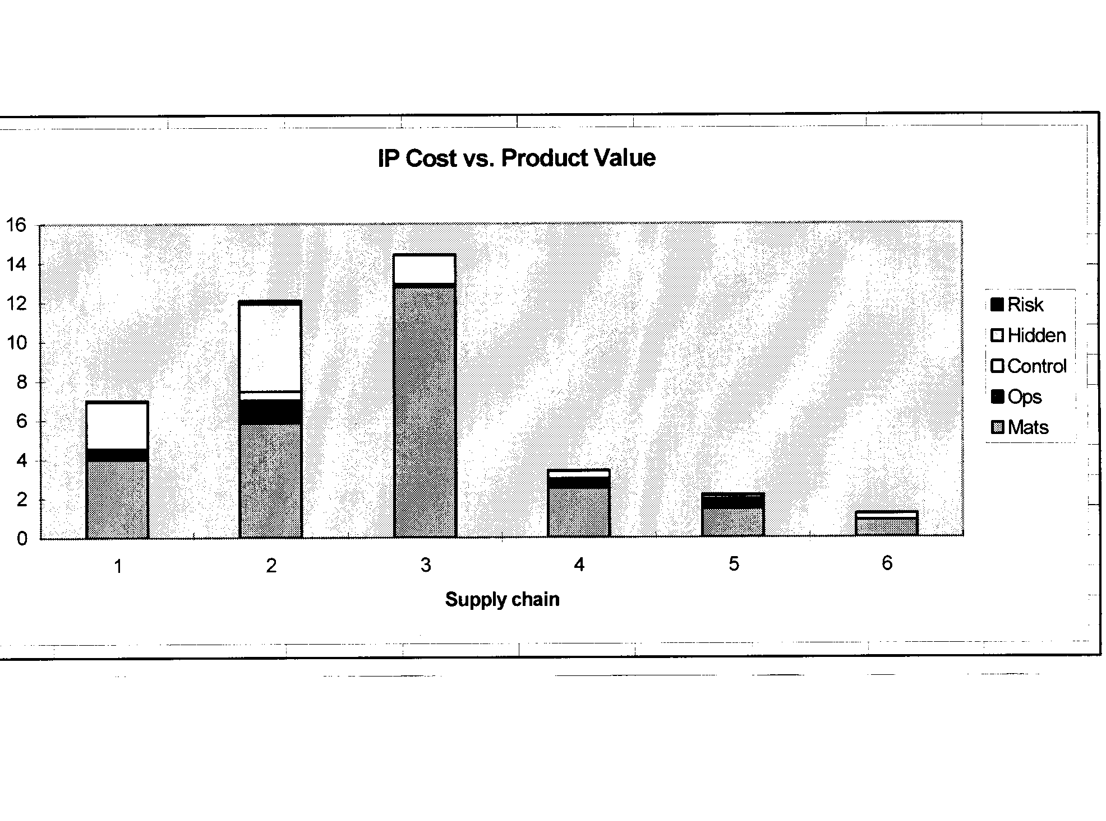
In this graph, numbers on the horizontal axis relate to supply chain stages, namely:
I agriculture
2 trading (export)
3 crushing
4 animal feed
5 livestock
6 meat (slaughter, slicing, cutting, processing)

The graph illustrates, for example, that to preserve the identity of soybeans at the farm level (bar 1), costs increase by approximately seven per cent of the price received by farmers. The chart further illustrates the different components of the cost increase. Continuing with the farm level example (bar 1), materials (Mats) contribute the most to increased costs due to the increase in costs for herbicides as three or four sprayings are required, rather than just one. More herbicide applications also increase operations costs (Ops) while control costs (Control) increase to avoid commingling and preserve identity. Hidden costs (Hidden) are costs associated with the loss in efficiency along the logistical chain and therefore show up particularly in bar 2, trading, while risk costs (Risk) are associated with insurance premiums.

Further research is required to determine the operational and cost implications of being able to include in the documentation the specification of the identity of specific events within a cargo before a decision can be taken on how best to proceed.

In the meantime, with implementation of the Biosafety Protocol, importers will be able to determine the possible events in any shipment bearing the "Cartagena Protocol Biosafety Provision" by checking the list of approved events in commercial production for the country of export in the Biosafety Clearing House.

To date, it appears that most importers are not prepared to pay the added costs associated with identifying each event contained in a specific shipment, even within mutually agreed upon tolerance levels. With the high costs associated with IP systems, only a very small percentage of the world trade in grains, oilseeds, pulses and special crops employ these sophisticated tracking procedures.

Article 18.2(a) Second Sentence Recommendations: In summary, the decision on the second sentence that could introduce a rigorous identity preservation system upon more than 260 million tonnes of grains, oilseeds, pulses and special crops and their products traded internationally each year for food, feed and processing is complicated and potentially extremely costly. The IGTC therefore recommends:

I . Meeting of the Parties concentrate on implementing the first sentence of Article 18.2(a) to ensure that the Protocol can be implemented effectively upon coming into force.

2. That the Meeting of the Parties commission further study during the two years following the Protocol's coming into force, possibly through an Expert Committee process, to (a) determine the effectiveness of the first sentence's requirements to protect global diversity and (b) to study the operational and cost implications of different options to implement the unique identifier requirement contained in the second sentence.

Annex One

International Grain Trade Coalition Members and Contact Points

The Grain and Feed Trade Association (GAFTA): GAFTA is the only worldwide trade association representing the interests of members who trade in grains, feeding stuffs, pulses and rice internationally, with over 800 members in 80 countries. Contact Point: Pamela Kirby Johnson, Director General, GAFTA House, 6 Chapel Place, Rivington Street, London, EC2A 3SH, United Kingdom, Tel: 44 20 7814 9666, Fax: 44 20 7814 8383 Email: PamelaKirbyJohnson@gafta.com

The North American Export Grain Association (NAEGA): NAEGA is comprised of grain and oilseed exporters and interested parties whose purpose is to promote and sustain the development of commercial export grain and oilseed trade from the United States. NAEGA members include 35 private and publicly owned companies and cooperatives domiciled in the United States and Canada. Contact Point: Gary C. Martin, President and CEO, North American Export Grain Association, Incorporated, 1300 L Street, N.W., Suite 900, Washington, D.C. 20005, Tel: 202 682 4030, Fax: 202 682 4033, Email: gcmartin@naega.org

COCERAL: COCERAL is the representation of the European trade in cereals, feedstuffs, oilseeds, olive oil, vegetable oil and agrosupply. It comprises the trade organizations in 15 EU member states, that for their part represent collectors, distributors, exporters, importers and storekeepers of the above-mentioned commodities. Furthermore COCERAL has associated members in Hungary, Poland and Switzerland. Contact Point: Chantal Fauth, Secretary General, COCERAL, 18 Square de Meeus, B 1050 Brussels, Belgium, Tel 02 502 08 08, Fax 02 502 60 30, Email: secretariat@coceral.com

Canada Grains Council (CGC): CGC has a membership of about 30 organizations involved in Canada's grains, oilseeds, pulses and special crops industry including producers, handlers, transporters, processors, exporters, banks and provincial and federal governments and their agencies. Contact Point: Dennis

Stephens, Consultant, Canada Grains Council, 1215-220 Portage Avenue, Winnipeg, MB, RX OA5, Canada Tel 204 925 2133, Fax 204 925 2132, Email: dstephens@canadagrainscouncil.ca

AWB Limited (Australian Wheat Board): AWB Limited is Australia's major national grain marketing organization and is one of the world's largest wheat management and marketing companies. It is involved in the managament and marketing of wheat (for which it is the nation's exclusive bulk exporter) as well as other grains including barley, sorghum, oilseeds and pulses. Contact Point: James Molan, Government Relations Advisor, Ceres House, 528 Lonsdale Street, Melbourne 3000,Victoria, Australia Tel 61 3 9209 2633 Fax 61 3 9670 1723 Email: jmolan@awb.com.au

National Grain and Feed Association (NGFA): NGFA consists of 1,000 grain, feed, processing and grain related companies that operate about 5,000 facilities that store, handle, merchandise, mill, process and export more than two-thirds of all US grains and oilseeds. About 70% of NGFA member firms are small businesses - country elevators and feed mills. Also affiliated with NGFA are 36 state and regional grain and feed associations. Contact Point: Mr. Tom O'Connor, Director of Technical Services, National Grain and Feed Association, 1201 New York Ave., N.W. Suite 830, Washington, D.C 20005-3917 Email: toconnor@ngfa.org

Soybean Processors Association of India (SOPA): SOPA is an all India based association having a membership of 600 members representing processing industries, exporters, buyers, brokers, surveyors, analysts as well as farmers. The Association members are actively involved in trading soybean meal for food and feed purposes. Contact Point: Mr. D. R. Kalra, Executive Director, Soybean Processors Association of India, Scheme No. 53, Bear Malviya Nagar, A. B. Road, Indore 452 008, India, Email: sopain@born4.vsnl.net.in

ANIAME: ANIAME is the Association of Oilseed (including soya, canola and sunseeds) Processors in Mexico. Contact Point: Lic Amadeo Ibarra, Director General, ANIAME, Praga 39 Piso 3, Col. Juarez, C. P. 06600, Mexico, D.F., Mexico, Email: aibarra@aniame.com

Hungarian Grain and Feed Association: The Hungarian Grain and Feed Association represents 80 -90% of the companies involved in Hungary's milling, grain-export, soymeal-import and feed milling industry. Contact Point: Mr. George Makay, General Secretary, Hungarian Grain and Feed Trade Association, Alkotmany U. 16.11.9, H-1 054 Budapest, Hungary, Email: gabonaszov@mail.datanet.hu

The Solvent Extractors' Association of India: The Solvent Extractors' Association of India was formed in 1963 to help and foster the development and growth of India's solvent extraction industry. At present the Association has about 900 members including about 550 solvent extraction plants having a combined oilcake/oilseed processing capacity of about 30 million tonnes. Contact Point: Mr. B.V. Mehta, Executive Director, 142 Jolly Maker Chambers No 2, 14 th Floor, 225, Nariman Point, Mumbai-400 021 India, Email: solvent@vsnl.com

National Corn Growers Association (NCGA): NCGA is a coalition of 27 affiliated state organizations and represents the interests of 350,000 corn producers in the United States. Contact Point: Mr. Fred Yoder, Director and Chairman, Biotechnology Committee, National Corn Growers Association, Email: seedman@netwalk.com or Tolman@ncga.com

APPAMEX: The Mexican Association of Providers of Agricultural Products represents organizations involved in the trade of imported and exported agricultural commodities in Mexico. Contact Point: Guadalupe Arriaga Rubio, Directora, Durango 245 Desp. 203, Col. Roma, 06700 Mexico D.F, Email: appamex@attglobal.net

US Wheat Associates: US Wheat Associates is the market development arm of the US wheat industry.
Contact Point: Nelson Denlinger, US Wheat Associates, Suite 801, 1620 1 Street, N.W., Washington, D.C. 20006-4005, Email: ndenlinger@uswheat.org

ANNEX TWO

Shipping Documents

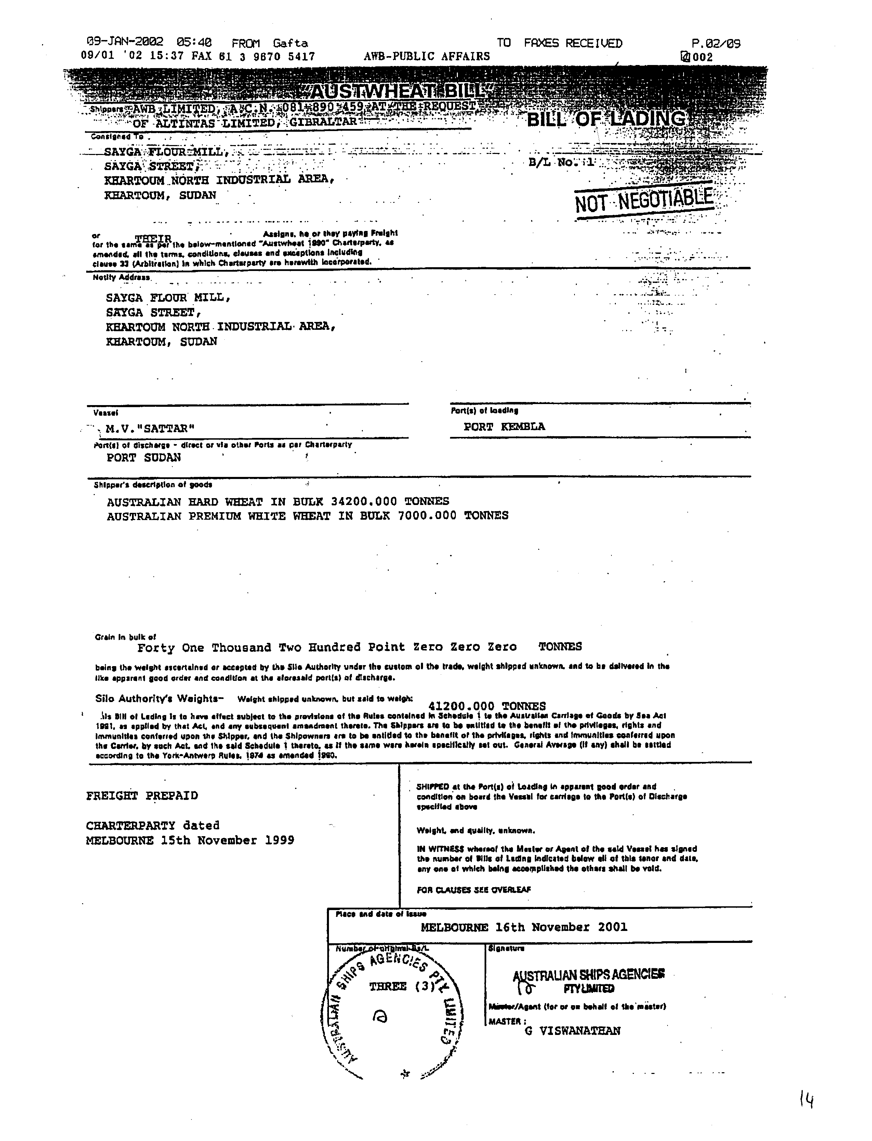
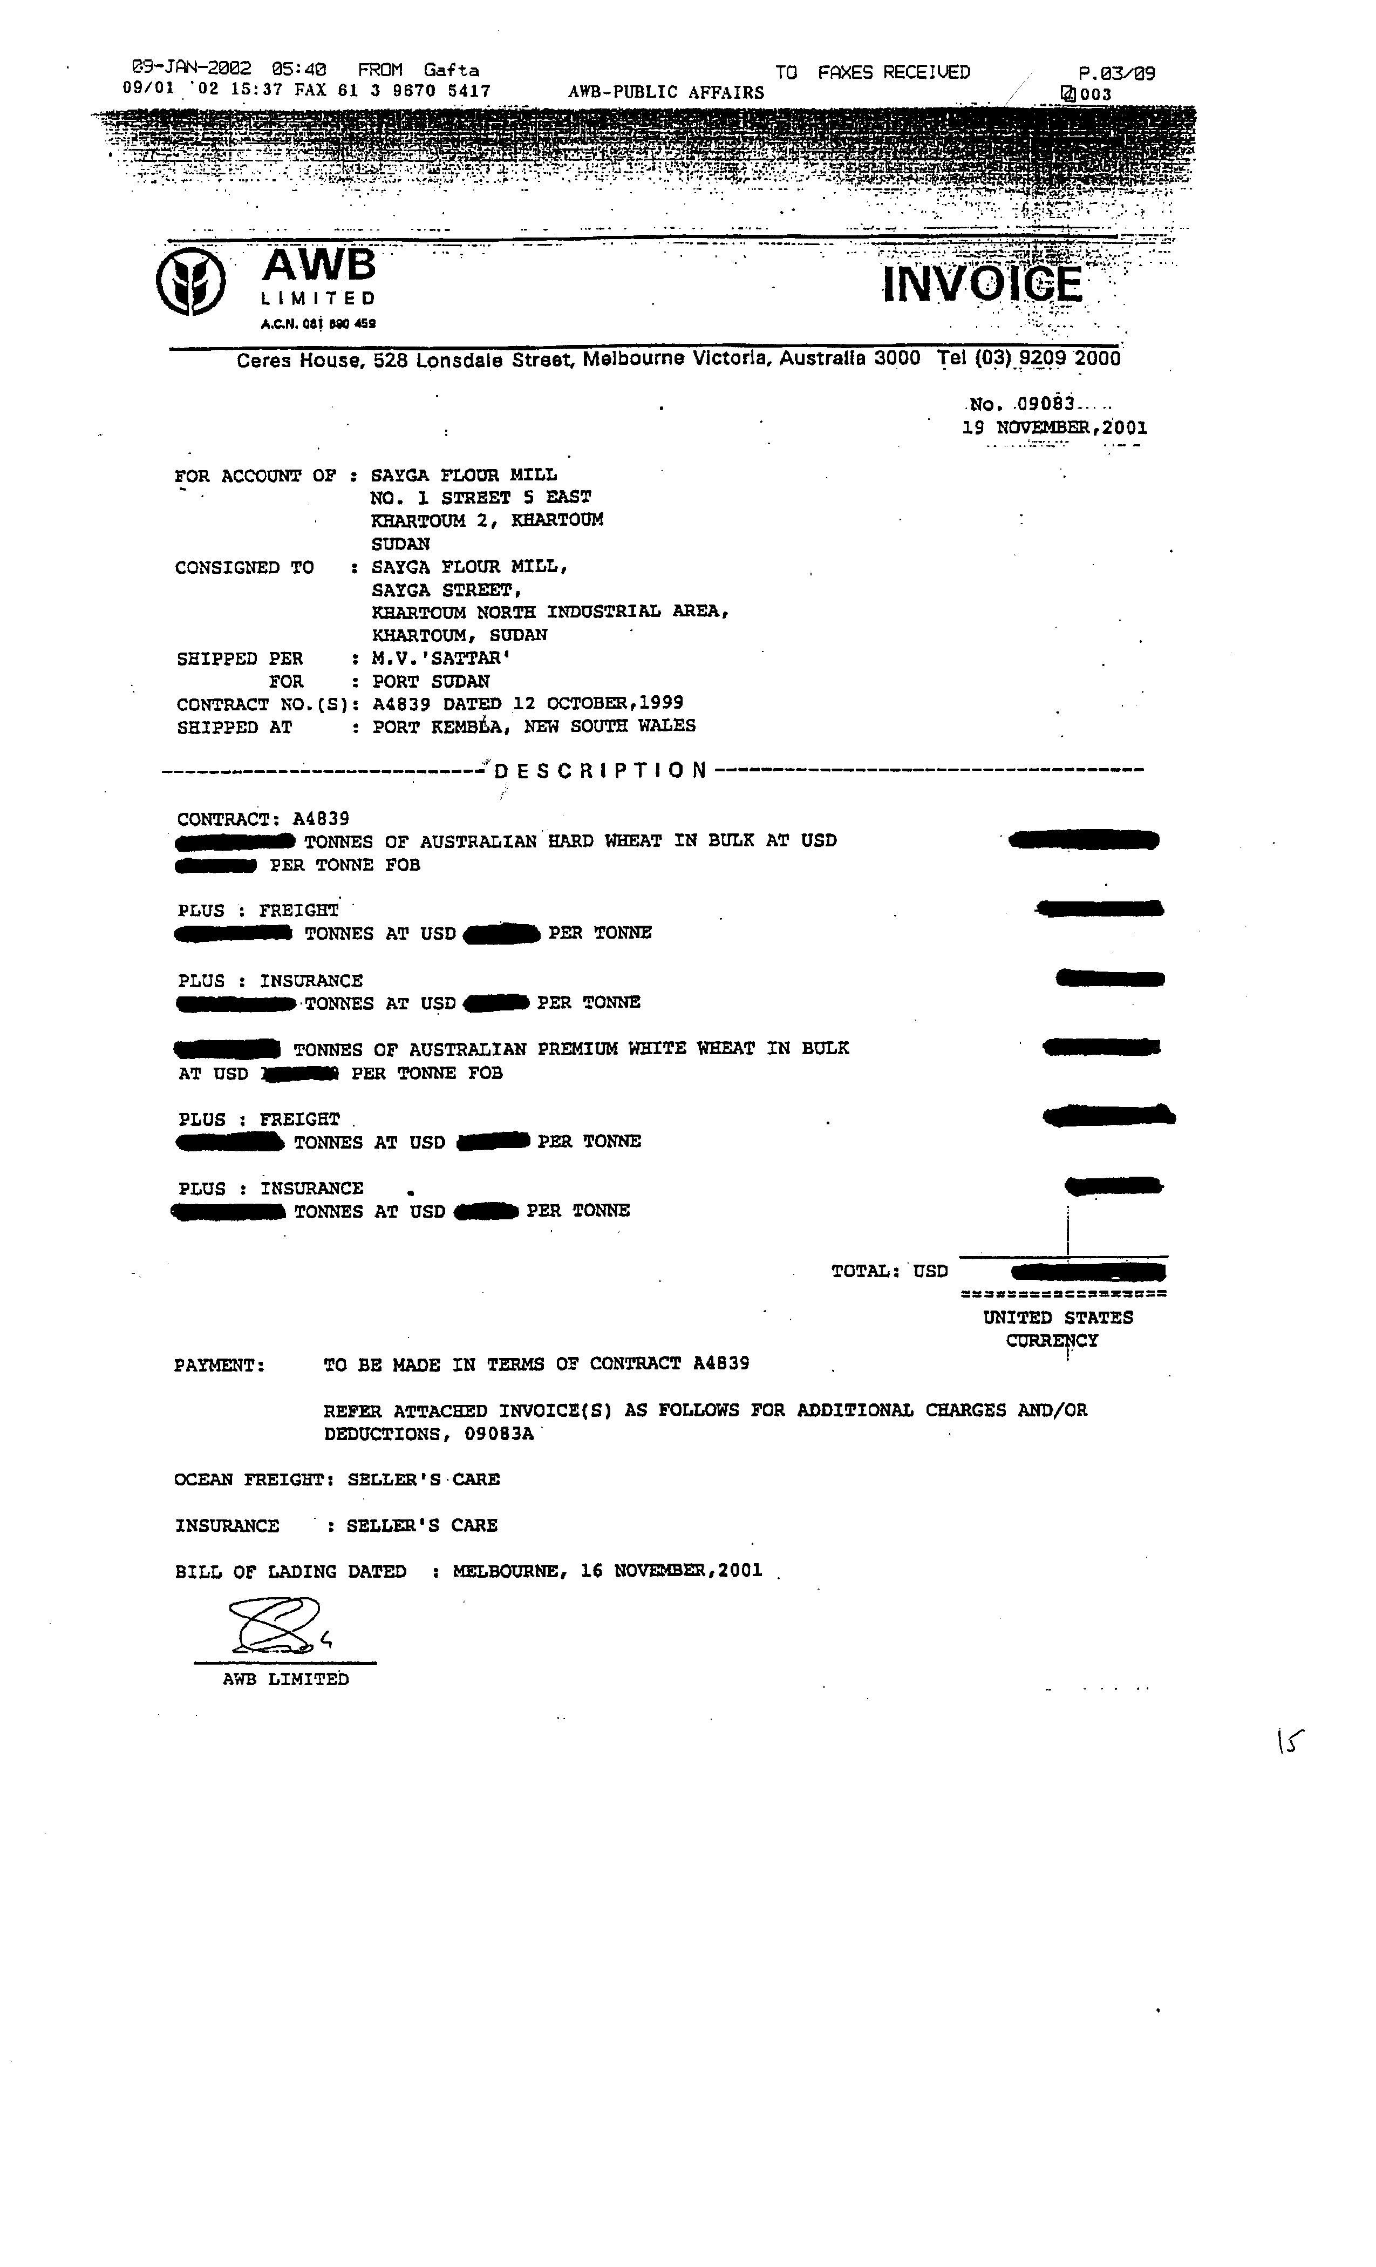
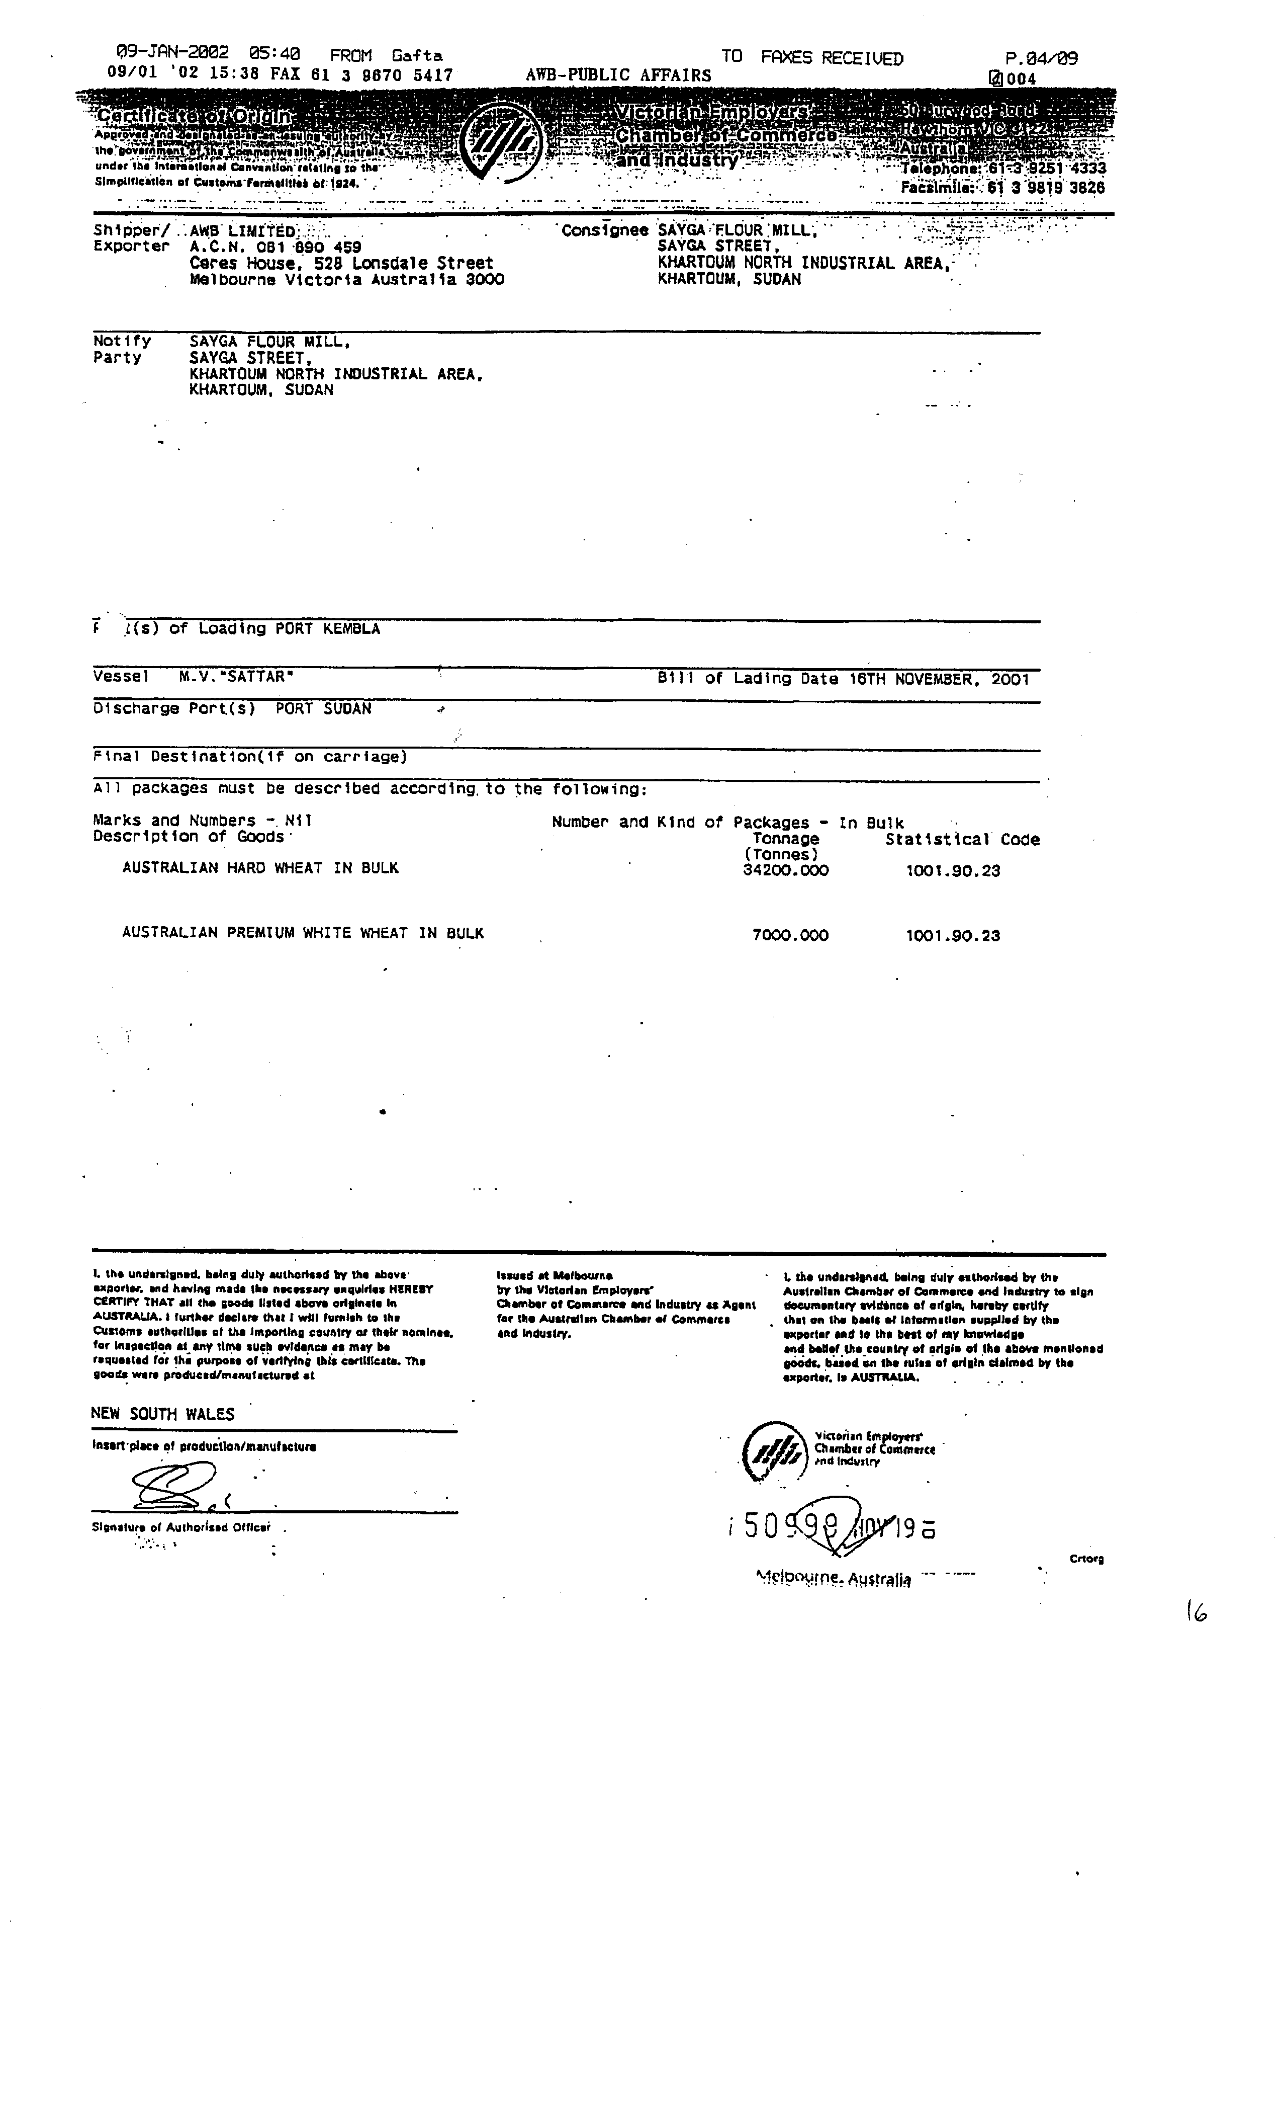
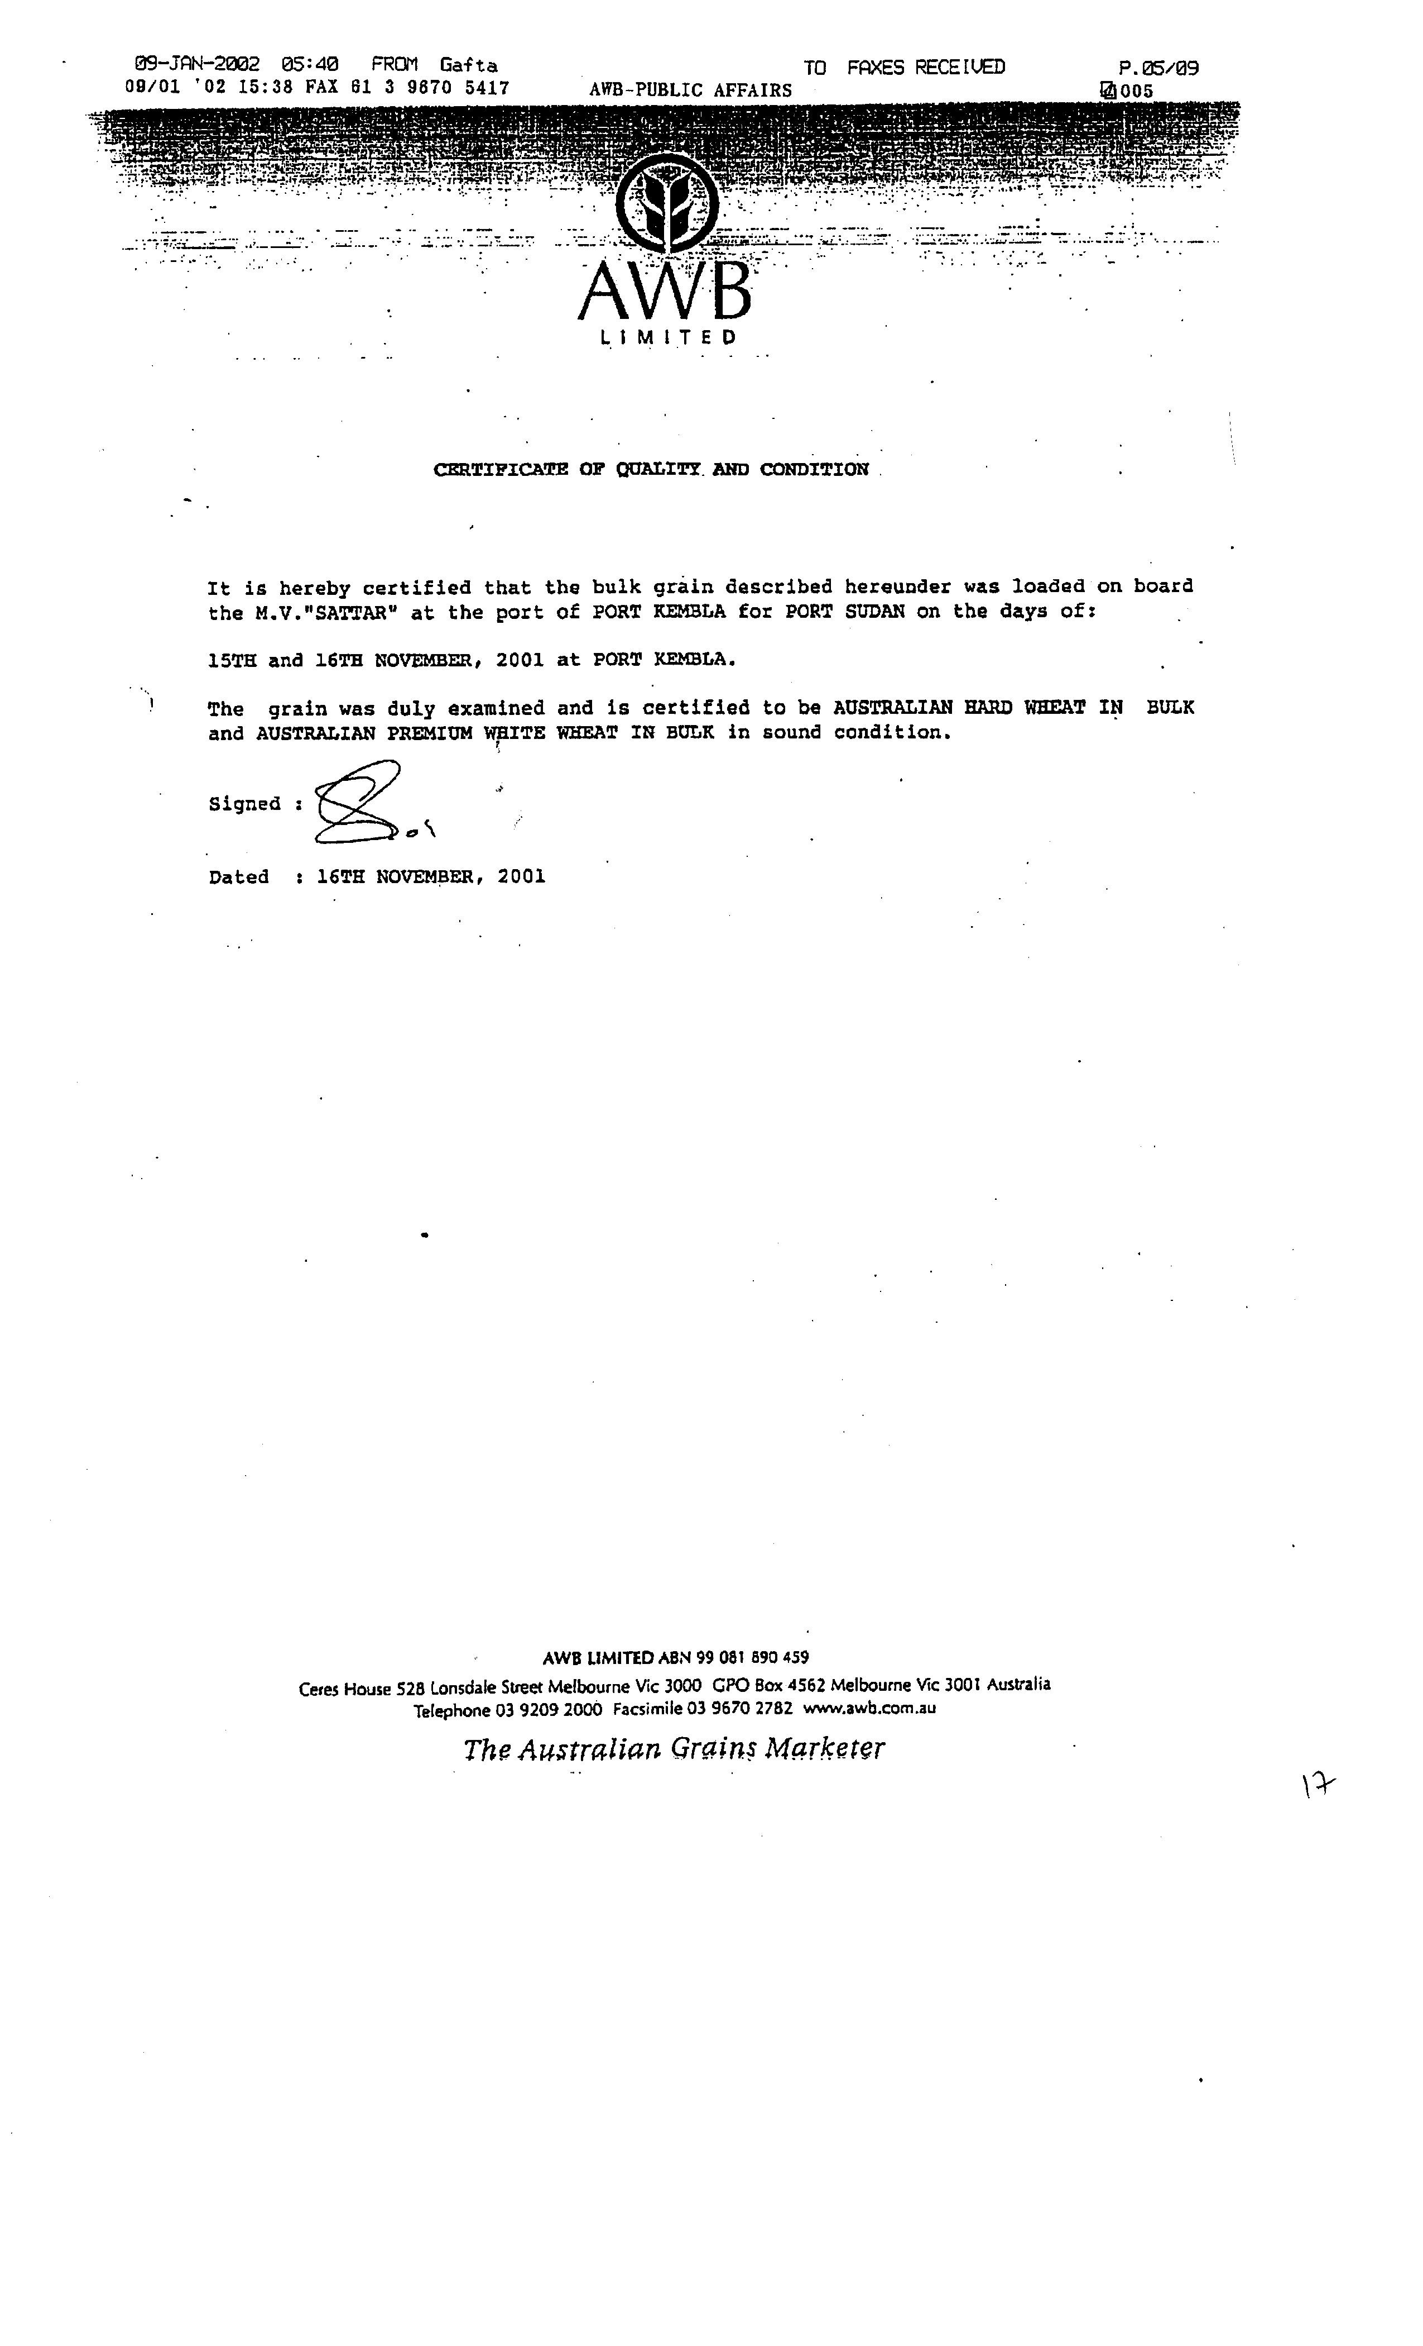
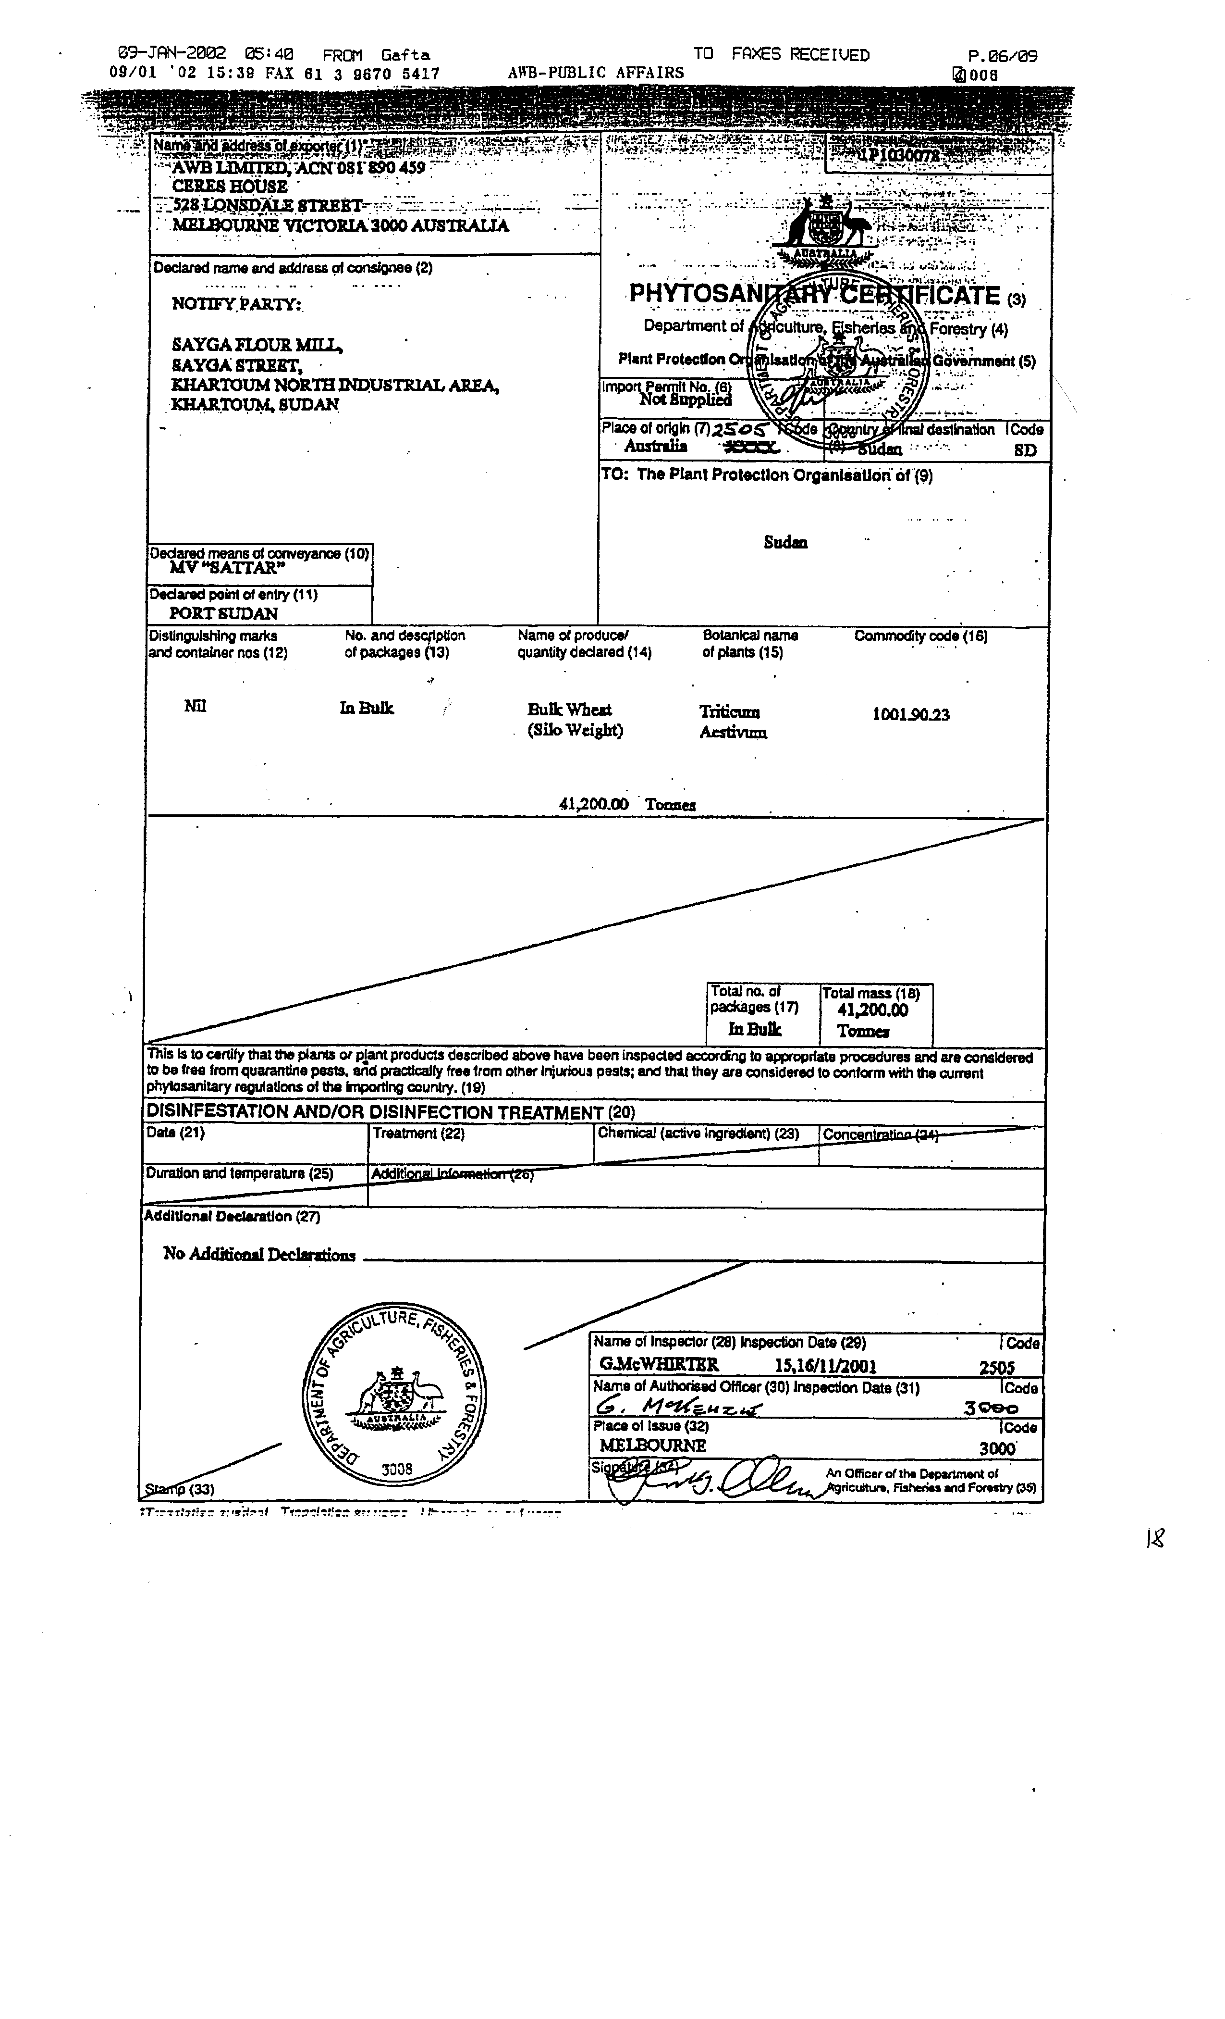
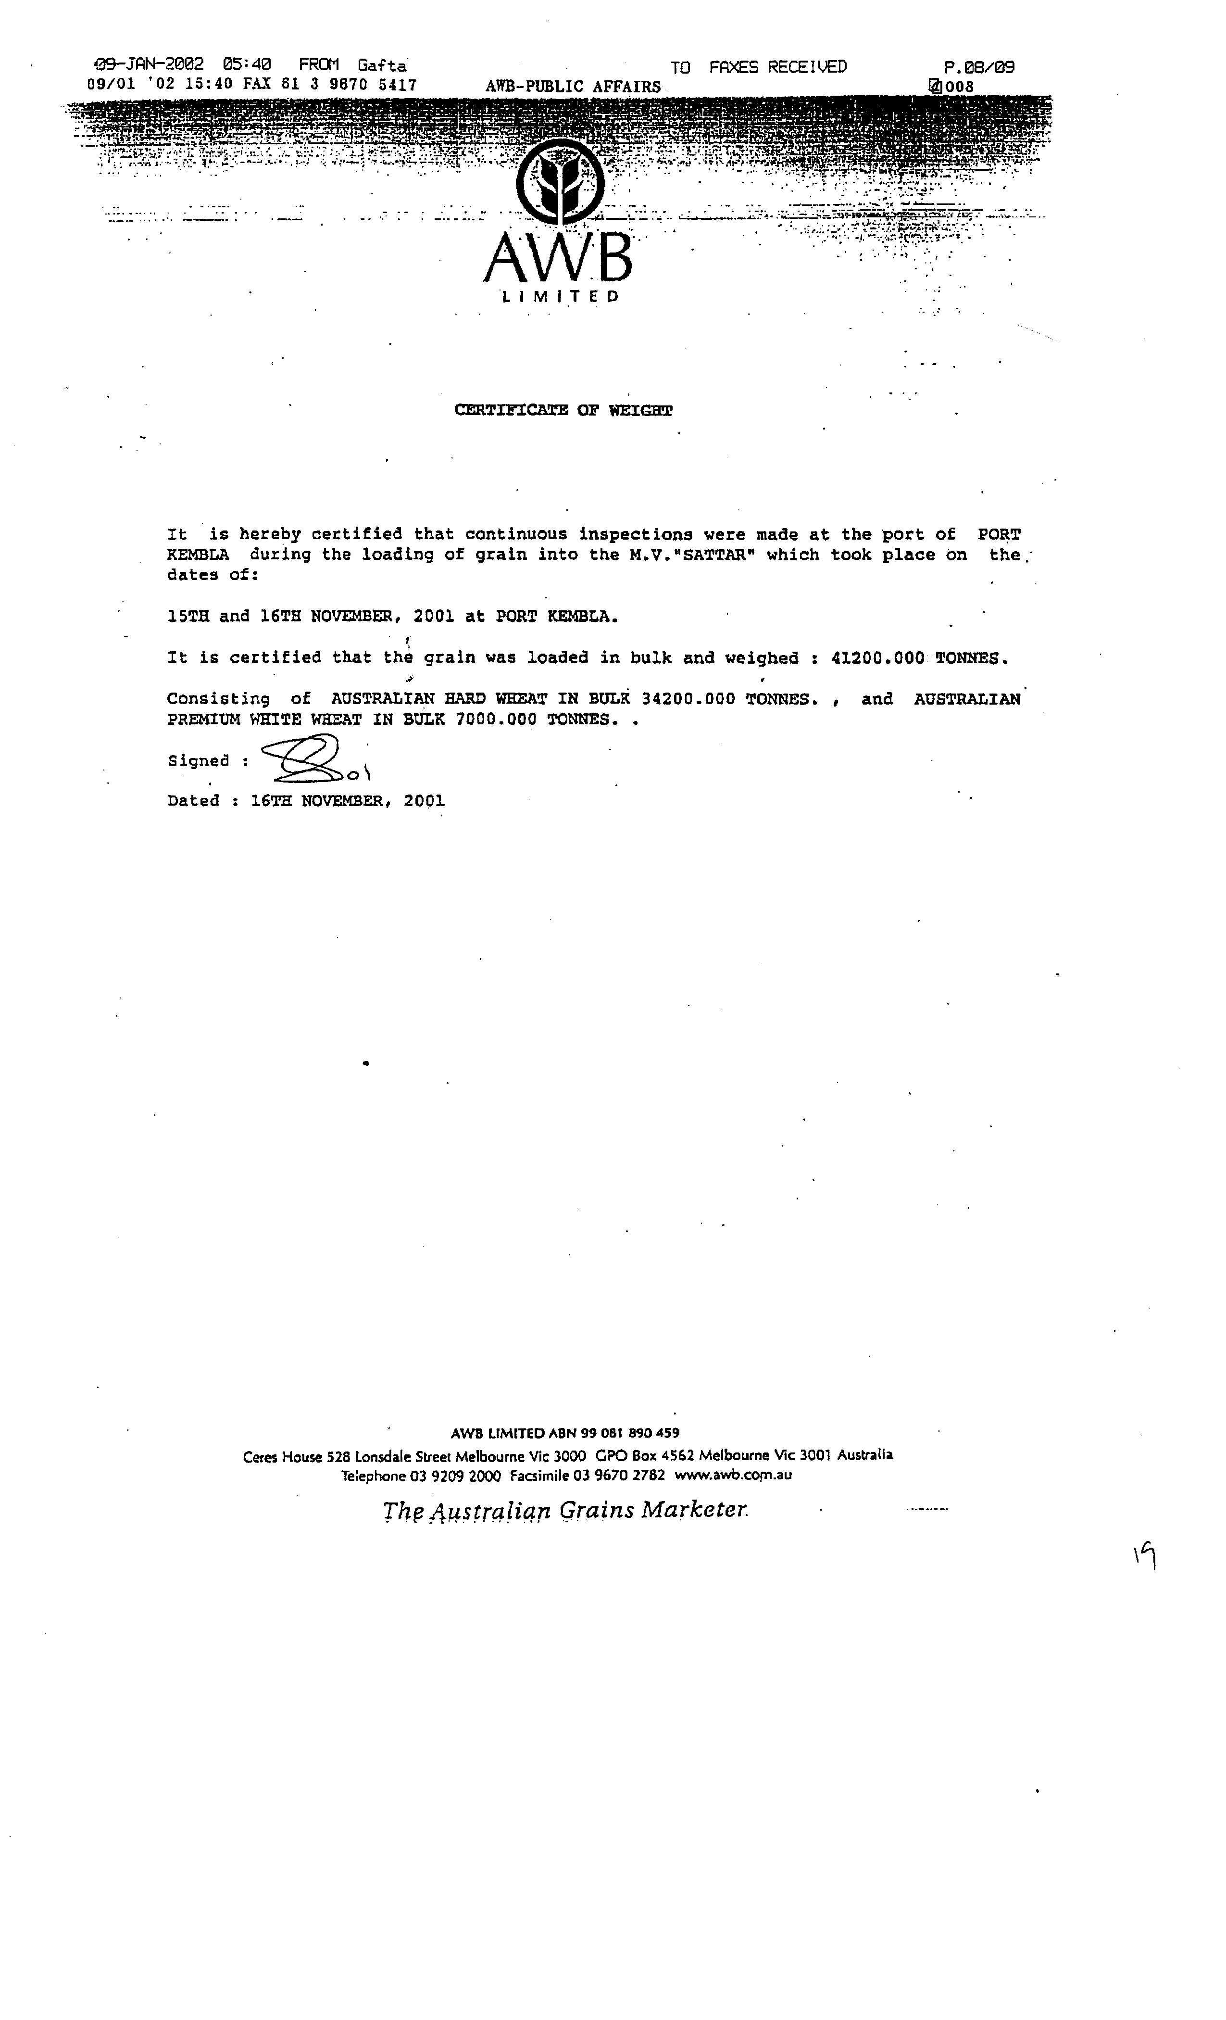
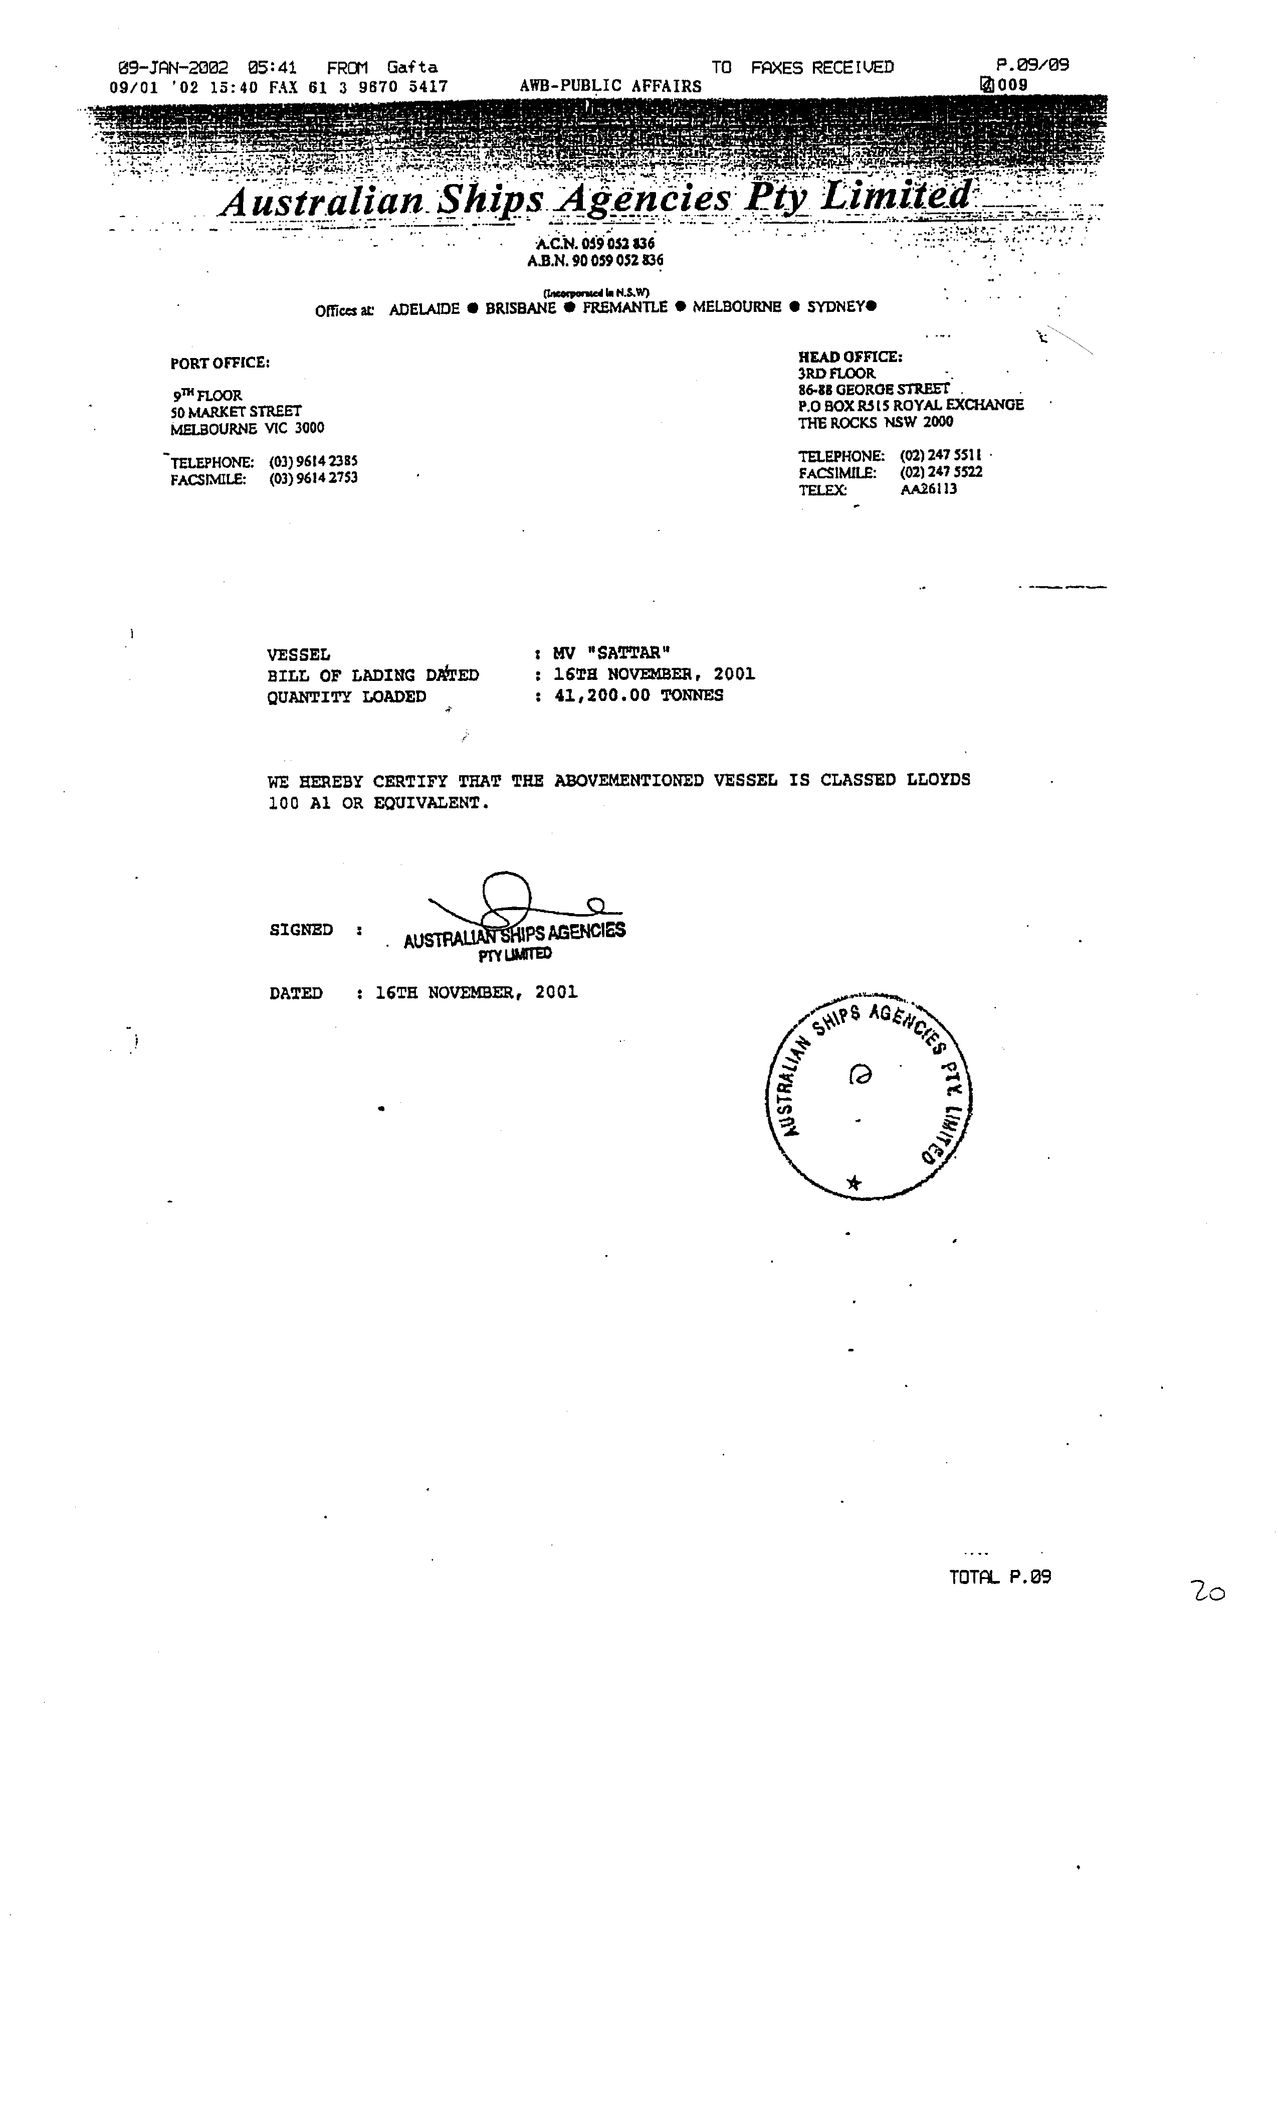
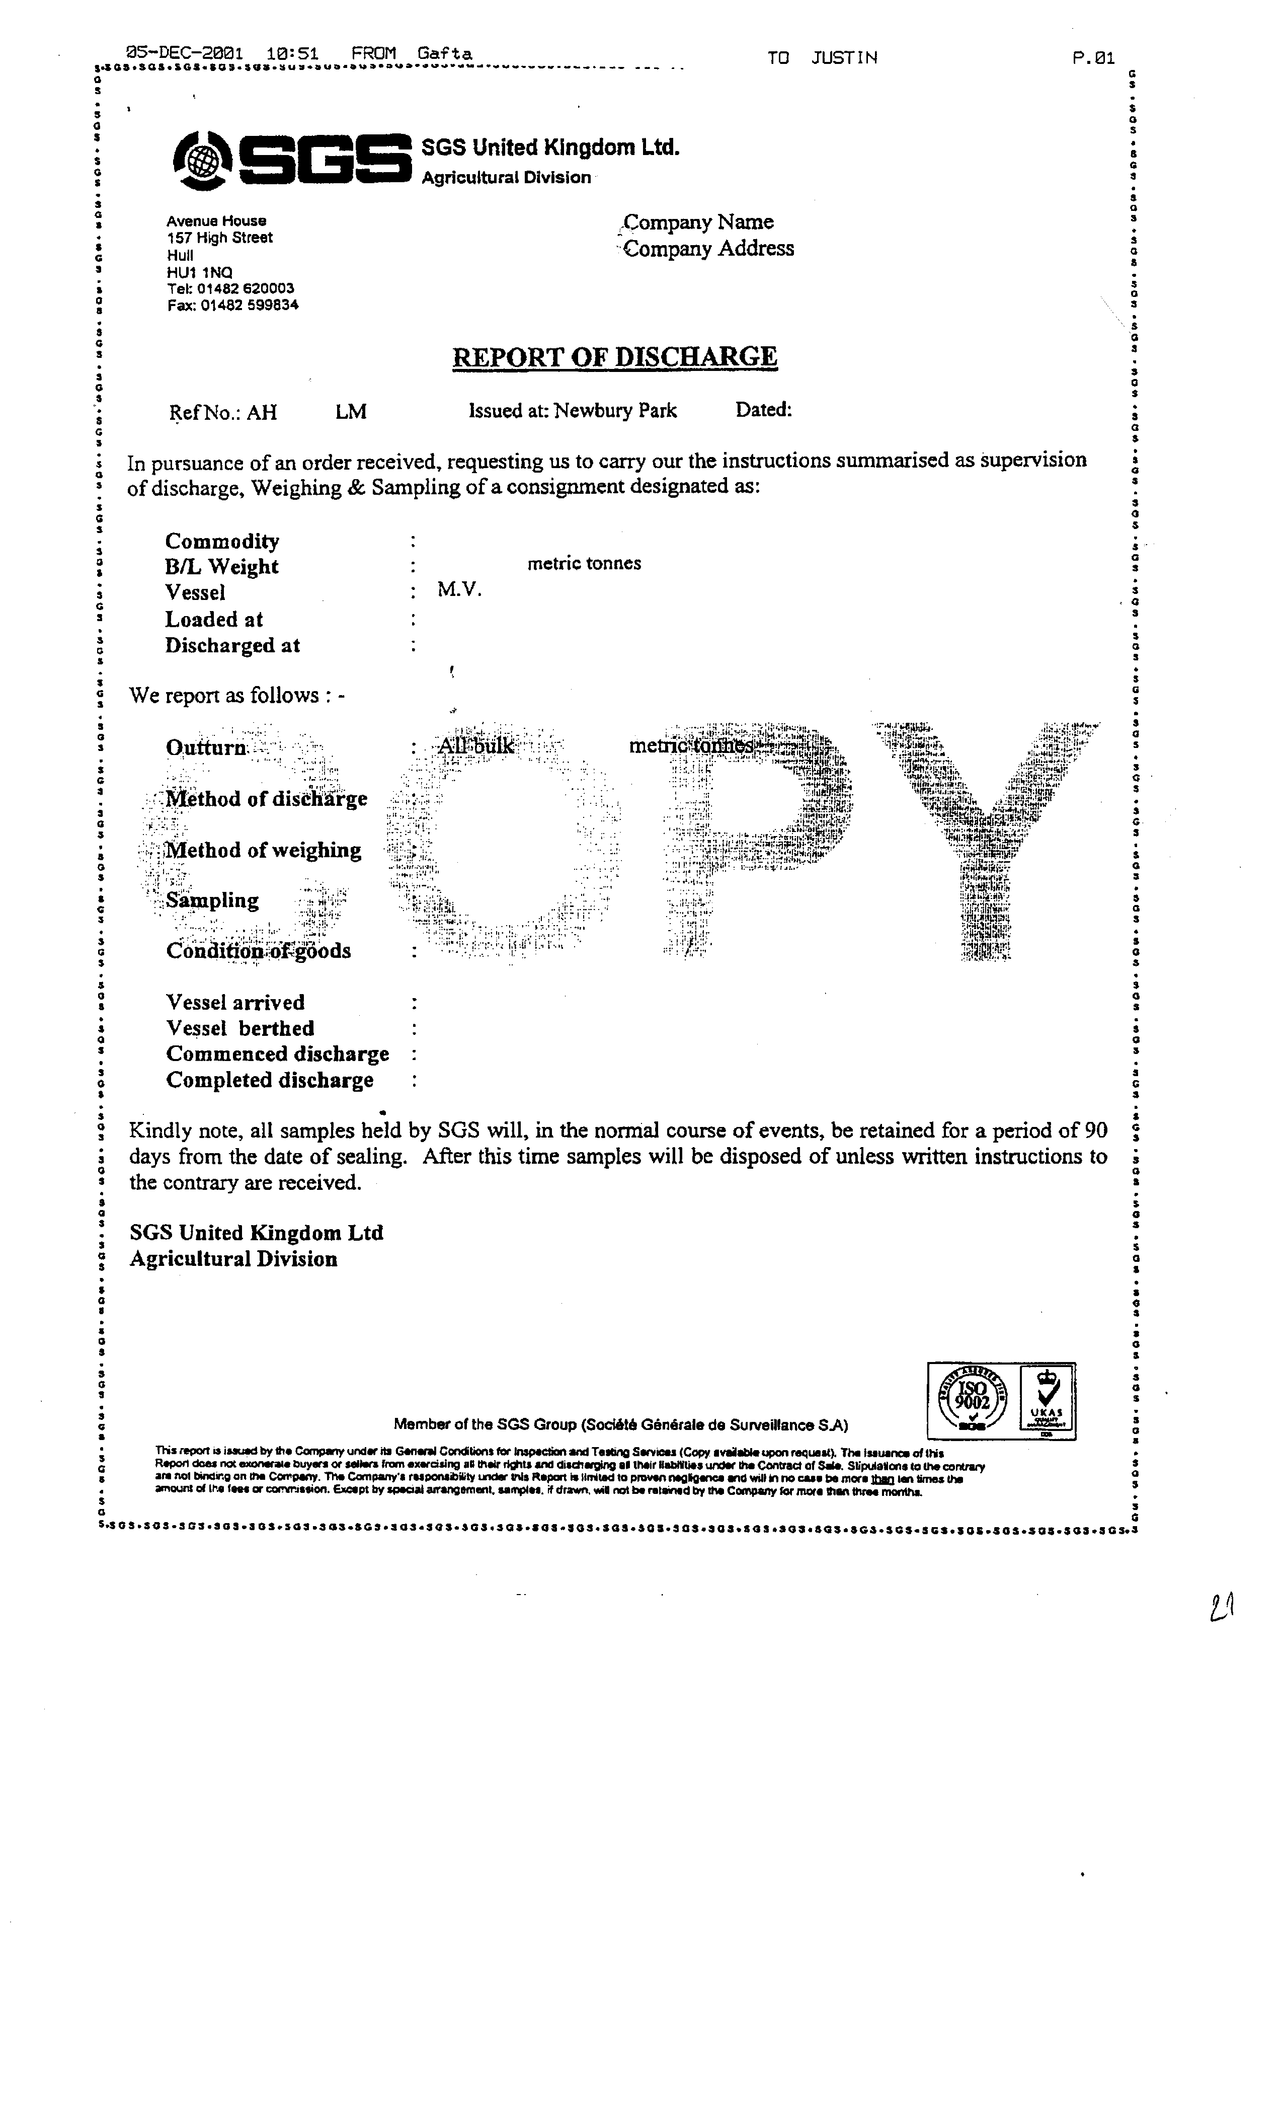
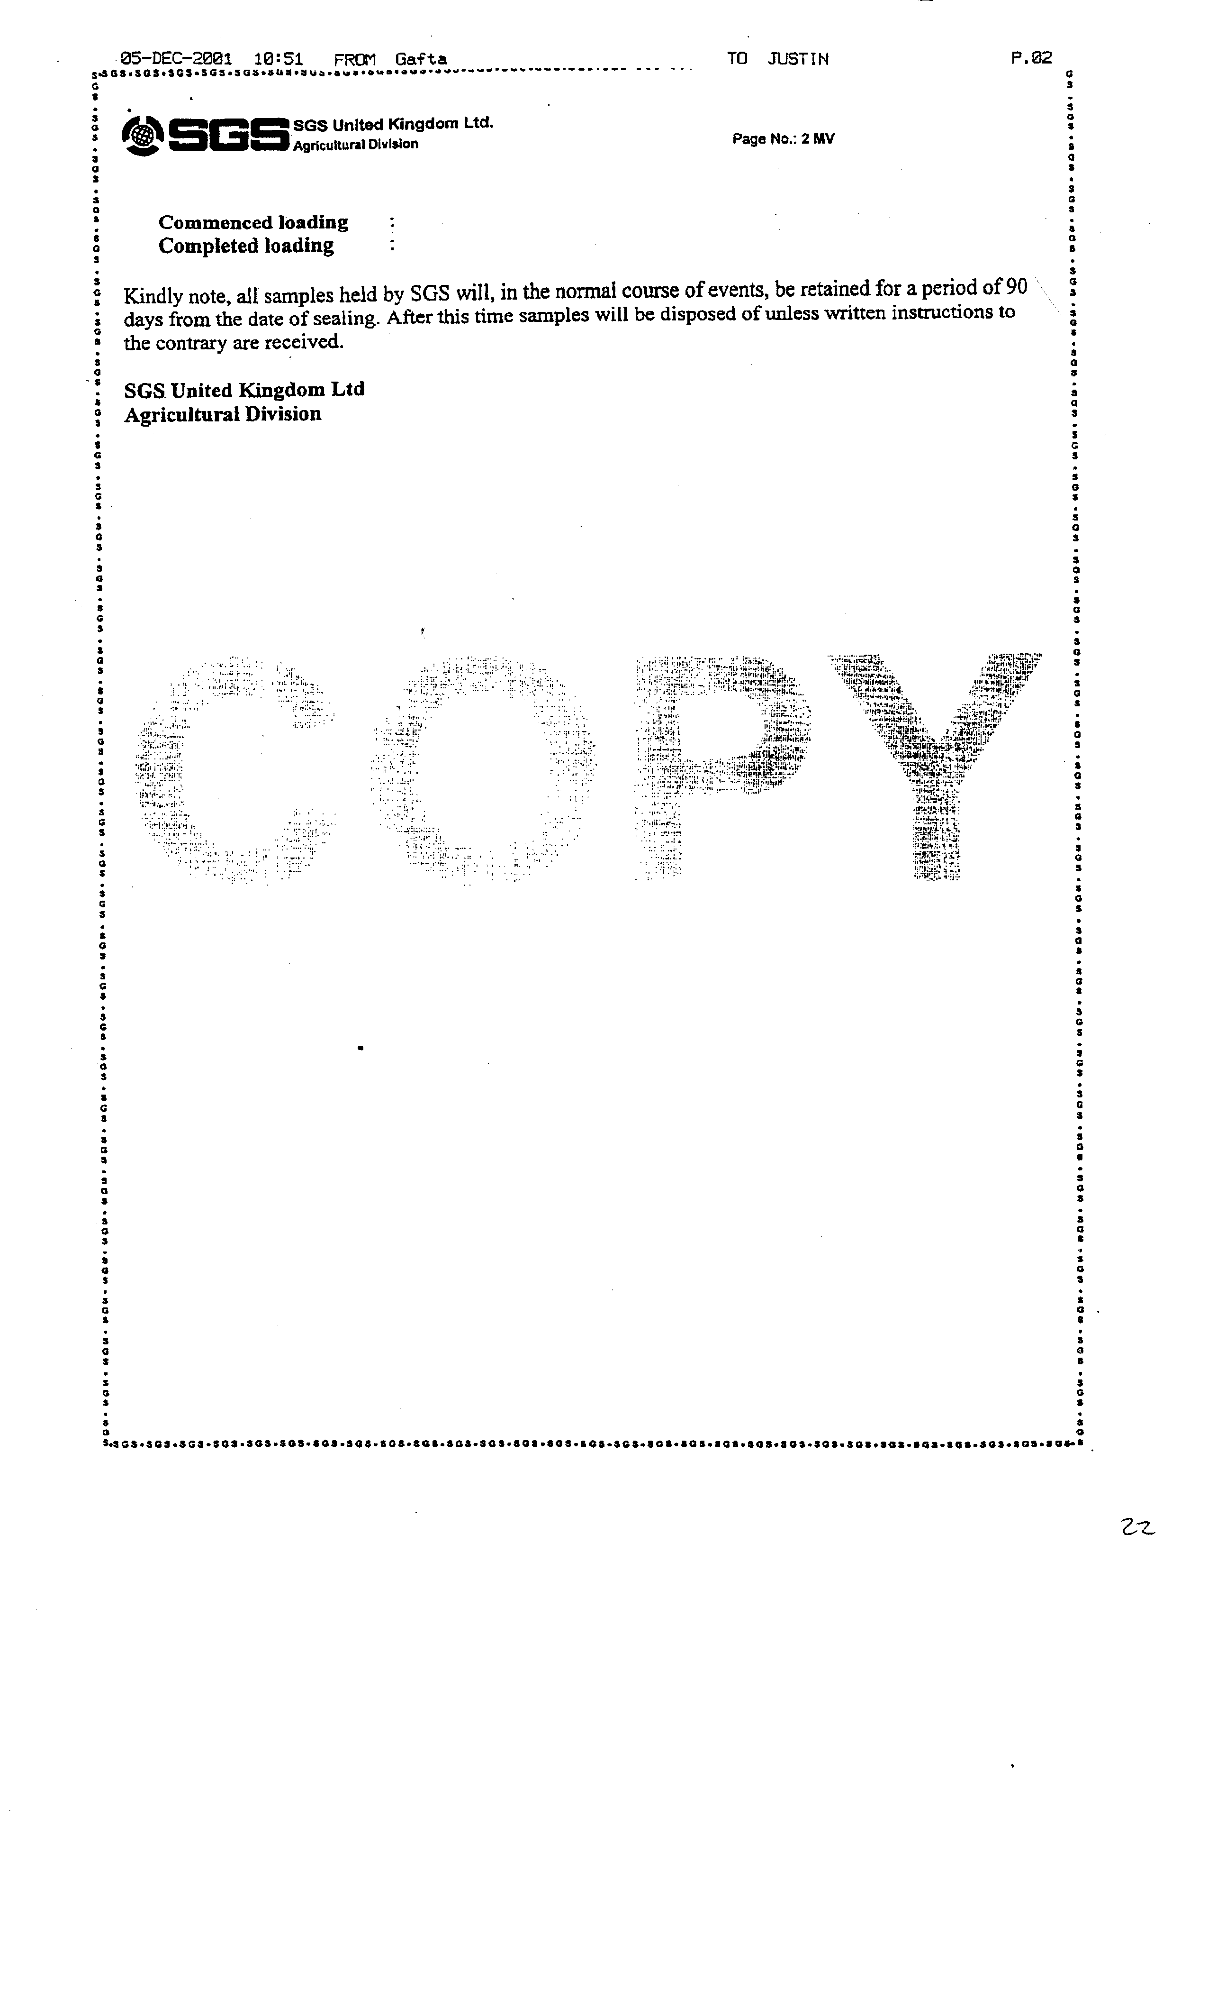
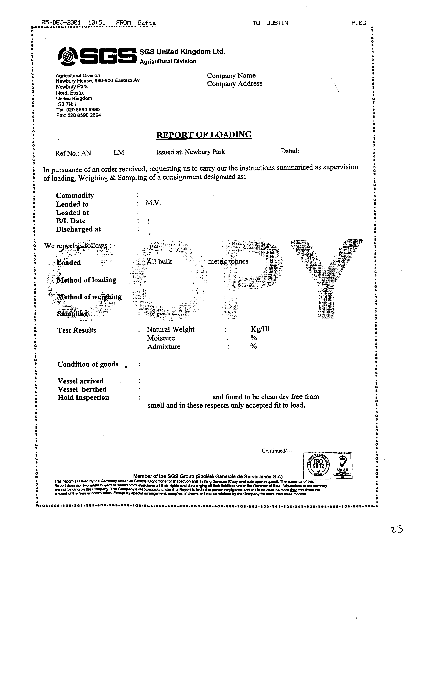
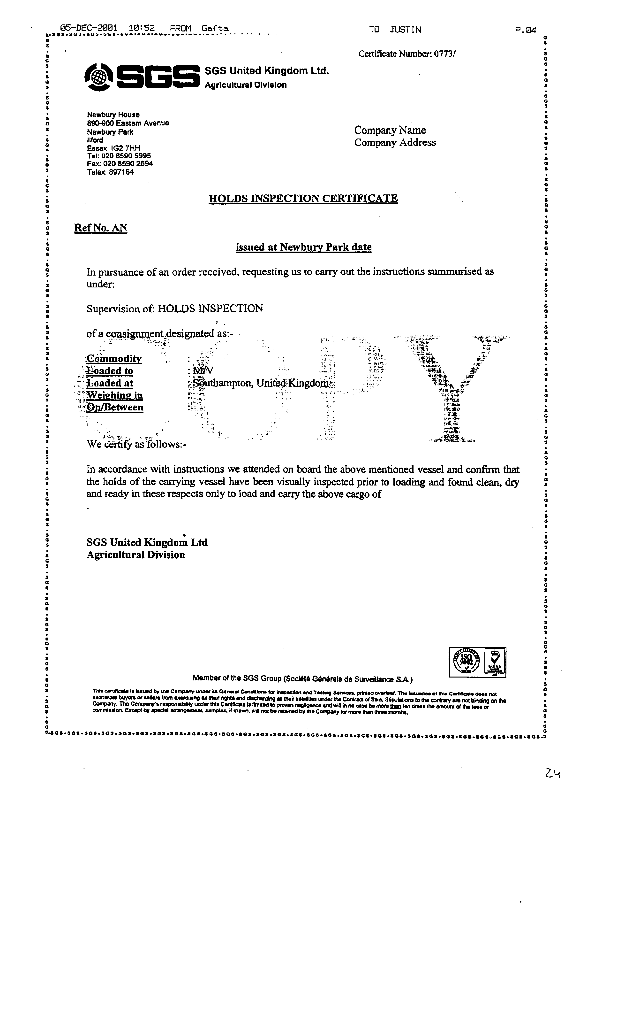
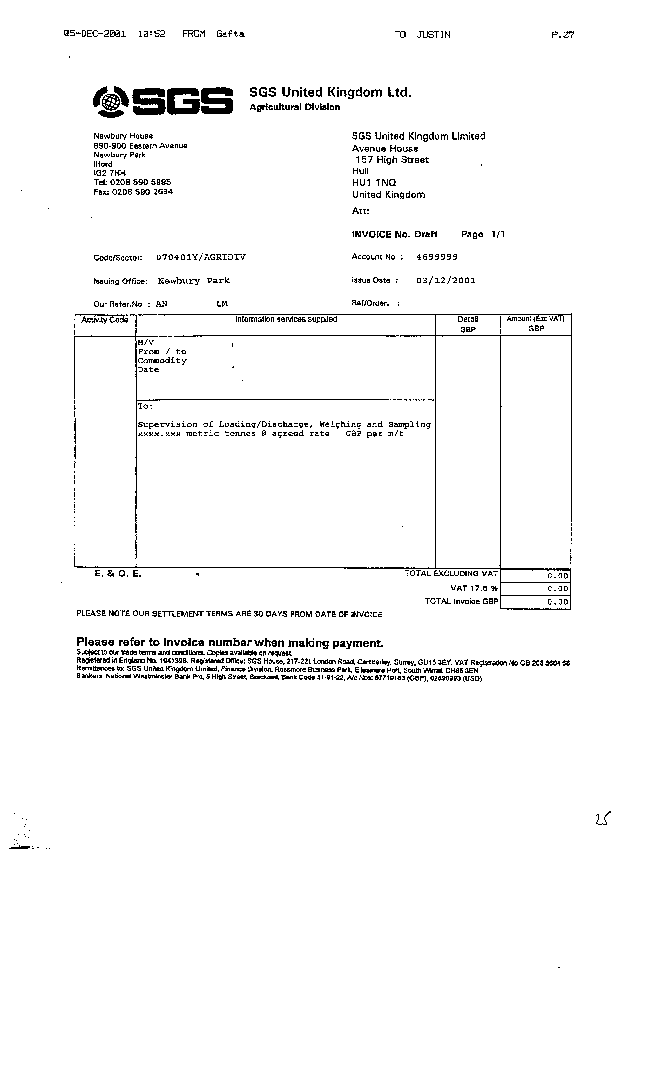
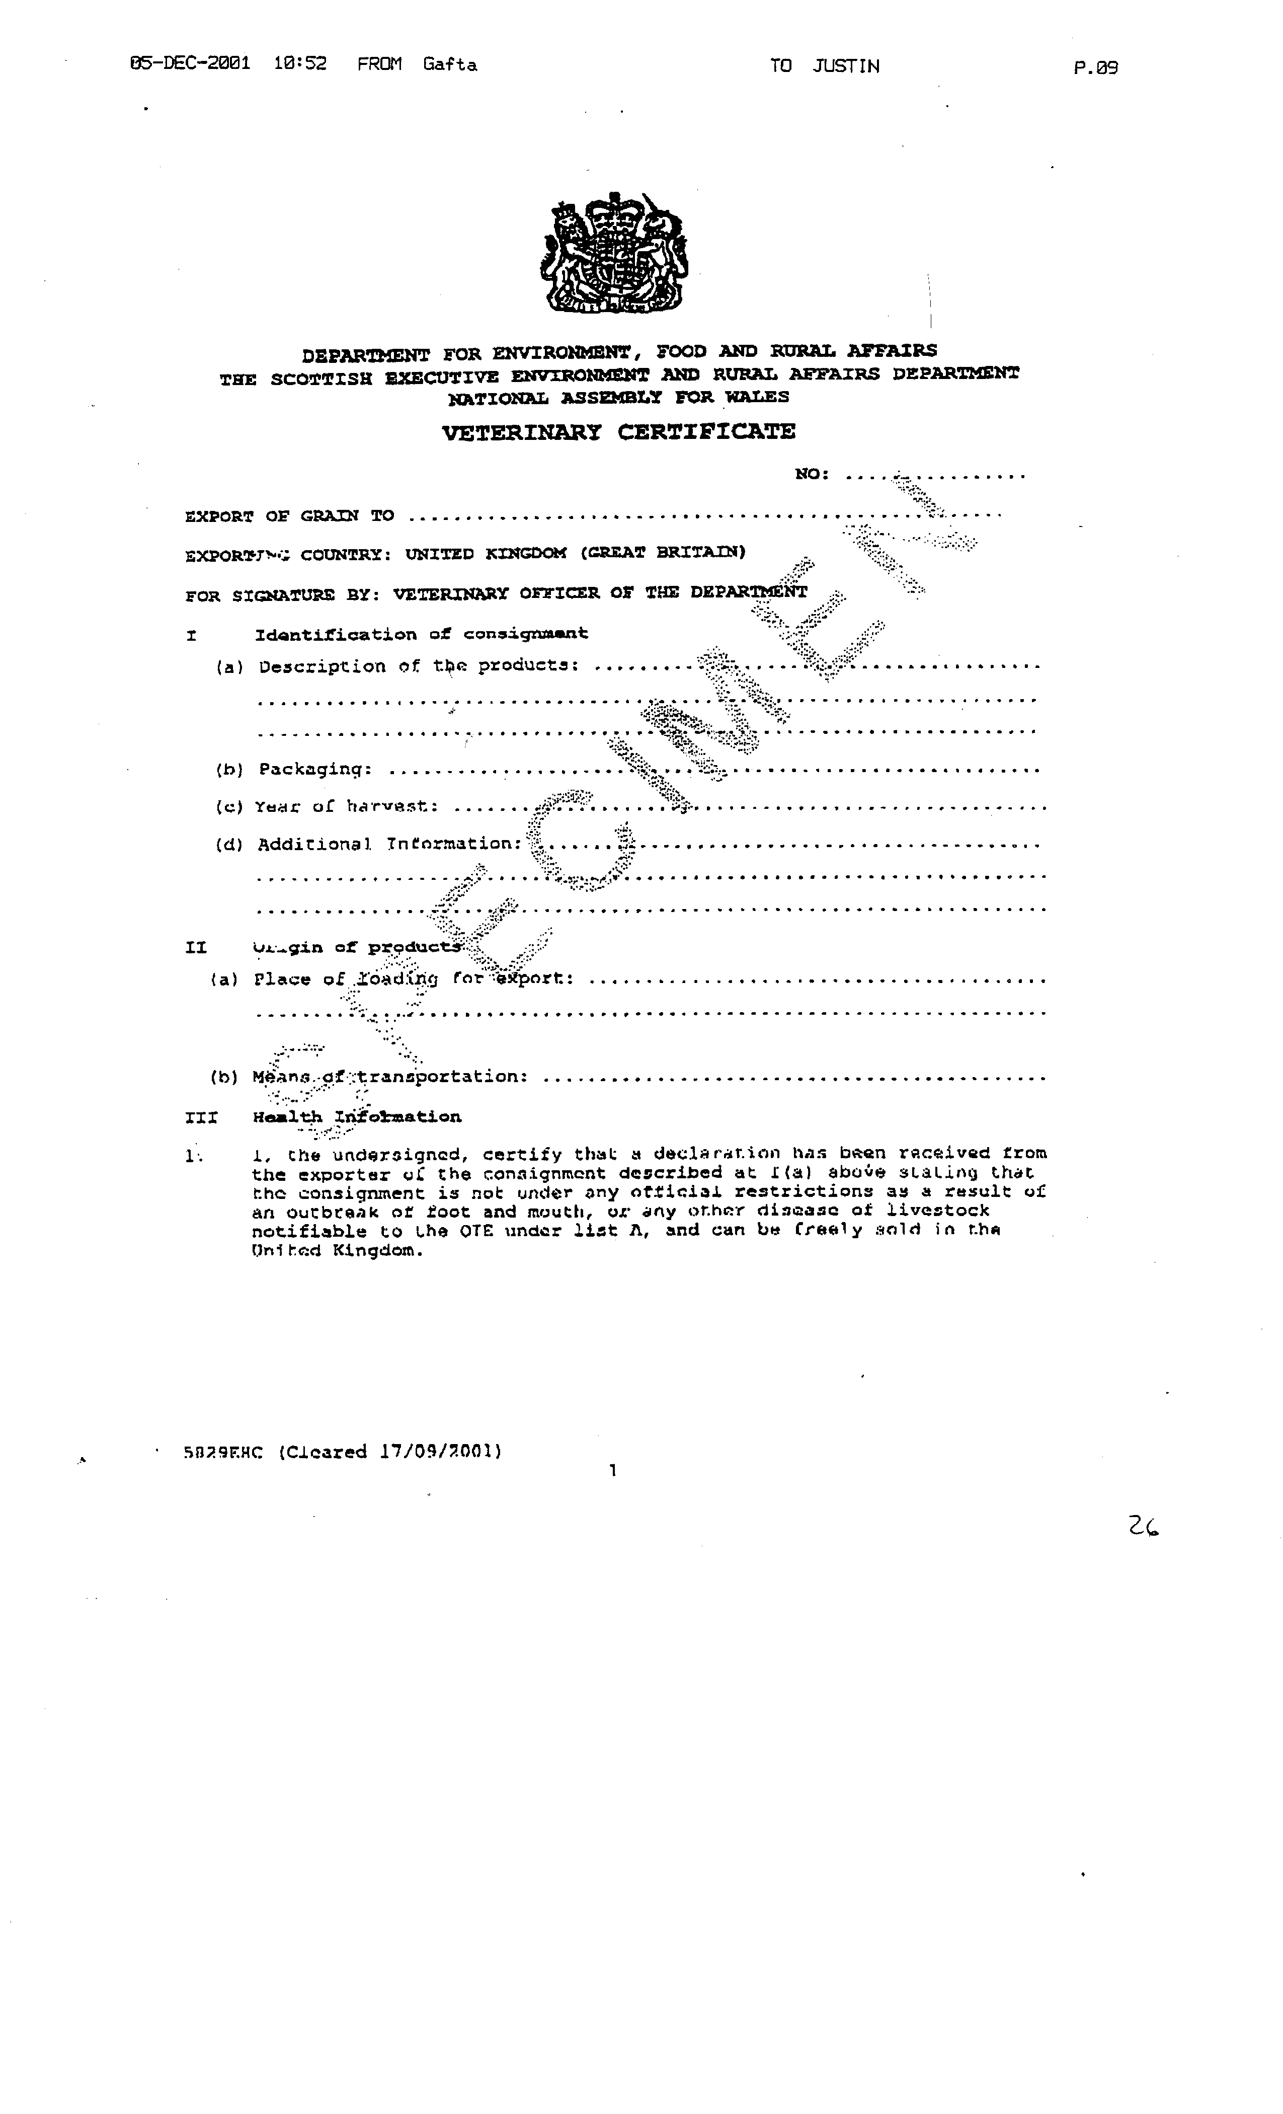

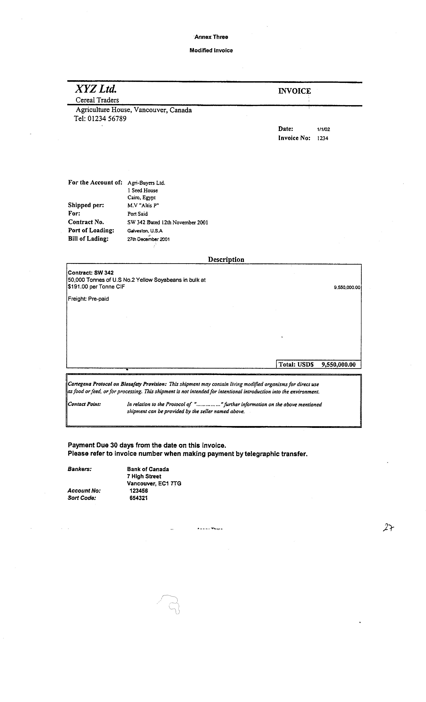

 Economic Research Service, United States Department of Agriculture, 'Biotechnology: U.S. Grain Handlers Look Ahead', Agricultural Outlook, April 2000
 Leading Dog Consulting and Peter Flottmann and Associates, Segregating Gene Technology Products - Requirements, Costs and Benefits ofIdentity Preservation, Segregation and Certification, Department of Agriculture, Fisheries and Forestry - Australia, May 200 1, this estimate is supported by the report from Avcare Australia; National Association of Crop Production and Animal Health, GM Canola - Issues and Potential Market Impactsfor Australia, which states "in terms of cost ... an additional 15% seems reasonable, equating to approximately A$25-35 a tonne extra cost through the grain supply chain"
 Max Foster, Genetically Modified Grains: Market Implicationsfor Australian Grain Growers, Australian Bureau of Agriculture and Resource Economics and Grains Research and Development Corporation, August 2001
 Kalaitzandonakes, N.,Maltsbarger, R., Bames, J.: Global IP Costs in Agricultural Supply Chains

