 |  |  | CBD
 |  | CONVENTION ON  BIOLOGICAL DIVERSITY |  |  | Distr.  LIMITED  UNEP/CBD/BS/TE-HTPI/2/INF.1  26 February 2002  ORIGINAL: ENGLISH
SECOND MEETING OF TECHNICAL EXPERTS ON HANDLING, TRANSPORT, PACKAGING AND IDENTIFICATION OF LIVING MODIFIED ORGANISMS
(ARTICLE 18, PARAGRAPHS 2(b) AND 2 (C))
Montreal, 13-15 March 2002

COMPILATION OF RESPONSE FROM RELEVANT INTERNATIONAL ORGANIZATIONS REGARDING PARAGRAPHS 2 (b) AND 2 (c) OF ARTICLE 18 OF THE BIOSAFETY PROTOCOL

CONTENTS

Submitting organization Page

Organisation for Economic Cooperation and Development (OECD) 2

United Nations Economic Commission for Europe (UNECE)
for the UN Sub-Committee of Experts on the Transport of Dangerous Goods 24

World Trade Organziation (WTO) 30

ORGANISATION FOR ECONOMIC COOPERATION AND [25 January 2002]
DEVELOPMENT (OECD) [SUBMISSION: ENGLISH]

The present notification concerns Article 18(c) (handling, packaging, transport and identification of living modified organisms) and tries to respond to the two questions raised in Mr. Zedan's letter.

1. Actions taken within the framework of the OECD Schemes for the Varietal Certification of Seed Moving in International Trade.

At their Annual Meeting held in Paris on 27-29 June 2001, Mrs. Harries (OECD Chairperson, Argentina) asked the OECD Secretariat to supply information about the OECD Seed Schemes to the CBD Secretariat, as requested. This was following a presentation by Messrs. Letodé_and Pythoud and the ensuing discussion.

At the Meeting of the Extended Advisory Group for the OECD Schemes held at Changins near Geneva on 19-20 October, Delegates shared the view that the Schemes were well suited to convey part of the information required by the Protocol and to do so efficiently. They were of the opinion that the well established mechanisms of information and co-operation between National Designated Authorities of the importing and exporting countries would allow an easy transmission and checking of critical data related to seed lot shipments.

2. Views on issues addressed by the ICCP that are of relevance to the OECD Seed Schemes.

The ICCP work may also take advantage, from a biosafety viewpoint, of the already implemented OECD standards, rules and directions for reducing the possible risk of GMO contamination.

At present, the Schemes allow that the OECD label "may be used for such additional information as the Designated Authority wishes to give" (Appendix 4, article 3.4 of each Scheme). This provision is already used for supplementary information to OECD certification as required by some importing countries and the EU.

The introduction of rules for information about Seed of OMO-Varieties on the OECD-Label as well as on the OECD-Certificate was discussed at several OECD-Seed Scheme meetings. The OECD Certificate would be useful for providing certain information, particularly the declaration that the movement is in conformity with the requirements of the Protocol, any requirements for safe handling, storage, transportation and use, contact point for further information, etc.

3. Other information and latest developments

A Working Group on Genetically Modified Seed Issues was established at the 2000 Annual Meeting held in Germany, with M. Pierre Miauton (Switzerland) in the Chair. The main aspects of discussions are the adventitious presence of genetically modified organisms in conventional seed and the identification of genetically modified varieties. No conclusions have been reached so far but the debate will undoubtedly be pursued in view of the implications for the assessment of varietal identity and purity across the seed generations from pre-Basic to Certified, without prejudice to the safety evaluation of conventional seed.

The proposal to identify GMO varieties in the annual OECD Official List of Varieties has been discussed since our 1998 South African meeting and was formally proposed by a country last year.

To date, 52 countries participate in the OECD Seed Schemes that are open to all UN Member States. The Russian Federation, Latvia, Yugoslavia and Mexico were admitted last month by the OECD Council, following Brazil, Lithuania, and Egypt which entered before: FAO, UPOV, ISTA, professional, scientific and farmers' organisations are regular observers at our meetings.

ORGANISATION FOR ECONOMIC COOPERATION [14 January 2002]
AND DEVELOPMENT (OECD) [SUBMISSION: ENGLISH]

Recommendations from the second meeting of the ICCP requesting action from relevant organizations

As regards activities that are part of OECD’s Environment Programme, there are two main items, which are being undertaken by OECD’s Working Group for the Harmonisation of Regulatory Oversight in Biotechnology, which are of relevance.

The first of these is co-operation between the OECD and the Secretariat of the CBD on the Biosafety Clearing House. As you know, this has mainly focused on developing interoperability between OECD’s databases and the BCH. We believe we have made good progress in our co-operation in this area, especially as regards interoperability with OECD’s Product Database, and we look forward to our continuing co-operation. We have now agreed a text of the draft Memorandum of Co-operation, which we expect will be signed by OECD’s Deputy Secretary-General and forwarded to you during the next few days.

The second area relates to the development of a unique identification system, which is mentioned in the annex to your letter of 7 November and is maybe of specific importance to article 18 of the Protocol. OECD’ Working Group is in the process of developing a unique identification system for transgenic plants and will discuss the topic at its forthcoming meeting to be held 14-15 January 2002. While it is not possible to prejudge the outcome, I hope and expect that the results of the discussion will be of value to the implementation of the protocol. Consequently, I will be giving you an update following the conclusion of the meeting of the Working Group.

Also published in the Series on Harmonization of Regulatory Oversight in Biotechnology:

No. 1, Commercialisation of Agricultural Products Derived through Modern Biotechnology: Survey Results (1995)

No. 2, Analysis of Information Elements Used in the Assessment of Certain Products of Modern Biotechnology (1995)

No. 3, Report of the OECD Workshop on the Commercialisation of Agricultural Products Derived through Modern Biotechnology (1995)

No. 4, Industrial Products of Modern Biotechnology Intended for Release to the Environment: The Proceedings of the Fribourg Workshop (1996)

No. 5, Consensus Document on General Information concerning the Biosafety of Crop Plants Made Virus Resistant through Coat Protein Gene-Mediated Protection (1996)

No. 6, Consensus Document on Information Used in the Assessment of Environmental Applications Involving Pseudomonas (1997)

No. 7, Consensus Document on the Biology of Brassica napus L. (Oilseed Rape) (1997)

No. 8, Consensus Document on the Biology of Solanum tuberosum subsp. tuberosum (Potato) (1997)

No. 9, Consensus Document on the Biology of Triticum aestivum (Bread Wheat) (1999)

No. 10, Consensus Document on General Information Concerning the Genes and Their Enzymes that Confer Tolerance to Glyphosate Herbicide (1999)

No. 11, Consensus Document on General Information Concerning the Genes and Their Enzymes that Confer Tolerance to Phosphinothricin Herbicide (1999)

No. 12, Consensus Document on the Biology of Picea abies (L.) Karst (Norway Spruce) (1999)

No. 13, Consensus Document on the Biology of Picea glauca (Moench) Voss (White Spruce) (1999)

No. 14, Consensus Document on the Biology of Oryza sativa (Rice) (1999)

No. 15, Consensus Document on the Biology of Glycine max (L.) Merr. (Soybean) (2000)

No. 16, Consensus Document on the Biology of Populus L. (Poplars) (2000)

No. 17, Report of the OECD Workshop on Unique Identification Systems for Transgenic Plants, Charmey, Switzerland, 2-4 October 2000 (2001)

No. 18, Consensus Document on the Biology of Beta vulgaris L. (Sugar Beet)

No. 19, Report of the Workshop on the Environmental Considerations of Genetically Modified Trees, Norway, September 1999.

No. 20, Consensus Document on Information used in the Assessment of Environmnetal Applications Involving Baculovirus

No. 21, Consensus Document on the Biology of Picea Sitchensis (Bong.) Carr. (Sitka Spruce)

No.22, Consensus Document on the Biology of Pinus Strobus L. (Eastern White Pine)

© OECD 2002

Applications for permission to reproduce or translate all or part of this material should be made to:
Head of Publications Service, OECD, 2 rue André-Pascal, 75775 Paris Cedex 16, France.

OECD Environment, Health and Safety Publications

Series on Harmonization of Regulatory Oversight in Biotechnology

No. 23

OECD GUIDANCE
FOR THE DESIGNATION OF A
UNIQUE IDENTIFIER
FOR
TRANSGENIC PLANTS

Environment Directorate

Organisation for Economic Co-operation and Development

Paris 2002

About the OECD
The Organisation for Economic Co-operation and Development (OECD) is an intergovernmental organisation in which representatives of 30 industrialised countries in North America, Europe and the Pacific, as well as the European Commission, meet to co-ordinate and harmonise policies, discuss issues of mutual concern, and work together to respond to international problems. Most of the OECD’s work is carried out by more than 200 specialised Committees and subsidiary groups composed of Member country delegates. Observers from several countries with special status at the OECD, and from interested international organisations, attend many of the OECD’s Workshops and other meetings. Committees and subsidiary groups are served by the OECD Secretariat, located in Paris, France, which is organised into Directorates and Divisions.
The Environment, Health and Safety Division publishes free-of-charge documents in nine different series: Testing and Assessment; Good Laboratory Practice and Compliance Monitoring; Pesticides; Risk Management; Harmonization of Regulatory Oversight in Biotechnology; Chemical Accidents; Pollutant Release and Transfer Registers; Safety of Novel Foods and Feeds; and Emission Scenario Documents. More information about the Environment, Health and Safety Programme and EHS publications is available on the OECD’s World Wide Web site (see below).

This publication is available electronically, at no charge.

For the complete text of this and many other Environment,
Health and Safety publications, consult the OECD’s
World Wide Web site (http://www.oecd.org/ehs/)

or contact:

OECD Environment Directorate,
Environment, Health and Safety Division

2 rue André-Pascal
75775 Paris Cedex 16
France

Fax: (33-1) 45 24 16 75

E-mail: ehscont@oecd.org

foreword

This guidance for a unique identifier for transgenic plants was developed by OECD’s Working Group on Harmonisation of Regulatory Oversight in Biotechnology. The purpose is for use as a “key” to unlock or access information in OECD’s database of products of modern biotechnology which have been approved for commercial application, as well as interoperable systems (such as the Biosafety Clearing-House of the CBD).
One of the first major steps in the development of this guidance was an OECD Workshop on Unique Identification Systems for Transgenic Plants, which was hosted by Switzerland in Charmey in October 2000. The report of the Workshop was declassified and published during 2001 [ENV/JM/MONO(2001)5].
At the time of the Charmey Workshop, a number of options for developing a unique identifier were under consideration. Subsequently, these options (and related issues) were discussed in detail at the 9th and 10th meetings of the Working Group (November 2000 and June 2001). The final step in the process was at the 11th meeting of the Working Group (14-16 January 2002) when delegations drafted and agreed the attached guidance. It includes an introductory section, a section on how to develop and generate unique identifiers, as well as a section on future developments. OECD’s Business and Industry Advisory Committee (BIAC) have played an important part at all stages in the discussion through their Expert Group on Biotechnology. This is important because according to the guidance, it is the developers of transgenic products who will generate the unique identifier.
At the 33rd Joint Meeting of OECD’s Chemicals Committee and Working Party on Chemicals, Pesticides and Biotechnology, it was agreed that this guidance be declassified so that it could be widely disseminated in a short time.

TABLE OF CONTENTS

OECD Guidance for the Designation of a Unique Identifier for
Transgenic Plants 10
Development and Designation of the Unique Identifier 10
Future Developments 12
Annex 13

OECD guidance for the designation of A unique identifier FOR TRANSGENIC PLANTS

Introduction
The purpose of the unique identifier is for its use as a key to accessing information in the OECD product database and interoperable systems for the products of modern biotechnology which have been approved for commercial application. This guidance addresses the development of a unique identifier for use in the product database. It was developed from plant products in the OECD BioTrack Product Database and its use is directly applicable to plant products entered into the database. While the concepts and principal components were developed for plants they may be considered for their potential applicability to other products.
OECD has been working on a “unique identifier for transgenic plants” since 2000. This was initiated with an OECD Workshop on Unique Identification Systems for Transgenic Plants, which was hosted by Switzerland in October of that year (Charmey, Switzerland, 2-4 October 2000).
A major objective was to identify the most efficient means of establishing a unique identifier for transgenic plants, and to draft conclusions, recommendations and points to consider within the context of OECD’s Product Database. In this context, the Workshop proposed several options for a unique identifier. (See the “Report of the OECD Workshop on Unique Identification Systems for Transgenic Plants” http://www.oecd.org/biotrack)
There was a consensus that there is a need for a unique identifier: a simple alphanumeric code based on the transformation event (rather than other options such as a new variety), with a single digit for verification. The unique identifier should be a “key” to unlocking more detailed information in the product database and interoperable systems (for example, the Biosafety Clearing-House). As such, it should be kept short, simple and user friendly. It should also be built in a flexible way and might potentially serve as a core unique identifier for future developments. It should also take into account experience with, and be applicable to, existing products.
Each applicant has their own internal mechanism to avoid applying the same designation of the “transformation event” to different products. Consequently, incorporating the applicant information into the unique identifier is the only way to enable applicants to generate the unique identifier for their own product, while at the same time ensuring its uniqueness from those generated by other applicants. Furthermore, this provides applicants with the flexibility to generate the unique identifier at the time they believe appropriate or necessary.

DEVELOPMENT AND DESIGNATION OF THE UNIQUE IDENTIFIER
Item 1
The purpose of the unique identifier is for its use as a key to accessing information in the OECD product database and interoperable systems for the products of modern biotechnology which have been approved for commercial application. This guidance addresses the development of a unique identifier for use in the product database. It was developed from plant products in the OECD BioTrack Product Database and its use is directly applicable to plant products entered into the database. While the concepts and principal components were developed for plants they may be considered for their potential applicability to other products.

Item 2
Applicants should designate to the national authority a unique identifier for their product, at the latest, at the time of application for the first commercial approval.
Item 3
The national authority should, at the time of the first approval for commercialisation, notify the OECD BioTrack Product Database of the designated unique identifier, in order to enable access to the relevant information in the database for all subsequent applications for commercialisation in other countries.
Item 4
The unique identifier is a code of a fixed length of 9 alphanumeric digits for a transformation event derived from modern biotechnology.1. It should be unique to that transformation event.
Item 5
The unique identifier is composed of three elements that must be separated by dashes (-). The total length is 9 digits, the last of which is a verification digit. The transformation event and the applicant designation should total 8 alphanumeric digits.
- 2 or 3 alphanumerical digits to designate the applicant;
- 5 or 6 alphanumerical digits to designate the “transformation event”2²;
- One numerical digit as a verification, as foreseen in item 7.

For example,

C | E | D | – | A | B | 8 | 9 | 1 | – | 6

or

C | E | – | A | B | C | 8 | 9 | 1 | – | 5

Item 6
The unique identifier should include the “applicant information” of 2 or 3 alphanumeric digits (for example, the first 2 or 3 digits of the applicant organisation name), followed by a dash. Any new applicant that is not identified within the database shall not be permitted to use the existing codes listed in the applicant’s code table within the database. The applicant shall inform the national authorities who will update the BioTrack Product Database, by including a new code that will be designed to identify the new applicant in the code table.

Item 7
The unique identifier should include one verification digit, which shall be separated from the rest of the unique identifier digits by a dash. The verification digit is intended to reduce errors by ensuring the integrity of the alphanumeric code, entered by the users of the database.
The rule to calculate the verification digit is as follows. The verification digit is made up of a single numerical digit. It is calculated by adding together the numerical values of each of the alphanumerical digits in the unique identifier. The numerical value of each of the digits is from ∅ to 9 for the numerical digits (∅ to 9) and 1 to 26 for the alphabetical digits (A to Z) (see annex). The total sum, if made up of several numerical digits, will be further calculated by adding the remaining digits together using the same rule, in an iterative process, until the final sum is a single numerical digit.
For example, the verification digit for the code CED-AB891 is calculated as follows:
Step one : 3+5+4+1+2+8+9+1 = 33;
Step two: 3+3 = 6; therefore the verification digit is 6;
Therefore, this unique identifier then becomes
CED-AB891-6

Item 8
The above guidance is sufficient to generate unique identifiers for the majority of existing plant products. As regards new products with more than one transformation event (often referred to as stacked transformation events) which have been previously approved for commercialisation, a flexible approach is taken. Two approaches are possible. First, an applicant may choose to generate a novel unique identifier for such products. Second, an applicant may choose to use a combination of the unique identifiers from products previously approved for commercialisation.

FUture developments
It was recognised that it may be necessary to revisit in the future the potential use of prefixes or suffixes if there is a need to incorporate further information fields. The use of prefixes or suffixes, on an ad hoc or voluntary basis, to incorporate further information fields for use in the BioTrack Product Database, as appropriate or requested by a country, will continue to be discussed and should be made public by national authorities.
This guidance for the development and designation of the unique identifier may be reassessed in the light of experience gained.

ANNEX

Form of digits to be used in the unique identifier
∅
1
2
3
4
5
6
7
8
9

Form of alphabetic characters to be used, plus numerical equivalents for calculating verification digit.
A=1
B=2
C=3
D=4
E=5
F=6
G=7
H=8
I=9
J=1∅
K=11
L=12
M=13
N=14
O=15
P=16
Q=17
R=18
S=19
T=2∅
U=21
V=22
W=23
X=24
Y=25
Z=26

ORGANIZATION FOR ECONOMIC COOPERATION AND [20 September 2001]
DEVELOPMENT (OECD) [SUBMISSION: ENGLISH]

In response to the request made in Annex 2 b) of the same report, I am pleased to send you some essential information about the OECD Seed Schemes which, I believe, offer a time-tested, UN-open official instrument for shipping seed across borders.

Established since 1958, the Schemes include at present almost as many non-OECD countries as countries of the OECD, from all continents (and including Kenya). They cover close to 25 000 varieties belonging to some 200 species. It is sometimes estimated that 90 per cent of the seed shipped under an internationally recognized system are under the OECD Schemes. The Schemes are also often used as domestic rules and in international technical cooperation. Certificates and markings are under the responsibility of governments, which set up suitable arrangements for national implementation. Over the years, the Schemes have demonstrated flexibility in public/private coordination and in using OECD documentation as a support for other official information. Advanced breeding methods, identification of GM varieties as well as thresholds on the presence of GMOs in conventional seed are among the difficult topics being discussed.

The OECD Seed Schemes co-operate closely with several international organizations including FAO, UPOV, ISTA and FIS.

Should you need additional information, I attach to my letter the map of participating countries and some relevant data.

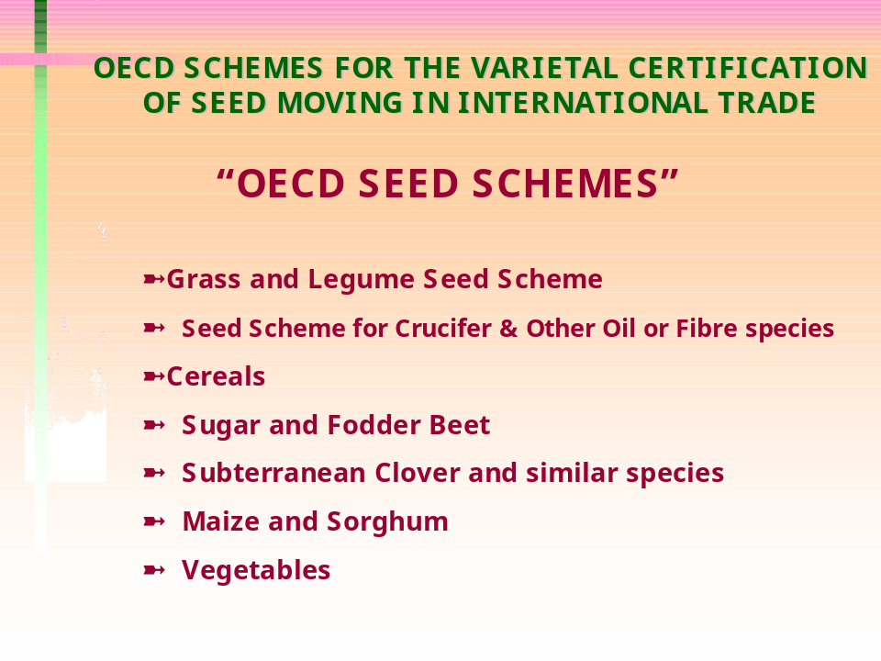

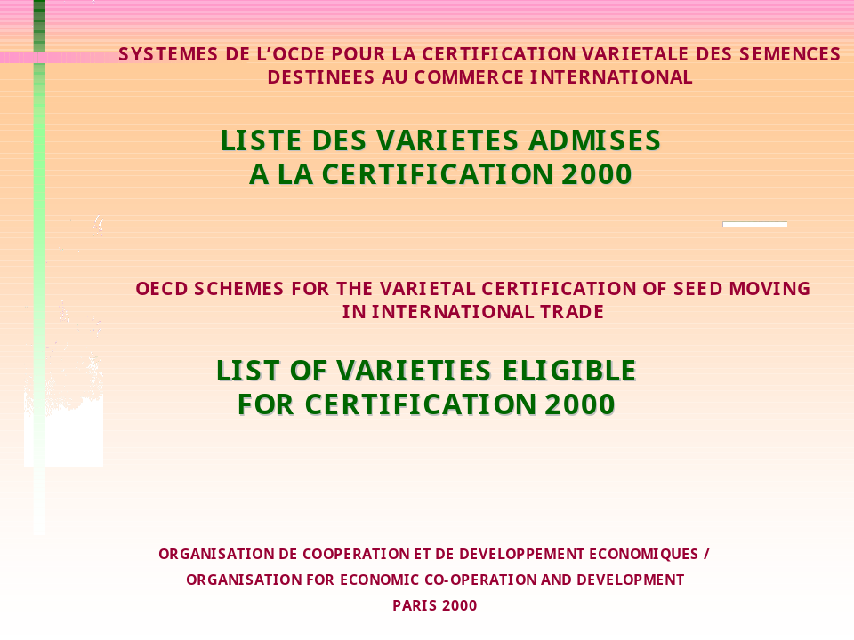

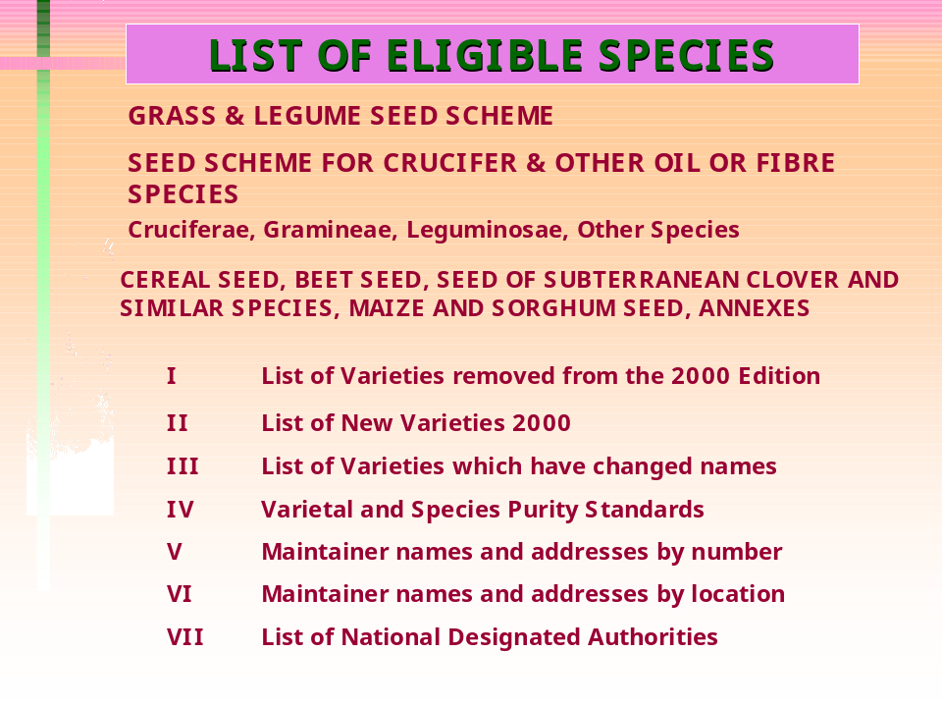

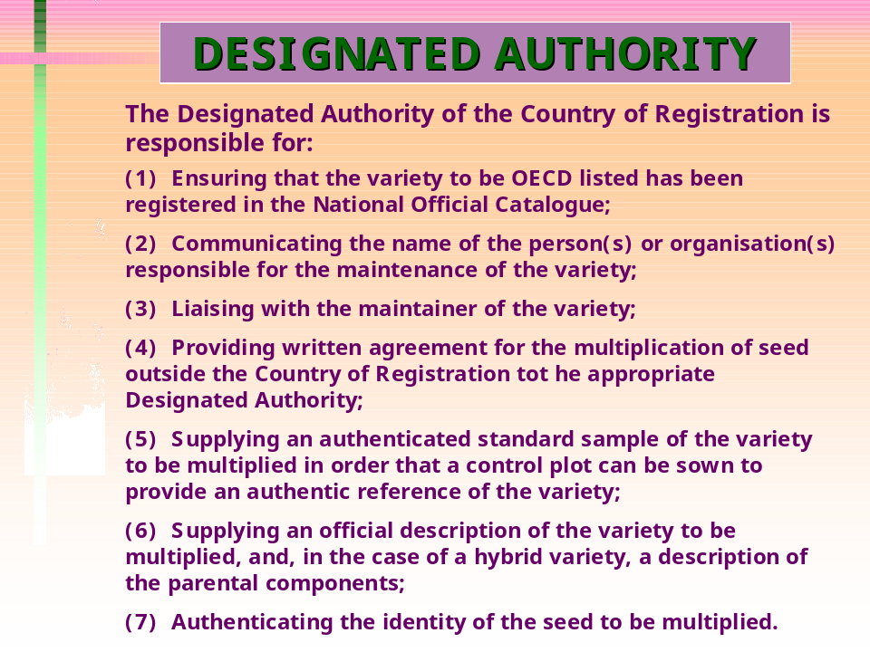

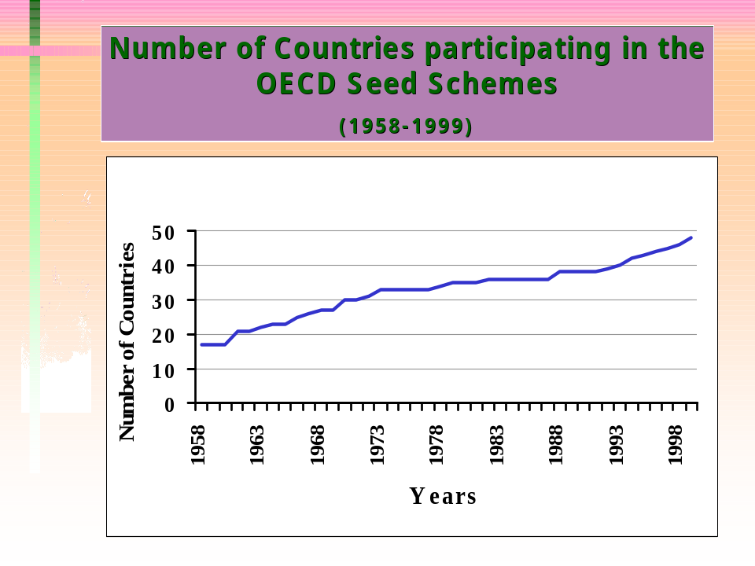
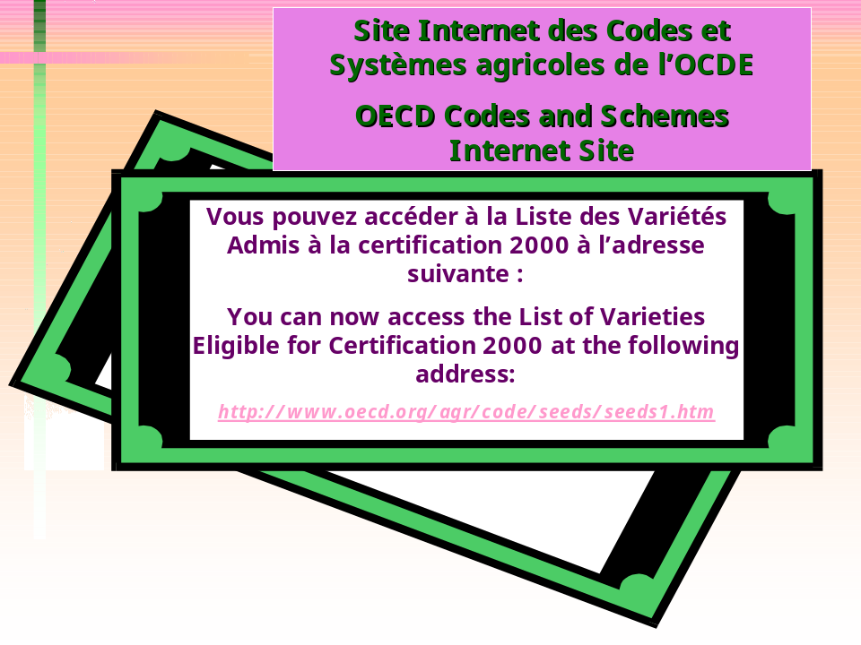
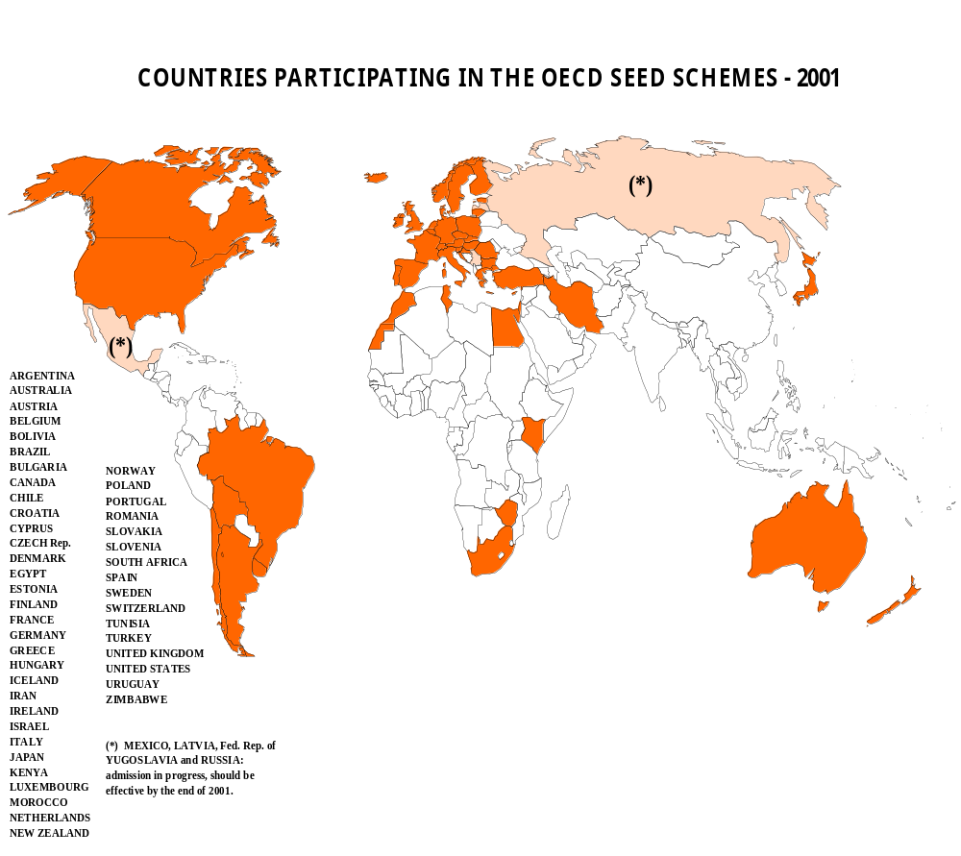

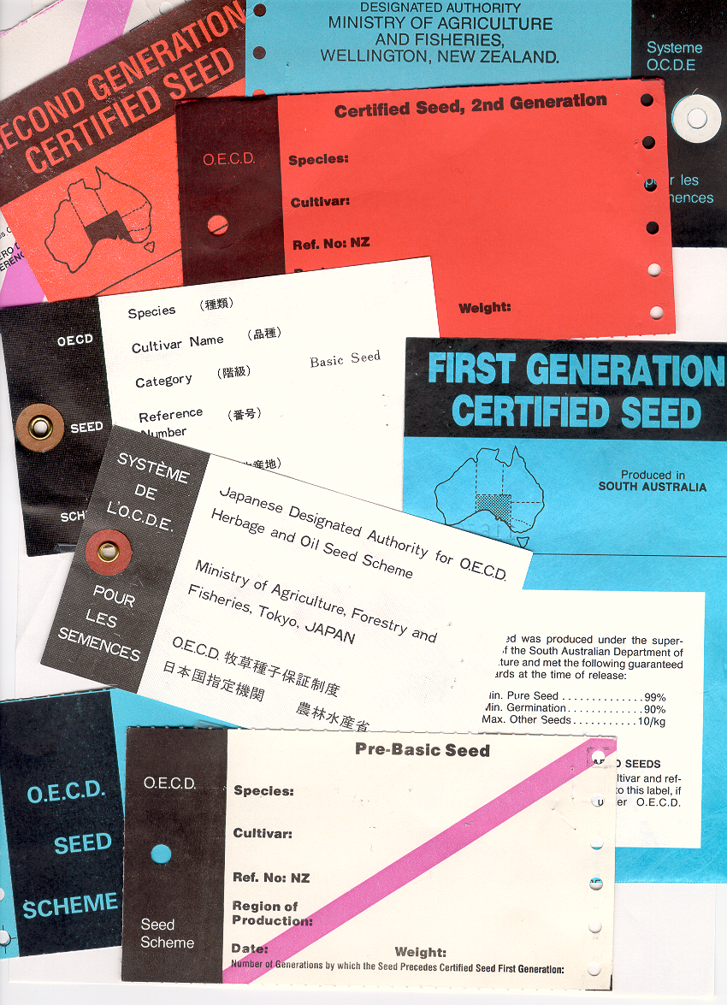

Excerpt from OECD SEED SCHEMES "2000" BROCHURE

APPENDIX 4

SPECIFICATION FOR THE OECD LABEL OR MARKING OF SEED CONTAINERS

1. Description
1.1Type: Labels may be either adhesive or non-adhesive. The information may be printed on one side only or on both sides.
1.2Shape: Labels shall be rectangular.
1.3Colour: The colours of the labels shall be:
- Pre-Basic Seed White with diagonal violet stripe;
- Basic Seed White;
- Certified Seed, 1st Generation Blue;
- Certified Seed, 2nd Generation or successive generations: Red;
- Not Finally Certified Seed Grey.
On all red labels and all grey labels for certified seed of 2nd or further generation the appropriate generation number must be stated.
One end of the label shall be overprinted black for a minimum distance of 3 cm leaving the rest of the label coloured.

1.4 Material: The material used must be strong enough to prevent damage in ordinary usage.

2. Reference to the OECD Scheme
Reference to the OECD Scheme shall be printed in English and in French within the black portion of the label or on the outside of the seed container (see Rule 10.1.2). This shall read: "OECD Seed Scheme" and "Système de l'OCDE pour les Semences".

3. Information on the Label
3.1 Prescribed Information:
The following information shall be printed in black type on the coloured portion of the label (white, blue red or grey).

3.1.1 Basic Seed
- Name and address of Designated Authority:
- Species:
- Variety: (Name or code number)
- open pollinated/ cross/ inbred line1
- Basic Seed
- Reference number: (see Appendix 3)
- Country of Production: (if the seed has been previously labelled as Not finally certified seed)
- Statement of re-labelling, if required.
On the label for not finally certified seed shall appear the statement:
- "Not Finally Certified Seed".
For Pre-Basic Seed the words "Pre-Basic Seed" must appear on the label. In addition to the above information, for open-pollinated varieties there shall be a statement of the number of generations by which the seed precedes Certified Seed, first generation.
3.1.2 Certified Seed
- Name and address of Designated Authority
- Species:
- Variety name:
- Open pollinated/ hybrid3³
- Certified Seed (1st, 2nd or other generation)
- Reference number: (see Appendix 3)
- Country of Production: (if the seed has been previously labelled as Not finally certified seed)
- Statement of re-labelling, if required.
On the label for not finally certified seed shall appear the statement:
- "Not Finally Certified Seed". The colour of the label shall be grey.
3.2 The space allowed and the size of the lettering shall be sufficient to ensure that the label is easily read.
3.3 When the information is marked indelibly on the container the layout of the information and the area marked shall conform as closely as possible to a normal label.

3.4 Additional Information:
Any space not occupied by the information in paragraph 3.1 may be used for such additional information as the Designated Authority wishes to give. Such information, however, must be in letters not larger than those used for the prescribed information. It shall be strictly factual and related only to seed certified according to the OECD Seed Scheme. No advertising matter may be used on the label or in the area of the container on which the prescribed information is indelibly marked.

4. Languages
All information shall be given in either English or French except reference to the Scheme that must be in both English and French as specified in paragraph 2 above. Translations into any other language may be added if thought desirable.

APPENDIX 5

SPECIMEN CERTIFICATE AND ANALYSIS RESULTS

A) SPECIMEN CERTIFICATE
Certificates must contain all the information outlined below, but the exact arrangement of the text is at the discretion of the Designated Authority.
Certificate Issued under the OECD Scheme
for the Varietal Certification of Maize and Sorghum Seed
Moving in International Trade

Name of Designated Authority issuing the Certificate:
Reference Number:
Species:
Variety: open-pollinated/cross/inbred line2
Name or Code number:
Statement of re-labelling, if required:
Number of containers and declared weight of lot:
The seed lot bearing this Reference Number has been produced in accordance with the OECD Maize and Sorghum Seed Scheme and is approved/provisionally approved as: ⁴
- Pre-Basic Seed (White label with diagonal violet stripe);
- Basic Seed (White label / Grey label);
- Certified Seed, 1st Generation (Blue label / Grey label);
- Certified Seed, 3 .. .Generation (Red label / Grey label).
Signature:
Place and Date:

B) ANALYSIS RESULTS
The results of the laboratory analyses should, whenever possible, be given on the Orange or Green International Seed Lot Certificate issued under the Rules of ISTA.
Those countries that do not wish to use these certificates as issued by the Association may use them as a model for reporting the results of laboratory analyses, as required in the Rules and Directions of the Scheme. Specimen copies may be obtained from:
Secretariat of the International Seed Testing Association
Reckenholz
P.O. Box 412
CH-8046 Zürich
Switzerland
The certificates issued by ISTA may be used only by those countries which have full authority to do so from the Association. Other countries using these certificates as a model for the presentation of results must ensure that there is no implication that they are issuing an Orange or Green Certificate. For instance, reference to ISTA must not be made and the certificate should not be on orange or green paper.

UNITED NATIONS ECONOMIC COMMISSION [17 January 2002]
FOR EUROPE (UNECE) [SUBMISSION: ENGLISH]

Referring to your notification to organizations dated 7 November 2001 concerning the "Recommendations from the second meeting of the Intergovernmental Committee for the Cartagena Protocol on Biosafety (ICCP) requesting action from relevant organizations", I should like to inform you that both the outcome of the meeting of technical experts on handling, transport, packaging and identification of living modified organisms (Paris, 13-15 June 2001) and the above-mentioned notification were brought to the attention of the United Nations Economic and Social Council Sub-Committee of Experts on the Transport of Dangerous Goods (respectively at its 19th session (2-6 July 2001) and at its 20th session (3-11 December 2001).

The reactions of the Sub-Committee are reflected in the reports of these sessions (ST/SG/AC.10/C.3/38, paras. 65-70 and ST/SG/AC.10/C.3/40, paras. 120-121, see attachments 3 and 4 to this letter). As indicated in these reports, the Sub-Committee is prepared to assist Contracting Parties to the Biosafety Protocol to meet the requirements of Article 18 by adjusting, when deemed necessary, the existing provisions of the UN Model Regulations on the Transport of Dangerous Goods concerning classification and identification of living modified organisms and their transport conditions. Some experts have offered to co-operate with their national representatives to the ICCP to develop amendment proposals to the UN Model Regulations to address the needs of the Cartagena Protocol with respect to transport.

You may also wish to note that the secretariat of the Convention on Biological Diversity may submit, on behalf of ICCP, any kind of amendment proposal to the UN Model Regulations which would be intended to adapt the existing transport requirements to the needs of the Cartagena Protocol.

ATTACHMENT 1
UN/SCETDG/19/INF.20
Sub-Committee of Experts on the
Transport of Dangerous Goods
(Nineteenth session,
2-6 July 2001, agenda item 6)

GENETICALLY MODIFIED ORGANISMS

Cooperation with the Conference of the Parties to the Convention on
Biological Diversity Cartagena Protocol on Biosafety

Note by the secretariat

1. The Sub-Committee had been informed at its thirteenth session (7-17 July 1997) that an additional protocol to the Convention on Biological Diversity was under consideration, and that this Protocol was likely to include provisions concerning the international transport of genetically modified microorganisms and organisms (ST/SG/AC.10/C.3/26, paras. 130-134).

2. On the request of the Sub-Committee at that session, the secretariat drew attention of the secretariat of the Convention on Biological Diversity on the legally binding nature of transport regulations based on the Recommendations on the Transport of Dangerous Goods and of the risk of possible conflicts.

3. The "Cartagena" Protocol on Biosafety was adopted on 29 January 2000. It was open for signature until 4 June 2001, and is now open for accession. As of 25 June 2001, it had been signed by 103 States subject to ratification, ratified by 3 States and acceded to by one State, i.e. it counted 4 Contracting States. The entry into force of the Protocol requires the deposit of instruments of ratification, acceptance, approval or accession by 50 States or regional economic integration organizations that are Parties to the Convention on Biological Diversity (presently 180 Parties). Additional detailed information (including the text of the Protocol, etc.) may be found on the web site of the secretariat of the Convention on Biological Diversity (http://www.biodiv.org).

4. To prepare the entry into force of the Protocol, the Conference of the Parties to the Convention on Biological Diversity has established an Intergovernmental Committee for the Cartagena Protocol ("ICCP") which met for the first time in Montpellier, France, from 11-15 December 2000, and which will meet for the second time in Nairobi, Kenya, from 1-5 October 2001. ICCP was requested in particular to consider, at its first and second meetings, Article 18 of the Protocol which deals with handling, transport, packaging and identification of living modified organisms, and more precisely to address the following:

(a) Overview of relevant international rules and standards pertaining to handling, transport, packaging and identification; and

(b) Consideration of modalities for developing standards with regard to handling, transport, packaging and identification.

5. For this purpose, a meeting of technical experts on handling, transport, packaging and identification of living modified organisms has been establish and the UNECE secretariat has been invited to participate in a session convened in Paris from 13-15 June 2001. The purpose of this session was to consider the needs and modalities for developing measures for Parties to meet their future obligations with regard to documentation accompanying living modified organisms intended for contained use and those intended for international introduction into the environment pursuant to paragraphs 2(b) and 2(c) of Article 18.

Article 18

6. The text of Article 18 of the Protocol is reproduced hereunder :

"Article 18”

HANDLING, TRANSPORT, PACKAGING AND IDENTIFICATION
1. In order to avoid adverse effects on the conservation and sustainable use of biological diversity, taking also into account risks to human health, each Party shall take necessary measures to require that living modified organisms that are subject to intentional transboundary movement within the scope of this Protocol are handled, packaged and transported under conditions of safety, taking into consideration relevant international rules and standards.
2. Each Party shall take measures to require that documentation accompanying:
(a) Living modified organisms that are intended for direct use as food or feed, or for processing, clearly identifies that they "may contain" living modified organisms and are not intended for intentional introduction into the environment, as well as a contact point for further information. The Conference of the Parties serving as the meeting of the Parties to this Protocol shall take a decision on the detailed requirements for this purpose, including specification of their identity and any unique identification, no later than two years after the date of entry into force of this Protocol;
(b) Living modified organisms that are destined for contained use clearly identifies them as living modified organisms; and specifies any requirements for the safe handling, storage, transport and use, the contact point for further information, including the name and address of the individual and institution to whom the living modified organisms are consigned; and
(c) Living modified organisms that are intended for intentional introduction into the environment of the Party of import and any other living modified organisms within the scope of the Protocol, clearly identifies them as living modified organisms; specifies the identity and relevant traits and/or characteristics, any requirements for the safe handling, storage, transport and use, the contact point for further information and, as appropriate, the name and address of the importer and exporter; and contains a declaration that the movement is in conformity with the requirements of this Protocol applicable to the exporter.
3. The Conference of the Parties serving as the meeting of the Parties to this Protocol shall consider the need for and modalities of developing standards with regard to identification, handling, packaging and transport practices, in consultation with other relevant international bodies."

7. Article 18.2 (b) concerns living modified organisms that are destined for contained use, i.e. most cases covered, either as microorganisms or as organisms, by paragraph 2.6.3.1.4 (a) to (d) of the Model Regulations. It should be noted however that the Model Regulations contains appropriate conditions of transport only for cases referred to under 2.6.3.1.4 (a) and (d) since in the other cases ((b) and (c)) reference is made to the competent authorities.

8. Article 18.2 (c) concerns living modified organisms that are intended for international introduction into the environment of the Party of import and any other living modified organisms within the scope of the Protocol. According to 2.6.3.1.4 (d), when such organisms are microorganisms, they are not subject to the Model Regulations when authorized for unconditional use by the Governments of the countries of origin, transit and destination. For organisms other than microorganisms, it is not clear whether this case would be covered by 2.6.3.1.4 (b). In any case, it should be noted that the Protocol on Biosafety requires that such living modified organisms are handled, packaged and transported under conditions of safety (Article 18, para. 1), and that shipments should be accompanied with documentation identifying them as living modified organisms, specifying their identity and any requirements for safe handling, storage, transport and use.

9. Copies of all relevant sections of the 12th revised edition of the Model Regulations concerning living modified organisms (identification, classification, packaging, marking, labelling, documentation) have been made available to the Meeting of Experts.

10. Since the main topic under discussion was documentation, it has been found that the requirements of Article 18.2(b) and 18.2 (c) were mostly covered by the Model Regulations in certain cases (notably UN 3245), partially in other cases (UN 2814 and 2900, where the proper shipping name does not make any difference between microorganisms and genetically modified microorganisms) and not at all in the cases where reference is made to the competent authorities or where the organisms are not subject to the Model Regulations.

11. It was noted however that the Model Regulations could be amended to take account of the requirements of the Protocol on Biosafety, and the Meeting of Experts recommended to ICCP to invite the Sub-Committee of Experts on the Transport of Dangerous Goods to provide advice on its ability to assist Parties to the Convention on Biological Diversity to meet the requirements of Article 18.2 (b) and 18.2 (c) of the Protocol on Biosafety and its ability to adjust the Model Regulations.

12. The question whether UN 3172 could be used for organisms/microorganisms intended to release toxins was also raised during discussion at working group level.

13. A copy of the recommendations of the Meeting of Experts to ICCP (advance, unedited) is reproduced as an annex hereto.

14. The other organizations concerned by these recommendations are OECD for their seed certification schemes (www.oecd.org/ehs/icbg/biodiv.htm) and FAO for the International Plant Protection Convention (IPPC) and related standards (International Standards for phytosanitary measures: Guidelines for phytosanitary certificates) (Appendix V to the report of the third Interim Commission on Phytosanitary Measures (ICPM)) (web site: www.fao.org/ag/AGP/AGPP/PQ/ ).

15. Recommendations concerning the transport of animals, procedures for import/export of animals and international transfer and laboratory containment of animal pathogens are also contained in the International Animal Health Code (mammals, birds and bees) published by the "Office international des épizooties" (World organization for animal health) (available on OIE web site, www.oie.int). This code also contains model international veterinary certificates. The activities of OIE include also the standardisation of diagnostic tests and vaccines and harmonization of provisions related to the preparation, storage and distribution of various biological products.

16. The Sub-Committee may wish to consider how to cooperate with the Conference of the Parties to the Convention on Biological Diversity on the basis of the above information, bearing in mind that the use of existing documentation systems and the development of a new specific system of documentation for living modified organisms are still two options to be discussed by ICPP.

ATTACHMENT 3

Extract from the report of the Sub-Committee of Experts on the Transport of Dangerous Goods on its nineteenth session (Geneva, 2-6 July 2001) (ST/SG/AC.10/C.3/38, paras. 65-70)

"Genetically modified organisms”
Informal document: INF.20 (Secretariat)
65. The Sub-Committee took note of the work done by the Conference of the Parties to the Convention on Biological Diversity in the context of the implementation of Article 18 of the Cartagena Protocol on Biosafety (Article 18: Handling, transport, packaging and identification).
66. In this context, the Sub-Committee was informed that a meeting of experts had been held in Paris from 13 to 15 June 2001 to consider how to reply to the requirements of paragraphs 18.2 (b) and 18.2 (c) of the Protocol regarding the documentation accompanying consignments of living modified organisms, in view of the main systems of regulations or directives currently governing their international carriage. The meeting of experts had recommended in particular that the Sub-Committee should be invited to give its opinion on its capacity to adjust - if necessary - the Model Regulations on the Transport of Dangerous Goods (Division 6.2 and Class 9), to help the Parties to the Protocol to meet the obligations stemming from the paragraphs in question.
67. The expert from Australia said that there was no reason to apply the Model Regulations to living modified organisms which were not dangerous when carried. She thought that the texts of the Model Regulations currently applicable to UN No. 3245 were not adequate.
68. Other experts considered that the provisions of present paragraph 2.6.3.1.4 did not permit all the cases arising in practice to be settled satisfactorily. It would be difficult to improve the situation, however, unless there were accurate criteria which would enable micro-organisms and genetically modified organisms to be classified according to their nature and the danger they represented during carriage, to people, animals or the environment. More appropriate conditions of carriage could be developed if the Conference of the Parties defined clearly the organisms which were to be the subject of transport regulations.
69. The expert from the United Kingdom expressed the hope that rules applicable to the transport of genetically modified organisms considered to be dangerous would not be dispersed among various sets of regulations since that would prejudice their effective implementation.
70. The Chairman invited the expert from Canada to continue in her role as leader in that regard, in accordance with the mandate entrusted to her by the Committee (ST/SG/AC.10/27, para. 149). All the experts were invited to reflect on these matters and to correspond with the expert from Canada. The expert from the United States of America offered to cooperate with the expert from Canada in this area with respect to genetically modified microorganisms."

ATTACHMENT 4

Extract from the report of the Sub-Committee of Experts on the Transport of Dangerous Goods on its twentieth session (Geneva, 3-11 December 2001) (ST/SG/AC.10/C.3/40, paras. 120-121)

"Cooperation with the Intergovernmental Committee for the Cartagena Protocol on Biosafety (ICCP)

120. The Sub-Committee noted the recommendations made by the second meeting of ICCP (Nairobi, Kenya, 1-5 October 2001). Recalling that the transport of some genetically modified organisms was subject to the provisions of the Model Regulations on the Transport of Dangerous Goods, and noting that ICCP had appropriate expertise in this field, the Sub-Committee agreed that cooperation should be established as regards matters concerning handling, packaging, transport and identification, and that the provisions of the Model Regulations could be amended to accommodate the transport regulatory needs of the Cartagena Protocol on the basis of concrete proposals.

121. The expert from the United States of America said that he was working with other officials in ICCP and was considering amendments to the UN Model Regulations to make them more consistent with regulations of other sectors and the Cartagena Protocol. He also indicated that he would cooperate with the expert from Canada regarding genetically modified microorganisms and the review of Division 6.2."

WORLD TRADE ORGANIZATION (WTO) [7 January 2002]
[SUBMISSION: ENGLISH]

WTO Transparency provisions possibly relevant to Article 18 of the Cartagena Protocol on Biosafety

1. Under the World Trade Organization Agreement on the Application of Sanitary and Phytosanitary Measures (the SPS Agreement), WTO Members have obligations relating to “transparency” of their sanitary or phytosanitary measures, according to Article 7 and Annex B of the SPS Agreement. Members are required to publish all sanitary and phytosanitary regulations. Members are also required to, notify new proposed SPS regulations or changes to existing ones, whenever there are no international standards, guidelines or recommendations, or if the regulations deviate substantially from these standards, and may have a significant effect on trade. The notification shall be made when the proposed regulation is still at a draft stage, so that comments can be received from interested Members and taken into account in the final measure. In case of emergency, Members have the right to introduce regulations without prior notification, but they have the obligation to notify such regulations immediately after their introduction (Annex B:6). In implementing the Agreement, countries are required to designate a single central government authority as responsible for the notification requirements of the SPS Agreement (the notification authority). Also, countries are required to establish an enquiry point responsible for answering questions from other countries about SPS measures and related issues (the enquiry point).

2. Under the Agreement on Technical Barriers to Trade (the TBT Agreement), WTO Members have similar transpareny obligations with regard to the technical regulations, (Article 2.9 of the TBT Agreement) and conformity assessment procedures (Article 5.6). Likewise, in case of emergency, Members have the right to introduce technical regulations without prior-notification, but they have the obligation to notify such measures immediately after their introduction (Article 5.7). The Code of Good Practice for the Preparation, Adoption and Application of Standards (Annex 3 of the TBT Agreement) provides transparency obligations to standardizing bodies that have accepted the Code.

3. In complying with their notification requirements under both agreements, several WTO Members have notified mesasures dealing with products derived from biotechnology. To date, 55 GMO-related SPS notifications from 16 countries and 43 TBT notifications from 16 countries have been received by the Secretariat and circulated to Members (in some cases Members have notified the same measure under both Agreements). A list of those notifications, up to December 2001, is attached for information. All SPS and/or TBT notifications can be downloaded from the WTO Website (WWW.wto.org)

ANNEX
GMO-RELATED MEASURES NOTIFIED TO THE WTO UNDER THE SPS AND TBT AGREEMENTS

(Last modified on 26 November 2001)

SPS NOTIFICATIONS

Symbol  G/SPS/N/ | Country | Date  (dd/mm/yy) | Product Covered
USA/15 | United States of America | 05/09/1995 | Genetically engineered plants
USA/15/Rev.1 | United States of America | 12/09/1995 | Genetically engineered plants
JPN/7 | Japan | 06/11/1995 | Food and food additives produced by recombinant DNA techniques
MEX/97 | Mexico | 23/01/1996 | Organisms manipulated by genetic engineering
JPN/10 | Japan | 08/02/1996 | Feed produced by recombinant DNA techniques
JPN/l 1 | Japan | 08/02/1996 | Feed additives produced by recombinant DNA techniques
CZE/2 | Czech Republic | 27/03/1996 | Seed and seedlings of crops
USA/64 | United States of America | 02/09/1996 | Veterinary Biological Products
CAN/14 | Canada | 26/09/1996 | Biotechnology
JPN/27 | Japan | 19/06/1997 | Feed Additives produced by the recombinant DNA techniques
NZL/19 | New Zealand | 28/08/1998 | Novel Foods
USA/126 | United States of America | 24/6/1998 | Export of animal drugs, biologics, food additives as well as the importation of components for incorporation or further processing into articles intended for export
AUS/73 | Australia | 08/09/1998 | Novel Foods
CAN/41 | Canada | 02/10/1998 | Novel Foods
CHE/17 | Switzerland | 21/10/1998 | Foodstuffs
COL/25 | Colombia | 12/01/1999 | Rice
USA/152 | United States of America | 31/03/1999 | Veterinary Biological Products
KOR/55 | Republic of Korea | 16/04/1999 | Foods and Food Additives
USA/157 | United States of America | 21/05/1999 | Animal Drugs, Human Drugs, Biologics and Devices
JPN/51 | Japan | 08/02/2000 | Foods and food additives produced by recombinant DNA techniques
JPN/52 | Japan | 08/02/2000 | Foods and food additives produced by recombinant DNA techniques
USA/228 | United States of America | 22/02/2000 | Biotechnological/Biological Veterinary  Medicinal Products
USA/237 | United States of America | 14/03/2000 | Pesticide: Cry1F Plant Pesticide
KOR/66 | Republic of Korea | 01/05/2000 | Foods
NZL/58 | New Zealand | 27/06/2000 | Food produced from insect-protected corn line
NZL/59 | New Zealand | 27/06/2000 | Food produced from glyphosate-tolerant com line
NZL/60 | New Zealand | 27/06/2000 | Food produced from glyphosate-tolerant cotton line
NZL/61 | New Zealand | 27/06/2000 | Food produced from high oleic acid soybean lines
NZL/62 | New Zealand | 27/06/2000 | Food produced from glyphosate-tolerant canola line
AUS/119 | Australia | 03/07/2000 | Processed foods in general (see NZL/58-62)
IDN/9 | Indonesia | 26/07/2000 | Food in general
JPN/56 | Japan | 04/08/2000 | Foods containing organisrns derived frorn biotechnology, processed foods
NZL/66-67-68 | New Zealand | 14/09/2000 | Food derived from modified potato lines
AUS/120 | Australia | 25/09/2000 | Food derived from modified potato, lines
NZL/71 | New Zealand | 06/10/2000 | Food derived from insect-protected, Bt-176 corn
NZL/72 | New Zealand | 06/10/2000 | Food derived from insect-protected, herbicide tolerant Bt- 11 corn
AUS/121 | Australia | 11/10/2000 | Processed corn food (derived from insect- protected, herbicide tolerant Bt- 11 corn, and from insect-protected, Bt-176 corn)
USA/348 | United States of America | 03/11/2000 | StarLink Com Cry9C Bt Corn Plant- Pesticide
JPN/63 | Japan | 22/01/2001 | Foods and food additives produced by recombinant DNA techniques
USA/384 | United States of America | 24/01/2001 | Bioengineered foods
JPN/63/Add. 1 | Japan | 22/03/2001 | Foods and food additives produced by recombinant DNA techniques – availability of additional safety assessments
CHL/74 and Add. 1 | Chile | 27/03/2001 | Live genetically modified plant products for propagation
USA/384/Add. 1 | United States of America | 09/04/2001 | Bioengineered. foods - extension of comment period
THA/55 | Thailand | 26/04/2001 | Foods contaminated with Cry 9C sequence (maize)
ZAF/9 | South Africa | 30/05/2001 | Labelling of foodstuffs obtained through certain techniques of genetic modification
KOR/94 | Korea | 11/06/2001 | Genetically modified organisms - environmental risks
KOR/95 | Korea | 11/06/2001 | Safety evaluations for genetically modified foods
KOR/96 | Korea | 11/06/2001 | Labelling of genetically modified foods
LKA/1 | SriLanka | 19/07/2001 | Restrictions on imports of food derived from DNA recombinant technology
LKA/1/Add.l | SriLanka | 10/09/2001 | Deferment of restrictions on imports of food derived from DNA recombinant technology
THA/55/Rev.l | Thailand | 12/09/2001 | Modification of prohibition measures on maize imports with Cry 9C DNA and certification of non-presence
THA/70 | Thailand | 12/09/2001 | Labelling of food and food products (soya, corn)
THA/71 | Thailand | 05/10/2001 | Labelling of food obtained through certain techniques of genetic modification
JPN/77 | Japan | 09/11/2001 | Feed and feed additives produced by recombinant DNA techniques
BRA/59 | Brazil | 26/11/2001 | Labeling requirements for packed food products containing genetically modified organisms

TBT NOTIFICATIONS

Symbol  G/TBT/Notif/ | Country | Date  (dd/mm/yy) | Product Covered
95.0266 | Canada | 12/09/1995 | Novel foods
97.0151 | European Union | 21/04/1997 | Foods and food ingredients made from genetically modified soya and maize
97.0382 | European Union | 06/08/1997 | Products Containing GMOs
97.0383 | Norway | 06/08/1997 | Prepacked Foodstuffs & ingredients except food additives, flavorings & extraction solvents.
97.0766 | European Union | 12/12/1997 | Labeling foods/food ingredients produced from genetically modified soya and maize
98.0442 | Germany | 28/08/1998 | Foodstuffs
99.0095 | Switzerland | 23/03/1999 | Products containing living genetically modified organisms (LGMO) or pathogenic organisms, such as seeds, pesticides, fertilizers, food, animal feeding stuffs, live vaccines
99.0134 | Australia | 26/03/1999 | Foods Derived From Gene Technology
99.0204 | Republic of Korea | 03/05/1999 | Agricultural & fishery products, & their processed products
99.0244 | New Zealand | 19/05/1999 | Foods derived from Gene Technology
99.0250 | Switzerland | 21/05/1999 | Medicines that contain/consist of genetically modified organisms or medicines manufactured by recombinant DNA technology
99.0275 | Australia | 14/06/1999 | Foods produced using gene technology
99.0343 | Norway | 22/07/1999 | Foodstuffs and Food Ingredients
99.0508 | Switzerland | 08/10/1999 | Fertilizers
99.0521 | European Union | 13/10/1999 | Foods and food ingredients produced from certain genetically modified soya and maize (various tariff headings)
99.0536 | Netherlands | 20/10/1999 | Foods and. drinks prepared without gene technology, in other words, foods and drinks not being a foodstuff or food ingredient as referred to in article 1, para. 2 (a to c) of (EC) Regulation 258/97
99.0552 | Switzerland. | 05/11/1999 | Seeds
99.0669 | Japan | 23/12/1999 | All foods and beverages on sale for consumers
00.0001 | Republic of Korea | 10/01/2000 | Genetically modified agricultural products (not processed)
00.0049 | Switzerland. | 01/02/2000 | Products containing living genetically modified organisms (LGMO), such as seeds, pesticides, fertilizers, animal feedstuffs, foodstuffs and live vaccines
00.0067 | European Union | 22/02/2000 | Seed of agricultural plant species and seed potatoes
00.0170 | Malaysia | 10/04/2000 | Food Regulation on Infant Formula
00.0207 | Republic of Korea | 03/05/2000 | Foods
00.0231 | Republic of Korea | 03/05/2000 | Foods
00.293 | Australia | 27/06/2000 | Food derived from insect-protected com; glyphosate-tolerant cotton; glyphosate- tolerant corn; glyphosate-tolerant canola; high oleic acid soybean
00.408 | New Zealand | 13/09/2000 | Food derived frorn modified potato lines
00.432 | Australia | 18/09/2000 | Food derived from modified potato lines
00.478 | Indonesia | 29/09/2000 | Labelling of food derived from biotechnology
00.487 | New Zealand | 10/10/2000 | Processed foods (derived from insect-protected Bt 176 corn, and insect-protected, herbicide tolerant Bt-11 corn)
00.500 | Australia | 17/10/2000 | Processed foods (derived from insect-protected Bt 176 corn, and insect-protected, herbicide tolerant Bt- 11 corn)
00.507 | Indonesia | 18/10/2000 | Food derived from biotechnology (food labelling and advertising)
G/TBT/N/HKG/2 | Hong Kong | 04/04/2001 | Genetically modified food
ZAF/5 | South Africa | 10/05/2001 | Labelling of genetically modified foodstuffs
KOR/12 | Korea | 13/06/2001 | Labelling of genetically modified foods
CHL/18 | Chile | 15/06/2001 | Transgenic foods - labelling
KOR/14 | Korea | 20/06/2001 | Safety evaluation of genetically modified products
JPN/15 | Japan | 22/06/2001 | Labelling standard for GMOs
NZL/2 | New Zealand | 16/07/2001 | Accidental importation of GM sweet corn seed
EEC/6 | European Communities | 30/08/2001 | GMOs for food or feed use etc.
EEC/7 | European Communities | 30/08/2001 | Products consisting of or containing GMOs - labelling
THA/49 | Thailand | 15/10/2001 | Labelling of food obtained through certain techniques of genetic modification
JPN/26 | Japan | 05/11/2001 | Mandatory GMO labelling - foods made from potatoes
BRA/27 | Brazil | 26/11/2001 | Labeling requirements for packed food products containing genetically modified organisms

Relevant documents:

G/SPS/GEN/186: National Regulatory Measures Related to Trade in Agricultural and. Food Products Modified by Modern Biotechnology (Submission by the United States)

G/SPS/GEN/203: Egypt - Import Prohibition of Canned Tuna with (GM) Soybean Oil (see also G/SPS/R/1 9, paras. 103-104)

G/TBT/W/l 15 Genetically Modified Agricultural and Food Products (Submission from the
And Add.1 United States)

------

 Zero should be reflected by the symbol ∅ to avoid confusion with the letter O.
 When the transformation event of an existing plant product, prior to the adoption of this guidance, is shorter or longer than 5 or 6 digits, the applicant should select 5 or 6 digits within the transformation event in order to fit it into this limit.
 Delete as necessary.
 Insert number of generation.
 Delete as necessary.
 Insert number of generation.

