 |  |  | CBD
 |  | CONVENTION ON  BIOLOGICAL DIVERSITY |  |  | Distr.  GENERAL  25 October 2002  ENGLISH ONLY
Workshop on Liability & Redress in the context of
the Cartagena Protocol.
Rome, Italy 2-4 December 2002.

Information for Participants

Venue
The Workshop on Liability & Redress in the context of the Cartagena Protocol will be held in Rome, Italy from Monday, 2 December to Wednesday, 4 December 2002 at:

AREA CONFERENZE DI PALAZZO ALTEMPS
Via dei Gigli d'oro N°21
Tel. + 39 06 6832565 - + 39 06 6832566

Opening and registration
The workshop will be opened at 9:00 a.m. on Monday, 2 December 2002. Registration will take place at the venue of the workshop from 8:30 to 9:00 a.m. the same day.

Working language of the workshop
The meeting will be held in English only.

Hotel information
Delegates are kindly reminded that they are responsible for making their own hotel bookings. A list of hotels located in the vicinity of the workshop venue with indicative prices is attached as annex I. Also attached, as Annex II, is a map showing the exact location of the hotels.
More information on hotels can be found on the web site www.romaturismo.it by using the following search engine:
http://alberghi.romaturismo.it/romatiaccoglie/langIndep/RicercaH.asp?lingua=EN&area=OP
For hotel reservation is possible to contact: STUDIO EGA Tel. +39 06 328121 Fax + 39 06 3240143 - + 39 06 3222006.

Time zone
In December, the time in Rome is GMT + 1 hour.

Weather
The average daytime temperature in the month of December is about 10ºC

Electricity
220 volts, 50 Hertz.

Visas
Delegates are advised to check with the nearest Italian diplomatic or consular mission regarding visa and vaccination requirements in order to secure an entry visa to Italy prior to departure.

Official language
The official language in Italy is Italian, but English and French are understood and spoken in hotels and restaurants.

Currency
The currency in Italy is the Euro. The current exchange rate against the US dollar stands at approximately one Euro for one US dollar.

Credit cards
Major credit cards are accepted in most hotels and restaurants in the city.

Further information
Other useful information can also be found on: http://www.romaturismo.it/

Annex I

LIST OF HOTELS WITH INDICATIVE PRICES
(Numbers below refer to the ones on the map in the annex II below)

1. Grand Hotel de la Minerve*****
Address: P.zza della Minerva,69 00186 Roma
Telephone: 06695201
Fax: 066794165
Email: minervahotel@invest.com
Web Site: http://www.hotel-invest.com
Prices Min - Max Single room with bathroom 325.36 - 392.50 Euro

2. Hotel Genio ***
Address: Via Giuseppe Zanardelli,28 00186 Roma
Telephone: 066833781 Fax: 0668307246
Email: leonardi@travel.it
Web Site: http://www.travel.it/roma/ianr
Prices Min - Max Single room with bathroom 77.47 - 206.58 Euro

3. Hotel S. Chiara ***
Address: Via di Santa Chiara,21 00186 Roma
Telephone: 066872979
Fax: 066873144
Email: info@albergosantachiara.com
Web Site: http://www.albergosantachiara.com
Prices Min - Max Single room with bathroom 81.35 - 162.69 Euro

4. Hotel Due Torri ***
Address: Vic. Del Leonetto,23 00186 Roma
Telephone: 066876983
Fax: 066865442
Email: hotelduetorri@interfree.it
Web Site: http://www.hotelduetorriroma.com
Prices Min - Max Single room with bathroom 88.00 - 155.00 Euro

Annex II

Workshop on liability and redress in the context of the Cartagena Protocol on Biosafety

Rome, Palazzo Altemps, December 2-4, 2002

Rome, Palazzo Altemps, December 2-4, 2002
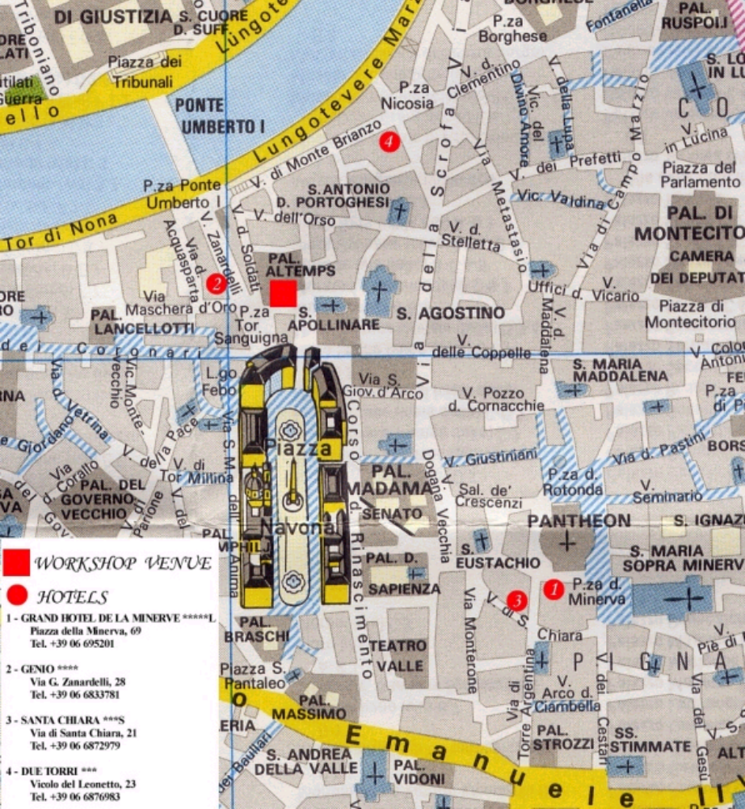

Hotels web-sites
Grand Hotel de La Minerve***** www.hotel-invest.com
Genio**** www.travel.it/roma/ianr
Santa Chiara***S www.albergosantachiara.com
Due Torri*** www.hotelduetorriroma.com
For any further information and reservation
Studio Ega
Tel + 39 06 328121 Fax + 39 06 3240143 - + 39 06 3222006
E-mail biosafety@ega.it
1 Grand Hotel de la Minerve*****L
2. Genio****
3. Santa Chiara***S
4. Due Torri***

