 | 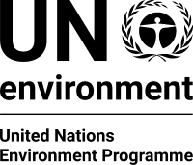 | CBD
Distr.
GENERAL

CBD/CP/HTPI/WS/2017/1/1
17 February 2016

ENGLISH ONLY
WORKSHOP ON DEVELOPING CAPACITY FOR NATIONAL BORDER CONTROLS ON LIVING MODIFIED ORGANISMS IN PACIFIC SMALL ISLAND DEVELOPING STATES
Suva, 27-29 March 2017

Provisional agenda
1. Opening of the workshop.
2. Overview and objectives of the workshop.
3. Introduction to the Cartagena Protocol on Biosafety.
4. Cartagena Protocol: identification and documentation, illegal and unintentional transboundary movements, and the Biosafety Clearing-House.
5. The role of customs and border-control officials in implementing the Protocol.
6. National experiences with transboundary movements of living modified organisms: presentations by participants.
7. Introduction to sampling, detection and identification of living modified organisms.
8. Need and gap analysis: group exercise.
9. Introduction to the Green Customs Initiative and the E-learning modules.
10. E-learning modules: group exercise.
11. Other matters.
12. Closure of the workshop.

__________

