 |  | CBD
 |  |  |  | Distr.  GENERAL  UNEP/CBD/BS/COP-MOP/5/INF/1  3 August 2010  ENGLISH ONLY
CONFERENCE OF THE PARTIES TO THE CONVENTION ON BIOLOGICAL DIVERSITY SERVING AS THE MEETING OF THE PARTIES TO THE CARTAGENA PROTOCOL ON BIOSAFETY
Fifth meeting
Nagoya, Japan, 11-15 October 2010
Information-sharing (Article 20)
Study of users and potential users of the Biosafety Clearing-House
1. The Conference of the Parties serving as the meeting of the Parties to the Cartagena Protocol on Biosafety, in its decision BS-IV/2 (Operation and activities of the Biosafety Clearing-House) requested the Executive Secretary to commission a study of users and potential users of the Biosafety Clearing-House in order to:
(a) Assess what information users and potential users of the Biosafety Clearing-House would find useful; and
(b) Prioritize the work programme of the Biosafety Clearing-House in order to focus the efforts of the Secretariat on making the Biosafety Clearing-House a useful tool;
2. The Executive Secretary is circulating herewith, for the information of participants in the fifth meeting of the Conference of the Parties serving as the meeting of the Parties to the Cartagena Protocol on Biosafety, the full text of the study. Further background information and a synthesis of the main points of the study are being circulated separately in the main document on the operation and activities of the Biosafety Clearing-House (UNEP/CBD/BS/COP-MOP/5/3).



Study of Users and Potential Users of the Biosafety Clearing House

Aleksej Tarasjev, PhD

April 2010



Abbreviations

AHTEG | Ad Hoc Technical Expert Group
BCH | Biosafety Clearing House
BCH IAC | Biosafety Clearing House Informal Advisory Committee
CBD | Convention on Biological Diversity
CEE | Central and Eastern Europe
CF | Common Format
CNA | Competent National Authority
COP MOP | Conference of the Parties serving as the meeting of the Parties to the Protocol
CPB | Cartagena Protocol on Biosafety
CSO | Civil Society Organization
GMO | Genetically Modified Organism
FAO | Food and Agriculture Organization of UN
FP | Focal Point
GEF | Global Environmental Facility
IT | Information Technology
LAC | Latin America and Caribbean
LMO | Living Modified Organism
LMO-FFP | Living Modified Organism intended for use as Food, Feed or for Processing
NAU | National Authorized User
NBC | National Biosafety Committee
NGO | Non Governmental Organization
RA | Regional Advisor
SCBD | Secretariat of Convention on Biological Diversity
OECD | Organization for Economic Cooperation and Development
UN | United Nations
UNEP | United Nations Environmental Programme
UNDP | United Nations Development Programme
WHO | World Health Organization
WTO | World Trade Organization

Contents

Executive Summary …………………………………………………………… 4

Introduction ...………………………………………………………………….. 7

Main Findings ………………………………………………………………….. 11

Conclusions and Recommendations ………………………………………….. 18

Annex 1. Online Survey of Users and Potential Users ………………………. 20

Annex 2. Targeted Semi Structured Interviews ……………………………… 42

Annex 3. Analysis of other existing relevant materials ………………………. 72

Executive Summary

The Study of BCH Users and Potential Users was mandated by the fourth Conference of the Parties to the Convention on Biological Diversity serving as the Meeting of Parties to the Cartagena Protocol on Biosafety (COP-MOP/4), held in Bonn, Germany, 12 – 16 May, 2008. The COP-MOP/4, in its decision BS-IV/2, defined the goals of the study as follows:
- Assess what information users and potential users of the Biosafety Clearing-House would find useful;
- Prioritize the work programme of the Biosafety Clearing-House in order to focus the efforts of the Secretariat on making the Biosafety Clearing-House a useful tool.
The elements of the study were further elaborated on at the fifth meeting of the Biosafety Clearing House Informal Advisory Committee (BCH-IAC) and presented in the recommendations of the meeting in document: UNEP/CBD/BS/BCH-IAC/5/2 which is available on the BCH.

The study consists of (i) an online survey (questionnaire), (ii) targeted semi-structured interviews and (iii) an analysis of existing materials. The online survey was open to all users and potential users from 12 December 2009 to 15 February 2010. It was structured to assess the role of BCH users and their level of participation in the BCH. The participants of the targeted semi structured interviews were selected in a geographically balanced manner with respect to the five CBD regions (Africa, Asia and Pacific, Central and Eastern Europe, Latin America and Caribbean, Western Europe and others) including twenty identified stakeholder groups. The available existing materials consisted of documents from the UNEP GEF Project “Building Capacity for Effective Participation in the Biosafety Clearing House (BCH) of the Cartagena Protocol”, its final report and another report entitled “Effective participation in the Biosafety Clearing House: Participation options and impediments to information provision”.

The study produced the following findings:
- In-house changes to the BCH Central Portal by the Secretariat significantly improved the functioning of the BCH
- Capacity building activities offered through the UNEP GEF Project raised the awareness of users significantly
- Lack of sufficient awareness among users and potential users regarding the BCH
- Existing constraints to reaching the optimum effective use of the BCH as the foremost biosafety information sharing facility
- Non-compliance with the information sharing obligations of Parties is one of the most important constraints
- Language constraints and translation issues
- Need for improvement of synergy and cooperation among relevant UN agencies and other organizations to increase the usefulness of the BCH
- Lack of fully operational self-sustaining national biosafety frameworks (NBFs)
- Use of the BCH is often on low national priority
- Need for regional and sub-regional approaches to capacity building for the BCH
- Urgent need for the continuation of the BCH capacity building projects
- Need to develop national and regional websites/nodes
- Need for further improvements to the BCH Central Portal
- Broadening of the use of the BCH for Online Forums and Conferences
- Issues of Governance of the BCH
On the basis of the above findings, the study has made specific recommendations for the prioritization of elements in the BCH work programme to help the Secretariat focus its activities to make the BCH a more useful tool for both users and potential users.

Introduction

The Cartagena Protocol on Biosafety to the Convention on Biological Diversity is an international treaty governing the transboundary movement of living modified organisms (LMOs) resulting from modern biotechnology from one country to another. It was adopted on 29 January 2000 as a supplementary agreement to the Convention on Biological Diversity and entered into force on 11 September 2003.

The Biosafety Clearing-House (BCH) was established in accordance with Article 20, paragraph 1, of the Cartagena Protocol on Biosafety as part of the Clearing-House Mechanism under Article 18, paragraph 3, of the Convention in order to (i) facilitate the exchange of information on, and experience with, living modified organisms, and (ii) to assist Parties to implement the Protocol.

First Meeting of the COP-MOP (23-27 February 2004, Kuala Lumpur, Malaysia): in decision BS-I/3, ‘Information-sharing and the Biosafety Clearing-House’, the Parties approved the transition of the pilot phase of the BCH to the fully operational phase. The Parties also adopted, in the annex to the decision, the Modalities of Operation of the BCH.

Second Meeting of the COP-MOP (30 May – 3 June 2005, Montreal, Canada): in decision BS-II/2, ‘Operations and activities of the Biosafety Clearing-House’, the Parties adopted, following an internal review of the operation of the BCH conducted by the Secretariat, a Multi-year Program of Work for the Operation of the BCH which is contained in the annex to the decision.

Third Meeting of the COP-MOP (13-17 March 2006, Curitiba, Brazil): in decision BS-III/2, ‘Operations and activities of the Biosafety Clearing-House’, among other things, the Parties requested the Executive Secretary to: (i) continue to collaborate with nodes that are interlinked and interoperable with the BCH; (ii) make easily available decisions and other information on LMOs-FFP, risk assessments and decisions taken under the AIA procedure; (iii) undertake translation of the BCH into the 6 official UN languages; (iv) undertake an external security audit of the BCH and its infrastructure; (v) continue to develop non-Internet based mechanisms for countries to access information in the BCH; and (vi) undertake another survey of BCH users.

Fourth Meeting of the COP-MOP (12-16 May 2008, Bonn, Germany): in decision BS-IV/2, ‘Operations and activities of the Biosafety Clearing-House’, the Parties requested the Executive Secretary, among other things, to: (i) improve the ease of browsing search results and add online tools for statistical analysis and graphic representations of data; (ii) improve the structure of the common formats and simplify the registration procedure; (iii) implement a confirmation mechanism for the updating of information by Parties; (iv) continue assisting BCH national nodes through the maintenance and improvement of Hermes and the BCH Ajax Plug-in; and (v) commission a study in order to assess what information is deemed useful by BCH users, and to prioritize the BCH work programme. The COP-MOP also urged the GEF to extend and provide additional funding to the UNEP-GEF BCH project in its current form with a view to ensuring the sustainability of national BCH nodes and providing more capacity-building support.

The Study of BCH Users and Potential Users was therefore mandated by COP-MOP. The aims of the study were set out in the above decision as follows:
- Assess what information users and potential users of the Biosafety Clearing-House would find useful; and
- Prioritize the work programme of the Biosafety Clearing-House in order to focus the efforts of the Secretariat on making the Biosafety Clearing-House a useful tool.
In its Decision BS-I/3, the COP-MOP adopted the Modalities of Operation of the Biosafety Clearing-House (BCH). Section 5 of the Modalities of Operation states: “The Secretariat may seek assistance from an informal advisory committee, constituted and coordinated by the Executive Secretary in a transparent manner, with a particular focus on providing guidance with respect to resolution of technical issues associated with the ongoing development of the Biosafety Clearing-House.” The Biosafety Clearing House Informal Advisory Committee (BCH-IAC) adopted at its first meeting its Operational Procedures.

The participants to the 5th BCH IAC Meeting, held in Montreal on 19-21 October 2009, discussed the Study of BCH Users and Potential Users and recommended for the improvement of the study the following:
- Use of a questionnaire as part of the study;
- Target the questionnaire to appropriate stakeholders groups including: project coordinators, participants in previous BCH workshops, regional advisors, civil society organizations (CSOs), industry, customs officers, phytosanitary officers, national focal points, competent national authorities, media, scientists, university community (e.g. students, researchers and professors), parliamentarians and their researchers, seed associations, farmers associations, etc.;
- Consult the Biosafety Clearing-House regional advisors to identify specific participants from previous training workshops to be targeted for the questionnaire;
- Request assistance from the Biosafety Clearing-House regional advisors to encourage participation in completing the questionnaire;
- Focus the study on assessing useful ways to analyze, present and package existing information on the BCH;
- Use workshop reports as part of the study;
- Use the study to increase awareness of the Biosafety Clearing-House;
- Make the questionnaire available in all official United Nations languages (i.e. Arabic, Chinese, English, French, Russian and Spanish);
- Design the questionnaire to address the issue of obstacles in the use of the Biosafety Clearing-House;
- Allow for the completion of the questionnaire online; and
- Include pop-up questions on the Biosafety Clearing-House regarding the level of satisfaction with its features.
Terms of reference:
  - Identify a list of stakeholder groups who are using and/or may become users of the BCH.
  - Prepare a questionnaire to be published online on the BCH with multiple sections targeting stakeholder groups as well as general users.
  - Draft e-mail messages to BCH users and potential users notifying them of the questionnaire.
  - Based upon the list of stakeholder groups (a) identify a balanced list of potential candidates for interviews, (b) contact them and (c) arrange and conduct phone interviews with at least 50 participants.
  - Based upon the relevant existing information on the BCH and its users and the feedback from the questionnaire and interviews, prepare a study on a) what information users and potential users of the BCH would find useful and b) suggestions for the prioritization of the work programme of the BCH in order to focus the efforts of the Secretariat on making the BCH a more useful tool.

Work Plan

Following the recommendations of the BCH IAC, 20 stakeholder groups were identified for the purposes of the study.

An online survey was administered to all users and potential users of the BCH Central Portal from 12 December 2009 to 8 February 2010. The survey was structured to take into consideration the role of BCH users and the level of participation of users in the BCH. Due to time and resource limitations, the online survey of BCH Users and Potential Users was conducted only in English. The Executive Secretary in a notification, informed National Focal Points about the survey by an information note. All registered users of the BCH were invited by email to participate in the survey. Following the recommendations of the BCH-IAC, Regional Advisors of the UNEP GEF BCH Project were contacted through the Regional Advisors portal and asked to help with the facilitation of participation in the online survey among participants of workshops held during the project.

The targeted semi structured interview was organized to take into consideration the geographical balance of the five CBD regions (Africa, Asia and Pacific, Central and Eastern Europe, Latin America and Caribbean, Western Europe and others) and twenty identified stakeholder groups. The limited sample size, the number of targeted participants (50-60) in relation to the total number of groups (20 stakeholder groups x 5 CBD regions = 100 groups) does not allow the outputs from these interviews to provide for a large-scale quantitative analysis. However, they do give qualitative insights and provide some developing trends.

Other existing materials analyzed in this study were:
- Mission reports from the “Building Capacity for Effective Participation in the Biosafety Clearing House (BCH) of the Cartagena Protocol” UNEP GEF Project;
- The final report of the “Building Capacity for Effective Participation in the Biosafety Clearing House (BCH) of the Cartagena Protocol” UNEP GEF Project; and
- An academic report entitled Effective participation in the Biosafety Clearing House: Participation options and impediments to information provision, prepared by Ms. Aarti Gupta, Assistant Professor, Wageningen University for the UNEP-GEF BCH Project in May 2008.

Main Findings

In-house changes to the BCH Central Portal by the Secretariat significantly improved the functioning of the BCH

The study revealed high levels of satisfaction with the number of the changes that were made to the BCH Central Portal by the SCBD after its launch in 2003. The following are among the changes that improved the usefulness and user-friendliness of the BCH:
- Redesigning of the BCH Central Portal
- Development of comprehensive and context-sensitive Help options
- Database re-organization that has provided dynamic, refined search options and options for grouping information
- In addition to national information validated by BCH NFPs, an increase in various types of information that can be submitted by all registered users,
- Introduction of training materials and FAQs, including a complete set of training materials on the BCH and the Cartagena Protocol, developed by the UNEP-GEF BCH Project
- Revamping of the Management Centre and introduction of new common formats
- Organizing Real time online conferences, online forums and collaborative portals on the BCH Central Portal.

Capacity building activities offered through the UNEP GEF Project raised the awareness of users significantly

The study also revealed user satisfaction with the UNEP GEF Project “Building Capacity for Effective Participation in the Biosafety Clearing House (BCH) of the Cartagena Protocol” and its outputs. This was especially true regarding the introduction of the network of Regional Advisors, various training materials and case studies as well as with hands-on training in the form of national, regional and global workshops. The project created platforms for discussing constraints in the functioning of the BCH and for the exchange of experiences and lessons learned.

Lack of sufficient awareness among users and potential users regarding the BCH

The study results indicated that the stakeholder groups that are least aware are (i) general public groups (parliamentarians, media), (ii) members of university community (university students and professors), (iii) custom and phytosanitary officers, (iv) members of various associations (farmer, seed, CSOs), (iv) social and legal experts and (v) industry representatives. These groups have important roles in ensuring a sustainable biosafety information exchange system – e.g. awareness of all other groups depends strongly on aware and well informed journalists as well as informed members of various associations. Awareness of the academia is also significant since members of academia usually stay longer within the biosafety system (unlike some government officials which in some countries have high turnover rates). Politicians and parliamentarians are important to functioning regulatory frameworks and the input of resources for a sustainable in-country biosafety system. Phytosanitary and customs officers also play an important role from the very start of the establishment of a biosafety system since they are the first points of contact. All of these groups should therefore be targeted for future capacity building activities at both the national and international level.

The study also indicated that scientists, employees of various UN agencies and emergency contact points are in the medium awareness group. This group of stakeholders needs to have their awareness raised since they play a major role in various activities such as capacity building, general biosafety issues and biosafety information exchange systems.

The groups that were identified as the most aware in the study were key players in national biosafety systems such as project coordinators, BCH Focal Points, CPB Focal points and Regional Advisors. However, the level of awareness within some of these groups is still far from satisfactory. The high turnover rate of National Focal Points results in insufficient awareness levels of new staff that need specific training programmes as often as possible.

Existing constraints to reaching the optimum effective use of the BCH as the foremost biosafety information sharing facility

The issue of non compliance with the information sharing obligations under the CPB has led to the current situation whereby some obligatory national information is absent from the BCH. It is also difficult to differentiate between information which is not available because it does not exist and information that has not been reported. A second major constraint is the unavailability of resources in all languages including the languages of online forums and conferences. A lack of efficient cooperation between various national and international agencies and organizations involved in biosafety also impedes more efficient participation in the BCH. Several features of the BCH central portal can also be viewed as possible constraints – e.g. tools for statistical analysis and graphic representation of data that are not easy to use, search results that are not well organized/presented, and Help resources (guides, tutorials, help, FAQ) that are not supportive enough.

Non-compliance with the information sharing obligations of Parties is one of the most important constraints

This study revealed significant levels of non-compliance regarding the information sharing obligations through the BCH of Parties to the Cartagena Protocol. In addition, most users and potential users find it difficult to differentiate between the cases of non-compliance and the cases of non-existent information (e.g. the difference between cases where the information is non-existent at the national level or the information exists but is not reported by the Party). Below are various possible reasons for non-compliance revealed by the study:
- Lack of effective monitoring of the implementation of CPB obligations;
- High turnover rate of government officials which creates problems with “institutional memory”;
- Lack of clarity regarding the role of BCH National Focal Points. National authorities are sometimes not clear on who can authorize and submit information. There is also sometimes lack of clarity at the national level regarding the Clearing House Mechanism of the CBD and the BCH as well as the roles of CPB Focal Points and BCH Focal Points. Sometimes there are requirements that publishing information on the BCH has to be officially approved by higher authorities and this significantly slows down the process of registering information;
- Lack of coordination among various national institutions; and
- Lack of awareness of the Protocol at all levels including national authorities. In most developing countries, biosafety is still not a priority and many potential users of the BCH (industry, academia, NGOs, general public, etc.,) that can request their government to publish information are still not sufficiently aware of the BCH.

While non-reporting is legally an issue of non compliance, the magnitude of this constraint suggests that currently it is still mostly a capacity building and awareness issue and that it should be primarily addressed from this standpoint. Activities should include (i) raising awareness at politically high levels (which will lead to a higher level of commitment from governments), (ii) dissemination of information regarding Party obligations and the role of National Focal Points, (iii) raising awareness of the general public that can influence the efficient implementation of NBFs and (iv) various other activities conducted by the Secretariat as well as other specific projects that will involve assisting, advising, coaching and training. Reviews of the current situation and sustainability issues should also be discussed at the sub-regional and regional level since those activities have proven to be very useful in the past.

Language constraints and translation issues

Language presented a significant constraint in the efficient use of the BCH. In the study itself language posed a challenge (e.g. the online survey was only available in English). The Targeted Semi Structured Interview was conducted in English, Russian and Bosnian-Serbian-Croatian. It is therefore reasonable to conclude that the proportion of users and potential users that experience language difficulties in using the BCH is even higher than indicated by this study. While availability of information on the BCH in the six official UN languages has improved from the time the BCH was launched, there is still some information that is available only in English. There has also been a time lag in the translation of several sections of the BCH into the other official UN languages. In the recently organized online Forums and Conferences, English and Spanish were the only languages used and this significantly reduced the level of participation in them. On the other hand, there is information that is available only in national languages which require courtesy translations into at least one of the official UN languages. Development of national and regional nodes, as well as organizing sub-regional and regional activities in languages common to regions where non-UN languages are widely spoken, can contribute to resolving this problem.

Need for improvement of synergy and cooperation among relevant UN agencies and other organizations to increase the usefulness of the BCH

There is a need to create awareness of the BCH among relevant UN agencies and other organizations involved in biosafety in order to ensure the necessary synergy, coordination and cooperation to improve the functioning of the BCH. This can help avoid duplications of activities among relevant UN agencies and organizations. While in the past such activities took place, they were done mostly in a sporadic and uncoordinated manner and therefore their full potential was not realized. The study indicates that these activities should be coordinated at the global, regional and sub-regional level rather than at the national level. Such coordination contributes to achieving sustainability. Other relevant UN agencies and their databases and activities could also be more visible on the BCH Central Portal and vice versa.

Lack of fully operational and self sustaining National Biosafety Frameworks (NBFs)

One of the ultimate goals of capacity building activities in biosafety is having self sustaining national biosafety frameworks (NBFs), including the full participation of countries in the BCH. A fully established, self-sustaining NBF can assure the timely reporting of the needed information on the BCH. By creating the necessary awareness of the BCH, the full benefits of the BCH can be exploited by all country stakeholder groups. This can be achieved by developing local capacities through, for example, the training of trainers, training and coaching of BCH-NFPs to fulfil their roles in national networking, development of national websites and other information sources in national languages, etc. Mission reports from the UNEP GEF BCH project contain information on the planning of such activities in several countries but only a few mention the actual implementation of the activities and their outputs at the national level. A survey of the outcomes of those planned activities would be very useful in future planning both at the national and regional level. A good way forward would be an exchange of experiences gained and lessons learned at sub-regional meetings. Regional nodes and websites in commonly used languages can also be beneficial in this process

Use of the BCH is often on low national priority

The study indicates that biosafety is not a top level national priority issue in many countries. This leads to limited national resources being mobilized for biosafety, understaffing of relevant departments, higher turnover of responsible persons, lack of national activities in the creation of awareness of the BCH and non-compliance with information sharing obligations under the Cartagena Protocol. Capacity building activities are needed to create awareness among all stakeholder groups in order to raise the priority level of biosafety issues, including effective participation in the BCH. Specific activities, measures and tools are also needed to enable NFPs and higher officials to fully understand their obligations under the Cartagena Protocol. National and sub-regional capacity building initiatives may also be useful.

Need for regional and sub-regional approaches to capacity building for the BCH

This study revealed that regional and sub-regional workshops and meetings have served as a good platform for discussing identified constraints and exchanging useful experiences between countries with different levels of NBF development. Regional and sub-regional workshops and meetings also served as the platform where NFPs and representatives of competent national authorities from countries that were not participating in the UNEP GEF BCH project were able to learn more about the BCH and to learn from the experience of their colleagues from participating countries.

Sub-regional activities were identified as the most useful since the CBD’s regions are too large for interactive discussions. At the sub-regional level, countries usually share common languages, have similar administrative systems, encounter similar obstacles and challenges, etc. The Regional Advisor network proved to be an extremely useful asset in capacity building at the sub-regional level. Because of their knowledge of regional conditions and languages, they serve as trainers, facilitators, information providers and disseminators of the lessons learned.

Urgent need for the continuation of the BCH capacity building projects

The implementation of the UNEP GEF BCH project proved to be a very positive experience among Parties and their stakeholders. The needs and priorities identified by the study calls for the continuation of the BCH capacity building project in order to address identified constraints, help build fully functional NBFs and make the BCH an even more useful tool. The projects should, in the next programme of work, include:
- Participation of Regional Advisors retrained on the new features of the BCH;
- Targeted training tailored to the specific needs of different stakeholder groups;
- Specific approaches tailored to different stakeholder groups (advising, facilitating, coaching and training);
- Exchange of experiences and lessons learned at the sub-regional level in order to ensure the participation of all Parties from that sub-region (the participation of Non-Parties should also be encouraged);
- Development of additional training materials and toolkits; and
- Inventorying and dissemination of good practices of countries that have succeeded in creating sustainable biosafety systems.

Need to develop national and regional websites/nodes

The success of local information exchange systems is based on the use of common national or regional languages and on the ability to address specific regional issues. With support from the SCBD, the BCH project and other relevant actors, the establishment of national and regional nodes/websites should be a country or region driven process which takes into account local capacities and demands. Sustainability should be addressed at the beginning of the process and maintained.

Need for further improvements to the BCH Central Portal

While both users and potential users have shown satisfaction in the recent revamping of the BCH central portal, the study reveals that there still exists room for improvement. Since the users and potential users are very diverse, there is a wide range of issues, depending on the stakeholder group in question, to be addressed on user-friendliness and satisfaction with information content. In its present form, the BCH Central Portal is user-friendly for scientists and regulators. However, for many other specific target groups (e.g. the media, general public, CSOs, etc.,) it is difficult to use without training. The list of proposed changes that were identified in the study is exhaustive and should be reviewed by both the SCBD and BCH-IAC. The most important needs identified include (i) search engine improvement, (ii) tools for statistical analysis and graphical representation, (iii) enabling the presentation of information in more languages and (iv) creating user-friendly “corners” for some of the stakeholder groups (e.g. the media) with easy-to-read basic materials. The common formats should also be reviewed periodically and amended.

The study also revealed the need of users and potential users for additional information on the BCH, most notably for access to peer reviewed articles and their abstracts in the Biosafety Information Resource Centre (BIRC).

It is important to note that some of the activities of the SCBD and the BCH IAC, as well as those initiated by them, require additional resources. Arrangements should be put in place to provide funding for these additional resources in the next programme of work.

Broadening of the use of the BCH for Online Forums and Conferences

The study revealed a significant level of satisfaction with the Online Forums and Conferences but also indicated that the level of participation in them should be enhanced. There is a need for the Online Conferences and Forums to be organized in all of the official UN languages in order to enable broader participation of users and potential users. The study further revealed that there is great interest in participating in future Online Conferences and Forums.

A list of suggested topics includes:
- Exchange in experience in analytic methods and methodology;
- Risk communications;
- Public awareness and participation;
- Capacity building under Liability and Redress;
- Capacity-building under public participation and education;
- Risk Management;
- Intellectual Property Rights and Biotechnology Post-market and Post-release monitoring;
- Coexistence,
- Liability and redress;
- Risk assessment of GMOs such as trees, fish, pharmacrops, viruses, terminator genes, etc.,;
- Contained use;
- LMO socio- economic issues;
- Labelling of living modified (LM) animals and their products;
- Illegal transboundary movements;
- Field releases in centres of origin and centres of diversity (with an emphasis on the in situ protection of plant germplasm and plant breeding programs);
- Compliance, post-market and post-release monitoring;
- Detection including sampling, thresholds, traceability; and
- Harmonized approaches/protocols on GMO.

It is recommended that the list be reviewed by the SCBD and BCH-IAC and implemented in the next programme of work.

Issues of Governance of the BCH

This study identified that some users and potential users consider the need for the SCBD to be mandated to ensure quality control, balanced representation and furnishing the BCH with research biosafety information. The following were noted: need for increased quality control of the information that is registered on the BCH and the SCBD ensuring that balanced information is provided in order to achieve a more balanced representation of different views. This notion was motivated by the argument that BCH should be viewed in broader information sharing and capacity building context of the Protocol and not only in technical context of posting Protocol obligated information. Some respondents would also like the SCBD to research for biosafety information and provide that to the BCH. It is recommended that these issues are included in the future BCH development discussions.

Conclusions and Recommendations

- The study of BCH Users and Potential Users revealed a general satisfaction with the BCH, especially with regards to the recent revamping undertaken by the Secretariat. It also revealed that the UNEP GEF Project “Building Capacity for Effective Participation in the Biosafety Clearing House (BCH) of the Cartagena Protocol” has contributed immensely to the present level of awareness on the functioning of the BCH. Most importantly, this study revealed that:

- Stakeholder groups need further capacity building for active participation in the BCH;
- Existence of constraints to the efficient use of the BCH;
- Existence of obstacles to the fulfillment by Parties of their obligations under the Protocol;
- Need for cooperation in capacity building programs and projects; and
- Need for improvements to the BCH central portal (infrastructure, tools, information, etc.).

Based on the results of this study, there is a need for the continuation of capacity building projects with special emphasis on the BCH in the programme of work of the Protocol. Those projects should build on the positive experiences and outcomes of the previous UNEP GEF BCH project (e.g. by using the unique network of Regional Advisors, the various training materials, etc.) Future projects should focus on raising the awareness of specific target groups in order to ensure the sustainability of national BCH systems. The project should also have specific funding for regional and sub-regional activities that could enhance the exchange of experiences among Parties and overcome obstacles in countries where biosafety is a low priority.

- In developing the programme of work of the BCH, a special emphasis should be placed on enhancing synergies and avoiding duplications of activities between relevant UN agencies and organizations. Activities should take place at the global, regional and sub-regional level rather than at the national level.

- Sustainability of national BCH systems must be a major goal of the next programme of work. In order to achieve compliance with the information-sharing obligations under the Protocol, it is important to create an enabling environment for the establishment and maintenance of national BCH systems. Several issues must be addressed, including creating awareness among key stakeholders, reducing the high turnover rate at the national level, improving the commitment of governments to biosafety, etc. Innovative methods must be established including advising, coaching and training of key political and administrative persons, training of trainers, regular programmes on updates, increasing general awareness, etc.

- The BCH programme of work must have a component dedicated specifically to further improvements to the BCH’s central portal. While these improvements should be led by the Secretariat, a considerable number of these activities will require additional resources for activities such as translations, BCH-IAC meetings, surveys, etc.

Specific recommendations

- To recommend to COP MOP to request financial support for the organization of BCH capacity building projects and SCBD activities in order to achieve needed goals
- Gathering information about the existing situation in countries regarding reporting through (i) BCH II workshops, (ii) national reports and (iii) NFPs,)
- Creating awareness among government officials through toolkits and other materials, in the various languages, on obligations to provide national information through the BCH
- Increase the diversity of languages on the BCH (Indicative activities: translation into all official UN languages of the BCH Central Portal of biosafety materials, reports, surveys, etc.)
- Use of the BCH as a platform for online forums and conferences in the official UN languages
- Translation of selected documents into other commonly used languages
- Provision of assistance to Parties for the development of regional and national nodes/websites in regionally/nationally used languages
- Increased cooperation among relevant UN agencies on information sharing lead by the Secretariat
- Establish a continuous linkage between the BCH-IAC and BCH NFPs so as to benefit from the input of the latter regarding the improvement of BCH
- Establish an on-going flow of peer-reviewed biosafety articles into the BCH
- Gather experience and lessons learned information and make it available to countries
- Organization of regional and sub-regional meetings for the exchange of experience and lessons learned
- Provision of assistance to countries for the establishment of national and regional nodes of the BCH
- Prioritize the suggested topics for the online forums/conferences and hold the conferences in different official UN languages
- Periodically review the Common Formats taking into account suggestions from various stakeholder groups and the BCH-IAC

Annex 1.

Online Survey of Users and Potential Users
of Biosafety Clearing House

On Line Survey (Questionnaire) Design

For Online Survey purposes Scientists group was further split into Scientist (natural sciences, basic and applied) and Social and legal expert, and NAU from CNA group was split into NAU and Employed in CNA groups, leading to 22 groups in Survey, Survey was structured with regard to role played in the BCH system and level of participation in BCH. It consisted of total of 38 questions but actual set of questions depended on whether respondent is Registered User or not, whether respondent is BCH Focal Point (or National Authorized User) or not, whether he has personally registered information on BCH or not, and whether he participated in online |forums and conferences or not (see Figure 1 with the flowchart of the Survey). Survey targeted various specific stakeholder groups and addressed issues of satisfaction with BCH Central Portal, what information users and potential users of the BCH would find useful, obstacles in the use of BCH, awareness of the BCH and possible ways to raise awareness and deal with the obstacles. Due to time and resource limitations, Online Survey of BCH Users and Potential Users was available only in English. Focal Points were informed by Information Note from Executive Secretary about this Survey. All Registered Users of the BCH received mail with general information about the Online Survey and invitation to participate in it. Following recommendation of Biosafety Clearing-House Informal Advisory Committee, Regional Advisors were contacted through RA Portal on BCH FP and asked to help with facilitation of participation in Online Survey among participants of workshops held during the UNEP GEF BCH Project,

Figure 1 Flow Chart of On line Survey of BCH Users and Potential Users

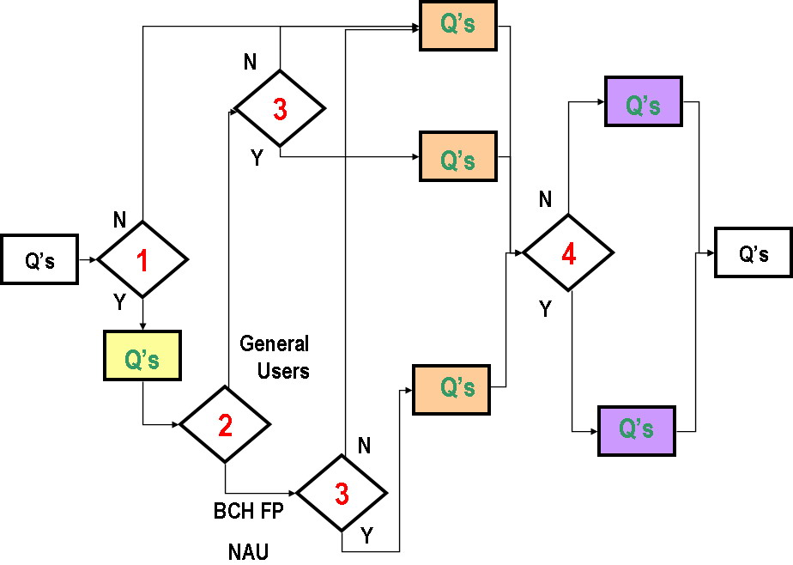

Qs – Questions
Questions that were specific for specific group
Questions that were different for different groups
Questions that were different for different groups
1 Question whether respondent is Registered User or not
2 Question whether respondent is BCH FP (or NAU) or General User
3 Question whether respondent had personally registered information on BCH or not
4 Question have Respondent participated in Online Forums and Conferences on BCH Central Portal or not
N – No
Y – Yes

Results of the Online Survey of Users and Potential Users of the BCH

1. Participants in the Survey

There were total of 157 records in Online Survey of Users and Potential user of Biosafety Clearing House database and there were completed 117 surveys (75 % of total records) . However, many of incomplete surveys contained answers to several questions and those incomplete records were in some cases more complete and detailed than several completed surveys.

All stakeholder groups were represented in this Survey, but their representation was very uneven. There were 69 scientists (46 % of all respondents) 57 participants in previous workshops (38 %) and 53 biosafety project coordinators (35 %), but only one representative of Parliamentarians and of Members of Farmer associations, three representatives of Customs and of Phytosanitary officers and four representatives of Media and of Members of seed association stakeholder groups. While stakeholder groups can be very different in size very low participation of several groups can also serve as indicator of their lesser awareness about BCH, It was also apparent that many respondents belong to the different stakeholder groups at the same time (76 % respondents belonged to more then one and 36 % to more than three stakeholder groups) Belonging to particular group is therefore better viewed as indicator of certain specific role that respondent has in relation to biosafety issues, rather than criteria for clear separation to different permanent groups. Proposed stakeholder groups covered well roles of most of the respondents, but 19 % of respondents added additional descriptions of their role in the biosafety system. While some of those descriptions overlap with already identified groups to a great extent, some of those descriptions pointed out to important groups that were not fully covered by existing classification (members of consultant bodies that are not experts, economic experts, experts. on ethical questions etc). .Representation of various CBD regions was more even than representation of different stakeholder groups, and participants of the Survey were from 74 different countries.

Proportion of Registered users and Current awareness service among respondents was quite high (75 and 51 % respectively). Also, experienced users of the BCH were dominant among Survey participants (73 % learned about BCH more than two years ago). However, this survey succeeded in attracting respondents for whose it was their first contact with BCH (12 %) and those that do not use it on regular basis (17%), therefore in part covering potential users of BCH, too. Participants learned about BCH in various ways (Annex 1 sections 1.6) and BCH is used by respondents for great variety of reasons (Annex 1 section 1.12). Respondents also use national nodes of the BCH (39 %) and importance of national nodes is further revealed by the fact that many respondents stated that their countries does not have national nodes/websites or are still developing them (12 and 17 % respectively) so it is reasonably to suppose that in future this proportion will rise. On the other hand, significant portion of respondents are not sure whether their country has a national website or not (24 %), so further actions on raising awareness are needed.

1.1 Participants in Survey by their stakeholder groups
 | Yes,  currently | Yes,  in the past | Total
Scientist (natural sciences, basic and applied) | 60 | 15 | 69
Participant in previous BCH workshops | 36 | 28 | 57
Biosafety project coordinator | 28 | 27 | 53
Employed by a Competent National Authority | 38 | 12 | 49
Member of a national expert biosafety committee | 32 | 18 | 47
National Focal Point for the BCH | 35 | 7 | 40
University professor | 32 | 8 | 37
Regional advisor | 17 | 6 | 20
National Focal Point for the CPB | 13 | 4 | 17
National Authorized User | 13 | 7 | 17
Industry or producers representative | 14 | 3 | 15
University student | 7 | 8 | 15
Employed by a relevant UN agency or body | 6 | 7 | 13
Social and legal expert | 11 | 1 | 11
Member of a Civil society organization (CSOs) | 7 | 1 | 8
Emergency Point of Contact under Artcle 17 | 5 | 2 | 7
Media | 3 | 1 | 4
Member of a Seed association | 2 | 2 | 4
Phytosanitary officer | 3 | 0 | 3
Customs officer | 3 | 0 | 3
Parliamentarian | 0 | 1 | 1
Member of a Farmer association | 1 | 0 | 1
Total Respondents: 150

1.2 Participants in Survey grouped by number of stakeholder groups to which they belong
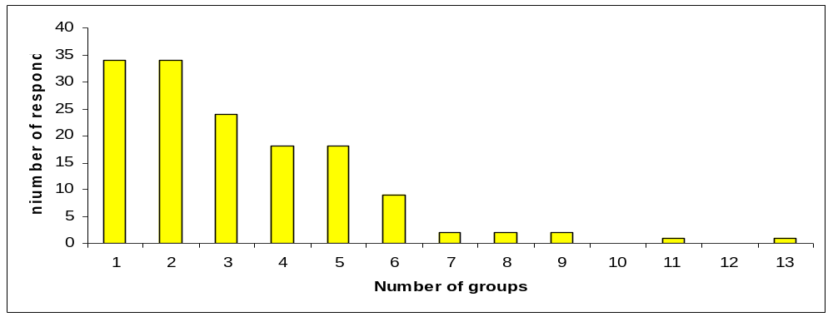
1.3 Participants in Survey grouped by CBD Region and Country
CBD Regions
Africa  (Respondents from 17 countries) | Asia and the Pacific  (Respondents from 13 countries) | Central and Eastern Europe  (Respondents from 14 countries) | Latin America and the Caribbean  (Respondents from 14 countries) | West Europe and Others  (Respondents from 16 countries)
Benin (2)  Botswana  Burkina Faso (2)  Burundi  Egypt (4)  Eritrea  Ethiopia  Guinea Bissau  Kenya  Lesoto  Madagascar (2)  Mali  Mauritania  Niger republic  Nigeria  Tunisia (2)  Uganda (3) | Cook Islands  India (2)  Iran (3)  Malaysia  Mongolia  Philippines (2)  Pakistan (2)  Samoa  Singapore  South Korea  Thailand  Tajikistan  Yemen | Albania (2)  Belarus (2)  Croatia  Czech Republic  Hungary (2)  Latvia  Lithuania (2)  Moldova (2)  Poland  Romania  Russia  Serbia (5)  Slovak Republic  Slovenia (2) | Barbados (2)  Belize  Brasil (4)  Chile (3)  Colombia (3)  Costa Rica (2)  Cuba  Ecuador  Guatemala  Guyana  Honduras (3)  Jamaica  Mexico (17)  Uruguay (2) | Australia  Austria  Belgium (3)  Canada  Germany  Greece  Ireland  Italy  Japan (3)  Malta  Netherlands (2)  New Zealand (2)  Norway  Switzerland (4)  Turkey (2)  USA (12)
26 | 18 | 24 | 42 | 37

1.4 Participants in Survey grouped by their role in BCH
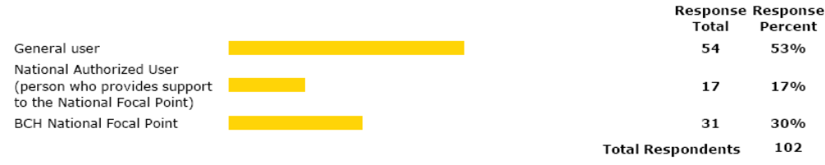

1.5 When participant learned about BCH
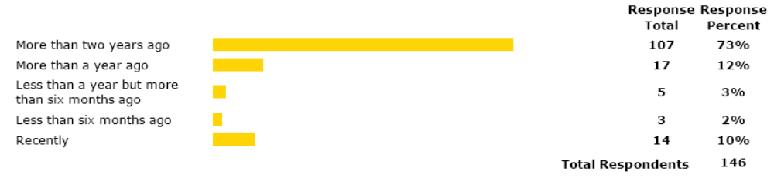
1.6 How participant learned about BCH
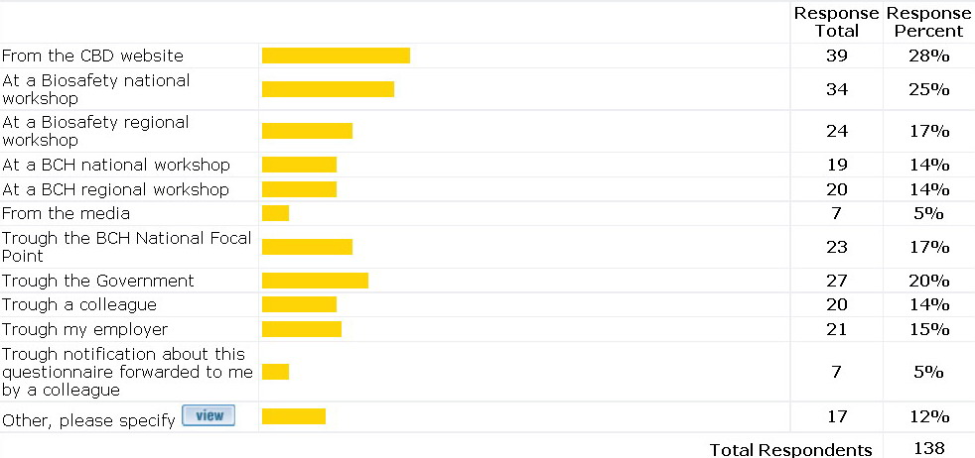

1.7 When participant started to use BCH
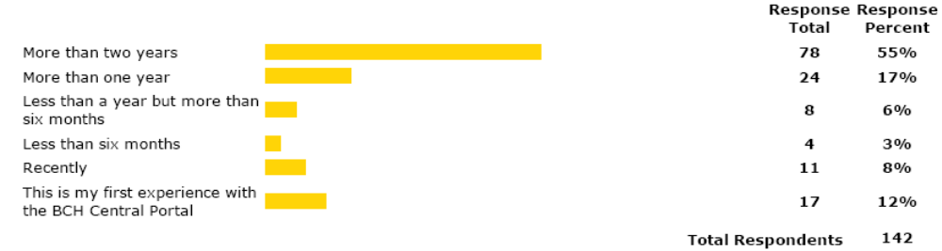

1.8 How often participant is using BCH
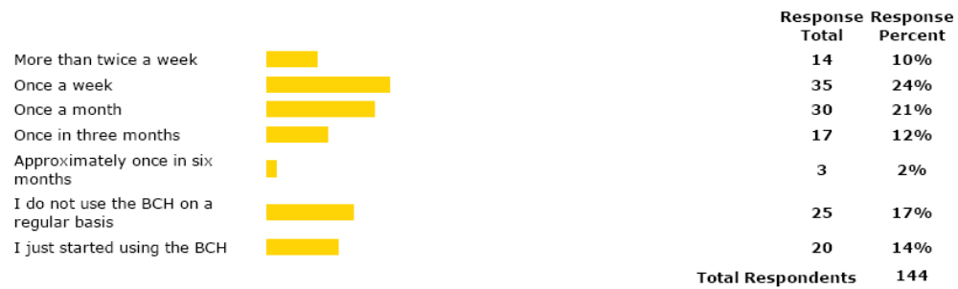

1.9 Was the participant Registered User of the BCH
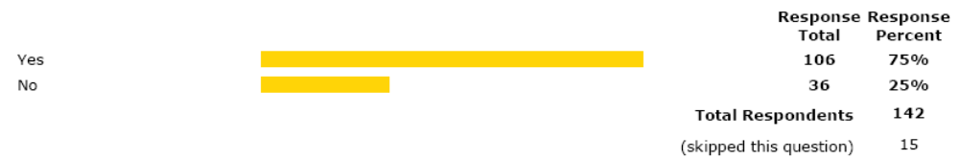

1.10 Is the participant subscriber to Current Awareness Service
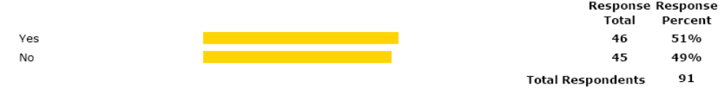

1.11 Using of National BCH nodes
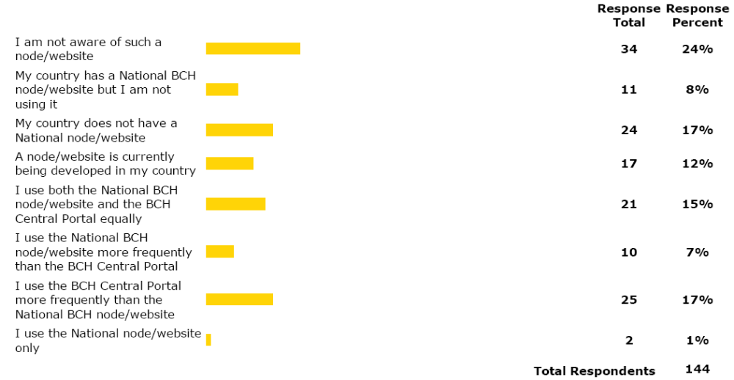

1.12 For what purposes participant is using BCH
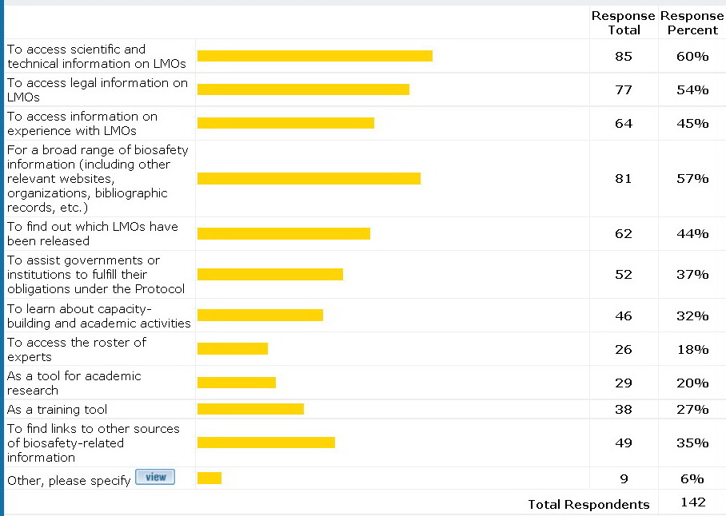
2. Finding Information on BCH

Information presented on BCH

Most of the participants were satisfied with quality of translations ((Annex 1 Section 2.1) as well as with sections of BCH Central Portal (Annex 1 Section 2.2) On the other hand, in respondent view almost all sections on BCH Central Portal could be improved). Suggestions for improvement were numerous and detailed, and many of them mentioned that information is not available in all languages. Respondent proposed sorting country decisions by event. Several participants suggested that he finding information section need to be improved regarding the existing information versus the reported information and that database is not updated in comparison with other private information systems. There are problems with accuracy of information and the quality control: for example, laws and regulations are sometimes posted but not officially approved by member country; capacity building info is often outdated. Finding information is not easy when not having previous training. Couple of respondents reported problems with exporting information. Having a common format for a risk assessment and quality control processes is a high priority for some of the participants. Accessing the BCH from the central page of the CPB should be obvious, but is not. Also, the difference between "Browse all records" and "Search" functions is no clear. There were a suggestion that when a search result is generated, it should state (as a title) the search fields used. There are issues with record classification. It was suggested that BCH-IAC: meetings should be transparent, with agenda open to discussion with the BCH NFPs before the meetings, and that there should be a link of communication between BCH NFPs and members of the BCH-IAC. If possible, for PCR based LMO detection Gene/marker/promoter sequences should be also available on Gene registry. It would be useful if COP-MOP Decisions are available also in PDF (Now they are provided as html only).

Participants also suggested many types of information that can be added to BCH, Suggestions included Case studies from the European countries, Risk Management reports regarding LMO releases, biosafety measures effectiveness analysis, status of UNEP´s projects as well as funding opportunities by that and other agencies, consequences of living modified organisms on biodiversity, human and animals in the countries where its used, more information about methods and methodic of biosafety assessment of LMOs , animated tools for beginners etc. Respondents also expressed their wish to have access to scientific journals through BCH.

2.1 Satisfaction with translations

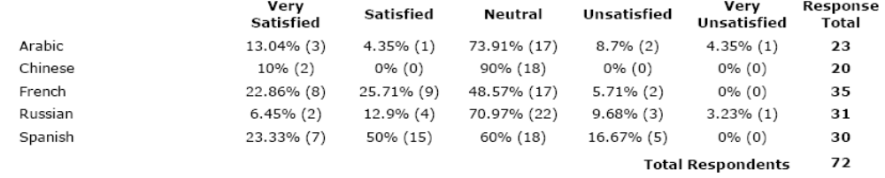
2.2 Satisfaction with different sections on BCH Central Portal
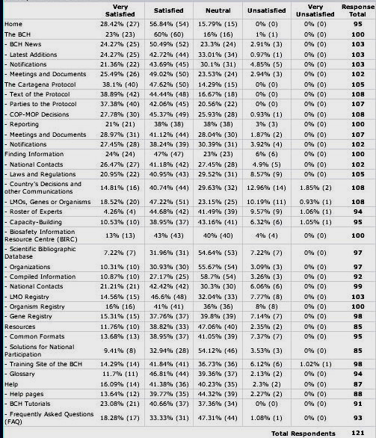
3.Online Forums and Conferences

Online Conferences and forums

Many participants in the Survey (47 %) have also participated in Online Forums and Conferences, mostly by reading posted messages (from 45 % to 85 % depending on Forum or Conference in question) and were generally satisfied with them.

Both those respondents that participated in previous activities and those that did not, have suggested additional topics for the future Forums and Conferences. These topics included, among others, the LMO socio - economic and environment debate, Risk management of LMO of perennial plant species, Capacity building for developing countries, labeling of LM animals and their products, public awareness and participation, illegal transboundary movements, topics related to the introduction of transgenic plants in centres of origin of the corresponding species, risk assessment on stacked events, coexistence and monitoring, native species and genetic resources, liability and redress, topic of LMOs and family agriculture in third world including the conservation of traditional seeds, specialized risk assessment of GMOs where risk assessment is problematic, risk management and monitoring of GMO field releases in centres of origin and centres of diversity (with emphasis on the in situ protection of plant germplasm and plant breeding programs), compliance, risk communications, public awareness and participation; BioIPRs relevant to GMOs and biosafety as well as expiration of approvals and patents; post-market and post-release monitoring, detection including sampling, thresholds, traceability and harmonized approaches/protocols on GMO Detection, and risk assessment and monitoring.

Several respondents also proposed continuation or regular repeats of existing forums and conferences (risk assessment, risk management, capacity building) as well as organization of forums and conferences on capacity building for different aspects of CPB (risk assessment, public participation, liability and redress..). Several respondents suggested that regional forums and conferences should be organized on various topics (joint regional activities, preparation for COP/MOPs, status of approvals and legislations in region etc) in regional languages. Outputs can than be communicated to relevant bodies and groups (such as AHTEG)..

3.1 Participation in online forums and conferences
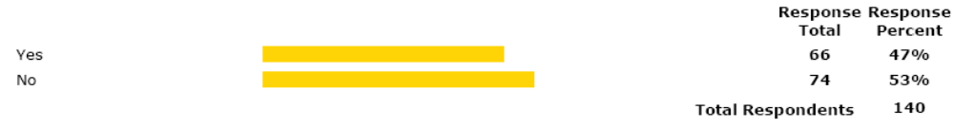

3.2 Type of participation by forum or conference
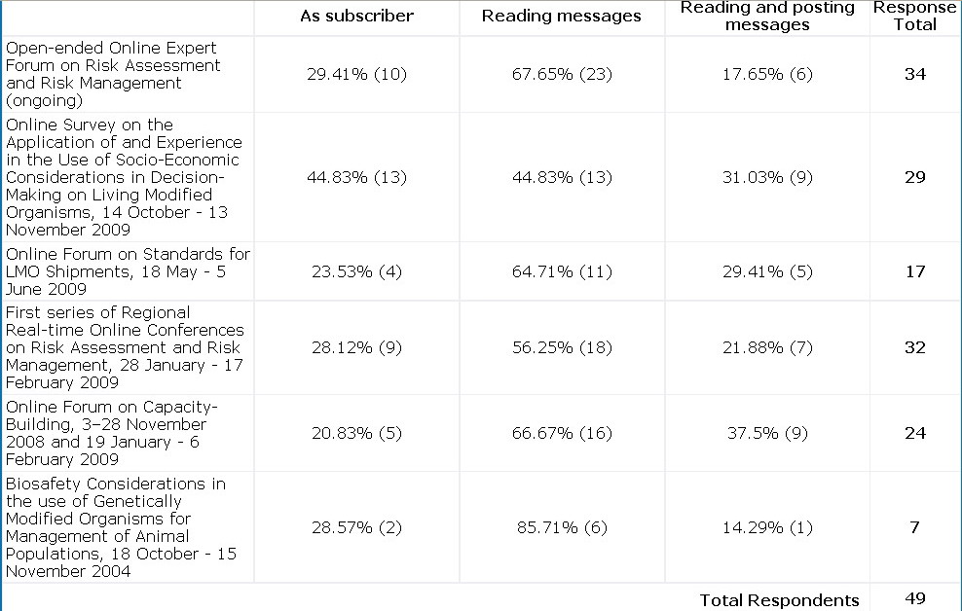

3.3 Satisfactions with forum or conference
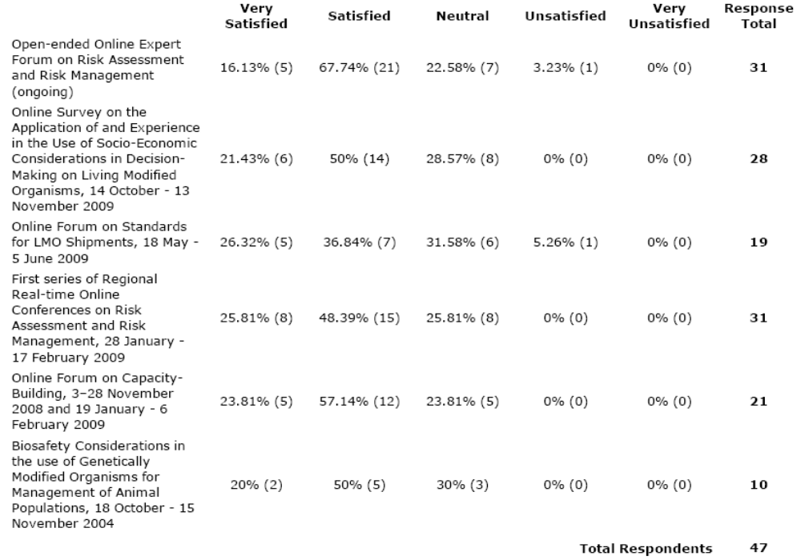

4. Registering information on BCH

Most of the participants have registered information on BCH (54 %) but significant portion of both BCH FPs and of General users are still not aware that all registered users can register some types of information on BCH Central Portal ( 25% and 38 % , respectively). Both BCH FPs and other users that registered information on BCH Central Portal are satisfied with revamped Management Centre (Annex 1 section 4.3) as well as with Common Formats (Annex 1 section 4.4). General users expressed their interest to register great variety of information on the BCH FP in future (Annex 1 section 4.5).

4.1 Have participant ever registered information on BCH ?
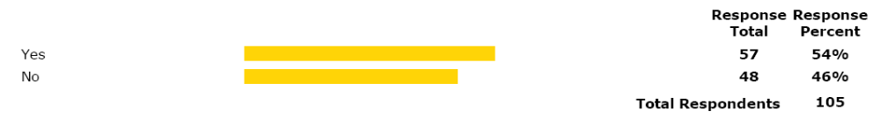

4.2 Awareness about possibility for every registered user to register some information on BCH
BCH focal points
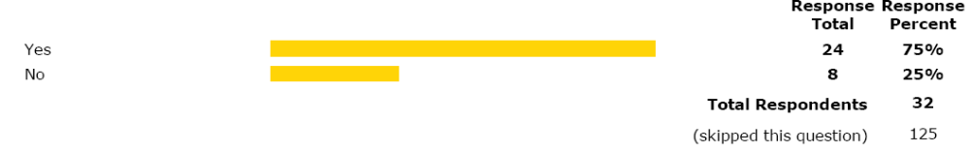
Other users
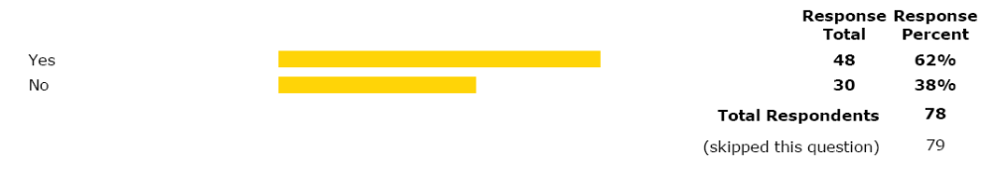

4.3 Satisfaction with revamped Management Centre
BCH Focal Points
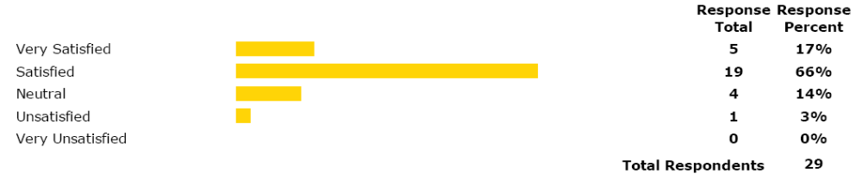
Other users that submitted information

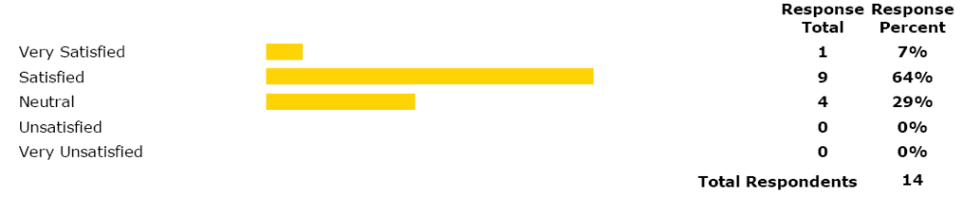

4.4 Information that General Users would like to register on BCH in future
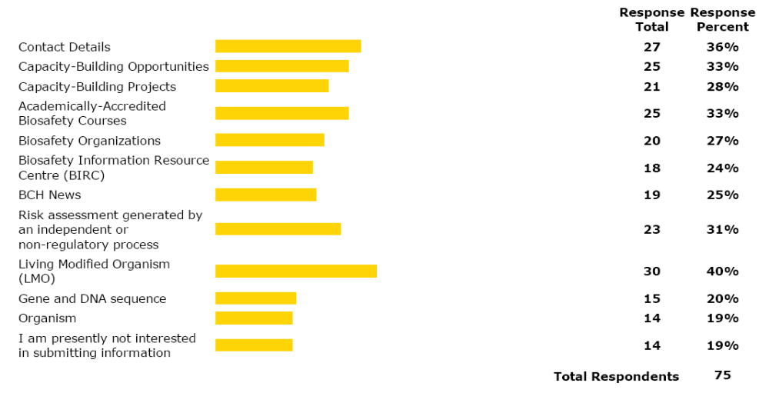
4.5 Levels of satisfaction with Common Formats
Common format for | Very Satisfied | Satisfied | Neutral | Unsatisfied | Very Unsatisfied | No
National Focal Points | 38.46% | 61.54% | 3.85% | 0% | 0% | 26
National Biosafety Website or Database | 22.73% | 54.55% | 13.64% | 9.09% | 0% | 22
Competent National Authority | 37.04% | 44.44% | 14.81% | 0% | 3.70% | 27
Biosafety Law, Regulation, Guidelines & Regional and International Agreements | 25.00% | 60.71% | 10.71% | 0% | 3.57% | 28
Country's Decision or any other Communication | 25.00% | 60.00% | 5.00% | 5.00% | 5.00% | 20
Risk Assessment Generated by a Regulatory Process | 5.56% | 50.00% | 33.33% | 5.56% | 5.56% | 18
Biosafety Expert | 13.04% | 43.48% | 30.43% | 8.70% | 4.35% | 23
Report on Biosafety Expert Assignment | 12.50% | 25.00% | 50.00% | 12.50% | 0% | 16
Contact Details | 23.81% | 38.10% | 38.10% | 0% | 0% | 21
Evaluated by General Users | 21.43% | 64.29% | 7.14% | 7.14% | 0% | 14
Capacity-Building Opportunities | 23.53% | 29.41% | 41.18% | 5.88% | 0% | 17
Evaluated by General Users | 14.29% | 64.29% | 14.29% | 7.14% | 0% | 14
Capacity-Building Projects | 22.22% | 33.33% | 38.89% | 0% | 5.56% | 18
Evaluated by General Users | 16.67% | 50.00% | 25.00% | 8.33% | 0% | 12
Academically-Accredited Biosafety Courses | 12.50% | 31.25% | 43.75% | 6.25% | 6.25% | 16
Evaluated by General Users | 0% | 63.64% | 27.27% | 9.09% | 0% | 11
Biosafety Organizations | 6.07% | 26.67% | 60.00% | 0% | 6.67% | 15
Evaluated by General Users | 9.09% | 72.73% | 18.18% | 9.09% | 0% | 11
Biosafety Information Resource Centre (BIRC) | 5.56% | 44.44% | 33.33% | 11.11% | 5.56% | 18
Evaluated by General Users | 8.33% | 75.00% | 8.33% | 8.33% | 0% | 12
BCH News | 10.53% | 68.42% | 21.05% | 0% | 0% | 19
Evaluated by General Users | 28.57% | 42.86% | 21.43% | 7.14% | 0% | 14
Risk assessment generated by an independent or non-regulatory process | 6.25% | 50.00% | 31.25% | 6.25% | 6.25% | 16
Evaluated by General Users | 0% | 40.00% | 50.00% | 10.00% | 0% | 10
Living Modified Organism (LMO) | 0% | 70.59% | 23.53% | 0% | 5.88% | 17
Evaluated by General Users | 11.11% | 66.67% | 11.11% | 11.11% | 0% | 9
Gene and DNA sequence | 0% | 68.75% | 25.99% | 0% | 6.25% | 16
Evaluated by General Users | 0% | 33.33% | 55.56% | 11.11% | 0% | 9
Organism | 0% | 62.50% | 31.25% | 0% | 6.25% | 16
Evaluated by General Users | 0% | 44.44% | 44.44% | 11.11% | 0% | 9

5. Obstacles, Suggestions and general Awareness

Obstacles, Suggestions and General Awareness

Obstacles listed in Survey were qualified as “True” or “Partially true” by significant number of participants in the Survey (ranging fro 46 to 78 participants depending on the obstacle in question). Main obstacle identified by participants in the Survey is that it was not easy to differentiate between information not available because it does not exist and information that has not been reported on (50 participants viewed this obstacle as true and 32 as partially true). This obstacle was already mentioned by several participants in their answers to what can be improved section of Survey. To lesser extent it was also pointed to information that is not accurately reported as a important obstacle (22 participants viewed this obstacle as true and 36 as partially true).

Second major obstacle was unavailability of resources in all languages (39 participants viewed this obstacle as true and 28 as partially true). It also corresponds to several suggestions for improvement of BCH Central Portal by making information available in other languages, including all UN official languages.

As a possible obstacles participants also viewed several features of BCH Central Portal that can also be improved in the future: Tools for statistical analysis and graphic representation of data that are not easy to use, search results that are not well organized/presented, and Help resources (guides, tutorials, help, FAQ) that are not supportive enough (Annex 1 section 5.1).

In respondents view, extremely important for successful functioning of the BCH is continuation with biosafety projects (55 participants viewed it as “Extremely important” and 31 as “Important”), using regional advisors in that activities (47 participants viewed it as “Extremely important” and 35 as “Important”),, and targeting specific groups (43 participants viewed it as “Extremely important” and 39 as “Important”), .As extremely important participants also viewed cooperation between various agencies in those activities . Suggestions include Enhancing cooperation with other relevant international organizations to maximize the use of existing experience and expertise and to minimize duplication of activities (54 participants viewed it as “Extremely important” and 41 as “Important”), Taking advantage of other biosafety activities and meetings to share experience in using the BCH (42 participants viewed it as “Extremely important” and 50 as “Important”) and Enhancing networking and development of additional opportunities for sharing experiences on the BCH (42 participants viewed it as “Extremely important” and 46 as “Important”)

Second group of important activities that participants in Survey think can improve functioning of the BCH are oriented to help then countries in establishing national and regional nodes (41 participants viewed it as “Extremely important” and 44 as “Important”) , help in solving problems with constrains on national level (40 participants viewed it as “Extremely important” and 40 as “Important”), In lesser degree participants viewed help to countries in providing courtesy translations of their documents

Other activities that were supported by Survey participants as significant for better functioning of the BCH included several improvements of the BCH Central Portal: development of graphic, analytical and training tools, continuation of online conferences, and additional user surveys and feedback mechanisms (Annex 1 Section 5.2)

Participants in Survey also rated the awareness about BCH of different stakeholder groups on the basis of their personal experience. As least aware participants (more that two thirds of respondents) viewed several general public groups (Parliamentarians, Media), members of Academia (University students and professors), Custom and Phytosanitary officers, members of various associations (Farmer, Seed, CSOs) as well as social and legal experts and industry representatives. These groups should therefore be the main target of capacity building activities.

Based on respondent’s experience, scientists, employees of various UN agencies and Emergency Contact Points belong in medium awareness group (more than one third of respondents view them as sufficiently aware and also more than one third of the respondents view them as not sufficiently aware, on the basis of their personal experience). Since this group contain stakeholders that play important role in biosafety system and in capacity building activities in biosafety, their awareness should also be raised.

Most of the key players in biosafety system belonged, in respondents experience, to the sufficiently aware groups of stakeholders (more than two thirds view them as sufficiently aware – Annex 1 Section 5.3). However, since some of important groups for efficient functioning of biosafety system were viewed by more that 30% of respondents as not sufficiently aware (Members of a national expert biosafety committee, Employed by a Competent National Authority) Bearing in mind they extremely important roles in the biosafety system, specific awareness raising and training programs would be needed for some of these stakeholder groups, too.

Participants also suggested various ways in which awareness of different stakeholder groups can be raised. Those suggestions made by 49 participants, among others, include raising general awareness through outreach campaigns. Those campaigns should include publications brochures, media and should aim on raising awareness about biosafety issues and not to limit only on awareness about BCH. Participants in Survey also suggested various training programmes - Targeted training workshops, meetings, on line conference and discussions for various different stakeholder groups. Among activities that respondents are viewing as useful for raising awareness is addition of biosafety courses to university curricula, several national activities by FPs and CNAs, but also UNEP GEF projects based on COP MOP decisions. Several respondents pointed out that awareness is dependent on motivation so it should rise with rise of level of interest in biosafety and biotechnology issues.

5.1 Obstacles in using BCH Obstacles are sorted by number of “True” answers
 | True | Partially  true | No  respondents
It was not easy to differentiate between information not available because it does not exist and information that has not been reported on | 50 | 32 | 78
Resources are not available in all languages | 39 | 28 | 65
Tools for statistical analysis and graphic representation of data that are not easy to use | 24 | 28 | 52
Information that is not accurately reported | 22 | 36 | 58
Search results that are not well organized/presented | 21 | 34 | 55
The information is not easy to find | 17 | 58 | 71
Help resources (guides, tutorials, help, FAQ) are not supportive enough | 8 | 38 | 46
Total respondents: 105

5.2 Activities that can improve BCH (sorted by number of “Extremely important” answers)
 | Extremely important | Important | Less important | Not important | Total
Continuation of the BCH capacity building projects | 55 | 31 | 7 | 1 | 94
Enhancing cooperation with other relevant international organizations to maximize the use of existing experience and expertise and to minimize duplication of activities | 54 | 41 | 2 | 1 | 97
Utilizing the BCH Regional Advisors network in the BCH Capacity Building | 47 | 35 | 8 | 2 | 91
Facilitating the BCH capacity building activities focused on specific target groups | 43 | 39 | 6 | 1 | 89
Taking advantage of other biosafety activities and meetings to share experience in using the BCH | 42 | 50 | 4 | 0 | 95
Enhancing networking and development of additional opportunities for sharing experiences on the BCH | 42 | 46 | 7 | 1 | 96
Further help in establishing national and regional nodes of the BCH | 41 | 44 | 7 | 0 | 92
Facilitating identification of constraints in the provision of requested information at the national level | 40 | 40 | 8 | 2 | 90
Further development of training materials as well as of BCH Resources and Help sections | 31 | 48 | 8 | 1 | 88
Further development of online tools for searching, grouping, statistical analysis and graphic representations of data | 30 | 51 | 6 | 2 | 89
Facilitating the provision of courtesy translations of information in the BCH | 22 | 36 | 25 | 2 | 85
Further development of online BCH user feedback mechanisms directly on the BCH | 21 | 47 | 17 | 1 | 86
Organization of more online forums on specific topics | 19 | 49 | 21 | 1 | 90
Further employment of targeted follow-up surveys and BCH usability studies | 15 | 48 | 19 | 3 | 85
Total respondents: 107
5.3Awareness of different stakeholder groups

Higher awareness Stakeholder groups (Groups that more than two thirds of respondents view as “Aware” or “Sufficiently aware” on the basis of their personal experience).
 | Aware | sufficiently aware | Not sufficiently aware | Not aware | No. of respondents
National Focal Points for the BCH | 64.00 % | 28.00 % | 9.33 % | 0 % | 75
National Authorized Users | 45.71 % | 38.57 % | 14.29 % | 1.43 % | 70
Participants in previous BCH workshops | 31.51 % | 52.05 % | 15.07 % | 2.74 % | 73
Biosafety project coordinators | 62.96 % | 19.75 % | 12.35 % | 4.94 % | 81
National Focal Points for the CPB | 54.29 % | 24.29 % | 20.00 % | 1.43 % | 70
Regional advisors | 59.02 % | 16.39 % | 18.03 % | 6.56 % | 61
Members of a national expert biosafety committee | 35.37 % | 32.93 % | 29.27 % | 2.44 % | 82
Employed by a Competent National Authority | 25.32 % | 43.04 % | 27.85 % | 3.80 % | 79

Medium awareness Stakeholder groups (Groups that more than one third of respondents view as “Aware” or “Sufficiently aware” and more than one third of respondents view as “Not aware” or “Not sufficiently aware” on the basis of their personal experience).
 | Aware | sufficiently aware | Not sufficiently aware | Not aware | No. of respondents
Employed by a relevant UN agency or body | 24.53 % | 39.62 % | 28.30 % | 7.55 % | 53
. Emergency Points of Contact under Artcle 17 | 27.78 % | 29.63 % | 31.48 % | 11.11 % | 54
. Scientists (natural sciences, basic and applied) | 14.10 % | 28.21 % | 43.59 % | 15.38 % | 78

Not sufficiently aware Stakeholder groups (Groups that more than two thirds of respondents view as “Not aware” or “Not sufficiently aware” on the basis of their personal experience).
 | Aware | sufficiently aware | Not sufficiently aware | Not aware | No. of respondents
. Industry or producers representatives | 12.50 % | 20.00 % | 43.75 % | 23.75 % | 80
. Members of a Seed associations | 10.29 % | 20.59 % | 48.53 % | 20.59 % | 68
. Social and legal experts | 5.71 % | 22.86 % | 45.71 % | 25.71 % | 70
. Members of a Civil society organizations (CSOs) | 4.23% | 22.54 % | 56.34 % | 16.90 % | 71
. University professors | 11.39 % | 20.25 % | 41.77 % | 27.75 % | 79
. Phytosanitary officers | 4.55 % | 22.73 % | 46.97 % | 25.76 % | 66
. Customs officers | 8.22 % | 13.70 % | 52.05 % | 26.03 % | 73
. Members of a Farmer associations | 4.05 % | 14.86 % | 47.30 % | 33.78 % | 74
. University students | 1.30 % | 12.99 % | 38.96 % | 46.75 % | 77
. Media | 1.27 % | 8.86 % | 56.96 % | 32.91 % | 79
. Parliamentarians | 1.41 % | 7.04 % | 46.48 % | 45.07 % | 71

General comments of Survey participants

Participants in the Survey were given opportunity to make general comments and suggestions at the end of the Survey. Forty eight comments were received and they included following issues;
- Continuation of projects and capacity building activities since in most countries system is still not sustainable without external help
- Language issues – many participants expressed need for more quality translations to other UN languages
- Need for biosafety courses in schools and universities were also expressed.
- It was stressed that the quality and accuracy of the information in BCH will contribute to its use.
- It was pointed out that there are two issues regarding quality of BCH Central Portal - user friendliness/structure and quality of the information entered by countries. With regard to the first respondents expressed general satisfaction, with regard to the latter, respondents was not so satisfied. Suggestion was to clarify in the questionnaire whether the questions refer to form or substance.
- It was pointed out that the BCH is an essential tool for compliance with the CPB but countries still require significant assistance in using it and educating the national stakeholder groups in its usage. Without such external assistance, the use of the BCH in developing countries will progress very slowly
- Problems with common formats for Roster of Experts were also reported. \It took a lot to fill the forma and some required information such as exact date (day, month) of graduation or employment is not very necessary but without them the filled documents are rejected.
Many participants in Survey congratulated SCBD on good work on BCH and expressed satisfactions with continuous improvements of BCH during previous period

Annex 2.

Targeted Semi Structured Interviews with Users and Potential Users
of Biosafety Clearing House

Targeted Semi Structured Interview Design

Targeted semi structured interview with selected participants was balanced with respect of five CBD regions (Africa, Asia and Pacific, Central and Eastern Europe, Latin America and Caribbean, Western Europe and others) and twenty stakeholder groups.

In each CBD region there were 12 targeted participants from different stakeholder groups and each stakeholder group had three targeted participants from different CBD regions, Targeted participants were also balanced in following respects:
- Each of 10 possible combinations of three regions selected to represent stakeholder group were to appear twice in total of 20 stakeholder groups
- Each region will be represented either by a custom or by a phytosanitary officer (or both)
- Each region will be represented either by a scientist or by a member of expert council (or both)
- Each region will be represented by at least one NFP (CPB, BCH or Article 17 FP)
- Each region will be represented by three out of five NFPs, CNA and Project Coordinator stakeholder groups
Due to relationship of number of potential participants (60) and total number of groups (20 stakeholder groups x 5 CBD regions = 100 groups) outputs from this interviews are not suitable for large-scale quantitative analysis, but can be used to provide qualitative insights and possible examples relating to studied issues.

Targeted Semi Structured Interview Summary

Participants that were targeted for semi structured interview were also asked to fill online Survey. Among participants in the Interview, 27 were interviewed by phone and also had filled the Survey, 16 were interviewed by phone only, 6 submitted they responses in writing, 3 were interviewed in person and one respondent filled in the online Survey in response to the request for Interview. Targeted participants were evenly distributed among CBD regions and defined stakeholder groups and also provided greater insight in topics addressed by online Survey

Improvements of BCH Central Portal

Participants in interview were satisfied with BCH Central Portal and described it mostly as user friendly and well designed. Many of them appreciated improvements that have been made in previous period. However, some respondents also pointed that user friendliness depends on particular group in question and that in present form it is suitable for scientists and regulators but not so user friendly for general public (media, CSO, consumers’ organizations). For those groups it can be hard to find information and lot of scrolling and browsing involved, and for not so good internet connection it is hard to browse. In opinion of those respondents, CP is also easy to use for people trained through BCH project and regional advisors but it can be difficult for beginners. It can be improved by more graphic representation and overview in “contextual page” for each section. There was also suggestion that there should be “corners” for such users. Introduction should be given in a simple way

Respondents also noted that general design of BCH is good and problem lies is timeliness, accuracy and quality control of presented information. Respondents also reported that sometimes can’t get documents (links are not working) and sometimes linked documents are not in English (language issue). For not developed countries is not easy to download .They are excellent tools but they should be smaller in size. Windows Media Player uses bigger files – they should be in different format.

Some respondents also stated their dissatisfaction with certain sections of the BCH Central Portal, for example dissatisfaction with Frequently Asked Questions (FAQ), dissatisfaction with Capacity building section (old information, should be updated information about trainings in future). Respondents also suggested that FAQ presented on BCH Central Portal is very important, not only on BCH functioning, but also as way to exchange experiences on biosafety issues. They also suggested that on CP, FAQ should be more visible and maybe put on home page Respondents also reported that important information can be found on BCH but there is delay in providing information. For efficient participation timely information is needed. More information is currently available on national nodes and it is published under national legislation obligations. Several additional training modules should be developed, targeting specific groups (customs, phytosanitary officers, industry) and existing materials should be updated. Help system is also needs to be updated. Awareness about training materials should be also raised.

Respondents also observed that it is hard to search by keywords if you don t know very specifically what you are looking for. Keyword search should be at all pages including home page.

Respondents also suggested various possible improvements like statistics on click, pie charts (by region, continent) , maps, further development of online tools for searching, grouping, statistical analysis and graphic representations of data, adding 'drag and drop' and 'archiving' news functions, Respondents also reported that difference between Search and Browse buttons is not clear and there are sometimes problems with registration. Online Analytical Processes (OLAP) with very user-friendly interface should be employed. It is not an easy task and Secretariat should find the right balance on that matter.

Respondents also reported that information on risk assessment on BCH is limited and some information is not easily accessible – search should be improved.

One respondent also pointed out that answer to the question “what kind of information is useful” is different from country to country. For example, information on laws and regulations of other countries are especially useful for parties on the way of developing their national legislation system.

Suggested additional information for the BCH Central Portal

Respondents to targeted semi structured interview also expressed need for addition information and stated that structured information on BCH Central Portal for different stakeholder groups is needed. They suggestions included:
- More Toolkits and Training materials are also needed.
- More information in training, published news, country decisions and regulations sections, brief country experiences, Guidelines, information about other relevant organizations (FAO, OECD, WTO, and Codex Alimentarius). It will be very useful to integrate into BCH information about FAO, Codex and other sources
- Results of broad and constant, long time monitoring of LMO that is performed by neutral entities. Respondents also stated that for CSOs it is crucial to have information regarding planned field trials
- Regional information would be also very useful (information about neighbouring countries).
- Simple information (booklet about country and different CNAs obligations) is needed for decision makers. Information is also needed for higher level than CNA and there is need for special publications for Parliamentarians. It is important to target higher officials, parliamentarians and media.
- Short basic information in national languages
- For NBC work, more information about methods and methodic of biosafety assessment of LMOs are needed (sequences etc). If possible, for PCR based LMO detection Gene/marker/promoter sequences should be also available on Gene registry. Raw sequences of the genes an long with the flanking sequences should be published on BCH.
- Peer reviewed RA are needed as well as information on socioeconomic impact. NGOs and Farmers groups, consumers groups, media needs capacity building
- Access to scientific journals was also requested. In respondents view Secretariat could find the ways to enable access to peer reviewed articles through BCH. At least information about new issues of relevant journals, for Nature Biotechnology for example, should be distributed. It would be of great improvement to have the possibility of choosing full free available articles
- New events and detection methods (primers sequences). Respondent also uses Gene Compass (most informative) connected with JCR website with all methods and their validation. That information is also needed on BCH
- It was suggested that it would be useful to have blog on BCH

Language issues

Many respondents complained that resources are not available in many languages. Language is an issue in LAC, Africa, CIS countries and many other regions both in searching for and in presenting information. It is also an issue in conducting workshops, especially for some specific stakeholder groups (Media, parliamentarians, politicians), In LA it is a problem to conduct workshops in English.
English summaries are needed in News section. Regulations and Country's Decisions (Laws are not translated to English for example Swiss, German ...). Respondent suggested that translating can be supported by UNEP GEF on the basis of COP MOP decision. Even information presented by SCBD that is good and presented on time (COP MOP decisions, meeting reports), is not always translated on time. Online forum in other languages would be very useful. Also, Parties should be encouraged to translate materials to at least one UN language. Translation of CP itself is the first step in addressing language problem. In Africa region you have many languages in use. Also there is question of translation of links, attachments etc.

National websites

Respondents viewed National websites as very important for many users in country as on them they can follow in country problems. Some respondents have raised question of operation costs. To maintain sustainable websites in other countries, problem of staff members that are not used to use internet can be solved by training. Respondent thinks UNEP-GEF BCH training program is working effectively for this purpose. In one respondent view, For national nodes/websites Hermes and Ajax can be used but follow up by designated persons is extremely important – if it is only BCH FP is a question of motivation, IT persons should also be involved .It was also pointed out that Secretariat developed two tools – HERMES and AJAX so now you don’t need to be software developer to build your own national website. Secretariat also provided hosting for those websites (which solves problem with bandwidth). Those two tools should be more promoted. It also helps countries to display information in their own languages.

Registering information issues

Not all respondents are aware that all registered users can post information on BCH and is interested in posting information. Time is limiting factor – only companies have enough resources to provide information, Respondent from CSO stated that CSOs does not have resources and it is starting to be an issue and it is creating imbalance. This, in respondent opinion, raises an issue of governance of BCH, Who decides and how? How quality control of information presented by registered users is managed? If some organizations is given special privileges (all information is published) on others do not it raises issues of governance, quality control and balance.

Respondent appreciate recent improvement of the online registration system (especially on national decisions). It became easier to register information than it was years ago. When mandatory fields are newly added to registration forms, it should be notified to users in advance in a manner which attract more attention.

Respondent unsatisfied with Common Formats for Competent National Authority Mandatory field with personal contact data creates problems. Politically correct is to put minister, but most will not put contact details. Possible solution is to have two fields – one with Responsible person without contact details (minister for example), and other for Contact person with contact details. Several questions in CF should not be mandatory. Country's Decision or any other Communication very long CF can be confusing for many countries. It should be improved. Suggestion – separate CF for each type of Decision (it will be shorter and clearer).

Many respondents were unsatisfied with CF for Biosafety Expert. Limited registration to only one field of expertise in CF for Roster of Experts is not appropriate. Because of that many quality experts will not be on Roster and smaller number of experts in new Roster should not be interpreted as a sign of increased quality. There should be no limits on the fields of expertise. On the other hand new detailed groups and subgroups in Roster of Experts are excellent. Roster of Expert CF is become too complicated. Some pages were very slow and sometimes the whole information that was registered was lost. Some required information such as exact date (day, month) of graduation or employment is not very necessary but without supplying them the filled documents are rejected. Respondent understand the need to scrutinize list of experts, but at present it is too complicated to fill the forms (approx. two hours) Recognized experts would not be very happy with the idea to submit such extensive information – they may feel offended.

Other respondent had registered information on BCH and is unsatisfied with Common Formats for Risk Assessment. Existing formats are not suitable for difficult cases of Risk assessments (trees, fish, pharmacrops, viruses, terminator genes). Form should be simplified. IAC should discuss this subject, as well as other bodies. Respondent is also unsatisfied with CF for Living Modified Organism (LMO), Gene and DNA sequence and Organism; CF should be more flexible and more dynamic – it should be changed more often and that topic should be also be brought to the attention of BCH IAC

Online conferences

Respondents expressed their satisfaction with Online Forums and conferences but also raised several issues regarding them. Problem of time for participation in online discussions was also raised – matter of resources and imbalance, and therefore not very useful.

In real-time forums communication can be difficult. Observers sometimes have to wait for a long time to post a comment. In this intervening time, the conversation has likely moved to another subject. Respondent finds the online forums much more useful and valuable. Information and opinions can be communicated thoughtfully. Respondents also stated that for conferences some clear guidelines are needed because there are many problems like different time zones etc. Sometimes there are too many topics, links, options, comments within one conference which make discussion too complex. There should be option to track and receive mail notifications only for specific topics within conference as well as search engine within conference

Respondents also suggested several additional topics for forums and conferences. They include:
- Status of LMO legislation and event approvals en Latin America
- African activities in capacity building, labeling, segregation systems, liability and redress
- Contained use
- .Exchange of experience in analytic methods and methodology
- Risk communications;
- Public awareness and participation;
- Capacity building under Liability and Redress of the Cartagena Protocol on biosafety;
- Capacity-building under public participation and education;
- Risk Management;
- BioIPRs relevant to GMOs and biosafety;
- Post-market and Post-release monitoring;
- Coexistence.
- liability and redress
- specialized risk assessment of GMOs where RA is problematic (trees, fish, pharmacrops, viruses, terminator genes)
Respondents also suggested that participation should be facilitated in some way since number of participants in previous conferences was fairly low. Maybe more detailed general information should be also part of those activities because topics are new and not many people have experiences with them. Organizing forums and conferences in languages other than English was viewed as extremely important for increased participation.

Obstacles, Proposed activities and Awareness

Participants in the Targeted, Semi Structured interview gave similar comments about obstacles, need to raise awareness and ways to solve existing problems as participants in Online Survey, but were able to explore it in grater depth.

Respondents pointed to continuation of BCH projects as a extremely important way to improve functioning of the BCH They view participation in BCH phase II Project as important, but they are pointing out that it is very hard to obtain commitment from the government on the basis of Invitation letter that was not accompanied by the Terms of Reference.

Respondents stressed extreme importance of targeted training and stated that workshops are needed, similar to previous ones but with broader involvement of various other stakeholder groups. Specific training is needed for specific groups.

Some of respondents expressed opinion that prime targets for capacity building should be employees in ministries that are CNAs – they have insufficient information so sometime you can hear very incompetent statements from them. For government officials workshops in country capital is not efficient (they are often distracted). Regional seminars are also very important but they need country workshops as priority for ministry officials. . For raising awareness of Parliamentarians sub regional approach is needed – organization of meetings of parliamentarians at sub regional level are important because number of parliamentarians interested in environmental issues in each country is low. By opinion of a member of CSO and a former parliamentarian, CSO can help a lot to identify interested parliamentarians in each country because they have great experience in working with parliamentarians. Utilization of CSO is also less expensive and can be organized with cooperation of relevant ministries. Formal approach will not produce results in case of parliamentarians – they will not send the right people but mostly those who are free at the moment. In respondent view UN agencies in countries are sometimes too bureaucratic and inefficient and can’t help at present.

Other group that needs to be targeted in respondents view are journalists, Special programs are needed for capacity building for media – media should be invited to workshops but the best option is series of seminars specifically organized for media in different cities, combined with capacity building for CSO. Journalists are mostly interested in local information on biosafety and that information is lacking. Topic of GMO is very interesting for media in respondent country based on previous experience with press conferences. Because good press materials were prepared all follow up articles in press were of good quality without any sensationalistic writing. Specialized media may be aware of existence of BCH but respondent doubt that they are using it. For media best approach are special workshops for media. Journalists usually are covering many other topics beside environmental issues. Best way to reach media is through E mail letters, regular Newsletter that will be distributed to all relevant to specific scientific, environmental branches. In countries quite sophisticated and elaborated system for covering environmental issues. They are receiving information in that form (newsletter) from Greenpeace and Friends of the Earth. Journalists from respondent’s country do not search for information on websites unless they are performing very specific research. Getting addresses of journalist can be quite difficult they can be obtained from NGOs as a gesture of friendships. Lists of journalists accredited to COP MOP can serve as start, but this question should be addressed to colleague that was accredited to last COP MOP. Feed form on internet can also be useful way to approach journalists.

Phytosanitary and customs officers are also not sufficiently aware. To improve their awareness different approach is needed. They need training in place where they work. Training of trainers who know the situation with customs, borders and inspections would probably be the best approach. It should also focus on Article 18.Customs officers should be a target of BCH II project. For farmer groups and local communities internet is not always available so other means to approach them are needed.

Workshops for industry and producers are also needed and further activities can be defined on those workshops. In respondent country contacts with producers from other countries are on individual level and based on personal initiative. For example, there is no automatic distribution of information to national producers about changes in EU legislation. There are various producer organizations in country. Hands on trainings in new techniques are also needed. Greater efforts are needed to get information for laboratories in respondent country compared to their colleagues from EU.

In member of CSO view, university trained representatives of CSOs should be involved in BCH capacity building activities with consumers. CSOs should be trained in use of electronic media and on how to set national nodes. Special role of consumers associations (depending of various definitions) since they are the only representatives on demand side (in contrast to supplier one).

Specific issue that is also mentioned by several respondents is raising awareness of Academia, To improve awareness of Academia, degree and diploma granting courses should be organized. Online courses are also good solution (like those by UN, UNITAR).

In respondents view complex capacity building projects including various aspects and stakeholder groups (CSOs, Media, Educators, Legislators, scientific institutions, government officials...) are needed, both on national and on regional levels and by various means (Seminars, workshops, online forums). Special emphasis should be put on general public. Utilizing CSOs can significantly reduce costs of those activities, including various publications, TV, radio programmes and other media. In respondent view BCH should be situated in bigger Information sharing context, not limiting it to internet website. Workshops and publications are needed (but there are also limited), use of media in more general way (radio, broadcasting).

Specific obstacle that was raised by several participants in Interview is the obstacle of non compliance with information sharing oblations. Reasons for that, in respondents view include
- High turnover of officials that create problems with “institutional memory”.
- lack of implementation of NBF, lack of education of all levels including authorities information has to be officially approved.
- Not enough capacity in the government, no monitoring is going on and there are no penalties so governments are not worried.
- administrative – if within country system it is not clear who can authorize and submit information, there will be problems with reporting (there is sometimes confusion between roles of CPB FP and BCH FP), There is sometimes confusion regarding CH and BCH mechanisms.
- There is lack of coordination between different institutions. In most developing countries biosafety is still not a priority and many potential users of BCH (industry, academia, NGOs, general public) that can ask their government to publish information is still not sufficiently aware about BCH.
The following ways to address this problem were suggested:
- Should be solved by some action by Secretariat on international level – some questions on global some on regional level
- To continue with education, change of government officials is a big problem, hierarchical and political approach to make system sustainable.
- It is important to raise awareness to high political hierarchies to reach commitment from governments
- We need to reach other people (now we too much we are preaching to the converted) and on higher levels.
- Targeted training is needed. Two or three different scenarios to approach politician’s limits: attention and time.
- Pressure is needed for compliance.
- SCBD should explore ways to have better relation with NFPs - they are changing frequently and transition period create problems.
- BCH FP should be clearer in reporting on that. It specially applies to risk assessments reports.
- It is matter of national sovereignty but COP MOP could encourage Parties to present information
- Strong link between information on BCH and Protocol itself should be demonstrated during the training (that BCH is a tool of the Protocol). It is also helping in raising awareness about obligations to report certain types of information
- Sustainability should be a topic of RA meeting. Mentor initiative of UNEP can also be a useful way to tackle these problems.
- Industry, farmers, academia civil society should be the main driving forcers to make governments to make biosafety a daily issue.
Couple of respondents raised the question of governance of the BCH. While others pointed to regional activities and cooperation between different agencies as important way to solve potential problems. In those views SCBD should raise awareness among UN agencies relevant to biosafety and outreach to them. Biodiversity issues are new for many stakeholders, not to mention biosafety. There are different activities in a region by different agencies or bodies – agencies should pull their resources together BCH II project can also be used to build relationships with other relevant UN agencies (FAO, UNIDO) and to try to be more proactive in coordination. More workshops and conferences organized on regional level by various agencies are needed to meet people working in other countries on the same issues “face to face” is very important. Previous contacts on conference led to exchange of expert visits. It all is leading to exchange of experiences and capacity building in all countries in a region.

Overview of Individual Responses

Biosafety project coordinator

Respondent is National Project Coordinator, but also BCH Focal Point and Biologist employed in Competent National Authority. Most often searches for risk assessments, decisions and regulations of other countries on BCH Central Portal. Satisfied with BCH Central Portal but sometimes cant get documents (links are not working) and sometimes documents are not in English (language issue). More information in Training, Published News, Country Decisions and Regulations sections are needed. Respondent is satisfied with common formats. Country has a national website (push option)/but there is question of operation costs. Limited time (other obligations) is the main obstacle for participation in online forums and conferences. Capacity building and raising awareness for Biosafety Clearing House is not specifically covered as a topic in implementation project. Only FPs and employed in CNA are aware, other groups (scientists, professors, officers, NBC...) are not sufficiently aware. Workshops are needed, similar to previous ones but with broader involvement of various other stakeholder groups. Specific training is needed for specific groups. Language is a problem. Additional information on BCH should include brief country experiences, Guidelines, information about other relevant organizations (FAO, OECD, WTO, and Codex Allimentarius). More Toolkits and Training materials are also needed.

Biosafety project coordinator

Respondent learned about BCH more than two years ago during NBF project. During preparation of BCH project used BCH Central Portal continuously, now not using it on regular basis. BCH Central Portal used for searching information on Import and export of LMO. User friendliness depends on type of user, for non-specialist information is not easy to find. It was hard to find banned LMO in registry of LMO. Not participated in On line conferences and conferences. National contact should contain not only FPs but contact persons form other CNA , Depending on type of users other documents would be useful – information on regulatory system, needed documentation for LMO approval. Specialized users (industry) and general public are two main target groups with different needs (both groups are not sufficiently informed – information on BCH Central Portal is suitable mostly for scientists). Regional information would be also very useful (information about neighbouring countries). Prime targets for capacity building should be employees in ministries that are CNAs – they have insufficient information so sometime you can hear very incompetent statements from them. Second group to be targeted are journalists (at present sensationalistic writing prevails). For government officials workshops in country capital is not efficient (they are often distracted). High turnover of officials create problems with “institutional memory”. Second problem with this group is non compliance regarding obligations on reporting. In country four ministries are CNA but FPs is only in one of them and others do not receive that information. This issue should be solved by some action by Secretariat on international level – some questions on global some on regional level. Simple information (booklet about country and different CNAs obligations) is needed for decision makers. Information is also needed for higher level than CNA and there is need for special publications for Parliamentarians. Short basic information should be on national languages. Structured information on BCH Central Portal for different stakeholder groups is needed. It is important to target higher officials, parliamentarians and media.

Biosafety project coordinator

Respondent was Biosafety project coordinator but also Regional advisor, Scientist, Social and legal and -Environmental Consultant. Learned about BCH more than two years ago at and using it approximately once in six months for the following purposes: To access scientific and technical information on LMOs; To access legal information on LMOs; To find out which LMOs have been released; To assist governments or institutions to fulfil their obligations under the Protocol; To learn about capacity-building and academic activities; To access the roster of experts; As a training tool. Very satisfied and satisfied with various sections of BCH as well as with Common Formats and translations to Spanish (Most training and help materials are translated. In LA it is a problem to conduct workshops in English).. Respondent participated and was satisfied with online forums and conferences. Additional suggested topic: Status of LMO legislation and event approvals en Latin America. All obstacles were evaluated as partially true. New version of CP is much better (great job) but there is room for improvements, statistics on click, pie charts (by region, continent), maps. Non-reporting is lack of implementation of NBF, lack of education of all levels including authorities information has to be officially approved. To continue with education, change of government officials is a big problem, hierarchical and political approach to make system sustainable. University is very important in that in that respect – key leaders (most of academia is not sufficiently aware) add those issues to curricula – important way to tackle this difficulty. Master degree, PhD degree is important It is important to raise awareness to high political hierarchies to reach commitment from governments and to facilitate insertion of Biosafety curricula at university and high school level. In second phase of BCH project we must approach those groups and also private sector (industry). Industry is worried that biosafety will stop their businesses not see benefits. Parts of the system are also not aware. We need to reach other people (now we too much we are preaching to the converted) and on higher levels. Targeted training is needed. Two or three different scenarios to approach politician’s limits: attention and time. Special kind of approach to Customs officers – they are eager for training. FAO, UNIDO, they are doing the same so we need coordination between those agencies on international level Another problem – key project manager with knowledge, passion, vision and clear scope, goals. Not to restrict Regional Advisors only to the BCH project. RAs network is good outcome of previous activities, they know situation in the region why not use the same approach and people in other conventions on Climate change, biodiversity, migratory species, water as a natural resources... Poverty is a main issue and biosafety is not priority in many countries pollution, lack of food.

Member of Civil society organization

Respondent is using BCH for more than two years but not using it on regular basis. Respondent is interested in information about releases in South Africa, but that information is not there. Organization sent complaint in writing to compliance committee but no action is taken. Problem with information that is not reported – no way to separate it form non existent. Other examples of non compliance in reporting exist. This makes BCH not reliable source of information. Reasons - Not enough capacity in the government, no monitoring is going on and there are no penalties so governments are not worried. Huge capacity building project by UNEP GEF improved situation but SA was not participating (on the excuse that SA does not need capacity building. It also has lot to do with politics. Pressure is needed for compliance. Not aware that all registered users can post information on BCH and is interested in posting information. Not participated in online forums and conferences but participated in survey on socioeconomic issues. Respondent interested in scientific risk assessment, African activities in capacity building, labelling, segregation systems, liability and redress. There is no RA published by SA, but there is positive example of NZ. Peer reviewed RA are needed as well as information on socioeconomic impact. Information what products are commercialized and was the science behind decisions good enough. Respondent is interested in environmental impact assessment and long term monitoring data. NGOs and Farmers groups, consumers groups, media needs capacity building. Electronic ways of disseminating information can be very effective, as well as publications. Workshops are very expensive – it would be nice to have training of trainers on regional level that can then work in their own countries. Compliance is main issue, as well as participation and capacity building for CSOs..

Member of Civil society organization

Respondent started using BCH since it has been established but does not using it on regular basis. Looking general to see overall progress of BCH but in particular mostly look for resources, capacity building, organizations It is not much user friendly, there is lot of different stuff and it is hard to find information, lot of scrolling and browsing involved. It can be improved by more graphic representation and overview in “contextual page” for each section, hard to search by keywords if you don t know very specifically what you are looking for In present form it is suitable for scientists and regulators but not user friendly for general public (media, CSO, consumers organizations) Introduction should be given in a simple way. For not so good internet connection it is hard to browse. Respondent never submitted information personally. Time is limiting factor – only companies have enough resources to provide information, CSO does not have resources and it is starting to be an issue and it is creating imbalance. Issue of governance of BCH, Who decides and how? How quality control of information presented by registered users is managed? If some organizations is given special privileges (all information is published) on others do not it raises issues of governance, quality control and balance. Respondent has never participated in On Line Forums and Conferences. The same problem of time for participate in online discussions – matter of resources and imbalance, and therefore not very useful. Not sufficiently aware - even NGOs many groups not even know much about BCH. For farmer groups and local communities internet is not always available. BCH should be situated in bigger Information sharing context, not limiting it to internet website. Workshops and publications are needed (but there are also limited), use of media in more general way (radio, broadcasting). Specialized media may be aware of existence of BCH but respondent doubt that they are using it. For media best approach are special workshops for media. Journalists usually covering many other things beside There are issues of governance, democratization and balance on BCH and they need to be addressed early and upfront. It is matter of BCH credibility, those who govern BCH should not only to present opportunity to all but also empower people to contribute to BCH because some groups have resources but others do not. Because of strict requirements for submitting information BCH is often viewed from technocratic point. Real question regarding BCH is why it is for and it must be approached from bigger picture of information sharing and public awareness. BCH is not only for regulators and technical people but for general public at large scale.

Member of Civil society organization

Respondent is member of Civil Society organization but also member of several working groups, advisory committees and scientific society boards. Respondent is not registered user of BCH. Information can be found on BCH but there is delay in providing information. There should be corner for CSOs on BCH. What is lacking is results of broad and constant monitoring of LMO performed by neutral entities. For CSOs it is crucial to have information regarding planned field trials. More information is currently available on national nodes and it is published under national legislation obligations. For efficient participation timely information is needed. Language is not an issue in respondent country but it is major issue for CSOs in LAC region (both in searching for and in presenting information) where CSOs are interested for example in soybean plantings in Argentina, Brazil and Paraguay and in comparison of small field trials and large scale ones. Important issues are raising awareness of media and consumers as well as sustainability of those activities. English summaries are needed in News section. University trained representatives of CSOs should be involved in BCH activities. CSOs should be trained in use of electronic media and on how to set national nodes. Special role of consumers associations (depending of various definitions) since they are the only representatives on demand side (in contrast to supplier one). They should be involved in biosafety activities on international level

Customs officer

Respondent is Customs Officer and also participant in previous BCH workshops. For making comments and suggestions that would be presented in writing respondent needs clearance from higher custom authorities. In written response they stated that despite organized training workshop BCH Central Portal is still difficult to use for customs officers. The most needed information is information regarding custom procedures regarding transboundary movements, export, import and transit of LMOs

Customs officer

Respondent is Customs officer but also Member of a national expert biosafety committee and Participant in previous BCH workshops. Respondent learned about BCH more than two years ago at a Biosafety national workshop; but is not using BCH on a regular basis (using it mostly as a training tool. Respondent is satisfied with most used sections. In future respondent is interested in submitting information on Capacity-Building Opportunities and Risk assessment generated by an independent or non-regulatory process. Main obstacles in using BCH are Information that is not accurately reported and Tools for statistical analysis and graphic representation of data that are not easy to use. While most activities on capacity building are viewed as important, further employment of targeted follow-up surveys and BCH usability studies is viewed as extremely important. From respondent experience Customs officers, Industry or producers representatives, Media, Members of a Seed and Farmers associations as well as participants in previous BCH workshops are not sufficiently aware of BCH. Respondent would have appreciated the opportunity to have the input of other members of staff from within the Customs Department while completing this form so that the conclusions drawn would be truly representative of Customs Department

Emergency Point of Contact under Article 17

Respondent is Emergency Point of Contact under Article 17. Satisfied with BCH I Project and waiting for BCH II. Major problem is internet connection – lines are not stable. Information on BCH is not complete – this is second problem. Third problem is that BCH Task Force is not constituted. National report on biodiversity was supported by SCBD. Need for assistance and workshops (on monitoring, for example). Participation in BCH II is important. Regional seminars are also very important but they need country workshops as priority for ministry officials.

Emergency Point of Contact under Article 17

Respondent is Emergency Point of Contact under Article 17 and BCH FP. BCH is very important for users as a main source of information about Cartagena Protocol. CP BCH is user friendly and relatively easy to navigate. For improvement of BCH and in order to raise its usefulness it is important to have information in Russian. Respondent is satisfied with existing translations but they should be more. FAQ presented on BCH Central Portal is very important but not only on BCH functioning but on biosafety issues as way to exchange experiences. More workshops and conferences organized on regional level by various agencies. To meet people working in other countries on the same issues “face to face” is very important. Previous contacts on conference led to exchange of expert visits. It all is leading to exchange of experiences and capacity building in all countries in a region. Various groups should be targeted, including producers, importers. It is question that is relevant to many groups.

Emergency Point of Contact under Article 17

Respondent is Emergency Point of Contact under Article 17 and BCH National Focal Point employed by a Competent National Authority who learned about BCH more than two years ago trough the BCH National Focal Point and is using BCH FP approximately once a month to access scientific and technical information on LMOs . Respondent is satisfied with all used sections of BCH Central Portal as well as with Common Formats. Obstacles that are partially encountered are fact that information is not easy to find and that it is not easy to differentiate between information not available because it does not exist and information that has not been reported on. Sometimes is difficult to find information but there is no easy solution to that but it is not big obstacle. If procedure of publishing is slow one possible solution is to allow FP to post information in News section before publishing it as official record. Responded participated, by reading posts, in ongoing Open-ended Online Expert Forum on Risk Assessment and Risk Management and in First series of Regional Real-time Online Conferences on Risk Assessment and Risk Management and is very satisfied with conferences. Contained use can be one of the topics for the next forum. From respondent personal experience persons employed by a Competent National Authority are aware of the BCH. The awareness problems should be addressed by CNA at national level and on level of EU. Biotech in EU will be moved form DG Environment to DG Health.

Industry representative

Respondent is biotech company representative for Asia that learned about BCH more than two years ago and uses it 3-4 times a year. BCH Central Portal is not too difficult to navigate and has very useful information. Concern - how up to date information is. Usually uses information on events and their status in the particular country. Majority of company people are not directly connected to Biosafety protocol and not too much aware of BCH. One person from the company is participating on expert technical committee on BCH. Three years ago respondent participated in online forum at BCH Central Portal. Never personally registered information on BCH but uses it to retrieve information. Quality of information is very good.

Industry representative

Respondent work in Industry (producers and exporters of non-GMO soybean) and head of one of national authorized GMO laboratories. Respondent learned about BCH recently, trough notification about this questionnaire forwarded by a colleague. It is respondent first experience with the BCH Central Portal. Information is incomplete – laws that are in place are not reported. Mostly user friendly design of CP and it is on right track. Not clear difference between Search and Browse buttons. Mostly interested in laws of countries in which they export. As head of laboratory interested in new events and detection methods (primers sequences). Respondent also uses Gene Compass (most informative) connected with JCR website with all methods and their validation. That information is also needed on BCH. Methodology can also be topic for exchange of experience between in analytic methods on Online Forums and Conferences on BCH. Workshops for industry and producers are also needed and further activities can be defined on those workshops. In our country contacts with producers from other countries are on individual level and based on personal initiative. For example, there is no automatic distribution of information to national producers about changes in EU legislation. There are various producer organizations in country. Hands on trainings in new techniques are also needed. Greater efforts are needed to get information for laboratories in respondent country compared to their colleagues from EU.

Industry representative

Respondent is industry representative but also scientist and member of Executive Committee of scientific society on biosafety research (ISBR). Respondent learned about BCH more than two years ago and is using it approximately once a month mostly to access legal information on LMOs to search for a broad range of biosafety information (including other relevant websites, organizations, bibliographic records, etc.) and to better understand how the Protocol is being implemented. While being satisfied with some other sections on the BCH respondent is unsatisfied with Country Decisions and Communications, LMOs Genes and Organisms, Capacity Building, Organizations, Compiled Information, Common Formats, Training site of the BCH, Glossary Sections. In respondent view general design of BCH is good and problem lies is timeliness, accuracy and quality control of presented information. Countries are not having appropriate information reported. What are reasons not aware or ignoring CF. Present information cannot be trusted, it is not timely an therefore of limited use, Information presented by SCBD is good and presented on time (COP MOP Decisions, Meeting reports), but translations are not always on time. SCBD should explore ways to have better relation with NFPs - they are changing frequently and transition period create problems. Careful review of experts is needed. For example, in ARTEC all experts are treated as equal while experts from different countries have different levels of experience. Respondent is satisfied with changes in roster of experts - they were badly needed and can serve as an example. Fore example, it happened earlier that after a week of training country added trained persons to the Roster of Experts. Party rights should be respected but also quality and scientific soundness. Additional Issues are political agendas of the training groups (especially on socioeconomic issues) and what constitute an expert. Respondent suggested using quality materials for different sources. Polarized view on technology, scientific soundness, balance must be ensured, checks and balances are necessary, SCBD should check for quality. You cannot interfere with what Party wants to post, but official site for training needs governance. Laws and decisions submitted by Parties is main function of BCH, and BCH should be focusing on AIA process, quality of translations etc. Respondent participated, as a subscriber, in ongoing Open-ended Online Expert Forum on Risk Assessment and Risk Management as well as in First series of Regional Real-time Online Conferences on Risk Assessment and Risk Management. Respondent finds the real-time forums to be of limited value. Communication is difficult and, as an observer, it difficult to make a point in a way that connects with a specific intervention. Observers sometimes have to wait for a long time to post a comment. In this intervening time, the conversation has likely moved to another subject. Respondent finds the online forums much more useful and valuable. Information and opinions can be communicated thoughtfully. In my experience, the BCH is very useful to retrieve meeting reports, agendas and legal texts (protocol and national laws). It is less useful to retrieve scientific information relevant to LMOs and biosafety. If money were available, respondent would recommend focused attention to organizing the information in the BCH to be relevant to the article of the protocol, classified as legal guidance or opinion and scientific peer reviewed or other. Perhaps the biggest challenge continues to be getting Parties to submit information in a consistent and useful form. Having a common format for a risk assessment and quality control processes is a high priority to make the BCH a powerful mechanism for information exchange. As a obstacles : The information is not easy to find, Information that is not accurately reported and Search results that are not well organized/presented are viewed by respondent as partially true. Further development of online tools for searching, grouping, statistical analysis and graphic representations of data, facilitating identification of constraints in the provision of requested information at the national level and Enhancing cooperation with other relevant international organizations to maximize the use of existing experience and expertise and to minimize duplication of activities are viewed by respondent as extremely important activities in the next period. Respondent doesn’t have suggestions for making the science community more aware of the BCH. It must be relevant to academics and other public researchers for it to become useful. The industry is sufficiently aware of the BCH and has put resources into ensuring quality control of the information contained.

Media

Respondent is journalist but also a member of CSO. BCH Central Portal is easy to navigate, well designed, but sometimes it there are sometimes problems with registration. Respondent learned about BCH more than two years ago and not using this on regular basis searching for country information. Media people in country are not using English but Russian so creating online forum in Russian would be very useful. Respondent is using BCH to search for information, satisfied with quality of translations, has never registered information. Special programs are needed for capacity building for media – media should be invited to workshops but the best option is series of seminars specifically organized for media in different cities, combined with capacity building for CSO. Journalists are mostly interested in local information on biosafety and that information is lacking. Topic of GMO is very interesting for media in respondent country based on previous experience with press conferences. Because good press materials were prepared all follow up articles in press were of good quality without any sensationalistic writing. In respondent region very important is that activities should be conducted in Russian, CSO, Scientists, Farmers, Civil Society, Parliamentarians, and Education. Training and materials for Parliamentarians are needed, Connections with Aarhus Convention is also useful. It would be good to include CSO in working groups and COP MOP on various topics on Cartagena Protocol (using Aarhus Convention process as example). CSO can than distribute information to media. Respondent has not participated in online forums and Conferences on BCH FP– for increased participation form Central Asian region Russian language is essential. Regional forums and conferences in different languages would be very useful, with summary of outcomes translated to other UN languages. Complex capacity building projects including various aspects and stakeholder groups (CSOs, Media, Educators, Legislators, scientific institutions, government officials...) are needed, both on national and on regional levels and by various means (Seminars, workshops, online forums). Special emphasis should be put on general public. Utilizing CSOs can significantly reduce costs of those activities, including various publications, TV, radio programs and other media.

Media

Respondent is journalist covering environmental issues and personally is not using BCH Central Portal. Best way to reach media is through E mail letters, regular Newsletter that will be distributed to all relevant to specific scientific, environmental branches. In countries quite sophisticated and elaborated system for covering environmental issues. They are receiving information in that form (newsletter) from Greenpeace and Friends of the Earth. Journalists from respondent’s country do not search for information on websites unless they are performing very specific research. Getting addresses of journalist can be quite difficult they can be obtained from NGOs as a gesture of friendships. Lists of journalists accredited to COP MOP can serve as start, but this question should be addressed to colleague that was accredited to last COP MOP. Feed form on internet can also be useful way to approach journalists.

Member of expert NBC

Respondent is member of Expert NBC but also scientist, university professor and National project coordinator for NBF. Started using BCH during NBF projects but have not participated in online conferences on BCH. As a member of NBC respondent receive information form person from ministry who collects needed information from BCH for NBC. Information on risk assessment on BCH is limited. Regional information exchange is needed. Academically accredited biosafety courses are needed to increase in country capacities. Roster of Experts is needed - for example to provide regional experts for GMO detection regional program. Regional activities (for AP region it means sub-region) in sharing experiences is very important due to similar situation in sub-regional countries (groupings as ASEAN, SAAC etc). Regional websites will be very useful for exchange of experience and information. Different groups have different objectives – IPR issues for students, health issues for doctors...Biggest problem is what is scientifically reliable information (use example of WHO and drugs, FAO should make something like that for GMO). UNEP GEF project was very useful. SCBD mandate should be clearer. No proper linkage between different agencies exists.

Member of expert NBC

Respondent is a Member of a national expert biosafety committee and also Scientist and participant in previous BCH workshops. Respondent learned about BCH more than two years ago at a Biosafety workshop; Respondent do not use the BCH on a regular basis, but use it for various purposes (To access scientific and technical information on LMOs; To access information on experience with LMOs; For a broad range of biosafety information (including other relevant websites, organizations, bibliographic records, etc.); To learn about capacity-building and academic activities; As a tool for academic research; To find links to other sources of biosafety-related information). Respondent is using both the National BCH node/website and the BCH Central Portal equally. National website is very important for many users in country and follows in country problems. Respondent is mostly satisfied with various sections on BCH but unsatisfied with Frequently Asked Questions (FAQ). CP is easy to use for people trained through BCH project and regional advisors but it can be difficult for beginners. Some information is not easily accessible – search should be improved. Main obstacles in using BCH in respondents experience are facts that It is not easy to differentiate between information not available because it does not exist and information that has not been reported on and that resources are not available in all languages (respondent is also unsatisfied with amount and quality of translations to Russian). Respondent viewed enhancing cooperation with other relevant international organizations to maximize the use of existing experience and expertise and to minimize duplication of activities as extremely important activity. This is especially visible on in country level. Respondent views most of stakeholder groups as not sufficiently aware of the BCH. CNA, Article 17 FP and other potential users still have to develop habit to use BCH, probably it will change with growing needs. For NBC work, more information about methods and methodic of biosafety assessment of LMOs are needed (sequences etc) since GMO are being developed in respondent country and imports of GMO could also be expected. They were also checking AGBIOS site but also find results of assessment but not methodologies. Work with general public because there is at present negative opinion about GMO created by the media.

Member of expert NBC

Respondent is employed by a Competent National Authority and is performing various BCH tasks on belhaf of CNA and NBCs. Respondent learned about BCH more than a year ago from the CBD website and trough a colleague and is using it once a week, mostly to access -decision and documents for previous meetings, especially COP-MOP decisions, and notifications SCBD (satisfied with information there). It would be useful if COP-MOP Decisions are available also in PDF (Now they are provided as html only). Respondent thinks that answer to the question “what kind of information is useful” is different from country to country. For example, information on laws and regulations of other countries are especially useful for parties on the way of developing their national legislation system. Respondent seldom browse “Country's Decisions” or “Laws and regulations” of other parties decisions or risk assessment in other countries and seldom refer to in respondent country decisions. There may be several reasons why, one of them is that risk assessment is different from country to country, it depends on country's environment and we have much experience in risk assessment of LMOs . Country have expert committees for risk assessment of LMOs in different fields (agriculture, veterinary vaccine, research etc.), and these committees scientifically examine the risk assessment reports submitted by applicants on committee's own expertise and experiences, Respondent has registered information on BCH and is satisfied with Common Formats. Respondent appreciate recent improvement of the online registration system (especially on national decisions). It became easier to register information than it was years ago. When mandatory fields are newly added to registration forms, it should be notified to users in advance in a manner which attract more attention. Respondent participated in Online forums and conferences and is satisfied with ongoing Open-ended Online Expert Forum on Risk Assessment and Risk Management. Respondent views further development of online BCH user feedback mechanisms directly on the BCH as important. From respondent experience employees of a Competent National Authority, National Focal Points for CPB and BCH as well as National Authorized Users are sufficiently aware about BCH. Respondent is using both the National BCH node/website and the BCH Central Portal equally. To maintain sustainable websites in other countries, problem of staff members that are not used to use internet can be solved by training. Respondent thinks that UNEP-GEF BCH training program is working effectively for this purpose. Newly developed BCH tutorials are also useful tools, but electric tools are not easy to access for users who are not used to use internet. More promotion by non electric channels (in paper, face-to-face training etc.) could be effective. If national system still has to be developed, there are existing tools for capacity building, including GEF programs, International Meeting of Academic Institutions, Coordination Meeting for Biosafety Capacity-building Activities and programs supported by other donors. Respondent also think that think online registering format has been improved well in past few years, and expect continuous improvement in BCH to make it more user-friendly system.

National Focal Point for CPB

Respondent is NFP for CPB and Regional advisor but in past has also been Biosafety project coordinator, member of a national expert biosafety committee and participant in BCH workshops. Respondent learned about BCH more than two years and is using it approximately once a week to access scientific and technical information on LMOs; to access legal information on LMOs; for a broad range of biosafety information (including other relevant websites, organizations, bibliographic records, etc.) and to find links to other sources of biosafety-related information. Respondent is satisfied with most sections on the BCH (laws, decision from countries and risk assessments as most important) but unsatisfied with Capacity building section (old information, should be updated information about trainings in future). In respondent view the main obstacles in using BCH are facts that It was not easy to differentiate between information not available because it does not exist and information that has not been reported on (Secretariat and governments has to motivate CPB and BCH FPs), that search results are not well organized/presented and that resources are not available in all languages (translation to all official UN languages is important). Respondent is interested in registering Contact Details and Capacity-Building Projects on the BCH. Several groups are in respondent experience not sufficiently aware of the BCH. As extremely important activities for the next period respondent view further development of training materials as well as of BCH Resources and Help sections, further development of online tools for searching, grouping, statistical analysis and graphic representations of data, further employment of targeted follow-up surveys and BCH usability studies, continuation of the BCH capacity building projects, facilitating the BCH capacity building activities focused on specific target groups (journalists, consumers, decision makers, politicians, scientist until now it was general training, it can be shorter 1 day or 1 and a half) Article 17 NFP are not sufficiently aware. Respondent also suggests as extremely important utilizing the BCH Regional Advisors network in the BCH Capacity Building (they should be retrained with updated information) and enhancing networking and development of additional opportunities for sharing experiences on the BCH. Workshops should be organize - not more than 2 days but in 2-3 sessions. For targeted groups, more communication sessions through workshops will be helpful for BCH awareness. BCH is good but we must improve information content. For national nodes/websites Hermes and Ajax can be used but follow up by designated persons is extremely important – if it is only BCH FP is a question of motivation, IT persons should also be involved . Follow ups after workshops are also needed.

National Focal Point for CPB

Respondent is National Focal Point for the CPB and BCH and Biosafety project coordinator employed by a Competent National Authority and also a participant in previous BCH workshops Respondent also belong to the different working groups at a national level that are involved in the preparation of different GMO regulations. Respondent was a member of the SCBD and Biosafety Section. Respondent was involved from the beginning of the BCH including the Pilot phase of the BCH at the CBD. Respondent uses BCH more than twice a week to access scientific and technical information on LMOs, to access legal information on LMOs; to access information on experience with LMOs; to access broad range of biosafety information (including other relevant websites, organizations, bibliographic records, etc.); to find out which LMOs have been released; to assist government or institutions to fulfil their obligations under the Protocol; to learn about capacity-building and academic activities and to find links to other sources of biosafety-related information. Respondent is very satisfied with most of the sections on the BCH but unsatisfied with Laws and Regulations and Country's Decisions (Laws are not translated to English for example Swiss, German ...). Translating can be supported by UNEP GEF on the basis of COP MOP decision. Not all laws and Decisions) and other Communications are reported by Parties. Respondent uses the BCH Central Portal more frequently than the National BCH node/website. Respondent stated that it was not easy to differentiate between information not available because it does not exist and information that has not been reported on. Also, resources are not available in all languages. Respondent is satisfied with revamped Management centre and with most Common Formats but unsatisfied with Common Formats for Competent National Authority Mandatory field with personal contact data creates problems. Politically correct is to put minister, but most will not put contact details. Possible solution is to have two fields – one with Responsible person without contact details (minister for example), and other for Contact person with contact details. Q14 is mandatory is also confusing – it was already covered by Q13.and Q14 should not be mandatory. Respondent is also unsatisfied with CF for Biosafety Law, Regulation, Guidelines & Regional and International Agreements Question 5 should be sufficient and Q6 should not be mandatory. Country's Decision or any other Communication very long CF can be confusing for many countries. It should be improved. Suggestion – separate CF for each type of Decision (it will be shorter and clearer). Respondent was also unsatisfied with CF for Biosafety Expert. Limited registration to only one field of expertise in CF for Roster of Experts is not appropriate. Because of that many quality experts will not be on Roster and smaller number of experts in new Roster should not be interpreted as a sign of increased quality. There should be no limits on the fields of expertise. On the other hand new detailed groups and subgroups in Roster of Experts are excellent. Respondent participated in many online Forums and conferences and satisfied with Online Forum on Capacity-Building, Respondent suggested following additional topics for Online Forums and Conferences :Compliance; Risk communications; Public awareness and participation; Capacity building under Liability and Redress of the Cartagena Protocol on biosafety; Capacity-building under public participation and education; Risk Management; BioIPRs relevant to GMOs and biosafety; Post-market and Post-release monitoring; Coexistence. In respondent view these are upcoming issues in biosafety that were not previously covered. Previous format for Forums and Conferences is good and can be used for mentioned topic. Participation should be facilitated in some way since number of participants in previous conferences was fairly low. Maybe more detailed general information should be also part of those activities because topics are new and not many people have experiences with them. In respondent view access to scientific journals is also a big problem. Secretariat could find the ways to enable access to peer reviewed articles through BCH. At least information about new issues of relevant journals, for Nature Biotechnology for example, should be distributed. Respondent also suggested that agendas of BCH IAC meetings should be distributed to NFPs in advance so they can give their suggestions and comments in advance. For BCH II project thera are still no distributed Terms of Reference and countries already received Invitation letter form UNEP. It is hard to endorse a project without ToRs.

National Focal Point for CPB

Respondent has been using BCH since its setting up, Respondent is using BCH once in a week at least, to reach information about registered LMOs and traits as well as decisions taken by Parties about them under section “finding information”. In respondent opinion, BCH is well designed, and it is easy to navigate and find information and there are no obstacles to its use. Assistance is needed in setting up of BCH national nodes and it should be priority issue for the purpose of effective information sharing and fulfilment of the notification obligation of the Parties. Scientists would be informed about the BCH by using linkages and/or announcement on scientific websites, national CHM web sites and scientific periodicals. Respondent has not participated in online forms and conferences,

National Focal Point for BCH

Respondent is National focal point for BCH and CPB and also Biosafety project coordinator, member of a national expert biosafety committee, participant in previous BCH workshops, scientist, social and legal expert and University professor; Respondent learned about BCH more than two years ago from NFP and is using BCH once a week to access scientific and technical information on LMOs; To access legal information on LMOs; To access information on experience with LMOs; For a broad range of biosafety information (including other relevant websites, organizations, bibliographic records, etc.); To find out which LMOs have been released; To assist governments or institutions to fulfil their obligations under the Protocol; and to learn about capacity-building and academic activities. Respondent is satisfied with most of the sections of the BCH. Respondent uses both the National BCH node/website and the BCH Central Portal equally and views further help in establishing national and regional nodes of the BCH as extremely important. Getting information form countries that have operational national nodes is most convenient, based on respondent experiences with work on study of biosafety in Arab countries. Those sites were often not linked to BCH Central Portal but to GEF sites because they were results of the NVF UNEP GEF project. Respondent stated that it is not easy to differentiate between information not available because it does not exist and information that has not been reported on. It is very difficult for SCBD to solve this problem. BCH FP should be clearer in reporting on that. It specially applies to risk assessments reports. It is matter of national sovereignty but COP MOP could encourage Parties to present information. Respondent stated that resources are not available in all languages and is very unsatisfied with amount of amount of translations to Arabic and sometimes it is available in Arabic only. Parties should br encouraged to translate materials to at least one UN language. Respondent had registered information on BCH and is unsatisfied with Common Formats for Risk Assessment. Existing formats are not suitable for difficult cases of Risk assessments (trees, fish, pharmacrops, viruses, terminator genes). Roster of Expert CF is become too complicated. Respondent understand the need to scrutinize list of experts, but at present it is too complicated to fill the forms (approx. two hours) Recognized experts would not be vety happy with the idea to submit such extensive information – they may feel offended. Form should be simplified. IAC should discuss this subject, as well as other bodies. Respondent is also unsatisfied with CF for Living Modified Organism (LMO), Gene and DNA sequence and Organism; They should be more flexible and more dynamic – it should be changed more often and that topic should be also be brought to the attention of BCH IAC. Respondent participated in Online Forums and Conferences and is satisfied with them. Respondent suggested topics of liability and redress (neglected area on BCH) and specialized risk assessment of GMOs where RA is problematic (trees, fish, pharmacrops, viruses, terminator genes) as a topics for future online forums and conferences. Respondent views organization of more online forums on specific topics as extremely important. As extremely important respondent also views continuation of the BCH capacity building projects and facilitating the BCH capacity building activities focused on specific target groups. Phase II BCH project will be very useful capacity building tool . Previous project was very important in raising awareness and training lot of people It was very influential activity. More information on accompanying documentation for shipments of LMOs are needed on BCH. As extremely important respondent also mentioned taking advantage of other biosafety activities and meetings to share experience in using the BCH, facilitating identification of constraints in the provision of requested information at the national level, as well as enhancing networking and development of additional opportunities for sharing experiences on the BCH All activities are important and they should all be carried on, Respondent stated on basis of personal experience that many stakeholder groups are not sufficiently aware of the BCH Raising awareness should be tackled on national level and SCBD should raise awareness among UN agencies relevant to biosafety and outreach to them. Biodiversity issues are new for many stakeholders, not to mention biosafety. Respondent wishes SCBD all the luck in this difficult task.

National Focal Points for BCH

Respondent is National Focal Point for the BCH and Secretary of Ministry of Science, Research and Technology Biosafety Committee as well as participant in previous BCH workshops. Respondent learned about BCH more than two years ago at a Biosafety national workshop; Respondent uses BCH once a week to access legal information on LMOs, to look for a broad range of biosafety information (including other relevant websites, organizations, bibliographic records, etc.); and to learn about capacity-building and academic activities . Respondent is satisfied with most sections on the BCH but unsatisfied with LMO, Organism, and Gene Registries. Respondent was unsatisfied with the information that are available under the National laws and regulations sections because some of them ware not in English, and a few countries even have not attached any documents. This kind of information is not useful. Respondent suggested adding 'drag and drop' and 'archiving' news functions to the BCH Central Portal. Respondent is using the BCH Central Portal more frequently than the National BCH node/website. Respondent stated that It was not easy to differentiate between information not available because it does not exist and information that has not been reported on. Respondent thinks that issue is very difficult to solve because, for example, as a BCH focal point respondent still do not exactly know the answer to this question at the level of my own country. For example there are some regulations and guidelines in different organizations that are related to biosafety but they have not been reported. Some biosafety workshops are held but they are not informing the BCH focal point and so on. Responded had registered information on BCH and is mostly satisfied with Common Formats As a BCH focal point, respondent tried to register a few names as Roster of Experts about two months ago but it took a lot of time to do that. Some pages were very slow and sometimes the whole information that was registered was lost. Some required information such as exact date (day, month) of graduation or employment is not very necessary but without supplying them the filled documents are rejected. As well as the exact date of graduation or employment, restricting the area of expertise to just one option is not ideal. Most experts from respondent country had mentioned more than one expertise. Respondent participated in Online Forum on Standards for LMO and is satisfied with that forum. As a topic that could be covered in next Online Forums and Conferences respondent suggests the required process to get permit for an LMO. Performing online conferences on “Regulatory and Safety Issues in Commercialization of Agricultural Biotechnology” is, in respondent view, a good opportunity to present real case studies of major GM producer countries such as Canada, Argentina and Brazil and to get benefit from their experiences in getting authorization and issuing approval for commercialization of GM products. Respondent viewed Customs officers, Media, Members of a Farmer associations, Parliamentarians, Scientists, Social and legal experts, University students and University professors as not sufficiently aware of BCH. Respondent views continuation of the BCH capacity building projects as extremely important activity. Respondent thinks that improvement of the software and allocating one day workshop just for BCH focal points to teach them how to register information on nBCH themselves (without the help of IT expert) is necessary if second phase of BCH project was approved. Respondent also suggested various capacity building activities for the next period, which include: Increase the amount of capacity building opportunities to train scientists and university students involved in modern biotechnology. Add modules on biosafety for university and high Scholl students. Perform more specific workshops in universities and research institutes. Produce TV programs to explain biosafety simply. Publish brochures and bulletins by different stakeholders. Support scientists to perform biosafety projects. Support NGOs to act on biosafety. Develop more rules and regulations on biosafety.

National Focal Points for BCH

Respondent is National Focal Point for BCH. BCH in respondent view is a good tool, which distributes knowledge that facilitate the implementation of the protocol of Cartagena in simple and didactic form.Regarding additions to the BCH respondent thinks that it would be suitable to include a visitors' book-keeper (meter) to the national portals. Language is a serious issue in LAC region. Different events for capacity building and raising awareness are needed in the country. Capacity building for different stakeholder groups is needed (for example for the journalists, the businessmen, general population...) Case studies on registering information are needed. For the compilation of scientific agreements between the environmental authority and the universities to obtain validated information are needed.

Parliamentarians and their researchers

Respondent is Secretary of Parliamentarian Board for Agriculture and Environmental Protection. Respondent was unaware of BCH but is very interested to be included in capacity building activities in the future. It can’t provide comments and suggestions right now but needs more information and is very interested in cooperation on biosafety issues.

Parliamentarians and their researchers

Respondent was Member of Parliament in the past (for several years headed CIS countries inter-parliamentary commission for ecology) and also is member of a CSO, participant in previous BCH workshops, scientist and member of the national biosafety committee under the MoE. Respondent learned about BCH more than two years ago at a Biosafety regional workshop and is using BCH once a month. To access scientific and technical information on LMOs; To access legal information on LMOs; To access information on experience with LMOs; To find out which LMOs have been released; To access the roster of experts; and as a training tool. Respondent is satisfied with most sections on the BCH. As a major obstacle respondent stated that Help resources (guides, tutorials, help, FAQ) are not supportive enough. Respondent is interested in registering Contact Details on BCH Central Portal. Respondent is satisfied with quality of translations to Russian Small number of visits to BCH from respondent country is situation in present. Popularization is needed by active approach maybe sending information by regular mail. In respondent region it should be in Russian. For parliamentarians in region language issue is extremely important and not so many of them are interested in environmental issues. Respondent uses both the National BCH node/website and the BCH Central Portal equally and national portals are important. Respondent viewed many activities as important and has identified many stakeholder groups as not sufficiently aware of the BCH. Approach in raising awareness should be group-specific and media are extremely important in that respect. If website address is included in the article, then educators, scientists and others can follow the link. Many participants in national biosafety system are not sufficiently aware of BCH (Customs, FP for Article 17, members of biosafety committee). Language is important problem and time is serious limitation (they are usually covering other issues in their regular work). For raising awareness of Parliamentarians sub-regional approach is needed – organization of meetings of parliamentarians at sub-regional level are important because number of parliamentarians interested in environmental issues in each country is low. CSO can help a lot to identify interested parliamentarians in each country because they have great experience in working with parliamentarians. Biosafety ru is one of organizations that can help in the CIS region. Utilization of CSO is also less expensive and can be organized with cooperation of relevant ministries. Formal approach will not produce results in case of parliamentarians – they will not send the right people but mostly those who are free at the moment. UN agencies in countries are sometimes too bureaucratic and inefficient and cannot help at present. There is always possibility that some important issues will be at Parliament agenda so parliamentarians would not be available. Consultants to special parliamentarian commissions (for science, environment and agriculture) can be also targeted since they are staying at their functions mostly longer than parliamentarians themselves.

Participant in previous BCH workshops

Respondent was Participant in previous BCH workshops and is also Biosafety project coordinator Cartagena Protocol and BCH National Focal Point employed by a Competent National Authority, member of a national expert biosafety committee, scientist. Respondent learned about BCH more than two years ago at a Biosafety workshop. Respondent is using BCH once a week To access scientific and technical information on LMOs; To access legal information on LMOs; To access information on experience with LMOs; For a broad range of biosafety information (including other relevant websites, organizations, bibliographic records, etc.); To find out which LMOs have been released; To assist governments or institutions to fulfil their obligations under the Protocol; To learn about capacity-building and academic activities; To access the roster of experts; As a training tool; and to find links to other sources of biosafety-related information; on line conference, discussions, etc . Respondent is very satisfied with most sections on the BCH. Internet connection is a problem so improvements could be made for downloading and uploading of documents. Respondent is using the BCH Central Portal more frequently than the National BCH node/website but views further help in establishing national and regional nodes of the BCH as extremely important. Respondent is very satisfied with translations to French. Respondent participated in many online forums and conferences and is very satisfied with them. Respondent view organization of more online forums on specific topics as extremely important and has suggested following additional topics for forums and conferences: Testing the roadmap on LMOs risk assessment and management; the use of roster of biosafety experts; Sharing experience under the Cartagena Protocol on capacity building. It is very hard to nominate expert to the Roster of experts. It should be made much easier. Further development of training materials as well as of BCH Resources and Help sections is extremely important - BIRC should make some additional documents available. Lack of information is a big problem. In respondent opinion Customs officers, Emergency Point of Contact under Article 17; Media, Member of a Seed and Farmers associations, Parliamentarians Phytosanitary officers, Social and legal experts and University students are not sufficiently aware; Respondent view continuation of the BCH capacity building projects, facilitating the BCH capacity building activities focused on specific target groups and utilizing the BCH Regional Advisors network in the BCH Capacity Building as extremely important. Successful and second phase should include more stakeholder groups. Previous project was very Organization of more meetings and workshops are needed, preferably on specific topics. Regional workshops and meetings and creating of regional networks are also important. Respondent suggests following additions to information on BCH Central Portal: Post Rio Conventions activities, biosafety trainings, training workshops opportunities, GEF, UNEP and other partners, financing opportunities Roadmap on LMOs RA and RM ,guiding materials, CD ROMS, on line activities, Respondent suggested following activities for the next period :Training workshops, meetings, on line conference and discussions Continue cooperation and capacities building : sharing experience, awareness and information for deciders and stakeholders, involving biosafety experts in decision making under the Protocol , financial assistance for equipments maintenance (computers, internet connection etc)and LMOs identification, movements control for developing countries parties. Respondent also viewed further development of online BCH user feedback mechanisms directly on the BCH , taking advantage of other biosafety activities and meetings to share experience in using the BCH, facilitating identification of constraints in the provision of requested information at the national level, enhancing cooperation with other relevant international organizations to maximize the use of existing experience and expertise and to minimize duplication of activities, as well as enhancing networking and development of additional opportunities for sharing experiences on the BCH as extremely important.

Participant in previous BCH workshops

Respondent is Participant in previous BCH workshops and also Biosafety project coordinator, Scientist and Project Investigator of National Referral Centre for Molecular Diagnosis of Transgenic Planting Material (national reference laboratory for GMO detection). They are also organizing training courses in GMO detection (panels, lectures and hands on training) and invite various very diverse stakeholder groups. Respondent learned about BCH more than two years ago from the CBD website and is using it once a week To access scientific and technical information on LMOs; To access information on experience with LMOs; For a broad range of biosafety information (including other relevant websites, organizations, bibliographic records, etc.); To find out which LMOs have been released; To assist governments or institutions to fulfil their obligations under the Protocol; To learn about capacity-building and academic activities; To access the roster of experts; As a tool for academic research; As a training tool; and to find links to other sources of biosafety-related information. Respondent is very satisfied with all sections of the BCH. Respondent used the BCH Central Portal more frequently than the National BCH node/website. National page is not regularly updated and respondent is very dissatisfied with it. Respondent is interested in registering following information on the BCH: Contact Details; Capacity-Building Opportunities; Capacity-Building Projects; Academically accredited biosafety courses; Biosafety Organizations; Biosafety Information Resource Centre (BIRC); BCH News; Living Modified Organism (LMO). Respondent had participated in Online Forum on Capacity-Building, and is satisfied with that forum. Respondent is suggesting that additional forums and conferences should be organized on topic related to risk assessment and management of LMOS, Capacity building in these areas, LMO detection etc. Respondent is quite satisfied with the information available on BCH. Regarding additional information on the BCH, Roster of Expert and Capacity-Building should be given more emphasis. If possible, for PCR based LMO detection Gene/marker/promoter sequences should be also available on Gene registry. Respondent has identified several stakeholder groups as not sufficiently aware of the BCH. By developing simple user friendly tutorials and identifying in each member countries volunteer who can sensitize these groups. Respondent also views many different activities as very important for capacity building. Identification of constraints on national level is very important. Respondent stated that national website is not regularly updated and that experts are not registered to the Rooster of experts (sometimes it is a clearance question). SCBD should have right to invite and to add experts to the list independently if experts meet certain criteria, as a second channel for populating expert list. SCBD should organize training of trainers so they can go back to their countries and train others. Regional advisors are also very important. Search on BCH Central Portal is excellent and user friendly, CP was much improved in last two years. Awareness is the main problem. Tutorials on BCH are quite good, very simple and easy to use, National trainings should be organized in different parts of the country- it should be responsibility of FPs. Press should be also informed of those activities. Raw sequences of the genes an long with the flanking sequences should be published on BCH. BCH phase II is very important. Respondent congratulates the team which has brought the BCH to this level; there is tremendous improvement in each section. Respondent is ready to contribute to further development. However, respondent don't see any representation of its country anywhere as advisory member or even as an observer. There are different activities in a region by different agencies or bodies – agencies should pull their resources together. Information about important SCBD meetings and capacity building activities should be announced on BCH well in advance. Arranging funding on short notice is big problem in developing countries

Participant in previous BCH workshops

Respondent is participant in previous biosafety workshops and also biosafety project coordinator - currently acting NPC for completion of the UNEP-GEF project “Support for implementation of the NBF”. Respondent learned about BCH more than two years ago and is using BCH once a week to search for a broad range of biosafety information (including other relevant websites, organizations, bibliographic records, etc.); To learn about capacity-building and academic activities; To access the roster of experts; and to find links to other sources of biosafety-related information. Respondent is satisfied with many sections of the BCH but unsatisfied with Country's Decisions and other Communications and LMOs, Genes or Organisms Sections. BCH is very useful tool for data on various topics. Search results should be organized in a different way. Various stakeholders should be able to approach different structure of data to suit their needs. It will help different stakeholder groups that are not sufficiently aware of the BCH such as Industry or producers representatives, Media, Members of a Seed and Farmers associations, Parliamentarians, Phytosanitary officers, Social and legal experts, University student and professors. CNAs and FPs should be working on raising awareness in country (for exampe to organize workshop)/ Training how to search information. Respondent is interested in registering Contact Details and Capacity-Building Projects on the BCH. Respondent participated in online forums and conferences and was satisfied with them. Respondent stated that it was not easy to differentiate between information not available because it does not exist and information that has not been reported and that facilitating identification of constraints in the provision of requested information at the national level is extremely important. Gap analysis of information should be done. Questionnaire for NFPs can be used to inquire into this question. In respondent view enhancing cooperation with other relevant international organizations to maximize the use of existing experience and expertise and to minimize duplication of activities is extremely important. Various activities should be structurized and presented on BCH Central Portal. Cooperation between various agencies should be discussed by BCH IAC. Next phase of BCH should inquire into that aspect by contacting country officials. Respondent is using both the National BCH node/website and the BCH Central Portal equally. Development of notational nodes/websites should be decided on country by country basis. It is important to have local database. Respondent also made this general comments and suggestions: There are certain major groups of society that have no demanded needs expressed to be sufficiently aware of the target issues BCH mechanism. So, there should be envisaged 68two-ways68 communication: BCH NFPs should organize awareness raising seminars targeted for specific groups of society at national level based on their current and/or future interests in finding information on LMOS through BCH. Summarizing, the central portal of BCH has been generally employed for searching some particular thematic information on demand-driven basis. NFP on BCH has played the major role in raising awareness among the national stakeholders that are/could be potential users of the BCH. Strengthening the personal capacities of the responsible officers working at the NCAs would be recommended. CP should be more user friendly to general public users

Phytosanitary officer

Respondent is Chief of Seed Control, Official Service in Ministry of Agriculture. Member of national biosafety committee and member of African seed association, Respondent learned about BCH more than two years ago. Respondent is not using BCH on regular basis (mostly to browse through available information). Access to internet is limited (from cybercafe). Country has its own national website. It is not difficult to use BCH after appropriate training. There is interest in capacity building programmes and workshops since GMO is an issue for phytosanitary control. More information is needed, but previous BCH project was good. Information presented on workshops for phytosanitary officers should be general information about Protocol and about GMO and its products. Training in GMO detection is needed. Cooperation between various agencies is needed. Online forums and conferences could have as additional topics questions how to asses the risks, how to have access to information, how to test imported seeds and prevent illegal transboundary movements.

Phytosanitary officer

Respondent is phytosanitary officer in Ministry of Agriculture and participant in previous BCH workshop. Respondent learned about BCH on that workshop. Other groups should be informed about BCH (including general public). CP is simple and easy to use and general design is fine. Information that respondent will like to see on BCH is explanations to general public about not only about risks but also about benefits from modern biotechnology (protection from diseases, increased yields etc). Primary target for raising awareness and capacity building should be primary agricultural producers. Media are also not aware about biotechnology and biosafety and are thinking mostly about publicity. Phytosanitary inspectors are also not sufficiently aware about BCH – both border and internal inspectors. Materials should be translated and quality of translations should be better. It can also help in raising awareness of general public. National portal on national language would be very helpful. Objective and not sensationalistic publications in media are important, but direct contact is best. Security and advantages from new technology (cost and benefits, socioeconomic aspects) will be good topics for online forums and conferences. The main present problem is lack of quality and objective information in media.

Regional advisor

Respondent is IT Regional advisor that learned about BCH More than two years ago and is using it once a month to learn about capacity-building and academic activities; As a tool for academic research; As a training tool; and to find links to other sources of biosafety-related information. Respondent is satisfied with most sections of BCH Central Portal. In respondent view Tools for statistical analysis and graphic representation of data that are not easy to use, Help resources (guides, tutorials, help, FAQ) are not supportive enough and Search results are not well organized/presented. Sometimes you don’t get you wanted result right on the first page but you need to do browsing and sometimes need to do some cross checking. Respondent also stated that it is not easy to differentiate between information not available because it does not exist and information that has not been reported on and sometimes it is not accurately reported. Additional statistical tools can be useful – there is no such tools existent on BCH right now. Graphic improvement can always be improved on the basis on experience how people is using CP, It should be a task for Regional advisors. It can be improved by new tools that are in us on internet – for example if you just put cursor over some LMO or decision most important information appear in small window without opening that webpage Resources are not available in all languages .Translation of CP itself is the first step in addressing language problem. In Africa region you have many languages in use. Also there is question of translation of links, attachments etc. Primary target in capacity building should be officials of the country. People that are in direct contact with information and that have to analyze that information, Second target should be those involved in research- scientists, academia etc. in the field of biotechnology and biosafety. Regional advisors should adjust training materials on basis of previous experience. Materials should be interactive. In some countries some participants had never used computer before, Hands on activities on computer are therefore very important. Strong link between information on BCH and Protocol itself should be demonstrated during the training (that BCH is a tool of the Protocol). It is also helping in raising awareness about obligations to report certain types of information.

Regional advisor

Respondent is IT Regional advisor and university professor. Most frequently respondent is using Finding information section (Country profiles, news, law and regulations). Keyword search should be at all pages including home page. Regional advisors are very important in enabling others to use. Sustainability is a main issue – even after training dome countries are not reporting. This can be result of high turnovers on some positions, after some time the people we have trained are no longer in charge of submitting information, The other obstacle is administrative – if within country system it is not clear who can authorize and submit information, there will be problems with reporting (there is sometimes confusion between roles of CPB FP and BCH FP), There is sometimes confusion regarding CH and BCH mechanisms. Sustainability should be a topic of RA meeting. Mentor initiative of UNEP can also be a useful way to tackle these problems. Existing training materials are really good and stakeholders are appreciating them. Respondent participated in online forums and conferences. Portals can serve as regional meeting place for exchange of information and as a place cross regional interaction. For conferences we need some clear guidelines because there are many problems like different time zones etc. On CP, FAQ should be more visible and maybe put on home page. We can also have blog on BCH. Content on BCH should be more populated. Use of RAs was very effective and they should be used in continuous build-ups as a channel to exchange information and for providing technical assistance (also in electronic form).

Regional advisor

Respondent is IT Regional advisor and also employed by a relevant UN agency or body, Participant in previous BCH workshops and University professor. Respondent learned about BCH more than two years ago using it more than twice a week to look for a broad range of biosafety information (including other relevant websites, organizations, bibliographic records, etc.); To assist governments or institutions to fulfil their obligations under the Protocol; To learn about capacity-building and academic activities; As a tool for academic research; As a training tool; and to find links to other sources of biosafety-related information. Respondent is satisfied with most sections on the BCH. In respondent experience there are lot of countries that do not have any published decisions on BCH and it is not easy to differentiate between information not available because it does not exist and information that has not been reported on. How to address this problem is very complex question. In many countries there is not operative NBF in place. There is lack of coordination between different institutions. In most developing countries biosafety is still not a priority and many potential users of BCH (industry, academia, NGOs, general public) that can ask their government to publish information is still not sufficiently aware about BCH. There are two lines of work in BCH II –to promote BCH as a tool for making daily decisions and to put all internal procedures in place for publishing data. Industry, farmers, academia civil society should be the main driving forcers to make governments to make biosafety a daily issue. BCH II addresses much broader audience in capacity building and at the same time continues assistance to government officials. We also can use BCH II project to build relationships with other relevant UN agencies (FAO, INIDO..) and to try to be more proactive in coordination. Countries are still not fully able to fully take by themselves care of capacity building of biosafety issues and countries still need strong support in biosafety capacity building activities. In that process Regional advisors have very significant role as they are trained and are also aware of latest changes in BCH (they will be retrained and updated). Several additional training modules will be developed, targeting specific groups (customs, phytosanitary officers, industry) and existing materials should be updated. Help system is also needs to be updated. Awareness about training materials should be also raised. Searching, aggregating and analysis of information should be improved. Online Analytical Processes (OLAP) with very user-friendly interface should be employed. It is not an easy task and Secretariat should find the right balance on that matter. Respondent also indicated that further help in establishing national and regional nodes of the BCH is extremely important. On the basis of experience on working with countries, it was request from most of the participating countries. Usually it requires lot of local IT resources and was far outside the possibilities of many countries. Secretariat developed two tools – HERMES and AJAX so now you don’t need to be software developer to build your own national website. Secretariat also provided hosting for those websites (which solves problem with bandwidth). Those two tools should be more promoted. It also helps countries to display information in their own languages. Respondent is interested in registering Contact Details; Capacity-Building Opportunities; Capacity-Building Projects; Academically-Accredited Biosafety Courses; Biosafety Information Resource Centre (BIRC) on the BCH. Respondent also participated in several online forums and conferences and was satisfied with them.

NAU from CNA

Respondent is National Authorized User employed by a Competent National and also Biosafety project coordinator and participant in previous BCH workshops Respondent learned about BCH More than two years ago trough the BCH National Focal Point and is using it once a month o access scientific and technical information on LMOs; To access legal information on LMOs; To find out which LMOs have been released; To assist governments or institutions to fulfil their obligations under the Protocol; As a tool for academic research; and as a training tool. Respondent is satisfied with most of the sections on the BCH as well as with Common Formats. While searching for particular law, respondent got bulk of records. Suggestion is to separate different types of regulations and in that way reduce number of record through which you should browse at the end of the search. Respondent is satisfied with change in Roster of expert. Respondent also uses resources from BCH for teaching in University (General Biology at Agricultural faculty and GMO at Biotechnological Faculty). New training modules are very useful – it is best way to present BCH. They can be further developed and with more case studies, especially on risk assessment. Respondent stated that it is not easy to differentiate between information not available because it does not exist and information that has not been reported on. In cased of respondent country there is no need for further approval of publication on VCH, For example, if law is approved and published in Official gazette, NAU can create new record with information about that Law, Enhancing cooperation with other relevant international organizations to maximize the use of existing experience and expertise and to minimize duplication of activities is extremely important in respondent view; Best way to achieve that cooperation is on national level through NFPs. It can also be topic of the survey. In respondent view Emergency Points of Contact under Article 17, Customs officers, Industry or producers representatives, Media, Parliamentarians, Phytosanitary officers, University students and professor are not sufficiently aware of BCH. Some of them are not aware because they are not situated in capital and don’t have internet connections. Their awareness could be raised through BCH phase II project.

NAU from CNA

Respondent is National Authorized User employed by a Competent National Authority and also Emergency Point of Contact under Article 17, Participant in previous BCH workshops, Phytosanitary officer, Scientist and University professor. Respondent is also in charge of Risk Assessment and Risk Management in Biotechnology program of Phytosanitary Service in Ministry for Agriculture
Respondent learned about BCH more than two years ago at a BCH national workshop and is using it once a week to access scientific and technical information on LMOs. To access legal information on LMOs. To access information on experience with LMOs; for a broad range of biosafety information (including other relevant websites, organizations, bibliographic records, etc.); to find out which LMOs have been released; and to o find links to other sources of biosafety-related information. Respondent is satisfied with many sections on the BCH Central Portal. Respondent is also satisfied with most of the Common Formats and with recently revamped Management Centre. To improve awareness of Academia, degree and diploma granting courses should be organized. Online courses are also good solution (like those by UN, UNITAR..) Phytosanitary and customs officers are also not sufficiently aware. To improve their awareness different approach is needed. They need training in place where they work. Training of trainers who know the situation with customs, borders, inspections would probably be the best approach. it should also focus on Article 18.Customs officers should be a target of BCH II project. Respondent is using both the National BCH node/website and the BCH Central Portal equally, National website is important because national information can be added – information about meetings etc. Counters should decide on this by themselves, but their experiences are very positive. Website should be easy to find by search engines. Respondent stated that search results are not well organized/presented and that tools for statistical analysis and graphic representation of data that are not easy to use. Respondent also viewed further development of online tools for searching, grouping, statistical analysis and graphic representations of data as extremely important; basic, general search engine should be available on all pages including the Main page. Statistics about LMO with graphic outputs and index, brief summaries can be an improvement. Respondent also suggested following sections where improvements are needed- Finding information: Way of presenting information and finding information is not easy when not having training. Bibliographic Database: It would be of great improvement to have the possibility of choosing full free available articles. Online Forums: It is difficult to follow the subject. It is difficult to find comments that are received by e-mail in the website. Respondent was unsatisfied with ongoing Open-ended Online Expert Forum on Risk Assessment and Risk Management and Online Forum on Standards for LMO Shipments. There are too many topics, links, options, comments within one conference which make discussion too complex. There should be option to track and receive mail notifications only for specific topics within conference as well as search engine within conference. Respondent also viewed further development of training materials as well as of BCH Resources and Help sections as extremely important; For not developed countries is not easy to download .They are excellent tools but they should be smaller in size. Windows Media Player uses bigger files – they should be in different format. Future BCH projects should target teachers, customs, also maintain small training courses for government agencies (people change often in them, especially decision makers). It will be very useful to integrate into BCH information about FAO, Codex and other sources

NAU from CNA

Respondent is using BCH from 2004, mostly reporting on Decisions and LMOs and updating information on CNAs. BCH Central Portal greatly improved in time, greatest improvement being organizing it as relational database. Prior to last changes Common Formats were easy to enter and flexible enough to accommodate country specifics (for example countries that do not actually make decisions on import but decisions on environmental release serve that purpose. Last changes in CF created two problems –one for users that input data (too many controlled vocabulary fields that can not accommodate country specifics). In transforming old records to new format new questions were added and they were filled with answers that were not in line with country positions and they were not entered by the countries. Some entries disappeared in that process, too. Previous version allowed for comment options and new way should too. It slowed process of entering records significantly. Second issue – lot of information in the record so it is hard to find information you want. Compiled information is a good and useful way to address this problem so it should be improved further (for example, more important is what is approved compared to specifics what authority approved it or under what article). It is also sometimes hard to differentiate between old decisions and the new ones. Graphic tools and visual representation can be of great help. Presently it is hard even for experts. Respondent understands need for extensive information as well as need for controlled vocabularies (standardized information) but those issues need to be solved. It can be done by providing more options or by making existing options less specific (for example, not to state that decision is made on import, but that it applies to import). Also it would be useful to give Common Formats some “pilot time” and to get feedbacks from users, preferably to test with help from some countries that have more records. Secretariat have great job in the past so it can do it in this case too. Buy test on real records is crucial. Idea to differentiate between data that is not reported and cases where there are no decisions is great but it is not implemented yet. Some countries made decisions not to develop their own national websites and to use only BCH but if country has to bend their national decisions to fit common vocabulary it can be reverted. One solution can be using of metadata “ghost words” – country enters their wording but choose for the record to appear if searched by some other word from common vocabulary.

Member of Relevant UN agency

Respondent is a scientist employed by a relevant UN agency or body but has been Biosafety project coordinator, employed by a Competent National Authority , member of a national expert biosafety committee and National Focal Point for the BCH in the past; Respondent also participated in previous BCH workshops and served as a Regional advisor Respondent learned about BCH through the negotiations on the Cartagena Protocol on Biosafety and is using it once a week for various purposes including participation in Online forums and conferences. Respondent expressed its satisfaction with various sections of the BCH and suggested additional topics for Onlin4e forums and conferences: GMO Detection including sampling, thresholds, traceability and harmonized approaches/protocols on GMO Detection Harmonized approaches to Risk Assessment beyond annex III of the CPB and the OECD Blue Book on Risk Assessment Inspection and Monitoring of LMOs. Respondent is unsatisfied with Reporting because countries still don’t appreciate the fact that reporting to the BCH is a legal obligation of the Parties. It is compliance problem and it is creating information that is accurately reported. To solve this problem we need to enhance public awareness, to continue with capacity building and Secretariat should bring this issue to COP MOP attention. Non compliance to the BCH obligation should be taken up at the next COP MOP with modalities drawn on uploading obligation information including training parties where the information is not available to indicate same on the BCH Enhancing awareness of decision makers and NAUs about their obligations is very important because they are not sufficiently aware about BCH. Many other stakeholder groups are also not sufficiently aware, for example Emergency Points of Contact under Article 17. In that regard more communications within the country is needed. Awareness varies from country to country and depends of level of technical knowledge. Respondent viewed many different activities as extremely important in capacity building (Further development of training materials as well as of BCH Resources and Help sections, Further development of online BCH user feedback mechanisms directly on the BCH , Further development of online tools for searching, grouping, statistical analysis and graphic representations of data, Further employment of targeted follow-up surveys and BCH usability studies, Further help in establishing national and regional nodes of the BCH, Continuation of the BCH capacity building projects, Utilizing the BCH Regional Advisors network in the BCH Capacity Building, Taking advantage of other biosafety activities and meetings to share experience in using the BCH Facilitating identification of constraints in the provision of requested information at the national level and Enhancing cooperation with other relevant international organizations to maximize the use of existing experience and expertise and to minimize duplication of activities) There is need to target further training activities for the stakeholder groups especially the media, regulatory officers (customs, phytosanitary officers) and academic institutions (scientist and university professor). Special attention must be given to counties with low internet access. To maximize the use of existing experience BCH should be part of in all in country activities. In some countries BCH is not part of ongoing implementation projects. UNEP assisted in some of the World Bank and UNDP projects that had BCH component. Representatives of relevant agencies (World Bank, UNDP, FAO) should participate in BCH IAC at least as observers. Also, documents produced by particular agency (for example new FAO Manual on Food Safety) can be used in other agencies activities. The problem with coordination is that new GEF biosafety programs are not global but country specific. UN Biotech Group was very useful in that respect and COP MOP could request that GEF ensure strong coordination among agencies and request that GEF have Biosafety fund set aside for those activities. Efforts of different agencies should be harmonized and coordination meetings held by SCBD are extremely important. Extremely important is continuous engagement of Regional Advisors in order to have them in new BCH project. It is also important that countries the incoming ten year Strategic plan very seriously and to prepare specific teams that can meet country obligations. Program or project to harmonize risk assessment is extremely important.
.
Member of Relevant UN agency

Respondent is employed by a relevant UN agency or body and has been in the past Participant in BCH workshops, Scientist and University professor. Respondent learned about BCH more than two years ago but do not use the BCH on a regular basis, mostly to access legal information on LMOs, to access information on experience with LMOs and to assist governments or institutions to fulfil their obligations under the Protocol,. Respondent is satisfied with sections of BCH.
The weakest point is providing of information or submission of data to BCH. Legal requirements need a summary or common format, just providing a link to a legal document in a non-UN language is useless. Therefore it is not easy to differentiate between information not available because it does not exist and information that has not been reported on and information is not accurately reported. BCH is very user friendly so problem lies in national biosafety system. Facilitation of translations is very important. Summaries of legislation are UN language should be required and this can be achieved through Common Formats. Networking and taking advantage of other activities and sharing experience, cooperation and avoiding duplications is extremely important. On the other hand employees in UN agencies are not sufficiently aware of the BCH. When there is activity going in particular country representatives of other agencies should be invited, Mailing lists and News sections could be used to inform and target specific groups including UN agencies and other organizations. Many stakeholder groups need their awareness of BCH to be raised. List of contact made on previous meetings and workshops should be kept and used fro information distribution. Problem with national biosafety nodes is that they are providing only the information that is required to be provided to the BCH Central Portal. National node should have more in country information, information about capacity building opportunities and so on. Assistance should include help how to make its own specific biosafety website.

Member of Relevant UN agency

Respondent is employed by a relevant UN agency or body but has been Biosafety project coordinator, employed by a Competent National Authority and participated in previous BCH workshops. Respondent learned about BCH more than two years ago and is using it approximately once in three months, primarily to access scientific and technical information on LMOs, to access legal information on LMOs and as a training tool. Respondent use the BCH Central Portal more frequently than the National BCH node/website and is satisfies with most of the sections on the BCH. Respondent stated that accessing the BCH from the central page of the CPB should be obvious, but is not. In finding information the difference between “Browse all records” and “Search” functions is not clear. BCH has undergone major improvements during the last months so this is only suggestions for minor further improvements. It was not easy to differentiate between information not available because it does not exist and information that has not been reported on. Limiting factor is that countries are not loading information. In the cases when search is complex and provides zero records it would be useful to have information about what number of records would simpler searches produce (with subset of criteria).Further development of online tools for searching, grouping, statistical analysis and graphic representations of data is extremely important. Respondent suggested that data could be regionally aggregated and that tendencies over time could be presented (using date of taking the decision or a date of record creation). Graphical representation of those data would be useful. Respondent viewed Continuation of the BCH capacity building projects, Facilitating the BCH capacity building activities focused on specific target groups (many groups are not sufficiently aware of the BCH) and Utilizing the BCH Regional Advisors network in the BCH Capacity Building as extremely important; Those initiatives can be realized through BCH II project and to raise awareness outside the governments for example at universities (to incorporate it in academic curricula) and other potential user sectors. It should be discussed by countries at COP MOP and side-events at COP/MOPs should be organized. Raising awareness should be done through targeted workshops and bulletins; User friendly materials targeted to specific audiences (indigenous communities, parliamentarians) like those produced under Biodiversity Convention as a whole can serve as a good guidance. Secretariat can extract interesting records that can serve as example for others and present it in the bulletin. Respondent advocated closer link between BCH capacity building and NBF implementation. BCH management and compliance should be put as a key issue in any reference on capacity building such as capacity building plans for next period, funding plants etc. Enhancing cooperation with other relevant international organizations to maximize the use of existing experience and expertise and to minimize duplication of activities is important, but employees at relevant UN agencies are not sufficiently aware of the BCH. Possible mechanism for stimulating awareness of other international organization could be through their websites where BCH should be visible. Green Customs initiative is one of ways to bring information about BCH to stakeholders and that kind of activities should be a priority.

Scientist

Respondent is Scientist but also a Emergency Point of Contact under Article 17, member of a national expert biosafety committee, National Focal Point for the CPB, National Focal Point for the BCH, participant in previous BCH workshops and Regional Advisor. Respondent do not use the BCH on a regular basis but uses it for a broad range of biosafety information (including other relevant websites, organizations, bibliographic records, etc.), Respondent use the BCH Central Portal more frequently than the National BCH node/website. University professors and scientist are not teaching bout biosafety and more capacity building activities are needed. Workshops should target specific interest groups eg. academia, for example during university holidays. Seed associations in developing countries should also be targeted by workshops about BCH, as well as custom officers (they are very important target group) plant inspectors and many other stakeholder groups. CSO are very important in informing the public like consumer protection groups etc. Researchers in various institutions connected to biotechnology and agricultural research should be also targeted by capacity building activities as well as research managers and law enforcement structures.. Awareness of local people should also be raised since they are often confused by conflicting statements about GMOs, as well as extension officers in agriculture and fisheries. In that context it is very important to ensure media awareness since it can properly inform general public and also avoid misinforming public. Efforts of raising awareness of legislators should be focused on committees of science of technology, committees dealing with natural resources and committees on agriculture. Specific approaches to parliamentarians are needed – they should be shorter and organized outside the capital. Briefing papers and FAQs are useful. Respondent stated that it is not easy to differentiate between information not available because it does not exist and information that has not been reported on. This is very complex problem that include lack of capacity in developing countries, problems with connectivity and availability (even in governmental institutions). Networking within country providing basic equipment as well training through BCH projects can help in this sensitive issue. Further development of training materials as well as of BCH Resources and Help sections is extremely important. They should fit needs of different countries and should lead to compliance with Protocol obligations. Continuation of the BCH capacity building projects, Facilitating the BCH capacity building activities focused on specific target groups, Utilizing the BCH Regional Advisors network in the BCH Capacity Building are extremely important in that respect. Countries should be grouped and regional and sub-regional approaches should be used. International support should be provided on regular basis. Training needs assessment is needed and national biosafety committees can help with that because needs vary from country to country. Information that can be found at the BCH as well as navigation tools is OK,

Scientist

Respondent is university professor, scientist and member of National Biosafety Committee Respondent is using BCH for more than two years (learned about it on regional workshop), but do not use it on regular basis and receives monthly digest from Current Awareness service. Respondent uses national website too, but uses BCH Central Portal more often (English version), mostly following sections: Decisions, Laws and Contact details (to contact authorities in other countries regarding import of corn and soya). Satisfaction with presented information – quality and amount of presented information vary from country to country. Information often not updated by parties. That strongly depends on BCH FP commitment and they are usually overloaded with other tasks. It is also a political issue – biosafety is usually not among top priorities. Other stakeholders usually search for information on internet, not on BCH. Respondent participated in Online Forums and Conferences (although it is too time consuming to view all numerous messages in real time, what look like chat, so respondent reads them later). Respondent suggested: to organize same exercises (topics) but on regional/ sub-regional level, in case of LA in Spanish. Groups that are not sufficiently aware of the BCH and should be targeted include decision makers, competent authorities (FPs), Scientists, University professors. Key role in raising awareness has BCH FP – it should facilitate others through seminars, e-mails, and other means but SCBD could help. Activities at national level are most important. Participants from regional workshop do not multiply knowledge gained at the workshops. In respondent view only way to improve quality and amount of information is to somehow measure compliance with BCH obligations.

Scientist

Respondent is University professor and scientist that do not use the BCH on a regular basis. Respondent uses BCH to search for a broad range of biosafety information (including other relevant websites, organizations, bibliographic records, etc.), to assist governments or institutions to fulfil their obligations under the Protocol, to learn about capacity-building and academic activities and to access the roster of experts. For respondent the information is sometimes not easy to find and sometimes it is not easy to differentiate between information not available because it does not exist and information that has not been reported on, so it would be much harder for general public. As a tool that ca be added to the BCH respondent recommended The Biosafety Assessment Tool (https://bat.genok.org/bat/)-, if possible as integrated part of the BCH and if not then as a link in resources section. Most of respondent experience with the coordinators in the S. Pacific indicated that they didn't know about the Roster or how to access experts on the BCH. Funding should be available if countries apply to Secretariat for use of nominated expert and process of application should be explained on BCH Central Portal. Continuation of the BCH capacity building projects focused on specific target groups are extremely important. How to make training interesting for particular group is a difficult task. Academia (professors, students, scientists) is still not sufficiently aware of the BCH. BCH is still to become used tool among genetics and molecular biology teachers and that gap is yet to be bridged. It has to become relevant to those groups. Media and Civil society organizations are too not aware of the BCH;

Member of Seed Association

Respondent is member of seed association but also is Biosafety Clearing-House Focal Point, Cartagena Protocol on Biosafety National Focal Point, employed by CNA, member of national biosafety committee and national project coordinator. Respondent learned about BCH more than two years ago and it is using Bch once a week to access scientific and technical information on LMOs, to access legal information on LMOs, to access information on experience with LMOs, to access the roster of experts, As a training tool; and to find links to other sources of biosafety-related information. Respondent expressed his dissatisfaction with various sections of the BCH Central Portal that should be improved. Respondent suggested topic of Living Modified Organisms and family agriculture in third world and topic of living Modified Organisms and the conservation of traditional seeds as important topics for online forums and conferences. Those issues should be taken into account in decision making processes. Industry or producers representatives, members of a national expert biosafety committees, members of Farmer associations, participants in previous BCH workshops, parliamentarians and university students are in respondents view not sufficiently aware of the BCH. Advocacy, sensibilization and building-capacity should be used to improve awareness. Respondent supported all kinds of capacity building activities and viewed them as extremely important. The language is the serious problem for the French countries users (respondent is not satisfied with French translations). Respondent recommendation is to invite secretariat to translate all information to French.

Member of Seed Association

Respondent is member of seed association, scientist, university professor and chair of national biosafety committee. Respondent started using BCH more than one year ago but is not using BCH on regular basis, mostly searching for information on potential risks. BCH Central Portal is very professional and latest information and news sections are very good. In his country language barriers are important so information in national language is needed. Awareness is still low both regarding Convention and Protocol. Biosafety project would be extremely important because respondent country is very biologically diverse and was not participating in previous projects. Members of seed associations are still not sufficiently aware about BCH and awareness is crucial for seed trade. Experience from other countries in the region (sub-region) could be extremely useful so BCH projects should have regional component (there are no language barriers between many countries in the region). Use of languages common in that region can raise awareness of general public. Various stakeholder groups should be targeted by the projects = government, research institutions, seed associations... Representatives of various groups can be trained together thorough workshops with special emphasis on practical benefits of the BCH. Biosafety and BCH are extremely important topics and all countries in the region should be included in capacity building activities (projects and workshops) because overall awareness in key stakeholder groups are generally very low. BCH Central Portal is excellent and very important information can be found on it.

Member of Farmer Association

Respondent is coordinator of organic farmer associations and also work in NGO network. Respondent learned about BCH through NGO network and is registered users. BCH is still not user friendly for general public (it is mostly suitable for scientists and professionals). For general public clear and quickly understandable summaries, comparisons among countries are very important BCH Central Portal is too technical in its present form. Graphical visual charts can help in that respect. Status of GMO approvals in countries are important for farmers associations, what institutions can be approached for support. Respondent has not participated in online forums or conferences but stated that it would be interesting to have learning activities about Cartagena protocol and coexistence and contamination issues, on practical experiences how work of national institutions can be improved etc. For farmers, language issues are important (not so big obstacle for organic farmers). Capacity building activities for farmers should be in country activity in national language. Combinations of meetings, web materials but also printed materials are needed, Work with government institutions (ministries) can be useful because it is “more official” and can raise interest because in respondent country associations and CSO are still not too strong. At present information from ministries regarding biosafety is not reaching general population. CSO and media are not aware of BCH. Organic farmers associations have limited contact with some journalists that cover environmental issues. Lack of resources is serious obstacle and since respondents country in EU member state they do not have access for UN support programmes. Introduction page of the BCH could have “information for beginners” part.

University Student

Respondent is medical biochemistry PhD student that learned about BCH one week ago. Respondent described BCH Central Portal as user friendly and clear (both English and French versions). Information presented on BCH is not of particular interest for respondent present work The BCH Central Portal itself is a good way to inform students about biosafety issues, but other means can be used too, for example inclusion of biosafety issues in academic curricula, to have information about BCH presented at seminars. Students are now not sufficiently aware about BCH

University Student

Respondent is PhD student working on transgenic maize that learned about BCH one year ago and is using it once a week. Respondent is interested in a broad range of biosafety information (including other relevant websites, organizations, bibliographic records, etc.). Respondent thinks that BCH is user friendly and is satisfied with its sections. The problem is that it is not easy to differentiate between information not available because it does not exist and information that has not been reported on. Respondent state that tools for statistical analysis and graphic representation of data that is not easy to use. Those tools should be improved. Respondent is generally satisfied with Spanish translations, but sometimes pieces of information are lost in translation. Students and professors are generally not aware of BCH. They can be invited by emails to visit BCH and learn more about it. Respondent haven’t participated in online forums and conferences. Workshops are also good way to raise awareness of the academia. Respondent wants to congratulate to authors of this wonderful and useful page.

University Student

Respondent is a student on Master environmental studies that previously worked as a journalist (BSc. in journalism) that covered environmental issues. Respondent learned about BCH more than two years ago but is not using it on regular basis. Respondent is using BCH for searching a broad range of biosafety information (including other relevant websites, organizations, bibliographic records, etc.), to find out which LMOs have been released, as a tool for academic research and to find links to other sources of biosafety-related information. Respondent is using the National BCH node/website more frequently than the BCH Central Portal due to work in media and need for national information. National nodes are very important for stakeholders in the countries. Respondent viewed many capacity building activities as important but viewed Further help in establishing national and regional nodes of the BCH, Facilitating the BCH capacity building activities focused on specific target groups, Utilizing the BCH Regional Advisors network in the BCH Capacity Building and Enhancing cooperation with other relevant international organizations to maximize the use of existing experience and expertise and to minimize duplication of activities as extremely important. Students at environmental courses are generally aware about BCH (students thar are interested in the course itself). In respondent view Media and Parliamentarians are not sufficiently aware about BCH. In respondent country there are no environmental journalists as such and it is global trend. Journalists usually have very limited time when they are preparing an article so short specific training (seminars are the best option) can be very useful. Internet is very powerful tool and journalists are usually going to Google, BCH should be more visible and it should have special section for media. Scientists, teachers, civil servants customs officers also need capacity building specifically designed for each group. Other UN agencies and regional advisors are important part of those activities because they have in country and on ground knowledge. Parliamentarians, even those working in relevant committees, are not sufficiently aware because they change very often so it is better to concentrate on ministry level because people stay there longer. Respondent’s studies are multidisciplinary so biosafety issues are covered but it should be also included in international relations.

University Professor

Respondent is university professor, scientist, and CPB FP. Respondent started using CP since the beginning and uses it to look for the information about their main trading partners. Respondent is not satisfied with information content especially about African countries since information is lacking. Secretariat should as a follow up of Country reports remind parties about their obligations and it is also an issue for Compliance Committee. Navigation through BCH Central Portal without training would be difficult. All groups are not sufficiently aware and do need training because people leave their jobs so there is new ones that needs to be trained. Training is needed specifically needed for farmers, general public and academia. Previous projects were fine and should be continued in the same way, but with more time for introductions. Respondent participated in online forums and conferences but mostly by going through follow ups because time is the problem (other obligations). Conferences can be organized in different way so there are different sessions on the same subject at different time (for example on different weeks) so more people can participate. National nodes are good thing but you need someone to update information so this depends on the country in question = establishing national nodes should be country driven. The problem is that not all countries submit needed information that is obligatory and it is not clear whether information is nonexistent or just not reported. Countries need regional training (workshops) funded by GEF and assisted by UNEP

University Professor

Respondent is University professor of genetics but also has been in the past Biosafety project coordinator employed by a Competent National Authority, National Focal Point for the CPB and National Focal Point for the Respondent started using BCH more than two years ago and I do not use the BCH on a regular basis, but is using it for various purposes. Respondent is satisfied with most of the sections. In respondent Professors and students are not sufficiently aware about BCH due to lack of capacity building by the CNA. Additional capacity building is needed, in form of workshops but also in a form of guidelines for officials and FP in order to enable BCH FP to fulfil its role in within country networking and in networking with BCH FP from neighbouring countries. Animation cartoons would be very useful for the students Scientists and employees of CNA are also not sufficiently informed about BCH due to lack of enforcement and lack of coherence of biosafety system. Without training situation can not be improved. Another stakeholder group that is not sufficiently aware is media. Media needs to sell itself so they are more interested in sensationalistic reporting. In respondent view roster of experts depends a lot on the nominating country and situation there. There should be feedback mechanism form experts and they should be also a part of a national biosafety system within a party so they can train new FPs. Experts should also be able to personally and directly add new information in their record. In respondent view all capacity building activities are extremely important. There are several obstacles to BCH and respondent is not satisfied with information content that countries report to BCH. Often BCH FP are not empowered to perform their roles so some guidelines for government officials of BCH FP role, tasks and obligations can be very useful. It can help to remove obstacles for compliance with the protocol in information respect. In respondent view Secretariat is moving in good direction and respondent could not be more pleased with their good work. Regional level of capacity building is important, especially in southern and eastern Europe where you have both EU member countries and countries that tend to become part of EU so they should communicate more closely.

Risk Assessor

Respondent is risk assessor whose work is mainly concerning molecular aspects of GMO. Recommendation to government is given on the basis of analysis of data supplied by the applicant. Respondent is using BCH to get information about status of different events all over the world. Respondent is using BCH approximately once in two weeks, depending on the applications. For those searches BCH is very useful, especially tables that summarize status of GMO in different countries but sometimes there is he difference between information in the table and information in the linked documents, probably due to different regulatory regimes in different countries. Graphic representation is very clear and documents contain much more information, Sometimes information about approved uses is not shown in the table. Access to risk assessments done in other countries is also very useful because sometimes differences in information presented to different countries can be detected, Respondent is also uses OECD and AgBios (and sometimes GMO Compas) databases as complementary to the BCH database. Respondent works almost entirely with in English version of BCH records. Respondent is registered user but have never registered information personally or participated in online forums or conferences. Collection of topics for forums and conferences was very good. Risk assessors in respondent institution are very well aware of BCH. Respondent is working with specific information on the BCH so could not comment on all information that is presented on the BCH but thinks that there is also interesting information for students and general public.

Annex 3.

Analysis of other existing relevant materials

Other Existing Relevant Materials

Other existing materials analyzed in this Study were
- Mission reports from “Building Capacity for Effective Participation in the Biosafety Clearing House (BCH) of the Cartagena Protocol” UNEP GEF Project (more then 400 national, 17 Regional and 6 global workshops with participation of 139 countries, more than 3200 persons and 45 regional advisors). Since BCH Central Portal was revamped in 2007, for this Study mission reports from Global and Regional workshops held in 2007, 2008 and 2009 as well as reports from national workshops held in 2008 and 2009 were analyzed.
- Final report of “Building Capacity for Effective Participation in the Biosafety Clearing House (BCH) of the Cartagena Protocol” UNEP GEF Project
- An academic report Effective participation in the Biosafety Clearing House: Participation options and impediments to information provision prepared by Ms. Aarti Gupta, Assistant Professor, Wageningen University for the UNEP-GEF BCH Project in May 2008.

Other Existing Sources of Information Summary

In this Study, Mission reports from Global and Regional workshops held under UEP GEF project in 2007, 2008 and 2009 wee utilized, as well as outputs from National workshops that were presented in 101 mission reports from 2008 and 2009 submitted after missions to 53 countries (Armenia, Antigua and Barbuda. Bahamas, Bangladesh. Belarus, Belize, Botswana, Burundi, Comoros, Central African Republic, Chad, Dominican Republic, Djibouti, Equatorial Guinea, Eritrea, Ethiopia, Fiji, Gabon, Grenada, Guinea Bissau, Honduras, Iran, Indonesia. Jamaica, Jordan, Kyrgyz Republic, Kiribati, Latvia, Libyan Arab Jamahiriya, Madagascar, FYR of Macedonia, Mozambique, Morocco, Montenegro, Nicaragua, Panama, Paraguay, Philippines, San Salvador, Sao Tome and Principe, Seychelles, Sudan, Sri Lanka, St. Kitts & Nevis, St Lucia, St. Vincent and The Grenadines, Trinidad and Tobago, Tajikistan, Tonga, Ukraine, Uruguay, Venezuela, Viet Nam) were also utilized in this study.

Regional and global workshops were excellent source of information regarding obstacles, constraints and the ways to solve them. Reports from National workshops contributed to identification of possible stakeholder groups for further training and in pointing out to significance of language issues.

All Mission reports contained expressions of participants’ satisfaction with BCH project, training, role of regional advisors. Reports also contained recommendations for continuation of training activities as well as various suggestions which groups should be targeted for future training.

According to Mission reports, participants’ especially appreciated regional and global workshops as a place where they can exchange experiences, promote regional cooperation, and learn from more experienced, countries. In particular, they stressed the importance of having trainings and meetings under auspices of COP/MOP meetings. On those meetings great asset is presence of BCH FPs, presence of SCBD team, presence of regional Advisors and presence of participants from developed countries. It was also a place where some clarifications were given. Need for more regional activities and approaches were also stated in several mission reports.

Number of Mission reports contained comments and explicit demands for having translation of materials and conducting workshops also in language other than English. Suggestions included not only use of other UN languages but also widely spoken languages such as Portuguese or Indonesian. It is specially emphasized that at present news can be submitted only in English. Participants in national workshops also pointed to some mistakes in translations and urged that BCH Central Portal versions in other UN languages to be timely updated. Bearing in mind that other sources of information were limited to only one language (in the case of the Survey that was available only in English) or only three languages (in the case of Targeted Semi structured Interviews that were conducted in English, Russian and BSC), special weight should be given to comments about language issues presented in Mission reports.

Participants of Global, Regional and National BCH workshops also suggested several improvements of BCH Central Portal. Many of them were implemented in recent revamping of the BCH Central Portal. Among others, participants reported that not only the owner of a submitted record and the NFP can edit it. But the participants found out that any NAU can edit the record and submit it for publishing that records which have been entered by the SCBD on behalf of a country do not seem to be under the control of the country, and cannot be edited by the country’s NFP. and that modifying the format of BCH data that is displayed by Hermes is extremely difficult, and the whole manner in which BCH data is formatted, as delivered by Hermes, needs to be redesigned so as to make it easy (and possible) to change. Participants also suggested adding more case studies to the training site. Discussions during the workshops also helped to clarify some misunderstandings about the data that must be present on BCH. Providing links to other major biosafety information providers and to university biosafety courses were also suggested.

Participants in workshops also suggested continuation of this type of capacity building activities and suggested various possible improvements in training structure. Major suggestions is that courses should be longer and with more time for various activities. Specific approaches to specific target groups were also suggested as well as focusing on specific issues.

According to Mission reports, participants in UNEP GEF BCH workshops also identified several obstacles and constraints for effective participation in BCH and compliance with information requirements of the Protocol. Main problems identified were lack of cooperation between stakeholders, frequent personnel rotation, not efficient flow of information , BCH focal point in some countries that are not operationally involved but are appointed as political figures, Lack of interest from the administrative apparatus to provide the information to the BCH, lack of interdepartmental distribution of responsibilities and roles, lack of established procedures for information sharing, Lack of legislative basis for operation, lack of political interest and low awareness. Capacity building for solution of those problems is needed.

Many respondents stated the need for development of national or regional nodes/websites. Such national websites could focus on local issues and in local languages and dialects. They can also have biosafety information not covered by CPB, had very flexible discussion forums and dynamic databases. Several other improvements in Hermes were also suggested in relation to national websites.

During BCH workshops, various approaches on national level that utilize national resources were discussed and planned. It included utilizing UEP GEF BCH workshops as a “Training of trainers” for further capacity building activities, finding financial resources within country, mainstreaming biosafety in other environmental activities, incorporating t in national planning and raising the level of its priority... Other topic included building good working relationship between NFPs and CNAs, briefing high political officials and, providing alternates for key personnel involved in the management of the system (Focal point, task force members, etc) in order to ensure its sustainability. Developing capacities for detection should be among national priorities. Some of Mission reports contained information on such activities that were already performed. Since exactly such activities are needed to have nationally sustainable biosafety system that will be no more rely and depend on external financial assistance, review of such activities will be extremely important in the next period.

Information about the Author

Aleksej Tarasjev, PhD is an evolutionary biologist from the Institute for Biological Research, University of Belgrade, Serbia, where he is the principal investigator on the Evolution in heterogeneous environments multi-year national project. His main scientific fields of expertise are evolutionary ecology and ecological genetics of plants. Since 2004, he has been the Chair of the Serbian Expert Council for Biosafety (formerly the National Biosafety Committee) and a member of the working group mandated to amend the Serbian GMO Law. He has worked for various UN agencies on biosafety issues – he was the Officer for Biotechnology and Agricultural Research in the FAO UN Regional Office for Europe and Central Asia and the Cartagena Protocol Regional Advisor for Central and Eastern Europe on UNEP GEF BCH Project. He is currently a member of the Biosafety Clearing House Informal Advisory Committee (BCH IAC), a member of the Liaison Group on Capacity-building for Biosafety and a member of the Steering Committee of Coordination Meetings for Governments and Organizations Implementing or Funding Biosafety Capacity-Building Activities to the SCBD.

Acknowledgements

For participation in the interviews and for help in identifying interview participants I am very much grateful to Nevena Alexandrova ,Chantal Nicole Andrianarivo, Boris Anoschenko, Maria-Mihaela Anotfie, Lidia Astanina, Aleksandra Bauer, Alex Owusu-Biney, Caroline Burgeff, Vendy Cano, Abdou Chakour Chadhouliati, Oksana Volosko Demkiv, Nataliya Dormann, Vehbi Eser, Nasrin Sadat Esmailzadeh, Francisca Acevedo Gasman, Jasmna Ginovska, David L.N. Hafashimana , Jack Heinemann, Claudette Hill, Thi Thanh Nhan Hoang, Tea Garcia-Huidobro, Jan Husby, Anastasia Idrisova, Marija Ilievska , Mariem Ben Jmiaa, Gintaras Jodinskas, Comlan Marcel Kakpo, Anni Koci Kallifa, Hiroshi Kamada, Mohamed Elyes Kchouk, Kay Khoo, Ejebay Kokanova, Aleksandar Kostovski, Manfred Ladwig, Li Lin Lim, Ileana Catalina Lopez, Angela Lozan, Irina Maia, Ruel Manningas, Tom McLoughlin, Hartmut Meyer, Srdjan Mihaljevic, Thomas Nickson, Kyoko Noda, Enrique N. Fernandez-Northcote, Ernesto Ocampo, Janet Olmedo, Athula Perera, Vaida Pilibaitytė, Esmeralda Plat, Zoraida Portillo, David Quist, Gurinder Randhawa, Ketamalala Randriamilandy, Antonietta Gutiérrez-Rosati, Lamine Sano, Martha Kandawa-Schulz, Alejandro Hernández Soto, Dubravka Stepic, Haidee Swanby, Ossama El-Tayeb. Pavai Taramai, Ilya Trombitsky, Vojislav Trkulja, Elena Voronkova, Nina Vik, Christine von Weizsäcker, Mahaman Gado Zaki and Slavka Zečević.

This study would not be possible without the help of Giovanni Ferraiolo, Andrew Bowers, Fréderic Vogel, Phillipe Leblond and Charles Gbedemah from the Secretariat as well as without help from all of the Regional Advisors.

I also want to thank all of the respondents to the Online Survey of BCH Users and Potential Users for filling in the questionnaire and providing extremely useful comments and suggestions.

Aleksej Tarasjev



http://www.cbd.int/doc/meetings/bch/bchiac-05/official/bchiac-05-02-en.pdf
User survey, feedback and other publication on the BCH are available at http://bch.cbd.int/about/reports-and-reviews/#feedback
Many respondents stated the need for the SCBD to be mandated to ensure quality control, balanced representation and provision of additional information. Further elaboration can be found in paragraph on page 16.
Biosafety project coordinators, Members of Civil society organizations (CSOs), Customs officers, Emergency Points of Contact under Article 17, Members of Farmers associations, Industry representatives, Media representatives, Members of expert NBCs, National Focal Points for the CPB, National Focal Points for the BCH, National Authorized Users from Competent National Authorities, Parliamentarians and their researches, Participants in previous BCH workshops , Phytosanitary officers, Regional advisors, Representatives of relevant UN agencies and bodies, Scientists, Members of Seed associations, University students and University professors. This list consists of all the groups identified by the BCH IAC (with FPs split to CPB FPS, BCH FPs and Article 17 Contact points) plus two additional groups: Representatives of relevant UN agencies and Members of National Biosafety Committees.
In the approach taken in this study, users and potential users form a continuum and what defines “potential user” is that for some reason she/he is not using some of the resources of the BCH (or the whole BCH) but in fact he/she would benefit from using those resources on BCH. There can be potential users of the BCH, potential registered users, potential providers of information, potential participants of online forums, and so on. Accordingly, the question of awareness can be raised not only at the general level but also in specific cases.
Participants of previous workshops were also the main available source of potential users of the BCH since for many countries. According to Google Analytics for BCH Central Portal, for many countries the number of visits to the BCH Central Portal in a six month period from a particular country is lower than the number of people that attended workshops (and therefore belongs to one of the stakeholder groups) in that particular country. Therefore, many of participants of previous workshops still do not use BCH on the regular basis (at least once in six months)
Participants were selected (targeted) on the basis of their region and stakeholder group. There was no definite list of questions but rather a list of topics that should be covered in a manner and sequence specific for each individual interview.
Under the “Building Capacity for Effective Participation in the Biosafety Clearing House (BCH) of the Cartagena Protocol” UNEP GEF Project, more then 400 national, 17 Regional and 6 global workshops were held with the participation of 139 countries, more than 3200 persons and 45 Regional Advisors). Since the BCH Central Portal was revamped in 2007, for this Study mission reports from Global and Regional workshops held in 2007, 2008 and 2009 as well as reports from national workshops held in 2008 and 2009 were analyzed.
Pilot phase of BCH Central Portal was launched in 2003 and Operational BCH Central Portal was launched in 2004
Country profiles, for example
For example, extensive improvements in defining areas of expertise in Roster of Expert Common Formats
In CSOs group, Consumers organizations should be targeted more often in raising awareness activities
More than one third of respondents view them as sufficiently aware and also more than one third of the respondents view them as not sufficiently aware, on the basis of their personal experience
For example. more than 30% of respondents to the online Survey viewed (on the basis of their personal experience) members of National Biosafety Committees and Employees in National Competent Authorities as not sufficiently aware of the BCH
“Institutional memory” refers to the preservation of knowledge and experience acquired through capacity building and other activities within governmental bodies about BCH. High personnel turnover without transmission of the acquired knowledge to others and/or preservation in some form was identified as a challenge.
See, for example, information regarding global, regional and sub-regional workshops on UNEP GEF BCH Projects contained in Annex 3 of this Study, and also a very detailed analysis of obstacles contained in an academic report entitled Effective participation in the Biosafety Clearing House: Participation options and impediments to information provision prepared by Ms. Aarti Gupta
News section, for example
In attachments and links
Portuguese, for example
For example, UNEP GEF Implementation Projects could have BCH functioning and BCH awareness as the most important components., since at present those topics are not covered sufficiently in Implementation project activities
Such as workshops organized by the country itself, development of national BCH nodes, preparation of specific information materials for different stakeholder groups, etc.
For example, in LAC region it is better to have activities organized for Caribbean islands and Latin America separately; in Asia Pacific region there are various sub-regions that share commonalities like Central Asia (Russian language), Pacific Islands, ASEAN, etc.
For example, information materials for NFPs and government officials regarding the fulfillment of information obligations under the Cartagena Protocol for Biosafety
Pages on BCH Central Portal specifically designed for particular stakeholder group with basic information and on level that is useful for that group, for example basic information for journalists that is not too technical etc.
For example, some fields in Common Formats should not be mandatory but optional (starting date of current employment for experts). Also, as an example, information about CNAs should be restructured to allow for the registration of both the Responsible person and Contact person within the same CNA. Responsible person is in many cases high level politician that would not provide his contact details
For example, translations, development of analytical tools, surveys and meetings...
For example, request for SCBD governance in quality control of training materials, or materials posted by organizations
For example, requests to ensure that information generated by regulatory processes, information generated by industry and information generated by independent academic research all are adequately represented. Also, comments contained request for more balanced treatment of different organizations
For example, suggestions that not only Parties to the Protocol but also the SCBD should be able to add specialists to the Rooster of Experts
Participants of previous workshops ware also main available source of potential users of the BCH since for many countries, (according to Google Analytics) number of visits to BCH Central Portal in six month period from particular country is lower that number of people that attended workshops (and therefore belong to one of the stakeholder groups) in that particular country
Three respondents filled the Survey twice so number of records is actually 154
For example, there were total of 140 answers to the question about participation in Online Forums and Conferences
Percentages do not sum to 100% since one participant can belong to many different stakeholder groups at the same time
Annex 1 section 1.1
For example, there are more university professors in relevant fields than national focal points for BCH in each country
Annex 1 section 1.3
One respondent was not sure if draft NBFs should be put in the category of "Law, regulation or guideline"
For the participation in Online Forums and Conferences see Annex 1 Section 3.2. For satisfaction with them, see Annex 1 Section 3.3
Countries are still not able to fully take by themselves care of capacity building of biosafety issues and countries still need strong support in biosafety capacity building activities. In that process Regional advisors have very significant role as they are trained and are also aware of latest changes in BCH (they will be retrained and updated
From member of CSO point of view there are issues of governance, democratization and balance on BCH and they need to be addressed early and upfront. It is matter of BCH credibility, those who govern BCH should not only to present opportunity to all but also empower people to contribute to BCH because some groups have resources but others do not. Because of strict requirements for submitting information BCH is often viewed from technocratic point. Real question regarding BCH is why it is for and it must be approached from bigger picture of information sharing and public awareness. BCH is not only for regulators and technical people but for general public at large scale. From indusstry representative point of view SCBD should check for quality. You cannot interfere with what Party wants to post, but official site for training needs governance. Laws and decisions submitted by Parties is main function of BCH, and BCH should be focusing on AIA process, quality of translations etc. Careful review of experts is needed. For example, in ARTEC all experts are treated as equal while experts from different countries have different levels of experience. Respondent is satisfied with changes in roster of experts; they were badly needed and can serve as an example. Fore example, it happened earlier that after a week of training country added trained persons to the Roster of Experts. Party rights should be respected but also quality and scientific soundness. Additional Issues are political agendas of the training groups (especially on socioeconomic issues) and what constitute an expert.
Global Workshop (Vietnam) 3.08.2007 – 17.08.2007; Second Latin American Regional Workshop, Panama 3-7 September, 2007; Second Caribbean Sub-Regional Workshop, Barbados 19 - 23 November, 2007; BCH Sub Regional Workshop Series A – Africa (Francophone), Asia, CEE – Group A (March 3-7, 2008, Cairo, Egypt); BCH Sub Regional Workshop Series B – Africa (Anglophone) and Arab Speaking Countries (10 – 14 March 2008 Cairo, Egypt); Training Workshop For BCH National Focal Points 9-10 May 2008, Bonn, Germany; Sub-Regional Workshop For Pacific Countries Sigatoka, Fiji 21-24 July, 2008
Examples of comments from reports: “The support of Regional Advisors had been very important. Interactive Modules were very instrumental”; “Given the importance of biosafety issue in the country and low level of awareness at the national level it is highly recommended to continue training sessions on BCH usage for various groups of involved stakeholders”; “Interactive modules were very well appreciated by participants as they considered them as very useful tools. HERMES and AJAX also impressed the participants”; “This training programme, as per the participants, is a good initiative and need to be continued”
“The main purpose of Workshop was to share experiences between countries. Regional advisors contacted participants prior to workshop asking them to prepare short presentations on their country experiences.”
“Some countries are working together as a region. Some are planning to work together in risk evaluation, education, biosafety, etc. The participants recognized the importance of the BCH in ensuring of biosafety and agreed that BCH has a great potential for the enhancing of regional cooperation”
“ experienced colleges shared their knowledge with less experienced and by the end of the workshop all participants were enjoying group work”; “Hold the workshop in developed countries to learn from their experiences”
“What made the collaboration even more interesting was that different countries were at different levels of advancement in their execution of the BCH Project and development of national websites. The workshop was structured to enable the more experienced countries were able to pass on their knowledge and experiences to other participants as well as to the BCH”
“It was further suggested that since the BCH Focal Points do attend the COP/MOPs, a training course for them could be arranged to piggy-back on those meetings”
“The presence and active participation of the SCBD was a great advantage in this workshop and a key element in its success”
“...was able to clarify several points in the Protocol which had not been clearly understood previously by many of the participants...”
“Establishment of the Regional BCH as the platform for promoting information collection, dissemination and sharing for biotechnology, biosafety and food safety in the GMS was discussed”; “Organise sub-regional workshops e.g. east Africa” “Ideas came up for the possibility of more inter-agency collaborations on current “food production needs” since the BCH project has successfully started this inter-agency collaboration in the government”;
“It is highly recommended for the Secretariat of the Convention on Biological Diversity to provide offline version of BCH Central Portal in other UN languages too as it will enhance not only efficiency of the work during the trainings, but also the implementation of the BCH in the countries with lack access to Internet and speaking languages other than English (e.g. Russian, French, etc)”. “Training Interactive Modules in Russian will be very convenient in Russian-understanding countries where participants haven’t strong English skills”; “Participants were delighted to have all BCH Workshop fully in Arabic”; “For the first time, Russian version of the Central Portal was used almost during the whole workshop and almost for all exercises thanks to recent translations undertaken by the SCBD. Also, it is highly recommended for the UNEP-GEF Biosafety Unit to have the Interactive modules translated into Russian so as to enable their effective use by participants in certain countries.”
“The use of Indonesian language during training regarded as one of the most important aspects contributing to easy-understanding of the training materials”;
Bosnian-Serbian-Croatian
It was a recommended that additional case studies specifically for data entry practice be developed since data entry has been identified as a critical area in which countries are not fulfilling their obligations under the CP.
For example, to clarify the stipulations under Article 11 in the Protocol for LMOs intended for use as food, feed and processing. eg. the differences between declarations under 11.1, article 11.4 and Article 11.6.As was stated in Mission report “This session was critically important as it clarified the meaning and ramifications of Article 11, which apparently had not been fully understood by many of the participants.”
“more time to discuss exercises,  additional time for uploading data,  give time at the beginning to explain basics of the area/topics” “Risk assessment,  more practice; more exercises, uploading of information on risk assessments studies,  country presentations of best practices,  hands on exercises,  using Hermes and Ajax plug-in,  filling up RA, or other more technical aspects/explanation of fields that are vague/broad”; “Extended workshop duration – say three days – with more case studies for practicing”; “Participants also expressed their wish to have more time for the workshop as the allocated time wasn’t sufficient”
“A possible field trip would have been another hands-on-approach to biotechnology to further visualize the scenario and aid the learning”; “Avoid holding a workshop within the ministry’s facilities (at the place of work), as people will not be able to solely focus on the workshop and might be tempted to tend to some urgent work matters when solicited or not”; “Examples for case studies should be related to the country”; “It was also suggested that future programs may be organized focusing a particular issues rather than combining various issues which, as also expressed by all the participants, dilutes the program”. “The difference between this workshop for mass-media representatives and workshops for BCH stakeholders is that journalists weren’t interested in Protocol and BCH objectives, but sensational events in GMO usage facts were more interesting. It is very important in the beginning of workshop to explain journalists that the goal of workshop is not provide sensational materials for newspaper, but to study how to find and use information”
Include a visitor’s counter in Hermes /Implement a quick search and an advanced search /Include reports /Translate screens /Add support information /Support for Flash on banner /Improve quality of images in Hermes manual /Add access to LMO & Gene Registry in Hermes /Add a hyperlink to unique identifiers /Add a hyperlink to national capacity building opportunities /New plug-ins for more advanced searches, for example: date created, organism identity, unique /identification, etc.
“Training of the trainer programs”; “Continuous training for NAUs by currently trained resource persons”; “Carrying out sensitization programs through Radio, TV and News papers on the importance and function of the BCH, and how the public can access the central portal”; “Frequent public awareness on BCH to encourage public participation”; “More awareness creation among stakeholders”; “Integrated training of personnel”
“ Mainstreaming nBCH activities in the government annual plan and secure government budget to run the nBCH;“ “It was emphasized that international financial support should beonly addition to governmental support otherwise functioning of national BCH could be stopped after finishing international financial support National Competent Authority should budget for periodic training of National Authorized Users/data entry personnel”; “Providing more funding for Biosafety activities in the national budget and also sourcing funds from the multilateral and bilateral organizations”
“Training Policy Makers and stakeholders“; “Parliamentarian will be engaged to provide briefing to high level decision-makers during sessions”; “Frequent brief on BCH to the Honorable Minister /Permanent Secretary”.
“Establishment of national laboratory for LMOs research”; “Establishment of the referenced laboratories for GMO detections at ministries of agriculture & health premises”; “Establishment of an Identification Mechanism of LMOs”.
“They have already developed two workshops this year by themselves in April”; “Customs is organizing a workshop for their employees, using the materials delivered in the first one”.

