 |  | CBD
 |  |  | Distr.  GENERAL  UNEP/CBD/BS/COP-MOP/5/INF/21  28 July 2008  ENGLISH, FRENCH AND SPANISH
CONFERENCE OF THE PARTIES TO THE CONVENTION ON BIOLOGICAL DIVERSITY SERVING AS THE MEETING OF THE PARTIES TO THE CARTAGENA PROTOCOL ON BIOSAFETY
Fifth meeting
Nagoya, 11 - 15 October 2010
Item 17 of the provisional agenda∗

STRATEGIC PLAN OF THE PROTOCOL
Compilation of submissions on the Strategic Plan of the Protocol
Note by the Executive Secretary

contents
SUBMISSIONS FROM PARTIES AND OTHER GOVERNMENTS 2
European Union 2
Japan 4
Norway 6
Thailand 8
COMMENTS FROM PARTIES AND OTHER GOVERNMENTS 9
Benin 9
Botswana 11
Brazil 11
Canada 14
China 18
Cuba 20
Czech Republic 22
Ecuador 25
Egypt 29
European Union 29
Honduras 34
Japan 36
Republic of Korea 37
Mexico 38
Mongolia 44
New Zealand 44
Niger 46
Norway 47

SUBMISSIONS FROM PARTIES AND OTHER GOVERNMENTS

European Union
European Union | [23 MARCH 2009] [SUBMISSION: ENGLISH]

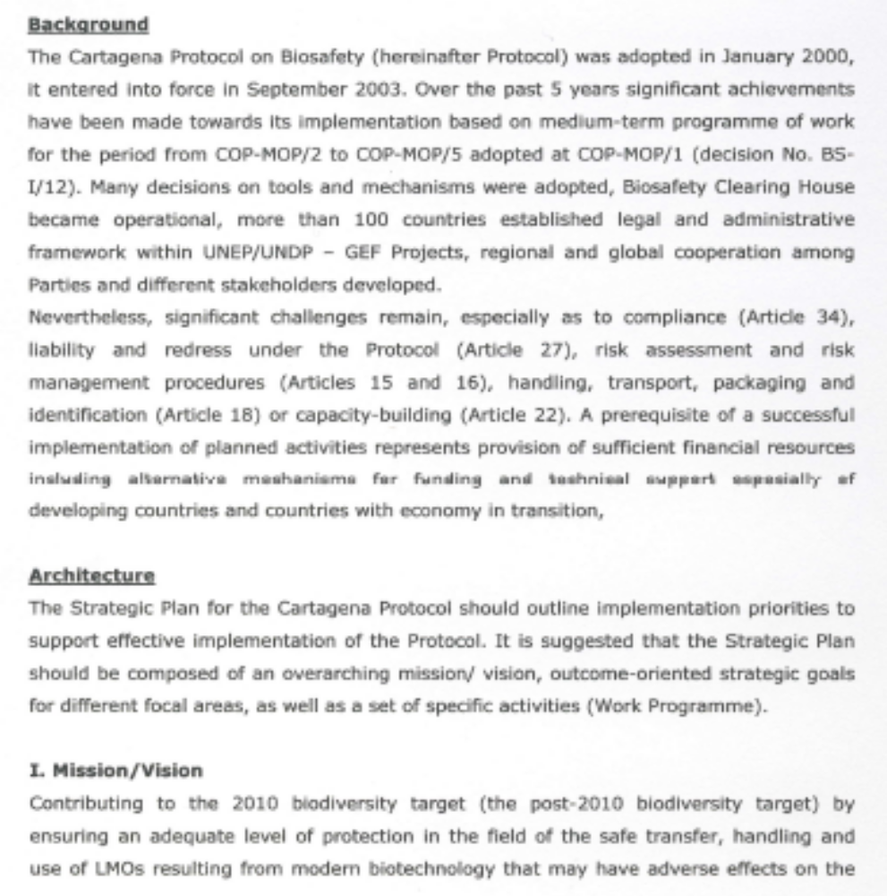
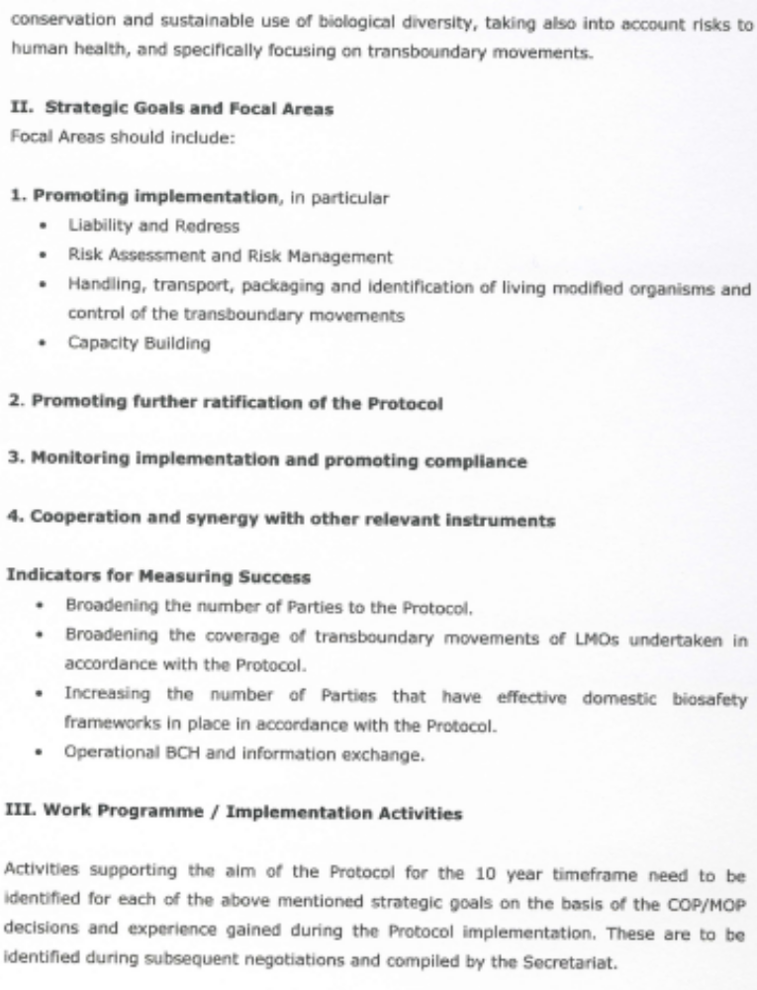

Japan
Japan | [8 APRIL 2009] [SUBMISSION: ENGLISH]

Views on a Strategic Plan for Implementation of the Cartagena Protocol on Biosafety
Government of Japan

- APPLICATION OF THE ADVANCE INFORMED AGREEMENT PROCEDURE（Article 7）、NOTIFICATION（Article 8）
(1)National implementation experiences are scheduled to be reviewed at the sixth meeting of the COP-MOP based on the analysis of the second national reports in accordance with BS-IV/18.
2. RISK ASSESSMENT（Article 15）, RISK MANAGEMENT（Article 16）
(1)At its sixth meeting, the COP-MOP may consider convening meetings of technical expert group on risk management in order to exchange views on appropriate level of risk management for specific LMOs by the seventh meeting of the COP-MOP.
(2) Outcome of discussions by other bodies such as OECD Working Group on the Harmonisation of Regulatory Oversight in Biotechnology would be useful in considering risk assessment and management.
(3)Outcome of the meetings of the Ad Hoc Technical Expert Group is to be reported to the fifth meeting of the COP-MOP in accordance with BS-IV/11. COP-MOP may consider working on this issue if further work of necessity is identified at its fifth meeting.
3. HANDLING, TRANSPORT, PACKAGING AND IDENTIFICATION（Article 18）
(1)This matter is scheduled to be reviewed at COP-MOP6 in light of the review of experience based on the analysis of the second national reports in accordance with BS-IV/8.
(2)Outcome of the online conference is to be considered at the COP-MOP5 in accordance with BS-IV/10. COP-MOP may consider working on this issue if further work of necessity is identified at its fifth meeting.
4. INFORMATION SHARING AND THE BIOSAFETY CLEARING-HOUSE（Article20）
(1) The COP-MOP may consider promoting obligatory submissions to the Biosafety Clearing-House using existing tools such as the UNEP-GEF Biosafety Clearing-House project.
5. CAPACITY-BUILDING（Article22）
(1) Implementation of the Coordination Mechanism is scheduled to be reviewed at the sixth meeting of the COP-MOP in accordance with BS-IV/3, which requests the Executive Secretary to report on implementation of the Coordination Mechanism.
(2)Use of the revised set of indicators is scheduled to be reviewed at the sixth meeting of the COP-MOP in accordance with BS-IV/3, which requests the Executive Secretary to prepare a synthesis report on the experiences with and lessons learned from the use of the indicators.
(3) Performance of the roster is scheduled to be reviewed at sixth meeting of the COP-MOP in accordance with BS-IV/4 which requests the Executive Secretary to prepare a document for consideration.
6. PUBLIC AWARENESS AND PARTICIPATION（Article23）
(1)The COP-MOP should implement the programme of work on public awareness, education and participation concerning the safe transfer, handling and use of living modified organisms which is to be considered at its fifth meeting.
(2)Implementation of the outreach strategy for the Cartagena Protocol on Biosafety (2008-2012) is scheduled to be reported by Executive Secretary in accordance with BS-IV/17, and therefore is to be reviewed, at the sixth meeting of the COP-MOP in accordance with BS-IV/17.
7. SOCIO-ECONOMIC CONSIDERATIONS（Article26）
(1) This item is scheduled to be reviewed at the sixth meeting of the COP-MOP based on the second national reports in accordance with BS-IV/16.
8. LIABILITY AND REDRESS（Article27）
(1)The group of the friends of the co-chairs on liability and redress decided at its first meeting held in Feb. 2009 to work towards legally binding provisions on administrative approach for liability and redress in the form of one supplementary protocol to the Biosafety Protocol. COP-MOP may continue to consider working on this issue if further work of necessity is identified at its fifth meeting.
9. SUBSIDIARY BODIES（Article30）
(1) The need to establish an open-ended subsidiary body for scientific and technical advice under the Protocol is scheduled to be considered at the sixth meeting of the COP-MOP in accordance to BS-IV/13.
(2) However, ad hoc technical expert groups referred to in paragraph 1 of BS-IV/13 seem to be sufficient for addressing technical matters.
10. MONITORING AND REPORTING（Article33）
(1) National reports are to be reviewed at sixth and eighth meetings of the COP-MOP in accordance with BS-I/9 which requests the Parties to submit reports every four years.
11. COMPLIANCE（Article34）
(1)COP-MOP should give higher priority to promoting fulfilment of the Parties’ obligation under the protocol rather than establishing new body such as subsidiary body for scientific and technical advice.

Norway
Norway | [20 MARCH 2009] [SUBMISSION: ENGLISH]

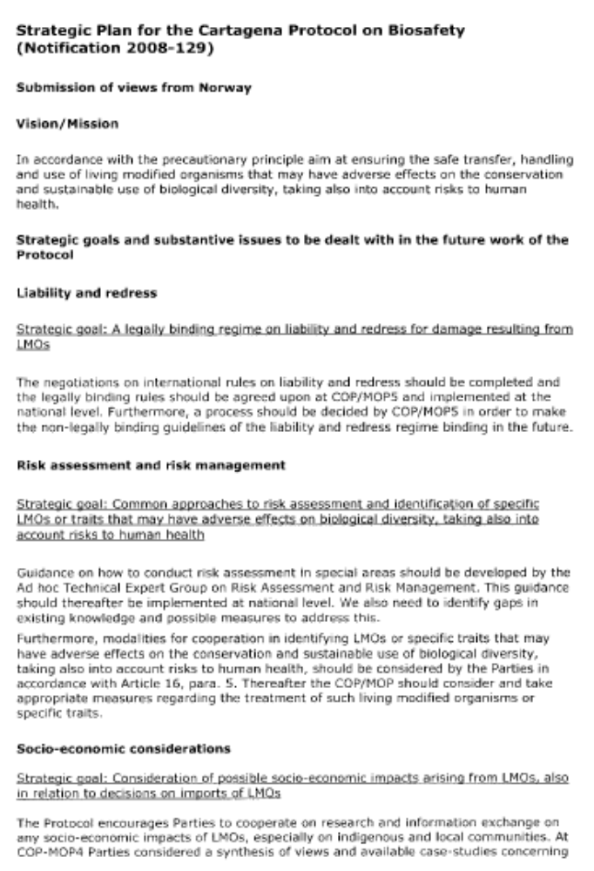
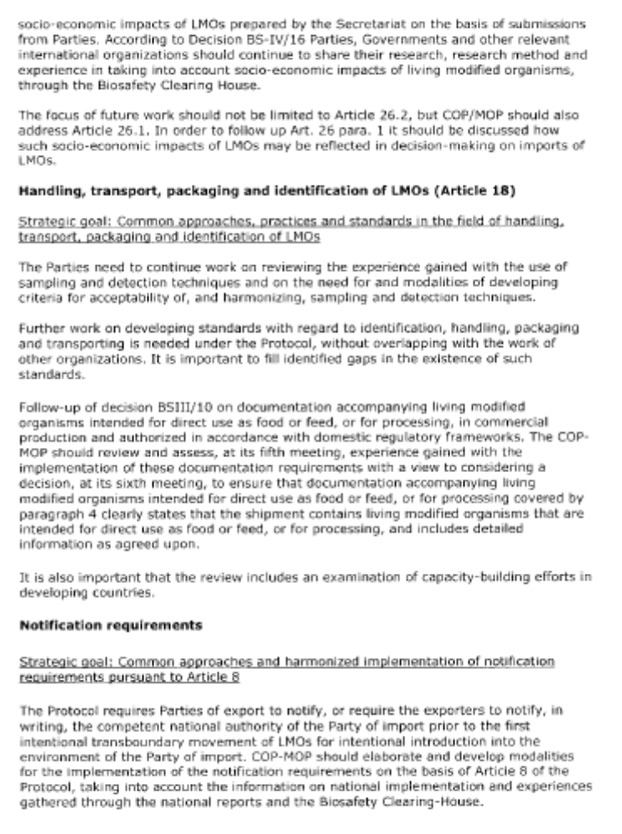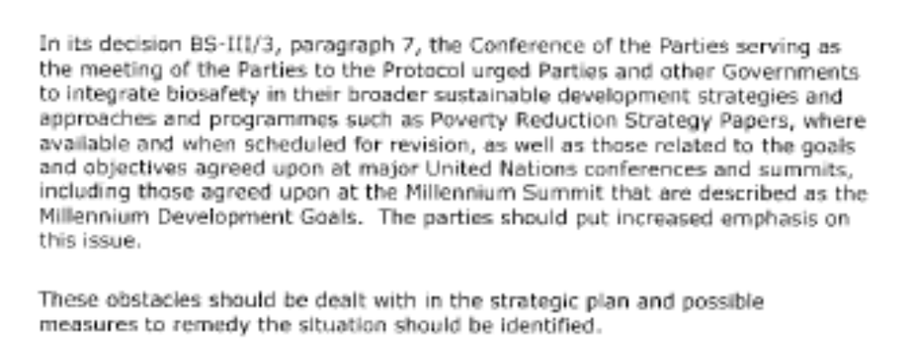

Thailand
Thailand | [30 DECEMBER 2008] [SUBMISSION: ENGLISH]

Thailand would like to include issues to be considered in preparation for a strategic plan for Cartagena Protocol on Biosafety as follows:

- Risk assessment and management (article 15 and 16)
- Risk assessment and management should be considered as a high priority issues, especially for the development of practical guideline as a reference and trade facilitation, such as practical guideline on low-level presence of recombinant-DNA plant (LLP).
- Information on risk assessment and management should be shared and harmonized among parties to strengthen their capacities and to provide basic information for further development.

- Handling, transport, packaging and identification (article 18)
Emphasis should be put on type of documents for identification of LMOs according to article 18 2 (b) and 2 (c), as well as considering needs and the development of standards for handling, transport, packaging and identification of LMOs.

- Information sharing and the Biosafety Clearing-House (article 20)
Parties should be urged to continuously share information, especially scientific and technical information on risk assessment and management through Biosafety Clearing-house. Funds should be allocated to support parties in developing and sustaining the operation of Biosafety Clearing-house both at central portal and national level.

- Capacity-building (article 22)
Difference in capacities of parties would hinder process in implementing the Protocol; therefore, capacity building, through series of sub-regional workshops, trainings and exchange of information should also be considered to equalize implementing capacities of the parties.

- Other issues to be continuously considered or introduced into strategic plan
- impacts of LMOs on agricultural and livestock sectors
- liability and redress
- socioeconomic consideration
- public awareness and participation

COMMENTS FROM PARTIES AND OTHER GOVERNMENTS

Benin
Benin | [21 JANUARY 2010] [SUBMISSION: FRENCH]
PROJET D’ÉLEMENTS DU PLAN STRATÉGIQUE DATE: 081209
PROTOCOLE DE CARTAGENA SUR LA PRÉVENTION DES RISQUES BIOTECHNOLOGIQUES

VISION
La diversité biologique est adéquatement protégée contre tout effet défavorable d’organismes vivants modifiés.
MISSION
Renforcer l’action à l’échelle mondiale pour assurer la manipulation, le transport et l’utilisation sans danger d’organismes vivants modifiés susceptibles d’avoir des effets défavorables sur la conservation et l’utilisation durable de la diversité biologique, compte tenu également des risques pour la santé humaine et animale.
Objectif stratégique | Effets escomptés | Objectifs concrets | Résultats | Indicateurs
1. Mettre en place les outils supplémentaires nécessaires à la pleine mise en œuvre du Protocole | La pleine compréhension et application du Protocole de Cartagena pour la prévention des risques biotechnologiques par les Parties
 |  | 1.6 Elaborer des directives et des outils destinés à aider les parties à mettre en place des zones ou territoires sans OVM | Les centres d’origine de ressources génétiques, les aires protégées et les zones spécifiques sont exempts d’OVM | Un nombre croissant de parties disposent des centres d’origine de ressources génétiques et d’aires protégées sans OVM
2. Renforcer la capacité des Parties d’appliquer le Protocole | Des systèmes réglementaires, administratifs et d’échange d’information effectifs et efficaces sont mis en place par les Parties aux fins de l’application du Protocole  La prise de décisions est plus rigoureuse et plus transparente | 2.4 Renforcer les capacités pour la manipulation, le transport, l’emballage et l’identification des organismes vivants modifiés | - Les douaniers, le personnel de laboratoire et les autres corps de contrôle sont en mesure d’appliquer les exigences relatives à la manipulation, au transport, à l’emballage et à l’identification des organismes vivants modifiés  - Le personnel (douanier, personnel de laboratoire et les autres corps de contrôle) est formé et équipé pour l’échantillonnage, la détection et l’identification des OVM | - Nombre de douaniers, le personnel de laboratoire et les autres corps de contrôle formés  - Nombre de Parties faisant rapport sur leur expérience de l’échantillonnage d’expéditions et de détection d’OVM dans leurs deuxième, troisième et quatrième rapports nationaux
 |  |  |  | - Nombre accru de documents en français dans le Centre d’échange pour la prévention des risques biotechniques
 |  | 2.8 Renforcer les capacités de suivi des zone/territoires sans OVM | Rapports des experts sur les études des zones/territoires sans OVM sont faits et disponibles | Nombre de rapports d’experts sur les zones/territoires sans OVM
5) Accroître la disponibilité, l’accès et l’échange d’informations pertinentes dans le Centre d’échange pour la prévention des risques biotechnologiques

Botswana
Botswana | [10 FEBRUARY 2010] [SUBMISSION: ENGLISH]

The concerns on food products derived from LMOs seem to be ignored. It is therefore suggested to be given attention on the basis of identification and transboundary movements hence regulated accordingly.

Brazil
Brazil | [01 FEBRUARY 2010] [SUBMISSION: ENGLISH]
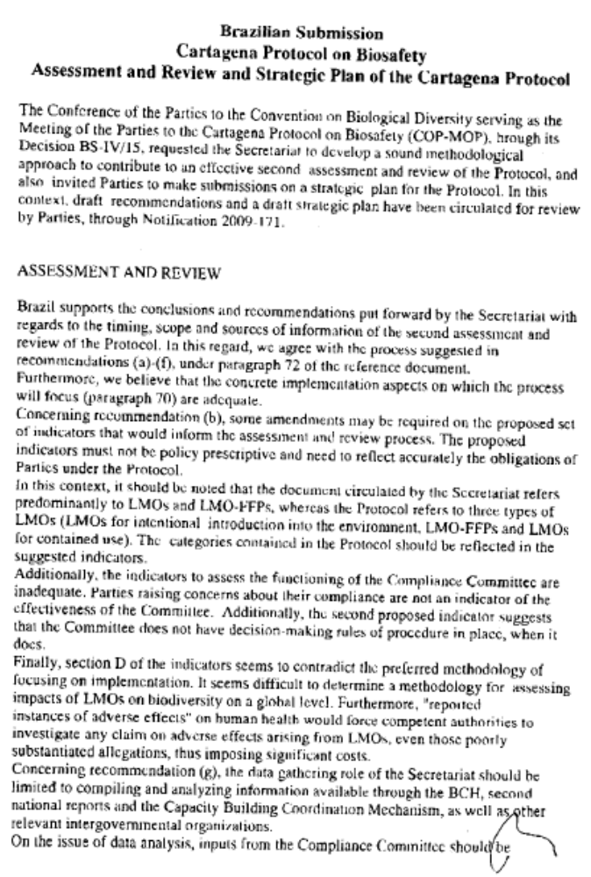
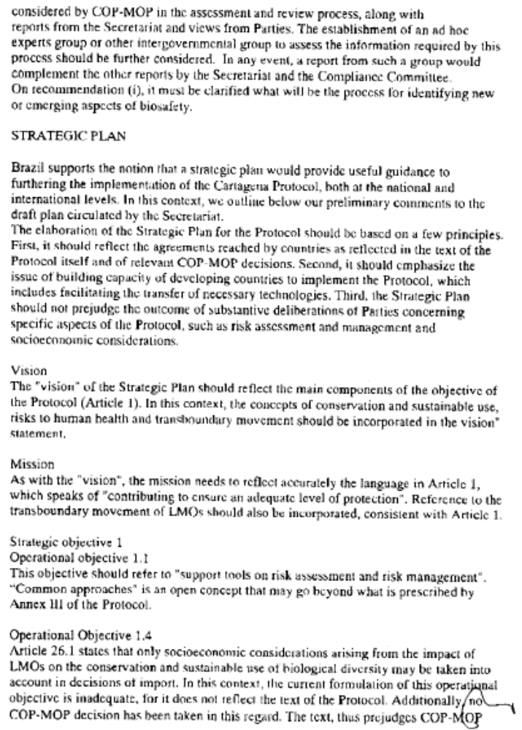
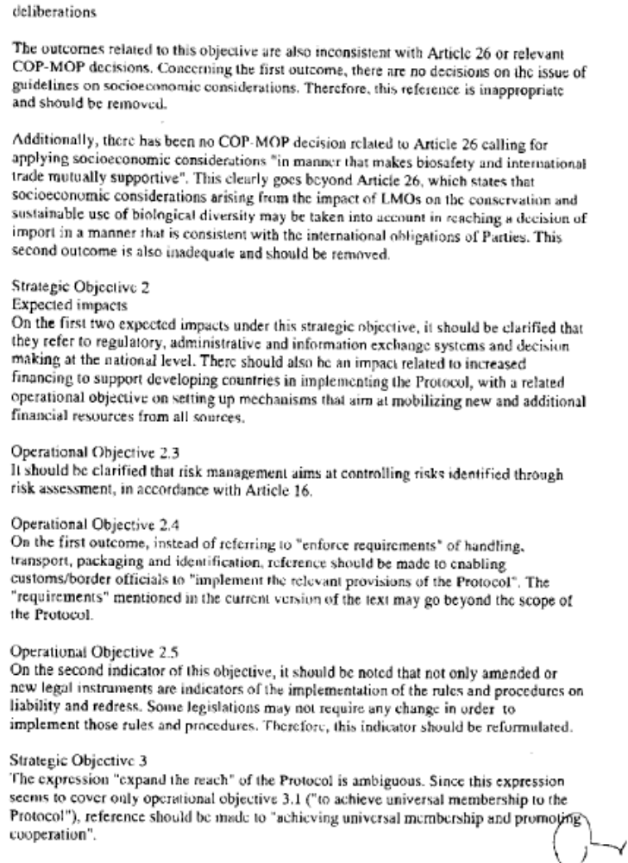
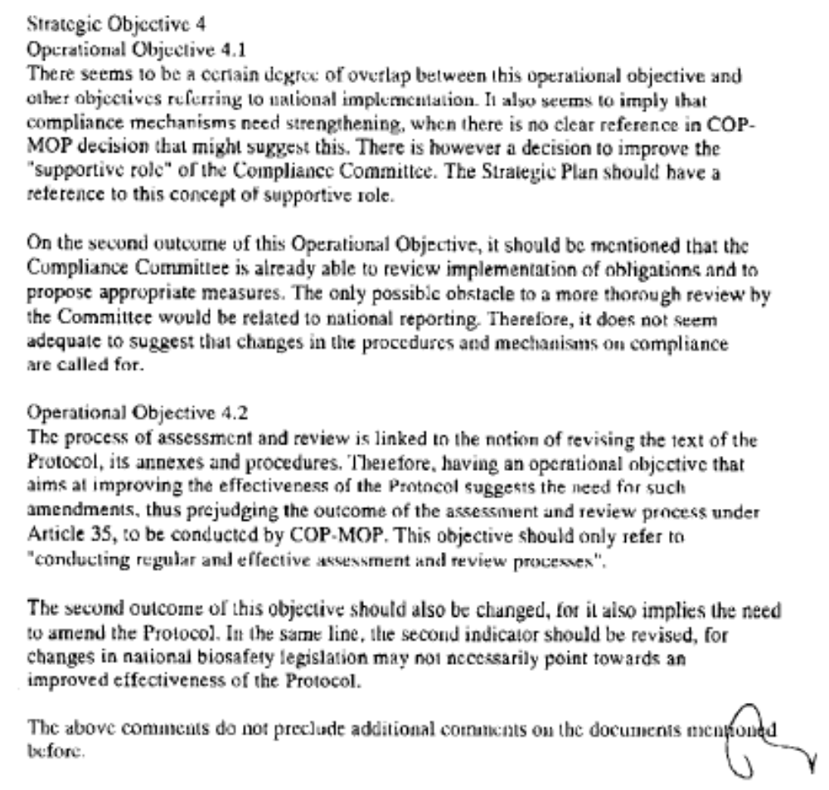

Canada
Canada | [13 MAY 2010] [SUBMISSION: ENGLISH]

Comments from Canada in response to Notification SCBD/BS/CG/jh/71409

General comments
The strategic plan includes operational objectives, outcomes and indicators, but no guidance as to actions to be taken to achieve the objectives. The performance indicators for the operational objectives and outcomes require additional explanation with respect to the process that will be used to collect the required information including description of: data collection (self-reporting or questionnaires to the Parties), data analysis, responsibility for reporting, format of report, report distribution and timeframes.

Quantitative performance indicators should monitor individual components. For example, in Objective 4.1, one of the performance indicators is the number of parties that have identified and addressed their non-compliance issues. Pooling the identification and remedial actions together in the same indicator will result in misrepresentation and loss of information. A suggestion is to have one indicator for the number of parties that have identified non-compliance actions, and another indicator for the number of parties that have addressed their non-compliances actions. Individual monitoring should apply to all the quantitative indicators.

Background
Para 6: The progress column in the Table outlining the preliminary review of progress towards the goals of the CBD could provide more meaningful information in order to better identify gaps and attempt to address these elements in a new strategy. For example, under Goal 1, an impressive number of Parties are listed as having ratified the Protocol. Further analysis of this information would reveal that few major exporting jurisdictions have ratified. Another example, under Goal 2, is identification of the many countries that have initiated measures to implement the Protocol. In reality, Parties should not ratify if they are not able to meet the obligations. Reports from the Compliance Committee have repeatedly noted the failure of Parties to fully implement the Protocol. The recent consultant’s report on effectiveness of the Protocol pointed out that so few Parties have implemented their obligations that effectiveness can not be assessed. Also under Goal 2, there is reference to 120 countries that have developed national frameworks and are in the process of operationalizing them. Are countries referred to here Parties? It is also unclear what is meant by “in the process of operationalizing”. Identification of the gaps in the process and where they occur would provide more useful information for future planning. Under Goal 3 low levels of national reporting should also be identified. A solution for making this table more useful as a planning tool would be to introduce a new column, with the heading Challenges, where some of these gaps might be identified.

Annex I, Context
p. 6: It should be noted in the Context section that few exporting countries are Parties; that many Parties have not implemented Protocol obligations through appropriate legislative measures; and that reporting levels are low. The low level of implementation has made it difficult to have a meaningful review of effectiveness. In order to assess the effectiveness of an instrument, a good understanding of the levels of compliance is required.

Annex I, Assumptions
Para 10: Some of the assumptions require validation. For example:
- If many Parties have not implemented the Protocol, can it be assumed they are incorporating MOP decisions into their domestic frameworks?
- The work of the Compliance Committee has shown that Parties will not submit timely national reports
- In the current economic climate, can it be assumed that "adequate and predictable financial resources will be available" and that there will be "a progressive increase in human resources at the international and national level"?
Monitoring, Review and Evaluation Para 13: The draft document proposes that the strategic plan will be implemented through a 10-year programme of work for the Protocol, supported by biennial work plans. The medium-term programme of work will, if necessary, be adjusted from time to time on the basis of experience gained in the implementation of the requirements of the Protocol and of the results of the periodic assessment and review of the effectiveness of the Protocol. A clause acknowledging the need for adjustment is a good addition. In light of some of the incorrect assumptions pointed out above, particularly with respect to implementation and effectiveness, this approach requires further consideration.

Draft Elements of the Strategic Plan, version 010310

Page 9-19:
Focal Area 1, Objective 1.2: Article 7.4 allows the MOP to create a list of LMOs not likely to have adverse effects. Recognizing this Article in the plan could ease the burden on developing countries. For the list that could have adverse effects, the requirements in Articles 10 and 15 for a case by case risk assessment would still need to be reflected in indicators, e.g. "timely risk assessments are conducted on a case-by-case basis". Another indicator might be "no incidents of releases with adverse effects on the conservation and sustainable use of biological diversity”.

Operational objective 1.3: The expected outcome is improved scientific and technical advice and the proposed indicator is the number of scientific and technical guidance materials provided. Increasing the amount of guidance material could actually lead to deterioration in the quality of scientific and technical advice. Maintaining and improving the quality of scientific and technical guidance requires that the advice is impartial, originates from independent scientific and technical experts and is subjected to a peer review process.

Objective 1.4: The indicator suggested for the objective related to identification, handling, packaging and transportation of LMOs is the percentage of Parties following procedures. Rather than reporting on percentage of Parties, we propose reporting on the percentage of companies or the percentage of shipments by Party. This indicator will better inform on the actual number of shipments with documentation and will not produce skewed data for countries in which only some companies follow the procedures. In addition, the Strategic Plan should also indicate how the identification of the LMO will be verified e.g. random verification carried out by the importing countries? a certification system by the exporting country?

Focal Area 2: Objective 2.1: Neither Article 28 nor Article 22 call for "new and additional" financial resources. The proposed indicator "new and additional financial resources being mobilized for the implementation of the Protocol" is not appropriate.

Objective 2.3: One of the indicators suggests recording the number of Parties that have infrastructure including laboratories for monitoring, management and control. The operational objectives and outcomes should clarify that it is the responsibility of exporting Parties to conduct risk assessments and risk management plans. For consistency in approaches to addressing risk assessment and risk management, we propose using the same indicators as suggested above under operational objective 1.2 e.g. "timely risk assessments are conducted on a case-by-case basis" and "no incidents of releases with adverse effects on the conservation and sustainable use of biological diversity”.

Focal Area 3, Objective 3.3, Communication and Outreach: An indicator should be included on “outreach to non-Parties who are large exporters of LMOs”.

Focal Area 4: Compliance and effectiveness are two different things and might be best addressed by two separate focal areas.

Objective 4.1: Rather than have an objective "to strengthen the mechanisms for achieving compliance it would be clearer to say "to strengthen Party compliance with the Protocol". In this way the indicators would include a list of mechanisms used to achieve the outcomes. The first Outcome is for each Party to regularly monitor the implementation of its obligations…etc. Would an appropriate first outcome not be that “each Party fully implements its obligations”? Obligations first have to be implemented before they can be monitored and reported upon.

The outcomes relating to the Compliance Committee require clarification. The Compliance Committee already thoroughly reviews implementation of systemic non-compliance. Is there additional outcome anticipated? The Compliance Committee is a facilitative committee, which is evidenced by the nature of the procedures and the powers given to it. How can the supportive role of the Compliance Committee be improved? It should also be indicated whether the sufficient financial resources for compliance are to come from the national or the international level.

The indicator on the number of Parties identifying and addressing non-compliance issues requires explanation as to where the information will come from.
The number of Parties having an approved and functional national biosafety framework would be improved by substituting “framework” with "Laws implementing the Protocol”. The indicator “number of parties having in place a system for handling requests should include "for Advance Informed Agreement". This could be added to the end of the indicator.

Objective 4.2: Improved reporting by Parties is not an outcome related to effectiveness. This outcome is related to compliance and should be included under Objective 4.1. The associated indicator on number of national reports received should also go under Objective 4.1. The indicator “Number of parties modifying their national biosafety frameworks with the aim of adapting to new biosafety challenges” requires clarification. A suggested modification is “Number of parties modifying their national biosafety frameworks to correspond with amendments to the Protocol adopted to address new challenges".
The link between the number of subsidiary bodies established by the MOP and the effectiveness of the Protocol is unclear. A proposed new indicator for this objective is "Key LMO exporting countries become Parties to the Protocol."

Focal Area 5, Objective 5.1: In order to understand the link between the objective and the indicator on the amount of traffic to the BCH and the number of references to the BCH, an explanation is required as to how the traffic would be quantified and where and how the references to the BCH would be quantified.
The indicator "Number of non-Parties having published biosafety laws and/or regulations on the BCH." should be deleted. Non-Parties do not have obligations. Non-parties who submit information are doing so voluntarily and their actions can not be considered as a measure of the success/implementation of the Protocol.

China
China | [16 MARCH 2010] [SUBMISSION: ENGLISH]

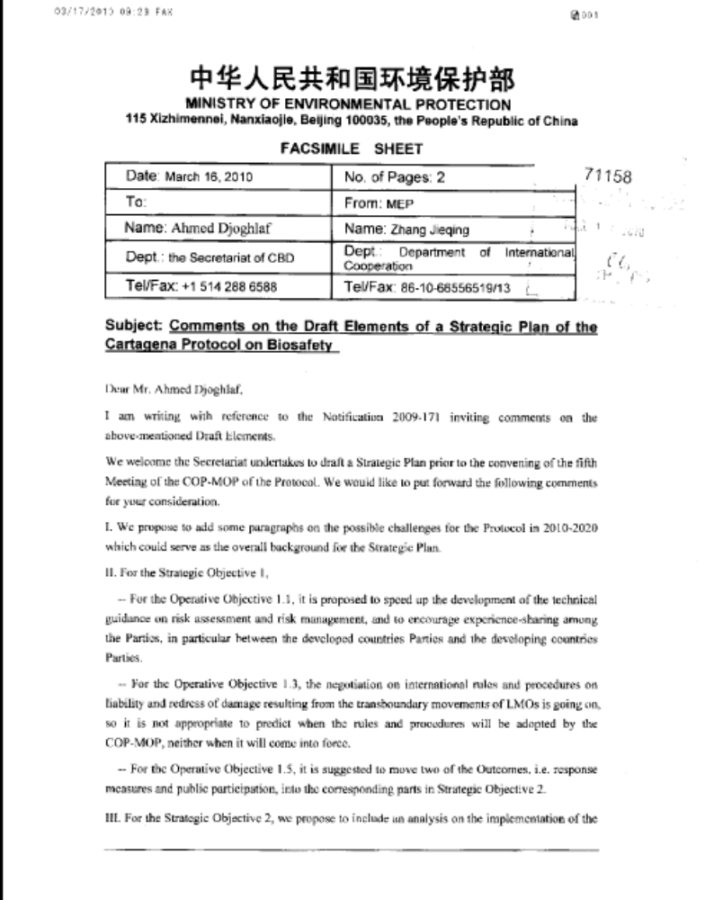
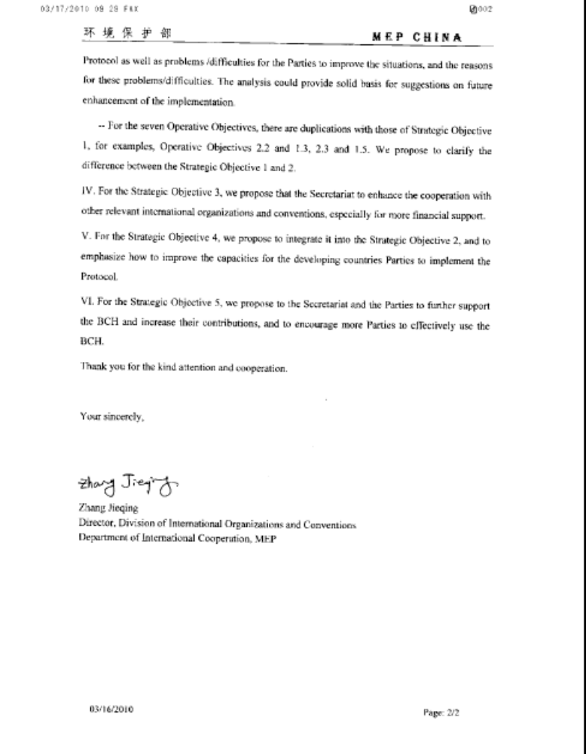

Cuba
Cuba | [17 MAY 2010]  [SUBMISSION: ENGLISH]

Comments made by the National Authority of Cuba on the Strategic Plan for the Cartagena Protocol, 2011- 2020.

GENERAL COMMENTS:

Work should be focused on the indicators, which are non-measurable in most cases, since they, basically, refer to either percentage of parties or number of parties without specifying figures.
A pattern that allows to measure percentage or number of parties should be taken as reference to determine if it is high, medium, or low.

Each expected impact, operational objective, result or indicator should be enumerated somehow to establish a horizontal logic.

SPECIFIC COMMENTS

Focal area 1. Further Guidance development

Page 10

Objective. 1.2 We feel that it is more tangible to refer to LMOs monitoring wholly and outline objectives, outcomes and indicators towards this aspect, whose gaps have been spotted by the parties.

Objective 1.3. More than fostering the mechanism, it would be creating a scientific and technical mechanism to the Protocol since it does not exist by the time. In keeping with this, the outcome would be the Mechanism created.

Objective 1.4 We reasonably think that a first part should be added to the objective in order to get clearer concepts concerning handling, transport, bottling and identification so as the parties have a greater capacity to implement requirements that are more concrete.

Page 11

Objective 1.5 The first indicator should be moved to the outcomes column. We feel that the Supplementary protocol and its entry into force classifies more as an outcome than an indicator.

Objective 1.6 The first indicator should be removed from here, for the second indicator contains it.

Page 12.

Objective 1.7. The first outcome should be removed from here, and insert transit in the second, since the objective covers transit issues in the guidelines.

Focal area 2. Capacity building

Pág. Page 13.

Objective.2.1 The first outcome should be removed due to ambiguity ( or for not being clear)

Page 14.

Objective 2.2 The outcomes should be removed from here. We consider that it would be more coherent to the objective if the outcome were stated as follows: the Biosafety national frameworks established by the parties taking into account the integration of Biosafety into the most relevant sectors

Objectives. 2.3 (pág 14), 2.4, 2.5 (page 15) and 2.7 (page16) should be removed from this focal area. These objectives are already under analysis in the plan; they can either be found under focal area 1 or further down in the document (area 5).

This proposal is based on the fact that, the outcomes and indicators proposed herein, do not differ that much from those described for these same objectives under the other areas.
Moreover, the outcomes and indicators set forth in areas 1 and 5 intrinsically deal with capacity building, without which these actions cannot be achieved. We recommend removing them from here and insert what is appropriate of its content in focal areas 1 and 5 in which these objectives are dealt from their technical viewpoint.

Page 15

Objective 2.6 The first outcome should relate to the provision of guidelines and training materials for the parties. There should be guidelines in place, first, for the parties to have access to, then. The second indicator should be removed from this indicator since the first one contains it already. The third indicator does not measure the objective; it is not necessary to have an expert network set in the matter of public education to comply with the objective.

Focal area 3: Outreach and cooperation

Page 16.

Objective 3.1 The indicator should refer to the 100% of the parties. In this case, to be in accordance with the expected outcome, the only and possible indicator is that of the 100% of the parties, otherwise, a lesser percentage should be established if delimited in time: for instance, 80% of the parties to the Convention are parties to the Protocol for 2017.

Focal area 5. Information sharing

Page 19.

Objective 5.1 The word Quantity should be replaced by Increase

Czech Republic
Czech Republic | [25 FEBRUARY 2010]  [28 APRIL 2010]  [SUBMISSION: ENGLISH]

Comments on the draft Strategic Plan to the CPB
(Notiication No. 2010-058)
Milena Roudná, National UNEP/GEF Project Coordinator, Czech Republic

Recommendations for the changes:
Annex 1 – I. Context, page 6, ad 5, add the following or correct (in bold):
This draft Strategic Plan and …have been prepared on the basis of ….decisions taken ….at its last four meetings, and through general discussion and comments received.
II., page 7, ad 6 – last sentence – formulation of strategic objectives need to be in accordance with those in the Table (pages 9-19) and reformulated as follows:
The focal areas underlying the five strategic objectives are as follows: 1. Implementation of the Protocol; 2. Capacity Building; 3. Outreach and Cooperation; 4. Compliance and Review; 5. Information Sharing.
Ad 7, second bullet: The operational objectives …..in order to implement impacts
Ad 8, in the last sentence delete for example: Some of the actions will be undertaken by Parties …
III., ad 10, (a): …. MPO decisions into their national/regional frameworks
(i.e. to use corresponding terminology)
c) – delete text in the parenthesis: Parties ……required information to the BCH
IV. , page 8 , ad 12 – last sentence, last line (to be text quite clear):
…and technical/capacity building support, as well as of two programme assistants
V., page 8, ad 13, last but one sentence:
Information will be drawn mainly from national reports and from other available sources to generate the data necessary for the analysis.
i.e. delete among other things

Draft Elements of the Strategic Plan – Table, pp. 9 - 19

Strategic Objective – Focal Area 1 (page 9)
Further Guidance Development – this is more a tool how to reach strategic objective not strategic objective as such – recommendation (in line with content):
Implementation of the Protocol (see page 7, II. Ad 6)

Expected Impacts
P. 13 – Expected Impacts arrange in a logical way, as follows (and complete add 2):
(1) Increased safety in …
(2) Effective and efficient regulatory, administrative and monitoring frameworks….
(3) Necessary mechanisms put in place ….
(4) More transparent and expeditious decision-making
(5) Full use of information exchange system
P. 19 - Expected Impacts arrange in a logical way, as follows:
(1) Transparency in the development …
(2) Increased compliance …
(3) Informed decision making
(4) Enhanced public awareness of biosafety

Operational Objectives
Focal Area 1, p. 9-12 - arrange in a logical way, as follows:
1.1 Scientific and technical advice
1.2 LMOs or traits that may have …
1.3 Risk assessment and risk management
1.4 Handling, transport, packaging and identification
1.5 Transit, contained use …
1.6 Liability and redress
Focal Area 2, p. 13-16 (proposed changes p. 15-16) - arrange in a logical way, as follows:
2.1 Coordination and support
2.2 National Biosafety Framework
2.3 Risk assessment and risk management
2.4 Handling, transport …
2.5 Liability and redress
2.6 Information sharing
2.7 Biosafety education and training
2.8 Public awareness …

Outcomes
P. 11:
Each Party takes ….necessary to implement the rules and procedures on liability and redress at national level
i.e. delete , at the domestic level,
P. 13:
Compare bullet 3rd and bullet 5th – recommendation to delete bullet 3: Parties have adequate …
Similar appears among Indicators – p. 13 – last but one bullet: Number of Parties that have predictable and reliable funding ….
Moreover, what means predictable financial resources, especially in our period and current economic situation? Who can guarantee them?
P. 16:
Outcomes related to 2.7 - arrange in a logical way, as follows:
(1) Increased access to information …
(2) Tools to facilitate implementation ..
(3) Information on BCH …
P. 18:
Outcomes related to 4.2 – second bullet:
The Protocol, including its procedure and annexes, is amended if new challenges are ….
i.e. replace adapted by amended
delete by Parties as the precise rules of procedure exists under which conditions Protocol can be amended - COP/MOP role etc. not Parties as such ?

Indicators
P. 11 – second bullet:
Percentage of Parties …having in place national administrative … (terminology)
P. 13 predictable and reliable funding ?
P. 14 – second bullet related to 2.3:
Number of risk assessment ….that are in compliance with the Protocol
P. 15 – second bullet related to 2.5: Number …in the field of liability and redress
Third bullet related to 2.6:
Number of Parties authorities with a network of biosafety and communication experts –
Questionable, not too realistic
P. 16 – second bullet related to 2.7: Amount of traffic to the BCH … ? – see as well p. 19
P. 17 – second bullet related to 3.3:
Percentage of Parties that have in place national communication strategies on biosafety …-
Maybe desirable, but not too realistic – such strategy can be a part of National Biosafety Strategy or of other related national strategic documents, depending on each Party conditions/situation.
P. 18
Second bullet related to 4.2:
Number of Parties …..with the aim to meet new biosafety chalanges (delete of adapting to new).
4th bullet to 4.2:
Number of subsidiary bodies …
Can this be really an indicator of success ? efficiency, synergy …?

Comments Made 25 February 2010
The last version of the proposed Strategic Plan has several positive elements, nevertheless some parts need to be restructured-reformulated.

Positive elements:
Arragement in the form of a Table
Vision and Mission - briefly and clearly defined
Comments to other parts:
Strategic Objectives - positive: restricted number - most important objectives, in some cases formulation can be improved
Expected Impacts - generally well defined, only small changes recommended (deletion of some details, which are not necessary)
Operational Objectives - in some cases better structuring or formulation recommended (e.g. 1.5)
Outcomes - more logical arrangement and re-definition in some cases needed, as well as deletion of some not necessary details
Indicators - most problematic part which needs to be redrafted - restructured:
need to measure progress
existing indicators not clearly defined (expresions such as "numerous" etc.; instead existing expressions use: percentage of Parties/ number of Parties)
missing logistic in precisely given terms (e.g. national biosafety legislation by 2015 - on the other hand documents for which the existing legislation represents the prerequisite required in a shorter horizon - e.g. national communication strategy, mechanism for ensuring public participation in decision-making, capacity-building action plan)
some of existing indicators have more character of outcomes (reallocation to corresponding part)
to be fully functional, indicators in SP need to be in correlation with indicators used in other related documents.

General comments:
Due to the character of the document - as strategic one - to delete all details which are not necessary (explanations in sentences, examples in parenthesis, some adjectives)
On the principle of synergy, i tis recommended to use results of other conventions or specialized groups, in this case especially results of the 6th Coordination Meeting for Governments and Organizations Implementing and/or Funding Biosafety Capacity-building Activities and the 7th Meeting of Liaison Group on Capacity-building for Biosafety (February 2010, Cambodia).

Ecuador
Ecuador | [15 APRIL 2010] [SUBMISSION: SPANISH]
PROYECTO DE ELEMENTOS DEL PLAN ESTRATÉGICO FECHA: 081209

PROTOCOLO DE CARTAGENA SOBRE SEGURIDAD DE LA BIOTECNOLOGÍA

VISIÓN
La diversidad biológica está adecuadamente protegida de cualquier efecto adverso de organismos vivos modificados.
MISIÓN
Fortalecer la acción mundial para garantizar la transferencia, manipulación y utilización seguras de todos los organismos vivos modificados que puedan tener efectos adversos en la conservación y utilización sostenible de la diversidad biológica, teniendo también en cuenta los riesgos para la salud humana.
Objetivo estratégico | Efectos esperados | Objetivos operacionales | Resultados | Indicadores
1. Establecer otros instrumentos necesarios para llevar el Protocolo plenamente a la práctica | Aplicación plena del Protocolo de Cartagena sobre Seguridad de la Biotecnología por las Partes  Mejora del desempeño de las Partes para alcanzar los objetivos generales de conservación y utilización sostenible de la diversidad biológica | 1.1 Desarrollar más a fondo y producir instrumentos basados en las ciencias sobre enfoques comunes de evaluación del riesgo y gestión del riesgo para las Partes | - Se pone a disposición de las Partes y otros interesados orientación sobre evaluación del riesgo y gestión del riesgo que aborda nuevos avances en la tecnología moderna  - Las Partes y otros Gobiernos establecen y adoptan enfoques comunes de evaluación del riesgo y gestión del riesgo, según proceda | - Se produce, y proporciona a las Partes y otros Gobiernos, una cantidad importante de instrumentos y documentos de orientación sobre evaluación del riesgo y gestión del riesgo.  Sugerimos plantearse el indicador asi: Instrumentos y documentos producidos y proporcionados a las Partes y otros Gobiernos, de orientación sobre evaluación del riesgo y gestión del riesgo  - Una cantidad importante de Partes adoptan enfoques comunes de evaluación del riesgo y gestión del riesgo. Sugerimos plantearse el indicador asi: Enfoques comunes de evaluación del riesgo y gestión del riesgo adoptados por las Partes.  Comentario: Para lograr esto hay que hacer un gran esfuerzo para establecer proyectos donde participen los países que pueden tener enfoques comunes. Por ejemplo al momento existe un proyecto donde participan algunos países andinos sobre evaluación de riesgo en nuestra región, pero a Ecuador nunca se le preguntó si quería o podía participar. Por lo tanto, la experiencia ganada será solo para algunos países de la región y luego se pretenderá que enfoques de evaluación se armonicen, pero sino hay un diálogo entre todas las partes interesadas es difícil llegar a estos acuerdos.  - Se reducen al mínimo los posibles efectos adversos de los OVM en la diversidad biológica  Sugerimos plantear en indicador así: Efectos adversos de los OVM en la diversidad biológica reducidos al mínimo.  Comentario:Es muy subjetivo, cómo se puede tener constancia de esto, talvez a través de sistemas nacional de bioseguridad que marchen y se fortalezcan. Creo que no esta planteado como indicador
 |  | 1.3 Adoptar y aplicar normas y procedimientos de responsabilidad y compensación por daños resultantes de los movimientos transfronterizos de organismos vivos modificados | - Normas y procedimientos internacionales de responsabilidad y compensación por daños resultantes de los movimientos transfronterizos de organismos vivos modificados adoptados, ratificados por las Partes y en vigor  - Cada Parte adopta la medidas administrativas y jurídicas necesarias para aplicar, en el nivel nacional, las normas y procedimientos de responsabilidad y compensación | - Adopción de normas y procedimientos internacionales de responsabilidad y compensación por daños resultantes de los movimientos transfronterizos de organismos vivos modificados  - Entrada en vigor de las normas y procedimientos internacionales de responsabilidad y compensación antes de la séptima reunión de la Conferencia de las Partes que actúa como reunión de las Partes en el Protocolo  - Un número mayor sacar esta palabra de Partes han establecido marcos nacionales administrativos y jurídicos que incorporan normas y procedimientos de responsabilidad y compensación por daños resultantes de los movimientos transfronterizos de organismos vivos modificados  El tema de responsabilidad y compensación es muy importante, sin embargo se ha visto lo difícill poder establecer normas en este sentido debido a que “el daño” de los OVMs no se ha dado, no es cuantificable ni previsible. Por lo tanto, creo que en general este indicador es de muy difícil ejecución y que muchos países van a requerir de apoyo para lograr fortalecer y/o establecer medidas administrativas y jurídicas dentro de esta temática.
 |  | 1.4 Aclarar los factores socioeconómicos básicos que se pueden tomar en cuenta al adoptar decisiones sobre importación de organismos vivos modificados | - Se elaboran directrices apropiadas respecto a las consideraciones socioeconómicas relativas a los organismos vivos modificados, que son utilizadas por las Partes  - Las consideraciones socioeconómicas son aplicadas, según proceda, por las Partes de una manera en que la seguridad de la biotecnología y el comercio internacional se apoyen mutuamente | - Número de Partes que notifican experiencias positivas al tomar en cuenta las consideraciones socioeconómicas en la adopción de decisiones sobre la importación de organismos vivos modificados  Hay muy pocas experiencias de procesos de toma de decisión que hayan establecido consideraciones socioeconómicas, por lo difícil de incluir este parámetro de forma sustentada y técnica. Definitivamente sería un aporte si se logra tener directrices aplicables y sustentadas y no basadas en análisis teóricos no aplicables a la realidad de nuestros países.
 |  | 2.1 Establecer mecanismos eficaces para desarrollar, coordinar y supervisar las actividades de creación de capacidad | - Se establece un enfoque más cohesivo y un mecanismo eficiente para la creación de capacidad relacionada con la seguridad de la biotecnología  - Mejor comprensión de las necesidades de creación de capacidad de las Partes que son países en desarrollo y de las Partes con economías en transición  - Las Partes cuentan con recursos financieros y técnicos adecuados y previsibles que les permiten cumplir con sus obligaciones conforme al Protocolo de manera integrada y sostenible  - Cada Parte adopta y aplica estrategias y planes de acción nacionales de creación de capacidad exhaustivos | - Todas las Partes han evaluado sus necesidades de capacitación y creación de capacidad institucional y han presentado la información al Centro de Intercambio de Información sobre Seguridad de la Biotecnología (CIISB) antes de 2011  - Por lo menos el 50% de las Partes han desarrollado planes de acción de creación de capacidad para aplicar el Protocolo antes de 2012 (asi es como una meta)  Sugerimos plantear el indicador asi: Número de Partes han desarrollado planes de acción de creación de capacidad para aplicar el Protocolo antes de 2012  - Por lo menos el 50% de las Partes han establecido programas de capacitación para el personal que se ocupa de cuestiones relacoinadas con la seguridad de la biotecnología y para la capacitación a largo plazo de los profesionales de la seguridad de la biotecnología. (asi es como una meta)  Sugerimos plantear el indicador así: Número de Partes que han establecido programas de capacitación para el personal que se ocupa de cuestiones relacoinadas con la seguridad de la biotecnología y para la capacitación a largo plazo de los profesionales de la seguridad de la biotecnología  - Las Partes han establecido mecanismos nacionales de coordinación para las iniciativas de creación de capacidad en seguridad de la biotecnología. (esta como actividad cumplida).  Sugerimos plantear el indicador así: Número de Partes que han establecido mecanismos nacionales de coordinación para las iniciativas de creación de capacidad en seguridad de la biotecnología  - Mejor coordinación y colaboración entre las Partes y las entidades que ejecutan o financian los esfuerzos de creación de capacidad en seguridad de la biotecnología (ES ACTIVIDAD)  - Se aprovechan y se usan más eficazmente los recursos y oportunidades existentes  Sugerimos plantear así: Porcentaje de aprovechamiento y uso eficaz de los recursos y oportunidades existentes  - Las redes e instituciones regionales y nacionales existentes colaboran más estrechamente para hacer avanzar la creación de capacidad en seguridad de la biotecnología  En el caso de Ecuador el tema de capacitación es prioritario, ya que no tenemos establecido un Sistema Nacional de Bioseguridad, no tenemos regulaciones que realmente manejen el tema de evaluación y gestión de riesgo, por eso requerimos urgentemente ampliar el número de personas capacitadas que manejen estos temas y dinamicen este proceso en el país.
 |  | 2.2 Asegurar que todas las Partes hayan establecido marcos nacionales de seguridad de la biotecnología para la aplicación del Protocolo | - Las decisiones respecto a la seguridad de un organismo vivo modificado se basan sobre normas reglamentarias y administrativas bien establecidas  - Las cuestiones relativas a la seguridad de la biotecnología y la aplicación del Protocolo de Seguridad de la Biotecnología están integradas en los restantes sectores pertinentes, especialmente los sectores de agricultura, medio ambiente/diversidad biológica, salud y ciencia y tecnología | - Todas las Partes han establecido políticas y leyes nacionales sobre seguridad de la biotecnología, incluidos sistemas para la inspección, supervisión y aplicación de dichas leyes, antes de 2015(TAL COMO ESTÁ ES UNA META)  - La mayoría de las Partes aplica de manera efectiva sus leyes y reglamentos sobre seguridad de la biotecnología. (TAL COMO ESTÁ ES UNA META) Número de Partes que aplica de manera efectiva sus leyes y reglamentos sobre seguridad de la biotecnología  - Todas las Partes han designado un centro focal nacional y autoridades nacionales competentes. TAL COMO ESTÁ ES UNA META) Número de Partes que han designado un centro focal nacional y autoridades nacionales competentes  - Todas las Partes han establecido comités nacionales de seguridad de la biotecnología u órganos similares. TAL COMO ESTÁ ES UNA META) Número de Partes que han establecido comités nacionales de seguridad de la biotecnología u órganos similares  - Por lo menos el 50% de las Partes han establecido normas y procedimientos administrativos claros para manejar las notificaciones y solicitudes de aprobación de importación o liberación de OVM. (TAL COMO ESTÁ ES UNA META)Número de Partes que han establecido normas y procedimientos administrativos claros para manejar las notificaciones y solicitudes de aprobación de importación o liberación de OVM.  - Todas las Partes cuentan con sistemas para proteger la información confidencial. sugerimos: Número de partes que cuentan con sistemas para proteger la información confidencial.
 |  | 2.6 Mejorar la capacidad en el nivel nacional, regional e internacional que faciliten los esfuerzos para aumentar la concienciación del público y promover la educación y participación respecto a la transferencia, la manipulación y la utilización seguras de organismos vivos modificados | - Las Partes tienen acceso a materiales de orientación y capacitación sobre concienciación, educación y participación del público respecto a la transferencia, la manipulación y la utilización seguras de los OVM  - Las Partes cuentan con capacidad para promover y facilitar concienciación, educación y participación del público respecto a la seguridad de la biotecnología | - Todas las Partes habrán establecido estrategias nacionales de comunicación sobre seguridad de la biotecnología antes de 2012. (TAL COMO ESTÁ ES UNA META)  - Todas las Partes han creado sitios web y archivos con funciones de búsqueda nacionales sobre seguridad de la biotecnología. (TAL COMO ESTÁ ES UNA META)  - Por lo menos el 50% tienen centros de recursos nacionales o secciones en las bibliotecas nacionales existentes dedicados a materiales de educación sobre seguridad de la biotecnología. (TAL COMO ESTÁ ES UNA META)  - Todas las Partes habrán establecido mecanismos para garantizar la participación del público en la adopción de decisiones respecto a los OVM antes de 2012. (TAL COMO ESTÁ ES UNA META)  - Se han desarrollado instrumentos de apoyo (p. ej., plantillas, juegos de herramientas), que utilizan los puntos focales nacionales, educadores y comunicadores, sobre seguridad de la biotecnología. (TAL COMO ESTÁ ES UNA ACTIVIDAD) instrumentos de apoyo desarrollados (p. ej., plantillas, juegos de herramientas), que utilizan los puntos focales nacionales, educadores y comunicadores, sobre seguridad de la biotecnología  - Se han preparado y compartido estudios de casos y prácticas óptimas sobre concienciación, educación y participación del público respecto a la transferencia, la manipulación y la utilización seguras de los OVM  - Se ha establecido una red de expertos en educación y comunicación sobre seguridad de la biotecnología antes de 2011
3) Ampliar el alcance del Protocolo y promover la cooperación | Aumento del apoyo político para la aplicación del Protocolo  Aumento del apoyo de las organizaciones, convenios e iniciativas pertinentes, y colaboración con los mismos, para la aplicación del Protocolo | 3.1 Lograr una membresía universal en el Protocolo | - Todas las Partes en el Convenio sobre la Diversidad Biológica se convierten en Partes en el Protocolo  - Reconocimiento mundial del Protocolo de Cartagena sobre Seguridad de la Biotecnología como el principal instrumento en la esfera de la transferencia, la manipulación y el uso de organismos vivos modificados resultantes de la biotecnología moderna;  - Se facilita el cumplimiento del Protocolo | - Por lo menos el 50% de aquellos que no son Partes se convierten en Partes dentro del año posterior a la adopción de este Plan Estratégico (TAL COMO ESTÁ ES UNA META)  - Todas las Partes en el Convenio sobre la Diversidad Biológica se convierten en Partes en el Protocolo antes de 2015  Este indicador es irreal, hay Partes del Convenio de Diversidad Biológica, como Argentina, que no se convertirá en Parte del Protocolo antes del 2015, el Protocolo tiene grandes retractores como los grandes países productores de OVMs, por lo tanto es conveniente reorientar este indicador, talvez lo interesante sería que los Países que no son Parte por lo menos reconozcan al Protocolo como un instrumento clave el manejo de este tema, que colaboren con el BCH, entre otras actividades, pero si se mantiene así este indicador, es poco probable su cumplimiento.
 |  | 3.3 Elevar el perfil del Protocolo | - Aumento de la concienciación respecto al Protocolo y su visibilidad  - Todas las Partes han diseñado y aplicado estrategias de educación y comunicación que originan una mayor conciencia acerca de los asuntos relacionados con la seguridad de la biotecnología y el uso y la manipulación seguros de los organismos vivos modificados entre el público general, especialmente los agricultores  - Los asuntos relacionados con la seguridad de la biotecnología y las actividades pertinentes del Protocolo son cubiertas regularmente por los medios de comunicación tanto locales como internacionales  - Se incluye la seguridad de la biotecnología en los contenidos curriculares pertinentes de las instituciones académicas o educativas | - Número de programas nacionales de concienciación nacional sobre seguridad de la biotecnología  - Número de sitos web o bases de datos nacionales sobre seguridad de la biotecnología  - Cantidad y diversidad de materiales de concienciación y educativos sobre seguridad de la biotecnología y el Protocolo disponibles, a los que el público puede acceder en formato impreso y electrónico, inclusive por conducto del CIISB, sitios web nacionales y otros canales de comunicación  Para la difusión del Protocolo es imprescindible tener los medios técnicos y económicos para realizar campañas en instituciones, grupos relacionados como los agricultores, colegios, escuelas, etc. Para eso se necesita de proyectos concretos como fue el Proyecto del BCH que logró a través de sus seminarios difundir la importancia del Protocolo y del BCH. Sin embargo este proyecto culminó y con él estas actividades de difusión. Se debería dar continuidad de este tipo de proyectos, o cómo a partir del Protocolo se estimula de forma concreta esta actividad.
5) Mejorar la disponibilidad e intercambio de información pertinente por conducto del Centro de Intercambio de Información sobre Seguridad de la Biotecnología | Transparencia en el desarrollo y uso de OVM;  Adopción de decisiones fundamentada,  Mejora de la concienciación del público  Mayor cumplimiento de los requisitos nacionales | 5.1 Aumentar la cantidad y calidad de la información enviada al CIISB y recuperada del mismo | - Se reconoce al CIISB como el repositorio de información más autorizado sobre seguridad de la biotecnología  - La información enviada al CIISB es precisa, completa y oportuna  - Un número mayor de países envían y recuperan información  - Los informes de evaluación de riesgo se comparten de manera oportuna por conducto del CIISB  - Facilitación del acceso a recursos y experiencias relacionados con la seguridad de la biotecnología | - Mayor reconocimiento y visibilidad para el CIISB y la SCDB  - Relación entre informes de evaluación de riesgo y cantidad de decisiones sobre OVM  - Aumento de la cantidad de publicaciones que contiene el Centro de Recursos de Información sobre Bioseguridad (CRIB)  - Mayor cantidad de visitantes en el CIISB  - Aumento en la cantidad de referencias al CIISB  - Capacidad de los interesados de reconocer o recordar la marca y la imagen del CIISB  Debería fortalecerse la lista de expertos, que se maneja dentro del CIISB, ya que al contar con una lista adecuada de expertos, ésta se podría convertir en una herramienta de apoyo a países en sus proceso de evaluación y gestión de riesgo.  Definitivamente el CIISB es la mejor herramienta con la que cuenta el Protocolo, por este motivo su fortalecimiento es vital, un indicador importante sería que la actualización de la información sea continua, que exista un mecanismo eficaz para que las Partes (y no Partes) nutran al CIISB de forma continua para que en realidad este sea un Centro de Intercambio autoirizado y reconocido.

Egypt
Egypt | [30 APRIL 2010] [SUBMISSION: ENGLISH]

On the whole, the SP is quite thorough and adequate. It has responded to experiences of Parties during the last 6 years and reflected the current concerns on implementation of the Protocol. Two comments may be made:
- Special mention should be made of the need for further studies on the methodologies for risk assessment for the more" problematic" LMOs such as aquatic organisms, trees, viruses and pharma-plants including the long term un-intended effects on complex ecosystems and their services to the planet.
- An additional indicator for focal area 5 (information sharing) which contributes towards further transparency, capacity building and compliance measures may be added relating to the percentage of detailed risk assessment studies on which basis decisions are made being posted or hyperlinked by Parties on the BCH.
Further comments will me made during discussion at the meeting.

European Union
European Union | [14 JANUARY 2010] [SUBMISSION: ENGLISH]

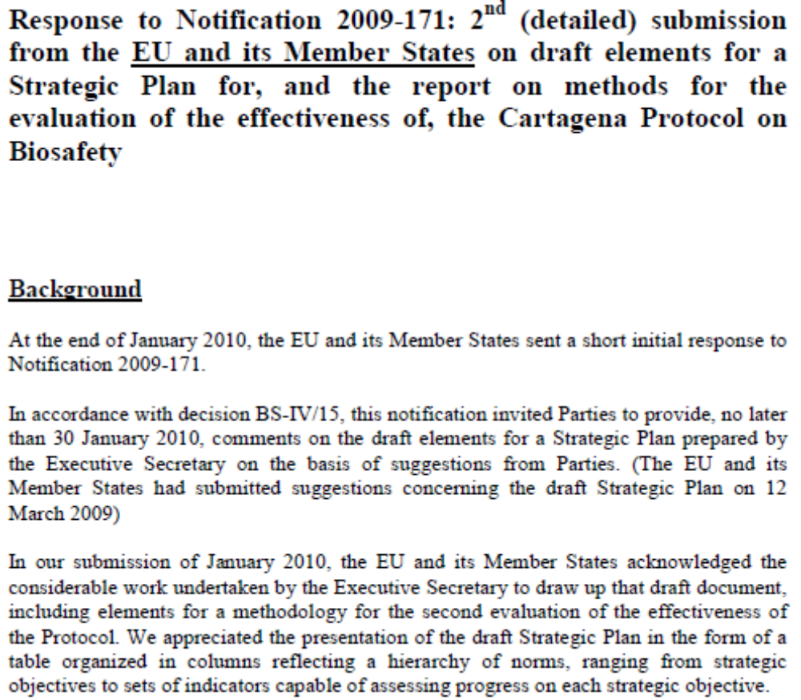
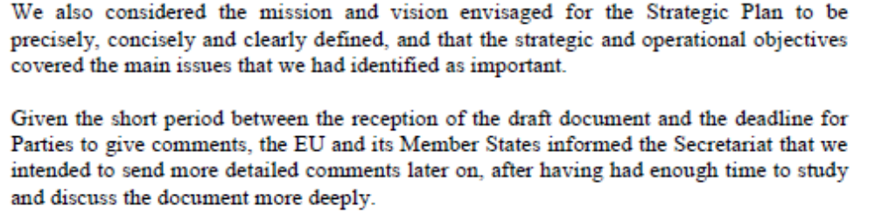
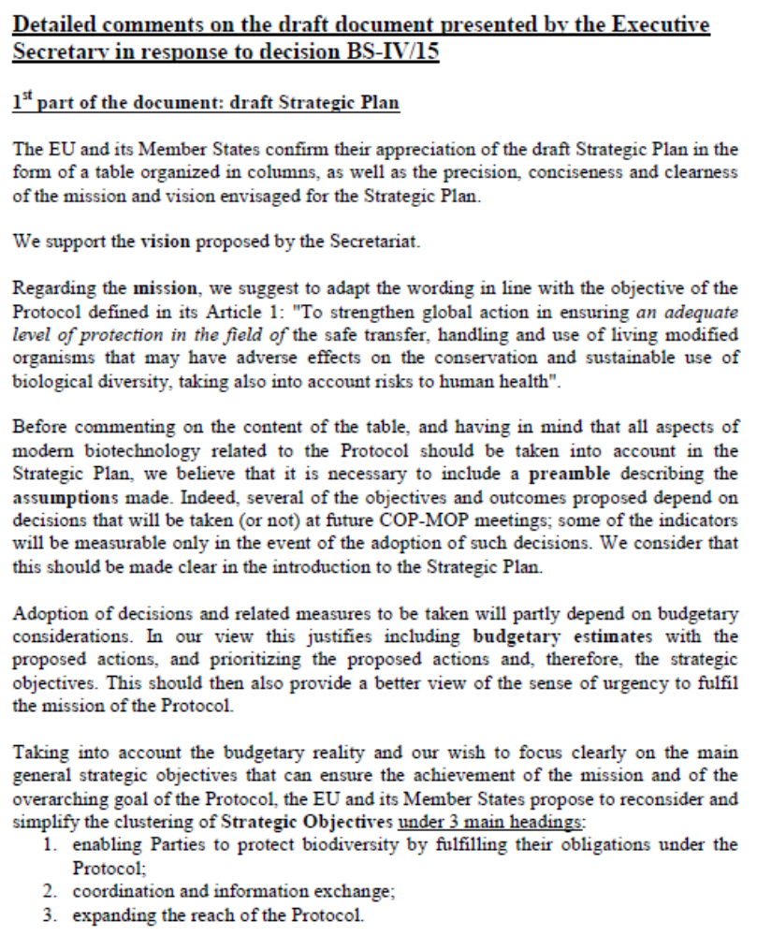
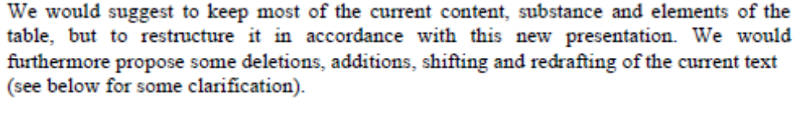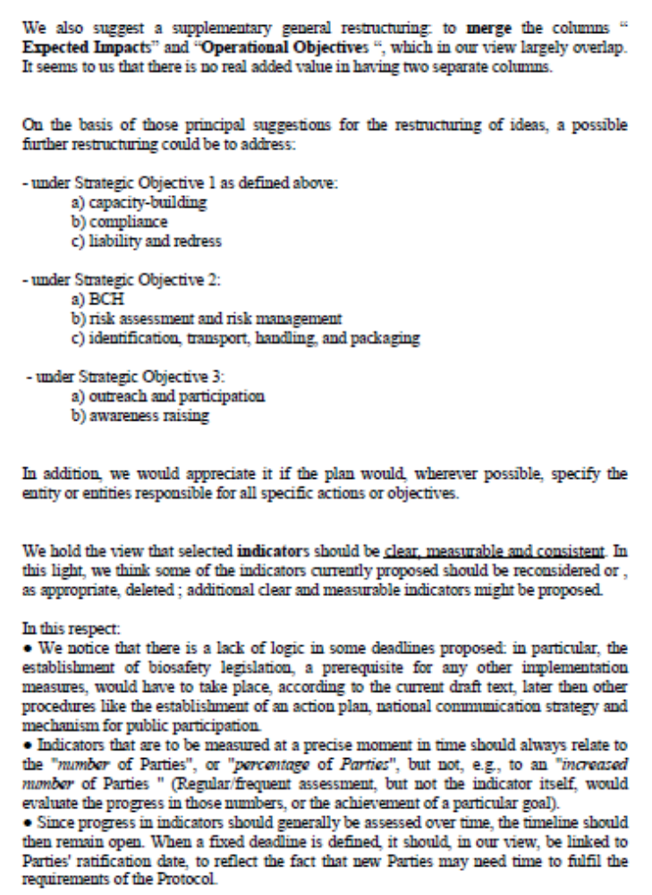
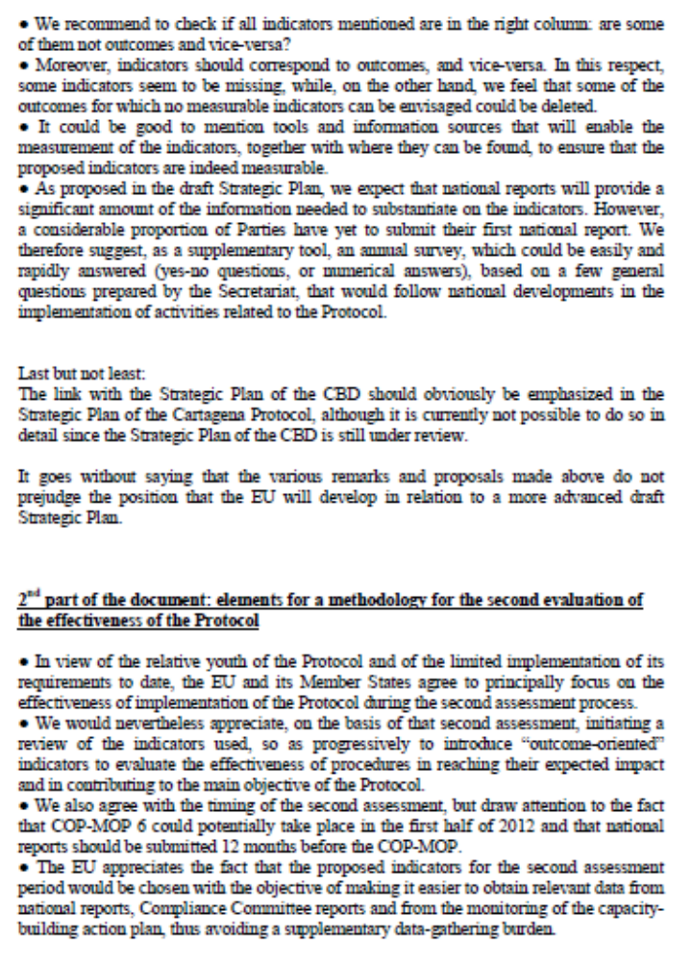
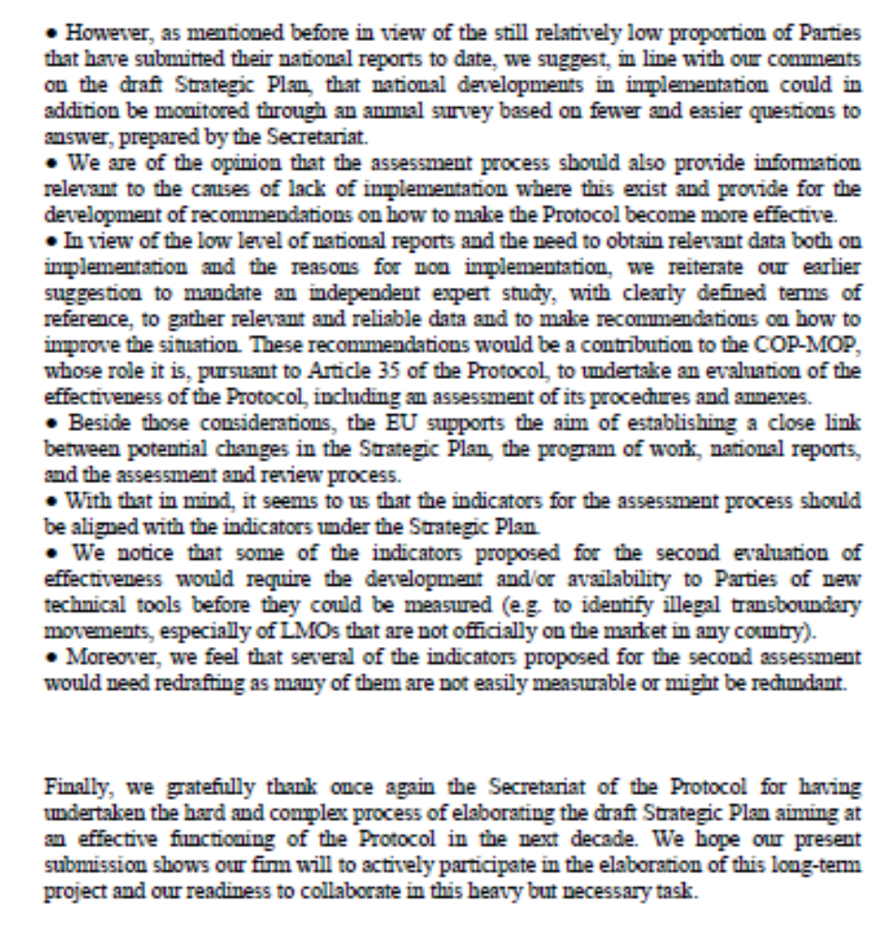

Honduras
Honduras | [01 FEBRUARY 2010] [SUBMISSION: SPANISH]
PROYECTO DE ELEMENTOS DEL PLAN ESTRATÉGICO FECHA: 081209
PROTOCOLO DE CARTAGENA SOBRE SEGURIDAD DE LA BIOTECNOLOGÍA

MISIÓN
Fortalecer la acción mundial para garantizar la transferencia, manipulación y utilización segura de todos los organismos vivos modificados que puedan tener efectos adversos en la conservación y utilización sostenible de la diversidad biológica, teniendo también en cuenta los riesgos para la salud humana.
Objetivo estratégico | Efectos esperados | Objetivos operacionales | Resultados | Indicadores
1. Establecer otros instrumentos necesarios para llevar el Protocolo plenamente a la práctica | Aplicación plena del Protocolo de Cartagena sobre Seguridad de la Biotecnología por las Partes | 1.1 Desarrollar más a fondo y producir instrumentos basados en las ciencias sobre enfoques comunes de evaluación del riesgo y gestión del riesgo para las Partes | - Se pone a disposición de las Partes y otros interesados que aborda nuevos avances en la tecnología moderna  - Las Partes y otros Gobiernos establecen y adoptan enfoques comunes de , según proceda | - Se produce, y proporciona a las Partes y otros Gobiernos, una cantidad importante de instrumentos y documentos de orientación sobre evaluación del riesgo y gestión del riesgo.  - Una cantidad importante de Partes adoptan enfoques comunes de evaluación del riesgo y gestión del riesgo  - Se reducen al mínimo los posibles efectos adversos de los OVM en la diversidad biológica
2. Desarrollar a fondo y fortalecer la capacidad de las Partes para aplicar el Protocolo | Las Partes establecen sistemas reglamentarios, administrativos y de intercambio de información efectivos y eficaces para aplicar el Protocolo  Adopción de decisiones más expeditiva y transparente  Las Partes cuentan con capacidad para llevar a cabo evaluaciones de riesgo adecuadas desde el punto de vista científico, habiéndose establecido todas las estrategias necesarias  Mayor seguridad en el movimiento transfronterizo, la manipulación y el uso de organismos vivos modificados | 2.3 Fortalecer a las Partes para llevar a cabo evaluaciones de riesgo adecuadas desde el punto de vista científico y transparentes y para regular, gestionar y controlar los riesgos de los OVM | - Hay recursos, incluidos los recursos humanos, requeridos para evaluar y gestionar los riesgos de los organismos vivos modificados disponibles en el nivel nacional, subregional o regional  - Se han establecido marcos de infraestructura y administrativos para la evaluación y gestión de los riesgos de los organismos vivos modificados en el nivel nacional, subregional o regional  - Se han desarrollado materiales de capacitación y orientación técnica adecuada desde el punto de vista científico sobre evaluación del riesgo y gestión del riesgo, que son utilizados por las Partes | - Número de personas capacitadas satisfactoriamente en evaluación del riesgo y gestión del riesgo por medio de eventos de capacitación en persona así como de capacitación a distancia  - Número de informes de evaluación de riesgo producidos que son compatibles con el Protocolo

5) Mejorar la disponibilidad e intercambio de información pertinente por conducto del Centro de Intercambio de Información sobre Seguridad de la Biotecnología | Transparencia en el desarrollo y uso de OVM;  Adopción de decisiones fundamentada,  Mejora de la concienciación del público  Mayor cumplimiento de los requisitos nacionales | 5.1 Aumentar la cantidad y calidad de la información enviada al CIISB y recuperada del mismo | - Se reconoce al CIISB como el repositorio de información más autorizado sobre seguridad de la biotecnología  - La información enviada al CIISB es precisa, completa, segura y oportuna  - Un número mayor de países envían y recuperan información  - Los informes de evaluación de riesgo se comparten de manera oportuna por conducto del CIISB  - Facilitación del acceso a recursos y experiencias relacionados con la seguridad de la biotecnología | - Mayor reconocimiento y visibilidad para el CIISB y la SCDB  - Relación entre informes de evaluación de riesgo y cantidad de decisiones sobre OVM  - Aumento de la cantidad de publicaciones que contiene el Centro de Recursos de Información sobre Bioseguridad (CRIB)  - Mayor cantidad de visitantes en el CIISB  - Aumento en la cantidad de referencias al CIISB  - Capacidad de los interesados de reconocer o recordar la marca y la imagen del CIISB

Japan
Japan | [04 MARCH 2010] [SUBMISSION: ENGLISH]

The Government of Japan submits comments A to G as follow:

- Vision
(Comment)
“Biological diversity is adequately protected from can adverse effects of in the field of the safe transfer, handling and use of living modified organisms”.

(Rationale)
The same expression as Article1 “Objective” of the Protocol

- 2.1 “Outcomes” item 4
(Comment)
“Adoption and implementation of comprehensive national capacity building strategies and action plans by each Party aiming to build its capacity to implement the Protocol”

(Rationale)
Parties who already have legal and institutional capacities to implement the obligation of the protocol need not to adopt strategies and action plans.

- 2.1 “Indicators“ item 2 and 3
(Comment)
“At least 50% of the Parties aiming to build capacity have developed national capacity-building action plans for implementing the Protocol by 2012”

“At least 50% of the Parties aiming to build capacity have put in place training programmes for personnel dealing with biosafety issues and for long-term training of biosafety professionals”

(Rationale)
To be consistent with the modification in “Outcomes”

- 2.6 “Indicators“ item 2 and 3
(Comment)
”All parties have in place national websites and searchable archives, national resource centres or sections in existing national libraries dedicated to biosafety educational materials”.

(Rationale)
Item 2 and 3 should be integrated because websites and searchable archives have the same function as resource centers or libraries in regions where internet is widely used. It is not necessary to have both cyber and real resource centers.

- 3.1 “Outcomes” item 2
(Comment)
“Global recognition of the Cartagena Protocol on Biosafety as the main instrument in the field of the safe transfer, handling and use of living modified organisms resulting from modern biotechnology that may have adverse effects on biological diversity”

(Rationale)
There are some other main instruments regarding safe use of living modified organisms such as Codex Alimentarius Commission for food safety. Therefore, it should be clarified that this focuses on biosafety.

- 3.3 “Outcomes” item 2
(Comment)
“by the general public, in particular those who handle LMOs including farmers “.

(Rationale)
As other people such as researchers and transporters handle LMOs, it is not appropriate to refer only to farmers.

- 4.2 “Outcomes” item 2
(Comment)
“The protocol, including its procedures and annexes, is adapted by Parties to if new challenges are brought about by new developments in the field of modern biotechnology “

(Rationale)
New developments would not always lead to adaptation of the Protocol.

Republic of Korea
Republic of Korea | [2 MARCH 2010] [SUBMISSION: ENGLISH]

Vision, Mission, Strategic Objectives and Expected Impacts is well-defined.

Some Suggestions :

  - (Strategic Objectives 1) include financial affairs for achieving each strategic objectives.
  - 2. (Strategic Objectives 5) provide comparable basic statistics(number of LMO approval, a LMO approval present for each country, etc.) using the information that accumulated BCH Central Portal and try to make use of information sharing for each country.

Mexico
Mexico | [05 FEBRUARY 2010]  [11 MAY 2010]  [SUBMISSION: SPANISH]

El Gobierno de México, en respuesta a la Notificación Ref: SCBD/BS/CG/jh/71409 que da atención a la Decisión BS-IV/15 de la Cuarta Conferencia de las Partes que actúa como Reunión de las Partes del Protocolo de Cartagena sobre Seguridad de la Biotecnología (COP-MOP 4), mediante la cual solicita emitir observaciones a la versión del 29 de marzo de 2010 del Proyecto del Plan Estratégico del Protocolo de Cartagena sobre Seguridad de la Biotecnología (2011-2020), en el que se retoman los comentarios hechos por algunos Países, entre ellos México, a la versión del 8 de diciembre de 2009 del mismo Proyecto; reconoce el esfuerzo del Secretariado en conjuntar el documento UNEP/CBD/BS/COP-MOP/5/16, con base en las ponencias y los elementos derivados del informe sobre la evaluación del Protocolo, así como en las observaciones enviadas por algunos Países.

Tomando en cuenta que el documento representa un avance significativo para el desarrollo del Plan Estratégico 2011-2020, el Gobierno de México desea aportar los siguientes insumos desarrollados de manera coordinada entre los Puntos Focales del Convenio sobre Diversidad Biológica y el Protocolo de Cartagena sobre Seguridad de la Biotecnología:

Con relación al PROYECTO DE ELEMENTOS DEL PLAN ESTRATÉGICO, nos permitimos presentar los siguientes comentarios generales, que pueden aplicar a varios componentes del documento (se precisan ejemplos para ilustrar cada punto):

- México reitera que el documento debe circunscribirse cuidadosamente al ámbito del Protocolo de Cartagena sobre Seguridad de la Biotecnología. Sirva como ejemplo de lo anterior, el mismo puesto a consideración para la versión anterior: la Visión propuesta por el Secretariado, a la letra dice: “La diversidad biológica está adecuadamente protegida de cualquier efecto adverso de organismos vivos modificados”, quedaría circunscrita al objetivo y ámbito del PCB, de acuerdo a la siguiente propuesta:

“El Protocolo de Cartagena contribuye sustancialmente a garantizar un nivel adecuado de protección a la diversidad biológica de organismos vivos modificados que puedan ocasionar efectos adversos.”

- Debido a que en esta ocasión, entendemos que por la premura del tiempo, no pudimos contar con la versión en español, México reitera que la traducción al español debe presentar traducciones precisas. Esta observación se basa, por lo dicho al principio del presente punto, en la versión anterior traducida al español.

- México reitera lo manifestado respecto a la columna de “Outcomes”, en el sentido de que en algunos casos se identifica claramente al responsable de generar los mismos y en otros casos no, por lo que de nueva cuenta se sugiere identificar responsables cuando resulte procedente.

- México considera que la nueva versión continua sin esclarecer del todo la relación entre los “Expected Impacts” que señala el documento y los “Operational Objetives” asociados, esto principalmente porque en la tabla sigue perdiéndose el formato de correspondencia.

- México reitera que puede ser prematuro presentar como “Outcomes” dentro de la propuesta de Plan Estratégico, temas que se encuentran aún en procesos de negociación. Como ejemplo está el contenido del “Operational Objetive 1.5”, donde se alude al tema de Responsabilidad y Compensación.

- Se reitera que en general, para varias de las actividades del Protocolo, como por ejemplo los programas de creación de capacidades y concienciación, se debería hacer explícita la interacción de los temas de seguridad de la biotecnología con las cuestiones de biodiversidad. Para ilustrar este comentario, sería que para establecer los riesgos al medio ambiente y la diversidad biológica, se puede tener en cuenta los indicadores de biodiversidad en general y quizá indicadores específicos para agro ecosistemas que maneja el CBD, lo cual contribuiría a dar mayor claridad sobre los objetivos comunes a los que contribuyen ambos instrumentos.

- En vista de que algunos “Indicators” se repiten en cada una de las áreas focales, México considera que habrá que analizar la conveniencia de mantener en algunas áreas, pero eliminar en otras, para que sea un documento más sencillo, pero sobre todo puntual. Para ejemplificar lo anterior podemos citar el indicador “Number of Parties with focal points registered on the BCH”, mismo que se repite para los Objetivos Operacionales “2.2 National Biosafety Frameworks”, “4.1 Compliance with the Protocol” y “5.1 BCH effectiveness”. En este caso en específico, consideramos que si bien dicho indicador aplica para el Objetivo Operacional 2.2, no es necesariamente indicador para los otros dos, por lo que se sugiere la eliminación en éstos.

Además de estos comentarios generales, nos permitimos poner a su amable consideración los siguientes comentarios puntuales a la matriz:

- Se reitera, respecto al “Operational Objetive” 1.1 agregar como Indicador el número de documentos relevantes ya existentes (por ejemplo de la OCDE o la FAO) traducidos o disponibles a través de links del BCH a las páginas de las organizaciones que los crearon.

- Se reitera, respecto al “Operational Objetive” 2.2 la sugerencia de añadir al primer texto de “Outcomes”, la siguiente propuesta de redacción: “Las decisiones respecto a la seguridad de un organismo vivo modificado se basan en evaluaciones de riesgo adecuadas desde el punto de vista científico como se establece en normas reglamentarias y administrativas”.

- Se reitera, respecto al segundo “Outcome” del mismo Objetivo Operacional 2.2 la sugerencia de agregar: “las cuestiones relativas a la seguridad de la biotecnología…, salud, ciencia y tecnología y aduanas”.

- Respecto del “Operational Objetive” 2.3, se sugiere cambiar el indicador: “Number of Parties that have infrastructure, including laboratories for monitoring, management and control available” por “Number of Parties that have infrastructure, including reliable laboratories for monitoring, management and control available”

- Se reitera la sugerencia de añadir en el “Operational Objetive” 2.4 como “Outcome” el siguiente: “Laboratorios nacionales y regionales certificados con capacidad de detección de OVMs”. Además incluir entre los “Indicators”: “Número de laboratorios certificados en operación”.

- Respecto al mismo “Operational Objetive” 2.4, se sugiere cambiar el “Indicator”: “Percentage of Parties that have established or have reliable access to detection laboratories”, por: “Percentage of Parties that have established or have access to reliable detection laboratories”.

- Se reitera la sugerencia de añadir como “Indicators” del “Operational Objetive” 2.6: “Número de usuarios de OVMs que han recibido capacitación sobre seguridad de la biotecnología impartidos por agencias gubernamentales”.

- Se reitera la recomendación de añadir en el “Operational Objetive” 4.2 como “Outcome” el siguiente: “Derivado de una decisión de la Conferencia de las Partes se establece a qué OVMs no se les aplicará el procedimiento de acuerdo fundamentado previo, conforme al artículo 7 párrafo 4 del Protocolo de Cartagena.”

Con relación al ANEXO II “MULTI-YEAR PROGRAMME OF WORK OF THE CONFERENCE OF THE PARTIES SERVING AS THE MEETING OF THE PARTIES TO THE CARTAGENA PROTOCOL ON BIOSAFETY UP TO 2020”, reiteramos los siguientes comentarios generales:

Para cada una de las siguientes actividades se puede desglosar una serie de acciones, que correspondan a las diferentes COP MOP, lo anterior en función de los avances en la implementación del Protocolo de Cartagena y de la experiencia que se genere y documente en función de la misma.

- Identificación de OVMs conforme al artículo 7 párrafo 4 del PCB y así como los OVMs correspondientes, de conformidad con el artículo 16 fracciones a) y b).

- Intercambio de información e investigación sobre los efectos socioeconómicos de OVMs.

- Fortalecimiento de mecanismos de creación de capacidades, conforme el artículo 22 del PCB.

Generación de insumos para atender esta Notificación.

Los insumos que se presentan en este documento fueron desarrollados de manera coordinada entre los Puntos Focales del Convenio sobre Diversidad Biológica y del Protocolo de Cartagena sobre Seguridad de la Biotecnología. En seguimiento a la Notificación Ref: SCBD/BS/CG/jh/71409 , el Punto Focal del Protocolo de Cartagena solicitó su opinión al documento, vía electrónica, a las instancias que conforman a la Comisión Intersecretarial de Bioseguridad de los Organismos Genéticamente Modificados (CIBIOGEM), integrada por la Secretaría de Agricultura, Ganadería, Desarrollo Rural, Pesca y Alimentación; Secretaría de Medio Ambiente y Recursos Naturales; Secretaría de Salud; Secretaría de Hacienda y Crédito Público; Secretaría de Economía; Secretaría de Educación Pública, así como el Consejo Nacional de Ciencia y Tecnología. Asimismo, solicitó sus observaciones a los órganos de consulta de la CIBIOGEM: Consejo Consultivo Científico, conformado por un conjunto de expertos de diferentes disciplinas relacionados con la biotecnología moderna y bioseguridad de los OVMs, así como al Consejo Consultivo Mixto, integrado por representantes de los sectores privado, productivo y social de nuestro país.

Comments received 05 February 2010

El Gobierno de México, en respuesta a la Notificación Ref: SCBD/BS/CG/jh/69854 que da atención a la Decisión BS-IV/15 de la Cuarta Conferencia de las Partes que actúa como Reunión de las Partes del Protocolo de Cartagena sobre Seguridad de la Biotecnología (COP-MOP 4) que invita a presentar comentarios sobre el Proyecto de Elementos de un Plan Estratégico del Protocolo de Cartagena sobre Seguridad de la Biotecnología; agradece el esfuerzo del Secretariado en conjuntar el documento UNEP/CBD/BS/COP-MOP/5/../Add/1, con base en las ponencias y los elementos derivados del informe sobre la evaluación del Protocolo.

Asimismo, y considerando que este documento constituye un buen avance para el desarrollo del Plan Estratégico 2011-2020, el Gobierno de México pone a su consideración los siguientes insumos desarrollados de manera coordinada entre los Puntos Focales del Convenio sobre Diversidad Biológica y el Protocolo de Cartagena sobre Seguridad de la Biotecnología:

Con relación al PROYECTO DE ELEMENTOS DEL PLAN ESTRATÉGICO, nos permitimos presentar los siguientes comentarios generales, que pueden aplicar a varios componentes del documento (se precisan ejemplos para ilustrar cada punto):

- México considera que el documento debe circunscribirse cuidadosamente al ámbito del Protocolo de Cartagena sobre Seguridad de la Biotecnología. Para ejemplificar un caso en el que podría delimitarse mejor el alcance, consideramos que la Visión propuesta por el Secretariado, a la letra dice: “La diversidad biológica está adecuadamente protegida de cualquier efecto adverso de organismos vivos modificados”, quedaría circunscrita al objetivo y ámbito del PCB, de acuerdo a la siguiente propuesta:

“El Protocolo de Cartagena contribuye sustancialmente a garantizar un nivel adecuado de protección a la diversidad biológica de organismos vivos modificados que puedan ocasionar efectos adversos.”

- Notamos que la traducción al español difiere en algunos casos del significado de la versión original en inglés, por ejemplo, en la versión en inglés se habla de “potential adverse effects”, mientras la versión en español lo traduce como: “posibles efectos adversos”. Sugerimos por lo tanto presentar traducciones más precisas.

- Asociado a la columna de Resultados, en algunos casos se identifica claramente al responsable de generar los mismos y en otros casos no, por lo que se sugiere identificar responsables cuando resulte procedente.

- Consideramos que no queda del todo clara la relación entre los Efectos Esperados que señala el documento y los Objetivos Operacionales asociados, particularmente porque en la tabla se pierde el formato de correspondencia.

- Se considera que puede ser prematuro presentar como Resultados dentro de la propuesta de Plan Estratégico, temas que se encuentran aún en procesos de negociación. Como ejemplo está el contenido del Objetivo Operacional 1.3, donde se alude al tema de Responsabilidad y Compensación.

- Percibimos que, en general, la columna de Indicadores está redactada en términos subjetivos que podrían dificultar su evaluación. Tales como “cantidad importante”, “se reduce al mínimo”, “cantidad y variedad de instrumentos”. Particularmente, en los Indicadores del Objetivo Operacional 2.3 se menciona: “número de personas capacitadas satisfactoriamente en evaluación de riesgo y gestión del riesgo por medio de eventos de capacitación en persona así como de capacitación a distancia”. Sin embargo, puede resultar complicado definir cómo establecer si una persona fue capacitada satisfactoriamente. Consideramos que esto podría sortearse con Indicadores asociados a resultados esperados de una capacitación considerada satisfactoria. Por ejemplo, en este caso el indicador puede ser “número de personas capacitadas que aplican o aplicaron la evaluación del riesgo y la gestión del riesgo derivado de programas de la capacitación en los Países Parte”.

- Se sugiere el uso de un lenguaje neutral. Por ejemplo en el caso del Indicador del Objetivo Operacional 1.4 se propone que se le dé igual fuerza a las experiencias positivas y negativas, en tanto que ambas son enriquecedoras, por lo que se propone la siguiente eliminación: “Número de Partes que notifican experiencias positivas al tomar en cuenta las consideraciones socioeconómicas en la adopción de decisiones sobre la importación de organismos vivos modificados.”

- En general, para varias de las actividades del Protocolo, como por ejemplo los programas de creación de capacidades y concienciación, se debería hacer explícita la interacción de los temas de seguridad de la biotecnología con las cuestiones de biodiversidad. Otro ejemplo para ilustrar este comentario, sería que para establecer los riesgos al medio ambiente y la diversidad biológica, se puede tener en cuenta los indicadores de biodiversidad en general y quizá indicadores específicos para agro ecosistemas que maneja el CBD, lo cual contribuiría a dar mayor claridad sobre los objetivos comunes a los que contribuyen ambos instrumentos.

Además de estos comentarios generales, nos permitimos poner a su amable consideración los siguientes comentarios puntuales a la matriz:

- Al Objetivo Operacional 1.1 se sugiere agregar como Indicador el número de documentos relevantes ya existentes (por ejemplo de la OCDE o la FAO) traducidos o disponibles a través de links del BCH a las páginas de las organizaciones que los crearon. Se sugiere también eliminar el tercer Indicador propuesto, ya que su cuantificación es poco factible y no tiene relación con este Objetivo Operacional.

- Sería deseable añadir el siguiente Resultado al Objetivo Operacional 1.3: “Documentar y evaluar experiencia adquirida en la atención de casos de responsabilidad y compensación por daños resultantes de movimientos transfronterizos de OVMs.”

- En el Objetivo Operacional 2.2 se sugiere añadir al primer texto de Resultados, la siguiente propuesta de redacción: “Las decisiones respecto a la seguridad de un organismo vivo modificado se basan en evaluaciones de riesgo adecuadas desde el punto de vista científico como se establece en normas reglamentarias y administrativas”.

Asimismo, en el segundo Resultado de éste Objetivo Operacional 2.2 se sugiere agregar: “las cuestiones relativas a la seguridad de la biotecnología…, salud, ciencia y tecnología y aduanas“

- Se sugiere añadir en el Objetivo Operacional 2.4 como Resultado el siguiente: “Laboratorios nacionales y regionales certificados con capacidad de detección de OVMs”. Además incluir entre los Indicadores: “bases de datos de laboratorios certificados en operación” y “Países Parte con laboratorios certificados para la detección de OVMs”.

- Se sugiere añadir como Indicador del Objetivo Operacional 2.6: “Los usuarios de OVMs han recibido capacitación sobre seguridad de la biotecnología impartidos por agencias gubernamentales”.

- En el Objetivo Operacional 3.3 se sugiere añadir como Indicador: “El número y nivel de programas de educación formal específicos en bioseguridad o que incluyan temas de bioseguridad”.

- Se recomienda añadir en el Objetivo Operacional 4.2 como Resultado el siguiente: “Derivado de una decisión de la Conferencia de las Partes se establece a qué OVMs no se les aplicará el procedimiento de acuerdo fundamentado previo, conforme al artículo 7 párrafo 4 del Protocolo de Cartagena.”

- En el Objetivo Operacional 5.1 se sugiere mover los Indicadores 1 y 3 al Objetivo Operacional 5.2. Adicionalmente en el Objetivo Operacional 5.1 añadir como Indicador “el número de ligas o conexiones a otras fuentes de información relevante”.

Con relación al ANEXO II “PROGRAMA DE TRABAJO DE LA CONFERENCIA DE LAS PARTES QUE ACTÚA COMO REUNIÓN DE LAS PARTES EN EL PROTOCOLO DE CARTAGENA SOBRE SEGURIDAD DE LA BIOTECNOLOGÍA HASTA 2020”, nos permitimos presentar los siguientes comentarios generales:

Para cada una de las siguientes actividades se puede desglosar una serie de acciones, que correspondan a las diferentes COP MOP, lo anterior en función de los avances en la implementación del Protocolo de Cartagena y de la experiencia que se genere y documente en función de la misma.

- Documentar y evaluar experiencia adquirida en la atención de casos de responsabilidad y compensación por daños resultantes de movimientos transfronterizos de OVMs.

- Identificación de OVMs conforme al artículo 7 párrafo 4 del PCB y así como los OVMs correspondientes, de conformidad con el artículo 16 fracciones a) y b).

- Intercambio de información e investigación sobre los efectos socioeconómicos de OVMs.

- Fortalecimiento de mecanismos de creación de capacidades, conforme el artículo 22 del PCB.

Generación de insumos para atender esta Notificación.

Los insumos que se presentan en este documento fueron desarrollados de manera coordinada entre los Puntos Focales del Convenio sobre Diversidad Biológica y del Protocolo de Cartagena sobre Seguridad de la Biotecnología. En seguimiento a la Notificación Ref: SCBD/BS/CG/jh/69854, el Punto Focal del Convenio sobre Diversidad Biológica solicitó, vía electrónica, a un grupo aproximado de 150 actores representantes de los sectores académico, industrial, de gobierno y ONGs involucrados en el tema; comentarios sobre el documento. Consideramos que la premura y las fechas (periodo vacacional) en las que se planteó dicha solicitud contribuyeron a que la respuesta y participación de estos actores fue muy limitada. Lo anterior nos incentiva a tomar medidas para fortalecer y enriquecer los mecanismos de concienciación y participación pública.

Mongolia
Mongolia | [11 FEBRUARY 2010] [SUBMISSION: ENGLISH]

I have read the Draft Elements of a Strategic Plan of the Cartagena Protocol on Biosafety.

I have not any comments and I have following idea;

It was going to "Operational Objectives 2.4 column Indicators third point"

"Parties that is developing country have etalon materials which would be able detection LMOs/GMOs"

New Zealand
New Zealand | [28 MAY 2010] [SUBMISSION: ENGLISH]

New Zealand Comments and Suggested Changes

New Zealand offers the following comments on the Strategic Plan document UNEP/CBD/BS/COP-MOP/5/16 to inform the Secretariat’s review which will result in a revised Strategic Plan for the Cartagena Protocol on Biosafety (the Protocol).

General comments
New Zealand notes the fact that effective implementation of the Protocol is an ongoing concern. Considerable effort has gone into capacity building which has had the laudable result of developing a number of draft biosafety frameworks; this seems to have had little impact however on encouraging reporting and implementation of operational regimes.
In the ongoing absence of reporting by many Parties, it is still not possible to accurately determine the nature of impediments to effective implementation i.e. does it result from lack of capacity or simply from conflicting priorities. Over 40 Parties still lack any form of a functional biosafety regulatory framework and most developing country Parties have little or no capacity to undertake risk assessments and develop risk management schemes.
If the effective implementation of the Protocol is an overarching objective of any new strategic plan New Zealand is of the view that urgent further work to evaluate capacity needs is required. This would include assessing how capacity issues are being addressed and evaluating support provided to date to identify whether current approaches are effective in meeting the needs of Parties that as yet have been unable to meet their obligations under the Protocol. To this end we support many of the measures proposed in new focal area 2, in particular those which encourage Parties to report so that effective assessments can be made of progress in implementation but also of reasons which prevent progress.
Specific comments

Focal Area 1
1.2 Coordination and support
We are curious as to how it is proposed that information will be captured about whether Parties have “predictable and reliable funding” and “use resources effectively” (the last two indicators)?
1.3 Risk Assessment and risk management
We are curious as to what data is proposed to be used for the indicators i.e. how will the Secretariat know that guidance documents are being used and Parties are adopting “common approaches” (and what that means in practice?).
1.4 LMOs or traits that may have adverse affects
We are concerned that the number of reports is seen as an effective indicator, rather than in the quality and accuracy of those reports.
1.5 Scientific and technical advice
Again, we are concerned that there is an emphasis on the number of scientific and technical guidance materials produced, as an indicator, and that that does not necessarily reflect improved scientific and technical advice (the expected ‘outcome’) or improved uptake of technical advice as reflected in improved and/or increased implementation. The CBD and its processes produce many reports, and much paper and we are keen to see an emphasis on the quality of reports.
  - Liability and redress
Given the need for Parties to ratify any supplementary Protocol on ‘liability and redress’ we wonder whether the proposed indicator of entry into force prior to CoP-MoP 7 as being perhaps overly optimistic?
We also note a general concern that limited capacity building efforts should not be redirected from working to improve basic implementation of the Protocol and regulatory frameworks (protecting biosafety from damage in the first instance) to developing liability frameworks (e.g. ambulances at the bottom of the biosafety cliff). We note in this regard the expected ‘outcome’ regarding implementation of any new ‘liability and redress’ regime and feel that this should not be at the expense of existing biosafety obligations and implementation, notably operational objectives 1.1 (National Biosafety Frameworks), 1.3 (Risk assessment and risk management) and 2.2 (Handling, transport, packaging and identification).

Focal Area 2
2.1 Coordination and support
We are curious as to how it is proposed that information will be captured about whether Parties have “predictable and reliable funding” and “use resources effectively” (the last two indicators)?
2.2 Handling, transport, packaging and identification
We suggest the first indicator is amended to reflect that customs officers and laboratory staff are trained in sampling, detection and identification of LMOs. We also suggest that it is the percentage of these officials trained that is the most reliable indicator rather than their number (a more populous Party may have significantly more persons trained than a lesser populated Party but the percentage of their border/customs officials they represent may actually be less).
2.6 Biosafety education and training
Again we are concerned that an indicator for “improved biosafety education and training programmes” (the outcome) is the “number of biosafety training materials and online modules available”. Once again there is a possible disconnect between the necessary quality and quantity.
We note that reference here, or elsewhere, to a need to periodically assess the effectiveness of the Biosafety Roster of Experts may be worthwhile.

Focal Area 3
3.1 Ratification of the Protocol
As a general comment, while New Zealand appreciates the aspirational goal of universal ratification we believe that focus should be directed to ensuring existing Parties effectively implement the Protocol rather than on trying to increase membership. How will non-Parties be encouraged to ratify if they do not see effective implementation amongst existing Parties?

Niger
Niger | [14 APRIL 2010 [SUBMISSION: ENGLISH]

Mobiliser les ressources financières pour assister les pays les moins avancés
À mettre en place un mécanisme efficace de gestion et d’évaluation des risques

Assurer une formation continue des acteurs intervenant Dans la biosécurité à l’usage du BCH

Norway
Norway | [01 FEBRUARY 2010] [SUBMISSION: ENGLISH]

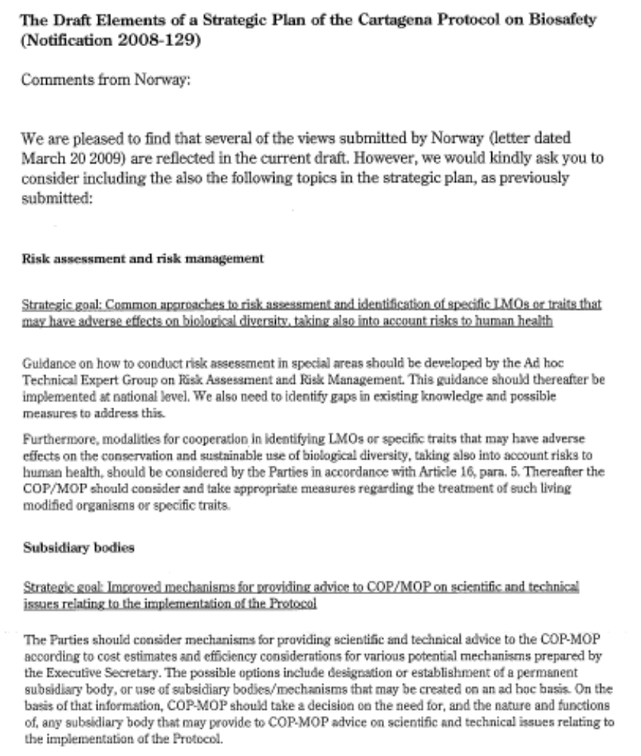

 UNEP/CBD/BS/COP-MOP/5/1

