 |  | CBD
 |  |  |  | Distr.  GENERAL  UNEP/CBD/BS/COP-MOP/6/INF/11  20 June 2012  ORIGINAL: ENGLISH
CONFERENCE OF THE PARTIES TO THE CONVENTION ON BIOLOGICAL DIVERSITY SERVING AS THE MEETING OF THE PARTIES TO THE CARTAGENA PROTOCOL ON BIOSAFETY
Sixth meeting
Hyderabad, India, 1-5 October 2012

Analysis of the online discussions under the Open-ended Online Expert Forum on Risk assessment and Risk Management (March 2011 - April 2012)

Note by the Executive Secretary

I. INTRODUCTION
- At their fourth meeting, the Parties to the Cartagena Protocol on Biosafety, in decision BS-IV/11, established an Ad Hoc Technical Expert Group (AHTEG) on Risk Assessment and Risk Management and an open-ended online forum on specific aspects of risk assessment (hereinafter, “the Open-ended Online Forum”) through the Biosafety Clearing-House (BCH) in accordance with the terms of reference annexed to that decision.
- The Secretariat, with the approval of the Bureau of the fourth meeting of the Conference of the Parties serving as the meeting of the Parties to the Protocol, established a continuous process, comprising of online discussions under the Open-ended Online Forum (i.e. ad hoc online discussion groups and regional real-time online conferences) and face-to-face meetings of the AHTEG, to realize the outcomes as established in decision BS-IV/11. The outcomes of the process were summarized in document UNEP/CBD/BS/COP-MOP/5/12 and include the “Guidance on Risk Assessment of Living Modified Organisms” (hereinafter “the Guidance”).
- At their fifth meeting, in decision BS-V/12, the Parties welcomed the Guidance and noted that its first version required further scientific review and testing to establish its overall utility and applicability to living modified organisms (LMOs) of different taxa introduced into different environments. In this context, the Parties requested the Executive Secretary to: (i) translate the first version of the Guidance into all United Nations languages with a view to enabling a larger number of experts to take part in the review process; (ii) coordinate with Parties and other Governments, through their technical and scientific experts, and relevant organizations, a review process of the first version of the Guidance; and (iii) make the comments of the review process available through the Biosafety Clearing-House.

- Furthermore, in decision BS-V/12, the Parties decided to extend the work of the Open-ended Online Forum and the AHTEG. According to the terms of reference annexed to that decision, the Open-ended Online Forum and the AHTEG should work primarily online, with the AHTEG meeting face-to-face twice prior to the sixth meeting of the Parties, with the view to achieving the following expected outcomes:
(a) A revised version of the “Guidance on Risk Assessment of Living Modified Organisms”;
(b) A mechanism, including criteria, for future updates of the lists of background materials;
(c) Further guidance on new specific topics of risk assessment, selected on the basis of the priorities and needs by the Parties and taking into account the topics identified in the previous intersessional period.
- The Parties further requested the Executive Secretary to convene, prior to their sixth meeting: (i) ad hoc discussion groups and real-time online conferences under the Open-ended Online Forum; and (ii) two meetings of the AHTEG. The Executive Secretary was also requested to compile the views and recommendations submitted by participants in the Online Forum for consideration by the Parties.
- Accordingly, a synthesis of the main outcomes under the the Open-ended Online Forum was prepared for consideration by the AHTEG at its fourth meeting to be held in Montreal, from 4 to 8 June 2012, and by the Parties, at their sixth meeting in Hyderabad, India, 1 to 5 October 2012.

II. ad hoc DISCUSSION GROUPS and REAL-TIME ONLINE CONFERENCES
- The Secretariat convened ad hoc discussion groups and regional real-time online conferences for deliberations among the experts of the Open-ended Online Forum on the expected outcomes as summarized under section III below.
- A total of fourteen ad hoc discussion groups were held between March 2011 and March 2012 under the Open-ended Online Forum. A total of 321 interventions were posted by 75 individual experts (42 from Parties, 3 from other Governments and 30 from organizations).
- The Third Series of Regional Real-time Online Conferences on Risk Assessment and Risk Management were also held under the Open-ended Online Forum. Four regional real-time online conferences took place: Latin America and the Caribbean (11 April), Western Europe and Others Group and Central and Eastern Europe (12 April), Africa (17 April), and Asia and the Pacific (19 April 2012). A total of 40 experts (29 from Parties and 11 from Organisations) took part in the four regional real-time conferences.
- The full transcripts of both the ad hoc discussion groups and the real-time online conferences are available online in the BCH.
- It is noted that the number of experts who took part in the Third Series of Regional Real-time Online Conferences on Risk Assessment and Risk Management was significantly lower than that in the discussion groups as well as in the previous two series of conferences. Moreover, while 27% of the experts who are registered in the Open-ended Online Forum took active part in the ad hoc discussion groups by posting comments, only 14% of the registered experts attended the real-time conferences.
- It is also noted that among the experts who took part in the real-time online conferences, nearly half are also members of the AHTEG (i.e. 17 out of 40) whereas less than a quarter of the experts who posted messages in the ad hoc discussion groups are members of the AHTEG (i.e. 18 out of 75).
- On this basis, taking into account the specific characteristics of the Open-ended Online Forum, including its mandate and expected outcomes, as well as the format of discussions, the ad hoc discussion groups appear to be a more useful and cost-effective tool that allow interaction among the larger group of experts than the real-time online conferences.

III. EXPECTED OUTCOMES as per decision bs-V/12
- The discussion groups and real-time online conferences focused on the expected outcomes as per decision BS-V/12 and reiterated in paragraph 4 above.
- A variety of views were expressed during both the ad hoc discussion groups and real-time online conferences on each of the expected outcomes. The following synthesis attempts to summarize the process undertaken under each expected outcome and the most pertinent views that emerged from the interventions made under the Open-ended Online Forum between March 2011 and April 2012.

A. Revision of the “Guidance on Risk Assessment of Living Modified Organisms”
- Under this outcome, participants in the Open-ended Online Forum were invited to make proposals for revising and improving the Guidance in collaboration with the AHTEG.
- In response to requests in decision BS-V/12, the Guidance was translated into all official United Nations languages and made available to the Parties, other Governments and relevant organizations for their scientific review between February and March 2011. A total of 33 submissions were received, 18 of which were from Parties, two from other Governments and 12 from organizations. All submissions received through the scientific review are available in the Biosafety Clearing-House.
- As a follow-up to the process, the Secretariat convened a round of ad hoc online discussion groups between 28 March and 11 April 2011 for the revision of the Guidance. A total of 121 interventions were posted under this topic of discussion.
- On the basis of the scientific review and the online discussions, the AHTEG Chair, in consultation with the Bureau and the Secretariat, prepared a Chair’s draft for the revision of the Guidance (version of 20 May 2011), which was discussed at the third meeting of the AHTEG. At that meeting, the AHTEG considered the Chair’s draft, and developed a draft revised Guidance that formed the basis for further work in collaboration with the Open-ended Online Forum (version of 4 July 2011).
- Three rounds of online discussions were held for the continued revision of the Guidance between July 2011 and January 2012. Following each round of online discussion, the AHTEG Chair, in consultation with the AHTEG Bureau and Secretariat, considered the views and comments provided for the progressive improvement of the revised Guidance.
- The Guidance was submitted to an external consultant for editorial improvements. On the basis of the suggestions by the consultant, the AHTEG Chair, in consultation with the AHTEG Bureau and Secretariat, prepared a revised version of the Guidance for a final round of discussion under the Open-ended Online Forum during the Third Series of Regional Real-time Online Conferences.
- The following diagram is a schematic summary of the activities held under the Open-ended Online Forum and AHTEG towards reaching outcome (a), a revised version of the “Guidance on Risk Assessment of Living Modified Organisms”.
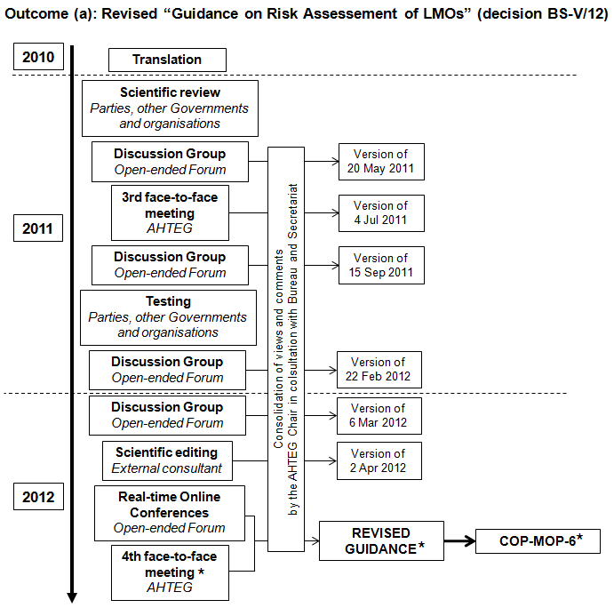
* Upcoming activities and expected outcome.

Synthesis of views regarding this outcome during
the Third Series of Regional Real-time Online Conferences
- During the real-time conferences and final round of online discussions, the majority of participants considered the Guidance a useful tool to assist Parties in conducting and reviewing risk assessments of living modified organisms. It was noted by participants that the Guidance has significantly improved since the last meeting of the Parties to the Protocol. Its structure is logical and follows the basic theoretical structure of risk assessment. Furthermore, some participants stated that the Guidance is also useful in pointing the reader to background documents relevant to the various issues being discussed. Some participants explained that activities involving multiple stakeholders were undertaken in their countries to test the Guidance with the conclusion that the Guidance is a very useful tool and may also be used to enhance national capacity to conduct risk assessments.
- A small number of participants, on the other hand, particularly in the GRULAC region, were of the view that the Guidance is not practical as a tool to assist countries with less experience in risk assessment of LMOs, and that it lacks a logical structure. They mentioned that its language is unnecessarily complicated which may lead to confusion among users of the Guidance.
- Participants also expressed diverging views on the section on “analysis of uncertainty” and “related issues”. While some judged these sections too long and outside the scope of the Guidance and recommended their deletion, others were of the view that these sections are useful and should be maintained or even expanded. Some diverging views also emerged relating to whether or not monitoring can be used to detect unexpected long-term and adverse effects as mentioned in step 5 of the roadmap.
- A number of specific recommendations were made during the real-time online conferences with the view to improving the Guidance. For example:
- The integration of additional considerations on human health, in situ conservation, identity preservation, relevant socioeconomic considerations that could result in environmental impacts, as well as the concept of “familiarity” and history of “safe use”;
- Strengthening the notion that risk assessments should be conducted in a step-wise manner and that risk assessments are multi-disciplinary undertakings where various disciplines are interrelated (e.g. ecology, human health, agriculture); and
- The addition of further information outlining the recommended actions that need to be taken to deal with the various “points to consider” under each step.

B. Possible mechanisms, including criteria, for future updates of the lists of background materials
- At their fifth meeting, the Parties to the Protocol mandated the Open-ended Online Forum and AHTEG to propose mechanisms for future updates of the lists of background materials linked to the Guidance. The lists of background documents were developed, by the Open-ended Online Forum and AHTEG, as a source of references that are relevant to the various sections of the Guidance.
- With a view to ensuring periodic updates for maintaining the lists in line with the available background materials and current new developments in the relevant subjects, the AHTEG decided to make the list of background materials available through the Biosafety Clearing-House, and make them accessible from the Guidance through web links placed at the end of each section of the Guidance.
- A round of online discussion on this outcome was held under the Open-ended Online Forum from 11 to 18 April 2011. Participants were invited to consider: (i) criteria for the selection of relevant background documents to be linked to the Guidance; and (ii) possible mechanisms for future update of the list of background materials including “who” would be responsible for updating and maintaining the list of background materials, taking into account the long-term sustainability of any proposed mechanism.
- A total of 19 interventions were made under this topic with recommendations for possible criteria for selection of background materials and mechanisms for future updates to the list.
Possible criteria for selection of background materials
- Some participants recommended that some criteria be established to allow only certain types of documents to be included in the lists of background materials (e.g. articles in peer-reviewed journals, acts and reports produced by national biosafety regulatory frameworks, books published by renowned editors/publishers, and internationally recognized guidance materials).
- Other participants recommended that the criteria for inclusion of background materials should be as open and transparent as possible, and also recommended that the background materials be categorized on the basis of their source and content. For example, documents from peer-reviewed publications, risk-assessment reports by regulatory or non-regulatory processes, national or international organizations, industry, non-government organizations, consumer organizations, etc.
Possible mechanisms for future updates
- In considering “who” would be responsible for updating the lists of background materials, recommendations included the following possible mechanisms: (i) an AHTEG; (ii) Parties, other Governments and relevant organizations; (iii) national competent authorities; or (iv) a group of experts nominated specifically for this activity by Parties, other Governments and relevant organizations.
- In considering the periodicity of updates, recommendations were made to add new relevant background documents either on an annual or biennial basis, and to reassess the relevance of existing documents after 5 to 10 years of their addition to the lists with the view of removing outdated publications.
- A recommendation was made that a search tool be made available to help find documents that are already part of the list of background materials in order to prevent duplications when updates are carried out.
- In accordance with decision BS-V/12, participants of the Open-ended Online Forum also recommended that the common format for submission of records to the Biosafety Information Resources Centre (BIRC) of the BCH be updated so that relevant background materials can be linked to the specific sections and steps of the Guidance.
- In discussing this outcome at its third meeting, on the basis of input from the online discussion, the AHTEG agreed that the AHTEG Chair in consultation with the AHTEG Bureau and Secretariat would remain responsible for updating the list of background materials linked to the Guidance for the duration of AHTEG mandate. Further, the AHTEG also agreed that the Secretariat would invite all Parties, non-Parties, relevant organizations and users of the BCH to submit background materials that are relevant to the Guidance for consideration by the AHTEG. With reference to future updates of the background materials linked to the Guidance after the completion of its mandate, the AHTEG recommended that a regionally balanced group of experts (e.g., ten experts, two experts per region), appointed periodically by the Parties (e.g. every four years), would work online to update, rearrange or remove background materials linked to the Guidance.
- Following an update of the BIRC common format by the Secretariat, to enable background materials to be linked to specific sections of the Guidance, the Secretariat invited Parties, other Governments and relevant organizations, through their technical and scientific experts, as well as registered BCH users to submit background materials that are relevant to the Guidance.
- An automatic mechanism was developed by the Secretariat for notifying an external group of experts, currently the AHTEG Chair and Bureau, when a proposal for new background material relevant to the Guidance is submitted. This automatic mechanism also allows for the group of experts to discuss, approve or reject the proposed background material. The online submission and approval/rejection of background materials relevant to the Guidance is ongoing through the BCH.
- The following diagram is a schematic summary of the activities held under the Open-ended Online Forum and AHTEG towards reaching outcome (b), a mechanism for future updates of the lists of background materials.

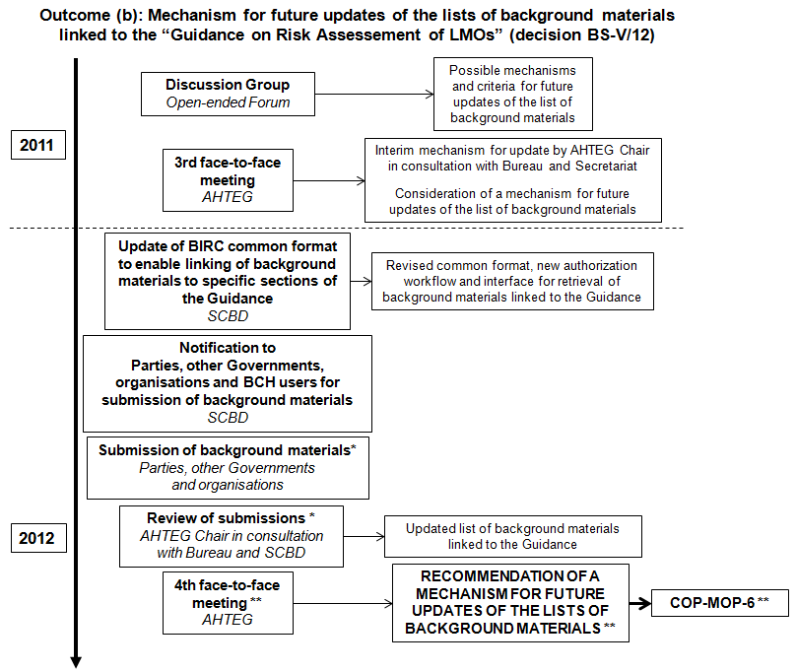
* Ongoing activities; ** Upcoming activities and expected outcome.

C. Specific topics for the development of further guidance
- Under the discussion on outcome (c), experts in the Open-ended Online Forum and AHTEG were invited to prioritize, from the list of topics identified in the previous intersessional period and taking into account the needs of Parties, the five most important topics for the development of further guidance.
- A total of 20 interventions were made under this topic of discussion. The topics identified and prioritized by the participants were given score points from 5 (highest priority) to 1 (lowest priority).
- According to the participants in the online discussions, the specific topics of risk assessment and risk management with highest priority for the development of further guidance are:
- Post-release monitoring and long-term effects of LMOs released into the environment;
- Risk assessment of living modified trees;
- Risk assessment of living modified fish;
- Risk assessment of living modified microorganisms and viruses; and
- Risk assessment and risk management in specific receiving environments.
- At its third meeting, in discussing this outcome, the AHTEG agreed to develop guidance on the top two topics chosen by the Open-ended Online Forum (i.e. “Monitoring of living modified organisms released into the environment”, and “Risk assessment of living modified trees”).
- Six online discussions were held between July 2011 and January 2012 for cooperation between the Open-ended Online Forum and the AHTEG for continuous improvement of the guidance documents “Monitoring of living modified organisms released into the environment” and “Risk assessment of living modified trees”.
- A face-to-face meeting of the AHTEG sub-working groups (SWGs) was held in Bonn, from 13 to 15 February 2012 to advance the work on the two draft guidance documents. The outcomes of that meeting were advance draft versions of the guidance documents.
- As a follow-up, participants of the Open-ended Online Forum were invited to recommend editorial improvements to these documents during a final round of online discussions held from 27 February to 11 March 2012.
- On the basis of the suggestions for editorial improvements, the Chairs of the sub-working groups, in collaboration with the members of the respective SWGs, developed revised advance draft documents on the two topics for consideration during the Third Series of Regional Real-time Online Conferences and fourth meeting of the AHTEG.
- The Third Series of Regional Real-time Online Conferences comprising four regional conferences (Latin America and the Caribbean (GRULAC); Western Europe and Others Group and Central and Eastern Europe (WEOG and CEE); Africa; Asia and the Pacific), were be held from 11 to 19 April 2012 at http://bch.cbd.int/onlineconferences/realtime_ra.shtml. A total of 29 experts representing 18 Parties to the Protocol took part in the four regional real-time online conferences.
- The following diagram is a schematic summary of the activities held under the Open-ended Online Forum and AHTEG towards reaching outcome (c), “Further guidance on new specific topics”.
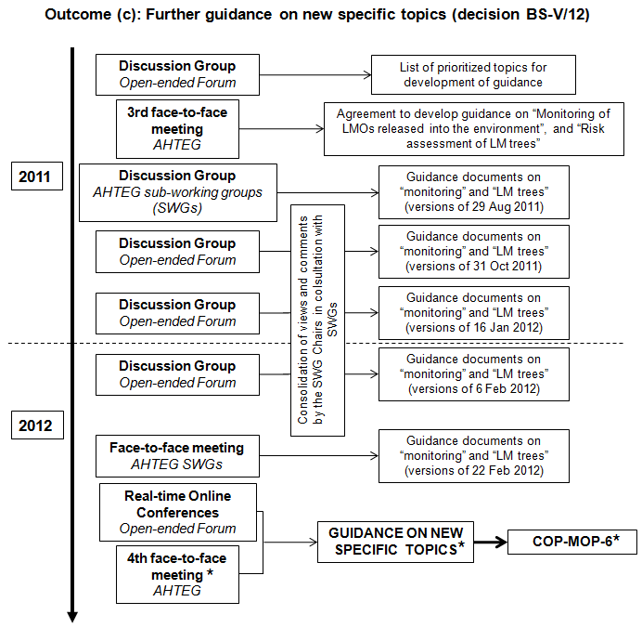
* Upcoming activities and expected outcome.

Synthesis of views regarding this outcome during
the Third Series of Regional Real-time Online Conferences
- Participants to the real-time conferences made a number of interventions regarding the two new guidance documents (i.e. “Monitoring” and “LM trees”) and how these documents could be formatted for consideration by the Parties at their sixth meeting. These include, for example:
Usefulness of the guidance on ‘Monitoring of LMOs released into the environment”
- The majority of participants were of the view that this guidance is concise yet comprehensive, and that it appropriately outlines the general concepts and considerations for the development of a monitoring plan for LMOs. Most participants were pleased with the improvements made during the meeting of the AHTEG sub-working group and were of the view that the current document is precise, streamlined and readable, covering the relevant aspects to be considered when implementing an LMO-monitoring plan, and stresses the importance of choosing meaningful statistical analyses and sound scientific methods.
- A few participants in the GRULAC region, on the other hand, were of the opinion that continued efforts are needed in order to improve the guidance on monitoring and that it should be submitted for consideration by the Parties to the Protocol as a draft document. They further recommended that the Roadmap should first be finalized before advancing the development of the guidance on monitoring.
- The issue of “general monitoring” for effects that were not anticipated in the risk assessment was the focus of intensive debate. While some participants recommended that this issue be excluded from the guidance, others were of the opinion that the issue should remain in the guidance and, in order to add more clarity, be renamed as “general surveillance”. It was noted that the formulation of the term as “general monitoring” is the result of lengthy discussions during the meeting of the AHTEG sub-working group and represents an attempt to reconcile diverging views.
- Several recommendations for amendments were made in order to expand the usefulness of this document. For example:
- Reviewing the nomenclature that is used within the document (for example, LMO vs. LMOs), and ensuring that the terms are consistent throughout;
- Better clarification of the concept of general monitoring as well as its scope and goals;
- An elaboration of the terms “indicators” and “parameters” in the case-by-case context and inclusion of examples.
Usefulness of the guidance on “Risk assessment of LM trees”
- Participants were of the view that the guidance on risk assessment of LM trees is useful since there are indeed aspects of trees that are different from crop plants, and which may influence how risk assessment and risk management are conducted.
- Some of the recommendations made in order to improve the usefulness of this document include:
- An expansion within the introduction to explain the particular importance of why LM trees require a unique set of risk assessment guidelines as compared to other types of plants, such as longevity, late onset of maturity, the long period of exposure of the environment to trees, multiple means of propagation, high number of propagules, different vectors for distribution, etc;
- Reviewing the nomenclature that is used within the document (for example, the term “transgenic”) and ensuring that the terms are consistent throughout;
- Further clarification on “fruit trees” within the guidance would be beneficiary;
- Submitting it for review by experts in the forestry sector;
- Following the steps of the Roadmap indicating how to conduct the risk assessment in order to increase the clarity of the document.
Formatting of the new guidance documents for submission to the Parties
- Most participants agreed that the documents should be combined into a single guidance document for presentation to COP-MOP. Discussions on how the different sections should be organized resulted in a general agreement that the section on “Risk assessment of LM trees” should be placed in “Part II” of the guidance. More in-depth debate was introduced regarding the placement of the guidance on “Monitoring of LMOs released into the environment”. Possible options included:
- Merging this section into “Part I” since it introduces concepts that are applicable to all types of LMOs;
- Placing this section in “Part II” consisting of the documents covering specific topics; or
- Leaving this section on its own as “Part III”; i.e. the Roadmap as overarching document as Part I, the complementing specific documents on traits or LMOs as Part II, and the monitoring section as Part III since it belongs more under risk management.
- A few participants also suggested that the new guidance documents should be presented as separate documents for consideration by the Parties to the Protocol.

IV. recommendations

- During the Third Series of Regional Real-time Online Conferences, experts of the Open-ended Online Forum made a number of recommendations for consideration by the Parties at their sixth meeting with regard future activities related to the Guidance. These include:
- Endorsement of the Guidance on Risk Assessment of Living Modified Organisms;
- Translating the Guidance into all United Nations languages and, as appropriate, into other national languages;
- Developing an online interface for the Guidance to facilitate its access by Parties;
- Integrating the Guidance and the “Training Manual on Risk Assessment of Living Modified Organisms” developed by the Secretariat in collaboration with other United Nations bodies and international organizations for the purpose of developing a coherent and complementary material to be used in capacity-building activities;
- Intensifying efforts for capacity-building and training utilizing the information developed by the AHTEG in concert with the Training Manual through national and (sub-)regional training courses, as well as e-learning;
- Collecting feedback from Parties to assess to what extent the Guidance is actually being used and to what extent Parties find it useful when conducting actual risk assessments;
- Establishing a mechanism to ensure that the Guidance remains up to date and for revising it if and when needed. Several suggestions on how to carry this out were presented:
  - Extend the duties of the AHTEG beyond the sixth meeting of the Parties to the Protocol such that it can continue to address the need of Parties for additional guidance and other arising issue relevant to risk assessment and risk management;
  - Maintain an online discussion group that is responsible for ensuring the Guidance remains relevant and possibly reconvene the AHTEG on an as needed basis in the event new guidelines need to be developed.

- Some participants in the Real-time Online Conferences also highlighted the need for additional guidance material on specific topics of risk assessment and risk management, which should be guided by the priorities and needs expressed by Parties. Among the specific topics mentioned for the development of further guidance were: LM animals including fish, LM microorganisms and viruses, LMOs intended for introduction into unmanaged ecosystems, LM pharmaplants and products of synthetic biology and risk management including the interface between risk assessment and decision-making, etc.

-----

Available at http://bch.cbd.int/onlineconferences/forum_RA.shtml.
Available at http://www.cbd.int/doc/?meeting=MOP-05.
The full transcripts of the discussion groups and real-time online conferences are available at http://bch.cbd.int/onlineconferences/archived_discussions_ra.shtml and http://bch.cbd.int/onlineconferences/realtime_ra.shtml, respectively.
See http://bch.cbd.int/onlineconferences/guidance_ra/review.shtml.
The third meeting of the AHTEG took place in Mexico City from 30 May to 3 June 2011. The report of that meeting is available at http://bch.cbd.int/protocol/meetings/documents.shtml?eventid=4736.
Available as annex V to document UNEP/CBD/BS/COP-MOP/5/12 (http://www.cbd.int/doc/?meeting=MOP-05).
The complete list of topics resulting from the priority setting exercise by the Open-ended Forum is available in document UNEP/CBD/BS/AHTEG-RA&RM/3/2 (http://bch.cbd.int/protocol/meetings/documents.shtml?eventid=4736).
The report of the meeting of the AHTEG SWGs is available at: http://bch.cbd.int/protocol/meetings/documents.shtml?eventid=5028.

