 |  | CBD
 |  |  |  | Distr.  GENERAL  UNEP/CBD/COP-MOP/8/12/Add.1  7 September 2016  ORIGINAL: ENGLISH
CONFERENCE OF THE PARTIES TO THE CONVENTION ON BIOLOGICAL DIVERSITY SERVING AS THE MEETING OF THE PARTIES TO THE CARTAGENA PROTOCOL ON BIOSAFETY
Eighth meeting
Cancun, Mexico, 4-17 December 2016
Item 14.2 of the provisional agenda
Assessment and review of the effectiveness of the Cartagena Protocol on Biosafety and the mid-term evaluation of the Strategic Plan for the Cartagena Protocol
Comparative analysis of data from the third reporting cycle in relation to the baseline data on the status of implementation
Note by the Executive Secretary
- INTRODUCTION
- Article 35 of the Cartagena Protocol requires the Conference of the Parties serving as the meeting of the Parties to the Cartagena Protocol on Biosafety (COP-MOP) to undertake, five years after the entry into force of the Protocol and at least every five years thereafter, an evaluation of the effectiveness of the Protocol, including an assessment of its procedures and annexes.
- The Strategic Plan for the Cartagena Protocol on Biosafety for the period 2011-2020 was adopted by the Conference of the Parties serving as the meeting of the Parties in 2010 through its decision BS-V/16. The Parties to the Protocol also decided that a mid-term evaluation of the Strategic Plan would be carried out five years after its adoption in conjunction with the third assessment and review of the effectiveness of the Protocol. The third assessment and review is scheduled to be conducted at the eighth meeting of the Parties, using appropriate evaluation criteria to be proposed by the Executive Secretary for consideration by the Parties at their seventh meeting.
- At its seventh meeting, the Conference of the Parties serving as the meeting of the Parties, in its decision BS-VII/14, welcomed, with revisions, the third national reporting format proposed by the Secretariat and recognized the intended role of the information contained therein in facilitating the conduct of both the mid-term review of the implementation of the Strategic Plan for the Cartagena Protocol as well as the third assessment and review of the Protocol.
- Furthermore, in the same decision, the Conference of the Parties serving as the meeting of the Parties requested Parties, among others, to use the revised format for the preparation of their third national report and to submit their report to the Secretariat:
    - Twelve months prior to the eighth meeting of the Conference of the Parties serving as the meeting of the Parties to the Protocol, which will consider the report;
    - Through the Biosafety Clearing-House, or in the format made available by the Secretariat for this purpose, duly signed by the national focal point;
- The Conference of the Parties serving as the meeting of the Parties also decided, in its decision BS-VII/3, that the third assessment and review of effectiveness of the Protocol should be combined with the mid-term evaluation of the Strategic Plan at the eighth meeting of the Conference of the Parties serving as the meeting of the Parties to the Cartagena Protocol and requested the relevant subsidiary body entrusted with the task of reviewing the implementation of the Protocol, including contributions from the Liaison Group on Capacity-Building, to review the information gathered and analysed by the Executive Secretary with a view to contributing to the third assessment and review of the Protocol and the mid-term evaluation of the Strategic Plan for the Cartagena Protocol on Biosafety for the period 2011-2020.
- The Conference of the Parties serving as the meeting of the Parties also requested the Compliance Committee to provide an input into the third assessment and review of the Protocol and the mid-term evaluation of the Strategic Plan in the form of an evaluation of the status of implementation of the Protocol in meeting its objectives.
- The present note was prepared to assist the Subsidiary Body on Implementation in its contribution to the third assessment and review of the Protocol and the mid-term evaluation of the Strategic Plan for the Cartagena Protocol on Biosafety for the period 2011-2020 and is now made available to assist the Conference of the Parties serving as the meeting of the Parties, at its eighth meeting, in facilitating its consideration of the recommendations on the Subsidiary Body on Implementation on the third assessment and review of the Protocol and the mid-term evaluation of the Strategic Plan.

- Section II describes the methodology used by the Secretariat in the collection, compilation and analysis of information on the implementation of the Protocol. Section III provides an analysis of the status and trends in the implementation of the Cartagena Protocol on Biosafety, based on the operational objectives of the Strategic Plan. The analysis in the present note was made available to the Liaison Group on Capacity Building for Biosafety. The analysis was also made available to the Compliance Committee of the Protocol.
- METHODOLOGY
- In its decision BS-VII/3, the Conference of the Parties serving as the meeting of the Parties decided that the mid-term evaluation of the Strategic Plan would draw upon available information from the third national reports as a primary source, the Biosafety Clearing-House and, where appropriate, additional data could be collected through dedicated surveys. Accordingly, the Executive Secretary was requested to collect, compile and analyse information on the implementation of the Protocol using the third national reports as a primary source, with a view to contributing to the third assessment and review of the Protocol in conjunction with the mid-term evaluation of the Strategic Plan.
- Earlier, in paragraph 11 of the Strategic Plan, the Conference of the Parties serving as the meeting of the Parties decided that the mid-term evaluation would use the indicators in the Strategic Plan to assess the extent to which the strategic objectives are being achieved. The evaluation is to capture the effectiveness of the Strategic Plan and allow Parties to adapt to emerging trends in the implementation of the Protocol.
- Furthermore, in its decision BS-VI/15, the Conference of the Parties serving as the meeting of the Parties noted the information provided in the second national reports and the analysis undertaken on the status of implementation of core elements of the Protocol (UNEP/CBD/BS/COP-MOP/6/17/Add.1) and decided that the data and information contained in that analysis would form the baseline for measuring progress in implementing the Protocol, in particular the subsequent evaluation of the effectiveness of the Protocol and the mid-term evaluation of the implementation of the Strategic Plan. Additionally, in the same decision, the Parties requested the Executive Secretary to undertake a dedicated survey to gather information corresponding to indicators in the Strategic Plan that could not be obtained from the second national reports or through other existing mechanisms.
- The Conference of the Parties serving as the meeting of the Parties further requested that the third assessment and review of the effectiveness of the Protocol be undertaken using a core set of elements and corresponding set of identified information needs as annexed to the decision (hereinafter “possible elements”).
- To initiate the process of gathering data on the implementation of the Protocol, the Executive Secretary issued a notification calling on Parties and inviting other Governments to complete and submit their third national reports. As of 31 December 2015, 105 national reports had been received and were used for the analysis herein. This represents 62 per cent of the 170 Parties to the Protocol.
- To facilitate the compilation and analysis of the available data, an online analyzer tool was developed. The tool was designed to enable an aggregation and comparison of data between the second national reports and the Survey, as baseline data, and data from the third national reports. The comparison was also done between responses of Parties that provided answers to the same questions both in the second national reports or the Survey and the third national reports.
- Additionally, where appropriate, data obtained from the Biosafety Clearing-House was used in the analysis of some indicators and compared with similar data used in the analysis during the second reporting cycle.
- Analysis of the status and trends in the IMPLEMENTATION OF THE CARTAGENA PROTOCOL ON BIOSAFETY
- As requested in decision BS-VII/3, paragraph 5, the Secretariat undertook an in-depth analysis of information submitted by Parties through their third national reports, in comparison to the baseline data as established based on analysis of information provided in the second national reports, the Survey and the Biosafety-Clearing House (BCH). Accordingly, this section presents a comparative analysis of the emerging trends in the implementation of the Cartagena Protocol on Biosafety.
- The analysis covers each of the operational objectives of the Strategic Plan and uses the respective indicators to assess the progress made towards the achievements of the operational objectives. Where applicable, the analysis of the indicators was carried out, taking into account the core set of information corresponding to the “possible elements” contained in the annex to decision BS-VII/3. In cases where the elements did not overlap with any of the existing indicators, an independent analysis of the element was carried out to address it.
- The analysis of operational objective 3.1, “To strengthen the mechanisms for achieving compliance” was undertaken by the Compliance Committee at its thirteenth meeting. The input of the Committee will be presented directly to the Subsidiary Body on Implementation and to the Conference of the Parties serving as the meeting of the Parties as part of the third assessment and review of the Protocol and the mid-term evaluation of the Strategic Plan for the Cartagena Protocol on Biosafety for the period 2011-2020.
- In order to facilitate an integrated assessment of the emerging trends in the implementation of the Cartagena Protocol on Biosafety and to avoid a duplication of information, related operational objectives of the Strategic Plan are analysed and discussed under 12 broad areas, namely: national biosafety frameworks; coordination and support; risk assessment and risk management; living modified organisms (LMOs) or traits that may have adverse effects; liability and redress; handling, transport, packaging and identification; socioeconomic considerations; transit, contained use, unintentional transboundary movements and emergency measures; information sharing; compliance and review; public awareness and participation, biosafety education and training; and outreach and cooperation.
- National biosafety frameworks (operational objectives 1.1and 2.1)
Operational objective 1.1: National biosafety frameworks
- The focus of operational objective 1.1 is to enable all Parties to have operational national biosafety frameworks in place for the implementation of the Protocol. Five indicators were set out to measure progress towards the achievement of this operational objective.
- With regard to indicator 1.1.1 (the number of Parties, in particular in centres of origin, that have in place national biosafety legislation and implementing guidelines not more than 6 years after accession to/ratification of the Protocol), 52 Parties (51%) report that they have fully introduced the necessary legal, administrative and other measures for the implementation of the Protocol, which is an increase of eight Parties (+8%). Most growth is reported in Latin America and the Caribbean (GRULAC) (+14%), followed by Africa (+12%), which are the regions within which more than two thirds of Parties have reported that they have not fully introduced the necessary legal, administrative or other measures, despite the progress made by some of the Parties in the region. A total of 38 Parties (37%) report that their legal, administrative and other measures are partially in place, which is a reduction of one Party (-1%) in comparison with the results of the second national report.
- The number of Parties which reported that their biosafety frameworks have become operational increased at slower rate (by nine Parties), during the last reporting period, as compared to rate during the second reporting cycle when the increase was more pronounced (26 Parties). Excluding those States that have become Parties to the Protocol within the last six years, the percentage of Parties having introduced all legal, administrative and other measures to implement the Protocol is 53 per cent.
- Parties have reported progress in adopting biosafety-specific and non-specific instruments, with 101 Parties (98%) reporting that at least some kind of instrument is in place, which is an increase of three Parties.
- In their comments Parties reported that the slow rate of adoption of legal, administrative and other measures continues to be one of the main obstacles to implementing the obligations under the Protocol, despite the progress reported in the third national report. Some Parties reported that further instruments are under development. Some Parties that reported that they have specific instruments in place noted that these instruments are still to be adopted.
- Among the Parties that have reported that they have introduced the necessary legal, administrative and other measures, 31 fall within centres of origin while 14 of these Parties have in place full measures.
- With regard to indicator 1.1.2 (the percentage of Parties that have in place administrative rules and procedures for handling notifications and requests for approval of imports of LMOs intended for direct use as food or feed, or for processing; contained use and for introduction into the environment), 75 per cent of Parties reported that they regulate contained use of LMOs, which represents an increase of 5 per cent. Also, 71 per cent of Parties (75 Parties) reported that they have adopted laws, regulations or administrative measures for the operation of the AIA procedure, or have a domestic regulatory framework that is consistent with the Protocol , which is an increase of four Parties. Most of those Parties reported that such laws and regulations also apply to decision-making regarding domestic use, including placing on the market for living modified organism intended for direct use as food or feed, or for processing (LMOs-FFP). A total of 68 Parties (67%) reported that they have such laws and regulations for LMOs-FFP, which constitutes an increase of two Parties (or 2%) in respect of the baseline. A similar number of Parties (70 Parties, or 69%) also reported that they have a mechanism in place for taking decisions on the import of LMOs-FFP, which is the same result as reported in the second reporting cycle.
- Despite regional differences, the global figures as presented above remain the same as that reported in the second national report in relation to the establishment of mechanisms for taking decisions on LMOs-FFP. Regional differences show that a majority of Parties in GRULAC reported having neither instruments nor mechanisms.
- With regard to indicator 1.1.3 (percentage of Parties that have designated national focal points and competent national authorities), all but two Parties (99%), have notified the Secretariat of their national focal point, in accordance with Article 19 of the Protocol. This is the same percentage reported when the baseline was set. As well, 91 per cent of Parties have designated one or more national competent authorities, which represents a decrease of 2 per cent in comparison to the second national report. Furthermore, all but two Parties have notified the Secretariat of their BCH national focal point in accordance with decision BS-I/3 and decision BS-II/2 (99%), which represents an increase of 1%. Of the 170 Parties, 105 (62%) have made available to the Biosafety Clearing-House the relevant details regarding the national point of contact in accordance with Article 17, related to unintentional transboundary movements.
- A total of 38 per cent of Parties (38 Parties) have reported that they have received notifications in accordance with Article 8 of the Protocol or the appropriate domestic legislation, as per indicator 1.1.4. This indicates a 7 per cent increase as compared to the baseline. A total of 29 per cent of Parties (29 Parties) have reported that they have received notifications in accordance with Article 8 of the Protocol in the current reporting period, which is an increase of three Parties (1%).
- Finally, with respect to indicator 1.1.5, the percentage of Parties that have made import decisions in accordance with Article 10 of the Protocol or the appropriate domestic legislation has remained almost unchanged, with 27 Parties (31%) indicating reporting that they have taken such decisions, one Party less than the baseline, on a total of 38% of Parties (38 Parties) reporting having ever received an application/notification. A total of 21 per cent of Parties (21 Parties) reported having taken a decision in the current reporting period, which is a decrease of 2 Parties. All Parties that reported that they have taken a decision also noted that they have legislation in place for taking such decisions. Most of these Parties also reported that they have mechanisms in place, although one Party reported that it does not have such a mechanism in place, and two others reported that they have such mechanisms in place to some extent.
- Under operational objective 2.1, the Parties aimed to further support the development and implementation of national regulatory and administrative systems. Data and information relating to national regulatory systems or frameworks is presented above in the context of operational objective 1.1.
- Concerning national administrative systems, while the third national reporting format does not contain specific questions explicitly referring to the number of Parties with functional administrative arrangements, as per indicator 2.1.2, a number of questions are related to administrative arrangements. The responses from Parties indicated a considerable decrease (-11 Parties or -11%) in the existence of mechanisms for budgetary allocations to support the operation of national biosafety frameworks, with just over half (53 Parties, or 52%) providing responses of having established such mechanisms. There is however a slight increase (+2 Parties, or +2%) among Parties that now have permanent staff to administer functions directly related to the national biosafety framework, with a global total of 87 Parties (85%) of the Parties. Progress is reported, especially in Africa, in the establishment of institutional capacity to enable competent national authorities to perform their administrative functions required under the Protocol, with 48 Parties (48%) reporting having done so, which represents an increase of 5 Parties (5%).
- Furthermore, some Parties have reported that institutional changes are being implemented or are about to be implemented. Some Parties reported that they have permanent staff dedicated to biosafety while others specified noted that staff is available to work on a part-time basis on biosafety related issues.
- Coordination and support (operational objective 1.2)
- Operational objective 1.2 focuses on putting in place effective mechanisms for establishing biosafety systems with the necessary coordination, financing and monitoring support. The desired outcomes are improved understanding of the Parties’ capacity-building needs, a cohesive approach and effective mechanisms address those needs, national biosafety capacity-building strategies and action plans, the availability of adequate and predictable financial and technical resources, and improved coordination and collaboration between Parties and entities implementing or funding biosafety capacity-building efforts. Seven indicators were set out to measure progress towards the achievement of this operational objective.
- With respect to indicator 1.2.1 (number of Parties that have assessed their capacity-building needs), 36 Parties (36%) reported that they carried out a capacity-building needs assessment during the third reporting period while 64 Parties (64%) reported that they had not done so. This represents a decrease compared to the second reporting period when 46 Parties (46%) that answered the question reported that they had carried out a capacity-building needs assessment and 55 Parties (54%) reported that they had not done so.
- However, with regard to indicator 1.2.2, the percentage of the Parties that developed a national biosafety capacity-building action plan has marginally increased by 3 per cent (from 26 to 29%). This slight increment was registered mainly by Parties in the Asian region.
- Concerning indicator 1.2.3 (percentage of Parties that have in place training programmes for personnel dealing with biosafety issues and for long-term training of biosafety professionals), there is a slight decrease of 3% (from 71% to 68%). Few Parties registered educational and training programmes (including academic courses) in the Biosafety Clearing-House. Some Parties highlighted the training workshops organized for government officials at different levels and on different topics including the detection of LMOs, risk assessment.
- There is also a notable decrease in the percentage of Parties that have in place national coordination mechanisms for biosafety capacity-building initiatives (indicator 1.2.4). According to the information provided in the second and third national reports, there has been an 11 per cent decrease (from 54 to 43%). Many Parties report that national focal points and competent national authorities are responsible for coordinating biosafety capacity-building initiatives at the national level.
- With respect to indicator 1.2.5 on the amount of new and additional financial resources mobilized for the implementation of the Protocol, has remained stable with 39 Parties reporting to have mobilized such resources. A number of Parties indicate that the Global Environment Facility continues to be the main source of funding support for biosafety projects.
- There is also a notable decrease in the percentage of Parties that have predictable and reliable funding for activities to strengthen their capacity to implement the Protocol (Indicator 1.2.6). Data from the second and third national reports shows a decrease of 13 per cent (from 46% to 33%). Most developing country Parties report that they have no predictable and reliable funding. In the third national reports, only one Party reported having accessed GEF funds for building capacity in biosafety.
- Finally, with regard to indicator 1.2.7, the number of Parties reporting that their capacity-building needs have been met has remained almost unchanged at 15 Parties (15%). At the regional level, the Central and Eastern European (CEE) countries reported the greatest decrease in need and, at the thematic level, most of the areas under the Protocol still need capacity-building interventions.
- Risk assessment and risk management (operational objectives 1.3 and 2.2)
Operational objective 1.3: Risk assessment and risk management
- Within focal area 1, “Facilitating the establishment and further development of effective biosafety systems for the implementation of the Protocol”, operational objective 1.3 targets “further developing and supporting implementation of scientific tools on common approaches to risk assessment and risk management for Parties”.
- Three indicators are provided under this operational objective to measure progress. Results from the third reporting cycle when compared with the baseline indicate that (figure 1):
- Adopting and using guidance documents for the purpose of conducting risk assessment or risk management, or for evaluating risk assessment reports submitted by notifiers increased by 2.5 per cent for both risk assessment and risk management during the reporting period (indicator 1.3.1a/b);
- Adopting common approaches to risk assessment increased by 11.2 per cent (indicator 1.3.2);
- Undertaking actual risk assessments pursuant to the Protocol increased by 7.5 per cent (indicator 1.3.3).
- Furthermore, among the Parties that submitted third national reports, 24 and 40 per cent of the Parties, respectively, are currently using the Guidance on Risk Assessment of Living Modified Organisms, which was developed by the Online Forum and the Ad Hoc Technical Expert Group on Risk Assessment and Risk Management, for purposes of conducting their own risk assessments or building capacity, respectively (data not shown). No earlier baseline data is available for this information and, therefore, a trend cannot be drawn for the current reporting cycle.
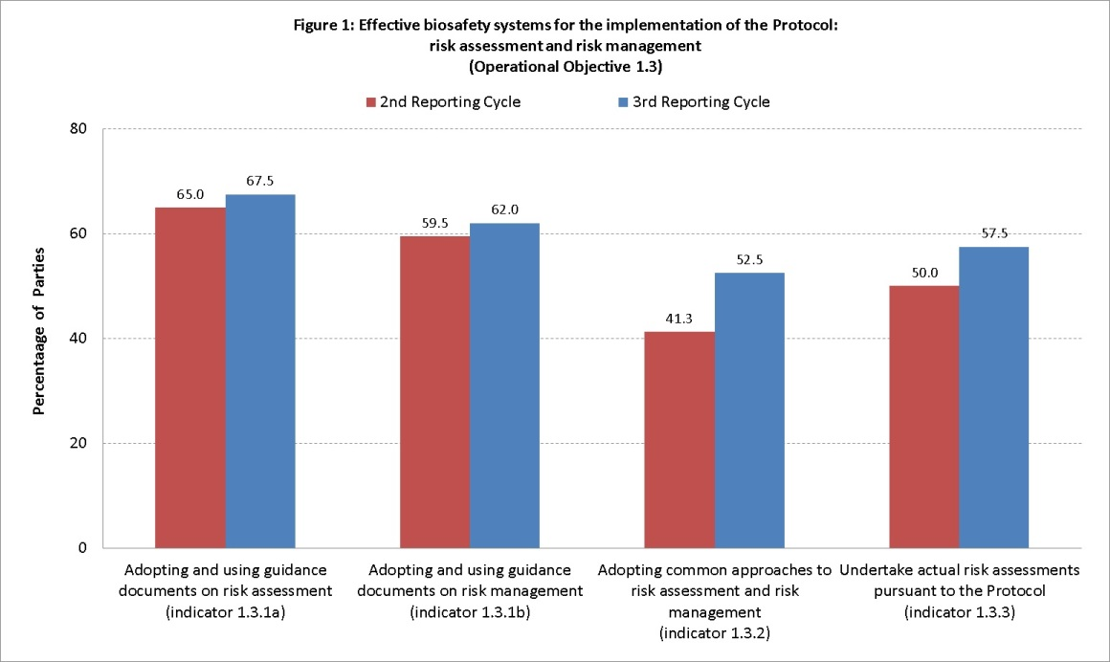
Operational objective 2.2: Risk assessment and risk management
- Within focal area 2 on “Capacity-building”, operational objective 2.2 aims at enabling Parties evaluate, apply, share and carry out risk assessments and establish local science-based capacities to regulate, manage, monitor and control risks of LMOs.
- Six indicators are provided under this operational objective to measure progress. Results from the third reporting cycle when compared with the baseline indicate that:
- The ratio between the number of risk assessment summary reports and the number of decisions on LMOs on the Biosafety Clearing-House went from 83 per cent as of December 2012 to 93 per cent as of December 2015, representing an increase by 10 per cent (indicator 2.2.1);
- The number of Parties that:
- Trained one or more people in risk assessment, risk management or monitoring decreased by 1, 2 and 5, respectively (indicator 2.2.3; figure 2);
- Have infrastructure, including laboratories for monitoring, management and control of LMOs increased by 2 (indicator 2.2.4; figure 2);
- Are using training materials and technical guidance for the purpose of capacity-building increased by 2 (indicator 2.2.5; figure 2);
- Consider the existing training materials and technical guidance sufficient increased by 1 (indicator 2.2.6; figure 2).
- Furthermore, among the Parties that submitted third national reports, 41 per cent of the Parties indicated that they are currently using the Training Manual on Risk Assessment, which was developed by the Secretariat, for purposes of building capacity (data not shown). No baseline data is available for this information and, therefore, a trend cannot be drawn for the current reporting cycle.
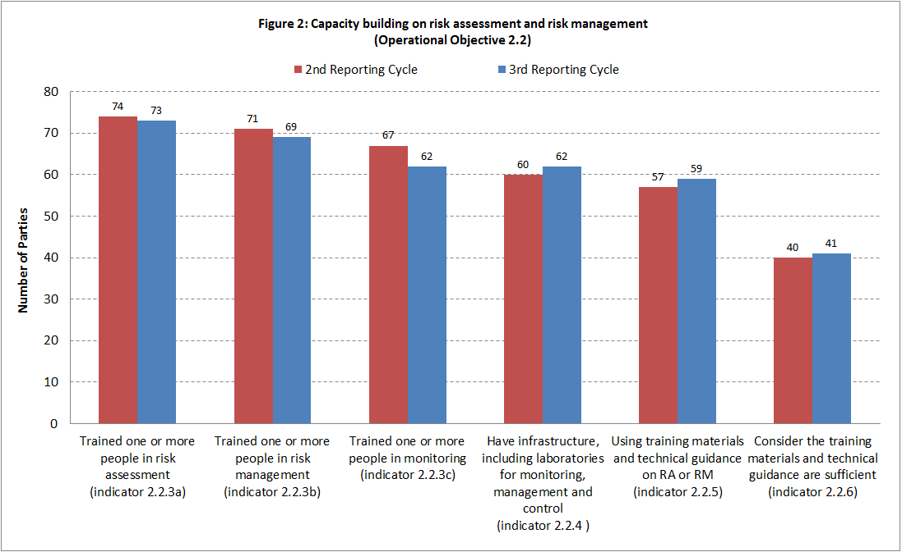
- LMOs or traits that may have adverse effects (operational objective 1.4)
- Operational objective 1.4 calls for the development of modalities for cooperation and guidance in identifying LMOs or specific traits that may have adverse effects on the conservation and sustainable use of biological diversity, taking also into account risks to human health.
- Two indicators are provided in the Strategic Plan to measure progress towards this operational objective. With regard to indicator 1.4.2, results from the third reporting cycle when compared with the baseline indicate that the number of Parties that are capable of identifying or assessing LMOs or specific traits that may have adverse effects decreased by 7 and 2, respectively, whereas the number of Parties that are capable of monitoring such LMOs or specific traits remained the same in comparison to the baseline, as indicated in figure 3.
- There were no reports of any guidance on living modified organisms or specific traits that may have adverse effects on the conservation and sustainable use of biological diversity, taking also into account risks to human health, developed by Parties and, therefore, indicator 1.4.1 cannot be measured.
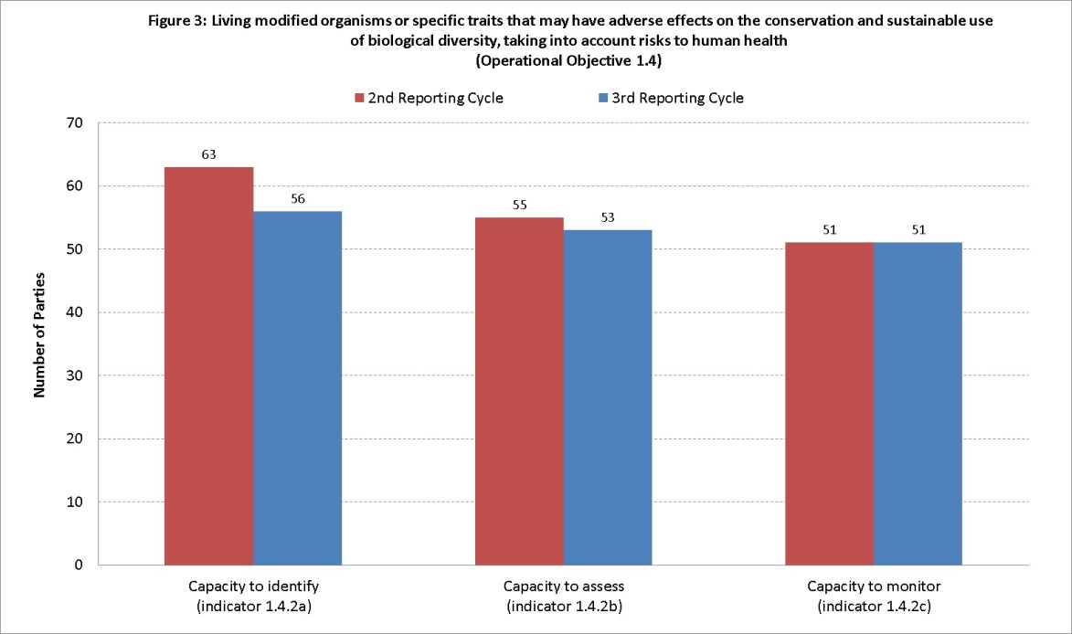
- Liability and redress (operational objectives 1.5 and 2.4)
Operational objectives 1.5 and 2.4: Liability and redress
- The Nagoya-Kuala Lumpur Supplementary Protocol on Liability and Redress to the Cartagena Protocol on Biosafety has not yet entered into force (indicator 1.5.1 Entry into force of the Nagoya-Kuala Lumpur Supplementary Protocol on Liability and Redress to the Cartagena Protocol on Biosafety prior to the seventh meeting of COP-MOP). As of 1 March 2016, 34 of the required 40 instruments have been deposited, of which all but one have been deposited in the current reporting period.
- Information on indicator 1.5.2 (percentage of Parties to the Supplementary Protocol having in place national administrative and legal frameworks incorporating rules and procedures on liability and redress for damage caused by living modified organisms), is not directly relevant given that the Supplementary Protocol has not entered into force. However, 51 Parties (64%) reported having administrative or legal instruments that provide for response measures for damage to biodiversity resulting from LMOs, which is the same result as reported in the baseline.
- In relation to indicator 2.4.1 (number of eligible Parties that received capacity-building support in the area of liability and redress involving LMOs), 7 Parties (9%) reported that they had received financial and/or technical assistance for capacity-building in the area of liability and redress relating to LMOs as compared to 15 Parties (19%) during the second reporting cycle. Information in relation to indicator 2.4.2 (number of domestic administrative or legal instruments identified, amended or newly enacted that fulfil the objective of the international rules and procedure in the field of liability and redress) is not available, and reference is made to the related indicator 1.5.2.
- Handling, transport, packaging and identification (operational objectives 1.6 and 2.3)
Operational objective 1.6: Handling, transport, packaging and identification
- With regard to the percentage of Parties that have put in place documentation requirements for LMOs intended for direct use as food or feed, or for processing, indicator 1.6.1, information is only available on a specific aspect of documentation requirements. As indicated in figure 4, 66 per cent of Parties (+6%) reported that they have taken measures, at least to some extent, to require that documentation accompanying shipments of LMOs-FFP clearly identifies that they may contain LMOs and are not intended for intentional introduction into the environment, where the identity of the LMO is not known through means such as identity preservation. Furthermore, 67 per cent also reported that, in cases where the identity of the LMO is known through means such identity preservation, they have taken measures, at least to some extent, to require that documentation accompanying such LMOs-FFP, clearly identifies that they contain LMOs-FFP, which represents no change as compared to the baseline, as indicated in figure 4.
- In the analysis of the percentage of Parties that have put in place documentation requirements for LMOs for contained use and for intentional introduction into the environment, (indicator 1.6.2) as indicated in figure 4, 77 per cent of Parties reported that they have taken measures, at least to some extent, to require that documentation accompanying LMOs destined for contained used, clearly identifies them as LMOs and specifies requirements for their safe handling, storage, transport and use, the contact point, as well as the contact point for further information including associated information. This is an increase of 4% in comparison to the baseline, with notable regional progress reported in CEE (+17%) and Africa (+16).
- Furthermore, as indicated in figure 4, 75 per cent of Parties reported that they have taken similar measures, at least to some extent, related to LMOs intended for intentional introduction into the environment within the Party of import. They require that documentation accompanying such LMOs identifies them as LMOs and specifies their identity and relevant traits and/or characteristics, requirements for safe handling, storage, transport and use, the contact point for further information, and requires that such documentation contains a declaration that the movement is in conformity with the requirements of the Protocol. This constitutes an increase of 7 per cent, with a notable increase reported by Parties in Africa (+16%) and a decrease by Parties in GRULAC (-14%).
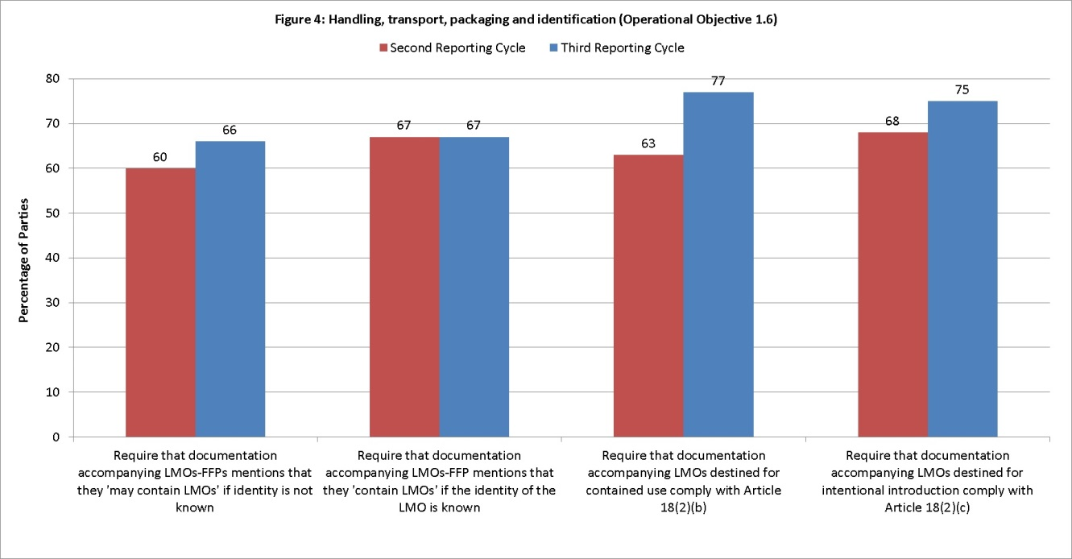
- With regard to the number of Parties with access to tools that are capable of detecting unauthorized LMOs (indicator 1.6.3), there has been an increase of 16 per cent as compared to baseline data.
- While information is not available on the number of Parties using guidance developed for the handling, transport and packaging of LMOs (indicator 1.6.4), 53 Parties (66%) reported having such guidance available, while 48 Parties (60%) reported that they had such guidance during the second reporting cycle. In the GRULAC region, three Parties (25%) have reported having such guidance.
Operational objective 2.3: Handling, transport, packaging and identification
- Operational objective 2.3 focuses on the development of Parties’ capacity for handling, transport, packaging and identification of living modified organisms. As indicated in figure 5, the number of Parties that replied positively to the relevant questions corresponding to each of the indicators increased in comparison with the baseline.
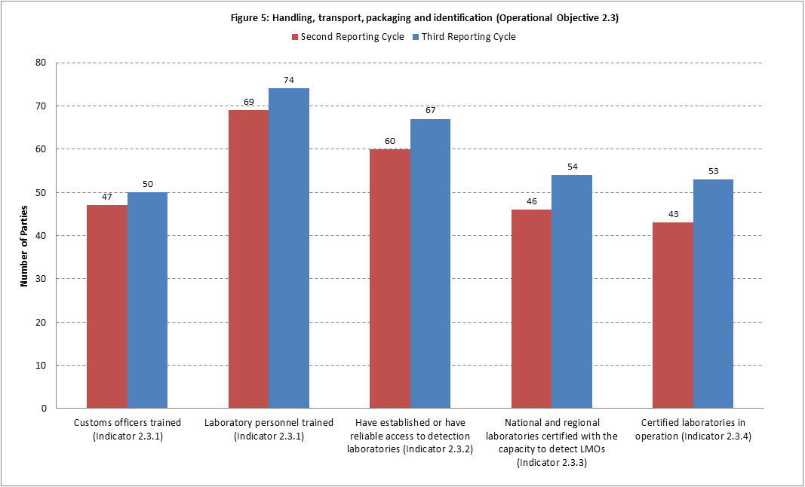
- In addition to their responses, Parties also noted in their comments, an equally positive outlook on their progress towards developing capacity for handling, transport, packaging and identification of LMOs as per operational objective 2.3. In their comments, some Parties noted that part or all of these procedures are carried out by officials from other relevant authorities, such as dedicated biosafety inspectors at ports of entry and quarantine officers. Parties also noted that the relevant border control officials receive ongoing training in LMO labelling and document identification as well as the sampling of shipments for the analytical detection of the presence of LMOs.
- Parties continue to train more laboratory personnel in the areas of detection and identification of LMOs. Furthermore, efforts are under way by several Parties to enhance the infrastructure of laboratories for the detection and identification of LMOs, both nationally and regionally.
- At the regional level, more Parties have reported the formation and participation in sub/regional networks that focus on the detection and identification of LMOs; these include the European Union, the Middle East and North Africa and the Caribbean. In addition through information obtained from the CBD Network of Laboratories for the Detection and Identification of Living Modified Organisms, there are other regional laboratory networks in the African region and in the region of the Association of Southeast Asian Nations. Several Parties in the Caribbean subregion in particular have indicated that they are also making use of a regional testing laboratory in cases where they do not have a national laboratory.
- At the national level, several Parties reported that they have access to the laboratory facilities, some of which are not exclusively used for LMO detection and identification. Among the Parties that reported having at least one operational laboratory, most had laboratories that were certified for LMO analysis. Furthermore, it was also noted that, despite not being certified, some laboratories apply the necessary quality control measures for ensuring accurate and consistent results. The results of the third national report are in line with the findings shared through the CBD Network of Laboratories for the Detection and Identification of Living Modified Organisms.
- In elaborating on the concept of certification, some Parties noted that this was interpreted to mean “accreditation”, which is the standard language used in the field to refer to the enforcement of quality assurance standards within a laboratory.
- Socioeconomic considerations (operational objective 1.7)
- With regard to the number of peer-reviewed research papers published, made available and used by Parties in considering socioeconomic impacts of LMOs (indicator 1.7.1), 29 Parties (37%) reported that they had used peer-reviewed published materials for the purpose of elaborating or determining national actions with regard to socioeconomic considerations, compared to 30 Parties in the baseline. While Parties were not required to indicate the exact number of such materials that they have used, almost half of the Parties (48%) that reported that they had used between one and four.
- In the analysis of the number of Parties reporting on their approaches to taking socioeconomic considerations into account (indicator 1.7.2) 38 Parties (48%) reported that they have specific approaches or requirements that facilitate how socioeconomic considerations should be taken into account in LMO decision-making. This constitutes a small increase in comparison to the information provided in setting the baseline, where 34 Parties (43%) reported that they have such approaches or requirements. At the regional level, the measurement of this indicator showed an increase in Africa (+25%) and a decrease in Asia and the Pacific (-8%) and the Western European and Others Group (WEOG) (-6%), while CEE and GRULAC reported the same results as in the baseline.
- A total of 13 Parties reported their experiences in taking socioeconomic considerations into account in reaching decisions on import of LMOs (indicator 1.7.3), while seven Parties report to have done so in some cases. This constitutes respectively 30 and 16 per cent of those 44 Parties that responded to the related question in both the third national report and the baseline. The responses show a decrease in comparison to the baseline, where 16 Parties (36%) reported having experience in taking into consideration socioeconomic considerations in decision-making related to import of LMOs, and 8 Parties (18%) reported having experience in some cases.
- Furthermore, some Parties indicated in their comments that socioeconomic considerations had been taken into consideration in field trials only. A number of Parties reported that legislation to this end is under development. One Party indicated that socioeconomic considerations could be taken into consideration as supplementary information.
- Transit, contained use, unintentional transboundary movements and emergency measures (operational objective 1.8)
- In the analysis of the percentage of Parties that have in place measures to manage LMOs in transit (indicator 1.8.1), the third national reports indicate that 69 per cent of Parties regulate the transit of LMOs, either fully or to some extent, which represents an increase of 8 per cent, as shown in figure 6. Some regional differences are noted. In WEOG all Parties reported that they have regulated transit, while in the CEE, only 88 per cent of Parties reported that they have regulated transit. In Africa, Asia and the Pacific, and GRULAC, the percentage of Parties that have regulated or regulated to some extent is also higher (respectively 57%; 50% and 60%).
- A slightly higher percentage of Parties reported that they have in place measures for contained use (75%, or 77 Parties) (indicator 1.8.2), which represents an increase of 5 per cent, as indicated in figure 6. All Parties in WEOG and almost all Parties in CEE (94%) reported that they regulate contained use, while percentages are lower in Africa and Asia and the Pacific (67% and 70%, respectively) and lowest in GRULAC (53%). GRULAC is the only region that shows a downward trend in respect of the second national report (-7%).
- A number of Parties reported that their legislation related to the establishment of measures for contained use is under development.
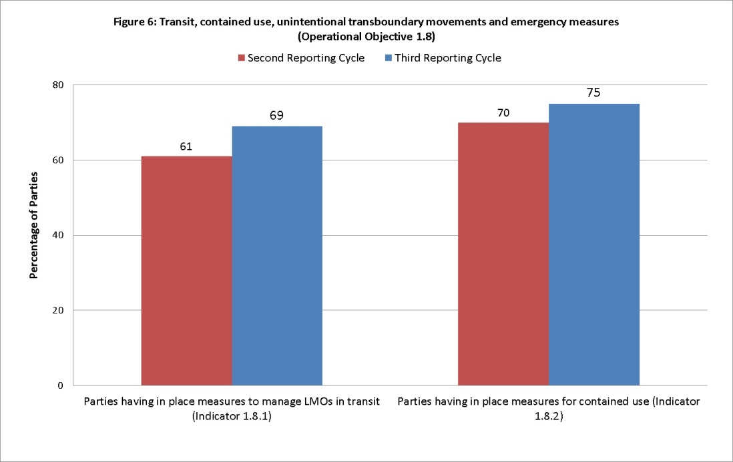
- In analysing use of guidance to detect the occurrence of unintentional releases of LMOs and being able to take appropriate response measures, it is noted that the Secretariat, in collaboration with the the CBD Network of Laboratories for the Detection and Identification of Living Modified Organisms, is in the process of developing the relevant guidance as requested in the Strategic Plan.
- With regard to Parties’ capacity to take appropriate measures in in the event that an LMO is unintentionally released, 44 Parties (56%) reported that they have such capacity. This represents an increase of 6 per cent as compared to the baseline.
- Information sharing (operational objectives 2.6, 4.1 and 4.2)
Operational objective 2.6: Information sharing
- Operational objective 2.6 on information sharing aims at ensuring that the Biosafety Clearing-House is easily accessed by all established stakeholders, in particular in developing countries and countries with economies in transition.
- Two indicators were established to measure progress towards within this operational objective. Results obtained from the Biosafety Clearing-House at the end of the third reporting cycle when compared with the baseline indicate that:
- The number of submissions to the Biosafety Clearing-House from developing countries and countries with economies in transition increased from 1,406 in the second reporting period to 2,103 in the third reporting period. In spite of the increase in the number of records, the percentage of submissions to the Biosafety Clearing-House from developing countries and countries with economies in transition in relation to all submissions decreased from 38.8 per cent when the baseline was set to 34.4 per cent in the last reporting cycle. These results indicate that although developing countries and countries with economies in transition continue to submit National Records to the Biosafety Clearing-House, the rate in which these countries are contributing has slowed down during the third national reporting period (indicator 2.2.1);
- The amount of traffic (annual average across the reporting periods) in the Biosafety Clearing-House by users from developing countries and countries with economies in transition, increased from 65,327 visits and 39,275 unique visitors in the second reporting cycle to 174,523 visits and 77,210 unique visitors in the third reporting cycle, representing increases of 167 per cent in the number of visits and 97% in the number of unique visitors from developing countries and countries with economies in transition (indicator 2.6.2). Interestingly, an analysis of these results show that the increase in total traffic observed during the third reporting cycle is due exclusively to an increase in the traffic from users to the Biosafety Clearing-House from developing countries and countries with economies in transition (figure 7; see also indicator 4.2.3).
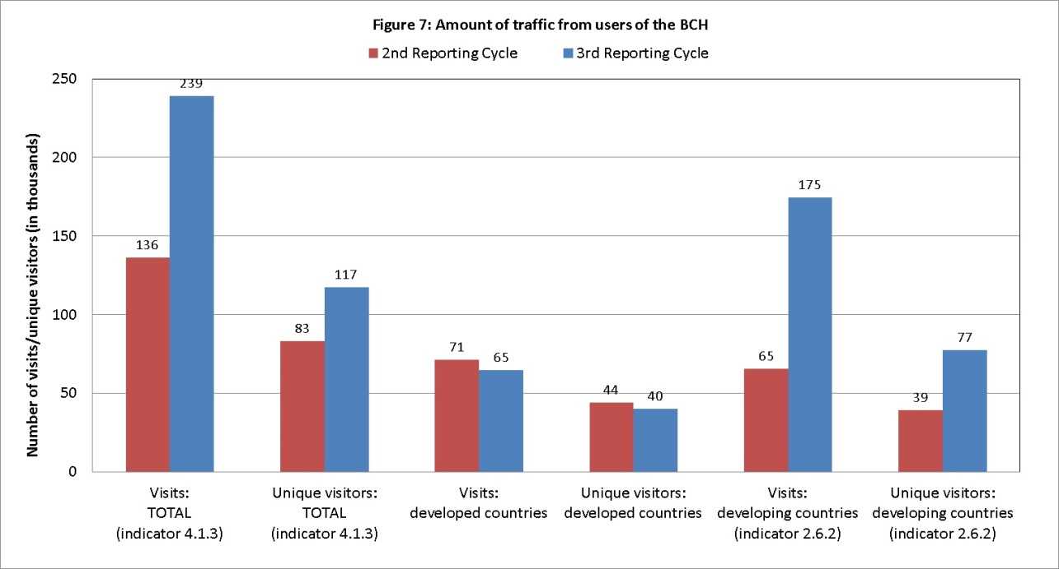
Operational objective 4.1: BCH effectiveness
- Operational objective 4.1 on the effectiveness of the Biosafety Clearing-House aims to increase the amount and quality of information submitted to and retrieved from the Biosafety Clearing-House.
- Eight indicators are provided in the Strategic Plan to measure progress towards this operational objective. Data obtained during the third reporting cycle compared with the baseline indicate that:
- The ratio of risk assessment summary reports as against number of decisions on “LMOs for intentional introduction into the environment” and “Decision on LMOs for direct use as food or feed, or for processing” increased from 83 per cent (536 risk assessments to 647 decisions) in the second reporting cycle to 93 per cent (1210 risk assessments to 1295 decisions) in the third reporting cycle (indicator 4.1.1). Interestingly, not only the ratio of risk assessment summaries to decisions increased, but also the number of such decisions increased by 100 per cent during the last reporting cycle;
- The number of publications contained in the Biosafety Information Resource Centre (BIRC) increased from 1,223 at the end of 2012 to 1,460 at the end of 2015, representing an increase of 19.4 per cent (indicator 4.1.2);
- The amount of traffic (annual average across the reporting periods) from users to the Biosafety Clearing-House (measured globally) increased from 136,450 visits and 83,159 unique visitors in the second reporting cycle to 239,153 visits and 117,210 unique visitors in the third reporting cycle, representing increases of 75 per cent in the number of visits and 40 per cent in the number of unique visitors (indicator 4.1.3; figure 7). The increase in the number of visits and number of unique visitors is due exclusively to an increase in traffic from users to the Biosafety Clearing-House coming from developing countries and countries with economies in transition. When only developed countries are considered, there was actually a decrease in the amount of traffic in the third reporting cycle in comparison to the baseline (see figure 7 above);
- Number of references to the Biosafety Clearing-House (indicator 4.1.4), measured as the number of people who arrived at the Biosafety Clearing-House by clicking on links in social media websites (e.g. Facebook, Twitter), increased from 1,458 during 2010-2012 (second reporting cycle) to 3,148 during 2013-2015 (third reporting cycle), representing an increase of 115 per cent;
- The number of countries with focal points registered on the Biosafety Clearing-House changed as follows (indicator 4.1.5):
- Cartagena Protocol Focal Point: increased from 176 (90%) to 180 (92%);
- Biosafety Clearing-House Focal Point: decreased from 192 (98% of countries) to 191 (97% of countries);
- Emergency Measures (Article 17) Contact Point: increased from 72 (37% of countries) to 109 (56% of countries);
- The number of countries having published biosafety laws and/or regulations on the Biosafety Clearing-House increased from 155 in the second reporting cycle to 159 in the third reporting cycle. This represents an increase of 2 per cent (from 79% to 81% of a total of 196 countries) (indicator 4.1.6);
- The number of AIA/domestic decisions available through the Biosafety Clearing-House, measured as the number of “Decision on LMOs for intentional introduction into the environment (according Article 10 or domestic regulatory framework)” and/or “Decision on LMOs for direct use as food or feed, or for processing (Article 11, LMOs-FFPs)” that were submitted by Parties, increased from 903 in the second reporting format to 1296 in the third reporting format. This represents an increase of 44 per cent in the number of such decisions submitted in the third reporting cycle as compared to the baseline (indicator 4.1.7).
Operational objective 4.2: BCH as a tool for online discussions and conferences
- Operational objective 4.2 on the Biosafety Clearing-House as a tool for online discussions and conferences aims to establish the Biosafety Clearing-House as a fully functional and effective platform for assisting countries in the implementation of the Protocol on the effectiveness of the Biosafety Clearing-House aims to increase the amount and quality of information submitted to and retrieved from the BCH.
- Three indicators are provided in the Strategic Plan to measure progress towards this operational objective. Data obtained from the Biosafety Clearing-House during 2013-2015 in comparison with data obtained during 2010-2012 as baseline indicate that:
- The average number of Parties that actively nominated participants to open-ended forums held under the Biosafety Clearing-House increased from 29 (18% of 163 Parties) in the second reporting cycle to 42 (25% of 170 Parties) in the third reporting cycle (indicator 4.2.1; table 1);
Table 1. Number of Parties that actively nominated participants to open-ended forums held under the BCH
 | Second reporting cycle  (2010-2012) | Third reporting cycle  (2013-2015)
Risk assessment | 50 | 53
Detection and identification | 18 | 41
Customs officers | 15 | N/A
Socioeconomic | 34 | 27
Synthetic biology | N/A | 48
Average | 29 | 42
Percentage | 18% | 25%
- The total number of participants who took part in open-ended online forums held under the Biosafety Clearing-House increased from 428 in the second reporting cycle to 687 in the third reporting cycle, representing an increase in 60 per cent (indicator 4.2.2; table 2);
Table 2. Number of participants who took part in open-ended online forums held under the BCH
 | Second reporting cycle  (2010-2012) | Third reporting cycle  (2013-2015)
Risk assessment | 281 | 261
Detection and identification | 34 | 91
Customs officers | 21 | N/A
Socioeconomic | 92 | 99
Synthetic biology | N/A | 236
Total | 428 | 687
- The number of capacity-building activities aimed to increase the transparency, inclusiveness and equity of participation in the Biosafety Clearing-House increased from two online forums (“BCH on BCH Forum” and “UNEP-GEF BCH Forum”) during the second reporting cycle to four in the third reporting cycle (by adding two new forums: “FAO-CBD-OECD Biosafety Databases Forum” and “BCH Informal Advisory Committee” to the already existing ones) (indicator 4.2.3).
- Compliance and review (operational objective 3.2)
Operational objective 3.1: Compliance with the Protocol
- Indicator 3.1.1 is related to the number of Parties that have identified and addressed their non-compliance issues. The Compliance Committee reviews compliance by the Parties with their obligations. Its proceedings constitute an appropriate source of information for identifying cases of non-compliance.
- Pursuant to the Procedures and Mechanisms on Compliance under the Cartagena Protocol on Biosafety, as contained in the annex of decision BS-I/7, the Compliance Committee may carry out functions in relation to promoting compliance and addressing cases of non-compliance. A Party may report to the Committee issues relating to compliance with respect to the Party itself. In addition, a Party, which is affected or likely to be affected, may report to the Committee issues relating to compliance with respect to another Party.
- In the current reporting period, Parties have not submitted information on compliance issues to the Compliance Committee. However, the Committee has started the substantive implementation of its extended mandate, as given in decision BS-V/1, in particular by taking the initiative to approach individual Parties facing difficulties with their compliance.
- In this context, the Committee took actions to support Parties to improve the rates of submission and completeness of the second national reports and to improve on issues of compliance identified from a review of information provided in the second national reports and the Biosafety Clearing-House.
- The supportive role of the Committee has contributed to the high submission rates and completeness of the second national reports and to the consistency of information provided in the second national reports and in the Biosafety Clearing-House. In this respect, Parties have made progress in addressing compliance issues.
- Indicator 3.1.2 relates to the number of Parties having approved and functional national legal, administrative and other measures to implement the Protocol.
- A total of 52 Parties (51%) report that they have fully introduced the necessary legal, administrative and other measures for the implementation of the Protocol, which represents an increase of eight Parties (+8%) (see figure 8). The most growth is reported in Africa, followed by GRULAC. The number of Parties reporting that their biosafety framework has become operational within the current reporting period has continued to increase (+9 Parties). Parties report progress in adopting biosafety-specific and non-specific instruments, with 101 Parties (98%) reporting that at least some kind of instrument is in place, which represents an increase of three Parties.
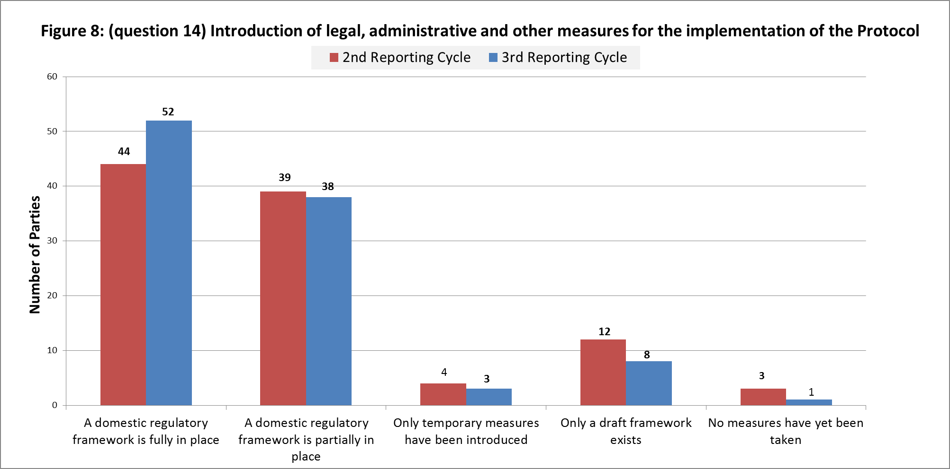

- Some Parties indicate in their free-text submissions that further measures are under development or that their adoption is pending. However, other Parties further reported that the measures have been awaiting adoption for many years. In this respect, some Parties indicated that awareness at the political and decision-making levels is insufficient and that this has resulted in a lack of priority being accorded to the strengthening of national biosafety frameworks. A considerable number of Parties that indicated that legislation, regulations and administrative measures are not yet fully in place reported that, to some extent, such measures have been adopted (38 Parties) (see figure 1). Some Parties that report having specific instruments in place indicate in their free-text submission that these instruments are still to be adopted.
- In their free-text submissions, Parties indicate that the slow rate of adoption of legal, administrative and other measures continues to be one of the main obstacles to implementing the obligations under the Protocol, despite the progress reported in the third national report.
- In relation to administrative structures, Parties reported the lack of sufficient human and financial resources in their free-text submissions. There is a considerable decrease (-11%) in the establishment of mechanisms that ensure budgetary allocations for the operation of their national biosafety framework. Just over half of the Parties (53 Parties) reported that such mechanisms have been established. A slight increase (+2 Parties, or +2%) is reported in the existence of permanent staff to administer functions directly related to the national biosafety framework, with a global total of 87 Parties (85%). However, some Parties clarified that their permanent staff only work on part-time basis on biosafety issues.
- Progress is reported, especially in Africa, in the establishment of institutional capacity to enable competent national authorities to perform the administrative functions required under the Protocol, with 48 Parties (48%) reporting having done so, which represents an increase of five Parties (5%). Despite making progress in establishing institutional capacities to some extent, in the GRULAC region, the number of Parties reporting that they had fully established adequate institutional capacities has decreased (1 Party), with a total of 2 out of 15 Parties reporting to have done so fully.
- In their free-text submissions, some Parties, including some of those that indicate that capacities have been established to some extent, reported that more capacity-building is required. Some reported that the legal framework providing the basis for the establishment and functioning of the competent national authorities has not been adopted.
- In relation to administrative structures, some Parties reported in their free-text submissions that institutional changes are being implemented or are about to be implemented. In examining this issue, the Compliance Committee recognized that many Parties face substantial budget reductions at the domestic level, which may negatively have affected their administrative structures.
- Indicator 3.1.3 is related to the Percentage of Parties that designated all national focal points. All but two Parties have notified the Secretariat of their national focal point, in accordance with Article 19 of the Protocol (99%). This is the same percentage as reported in the baseline. Furthermore, all but two Parties have notified the Secretariat of their BCH national focal point, in accordance with decision BS-I/3 and decision BS-II/2 (99%), which represents an increase of 1 per cent. Out of 170 Parties, 101 Parties (59%) have made available to the Biosafety Clearing-House the relevant details regarding the national point of contact, in accordance with Article 17, which relates to unintentional transboundary movements.
- Indicator 3.1.4 is related to the number of Parties that have in place a system for handling requests including for Advance Informed Agreement (AIA). Figure 9 shows the information provided by Parties in the second and third reporting cycles.
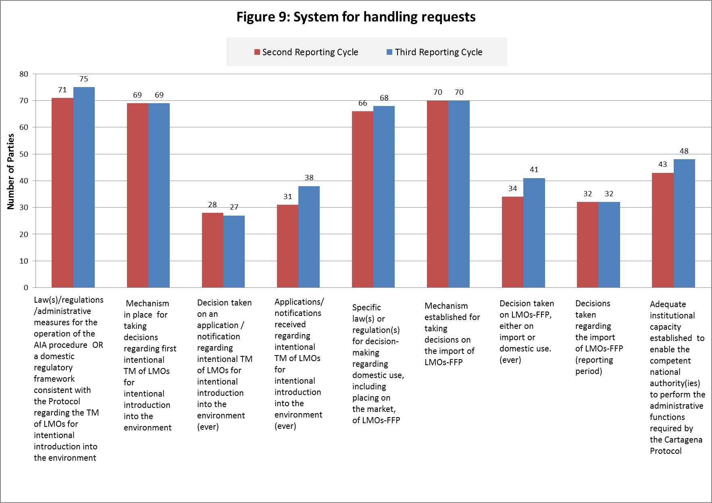
- A total of 75 Parties (71%) have reported that they have adopted laws, regulations or administrative measures for the operation of the AIA procedure, or have a domestic regulatory framework that is consistent with the Protocol, which is an increase of 4 Parties. A total of 69 Parties reported that a mechanism for taking decisions regarding first intentional introduction into the environment has been established, which is the same result as in the baseline. Regional differences are however noted. The percentage of Parties within the regions that report that a mechanism is fully in place varies between 47% (GRULAC) and 100 per cent (WEOG). Most Parties that have reported having laws, regulations or administrative measures also report that they have mechanisms for taking decisions in place (or in place to some extent) for taking decisions regarding first intentional introduction into the environment.
- The number of Parties that reported that they have taken a decision on an application/notification regarding intentional transboundary movements of LMOs for intentional introduction into the environment has remained stable with 27 Parties (31%) that indicated that they had taken such decisions. This is a decrease of one Party compared to the baseline. A total of 38 Parties have reported that they have received applications/notifications as compared to 31 in the second reporting cycle. All Parties that have indicated that they have taken a decision also reported that they have legislation in place for taking such decisions. Most of these Parties also report having mechanisms in place for taking decisions, although one Party reports not having such a mechanism in place, and two report having such mechanisms in place to some extent.
- In their free-text submissions, some Parties indicate that reviews of applications are currently being carried out. Others indicate that, pending the entry into force of legislation, applications cannot be processed.
- Most Parties that have indicated that they have laws, regulations and administrative measures with regard to decision-making for intentional introduction into the environment also reported that they have such laws and regulations for decision-making regarding domestic use, including placement on the market of LMOs-FFP. A total of 68 Parties, (67%) reported that they have such laws and regulations for LMOs-FFP, which constitutes an increase of two Parties (or 2%) compared to the baseline. A similar number of Parties (70) reported that they have a mechanism in place for taking decisions on the import of LMOs-FFP which remains the same as reported in the baseline. Despite regional differences, the global figures remain the same as that reported in the second national report in relation to the establishment of mechanisms for taking decisions on LMOs-FFP. Regional differences, however, show that a majority of Parties in GRULAC reported that they have neither instruments nor mechanisms for taking decisions.
- In their free-text submissions, some Parties indicated that, despite the absence of specific legal instruments with regard to AIA and LMOs-FFP, generally their biosafety framework addresses these issues. Some Parties that reported the existence of a legal framework indicate that the legislation has not yet been adopted or that informal procedures are being applied.
- A total of 41 Parties indicated that they have taken a decision on LMOs-FFP, which represents an increase of seven Parties (+7%), and 25 Parties reported that they have taken a decision on the import of LMOs-FFP in the current reporting period. A total of 25 Parties reported that they have taken a decision on domestic use, including placement on the market of LMOs-FFP. Most Parties that reported that they have taken a decision also reported that they have legislation and a mechanism in place for taking such decisions. However, five Parties reported that they have neither a mechanism nor specific legislation in place, although one of them clarifies that informal arrangements have been established and another indicates that, on the occasion when a decision was taken, the imports were rejected.
- Indicator 3.1.5 relates to the percentage of Parties that published all mandatory information via the BCH.
- In the submission of mandatory information to the BCH, Parties have reported progress on most types of information. The overall number of Parties that have reported that they have submitted information on national legislation, regulations and guidelines increased (+12%), although the percentage of Parties that have reported that they have submitted complete information on their frameworks remains just below two thirds (65%). The largest regional increases were reported in Africa (+19%) and GRULAC (+14%). Almost all Parties (96%) have reported that they have submitted at least some information on their frameworks.
- Despite the reported progress (+10%) on submission of summaries of any type of risk assessments to the BCH, only about a third of Parties (38%) reported that they have done so in all cases. In one region, Africa, none of the Parties reports having submitted such summaries in all cases. Considerable regional progress is reported in Asia and the Pacific (+27%) and GRULAC (+28%). When considering the number of Parties that have indicated that they have submitted summaries in some cases only, overall figures rise to just over two thirds (70%), which is a considerable increase (+16%) as compared to the baseline.
- About two thirds of Parties (64%) reported that they have submitted information on final decisions regarding LMOs for intentional introduction into the environment, which constitutes a considerable increase (+21%). Progress is attributable to GRULAC (+50%) and WEOG (+34%). Overall figures are similar in relation to submission of information regarding final decisions on import of LMOs-FFP (65%). A total of 14 Parties responded by providing information on decisions relating to LMOs for intentional introduction into the environment, and 23 Parties in relation to final decisions on import of LMOs-FFP. Information provided in response to different questions relating to submission of decisions on LMOs-FFP was found to be inconsistent.
- Of the 23 Parties that reported that they have provided such information in their second and third national reports, 48 per cent reported that they have always informed Parties through the BCH of decisions regarding domestic use of LMOs-FFP within 15 days. This represents a 9 per cent decrease. Regional differences are noted with decreases reported in Africa (-25%) and WEOG (-13%). A total of 26% of Parties report having always informed Parties through the Biosafety Clearing-House of decisions regarding domestic use of LMOs-FFP beyond the delay of 15 days, which represents an increase in respect of the baseline (+17%).
- In addition, the Secretariat reviewed information on decisions and risk assessments, as referred to in paragraph 1 of decision BS-V/2, in order to strive for completeness of information on decisions regarding LMOs. In this regard, the Secretariat compared the information available in the Biosafety Clearing-House with information available through other channels and databases. It also reviewed BCH records on decisions for which mandatory risk assessments have not been submitted.
- In this context, the Secretariat contacted Parties to draw their attention to inconsistencies and invited them to submit the relevant decisions that they have taken regarding LMOs and the corresponding risk assessments as required under Article 20 of the Protocol and subsequent COP-MOP decisions, or to provide clarification of the apparently incomplete data. This has resulted in an increase from 83 to 95 per cent in the rate of completeness of risk assessment reports in the Biosafety Clearing-House. The Secretariat has been in contact with Parties in relation to decisions available in the Biosafety Clearing-House, and has noted progress by Parties in addressing this issue.
- Out of 11 Parties that indicated that they have entered bilateral, regional or multilateral agreements or arrangements, 45 per cent indicated that they have always submitted related information to the Biosafety Clearing-House. This figure rises to just over 50 per cent when taking into consideration those Parties that have submitted such information in some cases only. Information on the same matter provided under different questions varies slightly.
- Of the Parties that have received information concerning cases of illegal transboundary movements of an LMO in the current reporting period, only four Parties (44%) reported that they submitted complete information to the Biosafety Clearing-House on these movements, which is the same as reported in the second national report. Only nine Parties report that such information is available.
- In their free-text submissions, Parties reported that, at the national level, information on field trials is not made available and therefore cannot be submitted. Some Parties indicated that information is available but not centrally stored and, therefore, not all information is made available through the BCH. Some Parties report that agencies, policymakers and legislators need to be made aware of the BCH and its functioning. Many Parties indicate that they lack the information and data altogether.
- In their free-text submissions, some Parties indicated that, where data exist, they are not always made available due to lack of capacity. Parties reported that human capacities and financial resources are insufficient for keeping the information in the Biosafety Clearing-House up to date. Some Parties reported on the beneficial effect of capacity-building activities offered through the UNEP/GEF in this respect. Parties reported a number of challenges in relation to making information available in full to the Biosafety Clearing-House, including: lack of permanent and full-time staff, rotation of staff, insufficient coordination in the collection of information at the national level, and insufficient awareness on need to submit certain types of information to the Biosafety Clearing-House. Some Parties indicate that there is a continuing need for training of officers in the use of the Biosafety Clearing-House. Some Parties indicate that, due to changes in personnel, acquired skills have been lost.
- Indicator 3.1.6 is related to the number of Parties that have in place a monitoring and enforcement system.
- Out of 78 Parties that responded to the related question in the second and third reporting cycle, about two thirds of Parties (56 Parties or 72%) reported that they have a monitoring system in place, which is an increase of six Parties (8%). Within the regions, differences are noted: within GRULAC, fewer Parties report having monitoring systems (42%) than in CEE (93%), WEOG (80%), Africa (78%) and Asia and the Pacific (57%). Out of 78 Parties responding to the related question in the second and third reporting cycles, a slightly higher number of Parties (59 Parties or 76%) reported that they have an enforcement system in place, with similar but slightly more pronounced regional differences (CEE 100%; WEOG 88%; Africa 78%; Asia and the Pacific 77%; GRULAC 25%).
- Indicator 3.1.7 is related to the number of national reports received under each reporting cycle.
- As of 31 December 2015, 105 Parties had submitted their third national report out of the 170 Parties to the Protocol that had the obligation to do so (62%). At a comparable point in time after the submission deadline for the second national reports, the submission rate was higher (89%). It is, however, difficult to compare these figures, due to delays in disbursing the available funding to Parties to support the completion of their third national report, related to the implementation of the Enterprise Resource Planning system (Umoja) by UNEP.
- With regard to previous reporting cycles, Parties reported as reasons for not having submitted one or more national reports the lack of financial resources, lack of relevant information at the national level and difficulty in compiling information from different sectors. These factors may have affected current submission rates.
- Indicator 3.1.8 is related to the number of Parties able to access financial resources to fulfil their obligations under the Protocol.
- About a third of 80 Parties that responded to the related questions in both the second and third reporting cycles (26 Parties or 33%) indicate that they dispose of predictable and reliable funding for capacity-building for the effective implementation of the Protocol, with the lowest results reported in GRULAC and Africa. Considerable regional differences are noted. Within Africa and GRULAC, four (17%) and two (17%) Parties respectively report having such resources. In Asia and the Pacific, WEOG and CEE, respectively, six (43%), seven (44%) and seven (50%) Parties reported that they have such funding. In the second reporting cycle, a total of 37 out of 80 Parties (46%) indicated having predictable and reliable funding for capacity-building for the implementation of the Protocol. Both overall and regional scores were higher in the Survey.
- About two thirds of Parties (69 Parties or 66%) indicated that they have received additional funding for implementation of the Protocol, which is similar to what was reported in the second reporting cycle, where 69 out of 109 Parties reported having received such funding (63%), although larger amounts (more than US$ 500,000) are reported than previously. When comparing only those 80 Parties providing information on this matter in the second and third national reporting cycle, the number of Parties reporting to have received new and additional funding remains stable at 39 (49%). The Global Environment Facility has continued to make available funding to support the implementation of the Protocol. As at 31 December 2015, 17 national and 1 regional projects were under implementation. Despite the availability of the additional resources, many Parties indicate that the lack of sufficient funding is one of the main obstacles to full implementation of the Protocol at the national level. Because no separate focal area exists for Biosafety within the Global Environment Facility, in practice biosafety projects have to compete with biodiversity projects when eligible Parties set priorities in their national allocations. Furthermore, poor coordination within and between government authorities and lack of awareness and capacities hamper accessing of GEF funds. Together, these issues have led to a relatively low uptake of available GEF funds for implementing the Cartagena Protocol.
- In addition, GEF/UNEP has made available funding for 82 Parties for completing their third national reports. In addition, 39 Parties that were eligible for GEF funding to complete their national reports either did not apply for those funds or were unable to access them.
Operational objective 3.2: Assessment and review
- In the analysis of the number of assessment reports submitted and reviews published, indicator 3.2.1, as of 31 December 2015, 105 (62%) third national reports were submitted out of the expected 170 that were due. In comparing reports submission at deadline time of both the second and third national reports, there has been a decrease from 89 per cent in the second national reports to 62 per cent in the third national reports. With regard to the previous reporting cycle, Parties have identified, among other things, lack of financial resources, lack of information at the national level and the challenges of compiling information from different sectors as some of the reasons for not submitting national reports. These factors may have affected current submission rates.
- In analysing the status of the number of Parties modifying their national biosafety frameworks to correspond with amendments to the Protocol adopted to address new challenges, indicator 3.2.2, it is noted that there have not been any amendments to the Protocol to date. However, Parties have reported on the implementation of guidance provided by the Conference of the Parties serving as the meeting of the Parties in the context of labelling requirements of shipments of LMOs-FFP. Half of the Parties have reported that, in cases where the identity of the LMO is known through such means as identity preservation, they have taken measures to require that documentation accompanying such LMOs-FFP, clearly identifies that they contain LMOs-FFP.
- Public awareness and participation, biosafety education and training
(operational objectives 2.5 , 2.7 and 4.3)

Operational objective 2.5: Public awareness, education and participation
- Operational objective 2.5 seeks to enhance capacity of Parties to raise public awareness, and promote public education and participation concerning the safe transfer, handling and use of LMOs. Three indicators were set out to measure progress towards the achievement of this objective.
- With regard to indicator 2.5.1, the percentage of Parties that reported having in place mechanisms for ensuring public participation in decision-making concerning LMOs increased by 17 per cent (from 63% to 80%) and the percentage of Parties reporting having no such mechanisms decreased by 16 per cent (from 37% to 21%). An increase was also reported with regard to the establishment of a mechanism to make available to the public the results of decisions taken concerning LMOs.
- The percentage of Parties that inform their public about existing modalities for participation (indicator 2.5.2) remained the same as the baseline, at 79 per cent. With regard to the specific types of modalities used to inform the public, the number of Parties using national websites as the main modality increased by 8 per cent. There was also a slight increase of 3 per cent in the number of Parties using public hearings while the use of newspapers, forums decreased.
- With regard to indicator 2.5.3 (number of Parties having in place national websites and searchable archives, national resource centres or sections in existing national libraries dedicated to biosafety educational materials), 60 Parties reported that they have such tools in place, which represents a 4 per cent (4 Parties) decrease as compared to the baseline.

Operational objective 2.7: Biosafety education and training
- Operational objective 2.7 seeks to promote education and training of biosafety professionals through greater coordination and collaboration among academic institutions and relevant organizations.
- An analysis of indicator 2.7.1 shows a slight increase of 5 per cent the number of Parties reporting having biosafety education and training courses and programmes. At the regional level, the increase was similarly modest with an average of one additional country per region reporting to have at least one academic institution offering biosafety education and training courses and programmes.
- Parties also reported an increase in the number of biosafety training materials and online modules available, as per indicator 2.7.2, with 13 more Parties indicating that they have one or more such materials and modules available.

Operational objective 4.3: Information sharing other than through the Biosafety Clearing-House
- Operational objective 4.3 focuses on enhancing understanding of biosafety through information exchange mechanisms other than the Biosafety Clearing-House. With regard to indicator 4.3.1 (the number of events organized in relation to biosafety), 74 Parties reported that they have organized at least one regional, national or international event related to biosafety, such as seminars, workshops, press conferences, educational events, etc. in the last 2 years. This represents a marginal increase of 2 per cent of the number of events held during the current reporting period as compared to the baseline.
- With regard to indicator 4.3.2 (number of biosafety related publications shared), 81 per cent of Parties reported that they have such publications, which represents a 3 per cent increase over the baseline. Parties are sharing their publications mainly through national websites and national libraries, while the number of Parties sharing information through the Biosafety Clearing-House central portal has marginally decreased.
- Outreach and cooperation (operational objectives 5.1, 5.2, and 5.3)

Operational objective 5.1: Ratification of the Protocol
- Indicator 5.1.1 provides an analysis of the percentage of Parties to the Convention on Biological Diversity that are Parties to the Protocol. As at 31 December 2011, 167 Parties to the Convention (84%) were Parties to the Protocol. As at 31 December 2015, the number of Parties to the Convention that were Parties to the Protocol increased by three to 170 (87%).

Operational objective 5.2: Cooperation
- In the analysis of the number of established relationships with other conventions as reflected in joint activities, as outlined in indicator 5.2.1, the Secretariat has established formal relationships with the Aarhus Convention, the Green Customs Initiative (GCI) and holds observer status in the Committee on Trade and Environment (CTE) of the World Trade Organization (WTO). The Secretariat has also renewed its request for observer status in other relevant WTO committees. Joint activities have also taken place in collaboration with the Organization for Economic Co-operation and Development (OECD) and the Food and Agriculture Organization of the United Nations (FAO) with a view to facilitating further discussion on effective communication mechanisms at the national level among the focal/contact points for the three biosafety databases.
- The Secretariat shares data on the Biosafety Clearing-House with OECD, the European Union Reference Laboratory for GM Food and Feed (EURL-GMFF), the CropLife International Detection Methods Database and, Biotradestatus Database, and the International Advisory Group on Pest Risk Analysis (IAGPRA), coordinated by the Secretariat of the International Plant Protection Convention.

Operational objective 5.3: Communication and outreach
- With regard to indicator 5.3.1 on the number of national awareness and outreach programmes on biosafety, there was a slight increase of 4 per cent in the number of Parties indicating that they have any awareness and outreach programmes on biosafety. In elaborating on the implementation of such programmes, several Parties from all regions reported that, at the national level, government ministries and departments are responsible for awareness and outreach programmes on biosafety, primarily through websites.
- In analysing indicator 5.3.2, 46 per cent of Parties reported that they had in place national communication strategies on biosafety not later than three years after having adopted national biosafety laws, which is an increase of 3 per cent over the baseline.
- With regard to indicator 5.3.3 on the percentage of Parties that have in place national biosafety websites, including national BCH nodes, that are accessible to and searchable by the public, 59 per cent of Parties reported having established a biosafety website searchable archives, national resource centres or sections in existing national libraries dedicated to biosafety educational materials, which represents a 4 per cent decrease as compared to the baseline.
- The number of Parties with awareness and educational materials on biosafety and the Protocol available and accessible to the public, including the diversity of these materials, as outlined in indicator 5.3.4, increased by 13 Parties (from 48 to 61 Parties).
__________

The Subsidiary Body on Implementation was established through COP decision XII/26 and its mandate includes supporting the Conference of the Parties serving as the meeting of the Parties in keeping under review the implementation of the Protocol.
The presented note is thus based on data and information available on 31 December 2015, as presented in UNEP/CBD/SBI/1/4/Add.1.
Decision BS-V/16, annex I.
Results of the survey are available at http://bch.cbd.int/database/reports/surveyonindicators.shtml.
Notification 2015-001 https://www.cbd.int/doc/notifications/2015/ntf-2015-001-bs-nr-en.pdf.
The Liaison Group on Capacity-Building, when providing its input to the third assessment and review and mid-term evaluation of the Strategic Plan, at its eleventh meeting, highlighted the importance of preparing an updated analysis including the additional reports submitted after the deadline of 31 December 2015 and making the updated document available to the Conference of the Parties serving as the meeting of the Parties at its eighth meeting as an information document. Accordingly, the Secretariat carried out an analysis of the 124 third national reports that had been received by 31 August 2016. Any significant differences between the analyses used by the SBI in its work and the updated analysis as at 31 August 2016 are presented in document UNEP/CBD/COP-MOP/8/INF/8.
The data used to carry out the analysis can be viewed in the National Report Analyzer, available at http://bch.cbd.int/database/reports/analyzer.
A matrix detailing the source of information based on which each indicator was analysed can be found at https://bch.cbd.int/protocol/issues/mid-term_evaluation.
For ease of reference, the Strategic Plan’s numbering system in the BCH, as found here http://bch.cbd.int/protocol/issues/cpb_stplan_txt.shtml#elements, was used throughout the present document.
Report of the Compliance Committee on its thirteenth meeting, held from 24 to 26 February 2016, will be available at http://bch.cbd.int/protocol/meetings/documents.shtml?eventid=5561.
The percentage figures in parentheses refer to the proportion of reporting Parties.
These changes are relative to the second reporting period.
Afghanistan, Bahrain, Côte d’Ivoire, Guinea Bissau, Iraq, Jamaica, Lebanon, Morocco, Somalia, United Arab Emirates, Uruguay.
Albania, Brazil, Cambodia, China, Costa Rica, Croatia, Cyprus, Ecuador, Egypt, Eritrea, France, Guatemala, Honduras, India, Indonesia, Italy, Kazakhstan, Kyrgyzstan, Lao People’s Democratic Republic, Malaysia, Mexico, Morocco, Peru, Republic of Korea, Slovenia, Spain, Tajikistan, Thailand, Tunisia, Turkey, Viet Nam.
Brazil, China, Croatia, Cyprus, France, India, Italy, Kyrgyzstan, Malaysia, Republic of Korea, Slovenia, Spain, Turkey, Viet Nam.
Strictly speaking, article 17 does not refer to “national focal points”, and information provided on national points of contact therefore does not necessarily need to be included in the analysis of this indicator. Given the binding character of the provision related to points of contact under Article 17 and considering that the information provided in relation to this matter is similar in nature to the information provided in relation to national focal points, the information provided on points of contact has been taken into consideration in this section.
For example, questions 17, 18 and 124 of the third national reporting format. In addition, questions 29 and 47 also refer to administrative measures in relation to the operation of the AIA procedure and for decision making on LMOs-FFP respectively, which have been addressed above under operational objective 1.1.
GEF support continues to focus on the development and implementation of national biosafety frameworks. Some of the supporting organizations reported by Parties include FAO, World Bank, International Centre for Genetic Engineering and Biotechnology (ICFEB); African biosafety network of expertise (ABNE), RAEIN Africa, AfricaBio, West and Central African Council for Agricultural Research and Development and Inter-American Institute for Cooperation on Agriculture (IICA).
There is no data available for measuring indicator 2.2.2 (number of risk assessment summary reports in the BCH that are in compliance with the Protocol). It is understood that for a risk assessment summary to be “in compliance with the Protocol”, it must summarize a risk assessment that was carried out in a scientifically sound and transparent basis and on a case-by-case manner for each LMO, its intended use and the likely potential receiving environment. Information related to the number of risk assessment summaries in the BCH that comply with these principles is not available.
It is noted that the number of Parties that trained at least one person in risk assessment, risk management and monitoring is being used as a proxy to measure the actual indicator “number of people trained in risk assessment, as well as in monitoring, management and control of LMOs” (indicator 2.2.3).
The approval by the European Union is not counted for the purposes of entry into force. Therefore, seven more instruments of ratification, acceptance, approval or accession need to be deposited.
There is no data available for measuring the number of users of the BCH requesting improvement on accuracy, completeness or timeliness of information (indicator 4.1.8).
Based on data available in the BCH on 31 December 2015.
The Biotradestatus database (www.biotradestatus.com), but also the databases of: (i) the Organization for Economic Co-operation and Development (OECD) (http://www2.oecd.org/biotech/); the International Portal on Food Safety, Animal and Plant Health (IPFSAPH) (http://www.ipfsaph.org/En/default.jsp); (ii) the European Food Safety Authority (EFSA) (http://registerofquestions.efsa.europa.eu/roqFrontend/login); and national biosafety clearing-houses, where applicable, have been used as references to identify gaps in the decisions published. The International Service for the Acquisition of Agri-biotech Applications (ISAAA) database is now also consulted.
Data for the second reporting cycle was drawn from the review by the Ad Hoc Technical Expert Group Meeting on the Second Assessment and Review of the Cartagena Protocol on Biosafety, held in June 2012 (UNEP/CBD/BS/A&R/1/INF/1).

