 |  | CBD
 |  |  |  | Distr.  GENERAL  UNEP/CBD/COP/9/INF/38  6 May 2008  ENGLISH ONLY

CONFERENCE OF THE PARTIES TO THE CONVENTION ON BIOLOGICAL DIVERSITY
Ninth meeting
Bonn, 19-30 May 2008
Item 3.5 of the provisional agenda*

COMPILATION OF VIEWS, experienceS, and OPTIONS in the implementation of the programme of work on incentive measures
Note by the Executive Secretary

I. INTRODUCTION
- In paragraph 1 of decision VIII/26, the Conference of the Parties decided to “initiate a structured, transparent and inclusive preparatory process for the in-depth review of work on incentive measures with a view to identify, for consideration by the Conference of the Parties at its ninth meeting, the further outcomes that would be required from a revised programme of work on incentive mechanisms to meet obligations under the Convention and the requirements of Parties, and possible options for a future programme of work.”
- In paragraph 3 of the same decision, the Conference of the Parties invited Parties, other Governments, international organizations and stakeholders to communicate to the Executive Secretary their experiences in the implementation of the programme of work on incentive measures contained in decisions V/15, VI/15 and VII/18 and provide views on elements such as:
- Lessons learned and key challenges in implementing the existing programme of work, based on practical examples and case-studies from national implementation, where available, including whether the measures initiated or adopted by Parties have maintained or improved the conservation and sustainable use of components of biodiversity;
- Options to address the challenges identified;
- Priorities for a future programme of work including requirements for effective national implementation, including financial and institutional support and capacity-building;
- Key gaps in the work to date, and gaps and obstacles in the existing programme of work that are impeding its implementation at the national level;
- Interface with other international initiatives and instruments in this area;
- Linkages to other programmes of work under the Convention.
- The present document complements the compilation of views, experiences and options provided by Parties, international organizations and stakeholders, contained in document UNEP/CBD/COP/9/INF/8. It provides views, experiences and options that were submitted after the deadline indicated in notifications 2007-032 and 2007-33 of 13 March 2007 and reminders sent on 9 November 2007 (notifications 2007-139 and 2997-140). The submission could therefore not be included in the summaries of views, experiences and options provided by Parties as well as by international organizations and stakeholders, contained, respectively, in documents UNEP/CBD/COP/9/12 and UNEP/CBD/COP/9/12/Add.2. The submission is reproduced as it was received by the Secretariat.

II. COMPILATION of views, Experiences, and options provided

United Nations Conference on Trade and Development; BioTrade Initiative
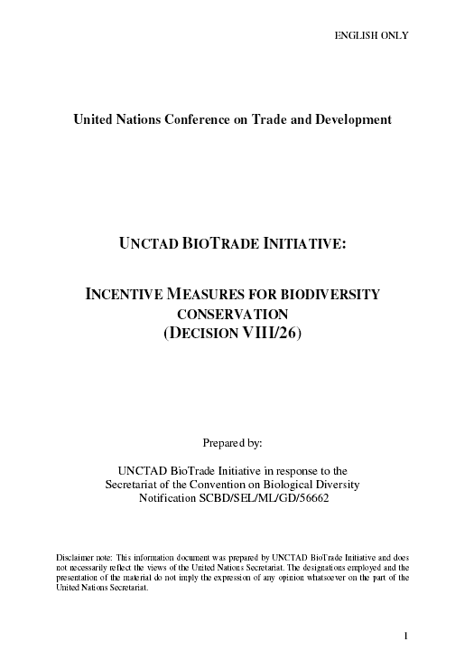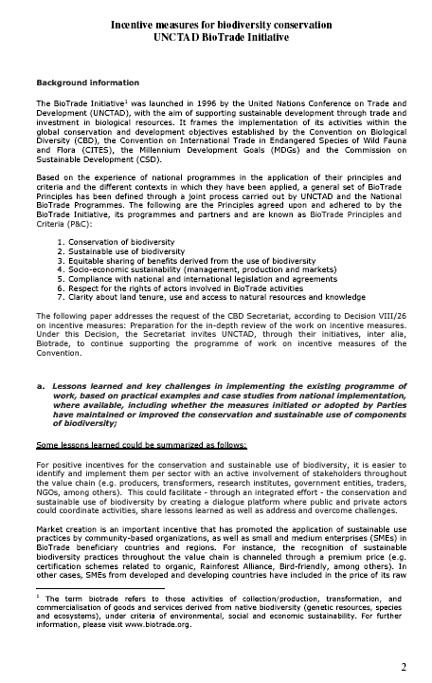
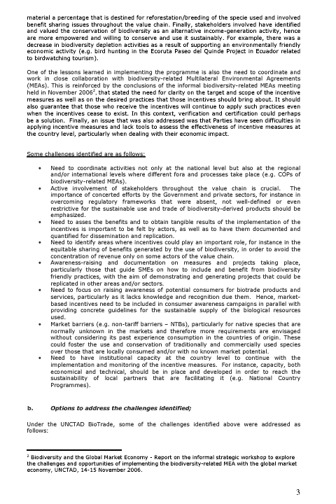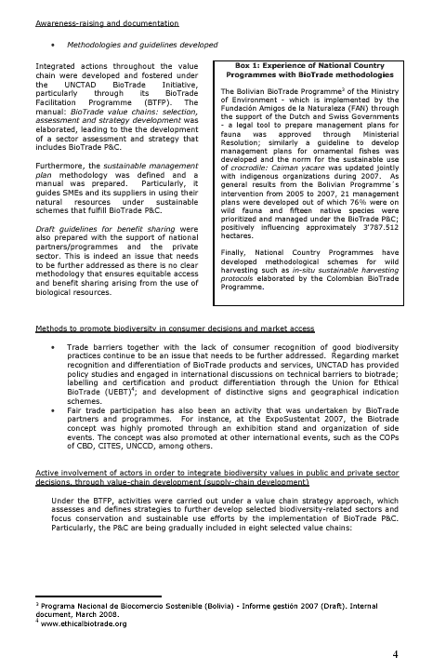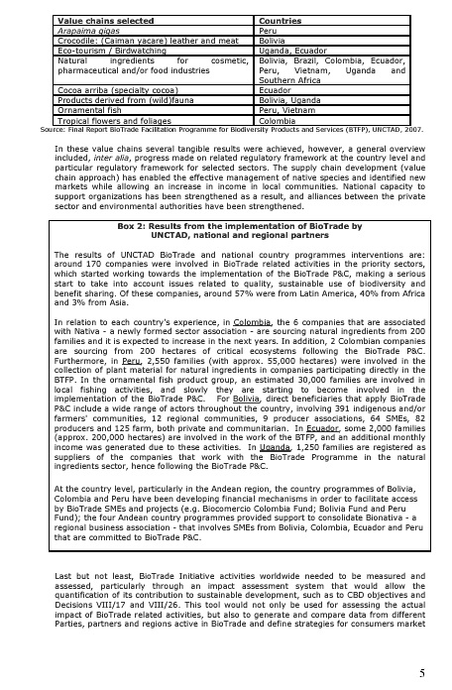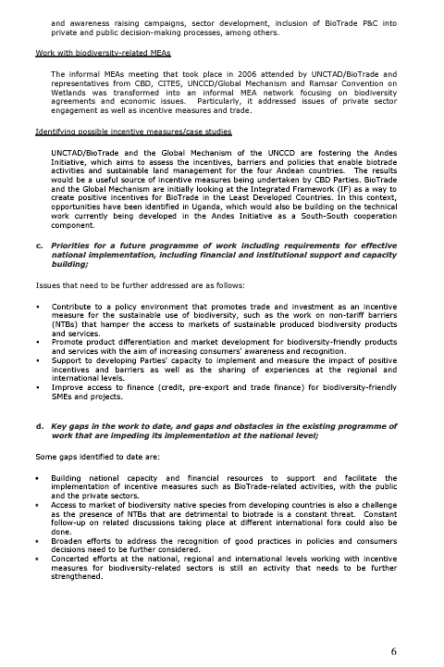

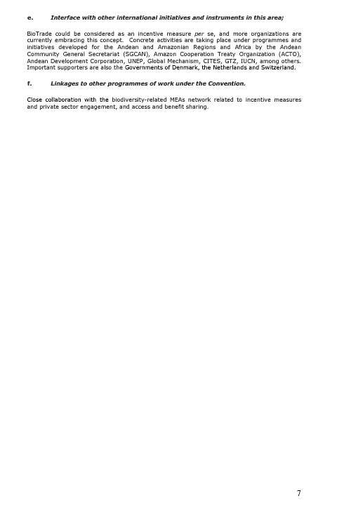

* UNEP/CBD/COP/9/1.

