 |  | CBD
 |  |  |  | Distr.  GENERAL  UNEP/CBD/COP/9/INF/42  22 April 2008  ENGLISH ONLY
CONFERENCE OF THE PARTIES TO THE CONVENTION ON BIOLOGICAL DIVERSITY
Ninth meeting
Bonn, 19–30 May 2008

A First Step Towards Environmental Reporting (2006- 2007)
Note by the Executive Secretary)

CONTENTS

1. Introduction 2
1.1. Message from the Executive Secretary 2
1.2. The UN Context 3
1.3. The Report 4
2. office Practices 4
2.1. Materials 4
2.1.1. Office Paper 4
2.1.2. Publications 5
2.1.3. Related Consumables 6
2.1.4. Recycle and Reuse 6
2.1.5. Utilities 6
2.1.6. Computers and IT Equipment 6
2.2. Green Procurement 6
2.3. Carbon emissions and offsetting activities 8
2.3.1. Staff Commute to Work 8
2.3.2. Calculations and Offsetting Initiatives 8
2.4. raising staff awareness 9
3. official meetings outside the cbd premises 9
3.1. Greening CBD Meetings 9
3.2. Efforts Towards Greening COP-9 10
4. Conclusion & POssible Next steps 11
5. Preliminary Gri index report content 12
6. Acronyms 14

1. Introduction

1.1. Message from the Executive Secretary

On World Environment Day on 5 June 2007, Secretary-General Ban Ki-moon pledged to reduce the United Nations (UN) carbon emissions and to work towards more efficient use of energy and resources. In so doing, he asked all members of the UN family to join him in this effort. The Executive Director of the United Nations Environment Programme (UNEP), Mr. Achim Steiner, confirmed UNEP’s commitment to achieving climate neutrality as well as assisting all UN agencies, funds, and programmes in these endeavours.

I am proud to say that we, the Secretariat of the Convention on Biological Diversity (SCBD), as the lead international instrument in the field of biodiversity fully support these commitments. Indeed, on 31 March 2006 at the closure of the eighth meeting of the Conference of the Parties (COP8) to the Convention, an agreement was signed with H.E. Mr. Roberto Requião, the Governor of the State of Paraná, Brazil, for the planting of 8 million trees to compensate for the environmental impacts of the meeting attended by 4,000 delegates. Another two-year agreement will be signed with the Governor of Paraná at the margins of the ninth meeting of the Conference of the Parties, to be held in Bonn in May 2008, to complement the commitment by Germany as reflected in the host agreement signed with the Secretariat to promote a carbon-neutral COP. A tradition has thus been established for greening the meetings of the Convention.

In my capacity as the head of the Secretariat of one of the most widely subscribed to international environmental agreements, I am very pleased to also announce that the 70 staff of the Secretariat, guided by the principle to lead by example and to walk the talk, have also established a tradition in greening its operations. Indeed in November 2006, a Memorandum of Understanding (MoU) was signed with the President of the Green Belt Movement and Nobel Laureate, Dr. Wangari Maathai to offset the environmental impact of the Secretariat processes by planting trees in Africa. Thanks to the leadership of Ms. Monique Barbut, CEO of the Global Environmental Facility (GEF), this historical MOU has been generously supported by the financial mechanism of the Convention. To compensate for the 2007 environmental impact of the Secretariat and offset the 500 tonnes of CO₂ equivalent from official staff travel, 3,000 trees will be soon planted by the Green Belt Movement in the Ngong forest, Kenya.

In signing a three-year agreement with the Secretariat on 22 May 2007 at the occasion of the celebration of the International Day on Biodiversity, the official travel agent of the Secretariat, MKI, has decided to join forces with the Secretariat to contribute to offsetting the emissions of MKI staff’s official travel as well as to promote the importance of neutralizing carbon on business travel to its client base.

Additionally, in September 2006, an internal greening task force of the Secretariat was established. The first Greening Plan was finalized and greening newsletters have been produced. We have a dedicated team that works to raise awareness amongst staff and green the practices of the CBD. In many cases, a great deal of progress has been made.

As the leading international instrument for the conservation and protection of biodiversity, we feel it is our job not only to green our practices but also to ensure that our practices do not directly harm the very thing we are trying to protect: biodiversity. It is for this reason that I feel it is important to share our work with the Conference of the Parties (COP); but more than this, to share it with other organisations too. While reducing carbon emissions and achieving climate neutrality are vital goals, and a valuable rallying point, the SCBD also wishes to encourage the world to do more than address GHG emissions. If we are to conserve and protect the biodiversity that is the mainstay of life on earth, we must also consider our impacts on it when making environmental choices. We hope that through our work within the SCBD we can lead by example and encourage the UN family and other organisations to consider not only their carbon emissions and efficient use of energy and resources, but their impacts on biodiversity as well. Naturally efficient use of resources will reduce the strain on biodiversity, but one also needs to consider which resources are being used: are they endangered species; are they harvested in a sustainable manner; are they benefiting local populations; and the list goes on.

At the same time, we note that we still have much to learn on reporting from other organisations. In our first report, we have focused on the environmental indicators of the Global Reporting Initiative. We must now address the economic and social practices of the Secretariat. Considering my own commitment to this, as well as the enthusiasm of the staff at the Secretariat, I have no doubt that we will achieve full reporting in the coming years.

As we all know, biodiversity is at the root of all life and every activity. Thus, actually achieving conservation of biodiversity requires a multi-layered web of intersecting initiatives involving all stakeholders. The Norwegian playwright Henrik Ibsen once said, “A thousand words will not leave so deep an impression as one deed.” Indeed, every small step counts and helps to build towards larger initiatives. It is our role, and moral responsibility as the SCBD, to forge new ground and set new standards. Our efforts, achievements, and goals are outlined in this document.

1.2. The UN Context
The Secretariat, as the body responsible for arranging, servicing and preparing documentation for meetings of the Convention, has a particularly important role in minimizing the Convention’s environmental footprint. Several initiatives across the UN and its Environment Programme in particular are relevant to the Secretariat’s greening efforts. These include:

- UNEP Governing Council decision 18/10 (1995) calling on the Executive Director of UNEP to consider and recommend strategies for the promotion of best practices in environmental housekeeping for use by UNEP at its headquarters and in its regional offices, and to advise and encourage the rest of the United Nations system to develop similar strategies;
- Governing Council decision 23/8 (2005) requesting the Executive Director of UNEP to prepare a report on environmental and equity considerations regarding current practices in UNEP;
- The creation in 2001 of the Environment Management Group (EMG) – (see box below);
- The publication of a Sustainability Report for 2004-2005 by UNEP’s Division of Technology, Industry, and Economics (DTIE) (see box below.)
- The Secretary General announced his plans to make the UN Headquarters carbon-neutral and environmentally sustainable and indicated that this initiative should include the other United Nations headquarters and offices around the globe. “We are already moving towards making our Headquarters in New York climate-neutral and environmentally sustainable. […] I would like to see our renovated Headquarters complex eventually become a globally acclaimed model of efficient use of energy and resources. Beyond New York, the initiative should include the other United Nations headquarters and offices around the globe.” (Ban Ki-moon, remarks to the World Tourism Organization, 5 June 2007, World Environment Day.)

The Environmental Management Group (EMG) www.unemg.org
What it is, how it helps the SCBD in greening its operations

The role of the EMG is to enhance UN system-wide inter-agency coordination related to specific issues in the field of, inter alia, the environment. In June 2007, an Issue Management Group (IMG) on Climate, or Carbon Neutral (C-Neutral), and another on Sustainable Procurement were created. The Secretariat provided input into IMG meetings.
UNEP/DTIE 2004-2005 Sustainability Report

The 2004-2005 Sustainability Report “Learning by doing” presents an overview of the organizational sustainability (economic, social and environmental) performance of the UNEP Division of Technology, Industry and Economics (UNEP/DTIE), using the Global Reporting Initiative Guidelines. UNEP DTIE was thus the first UN entity to produce a report on progress made in critical areas of sustainability. For further information, visit http://www.unep.fr/en/about/activity_report.htm

In this context, and in order to minimize its own footprint, the Secretariat:

(1) Prepared a draft plan for minimizing the environmental impact of the operations of the CBD (finalized in June 2006). The document addresses how the Secretariat can minimize the negative environmental impact of its operations, including meetings of the Convention. Appendix A shows the progress that has been made since this report.
(2) Established, in June 2006, a task force responsible for greening the activities of the Secretariat and to help implement the plan. The task force focuses on:
- Greening office operations;
- Minimizing the impacts of CBD meetings;
- Raising staff awareness and
- Reporting

1.3. The Report
This report highlights ‘greening’ efforts undertaken over 2006-2007. It analyzes the integration of sustainable practices into the Secretariat’s operations. This is the Secretariat’s first attempt at analyzing the integration of sustainable practices into its operations. The report uses, as much as much as possible, the environmental indicators of the Global Reporting Initiative (GRI) guidelines (3rd generation.) With this report, the Secretariat wishes to (1) demonstrate its commitment to minimizing the impacts of its operations, in line with the objectives of the Convention, (2) contribute to the efforts of greening UNEP and UN-wide operations. This report mainly examines the environmental performances of the SCBD’s operations and focuses on the environmental performances of the Secretariat operations, leaving the other sustainability aspects – social, economic and governance – for future reporting efforts.

2. office Practices

2.1. Materials

2.1.1. Office Paper [EN1] [EN6] [EN16]
Staff member says:
“I replaced my paper bills by e-bills to reduce my paper consumption.”

Facts and figures – The SCBD office uses 100% post consumer recycled paper, in all printers and photocopiers. In the year 2006, the Secretariat used 899 reams of paper (4500 lbs, or approximately 2 tonnes) corresponding to 3.6 tonnes of CO₂ equivalent. In 2007, the SCBD used 911 reams corresponding to 3.7 tonnes of CO_{2.} The slight upward trend for total paper consumption is due to the fact that there was a higher number of staff in 2007 due to a recruitment campaign to fill vacant posts and an increase in the number of interns – 14 interns enrolled in 2007, of which three started their internship in 2006. The slight increase from 2006 to 2007 in paper consumption compared to the large staff increase indicates an overall decrease in paper consumption by the SCBD staff. (The figures presented below also include paper consumption for small meetings held at the Secretariat).
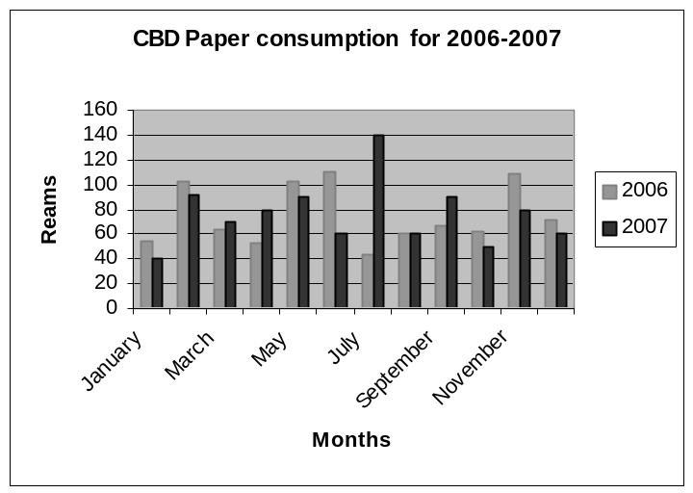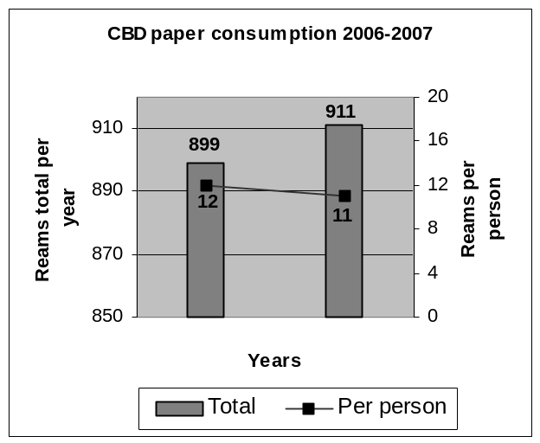

2006
2007

2.1.2. Publications [EN1] [EN5] [EN16]

Facts and figures – Specific environmental criteria is to be at the forefront of any request for proposal sent to vendors for printing of publications. At the time of the issuance of this Environmental Report, the SCBD changed from using the criteria in UNEP’s Publishing Policy, First Edition to the criteria contained in the Second Edition in their requests for proposals for printing of publications. Now, at least four of these criteria must be met an each and every publication:
[That’s our policy]
CBD business cards are printed on 100% recycled paper.
- Chlorine-free paper;
- Recycled Paper (preferably above 75% percentage);
- Wood pulp from sustainably managed forests;
- Post-consumer waste (percentage must be stated);
- Mill broke (percentage must be stated);
- Ink from renewable resources, e.g. vegetable soy, linseed;
- Coatings should be water based;
- Minimal percentage of paper bleach and
- Mailed in photodegradable polythene film.
Reducing our footprint… [EN5]
The paper used for our in-house copy paper and for printing of publications is Cascades’s Rolland Enviro100 Print. This paper contains 100% post-consumer fiber, is certified EcoLogo, is processed chlorine free, is FSC recycled and is manufactured using biogas energy. By using the Enviro100 Print paper as opposed to virgin fiber paper, we reduced our ecological footprint by saving:

649 trees
18,718 kg of solid waste
117.7 kg of suspended particles in the water
1, 770, 646 L of water
41, 103 kg of air emissions
2,674 m³ of natural gaz
www.ecologiquedenature.com/en/calculator.php

In 2007, the Secretariat published several newsletters, technical series, an annual report, bookmarks, postcards and other outreach products amounting to 76,000 lbs or 34.5 tonnes, equivalent to 62 tonnes of CO₂ equivalent.

Challenges and targets – As an alternative to printing of publications, electronic distribution of printed materials through the CBD website are being explored. This would reduce the amount of publications mailed out throughout the world to various interested partners and stakeholders.

2.1.3. Related Consumables [EN1][EN2]

Facts and figures – Toners are recycled after use. Reusable kitchen cutlery, as well as glasses and cups, were purchased to be used for all functions organized at the SCBD, replacing previously used paper and Styrofoam serving ware.

2.1.4. Recycle and Reuse
Staff member says:
“I separate my recycling bins by type at home and use red worm powered compost to reduce my waste production.”
Facts and figures – Documents printed on one-side are reused for draft paper, memo pads, fax confirmation paper and draft printings. Office supplies are systematically reused and supplies supporting outside meetings are returned to the CBD. The Secretariat, with the help of the building’s lessor has provided the office with recycling services for cans, metal and glass containers, batteries and mobile phones.

2.1.5. Utilities

Energy and Water Consumption Calculations [EN3]

Facts and figures –Based on the total energy consumption of the Montreal World Trade Center, in which the Secretariat is located, a basic estimation of our total energy consumption per year is 624,140 kWh of energy use. According to the WRI report, this is equivalent to 123 tonnes of CO₂ equivalent.
Staff member says:
“I turn heat down at night and I put a bottle into my toilet tank to save water for each flush.”

2.1.6. Computers and IT Equipment [EN5]
Staff member says:
“All our devices at home are Energy Star labeled.”
Facts and figures – Computers purchased belong to the Energy Star Programme. The energy savings for one computer is 0.4 tonnes of CO₂ equivalent. 122 computers are in use at the Secretariat; the total amount of energy savings is 51 tonnes of CO₂ equivalent. The UNEP policy is adhered to for the disposal of obsolete equipment. The SCBD’s 2007 disposal exercise is certified with a guarantee of disposal following the norms of Electronics Product Stewardship Canada (EPSC) to ensure that remanufacturing methods are environmentally safe.

2.2. Green Procurement

The SCBD is working towards systemizing efforts to incorporate into the procurement practice. The SCBD is following the work of EMG, which are currently developing guidelines for sustainable procurement policies, which set the ground in soliciting and purchasing environmentally-friendly and socially-responsible products and services. SCBD’s procurement polices will thus be based on EMG’s work.

Below are some of the mandatory criteria in achieving sustainable procurement:
- IT Equipment: At the time of the issuance of this Environmental Report, the CBD was one of the partners contributing to a draft of UNEP’s sustainable guidelines for the procurement of office IT equipment. This finalized document will be used as the CBD’s guidelines for procurement of IT equipment;
- Publishing Guidelines: As per the criteria in UNEP’s Publishing Policy and in section 2.1.2 of this report;
- Catering services: The CBD uses biodegradable, reusable, recycled and recyclable flatware, cutlery, napkins and décor. The Secretariat checks that menus proposed by caterers do not include threatened or overexploited species appearing in the IUCN Red List or listed in qualified international and national bodies.
- Choice of vendors must be recognized as using adequate labour and environmental standards as per the UN Global Compact found in the UN Procurement Manual. The 10 principles of the Global Compact encompass human rights, labor and environmental standards as a principle against corruption.

BUILDING SERVICES
The SCBD is located in the Montreal World Trade Center (WTC), a building administrated by SITQ. The WTC is certified “Go Green Plus”. The BOMA Go Green Plus Environmental Certification programme is a voluntary program designed for existing or occupied buildings. Its intent is to recognize buildings where environmental best practices have been implemented. The Go Green Plus certification indicates that our lessor identifies reduces, as far as possible, the utilization of ozone depleting substances; engages in energy consumption management, water efficiency, waste reduction and on-site recycling; engages in the safe disposal of hazardous materials and products; controls indoor air, lighting and noise and engages in an environmental management policy through a purchasing policy, emergency response and tenant awareness. The SITQ social responsibility report for 2007 provides additional information on property management best practices. SITQ, together with the Agence métropolitaine de transport (AMT) and Smart Commuting Montreal make bicycles (during summer months, free of charge) and a carpooling system available to the occupants of their buildings. Paper and cardboard recycling in SITQ buildings is strongly implemented. In 2006, over 1,600 tonnes of paper and cardboard were recovered and once recycled, close to 20,000 trees will have been saved. The cleaning products used at the CBD are all green cleaning products such as biodegradable dishwashing soap, biobased floor cleaner, hygienic paper made from 100% recycled fibres and hand towels from 94% recycled fibers.

2.3. Carbon emissions and offsetting activities [EN13]
Staff member says:
“I take public transport as much as possible and coordinate my errands to minimize use of car.”

2.3.1. Staff Commute to Work [EN16] [EN29]
Facts and figures – 76% of the CBD staff uses public transportation. Figures vary slightly depending on the season: in the summer, staff tend to slightly reduce their use of public transportation by walking or cycling to work. Yearly, the staff work commute emits approximately 93 tonnes of CO₂.
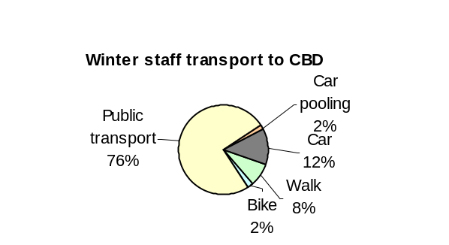
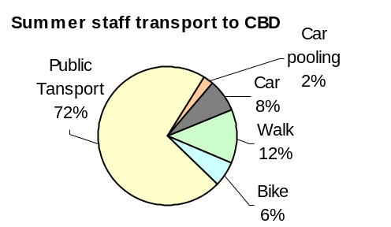

2.3.2. Calculations and Offsetting Initiatives
[That’s our policy]
Internal staff travel authorization forms must include an estimate of CO₂ emissions. Forms not bearing this calculation are not signed.

- SUMMARY OF CALCULATIONS
(In Tonnes of CO₂ equivalent)
2006 2007
Office paper | 3.6 | 3.7
Staff commute to work | 78 | 93
Official staff travel | 270 | 500
Travel of funded participants to CBD meetings | n/a | 2,049
CBD Publications | n/a | 62
Official meeting documents | n/a | 4.309
Electricity | 123 | 123
TOTAL CO₂ emissions | 474.6 | 2,835

How the CBD Offsets Official Travel

The Green Belt Movement http://greenbeltmovement.org/index.php
In our efforts to become carbon neutral, the Secretariat signed in November 2006 a Memorandum of Understanding (MoU) with the Green Belt Movement to offset carbon emissions by investing in tree-planting projects in Kenya. As a first step towards implementing this MoU, the Secretariat offset the emissions from official staff travel in 2006 and 2007. Through the planting, 3000 native trees will be planted in the Ngong forest, Kenya.

GEF Financing – www.gefweb.org

In 2006, the GEF Secretariat transferred USD 10,000 to the Secretariat as its contribution for offsetting CO₂ emissions related to the travel of CBD staff.

2.4. raising staff awareness
Staff member says:
“At home, we teach the kids how to save water and how to recycle and reuse”.
Electronic in-house staff awareness bulletins are a means to communicate internally on best office practices, such as green commuting, reduce waste, recycle and reuse. The one-page bulletins give a short overview of various issues with statistics, links for further information and examples of actions that can be performed at work and at home. The main objective is to further raise awareness and demonstrate ways to green the office through simple actions. Since January 2006, five bulletins have been disseminated dealing with: e-waste recycling, shopping bags, water consumption and special events. Our lessor also communicates with the SCBD through an internal quarterly bulletin, which addresses environment-related activities, innovations, suggestions and is displayed in common areas.

3. official meetings outside the cbd premises

Since 2006, SCBD staff have been discussing ways to improve the sustainability of CBD official meetings including COP, MOP, SBSTTA, Workshops, etc.

3.1. Greening CBD Meetings

Paper
The total number of meetings held in 2007 was 34 – this number does not include the four Bureau meetings. Six major meetings were held during the year: Liability and Redress-3 and 4, SBSTTA-12, WRGI-2, ABSWG-5 and WG8J-5. The number of pages produced for these meetings are presented below.
Meetings | Number of pages | Tonnes CO₂ equivalent*
Liability and Redress-4 | 51,605 | 587
WGRI-2 | 2,643 | 30
SBSTTA-12 | 44,597 | 507
Liability and Redress-3 | 20,651 | 235
ABSWG-5 | 154,323 | 1,756
WG8J-5 | 104,950 | 1,194
TOTAL | 378,769 | 4.309

*Calculated using 30% post-consumer recycled paper at www.papercalculator.org
Since 2007, all pre-session documents are only available on the CBD’s website, and no longer printed and distributed to all parts of the world for environmental reasons. Delegates are reminded, through information notes to meetings and on the bottom of the first page of all official documents to bring their own copies of documents. Participants are aware that CD-ROMs containing the pre-session documents are available. Since the paper consumption of documents for official meetings has been monitored only since 2007, the figures for 2006 are not available.

Efforts Made at COP-8 – Offsets

In March 2006, the CBD Secretariat and the Government of the State of Parana offered to plant eight million trees in excess of their projected reforestation activities in their State to offset the environmental impact of the Third Meeting of Parties to the Cartagena Protocol on Biosafety (MOP-3) and the Eight Conference of the Parties to the Convention on Biological Diversity (COP-8) both held in March in Curitiba, Brazil.

3.2. Efforts Towards Greening COP-9

Germany is the host of COP-MOP4 and COP9. A comprehensive environmental plan has been established by the Host Government to ensure that environmental impacts resulting from the meeting are avoided or reduced, thus indirectly promoting the goals of the meeting. The main areas are waste management, environmentally sound mobility of participants, efficient use of energy and water and catering with a direct link to agro biodiversity.

The government of Germany’s initiatives for cop-mop4 and cop9 – offsets

The Article X of the Agreement between the Government of the Federal Republic of Germany and the Secretariat of the Convention on Biological Diversity regarding COP-9 reads as follows:

“Article X
Minimizing the impacts of the meetings

The Government shall to its utmost and offset the negative impact of the Meetings on the environment in particular on biodiversity and its components, while raising awareness of delegates, contractors, staff and other partners about good practice. Sound environmental considerations should be borne in mind during all aspects of meeting organization: venue selection and construction, procurement, registration, catering, transporting, exhibitions, waste, accommodation etc. In line with the United Nations strategy for achieving climate neutrality, a particular emphasis should be given to first minimizing and then offsetting greenhouse gas emissions with the Meetings”.

Transport
The transport concept aims at providing participants with a comprehensive range of environmentally friendly public transport modes for journeys to and from the meeting. Vehicles such as shuttle buses will be subject to particularly stringent environmental standards.

Signage
Signage used for the various side-events and meetings should be reused at subsequent meetings, i.e. not made meeting or event specific.

Paper use and waste minimization and recycling
As for all CBD meetings, delegates are reminded to bring their own copies of the pre-session documents for the meetings, including the information documents. CD Roms containing the pre-session documents as well as the information documents of the meetings are also be made available to participants, upon request. The German COP-9 host committee has implemented measures to sort and recycle waste. These are the pictograms that will be used:

 For general waste (residual refuse)
 For paper, cardboard, packaging
 For plastics and other packaging material

Energy and water
Energy and water consumption for the meeting will be kept as low as possible. All electricity needs will be supplied by certified green electricity for the duration of the meeting.
Climate protection
All greenhouse-gas emissions, e.g. in the transport and energy sectors, well be kept as low as possible. All non-avoidable greenhouse-gas emissions, for example emissions resulting from the long flights which many participants must take to and from Germany, will be offset by investments in climate-protection projects elsewhere.

4. Conclusion AND POssible Next steps

In 2006, the Secretariat prepared a draft plan for minimizing the environmental impact of the operations of the CBD. The document addressed how the Secretariat could minimize the negative environmental impact of its operations, including meetings of the Convention. Significant progress has been made in implementing this plan. The plan will be revised in light of these efforts. Next steps could thus include, in particular:

- Increase our cooperation with SITQ and others tenants. It would be help to share information on green office practices, products and services, e.g. through the SITQ newsletter.
- Greening of meetings -- Based on the experience of prior COP meetings and other relevant events, the Secretariat may consider developing green guidelines to assist future host countries in the preparation of future CBD meetings.
- Further develop written ‘green’ policies and systemize implementation
- Enhance staff commitment in greening activities: dedicated space on the kitchen bulletin board to share ideas, or display materials and posters.
- Provide incentives: a small competition could include prize for the most active staff member(s) in terms of greening the office and their homes, green day or green week overlapping the International Day for Biological Diversity (22 May); “best green idea”, or recognition for undertaking strict energy saving measures.

5. Preliminary Gri index report

The table below gives some indication of what information the SCBD is currently able to report on and identifies where mechanisms should be put in place to collect more information.
F
N
Fully reported Not reported
Partially reported Information not available
P
N/A

Indicator |  | Reported | Page(s) | Results summary or explanation of  omission
Materials
EN1 | Materials used by weight or volume | P | 4, 5,6 | Total white copy paper purchased for 2006-2007 is 4 tonnes. Other materials not reported on.
EN2 | Percentage of materials used that are recycled input materials | P | 6 | All paper purchased is 100% post-consumer recycled paper. Other materials to be reported on in future reports.
Energy
EN3 | Direct consumption by primary energy source | F | 6 | A basic estimation of our total energy consumption per year is 624,140 kWh.
EN4 | Indirect energy consumption by primary source | N / A | - | Data not available.
EN5 | Energy saved due to conservation and efficiency improvements | P | 5,6 | Energy efficient computers, screens, printers and photocopiers are used.
EN6 | Initiative to provide energy-efficient or renewable energy based products and services, and reductions in energy requirements as a result of these initiatives | P | 4 | Through our lessor, energy management, water efficiency, waste reduction and recycling, reduction of air emissions; ozone depletion; water effluents, hazardous materials, hazardous products, health & safety, control of indoor air, lighting, noise and Environmental Management (EMS documentation, purchasing policy, emergency response, tenant awareness)
EN7 | Initiatives to reduce indirect energy consumption and reductions achieved | P | 6 | Energy efficient computers, screens, printers and photocopiers are used.
Water
EN8 | Total water withdrawal by source | N/A | - | SCBD’s activities do not require significant use of water.
EN9 | Water sources significantly affected by withdrawal of water | N/A | - | SCBD’s activities do not require significant use of water.
EN10 | Percentage and total of water recycled and reused | N / A | - | Data not available.
Biodiversity
EN11 | Location and size of land owned, leased, managed in, or adjacent to, protected areas and areas of high biodiversity value outside protected areas | N / A | - | Data not available.
EN12 | Description of significant impacts of activities, products, and services on biodiversity in protected areas and areas of high biodiversity value outside protected areas | Data not available.  -  N/A | - | Data not available.
EN13 | Habitats protected or restored | P | 8 | SCBD’s staff travels amounts to 500 tonnes of CO₂ for the year 2007 and is offset through tree plantings in Kenya, Ngong Hills, contributing to preserve the Ngong Hills natural habitats.
EN14 | Strategies, current actions, and future plans for managing impacts on biodiversity | N | - | Plan developed in 2006.
EN15 | Number of IUCN Red List species and national conservation list species with habitats in areas affected by operations, by level of extinction risk | N | - | Plan developed in 2006.
Emissions, effluents and waste
EN16 | Total direct and indirect greenhouse gas emissions by weight | P | 4,5,8 | Staff commute for official travel emissions totaled 593 tonnes of carbon equivalent.
EN17 | Other relevant indirect greenhouse gas emissions by weight | P | 8 | Staff commute to work predominantly by public transportation (estimated at an average of 73% for 2006-2007). Other data not available. Target for future reporting.
EN18 | Initiatives to reduce greenhouse gas emissions and reductions achieved | N | - | Data not available, target for future reporting.
EN19 | Emissions of ozone-depleting substances by weight | N/A | - | SCBD’s activities do not generate any waste that falls under this category.
EN20 | NO, SO and other significant air emissions by weight | N/A | -
EN21 | Total water discharge by quality and destination | N/A | - | Data not available.
EN22 | Total weight of waste by type and disposal | N/A | - | Data not available.
EN23 | Total number and volume of significant spills | N/A | - | Data not available
EN24 | Weight of transported, imported, exported, or treated waste deemed hazardous under the terns of the Basel Convention Annex I, II, III and VIII, and percentage of transported waste shipped internationally | N/A | - | SCBD’s activities do not generate any waste that falls under this category.
EN25 | Identify size, protected status, and biodiversity value of water bodies and related habitats significantly affected by the reporting organization’s discharges of water and runoffs | N/A | - | SCBD’s activities do not generate any waste that falls under this category.
Products and services
EN26 | Initiatives to mitigate environmental impacts of products and services, and extent of impact mitigation | N | - | SCBD’s staff travels amounts to 500 tonnes of CO₂ for the year 2007 and are offset through tree-planting in Ngong Forest, Nairobi, thus contributing to preserve the Ngong Forest natural habitats.
EN27 | Percentage of products sold and their packaging materials that are reclaimed by category | N/A | - | SCBD’s does not sell products.
Compliance
EN28 | Monetary value of significant fines and total number of non-monetary sanctions for non-compliance with environmental laws and regulations | N/A | - | SCBD’s activities do not generate compliance fines.
Transport
EN29 | Significant environmental impacts of transporting products and other goods and materials used for the organization’s operations, and transporting members of the workforce | F | 8 | The total carbon emissions of the staff commute and travel is 593 tonnes of CO₂ equivalent.
Overall
EN30 | Total environmental protection expenditures and investments by type | N | - | Data to calculate total expenditures not available, target for future reporting.

6. Acronyms

ABSWG Working Group on Access and Benefit-Sharing
SCBD Secretariat of the Convention on Biological Diversity
COP Conference of the Parties
ES Executive Secretariat
GHG greenhouse gas
MoU Memorandum of Understanding
SBSTTA Subsidiary Body on Scientific, Technical and Technological Advice
SCBD Secretariat of the Convention on Biological Diversity
UNEP United Nations Environment Programme
WG8J Working Group on Article 8 (j)
WRGI Working Group on Review of Implementation of the Convention on Biological Diversity
WRI World Resource Institute

-----

The references in square brackets are to the environmental indicators in the preliminary Global Reporting Initiative (GRI) guidelines (see page 13 below).
http://www.environmentaldefense.org/papercalculator/select.cfm
http://www.unep.org/policy/publications.pdf
http://www.unep.org/policy/Pub_Policy_SecondEdition.pdf
http://pdf.wri.org/wri_co2guide.pdf, World Resource Institute, Working 9 to 5 on Climate Change: An Office Guide
www.energystar.gov/guidelines
http://www.epsc.ca/
http://www.unglobalcompact.org/
www.nativeenergy.com
This figure was calculated with the calculation tool of the World Resource Institute (WRI) report “Working 9 to 5 on Climate Change: An Office Guide”. http://pdf.wri.org/wri_co2guide.pdf
This reads: “In order to minimize the environmental impacts of the Secretariat’s processes, and to contribute to the Secretary-General’s initiative for a C-Neutral UN, this document is printed in limited numbers. Delegates are kindly requested to bring their copies to meetings and not to request additional copies”.

