 |  | CBD
 |  |  |  | Distr.  GENERAL  UNEP/CBD/COP/10/INF/10  3 September 2010  ENGLISH ONLY
CONFERENCE OF THE PARTIES TO THE CONVENTION ON BIOLOGICAL DIVERSITY
Tenth meeting
Nagoya, Japan, 19-30 October 2010
Item 7 of the provisional agenda*
REPORT OF THE EXECUTIVE SECRETARY ON THE ADMINISTRATION OF THE CONVENTION AND THE BUDGET FOR THE TRUST FUNDS OF THE CONVENTION and the cartagena protocol on biosafety
Note by the Executive Secretary
The Executive Secretary is circulating herein, for the information of participants to the tenth meeting of the Conference of the Parties and the fifth meeting of the Conference of the Parties serving as the meeting of the Parties to the Cartagena Protocol on Biosafety, the status of contributions to the BY, BE, BZ and VB Trust Funds as at 31 December 2009 (annexes I-IV); the status of contributions to the BG, BH, and BI trust funds as at 31 December 2009 (annexes V-VII); the current scale of assessments for the Cartagena Protocol on Biosafety for 2009-2010 (annex VIII); the financial statements for the twenty-four months of the biennium 2008-2009 ended 31 December 2009 (annex IX).

Annex I
General Trust Fund for the Convention on Biological Diversity (BY)
(as at 31 December 2009)
Parties | Unpaid Pledges as at 31/12/08 | Pledges for 2009 | Collections in 2008 for 2009 & future years | Collections in 2009 for prior years | Collections During 2009 for 2009 & future years | Unpaid pledges for prior years | Unpaid pledges for 2009 | Unpaid pledges for 2009 &prior years
 | US $ | US $ | US $ | US $ | US $ | US $ | US $ | US $
Afghanistan | 0 | 129 | 431 |  |  | 0 | (302) | (302)
Albania | 0 | 776 |  |  | 1,622 | 0 | (846) | (846)
Algeria | 0 | 10,989 | 22,968 |  |  | 0 | (11,979) | (11,979)
Angola | 0 | 388 | 1,958 |  |  | 0 | (1,570) | (1,570)
Antigua & Barbuda | 0 | 259 |  |  |  | 0 | 259 | 259
Argentina | 0 | 42,019 |  |  |  | 0 | 42,019 | 42,019
Armenia | 0 | 259 |  |  | 259 | 0 | 0 | 0
Australia | 0 | 231,038 | 231,038 |  | 251,831 | 0 | (251,831) | (251,831)
Austria | 0 | 114,679 | 114,679 |  | 125,000 | 0 | (125,000) | (125,000)
Azerbaijan | 0 | 646 |  |  | 646 | 0 | 0 | 0
Bahamas | 0 | 2,069 | 2,069 |  | 2,255 | 0 | (2,255) | (2,255)
Bahrain | 0 | 4,267 | 8,917 |  |  | 0 | (4,650) | (4,650)
Bangladesh | 0 | 1,051 | 925 |  | 940 | 0 | (814) | (814)
Barbados | 0 | 1,164 | 1,164 |  |  | 0 | 0 | 0
Belarus | 31,062 | 2,586 |  | 2,819 | 2,586 | 28,243 | 0 | 28,243
Belgium | 0 | 142,476 |  |  | 142,476 | 0 | 0 | 0
Belize | 215 | 129 |  | 215 | 614 | 0 | (485) | (485)
Benin | 0 | 129 | 270 |  |  | 0 | (141) | (141)
Bhutan | 0 | 129 | 270 |  |  | 0 | (141) | (141)
Bolivia | 1,678 | 776 |  | 788 |  | 890 | 776 | 1,666
Bosnia & Herzegovina | 0 | 776 |  |  | 1,622 | 0 | (846) | (846)
Botswana | 0 | 1,810 | 3,783 |  |  | 0 | (1,973) | (1,973)
Brazil | 27,325 | 113,256 |  | 27,325 | 129,027 | 0 | (15,771) | (15,771)
Brunei Darussalam | 0 | 3,361 |  |  |  | 0 | 3,361 | 3,361
Bulgaria | 0 | 2,586 |  |  | 2,586 | 0 | 0 | 0
Burkina Faso | 653 | 259 |  | 653 | 31 | (0) | 228 | 228
Burundi | 1,006 | 129 |  |  |  | 1,006 | 129 | 1,135
Cambodia | 0 | 129 | 329 |  |  | 0 | (200) | (200)
Cameroon | 374 | 1,164 |  |  |  | 374 | 1,164 | 1,538
Canada | 0 | 384,891 | 384,891 |  | 419,531 | 0 | (419,531) | (419,531)
Cape Verde | 3,856 | 129 |  |  |  | 3,856 | 129 | 3,985
Central African Republic | 221 | 129 |  |  |  | 221 | 129 | 350
Chad | 108 | 129 |  | 108 | 270 | 0 | (141) | (141)
Chile | 0 | 20,815 |  |  | 20,815 | 0 | 0 | 0
China | 0 | 344,812 |  |  | 344,812 | 0 | 0 | 0
Colombia | 0 | 13,575 |  |  | 13,575 | 0 | 0 | 0
Comoros | 3,114 | 129 |  |  |  | 3,114 | 129 | 3,243
Congo | 233 | 129 |  |  |  | 233 | 129 | 362
Cook Islands | 0 | 129 |  |  |  | 0 | 129 | 129
Costa Rica | 5,052 | 4,137 |  | 2,300 |  | 2,752 | 4,137 | 6,889
Cote d'Ivoire | 2,147 | 1,164 |  |  |  | 2,147 | 1,164 | 3,311
Croatia | 0 | 6,464 |  |  | 6,464 | 0 | 0 | 0
Cuba | 33,928 | 6,982 |  |  |  | 33,928 | 6,982 | 40,910
Cyprus | 0 | 5,689 |  |  | 5,689 | 0 | 0 | 0
Czech Republic | 0 | 36,330 | 75,930 |  |  | 0 | (39,600) | (39,600)
Democratic People's Republic of Korea | 2,215 | 905 |  |  |  | 2,215 | 905 | 3,120
Democratic Republic of the Congo | 6,138 | 388 |  |  |  | 6,138 | 388 | 6,526
Denmark | 30 | 95,544 |  | 30 | 199,687 | 0 | (104,143) | (104,143)
Djibouti | 516 | 129 |  |  |  | 516 | 129 | 645
Dominica | 449 | 129 |  |  |  | 449 | 129 | 578
Dominica Rep. | 20 | 3,103 |  |  |  | 20 | 3,103 | 3,123
Ecuador | 0 | 2,715 |  |  | 2,715 | 0 | 0 | 0
Egypt | 0 | 11,377 | 13,204 |  |  | 0 | (1,827) | (1,827)
El Salvador | 2,421 | 2,586 |  |  |  | 2,421 | 2,586 | 5,007
Equatorial Guinea | 620 | 259 |  |  |  | 620 | 259 | 879
Eritrea | 0 | 129 | 300 |  |  | 0 | (171) | (171)
Estonia | 0 | 2,069 | 2,069 |  | 2,255 | 0 | (2,255) | (2,255)
Ethiopia | 0 | 388 | 388 |  | 423 | 0 | (423) | (423)
European Union | 40 | 262,645 |  | 40 | 262,645 | 0 | 0 | 0
Fiji | 0 | 388 | 3,504 |  |  | 0 | (3,116) | (3,116)
Finland | 0 | 72,919 | 72,919 |  | 79,481 | 0 | (79,481) | (79,481)
France | 0 | 814,645 |  |  | 814,645 | 0 | 0 | 0
Gabon | 0 | 1,034 | 23,389 |  |  | 0 | (22,355) | (22,355)
Gambia | 0 | 129 | 332 |  |  | 0 | (203) | (203)
Georgia | 0 | 388 | 388 |  | 423 | 0 | (423) | (423)
Germany | 0 | 1,108,905 |  |  | 1,108,905 | 0 | 0 | 0
Ghana | 2,629 | 517 |  |  |  | 2,629 | 517 | 3,146
Greece | 0 | 77,056 |  |  | 77,056 | 0 | 0 | 0
Grenada | 0 | 129 |  |  |  | 0 | 129 | 129
Guatemala | 3,301 | 4,137 |  |  |  | 3,301 | 4,137 | 7,438
Guinea | 1,551 | 129 |  |  |  | 1,551 | 129 | 1,680
Guinea-Bissau | 2,635 | 129 |  |  |  | 2,635 | 129 | 2,764
Guyana | 0 | 129 | 319 |  |  | 0 | (190) | (190)
Haiti | 646 | 259 |  |  |  | 646 | 259 | 905
Honduras | 24 | 646 |  |  | 646 | 24 | 0 | 24
Hungary | 0 | 31,546 | 31,546 |  |  | 0 | 0 | 0
Iceland | 0 | 4,784 | 4,784 |  | 5,214 | 0 | (5,214) | (5,214)
India | 0 | 58,180 |  |  | 58,145 | 0 | 35 | 35
Indonesia | 0 | 20,815 | 20,815 |  | 22,689 | 0 | (22,689) | (22,689)
Iran | 65,740 | 23,272 |  | 18,613 |  | 47,127 | 23,272 | 70,399
Iraq |  | 356 |  |  |  |  | 356 | 356
Ireland | 0 | 57,533 | 57,507 |  | 62,709 | 0 | (62,683) | (62,683)
Israel | 0 | 54,172 |  |  |  | 0 | 54,172 | 54,172
Italy | 0 | 656,655 | 656,645 |  | 715,763 | 0 | (715,753) | (715,753)
Jamaica | 0 | 1,293 |  |  | 2,702 | 0 | (1,409) | (1,409)
Japan | 0 | 2,311,272 |  |  | 2,311,272 | 0 | 0 | 0
Jordan | 0 | 1,551 |  |  | 1,551 | 0 | 0 | 0
Kazakhstan | 2,841 | 3,749 |  | 2,725 |  | 116 | 3,749 | 3,865
Kenya | 0 | 1,293 |  |  | 2,702 | 0 | (1,409) | (1,409)
Kiribati | 0 | 129 | 245 |  | 25 | 0 | (141) | (141)
Kuwait | 0 | 23,530 |  |  | 23,530 | 0 | 0 | 0
Kyrgyzstan | 0 | 129 | 485 |  |  | 0 | (356) | (356)
Lao Democratic People’s Republic | 0 | 129 | 270 |  |  | 0 | (141) | (141)
Latvia | 0 | 2,327 | 2,327 |  | 2,537 | 0 | (2,537) | (2,537)
Lebanon | 8,857 | 4,396 |  | 2,485 |  | 6,372 | 4,396 | 10,768
Lesotho | 0 | 129 | 1 |  |  | 0 | 128 | 128
Liberia | 0 | 129 |  |  |  | 0 | 129 | 129
Libyan Arab Jamahiriya | 58,828 | 8,016 |  |  |  | 58,828 | 8,016 | 66,844
Liechtenstein | 0 | 1,293 |  |  | 1,293 | 0 | 0 | 0
Lithuania | 0 | 4,008 |  |  | 4,008 | 0 | 0 | 0
Luxembourg | 0 | 10,989 |  |  | 10,989 | 0 | 0 | 0
Madagascar | 0 | 259 | 541 |  |  | 0 | (282) | (282)
Malawi | 0 | 129 |  |  |  | 0 | 129 | 129
Malaysia | 0 | 24,565 | 24,550 |  | 26,791 | 0 | (26,776) | (26,776)
Maldives | 0 | 129 |  |  | 270 | 0 | (141) | (141)
Mali | 0 | 129 | 18 |  |  | 0 | 111 | 111
Malta | 0 | 2,198 |  |  | 4,594 | 0 | (2,396) | (2,396)
Marshall Island | 215 | 129 |  |  |  | 215 | 129 | 344
Mauritania | 1,945 | 129 |  |  |  | 1,945 | 129 | 2,074
Mauritius | 0 | 1,422 |  |  | 1,422 | 0 | 0 | 0
Mexico | 13,674 | 291,803 |  |  |  | 13,674 | 291,803 | 305,477
Micronesia,Fed. States | 215 | 129 |  |  |  | 215 | 129 | 344
Monaco | 0 | 388 |  |  | 388 | 0 | 0 | 0
Mongolia | 0 | 129 | 270 |  |  | 0 | (141) | (141)
Montenegro | 0 | 129 |  |  | 245 | 0 | (116) | (116)
Morocco | 10,124 | 5,430 |  | 10,124 | 5,828 | 0 | (398) | (398)
Mozambique | 0 | 129 | 270 |  |  | 0 | (141) | (141)
Myanmar | 478 | 646 |  | 478 | 1,371 | 0 | (725) | (725)
Namibia | 0 | 776 | 776 |  | 846 | 0 | (846) | (846)
Nauru | 3,234 | 129 |  |  |  | 3,234 | 129 | 3,363
Nepal | 772 | 388 |  |  |  | 772 | 388 | 1,160
Netherlands | 0 | 242,157 |  |  | 242,136 | 0 | 21 | 21
New Zealand | 0 | 33,098 | 33,098 |  | 36,077 | 0 | (36,077) | (36,077)
Nicaragua | 215 | 259 |  |  |  | 215 | 259 | 474
Niger | 2,970 | 129 |  |  |  | 2,970 | 129 | 3,099
Nigeria | 0 | 6,206 |  |  |  | 0 | 6,206 | 6,206
Niue | 332 | 129 |  | 332 | 270 | 0 | (141) | (141)
Norway | 0 | 101,103 |  |  | 101,103 | 0 | 0 | 0
Oman | 0 | 9,438 | 9,438 |  | 10,287 | 0 | (10,287) | (10,287)
Pakistan | 365 | 7,628 |  | 365 | 5,362 | (0) | 2,266 | 2,266
Palau | 8 | 129 |  |  |  | 8 | 129 | 137
Panama | 1,485 | 2,974 |  | 1,485 | 2,974 | 0 | 0 | 0
Papua New Guinea | 646 | 259 |  |  |  | 646 | 259 | 905
Paraguay | 14,102 | 646 |  |  |  | 14,102 | 646 | 14,748
Peru | 70,084 | 10,084 |  |  |  | 70,084 | 10,084 | 80,168
Philippines | 8,669 | 10,084 |  | 8,669 | 20,094 | 0 | (10,010) | (10,010)
Poland | 0 | 64,773 |  |  | 64,773 | 0 | 0 | 0
Portugal | 0 | 68,135 |  |  |  | 0 | 68,135 | 68,135
Qatar | 0 | 10,989 |  |  | 10,989 | 0 | 0 | 0
Romania | 0 | 9,050 |  |  | 9,050 | 0 | 0 | 0
Republic of Korea | 119,020 | 280,943 |  |  |  | 119,020 | 280,943 | 399,963
Republic of Moldova | 0 | 129 |  |  | 270 | 0 | (141) | (141)
Russian Federation | 0 | 155,146 |  |  | 155,116 | 0 | 30 | 30
Rwanda | 0 | 129 |  |  |  | 0 | 129 | 129
Saint Vincent and the Grenadines | 2,285 | 129 |  |  |  | 2,285 | 129 | 2,414
Samoa | 240 | 129 |  | 240 | 211 | 0 | (82) | (82)
San Marino | 0 | 388 |  |  | 388 | 0 | 0 | 0
Sao Tome Principe | 787 | 129 |  |  |  | 787 | 129 | 916
Saudi Arabia | 78,455 | 96,708 |  | 78,455 | 96,678 | 0 | 30 | 30
Senegal | 0 | 517 | 2,423 |  |  | 0 | (1,906) | (1,906)
Serbia |  | 2,715 |  |  | 2,715 | 0 | 0 | 0
Seychelles | 0 | 259 | 65 |  |  | 0 | 194 | 194
Sierra Leone | 512 | 129 |  |  |  | 512 | 129 | 641
Singapore | 0 | 44,863 | 44,843 |  | 20 | 0 | 0 | 0
Slovak | 0 | 8,145 | 8,145 |  | 8,878 | 0 | (8,878) | (8,878)
Slovenia | 0 | 12,412 |  |  | 25,914 | 0 | (13,502) | (13,502)
Solomon Islands | 0 | 129 |  |  | 270 | 0 | (141) | (141)
Somalia | 0 | 8 |  |  |  | 0 | 8 | 8
South Africa | 0 | 37,494 |  |  | 78,362 | 0 | (40,868) | (40,868)
Spain | 0 | 383,727 |  |  | 383727 | 0 | 0 | 0
Sri Lanka | 1,791 | 2,069 |  |  |  | 1,791 | 2,069 | 3,860
Saint Lucia | 5 | 129 |  | 5 | 110 | 0 | 19 | 19
Saint Kitts and Nevis | 0 | 129 |  |  |  | 0 | 129 | 129
Sudan | 8,421 | 1,051 |  |  |  | 8,421 | 1,051 | 9,472
Suriname | 0 | 129 | 1,487 |  |  | 0 | (1,358) | (1,358)
Swaziland | 431 | 259 |  | 431 | 541 | 0 | (282) | (282)
Sweden | 0 | 138,468 |  |  |  | 0 | 138,468 | 138,468
Switzerland | 0 | 157,214 | 157,189 |  | 171,364 | 0 | (171,339) | (171,339)
Syrian Arab Republic | 0 | 2,069 |  |  | 2,007 | 0 | 62 | 62
Tajikistan | 0 | 129 | 437 |  |  | 0 | (308) | (308)
The former Yugoslav Republic of Macedonia | 0 | 646 |  |  | 646 | 0 | 0 | 0
Thailand | 0 | 24,048 |  |  | 20,347 | 0 | 3,701 | 3,701
Timor – Leste | 213 | 129 |  | 213 | 129 | 0 | 0 | 0
Togo | 18 | 129 |  |  |  | 18 | 129 | 147
Tonga | 10 | 129 |  |  |  | 10 | 129 | 139
Trinidad & Tobago | 0 | 3,491 |  |  | 3,491 | 0 | 0 | 0
Tunisia | 0 | 4,008 |  |  | 8,377 | 0 | (4,369) | (4,369)
Turkey | 0 | 49,259 |  |  | 49,259 | 0 | 0 | 0
Turkmenistan | 550 | 776 |  |  |  | 550 | 776 | 1,326
Tuvalu | 0 | 129 | 393 |  |  | 0 | (264) | (264)
United Kingdom of Great Britain and Northern Ireland. | 0 | 858,732 |  |  | 858,732 | 0 | 0 | 0
Uganda | 0 | 388 | 2,689 |  |  | 0 | (2,301) | (2,301)
Ukraine | 0 | 5,818 |  |  | 5,818 | 0 | 0 | 0
United .Republic of Tanzania | 0 | 776 | 16,827 |  |  | 0 | (16,051) | (16,051)
United Arab Emirates | 95 | 39,045 |  |  | 39,020 | 95 | 25 | 120
Uruguay | 0 | 3,491 |  |  |  | 0 | 3,491 | 3,491
Uzbekistan | 11,959 | 1,034 |  |  | 1,006 | 11,959 | 28 | 11,987
Vanuatu | 0 | 129 |  |  |  | 0 | 129 | 129
Venezuela (Bolivarian Republic of) | 1,085 | 25,858 |  | 1,085 |  | 0 | 25,858 | 25,858
Viet Nam | 0 | 3,103 |  |  | 6,485 | 0 | (3,382) | (3,382)
Yemen | 8,344 | 905 |  |  |  | 8,344 | 905 | 9,249
Zambia | 0 | 129 | 746 |  |  | 0 | (617) | (617)
Zimbabwe | 0 | 1,034 | 444 |  | 1,717 | 0 | (1,127) | (1,127)
Sub Total | 634,228 | 10,506,136 | 2,045,707 | 159,983 | 9,713,129 | 474,245 | (1,252,700) | (778,455)
Additional Contributions
Canada | 0 | 673,866 |  |  | 673,866 | 0 | 0 | 0
Quebec | 0 | 212,240 |  |  | 212,400 | 0 | (160) | (160)
Grand Total | 634,228 | 11,392,242 | 2,045,707 | 159,983 | 10,599,395 | 474,245 | (1,252,860) | (778,615)

Annex II
General Trust Fund for Additional Voluntary Contributions in Support of Approved Activities under the Convention on Biological Diversity (BE)
Status of contributions as at 31 December 2009 (in United States dollars)

Parties/organizations | Unpaid Pledges as at 31.12.08 | Pledges for 2009 |  | Collections in 2009 for prior years | Collections in 2009 for 2009 & future yrs | Unpaid pledges for 2009 & prior years
Belgium | 3,836 |  | 1/ | 3,836 |  | 0
Belgium |  | 38,363 | 13/ |  | 38,363 | 0
Canada | 63,661 |  | 2/ | 63,661 |  | 0
Canada |  | 43,518 | 14/ |  | 42,218 | 1,300
Canada |  | 81,104 | 15/ |  | 81,104 | 0
Canada |  | 166,667 | 44/ |  | 80,189 | 86,478
CIFOR |  | 4,000 | 16/ |  | 4,000 | 0
COMIFAC | 32,342 |  | 3/ | 16,469 |  | 15,872
European Union | 59,065 |  | 4/ |  |  | 59,065
European Union | 9,084 |  | 5/ | 9,084 |  | 0
European Union | 74,759 |  | 6/ |  |  | 74,759
European Union | 103,493 |  | 7/ |  |  | 103,493
European Union |  | 188,953 | 39/ |  | 115,385 | 73,568
FAO |  | 10,200 | 42/ |  |  | 10,200
Finland |  | 47,657 | 9/ |  | 47,657 | 0
Finland |  | 258,893 | 25/ |  | 258,893 | 0
Finland |  | 7,032 | 31/ |  | 7,032 | 0
Finland |  | 21,583 | 36/ |  | 21,583 | 0
France |  | 2,930 | 34/ |  | 2,930 | 0
France |  | 14,793 | 40/ |  | 14,793 | 0
Germany | 104,987 |  | 8/ | 104,987 |  | 0
Germany |  | 533,339 | 17/ |  | 533,339 | 0
Germany |  | 60,647 | 18/ |  | 60,647 | 0
Germany |  | 235,755 | 19/ |  | 235,755 | 0
Germany |  | 138,558 | 20/ |  | 138,558 | 0
Germany |  | 80,000 | 28/ |  | 76,854 | 3,146
Germany |  | 30,000 | 30/ |  | 30,000 | 0
Germany |  | 7,379 | 32/ |  | 7,379 | 0
Germany |  | 151,248 | 35/ |  | 151,248 | 0
Germany |  | 60,000 | 38/ |  | 60,000 | 0
Germany |  | 90,361 | 43/ |  | 90,361 | 0
Germany |  | 384,200 | 47/ |  | 111,500 | 272,700
Heidehof Foundation |  | 41,491 | 33/ |  | 14,535 | 26,956
Instituto do Mar |  | 5,997 | 29/ |  | 5,997 | 0
Japan |  | 114,203 | 21/ |  | 114,203 | 0
Japan |  | 50,000 | 22/ |  | 50,000 | 0
Japan |  | 20,000 | 23/ |  | 20,000 | 0
Japan |  | 100,000 | 37/ |  |  | 100,000
Japan |  | 100,000 | 49/ |  |  | 100,000
Kew Gardens |  | 3,158 | 24/ |  | 3,158 | 0
Netherlands |  | 493,827 | 27/ |  |  | 493,827
Norway |  | 79,940 | 26/ |  | 79,940 | 0
Norway |  | 347,615 | 41/ |  | 347,615 | 0
Spain |  | 2,048,193 | 46/ |  | 2,048,193 | 0
Switzerland |  | 49,975 | 45/ |  | 49,975 | 0
United Kingdom | 200,000 |  | 10/ | 200,000 |  | 0
United Kingdom | 15,606 |  | 11/ | 15,606 |  | 0
United Kingdom | 14,468 |  | 12/ | 14,468 |  | 0
WCMC |  | 8,000 | 48/ |  |  | 8,000
Total | 681,301 | 6,119,581 |  | 428,111 | 4,943,404 | 1,429,366

1/Belgium pledged EUR 15,000 and the Flemish Government EUR 30,000, towards the AHTEG on Biodiversity and Climate Change
2/Canada pledged Cdn$ 79,500 for the AHTEG on Access and Benefit Sharing, Namibia, 2 - 5 December 2008
3/COMIFAC pledged EUR 25,000 towards the Poverty Alleviation Project
4/EC pledged EUR 50,000 towards the Expert Workshop on Protected Areas, Curibati, Brazil, 17-18 March 2006
5/EC pledged US$ 214,334 towards Various Approved Activities
6/EC pledged EUR 220,000 - Contribution Agreement No. 21.0401/2007/487777/SUB/E2
7/EC pledged EUR 400,000 - Contribution Agreement No. 21.0401/2008/514760/SUB/E2
8/Germany pledged EUR 110,000 towards the improvement of the CBD website content on Protected Areas
9/Finland pledged EUR 35,149 towards the 2nd Meeting of the AHTEG on Biodiversity and Climate Change, Helsinki, Finland, 18-22 April 2009
10/UK pledged US$ 200,000 towards GBO-3
11/UK pledged GBP 10,000 towards the AHTEG Climate Change and Biodiversity
12/UK pledged GBP 10,000 in support of the CBD Gender Plan of Action
13/Belgium pledged EUR 30,000 towards the Global Life Web Project
14/Canada pledged Cdn$ 47,000 towards the Marine Expert Meeting on Ecologically and Biologically Significant Areas
15/Canada pledged Cdn$ 100,000 for the 2010 Target, NBSAPs and IYB
16/CIFOR pledged US$ 4,000 towards the printing of the CBD Technical Series # 33 on Bushmeat , in English and Spanish
17/Germany pledged EUR 397,640 towards the Life Web Initiative, for 2009
18/Germany pledged EUR 46,213 towards the COP Bureau Meeting, Nairobi, Kenya, 13 February 2009
19/Germany pledged US$ 235,755 for an SCBD Liaison Officer, for 2009
20/Germany pledged EUR 108,352 towards the High Level Working Group Meeting on 2010 Biodiversity Target and Post 2010 Target, Bonn, Germany, 9 -10 March 2009
21/City of Nagoya, Japan pledged US$ 114,203 towards the secondment of Mr. Chikara Hombo
22/Japan pledged US$ 50,000 towards the Conference Costs of ABS-9
23/Japan pledged US$ 20,000 towards the organization of SBSTTA-14 Meeting, Nairobi, Kenya, May 2010
24/Royal Botanic Gardens pledged GBP 2,000 for the Travel costs of delegates from Tropical African Countries
25/Finland pledged EUR 196,500 towards the Gender Issues & Desertification Activities
26/Norway pledged NOK 530,000 for the support of Expert and Regional Meetings
27/Netherlands pledged US$ 493,826.75 towards the 2009 Workplan for activities under the Letter of Intent
28/Germany pledged US$ 80,000 towards the Forest Biodiversity and Climate Workshop, Singapore, 16-19 September 2009
29/Instituto do Mar, Portugal, pledged US$ 5,997 towards the Production of Azores Brochure
30/Germany pledged US$ 30,000 towards the Marine Expert Workshop on bio-geograhic classification systems, Ottawa, Canada, 29 September to 2 October 2009
31/Finland pledged EUR 5,000 towards the Drafting Committee Meeting for the AHTEG on Biodiversity and Climate Change, Cape Town, South Africa, 20-24 July 2009
32/Germany pledged EUR 5,254 for the COP-9 Bureau Meeting, Stromstad, Sweden, 9-10 September 2009
33/Heidehof Foundation pledged EUR 29,500 towards the 2nd CBD Indigenous Tourism and Biodiversity Award
34/France pledged EUR 2,036 towards the Marine Expert Workshop Reception
35/Germany pledged EUR 100,429 for the Workshop on Innovative Financial Mechanisms, Bonn, Germany, 27-29 January 2010
36/Finland pledged EUR 15,000 towards the IUCN World Commission on Protected Areas
37/Japan pledged US$ 100,000 towards the production of GBO-3
38/Germany pledged US$ 60,000 towards the Regional Workshops on Protected Areas
39/EC pledged EUR 130,000 - Contribution Agreement No. 21.0401/2009/540979/SUB/E2
40/France pledged EUR 10,000 towards the French translation of CBD Website
41/Norway pledged NOK 2,000,000 for the support of Activities of the CBD Secretariat
42/FAO pledged US$ 10,200 towards the Biodiversity Educational Materials/Green Wave
43/Germany pledged EUR 60,000 towards the Regional Workshop in Africa on Biofuels, Accra, Ghana, 8-10 December 2009
44/Canada pledged Cdn$ 175,000 towards the Implementation of the CBD
45/Switzerland pledged US$ 50,000 for the preparation of the high-level special session on Biodiversity at the 65th session of the UNGA
46/Spain pledged EUR 1,360,000 for Additional Approved Activities
47/Germany pledged US$ 384,200 towards the Conference Costs of ABS-9
48/World Conservation Monitoring Centre pledged US$ 8,000 towards the publication of Technical Series 45 and 46 on Ocean Fertilization and Ocean Acidification scientific synthesis
49/Japan pledged US$ 100,000 towards the activities on the International Year of Biodiversity

Annex III
General Trust Fund for Additional Voluntary Contributions to Facilitate the Participation of Parties in the Process of the Convention on Biological Diversity (BZ)
Status as at 31 December 2009 (in United States dollars)

PARTIES | Unpaid Pledges as at 31.12.08 |  | Pledges for 2009 | Collections in 2009 for prior years | Collections in 2009 for 2009 & fut yrs | Unpaid pledges for 2009 & prior years
Denmark | 27,076 | 1/ |  |  |  | 27,076
Denmark |  | 6/ | 57,034 |  | 57,034 | 0
European Union | 95,270 | 2/ |  |  |  | 95,270
European Union |  | 8/ | 352,518 |  | 217,456 | 135,062
Finland |  | 4/ | 13,263 |  | 13,263 | 0
France |  | 10/ | 30,120 |  | 30,120
Germany |  | 3/ | 200,552 |  | 200,552 | 0
Germany |  | 7/ | 75,592 |  | 75,592 | 0
Norway |  | 5/ | 75,415 |  | 75,415 | 0
Norway |  | 9/ | 71,175 |  | 71,175 | 0
Total | 122,346 |  | 875,669 | 0 | 740,607 | 257,408

1/Denmark pledged DKK 150,000 towards the SBSTTA 12 Meeting and the 2nd Meeting of the Ad Hoc Open-Ended Working Group on Review of Implementation of the Convention, Paris, France, 2-13 July 2007
2/EC pledged EUR 360,000 - Contribution Agreement No. 21.0401/2007/487777/SUB/E2
3/Germany pledged EUR 150,000 towards the 7th, 8th and 9th Access and Benefit-Sharing Meetings
4/Finland pledged EUR 10,000 towards the 8th Access and Benefit Sharing and towards the Art 8(j)-6 Meetings
5/Norway pledged NOK 500,000 to support the Developing Country Participants to the Working Group Meetings under the Convention on Biological Diversity
6/Denmark pledged DKK 300,000 for: ABS-8, Art 8(j)-6, SBSTTA-14, WGRI-3 and COP-10 Meetings
7/Germany pledged EUR 51,100 towards the Art 8(j)-6 Meeting
8/EC pledged EUR 245,000 - Contribution Agreement No. 21.0401/2009/540979/SUB/E2
9/Norway pledged NOK 400,000 towards: the ABS-9 and Preparatory Meeting
10/France pledged EUR 20,000 towards: the ABS-9 Meeting

Annex IV
General Trust Fund for Voluntary Contributions to Facilitate the Participation of Indigenous and Local Communities in the Work of the Convention on Biological Diversity (VB)
Status as at 31 December 2009 (in United States dollars)

COUNTRIES | Unpaid Pledges as at 31.12.08 |  | Pledges for 2009 | Collections in 2009 for prior years | Collections in 2009 for 2009 & fut yrs | Unpaid pledges for 2009 & prior years
Denmark |  | 2/ | 114,068 |  | 114,068 | 0
Norway |  | 1/ | 37,707 |  | 37,707 | 0
Spain |  | 3/ | 202,020 |  | 202,020 | 0
Total | 0 |  | 353,795 | 0 | 353,795 | 0

1/Norway pledged NOK 250,000
2/Denmark pledged DKK 600,000 for: ABS-8, Art 8(j)-6 and ABS-9 Meetings
3/ Spain pledged EUR 140,000 towards the Participation in CBD Meetings

Annex V
General Trust Fund for the Core Budget of the Cartagena Protocol on Biosafety
(as at 31 December 2009)

Parties | Unpaid Pledges as at 31/12/08 | Pledges for 2009 | Collections in 2008 for 2009 & future year | Collections in 2009 for prior years | Collections during 2009 for 2009 & future years | Unpaid pledges for prior years | Unpaid pledges for 2009 | Unpaid pledges for 2009 & prior years
 | US$ | US$ |  | US$ | US$ | US$ | US$ | US$
Albania | 0 | 166 |  |  | 369 | 0 | (203) | (203)
Algeria | 0 | 2,357 | 2,357 |  |  | 0 | 0 | 0
Antigua and Barbuda | 184 | 55 |  | 184 | 122 | 0 | (67) | (67)
Armenia | 52 | 55 |  | 52 | 55 | 0 | 0 | 0
Austria | 0 | 24,589 | 24,589 |  | 29,945 | 0 | (29,945) | (29,945)
Azerbaijan | 542 | 139 |  | 542 | 139 | 0 | 0 | 0
Bahamas | 0 | 444 | 444 |  | 542 | 0 | (542) | (542)
Bangladesh | 756 | 196 |  |  |  | 756 | 196 | 952
Barbados | 0 | 249 | 544 |  |  | 0 | (295) | (295)
Belarus | 0 | 555 |  |  | 531 | 0 | 24 | 24
Belgium | 262 | 30,549 |  | 262 | 30,549 | 0 | 0 | 0
Belize | 61 | 28 |  | 61 | 28 | 0 | 0 | 0
Benin | 0 | 28 | 28 |  |  | 0 | 0 | 0
Bhutan | 0 | 28 | 30 |  | 32 | 0 | (34) | (34)
Bolivia | 551 | 166 |  |  |  | 551 | 166 | 717
Botswana | 0 | 388 | 338 |  | 998 | 0 | (948) | (948)
Brazil | 39,889 | 24,181 |  | 39,889 | 24,181 | 0 | 0 | 0
Bulgaria | 0 | 555 |  |  | 555 | 0 | 0 | 0
Burkina Faso | 0 | 55 | 353 |  |  | 0 | (298) | (298)
Burundi | 0 | 28 |  |  |  | 0 | 28 | 28
Cambodia | 0 | 28 | 28 |  |  | 0 | 0 | 0
Cameroon | 1,000 | 250 |  |  |  | 1,000 | 250 | 1,250
Cape Verde | 89 | 28 |  |  |  | 89 | 28 | 117
Central African Rep. | 0 | 24 |  |  |  | 0 | 24 | 24
Chad | 28 | 28 |  | 28 | 44 | 0 | (16) | (16)
China | 0 | 74,016 |  |  | 74,332 | 0 | (316) | (316)
Colombia | 0 | 2,903 |  |  | 2,903 | 0 | 0 | 0
Comoros | 0 | 14 |  |  | 15 | 0 | (1) | (1)
Congo | 85 | 28 |  |  |  | 85 | 28 | 113
Costa Rica | 1,529 | 889 |  |  |  | 1,529 | 889 | 2,418
Croatia | 0 | 1,388 |  |  | 1,388 | 0 | 0 | 0
Cuba | 5,372 | 1,498 |  |  |  | 5,372 | 1,498 | 6,870
Cyprus | 0 | 1,220 |  |  | 1,220 | 0 | 0 | 0
Czech Republic | 0 | 7,804 | 7,804 |  | 9,532 | 0 | (9,532) | (9,532)
Democratic Republic of Korea | 1,250 | 194 |  |  |  | 1,250 | 194 | 1,444
Democratic Republic of the Congo | 328 | 83 |  | 328 | 63 | 0 | 20 | 20
Denmark | 43,912 | 20,486 |  | 43,912 | 20,486 | 0 | 0 | 0
Djibouti | 124 | 28 |  |  |  | 124 | 28 | 152
Dominica | 124 | 28 |  |  |  | 124 | 28 | 152
Dominican Republic | 0 | 664 |  |  |  | 0 | 664 | 664
Ecuador | 0 | 582 |  |  | 561 | 0 | 21 | 21
Egypt | 0 | 2,451 | 354 |  |  | 0 | 2,097 | 2,097
El Salvador | 576 | 554 |  |  |  | 576 | 554 | 1,130
Eritrea | 0 | 28 | 28 |  |  | 0 | 0 | 0
Estonia | 0 | 444 | 444 |  | 543 | 0 | (543) | (543)
Ethiopia | 0 | 83 | 201 |  |  | 0 | (118) | (118)
European Union | 35 | 48,924 |  | 35 | 48,924 | 0 | 0 | 0
Fiji | 245 | 83 |  | 245 | 63 | 0 | 20 | 20
Finland | 0 | 15,637 | 15,637 |  | 19,441 | 0 | (19,441) | (19,441)
France | 0 | 174,688 |  |  | 174,688 | 0 | 0 | 0
Gabon | 383 | 222 |  |  |  | 383 | 222 | 605
Gambia | 0 | 28 | 30 |  |  | 0 | (2) | (2)
Georgia | 0 | 76 |  |  | 179 | 0 | (103) | (103)
Germany | 0 | 237,717 | 237,717 |  | 289,297 | 0 | (289,297) | (289,297)
Ghana | 500 | 111 |  | 500 | 111 | 0 | 0 | 0
Greece | 0 | 16,530 |  |  | 16,530 | 0 | 0 | 0
Grenada | 124 | 28 |  |  |  | 124 | 28 | 152
Guatemala | 0 | 887 |  |  |  | 0 | 887 | 887
Guinea | 64 | 28 |  |  |  | 64 | 28 | 92
Guyana | 14 | 28 |  | 14 | 62 | 0 | (34) | (34)
Honduras | 0 | 122 |  |  |  | 0 | 122 | 122
Hungary | 0 | 6,781 | 6,781 |  |  | 0 | 0 | 0
India | 20 | 12,477 |  |  | 12,477 | 20 | 0 | 20
Indonesia | 0 | 4,465 | 4,191 |  | 5,720 | 0 | (5,446) | (5,446)
Iran | 19,616 | 4,993 |  | 9,602 |  | 10,014 | 4,993 | 15,007
Ireland | 0 | 12,349 | 12,349 |  | 15,082 | 0 | (15,082) | (15,082)
Italy | 0 | 140,805 | 140,805 |  |  |  | 0 | 0
Japan | 0 | 430,531 |  |  | 430,531 | 0 | 0 | 0
Jordan | 0 | 333 |  |  | 333 | 0 | 0 | 0
Kazakhstan | 43 | 808 |  | 43 | 629 | 0 | 179 | 179
Kenya | 0 | 277 |  |  | 532 | 0 | (255) | (255)
Kiribati | 0 | 28 | 30 |  | 32 | 0 | (34) | (34)
Kyrgyzstan | 0 | 28 | 28 |  | 34 | 0 | (34) | (34)
Lao People's Democratic Republic | 165 | 27 |  |  |  | 165 | 27 | 192
Latvia | 0 | 499 | 499 |  |  | 0 | 0 | 0
Lesotho | 0 | 28 | 37 |  |  | 0 | (9) | (9)
Liberia | 0 | 28 |  |  |  | 0 | 28 | 28
Libyan Arab Jamahiriya | 13,033 | 1,708 |  |  |  | 13,033 | 1,708 | 14,741
Lithuania | 0 | 860 |  |  | 1,911 | 0 | (1,051) | (1,051)
Luxembourg | 0 | 2,357 |  |  | 2,357 | 0 | 0 | 0
Madagascar | 0 | 55 | 55 |  |  | 0 | 0 | 0
Malawi | 0 | 17 |  |  |  | 0 | 17 | 17
Malaysia | 0 | 5,264 | 5,264 |  | 6,400 | 0 | (6,400) | (6,400)
Maldives | 0 | 28 | 28 |  |  | 0 | 0 | 0
Mali | 60 | 28 |  |  |  | 60 | 28 | 88
Malta | 0 | 472 |  |  | 472 | 0 | 0 | 0
Marshall Islands | 124 | 28 |  |  |  | 124 | 28 | 152
Mauritania | 95 | 28 |  |  |  | 95 | 28 | 123
Mauritius | 0 | 305 | 325 |  | 351 | 0 | (371) | (371)
Mexico | 0 | 62,615 | 55,574 |  | 83,459 | 0 | (76,418) | (76,418)
Mongolia | 61 | 28 |  |  |  | 61 | 28 | 89
Montenegro | 80 | 28 |  |  |  | 80 | 28 | 108
Mozambique | 0 | 28 | 28 |  | 30 | 0 | (30) | (30)
Myanmar | 166 | 139 |  |  |  | 166 | 139 | 305
Namibia | 0 | 166 |  |  |  | 0 | 166 | 166
Nauru | 124 | 28 |  |  |  | 124 | 28 | 152
Netherlands | 0 | 51,942 |  |  |  | 0 | 51,942 | 51,942
New Zealand | 13,716 | 7,101 |  | 13,716 | 15,904 | 0 | (8,803) | (8,803)
Nicaragua | 0 | 56 |  |  |  | 0 | 56 | 56
Niger | 124 | 28 |  |  |  | 124 | 28 | 152
Nigeria | 814 | 1,331 |  |  |  | 814 | 1,331 | 2,145
Niue | 19 | 28 |  | 19 | 28 | 0 | 0 | 0
Norway | 0 | 21,691 |  |  | 48,149 | 0 | (26,458) | (26,458)
Oman | 0 | 2,024 | 2,024 |  |  | 0 | 0 | 0
Pakistan | 0 | 967 |  |  |  | 0 | 967 | 967
Palau | 124 | 28 |  |  |  | 124 | 28 | 152
Panama | 374 | 638 |  | 374 | 638 | 0 | 0 | 0
Papua New Guinea | 270 | 55 |  | 270 | 55 | 0 | 0 | 0
Paraguay | 1,499 | 138 |  |  |  | 1,499 | 138 | 1,637
Peru | 11,495 | 2,160 |  |  |  | 11,495 | 2,160 | 13,655
Philippines | 5,995 | 2,159 |  | 5,995 | 2,159 | 0 | 0 | 0
Poland | 22 | 13,892 |  | 22 | 13,892 | 0 | 0 | 0
Portugal | 12,310 | 14,616 |  | 12,310 | 14,616 | 0 | 0 | 0
Qatar | 0 | 2,364 | 5,382 |  |  | 0 | (3,018) | (3,018)
Republic of Korea | 0 | 60,564 | 60,564 |  | 66,377 | 0 | (66,377) | (66,377)
Republic of Moldova | 0 | 28 |  |  | 28 | 0 | 0 | 0
Romania | 0 | 1,942 |  |  | 1,942 | 0 | 0 | 0
Rwanda | 0 | 28 | 28 |  |  | 0 | 0 | 0
Saint Kitts and Nevis | 0 | 28 | 28 |  | 34 | 0 | (34) | (34)
Saint Lucia | 0 | 28 | 17 |  | 53 | 0 | (42) | (42)
Saint Vincent and the Grenadines | 124 | 28 |  |  |  | 124 | 28 | 152
Samoa | 26 | 28 |  | 26 | 62 | 0 | (34) | (34)
Saudi Arabia | 0 | 20,831 | 21,136 |  |  | 0 | (305) | (305)
Senegal | 471 | 111 |  |  |  | 471 | 111 | 582
Serbia | 0 | 582 |  |  |  | 0 | 582 | 582
Seychelles | 0 | 55 | 55 |  |  | 0 | 0 | 0
Slovakia | 0 | 1,748 | 1,748 |  | 2,134 | 0 | (2,134) | (2,134)
Slovenia | 0 | 2,663 | 2,663 |  | 3,249 | 0 | (3,249) | (3,249)
Solomon Islands | 124 | 28 |  | 124 | 28 | 0 | 0 | 0
South Africa | 0 | 8,038 |  |  | 8,038 | 0 | 0 | 0
Spain | 0 | 82,333 |  |  | 82,333 | 0 | 0 | 0
Sri Lanka | 0 | 443 | 888 |  |  | 0 | (445) | (445)
Sudan | 617 | 196 |  |  |  | 617 | 196 | 813
Suriname | 0 | 28 | 30 |  |  | 0 | (2) | (2)
Swaziland | 0 | 55 |  |  | 55 | 0 | 0 | 0
Sweden | 0 | 29,696 |  |  | 29,825 | 0 | (129) | (129)
Switzerland | 0 | 33,707 | 33,707 |  | 41,013 | 0 | (41,013) | (41,013)
Syrian Arab Republic | 0 | 440 |  |  |  | 0 | 440 | 440
Tajikistan | 124 | 28 |  | 100 |  | 24 | 28 | 52
Thailand | 0 | 5,152 |  |  | 5,152 | 0 | 0 | 0
The former Yugoslav Republic of Macedonia | 0 | 138 |  |  |  | 0 | 138 | 138
Togo | 124 | 28 |  | 124 | 8 | 0 | 20 | 20
Tonga | 26 | 28 |  |  |  | 26 | 28 | 54
Trinidad and Tobago | 0 | 749 |  |  | 749 | 0 | 0 | 0
Tunisia | 0 | 859 |  |  | 859 | 0 | 0 | 0
Turkey | 0 | 10,562 |  |  | 10,562 | 0 | 0 | 0
Turkmenistan | 15 | 167 |  |  |  | 15 | 167 | 182
Uganda | 0 | 83 | 690 |  | 1,760 | 0 | (2,367) | (2,367)
Ukraine | 0 | 1,248 |  |  | 1,248 | 0 | 0 | 0
United Kingdom of Great Britain and Northern Ireland | 0 | 184,177 | 184,177 |  |  | 0 | 0 | 0
United Republic of Tanzania | 182 | 166 |  | 182 | 458 | 0 | (292) | (292)
Venezuela (Bolivarian Republic of) | 0 | 5,548 |  |  |  | 0 | 5,548 | 5,548
Viet Nam | 0 | 666 | 666 |  |  | 0 | 0 | 0
Yemen | 519 | 194 |  |  |  | 519 | 194 | 713
Zambia | 0 | 28 | 435 |  |  | 0 | (407) | (407)
Zimbabwe | 0 | 222 |  |  | 222 | 0 | 0 | 0
GRAND TOTAL | 180,780 | 1,959,191 | 831,158 | 128,959 | 1,660,408 | 51,821 | (532,374) | (480,553)
Additional Contributions
Canada | 0 | 175,100 |  |  | 175,100 | 0 | 0 | 0
Grand Total | 180,780 | 2,134,291 | 831,158 | 128,959 | 1,835,508 | 51,821 | (532,374) | (480,553)

Annex VI
Special Voluntary Trust Fund for Additional Voluntary Contributions in Support of Approved Activities of the Cartagena Protocol on Biosafety (BH)
(as at 31 December 2009 (in United States dollars))

PARTIES | Unpaid Pledges as at 31.12.08 | Pledges for 2009 |  | Collections in 2009 for prior years | Collections in 2009 for 2009 & futures yrs | Unpaid pledges for 2009 & prior years
European Union | 10,585 |  | 1/ |  |  | 10,585
European Union | 25,873 |  | 2/ |  |  | 25,873
European Union |  | 129,496 | 11/ |  | 79,882 | 49,615
Finland |  | 6,588 | 5/ |  |  | 6,588
Germany |  | 30,120 | 12/ |  | 30,120 | 0
Japan |  | 135,927 | 9/ |  |  | 135,927
Netherlands | 45,000 |  | 3/ | 45,000 |  | 0
Netherlands | 150,000 |  | 4/ | 150,000 |  | 0
Netherlands |  | 89,992 | 7/ |  | 89,992 | 0
Norway |  | 51,282 | 6/ |  | 51,282 | 0
Spain |  | 143,885 | 10/ |  | 143,885 | 0
Sweden |  | 20,674 | 8/ |  | 20,674 | 0
Total | 231,458 | 607,964 |  | 195,000 | 415,835 | 228,587

1/EC pledged EUR 40,000 - Contribution Agreement No. 21.0401/2007/487777/SUB/E2
2/EC pledged EUR 100,000 - Contribution Agreement No. 21.0401/2008/514760/SUB/E2
3/Netherlands pledged US$ 45,000 towards the participation of Developing Countries in the Meeting of the Friends of the Co-Chairs on Liability & Redress
4/Netherlands pledged US$ 150,000 regarding Letter of Intent for the period 2007
5/Finland pledged EUR 5,000 towards the 1st Meeting of the Friends of the Co-Chairs on Liability & Redress
6/Norway pledged NOK 340,000 towards additional Approved Activites
7/Netherlands pledged US$ 90,000 in support of the Intersessional process on Risk Assessment and Risk Management
8/Sweden pledged SEK 150,000 for the assessment and review of the Biosafety Protocol
9/Japan pledged JPY 12,981,000 towards the 2nd Meeting of the Friends of the Co-Chairs on Liability & Redress
10/Spain pledged EUR 100,000 to support for the Implementation of the Cartagena Protocol on Biosafety
11/EC pledged EUR 90,000 - Contribution Agreement No. 21.0401/2009/540979/SUB/E2
12/Germany pledged EUR 20,000 towards the Meeting of the Friends of the Co-Chairs on Liability & Redress

Annex VII
Special Voluntary Trust Fund for Additional Voluntary Contributions to Facilitate the Participation of Parties in the Cartagena Protocol on Biosafety (BI)
(as at 31 December 2009 (in United States dollars))

COUNTRIES | Unpaid Pledges as at 31.12.08 | Pledges for 2009 |  | Collections in 2009 for prior years | Collections in 2009 for 2009 & future yrs | Unpaid pledges for 2009 & prior years
European Union | 11,813 |  | 1/ |  |  | 11,813
European Union | 34,678 |  | 2/ | 34,678 |  | 0
European Union |  | 50,872 | 3/ |  | 31,065 | 19,807
Total | 46,491 | 50,872 |  | 34,678 | 31,065 | 31,620

1/EC pledged EUR 50,000 towards the Second Meeting of the Ad Hoc Open-Ended Working Group on Liability and Redress under the Biosafety Protocol, Montreal, Canada, 20-24 February 2006
2/EC pledged EUR 100,000 towards the participation Costs to the 3rd and the 4th Meetings on Liability and Redress under the Biosafety Protocol
3/EC pledged EUR 35,000 - Contribution Agreement No. 21.0401/2009/540979/SUB/E2

Annex VIII
SCALE OF ASSESSMENTS (2009-2010) for THE CARTAGENA PROTOCOL ON BIOSAFETY AS AT 30 June 2010

 | UN scale of assessment 2009 | Scale with 22% ceiling, no LDC paying more than 0.01% | Contributions per 1 Jan. 2009 | UN scale of assessment 2009 | Scale with 22% ceiling, no LDC paying more than 0.01% | Contributions as of per 1 Jan. 2010 | Total contributions 2009-2010
Party | (per cent) | (per cent) | US$ | (per cent) | (per cent) | US$ | US$
Albania | 0.006 | 0.008 | 167 | 0.006 | 0.008 | 206 | 373
Algeria | 0.085 | 0.120 | 2,365 | 0.085 | 0.120 | 2,924 | 5,289
Antigua and Barbuda | 0.002 | 0.003 | 56 | 0.002 | 0.003 | 69 | 124
Armenia | 0.002 | 0.003 | 56 | 0.002 | 0.003 | 69 | 124
Austria | 0.887 | 1.255 | 24,685 | 0.887 | 1.254 | 30,510 | 55,195
Azerbaijan | 0.005 | 0.007 | 139 | 0.005 | 0.007 | 172 | 311
Bahamas | 0.016 | 0.023 | 445 | 0.016 | 0.023 | 550 | 996
Bangladesh | 0.010 | 0.010 | 197 | 0.010 | 0.010 | 243 | 440
Barbados | 0.009 | 0.013 | 250 | 0.009 | 0.013 | 310 | 560
Belarus | 0.020 | 0.028 | 557 | 0.020 | 0.028 | 688 | 1,245
Belgium | 1.102 | 1.559 | 30,668 | 1.102 | 1.558 | 37,906 | 68,574
Belize | 0.001 | 0.001 | 28 | 0.001 | 0.001 | 34 | 62
Benin | 0.001 | 0.001 | 28 | 0.001 | 0.001 | 34 | 62
Bhutan | 0.001 | 0.001 | 28 | 0.001 | 0.001 | 34 | 62
Bolivia | 0.006 | 0.008 | 167 | 0.006 | 0.008 | 206 | 373
Bosnia and Herzegovina |  |  |  | 0.006 | 0.008 | 206 | 206
Botswana | 0.014 | 0.020 | 390 | 0.014 | 0.020 | 482 | 871
Brazil | 0.876 | 1.240 | 24,378 | 0.876 | 1.239 | 30,132 | 54,511
Bulgaria | 0.020 | 0.028 | 557 | 0.020 | 0.028 | 688 | 1,245
Burkina Faso | 0.002 | 0.003 | 56 | 0.002 | 0.003 | 69 | 124
Burundi | 0.001 | 0.001 | 28 | 0.001 | 0.001 | 34 | 62
Cambodia | 0.001 | 0.001 | 28 | 0.001 | 0.001 | 34 | 62
Cameroon | 0.009 | 0.013 | 250 | 0.009 | 0.013 | 310 | 560
Cape Verde | 0.001 | 0.001 | 28 | 0.001 | 0.001 | 34 | 62
Central African Republic | 0.001 | 0.001 | 24 | 0.001 | 0.001 | 34 | 58
Chad | 0.001 | 0.001 | 28 | 0.001 | 0.001 | 34 | 62
China | 2.667 | 3.774 | 74,221 | 2.667 | 3.772 | 91,738 | 165,958
Colombia | 0.105 | 0.149 | 2,922 | 0.105 | 0.148 | 3,612 | 6,534
Comoros | 0.001 | 0.000733 | 14 | 0.001 | 0.001 | 34 | 49
Congo | 0.001 | 0.001 | 28 | 0.001 | 0.001 | 34 | 62
Costa Rica | 0.032 | 0.045 | 891 | 0.032 | 0.045 | 1,101 | 1,991
Croatia | 0.050 | 0.071 | 1,391 | 0.050 | 0.071 | 1,720 | 3,111
Cuba | 0.054 | 0.076 | 1,503 | 0.054 | 0.076 | 1,857 | 3,360
Cyprus | 0.044 | 0.062 | 1,224 | 0.044 | 0.062 | 1,513 | 2,738
Czech Republic | 0.281 | 0.398 | 7,820 | 0.281 | 0.397 | 9,666 | 17,486
Democratic Republic of Korea | 0.007 | 0.010 | 195 | 0.007 | 0.010 | 241 | 436
Democratic Republic of the Congo | 0.003 | 0.004 | 83 | 0.003 | 0.004 | 103 | 187
Denmark | 0.739 | 1.046 | 20,566 | 0.739 | 1.045 | 25,420 | 45,985
Djibouti | 0.001 | 0.001 | 28 | 0.001 | 0.001 | 34 | 62
Dominica | 0.001 | 0.001 | 28 | 0.001 | 0.001 | 34 | 62
Dominican Republic | 0.024 | 0.034 | 668 | 0.024 | 0.034 | 826 | 1,493
Ecuador | 0.021 | 0.030 | 584 | 0.021 | 0.030 | 722 | 1,307
Egypt | 0.088 | 0.125 | 2,449 | 0.088 | 0.124 | 3,027 | 5,476
El Salvador | 0.020 | 0.028 | 557 | 0.020 | 0.028 | 688 | 1,245
Eritrea | 0.001 | 0.001 | 28 | 0.001 | 0.001 | 34 | 62
Estonia | 0.016 | 0.023 | 445 | 0.016 | 0.023 | 550 | 996
Ethiopia | 0.003 | 0.004 | 83 | 0.003 | 0.004 | 103 | 187
European Union | 2.500 | 2.500 | 49,167 | 2.500 | 2.500 | 60,808 | 109,974
Fiji | 0.003 | 0.004 | 83 | 0.003 | 0.004 | 103 | 187
Finland | 0.564 | 0.798 | 15,696 | 0.564 | 0.798 | 19,400 | 35,096
France | 6.301 | 8.916 | 175,352 | 6.301 | 8.911 | 216,737 | 392,090
Gabon | 0.008 | 0.011 | 223 | 0.008 | 0.011 | 275 | 498
Gambia | 0.001 | 0.001 | 28 | 0.001 | 0.001 | 34 | 62
Georgia | 0.003 | 0.004 | 77 | 0.003 | 0.004 | 103 | 180
Germany | 8.577 | 12.137 | 238,692 | 8.577 | 12.129 | 295,026 | 533,718
Ghana | 0.004 | 0.006 | 111 | 0.004 | 0.006 | 138 | 249
Greece | 0.596 | 0.843 | 16,586 | 0.596 | 0.843 | 20,501 | 37,087
Grenada | 0.001 | 0.001 | 28 | 0.001 | 0.001 | 34 | 62
Guatemala | 0.032 | 0.045 | 891 | 0.032 | 0.045 | 1,101 | 1,991
Guinea | 0.001 | 0.001 | 28 | 0.001 | 0.001 | 34 | 62
Guinea Bissau |  |  |  | 0.001 | 0.00053 | 13 | 13
Guyana | 0.001 | 0.001 | 28 | 0.001 | 0.001 | 34 | 62
Honduras | 0.005 | 0.006 | 121 | 0.005 | 0.007 | 172 | 292
Hungary | 0.244 | 0.345 | 6,790 | 0.244 | 0.345 | 8,393 | 15,183
India | 0.450 | 0.637 | 12,523 | 0.450 | 0.636 | 15,479 | 28,002
Indonesia | 0.161 | 0.228 | 4,481 | 0.161 | 0.228 | 5,538 | 10,018
Iran (Islamic Republic of) | 0.180 | 0.255 | 5,009 | 0.180 | 0.255 | 6,192 | 11,201
Ireland | 0.445 | 0.630 | 12,384 | 0.445 | 0.629 | 15,307 | 27,691
Italy | 5.079 | 7.187 | 141,345 | 5.079 | 7.183 | 174,704 | 316,049
Japan | 16.624 | 22.000 | 432,666 | 16.624 | 22.000 | 535,106 | 967,772
Jordan | 0.012 | 0.017 | 334 | 0.012 | 0.017 | 413 | 747
Kazakhstan | 0.029 | 0.041 | 807 | 0.029 | 0.041 | 998 | 1805
Kenya | 0.010 | 0.014 | 278 | 0.010 | 0.014 | 344 | 622
Kiribati | 0.001 | 0.001 | 28 | 0.001 | 0.001 | 34 | 62
Kyrgyzstan | 0.001 | 0.001 | 28 | 0.001 | 0.001 | 34 | 62
Lao People's Democratic Republic | 0.001 | 0.001 | 28 | 0.001 | 0.001 | 34 | 62
Latvia | 0.018 | 0.025 | 501 | 0.018 | 0.025 | 619 | 1,120
Lesotho | 0.001 | 0.001 | 28 | 0.001 | 0.001 | 34 | 62
Liberia | 0.001 | 0.001 | 28 | 0.001 | 0.001 | 34 | 62
Libyan Arab Jamahiriya | 0.062 | 0.088 | 1,725 | 0.062 | 0.088 | 2,133 | 3,858
Lithuania | 0.031 | 0.044 | 863 | 0.031 | 0.044 | 1,066 | 1,929
Luxembourg | 0.085 | 0.120 | 2,365 | 0.085 | 0.120 | 2,924 | 5,289
Madagascar | 0.002 | 0.003 | 56 | 0.002 | 0.003 | 69 | 124
Malawi | 0.001 | 0.001 | 17 | 0.001 | 0.001 | 34 | 51
Malaysia | 0.190 | 0.269 | 5,288 | 0.190 | 0.269 | 6,535 | 11,823
Maldives | 0.001 | 0.001 | 28 | 0.001 | 0.001 | 34 | 62
Mali | 0.001 | 0.001 | 28 | 0.001 | 0.001 | 34 | 62
Malta | 0.017 | 0.024 | 473 | 0.017 | 0.024 | 585 | 1,058
Marshall Islands | 0.001 | 0.001 | 28 | 0.001 | 0.001 | 34 | 62
Mauritania | 0.001 | 0.001 | 28 | 0.001 | 0.001 | 34 | 62
Mauritius | 0.011 | 0.016 | 306 | 0.011 | 0.016 | 378 | 684
Mexico | 2.257 | 3.194 | 62,811 | 2.257 | 3.192 | 77,635 | 140,445
Mongolia | 0.001 | 0.001 | 28 | 0.001 | 0.001 | 34 | 62
Montenegro | 0.001 | 0.001 | 28 | 0.001 | 0.001 | 34 | 62
Mozambique | 0.001 | 0.001 | 28 | 0.001 | 0.001 | 34 | 62
Myanmar | 0.005 | 0.007 | 139 | 0.005 | 0.007 | 172 | 311
Namibia | 0.006 | 0.008 | 167 | 0.006 | 0.008 | 206 | 373
Nauru | 0.001 | 0.001 | 28 | 0.001 | 0.001 | 34 | 62
Netherlands | 1.873 | 2.650 | 52,124 | 1.873 | 2.649 | 64,426 | 116,550
New Zealand | 0.256 | 0.362 | 7,124 | 0.256 | 0.362 | 8,806 | 15,930
Nicaragua | 0.002 | 0.003 | 56 | 0.002 | 0.003 | 69 | 124
Niger | 0.001 | 0.001 | 28 | 0.001 | 0.001 | 34 | 62
Nigeria | 0.048 | 0.068 | 1,336 | 0.048 | 0.068 | 1,651 | 2,987
Niue | 0.001 | 0.001 | 28 | 0.001 | 0.001 | 34 | 62
Norway | 0.782 | 1.107 | 21,763 | 0.782 | 1.106 | 26,899 | 48,661
Oman | 0.073 | 0.103 | 2,032 | 0.073 | 0.103 | 2,511 | 4,543
Pakistan | 0.059 | 0.04915 | 967 | 0.059 | 0.083 | 2,029 | 2,996
Palau | 0.001 | 0.001 | 28 | 0.001 | 0.001 | 34 | 62
Panama | 0.023 | 0.033 | 640 | 0.023 | 0.033 | 791 | 1,431
Papua New Guinea | 0.002 | 0.003 | 56 | 0.002 | 0.003 | 69 | 124
Paraguay | 0.005 | 0.007 | 139 | 0.005 | 0.007 | 172 | 311
Peru | 0.078 | 0.110 | 2,171 | 0.078 | 0.110 | 2,683 | 4,854
Philippines | 0.078 | 0.110 | 2,171 | 0.078 | 0.110 | 2,683 | 4,854
Poland | 0.501 | 0.709 | 13,942 | 0.501 | 0.709 | 17,233 | 31,176
Portugal | 0.527 | 0.746 | 14,666 | 0.527 | 0.745 | 18,127 | 32,793
Qatar | 0.085 | 0.120 | 2,365 | 0.085 | 0.120 | 2,924 | 5,289
Republic of Korea | 2.173 | 3.075 | 60,473 | 2.173 | 3.073 | 74,745 | 135,218
Republic of Moldova | 0.001 | 0.001 | 28 | 0.001 | 0.001 | 34 | 62
Romania | 0.070 | 0.099 | 1,948 | 0.070 | 0.099 | 2,408 | 4,356
Rwanda | 0.001 | 0.001 | 28 | 0.001 | 0.001 | 34 | 62
Saint Kitts and Nevis | 0.001 | 0.001 | 28 | 0.001 | 0.001 | 34 | 62
Saint Lucia | 0.001 | 0.001 | 28 | 0.001 | 0.001 | 34 | 62
Saint Vincent and the Grenadines | 0.001 | 0.001 | 28 | 0.001 | 0.001 | 34 | 62
Samoa | 0.001 | 0.001 | 28 | 0.001 | 0.001 | 34 | 62
Saudi Arabia | 0.748 | 1.058 | 20,816 | 0.748 | 1.058 | 25,729 | 46,546
Senegal | 0.004 | 0.006 | 111 | 0.004 | 0.006 | 138 | 249
Serbia | 0.021 | 0.030 | 584 | 0.021 | 0.030 | 722 | 1,307
Seychelles | 0.002 | 0.003 | 56 | 0.002 | 0.003 | 69 | 124
Slovakia | 0.063 | 0.089 | 1,753 | 0.063 | 0.089 | 2,167 | 3,920
Slovenia | 0.096 | 0.136 | 2,672 | 0.096 | 0.136 | 3,302 | 5,974
Solomon Islands | 0.001 | 0.001 | 28 | 0.001 | 0.001 | 34 | 62
South Africa | 0.290 | 0.410 | 8,070 | 0.290 | 0.410 | 9,975 | 18,046
Spain | 2.968 | 4.200 | 82,597 | 2.968 | 4.197 | 102,091 | 184,689
Sri Lanka | 0.016 | 0.023 | 445 | 0.016 | 0.023 | 550 | 996
Sudan | 0.010 | 0.010 | 197 | 0.010 | 0.010 | 243 | 440
Suriname | 0.001 | 0.001 | 28 | 0.001 | 0.001 | 34 | 62
Swaziland | 0.002 | 0.003 | 56 | 0.002 | 0.003 | 69 | 124
Sweden | 1.071 | 1.516 | 29,805 | 1.071 | 1.515 | 36,840 | 66,645
Switzerland | 1.216 | 1.721 | 33,840 | 1.216 | 1.720 | 41,827 | 75,668
Syrian Arab Republic | 0.016 | 0.023 | 445 | 0.016 | 0.023 | 550 | 996
Tajikistan | 0.001 | 0.001 | 28 | 0.001 | 0.001 | 34 | 62
The former Yugoslav Republic of Macedonia | 0.005 | 0.007 | 139 | 0.005 | 0.007 | 172 | 311
Thailand | 0.186 | 0.263 | 5,176 | 0.186 | 0.263 | 6,398 | 11,574
Togo | 0.001 | 0.001 | 28 | 0.001 | 0.001 | 34 | 62
Tonga | 0.001 | 0.001 | 28 | 0.001 | 0.001 | 34 | 62
Trinidad and Tobago | 0.027 | 0.038 | 751 | 0.027 | 0.038 | 929 | 1,680
Tunisia | 0.031 | 0.044 | 863 | 0.031 | 0.044 | 1,066 | 1,929
Turkey | 0.381 | 0.539 | 10,603 | 0.381 | 0.539 | 13,105 | 23,708
Turkmenistan | 0.006 | 0.008 | 167 | 0.006 | 0.008 | 206 | 373
Uganda | 0.003 | 0.004 | 83 | 0.003 | 0.004 | 103 | 187
Ukraine | 0.045 | 0.064 | 1,252 | 0.045 | 0.064 | 1,548 | 2,800
United Kingdom of Great Britain and Northern Ireland | 6.642 | 9.399 | 184,842 | 6.642 | 9.393 | 228,467 | 413,309
United Republic of Tanzania | 0.006 | 0.008 | 167 | 0.006 | 0.008 | 206 | 373
Venezuela (Bolivarian Republic of) | 0.200 | 0.283 | 5,566 | 0.200 | 0.283 | 6,879 | 12,445
Viet Nam | 0.024 | 0.034 | 668 | 0.024 | 0.034 | 826 | 1,493
Yemen | 0.007 | 0.010 | 195 | 0.007 | 0.010 | 241 | 436
Zambia | 0.001 | 0.001 | 28 | 0.001 | 0.001 | 34 | 62
Zimbabwe | 0.008 | 0.011 | 223 | 0.008 | 0.011 | 275 | 498
TOTAL | 72.511 | 100.000 | 1,966,662 | 72.518 | 100.000 | 2,432,301 | 4,398,963

Annex IX
financial statements for the twenty-four months of the biennium 2008-2009 ended 31 December 2009
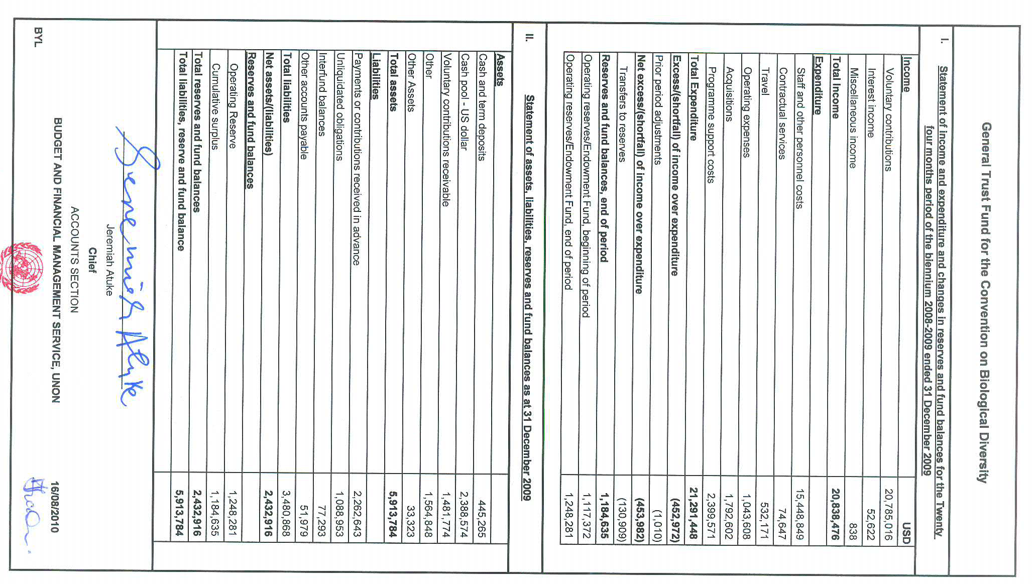

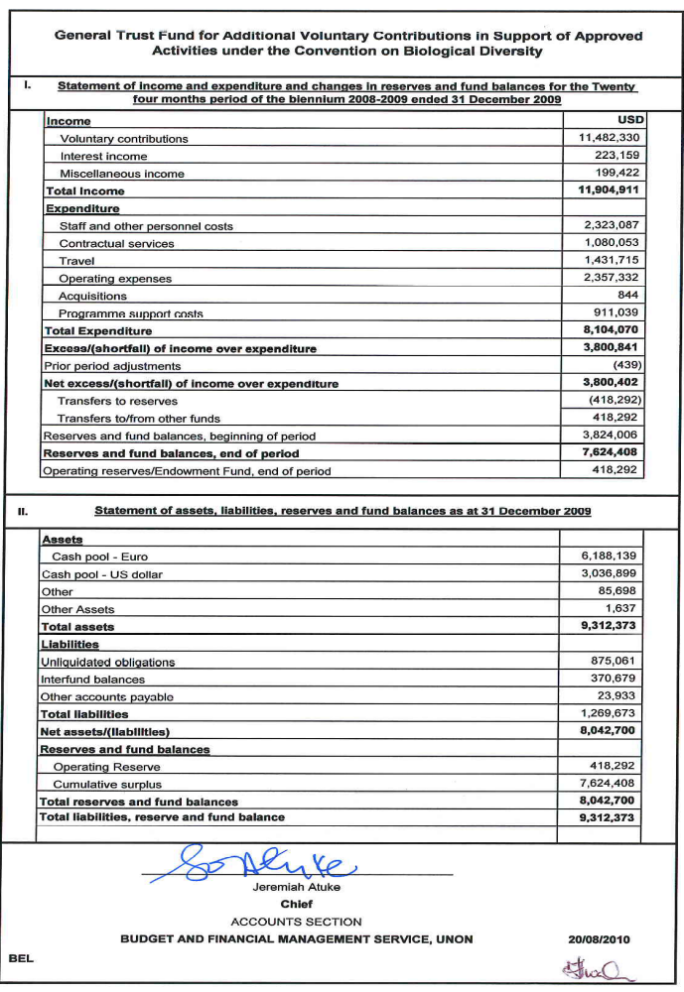
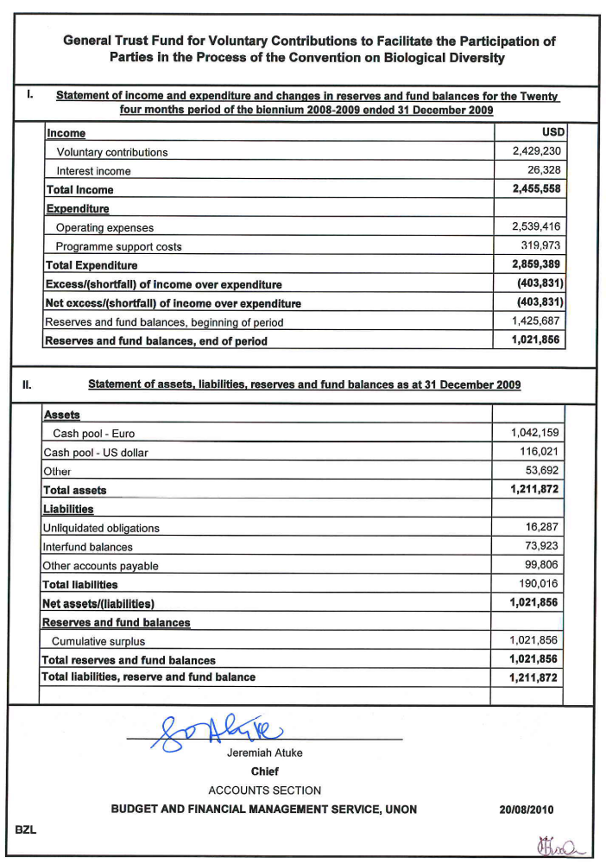
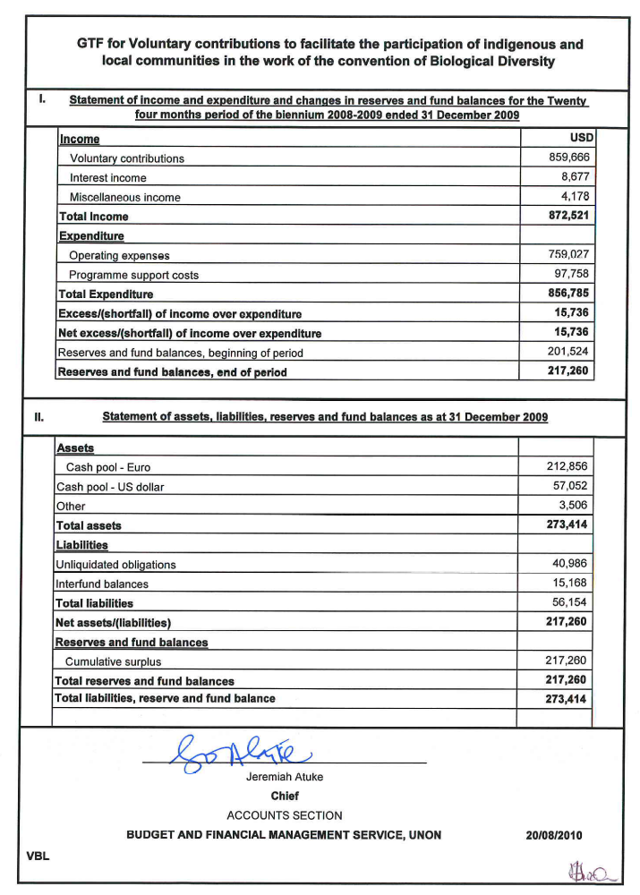
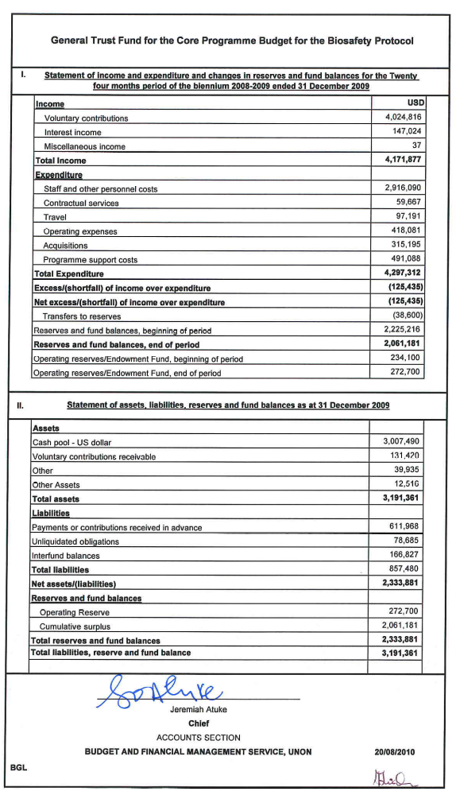
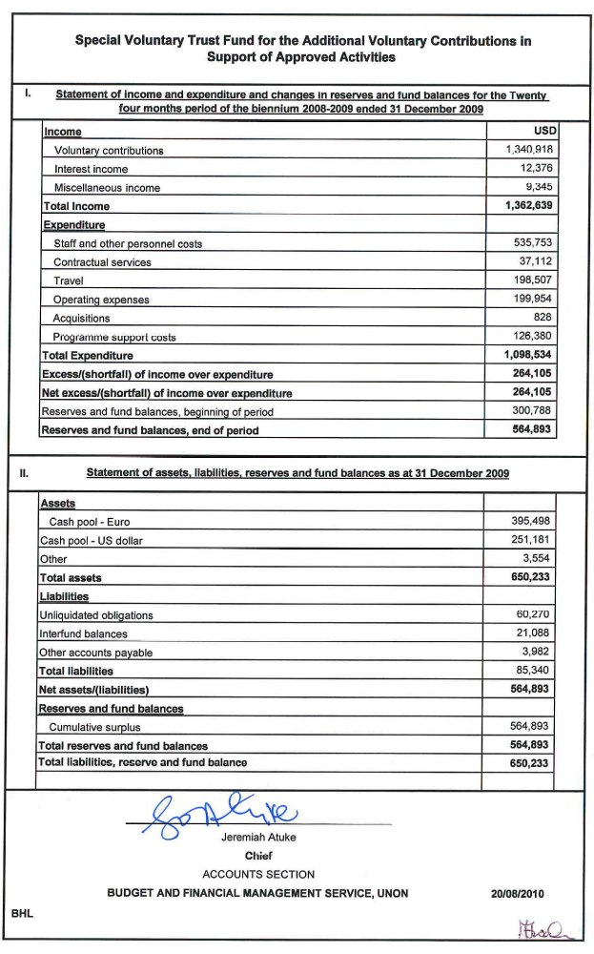

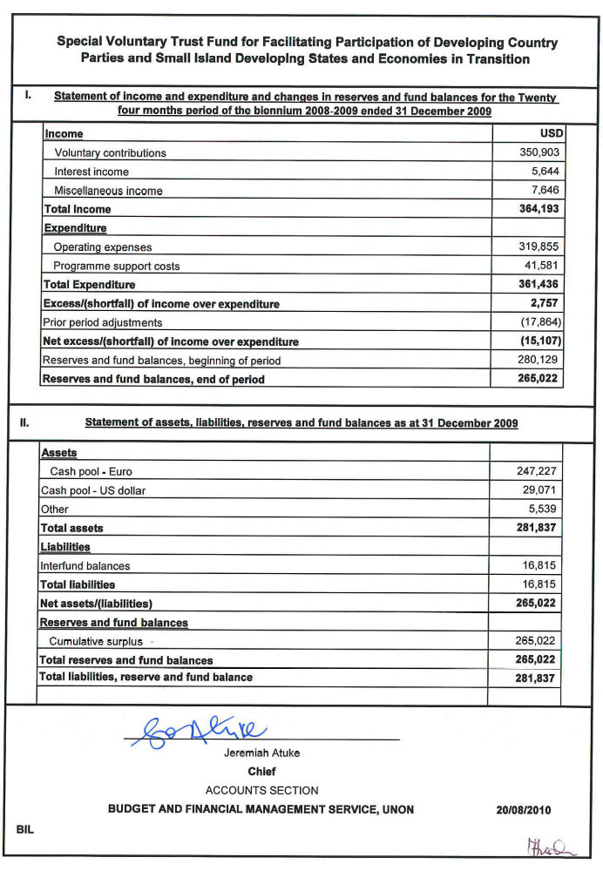

-----

* UNEP/CBD/COP/10/1.

