 |  | CBD
 |  |  |  | Distr.  GENERAL  UNEP/CBD/COP/11/INF/3  21 August 2012  ORIGINAL: ENGLISH/FRENCH
CONFERENCE OF THE PARTIES TO THE CONVENTION ON BIOLOGICAL DIVERSITY
Eleventh meeting
Hyderabad, India, 8-19 October 2012
Item 6.2 of the provisional agenda
COMPILATION OF VIEWS ON THE NEED FOR AND POSSIBLE DEVELOPMENT OF ADDITIONAL MECHANISMS TO ENABLE PARTIES TO MEET THEIR COMMITMENTS UNDER THE CONVENTION AND THE IMPLEMENTATION OF THE STRATEGIC PLAN FOR BIODIVERSITY 2011-2020

I. INTRODUCTION
- In paragraph 15 of decision X/2 (The Strategic Plan for Biodiversity 2011-2020 and the Aichi Biodiversity Targets), the Conference of the Parties decided to consider, at its eleventh meeting, the need for and possible development of additional mechanisms to enable Parties to meet their commitments under the Convention and the implementation of the Strategic Plan for Biodiversity 2011-2020.
3. This compilation of views has been prepared by the Executive Secretary to assist the eleventh meeting of the Conference of the Parties in examining the need for and possible development of additional mechanisms to enable Parties to meet their commitments under the Convention and the implementation of the Strategic Plan for Biodiversity 2011-2020.
- In preparation for this meeting, Parties, other Governments, international organizations, indigenous and local communities and relevant stakeholders were invited to provide by 1 June 2012 their views to the Executive Secretary in Notification 2012-046 (March 2012).
- In response to the notification, the Executive Secretary had received as of 1 August 2012 submissions from Canada, the European Union (including individual inputs from Austria, Belgium, Denmark, Finland, United Kingdom and France as an annex), Norway, Greenpeace and Pew Environment Group. The submissions have been synthesized in document UNEP/CBD/COP/11/19.
- The contributions have been reproduced in their original unedited form and in the language in which they were received by the Secretariat.

II. SUBMISSIONS FROM PARTIES

European union
European union | [2 JULY 2012]  [SUBMISSION: ENGLISH]

EU submission to notification 2012-046 on views on updating and Revision of the Strategic Plan 2 July 2012
The submission for this Notification has a mixed format. The common EU chapeau contains the EU views and general statements, followed by individual inputs from Member States.

In response to Notification 2012-046, the EU and its Member States would like to stress that COP X decided to consider both the need for the development of new mechanisms as well as the enhancement of existing mechanisms as specified in §15 of Decision X/2. This should be reflected in the compilation by the Secretariat in order for COP11 to have the necessary information before it.

The EU and its Member States consider it very important to have the necessary mechanisms in place that can enable Parties to meet their commitments under the CBD and its Strategic Plan, in particular with regards to capacity building, awareness raising, monitoring, financing, etc. However, both within the CBD and beyond, there are already quite some mechanisms available that would need to be built on before considering developing new mechanisms under the CBD.

With regards to the mechanisms available within the CBD, the EU and its Member States share the view of the Executive Secretary that it is important to focus on the implementation of the commitments regarding the CBD and it Strategic Plan and in this context make better use of the existing instruments under the CBD. Therefore the added value of any new mechanism should be considered carefully before its development in order not to distract from the actual national and regional efforts by the Parties. In this regard, we believe that the approach taken by WGRI4 in preparation for COP11 has made a good start in connecting different supporting instruments under the CBD in order to increase their efficiency.

Regarding mechanisms beyond CBD, it is important to refer to the §16 of Decision X/2 which, among others, invites relevant international agencies, working at the country level, to facilitate activities to support the implementation of the Convention and the Strategic Plan. Enhanced focus of those global processes on the national implementation could provide support to Parties to meet their biodiversity commitments. In particular the mapping exercise undertaken by the Environmental Management Group, in close cooperation with the CBD Secretariat, whereby several international organizations and biodiversity conventions identify how they can support the Aichi targets, could be directly relevant to enable national communication and cooperation among focal points of the different processes in support of the Aichi targets. It will be important for COP to be able to consider the results of relevant activities related to §16 of Decision X/2 and the EU and its MS would appreciate if this could be taken into account by the Secretariat when preparing the documentation for COP11 on §15 of Decision X/2.

Below is a compilation of information provided by the EU and Member States on relevant mechanisms, initiatives etc.

European Union
The EU Biodiversity Strategy to 2020 and its Common Implementation & Monitoring
Framework
In May 2011, the European Union endorsed a new strategy 'Our life insurance, our natural capital: an EU biodiversity strategy to 2020' (COM 2011/244 final) that lays down the framework for EU action over the next ten years in order to meet the 2020 biodiversity headline target set by EU leaders in March 2010. The strategy is built around six mutually supportive targets which address the main drivers of biodiversity loss and aim to reduce the key pressures on nature and ecosystem services in the EU. Each target is further translated into a set of time-bound actions and other accompanying measures. The strategy is the key EU instrument to ensure the global biodiversity commitments adopted at the 2010 Conference of Parties to the Convention on Biological Diversity in Nagoya, Japan, are met. It is underpinned by the EU 2010 Biodiversity Baseline providing facts and figures on the state and trends of the different biodiversity and ecosystem components and thereby factual data for measuring and monitoring progress in the EU from 2011 to 2020.

A coherent framework for monitoring, assessing and reporting on progress in implementing the Strategy is currently being developed linking existing biodiversity data and knowledge systems with the Strategy and streamlining EU and global monitoring, reporting and review obligations under environmental and other relevant legislation as well as to avoid duplication and increase of reporting and administrative burden.

As part of the mid-term review of the Strategy in early 2015, the further actions may be recommended, in justified cases, contributing to enhance the effectiveness of the second stage of the Strategy's implementation, and in order to ensure that the headline target of the Strategy is achieved by 2020. To this end the European Commission will report back to the European Council of Ministers and the European Parliament on the findings of this review and present its recommendations.

The strategy underlines the need for close coordination between authorities at all levels – EU, national, sub-national – responsible for ensuring implementation of the Strategy as well as stakeholders' involvement in implementation. Since the Strategy covers a 9 year timeframe, is interlinked with several sectors and intends to involve numerous stakeholders, a governance structure is needed to ensure effective and efficient co-ordination and that progress is being made towards reaching the EU biodiversity targets.

The strategy refers specifically to the establishment of a common implementation framework, such a framework, involving representatives of all relevant actors, sectors and institutions concerned at all levels. Such a governance structure should support a co-ordinated and streamlined approach for the implementation of the Strategy, including a coherent framework for monitoring, assessing and reporting on progress in implementing the Strategy.

The Common Implementation Framework (CIF) is the governance structure to underpin the effective delivery of the EU Biodiversity Strategy to 2020, involving the European Commission and Member States in partnership with key stakeholders and civil society. It includes the governance aspects related to the coherent framework for monitoring, assessing and reporting on progress towards reaching the EU targets and streamlining this work as far as possible with monitoring, assessment and reporting obligations under the CBD (notably the Aichi Targets).

The purpose of the CIF is to:

- facilitate implementation of the EU 2020 Biodiversity Strategy by putting in place a clear and logical EU level governance framework that is as efficient and effective as possible;
- create ownership for the implementation of the Biodiversity Strategy across all relevant policy areas by involving representatives from a wide range of services, ministries and institutions in implementation of the Strategy;
- ensure the involvement of all relevant stakeholders at the appropriate level of policy
- making, beyond the traditional biodiversity community. The scope of current stakeholder
- representation should be broadened, as appropriate;
- minimise duplication of effort and maximise synergies between efforts undertaken at
- different levels and by different actors and stakeholders; share information and best practice and address common challenges.

The proposal on a Common Implementation Framework including the overall structure as proposed by the EU Commission has been welcomed and validated in general by the EU nature Directors at their meeting of 22 May 2012, in Denmark.

Prioritised Action Frameworks (PAFs)
Natura 2000 prioritised action frameworks are important planning tools to strengthen the integration of Natura 2000 financing into the use of relevant EU financial instruments. They will provide a clearer framework to set out priorities, describe the Natura 2000 activities to be financed and provide an integrated overview of how to achieve them.

Member States are requested to submit PAFs to the EU Commission before the end of 2012 to be discussed bilaterally and refined/finalised in early 2013 and to also specify their financing needs for Natura 2000 under relevant plans or programmes.

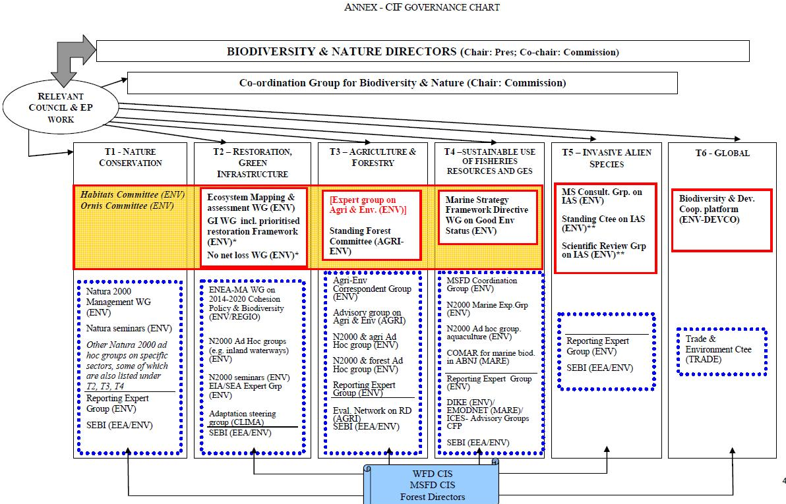

Austria
Austria | [02 July 2012]  [SUBMISSION: ENGLISH]

Mechanism for implementation of the CBD in Austria:

The National Biodiversity Commission

In 1994 Austria ratified the Convention on Biological Diversity.

Recognizing the legislative and divided responsibilities for biodiversity, in 1995 a “National Commission on Biodiversity” was set up by the Federal Ministry for Environment to guide the efforts on implementing the CBD in Austria. The Commission is tasked to facilitate coordination and cooperation in the many activities and programmes in the field of biodiversity. It provides an important platform for information exchange on various national, EU and international issues related to biodiversity.

The Commission is composed of representatives of
- Administrative Authorities (Federal Ministries, Provincial Governments)
- Public & Private Interest Groups (Landowner Associations, Chamber of Commerce, Hunting Association, Fishing Association, etc.)
- Scientists (Universities, Austrian Academy of Science, Natural History Museum, Federal Environment Agency, The Research and Training Centre for Forests, Natural Hazards and Landscape, etc.)
- Representatives from NGOs (WWF Austria, Greenpeace, Birdlife, etc.) but also the
Austria Federal State Forests

The Commission is chaired by the Federal Ministry for Environment and meets two times a year. A lot of coordination work is done per E‐Mail. It was decided not to give formal rules of procedure to the Commission but to keep it rather flexible and open in its operations. The members of the Commission take decisions generally by consensus.

The Commission has established cooperation with various relevant other bodies relevant for biodiversity in Austria, e.g. the National Forest Dialogue, the National Ramsar Committee, etc..

In 1997 the National Commission elaborated the first National Report of Austria to the Convention on Biological Diversity. Many other reports to the CBD followed. Whenever necessary, ad hoc sub groups are established under the Commission to work on specific issues.

In 1997 the Austrian Ministerial Council took cognizance of the First Austrian Strategy for the Implementation of the Convention on Biological Diversity. The Strategy had been prepared by the National Biodiversity Commission. The Commission has also been tasked with the further development of the Strategy (2005), as well as the National Action Plan on Invasive Alien Species (2004).

In 2007 the National Biodiversity Commission adopted “Outcome‐oriented targets for achieving the 2010 Biodiversity Target of stopping the loss of biodiversity in Austria – and beyond”.

Seven overall goals and 29 targets in total, some of them also including sub‐targets, should guide the implementation of the National Biodiversity Strategy. The relevant framework of goals and targets of the Convention on Biological Diversity has been the basis for developing the national goals and targets. In addition, the goals and targets to achieve the 2010 Biodiversity Target in Austria should also contribute to the implementation of the EU Biodiversity Action Plan 2010 and beyond.

Austria is currently starting a participatory process to review the national strategy and the national biodiversity targets in light of new EU Biodiversity Targets 2020 as well as the global Strategic Plan for Biodiversity and the Aichi Biodiversity Targets and to prepare an updated one.

Information can also be found at www.biologischevielfalt.at.

belgium
belgium | [02 July 2012]  [SUBMISSION: ENGLISH]

Belgian reply to CBD notification 2012046 on decision X/2:
Updating and Revision of the Strategic Plan

Mechanisms to meet the 2020 Aichi targets

Pursuant to paragraph 15 of Decision X/2, the SCBD Secretariat requests information on need for, and possible development of, additional mechanisms to enable Parties to meet their commitments under then Convention and the implementation of the Strategic Plan for Biodiversity 2011‐2020
http://www.cbd.int/doc/notifications/2012/ntf‐2012‐046‐sp‐en.pdf

National mechanisms in Belgium

Belgium’s National Biodiversity Strategy 2006‐2016 (NBS)
The NBS was adopted by the Interministerial Conference for the Environment, which is composed of the competent ministers of the Federal Government and the three Regions of Belgium (Flanders, Brussels, Wallonia) on 26 October 2006.

The strategy is a framework document that supports the integration and the fine‐tuning of Regional and Federal action plans. It is the Belgian answer to the formal obligation under the CBD, while also taking into account existing strategies, plans and documents at (pan‐)European level. The strategy spells out a range of 15 priority strategic objectives and 78 operational objectives to guide the development of actions by the competent regional end federal authorities. The text of the NBS clearly identifies, for each objective, the link with articles of the CBD, thematic programs of work, guidelines, etc. adopted under the Convention. Its main focus is on sectoral integration of Biodiversity.

Where necessary, implementation measures are undertaken in a coordinated way by the Regional and Federal Governments and other relevant actors. Examples of achievements until 2009 are published in the fourth national report. When implementing the Strategy, specific attention is paid by the federal and regional authorities to stakeholders’ information, involvement and participation. This implies consultation and collaboration between the different stakeholders, which will increase the support for and thus give a boost to the carrying out of Belgium’s National Biodiversity Strategy. Collaboration and partnerships with stakeholders on concrete projects associated to priority objective of the strategy also helps to raise their interest (legal framework on thematic issues, common Life+ project, common studies, common CEPA activities towards stakeholders and the public).

Reporting on progress made and obstacles for implementing the National Biodiversity Strategy takes place through the national reporting procedure for the CBD (2009, 2014). The information of the national report is also published on the website of the Belgian Clearing‐House Mechanism.

In 2010, the EU Baseline on the state of biodiversity and ecosystems in Europe produced a country study for Belgium. In 2011, a mid‐term state of play of the implementation of the NBS 2006‐2016 was prepared. The EU Baseline for Belgium and the mid‐term state of play of the NBS form the basis for monitoring progress towards the 2020 targets.

Recommendations for updating and further implement the NBS until 2020 where formulated in 2012. The chapter on the implementation and follow‐up of the NBS was identified as a weak point and its content will be significantly updated in the revised SNB, as well as some adaptation to reflect fully the commitment to meet the Aichi targets and the new EU Biodiversity Strategy to 2020.

The revision and up‐dating of the NBS is currently ongoing. The CBD National Focal Point is preparing the revised NBS for the period 2012‐2020 under the supervision of the national Steering Committees ‘Biodiversity Convention’ and ‘Nature’ (see description of these structures below). The validity of the NBS 2006‐2016 will be extended until 2020. The revision will take the form of a supplement presenting the updates to the text of the SNB. This update will be submitted to a public consultation and discussed during a workshop with stakeholders.

The coordinating structures and the role of the Steering Committee ‘Biodiversity Convention’

The conservation and sustainable use of nature and biodiversity conservation are essentially a competence of the three regions in Belgium while the federal government is responsible for the North Sea. Some coordination at national level is therefore essential to undertake a coherent policy. The Coordinating Committee for International Environmental Policy (CCIEP) composed of representatives of federal and regional competent administrations, has been set up to provide coordinated action in response to European and international commitments. By means of consensus, it is the responsibility of the CCIEP to ensure the consistency of the international action in the field of environmental policy of the Belgian State and its various entities. The work of the group also involves stakeholders on regular basis (experts and NGO’s). Several thematic committees are currently operating under the direct authority of the CCIEP.

One of these thematic committees is the Steering
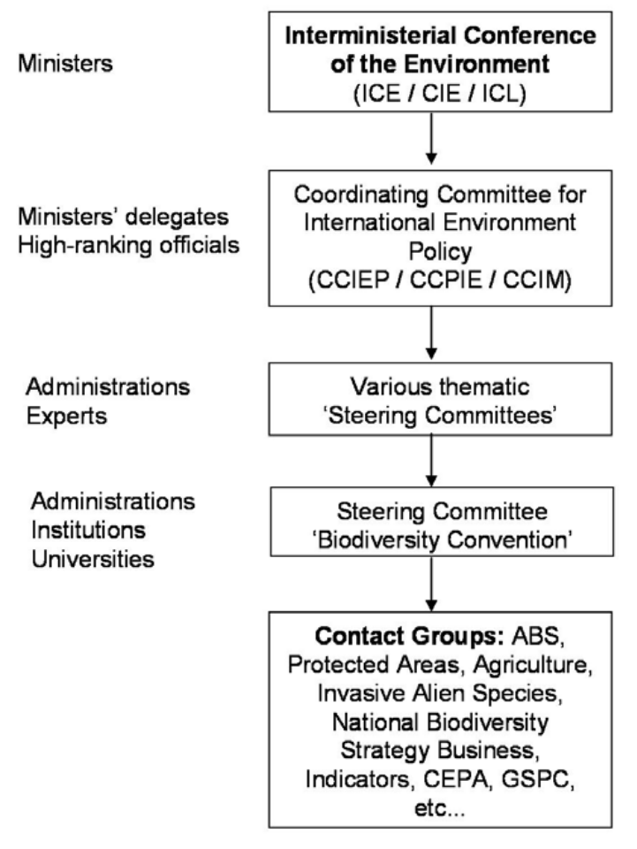
Committee 'Biodiversity Convention', which deals specifically with all aspects linked to the
implementation of the Convention on Biological
Diversity. It holds several meetings per year, in
function of the international and European
agendas. Its terms of reference are the following:
- preparation of Belgium's National Reports,
- preparation of a Biological Diversity Country
- Study,
- preparation of a National Biodiversity Strategy
- and Action Plans,
- preparation of Belgian points of view and
- statements under the CBD process,
- preparation and follow‐up of SBSTTA and COP
- meetings,
- expertise in Convention matters.

Another thematic committee, the Steering Committee 'Nature', is more specifically in charge of the follow‐up of other biodiversity‐related conventions (Ramsar, CMS, CITES, Bern) and of EU policy.
One of the specificities of the Steering Committee 'Biodiversity Convention' is that is it is not only composed of administrative correspondents, but that it includes a number of NGO’s and of scientific and technical experts selected for their expertise in a wide range of fields (conservation, management, agriculture, forestry, etc.). The latter usually come from universities, scientific institutions or advisory bodies. These actors are even more closely involved in the work of thematic Contact Groups acting under the Steering Committee to deal with specific issues at national level (Invasive Alien Species; Access and Benefit Sharing, ‘Communication, Education and Public Awareness’; Agriculture; Marine biodiversity; etc.). A contact Group on Bees and Pollinators was recently created and the network of experts is under development.

Stakeholders dialogues on biodiversity are organised on an ad hoc basis to involve actors from the sectors in the implementation of the NBS and raise awareness and support for the implementation of the CBD and the NBS.

The Presidency and Secretariat of the Steering Committee “Biodiversity Convention” is held by the Belgian CBD National Focal Point hosted by the Royal Belgian Institute of Natural Sciences (a federal scientific institution).

Other relevant national mechanisms for CBD implementation

‐ Belgian Forum on Invasive Species
The Belgian Forum on Invasive Species gathers scientific information on presence, distribution, autoecology, adverse impacts and management of invasive alien species. It regularly updates a reference list of exotic species in Belgium and is responsible for the elaboration of a black list gathering species with a strong detrimental impact on biodiversity. Information exchange on exotic species is promoted through this website and by occasional forum meetings. The Belgian Forum on Invasive Species supports activities of the Belgian Contact Group on Invasive Species. It is the national node of the IUCN Invasive Species Specialist Group and of the NOBANIS network. URL: http://ias.biodiversity.be/

‐ Co‐financing with CION CIF
Through participation in the EU Nature Directors Meetings and in the various EU working groups Belgian representatives give their inputs in the development and implementation of the Common Implementation Framework CIF, the governance structure established at EU level to underpin the effective delivery of the EU Biodiversity Strategy to 2020 (cf. info under EU chapeau) including options for co‐financing nature and biodiversity under the new EU financial policies. Preparation of Belgian positions and follow up of outcomes are done in the national Steering Committees “Nature” and/or “Biodiversity Convention”. Main aim is to enhance coordination between authorities and stakeholders to ensure integration of biodiversity in the relevant sectoral processes.

Mechanisms under development at national level

‐ Online reporting on NBS via the CHM and interoperability with EU CHM and CBD CHM
In decision COPX/2 the Clearing‐house mechanism is mentioned as a supporting tool for reporting on the SP2011‐2020. The Belgian CHM is developing, in collaboration with the European CHM, a web‐based tool to facilitate reporting to the Convention’s SP and its 20 Aichi targets as well as to the NBS. The tool will have a possibility to automatically link some of the data to the central CHM. This tool will be tested in 2012 and be available for partner countries of the Belgian and European CHM trough the CHM Portal Toolkit.

‐ Community of practice on Biodiversity and Ecosystem Services
On April 26th of 2012, at the end of the BElgium Ecosystem Services (BEES) research project, a Community of Practice on ecosystem services in Belgium (BEES community) was established with the following aims and scope:
- Develop mainstreaming/policy tools, to promote the uptake of ecosystem services concepts in
- policy and management, business and society;
- Facilitate capacity building, exchange of expertise and experience, to enable involvement of Belgian
- experts in international initiatives and build the capacity to conduct ecosystem assessments;
- Provide an overview of state of the art knowledge review tools and best practices,

This BEES community is an open and flexible network that serves as interface between different societal sectors. It is open to all potentially interested organisations and it is flexible in the sense that it is informal in its functioning, organisation and membership. Its activities are demand‐driven, responsive to societal needs, and it will serve as national contact point to promote the engagement of, and represent, Belgian ecosystem services experts in relevant national and international initiatives.
URL: http://www.biodiversity.be/bees

‐ Community of Practice on Biodiversity and Public Health
The 2011 Belgian Biodiversity – Public health Conference held on 30/11/2011 aimed to raise scientific and policy attention for the relation between Biodiversity and Public health in Belgium, to stimulate networking amongst experts and to discuss how to improve the knowledge base on services provided by biodiversity.
At the conference, participants expressed their wish for the establishment of a Community of Practice on Biodiversity and Public Health in Belgium which is now in its starting phase. This CoP will: (i) build a strong network and stimulate capacity building; (ii) produce an overview of the current state of Belgian knowledge regarding Biodiversity and Public Health; and (iii) respond to the demands of policy makers and stakeholders regarding Biodiversity and Public Health expertise at a Belgian level, as well as the international level; in the context of the establishment of the Intergovernmental Platform on Biodiversity and Ecosystem Services.
URL: http://www.biodiversity.be/health/page/show/18

Possible mechanism

‐ Working on biodiversity with the business sector in Belgium
Punctual initiatives and projects on business and biodiversity (like organizations of seminars and participation to conferences, consultation groups, publications, scoping studies) are conducted since 2007 by the regional agencies or the federal government, sometimes in partnership with NGOs. Nevertheless, no global overview of these actions exists, there is only little communication between the different groups that are working on the topic. A mechanism (to be defined) to share the information, shape complementary actions/measures with the business sector in Belgium and promote business engagement in the implementation of the Convention could be used at this effect.

CANADA
CANADA | [30 June 2012]  [SUBMISSION: ENGLISH]

Notification SCBD/SEL/LG/79317 (2012-046)

Views on the need for and possible development of additional mechanisms to enable Parties to meet their commitments under the Convention and the implementation of the Strategic Plan for Biodiversity 2011-2020.

Submission from Canada

30 June 2012

In Canada’s view, the Convention’s existing mechanisms provide a sufficient basis to enable Parties to meet their commitments under the Convention and to implement the Strategic Plan for Biodiversity 2011-2020. In general, Canada would be supportive of using existing mechanisms to enable Parties to meet their commitments and would be wary of proposals for new bodies or initiatives that could necessitate additional resources and coordination. Any such proposals must be carefully formulated to ensure that they are within the mandate of the Convention, that they will yield clear outputs, do not create unreasonable resource demands or cause duplication, and have a high probability of providing value for time and money invested. All of the Convention’s mechanisms should be periodically reviewed for effectiveness.

That being said, there are additional mechanisms that Canada could be supportive of that require minimal resources, yet would assist Parties in meeting their commitments under the Convention and also assist Parties in the implementation of the Strategic Plan for Biodiversity 2011-2012. Such activities include workshop activities, such as for capacity building on implementation priorities, or mechanisms to encourage private sector engagement.

Canada is also of the view that encouraging synergies among biodiversity-related conventions and other relevant organizations is another mechanism that can aid Parties in meeting their commitments and implementing the Strategic Plan for Biodiversity 2011-2020.

DENMark
DENMark | [02 July 2012]  [SUBMISSION: ENGLISH]

Danish submission to CBD notification (2012- 046) on Decision X/2 : Updating and revision of the Strategic Plan
Please find below information on recent Danish initiatives relevant for the implementation of the
CBD Strategic Plan for Biodiversity 2011 – 2020.

The Danish government has decided to prepare a “Nature Plan Denmark,” to be finalized in 2013 and by that identify and concretize the Danish implementation of the EU Biodiversity Strategy and the CBD Strategic Plan for Biodiversity with its Aichi Targets.. “Nature Plan Denmark” will be Denmark’s revision and updating of the existing NBSAP in accordance with Aichi Target 17.

An independent Commission for Nature and Agriculture has been established in 2012 with the overall aim to to adresss in an integrated manner the structural, economic and environmental challenges in the agricultural sector and come up with policy recommendations to that effect. The recommendations will feed into the preparations of Nature Plan Denmark.

The Commission for Nature and Agriculture has an independent status and its members represent NGOs, Academia as well as sectoral interests. The Commission will ensure an open and transparent process that allows serious involvement of all interested parties.

Sectoral integration is expected to be a significant element of the Plan especially with regard to agriculture and forestry. On the latter sector the Danish Nature Agency has started an evaluation of existing forest policy to improve the means to protect biodiversity in the Danish forest sector which will take into consideration the EU Biodiversity Strategy as well as the CBD Strategic Plan. The results will be fed into “Natur Plan Denmark.”

finland
finland | [02 July 2012]  [SUBMISSION: ENGLISH]

Notification 2012-046 of 26 March 2012

Decision X/2: Updating and Revision of the Strategic Plan

The new Finnish National Biodiversity Strategy 2012–2020 has been prepared and will be adopted by the Government in August–September 2012. The aim of the new revised biodiversity strategy is to implement the Strategic Plan for Biodiversity and its Aichi Targets by 2020; to improve the state of biodiversity from the current level; and to sustainably increase the benefits of ecosystem services to all. The work has been coordinated by the Ministry of the Environment. A biodiversity committee including all relevant ministries and stakeholders was established in 1995, and has continued its work from there on. The aim has been to promote cooperation between ministries and to define their respective responsibilities in the implementation of the Strategic Plan and the Aichi targets.

The Action Plan has also been revised in line with the main goals and targets of the Strategic Plan for Biodiversity. The Action Plan on Biological Diversity, drawn up by the National Biodiversity Committee, fulfils the commitments set forth in Article 6 of the Convention on Biological Diversity. The national action plan is designed to fulfil the EU commitments, to conserve and restore a sufficiently representative sample of species, habitats and ecosystems in Finland, and to strengthen sector integration and responsibility for biodiversity. The national Action Plan integrates various spheres of administration, trade and industry under the joint objective of protecting and promoting the sustainable use of biological resources. Ministries and private sector are accordingly held accountable for ensuring that their activities do not conflict with the conservation of biodiversity. A set of indicators has been developed and adopted to fulfil the reporting requirements under the CBD. Finland has been working with the reporting mechanisms and has actively developed biodiversity indicators together with, for example, the Nordic countries and the European Environment Agency.

The Action Plan covers the period 2012–2020. At the end of this period, the plan will be reviewed. The review will take into account the set of indicators developed (www.biodiversity.fi) with a view to current needs in the conservation of biological diversity and sustainable use of its components, and the latest research findings and national and international developments in this field. Biodiversity.fi now includes more than 100 indicators reflecting the development of various components of biological diversity, as well as factors driving these developments.

To put the conservation and sustainable use of biological diversity into action in Finland, the Finnish Government adopted already in 2006 a comprehensive National Strategy and Action Plan for Conservation and Sustainable Use of Biodiversity – Saving Nature for People 2006–2016, covering all aspects relevant to this issue. Already during the years 1996–1997 the first National Action Plan for biodiversity in Finland was drawn up by the National Biodiversity Committee. This plan included 124 measures designed to promote the conservation, management and sustainable use of biodiversity. The strategy's aim was to mobilize and bring together all relevant sectors in society to reduce the threat to biodiversity, improve its sustainable use and halt the loss of biodiversity.
www.ymparisto.fi/lumonet/

The Clearing House Mechanism has been an important part of the outreach and work on generating knowledge in Finland, and the mechanism will be developed in line with the environmental administration's web pages -reform under way. It is important to encourage the active use of the CHM by all Parties to the CBD and its protocols. For more information on the CHM: http://www.ymparisto.fi/lumonet
Climateguide.fi
The new website provides analysed data about the Finnish climate and climate change, including data for individual regions. The mitigation and adaptation measures taken in Finnish municipalities can be studied through the solutions collected for Climateguide.fi. The Climateguide.fi site provides not only scientific background information on climate change, but also tangible means for mitigation and adaptation. The material has been prepared by Finland’s leading climate researchers and experts. The contents will be supplemented and developed gradually. The Swedish and English versions also contain a wide range of new information on climate change, produced from the Finnish perspective.

Biodiversity research
A number of Finnish research institutes, universities and natural history researchers have, for many years, been making significant contributions to research on biodiversity and its sustainable use, including the impacts of climate change on biodiversity.
http://www.ymparisto.fi/default.asp?contentid=407596&lan=EN

1.1.1. An greater level of knowledge
Thanks to both the research programme of deficiently known and threatened forest species (PUTTE), which is part of the Forest Biodiversity Programme for Southern Finland (METSO), and proactive work by working groups on different organisms, the scope of the 2010 evaluation expanded by as much as 40 per cent. The 2010 evaluation covered over 5,000 more species of Diptera, Hymenoptera, Homoptera and arachnids than in 2000. The evaluation of fungi and lichens has also considerably expanded by over 700 species. However, the evaluation of aquatic organisms remains highly incomplete, as data is limited and sporadic; and for some species, such as algae and crustaceans, the scope of the evaluation became even more limited.

2010 Red List of Finnish Species

2010 Red List of Finnish species
The fourth assessment of threatened species in Finland was

published in December 2010. The assessment of threatened
species is made once every ten years in Finland. The work
took four years and the results of the assessment were
presented and handed over to the Minister of the
Environment in 2010. Finland’s Red List evaluation is the
most comprehensive in the world. During 2007–2010, the
Steering Group for Evaluation of Threatened Species
(LAUHA), which was appointed by the Ministry of the
Environment, led 15 expert groups in an assessment of the conservation status of Finland’s Drawing Terhi Ryttäri
species. A total of 160 of Finland’s top experts contributed to the evaluation.

Linking biodiversity research and policy
The Intergovernmental Science-Policy Platform on Biodiversity and Ecosystem Services, IPBES, aims to close the gap between scientific findings about the alarming loss of biodiversity and its services, on the one hand, and knowledge about effective solutions and necessary policy measures, on the other. Finland welcomes the establishment of IPBES, and its benefits for decision-making. The work ahead is important and should be finalised and the opportunities fully utilised. The requirements for capacity building are important to assess. As part of the Finnish development cooperation, biodiversity conservation has been taken into consideration in financial plans, including the Global Environment Facility (GEF). For instance, the Regional Biodiversity Programme in the Andean Community (BIOCAN) project 2010–2013, and its implementation phase, has generated some EUR 6.5 million. One of the main purposes is to help strengthen regional scientific capacity and implementation of national biodiversity strategies and action plans, including biodiversity research. The work builds on the well-received Biodamaz project (1997–2007) between Peru and Finland.
For more information: www.formin.fi > Development policy > Appropriations and their use> Development projects > Regional Projects

The biodiversity-MEAs have long suffered from the lack of an external mechanism to guide decision-making. IPBES intends to fulfill this gap, but necessary steps need to be taken to ensure a synergetic relationship between the new panel and the biodiversity-related MEAs.

Finland also supports cross-border development and regional cooperation for strengthening both scientific cooperation and implementation of existing biodiversity and EU commitments. This has been well established in the Barents Region and the Baltic Sea region.

Improvements in eco-efficiency

The promotion of eco-efficiency is and important part of sustainable consumption and production work. Finland strongly supports quality and variety of Finland's environment. Mainstreaming of biodiversity concerns and its economic value needs to be integrated into policies and practices more efficiently. In this regard it is important to continue to improve coherence between different policies.

Improved communication and public awareness

The National Biodiversity Communications Programme is part of the National Biodiversity Strategy and Action Plan, and it covers the years 2009-2016. The aim of the communications programme is to promote interest in, and increase awareness of, the ecological basis of biodiversity and of the importance and benefits of the conservation and sustainable use of nature for the national economy, business and individuals. The purpose is to disseminate information even on difficult issues and aspects of biodiversity in a manner which motivates the various parties to take active measures towards a shared goal. The programme includes an action plan that is updated every year The Finnish biodiversity communication working group is chaired by the Ministry of the Environment and consists preliminarily of communication experts from different ministries and institutions.
The National logo ‘Biodiversity - essential to life’ was launched in Finnish, Swedish, Sámi and English in 2010 and used since then for branding biodiversity more generally. The first-ever issue of inter-organizational electronic Biodiversity newsletter was published in Finnish and Swedish in January 2010. The newsletter has appeared since 2010 regularly. http://www.ymparisto.fi/syke/luonnonkirjo The launch of the Biodiversity Competition, best act for promoting biodiversity in Finland since 2006, has by today been launched three times and will be announced for the fourth time in August 2012 http://www.ymparisto.fi/default.asp?contentid=358679&lan=en The aim is to find an organization or individual that has been able to safeguard the vitality of nature by actions of its or his own, during the period 2011-2012 in Finland. The actions may include practical nature conservation work, communications, environmental education, research or business.

Promoting synergies within the cluster of biodiversity-related MEAs
Finland strongly advocates that we should make better use of and develop the existing mechanisms under the CBD instead of creating new ones. We are well aware that countries report on the weakened implementation of the MEAs, due to overloaded agendas, duplication of tasks, failed national coordination, overlapping and intricate reporting procedures. Despite the wide range of coordination mechanisms, no overarching mechanism exists that brings the Parties of the MEAs together to identify joint solutions for common issues or shared concerns (ref. UNEP WCMC report 2012: Promoting synergies within the cluster of biodiversity-related multilateral environmental agreements).
Finland calls for enhanced synergies between the biodiversity-related Multilateral Environmental Agreements with the aim of making national implementation more coherent and effective by initiating a party-driven process. The proposal is intended to secure a Party-driven process that would have the will to move the synergies agenda forward on the biodiversity-related MEAs and that would together identify joint solutions for common programmatic issues (implementing the Strategic Plan, revision and preparing NBSAPs, national reporting, administration, capacity building, science-policy interface). This process could be initiated by CBD COP-11. It would strengthen the work of the BLG, since it would be needs-driven and party-driven for addressing common issues to be presented and solved. The proposal is described in more detail in a new UNEP-WCMC report 2012: http://www.unep-wcmc.org/synergies-among-meas-and-the-harmonization-of-nationalreporting--- key-papers_580.html

Helsinki 15.6.2012/mvw

france
france | [02 July 2012]  [SUBMISSION: FRENCH]

National contribution by France to CBD Notification 2012-046

La nouvelle stratégie nationale pour la biodiversité (SNB)
- La France porte une importante responsabilité en matière de biodiversité eu égard à la richesse de son territoire métropolitain et ultramarin. C’est pourquoi elle est partie à la convention sur la diversité biologique (Rio de Janeiro, 1992) et a adopté une première stratégie en 2004. Le processus de révision a été lancé en juillet 2010 selon un mode de gouvernance concertée inspiré du Grenelle de l’environnement. Il a abouti à une SNB structurée en 6 orientations stratégiques et 20 objectifs, concrétisant l’engagement français au titre de la Convention sur la diversité biologique (CDB). La SNB constitue également le volet biodiversité de la Stratégie nationale de développement durable (SNDD), et est placée sous le timbre du Premier ministre. La même année, l’Union européenne adoptait sa propre stratégie pour la biodiversité et demandait à la Commission de définir un cadre cohérent de mise en œuvre.
- La nouvelle SNB française 2011-2020 vise à produire un engagement plus important des divers acteurs, à toutes les échelles territoriales, en métropole et en outre-mer, en vue d’atteindre les objectifs adoptés. Elle fixe pour ambition commune de préserver et restaurer, renforcer et valoriser la biodiversité, en assurer l’usage durable et équitable, et de réussir pour cela l’implication de tous et de tous les secteurs d’activité. Les orientations couvrent tous les domaines d’enjeux pour la société.
- Le fondement et l’originalité de la SNB 2011-2020 sont de mettre en place un cadre cohérent pour que tous les porteurs de projets publics et privés puissent contribuer à l’ambition sur une base volontaire, en assumant leurs responsabilités. La SNB vise à renforcer notre capacité individuelle et collective à agir, aux différents niveaux territoriaux et dans tous les secteurs d’activités (eau, sols, mer, climat, énergie, agriculture, forêt, urbanisme, infrastructures, tourisme, industrie, commerce, éducation, recherche, santé, etc.).
- L’Etat s’est engagé unilatéralement à travers une série d’engagements interministériels pour la période 2011-2013. Une grande partie des engagements sont réalisés, d’autres doivent être poursuivis, certains nécessiteront une initiative de relance. Un des engagements porte sur l’accès aux ressources génétiques partagées qui fait l’objet d’un travail interministériel pour en définir le cadre juridique compte tenu de l’importance économique du concept, notamment dans les territoires d’outre-mer.
- Un autre engagement portait sur la réalisation d’appels à projets destinés à engager concrètement des opérations de restauration de milieux naturels et de continuité écologiques, avec des volets de développement de filières ou de l’innovation. Financés pour l’essentiel sur le fonds FIBRE ou via les agences de l’eau et l’ONEMA, plus de 70 projets ont été sélectionnés début 2012 sur tout le territoire, y compris ultramarin. Deux appels à projets sont lancés actuellement pour une sélection en septembre 2012 et financés sur le fonds FIBRE (2 m€) ; d’autres appels à projets pourraient être lancés en 2012.
- Les autres acteurs personnes morales (collectivités, entreprises, associations, syndicats,...) sont invités depuis avril 2012 à faire reconnaître leur propre engagement en faveur de la biodiversité par le biais d’une adhésion à la SNB (237 adhérents en avril 2012) et d’un système de reconnaissance de leur engagement. A l’instar des Agendas 21, le comité national chargé de la biodiversité (actuellement le comité de révision), sur la base d’une évaluation menée en son sein, délivre une reconnaissance de l’engagement volontaire pour un projet présenté par un acteur pour une ou plusieurs années. Cette reconnaissance donne une visibilité médiatique au porteur de projet et assure une mise en lumière à des fins de mutualisation des actions en faveur de la biodiversité. Le processus de reconnaissance a été lancé en avril 2012.
- Les régions seront invitées à poursuivre l’élaboration de leur stratégie régionale en collaboration avec l’Etat. Pour les DOM, des initiatives locales en faveur de la biodiversité (IFREBIOM) sont discutées pour faire émerger, notamment à travers des stratégies régionales, le cadre d’une action cohérente. Ces démarches sont relayées par une initiative nationale dédiée à la biodiversité ultramarine.
- La SNB n’est pas financée directement. Les actions inscrites dans les plans d’actions sont financées par les départements ministériels concernés, dans le cadre de leur dotation.
- L'amélioration et la diffusion de la connaissance du patrimoine naturel et de la biodiversité, l'expertise en appui à la décision publique :
- Le volet « connaissance » de la stratégie nationale pour la biodiversité (SNB) s’appuie notamment sur la mobilisation et l’amélioration des connaissances au travers de :
- l’évaluation de l’état de conservation des habitats et des espèces d’intérêt communautaire,
- l’achèvement de la modernisation de l’inventaire des ZNIEFF en métropole, la réalisation des ZNIEFF dans les départements d’outre-mer, la réalisation d’une cartographie des habitats naturels couvrant toute la France au 1/25000,
- la consolidation de l’inventaire national du patrimoine naturel (INPN) conforté en 2002 par la loi relative à la démocratie de proximité, géré par le Muséum national d'histoire naturelle (MNHN),
- la réalisation d’atlas des paysages ainsi que d'atlas de la biodiversité dans les communes (ABC), ce dernier projet étant destiné d'une part à sensibiliser les élus, la population et les acteurs socio-économiques aux enjeux de biodiversité, et d'autre part à compléter les connaissances naturalistes disponibles à l'échelle locale,
- le lancement de la cartographie nationale des enjeux territorialisés de biodiversité remarquable (Carnet-B) pour disposer de données systématiques sur l'ensemble du territoire concernant les espèces et habitats naturels à enjeu, afin d'anticiper très en amont leur intégration dans la conception des projets d'infrastructure et d'urbanisme, et pour récupérer et valoriser les données acquises lors des études d'impact de ces projets.
- Le développement et le soutien à la qualité des sciences participatives
- Des études, notamment sur les services écosystémiques ou encore les programmes de recherche du ministère tels que « changements globaux et biodiversité » décrivant les effets du changement climatique sur la biodiversité viennent compléter ce volet connaissance.
- La direction en charge de la nature s’appuie techniquement sur le Muséum national d'histoire naturelle (MNHN) pour la mise en œuvre de ses politiques de conservation de la nature. Le MNHN a notamment en charge la responsabilité scientifique des inventaires du patrimoine naturel (faune, flore, habitats, géologie) en milieux terrestres et marins.
- Depuis 2007, cette structuration de la connaissance sur la biodiversité et de sa diffusion progresse avec la mise en place du système d'information sur la nature et les paysages (SINP) dont le nouveau protocole d’adhésion devrait être publié en juillet 2012. Celui-ci formalise les objectifs, l’organisation et le fonctionnement du SINP. Il regroupe d’ores et déjà les principaux fournisseurs et utilisateurs des données sur la biodiversité. Une architecture commune doit émerger en 2012 pour assurer une interopérabilité des données sans pour autant chercher à les centraliser et en assurant le respect de la propriété des données.
- L'appui aux décisions publiques nécessite de disposer d’indicateurs à différentes échelles et de mettre ces informations à disposition de l'ensemble des acteurs publics ou privés et des citoyens, dans le cadre de la directive INSPIRE. A cet effet, la loi Grenelle 1 a acté la création d’un observatoire national de la biodiversité. Les indicateurs de l’ONB seront présentés le 22 mai 2012. L’ONB a pour missions de :
- fournir des éléments d'appréciation complets et structurés de l'état et de l'évolution de la biodiversité, en lien avec les activités anthropiques, pour permettre l'évaluation de l’impact des plans, programmes et projets ;
- mettre à la disposition des citoyens une information suffisante sur la biodiversité et ses enjeux pour permettre le débat ;
- alimenter en données structurées les rapportages correspondants aux engagements, européens et internationaux.
- Les indicateurs produits sont accessibles à tous via un site internet. S’ils permettent notamment de mesurer les effets de la SNB, ils n’ont pas vocation à évaluer directement les politiques publiques. En particulier, l’ONB ne donne pas de valeur cible à atteindre, laissant cette prérogative aux instances dédiées. Les indicateurs ont été produits par des groupes de travail multi-acteurs, validés par un comité national de composition type Grenelle et leur pertinence est analysée par un comité technique et scientifique indépendant.
- L’Etat, dans le cadre du Grenelle, apporte un soutien, par le biais de conventions pluriannuelles d’objectifs, aux principales associations de protection de la nature (FNE, LPO, UICN, etc.) et à l’ensemble des conservatoires botaniques nationaux. Il attribue également des subventions pour charges de service public aux opérateurs venant en appui à l’expertise (GIP ATEN et Muséum national d’histoire naturelle).

norway
norway | [02 July 2012]  [SUBMISSION: ENGLISH]

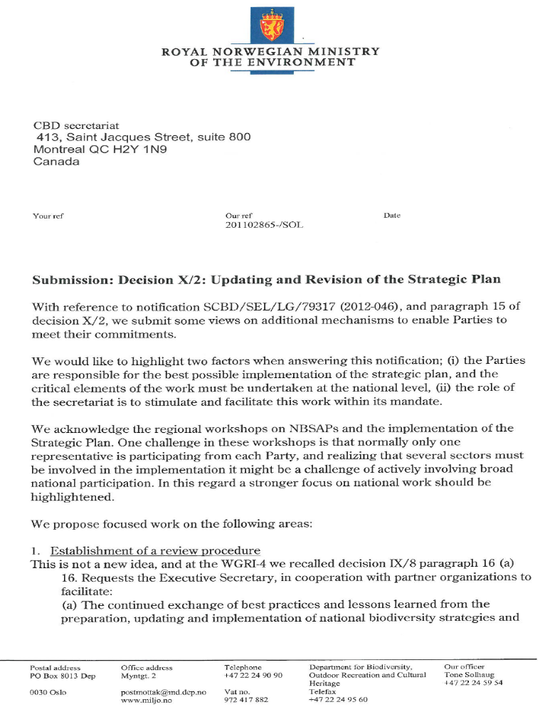
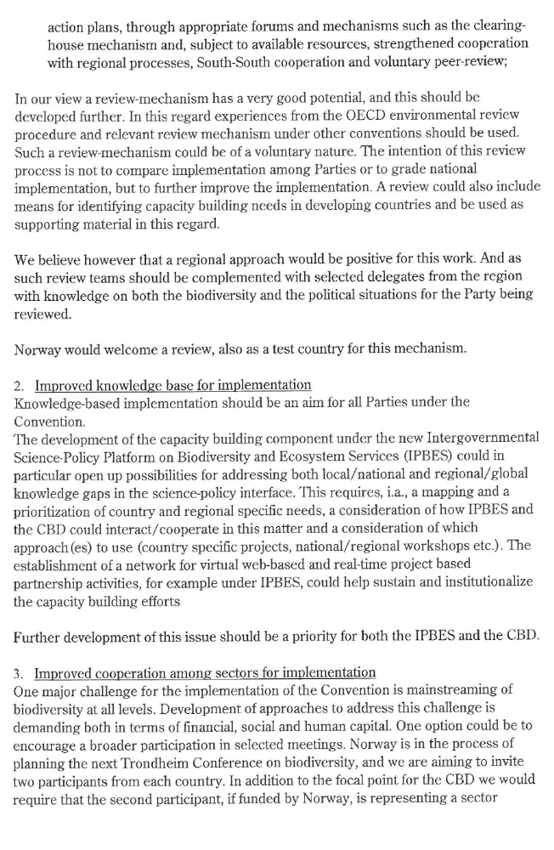
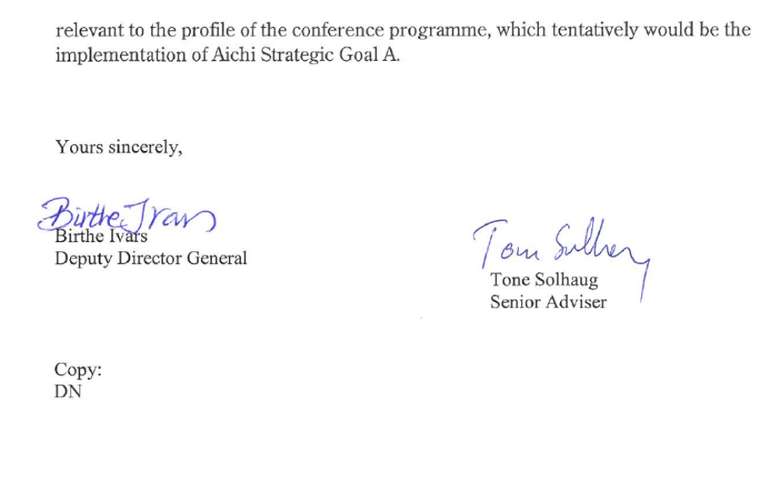

untied kingdom
untied kingdom | [02 July 2012]  [SUBMISSION: ENGLISH]

United Kingdom
CBD Notification 2012-046
Decision X/2: Updating and Revision of the Strategic Plan
UK Government Response
The UK Government submits the following as examples of mechanisms that are being developed, tested and applied in the UK and Parties may wish to consider, along with the supporting guidance and information to contribute to their implementation of the Strategic Plan and meeting commitments under the Convention.
The UK Biodiversity Framework

Responsibilities in the United Kingdom for biodiversity and the natural environment are devolved to the component parts of the UK, namely England, Northern Ireland, Scotland and Wales, with some biodiversity functions reserved to the UK Government

Although differing in details and approach, the four UK countries have each published their own biodiversity strategies which have been, or are in the process of being, updated to align with the CBD’s Strategic Plan for Biodiversity 2011–2020, the Aichi Targets and the EU Biodiversity Strategy. Biodiversity 2020: A strategy for England’s wildlife and ecosystem services was published in August 2011
http://www.defra.gov.uk/publications/2011/08/19/pb13583-biodiversity-strategy-2020/

However, in order to enable a joined-up, cohesive approach to biodiversity conservation across the UK, a body comprised of representatives of the four countries (the ‘Four Countries Group’) has been established.

In turn, this group has developed a UK Biodiversity Framework to set a broad enabling framework for action across the UK over the next ten years and, specifically, to:
- Set out a shared vision and priorities for UK scale activities, in a framework jointly
- owned by the four countries, and to which their own strategies will contribute.
- Identify priority work at a UK level which will be needed to take forward the Aichi
- targets and the EU Biodiversity Strategy
- Facilitate the aggregation and collation of activities and outcomes across all
- countries of the UK, where the four countries agree this will bring benefits compared
- with individual country work.
- Streamline governance arrangements for UK scale activity.
- Facilitate UK reporting on international commitments, including the 5th and 6th National Reports to the CBD.
The UK Biodiversity Framework will be published on the 17th July
http://jncc.defra.gov.uk/page-6189. A delivery plan is now being developed.

UK Biodiversity Framework Indicators

The UK Biodiversity Indicators in Your Pocket were developed and published between 2007 and 2011 for reporting on progress with international and European commitments to halt or slow biodiversity loss by 2010. Following the adoption of the Strategic Plan for Biodiversity 2011-2020, the existing indicators have been reviewed² and a programme of work put in place to adapt them and develop new ones to be used in the 5th and 6th CBD National reports.

Biodiversity policy is a devolved responsibility in the UK, and England, Scotland, Wales and Northern Ireland have each developed or are developing their own biodiversity or environment strategies. Indicators are being developed to track progress with the respective commitments in each country. The UK indicator set is streamlined with the indicators in each country, and provides a mechanism to evaluate progress across the UK as a whole towards the Aichi Targets. The UK indicators have a specific purpose for international reporting and were selected following consultation and agreement between the administrations. The indicators provide a flexible framework and a common set of methodologies which in some cases can also be used for country reporting. The UK is thereby creating a joined up, scaled system of indicators which relate both to country level implementation and international reporting.

The UK has instigated an independent review of data and indicator methodologies to address gaps identified in the earlier review, and for indicators with uncertain future data supply. Where possible methods should allow for aggregation or disaggregate between UK and the four component countries - England, Scotland, Wales and Northern Ireland. The UK Biodiversity Framework indicators were published at the end of May 2012. http://jncc.defra.gov.uk/page-4229. Further work will be needed over the next few months to make clearer linkages with the new EU Biodiversity Strategy, and the indicators that will be used to measure progress against the targets and actions in that strategy.

The Natural Capital Committee
The creation of the Natural Capital Committee was announced in the UK Natural Environment White Paper (published in June 2011), This Committee will report to the Economic Affairs Committee (chaired by the Chancellor of the Exchequer) and aims to provide independent expert advice on the state of English natural capital. The Natural Capital Committee is designed to ensure that Government has a better informed understanding of the value of Natural Capital, and will help it to prioritise actions to support and improve the UK’s natural assets. By reporting into the Economic Affairs Committee and the Chancellor, this Committee has the opportunity to truly influence economic policy for the good of the natural environment. It will address the question of how can we safeguard the value of England’s natural capital and help drive sustainable economic growth?
It will provide advice on when, where and how natural assets are being used unsustainably. Secondly, it will advise the Government on how it should prioritise action to protect and improve natural capital, so that public and private activity is focused where it will have greatest impact on improving wellbeing in our society. Finally, it will advise the Government on research priorities to improve future advice and decisions on protecting and enhancing natural capital. Part of this work will be to check which parts of our natural capital are in good condition and which are likely to decline.

Dieter Helm, Professor at the University of Oxford and a Fellow of New College, Oxford, was appointed chair of the committee in March 2012. Other members of the committee include; Giles Atkinson, Ian Bateman, Kerry ten Kate, Robin Smale and Rosemary Hails. The Natural Capital Committee will be supported by a natural capital asset check scoping study, and the 2nd phase of the highly influential UK National Ecosystem Assessment (http://uknea.unep-wcmc.org/)

Nature Improvement Areas
Nature Improvement Areas (NIAs) are a new approach to achieving the step change that is necessary for the creation of a coherent and resilient ecological network in England, in support of our biodiversity objectives and to help deliver the Aichi Targets.

The characteristics of NIAs vary across the country according to what is possible and what is needed, these will be places where:
- opportunities to deliver ecological networks, both in terms of large area scale and
valuable benefits accruing to wildlife and people, are particularly high;
- a shared vision exists among a wide partnership including statutory and voluntary
sectors;
- significant enhancements of the network can be achieved over large areas by
enlarging and enhancing existing wildlife sites, improving ecological connectivity
and/or creating new sites;
- the surrounding land use is better integrated with the management of the ecological network; wildlife habitats and underpinning ecosystem processes are restored, helping to mitigate climate change impacts; and
- people are inspired by their enhanced experience of the outside world.

Government has committed to assist partnerships of local authorities, local communities and landowners, the private sector and conservation organisations to establish new NIAs, based on a local assessment of opportunities for restoring and connecting nature on a significant scale. Government is providing funding of £7.5million for 12 initial NIAs to illustrate the approach and inform how it can be rolled out more widely. The initial NIAs where announced in March 2012 following a national competition
(http://www.naturalengland.org.uk/ourwork/conservation/biodiversity/funding/nia/default.aspx).

Local Nature Partnerships
In its Natural Environment White Paper, Government recognised that partnership working is key to delivering our ambitions for the natural environment at a local level and set out its vision for Local Nature Partnerships (LNPs). The Government undertook to encourage and support LNPs where local areas around England wish to establish them.

The ambition for LNPs is that they will help their local area to manage the natural environment as a system and to embed its value in local decisions for the benefit of nature, people and the economy. To do this effectively they will need to be self-sustaining strategic partnerships of a broad range of local organisations, businesses and people with the credibility to work with and influence other local strategic decision makers.

The overall purpose of an LNP is to:

- Drive positive change in the local natural environment, taking a strategic view of the challenges and opportunities involved and identifying ways to manage it as a system for the benefit of nature, people and the economy.

- Contribute to achieving the Government’s national environmental objectives locally, including the identification of local ecological networks, alongside addressing local priorities.

- Become local champions influencing decision-making relating to the natural environment and its value to social and economic outcomes, in particular, through working closely with local authorities and other local decision makers.

At the heart of the ambition for LNPs is that each area finds its own way to make the LNP role real and meaningful locally. Within the framework of the overall LNP role, it is for each LNP to decide what their priorities are and how they work in the way that best suits the needs and challenges of their local area.

It is envisaged that there will be about 50 LNPs forming across England - large enough to add value at a strategic scale, but small enough to be manageable. Applications for LNP status have been received and it is intended to announce the first LNPs in summer 2012.

Biodiversity Offsets
Defra, Natural England and local authorities in six pilot areas in England are working together to test the biodiversity offsetting approach. The pilots will develop a body of information and evidence that the Government will use to decide whether to support greater use of biodiversity offsets, and if so, how to use it most effectively. The biodiversity offsetting pilots have now started, and will run for two years, until April 2014.
The Defra offsetting website -
http://www.defra.gov.uk/environment/natural/biodiversity/uk/offsetting/ - includes further details on:
- the pilot areas

- a series of complementary projects that will feed in to the evaluation of biodiversity offsetting

- the guidance and information made available for those who’d like to use the biodiversity offsetting approach

- the policy background

The approach of trailing offsetting to was announced in the UK Natural Environment White Paper (published in June 2011), which followed the publication of the UK National Ecosystem Assessment (http://uknea.unep-wcmc.org/). The White Paper acknowledged the need put nature at the heart of decision making. Offsetting is seen as one potential instrument to help do this with respect to built development. It should be noted that offsetting remains at the bottom of the mitigation hierarchy i.e. before resorting to offsetting any impacts should ideally be prevented, any remaining impacts should be mitigated, and only where residual unavoidable impacts exist should offsetting be used to provide compensation.

Sustainable consumption and production

Activities to promote sustainable consumption and production reduce demand for natural resources and therefore help to mitigate impacts on biodiversity, thus contributing to Aichi target 4. In particular the UK implements the EU Sustainable Consumption and Production Action Plan.

The UK is also working to produce guidance for business to assist them with reporting on their environmental impacts, which this contributes to target 4. The guidance is one of the commitments made in the Natural Environment White Paper.
The purpose of the guidance is to encourage organisations to report regularly and publicly on their environmental impacts, policies and performance. It covers 5 broad themes, Air Pollution and Other Emissions, Water, Biodiversity/Ecosystem Services, Extracted Materials and Waste

The guidance is voluntary in nature and sets out the benefits of reporting and defines a Key Performance Indicator (KPI). It provides information on how an organisation might establish what its environmental impacts are, its own operating boundaries, details on measuring and reporting and setting targets and considering supply chain information.

The KPI Guidance can be used by the whole of the business community however, it primarily seeks to engage those quoted and large private companies with reporting obligations under the Companies Act. We are aiming to publish a finalised version by the end of 2012.

The Products Sustainability Forum’s initial evidence on measuring biodiversity impacts associated with particular products and services, will identify gaps in terms of our understanding of the links between business activities and biodiversity impacts, and perhaps even more so, gaps on understanding of how impacts might be apportioned between activities within an area and along a supply chain.

EU Marine Strategy Framework Directive

Implementation of the EU Marine Strategy Framework Directive will support Aichi targets 3, 4, 5, 6, 7, 8, 9, 10, 11, 12, 14, 15. Successful implementation of this Directive will directly implement Strategic Plan actions to:
- Identify any additional measures necessary to move towards achieving Good Environmental Status, ensuring these are in place by 2016, and;
- Put in place any additional fisheries management measures necessary to achieve the wider conservation objectives of the MSFD

The UK Marine Policy Statement (MPS) adopted by all UK Administrations in March 2011 contains many environmental considerations which will also help implement the Strategic Plan and contribute to fulfilling the UK vision for ‘clean, healthy, safe, productive and biologically diverse oceans and seas.

The MPS provides the framework for the development of marine plans and all decisions by public authorities which are likely to impact the marine area. The considerations within the MPS are given effect by the plans developed and the decisions made in accordance with it. The first two Marine Plans for England (East Inshore and East Offshore) are on course to be completed by the Marine Management Organisation in 2013. The Marine Management Organisation is on course to have Marine Plans in place for the whole of the English marine area by 2022.

Ecosystems Knowledge Network
The UK Government are funding a contractor to run an organised network consisting of researchers, local interest groups, decision makers and managers involved in a range of locally based land/marine projects which are applying an ecosystems approach. The network promotes knowledge exchange between these different groups and uses this knowledge to answer key evidence gaps. Opportunities for knowledge exchange include identifying where particular local scale projects have developed techniques for ecosystems valuation, demonstrated community participation and shown how they can use complex biodiversity/ecosystems data to make decisions.

As the network develops, it will take the evidence and insights on how effective delivery can being achieved and share this with new audiences to help them make better marine/land management decisions which take into account the full value of the natural environment to society and the economy. http://ekn.defra.gov.uk/

Lessons learnt from incorporating the values of biodiversity and ecosystem services into
the development of NBSAPs
This project aims to identify the lessons learned and provide a map of good practice for
mainstreaming the values of biodiversity and ecosystem services into National Biodiversity Strategies and Action Plans (NBSAPs) and what entry points or tools countries have used such as planning processes, poverty reduction strategy papers, assessments or national accounting.
Articulating lessons learned from countries who have already undertaken or are currently undertaking a process of mainstreaming values into their NBSAPs or similar processes will be valuable to over countries.
The project has already carried out a survey of developed and developing countries to examine progress on developing NBSAPs, the next stage will be to work on the ground with up to 6 developing countries to examine the role values and valuation have played in developing an NBSAPs and mainstreaming biodiversity concerns. This will be complemented with lessons learned from developed countries and provide advice and tools which can be used by other parties in developing their own NBSAPs. The project will have an interim report which will be presented at a side event at COP-11, the final report of the project is due towards the middle of 2013.

Other relevant regional mechanisms
Mechanisms within Europe
- European expert meetings in preparation of SBSTTA meetings, island of Vilm, Germany
The European expert meetings in preparation of the upcoming meetings of the Subsidiary Body on Scientific, Technical and Technological Advice (SBSTTA) of the Convention on Biological Diversity (CBD) are held as informal scientific workshops, aiming to exchange information and opinions on the topics to be discussed at the upcoming meetings of SBSTTA. The meetings are open to participation of European countries from the WEOG and CEE UN Regions who attend in their personal capacity as biodiversity experts. A representative of the CBD Secretariat is invited to take part in the meetings as an observer. The objective of the expert meeting is to exchange information on the draft recommendations to be negotiated at SBSTTA meeting between national experts from countries of the European region. These informal discussions are based on the documents prepared by the Secretariat of the Convention on Biological Diversity.

- Biodiversity Information System for Europe (BISE) http://biodiversity.europa.eu/
BISE is a single entry point for data and information on biodiversity in the EU. Bringing together facts and figures on biodiversity and ecosystem services, it links to related policies, environmental data centres, assessments and research findings from various sources. It is being developed to strengthen the knowledge base and support decision-making on biodiversity.

The European Biodiversity Clearing House Mechanism has been integrated within the Biodiversity Information System for Europe (BISE), supporting the Convention on Biological Diversity. BISE is a partnership between the European Commission (DG Environment, Joint Research Centre, Eurostat) and the European Environment Agency (EEA). It incorporates the network of the European Clearing House Mechanism.

BISE is the gateway to information on European biodiversity: www.biodiversity.europa.eu
Comments or questions: www.eea.europa.eu/enquiries\

- Enhancement of regional community of practice on biodiversity indicators
The European Union (EU) is supporting projects to enhance regional communities of practice to share national experiences of the selection, development and use of biodiversity and related indicators to measure progress towards the CBD Aichi targets, so that governments and the global community are able to make more informed decisions on action to stem biodiversity loss and to achieve global biodiversity targets. This will be implemented by enhancing regional capacity to support national indicator development in the context of their national biodiversity strategies and action plans (NBSAPs) revision. Working through regional hubs, the project will enhance indicators developed at sub-national, national and regional scales, in support of national target setting under the new framework of the CBD Aichi targets. It will assist the participating countries to understand the Aichi targets and how a flexible framework can be utilized to establish country-specific indicators to track progress towards the targets. The project will embed capacity at the regional level to provide sustained technical support to countries. It will also draw on the expertise of the 40+ global institutional partners within the established Biodiversity Indicators Partnership, enhancing the multi-scale global network of biodiversity indicator developers and users and providing online resources and opportunities for lessonsharing. The project will result in, amongst other things, future CBD National Reports including a greater use of appropriate indicators to provide quantitative information on progress towards national, regional and global targets. (e.g. EU support to BIP and development of indicators to monitor the Aichi targets; EU support for sub-global assessments and regional workshops; EU support to ecosystem restoration through compilation of guidance and best practices and organisation of regional workshops with practitioners; EU support to TEEB follow-up).

Mechanisms supporting third countries

- Support to TEEB national implementation
Building on the previous accomplishments of TEEB, including the track record of coordination functions carried out by the UNEP/DTIE TEEB office, the proposed project seeks to assist governments in accounting for the values of biodiversity and ecosystem services and reflecting these values in decision making. In this respect, the project directly contributes to the implementation of the CBD Strategic Plan 2011-2020, and in particular Targets 1, 2 and 4 under Strategic goal A (“Address the underlying causes of biodiversity loss by mainstreaming biodiversity across government and society”). The objective of this project will be to support the implementation of 8-10 national TEEB projects led by developing country institutions in close cooperation with national government ministries. This project will allow UNEP to respond to expressed developing country interest and demand by building national, regional and local government capacity to produce tailored economic assessments of ecosystems and biodiversity and support the mainstreaming of this information in policymaking processes.

- Wealth Accounting and Valuation of Ecosystem Services (WAVES)
The Global Partnership Program on Wealth Accounting and Valuation of Ecosystem Services (WAVES), 2012-2016, aims to promote sustainable development worldwide through environmental accounts which reflect values of ecosystem services. The objective is to incorporate these values into national income and comprehensive wealth accounting to generate better information for decision-making, including measuring attainment of MDG 7 on "environmental sustainability and of Aichi Target 2 of the Strategic Plan for Biodiversity 2011- 2020. The indicative list of pilot countries based on feasibility studies include Botswana, Colombia, Costa Rica, Madagascar, Philippines. The Partnership entails implementation of a concerted effort to develop environmental accounts in a variety of countries as basis for formulating international standards for ecosystems valuation in the UN System of UN System of Environment and Economic Accounts (SEEA).

The project is committed to identifying and exploiting complementarities where these exist, through the partnership activities, and to bring together regional organisations such as the European Environment Agency engaged in complementary activities. At the pilot-country level, the project exploits complementarities with other activities to improve efficiency of management, for example, in Botswana and the Philippines the project works in partnership with the UNEP-UNDP Poverty-Environment Initiative.

- Joint Capacity Development Activities for Resource Mobilization
In 2011, CBD Secretariat organized eleven regional and subregional workshops on biodiversity and finance in support of the 2020 Strategic Plan, with financial support from European
Commission and The Netherlands, in collaboration with the GEF Country Support Programme. The workshops have well complemented the GEF Expanded Constituency Workshops. The purpose of the GEF Expanded Constituency Workshops is to promote effective use of available resources from the financial mechanism of all the conventions. The CBD workshops on biodiversity and finance are to look at how to mobilize additional resources beyond GEF from all other sources of funding, particularly through innovative financial mechanisms. A series of 5-6 workshops are being planned for 2012.

- Integrating TEEB approach into NBSAP revision for 2012
As follow-up to the TEEB study, COP10 called for further work on the economic aspects of ecosystem services and biodiversity, by developing tools to support biodiversity mainstreaming and the implementation of the Strategic Plan, and by facilitating implementation and capacitybuilding for such tools, including through workshops on valuation and incentive measures. Additional funding is being sought for a series of three subregional workshops for West Asia and North Africa, Eastern and Western Africa, as well as Eastern Europe and Central Asia, which are being planned for 2012.

- Invasive Alien Species Information Facility
As a contribution to Aichi Biodiversity Target 9 to prevent introduction and establishment of invasive alien species, this projects aims to further enhance regional collaboration of the Global Invasive Species Information Network (GISIN) in Costa Rica, Brazil, Mexico, Venezuela, Panama, Argentina, Uruguay, and Cuba and to develop and maintain invasive alien species information portal for the global users. This activity will implement the joint work programme of GISIN, GBIF, IUCN, CABI, NOBANIS, DASIE, FishBase and Secretariat of the CBD, prepared in response to paragraph 3 in annex to decision X/38.

SUBMISSIONS FROM ORGANIZATIONS

greenpeace
greenpeace | [MAY 2012]  [SUBMISSION: ENGLISH]

Submission on Decision X/2
Updating and revision of the Strategic Plan

May 2012

In paragraph 15 of decision X/2 (Updating and revision of the Strategic Plan), the CBD Conference of the Parties (COP) decided to consider at its eleventh meeting, the need for and possible development of additional mechanisms to enable Parties to meet their commitments under the Convention and the implementation of the Strategic Plan for Biodiversity 2011-2020.

The high seas and seabed area beyond national jurisdiction contain perhaps the largest reservoir of biodiversity left on Earth. Overfishing, climate change, ocean acidification, pollution, invasive species and other stressors and threats continue to adversely impact the ocean and its biodiversity. In 2002, world leaders in Johannesburg called for the establishment of a representative network of marine protected areas (MPAs) by 2012. Aichi Target 11, adopted by CBD COP10 in 2010, states that by 2020, at least 17 per cent of terrestrial and inland water areas, and 10 per cent of coastal and marine areas, especially areas of particular importance for biodiversity and ecosystem services, are conserved through effectively and equitably managed, ecologically representative and well connected systems of protected areas and other effective area-based conservation measures, and integrated into the wider landscapes and seascapes. However, currently only slightly more than 1% of the ocean is currently protected, and a tiny fraction of that is on the high seas.

In Nagoya, Parties to the CBD recognized that progress in establishing MPAs in areas beyond national jurisdiction has been slow, as well as “the absence of a global process for designation of such areas”. Parties also identified the need for the UN General Assembly, and in particular the Ad Hoc Open-ended Informal Working Group to study issues relating to the conservation and sustainable use of marine biological diversity beyond areas of national jurisdiction , to expedite its work (decision X/29/para13(c)).

This Working Group ("BBNJ") has been meeting since 2006 on approaches to promote international cooperation and coordination for the conservation and sustainable use of marine biological diversity in areas beyond national jurisdiction. In 2011, following its recommendation,the UN General Assembly (UNGA) decided in December 2012 to initiate a process with a view to ensuring that the legal framework for the conservation and sustainable use of marine biodiversity in areas beyond national jurisdiction effectively addresses those issues by identifying gaps and ways forward, including through the implementation of existing instruments and the possible development of a multilateral agreement under the United Nations Convention on the Law of the Sea (UNCLOS). However, progress made by BBNJ since then has been slow and partial. At its latest meeting at the UN in New York from 7-11 May 2012, it recommended only for two informal intersessional workshops to occur in 2013; the only tangible outcome was the definition of the terms of reference for these workshops which will feed into discussions at the 2013 BBNJ.

This submission is drafted in advance of the Rio+20 Conference, where in response to the urgency of the oceans crisis a draft outcome is currently being negotiated for an agreement to initiate as soon as possible the negotiation of an implementing agreement under UNCLOS that would address the conservation and sustainable use of high seas marine biodiversity. This submission is therefore subject to the outcome of the Rio Conference. This outcome would fast-track the BBNJ process, and has received wide support from a large number of countries. We hope that such a new high seas agreement will be one of the Rio+20 legacies.

Greenpeace believes that the CBD could play an important role in supporting the development of such an agreement, given its expertise on biodiversity. This agreement would strongly support the work of the CBD Convention, through facilitating the establishment of a global network of marine protected areas also on the high seas, as well as protecting ecologically and biologically significant areas that are currently being identified within the CBD process.

Greenpeace therefore submits that CBD COP11 should decide to engage actively in a solution to the above-mentioned concerns. Specifically we call on the CBD COP11 to urge the UNGA to take urgent action to ensure that the legal framework for the conservation and sustainable use of marine biodiversity in areas beyond national jurisdiction is effectively addressed through the development of an international agreement under the UN Convention on the Law of the Sea. Such an agreement should address together and as a whole: area-based management tools, including marine protected areas and no-take reserves; marine genetic resources, including questions on the sharing of benefits; environmental impact assessments; and capacity-building and the transfer of marine technology. The agreement should seek to fully reflect the three aims of the CBD with respect to marine areas beyond national jurisdiction. The development of the agreement should be fully consistent with the provisions of the UN Convention on the Law of the Sea and the CBD, should ensure the participation of all States, including non-Parties to the Convention, and should urge States to complete negotiations by December 2015.

For more information please contact:
Nathalie Rey, Senior Oceans Policy Advisor, Email: nathalie.rey@greenpeace.org
Sofia Tsenikli, Senior Oceans Policy Advisor, Email: sofia.tsenikli@greenpeace.org

PEW ENVIRONMENTAL GROUP
PEW ENVIRONMENTAL GROUP | [01 JUNE 2012]  [SUBMISSION: ENGLISH]


Braulio Ferreira de Souza Dias
Executive Secretary
Secretariat of the Convention on Biological Diversity
United Nations Environment Programme
413 Saint-Jacques Street, Suite 800
Montreal, Quebec, Canada H2Y 1N9
Via email: secretariat@cbd.int

1 June 2012

Re: Paragraph 15 ofDecision X/2 (Updating and revision of the Strategic Plan): Additional mechanisms.
Notification No. 2012-046

Dear Secretary Ferreira de Souza Dias,

In paragraph 15 of decision X/2 (Updating and revision of the Strategic Plan), the Conference of the Parties to the Convention on Biological Diversity (CBD) decided to consider, at its eleventh meeting, the need for and possible development of additional mechanisms to enable Parties to meet their commitments under the Convention and the implementation ofthe Strategic Plan for Biodiversity 2011-2020.

We hereby submit our views to be be compiled by the Secretariat, as solicited in your Notification No. 2012- 046, for consideration by the CBD Conference ofthe Parties at its eleventh meeting, to be held from 8 to 19 October 2012 in Hyderabad, India, in accordance with the above-mentioned decision.

Thank you very much for your consideration of these views.

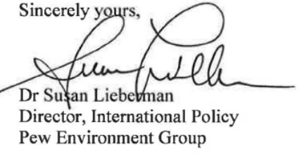

Pew Environment Group
Submission on Decision X/2

In paragraph 15 of decision X/2 (Updating and revision of the Strategic Plan), the CBD Conference of the Parties (CoP) decided to consider, at its eleventh meeting, the need for and possible development of additional mechanisms to enable Parties to meet their commitments under the Convention and the implementation ofthe Strategic Plan for Biodiversity 2011-2020.

The high seas and seabed Area beyond national jurisdiction contain perhaps the largest reservoir of biodiversity left on Earth. Overfishing, climate change, ocean acidification, pollution, invasive species and other stressors and threats continue to adversely impact the ocean and its biodiversity. Aichi Target 11, adopted by CBD CoP10 in 2010, states that by 2020, at least 17 per cent ofterrestrial and inland water areas, and 10 per cent of coastal and marine areas, especially areas of particular importance for biodiversity and ecosystem services, are conserved through effectively and equitably managed, ecologically representative and well connected systems of protected areas and other effective area-based conservation measures, and integrated into the wider landscapes and seascapes. However, currently only slightly more than 1% of the ocean is protected, not all of that is fully protected as no-take areas, and only a tiny fraction of that is on the high seas.

In 2002, world leaders in Johannesburg called for the establishment of a representative network of marine protected areas (MPAs) by 2012. It is now 2012, and there is still no international governance mechanism to establish and manage MP As, including reserves, on the high seas. The UN Ad Hoc Open-ended Informal Working Group to study issues relating to the Conservation and Sustainable Use of Marine Biological Diversity beyond Areas of National Jurisdiction ("BBNJ") has been meeting since 2006 on approaches to promote international cooperation and coordination for the conservation and sustainable use of marine biological diversity in areas beyond national jurisdiction. However, progress made by BBNJ has been slow and limited, and at its latest meeting at the UN in New York on 7-11 May 2012, BBNJ only recommended that two informal intersessional workshops occur in 2013; the only tangible outcome was the definition of the terms of reference for these workshops which will feed into discussions at the 2013 BBNJ.

This is despite the agreement at BBNJ 20 II, and its adoption by the UN General Assembly in December 2012, of a recommendation that a process be initiated with a view to ensuring that the legal framework for the conservation and sustainable use of marine biodiversity in areas beyond national jurisdiction effectively addresses those issues by identifying gaps and ways forward, including through the implementation of existing instruments and the possible development of a multilateral agreement under the United Nations Convention on the Law of the Sea (UNCLOS).

There can therefore be little confidence that BBNJ will in the near future be in a position to take the necessary steps towards establishing a global process for designation of MPAs, including reserves, in areas beyond national jurisdiction.

The Pew Environment Group therefore submits that CBD CoP-11 should decide to seek a solution to the above-mentioned concerns through calling for an intergovernmental conference to develop an international agreement to be held in New York in 2013 with the view of ensuring an effective legal framework for the conservation and sustainable use of marine biodiversity in areas beyond national jurisdiction, and in particular, together and as a whole: area-based management tools, including marine protected areas and no take reserves; marine genetic resources, including questions on the sharing of benefits; environmental impact assessments; and capacity-building and the transfer of marine technology. The results of such a conference should seek to fully reflect the three aims of the CBD with respect to marine areas beyond national jurisdiction. The work and the results of the conference should be fully consistent with the provisions of the UNCLOS and the CBD, should ensure the participation of all States, including non-Parties to both Conventions, and should urge States to complete negotiations by December 2015.

http://www.developpement-durable.gouv.fr/Presentation-generale-de-la.html
ZNIEFF : zones naturelles d’intérêt écologique, faunistique et floristique
Article L. 411-5 du code de l’environnement
Le site Internet, http://inventaire.naturefrance.fr, fournit désormais une vision globale des données existantes dans le domaine de la nature, de leurs modalités de production et de stockage et de leur accessibilité.
1 http://jncc.defra.gov.uk/page-42292 2 http://jncc.defra.gov.uk/page-5781

