 |  | CBD
 |  |  |  | Distr.  GENERAL  UNEP/CBD/COP/11/INF/53  2 October 2012  ENGLISH/SPANISH ONLY
CONFERENCE OF THE PARTIES TO THE CONVENTION ON BIOLOGICAL DIVERSITY
Eleventh meeting
Hyderabad, India, 8-19 October 2012

Item 4.1 of the provisional agenda*

WORKSHOP ON FINANCIAL MECHANISMS SUPPORTING CONSERVATION AND THE INTEGRAL AND SUSTAINABLE MANAGEMENT OF BIODIVERSITY IN BOLIVIA AND SOUTH AMERICA
La Paz, 22-23 August 2012

Note by the Executive Secretary
1. The Executive Secretary is circulating herewith, for the information of participants in the eleventh meeting of the Conference of the Parties to the Convention on Biological Diversity, the report on the Workshop on Financial Mechanisms supporting Conservation and the Integral and Sustainable Management of biodiversity in Bolivia and South America held in La Paz on 22-23 August, 2012. In recommendation 4/2, the Ad Hoc Open-ended Working Group on Review of Implementation of the Convention, at its fourth meeting, had requested the organization of regional and expert workshops, as appropriate, and to assist Parties in exploring relevant financing mechanisms, including guiding principles and safeguards, and in gathering information and sharing national experiences on using the flexible reporting framework. This workshop was hosted by the Government of Plurinational State of Bolivia in support of the discussions under the Convention on Biological Diversity on the Strategy for Resource Mobilization.
2. The document is being circulated in the form and languages in which it was received by the Convention Secretariat.

Annex
Workshop on Financial Mechanisms supporting Conservation and the Integral and Sustainable Management of Biodiversity in Bolivia and South America:
La Paz on 22-23 August, 2012
Taller sobre Mecanismos Financieros de apoyo a la Conservación y Manejo Integral y Sustentable de la Biodiversidad en Bolivia y América del Sur
La Paz / 22 y 23 de agosto de 2012
/documento-síntesis/

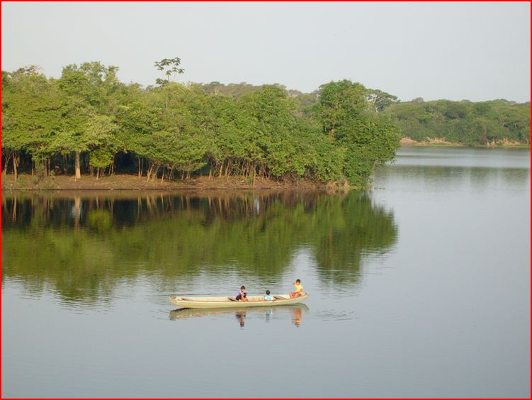
Fotografía: Fernando Endara, Parque Nacional Noel Kempff Mercado (Bolivia), FUNDESNAP-ABOLAC.
Executive Summary
The Workshop on Financial Mechanisms supporting Conservation and the Integral and Sustainable Management of Biodiversity in Bolivia and South America —conducted in La Paz on 22-23 August, 2012— had the purpose of introducing and analyzing the existing financial mechanisms as well as others being developed, as tools for the conservation of biodiversity in South America on the basis of the experiences on their application in different countries.
This workshop was preceded by the International Seminar on Finances for Biodiversity, held in Quito, from March 6 to March 9, 2012, during which the importance of a greater knowledge and debate regarding the application of the aforementioned tools —in order to increase and share knowledge, exchange views and initiatives, and promote a synergy amongst the different stakeholders involved with biodiversity in South America— became apparent.
The Ministry of Foreign Affairs of the Plurinational State of Bolivia took upon itself the tasks of planning, organizing and conducting the meeting along with the Bolivian Ministry of Environment and Water, the Secretariat of the Convention on Biological Diversity (CBD), the Regional Office of the International Union for Conservation of Nature in South America (IUCN-Sur) and the Foundation for the Development of a National System of Protected Areas (FUNDESNAP) of Bolivia.
The workshop included 51 participants from both public and private institutions: governments, development agencies, NGOs and foundations local communities, social organizations, researchers and technicians, all of whom have experience and an interest on the management and protection of biodiversity. Methodologically speaking, the workshop combined presentations and discussion panels with group work, a plenary session and a permanent exchange through comments, questions, replies, and additional information. It is important to highlight the participation of Braulio Ferreira de Souza Dias, Executive Secretary of the Convention on Biological Diversity (CBD) throughout the event. According to the Bolivian Office of Foreign Affairs, it was the first time Bolivia had a high-ranking United Nations Officer of this level guide such a debate and exchange of experiences in the country.
During the inauguration of the event, Beatriz Zapata Ferrufino, Vice-minister of Environment, Biodiversity, Climate Change and Forest Management and Development of Bolivia ratified the goal of sharing and exchanging experiences regarding financial mechanisms. Arturo Mora, Program Officer of the IUCN South America Regional Office, highlighted the importance of having participants from seven South American countries in attendance. To conclude the inauguration, Braulio Ferreira, Executive Secretary of the CBD, mentioned the difficulties that environmental finances entail and expressed his total willingness to highlight the proposals from the countries in the region.

First Day: negotiations prior to the COP 11, on financial mechanisms and case studies in Bolivia
Throughout the first day, contents were developed surrounding: the status of negotiations prior to the COP 11, the theory of the ecosystem value of biodiversity and of Payments for Environmental Services (PES). The first day session concluded with the presentation of three Bolivian experiences pertaining to the conservation and adequate use of vicuñas and lizards, and an entrepreneurial initiative of community tourism in a National Park, all of which followed the logic of an integral and ecosystem management.
Regarding the development of such contents, the Executive Secretary of the CBD described the precedents and prior perspectives in connection with the COP 11, to be held in Hyderabad, India, from October 8 to October 19, 2012, and mentioned the most relevant juridical instruments in terms of goals, strategies, and resources. The Secretary reviewed the most significant contents of the Strategic Plan for Biological Diversity 2011-2020, the Protocol of Nagoya and the Protocol of Cartagena on Security and Biotechnology. He also detailed the principal thematic axis of the COP 11 agenda, emphasizing the need to have updated information regarding the expenses and budgetary requirements for the preservation of biodiversity on each country.
Next, Arturo Mora, Program Officer of the IUCN South America Regional Office, spoke about the concept of the economic value of biodiversity in connection to the Second Aichi Goal which states that the value of nature must be integrated to processes of planning for development and reduction of poverty until 2020. Mora discussed the differences between economic and commercial value. He underscored the types of environmental services available, and mentioned the diverse tools of economic valuation as well as their applications, and addressed the use of financial mechanisms.
Following a similar intent of dissemination of relevant information, Doris Cordero, Program Officer of IUCN South America Regional Office, presented a conceptualization of environmental services while enumerating the most prominent. She offered an explanation of the features of an environmental service for the conservation of biodiversity, particularly of the modality of Payments for Environmental Services (PES) and she concluded by outlining a brief panorama of environmental services in Latin America, among which the experiences in the voluntary carbon market and water basin conservation schemes stood out.
During the second part of the session, three Bolivian experiences on Integral Management of Biodiversity —led by the Vice-Minister of Environment, Biodiversity, Climate Change and Forest Management and Development— were presented. Firstly, Jorge Laura Camacho, responsible for the National Vicuña Program, spoke about the historical precedents on the management and efficient use of vicuñas, marked by their threat of extinction in 1960. He addressed the goals, contents, juridical guidelines and characteristics of the program, while sharing its principal results which have mainly consisted of an increase in the vicuña population and on greater income for the commercialization of its fiber, thanks to the joint work of the State and the communities.
Secondly, Fernando Cisneros, responsible for the National Program for the Conservation and Efficient Use of Lizards, explained the modality promoted by the Plurinational State of Bolivia for the management of this variety of alligator on the basis of an alliance with the indigenous communities of the northern Amazon. It is an efficient use based on the participation and social control which —through the establishment of quotas— has allowed for the use of up to 6,139 specimens generating net profits of approximately 57 thousand dollars that were distributed in different proportions, among hunters, communities, indigenous organizations and as provisions for reinvestment. Using different techniques of planning and zoning, this system allows for the preservation of the species and its ecosystem.
Finally, Daniel Maidana, technician of the Management of Nature Preserves and Buffer Zones Project (MAPZA) presented the planning, development and results of a community tourism initiative in Sajama National Park. Based on the characteristics of an ecotourism venture in a Protected Area, Maidana explained the contents of a community business design whose purpose is to generate profits and jobs for the community without distorting their identity, life and culture. In this sense, the bottom line stands out not only the sustainability of the project but also generating greater awareness and commitment to the preservation of nature.
The first day concluded with an insight shared by the Executive Secretary of the CBD, Braulio Ferreira, who stressed the importance and relevance of the experiences offered by Bolivia and explained the procedures of the Convention.
"The issues that you are working on with communities are very interesting ways to promote both conservation and the sustainable use of biodiversity. It is an issue which, perhaps, has not received the attention it deserves from the Convention and I think this can be corrected. You can do much more in terms of mobilizing international support to bolster these initiatives. In order to do that, we need the parties to identify this as a priority" he pointed out.

Second day: South American experiences, workshops, plenary and closing
On the second day, an overview of the various funding initiatives for the preservation of biodiversity in seven countries in the region —Bolivia, Argentina, Brazil, Ecuador, Chile, Colombia and Paraguay— was outlined. Bolivia started the round with a presentation on the Mitigation and Adaptation Mechanism for an Integral and Sustainable Management of Forest and Mother Earth, by Diego Pacheco, Advisor of the Bolivian Foreign Affairs Office. Pacheco summarized this proposal put forward as an alternative that is based on the non-commodification of environmental functions, and on an integral and sustainable management of such functions with an emphasis on local and traditional production practices, and the promotion of the multiple functions of forests.
Secondly, Ana di Pangracio, the Environment and Natural Resources Foundation (FARN) of Argentina, gave a brief overview of the different economic tools applied in that country for the conservation of biodiversity, as part of the National Biodiversity Strategy adopted in 2003. Pangracio went through seven different instruments (funds for forest conservation, tax exemptions, compensation for use restrictions on the use and the REDD strategy, among others) and she also mentioned some particular cases while labeling such tools as a "low priority" for her country, judging by the advances on public policy in this regard.
Moreover, Sergio Collaço Henrique de Carvalho, from the Ministry of Environment of Brazil, presented ​​four environmental financial mechanisms currently being applied in that country, among which the most remarkable were the TEEB Brazil and compensation for significant environmental impacts. He also elaborated on the status of the dialogue between the European Union and Brazil on the use of environmental services as an instrument for public policy.
The fourth presentation was made by Diego Mogollon, from the National Secretariat for Planning and Development (SENPLADES) of Ecuador, who explained the changes in the nature conservation policies based on the paradigm of "Good Living" that guided the new Constitution (2008) and Ecuador’s National Development Plan (NDP) 2009-2013. Given the proposal of a public environmental policy based on the combination of integrated approaches, the presentation focused on the content and implementation of the Socio Bosque Program and concluded by mentioning some other lines of action for environmental conservation.
Then, Pamela Fernandez, from the Ministry of Environment of Chile, described the situation of the National Biodiversity Strategy (ENDB) by explaining the workings of the National System of Protected Areas (SNAP) of Chile, addressing the type of system, its strengths and weaknesses, the public budget allocated to it, its current funding and the financing strategies for these areas and for biodiversity as a whole.
The next to last experience was presented by María Isabel Vieira-Muñoz, from the Alexander von Humboldt Research Institute of Biological Resources of Colombia, who talked about the National Policy for the Integral Management of Biodiversity and Ecosystem Services (PNGIBSE), particularly focusing on the axis relative to biodiversity, economic development, competitiveness and quality of life. The presentation emphasized the concept of “integral value” of biodiversity and concluded by presenting two specific case studies.
To close the round of experiences in the region, Patricia Abed, from the Institute for Environmental Law and Economics (IDEA) of Paraguay, explained the content of the Law for the Compensation of Environmental Services, passed in 2006, which provides for the granting of certificates of environmental service whose performance as “securities” (or Títulos-Valor in Spanish) means they can be traded freely within the framework of Paraguayan laws. All presentations were followed by comments, questions and clarifications.
After the presentations, three roundtables of participation and discussion were organized to address the following themes: financial mechanisms prioritized as a region for COP11 (Table 1), current financial mechanisms and challenges for their implementation (Table 2), and regional support instances for financial mechanisms (Table 3). The questions served as motivation to encourage a pluralistic participation and reciprocal exchange of information and views. To ensure this, we tried tables to be composed of participants from as many different countries as possible. Afterwards, the groups presented their views, proposals and suggestions in a plenary session with the understanding that these would not necessarily have to represent the official position of their countries or be considered final conclusions.
The first group, whose axis of debate was prioritized financial mechanisms for COP 11, presented a list of 20 general guidelines that went beyond the initial question by outlining a regional overview. Some of the suggestions were:
- Promoting financing and local community management of biodiversity, with a more holistic and ecosystemic approach.
- Promoting an integral view of biodiversity and its management, since it is considered that this natural resource must be protected by the States, thus preventing its privatization.
- Considering the integrity (social and environmental) of biological resources.
- Analyzing how to bridge the deficit (financial "gap") to conserve Protected Areas.
- Regulating the private sector's contribution to conservation.
- Sharing experiences regionally in relation to biodiversity strategies that are being updated in most countries.
- Simplifying financing systems and tools since they are excessively bureaucratic, slow and difficult to apply.
- Coordinating training activities through joint work between the CBD and the Intergovernmental Science-Policy Platform on Biodiversity and Ecosystem Services (IPBES).
- Involving productive activities of "informal" sectors of the economy (such as small-scale mining) in conservation.
- Regulating the private sector’s contribution to the conservation overcoming the notion of "voluntarism".
The second panel pointed out, the most appropriate financial mechanisms for each country in the South American context and referring, when appropriate, to: the compensation for mitigation in infrastructure, tax exemptions for conservation, funding linked to government budget, funds for supporting the management of Protected Areas, the application of PES type and REDD schemes, and other kinds of initiatives.
With regards to the limitations for the implementation of these tools, they identified the absence of legal frameworks, the reluctance of industry to contribute, the lacking institutional coordination, the fragmentation of information, the lack of transparency, the dependence on cooperation resources and the inadequate technical capabilities. Regarding the recommendations and lessons learned identified the strengthening of the command and control actions, the articulation of the various levels of government, the "South-South" exchange and attention to local diversity of each country and region.
Regarding the opportunities for the application of financial mechanisms at a South American level, the third group emphasized the importance of creating a Regional Fund with enough autonomy and capacity to respond, manage and finance regional demands according to their own agenda and without depending on third parties. The group also noted the need to put an end to so-called "perverse incentives" and promote financing alternatives in the region. In this scenario, the strengthening of capacities in all fields was proposed, as well as the design and development of a strategy for implementing programs and financial mechanisms. The three presentations conducted during the plenary session were accompanied by a dynamic debate, questions and comments from other participants which are summarized in the body of this document.
Finally, the workshop ended with the closing remarks of Arturo Mora, Braulio Ferreira and Alexandra Moreira, the Mother Earth and Water Unit (UMTA) of the Ministry of Foreign Affairs of Bolivia. Mora underlined the atmosphere of productive exchange of information about initiatives that could be replicated in other countries and the challenge and opportunity that this kind of dialogue represents for IUCN-Sur. Ferreira, expressed interest in following up on the ideas presented to promote greater regional exchange. He also referred to several key issues to be discussed during the upcoming COP 11 and invited countries to work together and include the issues and demands they consider to be priorities for the work of the CBD.
Finally, Alexandra Moreira closed the event by expressing the satisfaction of the country hosting the workshop for the learning opportunity it provided, for the amount and diversity of information shared and for the willingness of the organizers to further deepen the dissemination of knowledge, tools and inputs geared towards the conservation of biodiversity.

Note: To view the presentations and reference documents of the workshop, visit:
http://www.fundesnap.org/fundesnap/descargas/159

Instituciones organizadoras:
Los Ministerios de Relaciones Exteriores, y de Medio Ambiente y Agua del Estado Plurinacional de Bolivia, la Secretaría del Convenio sobre la Diversidad Biológica (CDB), la Oficina Regional de la Unión Internacional para la Conservación de la Naturaleza en América del Sur (UICN-Sur) y la Fundación para el Desarrollo del Sistema Nacional de Áreas Protegidas (FUNDESNAP) de Bolivia se encargaron de la convocatoria, planificación y desarrollo del taller.

Con el apoyo de:
El Programa de Resiliencia y Desarrollo (SwedBio) del Centro de Resiliencia de la Universidad de Estocolmo proporcionó su respaldo económico para la realización de este taller.

Apoyo institucional:
Agencia Sueca para el Desarrollo Internacional (SIDA).

Edición: Víctor Orduna
Diseño: Dalia Nogales
Fotografías: FUNDESNAP

Las opiniones expresadas en este documento no corresponden, necesariamente, con las de las instituciones que organizaron, financiaron y apoyaron la realización del taller.
Para consultar las presentaciones y documentos de referencia del taller, visite:
http://www.fundesnap.org/fundesnap/descargas/159

Contenidos

Presentación
Resumen Ejecutivo
Executive Summary
Acerca del taller
Primera jornada
Negociaciones previas a la COP 11, mecanismos financieros ecosistémicos y estudios de caso en Bolivia
1. Palabras de bienvenida
2. Estado actual de las negociaciones para la Conferencia de las Partes (COP 11) Braulio Ferreira de Souza Dias, Secretario Ejecutivo del CDB
3. Valor económico de la biodiversidad y servicios ecosistémicos asociados
Arturo Mora, Oficial de Programa de UICN-Oficina Regional América del Sur
4. Pagos por Servicios Ambientales (PSA): Una herramienta para el manejo y la conservación de los ecosistemas
Doris Cordero, Oficial de Programa UICN-Oficina Regional América del Sur
5. Herramientas para la gestión integral de la biodiversidad en Bolivia (estudios de caso)
5.1. Programa Nacional para la Conservación y Aprovechamiento de la Vicuña
Jorge Laura Camacho, responsable del Programa Nacional de Vicuña
5.2. Programa Nacional de Conservación y Aprovechamiento sostenible del lagarto (Caiman yacare)
Fernando Cisneros, responsable del Programa Nacional de Lagarto
5.3. Experiencia de turismo comunitario en el Parque Nacional Sajama
Daniel Maidana, técnico del proyecto MAPZA
6. Algunas valoraciones de la primera jornada
Segunda jornada
Experiencias sudamericanas, mesas de trabajo, plenaria y clausura
1. Panorama de las experiencias sudamericanas
1.1. Bolivia: Mecanismo de Mitigación y Adaptación para el Manejo Integral y Sustentable de los Bosque y la Madre Tierra
1.2. Argentina: Instrumentos económicos para la conservación de la biodiversidad
1.3. Brasil: Mecanismos financieros, acciones en curso en el Ministerio de Medio Ambiente
1.4. Ecuador: Cambio de paradigma, el “Buen Vivir”
1.5. Chile: Situación y perspectivas de gestión de las Áreas Protegidas
1.6. Colombia: Generalidades sobre las herramientas financieras y no financieras para la gestión ambiental
1.7. Paraguay: Avance en la implementación de mecanismos financieros para la conservación
2. Mesas de trabajo
2.1. Mesa 1: Mecanismos financieros priorizados como región para la COP 11
2.2. Mesa 2: Mecanismos financieros actuales y desafíos de su implementación
2.3. Mesa 3: Instancias regionales de apoyo a mecanismos financieros
3. Plenaria
4. Palabras de clausura

Referencias bibliográficas
Anexos
I. Programa del taller
II. Lista de participantes

Índice gráfico

Cuadro 1 ¿Qué es el Convenio sobre Diversidad Biológica?
Cuadro 2 Ejemplos de las Metas de Aichi para la Diversidad Biológica
Cuadro 3 Valor Económico Total (VET) de la biodiversidad

Gráfico 1 Resumen de indicadores de diversidad biológica
Gráfico 2 Aplicación del enfoque TEEB
Gráfico 3 Mercado de carbono: localización de compradores y oferta contratada en 2010
Gráfico 4 Evolución de los ingresos percibidos por las comunidades manejadoras de vicuña (1998-2010)
Gráfico 5 Estructura organizativa del Mecanismo de Mitigación y Adaptación propuesto por Bolivia
Gráfico 6 Estructura de incentivos del Programa Socio Bosque
Gráfico 7 Gasto Público en Áreas Protegidas
Gráfico 8 Ejes temáticos de la Política Nacional para la Gestión Integral de la Biodiversidad y sus Servicios Ecosistémicos (PNGIBSE) de Colombia
Gráfico 9 Oportunidades para la aplicación de mecanismos financieros en Sudamérica
Gráfico 10 Mecanismos financieros prioritarios a nivel regional
Gráfico 11 Tipo de recursos necesarios para la aplicación de mecanismos financieros
Gráfico 12 Cómo incidir en las instancias regionales para implementar mecanismos financieros

Mapa 1 Parque Nacional Sajama (Oruro, Bolivia)

Siglas y acrónimos

AP Área Protegida
ASDI Agencia Sueca de Cooperación Internacional para el Desarrollo
BBOP Programa de Negocios y Compensaciones para la Biodiversidad
BMF Mecanismos de Financiamiento de la Biodiversidad
CAN Comunidad Andina de Naciones
CDB Convenio sobre la Diversidad Biológica
CIRABO Central Indígena de la Región Amazónica de Bolivia
CMNUCC Convención Marco de Naciones Unidas sobre el Cambio Climático
CNMCBS Confederación Nacional de Mujeres Campesinas Bartolina Sisa (Bolivia)
CONAF Corporación Nacional Forestal de Chile
COP Conferencia de las Partes de la CMNUCC
COP/MOP Conferencia de las Partes en Calidad de Reunión de las Partes del Protocolo de Kyoto.
CPEMB Central de Pueblos Étnicos Mojeños del Beni (Bolivia)
ENBPA Estrategias Nacionales de Biodiversidad y Planes de Acción
ENE Emisiones Netas Evitadas
FMAM Fondo Mundial para el Medio Ambiente
FONAG Fondo para la Protección del Agua (Quito, Ecuador)
FUNBIO Fondo Brasileño para la Biodiversidad
FUNDESNAP Fundación para el Desarrollo del Sistema Nacional de Áreas Protegidas (Bolivia).
GEF Fondo Mundial para el Medio Ambiente
GFC Coalición Global para los Bosques
GTZ-GIZ Cooperación Técnica Alemana
IPBES Panel Intergubernamental Científico sobre Diversidad y Ecosistemas
ITF Impuestos a las Transacciones Financieras
MAPZA Proyecto Manejo de Áreas Protegidas y Áreas de Amortiguación (Bolivia)
MERCOSUR Mercado Común del Sur
MFI Mecanismos Financieros Innovadores
MMAyA Ministerio de Medio Ambiente y Agua de Bolivia
MRE Ministerio de Relaciones Exteriores de Bolivia
NORAD Agencia Noruega de Cooperación para el Desarrollo
OCDE Organización para la Cooperación y el Desarrollo Económico
ODM Objetivos de Desarrollo del Milenio
OTCA Organización del Tratado de Cooperación Amazónica
OVM Organismos Vivos Modificados
PNGIBSE Política Nacional para la Gestión Integral de la Biodiversidad y sus Servicios Ecosistémicos de Colombia.
PNUMA Programa de Naciones Unidas para el Medio Ambiente
PPSA Programa de Pagos por Servicios Ambientales
PSA Pago por Servicios Ambientales
REDD y REDD+ Reducción de Emisiones por Deforestación y Degradación de Bosques
RedLAC Red de Fondos Ambientales de Latinoamérica y el Caribe
SCE Sistema de Comercio de Emisiones
SERNAP Servicio Nacional de Áreas Protegidas de Bolivia
SNAP Sistema Nacional de Áreas Protegidas de Chile
SwedBio Programa de Resiliencia y Desarrollo del Centro de Resilencia de Estocolmo.
TDR Transferencias de Derechos de Desarrollo
TEEB Informe sobre la Economía de los Ecosistemas y la Biodiversidad
UE Unión Europea
UICN Unión Internacional para la Conservación de la Naturaleza
WAVES Alianza Mundial de la Contabilidad de la Riqueza y Valoración de los Servicios de los Ecosistemas.
WWF Fondo Mundial para la Naturaleza

Presentación
El Ministerio de Relaciones Exteriores del Estado Plurinacional de Bolivia, en cumplimiento de su mandato respecto a la promoción de la defensa de la Madre Tierra, y en el marco de un nuevo paradigma de vida bajo la filosofía del Vivir Bien, tuvo la iniciativa de generar un espacio de intercambio de experiencias y reflexiones a nivel regional sobre la conservación de la biodiversidad.
En este contexto, la Cancillería y el Ministerio de Medio Ambiente y Agua de Bolivia, junto con la Secretaría del Convenio sobre la Diversidad Biológica (CDB) y con el apoyo de UICN-Sur, FUNDESNAP y SwedBio, organizaron el Taller sobre Mecanismos Financieros de apoyo a la Conservación y Manejo Integral y Sustentable de la Biodiversidad en Bolivia y América del Sur.
El objetivo del encuentro fue contribuir al desarrollo de capacidades técnicas en la región respecto a la aplicación y búsqueda de diversas herramientas financieras para la conservación de la biodiversidad en América del Sur, en el franco entendimiento de las distintas visiones y realidades de los países, y el respeto y consideración que los diferentes enfoques merecen en el momento de adoptar Decisiones en el seno del Convenio sobre la Diversidad Biológica.
Así, también se pudo contribuir a la preparación de los delegados de los países para la onceava Conferencia de la Partes del CBD (COP 11), que se desarrollará próximamente en la India, toda vez que la predisposición del Secretario del Convenio fue altamente acertada en comunicar los retos que a los países de la región nos esperan en este Foro Internacional.
El evento fue altamente valorado, sobre todo por Bolivia, toda vez que, bajo su concepción, las prácticas de conservación dependen directamente de los sistemas de valores, es decir, de la manera cómo se concibe y representa la naturaleza. A su vez, en esta relación influyen múltiples factores físicos, socio-históricos, político-económicos o espirituales. Si la representación de la naturaleza varía, la manera de interactuar con ella también puede cambiar. Se necesita ver al planeta como la casa en la que debemos vivir “juntos” y no “a costa” de ella. Somos inherentes a la Madre Tierra en la que no sólo estamos, sino de la cual formamos parte.

Resumen Ejecutivo
El Taller sobre Mecanismos Financieros de apoyo a la Conservación y Manejo Integral y Sustentable de la Biodiversidad en Bolivia y América del Sur —realizado en La Paz, el 22 y 23 de agosto de 2012— tuvo el propósito de presentar y analizar los mecanismos financieros existentes y otros en proceso de construcción, como herramientas para la conservación de la biodiversidad en América del Sur, a partir de experiencias aplicadas en los distintos países.
En encuentro tuvo como antecedente el Diálogo internacional de Finanzas para la Biodiversidad, realizado en Quito, entre el 6 y el 9 de marzo de 2012, en el que se apreció la importancia de generar mayor información y debate en torno a la aplicación de las mencionadas herramientas para mejorar y compartir el conocimiento, intercambiar visiones e iniciativas y promover la sinergia en Sudamérica entre los diferentes interesados en la biodiversidad.
El Ministerio de Relaciones Exteriores del Estado Plurinacional de Bolivia asumió, de manera fundamental, las tareas de planificación, organización y desarrollo de la reunión junto con el Ministerio de Medio Ambiente y Agua de Bolivia, la Secretaría del Convenio sobre la Diversidad Biológica (CDB), la Oficina Regional de la Unión Internacional para la Conservación de la Naturaleza en América del Sur (UICN-Sur) y la Fundación para el Desarrollo del Sistema Nacional de Áreas Protegidas (FUNDESNAP) de Bolivia.
El taller reunió a 51 participantes de instituciones públicas y privadas; gobiernos, agencias de desarrollo, ONG y fundaciones, comunidades locales, organizaciones sociales e investigadores y técnicos, todos ellos con interés y experiencia en la gestión y protección de la biodiversidad. Metodológicamente, en el taller se combinó la modalidad de presentaciones y paneles, con el trabajo en grupos, una sesión plenaria y el intercambio permanente a través de comentarios, preguntas, réplicas y complementaciones. Cabe destacar la participación de Braulio Ferreira de Souza Dias, Secretario Ejecutivo del Convenio sobre la Diversidad Biológica (CDB), a lo largo de todo evento. De acuerdo a la Cancillería boliviana, se trata de la primera vez que Bolivia cuenta con la participación de un alto funcionario de Naciones Unidas de este nivel para guiar un intercambio de experiencias y un debate de esta naturaleza en el país.
Durante el acto de bienvenida, Beatriz Zapata Ferrufino, Viceministra de Medio Ambiente, Biodiversidad, Cambios Climáticos y de Gestión y Desarrollo Forestal de Bolivia ratificó el objetivo de compartir e intercambiar experiencias sobre mecanismos financieros. Por su parte, Arturo Mora, Oficial de Programa de UICN-Oficina Regional para América del Sur, destacó la importancia de contar con participantes de siete países sudamericanos. Para concluir la introducción, Braulio Ferreira, Secretario Ejecutivo del CDB, mencionó las dificultades que conlleva la cuestión financiera ambiental y manifestó su plena predisposición para impulsar las propuestas de los países de la región.

Primera jornada: negociaciones previas a la COP 11, mecanismos financieros ecosistémicos y estudios de caso en Bolivia
A lo largo de la primera jornada se desarrollaron contenidos en torno a la situación de las negociaciones previas a la realización de la COP 11, a la teoría del valor ecosistémico de la biodiversidad y al Pago por Servicios Ambientales (PSA). La jornada concluyó con la presentación de tres experiencias bolivianas referidas a la conservación y al aprovechamiento de la vicuña y el lagarto, y a un emprendimiento de turismo comunitario en un Parque Nacional.
En relación al desarrollo de los contenidos, el Secretario Ejecutivo del CDB describió los antecedentes y las perspectivas previas a la celebración de la COP 11, a realizarse en Hyderabad, India, del 8 al 19 de octubre de 2012, mencionando los instrumentos jurídicos más relevantes en cuanto a las metas, las estrategias y los recursos. El Secretario revisó los contenidos más significativos del Plan Estratégico para la Diversidad Biológica 2011-2020, del Protocolo del Nagoya y del Protocolo de Cartagena sobre Seguridad y Biotecnología. También detalló los ejes principales de la agenda de la COP 11, subrayando la necesidad de disponer de información actualizada sobre los gastos y requerimientos presupuestarios para la preservación de la biodiversidad en cada país.
A continuación, Arturo Mora, Oficial de Programa de UICN-Oficina Regional para América del Sur, expuso el concepto de valor económico de la biodiversidad en función de la Meta 2 de Aichi que establece que (hasta 2020) los valores de la naturaleza deben ser integrados en los procesos de planificación del desarrollo y de reducción de la pobreza. Mora expuso las diferencias entre valor económico y valor comercial, detalló los tipos de servicios ambientales existentes, mencionó las distintas herramientas de valoración económica y sus aplicaciones, y abordó el uso de los mecanismos financieros.
En esta misma línea de difusión de información relevante, Doris Cordero, Oficial de Programa de UICN-Oficina Regional América del Sur, presentó una conceptualización sobre los servicios ambientales, enumerando los más destacados. Realizó una explicación de las características del servicio ambiental de conservación de la biodiversidad y, concretamente, de la modalidad de Pagos por Servicios Ambientales (PSA) y finalizó trazando un breve panorama de los servicios ambientales en América Latina, entre los que destacan las experiencias en el mercado voluntario de carbono y los esquemas de conservación de cuencas hidrográficas.
Durante la segunda parte de la jornada, se expusieron tres experiencias bolivianas de gestión integral de la biodiversidad gestionadas por el Viceministerio de Medio Ambiente, Biodiversidad, Cambios Climáticos, de Gestión y Desarrollo Forestal. En primer lugar, Jorge Laura Camacho, responsable del Programa Nacional de Vicuña, expuso los antecedentes históricos del manejo y el aprovechamiento de la vicuña, marcados por la amenaza de extinción en 1960. Abordó los objetivos, contenidos, disposiciones jurídicas y características del programa, señalando los principales resultados que han consistido en un crecimiento de la población de vicuñas y en mayores ingresos por la comercialización de su fibra, gracias al trabajo conjunto entre el Estado y las comunidades.
En segundo lugar, Fernando Cisneros, responsable del Programa Nacional de Conservación y Aprovechamiento Sostenible del Lagarto, explicó la modalidad impulsada por el Estado Plurinacional boliviano para la gestión de este tipo de caimán a partir de una alianza con las comunidades indígenas del norte amazónico. Se trata de un aprovechamiento basado en la participación y el control social que ha permitido, a través del establecimiento de cuotas, la explotación, en 2011, de hasta 6.139 ejemplares generando beneficios netos de aproximadamente 57 mil dólares americanos que se repartieron, en distintas proporciones, entre los cazadores, las comunidades, las organizaciones indígenas y como previsiones de reinversión. Utilizando distintas técnicas de planificación y zonificación, este sistema permite la preservación de la especie y de su ecosistema.
Por último, Daniel Maidana, técnico del proyecto Manejo de Áreas Protegidas y Áreas de Amortiguación (MAPZA) presentó la planificación, desarrollo y resultados de una iniciativa de turismo comunitario en el Parque Nacional Sajama. Partiendo de las particularidades de una emprendimiento ecoturístico en un Área Protegida, Maidana explicó los contenidos de un diseño empresarial comunitario cuyo propósito es generar beneficios y empleos para la comunidad sin distorsionar su identidad, su vida y su cultura. En este sentido, el balance final destaca no sólo la sostenibilidad del proyecto sino, también, la generación de una mayor conciencia y compromiso con la preservación de la naturaleza.
La primera jornada concluyó con una reflexión del Secretario Ejecutivo del CDB, Braulio Ferreira subrayando la importancia y el interés de las experiencias expuestas por Bolivia y explicando los procedimientos propios del Convenio.
“Las cuestiones que ustedes están trabajando acá con las comunidades son muy interesantes para promover tanto la conservación como el uso sostenible de la biodiversidad. Es un tema que quizá no ha recibido toda la atención que merece por parte del Convenio y creo que esto se puede corregir. Se puede hacer mucho más en términos de movilización de apoyo internacional para apoyar este tipo de iniciativas. Para eso, necesitamos que las partes indiquen esto como una prioridad”, señaló.

Segunda jornada: experiencias sudamericanas, mesas de trabajo, plenaria y clausura
Durante la segunda jornada se esbozó un panorama general de las distintas iniciativas de financiamiento de la preservación de la diversidad biológica en siete países de la región: Bolivia, Argentina, Brasil, Ecuador, Chile, Colombia y Paraguay. Bolivia inició la ronda con una exposición sobre el Mecanismo de Mitigación y Adaptación para el Manejo Integral y Sustentable de los Bosques y la Madre Tierra, a cargo de Diego Pacheco, técnico del Viceministerio de Medio Ambiente de Bolivia. Pacheco resumió esta propuesta planteada como una alternativa que se basa en la no mercantilización de las funciones ambientales, en su manejo integral y sustentable con énfasis en las prácticas productivas locales y tradicionales, y en la promoción de las múltiples funciones del bosque.
En segundo lugar, Ana di Pangracio, de la Fundación Ambiente y Recursos Naturales (FARN) de Argentina, hizo un breve repaso de las distintas herramientas económicas aplicadas en este país para la conservación de la biodiversidad, en el marco de la Estrategia Nacional de la Biodiversidad aprobada en 2003. Pangracio repasó siete instrumentos distintos (fondos para conservación de bosques, exenciones impositivas, compensaciones por restricciones al uso y estrategia REDD, entre otros) y mencionó también algunos casos particulares calificando como de “baja prioridad” para su país estos instrumentos, a juzgar por el avance de las políticas públicas al respecto.
Por otra parte, Sergio Henrique Collaço de Carvalho, del Ministerio de Medio Ambiente de Brasil, expuso cuatro mecanismos financieros ambientales que se aplican actualmente en ese país, entre los que destacan el TEEB Brasil y la compensación por impactos ambientales significativos. Explicó también el cuso del diálogo entre la Unión Europea y Brasil para el uso de servicios ambientales como instrumento de políticas públicas.
La cuarta presentación correspondió a Diego Mogollón, de la Secretaría Nacional de Planificación y Desarrollo del Ecuador (SENPLADES), quien explicó los cambios en las políticas de preservación de la naturaleza a partir del paradigma del “Buen Vivir” que orientó la nueva Constitución (2008) y el Plan Nacional de Desarrollo (PND) 2009-2013 del Ecuador. A partir de la propuesta de una política pública ambiental en base a la combinación de enfoques integrados, la presentación se centró en los contenidos y la ejecución del Programa Socio Bosque y concluyó con la mención de algunas otras líneas de acción para la conservación ambiental.
A continuación, Pamela Fernández, del Ministerio de Medio Ambiente de Chile, describió la situación de la Estrategia Nacional de Diversidad Biológica (ENDB) explicando el funcionamiento del Sistema Nacional de Áreas Protegidas (SNAP) de Chile, su tipología, sus fortalezas y debilidades, el gasto público en este rubro, el financiamiento actual y las estrategias financieras para estas áreas y para la biodiversidad, en general.
La penúltima experiencia fue expuesta por María Isabel Vieira-Muñoz, del Instituto de Investigación de Recursos Biológicos Alexander von Humboldt de Colombia, quien se refirió a la Política Nacional para la Gestión Integral de la Biodiversidad y sus Servicios Ecosistémicos (PNGIBSE), enfocándose, sobre todo, en el eje referido a la biodiversidad, el desarrollo económico, la competitividad y la calidad de vida. La presentación subrayó el concepto de “valoración integral” de la biodiversidad y finalizó presentando dos casos de estudio concretos.
Para cerrar la ronda de experiencias en la región, Patricia Abed, del Instituto de Derecho y Economía Ambiental (IDEA) de Paraguay, explicó el contenido de la Ley de Retribución de Servicios Ambientales, aprobada en 2006, que establece la otorgación de certificados de servicios ambientales cuyo funcionamiento como títulos-valor permite que éstos sean negociados libremente, en el marco de las disposiciones legales paraguayas. Todas las exposiciones estuvieron acompañadas de comentarios, preguntas y aclaraciones.
Después de las exposiciones se organizaron tres mesas de participación y debate sobre los siguientes ejes: mecanismos financieros priorizados como región para la COP 11 (Mesa 1), mecanismos financieros actuales y desafíos de su implementación (Mesa 2), e instancias regionales de apoyo a mecanismos financieros (Mesa 3). Las preguntas sirvieron como motivación para estimular la participación plural y el intercambio recíproco de información y de puntos de vista. Para ello, se procuró que las mesas estuvieran integradas por participantes del mayor número posible de países. Posteriormente, los grupos presentaron en plenaria sus planteamientos, propuestas y sugerencias sin que éstos representaran la voz oficial de los países ni, tampoco, conclusiones cerradas.
El primer grupo, cuyo eje de debate fueron los mecanismos financieros priorizados para la COP 11, presentó un listado de 20 lineamientos generales que fueron más allá de la pregunta inicial trazando una suerte de panorama general regional. Algunas de las sugerencias fueron:
- Promover el financiamiento a la gestión comunitaria y local de la biodiversidad.
- Considerar la integralidad (social y ambiental) de los recursos biológicos.
- Analizar cómo cubrir el déficit (“brecha” financiera) para conservar las Áreas Protegidas.
- Regular el aporte del sector privado a la conservación.
- Compartir regionalmente las experiencias en relación a las estrategias de biodiversidad que están siendo actualizadas en la mayoría de los países.
- Simplificar los sistemas y herramientas de financiamiento pues éstos son demasiado burocráticos, lentos y difíciles de aplicar.
- Coordinar acciones de capacitación a través de la coordinación entre el CDB y el Panel Intergubernamental Científico sobre Diversidad y Ecosistemas (IPBES).
- Involucrar en la conservación a actividades productivas de sectores “informales” de la economía (como la pequeña minería).
- Regular el aporte del sector privado a la conservación superando el “voluntarismo”.
La segunda mesa señaló, por país, los mecanismos financieros más apropiados en el contexto sudamericano aludiendo, según el caso, a la compensación por mitigación en obras de infraestructura, la exención de impuestos por conservación, el financiamiento vinculado al presupuesto público, los fondos para sostener la gestión de Áreas Protegidas, la aplicación de esquemas “tipo PSA” y REDD, y otro tipo de iniciativas.
En relación a las limitaciones para la aplicación de estas herramientas se identificó la ausencia de marcos legales, la reticencia de la industria a contribuir, la escasa articulación institucional, la fragmentación de la información, la falta de transparencia, la dependencia de recursos de la cooperación y las insuficientes capacidades técnicas. Respecto a las recomendaciones y lecciones aprendidas se señaló el fortalecimiento de las acciones de comando y control, la articulación de los distintos niveles estatales, el intercambio “Sur-Sur” y la atención a la diversidad local de cada país y región.
Respecto a las oportunidades para la aplicación de mecanismos financieros a nivel sudamericano, el tercer grupo insistió en la importancia de crear un Fondo Regional propio que disponga de la autonomía y capacidad suficientes para atender, gestionar y financiar las demandas regionales en función de una agenda propia y sin depender de terceros. El grupo también anotó la pertinencia de desarrollar servicios ambientales en la región y de acabar con los denominados “incentivos perversos”. En este escenario, se propuso el fortalecimiento de capacidades en todos los campos y el diseño y desarrollo de una estrategia de implementación de programas y mecanismos financieros. Las tres presentaciones en plenaria estuvieron enmarcadas en una dinámica de debate, preguntas y comentarios del resto de los participantes que se resumen en el cuerpo de este documento.
Finalmente, el taller concluyó con unas palabras de clausura a cargo de Arturo Mora, Braulio Ferreira y Alexandra Moreira, de la Unidad Madre Tierra y Agua (UMTA) del Ministerio de Relaciones Exteriores de Bolivia. Mora destacó el clima de intercambio fructífero que permitió conocer iniciativas que podrían ser replicadas en otros países y el desafío y oportunidad que este tipo de diálogos representan para UICN-Sur. Ferreira expresó su interés por dar seguimiento a los planteamientos realizados y por promover un mayor intercambio regional. Aludió también a varios temas centrales a tratarse en la próxima COP 11 y convocó a los países a trabajar juntos y a incluir los temas y las demandas que consideren prioritarios para el trabajo del CDB.
Por último, Alexandra Moreira, clausuró el evento señalando la satisfacción del país anfitrión del taller por el aprendizaje que éste representó, por la cantidad y diversidad de información compartida y por la disposición de los organizadores para seguir profundizando la difusión de conocimientos, herramientas e insumos orientados a la conservación de la biodiversidad.

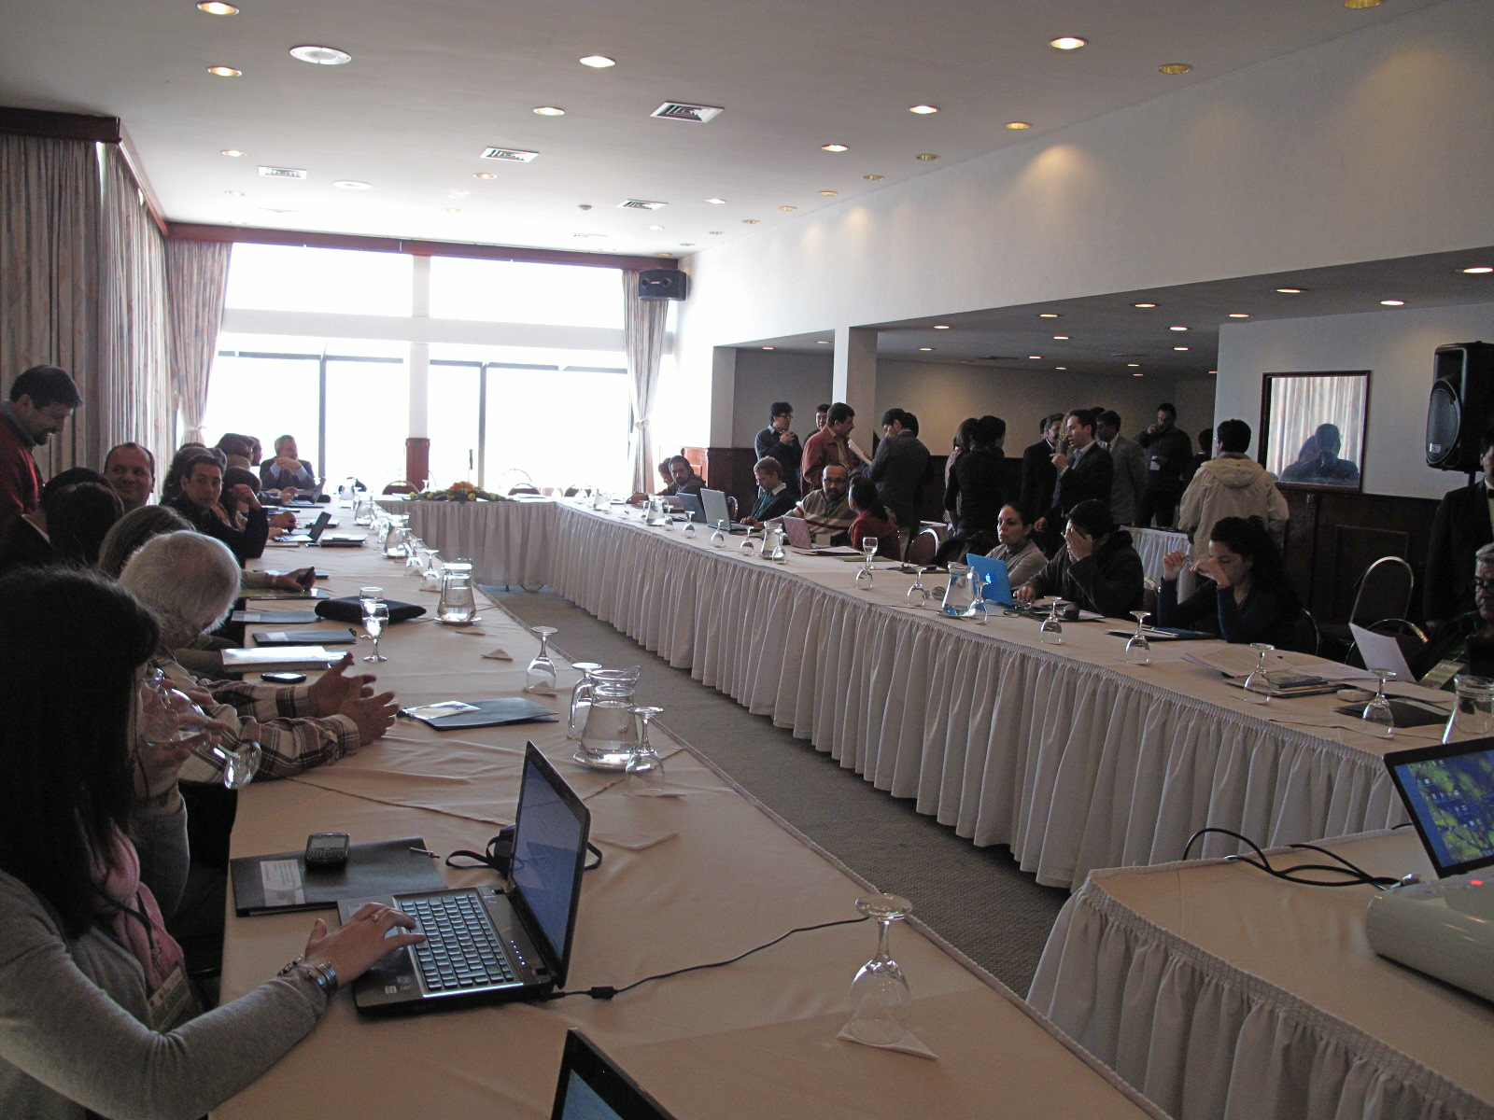
Vista general del salón del Hotel Plaza (La Paz) donde se realizó la reunión.
Fotografía: FUNDESNAP.

Executive Summary
The Workshop on Financial Mechanisms supporting Conservation and the Integral and Sustainable Management of Biodiversity in Bolivia and South America —conducted in La Paz on 22-23 August, 2012— had the purpose of introducing and analyzing the existing financial mechanisms as well as others being developed, as tools for the conservation of biodiversity in South America on the basis of the experiences on their application in different countries.
This workshop was preceded by the International Seminar on Finances for Biodiversity, held in Quito, from March 6 to March 9, 2012, during which the importance of a greater knowledge and debate regarding the application of the aforementioned tools —in order to increase and share knowledge, exchange views and initiatives, and promote a synergy amongst the different stakeholders involved with biodiversity in South America— became apparent.
The Ministry of Foreign Affairs of the Plurinational State of Bolivia took upon itself the tasks of planning, organizing and conducting the meeting along with the Bolivian Ministry of Environment and Water, the Secretariat of the Convention on Biological Diversity (CBD), the Regional Office of the International Union for Conservation of Nature in South America (IUCN-Sur) and the Foundation for the Development of a National System of Protected Areas (FUNDESNAP) of Bolivia.
The workshop included 51 participants from both public and private institutions: governments, development agencies, NGOs and foundations local communities, social organizations, researchers and technicians, all of whom have experience and an interest on the management and protection of biodiversity. Methodologically speaking, the workshop combined presentations and discussion panels with group work, a plenary session and a permanent exchange through comments, questions, replies, and additional information. It is important to highlight the participation of Braulio Ferreira de Souza Dias, Executive Secretary of the Convention on Biological Diversity (CBD) throughout the event. According to the Bolivian Office of Foreign Affairs, it was the first time Bolivia had a high-ranking United Nations Officer of this level guide such a debate and exchange of experiences in the country.
During the inauguration of the event, Beatriz Zapata Ferrufino, Vice-minister of Environment, Biodiversity, Climate Change and Forest Management and Development of Bolivia ratified the goal of sharing and exchanging experiences regarding financial mechanisms. Arturo Mora, Program Officer of the IUCN South America Regional Office, highlighted the importance of having participants from seven South American countries in attendance. To conclude the inauguration, Braulio Ferreira, Executive Secretary of the CBD, mentioned the difficulties that environmental finances entail and expressed his total willingness to highlight the proposals from the countries in the region.

First Day: negotiations prior to the COP 11, on financial mechanisms and case studies in Bolivia
Throughout the first day, contents were developed surrounding: the status of negotiations prior to the COP 11, the theory of the ecosystem value of biodiversity and of Payments for Environmental Services (PES). The first day session concluded with the presentation of three Bolivian experiences pertaining to the conservation and adequate use of vicuñas and lizards, and an entrepreneurial initiative of community tourism in a National Park, all of which followed the logic of an integral and ecosystem management.
Regarding the development of such contents, the Executive Secretary of the CBD described the precedents and prior perspectives in connection with the COP 11, to be held in Hyderabad, India, from October 8 to October 19, 2012, and mentioned the most relevant juridical instruments in terms of goals, strategies, and resources. The Secretary reviewed the most significant contents of the Strategic Plan for Biological Diversity 2011-2020, the Protocol of Nagoya and the Protocol of Cartagena on Security and Biotechnology. He also detailed the principal thematic axis of the COP 11 agenda, emphasizing the need to have updated information regarding the expenses and budgetary requirements for the preservation of biodiversity on each country.
Next, Arturo Mora, Program Officer of the IUCN South America Regional Office, spoke about the concept of the economic value of biodiversity in connection to the Second Aichi Goal which states that the value of nature must be integrated to processes of planning for development and reduction of poverty until 2020. Mora discussed the differences between economic and commercial value. He underscored the types of environmental services available, and mentioned the diverse tools of economic valuation as well as their applications, and addressed the use of financial mechanisms.
Following a similar intent of dissemination of relevant information, Doris Cordero, Program Officer of IUCN South America Regional Office, presented a conceptualization of environmental services while enumerating the most prominent. She offered an explanation of the features of an environmental service for the conservation of biodiversity, particularly of the modality of Payments for Environmental Services (PES) and she concluded by outlining a brief panorama of environmental services in Latin America, among which the experiences in the voluntary carbon market and water basin conservation schemes stood out.
During the second part of the session, three Bolivian experiences on Integral Management of Biodiversity —led by the Vice-Minister of Environment, Biodiversity, Climate Change and Forest Management and Development— were presented. Firstly, Jorge Laura Camacho, responsible for the National Vicuña Program, spoke about the historical precedents on the management and efficient use of vicuñas, marked by their threat of extinction in 1960. He addressed the goals, contents, juridical guidelines and characteristics of the program, while sharing its principal results which have mainly consisted of an increase in the vicuña population and on greater income for the commercialization of its fiber, thanks to the joint work of the State and the communities.
Secondly, Fernando Cisneros, responsible for the National Program for the Conservation and Efficient Use of Lizards, explained the modality promoted by the Plurinational State of Bolivia for the management of this variety of alligator on the basis of an alliance with the indigenous communities of the northern Amazon. It is an efficient use based on the participation and social control which —through the establishment of quotas— has allowed for the use of up to 6,139 specimens generating net profits of approximately 57 thousand dollars that were distributed in different proportions, among hunters, communities, indigenous organizations and as provisions for reinvestment. Using different techniques of planning and zoning, this system allows for the preservation of the species and its ecosystem.
Finally, Daniel Maidana, technician of the Management of Nature Preserves and Buffer Zones Project (MAPZA) presented the planning, development and results of a community tourism initiative in Sajama National Park. Based on the characteristics of an ecotourism venture in a Protected Area, Maidana explained the contents of a community business design whose purpose is to generate profits and jobs for the community without distorting their identity, life and culture. In this sense, the bottom line stands out not only the sustainability of the project but also generating greater awareness and commitment to the preservation of nature.
The first day concluded with an insight shared by the Executive Secretary of the CBD, Braulio Ferreira, who stressed the importance and relevance of the experiences offered by Bolivia and explained the procedures of the Convention.
"The issues that you are working on with communities are very interesting ways to promote both conservation and the sustainable use of biodiversity. It is an issue which, perhaps, has not received the attention it deserves from the Convention and I think this can be corrected. You can do much more in terms of mobilizing international support to bolster these initiatives. In order to do that, we need the parties to identify this as a priority" he pointed out.

Second day: South American experiences, workshops, plenary and closing
On the second day, an overview of the various funding initiatives for the preservation of biodiversity in seven countries in the region —Bolivia, Argentina, Brazil, Ecuador, Chile, Colombia and Paraguay— was outlined. Bolivia started the round with a presentation on the Mitigation and Adaptation Mechanism for an Integral and Sustainable Management of Forest and Mother Earth, by Diego Pacheco, Advisor of the Bolivian Foreign Affairs Office. Pacheco summarized this proposal put forward as an alternative that is based on the non-commodification of environmental functions, and on an integral and sustainable management of such functions with an emphasis on local and traditional production practices, and the promotion of the multiple functions of forests.
Secondly, Ana di Pangracio, the Environment and Natural Resources Foundation (FARN) of Argentina, gave a brief overview of the different economic tools applied in that country for the conservation of biodiversity, as part of the National Biodiversity Strategy adopted in 2003. Pangracio went through seven different instruments (funds for forest conservation, tax exemptions, compensation for use restrictions on the use and the REDD strategy, among others) and she also mentioned some particular cases while labeling such tools as a "low priority" for her country, judging by the advances on public policy in this regard.
Moreover, Sergio Collaço Henrique de Carvalho, from the Ministry of Environment of Brazil, presented ​​four environmental financial mechanisms currently being applied in that country, among which the most remarkable were the TEEB Brazil and compensation for significant environmental impacts. He also elaborated on the status of the dialogue between the European Union and Brazil on the use of environmental services as an instrument for public policy.
The fourth presentation was made by Diego Mogollon, from the National Secretariat for Planning and Development (SENPLADES) of Ecuador, who explained the changes in the nature conservation policies based on the paradigm of "Good Living" that guided the new Constitution (2008) and Ecuador’s National Development Plan (NDP) 2009-2013. Given the proposal of a public environmental policy based on the combination of integrated approaches, the presentation focused on the content and implementation of the Socio Bosque Program and concluded by mentioning some other lines of action for environmental conservation.
Then, Pamela Fernandez, from the Ministry of Environment of Chile, described the situation of the National Biodiversity Strategy (ENDB) by explaining the workings of the National System of Protected Areas (SNAP) of Chile, addressing the type of system, its strengths and weaknesses, the public budget allocated to it, its current funding and the financing strategies for these areas and for biodiversity as a whole.
The next to last experience was presented by María Isabel Vieira-Muñoz, from the Alexander von Humboldt Research Institute of Biological Resources of Colombia, who talked about the National Policy for the Integral Management of Biodiversity and Ecosystem Services (PNGIBSE), particularly focusing on the axis relative to biodiversity, economic development, competitiveness and quality of life. The presentation emphasized the concept of “integral value” of biodiversity and concluded by presenting two specific case studies.
To close the round of experiences in the region, Patricia Abed, from the Institute for Environmental Law and Economics (IDEA) of Paraguay, explained the content of the Law for the Compensation of Environmental Services, passed in 2006, which provides for the granting of certificates of environmental service whose performance as “securities” (or Títulos-Valor in Spanish) means they can be traded freely within the framework of Paraguayan laws. All presentations were followed by comments, questions and clarifications.
After the presentations, three roundtables of participation and discussion were organized to address the following themes: financial mechanisms prioritized as a region for COP11 (Table 1), current financial mechanisms and challenges for their implementation (Table 2), and regional support instances for financial mechanisms (Table 3). The questions served as motivation to encourage a pluralistic participation and reciprocal exchange of information and views. To ensure this, we tried tables to be composed of participants from as many different countries as possible. Afterwards, the groups presented their views, proposals and suggestions in a plenary session with the understanding that these would not necessarily have to represent the official position of their countries or be considered final conclusions.
The first group, whose axis of debate was prioritized financial mechanisms for COP 11, presented a list of 20 general guidelines that went beyond the initial question by outlining a regional overview. Some of the suggestions were:
- Promoting financing and local community management of biodiversity, with a more holistic and ecosystemic approach.
- Promoting an integral view of biodiversity and its management, since it is considered that this natural resource must be protected by the States, thus preventing its privatization.
- Considering the integrity (social and environmental) of biological resources.
- Analyzing how to bridge the deficit (financial "gap") to conserve Protected Areas.
- Regulating the private sector's contribution to conservation.
- Sharing experiences regionally in relation to biodiversity strategies that are being updated in most countries.
- Simplifying financing systems and tools since they are excessively bureaucratic, slow and difficult to apply.
- Coordinating training activities through joint work between the CBD and the Intergovernmental Science-Policy Platform on Biodiversity and Ecosystem Services (IPBES).
- Involving productive activities of "informal" sectors of the economy (such as small-scale mining) in conservation.
- Regulating the private sector’s contribution to the conservation overcoming the notion of "voluntarism".
The second panel pointed out, the most appropriate financial mechanisms for each country in the South American context and referring, when appropriate, to: the compensation for mitigation in infrastructure, tax exemptions for conservation, funding linked to government budget, funds for supporting the management of Protected Areas, the application of PES type and REDD schemes, and other kinds of initiatives.
With regards to the limitations for the implementation of these tools, they identified the absence of legal frameworks, the reluctance of industry to contribute, the lacking institutional coordination, the fragmentation of information, the lack of transparency, the dependence on cooperation resources and the inadequate technical capabilities. Regarding the recommendations and lessons learned identified the strengthening of the command and control actions, the articulation of the various levels of government, the "South-South" exchange and attention to local diversity of each country and region.
Regarding the opportunities for the application of financial mechanisms at a South American level, the third group emphasized the importance of creating a Regional Fund with enough autonomy and capacity to respond, manage and finance regional demands according to their own agenda and without depending on third parties. The group also noted the need to put an end to so-called "perverse incentives" and promote financing alternatives in the region. In this scenario, the strengthening of capacities in all fields was proposed, as well as the design and development of a strategy for implementing programs and financial mechanisms. The three presentations conducted during the plenary session were accompanied by a dynamic debate, questions and comments from other participants which are summarized in the body of this document.
Finally, the workshop ended with the closing remarks of Arturo Mora, Braulio Ferreira and Alexandra Moreira, the Mother Earth and Water Unit (UMTA) of the Ministry of Foreign Affairs of Bolivia. Mora underlined the atmosphere of productive exchange of information about initiatives that could be replicated in other countries and the challenge and opportunity that this kind of dialogue represents for IUCN-Sur. Ferreira, expressed interest in following up on the ideas presented to promote greater regional exchange. He also referred to several key issues to be discussed during the upcoming COP 11 and invited countries to work together and include the issues and demands they consider to be priorities for the work of the CBD.
Finally, Alexandra Moreira closed the event by expressing the satisfaction of the country hosting the workshop for the learning opportunity it provided, for the amount and diversity of information shared and for the willingness of the organizers to further deepen the dissemination of knowledge, tools and inputs geared towards the conservation of biodiversity.

Note: To view the presentations and reference documents of the workshop, visit:
http://www.fundesnap.org/fundesnap/descargas/159

Acerca del taller
El Taller sobre Mecanismos Financieros de apoyo a la Conservación y Manejo Integral y Sustentable de la Biodiversidad en Bolivia y América del Sur —que se llevo a cabo en La Paz, el 22 y 23 de agosto de 2012— tuvo el propósito de presentar y analizar los mecanismos financieros existentes y otros en proceso de construcción, como herramientas para la conservación de la biodiversidad en América del Sur, a partir de experiencias aplicadas en los distintos países de la región.
En encuentro tuvo como antecedente el Diálogo internacional de Finanzas para la Biodiversidad, realizado en Quito, entre el 6 y el 9 de marzo de 2012, en el que se apreció la importancia de generar mayor información y debate en torno a la aplicación de las mencionadas herramientas para mejorar y compartir el conocimiento, intercambiar visiones e iniciativas y promover la sinergia en Sudamérica entre los diferentes interesados en la biodiversidad.
El Ministerio de Relaciones Exteriores del Estado Plurinacional de Bolivia asumió, de manera fundamental, las tareas de planificación, organización y desarrollo de la reunión junto con el Ministerio de Medio Ambiente y Agua de Bolivia, la Secretaría del Convenio sobre la Diversidad Biológica (CDB), la Oficina Regional de la Unión Internacional para la Conservación de la Naturaleza en América del Sur (UICN-Sur) y la Fundación para el Desarrollo del Sistema Nacional de Áreas Protegidas (FUNDESNAP) de Bolivia.
La reunión se organizó como un espacio de diálogo y de intercambio a partir de la combinación de presentaciones, estudios de caso, comentarios, rondas de preguntas, mesas de trabajo y de una plenaria final. En este sentido, se hizo hincapié en la importancia de la dinámica de transferencia de información de unos países a otros y en la búsqueda de un equilibrio temático entre lo local y lo global, por una parte, y entre lo político y lo técnico, por otra.
El encuentro contó con la presencia de diversos actores interesados e involucrados en la preservación de la biodiversidad, tanto de la sociedad civil como del Estado. En este sentido, en el taller participaron 51 representantes de instituciones públicas y privadas de siete países sudamericanos; gobiernos, agencias de desarrollo, ONG y fundaciones, comunidades locales, organizaciones sociales e investigadores, todos ellos con experiencia en la gestión y protección de la biodiversidad. Óscar Bazoberry Chali, coordinador del Instituto para el Desarrollo Rural de Sudamérica (IPDRS), ejerció la tarea de facilitador durante el encuentro.
Los resultados esperados a propósito de la convocatoria al taller fueron la obtención de insumos para una mejor aplicación de herramientas financieras para la conservación de la biodiversidad en América del Sur y la promoción de sinergias entre los diferentes actores públicos y privados involucrados e interesados en la preservación de la diversidad biológica.

Primera jornada
Convenio sobre la Diversidad Biológica (CDB), mecanismos financieros ecosistémicos y estudios de caso en Bolivia

1. Palabras de bienvenida
La inauguración del taller estuvo a cargo de Beatriz Zapata Ferrufino, Viceministra de Medio Ambiente, Biodiversidad, Cambios Climáticos y de Gestión y Desarrollo Forestal de Bolivia; Arturo Mora, Oficial de Programa de UICN-Oficina Regional para América del Sur y Braulio Ferreira de Souza Dias, Secretario Ejecutivo del CDB.
La viceministra Beatriz Zapata agradeció la presencia de los invitados de distintos países, manifestó la disposición y el interés de Bolivia como país anfitrión de la reunión para escuchar las diversas propuestas, y remarcó la posición boliviana contraria a la mercantilización de la naturaleza. En este sentido, la autoridad subrayó la necesidad de que las políticas públicas se orienten por el principio de generar beneficios para las poblaciones locales, comunidades y pueblos indígenas.
Por su parte, Arturo Mora destacó la importancia de contar con participantes de siete países sudamericanos en el encuentro para enriquecer así el diálogo en relación a los instrumentos financieros o económicos para el apoyo al manejo integral y sustentable de la biodiversidad.
Finalmente, Braulio Ferreira, secretario del CDB, recalcó la necesidad de que los países con riqueza en biodiversidad promuevan el debate en torno a la calidad de vida, el empleo y las cuestiones relativas a los servicios ambientales. Valoró, además, la calidad del Diálogo internacional de Finanzas para la Biodiversidad que se realizó en Quito, entre el 6 y el 9 de marzo de 2012, cuyos resultados y documentos están disponibles en la web y alentó a los distintos países a reproducir escenarios de diálogo que favorezcan emprendimientos y acciones a favor de la biodiversidad.
Para concluir con la introducción, el secretario del CDB mencionó las dificultades que conlleva la cuestión financiera ambiental actual y manifestó su plena predisposición como Secretario para que, en su condición de sudamericano, los países de la región puedan compartir iniciativas y proponer soluciones para un uso sostenible de la biodiversidad.

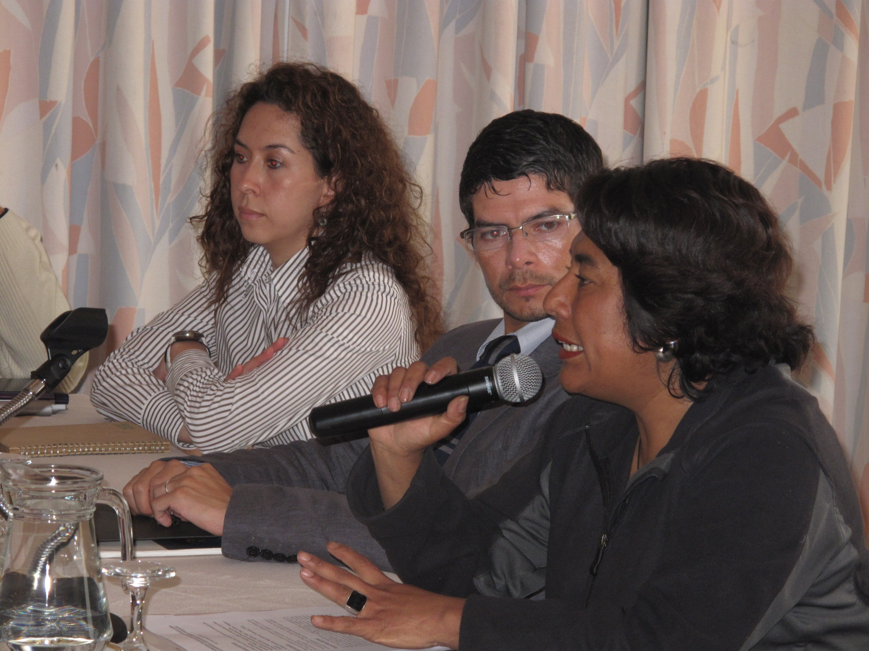
Beatriz Zapata Ferrufino, Viceministra de Medio Ambiente de Bolivia, dando la bienvenida a los participantes durante la inauguración de la reunión.
Fotografía: FUNDESNAP.

2. Estado actual de las negociaciones para la Conferencia de las Partes (COP 11)
Braulio Ferreira, Secretario Ejecutivo del CBD, describió los antecedentes y las perspectivas previas a la celebración de la COP 11, mencionando los instrumentos jurídicos más relevantes en cuanto a las metas, las estrategias y los recursos. El Secretario revisó los contenidos más significativos del Plan Estratégico para la Diversidad Biológica 2011-2020, del Protocolo de Nagoya y del Protocolo de Cartagena sobre Seguridad de la Biotecnología y detalló los ejes principales de la agenda de la COP 11, señalando los compromisos y desafíos de la comunidad internacional y la necesidad de disponer de información de los distintos países en desarrollo sobre los gastos y requerimientos presupuestarios para la protección de la biodiversidad.
[Descargar presentación completa: http://www.fundesnap.org/files/01_cdb__cop11.pdf]

Braulio Ferreira, Secretario Ejecutivo del CDB, explicó los antecedentes y las perspectivas en relación a la realización de la Conferencia de las Partes (COP 11). En este sentido, se refirió a las 47 decisiones de la COP 10 —entre las que destacan el Protocolo de Nagoya, el Plan Estratégico y Metas de Aichi, y la Estrategia de movilización de recursos— poniendo énfasis en las 20 metas globales establecidas hasta 2020.
Sobre la discusión en torno a los mecanismos financieros para la conservación de la biodiversidad, el secretario dijo que existe una preocupación legítima en distintas organizaciones de América del Sur por una posible transferencia al sector privado del futuro de la biodiversidad; preocupación sensiblemente vinculada al futuro de los pueblos indígenas y de las comunidades campesinas, entre otros actores sociales.

Cuadro 1. ¿Qué es el Convenio sobre la Diversidad Biológica (CDB)?
Este Convenio representa uno de los tres resultados más significativos de la Conferencia de las Naciones Unidas sobre Medio Ambiente y Desarrollo, conocida como “Cumbre de la Tierra”, realizada en Rio de Janeiro en 1992. Los otros dos resultados significativos de la mencionada Cumbre fueron la Convención Marco de las Naciones Unidas sobre el Cambio Climático (CMNUCC) y la Convención de Lucha contra la Desertificación (CNULD). El CDB fue firmado por 168 países y entró en vigor el 29 de diciembre de 1993, 90 días después de ser ratificado por 30 países. El Convenio representa un paso decisivo hacia la conservación de la diversidad biológica, la utilización sostenible de sus componentes y la distribución justa y equitativa de los beneficios obtenidos del uso de los recursos genéticos.
La Secretaría del CDB se estableció con el fin de brindar apoyo para el logro de los objetivos del Convenio y sus principales funciones son preparar las reuniones de la Conferencia de las Partes (COP) y también de otros órganos subsidiarios del Convenio, y gestionar la coordinación con otros organismos internacionales pertinentes.
Fuente: www.cdb.int y www.biodiversidad.gob.mx/planeta/CDB/cdb.html

Cuadro 2. Ejemplos de las Metas de Aichi para la Diversidad Biológica
- Por lo menos, reducir a la mitad y, cuando sea posible, acercar a cero el ritmo de pérdida de los hábitats naturales, incluidos los boques.
- Establecer una meta de conservación del 17% de regiones terrestres y de las aguas interiores y del 10% de las regiones marinas y costeras.
- Restaurar al menos el 15% de las regiones degradadas mediante actividades de conservación y restauración.
- Hacer un esfuerzo especial para reducir las presiones que enfrentan los arrecifes de coral.

Fuente: http://www.cbd.int/sp/.
Con un tono crítico, Ferreira se refirió a un estudio sobre el estado y las tendencias de la Biodiverdidad (Secretaría del Convenio sobre Diversidad Biológica, 2010): “Hemos fracasado, ha sido un gran fracaso, no hemos alcanzado la meta acordada en 2002, en la COP 6, en La Haya (Holanda)”. Cabe señalar que en 2002 la meta acordada por los gobiernos fue “lograr para el año 2010 una reducción significativa del ritmo actual de pérdida de la biodiversidad, a nivel mundial, regional y nacional, como contribución a la reducción de la pobreza y en beneficio de todas las formas de vida en la tierra” (Ibíd: 9).
Según el Secretario del CDB, la situación en gran parte del mundo es de declive en la biodiversidad (ver Gráfico 1), a pesar del incremento de las acciones de respuesta a nivel global, hecho que, a juzgar por los datos disponibles, ha resultado insuficiente. “Si queremos evitar que se repita el fracaso en 2020, no basta con el compromiso político, hay que crear las condiciones adecuadas”, apuntó Ferreira, sugiriendo una serie ámbitos en los que es necesario mejorar: marcos legales, capacitación, instrumentos financieros, cooperación “Sur-Sur” y área científica. En esta línea, recomendó la implementación de un mecanismo de monitoreo para saber si se están logrando progresos respecto a los objetivos planteados y así evitar que se llegue al 2020 y “llevarnos una sorpresa”, dijo. Sobre este punto, indicó que la dificultad consiste en disponer de la información necesaria para actualizar los indicadores.

Gráfico 1. Resumen de indicadores de diversidad biológica
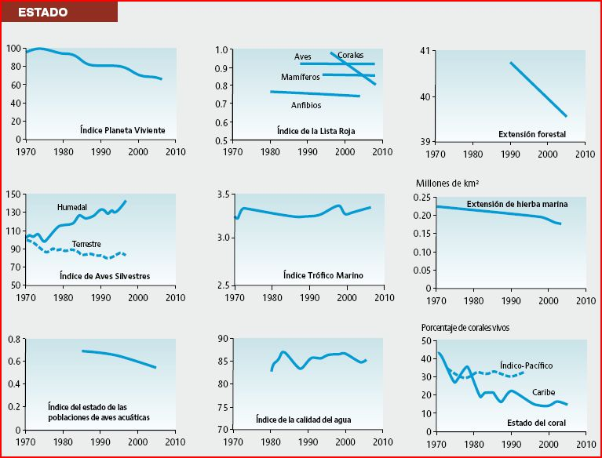
Fuente: Secretaría del Convenio Sobre la Diversidad Biológica, 2010.
En relación al Plan Estratégico para la Diversidad Biológica 2011-2010 —adoptado en la COP 10 que se realizó en octubre de 2010 en Nagoya (Japón)—, señaló que los pasos siguientes son:
- Para el 2012, desarrollar las metas nacionales, considerando las metas globales así como el estado y tendencias de la diversidad biológica en cada país.
- Revisar, actualizar y modificar las Estrategias y Planes de Acción (EPANB), en concordancia con el Plan Estratégico.
- Utilizar las versiones revisadas y actualizadas de las estrategias y planes de acción como instrumentos para la integración de metas políticas y estrategias de desarrollo y erradicación de la pobreza.
A continuación, convocó a aprovechar, en cada país, la oportunidad que representa la declaratoria del Decenio de las Naciones Unidas sobre Diversidad Biológica (2011-2020). Sobre este aspecto, cabe anotar, que después de la COP 10, la Asamblea General de las Naciones Unidas declaró el mencionado decenio con el fin de contribuir a la aplicación del Plan Estratégico para la Biodiversidad 2011-2020.
Con un discurso didáctico y tratando de no omitir ninguna de las cuestiones actuales del debate sobre la biodiversidad, Ferreira repasó los principales elementos del Protocolo de Nagoya (ver pie de pág. n° 4) que aspira a crear un marco legal con el fin de avanzar en la aplicación de uno de los tres objetivos del CDB: la participación justa y equitativa en los beneficios que deriven de la utilización de los recursos genéticos (y de los conocimientos tradicionales asociados a los recursos genéticos). Los elementos centrales señalados fueron los siguientes:
- Los usuarios que quieran acceder a un recurso genético deben obtener el permiso del país proveedor.
- Tanto usuarios como proveedores de recursos genéticos tienen que alcanzar un acuerdo sobre las condiciones de acceso y la participación en los beneficios.
- Las comunidades indígenas y locales obtienen una participación en los beneficios del uso de su conocimiento tradicional asociado a los recursos genéticos.
Sobre la situación jurídica de dicho Protocolo, el Secretario informó que, hasta el momento, 92 partes (países) han firmado el compromiso de ratificación y que cinco ya lo han ratificado, encontrándose, por lo tanto, en la mayoría de los casos, en proceso de ratificación. Manifestó, además, su expectativa de que hasta fines de 2014 (COP 12) se haya conseguido la ratificación de, al menos, 50 países; requisito previo para que dicho instrumento entre en vigor.
Por otra parte, el alto funcionario de Naciones Unidas hizo un breve repaso de los contenidos del Protocolo de Cartagena sobre Seguridad de la Biotecnología, adoptado el 29 de enero de 2000 y vigente desde el 11 de septiembre de 2002, cuyo objetivo es garantizar la seguridad en el manejo, transporte y uso de organismos vivimos modificados resultantes de la biotecnología que podrían tener efectos adversos sobre la diversidad biológica, teniendo en cuenta también los riesgos para la salud humana (Fuente: http://bch.cbd.int/protocol/).
Para completar la dimensión jurídica del tema, se refirió también al Protocolo de Nagoya-Kuala Lumpur sobre Responsabilidad y Compensación Suplementario al Protocolo de Cartagena sobre Seguridad de la Biotecnología, adoptado en Nagoya (Japón), el 10 de octubre de 2010, que proporciona normas y procedimientos internacionales en el ámbito de la responsabilidad y compensación en relación al daño a la diversidad biológica resultante de los Organismos Vivos Modificados (OVM).
Destacó que este Protocolo contribuye a la prevención del daño mediante la creación de incentivos para que los operadores introduzcan medidas de seguridad más confiables y eficaces; crea condiciones favorables para desarrollar y aplicar la biotecnología moderna de manera segura; promueve una mayor confianza en la seguridad de la biotecnología e incrementa la eficacia del Protocolo de Cartagena sobre Seguridad de la Biotecnología.
El resto de la exposición se centró, sobre todo, en abordar la agenda prevista para la COP 11 —que se realizará en Hyderabad, India, del 8 al 19 de octubre de 2012—, cuyos ejes principales en relación a los contenidos son los anotados:
- Situación del Protocolo de Nagoya.
- Aplicación del Plan Estratégico para la Diversidad Biológica 2011-2020 y progreso hacia las Metas de Aichi.
- Recursos financieros y mecanismos financieros.
- Cooperación, extensión y Decenio de las Naciones Unidas sobre la Diversidad Biológica.
- Operaciones del CDB (periodicidad de las reuniones, consideración de la necesidad de fortalecer mecanismos existentes, retiro de decisiones).
- Artículo 8 j) del Convenio (conocimiento, innovaciones y prácticas de las comunidades indígenas y locales) y disposiciones conexas.
- Examen del programa de trabajo sobre diversidad biológica de las islas.
- Diversidad biológica marina y costera.
- Biodiversidad y cambio climático (REDD+ y aplicación de salvaguardias pertinentes para la biodiversidad en relación con la reducción de emisiones globales debidas a la deforestación, entre otros).
- Diversidad biológica y desarrollo.
Por último, el Secretario del CDB, se refirió a la Estrategia para la movilización de recursos, señalando que en la COP 10 se acordó negociar metas para la movilización de recursos financieros con base en informaciones sólidas sobre una línea de base de recursos aplicados entre 2006 y 2010, y con base en información sobre las necesidades financieras. Las fuentes de información al respecto son:
- Las Estrategias Nacionales de Biodiversidad y Planes de Acción (ENBPA).
- Los estudios sobre necesidades para el GEF6.
- El Estudio del Grupo de Expertos de Alto Nivel coordinado por Reino Unido e India.

Para concluir, el representante de Naciones Unidas apeló a la necesidad de disponer de información de los distintos países en desarrollo en relación a los gastos y requerimientos presupuestarios para la protección de la biodiversidad puesto que, de lo contrario, se corre el riesgo de que la inexistencia de información sobre recursos financieros sea utilizada como argumento para demorar la discusión sobre las metas, en el marco de la realización de la COP 11.

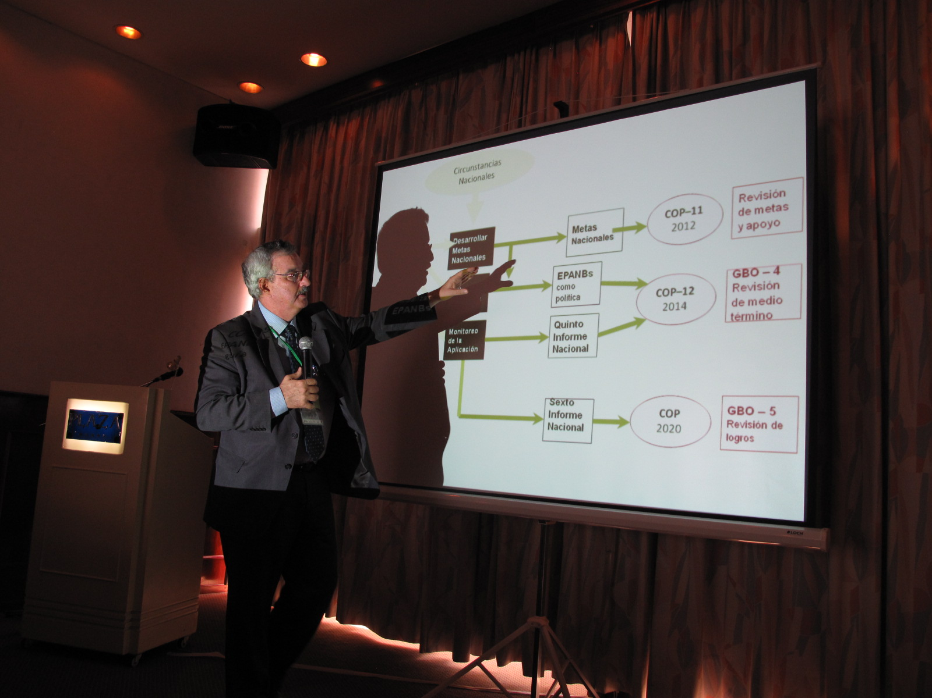

Braulio Ferreira, Secretario Ejecutivo del CDB durante su exposición sobre las negociaciones para la COP 11.
Fotografía: FUNDESNAP.

3. Valor ecosistémico de la biodiversidad y servicios ecosistémicos asociados
Arturo Mora, Oficial de Programa de UICN-Oficina Regional para América del Sur, expuso el concepto de valor económico de la biodiversidad en función de la Meta 2 de Aichi que establece que, hasta 2020, los valores de la naturaleza deben ser integrados en los procesos de planificación del desarrollo y de reducción de la pobreza de los distintos países. Mora señaló las diferencias entre valor económico y valor comercial, detalló los tipos de servicios ambientales, mencionó las herramientas de valoración económica y sus aplicaciones, se detuvo en la explicación del enfoque TEEB, aludió a la demanda creciente de productos y servicios “verdes”, abordó el uso de mecanismos financieros —exponiendo su clasificación y varias experiencias— y analizó el vínculo entre las economías locales y la biodiversidad. La exposición concluyó con una serie de preguntas dirigidas a generar debate e intercambio de opiniones.
[Descargar presentación completa: http://www.fundesnap.org/files/02_uicn_valor_economico.pdf]

El valor económico de la biodiversidad. A la biodiversidad se le pueden asignar distintos valores: espiritual, cultural, recreacional, escénico… y también económico. En este sentido, uno de las metas acordadas a nivel internacional en 2010 (Metas de Aichi, COP 10) fue que “para 2020, a más tardar, los valores de la diversidad biológica habrán sido integrados en las estrategias y los procesos de planificación de desarrollo y reducción de la pobreza nacionales y locales y se estarán integrando en los sistemas nacionales de contabilidad…”.
Ejemplos de servicios ambientales. Centrando la atención en esta perspectiva, a los bienes o servicios de la biodiversidad —como se señaló— también se les puede asignar un valor económico, lo cual no implica, necesariamente, la explotación comercial de estos recursos o su monetización efectiva. Para ilustrar de qué se habla al mencionar los servicios ambientales, es posible utilizar varios ejemplos: una planta purificadora de agua, un espacio para pesca deportiva, un diseño inspirado en la naturaleza, el uso recreacional y turístico de un parque natural asociado a su preservación, etcétera.
Demostrar el valor, herramientas de valoración y aplicaciones. En general, esta valoración económica tiene que ver con el propósito de obtener valores “ocultos” de la biodiversidad para la mejor toma de decisiones. Sin embargo, no todo puede ser valorado (p. e., resulta difícil medir los valores intrínsecos o espirituales) y, además, toda valoración necesita ser demostrada y, de algún modo, cuantificada. Para ello existen distintas herramientas de valoración económica que proveen, generalmente, información útil y confiable siempre y cuando se apliquen de manera adecuada, considerando cuáles son los valores relevantes en cada caso particular. Así, estas herramientas tienen distintas aplicaciones, según el contexto:
- Concientización; en el caso, por ejemplo, de uno o unos pocos servicios ecosistémicos considerados “clave” en un contexto nacional particular.
- Evaluación de proyectos; para el análisis de costo-beneficio, de costo-efectividad o de corrección de precios.
- Elaboración de programas y políticas; para el desarrollo de un determinado sector, para la planificación, o para la integración de estos insumos ambientales en la contabilidad nacional.

Cuadro 3. Valor Económico Total (VET) de la biodiversidad
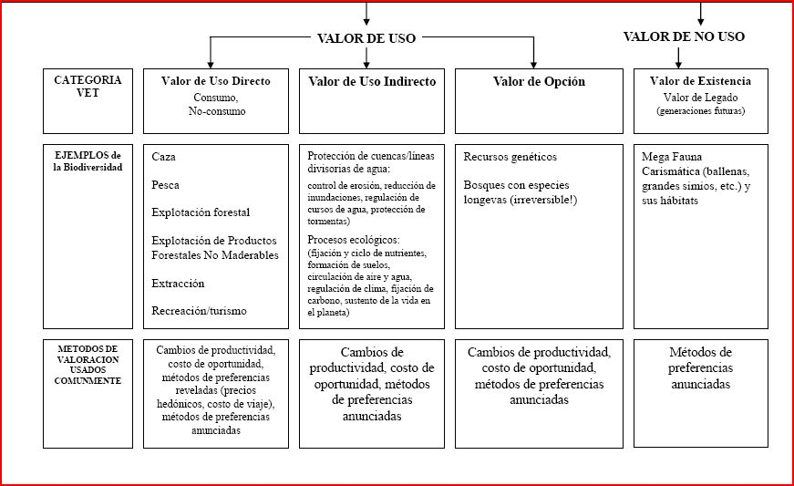
Fuente: CDB, 2010.

El TEEB y los beneficios económicos de la biodiversidad. En esta línea, uno de los enfoques internacionales es el que se denomina como Informe sobre la Economía de los Ecosistemas y la Biodiversidad (TEEB, por sus siglas en inglés) que se basa en tres principios en relación a la biodiversidad:
- Reconocer el valor, como un atributo de todas las comunidades y sociedades humanas;
- Demostrar el valor, en términos económicos, con el fin de la toma de decisiones, y;
- Capturar el valor, introduciendo mecanismos que incorporan los valores de los ecosistemas en la toma de decisiones.

Gráfico 2. Aplicación del enfoque TEEB
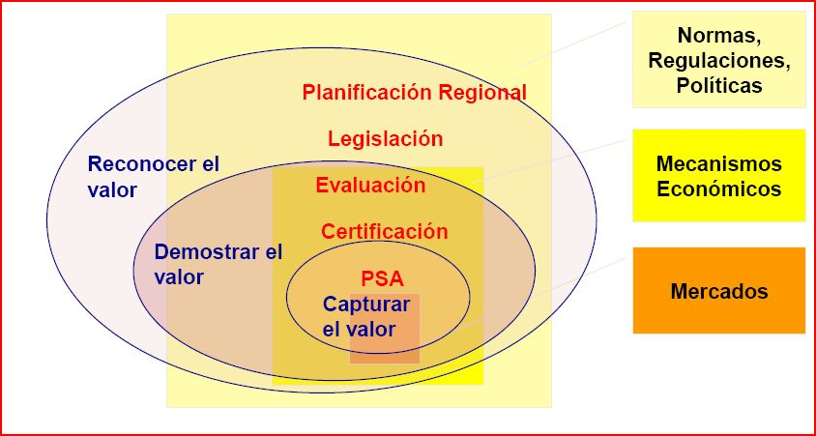
Fuente: Mora, Arturo. Valor Económico de la Biodiversidad y Servicios Ecosistémicos asociados (presentación, pdf).

Demanda mundial de productos y servicios “verdes”. La “captura del valor” está relacionada, por ejemplo, con la creciente demanda mundial de productos y servicios “verdes”, como los alimentos orgánicos (que representaron una venta por valor de 60 billones de dólares americanos en 2009), los productos forestales certificados “sostenibles” (que multiplicaron por cuatro su venta entre 2005 y 2007), el mercado global para pescado “eco-etiquetado” (que creció más de un 50% entre 2008 y 2009) y la incorporación de productos “amigables con la ecología” en las más grandes marcas de consumo, como Mars (Rainforest Aliance Cocoa), Kraft (Rainforest Alliance Kenco Coffe) o Unilever (Rainforest Alliance PG Tips).
Alcance de los mecanismos financieros y clasificación. El alcance de los mecanismos financieros puede ser local, subnacional, nacional y regional-internacional, y se los puede clasificar en cuatro categorías, según estén organizados de manera pública o privada:
a) Organización de mercados por actores privados:
- Pago para uso de servicios ambientales “puros”.
- “Eco-sellos” o “eco-etiquetados”.
- Tasas de usuarios (p. e., el ecoturismo).
b) Organización de mecanismos financieros voluntarios sin mercado, por actores privados:
- Fondos privados (p. e., las donaciones).
- Loterías “verdes”.
- Eco-Fondos por Fundaciones Internacionales (p. e., las fundaciones Tinker, Perkin, Samuel Rubin o Konrad Adenauer).
c) Organización de mercados apoyada por los gobiernos:
- Fondos de compensación.
- Bancos de compensaciones.
d) Mecanismos financieros establecidos por los gobiernos:
- Impuestos y subsidios (p. e., el Impuesto Ecológico de las Corporaciones Autónomas Regionales, CAR, en Colombia).
- Fondos Gubernamentales (p. e., el Fondo para la Protección del Agua, FONAG, en Quito).
- Pagos gubernamentales directos.
- Canjes de deuda por naturaleza.
- Bioprospección.
- Títulos de renta fija.
Economías locales y biodiversidad. Mediante la integración de los valores de la comunidad, del ecosistema en el mercado y del desarrollo de actividades productivas vinculadas a los recursos naturales, se puede favorecer la conservación de la biodiversidad, en el contexto del desarrollo de economías locales cuyas poblaciones, por lo general, suelen ser las más desfavorecidas y dependientes de los recursos naturales y, en consecuencia, también las más amenazadas por la degradación de los ecosistemas.
Movilización de recursos financieros (Meta de Aichi 20). Esta meta establece, hasta 2020 como máximo, la movilización de recursos financieros provenientes de todas las fuentes para aplicar de manera efectiva el Plan Estratégico para la Diversidad Biológica 2011-2020. En este sentido, algunas preguntas “clave” en torno al valor económico de la biodiversidad y a los servicios ecosistémicos asociados son las siguientes:
- ¿Qué servicios pueden ser útiles en su región y país, y para qué?
- ¿Cómo se han hecho los ejercicios de valoración económica que conoce y cuáles son las áreas y los vacíos detectados?
- ¿Qué ejemplos de mecanismos financieros han sido aplicados en su país o región y cuáles han sido los resultados de estas experiencias?

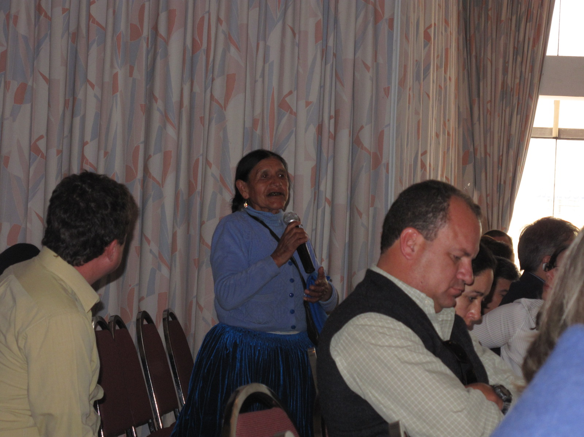
Participación de los asistentes al taller durante la primera jornada.
Fotografía: FUNDESNAP.

participación: comentarios y preguntas/
—Pamela Fernández, del Ministerio de Medio Ambiente de Chile, explicó la experiencia chilena en relación a la creación de un sistema nacional integral de áreas protegidas, destacando, concretamente, una iniciativa (un estudio) para asignar valor económico a los servicios ecosistémicos asociados a las áreas protegidas (el 15% del territorio terrestre chileno está protegido en distintas categorías de manejo, según apuntó Fernández).
Este estudio concluyó valorando los servicios ecosistémicos de las áreas protegidas en Chile, en alrededor de 2.500 millones de dólares americanos anuales; de los cuales 2.400 corresponderían a la captura de carbono. “Ese estudio ha permitido ir aumentado de manera pequeña, pero gradual y sistemática el presupuesto del sistema nacional de áreas protegidas en Chile. Nos falta avanzar en el pago por servicios ambientales pero ya tenemos el tema teórico sobre la mesa, lo cual nos permite discutir con los diferentes ministerios que son más de carácter productivo”, concluyó Fernández.
—Mario Baudain, boliviano, doctor en Biología, llevó el debate el terreno de la experiencia propiamente campesina al señalar que “la decisión de tumbar un árbol es una decisión económica pero la distancia entre ésa y la cuentas nacionales me parece tremendamente grande. La decisión (de desboscar) la toma un campesino que está parado frente a un árbol y las cuentas nacionales las maneja un burócrata que está en la ciudad que tiene ciertas presiones”. Baudain alertó sobre la distancia existente entre la contabilidad asociada al discurso de los servicios ambientales y la práctica cotidiana del campesino. “Y eso es muy preocupante porque por muy refinados que sean esos instrumentos (relacionados con los servicios ecosistémicos) si no llega apoyo al campesino para decidir no tumbar el árbol, lo va a reemplazar por arroz independientemente de cuál sea la discusión”, señaló.
—Jessica Díaz, del Ministerio de Relaciones Exteriores de Argentina, destacó los tres pilares del desarrollo sustentable (económico, social y ambiental) y subrayó la necesidad de buscar un equilibrio entre éstos. Planteó algunas dudas sobre los mecanismos financieros mencionados en la exposición y señaló, concretamente, el problema que particular que existe en Argentina al hablar de subsidios y la preocupación porque éstos, en lugar de ser subsidios ambientales se conviertan en subsidios agrícolas. Finalmente, Díaz comentó que en la presentación se mencionaron ejemplos de esquemas de certificación relacionados con empresas internacionales como Unilever o Kraft, sin embargo, “¿cómo hace el campesino de la comunidad para acceder a esos estándares?, ¿será necesaria la transferencia de recursos, capacidades, etcétera?”, preguntó.
—Iván Arnold, Director Fundación Naturaleza, Tierra y Vida de Tarija, Bolivia (NATIVA), propuso una mirada retrospectiva señalando que, durante la última década, en muchos casos, se ha subestimado la influencia de los economistas en las cuestiones de la conservación y que, después de todo, en lugar de que la economía se adapte a los imperativos de la conservación se ha terminado adaptando la conservación a la economía dominante. Arnold destacó la validez de los instrumentos económicos presentados y la necesidad de su aplicación, criticando, al mismo tiempo, el hecho de que muchas empresas hayan lavado su imagen a través de este tipo de mecanismos.
—Justina Vélez, de la Confederación Nacional de Mujeres Campesinas Bartolina Sisa (CNMBS) de Bolivia testimonió la dificultad que se vive en la Amazonía boliviana para una producción con valor agregado puesto que la existencia de una zona franca, en Pando facilita el ingreso de productos asiáticos con los que es muy difícil competir. La representante campesina criticó las cumbres internacionales (Rio+20, entre otras) concluyendo que estos eventos son, en el fondo, “un negocio para los que trabajan en las ONG”.
—Para cerrar, Arturo Mora, autor de la presentación, señaló que, efectivamente, es posible cuestionar por qué utilizar mecanismos económicos-financieros para proteger la biodiversidad cuando es la economía tradicional la que genera impacto en la diversidad. Sin embargo, frente a esta situación, “¿qué otros mecanismos quedan en este momento?”, “¿qué mecanismos podemos crear?”, preguntó Mora interpelando al público al afirmar que la respuesta y las alternativas tienen que provenir de cada uno en cada país. Por otra parte, Mora afirmó que el tema de los servicios ecosistémicos tiene ya muchos años de debate y de agenda pública y que una de las preguntas de fondo es: ¿cuándo, realmente, las decisiones de desarrollo de los países serán planificadas teniendo en cuenta consideraciones ecosistémicas? En este sentido, Mora destacó ciertas experiencias mencionadas por representantes del Instituto Humboldt de Colombia, en relación a la toma de decisiones a través de mapas, cartografía e información, por ejemplo, sobre la situación de las cuencas hidrográficas.
Por otra parte, en relación a la cuestión de los subsidios, Mora afirmó que, efectivamente, según la teoría económica liberal, los subsidios son una grave distorsión en la aplicación de un modelo de mercado. Sin embargo, desde el punto de vista de la preservación de la biodiversidad, es necesario analizar cuándo son aplicables y cuándo no. Por ejemplo, en el caso de los mecanismos de certificación, éstos tratan de corregir los precios de mercado incorporando la variable de los servicios ecosistémicos. La dificultad, no obstante, es que estos mecanismos encarecen los productos y los hacen menos competitivos. Finalmente, Mora destacó el aporte de las comunidades locales, campesinas e indígenas, puesto que éstas plantean elementos en relación al reconocimiento de diversos valores de la naturaleza que, por lo general, son un tanto ajenos a la vida de las ciudades y a la dinámica urbana.

4. Pagos por Servicios Ambientales (PSA): una herramienta para el manejo y la conservación de los ecosistemas
Doris Cordero, Oficial de Programa de UICN-Oficina Regional América del Sur, presentó una conceptualización sobre los servicios ambientales, enumerando los más destacados. Realizó una explicación de las características del servicio ambiental de conservación de la biodiversidad y, concretamente, de la modalidad de Pagos por Servicios Ambientales (PSA). Trazó un breve panorama de los servicios ambientales en América Latina, entre los que destacan las experiencias en el mercado voluntario de carbono y los esquemas de conservación de cuencas hidrográficas. Finalizó su exposición señalando los aspectos a considerar para la aplicación de instrumentos “tipo PSA” y las lecciones aprendidas de las distintas experiencias.
[Descargar presentación completa: http://www.fundesnap.org/files/03_psa___copia.pdf]
Definición de los servicios ambientales (servicios de los ecosistemas o ecosistémicos). Se trata de las funciones de los ecosistemas que brindan servicios o beneficios económicos, ecológicos y sociales para la población local, nacional o internacional. Los más destacados son:
- Aquellos vinculados al mercado de carbono: secuestro-almacenamiento de carbono, Reducción de Emisiones por Deforestación y Degradación forestal (REDD) y gestión sostenible de los bosques y aumento de las reservas de carbono (REDD+).
- Conservación de cuencas hidrográficas.
- Provisión de belleza escénica y de espacios para recreación y turismo.
- Conservación de la biodiversidad.

Características del servicio ambiental de conservación de la biodiversidad. Este servicio comprende la conservación de genes, especies y ecosistemas. Sin embargo, no existe una unidad específica de medición de la biodiversidad, por lo que se utilizan algunos indicadores indirectos como unidades de medición; éstos pueden ser, por ejemplo, las hectáreas de área conservada o las especies amenazadas, entre otros. En todo caso, se requieren mecanismos de monitoreo y seguimiento para medir el impacto en la conservación de la biodiversidad.

Pagos por Servicios Ambientales (PSA). Esta modalidad se basa en la consideración de que los proveedores de servicios ambientales se verán recompensados por mantener la provisión de dichos servicios, mientras que los que se benefician de los mismos deben pagar por ello. Teóricamente, los PSA son una transacción voluntaria en la que un servicio ambiental bien definido o un uso de la tierra que aseguraría ese servicio es “comprado” por al menos un comprador (del servicio ambiental) a, por lo menos, un vendedor (del servicio ambiental) sólo si el proveedor asegura la provisión del servicio ambiental transado (Wunder, 2005).

El panorama de los servicios ambientales en América Latina. En la región existen iniciativas en curso —experiencias en el mercado voluntario de carbono y diversidad de esquemas para la conservación de cuencas hidrográficas (especialmente en la cordillera de los Andes), principalmente— que proporcionan valiosas lecciones. En el Gráfico 4 se puede apreciar la relevancia de América Latina en relación a la localización de compradores y a la oferta contratada en el mercado de carbono forestal.

Gráfico 3. Mercado de carbono: localización de compradores y oferta contratada en 2010 (sólo en el mercado primario)
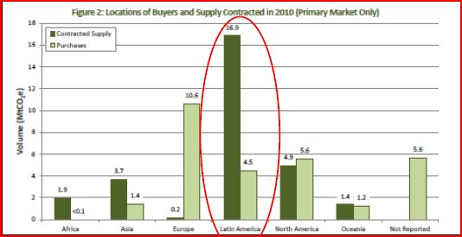
Fuente: Ecosystem Marketplace, 2011.

Algunos ejemplos de esquemas que buscan la protección de los servicios ambientales en América Latina. El Sistema de Incentivo a los Servicios Ambientales en el Estado de Acre, en Brasil, el Programa de Pagos por Servicios Ambientales en Costa Rica —con más de 15 años de vigencia— el Programa Socio Bosque en Ecuador y el Programa para la Conservación de Bosques y Mitigación del Cambio Climático en Perú, son algunas muestras de la aplicación de estos esquemas en la región.
Aspectos a considerar en el diseño de instrumentos “tipo PSA”. Se requiere una fuente de financiamiento sostenible, considerar los costos de transacción desde el inicio, revisar la institucionalidad, la legalidad y las políticas de gobiernos que inciden negativamente en la conservación (p. e., las políticas agrarias), utilizar la información técnica existente (contratos, monitoreo, mapas, entre otros), y claridad en la tenencia de la tierra y en los derechos de uso y aprovechamiento de los bienes y servicios. Por ello, se sugiere seleccionar el instrumento en función de los objetivos y del contexto considerando los aspectos culturales e incluyendo las variables de género y de equidad social desde la fase de diseño.

Lecciones aprendidas. Es necesario tomar en cuenta el rol del Estado como facilitador, la necesidad de seguridad jurídica y de un ambiente favorable, la aplicación de estándares y “mejores prácticas” como garantía a los compradores y vendedores, el respeto a los derechos de propiedad y uso de la tierra, la necesidad de establecer un vínculo con el sector financiero y el uso de herramientas de comando y control. Respecto al pago por servicios de los ecosistemas, se requiere claridad respecto a qué se compra y qué se vende y un marco de instituciones sólidas, transparentes y confiables que vinculen a quienes ofrecen y quienes demandan.

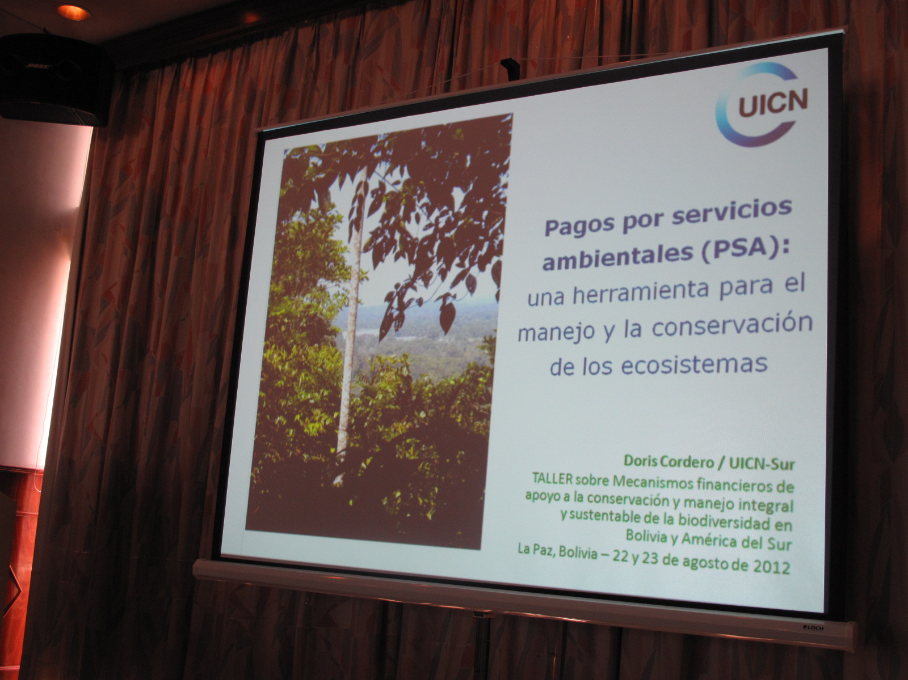
Presentación sobre el Pago por Servicios Ambientales (PSA), de Doris Cordero, Oficial de Programa de UICN-Sur.
Fotografía: FUNDESNAP.

participación: comentarios y preguntas/
—Cándido Pastor, de Conservación Internacional Bolivia comentó algunos ejemplos de experiencias de servicios ambientales en el país. Se refirió, específicamente, al caso de Comarapa, Mairana y Samaipata donde existe un sistema de compensación económica a los lugareños de las partes altas por parte de las comunidades de las partes bajas en relación a la gestión del agua. “En Bolivia estamos hablando más de compensación que de pago porque pago es un mecanismo que se asocia más con el mercado, y ésa es la discusión que tenemos en Bolivia”, dijo Pastor.
—Mario Baudain, boliviano, doctor en Biología, recurrió a la memoria de la práctica ancestral agrícola campesina insistiendo en que “para el campesino la tierra es todo pero sin agua es nada”, por lo que los mecanismos de distribución del agua en el campo se han ido heredando y reproduciendo desde hace miles de años. “Entonces, tú introduces el tema del pago por servicios sobre algo que es un derecho distribuido consuetudinariamente y lo que estás haciendo es sacudir el árbol de una forma tremendamente amenazadora para esas poblaciones”, dijo. En este sentido, Baudain recordó el intento fracasado de un partido de gobierno en Bolivia, el Movimiento Nacionalista Revolucionario (MNR), para aprobar una ley de aguas que pretendía convertir este elemento vital en una mercancía.
—Humberto Gómez, de la Fundación Amigos de la Naturaleza de Bolivia, advirtió que la cuestión de los servicios ambientales es compleja en el país y que la resistencia más fuerte se debe “a ese reduccionismo referido a que estamos pagando por el agua”. Gómez explicó que esta situación obedece, en parte, a la incapacidad de los técnicos para entender los recursos naturales, y concretamente el agua, como los entienden las comunidades. “Se dice no a la mercantilización de las funciones ecológicas, a las compensaciones y a todos estos mecanismos porque, en parte, no hemos logrado conceptualizar de manera adecuada estos sistemas y estos esquemas de compensación”, apuntó Gómez.
—Ana di Pangracio, de la Fundación Ambiente y Recursos Naturales (FARN) de Argentina, aludió a un estudio realizado por su institución en la provincia Misiones donde se ubica el Bosque Atlántico compartido entre Argentina, Brasil y Paraguay. Pangracio afirmó que, según el estudio, un problema común es la informalidad en lo económico; la falta de regularización de los potenciales favorecidos para la aplicación de un sistema de compensación por servicios ambientales. Es decir, la carencia de títulos de propiedad. “¿Cómo vamos a saber a quién se va a compensar si no se sabe quién es dueño de la tierra?”, cuestionó, enfocando un problema general en la región.
—Olaff Westermann, del SERNAP Bolivia, realizó varios comentarios acompañados de preguntas. Dijo, en primer lugar, que, según la experiencia de alguna institución en Bolivia —como Fundación Natura— no necesariamente debe existir un derecho legal de propiedad sobre la tierra para aplicar un esquema de pago por servicios ambientales, pues es suficiente un reconocimiento de los límites de los predios. En segundo lugar, Westermann se preguntó qué sucede con los más pobres, es decir, con aquellos que además de carecer de derecho propietario, en muchas ocasiones, por usos y costumbres, ingresan al bosque para utilizar los recursos forestales como la leña y otros productos. “¿Cómo cambiaría esta situación con la aplicación de un esquema de pago por servicios ambientales?”, preguntó. Por último, el funcionario del SERNAP, se refirió a los denominados “incentivos perversos”. “Si introducimos un servicio de pagos ambientales, tal vez gente que ha conservado el bosque por usos y costumbres va a ocupar el bosque para tener derecho al pago por conservarlo (…) Es contradictorio, si tenemos una ley que establece que hay que conservar las áreas protegidas, ¿por qué tenemos que proveer un incentivo económico para que se cumpla con la ley? A nivel teórico es una contradicción, aunque en la práctica puede funcionar”, concluyó.
—Ernesto Aramayo, del FUNDESNAP Bolivia, mencionó que es necesario tener en cuenta que el tema de los servicios ambientales está relacionado con el traspaso de responsabilidades de los países desarrollados y con el incumplimiento de estos países en sus compromisos de reducción de emisiones de gases de efecto invernadero. Por otra parte, Aramayo puso sobre el tapete de debate la cuestión de la crisis económica internacional que, con seguridad, afectará también al pago por servicios ambientales. “¿Qué previsión están tomando ustedes para considerar futuros pagos ambientales?”, preguntó.
—Alexandra Moreira, de la Unidad Madre Tierra y Agua (UMTA) del Ministerio de Relaciones Exteriores de Bolivia, subrayó que Bolivia, como país, no comulga con los mecanismos denominados de REDD o de REDD+. Afirmó que este tipo de mecanismos de pago por servicios ambientales pueden ocasionar una distorsión de las responsabilidades de los países desarrollados respecto a los países en desarrollo por la contaminación de gases de efecto invernadero y del espíritu del Protocolo de Kyoto expresado en el principio de “responsabilidades comunes pero diferenciadas”. Moreira insistió en que es necesario incluir en el debate las preocupaciones sobre los riesgos de privatización de los recursos naturales y acerca de las desiguales capacidades de los países en desarrollo —con diferentes niveles de estándares de gestión ambiental y de estabilidad institucional— para optar por los distintos mecanismos expuestos. “Un ejemplo es el del MDL (Mecanismo de Desarrollo Limpio) que exige unos requisitos muy complicados y que está repartido entre muy pocos países en desarrollo”, afirmó, haciendo hincapié en la existencia de otros modelos, visiones y enfoques para la gestión integral de la biodiversidad —como el planteado por el Estado Plurinacional de Bolivia— que deben ser considerados como alternativas.
Para concluir, Doris Cordero, responsable de la exposición, trató de responder a las distintas cuestiones planteadas por los participantes en los comentarios. Respecto a las prácticas campesinas consuetudinarias de gestión de los recursos hídricos, Cordero aclaró que no se deben confundir dos aspectos distintos: el derecho humano de acceder al agua, por un lado, y el recibir un pago por hacer un uso determinado del suelo. Esto último, ocurre, por ejemplo, con la retribución por la reducción del uso de químicos, por una menor producción o por el empleo de otros sistemas de cultivo más amigables con el medio ambiente.
En relación a la necesidad de títulos de propiedad para el desarrollo de pagos por servicios ambientales, Cordero precisó que, en ocasiones, no existen títulos “en papel” pero sí existen derechos consuetudinarios que son suficiente aunque siempre se corre el riesgo de que, a posteriori, aparezcan terceros reclamando la propiedad de la tierra. Sobre los “incentivos perversos”, la Oficial de Programa de UICN-Sur opinó que esto es algo que siempre va a existir puesto que al igual que hay incentivos positivos también los hay negativos. En este sentido recomendó ser muy cuidadosos a la hora de determinar por qué se está pagando. “Por ejemplo, pagar por un área protegida no tiene sentido, hay otras formas de ayudar a cuidar un área protegida. Los PSA funcionan en algunos casos pero no en todos”, dijo.
Sobre la crisis económica y su repercusión en los fondos para pagos por servicios ambientales, Cordero aclaró que si bien esto es algo que afectará a los presupuestos para hacer conservación, todas las cifras mostradas durante su exposición corresponden al mercado voluntario, no al mercado reglamentado bajo el Protocolo de Kyoto. “Es el mercado de empresas privadas que, en algunos casos por responsabilidad social, ambiental o porque hay leyes nacionales que les motivan a hacerlo, invierten en esto. Estoy hablando de una fuente que sí se verá afectada por la crisis pero no hasta el punto en que están afectados algunos gobiernos. Por otra parte, si tenemos menos fondos habrá más competitividad y será más difícil acceder a los recursos, esto también hay que considerarlo”, reflexionó.
Finalmente, respondiendo a las críticas a los servicios ambientales y a lo que, en general, se ha denominado como “economía verde”, Cordero señaló que, efectivamente, los países que más han contaminado son los que tienen mayor responsabilidad y que existen mecanismos, como el MDL, técnicamente costosos y complejos. “Hay asimetrías en todo lo que es la Convención del Cambio Climático y en la forma cómo se negocia. Es algo en lo que hay que ser muy realistas porque así funciona, desafortunadamente”, dijo. Sin embargo, a título personal, Cordero opinó que los países de la región tienen, a pesar de todo, una oportunidad para negociar mejores condiciones.

5. Herramientas para la gestión integral de la biodiversidad en Bolivia (estudios de caso)
5.1. Programa Nacional para la Gestión y Aprovechamiento de la Vicuña
Jorge Laura Camacho, responsable del Programa Nacional de Vicuña del Viceministerio de Medio Ambiente, Biodiversidad, Cambios Climáticos, de Gestión y Desarrollo Forestal de Bolivia, expuso los antecedentes históricos del manejo y el aprovechamiento de la vicuña, marcados por la amenaza de extinción en 1960. Abordó los objetivos, contenidos, disposiciones jurídicas y características del programa, señalando los principales resultados que han consistido en un crecimiento de la población de vicuñas y en mayores ingresos por la comercialización de su fibra, gracias al trabajo conjunto entre el Estado y las comunidades.
[Descargar presentación completa: http://www.fundesnap.org/files/04_bolivia_vicuna.pdf]
Antecedentes históricos. Desde tiempos prehispánicos, la cultura incaica usaba la vicuña con fines de vestimenta y alimentación. Con la Colonia española se pierde esta práctica y aparece la caza ilegal, y con la creación de la república, los gobiernos empiezan a emitir normas para prohibir la caza de este animal. Hacia 1960, por la amenaza de extinción, la preocupación por esta especie cobra mayor importancia.
Programa nacional de vicuña. Este programa se crea en 1997 con el propósito de coordinar a nivel nacional la conservación, aprovechamiento sustentable, control, desarrollo de capacidades, generación de valor agregado y gestión de la vicuña. El marco normativo establece que la conservación de esta especie es una atribución prioritaria del Estado, que la custodia y aprovechamiento lo realizarán las comunidades manejadoras de la vicuña y que el aprovechamiento es en silvestría y desde las comunidades. Con esta finalidad, se crea el Comité Interinstitucional de la Vicuña cuyas atribuciones son autorizar las capturas y esquila, y realizar la fiscalización de la comercialización y distribución de beneficios. Este Comité Interinstitucional está compuesto por diversas instancias del Estado —como el Viceministerio de Medio Ambiente, el Servicio Nacional de Áreas Protegidas (SERNAP) y las Secretarías Departamentales— y de la sociedad civil, como la Asociación Nacional de Manejadores de Vicuña y las asociaciones regionales.
Hitos históricos en la conservación de la vicuña. El convenio entre Perú y Bolivia de 1969, el conteo de vicuñas realizado en 1981, el primer censo nacional de vicuñas de 1996 —que censó a 33.844 ejemplares—, la creación del Programa Nacional de la vicuña en 1997, la autorización para su comercialización en 2007 y las distintas ventas a nivel nacional son los momentos cronológicos más importantes en la historia de la preservación y manejo de este animal. Prueba de la eficacia de estas políticas es el crecimiento de su población estimada en 112.249 vicuñas, según datos de 2009.
Transferencia de recursos económicos. El marco normativo que regula el aprovechamiento de la vicuña dispone que, dentro de las áreas protegidas, se transferirá un 3% de los recursos obtenidos al Viceministerio de Medio Ambiente, otro 3% al SERNAP y un 2% a los municipios donde estén presentes las asociaciones regionales. Fuera de las áreas protegidas, la única variación es que el porcentaje destinado al SERNAP pasa a los Gobiernos Departamentales. El destino de estas transferencias son las actividades de fiscalización, control, monitoreo, vigilancia, lucha contra la caza furtiva y fortalecimiento técnico, entre otras.
Resultados y logros. La aplicación del programa ha conseguido incrementar notablemente la población de vicuñas —de 33.844 ejemplares en 1996 a 112.249 en 2009—, generar ingresos de 605 mil dólares americanos en 2012 por la comercialización de la fibra, estimular el crecimiento del número de asociaciones regionales e incrementar tanto la comercialización como los ingresos históricos por la venta de la fibra. Estos logros se pueden atribuir a un trabajo conjunto entre las instituciones públicas y las comunidades. Para Bolivia, este modelo de programa ha resultado un éxito por el manejo integral, por su visión de sustentabilidad y por la distribución equitativa de los beneficios entre las comunidades locales.

Gráfico 4. Evolución de los ingresos percibidos por las comunidades manejadoras de vicuña (1998-2010)
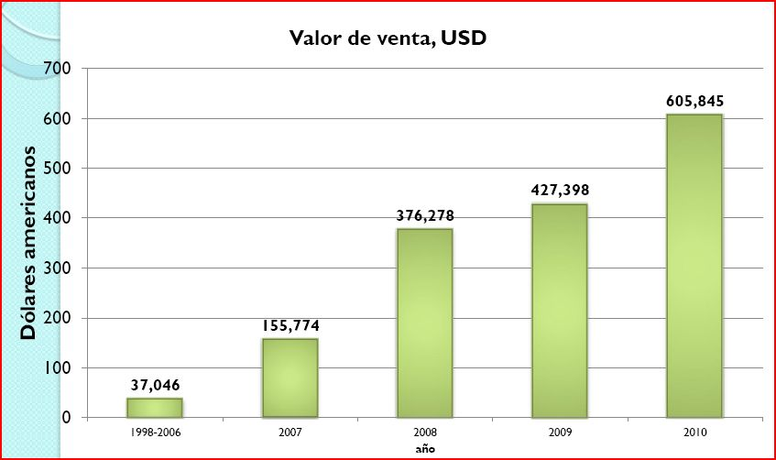
Fuente: Laura, Jorge. Programa Nacional para la Conservación y Aprovechamiento de la vicuña (presentación, pdf).

participación: comentarios y preguntas/
—Luis Arteaga, biólogo y consultor independiente boliviano, complementó algunos aspectos sobre el aprovechamiento de la vicuña señalando que, a nivel regional, cinco países disponen del mismo recurso y acceden, prácticamente, al mismo mercado. “Lo interesante es analizar cómo se pueden ir generando modelos y mecanismos particulares sobre un mismo recurso. En el caso de Bolivia, se ha apostado por priorizar la conservación trabajando en silvestría y con un sistema de gestión compartida con las comunidades que se benefician. Por lo tanto, el objetivo no es la venta, es algo un poco más complejo que ver dónde hay mercados y anexarnos a esos mercados”, afirmó.
—Doris Cordero, Oficial de Programa de UICN-Sur, consultó acerca de la forma de distribución de los ingresos dentro de las comunidades y de las inversiones que se realizan en caso de que éstas existan.
Jorge Laura Camacho, responsable del Programa de Vicuña en Bolivia, respondió a las preguntas y comentarios precisando que en el caso de este camélido no se pensó en el pago por servicios ambientales sino, fundamentalmente, en salvar la especie de la extinción. Explicó que, en Bolivia, no existe “matanza” de la vicuña sino que sólo se aprovecha la fibra y luego se la deja en libertad, y mencionó que este proceso de conservación tiene ya una historia de 40 años e involucra, directamente, a cuatro o cinco mil originarios como beneficiarios directos.
Respecto a la distribución de los beneficios, Laura dijo que ésta se realiza a través de la Asociación Nacional que es la instancia encargada de la comercialización de la fibra. Una vez realizada la venta, las autoridades nacionales hacen entrega, mediante acto público, de la parte correspondiente (según la cantidad de fibra aportada) a cada asociación regional. Previamente, no obstante, se realiza el descuento por los costos operativos, impuestos, certificados sanitarios, transporte, etcétera. Posteriormente, los presidentes de las asociaciones regionales distribuyen los recursos económicos a los presidentes de las comunidades manejadoras y éstos, a su vez, a cada comunario de acuerdo a las horas o jornadas de trabajo. Al final, para proceder con una nueva venta, es necesario presentar las actas y descargos de la venta anterior.

5.2. Programa Nacional de Conservación y Aprovechamiento Sostenible del Lagarto (Caiman yacare)
Fernando Cisneros, responsable del Programa Nacional de Conservación y Aprovechamiento Sostenible del Lagarto, del Viceministerio de Medio Ambiente, Biodiversidad, Cambios Climáticos, de Gestión y Desarrollo Forestal de Bolivia, explicó la modalidad impulsada por el Estado para la gestión de este tipo de caimán a partir de una alianza con las comunidades indígenas del norte amazónico. Se trata de un aprovechamiento basado en la participación y el control social que ha permitido, a través del establecimiento de cuotas, la explotación en 2011, de hasta 6.139 ejemplares generando beneficios netos de aproximadamente 57 mil dólares americanos que se repartieron, en distintas proporciones, entre los cazadores, las comunidades, las organizaciones indígenas y las previsiones de reinversión. Utilizando distintas técnicas de planificación y zonificación, este sistema permite la conservación de la especie y de los ecosistemas asociados.
[Descargar presentación completa: http://www.fundesnap.org/descargas/lagartojpg/35]

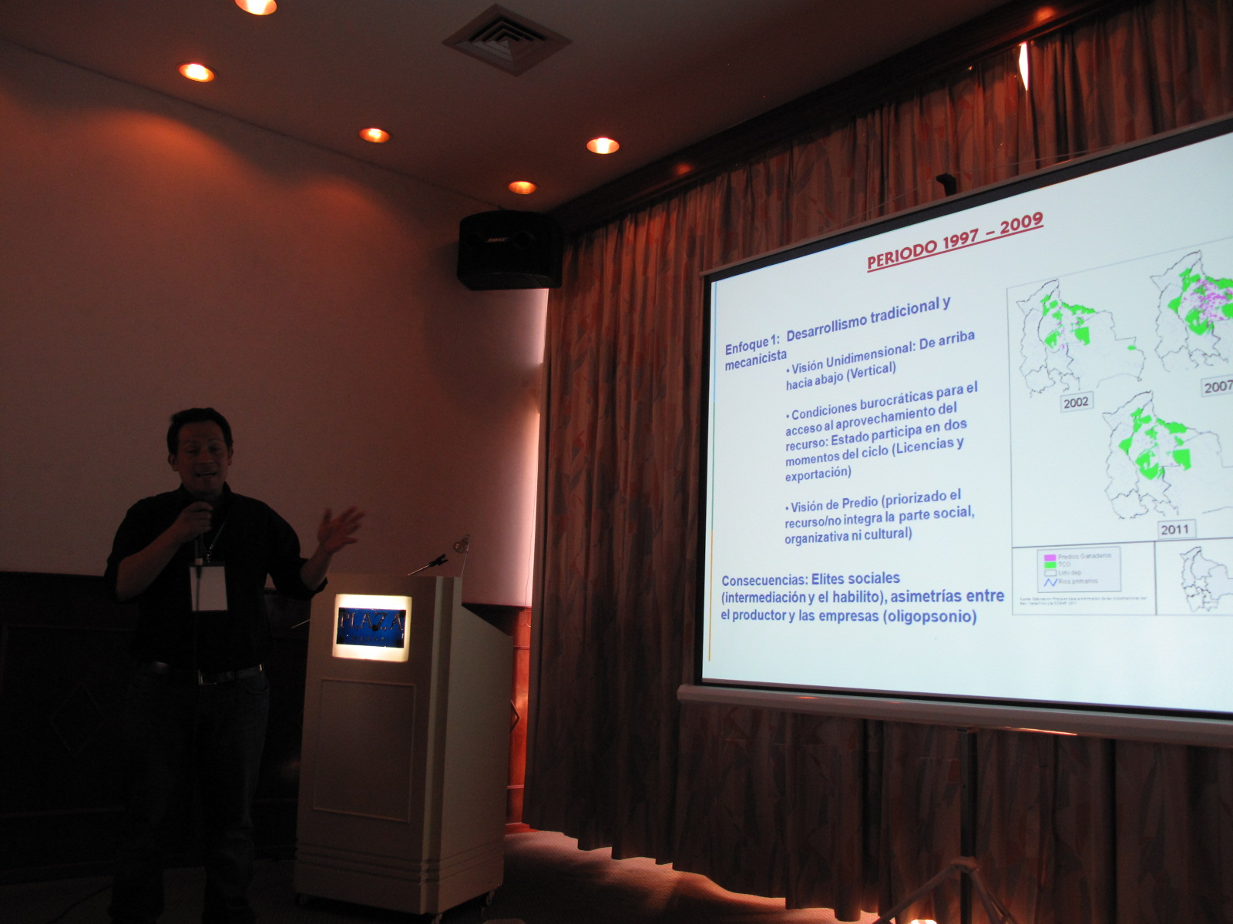
Fernando Cisneros, exponiendo el programa de conservación y aprovechamiento del lagarto en Bolivia.
Fuente: FUNDESNAP.
Características del aprovechamiento del lagarto. Está basado en la “cosecha” de animales silvestres, a través de cuotas anuales de extracción dirigidas a beneficiarios de las Tierras Comunitarias de Origen (TCO), comunidades indígenas, campesinas y estancias privadas. En la línea de tiempo del marco normativo, cabe mencionar: la creación del Programa Lagarto (1997), su reglamentación (2002), los planes de manejo (2004), la elaboración y aprobación participativa de la estrategia (2008-2009), la implementación de la estrategia (2010) y el reglamento de gestión compartida (2011).
“Medios de vida, desarrollo rural con enfoque territorial”. Desde 2008 se recondujo el programa a partir de un enfoque que promueve la cohesión social entre las comunidades y el empoderamiento sobre los recursos del territorio, considerando que el manejo del lagarto puede influir directa o indirectamente en la conservación de otras especies y de los ecosistemas generando también fuentes de trabajo temporal.
Principios del nuevo enfoque de gestión del lagarto. Actualmente, el “Programa Lagarto” basa en una serie de elementos, como:
- La priorización de la conservación de la especie y de los ecosistemas.
- La participación y el control social para asegurar el empoderamiento de los actores locales.
- La equidad social y distribución equitativa de los beneficios protegiendo y respetando los valores sociales.
- La planificación y zonificación para el manejo del recurso en función a las escalas espaciales y temporales adecuadas.
- La complementariedad entre los pueblos indígenas que, a partir de su cosmovisión, ven al lagarto como un recurso que es parte del entorno y de sus formas de vida, y el Estado que participa como agente facilitador, impulsor y articulador.
Regionalización y trabajo con las comunidades indígenas. El aprovechamiento del lagarto se concentra en el Norte amazónico de Bolivia (Norte de La Paz, Beni y Pando) y el trabajo se desarrolla en coordinación con dos organizaciones indígenas regionales que integran la Central Indígena de la Región Amazónica de Bolivia (CIRABO) y la Central de Pueblos Étnicos Mojeños del Beni (CPEMB).
Resultados en la gestión del recurso (2010-2012). La aplicación del nuevo enfoque del programa ha significado distintos cambios, entre los que destaca:
- El cambio de lógica de los “predios” (finca o propiedad) por la regional indígena.
- La eliminación del “habilito” a nivel regional.
- La aplicación de nuevos criterios para establecer cupos justos y sostenibles de explotación del lagarto, en base a evaluación de poblaciones, análisis del excedente productivo, discusión sobre el “cupo mínimo” que puede brindar beneficios sociales, culturales y económicos, y análisis a través de la predicción de la aptitud de hábitats acuáticos mediante modelos SIG.
Comercialización y resultados. La cuota de “cosecha” autorizada en 2011 fue la misma que en 2010: 6.139 ejemplares. El ingreso total neto en 2010 en el mercado tradicional (donde, fundamentalmente, se comercializa el cuero del lagarto) fue de 73.256 bolivianos (unos 10.525 dólares americanos, aproximadamente). Sin embargo, en 2011, mediante una alianza comercial que facilitó también la venta del carne del lagarto, el ingreso neto se incrementó hasta los 398.454 bolivianos (unos 57.249 dólares americanos, aproximadamente). Estos ingresos se distribuyen entre las distintas organizaciones indígenas locales y los beneficios se reparten, de mayor a menor proporción, al cazador (individual), como reinversión, a la comunidad y a la organización indígena regional.
Lecciones aprendidas. A partir del nuevo enfoque del programa, se puede concluir que el derecho de acceso al aprovechamiento del recurso debe respetar las estructuras organizativas comunitarias. Por otra parte, es importante diferenciar entre lo productivo-comunitario y lo representativo-orgánico (autoridades locales). La administración del “recurso lagarto” desde una visión regional ha dado lugar a una mayor participación y control social, y a la conservación del ecosistema mejorando y facilitando la administración pública. De igual forma, es necesario avanzar hacia una gestión compartida del “recurso lagarto” estableciendo una alianza entre el Estado y los usuarios de la tierra y de los recursos naturales. Esto está vinculado con las competencias de la autonomía indígena establecidas en la Constitución y con el fortalecimiento de las capacidades de los comités, asociaciones y juntas de base de las comunidades indígenas.
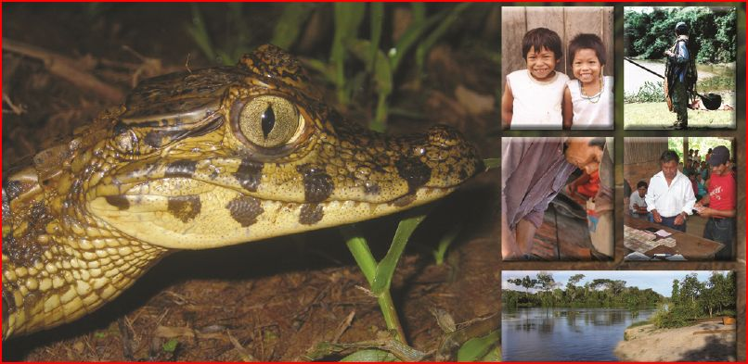
Composición fotográfica de la Estrategia para la Reconducción del Programa Nacional de Conservación y Aprovechamiento Sostenible del Lagarto.
Fuente: Cisneros, Fernando. Experiencia boliviana. Programa Nacional de Conservación y Aprovechamiento Sostenible del Lagarto (Caiman yacaré). Período 1997-2009 y período 2010-2012 (presentación, pdf).

participación: comentarios y preguntas/
—Pamela Fernández, del Ministerio de Medio Ambiente de Chile, consultó acerca de la distribución de los ingresos y de los criterios de reinversión de los recursos. “¿Está regulado de alguna manera que ciertos porcentajes vayan a la reinversión del programa o a cada comunidad?”, preguntó.
—Elyzabeth Huanca, técnico del proyecto MAZPA, complementó algunos aspectos sobre el aprovechamiento del lagarto en Bolivia. Explicó que todo el manejo del lagarto se basa en el concepto indígena de “usar cuidando” que equivale a aprovechar el recurso pero conservándolo. En este sentido, afirmó que existen técnicos indígenas con la capacidad de hacer monitoreo de la abundancia de la especie generando, además, un proceso de apropiación de la integralidad de su territorio. “Por ejemplo, en el caso del TIPNIS (Territorio Indígena Parque Nacional Isiboro Sécure), el cupo otorgado por la autoridad competente es de 1.500 cueros pero las comunidades, después de hacer su propio monitoreo, han decido cosechar un máximo de 1.200 lagartos. Esto lo hacen pensando en su futuro”, dijo.
A partir de esta experiencia, según Huanca, se están generando nuevas estrategias de conservación de la biodiversidad que rompen con la vieja lógica de que en las áreas protegidas no se puede “tocar” nada. “Hay población que necesita subsistir dependiendo de estos ecosistemas (áreas protegidas). ¿Cómo puedes pedir conservación en lugares donde hay población que tiene necesidades y donde existen prácticas ancestrales de manejo del territorio y de los recursos? Con este nuevo enfoque de ‘áreas protegidas con la gente y de la gente’ que se viene trabajando desde hace años en Bolivia, se han generado estas alternativas donde es la misma gente del lugar quien cuida su patrimonio natural que es, al mismo tiempo, el patrimonio natural y cultural del país”, reflexionó.
—Alexandra Moreira, de la Unidad Madre Tierra y Agua (UMTA) del Ministerio de Relaciones Exteriores de Bolivia, destacó los casos de la gestión de la vicuña y del lagarto como ejemplos de gestión sostenible de la biodiversidad a largo plazo y señaló la necesidad de que exista apoyo internacional para cooperar con este tipo de experiencias de gestión integrada y compartida de los recursos naturales.
Finalmente, Fernando Cisneros, responsable del programa de lagarto en Bolivia, señaló que existen reglamentos, a nivel local y regional establecidos por las comunidades indígenas para la distribución de los recursos. Sin embargo, puntualizó que en los talleres se pone en énfasis en la visión que las comunidades tienen del recurso, más que en la dimensión meramente económica. “El lagarto no es como la madera, migra por todo lado. Por eso, la percepción que tienen los indígenas del recurso es que éste es de todos”, dijo. Mencionó, no obstante, que los recursos obtenidos por la gestión del lagarto, están siendo invertidos en el mejoramiento de la infraestructura para el mismo aprovechamiento, en el fortalecimiento de las postas sanitarias y en escuelas. Respecto a la contribución a las arcas fiscales, Cisneros explicó que, desde su punto de vista, es un tanto injusto que las comunidades contribuyan pues son las que menos beneficio reciben y que se está trabajando para que se aplique un 3% de retención sobre cada factura comercial en relación a los porcentajes de exportación.
Resaltando la particularidad de la iniciativa boliviana, Cisneros concluyó mencionando que en la región existen experiencias de cría de lagarto que son de tipo individual y que carecen de la connotación social y comunitaria de la experiencia boliviana. “Por eso, estamos estudiando alguna forma de certificación de este aprovechamiento pero no existen todavía protocolos sobre el sacrificio de animales, a pesar de que, en este caso, es sostenible desde el punto de vista social, ambiental y económico”, dijo.

5.3. Experiencia de turismo comunitario en el Parque Nacional Sajama (Oruro, Bolivia)
Daniel Maidana, técnico del proyecto Manejo de Áreas Protegidas y Áreas de Amortiguación (MAPZA), iniciativa conjunta del SERNAP y de la cooperación técnica alemana, GTZ (ahora cooperación internacional alemana - GIZ), presentó la planificación, el desarrollo y los resultados de un emprendimiento de turismo comunitario en el Parque Nacional Sajama. Partiendo de las particularidades de un proyecto ecoturístico en una Área Protegida, Maidana explicó los contenidos de un diseño empresarial comunitario cuyo propósito es generar beneficios y empleos para la comunidad sin distorsionar su identidad, su vida y su cultura. En este sentido, el balance final destaca no sólo la sostenibilidad del proyecto —como una actividad más que favorece la tradicional diversificación económica propia de las comunidades altoandinas— sino, también, la generación de una mayor conciencia y compromiso con la preservación de la naturaleza.}
[Descargar presentación completa: http://www.fundesnap.org/files/06_bolivia_turismo.pdf]
Parque Nacional Sajama. Este Parque está ubicado en la zona nor-occidental de Oruro y fue creado el 2 de agosto de 1939 con el propósito de proteger los bosques de qeñua, conservar los ecosistemas de la región altoandina semiárida, conservar especies de flora y fauna silvestre, las cabeceras de cuencas y promover la investigación científica. La vegetación más importante del área son los “bofedales” (espacios de altura permanentemente húmedos que son fuente de alimento para las vicuñas) ubicados en los valles glaciares al pie del volcán Sajama (6.542 msnm) y alrededor de las lagunas, donde se encuentran las especies nativas de peces, anfibios y reptiles. La fauna característica del lugar son las vicuñas, los pumas, los zorros, los suris, los quirquinchos y varias especies de aves pequeñas (Fuente: http://www.sernap.gob.bo/images/descargas/Materiales/Broshure/sajama.pdf). En este contexto es donde se lleva a cabo la iniciativa de turismo comunitario descrita en este apartado.
Turismo en un Área Protegida (AP). Toda AP tiene un intrínseco potencial turístico; esto dio la oportunidad de articular la conservación con el desarrollo económico local. El ecoturismo tiene alta compatibilidad con la conservación del AP y sus zonas de amortiguación, por lo que el fortalecimiento de la cooperación entre las comunidades y el AP permitió generar procesos de corresponsabilidad. Esto ha significado un cambio de actitud respecto a la “leyenda negra” que antes existía en relación a que las AP eran sinónimo de restricción y prohibición. Esta idea ha cambiado.
Antecedentes turísticos. Antes del desarrollo del proyecto de turismo comunitario Sajama —denominado Albergue de Ecoturismo Tomarapi—, en la zona tan sólo una comunidad se beneficiaba del turismo bajo un esquema totalmente individualista. Por otra parte, había una imposición de las reglas de juego por parte de las empresas operadoras de turismo y, básicamente, se trataba de un funcionamiento intrusivo en relación a la dinámica comunal que ahondaba las desigualdades. Era un turismo insensible a la conservación.
Desarrollo del proyecto de turismo comunitario. Esta iniciativa turística fue diseñada en fases, a mediano plazo, con apoyo de MAZPA, un proyecto gestionado por el SERNAP y la GTZ. La primera fase (2001-2003) —la más intensa y dura— consistió en implementar la infraestructura, lo administrativo-organizativo, la capacitación del personal y el inicio del funcionamiento del servicio turístico, es decir, la puesta en marcha. Esto requirió de un intenso apoyo tanto técnico como financiero. En la segunda fase (2004-2007), se requirió complementar la infraestructura, hacer un acompañamiento, asesoramiento técnico y reforzar algunos aspectos de la capacitación. La tercera fase (2007-2010) consistió en proveer algún asesoramiento puntual.
Diseño empresarial comunitario. El marco jurídico boliviano no consideraba ninguna figura diseñada para que una comunidad indígena o campesina pueda habilitarse como actor económico. De tal manera que se hizo un análisis jurídico y se decidió que la figura de Sociedad de Responsabilidad Limitada (SRL) es la que más se acercaba a la realidad comunal. Actualmente, la estructura de la empresa está integrada por las 26 familias de la comunidad, con un directorio, un gerente como representante legal y los empleados del albergue. Desde un principio, la idea fue generar excedentes para destinarlos a los gastos sociales de la comunidad. Adicionalmente, se identificaron otros beneficios para la comunidad como la generación de empleo con la ampliación gradual de los servicios. Los cinco componentes iniciales fueron: la infraestructura y la logística inicial, la organización y fortalecimiento de la empresa, la capacitación y el asesoramiento técnico para el funcionamiento de la empresa, la promoción de los servicios hacia el grupo meta y, por último, la implementación de un sistema de monitoreo de los impactos ambientales y socioculturales.
Un nuevo modelo alternativo de gestión turística. Se planteó un modelo alternativo que genere beneficio económico y social para el desarrollo local, que fortalezca social, cultural y organizativamente a las comunidades locales basándose en la estructura social y en las capacidades locales y que se sustente en una planificación participativa y concertada. También se propuso promover una instancia de gestión técnica participativa. Por eso, el término “empresa comunitaria” ha ido adquiriendo peso. En este sentido, se establecieron los siguientes objetivos generales:
- Implementar servicios manejados por la comunidad, no individualmente.
- Incorporar elementos de gestión empresarial que sean compatibles con las formas de gestión comunal.
- Crear capacidades y, sobre todo, formar recursos humanos locales.
- Ofrecer servicios de alta calidad para un público exigente. Así, se identificó un nicho de mercado integrado por visitantes con intereses en la naturaleza y en la cultura. Con esto se trató de superar el nicho de mercado tradicional compuesto por montañistas que prácticamente y no generaban beneficio económico.
Resultados para la comunidad y distribución de beneficios. Actualmente, existe una infraestructura turística modelo implementada, una oferta de servicios turística diversificada, servicios posesionados en el mercado y articulados a circuitos turísticos nacionales e internacionales, una organización empresarial funcionando, capacidades generadas, ingresos económicos regulares y también beneficios sociales para las familias. Todas las comunidades participan en esta iniciativa —pues en la realidad andina no puede ser de otra forma— y la tendencia es que todos se distribuyan los beneficios o el acceso a algún beneficio. En este sentido, en el albergue, a parte de los servicios habituales, también se hacen artesanías, se vende carne, etcétera. Además, se ha implementado un sistema de rotación (ocupación de los distintos cargos, responsabilidades y funciones de manera rotativa) propio de la comunidad.
Sostenibilidad del proyecto. Desde 2003, las visitas al albergue se han incrementado paulatinamente, al igual que los ingresos y las utilidades. Se ha puesto especial interés en la sostenibilidad del proyecto y en el tema financiero. Actualmente, se puede afirmar que hay rentabilidad económica en un mercado de alto gasto; sostenibilidad social (pues existe continuidad y adecuación de la empresa a la tradición organizativa local y se ha adaptado la administración a las tradiciones y formas propias de gestión de recursos), sostenibilidad técnico-administrativa (se dispone de recursos administrativos y técnicos formados y además un sistema ya de formación de nuevos recursos humanos); acompañamiento técnico social facilitado por el SERNAP y generación de capacidades locales. En lo ambiental, el proyecto refuerza y es compatible con la conservación pues, a partir del desarrollo de esta iniciativa de turismo comunitario, se ha podido apreciar un mayor compromiso de la comunidad con las tareas de conservación de la naturaleza. En términos comerciales la empresa ha logrado una serie de acuerdos comerciales con empresas turísticas operadoras, a través de ellos se contacta con el mercado. Se han hecho tareas de promoción del producto, infinidad de ferias turísticas, visitas de la prensa, etcétera.
Impactos de la experiencia de turismo comunitario. Esta iniciativa ha significado el reforzamiento de la identidad cultural ya que se han rescatado ciertos valores culturales y se ha evitado “folklorizar” la cultura; algo en lo que usualmente incurren los agentes turísticos. Esta actividad turística se ha incorporado como parte de las estrategias de diversificación económica de las comunidades. En este sentido, cabe mencionar que las culturas andinas son muy versátiles, es decir, que tienen una alta capacidad para diversificar sus actividades económicas. Esta iniciativa también ha significado un cambio de actitud y de compromiso en relación a la conservación. Por otra parte, también se ha podido intercambiar aprendiendo de otras iniciativas de turismo comunitario tanto en áreas protegidas como fuera de éstas. Actualmente existen tres emprendimientos turísticos que siguen en este modelo en la zona del Sajama: Tomarapi y Huayna Sajama dentro del área protegida y el circuito del río Lauca en la zona de amortiguación.
Perspectivas de futuro. Hacia adelante, se requiere consolidar y ampliar este modelo turístico. Para ello, es necesario fortalecer y ampliar algunos componentes de los servicios implementados, definir claramente el producto y el destino turístico, articular los distintos servicios y avanzar hacia una gestión regional. Esto mejoraría las condiciones para consolidar el mercado de alto gasto. Antes de estas iniciativas, el recorrido turístico tradicional era La Paz-Sajama-La Paz; esto se ha diversificado incluyendo diversos circuitos como el del río Lauca, el del Salar de Uyuni o el de Arica. Esta ampliación de las perspectivas va a representar nuevos desafíos y va a requerir que las instituciones del Estado que apoyan estas iniciativas a través de políticas púbicas, estén a la altura de la demanda.

Mapa 1. Parque Nacional Sajama (Oruro, Bolivia)
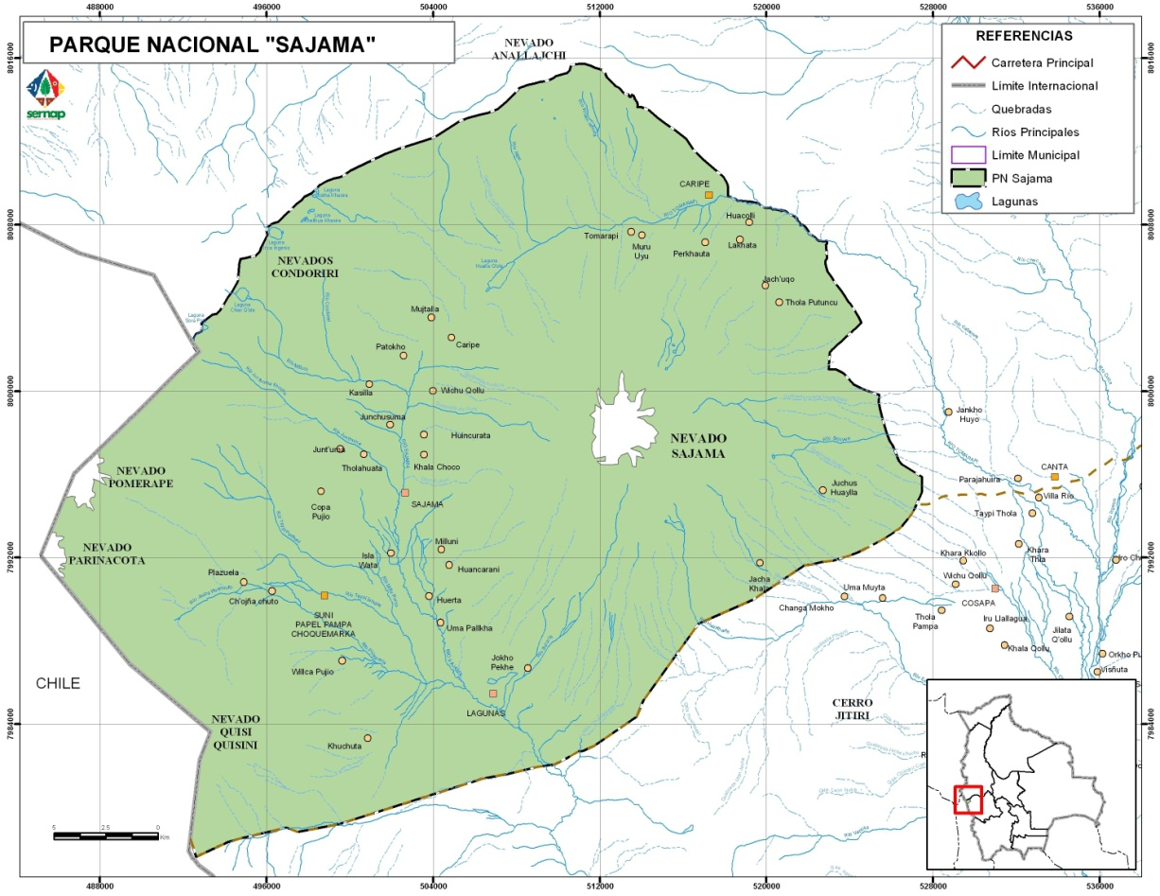
Fuente: Servicio Nacional de Áreas Protegidas de Bolivia (www.sernap.gob.bo)

6. Algunas valoraciones de la primera jornada
En relación a la exposición de las experiencias bolivianas de gestión sostenible de la biodiversidad expuestas durante la segunda parte de la jornada (vicuña, lagarto y turismo comunitario), el Secretario del CDB, Braulio Ferreira explicó que el Convenio trabaja, necesariamente, a demanda de las partes.
“Las cuestiones que ustedes están trabajando acá con las comunidades son muy interesantes para promover tanto la conservación como el uso sostenible de la biodiversidad. Es un tema que quizá no ha recibido toda la atención que merece por parte del Convenio y creo que esto se puede corregir. Se puede hacer mucho más en términos de movilización de apoyo internacional para apoyar este tipo de iniciativas”, señaló.
“Para eso —dijo— necesitamos que las partes indiquen esto como una prioridad. Un país como Bolivia con apoyo de otros países que tienen intereses semejantes pueden trabajar para colocar este tipo de demanda en una decisión de la COP solicitando iniciativas para que el Secretariado pueda consultar a diferentes organizaciones internacionales e identificar así qué tipo de mecanismos se pueden movilizar para apoyar estas iniciativas”.
Por otra parte, Ferreira comentó que un ámbito al que piensa dar más apoyo —en función de una de las metas de Aichi que promueve la ampliación de las áreas protegidas— es la gestión del programa de áreas protegidas incluyendo otras formas de conservación que puedan ser efectivas para la protección de la biodiversidad. “Estoy proponiendo una reunión durante la COP 11 en la que se pueda conocer la diversidad de iniciativas exitosas de distintos países en el trabajo de la promoción de la conservación y uso sostenible de la biodiversidad con las comunidades”, dijo.
Sin embargo, precisó que, en el marco del Convenio, cualquier proceso requiere de la iniciativa y la demanda de alguno de los países interesados para que se pueda iniciar la discusión y solicitar las reuniones técnicas y los informes especializados pertinentes.
Además del balance realizado por el Secretario del Convenio, como valoración de la primera jornadas se puede mencionar la abundancia de información proporcionada tanto acerca del CDB y de la agenda de la COP 11, como de las nociones teóricas y experiencias prácticas regionales sobre el aprovechamiento de las funciones ambientales, así como también sobre tres experiencias bolivianas vinculadas con una gestion integral de la biodiversidad con especial enfasis en la sustentabilidad y distribución equitativa de los beneficios entre las comunidades locales.
Además, durante la jornada prevaleció un tono de diálogo abierto, participación y crítica en relación a la información expuesta y a posiciones, como la expresada por Bolivia, contraria a la aplicación de esquemas de pago por servicios ambientales, REDD o REDD+.
Destacó también la posibilidad de escuchar y compartir distintas experiencias en relación a formas y alternativas para la conservación de la biodiversidad en cuanto a los mecanismos financieros que podrían operar.
Por último, cabe subrayar la manifiesta predisposición del Secretario del CDB para apoyar nuevas iniciativas de conservación de la biodiversidad relacionadas con la gestión compartida con las comunidades, siempre y cuando los países interesados incluyan estas demandas y cumplan con los requisitos para el trámite necesario establecidos en el Convenio.

segunda jornada
Experiencias sudamericanas, mesas de trabajo, plenaria y clausura

1. Panorama de las experiencias sudamericanas
1.1. Bolivia: mecanismo de mitigación y adaptación para el manejo integral y sustentable de los bosques y la madre tierra
Diego Pacheco, Asesor de la Cancillería de Bolivia,realizó un resumen del Mecanismo de Mitigación y Adaptación para el Manejo Integral y Sustentable de los Bosques y la Madre Tierra, planteado como una propuesta boliviana alternativa basada en la no mercantilización de las fundamentaciones ambientales, en su manejo integral y sustentable con énfasis en las prácticas productivas locales y tradicionales, en la promoción de las múltiples funciones del bosque y en la complementariedad de derechos, obligaciones y deberes.
[Descargar presentación completa: http://www.fundesnap.org/files/bolivia_mecanismo_mitigacion_y_adaptacion_para_manejo_integral.pdf]
El concepto de la Madre Tierra. Desde el punto de vista de Bolivia, la naturaleza no se puede considerar un stock de bienes o insumos, sino que la Madre Tierra debe entenderse como un sistema viviente conformado por una comunidad indivisible de todos los sistemas de vida y de los seres vivos, interrelacionados, interdependientes y complementarios que comparten un destino común. Por lo tanto, se considera que la Madre Tierra es sagrada pues alimenta y es el hogar que contiene, sostiene y reproduce todos los ecosistemas, la biodiversidad, las sociedades orgánicas y los individuos que la componen.
Posición de Bolivia ante la mercantilización de la naturaleza. En la Conferencia Mundial de los Pueblos sobre el Cambio Climático y los Derechos de la Madre Tierra (Cochabamba, Bolivia, abril de 2010), Bolivia expresó manifestó su oposición a los denominados mecanismos financieros: “Condenamos los mecanismos de mercado, como el mecanismo de REDD, y sus versiones + y ++, que están violando la soberanía de los Pueblos y su derecho al consentimiento libre, previo e informado, así como la soberanía de los Estados nacionales (…) y (que) violan los derechos, usos y costumbres de los Pueblos y los Derechos de la Naturaleza”.
Visión alternativa: Propuesta “Vida Sustentable del Bosque”. En este contexto de rechazo de los mecanismos financieros de la biodiversidad, Bolivia ha presentado una propuesta que se fundamenta en la no mercantilización de las funciones ambientales de los bosques, en su manejo integral y sustentable con énfasis en las prácticas productivas locales y tradicionales, en la promoción de las múltiples funciones de los bosques, en la complementariedad de derechos, obligaciones y deberes; y en el doble rol de los bosques en mitigación y adaptación. Esta propuesta es consistente con el enfoque basado en la no mercantilización de la naturaleza, presentado por Bolivia e incluido en las decisiones de la COP 17 (Durban, 2011).
Estructura organizativa de la propuesta boliviana. Ésta se inscribe en el Proyecto de Ley de La Madre Tierra y Desarrollo Integral para Vivir Bien, en proceso de discusión, y se articula a través de cuatro instancias:
- Una Autoridad Plurinacional de La Madre Tierra (en proceso de creación).
- Un mecanismo de mitigación y adaptación para el manejo integral y sustentable de los bosques y la Madre Tierra.
- Un mecanismo de adaptación.
- Un Fondo Plurinacional de la Madre Tierra.

Gráfico 5. Estructura organizativa del Mecanismo de Mitigación y Adaptación propuesto por Bolivia

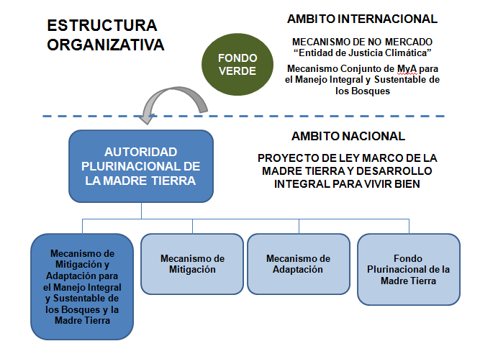
Fuente: Pacheco, Diego. Mecanismo de Mitigación y Adaptación para el Manejo Integral y Sustentable de los Bosques y la Madre Tierra (presentación, pdf).

Objetivo del Mecanismo de Mitigación y Adaptación para el Manejo Integral y Sustentable de los Bosques y la Madre Tierra. Este mecanismo tiene por objetivo promover el manejo integral y el aprovechamiento sustentable de los bosques y los ecosistemas de vida de la Madre Tierra, la conservación, protección y restauración de los sistemas de vida, el manejo, conservación y protección de la biodiversidad, y las funciones ambientales, facilitando usos óptimos del suelo a través del desarrollo de sistemas productivos sustentables.
Componentes del mecanismo. El primero de los tres componentes es la planificación y concertación a través de los Planes de Gestión Territorial o Planes de Vida, y de las metas comunes. El segundo componente es el Marco Operativo de Acción que considera los derechos, obligaciones y deberes, y las actividades de articulación, regulación, control y promoción. El tercer y último componente es el de monitoreo de los indicadores.
El desafío de desarrollar indicadores conjuntos. Sobre este aspecto, la propuesta incluye algunos indicadores preliminares como la presencia de incendios forestales (en el área de gestión de riesgos), la afectación a la salud humana (en el ámbito del desarrollo integral y medios de vida), la disponibilidad de agua y los cambios de uso de suelo (en el área de protección y conservación de las funciones ambientales del bosque) y las capacidades institucionales para el manejo local de bosques (en el ámbito de la autogestión).

participación: comentarios y preguntas/
—Doris Cordero, Oficial de Programa de UICN-Sur, realizó una pregunta concreta referida a si el mecanismo descrito en la presentación es una propuesta o si está en proceso de implementación.
Diego Pacheco, expositor, respondió que la aplicación del mecanismo requiere de un marco legal y que, en este sentido, actualmente se encuentra en discusión en la Cámara de Diputados de la Asamblea Plurinacional de Bolivia la propuesta de Ley de la Madre Tierra. Adicionalmente, explicó que se está trabajando en precisar distintos aspectos operativos y metodológicos para la aplicación del mecanismo descrito.

1.2. Argentina: instrumentos económicos para la conservación de la biodiversidad
Ana di Pangracio, de la Fundación Ambiente y Recursos Naturales (FARN) de Argentina, hizo un breve repaso de las distintas herramientas económicas aplicadas en este país para la conservación de la biodiversidad, en el marco de la Estrategia Nacional de la Biodiversidad aprobada en 2003. Pangracio repasó siete instrumentos distintos (fondos para conservación de bosques, exenciones impositivas, compensaciones por restricciones al uso y estrategia REDD, entre otros) y mencionó también algunos casos particulares calificando como de “baja prioridad para el país” estos instrumentos, a juzgar por el avance de las políticas públicas al respecto.
[Descargar presentación completa: http://www.fundesnap.org/files/argentina_lpb.pdf]
Estrategia Nacional de Biodiversidad (ENB) 2003. Esta estrategia se encuentra actualmente en proceso de revisión y actualización, y hace referencia a los incentivos económicos en distintos apartados, como, por ejemplo, en el referido al uso sostenible de recursos biológicos donde se promueve “la instauración de incentivos económicos que estimulen el uso sostenible de los recursos”. La ENB dedica todo un apartado a los aspectos económicos e incentivos para la conservación y el uso sostenible de la diversidad biológica con el objetivo general de desarrollar y aplicar incentivos que promuevan las buenas prácticas de gestión pública y privada.
Fondo Nacional para el Enriquecimiento y la Conservación de los Bosques Nativos (Ley 26.331 de Bosques Nativos). El objetivo de este fondo es compensar a las provincias que conservan los bosques nativos por los servicios que éstos brindan. El Fondo está integrado por varias partidas del presupuesto nacional (que no pueden ser inferiores al 0,3% del mismo), el 2% del total de las retenciones a las exportaciones de productos primarios y secundarios provenientes de la agricultura, la ganadería y el sector forestal; préstamos y/o subsidios otorgados por organismos nacionales e internacionales; donaciones y legados, y otros aportes menores.
Aplicación del Fondo. El 70% de los recursos del Fondo se aplican para conservar las tierras en cuya superficie se conservan bosques nativos, sean éstos públicos o privados, de acuerdo a las distintas categorías de conservación. El beneficio consiste en un aporte no reintegrable, abonado por hectárea y por año, teniendo los titulares la obligación de realizar y mantener actualizado un Plan de Manejo y Conservación de los Bosques Nativos. El 30% restante se destina a la Autoridad de Aplicación con fines de desarrollo y mantenimiento de una red de monitoreo y sistemas de información de sus bosques nativos, y para la implementación de programas de asistencia técnica y financiera destinados a la sustentabilidad de actividades no sostenibles desarrolladas por pequeños productores y/o comunidades indígenas y/o campesinas.
Exenciones impositivas en áreas protegidas privadas. Este instrumento consiste en la exención parcial o total de las cargas impositivas que graven los inmuebles, créditos de promoción, fomento, asesoramiento técnico o de otro tipo. Las provincias que han desarrollado en su sistema jurídico la conservación de la naturaleza en tierras de propiedad privada son: Buenos Aires, Catamarca, Chubut, Entre Ríos, Misiones Río Negro, Salta, San Juan y Santa Fe. Este mecanismo funciona a solicitud del propietario en la medida en que su predio tenga un interés científico particular o un especial atractivo por su belleza paisajística. En este sentido, las áreas protegidas privadas pasan a integrar el Sistema Provincial de Áreas Protegidas.
Compensaciones por restricciones al uso. Un ejemplo de esta modalidad, es el de la Reserva de la Biosfera Yabotí en la provincia de Misiones que abarca 253.773 hectáreas (ha), de las cuales 222.154 corresponden a tierras privadas cubiertas por bosques nativos. A efectos de compensar a los propietarios por la restricción de uso de esos bosques y tierras, se estableció que esa superficie quedaba eximida del pago del impuesto inmobiliario provincial (1 dólar/ha/año).
Compensaciones por pérdida de ganado. En la provincia de Misiones, el Plan Provincial de Conservación de Grandes Felinos establece compensaciones económicas a productores que sufran pérdidas de ganado por felinos, mediante la certificación pertinente de la autoridad a partir del valor de cotización de mercado del animal de la misma especie, según raza, edad, sexo y peso.
Estrategia REDD Argentina. Esta estrategia se encuentra aún en proceso de elaboración con fondos del Banco Mundial y su trámite adolece de serias deficiencias en la disponibilidad de información y participación pública.
Proyecto GEF 3623 de Incentivos para la Conservación de los Servicios Ecosistémicos de Importancia Global. A través de esta iniciativa, que dispone de 2,9 millones de dólares americanos, se busca ensayar mecanismos de compensación por los servicios que brindan diferentes ecosistemas naturales mediante el desarrollo de esquemas de Pago por Servicios Ecosistémicos (PSE) e intentando compatibilizar la conservación con la producción, adoptando prácticas de manejo sustentables y amigables con el medio ambiente. Los lugares piloto donde se ejecutará el proyecto se encuentran ubicados en las provincias del Chaco, Formosa, Entre Ríos y Jujuy.
Otros casos particulares. Para completar el panorama de los instrumentos de conservación de la biodiversidad aplicados en Argentina, se pueden mencionar varios casos particulares:
- Ley de Forestación: Instituye un régimen de promoción de las inversiones que se realicen en nuevos emprendimientos forestales y en las ampliaciones de bosques existentes.
- Alícuotas diferenciales a los derechos a la explotación: Esta modalidad fiscal se inició en 2002 aplicando el 13,5% y actualmente alcanza el 35% sobre la venta de soja a fin de promover la rotación de cultivos (maíz, trigo y sorgo).
- Incentivos perversos: Se aplica, por ejemplo, a la caza de animales que afectan a determinadas producciones. En la provincia de Río Negro se pagan, aproximadamente, 100 dólares americanos por cada ejemplar de puma muerto pues este felino está considerado una plaga debido a los daños que provoca a la ganadería ovina y vacuna.
- Agricultura orgánica: Existen pequeñas ayudas del Ministerio de Agricultura y un programa de formación de asesores para la producción de alimentos orgánicos. Sin embargo, recientemente se presentó el Plan Estratégico Agroalimentario que prevé incrementar la producción de granos hasta 160 millones de toneladas en 2020 (actualmente, la producción es de 100 millones de toneladas) incrementando la superficie cultivada de 34 a 42 millones de hectáreas. Sin embargo, no se menciona cuál es el impacto ambiental de esta expansión agrícola.
Valoración final. En base al último informe nacional sobre la Estrategia Nacional de la Biodiversidad (ENB), aprobada en 2003, presentado ante el CDB en 2010, se puede afirmar que la adopción de incentivos para la conservación de la biodiversidad tiene una prioridad baja para el país debido, principalmente, a la falta de voluntad y apoyo político.

participación: comentarios y preguntas/
—Jessica Díaz, del Ministerio de Relaciones Exteriores de Argentina, precisó que la Estrategia de la Biodiversidad de este país se encuentra, actualmente, en proceso de actualización. Asimismo, señaló que se ha conformado una Comisión Nacional de la Biodiversidad que está integrada por el Estado, las organizaciones indígenas, las cámaras empresariales y los sindicatos. Esta Comisión estudia, entre otros aspectos, las distintas oportunidades de financiamiento de la biodiversidad.

1.3. Brasil: mecanismos financieros, acciones en curso en el ministerio de de medio ambiente
Sergio Henrique Collaço de Carvalho, del Ministerio de Medio Ambiente de Brasil, abordó cuatro mecanismos financieros ambientales que se aplican actualmente en ese país, entre los que destacan el “TEEB Brasil” y la compensación por impactos ambientales significativos. Explicó también el cuso del diálogo Unión Europea-Brasil para el uso de servicios ambientales como un instrumento de políticas públicas.
[Descargar presentación completa: http://www.fundesnap.org/files/brasil_lpb.pdf]
Cuatro mecanismos financieros en curso. La Economía de los Ecosistemas y de la Biodiversidad “TEEB Brasil”, la compensación por un impacto ambiental significativo, las estimaciones de la demanda económica futura y el Pago por Servicios Ambientales (PSA) son las cuatro iniciativas actualmente activas.
Economía de los Ecosistemas y de la Biodiversidad, “TEEB Brasil”. El objetivo de esta iniciativa es identificar los beneficios económicos derivados de la conservación y uso sostenible de la biodiversidad y de los servicios ecosistémicos en el país, así como la evaluación del costo de su pérdida. El TEEB Brasil está dividido en cuatro componentes —formulación de políticas nacionales, sector negocios, ciudadanos y gobiernos locales y regionales— y es una iniciativa conjunta entre el Ministerio de Medio Ambiente de Brasil, el Instituto de Investigación Económica Aplicada de Brasil (IPEA, por sus siglas en portugués), el Programa de Naciones Unidas para el Medio Ambiente (PNUMA), Conservación Internacional (CI), la Agencia de Cooperación Técnica Alemana (GIZ), la Unión Internacional para la Conservación de la Naturaleza (UICN) y el Ministerio de Hacienda de Brasil.
Compensación por un impacto ambiental significativo. En Brasil, cualquier emprendimiento que está sujeto a una licencia ambiental debe apoyar la implementación de Unidades de Conservación. El monto aplicado varía en función del impacto de las actividades hasta un máximo de 0,5% del costo del proyecto. Esto implica valores significativos de hasta 40 millones de reales (19,8 millones de dólares americanos, aproximadamente) los proyectos más grandes.
Estimaciones de la demanda económica futura. Los recursos económicos requeridos para la conservación de las Áreas Protegidas en Brasil son, estimativamente, 250 millones de dólares americanos anuales. Por otra parte, las necesidades calculadas para Fondo para el Medioambiente Global 6 (GEF 6) alcanzan los 197 millones de dólares americanos. Como un elemento de contexto, cabe señalar que el Plan Estratégico de Biodiversidad 2020 de Brasil está en etapa de elaboración.
Pago por Servicios Ambientales (PSA). Existen varios proyectos de ley para aplicar este mecanismo que se encuentran en la Cámara de Diputados y que tienen el objetivo general de establecer una compensación o pago a quienes realizan esfuerzos para conservar o desarrollar los servicios de los ecosistemas. Los términos esenciales establecidos hasta ahora son:
- Identificación del demandante y del proveedor.
- Descripción de los servicios ambientales.
- Delimitación del ecosistema o área responsable de los servicios ambientales.
- Vinculación de ésta área con el proveedor.
- Precios y otras formas de pago.
- Eventuales criterios de bonificación para el proveedor que alcance un desempeño socioambiental superior al previsto en el contrato.
Diálogo Unión Europa-Brasil sobre servicios ambientales. Este diálogo tiene el propósito de construir una base de referencia para orientar una decisión sobre el uso de PSA como instrumentos de políticas públicas ambientales en Brasil, identificando posibilidades de cooperación con la Unión Europea en este tema. Como producto de este diálogo se han elaborado dos documentos: un análisis de cinco experiencias internacionales de PSA en políticas públicas y una sistematización del Estado del Arte de experiencias de PSA en Brasil comparadas con casos internacionales. Estos documentos están disponibles en: http://www.aprendizagempsa.org.br/biblioteca



Portada del documento Pago por servicios ambientales en el bosque Atlántico. Lecciones aprendidas y desafíos. Disponible en: http://www.mma.gov.br/
Fuente: Collaço de Carvalho, Sergio Henrique. Mecanismos Financieros. Acciones en curso en el Ministerio de Medio Ambiente de Brasil (presentación, pdf).

1.4. Ecuador: cambio del paradigma, el “buen vivir”
Diego Mogollón, de la Secretaría Nacional de Planificación y Desarrollo del Ecuador (SENPLADES) explicó los cambios en las políticas de preservación de la naturaleza a partir del paradigma del “Buen Vivir” que orientó la nueva Constitución (2008) y el Plan Nacional de Desarrollo (PND) 2009-2013. A partir de la propuesta de una política pública ambiental en base a la combinación de enfoques integrados, la presentación se centró en los contenidos y la ejecución del Programa Socio Bosque y concluyó con la mención de algunas otras líneas de acción para la conservación ambiental.
[Descargar presentación completa: http://www.fundesnap.org/files/ecuador_lpb_.pdf]
El paradigma de “Buen Vivir”. Las políticas de preservación de la naturaleza que se ejecutan en Ecuador tienen que ver con un contexto político de cambios caracterizado por la definición de un nuevo Estado, la aprobación de una nueva Constitución (2008), la puesta en marcha del Plan Nacional de Desarrollo (PND) 2009-2013 y, en general, con el paradigma del “Buen Vivir”, asociado a una vida plena, a la unidad en la diversidad, a la armonía con el medio ambiente, a la aplicación de derechos, libertades, oportunidades y potencialidades, y a un porvenir justo y compartido.
La naturaleza en la nueva Constitución. El artículo 276 de la Constitución aprobada en 2008 establece la necesidad de “recuperar y conservar la naturaleza y mantener un ambiente sano y sustentable que garantice a las personas y colectividades el acceso equitativo, permanente y de calidad al agua, aire y suelo, y a los beneficios de los recursos del subsuelo y del patrimonio natural”. Por otra parte, en el PND se consigna el objetivo de “garantizar los derechos de la naturaleza y promover un ambiente sano y sustentable”.
Combinación de enfoques integrados en la política pública ambiental. El diseño de políticas públicas a partir de la evaluación de los servicios ecosistémicos conlleva:
- La planificación del desarrollo. A partir de distintas etapas: transición energética, transición post extractivista y cambio de la matriz productiva e innovación para la diversificación económica.
- Incentivos económicos para la sostenibilidad, con un enfoque redistributivo e inclusivo. Entre los que se consideran los PSA a nivel local y nacional, los incentivos fiscales para una producción limpia y la provisión de servicios ecosistémicos globales con esquemas internacionales de compensación.
- Incentivos fiscales para una producción más limpia.
Objetivos del Programa Socio Bosque. Este programa forma parte del sistema de incentivos para la conservación de los bosques nativos y sus objetivo son proteger los bosques y su valor ecológico, económico y cultural; reducir las tasas de deforestación y la emisión de gases de efecto invernadero; y mejorar las condiciones de vida de las poblaciones rurales (aproximadamente, 1 millón de beneficiarios).
Cómo funciona el Programa Socio Bosque. Consiste en el pago de un incentivo condicionado a la conservación y protección de los ecosistemas. Se trata de un compromiso voluntario. Participan los propietarios de bosque nativo, páramos y otras formaciones vegetales, por lo que los beneficiarios pueden ser personas naturales, comunas legalmente constituidas, pueblos y nacionalidades indígenas o cooperativas y asociaciones. El monto que se paga depende de la extensión de la superficie, del tipo de ecosistema y del tipo de beneficiario (ver Gráfico 7) oscilando entre 0,50 y 60 dólares americanos por hectárea.
Gráfico 6. Estructura de incentivos del Programa Socio Bosque (en dólares americanos)
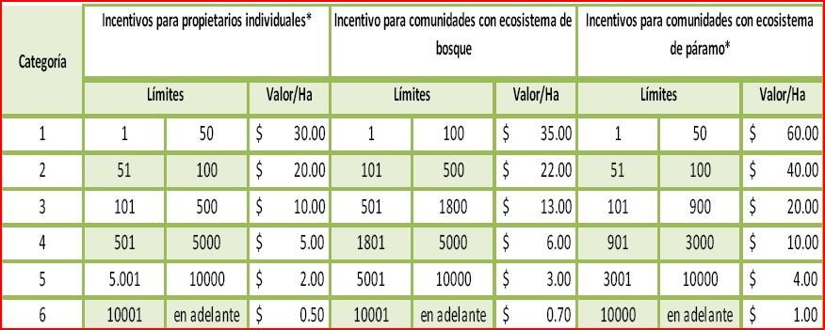
Fuente: Mogollón, Diego. Cambio de paradigma al “Buen Vivir” (presentación, pdf).

Criterios de priorización y obligaciones de los beneficiarios. Este programa prioriza las áreas con alta amenaza de deforestación, las áreas relevantes para la generación de servicios ambientales y también aquellas que registran altos niveles de pobreza. Por otra parte, los beneficiarios tienen la obligación de no talar en el área de conservación, no cambiar el uso de suelo, no realizar quemas, no cazar con fines comerciales o deportivos y no realizar actividades que alteren el comportamiento natural o que amenacen la capacidad de dar refugio a la biodiversidad.
Resultados del Programa Socio Bosque y financiamiento. Se suscribieron 2.563 convenios; las hectáreas bajo conservación son 883.223; los beneficiarios 90.162 y el monto anual de incentivos es de 6,1 millones. Actualmente, el financiamiento de Socio Bosque depende enteramente de los recursos fiscales, sin embargo, se están estudiando fuentes de la cooperación bilateral, posibles mecanismos REDD+ y otros sectores privados a nivel nacional.
Otras líneas de acción para la conservación ambiental. Además del Programa Socio Bosque, también se está trabajando en otras líneas, entres la que se pueden mencionar:
- La valoración ambiental en cuencas hidrográficas transfronterizas con Perú.
- La valoración económica de la biodiversidad en la cordillera del Cóndor.
- La valoración del manglar versus la producción acuícola del camarón.

1.5. Chile: situación y perspectivas de gestión de las áreas protegidas
Pamela Fernández, del Ministerio de Medio Ambiente de Chile, describió la situación de la Estrategia Nacional de Diversidad Biológica (ENDB) explicando el funcionamiento del Sistema Nacional de Áreas Protegidas (SNAP), su tipología, sus fortalezas y debilidades, el gasto público en este rubro, el financiamiento actual y las estrategias financieras para estas áreas y para la biodiversidad, en general.
[Descargar presentación completa: http://www.fundesnap.org/files/chile_lpb.pdf]
Breve contexto. En 1994, Chile ratificó el CDB y en 2003 elaboró su Estrategia Nacional de Diversidad Biológica (ENDB) que, actualmente (2012-2013) se encuentra en proceso de actualización. Hoy, en Chile existen 15,7 millones de hectáreas que corresponden a Áreas Protegidas; esto representa, aproximadamente, un 20,8% de la superficie continental e insular.
Tipología de Áreas Protegidas. En Chile existen nueve tipos de Áreas Protegidas: parques nacionales, reservas nacionales, monumentos naturales, bienes nacionales protegidos, santuarios de la naturaleza, sitios Ramsar, áreas marinas costeras protegidas, reservas marinas y parques marinos. También existen iniciativas de conservación privada. Estas áreas se inscriben en un marco regulatorio constituido básicamente por leyes y decretos supremos, y las entidades relacionadas con su gestión y conservación son, variando en cada caso, los ministerios de Economía, de Bienes Nacionales, de Agricultura y de Educación, la Corporación Nacional Forestal, la Corporación Nacional de Humedales y el Consejo de Monumentos Nacionales.
Fortalezas del Sistema de Áreas Protegidas (SNAP). La magnitud de la superficie bajo protección oficial en el ámbito terrestre, la antigüedad del Sistema de Áreas Protegidas, la diversidad de ambientes protegidos en el ámbito terrestre, la existencia de un marco político y estratégico acorde para impulsar la protección de la biodiversidad, el proyecto de ley para crear el Servicio de Biodiversidad y Áreas Protegidas y la Ley de Turismo (2010) con las fortalezas más relevantes del sistema.
Debilidades del SNAP. La ausencia de un cuerpo legal único que regule las áreas protegidas, la carencia de un marco legal e incentivos para las áreas protegidas privadas, el desbalance territorial en la representatividad ecosistémica de las distintas áreas, la bajísima protección y la falta de información de línea base de los ecosistemas costeros-marinos, los frecuentes conflictos de uso, la ausencia de conciencia de los valores económicos de la biodiversidad y la insuficiencia de recursos financieros para su mantención y administración son las principales debilidades del sistema.

Gasto público en las áreas protegidas. El hecho de que no se invierte lo suficiente en la preservación de la biodiversidad se puede ilustrar con los datos acerca del gasto público (en dólares americanos por hectárea) en el sistema de áreas protegidas. Mientras que en Costa Rica este gasto es de 16,47 dólares americanos/ha, en Chile es de 0,96 (ver Gráfico 8). Es decir, el Estado chileno gasta menos de un dólar por hectárea para la protección de la biodiversidad.

Gráfico 7. Gasto público en Áreas Protegidas (AP) (en dólares americanos por hectárea)
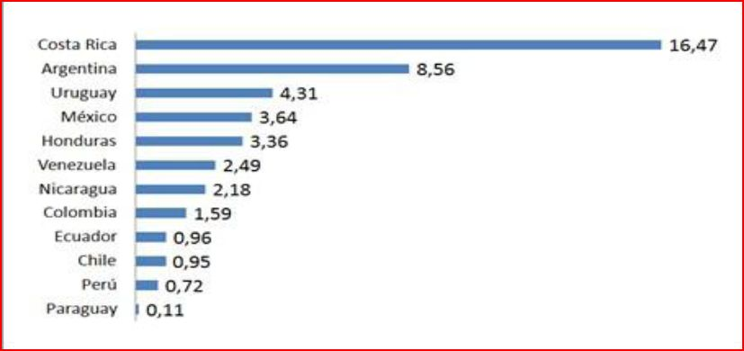
Fuente: Pacha, M.J. (2010). En: Fernández, Pamela. Chile: Taller Mecanismos Financieros de Apoyo para la Conservación de la Biodiversidad (presentación, pdf).

Financiamiento actual del SNAP. De acuerdo al Presupuesto 2010 del SNAP, el 82% del los recursos aportados proviene del Estado y el 18% restante de las propias Áreas Protegidas. En 2010, el presupuesto total disponible fue de 21,9 millones de dólares americanos, proviniendo casi el 50% de la Corporación Nacional Forestal de Chile (CONAF).
Estrategias financieras para la Biodiversidad y el SNAP. El Proyecto de Ley del Servicio de la Biodiversidad y Áreas Protegidas establece la creación de un Fondo Nacional. Por otra parte, asociado a la Ley de Turismo, existe un Reglamento de Concesiones Turísticas en AP del Estado. También hay que considerar la Ley de Recuperación del Bosque Nativo, el Proyecto GEF-SNAP de “Diseño Operativo de una Estrategia de Financiamiento de Mediano y Largo Plazo para el SNAP de Chile” y la elaboración de una propuesta para establecer Bancos de Conservación en biodiversidad.

1.6. Colombia: generalidades sobre las herramientas financieras y no financieras para la gestión ambiental
María Isabel Vieira-Muñoz, del Instituto de Investigación de Recursos Biológicos Alexander von Humboldt de Colombia, se refirió a la Política Nacional para la Gestión Integral de la Biodiversidad y sus Servicios Ecosistémicos (PNGIBSE), enfocándose, sobre todo, en el eje referido a la biodiversidad, el desarrollo económico, la competitividad y la calidad de vida. La presentación subrayó el concepto de “valoración integral” de la biodiversidad y concluyó presentando dos casos de estudio.
[Descargar presentación completa: http://www.fundesnap.org/files/colombia_lpb.pdf]
Política Nacional para la Gestión Integral de la Biodiversidad y sus Servicios Ecosistémicos (PNGIBSE). El objetivo de esta política es promover la gestión integral para la conservación de la Biodiversidad y de sus Servicios Ecosistémicos, de manera que se mantenga y mejore la resiliencia de los sistemas socio-ecológicos, así como también se oriente el uso y ocupación del territorio a escala nacional, regional y local, considerando escenarios de cambio y a través de la acción conjunta, coordinada y concertada del Estado, el sector productivo y la sociedad civil.
Marco conceptual de la PNGIBSE. Algunos elementos destacados del marco conceptual son:
- La aproximación socio-ecosistémica.
- El reconocimiento de la resiliencia, de los estados y umbrales de estabilidad y cambio de los socioecosistemas.
- El reconocimiento de que el suministro de los servicios ecosistémicos depende de la biodiversidad.
- La conservación entendida como resultado de las acciones de preservación, uso sostenible, restauración y generación de conocimiento e información.
- El reconocimiento de la validez de los diferentes sistemas de conocimiento.
- La identificación de impulsores directos de transformación y pérdida de la Biodiversidad (como el Cambio Ambiental).
- La identificación de los conflictos socioambientales como uno de los ejes transversales de la gestión en biodiversidad.
Ejes temáticos del PNGIBSE. Esta política nacional tiene seis ejes temáticos vinculados a la biodiversidad: Protección y cuidado de la naturaleza (I); Gobernanza y creación de valor público (II); Desarrollo económico, competitividad y calidad de vida (III); Gestión del conocimiento, tecnología e información (IV); Gestión del riesgo y suministro de servicios ecosistémicos (V); Biodiversidad, corresponsabilidad y compromisos globales (VI).
Biodiversidad, desarrollo económico, competitividad y calidad de vida. Este eje temático del PNGIBSE (el tercero) incorpora la biodiversidad y el suministro de servicios ecosistémicos en la planificación y toma de decisiones sectoriales para generar corresponsabilidad en acciones de conservación y valoración integral (económica y no económica), permitiendo mantener la sostenibilidad de las acciones de producción, extracción, asentamiento y consumo, y el mejoramiento de la calidad de vida. Esta valoración debe ser integral y considerar variables no económicas de la biodiversidad.
Líneas estratégicas. En primer lugar, es necesario desarrollar esquemas e instrumentos de valoración integral de la biodiversidad y de sus servicios ecosistémicos. También se requiere incorporar y mantener sistemas de conservación de la biodiversidad en los sistemas productivos y extractivos. De igual forma, es importante identificar y evaluar los costos y beneficios económicos, ecológicos, culturales y sociales a largo plazo derivados de la relación entre las actividades productivas y el mantenimiento de los servicios ecosistémicos de la biodiversidad. Por último, se precisa fortalecer las actividades y la institucionalidad relacionadas con la evaluación de los impactos ambientales, con la recuperación de pasivos ambientales y con la asignación de compensaciones ambientales por pérdida de biodiversidad.
Dos casos de estudio. Los casos de la Cuenca Alta del río Otún y del Páramo del Rabanal han sido estudiados con el propósito de identificar las necesidades de información para la valoración integral de los servicios ecosistémicos. En esta línea, se ha realizado diagnósticos y una propuesta de aproximación metodológica para la inclusión de los servicios ecosistémicos en la planificación territorial.

Gráfico 8. Ejes temáticos de la Política Nacional para la Gestión Integral de la Biodiversidad y sus Servicios Ecosistémicos (PNGIBSE) de Colombia
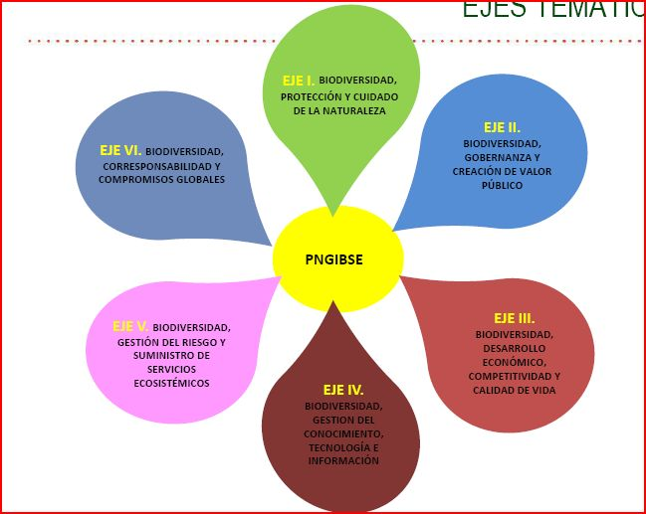
Fuente: Vieira-Muñoz, María Isabel. Generalidades sobre las herramientas financieras y no financieras para la gestión ambiental en Colombia (presentación, pdf).

1.7. Paraguay: avance en la implementación de mecanismos financieros para la conservación
Patricia Abed, del Instituto de Derecho y Economía Ambiental (IDEA) de Paraguay, explicó el contenido de la Ley de Retribución de Servicios Ambientales, aprobada en 2006, que establece la otorgación de certificados de servicios ambientales cuyo funcionamiento como títulos-valor permite que éstos sean negociados libremente, en el marco de las disposiciones legales.
[Descargar presentación completa: http://www.fundesnap.org/files/paraguay_lpb.pdf]
Situación de contexto. Ante una situación de grave pérdida de la masa boscosa en la Región Oriental del Paraguay, se llegó a una moratoria legal en el otorgamiento de nuevas autorizaciones de desmonte con fines de cambio de uso de suelo y de asentamiento de poblaciones, mediante la Ley 2524/04. Esta ley se convirtió en un éxito rápidamente pues, entre otras consecuencias, tanto desde el sector público como desde el privado se empezó a exigir la Declaración de Impacto Ambiental tanto para el otorgamiento de autorizaciones o préstamos, así como también se registró un mayor cumplimiento de las disposiciones legales por parte de los predios agropecuarios para evitar que sean declarados latifundios improductivos y, en consecuencia, sujetos a la reforma agraria.
Superficies destinadas a los servicios ambientales. Sin embargo, si bien la ley mencionada anteriormente consiguió reducir significativamente los índices de deforestación, también generó la queja de los propietarios que habían conservado bosques por encima de las exigencias legales por lo que exigían una compensación. Como el Estado no disponía de recursos, la solución consistió en reconocer las superficies adicionales a la reserva legal de bosques como áreas destinadas a servicios ambientales que pudieran ser objeto de transacciones comerciales.
Ley de Retribución de Servicios Ambientales (LRSA). Con estos antecedentes, en 2006 se aprobó la LRSA con el objetivo de propiciar la conservación, protección, recuperación y desarrollo sustentable de la diversidad biológica, a través de la valoración y retribución justa, oportuna y adecuada de los servicios ambientales. La ley define los servicios ambientales como aquellos generados por las actividades humanas de manejo, conservación y recuperación de las funciones del ecosistema que benefician en forma directa o indirecta a las poblaciones. La ley pretende retribuir una actividad humana dirigida a manejar, conservar y recuperar las funciones de los ecosistemas porque, implícitamente, se reconoce que estas actividades conllevan un costo económico.
Mecanismo de funcionamiento de la ley. La ley establece que quienes deseen ingresar al régimen de servicios ambientales deberán contar con la declaración de impacto ambiental; que la adhesión a este régimen no podrá ser inferior a cinco años; que quienes contribuyan a la generación de servicios ambientales tendrán derecho a una retribución; que el Poder Ejecutivo establecerá el valor de los servicios ambientales y que se emitirá un certificado de servicios ambientales.
Certificado de servicios ambientales. Éste es un título-valor libremente negociable por quienes no están obligados a invertir en servicios ambientales. En este sentido, la ley establece tres categorías de personas obligadas a adquirir certificados de servicios ambientales:
- Los titulares de proyectos, obras o actividades de alto impacto ambiental.
- Los condenados por daño ambiental.
- Quienes no hayan cumplido con el requisito de reserva legal establecido en la ley forestal.
Atribución del Estado. En este régimen, la atribución del Estado se limita a certificar las áreas destinadas a servicios ambientales y a permitir la compensación de hasta un 50% de lo que se adeudara en tributos nacionales o locales mediante certificados de servicios ambientales. Por lo tanto, el mecanismo de retribución por servicios ambientales establecido en la ley es, primordialmente, compensatorio. Se trata de un sistema por el cual los oferentes de servicios ambientales pueden negociar los certificados con quienes los requieran de acuerdo a las tres categorías descritas en el párrafo anterior y además, con quienes estuvieran interesados en invertir en servicios ambientales por un ánimo conservacionista o, tal vez, meramente especulativo.
Circunstancias políticas de la Ley de Retribución de Servicios Ambientales. Si bien esta ley se aprobó en 2006, su aplicación estuvo en la práctica “congelada” hasta la destitución del Presidente Fernando Lugo, el 22 de junio de 2012. Desde entonces, se ha reactivado el interés político por esta disposición legal y se está trabajando en su reglamentación. No obstante, su aplicación genera opiniones encontradas entre quienes critican o apoyan la aplicación de mecanismos de “libre mercado” para la conservación de la biodiversidad.

2. Mesas de trabajo
Después de las distintas ponencias generales y de las exposiciones sobre las diversas experiencias en los países de la región, se organizaron tres mesas de participación y debate con el propósito de compartir, intercambiar, conversar y tratar de señalar líneas de interés común respecto a las cuestiones propuestas. Los ejes centrales de cada una de las mesas fueron los siguientes:
- Mesa 1: Mecanismos financieros priorizados como región para la COP 11.
- Mesa 2: Mecanismos financieros actuales y desafíos de su implementación.
- Mesa 3: Instancias regionales de apoyo a mecanismos financieros.
Como se puede observar en los ejes temáticos, el centro del trabajo de los grupos fueron los mecanismos financieros en relación a las prioridades de la región, a los requerimientos institucionales, presupuestarios y administrativos para su implementación y a las instancias regionales que pueden viabilizar la aplicación de dichos mecanismos y, particularmente, las diferentes visiones y alternativas metodológicas que deben caracterizar a estos mecanismos según las realidades y enfoques de los Estados.
Metodológicamente, el criterio no fue sujetarse estricta y únicamente a las preguntas señaladas sino utilizarlas para estimular la participación plural y el intercambio muto de información, opiniones y puntos de vista privilegiando la diversidad de voces y el señalamiento de algunas ideas, planteamientos, propuestas o sugerencias con cierto nivel de cohesión colectiva.
Para ello se intentó que las mesas estuvieran integradas por participantes del mayor número de países posibles. Esto no significa, sin embargo, que las exposiciones presentadas por los tres grupos en la plenaria representaran conclusiones cerradas y unánimes y, tampoco, la voz oficial de los distintos países. Por lo tanto, el valor del trabajo en las mesas fue, sobre todo, compartir y apuntar propuestas, ideas e inquietudes orientadas por un mismo objetivo: conservar la biodiversidad.

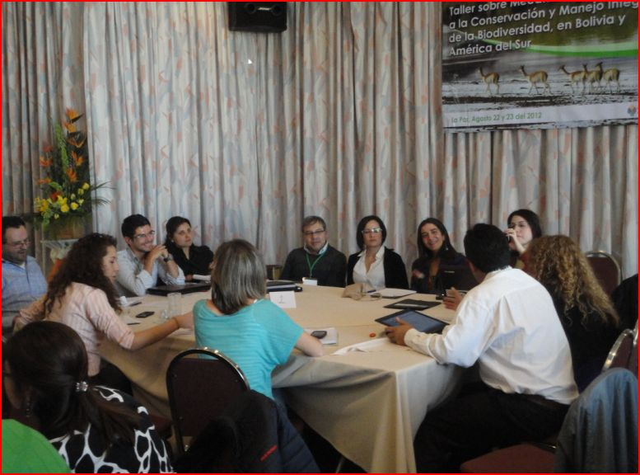
Mesa de trabajo 1, los grupos estuvieron integrados por participantes de diversos países.
Foto: FUNDESNAP.

2.1. Mesa 1: Mecanismos financieros priorizados como región para la COP 11
Las cuatro preguntas formuladas para motivar el debate y el intercambio en esta mesa fueron las siguientes:
- ¿Cuáles son los temas de mayor interés para los países sudamericanos respecto de los mecanismos financieros para la COP11?
- ¿Qué mensajes desde la región sudamericana al respecto de este tema se podrían llevar a la COP11?
- ¿Cómo se podría incidir a nivel internacional al respecto de estos mensajes en la región?
- ¿Qué deberían esperar los países de América del Sur al respecto de las decisiones sobre este tema para la COP11? (por ejemplo, respecto a los temas de necesidad de financiamiento).
Sin seguir al pie de la letra el orden de las preguntas planteadas, el diálogo y las intervenciones en la mesa se sucedieron libremente marcando algunos ámbitos o líneas de interés comunes. En primer lugar, desde distintas perspectivas, se manifestó la insuficiencia de las capacidades institucionales de los Estados para gestionar adecuadamente la biodiversidad. En este sentido, se mencionó la necesidad de disponer de estándares, indicadores y estimaciones presupuestarias adecuadas, en niveles nacionales, fortaleciendo además el conocimiento, la información y los instrumentos técnicos estatales para que las políticas públicas tengan consistencia y continuidad, y para que no queden aisladas en ciertos ministerios o reparticiones.
Otro ámbito de interés y coincidencia fue la preocupación en relación a la eficiencia y eficacia de los mecanismos financieros aplicados hasta hoy. Así, se cuestionó la lógica de las compensaciones pues, muchas veces, es contraproducente, y se señaló que es preciso poder medir y cuantificar de mejor manera el efecto real que estas iniciativas tienen en la conservación de la biodiversidad (algo que, en muchas ocasiones, no se llega a saber a ciencia cierta). En esta misma línea, se recomendó avanzar en alternativas y mecanismos financieros que sean menos burocráticos, más efectivos y cuyo proceso de aplicación se simplifique.
Por último, otro escenario de interés común fue el de la mejora de los marcos normativos y regulatorios. Sobre este aspecto, se señaló, por ejemplo, que la actividad de los agentes privados en relación a la conservación no puede depender, únicamente, del voluntarismo o la denominada “responsabilidad social” sino que deben implementarse normativas públicas concretas que regulen esta responsabilidad con el medio ambiente. De igual forma, se señaló a la actividad económica “informal” o de pequeña escala (la pequeña minería, por ejemplo) como un factor de alto impacto ambiental que, sin embargo, por lo general, opera al margen de la regulación y el control estatal. Al margen de estos tres ámbitos generales de interés relativamente más comunes, la mesa se caracterizó por un diálogo abundante en alusiones a situaciones particulares de cada país.

2.2. Mesa 2: Mecanismos financieros actuales y desafíos de su implementación
Se plantearon cuatro cuestiones para propiciar el diálogo entre los distintos participantes de la mesa:
- ¿Cuáles se consideran como los mecanismos financieros más apropiados al contexto sudamericano?
- ¿Qué limitaciones tienen estas herramientas al momento de su aplicación?
- ¿Qué otro tipo de mecanismos se deberían considerar para la aplicación de estas herramientas financieras?
- ¿Cuáles son las experiencias y lecciones aprendidas respecto a la aplicación de estos mecanismos financieros en Sudamérica?
Desde distintos puntos de vista y experiencias, en el diálogo se manifestó la pluralidad de opciones respecto a los mecanismos financieros dependiendo de las condiciones biológicas, ambientales, sociales y políticas de cada país. En este sentido, la gama de alternativas es amplia —desde compensaciones por mitigación asociada a grandes obras, hasta exenciones fiscales y esquemas tipo PSA o REDD— y su aplicación depende de cada contexto particular.
Un punto coincidente en el diálogo fue el señalamiento a la carencia, en mayor o menor medida, de marcos legales adecuados, recursos suficientes y autoridades con las competencias y la fortaleza institucional para ejecutar y aplicar la norma. Otro elemento que se mencionó de manera reiterada fue la necesidad de un mayor compromiso e inversión de las empresas que explotan recursos naturales —sobre todo, en los rubros de minería e hidrocarburos— con las acciones de remediación y conservación.
Una última línea de interés común fue la articulación de los distintos niveles político-administrativos de cada Estado para trabajar coordinadamente desde lo local, regional y nacional las necesidades de la biodiversidad.

2.3. Mesa 3: Instancias regionales de apoyo a mecanismos financieros
Las preguntas sugeridas para desarrollar el coloquio entre los participantes fueron las siguientes:
- ¿Qué oportunidades existen actualmente para la aplicación de mecanismos financieros a nivel sudamericano?
- ¿Qué mecanismos se pudieran considerar como prioritarios para una aplicación a nivel regional?
- ¿Qué tipo de recursos (técnicos, humanos y financieros, entre otros) se necesitan para la aplicación de estos mecanismos a nivel regional?
- ¿Cómo se podría lograr incidir en las instancias regionales (como la CAN, el MERCOSUR o la OTCA) para la implementación de estos mecanismos?
Un tema de acuerdo general fue que se considera indispensable la creación de un Fondo Regional con agenda y estrategia propias que permitan atender las necesidades de financiamiento de las distintas iniciativas regionales. Sobre este punto, la Secretaría del Convenio señaló su disposición a apoyar la creación de este fondo.
Por otra parte, también de manera general se coincidió en la urgencia de fortalecer y desarrollar todo tipo de capacidades (técnicas, humanas, normativas, etcétera) si se quieren aprovechar las oportunidades que representa la vigencia del CDB. En este sentido, se planteó como un imperativo la convocatoria a trabajar de manera coordinada a nivel regional superando las visiones estrictamente nacionales.
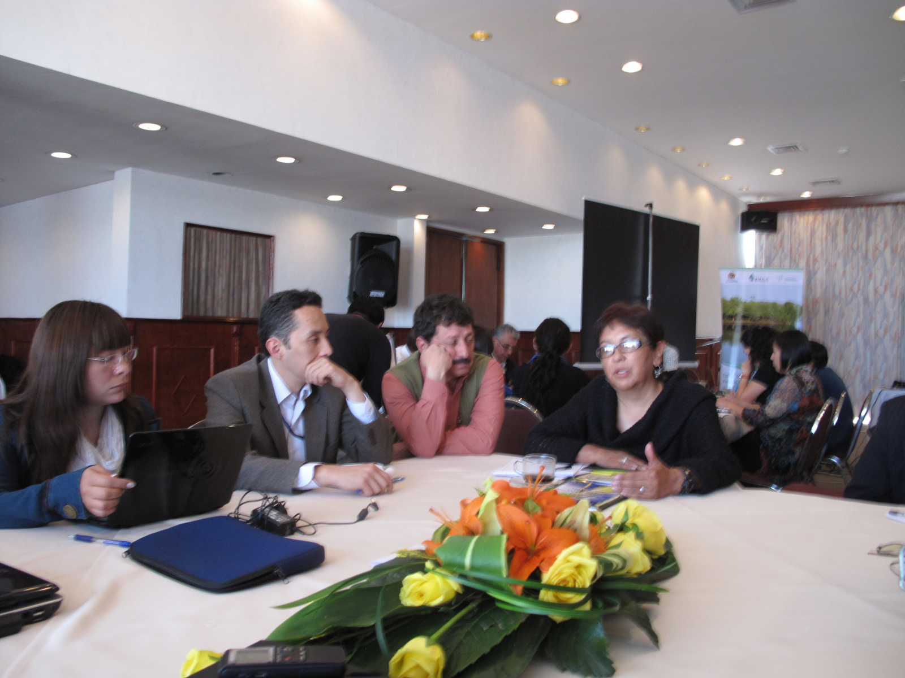
El tercer grupo de trabajo debatió en torno a las oportunidades actuales para la aplicación de mecanismos financieros en la región.
Fotografía: FUNDESNAP.

3. Plenaria
Después del trabajo en cada una de las tres mesas, se realizó una sesión conjunta en la que se presentaron los planteamientos de cada grupo y se generó un intercambio final general, a partir de intervenciones, comentarios y preguntas.
Las exposiciones de cada mesa trataron de reunir los puntos, lineamientos y sugerencias expresados en cada grupo sin que éstos expresen una conclusión unánime de los participantes ni tampoco la postura oficial de los distintos países concurrentes. De tal manera que lo expresado en estas mesas tuvo un propósito referencial y un alcance que, a partir de la sistematización del taller, pretende contribuir informativamente en otros escenarios y reuniones. Para ello también se incluyen en este documento la participación y los comentarios de los participantes del taller después de cada presentación.

a) Mesa 1: Mecanismos financieros priorizados como región para la COP 11
Como resultado del trabajo de los participantes de este grupo, se presentó un conjunto de 20 planteamientos, ideas o sugerencias generales que, según se dijo, no constituyen conclusiones consensuadas sino, más bien, lineamientos anotados como producto del debate y del diálogo en la Mesa 1.
En este sentido, los 20 puntos señalados no responden específica y ordenadamente a cada una de las preguntas de la mesa sobre los mecanismos financieros que se deben priorizar para la COP 11 sino abordan cuestiones y preocupaciones de orden más general entorno a la conservación de la naturaleza, como, por ejemplo, la necesidad de un enfoque que considere la integralidad de los recursos, la mejora de estándares o indicadores, la continuidad de las políticas públicas, el intercambio regional, el déficit general en el financiamiento de las áreas protegidas, la necesidad de regular el aporte del sector privado y, en general, la preocupación por encontrar mecanismos y herramientas financieras que tengan mayor eficacia y eficiencia en la preservación de la biodiversidad que las que se aplicaron hasta ahora. Los 20 puntos expuestos son los siguientes:
- Reforzar la visión particular latinoamericana/sudamericana respecto a la mirada de otros ámbitos geográficos. Latinoamérica y Sudamérica representan una voz particular en el concierto internacional en relación a las políticas sobre biodiversidad. Se trata de una mirada singular que merece ser impulsada pues incluye preocupaciones y aportes fundamentales de actores como campesinos, pueblos indígenas, movimientos sociales y distintas organizaciones de la sociedad civil.
- Promover el financiamiento a la gestión comunitaria y local de la biodiversidad. Se requiere generar mayor apoyo internacional a iniciativas de conservación que están directamente vinculadas con la gestión de las comunidades, pueblos indígenas y organizaciones sociales (p. e., las experiencias mencionadas sobre vicuña, lagarto y ecoturismo en Bolivia) que propugnan la equidad y justa redistribución de los recursos.
- Considerar la integralidad (social y ambiental) de los recursos. Los recursos naturales y biológicos no pueden ser considerados desde un enfoque segmentado pues forman parte del conjunto de los ecosistemas y, por lo tanto, tienen derivaciones ecológicas, sociales, económicas, culturales y políticas que deben ser tomadas en cuenta.
- Analizar cómo cubrir el déficit y la “brecha” financiera para áreas protegidas. Es un denominador común en la región la “brecha” o déficit financiero para cubrir la gestión de las áreas protegidas y de la biodiversidad, en general. Se precisa pensar y planificar nuevos mecanismos que permitan acortar esta brecha. En el caso de las áreas protegidas se abre aquí el debate sobre autofinanciamiento o financiamiento público (nacional e internacional).
- Motivar el aporte del sector privado a la conservación. Es urgente la participación de los sectores privados (empresarial y otros) para que aporten de una manera más decidida y significativa a la conservación de la biodiversidad, desde una perspectiva de mayor responsabilidad.
- Regular el aporte del sector privado a la conservación. Se sugiere superar el mero “voluntarismo” empresarial compensatorio a través de una regulación pública estatal (marco normativo) que permita regular el aporte de los privados (p. e., en el caso del uso de agua para la producción de cerveza).
- Crear o mejorar los estándares e indicadores. La mayoría de los países de la región carecen de estándares claros y precisos (p. e., tasas de pérdida de biodiversidad) que permitan aplicar políticas públicas adecuadas. Así, en muchos casos, la compra de créditos compensatorios se convierten en mecanismos de dudosa eficacia (no se compensa lo que se ha afectado ambientalmente o no se puede llegar a comprobar si realmente se está compensando en términos de biodiversidad).
- Compartir regionalmente las experiencias en relación a las estrategias de biodiversidad que están siendo actualizadas en la mayoría de los países. Al igual que los países de la región comparten unos ecosistemas y una diversidad biológica que no conoce fronteras administrativas, es preciso un intercambio permanente en torno a las políticas públicas, iniciativas privadas y experiencias en general a cerca de la gestión y conservación de la biodiversidad.
- Involucrar en conservación a actividades productivas de sectores “informales” de la economía. En la región la presencia de sectores productivos en el rango de la “informalidad” (como la pequeña minería) constituye un sector que genera importantes impactos ambientales y que, sin embargo, generalmente no está incluido en las políticas de conservación. Éste es un desafío.
- Revisar-mejorar la lógica de las compensaciones. La lógica de las compensaciones es actualmente confusa y hasta contraproducente. Se requiere revisarla para que cumpla con el propósito de preservar la naturaleza.
- Involucrar a la estructura ejecutiva de los Estados en la temática. Un rasgo general en los países de la región es que la temática “medioambiental” está restringida a determinados ministerios o reparticiones estatales y, en cierta medida, aislada del resto del aparato estatal. Por ello, se requiere que el enfoque de preservación de la diversidad biológica trascienda al conjunto de acciones estatales.
- Transversalizar las cuestiones de medio ambiente y conservación en las políticas de gobierno y de Estado. Las políticas sobre medio ambiente y naturaleza deberían convertirse en líneas de acción estatales permanentes que tengan coherencia y continuidad a lo largo del tiempo.
- Fortalecer la capacitación de los aparatos estatales en la temática. En muchas ocasiones, los Estado carecen de recursos humanos suficientemente capacitados para la gestión de la biodiversidad. Se requiere, por lo tanto, la ampliación de estas capacidades, conocimientos y destrezas técnicas.
- Ampliar la participación de los Estados de la región en reuniones previas a las COP. Las reuniones y mecanismos previos a las COP son de enorme importancia pues establecen las cuestiones de agenda, procedimientos y contenido. En este sentido, urge que los Estados tengan un mayor nivel de involucramiento y participación en este tipo de reuniones.
- Identificar autoridades-clave especialmente sensibilizadas y sensibilizar a aquéllas que no lo están. Se sugiere un trabajo de divulgación y concientización que permita sensibilizar a distintas autoridades acerca de la problemática de las cuestiones medioambientales y, a la vez, disponer del respaldo de quienes tienen poder de decisión y respaldan las acciones a favor del uso sostenible de los recursos naturales.
- Cuantificar con precisión las necesidades de financiamiento para la conservación de la biodiversidad por parte de los Estados. Es preciso disponer de información sistemática, consistente y actualizada del gasto público en biodiversidad y de las necesidades futuras tanto para la planificación local, regional y nacional, como para el intercambio y la acción conjunta internacional.
- Evaluar los requerimientos financieros para conservación no sólo a partir de las áreas protegidas sino ampliando el enfoque sobre biodiversidad. La integralidad e interrelación de las cuencas hidrográficas, de los ecosistemas y de la biodiversidad, en general, hace necesario un enfoque financiero que vaya más allá de los áreas protegidas y de sus zonas de amortiguación y considere el conjunto de la naturaleza y sus componentes críticos.
- Reestructurar los mecanismos de financiamiento de la Convención. En algunos casos las herramientas financieras disponibles son burocráticas, de complicada aplicación y dudosa eficacia. Por ello, hacen falta nuevas alternativas más eficientes.
- Actuar en conjunto regionalmente buscando puntos de acuerdo. Si bien en Sudamérica y en América Latina existen distintas percepciones, políticas y aproximaciones a la conservación de la biodiversidad, hay un gran número de cuestiones en las que puede prevalecer una visión y una acción conjuntas.
- Coordinar acciones de capacitación a través de la coordinación entre el Convenio sobre la Diversidad Biológica (CDB) y el IPBES (Panel Intergubernamental Científico sobre Biodiversidad y Ecosistemas). El CDB y el IPBES representan espacios de conocimiento, capacidades y herramientas técnicas que pueden ser mejor compartidas y difundidas entre los distintos países, a nivel de Estados y organizaciones sociales.
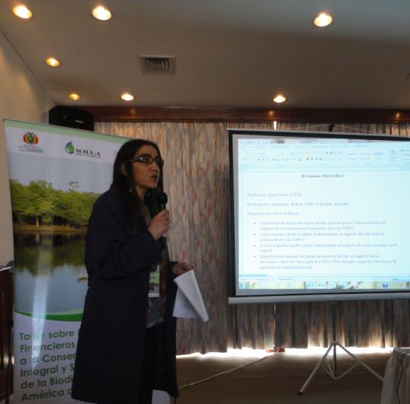
Presentación en plenaria de las reflexiones del primer grupo de trabajo.
Fotografía: FUNDESNAP.

participación: comentarios y preguntas/
—En los comentarios de los participantes del taller se subrayó el hecho de que la presentación de la mesa realizó un “buen barrido de ideas”. Sin embargo, se preguntó cuáles serían los tres o cuatro planteamientos prioritarios para llevar a una reunión como la COP 11.
—En respuesta, se señaló que, entre los temas prioritarios, debiera figurar el déficit presupuestario para la gestión de las Áreas Protegidas, la participación de los pueblos locales, campesinos e indígenas en la gestión de la biodiversidad, el enfoque de gestión integral de los recursos naturales y la simplificación de los sistemas y herramientas de financiamiento pues éstos son demasiados burocráticos, lentos y difíciles de aplicar.

b) Mesa 2: Mecanismos financieros actuales y desafíos de su implementación
La presentación trabajada por esta mesa incluyó la mención, por separado, a las distintas iniciativas financieras en los distintos países de la región, señalando puntos comunes —como la insuficiencia de los marcos legales y la búsqueda del fortalecimiento de la institucionalidad estatal vinculada con el medio ambiente— y poniendo el énfasis en compartir ideas, iniciativas y proyectos a nivel sudamericano. La exposición en plenaria de este grupo organizó sus respuestas en función de cada una de las preguntas planteadas.
¿Cuáles se consideran como los mecanismos financieros más apropiados al contexto sudamericano?
- En Brasil, la compensación por mitigación en obras de infraestructura con impacto ambiental. A futuro, sería un buen mecanismo un “PSA voluntario” entre los proveedores del servicio y los beneficiarios.
- En Paraguay, la exención de impuestos inmobiliarios por conservación privada declarada mediante ley o decreto. A futuro, sería interesante el desarrollo de mecanismos tipo PSA, en tanto se reglamente la ley.
- En Argentina, el financiamiento vinculado al presupuesto público. Los recursos naturales son de dominio originario de las provincias, así que las medidas deben ser locales y nacionales, a través de los presupuestos nacionales, provinciales e interjurisdiccionales. Por otra parte, el desarrollo de servicios de PSA debe realizarse en el marco de los compromisos internacionales.
- En Chile, el financiamiento mediante la Ley de Presupuestos anual que asigna recursos a la Corporación Forestal de Chile (CONAF) y al Ministerio de Medio Ambiente. La Ley de Medio Ambiente establece mecanismos de mitigación y adaptación, cualquiera sea el proyecto. Por otra parte, la Ley de Bosque Nativo financia varios fondos. Además, las Áreas Protegidas privadas están exentas del pago de impuestos territoriales. Existen también ingresos por tarifas en las Áreas Protegidas y por otorgamiento de concesiones turísticas. Sobre la aplicación de mecanismos PSA, no existe una posición definida.
- En Colombia, los PSA, REDD, la tasa por uso de agua (que se reinvierte en la gestión integral de las cuencas) y la reducción de impuestos por conservación de agua aplicadas a contextos regionales. También las compensaciones y regalías —en el caso de la minería y de la explotación de hidrocarburos— destinadas a áreas de conservación y a proyectos productivos sostenibles.
- En Bolivia, aquellos mecanismos financieros que consideren la gestión comunitaria y que destinen los beneficios de la conservación y del manejo integral y sustentable de la biodiversidad lleguen a las comunidades locales, como es el caso del los programas de conservación de la vicuña y del lagarto.
- Otras iniciativas destacables, en general, son el cobro por visitas de áreas protegidas (SERNAP), FONABOSQUE, el Programa de Incentivos Forestales (COMSERBO), los fondos fiduciarios para áreas protegidas y los acuerdos recíprocos de agua (Fundación Natura Bolivia).
¿Qué limitaciones tienen estas herramientas al momento de su aplicación?
- En Brasil, aún está en desarrollo un marco legal para los PSA. La industria se muestra un poco reticente al pago de compensaciones.
- En Argentina, el marco normativo es insuficiente, hay una escasa articulación institucional y la información está fragmentada.
- En Paraguay, se requiere el perfeccionamiento del marco legal y es necesaria mayor transparencia.
- En Colombia, la dependencia de los recursos de la cooperación internacional es excesiva y la asignación de fondos públicos insuficiente. Por otra parte, las empresas extranjeras tienen excesivas facilidades para explotar los recursos naturales en desmedro del medio ambiente.
- En Chile, los fondos públicos son insuficientes para la gestión de las áreas protegidas y el aprovechamiento de los recursos naturales de manera sostenible.
- En general, se requiere un fortalecimiento de las autoridades competentes, a partir de la asignación de mayores recursos y, consiguientemente, la generación de capacidades técnicas. Es necesario mejorar el monitoreo de las áreas en las que se desarrollan programas de servicios ambientales.
¿Qué otro tipo de mecanismos se deberían considerar para la aplicación de estas herramientas financieras?
- En Bolivia, los aportes de los sectores de construcción de infraestructura, minería e hidrocarburos para la conservación y/o restauración de la biodiversidad.
- Fortalecer las acciones de comando y control.
- Una estructura local, municipal, provincial, regional, federal o nacional (dependiendo de cada país y de cada caso) con mayor capacidad de operar, a través de la articulación de los distintos niveles estatales.
¿Cuáles son las experiencias y lecciones aprendidas respecto a la aplicación de estos mecanismos financieros en Sudamérica?
- Es necesaria una mejor articulación de los actores involucrados.
- Se precisa el intercambio de experiencias “Sur-Sur”.
- Hay que atender también los ámbitos de conservación y restauración.
- Para una buena planificación hay que considerar la diversidad local y los distintos escenarios dentro de cada país.

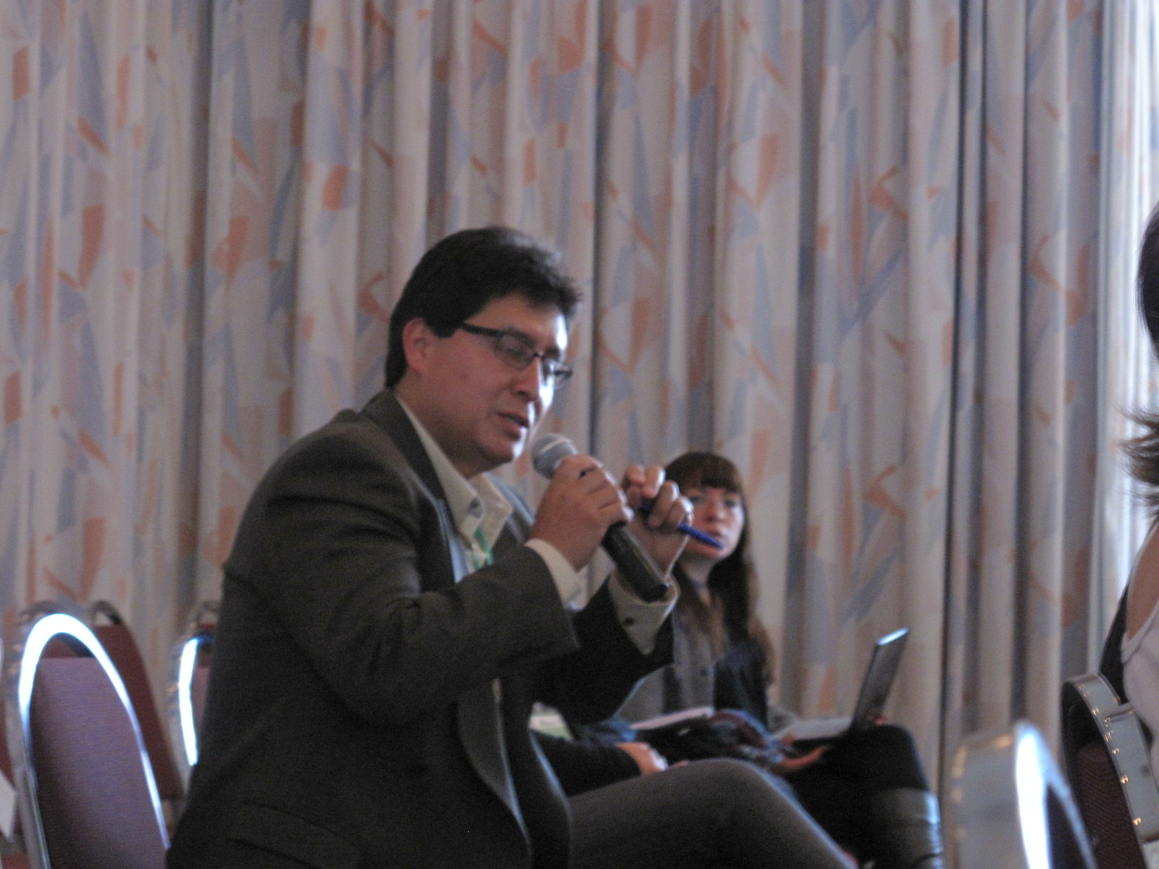
Los participantes intercambiaron reflexiones y comentarios sobre las presentaciones.
Fuente: FUNDESNAP.

participación: comentarios y preguntas/
—Algunos participantes de la Mesa 2 señalaron cuestiones complementarias o aclaratorias como el hecho de que lo expresado en relación a Bolivia representa ciertas opiniones planteadas en la mesa pero no la postura oficial el país. También se remarcó que algunos mecanismos financieros pueden funcionar bien en un país pero no en otros no sólo por cuestiones normativas o biológicas sino, sobre todo, por la idiosincrasia cultural de cada lugar e, incluso, de cada estructura administrativa.
—Por último, en los comentarios finales se apuntó la pertinencia de establecer, de alguna manera, cómo llega el dinero a los actores reales, es decir, cómo se distribuyen los recursos en las comunidades que son las que realmente están vinculadas a la conservación a través de la práctica cotidiana.

c) Mesa 3: Instancias regionales de apoyo a mecanismos financieros
La exposición de esta mesa se centró en una propuesta para la creación de un Fondo Regional propio sudamericano que permita atender financieramente, en términos de estrategia y planificación, las prioridades, necesidades y demandas de los países de la región.
En esta línea, la tendencia de las intervenciones en la mesa apuntó a constituir, mediante el intercambio y el trabajo conjunto regional, propuestas, iniciativas y mecanismos a partir de la identidad y las necesidades específicas de los países de la región. La exposición de esta mesa se organizó respondiendo, en el orden planteado, a las cuatro preguntas iniciales.
¿Qué oportunidades existen actualmente para la aplicación de mecanismos financieros a nivel sudamericano?
- En relación a las oportunidades para la aplicación de mecanismos financieros en la región, en la mesa se habló de desarrollar plataformas regionales para compartir información, de la búsqueda de mecanismos innovadores privados y de la cooperación internacional y los fondos estatales. Finalmente, se llegó a la conclusión de que es importante constituir un Fondo Regional propio para el cumplimiento de las agendas regionales (ver Gráfico 10).
Gráfico 9. Oportunidades para la aplicación de mecanismos financieros en Sudamérica
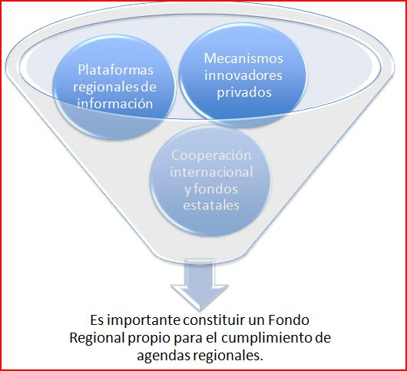
Fuente: Trabajo de grupo, Mesa 3.

¿Qué mecanismos se pudieran considerar como prioritarios para una aplicación a nivel regional?
- Se mencionó, de nuevo, un Fondo Regional como un mecanismo prioritario para aplicar a nivel sudamericano. Se habló también de los derechos de la naturaleza en el sentido de qué derechos se deben financiar. Y por último se mencionaron las leyes o marcos jurídicos nacionales en los que se establecen los principios de equidad entre las actividades humanas y el medio ambiente. Finalmente, se llegó a la conclusión de que uno de los mecanismos financieros prioritarios debe ser la compensación por servicios naturales. Se subrayó también la necesidad de acabar con los incentivos perversos (ver Gráfico 11).
Gráfico 10. Mecanismos financieros prioritarios a nivel regional
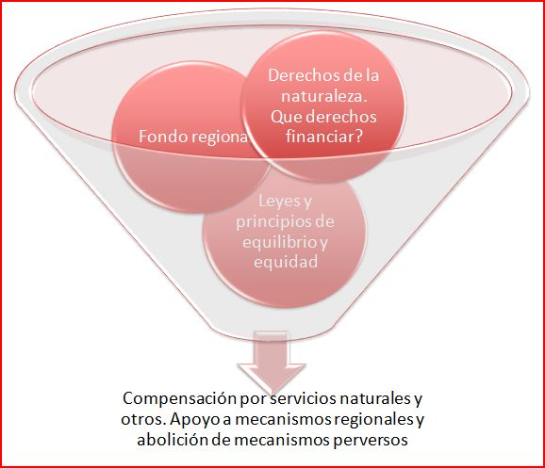
Fuente: Trabajo de grupo, Mesa 3.

¿Qué tipo de recursos (técnicos, humanos y financieros, entre otros) se necesitan para la aplicación de estos mecanismos a nivel regional?
- Se requiere fortalecer todo tipo de capacidades: locales, financieras e institucionales. No obstante, también es necesario reforzar la normativa legal para establecer criterios y puntos comunes en cuanto a la degradación ambiental y para facilitar la canalización de los recursos (ver Gráfico 12).
Gráfico 11. Tipo de recursos necesarios para la aplicación de mecanismos financieros
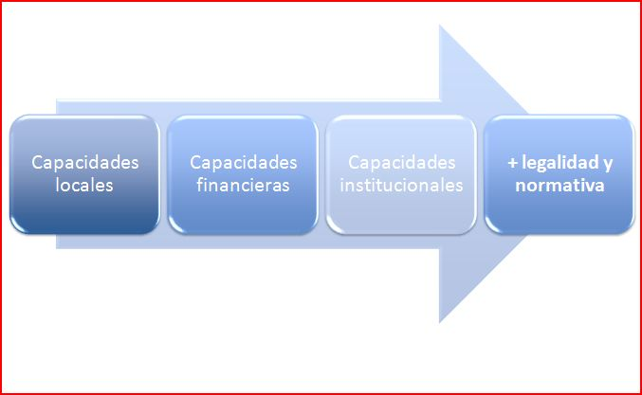
Fuente: Trabajo de grupo, Mesa 3.

¿Cómo se podría lograr incidir en las instancias regionales (como la CAN, el MERCOSUR o la OTCA) para la implementación de estos mecanismos?
- Para generar incidencia es necesario trabajar en la sensibilización política, en la promoción de agendas ambientales en función del conocimiento actual de cada realidad local. En conclusión, se debe desarrollar una estrategia de implementación de programas y de mecanismos financieros (ver Gráfico 13).

Gráfico 12. Cómo incidir en las instancias regionales para implementar mecanismos financieros
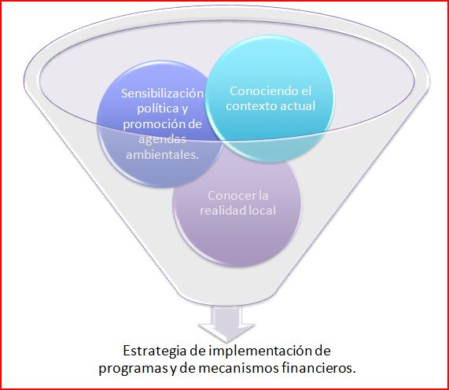
Fuente: Trabajo de grupo, Mesa 3.

participación: comentarios y preguntas/
—Varios participantes de la Mesa 3 complementaron algunos aspectos. Se apuntaron dos líneas maestras de debate: los mecanismos alternativos y las fuentes privadas de financiamiento. Otro aspecto relevante fue la necesidad de un mayor intercambio entre los países de la región si se quiere avanzar en la aplicación este tipo de herramientas. Por otra parte se sugirió que las Secretaría del CDB trabaje en la búsqueda de líneas de influencia hacia la Cooperación internacional para el desarrollo de programas de conservación en la región. Además, se señaló, con preocupación, cierta tendencia manifiesta en las reuniones y cumbres internacionales donde pareciera que algunos países quieren sustituir los mecanismos tradicionales de ayuda a los países en desarrollo por mecanismos financieros privados. En este sentido, se insistió en que es preciso que en las cumbres quede claro que los mecanismos financieros innovadores privados tienen que ser suplementarios a la ayuda tradicional.
—En cuanto a los comentarios de otros participantes del taller, destacó la reflexión en torno a los distintos entornos fiscales e impositivos que determinan la decisión de aportar para emprendimientos de preservación. Así, en Estados Unidos, según se afirmó, las donaciones están relacionadas con importantes exenciones fiscales, sin embargo, en contraste, en la región, las donaciones o aportes carecen de una fiscalidad estatal favorable que estimule a los contribuyentes a invertir en la conservación de la naturaleza. En esta línea, como réplica, se trajo a colación el caso del Paraguay y de la Ley de Retribución de Servicios Ambientales que permite que un contribuyente pague, mediante certificados de servicios ambientales, hasta el 50% de cualquier tipo de impuesto adeudado al Estado. Se trataría de la única experiencia en este sentido en la región. Por último, se planteó una pregunta referida a la propuesta sobre la constitución de un Fondo Regional cuestionando cuáles serían sus fuentes y su funcionamiento.
—Respecto a esta inquietud sobre el Fondo Regional se respondió puntualizando que, aunque en la mesa no se profundizó el tema, en principio, se trataría de un fondo propio creado mediante el respaldo de la Secretaría del CDB.

comentarios y reflexiones finales/
—Con un tono de evaluación, se argumentó que la biodiversidad debe ser también un factor que permita mejorar las condiciones de vida de las poblaciones locales, es decir, de las comunidades indígenas y campesinas. En este sentido, se señaló que el desafío consiste en convertir la riqueza de la biodiversidad en bienestar económico puesto que sino los monocultivos agrícolas seguirán extendiéndose y generando una pérdida progresiva del boque y de la biodiversidad.
—También se destacó que el enfoque de la CDB es, precisamente, ecosistémico o integral por lo que es pertinente volver a revisar los principios fundacionales del Convenio y los instrumentos y herramientas disponibles para usarlos adecuadamente en la coyuntura global actual.
—Se reiteró que en el debate actual sobre el futuro de la conservación un punto central es la gestión integral de la biodiversidad no sólo pensando en las Áreas Protegidas sino también en otros espacios que por diversos motivos son importantes. Por ello, se debe repensar la conservación, se señaló, utilizando todo lo que se ha aprendido en la gestión de las Áreas Protegidas para avanzar hacia un concepto más integral del desarrollo que alcance, por ejemplo, a las áreas de cultivos agrícolas.
—Para finalizar, se remarcó el pedido expreso realizado por el Secretario del CDB en relación a cuantificar, con precisión, las necesidades financieras de cada país de la región para la conservación de la biodiversidad puesto que si se carece de esta información, será muy difícil que la COP 11 avance en la negociación y definición de metas para la movilización de recursos.

3. Palabras de clausura
A modo de balance de los dos días de taller, Arturo Mora, Oficial de Programa de UICN-Oficina Regional para América del Sur, agradeció a los participantes por los insumos y el debate generado con el propósito de lograr una mejor aplicación de las herramientas de financiamiento de la conservación de la biodiversidad, objetivo que constituye un interés específico de UICN.
Mora recapituló los ejes de debate en torno a los desafíos regionales para la implementación de mecanismos financieros; a cuáles serían los más pertinentes a nivel regional y a qué mensajes se podrían llevar, de manera conjunta, a la COP 11. En este sentido, se refirió al uso de recursos naturales a un nivel directo con las comunidades que son las que, después de todo, tienen un contacto directo con la conservación. “Las personas que toman las decisiones tienen el gran reto de vincular la visión y las necesidades de quienes están en el campo con los temas del desarrollo y la conservación”, dijo.
Por otra parte, remarcó el interés general para que las autoridades nacionales coordinen mejor los presupuestos nacionales con un enfoque de conservación y uso de la biodiversidad vinculando a los distintos ministerios e instancias estatales. Mencionó que compartiendo experiencias “Sur a Sur” se logra un intercambio fructífero que permite conocer iniciativas que podrían ser replicadas en otros países. Todo esto en el marco de esquemas financieros no sólo de carácter internacional puesto que es generalizada la percepción de que todos los países requieren incrementar sus presupuestos para la conservación, sin olvidar las necesidades particulares de financiamiento que deben ser plantadas en la COP 11. Concluyó manifestando, a nombre de UICN-Sur, la oportunidad y el reto que representan estas plataformas de debate y diálogo abierto y constructivo, inspirados en la búsqueda de resultados prácticos y viables.
Posteriormente, Braulio Ferreira, Secretario Ejecutivo del CDB, valoró el intercambio de información realizado en el taller y expresó su interés por dar seguimiento a los planteamientos y por promover un mayor intercambio regional. En relación a las propuestas y demandas planteadas en los distintos grupos, señaló que se precisa utilizar mejor los instrumentos disponibles en el marco del CDB y apuntó que este Convenio es un “proceso en construcción” por lo que cualquier propuesta tiene que trabajarse a partir de las reuniones preparatorias. Para avanzar en este sentido, Ferreira explicó que los países interesados pueden seguir el proceso correspondiente y solicitar al Secretario Ejecutivo del Convenio que organice reuniones, estudios y consultas sobre un determinado tema.
Ferreira insistió en varios temas de la agenda de la COP 11, como la implementación del Plan Estratégico 2011-2020 (tema 5) —y, específicamente, la perspectiva regional de implementación del CDB—, la disposición de recursos financieros (tema 4), la cooperación en torno al Decenio de las Naciones Unidas sobre Diversidad Biológica (2011-2020) y la cuestión de los conocimientos tradicionales (tema 7).
Sobre la cuestión de los recursos y el financiamiento, informó sobre un nuevo proceso de planificación del GEF con el objetivo de que éste sea más proactivo ayudando a los países que demandan recursos y subrayó, refiriéndose al trabajo realizado en las mesas, la inexistencia de un mecanismo financiero de apoyo “Sur-Sur”. Reiterando que cualquier demanda específica debe ser planteada por las partes del Convenio, es decir, por los distintos países, Ferreira se despidió previendo que la discusión sobre los recursos financieros en la COP 11 será difícil y agradeciendo a todos los participantes por el interés y el trabajo conjunto.
Finalmente, Alexandra Moreira, de la Unidad Madre Tierra y Agua (UMTA) del Ministerio de Relaciones Exteriores de Bolivia, destacó que la realización del taller representó un aprendizaje para todos puesto que, entre otras cosas, se pudieron conocer, de primera mano, las distintas experiencias en siete países vecinos (Paraguay, Colombia, Ecuador, Chile, Argentina, Brasil y Bolivia). “No somos extraños por mucho que tengamos diferencias ideológicas”, dijo Moreira a tiempo de solicitar al Secretario del CDB la realización de reuniones más frecuentes que permitan profundizar los conocimientos técnicos y compartir información sobre la actualización de las estrategias nacionales. Después de todo, apuntó, todos los participantes del taller “compartimos el compromiso de trabajar para que se preste una mayor atención a la biodiversidad y para que los países generen políticas públicas en este sentido”.

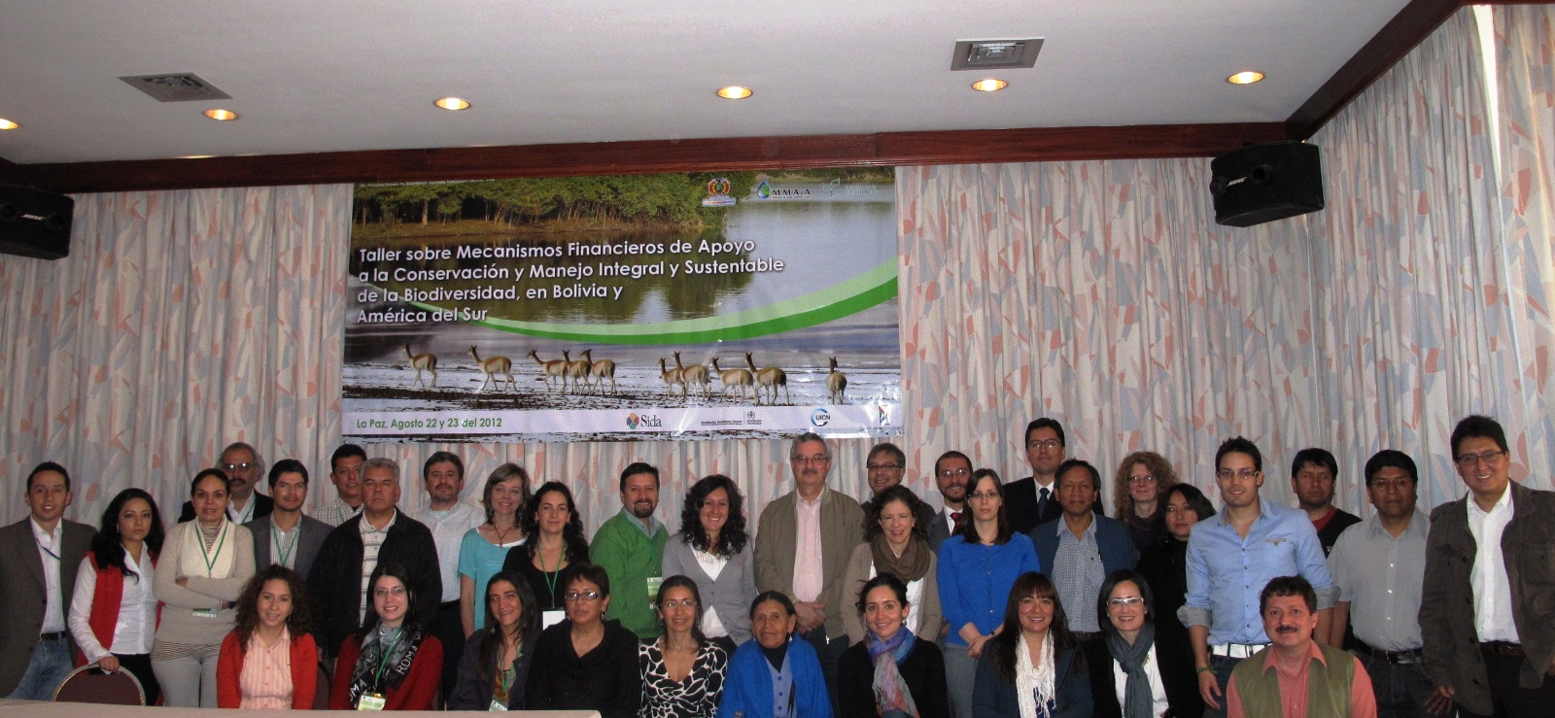
Foto de grupo de los participantes en el Taller sobre Mecanismos Financieros de apoyo a la Conservación y Manejo Integral y Sustentable de la Biodiversidad en Bolivia y América del Sur.
Fotografía: FUNDESNAP.
Referencias bibliográficas

Naciones Unidas
1992 Convenio sobre la Diversidad Biológica. Disponible en:
http://www.cbd.int/doc/legal/cbd-es.pdf
Secretaría del Convenio sobre la Diversidad Biológica
2011 Protocolo de Nagoya sobre acceso a los recursos genéticos y participación justa y equitativa en los beneficios que se deriven de su utilización al Convenio sobre la Diversidad Biológica. Montreal: CDB. Disponible en: http://www.cbd.int/abs/doc/protocol/nagoya-protocol-es.pdf
2010 Perspectiva Mundial sobre la Diversidad Biológica 3. Montreal: CDB. Disponible en: www.cbd.int/GBO3
2000 Protocolo de Cartagena sobre seguridad de la biotecnología del Convenio Sobre la Diversidad Biológica. Montreal: CDB. Disponible en: http://bch.cbd.int/protocol/publications/cartagena-protocol-es.pdf
TEEB (Economía de los Ecosistemas y la Biodiversidad)
2010 La economía de los ecosistemas y la diversidad: incorporación de los aspectos de la naturaleza. Una síntesis del enfoque, las conclusiones y las recomendaciones del estudio TEEB. Malta: TEEB.
Wunder, Seven
2005 Payments for environmental services: some nuts and bolts. Cornell University: CIFOR.

-----

* UNEP/CBD/COP/11/1.
En muchos casos, como se puede apreciar, las siglas y acrónimos corresponden a su nominación en inglés.
La información referente a esta reunión se puede consultar en: www.dialogueseminars.net
La Conferencia de las Partes (COP) es el órgano rector del Convenio sobre Diversidad Biológica (CDB) y promueve la aplicación del Convenio a través de las decisiones que adopta en sus reuniones periódicas. Hasta la fecha, la Conferencia de las Partes ha celebrado 10 reuniones ordinarias y una reunión extraordinaria (esta última, dividida en dos partes, fue para adoptar el Protocolo de Seguridad de la Biotecnología). La décima reunión de la Conferencia de las Partes (COP 10) se celebró en Nagoya, Japón, del 18 al 20 de octubre de 2010. La undécima reunión (COP 11) se llevará a cabo en la India, en octubre de 2012 (Fuente: http://www.cdb.int/cop/).
El Protocolo de Nagoya sobre el acceso a los recursos genéticos y la participación justa y equitativa en los beneficios derivados de su utilización en el Convenio sobre la Diversidad Biológica es un acuerdo internacional cuyo objetivo es compartir los beneficios derivados de la utilización de los recursos genéticos en forma justa y equitativa, un acceso adecuado a esos recursos y una transferencia apropiada de tecnologías pertinentes. Este Protocolo fue adoptado por la COP 10, el 29 de octubre de 2010 en Nagoya (Japón) y entrará en vigor 90 días después del depósito del quincuagésimo instrumento de ratificación, aceptación, aprobación y adhesión (Fuente: http://www.cbd.int/abs/).
La decima reunión de la Conferencia de las Partes (COP 10), celebrada del 18 al 29 de octubre de 2010 en Nagoya (Aichi, Japón), adoptó para el período 2011-2020 un Plan Estratégico para la Diversidad Biológica revisado y actualizado que incluye las Metas de Aichi para la Diversidad Biológica. Este nuevo plan será el marco global para la diversidad biológica, no sólo para los convenios relacionados con la diversidad biológica sino para todo el sistema de las Naciones Unidas.
Fondo Mundial para el Medio Ambiente 6, por sus siglas en inglés.
Es preciso señalar que la ponencia de Arturo Mora, Oficial de Programa de UICN-Oficina Regional para América del Sur, es una adaptación de un trabajo de Markus Lehmann, Secretaría del CDB; Andrew Seidi y Josh Bishop, IUCN.
El TEEB es una iniciativa internacional para llamar la atención sobre los beneficios económicos globales de la biodiversidad, poniendo de relieve los crecientes costos de la pérdida de biodiversidad y de la degradación de los ecosistemas. Esta iniciativa tiene el propósito de reunir conocimientos y experiencias en los campos de la ciencia, la economía y la política para desarrollar acciones prácticas en la línea señalada (Fuente: www.teebweb.org).
El “habilito” es un sistema de explotación laboral propio de las tierras bajas de Bolivia, y especialmente de Chaco guaraní, mediante el cual los patrones o dueños de las propiedades agropecuarias mantienen en condición de “semicautivos” a los peones indígenas, estableciendo un mecanismo de endeudamiento que incluye el pago del trabajo por comida u otros bienes.
El Sistema de Información Geográfica (SIG) es una integración organizada de hardware, software y datos geográficos diseñada para capturar, almacenar, manipular, analizar y desplegar en todas sus formas la información geográficamente referenciada con el fin de resolver problemas complejos de planificación y gestión geográfica (Fuente: http://es.wikipedia.org/wiki/Sistema_de_Informaci%C3%B3n_Geogr%C3%A1fica).
En este apartado se propone un título distinto al de la presentación puesto que el original —Chile: Taller Mecanismos Financieros de Apoyo para la Conservación de la Biodiversidad— dice poco del contenido de la misma.
La Convención Relativa a los Humedales de Importancia Internacional especialmente como Hábitat de Aves Acuáticas, conocida en forma abreviada como Convenio de Ramsar —pues fue suscrita en la ciudad de Ramsar (Irán), en febrero de 1971— tiene por objetivo la conservación y el uso racional de los humedales mediante acciones locales, regionales y nacionales (Fuente: http://es.wikipedia.org/wiki/Convenio_de_Ramsar).
Fondo Global para el Medioambiente.

