 |  | CBD
 |  |  |  | Distr.  GENERAL  UNEP/CBD/COP/12/INF/7  26 September 2014  ORIGINAL: ENGLISH
CONFERENCE OF THE PARTIES TO THE CONVENTION ON BIOLOGICAL DIVERSITY
Twelfth meeting
Pyeongchang, Republic of Korea, 6-17 October 2014
Item 26 of the provisional agenda*
CONCEPTUAL AND METHODOLOGICAL FRAMEWORK FOR EVALUATING THE CONTRIBUTION OF COLLECTIVE ACTION TO BIODIVERSITY CONSERVATION
Note by the Executive Secretary
1. The Executive Secretary is circulating herewith, for the information of participants in the twelfth meeting of the Conference of the Parties to the Convention on Biological Diversity, the full report “Conceptual and Methodological Framework for Evaluating the Contribution of Collective Action to Biodiversity Conservation” prepared through an initiative of the Bolivian Government with the support of the Amazon Cooperation Treaty Organization (OTCA) through the Amazon Regional Programme (ARP)-GIZ, and the IUCN South (International Union for Conservation of Nature) – Resilience and Development Programme (SWEDBIO).
2. The summary of the present report is made available in the report by the Executive Secretary on activities on collective actions and non-market-based approaches for resource mobilization (UNEP/CBD/COP/12/13/Add.5) dated 25 August 2014.
3. The document is being circulated in the form and language in which it was provided to the Secretariat.

CONCEPTUAL AND METHODOLOGICAL FRAMEWORK FOR EVALUATING THE CONTRIBUTION OF COLLECTIVE ACTION TO BIODIVERSITY CONSERVATION

Table of contents:
SUMMARY

PART 1: CONCEPTUAL FRAMEWORK AND REPORT STRUCTURE
1.1 Introduction: Goals of the report and limitations of the proposed methodology
1.2 Overall Approach and Methodology
1.3 Rationale: Institutions, collective action, and biodiversity conservation
1.4 Describing the Conceptual basis of the CASES Framework
1.4.1 Defining terms
1.5 Linking the Conceptual and the Methodological basis of the CASES Framework
1.6 Linking Methodological Modules to Indicators of Resource Mobilization Strategies, the National Reports, Aichi Targets

PART 2: METHODOLOGICAL MODULES:
2.1 Introduction
2.2 A Geospatial Modeling Approach
2.2.1 Data and Methods
2.2.2 Data Acquisition
2.2.2.1. Satellite imagery
2.2.2.2. Forest change/monitoring tools
2.2.2.3. Additional GIS layers
2.2.3 Data pre-processing:
2.2.4 Data Analysis
2.2 An Institutional Analysis Module
2.2.1 Fieldwork to measure local resource users’ efforts to protect biodiversity
2.3 An Ecological Assessment Module

BIBLIOGRAPHY

APPENDIX 1: Linking the methodology to the Aichi Goals and Targets
APPENDIX 2: CBD Guiding questions for the Fifth National Report.
SUMMARY
Resolution XI/4, paragraph 23, approved during COP 11 of the CBD recognized the role of collective action, including by indigenous and local communities, and non-market-based approaches to achieving the objectives of the Convention, and requested the development of an approach to assess the contribution of local resource users and communities’ collective action to the conservation of biodiversity. This report is the first approximation of developing such a methodology.

The goal of this report is to develop a conceptual and methodological framework to assess the contribution of collective action and local resource users, including indigenous and rural communities, to the conservation of biodiversity. After discussing the proposal’s conceptual rationale and theoretical underpinnings, is presented a methodological proposal that consists of three modules: (1) A geospatial modeling module to estimate the rate, extent, direction, spatial pattern, and the area of terrestrial ecosystems that is protected by indigenous and local communities; (2) An institutional analysis module which includes elements to be used with the geospatial module and a field-based protocol for measuring specific characteristics of institutional arrangements related to the protection of biodiversity in a sample of measurement areas, and (3) An ecological assessment module that includes field-based protocols and sampling to validate the geospatial model, to understand how collective action and institutional arrangements influence the conservation of biological diversity and resources.

Finally, for each of these modules the proposal identifies a series of elements and indicators for assessing the contributions of collective action by indigenous and local communities to the conservation of biological diversity at different levels: national/regional, sub-regional, local/community, and site/resource specific. These indicators are mapped into different options to evaluate the contribution of these actions to resource mobilization for biodiversity and to the broader protection of ecosystems, environmental functions, and resources, and their contributions to specific dimensions of human integral development and people’s quality of life more generally.

PART 1: CONCEPTUAL FRAMEWORK AND REPORT STRUCTURE

1.1 Introduction: Goals of the report and limitations of the proposed methodology
The goal of this report is to propose a conceptual and methodological framework to assess the contribution of collective action among members of indigenous and local communities to the conservation of biodiversity, as outlined in the Terms of Reference proposed by the Organization of the Cooperation of the Amazonian Treat (OTCA). The conceptual and methodological framework proposed here was requested by OTCA following resolution XI/4, paragraph 23 taken during COP 11 of the Convention on Biological Diversity, which requested the development of an approach to assess the contribution of indigenous peoples and local communities’ collective action to the conservation of biodiversity. Paragraph 23 states:
“23.Requests the Ad Hoc Open-ended Working Group on Review of Implementation of the Convention, at its fifth meeting, to further review the preliminary reporting framework and baseline information for each of the targets, including the role of collective action, including by indigenous and local communities, and non-market-based approaches to achieving the objectives of the Convention; and requests the Executive Secretary to prepare for this review, based on information received from Parties on the application of the preliminary reporting framework and on funding needs, gaps and priorities;”

This report is the first approximation of developing the proposed conceptual framework and methodology, which we call Collective Action in Socio-Ecological Systems [CASES]. Below is presented the rationale and conceptual underpinnings of the proposal, an overview of the methodology, including its connections to the CBD requirements for National Reports and how it corresponds to the Aichi targets, and for the incorporation of these contributions in the framework of mobilization of financial resources within National Strategic Plans for Biodiversity Conservation. An overview of each module proposed is presented in more detail in part 2 of this document.

Following the statement in resolution XI/4 and the guidelines for the Fifth National Reports of the CBD, the proposed conceptual framework and methodology aims at supporting countries to assess and report the contribution of collection action for biodiversity for the implementation of the Strategic Plan for Biodiversity for 2011-2020, including the development of country-specific frameworks for mobilization of financial resources that consider the contribution of indigenous people and local communities to the national strategy for biodiversity conservation. The specific needs and type of implementation of the proposed framework and methodology will eventually need to be adapted to individual country needs. Likewise, these tools can provide different degrees of support for biodiversity planning and monitoring at national/regional levels, and more specifically at sub-regional and local levels. The methodology recognizes that the CBD explicitly requests that countries ‘involve stakeholders in the preparation of their national reports’.

It is important to clarify that, at this stage, (a) the approach proposed here does not include detailed information on the entire set of components defined under the CBD national reporting requirements. More importantly, (b) the approach proposed here only provides options for indicators to be considered in the national frameworks of mobilization of financial resources. In the first case (a), many of these components refer to country-specific policies and initiatives not intended to be captured by the proposed approach, while in the second case (b) the definition of what and how to estimate different types of values associated with biodiversity conservation and the sustainable use natural resources is a decision to be considered by policy makers and relevant stakeholders in each country. Depending on member countries’ resources and interests, it is possible to develop protocols for different types of indicators of monetary and non-monetary resource mobilization as well as additional modules to assess biodiversity and environmental functions. The modules outlined below propose a sampling process based on environmental change within different institutional arrangements and property regimes.

1.2 Overall Approach and Methodology
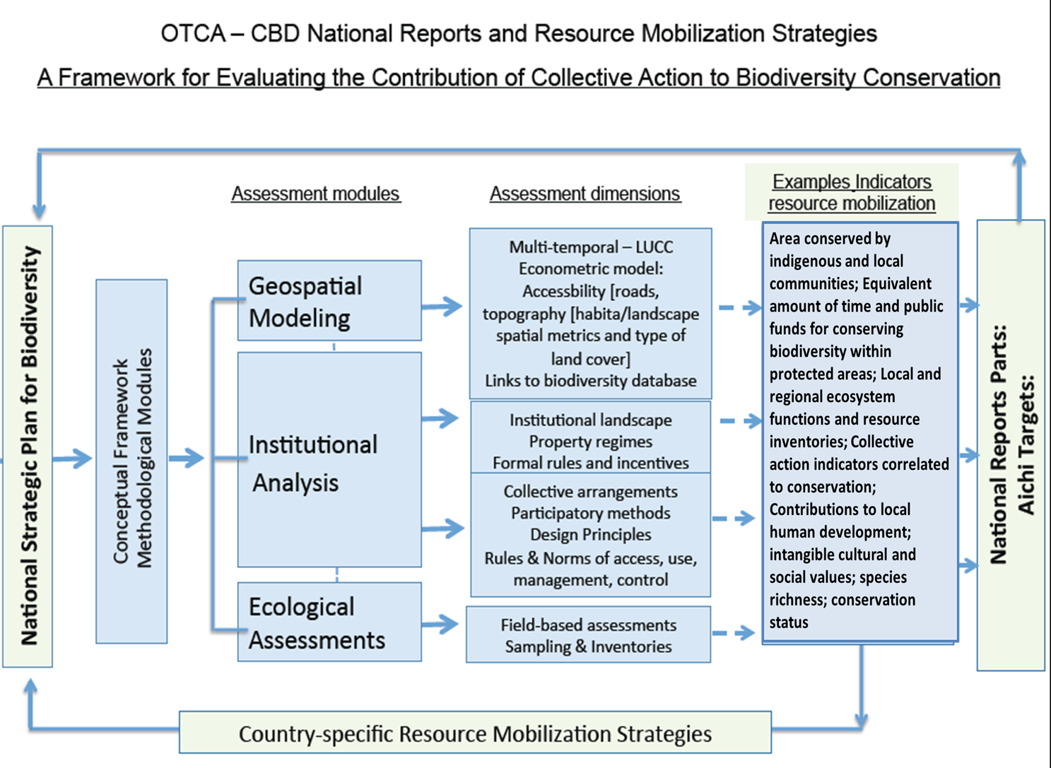
Figure 1: Overall approach and methodology for the assessment of the contribution of collective action to the conservation of biodiversity]

Figure 1 presents an overview of the overall approach and methodology, including the contribution of each module and level of analysis to different assessment dimensions that provide the basis for calculating the contribution of the role of collective action of indigenous peoples and local communities through monetary and non-monetary valuation of resource mobilization indicators and as well as their contribution to specific components [i.e., National Reports guiding questions] of National Strategic Plans for Biodiversity and the Aichi Targets. Below we provide an overview of this figure by describing each component and level of analysis, which are then presented in more detail in part II. The figure is organized to show how each module and its respective assessment dimensions relate to different levels of analysis (from national to local), types of indicators at each level that can be used to evaluate resource mobilization, and their contribution to NSP goals and targets.

1.3 Rationale: Institutions, collective action, and biodiversity conservation
One of the most successful efforts to halt biodiversity loss has been the promotion and creation of conservation units and protected areas of different types. The CBD in collaboration with governmental, non-governmental organizations, indigenous peoples and local communities, has been instrumental to developing this approach. Much of this effort has been done directly or indirectly in collaboration with local populations and communities involved in the use and management of natural resources. In tropical areas such as the Amazon, these areas, and particularly areas managed by indigenous and local communities, have been recognized as significant buffers against deforestation and the degradation of ecosystems and biodiversity (Ricketts et al 2010; Soares-Filho et al 2010).

On the other hand, the expansion of protected areas has occurred side-by-side with the expansion of agro-pastoral and resource-extraction activities, in many cases creating islands of conservation. While there is evidence that protected areas are often not effective by themselves in protecting biodiversity, there is significant evidence that indigenous peoples, local communities and resource user groups are central to the effectiveness of protecting biodiversity within and outside of these areas (Cox et al 2010). Equally important, there is evidence that local user groups and communities, including private landowners, effectively promote conservation and productive management of forests, lakes, and other natural resources outside of protected areas (Castro et al 2003; Brondizio 2008).

In many cases, however, these communities are subsumed and overwhelmed by pressures and transformations occurring around them, such as the consequences of extractive and agro-industrial expansion. In this context, it is important to understand the ways in which local resource users, and indigenous peoples and local communities in particular, organize themselves to respond to external pressures in maintaining biodiversity ecosystem functions. In some cases, these local actions are aimed at protecting a given area or territory, while in others they are organized to protect specific resources or environmental functions (e.g., water quality). Conservation mechanisms that rely on formal institutional agreements require monitoring and enforcement activities in order to ensure compliance, and the performance of such arrangements hinges on how local communities and groups of users organize themselves and the extent to which these local actions reinforce or counteract the formal institutional arrangements in place (Gibson et al 2000; Persha and Andersson et al 2014).

On the other hand, there is still limited understanding of the ways in which national conservation policies and local resource user groups interact and how these interactions affect conservation outcomes (Andersson and Gibson 2007). In regions such as the Amazon, the socio-economic realities of local populations also limit the effectiveness of protected and indigenous areas in curbing, at least to some extent, deforestation and other pressures on biodiversity and resources. It is therefore important to recognize the limitations of complete self-regulation and consider how institutions developed at higher levels can contribute, create incentives, and facilitate or undermine local efforts of conservation (Andersson and Ostrom, 2008; Brondizio et al 2009). The methodology proposed here brings together advances in land change sciences that link – through geospatial analysis – the analysis of environmental change at different scales with the analysis of institutional arrangements that examine the underlying mechanisms of local individual and collective action to protect biodiversity and ecosystems. From this combination of modules different indicators can be generated to evaluate the relationship between collective action and biodiversity conservation, as well as what they represent in terms of monetary and non-monetary values [depending on the choice of indicators] with respect to resource mobilization.

While much advance has been made in developing methodologies to help understanding biodiversity conservation at aggregated scales (regional, country level), National Reports and National Strategic Plans for Biodiversity more generally still lack approaches to provide information about the role of collective action and institutional arrangements for biodiversity conservation at the local and sub-regional levels, including measures that are needed to assess the contribution of indigenous peoples and local communities (for instance, relative to national and international resource mobilization) towards progress made to achieve the Aichi goals and targets.

Researchers from the so-called Bloomington School of institutional analysis (e.g., Ostrom 1990; McGinnis 2011) have analyzed case studies from around the world and shown that long-term effective and robust resource management systems at the local level share several key characteristics, or so-called ‘design principles’. These design principles correspond to the conditions under which human-environmental interactions are likely to be more sustainable. We use these widely accepted design principles and associated conceptual tools (ex. types of rules, bundles of rights) as the basis to analyze how local actions contribute to the conservation of biodiversity at local and sub-regional levels. The design principles include:

1. Clearly defined physical (1.1) and social (1.2) boundaries;
2. Congruence between local conditions, appropriation, and provision rules;
3. Adaptability of collective choice arrangements;
4. Appropriate monitoring;
5. Graduated and implementable sanctions;
6. Mechanisms for conflict resolution;
7. Recognized rights to organize; and
8. Nesting of local into higher-level institutional arrangements.

Design principle #8 poses particular challenges to achieving the goals of the Aichi targets and requires approaches that link institutional analysis at local to sub-regional and regional levels. Local management systems are nested within regional and national institutional arrangements and infrastructure networks, as well as within various types of commodity chains. These arrangements have a direct impact on the way local communities use their resources, and thereby shape the biophysical attributes of landscapes at the local and, cumulatively, larger scales (Lambin and Meyfroidt 2011). By linking a geospatial modeling framework for multi-temporal and contextual landscape analysis (country and regional levels) and modules for institutional analysis at sub-regional and local levels, the proposed methodology aims to capture the interconnection of these different dimensions and scales, and how local collective action to conserve biodiversity aggregate to larger scales.

It is important however, to understand the conceptual underpinnings of the proposed analysis. The modules of institutional analysis, based on the Institutional Analysis and Development Framework (IAD) and ecological assessments allow the understanding of rules and norms that mediate collective action regarding the use, management, control, and monitoring at the local level. At this level, we can use the Design Principles as a guide to evaluate the effectiveness of local collective action in conserving biodiversity (Ostrom 1990; Cox et al 2010; Andersson et al 2014). In order to understand how local collective action arrangements nest within other arrangements at broader scales, we call attention to the concepts of institutional fit, scale, and interplay (Young 2006; Young et al 2008). These concepts are used here to highlight the importance of understanding the linkages between country-level indicators of biodiversity and the reality on the ground, i.e., the understanding of conditions that facilitate or limit the ability of local users and communities to conserve biodiversity.

Institutional fit is used to describe the congruence or compatibility between the social and ecological systems, i.e. whether a form of collective action at a local level matches the larger ecological system within which it is subsumed (Acheson 2006). Given that the Amazon region has a diversity of scale-dependent institutional arrangements and property systems, there are significant cross-scale interactions among governance systems, many of which are in tension with each other (Brondizio et al 2009). For instance, a community-level institutional arrangement to manage a forest may be surrounded by a concession area for resource exploitation under a different set of rules and goals. Young (2006) calls these types of institutional interactions (or tensions) interplay, i.e., interactions between different governance arrangements. This is becoming increasingly common in the Amazon where one observes an increasing density of, often contrasting, governance arrangements. The methodology proposed here acknowledges that understanding how biodiversity may be protected requires a recognition of institutional fit and interplay across scales of analysis (Brondizio et al 2010). In particular, it provides tools to identify and analyze the types of mismatches between institutions and governance systems set to conserve biodiversity at different scales. These conditions are identified [Figures 1 and 3, and, in more detail, in Appendices 1, 2] according to different types of dimensions and indicators that can be used to evaluate monetary and non-monetary resource mobilization, and to assess specific questions of the National Reports and the Aichi Targets.

A recent report of social scientists to the CBD (Durraiapah et al 2013) highlighted that “Matching the mismatches with institutional innovation is key to improving the conservation and sustainable use of biodiversity.” The report highlighted that institutional mismatch is an underlying cause of the apparent ineffectiveness in biodiversity governance reported by the GBO-3 (2010) and the Millennium Assessment (2005), and call attention to approaches that will help to understand the design and promote such “bridging institutions.” In the long run, the methodology proposed here aims to contribute to the understanding and design of bridging institutions, defined as institutional arrangements that interlink different types of governance systems and efforts of collective action, otherwise specific to a level or part of an ecosystem. They help to provide coordination across existing institutions operating at the same or different scales, thus contributing to a higher level of collective action aiming at the conservation and sustainable use of biodiversity and environmental functions.

1.4 Describing the Conceptual basis of the CASES Framework:
The assessment methodology is grounded in a conceptual framework for the analysis of Collective Action in Socio-Ecological Systems [CASES]. This framework is itself grounded in two established conceptual frameworks: the Socio-Ecological Systems framework (SES) and the Institutional Analysis and Development Framework (IAD) proposed by Elinor Ostrom at the Ostrom Workshop of Political Theory and Policy Analysis at Indiana University, United States (Ostrom 1990, 2009). This proposal relies on these established frameworks because of the broad acceptance that they enjoy among both scholars and practitioners, both in the social and natural sciences.

As illustrated in figure 2, the conceptual framework has four main groups of variables. The top two groups account for the interactions of ‘governance systems’ and ‘resource systems’ at a broader level of analysis (e.g., regional), while the lower level groups of variables account for the interactions of more narrowly defined ‘user groups’ and ‘resource units’. Detailed sets of variables are operationalized within each of these groups to allow examination of specific dynamics and questions related to the use and management of natural resources and biodiversity and their implications for environmental functions and landscape changes. The spatial and temporal dynamics associated with biodiversity changes at both levels are influenced by different types of interactions and pressures, internal and external, at a given level and unit of analysis. These interactions and pressures, however, are mediated by a series of contextual conditions (including the type of factors that motivate human behavior, including both instrumental and intrinsic sources of motivation, constraints, access, technology used to exploit resources, and the nature of the resources themselves) and mediated by different degrees of collective action involving different stakeholders and user groups.

1.4.1 Defining terms
The term “collective action” is used here to mean the cooperation among two or more individuals to try to achieve outcomes that none of these individuals could achieve on their own. As such, collective action involves different types of cooperation among individuals and/or groups of individuals to solve collective problems and choices at different levels. Collective action theory (based on Olson 1965) poses that cooperation among individuals can lead to better results in the management and provisioning of public and common goods by reducing tendencies of individual short-term profit maximization and ‘free-riding’ problems [i.e., individual benefits at the expense of the efforts of the collective]. It also recognizes that collective action is difficult in proportion to the scale of the problem as well as to the size and heterogeneity of the group of actors: the larger and more diverse the group, the harder it is to act collectively. Collective action may take different forms depending on the level of analysis and the type of problem involved, from international to national to regional to local. Collective action influences and mediates the rules, norms, and forms of natural resource use, management, control, and monitoring in relation to the observable outcomes of change in landscapes, biodiversity, different ecosystem functions, as well as social conditions.

Before moving forward, however, other important definitions are necessary, including that of ‘institutions’ and types of institutions, bundles of rights and property systems, and the design principles of sustainable resource use.

Institutions are understood as formal and informal rules and norms that structure human interactions so as to reduce the uncertainties inherent in interactions (Ostrom 1990, 2005). Institutional arrangements, or institutions, influence the behavioral processes associated with natural resources claims and usage, and therefore biodiversity management outcomes. Rules and norms defined by institutions, at different levels of organization, help to reduce uncertainty for people and help to mediate competing actions and the values that individuals and groups bring to biodiversity management.

Allocative institutions operate at all levels by mediating interactions between the natural system, environmental functions, and their access and use by different members of society. Allocative institutions play key mediating roles in how natural resources and biodiversity are distributed and used, and could be evaluated by different indicators of efficiency and effectiveness. These include the informal communal rules or more formal land tenure systems on access and use of common pool resources.

Distributive institutions oversee the access and distribution of the various types of assets across the various social groups operating at different scales and levels. Examples include formal institutions, such as, taxes and subsidies, and informal institutions that define rules about common resource use within a given community and property regime.

Bundles of rights include the assembly of different types of rights assigned to individual users or user groups. They include rights of access, extraction, management, exclusion and alienation of given resources or areas. Different assemblages of rights along with the degree of exclusion and rivalry indicate different types of property systems of specific resources or areas/territories as a whole, i.e., open access, government property, common property, and private property.

The SES conceptual framework offers a general guidance and operationalization of these concepts for the proposed methodology, i.e., linking a conceptual basis for the understanding of collective action and institutions in social-ecological systems and assessment procedures evaluate its contributions at different levels. Its implementation at a lower level (e.g., community), however, is facilitated by the use of the sister framework, the IAD, and its related lexicon of types of rules that mediate the interaction between users and biodiversity. The strength of the IAD framework lies in its holistic approach to the analysis of collective action situations, i.e., as individuals and groups are part of ‘action situations’ affected by a combination of biophysical, political, cultural, and economic factors defined by various sets of rules, incentives, and constraints (Ostrom 2005; 2011). Of particular interest to the methodology proposed here is the definition of 7 types of rules that help to understand the organization of collective action at different levels of analysis. These rules include:

Rules | Definition
Position Rules | Establish a set of positions, each of which has a unique combination of resources, opportunities, preferences, and responsibilities.
Boundary Rules | Specify how participants enter or leave these positions, defining the number of participants, their attributes and resources.
Choice Rules | Specify which set of actions is assigned to which position, and what they may, must or must not do.

Scope Rules | Delimit the potential outcomes that can be affected and, working backward, the actions linked to specific outcomes.
Aggregation Rules | Specify the level of control that a participant in a position exercises in the selection of an action at a conflict.
Information Rules | Specify the knowledge-contingent and information available to the participants.
Payoff Rules | Specify the benefits and costs that will be assigned to particular combinations of actions and outcomes.
Source: Adapted from Ostrom (2011) and McGinnis (2011).
[Table 1: The seven types of rules that could influence the organization of an action situation]
This set of rules is used in the methodology for institutional analysis described below to operationalize the SES and IAD framework. They provide elements to describe 8 groups of variables necessary to the understanding of collective action situations operating at the local level and their connections to institutions at higher levels.

1.5 Linking the Conceptual and the Methodological basis of the CASES Framework:
In order to capture environmental and biodiversity changes at different levels, the proposed methodology has three integrated modules as illustrated in Figure 2. 1-The Geospatial Analysis module aimed at country and regional-level assessment, including the identification of areas that are likely to be protected by indigenous peoples and local communities. This module focuses on the analysis of the inter-relationships among land cover change, landscape structure, accessibility networks, property systems and institutional arrangements, topography, and other infrastructure and contextual variables of relevance). 2-The Institutional Analysis module has elements to be applied at the sub-regional and at the local level. At sub-regional level, it uses geospatial data to analyze landscape change associated with different institutional arrangements and property regimes. At the local level, it uses participatory mapping and a protocol for the analysis of collective action based on specific components of the Ostrom Design Principles, including types of rules and norms, forms of collective arrangement, and mechanisms of monitoring, sanction, and conflict resolution.3- A module of field-based ecological assessments that includes different levels of details for assessment depending on identified need. These modules are described in more detail in part 2 of this report.
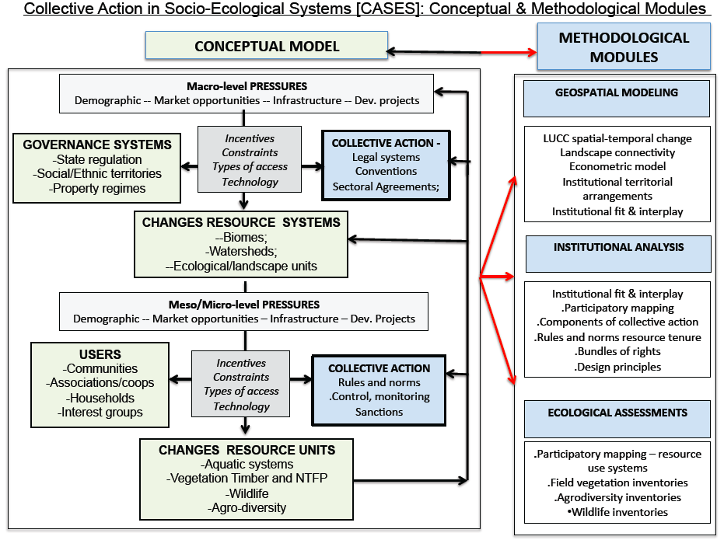
[Figure 2: Linking the conceptual and methodological modules]

1.6 Linking Methodological Modules to Indicators of Resource Mobilization Strategies, the National Reports, Aichi Targets

Figure 3 provides more detail on components of each methodological module, the possibilities of generating different types of monetary and non-monetary indicators of resource mobilization by indigenous peoples and local communities, and their contributions to specific questions of the National Reports and specific Aichi Targets. At this stage, 10 types/groups of monetary and non-monetary indicators of resource mobilization are introduced. The methodology contributes directly or indirectly to 8 of the 12 questions of the three parts of the National Report and more specifically to 14 of 20 of the Aichi Targets. There are three indicators that are directly linked to resource mobilization: (1) total area protected by indigenous and local communities (km²); (2) the number of full-time employees that the national park service would need to employ to protect an area of the same size as the land protected by indigenous and local communities (man hours per year) and (3) the total amount of public funds that the national park service spends on protecting an area that is of equivalent size as the area protected by indigenous and local communities (euro-equivalent amount). The remaining seven indicators are indirectly relevant to resource mobilization in that they can help explain why some indigenous and local communities are more successful in protecting biodiversity, and these indirect indicators—such as human integral development indicators, resource-system condition, and cultural values—may be used in the empirical analysis of the conditions under which particular resource conservation strategies are more productive.

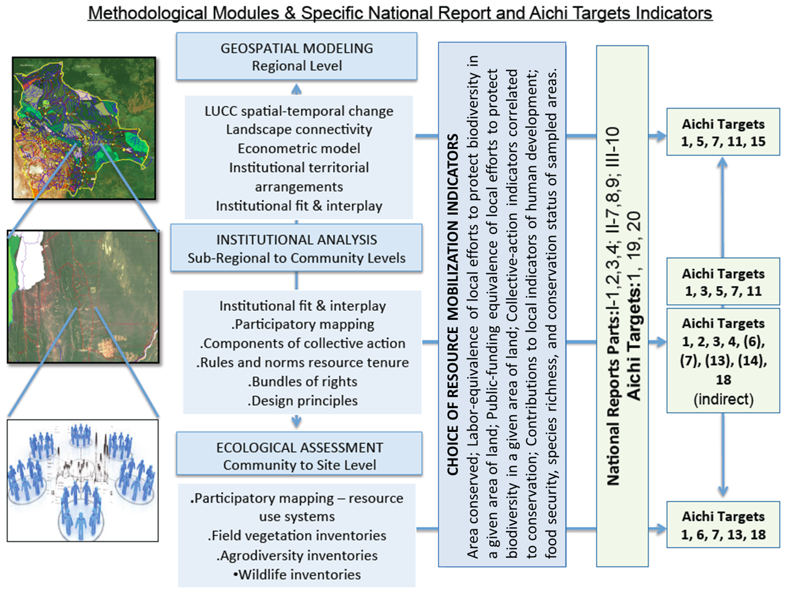
Figure 3: Analytical results linked to possible types of resource mobilization indicators, National Report questions and specific Aichi targets]

PART 2: METHODOLOGICAL MODULES
2.1 Introduction: Why is collective action among indigenous and local communities important for the conservation of biodiversity? As indicated in the introduction of the document, there are two main reasons for this, as follows: First, when natural resources that are shared by multiple users, collective action that involves the resource users is needed to prevent the over-exploitation of the resources. The ecosystems that are rich in biodiversity –such as forests, oceans, and riverine systems—are often so vast in area that they are hard to protect from encroachment, making them vulnerable to overuse. To prevent overexploitation, rules must be in place that regulate who has access to these resources and rules that control the use of those resources. And even if such rules exist because governmental organizations have created them, they may not be viewed as legitimate by local resource users and hence will not be respected. Research has shown that rules are more likely to be effective when the resource users themselves have had a say in the collective, rulemaking process (Ostrom, 1990).

Second, collective action involving resource users is needed to monitor and enforce compliance to these rules. The rules by themselves will not conserve the resource, especially if the rules have been created by governmental organizations, without the active input from local users. Several empirical studies have shown that natural resources are more likely to be conserved when resource users have acted collectively to organize monitoring and enforcement activities (Gibson et al 2005; Agrawal and Chhatre, 2008; Persha et al 2011). These activities include assisting authorities to enforce rules, and if necessary, impose sanctions on those who have violated the rules. If indigenous and local communities act collectively to protect the natural resources through monitoring and enforcement activities, the likelihood of effective resource protection increases because of improved regulation. In the absence of local collective action on behalf of indigenous and local communities, individual resource users will be less constrained to use the natural resources for short-term and personal benefit.

Although all parties to the CBD recognize the important contributions of local people to the success of efforts to conserve biological diversity, almost all countries lack systematic information about the contributions of indigenous peoples and local communities to the conservation of biodiversity, including in terms of monetary and non-monetary resource mobilization. The problem is that without such information at hand, national governments risk creating policies that undermine the protection activities already undertaken by local communities of users. The purpose of this section is to describe a plausible methodology for assessing the contribution of local actions, and particularly the collective actions of indigenous and local communities, to the protection of terrestrial biodiversity.

One of the main expected outputs of applying the methodology described in this section is the estimation of the total area of different vegetation types in a country that is being conserved thanks to different types of institutional arrangements and the actions of indigenous and local communities of resource users. Exactly how this will be achieved is the topic of the rest of the next section.

2.1.1 The Methodological Approach and Expected Outputs
At the outset, the methodological approach proposes that biodiversity may be under effective conservation and management for three basic reasons. First, an area may be conserved by nature itself, that is, it is protected by its geographical properties. For instance, an area may be protected because it is inaccessible to large number of people due to its remoteness or rugged terrain. Second, a resource system may be conserved because the national government has created a protected area in which it enforces formal rules and legislation. And, a third possibility is that an area and resources are protected and managed sustainably due to the collective actions undertaken by indigenous and local communities to develop and enforce the institutional arrangements that are needed to protect the resource system. In reality, more than one of these mechanisms may be at work simultaneously, but it is essential to recognize that the collective action among indigenous and local communities will affect outcomes in all three categories of protection, although it is likely to be more important in the third category than in the first two.

The proposed methodology consists of two phases. In the first phase, the regional data are analyzed using a Geographical Information System (GIS). In this stage, multi-temporal change detection is used to identify areas likely to be protected for each of the three reasons outlined above. To do so, the analysts draw on findings from previous studies that have established that natural ecosystems are more likely to be disturbed and altered when (1) the land is flat (making it more useful for agriculture and other land uses); (2) in close proximity human settlements, roads, and markets; and (3) the government authorities do not actively oppose human interventions into these ecosystems (i.e. see findings from Kaimowitz and Angelsen, 1998; Geist and Lambdin, 2002; Rudel et al 2009; DeFries et al 2010).

The second phase in the proposed methodology involves a combination of sub-regional geospatial analysis, institutional analysis and field-based assessments and measurements, which, if implemented, greatly strengthen the validity of the results and enables collaboration with local user groups and a deepened understanding of why and how local collective action promotes biodiversity conservation.

This means that there are three sets of tools/modules that will be implemented in two phases. The geospatial modeling will be implemented during the first phase and the institutional analysis as well as the ecological assessments in the second phase. Table 2 below summarizes the three modules and presents the criteria and examples of indicators for resource mobilization that can be developed using these tools.

Module | Criteria | Examples Indicators resource mobilization
Geospatial  Modeling  Module | Local resource users are able to conserve natural resources under increasing pressures from growing population and market opportunities | Area conserved by local communities (km²)  Regional environmental functions and resource inventories
Institutional Analysis  Module | The active involvement of local resource users in the creation, monitoring and enforcement of rules associated with natural resource use and environmental functions improves the cost-effectiveness of conservation efforts both inside and outside protected areas. | Labor-equivalent indicators  Collective action indicators correlated to conservation  Contributions to local Living-well/human wellbeing  Intangible cultural and social values  Local environmental functions and resource inventories
Ecological Assessment  Module | Local protection efforts, individual or collective, improves the condition of the natural resource base. | Resource provisioning and food security  Species richness  Conservation status
Table 2: The proposed metrics for quantifying local people’s contribution to the conservation of biological diversity (Source: Authors’ elaboration).

2.2 A Geospatial Modeling Approach
As mentioned above, the proposed modeling approach assumes that there are three basic reasons that biodiversity may be protected. It is protected because (1) it has been given a formal protected status by a government agency; (2) it is difficult to access and extract resources from, and (3) local resource users take actions to protect the natural resources. The last category of local action can be individually driven (i.e. a landowner who maintains native forest cover for personal reasons), or collectively driven (i.e. a community that communally manages forest for subsistence needs). The goal of our methodology is to carry out analysis at country and regional level to identify how rates of change observed regionally may relate to the role of the three factors identified above. This analysis will help to show how these three factors correlate to rates and pattern of change and types of local action.

It is important to note, however, that the above reasons for biodiversity conservation are not mutually exclusive. It is possible that some areas are protected because of a combination of two or more of these three categories of conservation. For instance, one could imagine a formally protected national park that is far from roads or rivers and that has local and indigenous populations that use the forest for subsistence (e.g., hunting, and collection of fruits and medicinal plants) and is organized to manage, monitor and exclude outsiders. For this reason, we do not attempt to categorize all well-conserved lands into one of the three types of protection (e.g., protected area, inaccessible, local action). Rather, an empirical approach is taken to estimating the probability that a particular area of vegetation is conserved due to local management efforts by local resource users. This information is used to prioritize areas for sub-regional analysis and for field investigation of the potential role of local action in preserving local biodiversity.

The probability that land is protected by local people’s action will be evaluated using an econometric model. In this model, specific characteristics of land areas—characteristics that previous studies have shown to affect the likelihood of land cover change—will be used to parameterize a model of forest cover change (F), as specified in equation 1 below.

In this model, R is remoteness from rivers and highways, S is slope of land, P is local population density, PA is presence of a protected area, and A is a spatial autocorrelation term. Some notes and key decisions on these variables are found in Table 3.

Table 3. Variables used in our model of forest cover.
Symbol | Description | Details and other considerations
LC | Land cover [in particular forest cover] | Depending on the spatial scale of the analysis, LC could be treated as a presence/absence variable, or as the proportion of forest within a larger unit of analysis.
R | Remoteness | Straight-line distance to the nearest road or river. Probably need some size cutoffs for our definitions of ‘road’ and especially ‘river’.
S | Slope | Steepness or ruggedness of land, dependeing on the scale of analysis.
P | Population | Local population density. This could be calculated in two ways. The first is to calculate the population density within a fixed radius of a point. This requires choosing a fixed cutoff distance that will ultimately be arbitrary. The second is using a decay function to weight the contribution of population centers by their distance to the point of analysis. Thus, the value of P at a particular point would be  . The exponent of 2 can be justified in terms of working in 2-dimensional space. The drawback of this method is that it is harder to calculate than population density within a fixed radius.  Also important to keep in mind is treatment of borders and if there is cross-border demand for products.
PA | Protected Area | Whether a given area falls within the boundaries of a Government Protected Area.
CP | Community Property Boundaries | Whether a given pixen exists within a government-titled indigenous or local community of natural resource users.
A | Spatial Autocorrelation | This variable will be similar to the population variable in that it can be calculated using a fixed radius or a decay function. It should reflect the amount of forest in the neighborhood of the focal region.

2.2.1 How will the indicator of “total land area conserved by collective action within indigenous and local communities” be calculated?

We start by calculating the probability that a given pixel has natural resources in a relatively preserved condition. This is done by creating a model in which the causal variables (slope, population, distance to roads, etc.) are used to predict the main outcome variable (forest cover in this case). The model will, in other words, predict whether a given pixel in the area of study is conserved or not. Having these model predictions for all pixels on the map, we will then be able to compare our model’s prediction with the actual state of the ecosystem (according to the satellite image-based map). The model is likely to find that most areas that are close to major roads, near large human settlements, and are relatively flat have a greater likelihood of being degraded (not conserved). But we might also find that our model incorrectly predicts some areas to be degraded while they are actually conserved. This anomaly is exactly what we are interested in because it suggests that although known drivers of environmental degradation are present in some areas, making conservation unlikely, the natural resource system has somehow been conserved. What this “somehow” is will be investigated next. To do so, we overlay existing community boundaries (indigenous and local community boundaries available from government sources) on top of the map we used in the predictive modeling exercise. We will now be able to observe whether the pixels that are actually conserved—but were incorrectly predicted to be degraded by our model—are located within the boundaries of indigenous and local communities. If they are within these boundaries, and the lands are legally controlled by indigenous and local communities, we can infer that these resources have been conserved thanks to the collective efforts of the local community members. Given the presence of known drivers of environmental degradation--high population, flat landscape, and proximity to major roads and markets—it is very likely that these resources would not have been conserved if the local people had not acted collectively to protect the biodiversity within these resource systems. We will quantify this contribution to biodiversity conservation at the national level by adding up all pixels that fall within all the indigenous and local community lands within a country, which are actually conserved despite being exposed to major outside pressure (as indicated by our model’s causal variables).

On the basis of the indicator that estimates the total area conserved by indigenous and local communities, two more indicators may be derived that are relevant for CBD member countries’ resource mobilization strategies. First, it is possible to calculate the labor-equivalent of conserving one hectare of land, based on a comparison of the national system of protected areas in the country. For example, if the country’s national park device has 2,000 full-time employees who collectively work to conserve the ecosystems on 2 million hectares of land, we can determine that each full time employee’s effort corresponds to 1,000 hectares of conservation. That means that if the modeling exercise described earlier finds that a total of 500,000 hectares of land on indigenous and local community lands have been conserved thanks to their collective efforts, that effort is equivalent to 500 national park service employees working full time.

Second, it is possible to perform a similar translation of the area conserved by local communities to the equivalent in public funds spent on conserving an equivalent area within the government’s protected areas. For example, if the total budget for the national parks service is 20 million euros per year to manage and protect 2 million hectares of [park land, the average cost per hectare is 10 euros. This figure can be applied to the 500,000 hectares of land that indigenous and local communities have been able to conserve, so that this land area represents what it costs the government to protect an area of the same size, which in this example would be 5 million euros. In sum, these three indicators would be useful for CBD member countries’ resource mobilization strategies and they may be calculated with data that most countries in the world today readily available.

The areas that our model identifies as being likely to be protected thanks to the collective actions of indigenous and local communities should be preferentially targeted for fieldwork to learn more about the specific mechanisms at work in each location that allow the natural resources to be protected against outside pressures. By applying this approach we seek to produce one essential indicator of local people’s contributions to biodiversity conservation: the total land area effectively conserved by local people as a proxy of conservation of biodiversity.

2.2.1 Data and Methods
Based on free satellite imagery, publicly available forest-monitoring datasets and tools, and open-source GIS software, we present a methodology that estimates the total land area that is effectively conserved by local resource users within a country. For purposes of illustration, we use an image/overlaid map of Bolivia (Figure 4) to explore the variety of existing data sets that may be used to carry out the proposed geospatial modeling analysis.

2.2.2 Data Acquisition

2.2.2.1. Geospatial data and analysis
Landsat images are freely available to be downloaded from http://earthexplorer.usgs.gov/ once an account is created. Users can obtain images by specifying a location (address or place), or by providing the coordinates. Landsat images have been acquired in an 8- to 16-day cycle since 1972, and these images serve as the starting points in evaluating forest change over time. More information can be found at http://landsat.usgs.gov/index.php.

Digital Elevation Models (DEM) provide terrain elevation data from which slope and other measures of terrain roughness can be calculated. elevation data is freely available at 90m and 30 m resolution. DEMs can also be obtained from the Global Land Cover Facility (http://glcf.umd.edu/data/glsdem/) or the ASTER project (http://asterweb.jpl.nasa.gov/gdem.asp).

Various GIS software packages can be used to analyze the raster images in order to obtain forest change and slope information. Freely available packages include GRASS GIS and QGIS in addition to better known commercial software liek ArcGIS and IDL/ENVI.

2.2.2.2. Forest change/monitoring tools
Instead of calculating forest cover change from raw satellite images, one can opt for using a processed dataset like the one from the Global Forest Change project (http://earthenginepartners.appspot.com/science-2013-global-forest). This free dataset provides annual Landsat-based estimates of forest coverage between 2000 and 2012 at a 30 meter spatial resolution. Users can use the JavaScript API provided by the Google Earth Engine to calculate forest cover change for a particular area. More information is available at https://sites.google.com/site/earthengineapidocs/tutorials/global-forest-change-tutorial.

For tropical forests, CLASlite can be used to generate images that indicate deforestation and disturbance. CLASlite takes time-differentiated satellite images and runs through the process of calibration, classification, and change detection to produce forest change results. More information is available at http://claslite.carnegiescience.edu/en/. A free 1-year license is available once the tutorial is completed with a passing grade.

2.2.2.3. Additional GIS layers
Multiple GIS layers are needed to capture the relationship between the land cover change and other spatial characteristics:
  - Protected areas – this layer displays the boundaries of areas set aside for conservation purposes.
  - Indigenous areas, extractive reserves, traditional population areas – this layer displays property regimes associated with different populations/indigenous groups and observing formal rules and management plans regulating access and use rights and types of resource uses and management.
  - Other relevant institutional arrangements and property regimes – this layer displays, where applicable, other forms of territorial arrangement such as related to resource extraction and management concessions, colonization areas, and ecological and economic zoning.
  - Roads – this layer displays the major roads that traverse the landscape. We define major roads as ones that allow trucking timber out of the forest, making them a factor in facilitating forest change
  - Watersheds and Rivers – this layer displays watershed units at different levels of aggregation that can serve as units of analysis. It also will help to identify the major waterways which facilitate access to and extraction of resources like timber.
  - Districts, municipalities, and state other administrative boundaries – these layers display administrative boundaries of political and census units that allow disaggregated reporting of land cover change.
  - Community locations and populations – this layer displays the coordinates of a central point within the settlements, e.g. a church, a school, or a community hall, and the community’s population. The central point and the population data will be used to calculate regional population density.

2.2.3 Data pre-processing:
Two basic pre-processing steps will have to be performed on the datasets listed above: geo-referencing/projection conversion and linking spatial layers to [geo] databases. Pre-processing steps such as geo-referencing and projection conversion are needed to ensure compatibility of coordinate and projection systems and spatial accuracy. Each layer should be related/linked to attribute tables (and associated databases). A hierarchical ID system should be developed to facilitate of linking different units of analysis, from the most disaggregated to the most aggregated level of analysis, for instance from a district to a municipality to a state to a country.

2.2.4 Data Analysis
By combining the satellite images and the GIS layers, different representations of the landscape can be obtained, as illustrated in Figure 4.
For each pixel (or groups of pixels), the following information may be calculated and used as input variables for the model:
- Land cover change – given a specific timeframe, a pixel can maintain a continuous cover of forest or other vegetation, or it can gain or lose that cover.
- Remoteness – this measures (in km) the shortest distance from the pixel to the nearest roads or rivers.
- Slope – this measures the steepness of terrain within a pixel. The average slope is calculated for each unit of analysis.
- Population density – the number of people living in or near the group of pixels used as the primary unit of analysis.
- Protected areas and other property regimes– this indicates if the pixel falls within an official protected area or other categories of use and conservation
- Spatial autocorrelation(s) –all else being equal, a pixel is more likely to be forested if it is in a more heavily forested landscape.
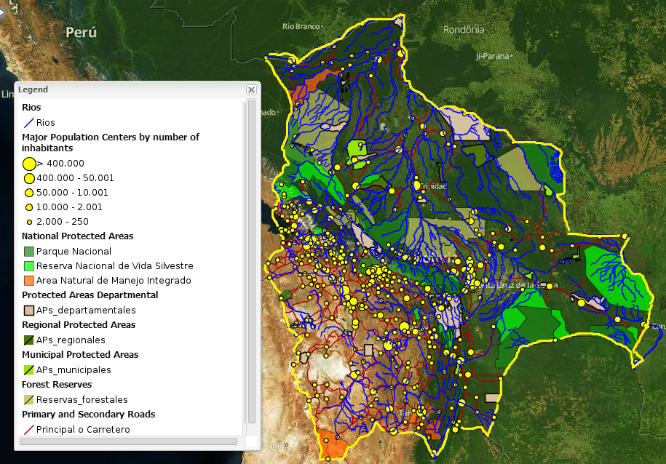

[Fig. 4 Satellite image of Bolivia overlaid by protected areas, roads, rivers, and population layers]

The data sets above allow for different types of analysis to inform reporting needs at the country and regional levels, and to identify areas undergoing different degrees and rates of change for further examination at sub-regional and local levels. As a first step, this analysis is carried out through a ‘transition matrix’ routine (in a GIS or image processing software), which indicates the direction of change in land cover between two or more dates (Brondizio and Van Holt 2014; Siren and Brondizio 2009). This analysis will produce a transition image indicating classes of change and no change from forest and non-forest cover. These images can be used to estimate the extent, direction, and rate of land use/cover change across multiple units/scales of analysis (e.g., roads and buffer zones, farm lots, settlements, community areas, indigenous reserves, municipalities, states, countries, etc.). In turn, this processing will allow assessing the degree of correlation between landscape change and types of access, property regimes and territorial arrangements, and environmental conditions.

This modeling exercise will produce an estimate of the total area of different vegetation types in a country that is being conserved thanks to different types of institutional arrangements and the actions of local communities and resource users, acting either individually or collectively.

2.2 An Institutional Analysis Module
Using the Institutional Analysis and Development Framework (IAD) as a reference, the institutional analysis module is applied at two levels. At a regional level, institutional analysis is carried out to understand how land cover change associate with layers containing types of institutional arrangement and property regimes. This analysis is performed using the geospatial analysis module. At this level, layers designating institutional arrangements and property regimes are associated with attribute tables containing data about property systems, population characteristics, and rules of resource access, management, and use. This type of analysis can be extended to sub-regional levels, through a sampling approach, to allow closer examination of rates of land cover change associated with different types of institutional arrangements, property regimes, and populations.
Figure 5 shows the organization of key groups of variables used for institutional analysis at different levels and related to different types of questions. At regional and sub-regional levels, analysis can focus on the role of different types of property regimes and institutional arrangements (e.g., types of reserves, protected areas, specific legislation) on the extent, location, and direction environmental change. At this level, analysis can focus on the types of institutional-ecological fit and institutional interplay (see part I for a discussion of both concepts).
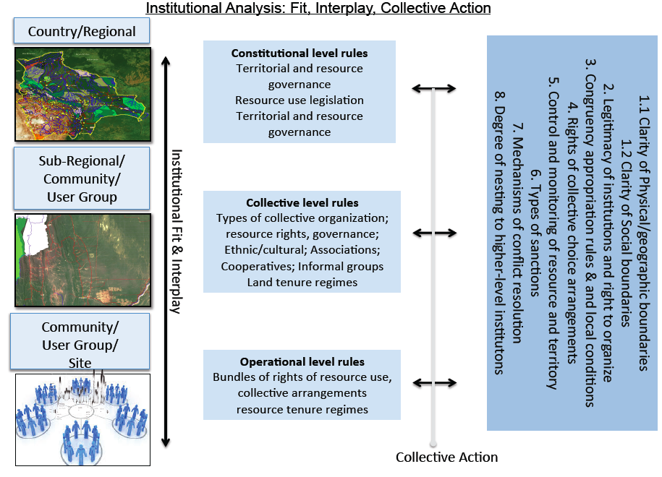
[Fig. 5 Elements considered for institutional analysis at different levels.]

At a local level, institutional analysis is carried out in sampled locations to understand the institutional arrangements associated with specific areas, social and resource user groups, and/or communities. These areas are identified through a sampling process and the sample size should be adjusted to the availability of available resources and desired level of precision of the data. And it is in these areas that regional and sub-regional analysis will be carried out for more in-depth investigation of why some areas are better conserved than others.

At this level, institutional analysis is applied to understand the interaction of two dimensions of collective action, i.e., at the level of a given area or territory and at the level of a specific natural resource. This level of work involves a combination of participatory mapping and community level questionnaires with the goal of understanding how different forms of institutional arrangement and collective action relate to the management and use of different areas/territories and resources (see Figure 6 for illustration). This analysis will allow for field-based adjustments (validation) of the estimates of areas conserved by local people produced by the geospatial model in the previous stage.

The field-based analysis, which will be carried out in a sample of local communities, is guided by eight structuring dimensions or components of collective action, which are used to examine the underlying elements of collective action at both the level of a given territory and at the level of a user group and/or community. These eight components include: 1.1 Physical/geographic boundaries; 1.2 Social boundaries; 2. Legitimacy of institutions and right to organize; 3. Congruency between rules of resource appropriation and local conditions; 4. Collective choice arrangements; 5. Control and monitoring of resource and territory; 6. Sanctions; 7. Mechanisms of conflict resolution; 8. Degree of nesting to higher-level institutions.

Some basic questions associated with each element of institutional analysis include:
1.1 Physical/geographic boundaries and associated bundles of rights: what are the geographic boundaries associated with a given property/territorial regime, including characteristics of demarcation degree of access, level of formal and informal agreement and recognition. What are the overlaps between different kinds of property regimes associated with a given boundary: are boundaries of access, extraction, management, exclusion and alienation clearly defined?

1.2 Social boundaries and associated bundles of rights: who is and can be a member of the group/community. How are rights of access, extraction, management, exclusion and alienation associated with a given social group? In what degree social boundaries are perceived as legitimate, understood, and respected by members of the group and those outside?

2. Legitimacy of institutions and right to organize: How a given user group and/or community is recognized by external actors and agencies as legitimate to manage and implement rights of access, use, management, control and monitoring, and sanction of a given area and/or resource?

3. Congruency between rules of resource appropriation and local conditions: In relation to the resources important to the local economy, are there formal external rules that define type and level of use and extraction of resources? Do these rules define when, where, type of technology, and how much resources can be appropriated by who?

4. Collective choice arrangements: Who has the right to participate and create rules of resource use and management. Who has the right to participate on a given effort of collective action and how are rights of defining rules, control and monitor, give sanction, and resolve conflict regarding specific types of resource use? To what extent members outside of the group or community have rights to participate in local collective action and on the process of rule crafting regarding a given territory and resource system.

5. Control and monitoring of resource and territory: For a given area or territory and/or a resource use system, what are the internal and external systems of control and monitoring in place. What mechanisms and technologies are in place to provide control and monitoring: policing, environmental agents, local monitors, remote sensing, etc.

6. Sanctions: For a given area or territory and/or a resource use system, are there different and graduate systems of sanctions? What are the internal and external, formal and informal, systems of sanctions in place? Are they considered effective by local members of the group and by external actors? How are these sanctions applied and who has authority at different levels to apply them?

7. Mechanisms of conflict resolution: In a given area/territory and/or regarding a specific resource, what are the internal and external mechanisms of conflict resolution and who have the right to participate and apply them at different levels?

8. Degree of nesting to higher-level institutions: How are different local [formal and informal] institutions nested (i.e., congruency in types of rules; compatibility; level of recognition) to formal institutions at higher levels of social organization?

2.2.1 Fieldwork to measure local resource users’ efforts to protect biodiversity

The above analytical components serve as the basis for detailed questionnaires that can be designed to be applied at the level of a sample of community and/or user group. This portion of the methodology also includes participatory mapping, which serves two functions. First, it serves as an interface between regional/sub-regional geospatial analysis and local analysis, i.e., to capture how local groups understand and define rules and bundles of rights (and the 8 elements mentioned above) associated with a given area and/or territory. Second, it serves to map out different resource use systems and a sampling frame of areas for detailed ecological inventories. Figure 6 illustrates the use of satellite imagery and questionnaire for participatory mapping with a group of small farmers in Eastern Amazon.

Combining participatory mapping and institutional analysis can help to clarify the relationship between different forms of collective action and resources, for instance:

a. Reconstruct institutional changes associated with a particular area during a given time period to understand how these institutions mediate external and internal pressures on biodiversity and resources;
b. Identify overlaps in property systems associated with a given area/landscape or with specific resources and the contribution of different property systems to conservation;
c. Identify and define landscape units/resource system areas that are recognized locally as economically and culturally important and associated with particular institutional arrangements;
d. Develop a local toponymy (definitions of local names for areas/parts of the landscape, resources, ecological units) and associated history of use and occupation important to the understanding of resource uses.
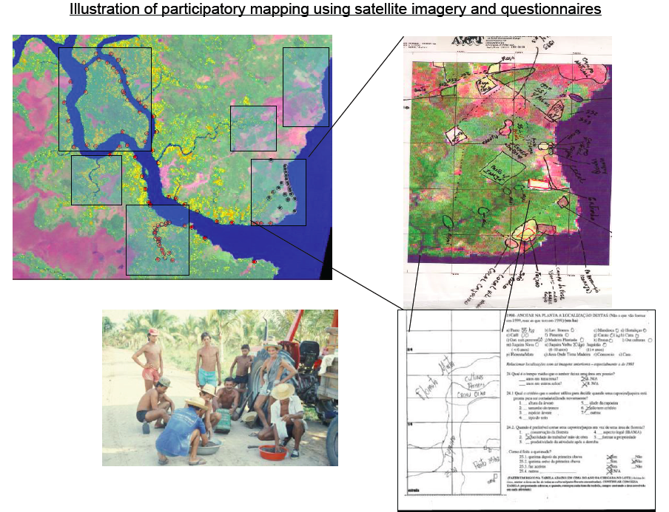

[Figure 6. Illustration of participatory mapping using satellite imagery and questionnaire with a group of small farmers in Eastern Amazon]

As part of the second version of this report, detailed information will be provided on the preparation of questionnaires (landscape/property regime level and local/resource use level) and the preparation and application of satellite images and maps for use during participatory mapping (different spatial and temporal scales). In addition to this planned analysis, during the second version of this report we will propose an initial coding system to qualify and quantify different components of collective action at the local level and their implications for resource mobilization.

2.3 An Ecological Assessment Module
While the modules presented above build understanding of the drivers of land cover, landscape structure, habitat (e.g., integrity and connectivity) and biodiversity change, ecological assessments measure these changes themselves. Although satellite imagery is used as a basis for identifying potential areas conserved by collective action, it is necessary to engage in more detailed assessments to determine whether lands are truly protected, or are ‘empty forests’, selectively logged of valuable trees and hunted free of large animals. Assessments can be made across ecosystems, or target particular species of interest, including plants and wildlife important to the local economy. As mentioned, participatory mapping allows for spatial understanding of institutional arrangements associated with collective action at the level of landscapes and communities. It also serves as a basis for defining resource use areas and, thus the selection of sites for ecological assessments and inventories. Here, we provide an initial outline of ecological assessment options for timber and non-timber forest products and wildlife and how they may be used to evaluate subjects of interest such as biodiversity and carbon storage.

Ecological assessments of plant and animal resources can be developed at different levels of detail, from systematic inventories providing specific information about density, frequency, and dominance of key species in a given area, to general conditions of the vegetation and fauna. Here we outline three types of assessments, systematic surveys, rapid assessments, and targeted interviews. The choice of level of detail will influence the types of indicators [monetary and non-monetary] that can be calculated. We outline the operational and analytical trade-offs associated with different choices of methods and their implications for the development of different indicators.

Systematic surveys - The most detailed option we present here are what we call ‘systematic surveys’. Systematic surveys involve detailed enumeration and measurement of species present, and provide data that can be applied toward direct estimation of forest biomass (carbon sequestration) and biodiversity of different taxa (plants, mammals, birds, etc.). Systematic vegetation surveys will be carried out in multiple plots in randomized locations. Within these plots, plants of different statures (trees, shrubs, herbs) and life stages (adults, saplings, seedlings) will be identified to species and measured in specified areas. Faunal surveys will involve repeated observation of key groups (mammals, birds, reptiles and amphibians) in fixed transects or survey points.
Systematic surveys enjoy several advantages. They can provide quantitative estimates of the biomass of forests and the relative abundance of all species in evaluated categories. They can also provide detailed information on the abundance and demographic viability of species of interest, such as economically or culturally important organisms, or threatened and endangered species. The disadvantage of systematic surveys is their cost. This type of work requires substantial effort in each site visited by teams of trained specialists familiar with local plant and animal species. For particularly species rich areas, surveys providing reasonable levels of certainty for species-specific abundances would require prohibitively intensive sampling. Timing of the faunal surveys may also be an issue in areas with many migratory species.

Rapid assessments – Rapid assessments are a method of assessing local biodiversity with less effort than systematic surveys. They typically involve a short, intensive effort by a few experts in different taxonomic groups to draw up a list of species confirmed present in an area. Because the visits are shorter and teams smaller, substantial cost savings relative to systematic surveys are possible, while still providing a broad picture of local biodiversity. Disadvantages of rapid assessments are that they provide a lower level of detail than systematic surveys. No measurements are made of trees, so biomass and carbon sequestration calculations are not possible. Demographic structure of populations is not available, and the relative abundance of species is available as coarse guesstimates at best.

Targeted interviews – Targeted interviews are an alternative to typical biodiversity assessments to provide quick data on the effectiveness of local biodiversity conservation. Rather than attempting a complete enumeration of species present in an area, this method relies on interviews with local residents to determine the abundance and population trends of species vulnerable to human overexploitation or extermination. These include useful species such as timber trees, animals eaten as bushmeat such as primates and medium to large herbivores, and large carnivores that may be viewed as a danger to humans or livestock. Central to this method will be developing a locally appropriate list of target species. Interview data can be supplemented with forest visits to confirm informant responses, particularly in the case of timber trees.
By focusing only on bellwether species, this method substantially reduces the time and effort required for more detailed surveys. Field workers require less training and specialized knowledge than for rapid assessments or systematic surveys, although they will need some familiarity with interview techniques and the local species of interest. By focusing on charismatic species, this technique may miss declines in less visible organisms, although this may be overcome by asking about other species in decline during interviews.

BIBLIOGRAPHY:
Acheson, J. 2006. Institutional failure in resource management. Annual Review of Anthropology 35: 117-134.

Andersson, K. 2013. Local Forest Governance and the Role of External Organizations: Some Ties Matter More than Others. World Development 43 (1) 226-237.

Andersson, K. Benavides, J.P. León, R. 2014. Institutional Diversity and Local Forest Governance. Environmental Science and Policy 36: 61-72

Andersson, K. and Ostrom, E. 2008. Analyzing Decentralized Natural Resource Governance from a Polycentric Perspective. Policy Sciences 41(1):1-23.

Andersson, K. and Gibson, C. 2007. Decentralized Governance and Environmental Change: Local Institutional Moderation of Deforestation in Bolivia. Journal of Policy Analysis and Management 26(1): 99-123

Brondizio, E. S. 2008. The Amazonian Caboclo and the Açaí palm: Forest Farmers in the Global Market.” New York: New York Botanical Garden Press. Pp. 402

Brondizio E S, Ostrom E, Young O. 2009. Connectivity and the Governance of Multilevel Socio-ecological Systems: The Role of Social Capital. Annual Review of Environment and Resources 2009, 34:253–78

Brondizio, E. S., A. Cak, M. Caldas, C. Mena; R. Bilsborrow, C. T. Futemma, E. F. Moran, M. Batistella, and T. Ludewigs. 2009. Small Farmers and Deforestation in Amazônia. In M. Keller, M. Bustamante, J. Gash, and P. Silva Dias (eds.) Amazônia and Global Change: A Synthesis of LBA Research. World Scientific Publishing (American Geophysical Union, Geophysical Monograph Series 186). P.117-143.

Brondizio, E. S., F. Gatzweiler, C. Zagrafos, M. Kumar. 2010. Socio-cultural context of ecosystem and biodiversity valuation.(Chapter 4) In P. Kumar (ed.) The Economics of Ecosystems and Biodiversity (TEEB). London, UK: Earthscan Press. Pp. 150-181.

Brondizio, E. S. and E. F. Moran. 2012. Level-dependent deforestation trajectories in the Amazon: 1970-2001. Population and Environment. DOI 10.1007/s11111-011-0159-8 [electronic Dec. 2011].

Brondizio, E. S. and T. Von Holt. 2014. Geospatial Analysis in Anthropology. In H. R. Bernard and C. L. Gravelee (eds.) Handbook of Methods in Cultural Anthropology. Lanham, Maryland: Altamira Press. Chapter 19, p. 601-629.

Castro, F. and McGrath, D. 2003. Community-Based Management of Lakes and Sustainability of Floodplain Resources in the Lower Amazon. Human Organization 62(2):123-133..

Cox, M., G. Arnold, and S.V. Tomas. 2010. A review and reassessment of design principles for community-based natural resource management. Ecology and Society. [online]

DeFries, R. S., Rudel, T., Uriarte, M., & Hansen, M. (2010). Deforestation driven by urban population growth and agricultural trade in the twenty-first century. Nature Geoscience, 3(3), 178-181.

Duraiappah, A., S. Asah, E. S. Brondizio, L. Hunter, N. Kosoy, A-H. Prieur-Richard, S. Subramaniam. 2013. Managing biodiversity is about people: The Role of Social Sciences in Achieving the Strategic Plan for Biodiversity 2011-2020 and its Aichi Targets. Background Paper for the Trondheim Conference 1 on Biodiversity. Montreal: UN-CBD.

Geist, H. J., & Lambin, E. F. (2002). Proximate Causes and Underlying Driving Forces of Tropical Deforestation Tropical forests are disappearing as the result of many pressures, both local and regional, acting in various combinations in different geographical locations. BioScience, 52(2), 143-150.

GBO-3 2010. Global Biodiversity Outlook 3. Secretariat of the Convention on Biological Diversity. Montréal, Canada. 94 pages.

Kaimowitz, D., & Angelsen, A. (1998). Economic models of tropical deforestation: a review. Cifor.

Lambin, E. F. and P. Meyfroidt. 2011. Global land use change, economic globalization, and the looming land scarcity PNAS 2011 108 (9) 3465-3472

Mcginnis, M. D. 2011 An Introduction to IAD and the Language of the Ostrom Workshop: A Simple Guide to a Complex Framework. The Policy Studies Journal, Vol. 39, No. 1.

Millennium Ecosystem Assessment. 2003. Ecosystem and human well-being: a framework for assessment. World Resources Institute, Washington, DC.

Olson, M. 1965. The Logic of Collective Action: Public Goods and the Theory of Groups. Harvard University Press.

Ostrom, E. 1990. Governing the commons: The evolution of institutions for collective action. Cambridge University Press, New York.

Ostrom, E. 2005 . Ostrom E. 2005. Understanding Institutional Diversity. Princeton, NJ: Princeton Univ. Press.

Ostrom, E. 2009. A General Framework for Analyzing Sustainability of Social-Ecological Systems. Science 325 (5939): 419-422. DOI:10.1126/science.1172133

Ostrom, E. 2011. Background on the Institutional Analysis and Development Framework. The Policy Studies Journal, Vol. 39, No. 1.

Persha, L. and Andersson, K. 2014. Elite capture risk and mitigation in decentralized forest governance regime. Global Environmental Change 24:265-276

Rudel, T. K., Defries, R., Asner, G. P., & Laurance, W. F. (2009). Changing drivers of deforestation and new opportunities for conservation. Conservation Biology, 23(6), 1396-1405.

Sirén, A. H. and E. S. Brondizio. 2009. Detecting subtle change in small-scale tropical forest shifting cultivation systems: Methodological contributions integrating field and remotely-sensed data. Applied Geography 29(2):201–211

Soares-Filho B, da Fonseca G A B, Nepstad D, Pfaff A, Petsonk A, Anderson A, Boucher D, Cattaneo A, Conte M, et al.: Indigenous Lands, Protected Areas, and Slowing Climate Change. PLoS Biol 2010, 8(3): e1000331.

Ricketts TH, Soares-Filho B, da Fonseca GAB, Nepstad D, Pfaff A, et al. (2010) Indigenous Lands, Protected Areas, and Slowing Climate Change. PLoS Biol 8(3): e1000331. doi:10.1371/journal.pbio.1000331

Young O R. 2006. Vertical interplay among scale-dependent environmental and resource regimes. Ecology and Society, 11(1):27. http://www.ecologyandsociety.org/vol11/iss1/art27/

Young O. R., L. A. King, H. Schroeder, Eds. 2008. Institutions and Environmental Change (MIT Press, Cambridge, MA.

APPENDIX 1:. Linking the methodology to the Aichi Goals and Targets
Strategic Plan Target | Contribution of the Proposed Methodology
#1: People are aware of the value of biodiversity & of the steps they can take to conserve and sustainably use biodiversity (by 2020) | The cross-level approach proposed here, including field-based assessment, will help to understand different dimensions of value embedded on how people/user groups develop rules to manage and protect natural resources and their degree of economic and material dependency on them. Country and regional level assessments offer information about the impact of policy, economic, demographic, and environmental pressures on natural resources and biodiversity and local populations, thus the types of values underlying societal actions towards biodiversity.
#2: Biodiversity values have been integrated into national and local strategies for development, poverty reduction and planning processes and are being incorporated into national accounting and reporting systems (by 2020) | The institutional analysis module and field-based assessments proposed here will help estimate the extent to which the biodiversity values permeate local strategies for resource use and management.
#3: Incentives, including subsidies, harmful to biodiversity are eliminated, phased out or reformed and positive incentives are developed and applied (by 2020) | The institutional analysis module and field-based assessments proposed here will help to understand whether there is lack of congruence between resource and biodiversity appropriation rules (and incentives) and local conditions.
#4: Governments, business and stakeholders at all levels have taken steps to achieve sustainable production and consumption and have kept the impacts of use of natural resources well within safe ecological limits (by 2020) | This may be the target where this proposal can make its biggest contribution. The proposed employs a scientifically sound, yet practical approach to estimate the contribution of local communities and user groups to make progress towards this target.
#5: The rate of loss of all natural habitats, including forests, is at least halved and where feasible brought close to zero, and degradation and fragmentation is significantly reduced | - The proposed methodology allows assessing this target from national to local levels, including identifying spatial-temporal patterns of change (land cover) associated with different institutional/territorial arrangements, types of infrastructure and accessibility, and environmental conditions.
#6: All fish and invertebrate stocks and aquatic plants are managed and harvested sustainably and legally [ecosystem approach] (by 2020) | The institutional analysis module provides detailed information regarding types of local collective action regarding rules and bundles of rights underlying the management of resource systems and resource units. The ecological analysis module (currently proposed for vegetation resources) provides data on the impact of local institutional arrangements on resource/biodiversity stocks and flows.
#7: Areas under agriculture, aquaculture and forestry are managed sustainably (by 2020) | The proposed methodology uses existing longitudinal LUCC data to estimate the degree to which land use categories are maintained stable by local resource users under different types of land tenure arrangements as well as the role of governmental protected areas, reserves, and concessions. The ecological analysis module can provide data on agricultural and forest indicators such as related to agrodiversity, productivity, among others.
#8: Pollution, including from excess nutrients, has been brought to levels that are not detrimental to ecosystem function and biodiversity (by 2020)

#9: Invasive alien species and pathways are identified and prioritized, priority species are controlled or eradicated and measures are in place to prevent their introduction and establishment (by 2020)

#10: The multiple anthropogenic pressures on coral reefs and other vulnerable ecosystems impacted by climate change or ocean acidification are minimized (by 2015)

#11: At least 17 % of terrestrial and inland water areas and 10 % of costal and marine areas are conserved through systems of protected areas (by 2020) | The geospatial analysis model provides information at the country/regional and sub-regional levels of the area extent and distribution of different types of reserves and protected area.
#12: Extinction of known threatened species has been prevented and their conservation status has been improved and sustained (by 2020)

#13: Genetic diversity of cultivated plants and farmed and domesticated animals and of wild relatives is maintained and strategies developed and implemented for minimizing genetic erosion and safeguarding genetic diversity (by 2020) | The institutional analysis module can be used to provide detailed information regarding types of local collective action regarding use and management of agrodiversity. The ecological analysis module can provide data on the impact of local institutional arrangements agrodiversity.
#14: Ecosystems that provide essential services, including services related to water, and contribute to health, livelihoods and well-being, are restored and safeguarded, taking into account the needs of women, indigenous and local communities, and the poor and vulnerable (by 2020) | The institutional analysis module can provide elements to define types and degrees of access to different types of natural resources, including water, by different social groups. The methodology explicitly defines specific components of ‘bundles of rights’ associated with resource systems or specific resource units.
#15: Ecosystem resilience and the contribution of biodiversity to carbon stocks has been enhanced through conservation and restoration of at least 15% of degraded ecosystems, thereby contributing to climate change mitigation and adaptation and to combating desertification (by 2020) | The proposed geospatial module of LUCC can provide data on rate, extent, and direction of land cover change that can be integrated into biomass and carbon stock models to assess progress towards the agreed target.
#16: The Nagoya Protocol on Access to Genetic Resources and the Fair and Equitable Sharing of Benefits Arising from their Utilization is in force and operational, consistent with national legislation (by 2015 )

#17: Each party has developed, adopted as a policy instrument, and has commenced implementing an updated National Biodiversity Strategy and Action Plan (NBSAPs) (by 2015)

#18: Traditional knowledge, innovations and practices of indigenous and local communities and their customary use are respected and fully integrated in the implementation of the CBD with full and effective participation of indigenous and local communities (by 2020) | The proposed methodology explicitly integrates the assessment of local levels of collective efforts of indigenous and local communities and their customary systems of use, management, and protection of natural resources and biodiversity.
#19: Knowledge, the science base and technologies relating to biodiversity, its values, functioning and status and trends, and the consequences of its loss, are improved, widely shared and transferred, and applied (by 2020) | The implementation of the proposed methodology and its cumulative development, including its potential to serve as a participatory tool for use by different stakeholders, is intended to contribute to this goal.
#20: The mobilization of financial resources for effectively implementing the Strategic Plan for Biodiversity from all sources should increase substantially from current levels, in accordance with the Strategy for Resource Mobilization and based on resource needs assessments to be developed and reported by Parties (by 2020) | Local users’ efforts are often very important for a country’s effectiveness to protect biodiversity, although these contributions are made in-kind rather than monetarily. The proposed methodology offers tools to assess these contributions quantitatively (e.g., impact on rates, extent, direction of environmental change) and qualitatively (e.g., impact of formal and informal rules regarding resource use and management). Additional modules could be developed and integrated to allow estimation of different types of value (e.g., cultural, economic, societal).

APPENDIX 2: CBD Guiding questions for the Fifth National Report.
Part I - An update on biodiversity status, trends, and threats and implications for human well-being.
Q1: Why is biodiversity important for your country?
Q2: What major changes have taken place in the status and trends of biodiversity in your country?
Q3: What are the main threats to biodiversity?
Q4: What are the impacts of the changes in biodiversity for ecosystem functions and the socio-economic and cultural implications of these impacts?
Optional question: What are possible future changes for biodiversity and their impacts?
Part II - The national biodiversity strategy and action plan (NBSAP), its implementation, and the mainstreaming of biodiversity.
Q5: What are the biodiversity targets set by your country?
Q6: How has your national biodiversity strategy and action plan been updated to incorporate these targets and to serve as an effective instrument to mainstream biodiversity?
Q7: What actions has your country taken to implement the Convention since the fourth report and what have been the outcomes of these actions?
Q8: How effectively has biodiversity been mainstreamed into relevant sectoral and cross-sectoral strategies, plans and programmes?
Q9. How fully has your national biodiversity strategy and action plan been implemented?
Part III - Progress towards the 2015 and 2020 Aichi Biodiversity Targets and contributions to the relevant 2015 Targets of the Millennium Development Goals. This part should also evaluate how national action plans are being implemented and contributing to these goals.
Q10: What progress has been made by your country towards the implementation of the Strategic Plan for Biodiversity 2011-2020 and its Aichi Biodiversity Targets?
Q11: What has been the contribution of actions to implement the Convention towards the achievement of the relevant 2015 targets of the Millennium Development Goals in your country?
Q12: What lessons have been learned from the implementation of the Convention in your country?

* UNEP/CBD/COP/12/1/Rev.1.
Developed per request of the Amazon Cooperation Treaty Organization (OTCA) with the support of the Amazon Regional Programme (ARP)-GIZ, and the IUCN South (International Union for Conservation of Nature) – Resilience and Development Programme (SWEDBIO). This proposal has been developed by Eduardo S. Brondizio, Indiana University-Bloomington, and Krister P. Andersson, University of Colorado-Boulder, with contributions and monitoring of Diego Pacheco, Rector of the University of the Cordillera and Advisor of the Ministry of Foreign Affairs from Bolivia, and the Unit of Mother Earth and Water (UMTA) of the Ministry of Foreign Affairs of the Plurinational State of Bolivia.
The term human integral development is used to mean the degree to which people have access to essential public goods and services so that they are in good health, food secure, and enjoy access to public services such as sanitation, clean water, health, and education. In this sense, the term is consistent with the concept of “Living Well”
This resolution is a result of Bolivia’s proposal presented at the Convention of Biological Diversity Conference of the Parties 11.
The framework proposed here also contributes to the resolution in paragraph 17, which states: “17. Encourages Parties to undertake institutional mapping/analysis, covering the whole range of biodiversity resourcing options, as part of developing country-specific resource mobilization strategies within the framework of revising national biodiversity strategies and action plans;”
As described by McGinnis (2011) and Ostrom (2011), institutional analysis using the IAD framework is based on distinguishing three levels of analysis in which different types of choice processes take place. “At the (1) operational level, actors (either as individuals or as representatives of collective entities) make practical choices among their available options, as determined by (2) collective-level choices involving the determination of which strategies, norms, and rules are, should be, or are not available to actors fulfilling the specific roles defined by that group (as well as specifying who is assigned to fill these roles); and (3) constitutional-level choices relating to who is or should be empowered to participate in the making of collective and operational-level decisions.”
The IAD framework aims at accommodating multiple levels of institution analysis, approaching the interaction between levels by identifying a conceptual analytical unit defined as an action arena. The action arena helps to define the focus of analysis (i.e., a given question or problem to be examined), prediction, and explanation of individual and collective behavior and to explain their outcomes and feedback mechanisms at different levels. The IAD presupposes that collective action problems are dynamic and evolving, where new institutional alternatives to deal with these problems are created. At the most basic level, the IAD includes an action arena, with social actors and action situations, contextual inputs (environmental, institutional, and social attributes), patterns of interactions, and outcomes, the latter evaluated by a series of evaluative criteria.
Since most protected areas are not void of people, the degree of collective action among local inhabitants is also an important driver of conservation success. For the sake of simplicity, however, our approach does not seek to quantify the contribution of local collective action within protected areas and hence attribute the conservation of resources within parks entirely to the efforts of the government. This means that our estimates of the contribution of local collective action underestimates the real contribution. In that sense, the estimates are conservative indicators of local resource user contributions to conservation outcomes.
See reviews on the main drivers of tropical deforestation in Kaimowitz and Angelsen, 1998; Geist and Lambdin, 2002.
In many ecosystems, the conservation of the natural resource may be observable by analyzing a satellite image and although this technique has some limitations, this is the technique that we propose to use for the modeling exercise here. In subsequent phases of the work, however, we will rely more on field-based techniques will serve to validate results from the modeling work in this initial phase.
Sample size will vary with available resources and desired level of precision in the estimated indicators. A meaningful sample size maybe as small as n=3 if the cases are selected with a clear purpose (King et al 1994), but to validate the output of our modeling exercise, a sample approaching n=30 would be preferable.

