 |  | CBD
 |  |  |  | Distr.  GENERAL  UNEP/CBD/COP/12/INF/10  1 October 2014  ENGLISH ONLY
CONFERENCE OF THE PARTIES TO THE CONVENTION ON BIOLOGICAL DIVERSITY
Twelfth meeting
Pyeongchang, Republic of Korea, 6-17 October 2014
Item 22 of the provisional agenda*

ANalysis on PATHWAYS for the INtroduction of
invasive Alien species: Updates
Note by the Executive Secretary

INTRODUCTION
- As requested by the Conference of the Parties in paragraph 25 of decision XI/28, the Executive Secretary prepared, in collaboration with experts and partners of the Global Invasive Alien Species Information Partnership, a note on (a) a preliminary list of the most common pathways for the introduction of invasive alien species; (b) criteria for use at the regional and subregional levels or other ways by which they may be prioritized; (c) and a range of tools that may be used to manage or minimize the risks associated with these pathways for consideration by the Subsidiary Body on Scientific, Technical and Technological Advice at its eighteenth meeting.
- The present note provides a more detailed analysis of the six categories of common pathways. This updated pathway analysis was prepared by the IUCN-Species Survival Commission-Invasive Species Specialists Group.
- The submission is being reproduced in the form and languages in which it was provided to the Secretariat.

ANalysis on PATHWAYS for the INtroduction of
invasive Alien species: Updates

Applying a standard categorization to identify priority pathways of introduction of
invasive alien species at different scales

- INTRODUCTION

This document is aimed at informing on a possible preparation for comprehensive pathway management to the Conference of the Parties. The document has been developed by the IUCN-Species Survival Commission-Invasive Species Specialist Group, with input from leading experts on the issue, and taking into account the outcomes of several scientific papers, published or in preparation as follows:

- Blackburn, T.M., Essl, F., Evans, T., Hulme, P.E., Jeschke, J.M., Kühn, I., Kumschick, S., Marková, Z., Mrugała, A., Nentwig, W., Pergl, J., Pyšek, P., Rabitsch, W., Ricciardi, A., Richardson, D.M., Sendek, A., Vilà, M., Wilson, J.R.U., Winter, M., Genovesi, P. & Bacher, S. (2014). A Unified Classification of Alien Species Based on the Magnitude of their Environmental Impacts. PLoS Biol., 12, e1001850.
- Essl F., et al. In prep. Moving to new frontiers in tackling pathways in biological invasions. Submitted to Frontiers in Ecology and the Environment.
- Jeschke J.M., et al. in preparation.
- McGeoch M.A., Genovesi P., Bellingham P.J., Costello M., McGrannachan C., and Sheppard A. Submitted. Prioritizing species, pathways and sites: addressing the Aichi target for biological invasions.
- Pergl J., Pyšek P., Bacher S., Essl F., Genovesi P., Harrower C.A., Hulme P.E., Jeschke J.M., Kenis M., Kühn I., Perglová I., Rabitsch W., Roques A., Roy D., Roy H., Vilà M., Winter M., Nentwig W. In prep. Troubling travellers: alien impacts are a function of introduction pathways.
- Saul W.C., Booy O., Carnevali L., Chen H.J., Genovesi G., Harrower C.A., Pagad S., Pergl J, Roy H.E., Jeschke J.M. Combining two major databases to assess taxonomic and habitat-related patterns in introduction pathways of alien species (oral presentation at Neobiota 2014, Antalya – Turkey, 3-8 November 2014).

II. PROGRESS ON PATHWAY ANALYSIS
- Pathway definition
The use of the term ‘pathways’ in the context of biological invasions refers to any human mediated means that enables the entry or spread of an alien species within a region or beyond. This includes physical vectors, as well as general activities causing the introduction of alien species.

The Guiding Principles for the Prevention, Introduction and Mitigation of Impacts of Alien Species that Threaten Ecosystems, Habitats or Species (The Guiding Principles) distinguish between intentional introductions (guiding principle 10) and unintentional introductions (guiding principle 11). The Guiding Principles indicate that intentional introduction should be addressed by an authorisation system which is based on a risk analysis, and regarding unintentional introduction, all States should have provisions in place, which include statutory and regulatory measures and establishment or strengthening of institutions and agencies with appropriate responsibilities. The activities such as fisheries, agriculture, forestry, horticulture, shipping (including the discharge of ballast waters), ground and air transportation, construction projects, landscaping, ornamental aquaculture, tourism and game-farming may be considered that are pathways for unintentional introductions of potential invasive alien species.

The Guiding Principles make a reference to the ‘pathways’ and ‘vectors’ of introduction only with regard to unintentional introductions. However, the patterns of introductions are indeed very complex, and in many cases it is not possible to distinct between intentional introductions and unintentional introductions, and therefore global databases validated by experts do not consistently assign this information to pathways. For instance, international trade of pets, aquarium species, live baits or nursery plants is an intentional activity, but such intentional trade often causes unintentional introduction of alien species into the wild (escape of invasive species from confined condition).

Similarly, activities of biological control, forestry, hunting and other uses of alien species in natural environment are intentional, but its eventual spread would be unintentional introduction in the environment.

Scientific evidence shows that the overall framework causing the movement of species is highly dynamic, and the key features of pathways are subject to spatio-temporal changes. New pathways and novel means of introduction progressively emerge. In the case of the internet trade of living organisms for different purposes is an example of such emerging introduction pathway.

Taking into account the emerging means of introduction, the definitions of pathways presented in the following section are made consistent with the terminology adopted under the International Plant Protection Convention, which defines ‘pathway’ as any means that allows the entry or spread of a “pest”.

- Pathway classification and terminology
A large number of means for entry of alien species has received significant attention by the scientific community over the past decade, and there have been several attempts to split and lump the groups of pathways. Standardized classification and terminology for pathways are crucial to identify and prioritize the most significant means of arrival of invasive alien species by using the information from different databases on invasive alien species.

As described in the previous section, a modern definition of common pathways includes both intentional and unintentional introductions of species. All of the proposed categorizations of common pathways in literatures do not clearly distinguish between intentional and unintentional introductions.

For example, a clear distinction between intentionality and unintentionality cannot always be easily made in many cases of escapes of live organisms. Escape from a partly contained facility into the wild (e.g. ornamental plants spread from gardens, freshwater species from aquaculture facilities) may not be intentional.

In the previous analysis incorporated in UNEP/CBD/SBSTTA/18/9/Add.1, the spread of escaped invasive alien species was indicated as a distinct pathway which can be caused by irresponsible or careless human activities in some cases, in other cases the risk of escape is intrinsic to the containment facility. It should be noted that any activities of importing alien species into a confined context carry a risk of escapes of live organisms into the wild. This should be defined as a distinct pathway of introduction.

The level of details in the categorization of pathways can vary between different databases, ranging from tens to hundreds of specific mechanisms, to a few broad categories. Several authors have expanded this classification also to cover the mechanisms causing or facilitating the secondary movement of alien species after initial introduction into a country/territory as “unaided” spread.

However, following the definition of alien species adopted under the CBD, introduction only refers to the movement of species by human agency, and it does not apply to mechanisms of secondary spread of alien species by natural means. For the sake of consistency with the majority of decisions adopted under the CBD, secondary spread by natural means are treated as a separate and a distinctive pathway from the first introduction pathway.

In the following section the standard categorisation presented in the document UNEP/CBD/SBSTTA/19/9/Add.1 has been further tested using two comprehensive datasets, representative of different geographic scales using three databases: (i)The IUCN-ISSG Global Invasive Species Database on 800 key invasive species; (ii) the DAISIE (Delivering Alien Invasive Species Inventories for Europe) European database on over 40,000 introduction events of over 13000 alien species in the European region; and (iii) the Great Britain Non-Native Species Information Portal, hosted by the GB Non-Native Species Secretariat and developed by the Centre for Ecology & Hydrology (CEH), that includes data on pathways of introduction of close to 3000 alien species in Great Britain.

- An example of a global, regional and national analysis of pathway data to prioritize action
An analysis has been conducted using the standard categorisation of pathways presented in UNEP/CBD/SBSTTA/18/9/Add.1. The categorisation is based on two levels of description: five major categories (release, escape, contaminant, stowaway and corridor) and a second more detailed level. Data was analysed by major taxonomic groups (plants, vertebrates, invertebrates, algae, fungi, other) and habitats (terrestrial, freshwater, marine). The preliminary results of the analysis are presented below.

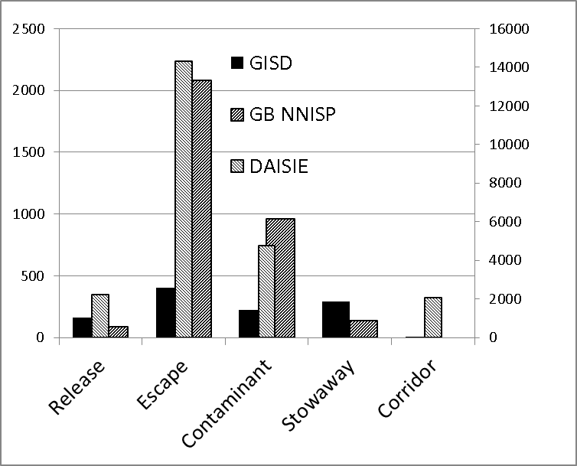
Fig. 1 – Pathways of introduction of alien species: a pilot comparison of the frequency of the main categories at the global (GISD – invasive alien species), European (DAISIE – alien species), and national (Great Britain; GBNNISP - alien species) scale

Figure 1 suggests that escape is the highest contribution on introduction of alien species at global, regional and national levels. Pathways falling in the stowaway category have a relatively large effect at global level on the spread of alien species that are known as invasive.

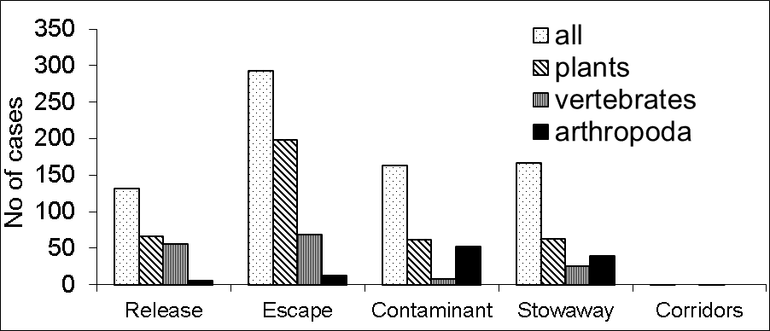

Fig. 2 – Pathways of introduction of alien species: comparison of the frequency by major taxonomic groups
(GISD and DAISIE datasets combined)
Figure 2 highlights that corridors are a more frequent pathway of introduction in Europe than globally or at the GB scale, due to the high number of marine species arrived into the Mediterranean basin by Lessepsian migrations.

Fig. 3 – Pathway data: GBNNSIP dataset; all taxonomic groups
Fig. 4 – Pathway data: DAISIE dataset - vertebrates

Fig. 5 – Pathway data: GBNNSIP dataset - vertebrates

Figures 3, 4 and 5 illustrate the importance of the introduction of plants and animals for ornamental purposes in the overall movement of alien species, and more specifically of activities such as hunting, pet trade and aquaculture in the introduction of alien vertebrates in Europe. This result seems to confirm the need to address invasions through regulatory approaches in this region.
Figures 4 and 5 show the role of activities such as hunting, pet trade, or aquaculture in the introduction of alien vertebrates to Europe.

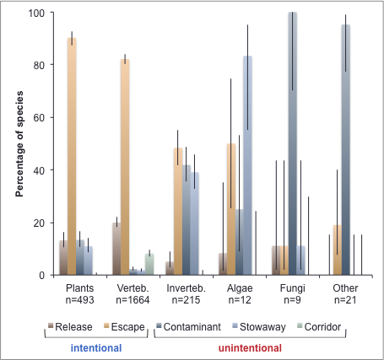

Fig. 6 – Pathway data: GISD dataset – by taxonomic group (Saul et al. in prep)

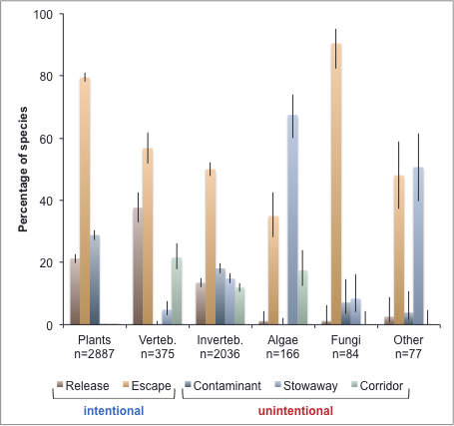

Fig. 7 – Pathway data: DAISIE dataset – by taxonomic group (Saul et al. in prep)

Figures 1, 6 and 7 highlight that the role of accidental movement of species is more relevant for arthropods, as well as for algae and fungi, than for plants or vertebrates.

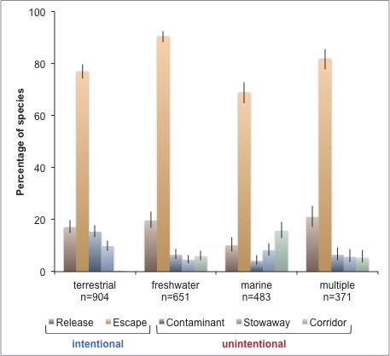

Fig. 8 – Pathway data: GISD dataset – by environment (Saul et al. in prep)
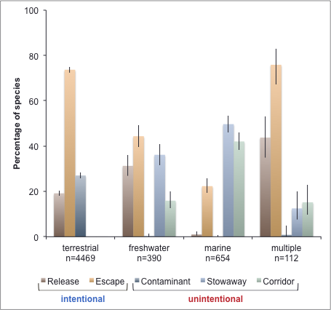

Fig. 9 – Pathway data: DAISIE dataset – by environment (Saul W. et al. in prep)

As shown by the data reported in all figures from 1 to 9 above, and of the figures 1b and 2b of UNEP/CBD/SBSTTA/18/9/Add.1, the standard categorisation of common pathways reveals the dominant relevant pathways, allowing a comparison of the role of the different categories at various geographical scales.

Figures 8 and 9 highlight as the accidental movement of species is more relevant in the marine than in the terrestrial environment.

It must be noted that the results shown in these figures from 1 through 9 are preliminary results of the pathway analysis, and that more detailed applications of the standard categorisation on common pathways are in preparation.

Also, results of pathways analyses differ depending on the regions (scale), and priority pathways may also undergo substantial changes over the time. Prioritization may therefore lead to different results in different areas, or depending on the periods that are considered. For example, the role of hunting in the introduction of alien vertebrates has significantly decreased in recent time, but it is still highlighted in the overall analysis of pathway data (see also in figure 6).

The preliminary results of pathway analyses presented in this document confirm the importance of the adoption of a standard terminology among the databases from different regions and categorisation of common pathways to enable comparison of pathways by regions, taxonomic groups, or by the temporal scale.

Referring to the level of details in the categorization of common pathways, it must be stressed that the required details depend very much on how such information will be used. The required information may include:

- Pest risk assessors may need quite specific details of the pathway attributes of an individual commodity including the potential level of infestation, the volume of potentially infested material imported and the maximum pest limit (the maximum number of individuals that could lead to establishment);
- Quarantine officers inspecting goods at a national border will require sufficient information to prioritise their search effort across several different commodities;
- Legislators may wish to align common pathway categories in relation to liabilities and feasibility of regulation;
- Decision-makers may encourage responsible behaviours of specific sectors on specific activities through voluntary measures such as codes of conduct.

Thus a hierarchical system of pathway classification such as the system presented in UNEP/CBD/SBSTTA/18/9/Add.1 serves the purposes of broad scale decision-making, helping to identify key areas, also permitting to encourage responsible behaviours, to enforce regulations and/or to focus inspection efforts. However, such a broad system may not be sufficient to inform risk assessment because this may require a more detailed analysis, to be conducted at the national or local scale, or on specific items or taxonomic groups depending on the end use.

In order to permit a prioritization of pathways other schemes comprising additional detail should be nested on the standard categorisation proposed in UNEP/CBD/SBSTTA/18/9/Add.1, and all data providers and relevant institutions should consider adopting the standard categorization, integrating the system with more detailed levels of description of pathways depending on the specific focus of the different datasets or institutions.

- Prioritization
As indicated in Aichi Biodiversity Target 9, prioritization is a critical path for Parties to make progress in the management of the invasive species and their negative impacts on biodiversity. In fact, prioritization goes well beyond the identification of the most frequent pathways of introduction of alien species, and should be extended to the definition of potential or realized impacts, and other criteria, such as feasibility of management, the likelihood of management success for a given level of investment (cost-effectiveness) and social preference.

Prioritization of pathways is thus only one element of a decision-making process. It is important that prioritization of pathways should include an assessment of impact of invasive alien species and also address the geographic aspect, identifying the key locations where to apply the prevention and management measures.

In addition, analysis on the routes and means of arrival into a new biogeographic region and targeted site, key steps in a pathway prioritization should include the follows:
- Identify casual chains between a putative pathway and levels of invasion in the region of interest;
- Assess the diversity, abundance and survivorship of invasive alien species along the pathway;
- Describe how the pathway risk is changing both spatially (in terms of suitability of different regions), taxonomically and temporally (rate and magnitude of potential introductions);
- Distinguish between pathways where introduction may cause high impacts from those where impacts will be minor;
- Present means to assess and implement means to mitigate the problems posed by the pathway; and
- Identify new and emerging pathways.

Furthermore, the future of a pathways component to enable prevention will need to progressively move away from qualitative classification towards more quantitative approaches.

The assessment of pathways is only one step in the achievement of Aichi Target 9, and in preventing and mitigating the impacts of invasive alien species. Global efforts on this threat needs to address the prioritization and enforcement of concrete measures in terms of prevention and response to biological invasions. In the following section further key steps are presented and discussed.

- FURTHER STEPS IN THE IMPLEMENTATION OF AICHI TARGET 9
ON INVASIVE ALIEN SPECIES

- Prioritization of invasive species
Prioritization of invasive alien species is globally acknowledged as a crucial step in the response to this threat, and to guide decision making, in terms of prevention and response. As already recalled, Aichi Target 9 calls on Parties to identify and prioritize invasive alien species, so that priority invasive species are controlled or eradicated.

Several studies have proposed methods to prioritize invasive alien species, but with limited taxonomic or geographic scope. No agreed methodology has so far been developed to prioritize invasive alien species in all taxonomic groups, regions, and environments.

A recent paper published in PLoS Biology (Blackburn et al. 2014) has presented a new methodology for prioritizing invasive alien species, within a broad framework. The system has been updated with: (i) the standardized terminology to describe impacts of invasive species in the IUCN ISSG Global Invasive Species Database; (ii) is based on the IUCN Red Listing experience, and (iii) is designed to guide decision making.

The approach proposed by the paper has been presented at last SBSTTA 18, and the recommendation to the CBD COP (http://www.cbd.int/doc/meetings/sbstta/sbstta-18/in-session/sbstta-18-crp-08-en.pdf) includes a formal invitation to IUCN SSC ISSG to continue developing this system for classifying invasive alien species based on the nature and magnitude of their impacts.

The primary problem in understanding the impacts of alien species is that these impacts are manifested in a variety of ways, and on different levels of biological organization (e.g. individuals, populations, communities, ecosystems). Examples include changes in extinction probabilities, species, phylogenetic and taxonomic diversity, individual behaviour and fitness, trophic networks, productivity, water and nutrient cycling, and disturbance regimes.

However, many alien species apparently have had minor effects on their new environment and some may even be considered to be positive additions to ecosystems. Therefore, a critical need is the capacity to evaluate, compare and predict the magnitudes of the impacts of different alien species, so that conservationists and land managers can target actions at the most harmful species.

The method developed by Blackburn and co-authors, is based on explicit semi-quantitative scenarios of effect for the 12 mechanisms of impact by alien species defined in the IUCN-SSC-Invasive Specialist Group’s GISD (e.g. impacts through competition, predation, hybridization, etc.). The semi-quantitative scenarios describe increasing levels of impact on native ecosystems under each mechanism, and are designed so that successively higher categories reflect an increase in the order of magnitude (or level of organization) of the particular impact (Figure 10). A documented impact for a species can be linked to a given impact mechanism, and then the measured magnitude of that impact can be matched to a given scenario under that mechanism.

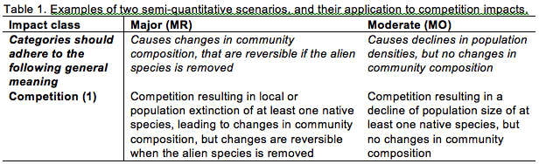
Table 1 –Example of two semi-quantitative scenarios to describe the magnitude of impact of an invasive alien species that impacts native species through competition (from Blackburn et al., 2014)

Linking impacts to scenarios in this way provides a transparent approach for assigning an alien species to one of five sequential categories of impact: Minimal, Minor, Moderate, Major, and Massive. The impact category to which a species is ultimately assigned is the one corresponding to the highest level of deleterious impact identified from any of the impact mechanisms. The scenarios associated with each of the five impact categories have a common scaling, meaning that the magnitudes of impacts under different mechanisms are comparable. Species assigned to higher impact categories are considered, on the basis of available evidence, to have a greater deleterious impact on an aspect of an environment in which it is alien than a species in a lower category (Figure 1 excerpted from Blackburn et al. 2014).

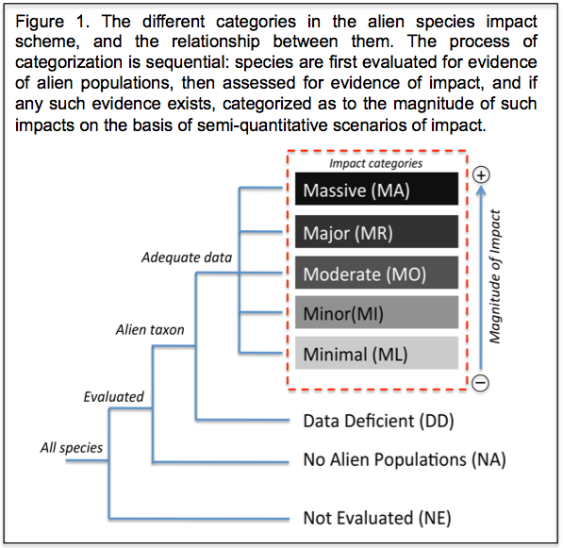

Fig. 10 – Categories of impact caused by invasive alien species by the magnitude of their impact, and the relationship between categories (from Blackburn et al., 2014)

Also taking into account the recommendation proposed by the SBSTTA, the IUCN is working to improve the scheme proposed by Blackburn and co-authors, in order to develop a standard methodology to rank invasive species in terms of their environmental impacts. This will be based on a formal process that is transparent, objective and that ensures full consistency of assessments.

The methodology that is being developed takes into account the experiences gathered in the IUCN Red List process, and in fact it is immediately apparent from Figure 11 that the scheme is analogous in its structure, logic and protocol to the IUCN Red List, and indeed the Red List was the inspiration for it.

In order to develop a formal process for applying a system for classifying invasive alien species based on their impacts, it is crucial to ensure a consultation phase, which shall be open to key global stakeholders, to ensure that any possible input is dealt with from the start, and IUCN is committed to launch this phase as soon as possible, depending on the availability of resources, and to keep the Secretariat of the Convention on Biological Diversity informed on the developments.

Furthermore, IUCN intends to carry out preliminary, parallel applications of the methods to a restricted set of species, to assess the feasibility and consistency of the process. The methodology will be open to revisions and improvements during the consultation phase, and the process will need to ensure full transparency, objectivity, repeatability and full consistency with the formal criteria that will be developed.

- Access and management of information
A key constraint to an effective prioritization approach to addressing the threat of invasive alien species, is the access to data and information. Such gaps are not solely due to a lack of local data, but to a lack of standards in fundamental areas such as species nomenclature, pathways categorization, as well as in the adoption of good practice in biodiversity data management.

This constraint is being addressed by the Global Invasive Alien Species Information Partnership, launched by the CBD, and aimed at facilitating the access to key information on invasive alien species globally.

Several authors have stressed as the most cost-effective solution to having quality data management accessible to all countries is to support existing international databases and information systems. For example, IUCN GISD and CABI Invasive Species Compendium contain peer-reviewed information on many invasive alien species, and the Global Invasive Alien Species Information Partnership provides a facilitated access to these and other sources. The World Register of Marine Species provides expert validated taxonomy for all 220,000 marine species. All of these resources are freely available online and continue with varying funding contributions from institutional and/or government sources.

As stated in the Aichi Biodiversity Target 9, reducing the impacts that are caused by invasive alien species requires identification and prioritization of pathways of introduction of invasive alien species, and the invasive alien species to be managed. A comprehensive understanding about pathways is a determinant for conducting successful risk assessment. Improved prevention measures need to be in place, and effective management of invasive alien species is also a key, which include early detection and rapid response, monitoring and reporting (surveillance), and control and containment.

__________

* UNEP/CBD/COP/12/1.
UNEP/CBD/SBSTTA/18/9/Add.1 http://www.cbd.int/doc/meetings/sbstta/sbstta-18/official/sbstta-18-09-add1-en.pdf
Guiding principles for the prevention, introduction and mitigation of impacts of alien species that threaten ecosystems, habitats or species. Annexed to COP Decision VI/23 Alien species that threaten ecosystems, habitats or species.
Garcia-Berthou, E., Alcaraz, C., Pou-Rovira, Q., Zamora, L., Coenders, G. & Feo, C. (2005). Introduction pathways and establishment rates of invasive aquatic species in Europe. Can. J. Fish. Aquat. Sci., 62, 453–463. Hulme, P.E. (2009). Trade, transport and trouble: managing invasive species pathways in an era of globalization. Front. Ecol. Environ., 10–18. Hulme, P.E., Bacher, S., Kenis, M., Klotz, S., Minchin, D., Nentwig, W., Olenin, S., Panov, V., Pergl, J., Roques, A., Sol, D., Solarz, W. & Vilà, M. (2008). Grasping at the routes of biological invasions: a framework for integrating pathways into policy. J. Appl. Ecol., 45, 403–414. Pysek, P., Jarošík, V. & Pergl, J. (2011). Alien Plants Introduced by Different Pathways Differ in Invasion Success : Unintentional Introductions as a Threat to Natural Areas. PLoS One, 6.
Hulme et al. 2008 proposed the following categories: release, escape, contaminant, stowaway and corridor, plus an additional category for secondary spread (unaided).
UNEP/CBD/SBSTTA/18/L.8 Draft recommendation, point 4: “Invites the Invasive Species Specialist Group of the International Union for Conservation of Nature and other technical partners to continue and complete the work on pathway analysis, and to continue to develop a system for classifying alien species based on the nature and magnitude of their impacts”.
Costello MJ, Wieczorek J. 2014. Best practice for biodiversity data management and publication. Biological Conservation, 173, 68-73.
Costello MJ, Appeltans W, Bailly N, Berendsohn WG, de Jong Y, Edwards M, Froese R, Huettmann F, Los W, Mees J, Segers H, Bisby FA. 2014. Strategies for the sustainability of online open-access biodiversity databases. Biological Conservation 173, 155-165.

