 |  | CBD
 |  |  |  | Distr.  GENERAL  UNEP/CBD/COP/12/INF/39/Add.1  6 October 2014  ENGLISH ONLY
CONFERENCE OF THE PARTIES TO THE CONVENTION ON BIOLOGICAL DIVERSITY
Twelfth meeting
Pyeongchang, Republic of Korea, 6-17 October 2014
Item 13 of the provisional agenda*
Options for enhancing technical and scientific cooperation
and clearing-house mechaniSms
Note by the Executive Secretary
- Introduction
- In its decision X/2, the Conference of the Parties emphasized the need for capacity-building activities and the effective sharing of knowledge, in order to support countries and indigenous and local communities in the implementation of the Strategic Plan for Biodiversity 2011-2020. Through decision XI/2, the Conference of the Parties requested the Executive Secretary, among other things, to develop a coherent, consistent and coordinated approach to technical and scientific cooperation, to act as a convenor to build partnerships and capacity, and to facilitate the continued exchange of best practices and lessons learned and strengthened cooperation with regional and subregional processes, South-South and triangular cooperation.
- Technical and scientific cooperation will be further considered at the twelfth meeting of the Conference of the Parties on the basis of recommendation 5/11 of the Ad Hoc Open-ended Working Group on Review of Implementation of the Convention.
- In this context, and with a view to providing information on relevant experience, the Executive Secretary invited national biodiversity institutes, among members of the Consortium of Scientific Partners on Biodiversity, to make available, for the information of participants at the twelfth meeting of the Conference of the Parties, brief notes on the roles these organizations play in (a) supporting their respective national governments in the implementation of the Convention, particularly through the management, analysis and sharing of data and information and (b) cooperating with partners and institutions outside their own countries on technical and scientific issues relevant to the objectives of the Convention and the implementation of the Strategic Plan for Biodiversity 2011-2020.
- The intention is not to provide a comprehensive survey but to offer a few specific examples of the way in which selected national institutions (a) support capacity development on biodiversity, both domestically and internationally, (b) act as clearing-house mechanisms and (c) engage in technical and scientific cooperation within their subregions and beyond.
- The Executive Secretary received reports from the South African National Biodiversity Institute (SANBI) and other institutes whose report summaries can be found in UNEP/CBD/COP/12/INF/39. The report of SANBI is annexed to this note in the form and language in which it was provided to the Secretariat. A brief summary of key points is provided in the following section.
- The designations employed in this note do not imply the expression of any opinion whatsoever on the part of the Secretariat concerning the legal status of any country, territory, city or area or of its authorities, or concerning the delimitation of its frontiers or boundaries.
- Summary of report from SANBI on their contributions to
technical and scientific cooperation
and clearing-house mechaniSms
- The South African National Biodiversity Institute (SANBI) was established in 2004 through the National Environmental Management: Biodiversity Act (Act 10 of 2004), as a public entity falling under the Minister of Environmental Affairs.
- SANBI is mandated to play a leading role in South Africa’s national commitment to the conservation, management and sustainable use of biodiversity, particularly in relation to the biodiversity research agenda, provision of knowledge and information, policy support and advice, monitoring and reporting on the state of biodiversity, and managing botanical gardens. Since its establishment, SANBI has played a key role in supporting South Africa and other Parties to the Convention on Biological Diversity to meet their obligations as well as assisting regional and international organizations.
- The first section of the report highlights some of the key contributions of SANBI as a national institution focused on biodiversity science and policy advice. The main areas of SANBI’s scientific and technical contributions include: biodiversity information management and information sharing, assessing the status of biodiversity, development of science-based policy tools, mainstreaming biodiversity in national policy and planning, communicating the benefits of biodiversity, on the ground impact, human development capital, and international and regional cooperation.
- In recent years, the Institute has had 18 cooperation exchanges with a number of countries, especially from the African region but also such countries as Brazil, Mexico, Costa Rica, Colombia and China. The exchanges mainly involve capacity-building and training of personnel, the improvement of institutional capacity, making financial and in-kind contributions, and sharing experience on establishing biodiversity information systems, among others.
- Finally, the report highlights the main constraints for the Institute in hosting visits from other countries or undertaking visits: (a) limited time of the relevant experts; and (b) lack of coordinated capacity within SANBI to ensure a coherent approach to cooperation with other countries.

Annex
Report on
Technical and Scientific Contribution and Co-operation

South African National Biodiversity Institute
October 2014

Prepared by SANBI for CBD COP12
6 – 17 October 2014, Pyeongchang, Republic of Korea

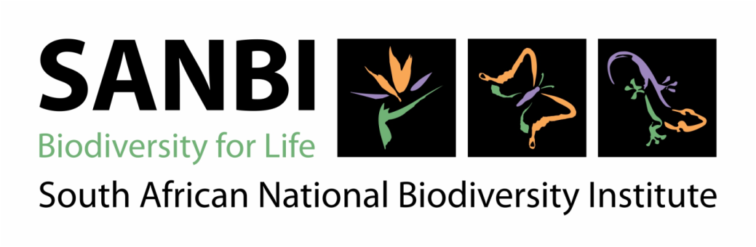
Contents

1. Introduction 1
2. Overview of SANBI’s technical and scientific contribution to South Africa and the region 2
3. Summary of SANBI’s technical and scientific co-operation with other countries 6

- 1. Introduction

This report has been prepared for the 12th meeting of the Conference of the Parties (COP 12) to the Convention on Biological Diversity (CBD). Article 18 of the CBD commits contracting parties to promote international technical and scientific cooperation related to biodiversity, through appropriate international and national institutions, and COP 12 includes a focus on technical and scientific co-operation.

The South African National Biodiversity Institute (SANBI) was established in 2004 in terms of the National Environmental Management: Biodiversity Act (Act 10 of 2004), as a public entity falling under the Minister of Environmental Affairs. SANBI is mandated to play a leading role in South Africa’s national commitments to the conservation, management and sustainable use of biodiversity, particularly in relation to the biodiversity research agenda, provision of knowledge and information, policy support and advice, monitoring and reporting on the state of biodiversity, and managing botanical gardens. Since its establishment, SANBI has played a key role in supporting South Africa and other regional and international parties to the CBD to meet their obligations.

The CBD’s Consortium of Scientific Partners on Biodiversity was established in 2006, initially with six member institutions and now with more than 20. SANBI joined the Consortium in 2011, as the first African partner. The role of the Consortium includes supporting the implementation of the Strategic Plan for Biodiversity 2011-2020 and its Aichi Biodiversity Targets by building the capacity of developing countries and promoting by offering information, tools and services.

This report summarises some of SANBI’s key technical and scientific contributions as a national institute focused on biodiversity science and policy advice, as well as our growing work in the area of international co-operation.

- 2. Overview of SANBI’s technical and scientific contribution to South Africa and the region

This section summarises some of SANBI’s key contributions as a national institution focused on biodiversity science and policy advice. For further information please see South Africa’s Fifth National Report to the CBD (March 2014) (https://www.cbd.int/doc/world/za/za-nr-05-en.pdf).

SANBI’s work is organised according to a “value chain” shown in Figure 1. Foundational biodiversity information on ecosystems, species and genes provides a vital basis for building our knowledge on how biodiversity is doing and how best to manage and conserve it, which in turn is used to inform policy and action. SANBI’s work in all three of these aspects of the value chain involves close collaboration with a range of partners, both inside and outside government, with the ultimate objective of unlocking the benefits of biodiversity for society.

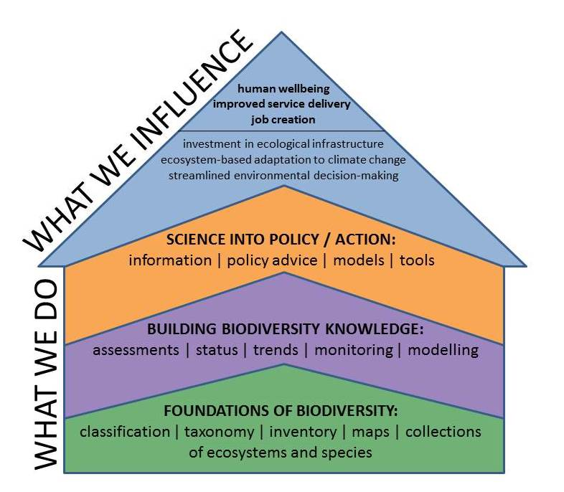
Figure 1: SANBI's value chain, showing how foundational biodiversity information contributes to biodiversity knowledge, which in turn informs policy advice and tools, with the ultimate objective of contributing to human wellbeing

Examples of SANBI’s scientific and technical contributions are given below (please note that this is not intended to be a comprehensive list).

Biodiversity information management and information sharing
- SANBI hosts the Biodiversity Advisor web portal, which draws together many individual biodiversity information websites with clear guidelines on how to use the information for biodiversity planning, research and land-use decision making. The website provides access to more than 14 million biodiversity records, hundreds of GIS maps and many biodiversity plans. It includes a land-use decision-support tool developed to support EIA practitioners and government officials in using the best available biodiversity information in decision-making.
- Participation in the Global Biodiversity Information Facility (GBIF), including playing a leadership role in coordinating the activities of the African GBIF members. In 2011 South Africa was the fourth largest contributor of biodiversity data to GBIF with making 14 million records available to the world.
- The biodiversity information management community has been gathering on an annual basis at the national Biodiversity Information Management Forum since 2007, an event convened by SANBI. The attendance at the Forum has increased from 64 participants in 2007 to over 120 in 2012.
- Training and capacity building in biodiversity information management, including 24 biodiversity information-related training events attended by 415 people from a range of African countries.
- SANBI coordinates a range of citizen science projects, in which hundreds of volunteers have played a crucial role in gathering biodiversity data from the round of country, for example through atlassing projects and virtual museums that make use of modern technology platforms

Assessing the status of biodiversity
- The development and formalisation of a National Ecosystem Classification System, which involves the mapping and classification of ecosystem types, is being led by SANBI in South Africa. This system seeks to lay the foundation for assessment, planning and monitoring of ecosystems. Recent progress has been especially rapid in aquatic environments, including the development of a set of national marine and coastal habitat types for the first time ever.
- SANBI completed and published of the National Biodiversity Assessment in 2011, which synthesizes and adds to existing knowledge about ecosystems and species in South Africa using two indicators, threat status and protection level. The 2011 NBA will ultimately guide or inform the development of the second generation NBSAP to be completed by mid-2015.
- The ongoing process of updating the Red List of species is coordinated by SANBI’s Threatened Species Programme. South Africa is a world leader in Red Listing, and one of the few countries with a dedicated Threatened Species Programme that promotes Red Listing of a wide range of taxonomic groups. The most recent conservation assessments completed in South Africa are for amphibians (2010), plants (2011), reptiles (2011) and butterflies (2011).

Development of science-based policy tools
The interface between science and policy in the South African biodiversity sector is aided by the existence of SANBI as a knowledge institution in government with an explicit mandate to advise other organs of state on biodiversity-related matters.
- South Africa has a well-established capacity for producing spatial biodiversity plans that are based on best available science and relate directly to policy and legislative tools. These maps and accompanying data are a valuable information resource to assist with planning and decision-making in the biodiversity sector and beyond. SANBI provides technical guidance to ensure that spatial biodiversity plans are based on best available science and are consistent across the country.
- At the request of the Department of Environmental Affairs, SANBI developed a list of threatened ecosystems which was published by the Minister of Environmental Affairs in 2011 and is used to inform planning and decision-making in a range of sectors.
- Other science-based policy tools which SANBI has played a key role in developing include an Atlas of Freshwater Ecosystem Priority Areas, a Mining & Biodiversity Guideline to guide planning and decision-making in the mining sector, ecosystem management guidelines for grassland ecosystems, guidelines for offshore marine protected areas, and many more.

Mainstreaming biodiversity in national policy and planning
SANBI engages actively with a range of national policy and planning processes in various sectors, with a view to ensuring that biodiversity priorities are taken up beyond the biodiversity sector itself.
- South Africa’s National Development Plan 2030 recognises the importance of biodiversity and ecosystems, and highlights the need for programmes to conserve and rehabilitate ecosystems and biodiversity assets.
- The National Strategy for Sustainable Development and Action Plan (NSSDAP) includes three of five strategic priorities that reflect the need for sustaining healthy ecosystems, sustainable utilization of natural resources and the role ecosystems in climate change adaptation.
- Recent revisions of the National Water Resource Strategy (NWRS) and Water Pricing Strategy have recognised the importance of freshwater ecosystems for water security, as a result of engagement by the biodiversity sector in these processes. The National Water Resource Strategy (2013) recognises that Strategic Water Source Areas (the 8% of South Africa’s land that provides 50% of river flow) form the foundational ecological infrastructure on which a great deal of built infrastructure for water services depends, and are thus strategic national assets.

Communicating the benefits of biodiversity
- A project called “Making the Case for Biodiversity” was undertaken by SANBI with help of marketing and communications experts. Two clear lessons emerged: first, the strongest value proposition for decision-makers in government is that biodiversity is a national asset that can contribute to the development priorities of the country; second, the “doom and gloom” message of impending extinctions and imminent collapse, which the biodiversity sector has tended to use for decades, not only has no traction but in fact elicits apathy. The Making the Case project highlighted the need to show how biodiversity is relevant to government’s priority issues of the day – for South Africa these are job creation, poverty alleviation and rural development.
- LIFE: The State of South Africa’s Biodiversity (2012) is a summarised and simplified version of the National Biodiversity Assessment 2011, intended for a wide audience including politicians and the general public.

On the ground impact
- Through a GEF funded programme, the Grasslands Programme, SANBI has successfully managed to mainstream biodiversity into key production sectors of the economy including mining, forestry and urban development particularly to reduce their footprint and prevent further loss of biodiversity priority areas in the grassland biome. For instance, following extensive engagement with the mining sector, a Mining and Biodiversity Guideline was published jointly by the Minister of Environmental Affairs and the Minister of Mineral Resources in 2013.
- South Africa has nine established National Botanical Gardens, all of which are managed by SANBI. These botanical gardens are part of the conservation estate of the country.
- Biodiversity stewardship is a programmatic approach to securing contracts with private and communal landowners to conserve and manage biodiversity priority areas, and is implemented by provincial conservation authorities with the coordination and support of the Department of Environmental Affairs, SANBI and NGOs. As of September 2013, 38 protected areas had been declared through biodiversity stewardship, totalling 138 482 ha. Another 150 properties, totalling nearly 500 000 ha, were in negotiation.

Human development capital
- SANBI initiated a systematic programme to build human capital and skills in the biodiversity sector, known as the Biodiversity Human Capital Development Strategy (BHCDS). The BHCDS led to the establishment of GreenMatter, a partnership initiative that drives transformation in graduate level skills for biodiversity, as well as the Groen Sebenza (“Green Work”) Programme, which aims to promote and retain racial and gender representation in the biodiversity sector by creating sustainable job opportunities for 500 graduates and 300 school leavers from previously disadvantaged backgrounds over a 2½ year period. By the end of 2013, all 800 youths had been placed in 33 different partner organisations including government, NGOs and the private sector.

International and regional cooperation (also see section 3 of this report)
- In July 2014, SANBI was invited to the NBSAPs 2.0: Mainstreaming Biodiversity and Development Project Workshop in Namibia. The NBSAPs 2.0: Mainstreaming Biodiversity and Development Project is a three-year (2012-15) project aimed at building resilient and effective National Biodiversity Strategies and Action Plans (NBSAPs) that influence development decisions and improve outcomes for biodiversity and poverty focusing on four African countries (Botswana, Namibia, Seychelles and Uganda). As South Africa is not one of the project countries, SANBI was invited in particular to share its vast experiences in mainstreaming biodiversity and development.

- 3. Summary of SANBI’s technical and scientific co-operation with other countries

The table below summarises SANBI’s co-operation with other countries, starting with the most recent examples. Following the table is a short discussion on constraints and barriers.

Country visited or hosted | Purpose of visit | Visit outcomes / assistance provided | Follow-up meetings | Resultant long-term cooperative projects or programs
SANBI hosted members of Regional IUCN Specialist Group (Zimbabwe, Mozambique and Swaziland) | Capacity building predominantly in IUCN Red Listing | Sharing of expertise on managing conservation assessment projects (co-ordination of assessments, data management, as well as managing assessment submissions to the IUCN) | There have been little further Red Listing activities outside of South Africa. | Regional capacity building efforts have been less successful.
SANBI hosted Mozambique (July 2014) | Conduct conservation assessments for plants of the Northern Mozambique | SANBI also providing bursaries and supervision for Mozambican Botanists to study conservation biology Master’s degrees and to conduct conservation planning for threatened plants of Mozambique. | Assessments for plants of the Rovuma Centre of Endemism conducted and submitted to the IUCN Red List | Follow-up workshops will take place in 2015 and 2016 to complete assessment of all endemic Mozambican plants.
Kenya hosted SANBI (Global Pollination Project) | Sharing specific of expertise where respective countries experts train each other, for instance, bee taxonomy. | South African bee taxonomy expert ran courses in both Kenya and South Africa. | SANBI hosted Kenya for the same reasons.
SA hosted Nigeria and Kenya | Participate in a legal standards workshop for DNA samples in wildlife crime investigations as part of Barcode of Wildlife Project | Standard Operating procedures drafted; Kenya and Nigeria ran similar workshops in their countries to ensure compliance with their legal systems | Video conference meetings to discuss standards and processes (facilitated by Consortium for Barcode of Life) | Barcode of Wildlife Project anticipated to continue in SA, Kenya, Mexico and Nigeria
SANBI visited Mozambique | Part of SANBI’s role in the African Plants Initiative is to provide regional support to the API Project partners in Mozambique. Staff members from the National Herbarium at SANBI visited the LMU (Eduardo Mondlane University) and LMA Herbaria (IIAM – Agricultural Research Institute of Mozambique) to provide support to API Project activities and investigate research collaboration opportunities. | - Collections of Polygala at LMU and LMA were examined in view of a future collaborative project on the diversity of the genus in Mozambique.  - Specimens of Schizoglossum and allies were studied and photographed and 14 specimens were determined at LMU. 8 specimens were studied and photographed at LMA. Several of these specimens represent new distributions of the taxa that have not previously been encountered.  - Seminar on the SANBI National Herbarium (PRE) and the National Herbarium Plant Collecting Program presented to the final year Botany Students of the University Eduardo Mondlane (±40 students).  - Field trip to the Matutuine area (Lekwati Forest and Maputo Elephant Reserves) south of Maputo to support LMU students in establishing herbarium collection and field survey techniques. | None | Potential for further taxonomic research support and collaboration investigated.
SANBI visited Angola | Part of SANBI’s role in the African Plants Initiative is to provide regional support to the API Project partners in Angola. Staff members from the National Herbarium at SANBI visited the Lubango Herbarium, Angola to provide support to API Project activities and assist in herbarium curation activities. | - AAdvice in the capturing of new and transferring of existing data of the collections into BRAHMS.  - RReview of Herbarium Management practices at Lubango resulted in several interventions towards improving the filing system and ensuring the long-term preservation of collections. | None | Lubango Herbarium is looking to apply for funding for further research and collections management with SANBI through a submission of an the application for a joint research grant under the South African/Angola–Research Partnership Programme Bilateral Agreement 2011
SANBI hosted Botswana | Department of Botswana National Museum and Monuments visited the National Herbarium for benchmarking in the management of dried and living plants collections and plant collections database systems. | During the five-day visit, visiting staff members were guided through all processes related to collections management and databasing. Benchmarking documentation developed. | None | None
Uganda (National Council for Science and Technology) hosted SANBI (30 Aug – 1 Sep 2010) | The first regional meeting of African Participants of the Global Biodiversity Information Facility (GBIF) aimed to improve institutional capacity; enhance institutional policies; and develop and strengthen partnerships  . | The meeting served to galvanise the community of African biodiversity informaticians and allowed for the establishment of collective work priorities and a framework for cooperation.  SANBI has engaged with various African countries to encourage and support improved biodiversity information management in the region.  SANBI supported the organisation, execution and write-up of the meeting, and SANBI’s Deputy Director General, Dr Carmel Mbizvo chaired the meeting. | Following the initial regional meeting in Uganda in 2010, the GBIF Africa Group has met annually in various countries including Argentina, Benin, Germany, Rwanda and South Africa (twice). | Together with its African partners, SANBI has leveraged support from the JRS Biodiversity Foundation (~USD 250,000) to mobilize policy-relevant biodiversity data whilst strengthening regional collaboration and capacity in biodiversity informatics.  A group of West African countries raised USD 230,000 from the JRS Biodiversity Foundation to digitize and publish thousands of plant specimen data.  Additionally the GBIF Africa Group has made substantial progress in elevating biodiversity informatics up the African political agenda. This is evidenced in Angola where the apportionment of national R&D funds to biodiversity informatics has increased significantly.  To date, well over 100 Africans scientists (biodiversity informaticians) have taken part in the meetings of GBIF Africa and also actively collaborate with each other.
SANBI hosted the 2nd GBIF Africa Group (13-14 Sep 2011) | The meeting objectives were to set goals, prioritize regional activities, and elaborate joint strategies. | SANBI helped to coordinate African priorities; finalize the mode of cooperation; and develop an implementation plan for regional activities.  Other outcomes of the meeting were the elaboration of strategies for data publishing, capacity-building and strategic regional engagement. | The GBIF Africa Group has subsequently met on at least an annual basis. | As above.
Rwanda (Albertine Rift  Conservation Society and the National University of Rwanda) hosted SANBI (17-18 Jul 2012) | The objectives of the 3rd GBIF Africa regional meeting were to review the group’s progress and augment the implementation of the action plan. | SANBI supported the meeting by helping to formulate the programme, sending a 4-person delegation and facilitating each session.  The key outcomes of the meeting included an agreement on mechanisms to improve regional coordination, communication, collaboration, and participation; as well as a set of recommendations for implementing the 2012-2013 GBIF Work Programme in the region. | The GBIF Africa Group has subsequently met on at least an annual basis. | As above.
SANBI hosted the GBIF Africa Group (16-18 Apr 2013) | The 4th GBIF Africa regional meeting. Objectives of the meeting were to: review the implementation of the regional strategy; identify barriers impeding progress; share lessons from around the region; examine the availability and practical applications of biodiversity data in Africa; and identify key training opportunities. | SANBI made financial and in-kind contributions to the workshop. SANBI played a leading role in setting the programme and in facilitating each session.  Key outcomes of the meeting included the review and refinement of the regional strategy and the identification of learning and fundraising opportunities. | The GBIF Africa Group has subsequently met on at least an annual basis. | As above.
Benin hosted SANBI (1-4 Jul 2014) | Objectives of this 5th GBIF Africa regional meeting were to review progress in implementing the African regional strategy and discuss the way forward for implementing the strategy in the following year. | SANBI supported the meeting by helping to formulate the programme and making JRS project funds available to support the participation of several African delegates.  The primary outcomes of the meeting were the collective production of a 2015 work plan and the allocation of responsibilities to members of the GBIF Africa Group. | The GBIF Africa Group has subsequently met on at least an annual basis. | As above.
Kenya hosted SANBI (2011) | KenBIF organised a training workshop for Kenyan officials and invited SANBI to play a role as facilitator. | SANBI shared its experience in establishing a GBIF national node and creating the institutional arrangements conducive to successful biodiversity information management. | KenBIF visited Cape Town in March 2013 to participate in an international workshop on biodiversity information systems. | Both KenBIF and SANBI have made substantial progress in biodiversity information management but it is unclear how much of that progress can be directly attributed to the training workshop concerned.
SANBI hosted Kenya, Brazil, Mexico, and Costa Rica (March 2013) | International workshop on biodiversity information systems in particular to share experiences and lessons in establishing national biodiversity information systems. | The invitees committed to supporting SANBI in developing new, flexible biodiversity information architecture for South Africa. | Productive exchanges are maintained between the other countries, albeit that no immediate follow up trips have been organized. | The meeting resulted in a consensus that SANBI must lead the development of a shared national biodiversity information vision; strive to ensure synergy between different global initiatives such as EoL, GBIF, and BHL; establish a coherent regulatory, institutional and policy environment for biodiversity informatics; and develop a national policy on biodiversity data standards and on the commercial use of biodiversity data.
SANBI hosted Brazil (2010) | Training on a range of biodiversity issues including invasive species and plant conservation assessments | Information and data sharing on invasive species and plant conservation assessments | SANBI visited Brazil, particularly to share experiences and guide Brazil in process of Red Listing in July 2010. Brazilian team from the Centre for Flora conservation visited South Africa for Red List training in November 2010. South African Red List team did second training in Brazil in 2011. | Brazil updated their Plant Red List in 2013 and continues to conduct Red List assessments of plants.  South Africa and Brazil continue to work in partnership.  A detailed document on lessons learnt through the assessment of a mega-diverse flora has been developed.
SANBI visited Columbia (November 2013) | Exchange lessons on conducting plant conservation assessments , a three way exchange between Brazil, South Africa and Columbia | A proposal on conducting Red Listing for plants in Columbia developed. | As yet no further follow-up
China (Ministry of Environmental Protection) hosted SANBI. | SANBI shared its experiences on the development National Spatial Biodiversity Assessment (NBSBA) and how the said NSBA informed its NBSAP. | SANBI helped specifically to improve China’s process of revising its National Biodiversity Strategy and Action Plan (NBSAP).
SANBI hosted delegates from the Kansas University (2013) | Implementation of two Biodiversity Informatics training courses by KU experts, including a number of other experts from Brazil, Mexico etc. | SANBI was a partner on this project and showcased as a leading Informatics Institution in Africa. SANBI presented its mechanisms of a bridging institution in support of the data-science-policy interface. | Engagement on GBIF-Africa Training schedule with regional coordinator. | Ongoing engagement with the University of Kansas through the development of a Postgraduate Hub in Biodiversity Information Management.

The main constraint for SANBI in hosting visits from other countries or undertaking visits is limited time of the relevant experts, particularly given that SANBI is already stretched in terms of human capacity to fulfil our national mandate. Meaningful engagement, especially if follow-up is required, is often time consuming, and the number of people in SANBI (or South Africa more widely) who have the relevant expertise is usually limited. A related constraint is lack of co-ordination capacity within SANBI to ensure a coherent rather than ad hoc approach to co-operation with other countries.

Other constraints can include:
- Language barriers
- Travel costs
- Limited flight networks
- Visa complications
- Travel authorisation delays
- Limited funds for taking projects forward

__________

* UNEP/CBD/COP/12/1/Rev.1.

