 |  | CBD
 |  |  |  | Distr.  GENERAL  UNEP/CBD/COP/13/INF/17  3 November 2016  ENGLISH ONLY
CONFERENCE OF THE PARTIES TO THE CONVENTION ON BIOLOGICAL DIVERSITY
Thirteenth meeting
Cancun, Mexico, 4-17 December 2016
Item 10 of the provisional agenda*

Protected areas: facilitating THE achievement

of Aichi Biodiversity target 11

Note by the Executive Secretary

Introduction
- At its tenth meeting held in Nagoya, Japan, in October 2010, the Conference of the Parties (COP) to the Convention on Biological Diversity adopted the Strategic Plan for Biodiversity 2011-2020, including 20 Aichi Biodiversity Targets under five strategic goals. Strategic Goal C on improving the status of biodiversity by safeguarding ecosystems, species and genetic diversity includes, among others, Target 11 on protected areas. At its eleventh meeting held in Hyderabad, India, in October 2012, the Conference of the Parties further invited Parties to undertake major efforts, with appropriate support and consistent with national circumstances, to achieve all elements of Aichi Target 11 in paragraph 1 of decision XI/24 on protected areas.
- In the midterm evaluation of the status of progress towards the achievement of Aichi Biodiversity Targets, assessed in the fourth edition of the Global Biodiversity Outlook in 2014, Target 11 showed a promising picture, suggesting that with more focus and systematic efforts, many elements of the target could be achieved by 2020. In order to facilitate the achievement of Target 11, the Secretariat of the Convention developed a two-phase strategy, which includes renewing partnerships and commitments from partner organizations; developing baseline data for countries in the form of information dossiers; providing capacity development to Parties; and securing the submission of questionnaires, status matrices, and national actions (identified priority actions to be undertaken in the next four years in the form of road maps) through regional workshop, as a country driven process. The first phase (2015-2016), involved, inter alia, collecting information on the status of each element of Target 11, as well as focused actions for implementation as a country driven process, while the second phase (2017-2020) will involve, inter alia, facilitating the implementation of identified actions to achieve Aichi Biodiversity Target 11. Details of the Secretariat’s approach including results from three workshops (covering mainland Asia and Latin America and Caribbean regions) were presented to the twentieth meeting of the Subsidiary Body on Scientific, Technical and Technological Advice and to the first meeting of the Subsidiary Body on Implementation as information documents UNEP/CBD/SBSTTA/20/INF/43 and UNEP/CBD/SBI/1/INF/41.
- Subsequently, three more workshops covering Africa, Central and Eastern Europe and Pacific Island regions were organized, thus covering all regions of the United Nations except the Western Europe and Others Group (WEOG). Governments of Japan, Germany and the Republic of Korea provided financial support and the Governments of host countries (China, Brazil , India, Uganda, Belarus and Fiji) provided logistical and other support for the organization of these workshops Updated results from the regional workshops are very encouraging; nearly all participants rated their overall appreciation of the workshops as ‘good’ or ‘very good’. Details of the workshops and information on submissions received are given in Table 1.
- The present document summarizes the updated status of the target per element and the number of priority actions identified by the countries from the regional workshops; projections for the status of each element by 2020 when identified priority actions are implemented; as well as next steps to be undertaken in next four years to increase the achievement level of each element.
Table 1 Summary of capacity-building workshops on achieving Aichi Biodiversity Target 11.
Workshop | Number of countries invited | Number of countries that attended | Number of countries that submitted information on the status of Aichi Biodiversity Target 11 | Number of countries that submitted their priority actions to achieve Aichi Biodiversity Target 11 in the next 4 years
East and Southeast Asia  Yanji City, China  15 - 18 September 2015 | 17 | 12 | 11 | 7
Latin America and the Caribbean, Curitiba, Brazil  28 September - 1 October 2015 | 33 | 24 | 21 | 24
South, Central and West Asia  New Delhi, India  7 - 10 December 2015 | 29 | 16 | 14 | 13
Africa  Entebbe, Uganda  21-24 March 2016 | 54 | 42 | 36 | 31
Central and Eastern Europe  Minsk, Belarus  14 - 17 June 2016 | 29 | 17 | 14 | 13
Pacific  Nadi, Fiji  11 - 13 July 2016 | 16 | 13 | 11 | 11
- There were 124 countries that attended one of the six workshops, where 108 countries submitted status information, and 100 countries submitted their priority actions to be undertaken in the next four years. Through this series of workshops, covering all regions except WEOG, over 1400 priority actions addressing elements of Target 11 have been identified by countries. The analysis of the priority actions submitted by countries reveals that when implemented, they will not only contribute to achieve elements of Target 11, but will also contribute to other Aichi Biodiversity Targets, namely 5, 6, 7, 9, 10, 12, 13, 14, 15, 18, 20 directly, and 1, 2, 19 indirectly (details are presented in information note UNEP/CBD/COP/13/INF/20), relevant targets of Sustainable Development Goals namely 14.5, 15.1, 15.2, 15.5, 15.8 directly, and 1.2, 12.2, 15.7, 15.8 indirectly, through the goods and services provided by protected areas (details are presented in information note UNEP/CBD/COP/13/INF/19).

II. STATUS AND PROJECTIONS
- To present the status and projections of Aichi Biodiversity Target 11, the target is divided into multiple, easily defined elements. These elements, each discussed in a separate sub-section, are:
  - At least 17 per cent of terrestrial and inland waters are conserved;
  - At least 10 per cent of coastal and marine areas are conserved;
  - Ecologically representative;
  - Areas of particular importance for biodiversity;
  - Areas of particular importance for ecosystem services;
  - Effectively managed;
  - Equitably managed;
  - Well connected systems of protected areas;
  - Integrated into the wider landscapes and seascapes;
  - Other effective area-based conservation measures.

- Each sub-section presents a dashboard of the element, including: (a) the status of the element as of 2016; (b) what is needed at a minimalistic level to achieve the element by 2020; and (c) what are the chances of reaching this element by 2020. Next, global and regional data and information is summarized, as per global databases maintained by partner organizations, and submissions made by Parties through the workshops. Lastly, country or subregional projections and examples, as collected from the six workshops listed in table 1 above, are presented.
- A modified dashboard (building on the one used in the fourth edition of the Global Biodiversity Outlook and updated analysis produced for SBI 1) will be used to present an estimate of the chances of reaching the element by 2020, acknowledging that the indicators may change with improvements in implementation; the following symbols will be used to summarize this information:

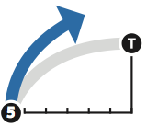 | 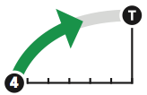 | 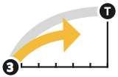 | 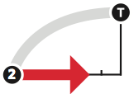 |  |  | Situation following implementation of Road Maps (compared to GBO-4 assessment)  Better  Similar  Worse
On track to exceed target (we expect to achieve the target before its deadline / target may already be met) | On track to achieve target (if current trajectory continues and Road Maps are implemented as proposed, we expect to reach the target by 2020) | Progress towards target but at an insufficient rate (may only reach the target by 2020 with additional effort) | No significant overall progress (we are neither moving towards the target nor away from it, may only reach the target by 2020 with significant additional effort) |  | Moving away from target (things are getting worse rather than better, will only reach target with rigorous effort)

A. At least 17 per cent of terrestrial and inland waters are conserved
Element | Status as of 2016 | What is needed for achievement? | What are the chances of reaching the target by 2020?
At least 17% terrestrial and inland water areas | As per the WDPA (April 2016), 14.7%, or 19.85 million km², of the world’s terrestrial and inland waters are covered by protected areas, excluding Antarctica and the Southern Ocean Islands. | An additional 2.3% or roughly 3 million km² of terrestrial and inland waters are required to be designated as protected areas. | Eighty-five actions were proposed which include the creation or expansion of terrestrial protected areas. Forty-two of these actions clearly identified the area to be added; taken together these 42 will add over 710,000 km², globally. The other 43 actions will further increase coverage, though the amount to be asses still needs to be determined. Adding approved GEF projects brings the total increase to almost 940,000 km².
- At the global level 14.7 per cent, or 19.85 million km², of the world’s terrestrial and inland waters are protected, excluding Antarctica and the Southern Ocean islands, as per an analysis of the April 2016 release of the WDPA carried out for the 2016 Protected Planet Report. Figure 1 provides a regional breakdown of terrestrial protected area coverage using the same dataset. For the terrestrial quantitative element, Latin America and the Caribbean Group (GRULAC) have already reached the 17 per cent target, while the Western Europe and Others Group (WEOG) is only 1.3 per cent away. All regions of the United Nations have greater than 10 per cent terrestrial protected area coverage.
- Comparing national status data received from Parties during the workshops to data from the WDPA alters the picture for this element slightly. Following completion of all six regional capacity-building workshops, 92 countries had submitted numerical information on the national status of protected area coverage of terrestrial and inland waters. From these 92 submissions, 48 Parties reported protected area coverage higher than what was in the WDPA, with 44 Parties reporting values which were lower; 27 Parties reported values that were within five per cent of that from the April WDPA release, while nine Parties reported values more than double what was in the WDPA. Some countries included areas that are not currently encompassed in the WDPA (like the protected forests or forest reserves in India). Conversely other Parties did not report on areas which are included in the WDPA (several countries in Latin America did not include Indigenous areas – see section J below). Compared to information from the WDPA, taking the national status reporting from these 92 Parties gives a slight decrease in global coverage (14.6 per cent); regionally, Africa and Asia-Pacific both report higher values than the WDPA, protected area coverage for GRULAC decreases but remains above the 17 per cent target, while protection in Eastern Europe and WEOG does not change (Figure 1).

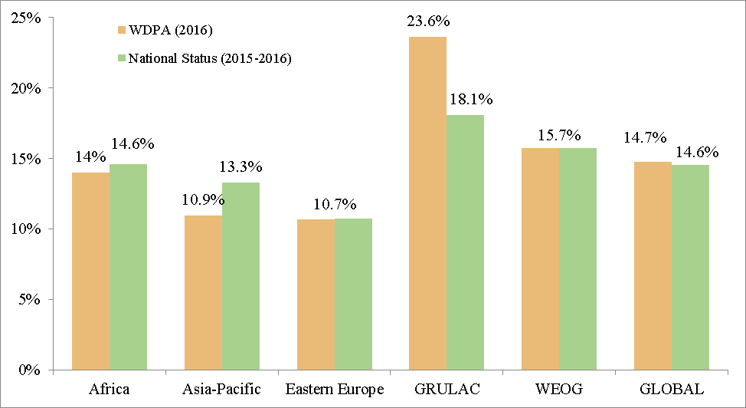
Figure 1 Global and regional status of terrestrial protected area coverage.
- From the 92 countries that submitted information on the national status of terrestrial protected area coverage during the six regional workshops, 38 have reached or surpassed the 17 per cent global target, five countries are close to reaching the target, with less than 1 per cent in additional protected areas needed, and 13 have less than 5 per cent of their territorial lands and inland waters in protected areas.
- At a subregional level, 8 of 22 subregions (recognized in the United Nations geoscheme) have reached the 17 per cent target; these eight subregions are distributed around the globe (Figure 2). Another three subregions are within two per cent of the target (Micronesia, Central America and the Caribbean). Once again, comparing the information on the national status of terrestrial protected area coverage received during the workshops (from 92 countries), to the coverage presented in the WPDA provides a slightly different picture; in this case there are several subregions for which there was no information received (primarily from WEOG).

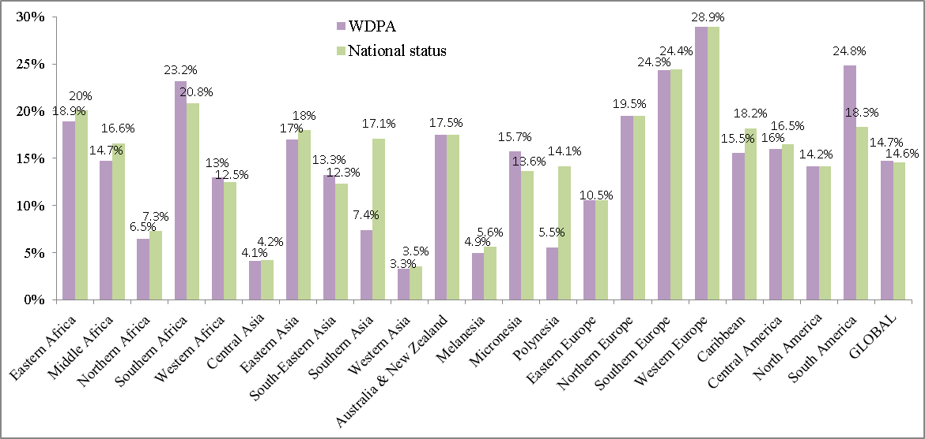
Figure 2 Subregional status of terrestrial protected area coverage.
- Following completion of the six workshops, 89 countries identified 184 different focused priority actions pertaining to the terrestrial quantitative element. Priority actions, specific opportunities, or proposed protected areas at various stages of gazettal, identifying a quantifiable planned increase in terrestrial protected area coverage have been identified by 42 countries; if these actions and opportunities are implemented as proposed, it will bring about an increase of over 710,000 km² to the global protected area estate, representing an increase in global coverage of 0.53 per cent. Figure 3 presents the increase from these actions, globally, and for each workshop region. For seven of the 42 countries, these priority actions and opportunities, if implemented as planned, will bring the national terrestrial protected area coverage over the 17 per cent target. Should the other 80 per cent of Parties to the Convention implement similar actions over the next four years, the terrestrial quantitative element of the Target should be achievable before its 2020 deadline.
- As of October 2015, Mexico had protected 13.15 per cent of its terrestrial and inland waters through several conservation measures and protected areas. As part of the priority actions of Mexico, the country aims to create 7 new terrestrial protected areas, adding 48,318.03 km² of protected areas, bringing the total per cent of terrestrial areas protected in Mexico to 15.61. To reach the 17 per cent target by the end of 2016, the country aims to classify and verify the conservation status of Wildlife Management Units and forest reserves in order to officially include those areas which meet optimal conditions, within the National System of Protected Areas.
- Montenegro has indicted in its priority actions that it will increase the coverage of terrestrial protected areas to 17 per cent, as per the targets set out in their national biodiversity strategy and action plan (NBSAP); this represents an increase in terrestrial coverage of just over 750 km². This increase will be completed through a revision of several existing protected areas as well as the designation of new protected areas. In May 2016, Montenegro began work on an IPA (Instrument for Pre-Accession Assistance) funded project to begin the process of establishing their Natura 2000 network; the field mapping and data gathered through this project will assist in improving protection of biodiversity and ecosystem services within the country.
- For its priority actions, Morocco aims to designate 25 new protected areas by 2020; these will cover 25,000 km², bringing protected area coverage in the country up to 19 per cent for terrestrial and inland waters. Morocco also plans to designate 30 new Ramsar sites, which will lead towards the formation of a coherent and comprehensive set of wetlands of national and international importance.
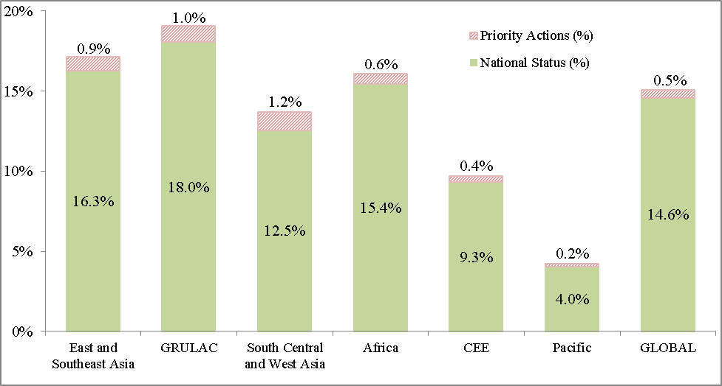
Figure 3 National status of terrestrial protected areas (by workshop region) and proposed increases from priority actions and opportunities. Regional data is included only for countries that attended a workshop (or submitted documents), while global status includes all countries; national status based on data submitted by 92 countries during the six workshops; for those countries that did not submit national status information, data from the April release of the WDPA was used.
- In addition to this planned increase from 42 Parties, a further 43 Parties proposed actions or opportunities which include the expansion or creation of new terrestrial protected areas, where the area or per cent increase was not indicated. Another 21 countries provided actions which will lead to an increase in protected area cover, where either the outcome of the action itself is unclear, or the amount being added to the protected area network needs elucidation. Several countries also have protected area expansion actions for other elements of Target 11. Further clarification of these actions being taken over the next four years to implement this element of the target will further improve the picture for global terrestrial protected area coverage.
- Figure 4 presents the national status of protected areas and proposed increases as identified in the outcomes of country’s project identification forms (PIF) in GEF 5 projects for terrestrial areas. Fifty-three countries have GEF projects listed as ‘concept approved’ or ‘project approved’, which will add to their existing terrestrial protected area networks and will add almost 239,000 km², globally.
- Twenty-two countries that either attended a workshop or submitted documents (status matrix, road maps, etc.) have approved GEF projects with quantifiable increases in terrestrial protected area coverage yet did not provide quantifiable priority actions. This highlights the need for more concrete focused actions, especially those that can be associated with the appropriate funding mechanisms. Capacity and access to funding were mentioned as two of the most commonly expressed gaps that exist in preventing possible achievement of the Target. Conversely, many countries did include GEF (or other agency-funded) projects in their status or priority action submissions.

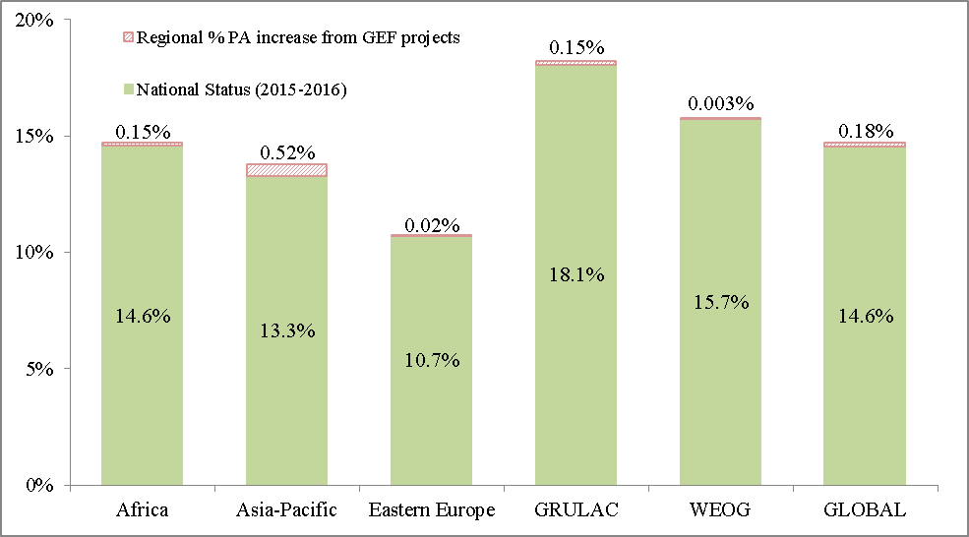
Figure 4 Global and regional status of terrestrial protected area coverage and proposed increase as identified in country’s project identification forms.
- For example, the priority actions identified by Swaziland include formalizing and gazetting six new informal protected areas, which will be formally demarcated and managed for biodiversity conservation. This addition will increase the formally gazetted protected area network form 4.23 per cent to 12.4 per cent. As well, a total of 18 protected areas (including both formal and informal), covering an area of 719.73 km² will be established and effectively managed. These priority actions will be assisted by a GEF-funded project (#5065) which is currently underway; the project aims to expand and effectively manage Swaziland’s protected area network, for the protection of biodiversity and important landscapes across the country.
- For its priority actions, Mauritius plans to prepare a GEF funded project, “Protected Area Network Expansion Strategy (PANES)”, as well as continue implementing their National Biodiversity Strategy and Action Plan. Mauritius also has an ongoing GEF funded project which aims to expand the existing protected area network in Mauritius, as well as ensuring its effective management (tracked using the Management Effectiveness Tracking Tool) and by assuring management and business plans are developed for all protected areas. The newly enacted Native Terrestrial Biodiversity and National Park Act (2015) will allow Mauritius to meet this target, designating new protected areas on both State-owned and private lands.
- Priority actions and projects identified in GEF PIFs should not be taken additively, as several countries aligned their priority actions with existing or proposed GEF projects. Removing these clear overlaps gives an increase of 939,820 km² (0.7 per cent) at the global level. If more countries were to incorporate the objectives of GEF 5 and 6 projects, as well as other bilateral projects, into their actions, a more encouraging picture would emerge. As this increase does not incorporate planned protected area expansions from the WEOG region, nor does it incorporate other effective area-based conservation measures (addressed in section II.J), the 17 per cent target should be achievable before the 2020 deadline.

B. At least 10 per cent of coastal and marine areas are conserved
Element | Status as of 2016 | What is needed for achievement? | What are the chances of reaching the target by 2020?
10% costal and marine areas | As per the WDPA (April 2016), coverage of coastal and marine protected areas in areas within national jurisdiction (0-200 nautical miles) is now 10.4%, excluding Antarctica’s EEZ, but including the EEZ of Southern Ocean Islands.  Coverage for the global ocean is 4.1%. | For areas under nation jurisdiction the 10% target has already been achieved.  For oceans as a whole, however, an additional 5.9% is needed. | From the six regional workshops, Parties have committed to increasing coastal and marine protected area coverage by 0.7%, globally.  Recent communications of large-scale marine protected areas by Chile, Palau, New Zealand, United Kingdom, USA, French Polynesia and CCAMLR will add over 10 million km² (which amounts to 6.4% of areas within national jurisdiction, or 2.9% for the oceans as a whole).
- Coverage of coastal and marine protected areas within national jurisdiction (including territorial waters and countries’ Exclusive Economic Zone; 0-200 nautical miles) has reached 10.4 per cent, as per the same analysis of the April 2016 release of the WDPA performed for the 2016 Protected Planet Report (this value excludes Antarctica but includes the EEZ around Southern Ocean islands). As shown in Figure 5, the Western Europe and Others Group is the only UN region to have hit the 10 per cent target, while Asia-Pacific is only 2 per cent short; all other regions have less than 4 per cent protected.
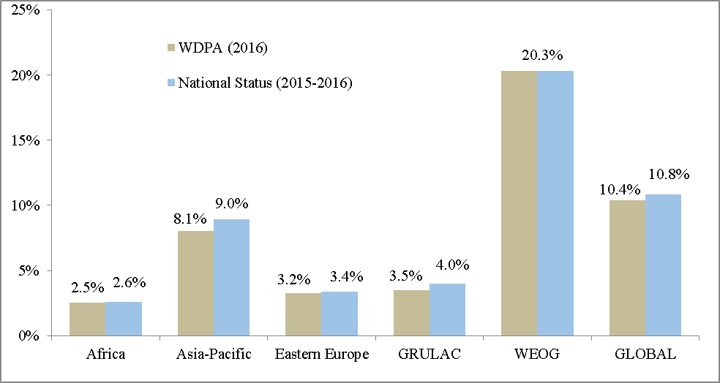
Figure 5 Global and regional status of marine protected areas within national jurisdiction (0 – 200nm).
- Comparing national status data received from Parties during the regional workshops to the information from the WDPA increases the protected area coverage in all regions which had workshop attendees (Figure 5). Out of the 60 countries submitting national status information for coastal and marine protected area coverage, 30 presented values greater than those reported in the April WDPA release, while 30 reported values that were smaller; 16 countries reported values more than double those in the WDPA, and nine reported values less than half of what was in the WDPA. Three other countries provided protected area coverage for nearshore marine areas only; as all other reporting includes protection for the entire EEZ, these values could not be used.
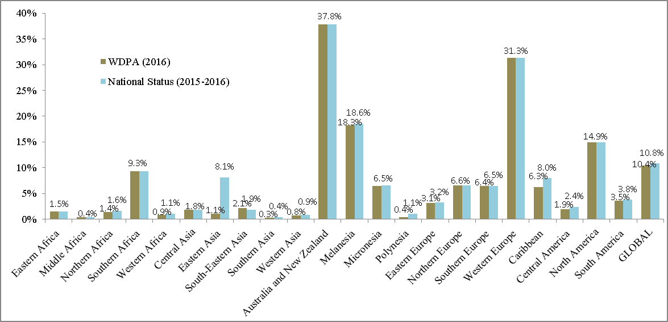
- Marine protected area coverage, however, is dominated by a small number of countries and territories with large marine protected area networks, each surpassing 1 million km² (Australia, New Caledonia, New Zealand, South Georgia and the Sandwich Islands and the United States and its Minor Outlying Islands). The marine protected area networks from these six countries and territories combined, accounts for nearly three quarters of all marine protected areas within national jurisdiction.
Figure 6 Subregional status of marine protected areas within national jurisdiction (0 – 200nm).
- Figure 6 presents the same protected area coverage data, broken down by UN subregion. Marine protected areas are concentrated in a few subregions, namely Australia & New Zealand, Melanesia, Western Europe and North America; however, Southern Africa also has significant coverage, and is only one per cent away from the target of ten per cent. Also displayed is the change in coverage that results when WDPA values are replaced by information on coastal and marine protected area coverage received from 60 countries during the six workshops.
- Figure 7 presents the national status and proposed increase for marine protected areas, as submitted by participants from the six regional workshops. Nationally, from the 60 countries that have submitted numerical information on the status of marine protected areas, 11 have reached or surpassed the ten per cent global target; while two other countries (China and Japan) are close to reaching the target, with less than one per cent in additional protected areas needed. Conversely, 24 of these countries have less than one per cent of the marine areas within national jurisdiction protected.
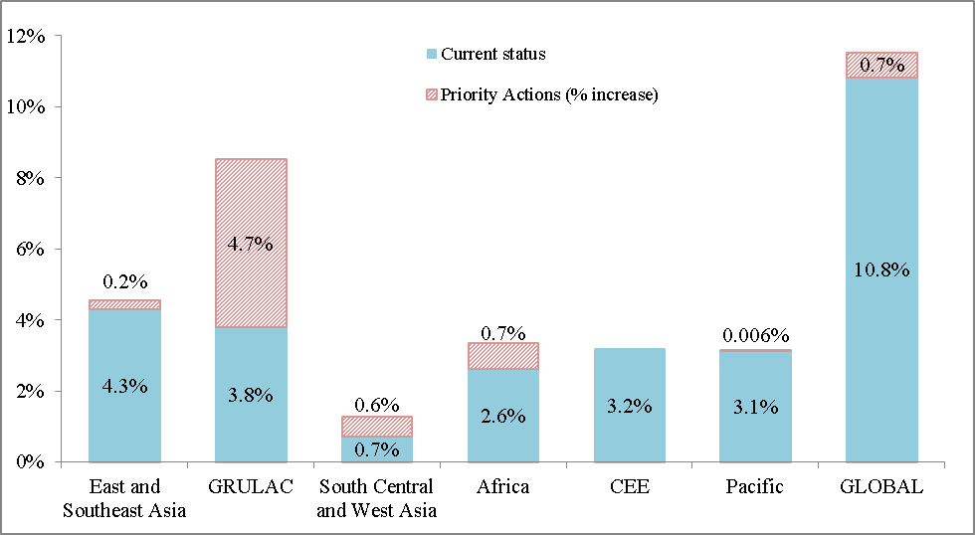
Figure 7 Status of marine protected areas within national jurisdiction (0 – 200nm) for Parties who attended one of the six regional capacity-building workshops (or submitted documents), plus increases that will occur from priority actions and opportunities.
- Forty-eight Parties identified 62 different priority actions for addressing the coverage of coastal and marine protected areas. From the information submitted, 25 countries have presented their projected increase for marine protected areas in a quantifiable manner (through priority actions, specific opportunities for implementation, or proposed protected areas at various stages of gazettal); from these, eight Parties are projected to reach the 10 per cent target if actions and opportunities are implemented as planned. Actions from these 25 countries will increase marine protected area coverage by nearly 1 million square kilometres globally, with the majority of this increase (over 850,000 km²) coming from eight countries in GRULAC (Figure 7). Including the large marine protected areas and marine managed areas communicated separately from the workshops (outlined below, in box 1), together with the priority actions identified in party submissions, will bring the marine protected area coverage in both Asia-Pacific and GRULAC above the 10 per cent target, and will bring the total protected area coverage for marine areas under national jurisdiction in WEOG to over 25 per cent.
- On top of this increase from 25 Parties, 22 further actions and three opportunities propose expansion of marine protected area networks, but the amount to be added is not specified, while another 4 Parties identified priority actions where the action will likely increase coverage of marine protected areas, however the actual increase is not discernible at this time. As details pertaining to these actions are finalized, the picture for marine conservation will continue to improve.
- The addition of large-scale marine protected areas and marine managed areas communicated outside of the workshop process (box 1) will increase protection for marine areas within national jurisdiction by an additional 6.4 per cent, while the addition of the Ross Sea MPA will improve coverage for areas beyond national jurisdiction. These additions will also increase protection in the global oceans by nearly 2.9 per cent, moving closer to ten per cent protection for the oceans as a whole, from the current level of protected area coverage of only 4.1 per cent. This large increase will also improve the coverage of several marine ecoregions (section II.C).

- Despite these increases, coverage of protected areas for marine areas beyond national jurisdiction (ABNJ), which constitute the majority of the world’s oceans, is still inadequate, at just 0.25 per cent. UNESCO has been exploring avenues through which Parties to the World Heritage Convention could bring in changes to permit the protection of sites of outstanding universal value (OUV) in marine ABNJ through inclusion on the World Heritage List. Such mechanisms include: a “bold interpretation of the Convention”, as nothing in its original vision, would seem to preclude areas of OUV outside of national jurisdiction; an “amendment outside the terms of the 1972 Agreement”, or through an optional protocol to the original Convention, developed through international negotiation among Parties. A recent World Heritage report proposed five possible sites in the high seas, all of which are considered EBSAs, as examples of potential World Heritage Sites in marine ABNJ.
Box 1: 10,440,584 km² of Large-scale Marine Protected Areas and Marine Managed Areas

Chile – 989,144 km²
- The intention to protect Easter Island’s marine biodiversity (approximately 577,000 km² of the surrounding EEZ) was announced and is currently in development with the local board (Mesa del Mar Rapa Nui).
- The Nazca-Desventuradas marine park (300,035 km²) will be soon decreed.
- The Juan Fernández Archipelago MPA (12,109.02 km²) considers a mix of (6) marine parks (1,081.36 km²) with a multiple use MPA around them (11,027.66 km²) and will be soon decreed.
- The MPAs around the southern tip of Patagonia (100,000 km²) is being developed with key strategic partners and the government hopes to announce it in the near future

Palau – 500,000 km²
The small island nation controls a vast EEZ full of incredible marine diversity, including 1,300 species of fish. Historically, Palauans have managed their fisheries by closing important spawning grounds to fishing periodically, a process they call Bul. To protect their heritage and their livelihood, Palauans closed 80% of their EEZ to any fishing or extraction, creating a no-take marine reserve larger than California in the process.

New Zealand – 620,000 km²
The proposed Kermadec Ocean Sanctuary will protect a chain of underwater volcanoes and the world’s second deepest ocean trench. It will ensure that habitats used by whales, dolphins, sea turtles, and over 150 species of fish, many of which are endemic to the region, remain pristine.

United Kingdom – 840,000 km²
After creating the British Indian Ocean Territory Marine Protected Area in 2012, the UK upped the ante in 2015 and announced its intention to designate the largest contiguous no-take marine reserve in the world. The new MPA would encompass the entire EEZ of Pitcairn, a British Overseas Territory in the South Pacific.

United States of America – 1,145,972 km²
Earlier this summer, the United States of America expanded the Papahānaumokuākea Marine National Monument, in Hawaii, from its existing 363,598 km² (which was already larger than all other National Park Service park units combined), making it the biggest protected area on the planet at 1,508,670 km².

French Polynesia – 4,795,468 km²
Also this summer, French Polynesia announced the creation of a marine managed area, Taini Atea, which will cover the entirety of the territory’s exclusive economic zone (nearly 5 million square kilometres). This marine managed area, which will be an area nearly half the size of Europe, will build on the rāhui traditional management system.

Commission for the Conservation of Antarctic Marine Living Resources (CCAMLR) – 1.55 million km²
All Member countries have agreed to a proposal to establish an MPA covering a 1.55 million km² area of the Ross Sea, seventy-two percent of which will be a 'no-take' zone; the MPA will come into force in December 2017.

Source: Personal communications with the Secretariat, and Hawai’i commitments from IUCN World Conservation Congress, 2016.
- Figure 8 presents the national status of marine protected areas and the proposed increases as identified in country’s GEF 5 project identification forms (PIFs), for projects including the creation or expansion of coastal or marine areas. Nineteen countries have GEF projects that will increase the coverage of coastal and marine protected areas, by a total 211,940 km². From these projects, two countries will add their first marine protected areas, and several others will more than double the extent of existing marine areas protected. Once again, the amount of protected area increases from identified actions and opportunities, and approved GEF projects may not be additive; accounting for those cases where priority actions were clearly aligned with GEF projects gives an increase of 1,065,339 km².
- Seven countries that attended a workshop and submitted documents have approved GEF projects which will lead to an increase in marine protected area coverage, yet did not include quantifiable actions as part of their submission. There is a need to align the expected outcomes of GEF 5 and 6 projects, as well as other bilateral projects, into their road maps for implementation of Target 11 over the next four years. If this were to happen for all Parties to the Convention on Biological Diversity, a very encouraging picture for marine protection would emerge.
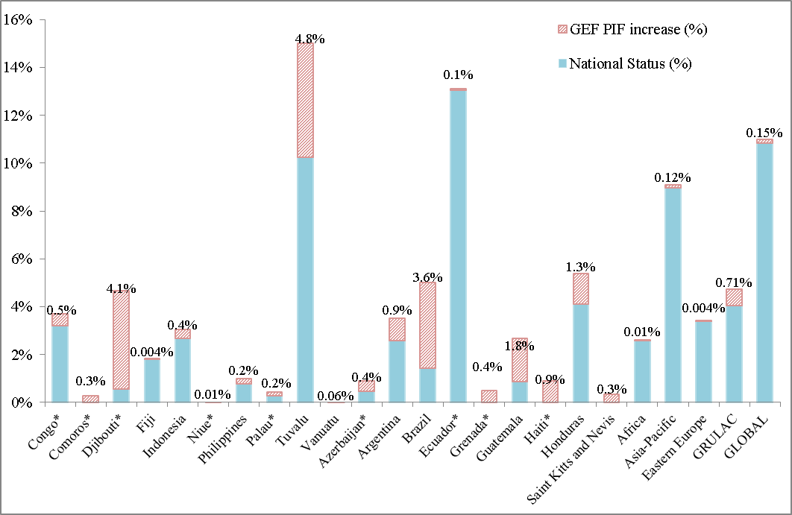
Figure 8 National and regional status of marine protected areas within national jurisdiction (0 – 200nm), plus increases that will occur from approved GEF projects.

C. Ecologically representative
Element | Status as of 2016 | What is needed for achievement? | What are the chances of reaching the target by 2020?
Ecological representation | Out of 821 terrestrial ecoregions (excluding 4 Antarctic ecoregions), 481 have 10% or more coverage under existing protected areas.  Out of 232 marine ecoregions, 84 have 10% or more coverage under existing protected areas. | Increased protection for 340 terrestrial and 148 marine ecoregions which are below 10% protected area coverage (some may not reach 10% coverage due to their fragmentation and the potentially very small size of remaining natural ecosystems). | Ninety-one countries have identified 171 focused actions addressing ecological representation.  Expansion of terrestrial and marine protected areas (II.A and II.B) will further improve the status of ecological representation.  With more concerted efforts by all in a coherent manner, facilitating effective implementation of their road maps, including mapping of OECMs and new PAs and their ovrelap with ecoregions, this element could be reached by 2020.
- Ecological representation refers to the need for protected areas to represent, or sample the full range of biodiversity; meaning they should capture the full variability among living organisms from all sources, including, inter alia, terrestrial, marine and other aquatic ecosystems and the ecological complexes of which they are a part, at all biological scales (ecosystems, species and within species variations). This means that protected area systems should contain adequate samples of the full range of existing ecosystems and ecological processes, configured so that the long-term persistence of the populations of all their species are maintained.
- At the global level, ecological representation is usually assessed based on the representation of diverse ecoregions within protected area networks. Ecoregions (or ecological regions) can be defined as “relatively large units of land [or sea] containing a distinct assemblage of natural communities and species, with boundaries that approximate the original extent of natural communities prior to major land-use change”. These ecoregions are then nested within a set of larger biomes (or provinces) and biogeographic realms.
- It is important to note that coverage of ecoregions is a useful indicator to assess ecological representativeness at the global level, but at a national level they may be too coarse to apply, therefore requiring proper alignment to the national systems. Many countries, when reporting on the status of ecological representation within their protected area networks provided information on the finer-scale designations in use nationally. In decision VIII/15, annex II; COP agreed that at least 10 per cent of each ecological region should be effectively conserved. In order to not complicate the issue by linking it with the coverage of species ranges, in a simple and practical way, protected area coverage of at least 10 per cent of each terrestrial and marine ecoregion is considered as the requirement for reaching this element, at conservative estimates.
- Globally, terrestrial areas are divided into 14 biomes, based on dominant vegetation types (like Temperate Conifer Forests or Flooded Grasslands & Savannas) and eight biogeographic realms, based on geography, plants and animals (like Australasia and the Neotropics). These contain 867 terrestrial ecoregions, 825 of which have been mapped (not including large lakes, and rock/ice covered areas), the remainder are primarily mangrove ecoregions, which are missing data, as they are usually small in land area and generally poorly mapped. Terrestrial ecoregions range from under 10 km² (St. Peter and St. Paul rocks or Malpelo Island xeric scrub) to the continent spanning Saharan desert at over 4.6 million km²; with the majority of terrestrial ecoregions less than 100,000 km².
- For marine areas from the coast to a depth of 200m, there are 232 marine ecoregions which have been defined; these are nested within 62 marine provinces, defined based on distinct abiotic features (hydrography, geochemistry, etc.), and 12 marine realms, driven largely by water temperature, and degree of historical isolation. For marine areas in open waters (depth > 200m), 37 pelagic provinces have been identified.
- Figures 9 and 10 present maps of the level of protected area coverage for all terrestrial and marine ecoregions, respectively, based on the biogeographic coverage analysis carried out by the European Commission's Joint Research Centre (JRC) for the Protected Planet Report 2016, using a pre-processed version of April WDPA 2016 release.
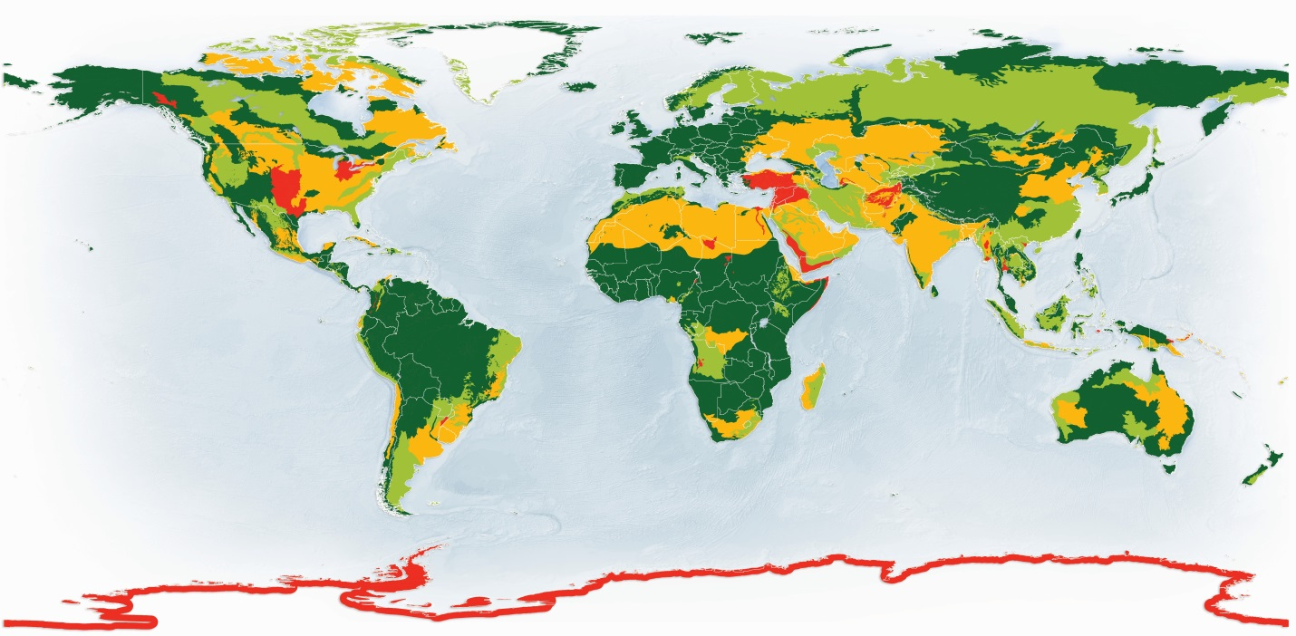
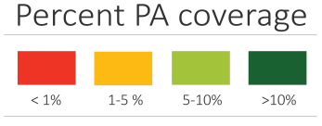

Figure 9 Map displaying the level of protected area coverage for terrestrial ecoregions.
- Globally, out of 821 terrestrial ecoregions, 481 (or 59 per cent) have reached the 10 per cent protection level (Figure 9). This represents a slight increase in the number of terrestrial ecoregions reaching 10 per cent protected area coverage, from a 2014 assessment where only 474 ecoregions out of 823 were protected at a level of 10 per cent or higher. Ecoregions in many areas have seen their protected area coverage increase, like the Western Polynesian tropical moist forests and the Kimberly tropical savanna. At the level of terrestrial biomes, 11 out of 14 have 10 per cent protected area coverage, a decrease from 12 out of 14 from the 2014 assessment; with protection for Deserts & Xeric Shrublands and Boreal Forests/Taiga falling below 10 per cent, while coverage in Tropical & Subtropical Dry Broadleaf Forests increased to greater than 10 per cent. Finally, out of eight biogeographic realms, all but one (IndoMalay) have reached 10 per cent protected area coverage, which represents an improvement from the 2014 assessment, when the Oceania realm was also below 10 per cent.
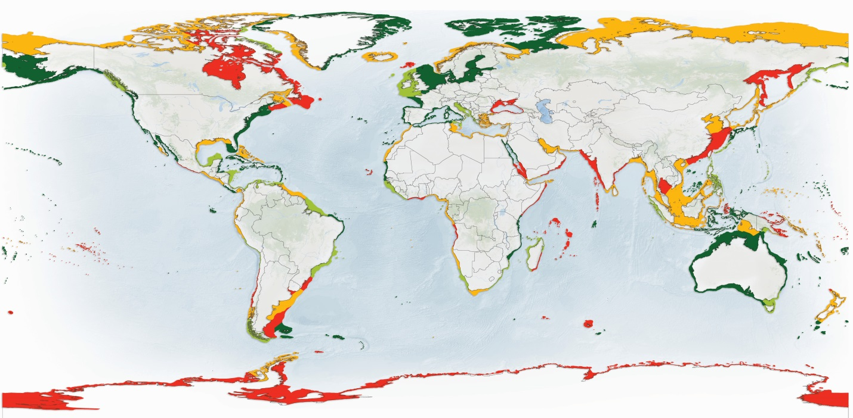

Figure 10 Map displaying the level of protected area coverage for 232 marine ecoregions.
- For marine ecoregions (Figure 10), 84 out of 232 have at least 10 per cent protected area coverage; while 28 out of 62 marine provinces and 6 out of 12 marine realms have reached 10 per cent protected area coverage. Since the 2014 Protected Planet Report there has been an increase in the number of marine ecoregions protected at 10 per cent or higher, increasing from 78 to 84, and the number of marine provinces with greater than 10 per cent protected area coverage rising from 24 to 28; while at the level of marine realms, there has been no change, with only half (6 of 12) reaching the target. As well, protected area coverage for pelagic provinces has improved; the number of pelagic provinces with over 10 per cent protected area coverage has increased (from two to three), while the number of pelagic provinces with less than 2 per cent protected area coverage has decreased.
- Figure 11 presents all terrestrial and marine ecoregions that have not yet reached 10 per cent protected area coverage, and the increase in coverage needed to reach it; as well as showing the number of ecoregions requiring different levels of protected area coverage to reach 10 per cent. Twenty terrestrial and 11 marine ecoregions have no protection at all; these unprotected ecoregions include, inter alia, Northern Anatolian conifer and deciduous forests, Kopet Dag semi-desert, and Tabuai tropical moist forest for terrestrial areas, and the Weddell Sea, Trindade and Martin Vaz Islands, and Southeast Madagascar, for marine.
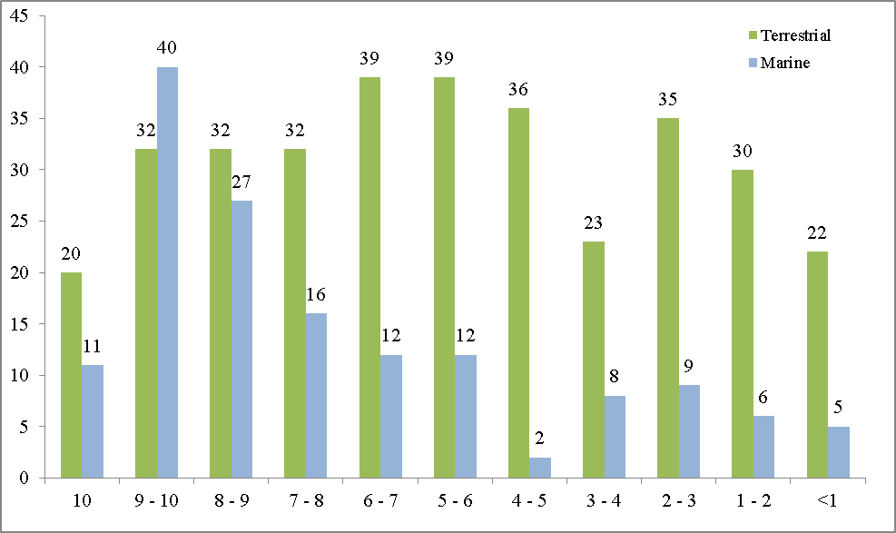
Figure 11 The number of terrestrial and marine ecoregions at different levels of protection (horizontal axis shows the additional percent protection needed to reach 10% coverage).
- As shown in Figure 11, the largest number of terrestrial ecoregions missing the 10 per cent target require an addition of between four and seven per cent. Although the area-based target of 10 per cent for marine protected area coverage has been met for areas within national jurisdiction at the global level, the majority of the world’s 232 marine ecoregions still fall short of this target, and one third of all marine ecoregions have less than 2 per cent protected area coverage (Figures 10 and 11). There are, however, 30 marine ecoregions with between 5 and 10 per cent protection, and just 70,000 km² of additional protected areas, added within these 30 ecoregions, would bring them up to 10 per cent coverage, thereby increasing the total number or marine ecoregions hitting the 10 per cent target to nearly half (114 of 232).
- Figures 12 and 13 present the number of terrestrial and marine ecoregions at different levels of protection in each UN region, as well as the global status. As ecoregions are defined biogeographically, and are not confined by administrative boundaries, there are some ecoregions which may occur in more than one UN region. Both figure 12 and 13 display the uneven distribution of ecoregions among UN regions; Asia-Pacific and WEOG have the highest number of both terrestrial and marine ecoregions. For terrestrial ecoregions, Africa and GRULAC have the highest proportion meeting the ten per cent protection target (more than two thirds in both cases), while Eastern Europe has the lowest proportion of terrestrial ecoregions with less than 5 per cent protected. For marine ecoregions, only WEOG has more than half protected (54 per cent), while Eastern Europe, Africa and Asia-Pacific all have more than half of their marine ecoregions at less than 5 per cent protected.

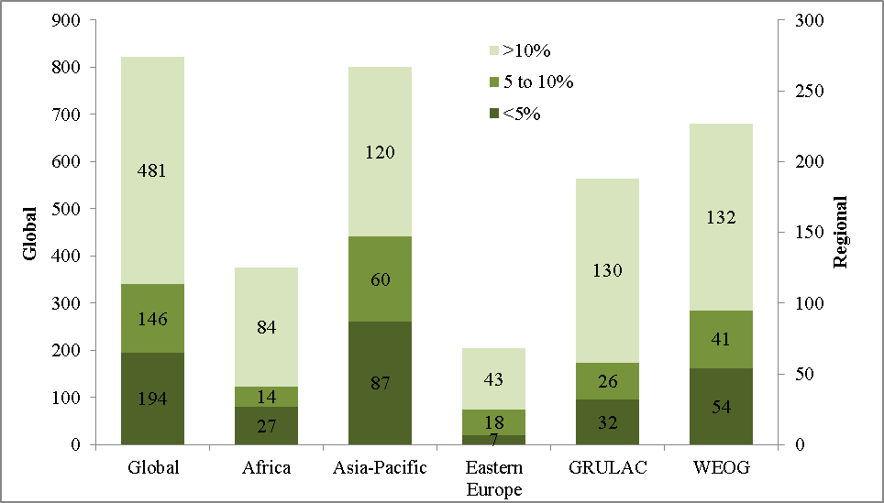Figure 12 Number of terrestrial ecoregions at different levels of protection, per region and globally.
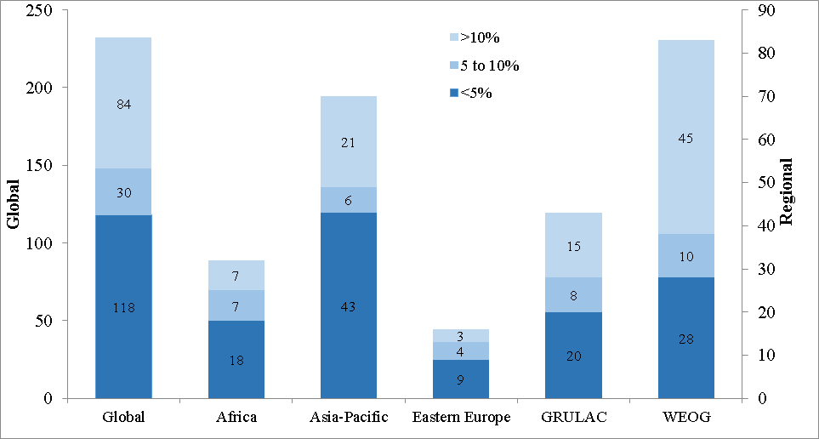
Figure 13 Number of marine ecoregions at different levels of protection, per region and globally.
- From the regional workshop attendees, 91 countries have identified 171 focused priority actions addressing ecological representation within their protected area networks. For example, out of the 10 ecoregions in Bangladesh, three have been assessed as high priority for protection by the country. As part of its priority actions, Bangladesh aims to extend the protection of the Sundarbans Mangrove Ecosystem by 4609 km² and the Lower Gangetic Plains Moist Deciduous Forests by 3000 to 4000 km². The country also aims to formally declare a 1738 km² marine park and a 582 km² marine reserve as protected areas, extending the level of protection of the Northern Bay of Bengal ecoregion.
- The current system of protected areas in Cuba covers different types of ecosystems and the range of many endemic species, as assessed in a gap analysis conducted in 2007. As part of its priority actions, the country aims to increase the protection of different landscape and ecosystem types by increasing the protection of: 4 per cent of landscape types, 3 per cent of natural wetlands, 3 per cent of marine ecosystems, 3 per cent of natural vegetation, 2 per cent of areas with endemic plants, 3 per cent of areas with endemic and/or threatened species of terrestrial vertebrates and 3 per cent of key areas for marine species.
- Reporting on the current status of ecological representation in their protected area network, Swaziland indicated that both grassland and savanna bushveld ecosystems can be found within protected areas in the country; these two ecosystem types account for over 90 per cent of the terrestrial area of the country. Forest ecosystems, however, are currently under-represented in Swaziland’s protected area network. For their priority actions, Swaziland aims to ensure that at least 10 per cent of each major ecosystem type is represented within the protected area network. As per Swaziland’s Fifth National Report to the CBD, none of the major ecosystem types have met this 10 per cent target, although two of the three do have global protection of greater than 10 per cent (only Drakensberg montane grasslands miss the 10 per cent target globally, which roughly corresponds to Swaziland’s montane grassland classification).
- As part of Sudan’s draft priority actions, they aim to establish six new protected areas, adding over 6000 km²; these new protected areas will be placed in ecological regions which are not currently represented in the country’s protected area network. The currently under- or un-represented ecological regions include: fresh water habitats, Red Sea hills, seasonal Wadis, and high rain savanna areas, all finer-scale national classifications, used within Sudan.
- Niger recognizes that there is one region in the country which lacks protection, and that the Saharan pastoral zone is not adequately represented in the current protected area network. For their priority actions, they indicate that the creation of the Tadress protected area will solve this problem of ecological representation, through the protection of currently under- or un-represented regions.
- Mapping activities for ecozones, key biodiversity areas and habitats have been identified as part of the priority actions by four different countries (Solomon Islands, Sri Lanka, Uganda and Botswana). Some form of ecological gap assessment was identified as priority actions by eight other Parties. Examples include Senegal which plans to conduct an ecological gap analysis of their national protected area system, taking into account the level of protection for different ecoregions, and Ethiopia which plans to identify gaps in the representativeness of their existing protected area network.
- Given the expansion of terrestrial protected areas from priority actions, opportunities and approved GEF projects (section II.A), at least 5, and possibly upwards of 65, terrestrial ecoregions will increase their protected area coverage above 10 per cent. Meanwhile 23 countries have identified priority actions with specific mention of the ecoregions for which protection will be improved; many of these countries did not include quantifiable increases for protected area coverage, hence the increase in the number of terrestrial ecoregions meeting the 10 per cent target may be even higher,
- There are 90 marine ecoregions represented within the EEZ’s of the 41 countries with proposed marine protected area increases, approved GEF projects with a marine protected area component or the countries adding large MPAs (box 1); 65 of these ecoregions are currently below the 10 per cent target (though 12 have less than 5 per cent of their area within the EEZ’s of the countries making additions). Priority actions and approved GEF projects could lead to an increase in the number of marine ecoregions surpassing 10 per cent protection, in as many as 34 currently under-protected marine ecoregions; this includes, among others the Bahamian and Gilbert/Ellis Islands ecoregions. Meanwhile, the expansion of large marine protected and marine managed areas identified by Chile, Palau, New Zealand, the United Kingdom of Great Britain and Northern Ireland, the United States of America, French Polynesia and the CCAMLR (box 1) will bring the level of protection in seven or eight further marine ecoregions above the 10 per cent target, including, among others, Juan Fernandez & Desventuradas and Rapa-Pitcairn. The expanded protection of the French Polynesian EEZ will also improve protected area coverage for the South Central Pacific Gyre pelagic province, bringing the number of pelagic provinces meeting the target to four out of 37 (or just over ten per cent).
- Given the priority actions planned for the next four years, and the protected area expansions from actions, opportunities and approved GEF projects, the ecological representativeness of the global protected area network will improve. These actions are coming from only a small subset of CBD Parties; should all other Parties implement similarly ambitious actions, a more encouraging picture would emerge that would have a bearing on this element in the next four years. In addition, mapping of proposed new protected areas vis-a-vis their coverage of ecological regions as well as mapping of community conserved areas and other effective area-based conservation measures would augment the chances of improving the ecological representation aspect of target 11, and improve the estimates for the number of ecoregions which will have met the ten per cent coverage target.

D. Areas of particular importance for biodiversity
Element | Status as of 2016 | What is needed for achievement? | What are the chances of reaching the target by 2020?
Areas of particular importance for biodiversity | Globally (including Antarctica and the High Seas):  - out of 12,532 IBAs, 2539 are completely covered, 3230 are 50-98% covered, 2627 are 2-50% covered and 4136 are not covered by existing protected areas;  - out of 585 AZEs, 114 are completely covered, 137 are 50-98% covered, 107 are 2-50% covered and 227 are not covered by existing protected areas;  - out of 4333 other KBAs, 720 are completely covered, 1058 are 50-98% covered, 907 are 2-50% covered and 1648 are not covered by existing protected areas | Bringing 6763 IBAs and 2555 other KBAs to at least 50 per cent coverage, and bringing 471 AZEs to complete coverage by protected areas and other effective area-based conservation measures. | Ninety countries have submitted 203 different priority actions to address the protection of areas important for biodiversity.  Actions aimed directly at improving protected area coverage of IBAs and AZEs (with the number of sites indicated), were identified by 12 Parties, and will increase coverage in at least 65 and 11, respectively; while the addition of terrestrial and marine protected areas (II.A and II.B) will invariably lead to further improvements.
- Key Biodiversity Areas (KBAs) are the most commonly used example of areas of particular importance for biodiversity, and are useful for targeting strategic expansion of protected area networks. KBAs are sites “contributing significantly to the global persistence of biodiversity” at the genetic, species and/or ecosystem level; they are nationally identified sites using global criteria and thresholds. Recently, a new global standard for the identification of KBAs was developed (see box 2), which can be used by Parties for national identification of areas important for biodiversity under Aichi Target 11 and to halt species extinctions under Aichi Target 12. Sites may be selected as KBAs to highlight the importance of protecting threatened biodiversity, range restricted biodiversity, ecological integrity, ecological processes or some form of irreplaceability. A summary of different areas important for biodiversity is reproduced in Table 2, from the IUCN Protected Area Governance and Management publication, while Figure 14 provides a map of select areas important for biodiversity, using updated information from the same table.
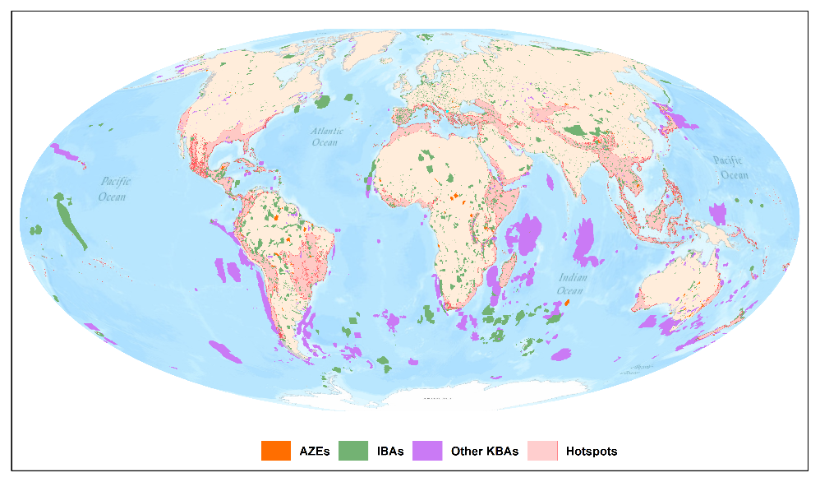
Figure 14 Map displaying the global distribution of select areas important for biodiversity.
Table 2 Select areas important for biodiversity
Name | Definition | Scale | Number of areas or sites | Total land area (million km²) | Percentage of global land area
Important Bird and Biodiversity Areas (IBAs) | Sites hold significant numbers of one or more globally threatened bird species; site is one of a set of sites that together hold a suite of restricted-range bird species or biome-restricted bird species; and/ or has exceptionally large numbers of migratory or congregative bird species | Site | 12,532 | 10.6 | 7.1%
Alliance for Zero Extinction sites (AZEs) | Site is sole area where an endangered (EN) or critically endangered (CR) species occurs (or contains > 95% of the EN or CR species’ global population for at least one life history segment) | Site | 585 | 0.6 | 0.4%
Other Key Biodiversity Areas (KBAs) | Sites contributing significantly to the global persistence of biodiversity, not including IBAs or AZEs, defined for a wider range of taxa | Site | 4333 | 2.8 | 1.9%
Endemic Bird Areas | Sole area where ≥ 2 bird species with global breeding ranges of < 50 000 km² occur | Site or Region | 218 | 14.2 | 9.5%
Biodiversity hotspots | Biogeographically similar aggregations of ecoregions holding ≥ 0.5% of the world’s plants as endemics, and with ≥ 70% of primary habitat already lost | Ecoregion clusters | 36 | 25 | 16.8%
High-biodiversity wilderness areas | Biogeographically similar aggregations of ecoregions holding ≥ 0.5% of the world’ s plants as endemics, and with ≥ 70% of primary habitat remaining and ≤ 5 people per km² | Ecoregion clusters | 5 | 11.8 | 7.9%
- As of April 2016, there were 14,595 KBAs identified globally (including Antarctica and the high seas); the level of coverage for these KBAs was assessed by BirdLife International for the Protected Planet Report 2016 and the results are presented in Figures 15, 16, 17 and 18. As per the analysis, 19.3 per cent of sites are completely covered by existing protected areas (indicating that at least 98 per cent of the site is covered), 24.5 per cent have a high level of coverage form existing protected areas (between 50 and 98 per cent), 20.7 per cent have a low level of coverage (between 2 and 50 per cent), while more than a third of sites (35.5 per cent) are not covered by the existing protected area network, indicating they have less than 2 per cent coverage.
Box 2: Development of new KBA standard

IUCN, through the World Commission on Protected Areas and the Species Survival Commission, has convened a Joint Task Force to develop of a new global standard for the identification of Key Biodiversity Areas. This standard builds on the work of existing approaches, most notably BirdLife International’s Important Bird and Biodiversity Areas, but is now inclusive of all taxa and levels of biodiversity. The new standard has undergone two rounds of global consultation and the new criteria and thresholds have been tested against existing data. The new KBA standard was recently finalized, has been approved by the IUCN Council and was launched during the World Conservation Congress in Hawaii; the next steps will involve the formation of a KBA Partnership to implement the standard. The new standard can be used by Parties for national identification of areas important for biodiversity under Aichi Target 11 and to halt species extinctions under Aichi Target 12. The KBA Partnership will assist Parties with national identification and delineation KBA sites.

Source: IUCN (2016) A Global Standard for the Identification of Key Biodiversity Areas, Version 1.0. Gland, Switzerland: IUCN.
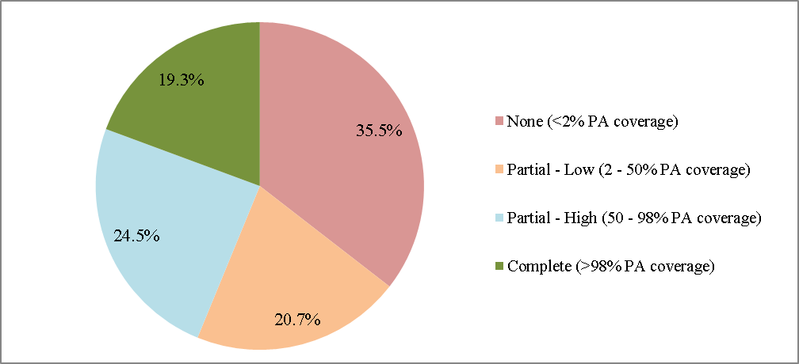
Figure 15 Level of protected area coverage for all identified KBAs (n = 14,595), globally (including Antarctica and the high seas)

- Figure 16 presents the number of Important Bird and Biodiversity Areas (IBAs) at different levels of protection, as analysed by Birdlife International. Globally, out of 12,532 IBAs, 2539 are completely covered by existing protected areas, 3230 have a high level of coverage (50 to 98 per cent) from existing protected areas, 2627 have a low level of coverage (2 to 50 per cent), and 4136 have no coverage within existing protected areas. Regionally, the Western Europe and Others Group (WEOG) has the highest number of identified IBAs, at 4365, or more than one third of all IBAs currently identified. However, Africa has the highest proportion of IBAs completely covered by existing protected areas (27.5 per cent). Africa, WEOG and Eastern Europe all have more than half of their identified IBAs with at least 50 per cent coverage by existing protected areas.
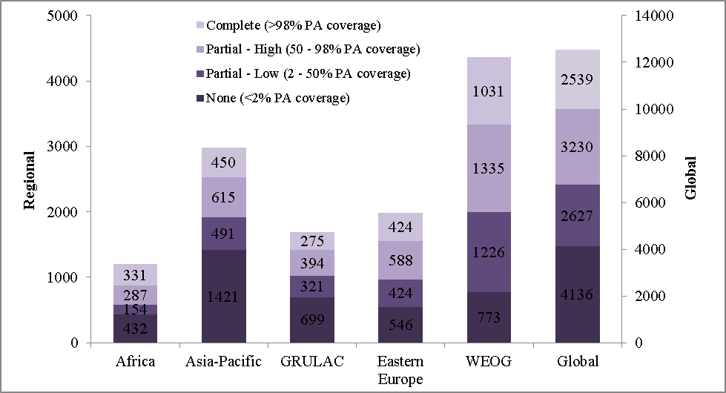Figure 16 Number of Important Bird and Biodiversity Areas with different levels of protection per UN region and globally (n = 12,532).
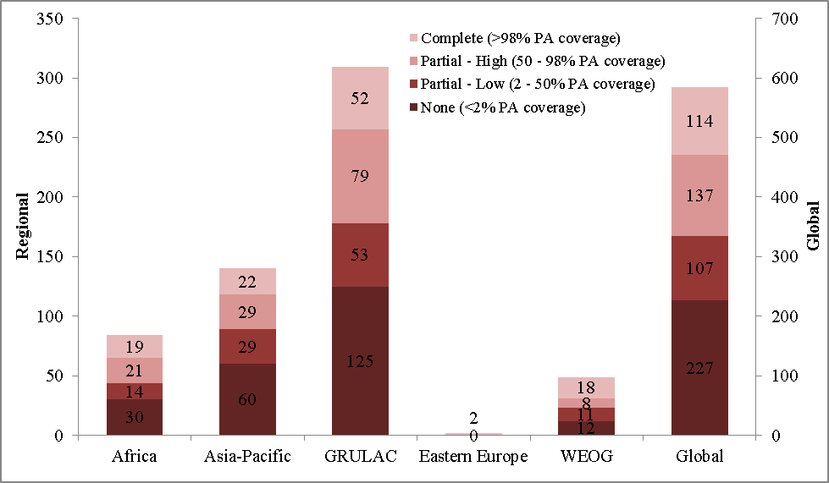
Figure 17 Number of AZEs with different levels of protection, per UN region and globally (n = 585).

- Figure 17 presents the number of AZEs at different levels of protection, at the global level and per UN Region. Globally, out of 585 AZEs, 114 are completely covered by existing protected areas, 137 have a high level of protected area coverage (50 to 98 per cent), 107 have a low level of protected area coverage (2 to 50 per cent) and 227 have no coverage with existing protected areas. Regionally, the Latin America and Caribbean group contains the majority of AZEs identified at this time (309 of the 585); however, more than 40 per cent of these are not covered by existing protected areas. Both of the two AZEs identified in Eastern Europe, and more than a third of the AZEs in the WEOG region have complete coverage by existing protected areas. As AZEs are “the highest priority subset of KBAs”, containing the only known sites for endangered (or critically endangered) species, it is important that they receive full protection.
- Finally, figure 18 presents the number of other KBAs at different levels of protection, as analysed by Birdlife International. Globally, out of 4333 other KBAs, 720 are completely covered by existing protected areas, 1058 have a high level of protected area coverage (50 to 98 per cent), 907 have a low level of protected area coverage (2 to 50 per cent) and 1648 have no coverage provided by existing protected areas. Regionally, Asia-Pacific contains the most other KBAs (1670), while Eastern Europe has the highest proportion of other KBAs with full protection (21.8 per cent). The WEOG region contains the lowest portion of other KBAs with no protection (18.1 per cent).
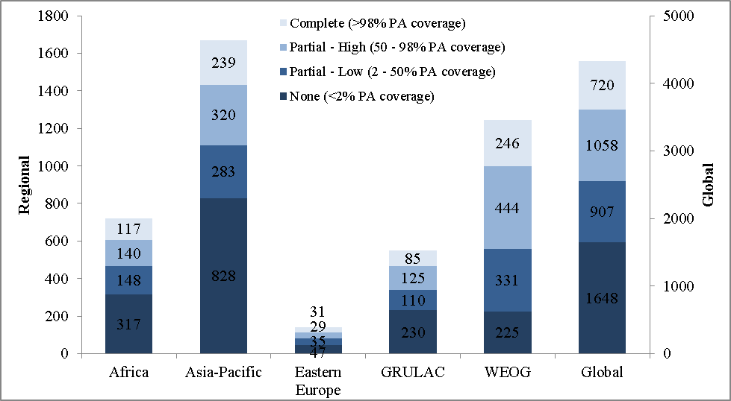Figure 18 Number of other Key Biodiversity Areas (KBAs) with different levels of protection per UN region and globally (n = 4333).
- From the workshop attendees, and those submitting documents, 90 countries submitted 203 different priority actions to address the protection of areas important for biodiversity. Twenty-six of these actions directly address the improvement of protection offered to IBAs and/or AZEs, with 12 countries providing the specific number of sites where protection would be improved. If actions from these 12 countries are implemented as planned, at least 65 IBAs and 11 AZEs will have improved protection status. Given the actions from the other 14 countries aimed at improving protection of IBAs or AZEs, the increase in protected area coverage for terrestrial and marine areas, as well as the other actions, the picture for protection of areas important for biodiversity is bound to improve.
- For example, Lebanon has identified 15 IBAs, out of which 7 are under legal protection. As part of its priority actions, Lebanon aims to include IBAs that are part of migratory routes of key bird species in its national system of protected areas, as well as to enforce the Hunting Law to reduce illegal hunting by 70 per cent by 2020.
- Indonesia has put great efforts into identifying areas important for biodiversity and has reported 227 IBAs, 31 AZEs, as well as 242 KBAs. Out of the 242 KBAs identified, 29 are partially protected and 108 have no protection. One of Indonesia’s priority actions over the next four years will be to improve the protection of priority species habitat in 5 partially or unprotected KBAs.
- Colombia has reported 124 IBAs and 45 AZEs. Out of these, 60 per cent of IBAs and 7 per cent of AZEs are fully protected, while 38 per cent of AZEs have partial protection. Colombia’s priority actions aim to increase the level of protection in at least 3 IBAs and 3 AZEs.
- Philippines reported the presence of 105 IBAs, out of which 11 are completely protected, 41 are partially protected and 53 have no protection. The Philippines included, as part of its priority actions, increasing the number of protected IBAs and improving their management effectiveness. These include the protection of 9 terrestrial IBAs under a UNDP-GEF programme on ICCA/LCA and a Supreme Court order to increase the protection of 5 IBAs in the Manila Bay region.
Box 3: 2,785,350 Km² of terrestrial areas protected through GEF,
58% are Key Biodiversity Areas

GEF has supported the development of 1,292 terrestrial protected areas (51 per cent of them in tropical biomes) in 119 countries, covering a total area of 2,785,350 km²; of these terrestrial protected areas, 58 per cent are considered Key Biodiversity Areas. Thirty-one per cent of these terrestrial protected areas have one or more international designations for high biodiversity and/or cultural values, as a WWF priority area, Conservation International Biodiversity Hotspot, Ramsar site, or UNESCO World Heritage site. The remaining 11 per cent of protected areas have various local or national designations that indicate a high-level of biodiversity.

Source: GEF. 2015. Impact Evaluation of GEF Support to Protected Areas and Protected Area Systems (Final Unedited Report). Available at www.thegef.org/
- Madagascar reported that 18 of the 20 AZE sites located in the country are under full protection, while there is one each with partial and no formal protection. As for IBAs, 21 have no protection, 6 have partial protection, and 51 are fully protected. All three of Madagascar’s “IBAs in danger” (those sites in under great threat and in need of immediate action) are fully protected and within their existing protected area network. Madagascar’s priority actions for this element over the next four years include focusing conservation funding towards the protection of these important areas for biodiversity.
- Several countries identified IBAs reported nationally, but not yet included in the global database. The international listings are however updated regularly; as such the global picture of protection for areas important for biodiversity will change. During the workshops, only 23 of 53 respondents to the questionnaire (43%) agreed with the information presented on IBAs and AZEs in their data dossier; while 84 per cent of respondents reported that the information would need to be updated to match their national records. As noted in previous sections, there are some differences between the level of protection indicated by Parties and that of the WDPA. Including the approximately 1 million km² in both terrestrial and marine protected areas to be added over the next four years if priority actions and opportunities are implemented, alongside the increases from approved GEF projects, will invariably lead to an improvement in the protection of areas important for biodiversity. The next step will be to map these protected area additions, including the additions added by OECMs (see section II.J) vis-à-vis their relation to the location of areas important for biodiversity, to assess their level of coverage.
- Aside from IBAs and AZEs, workshop participants identified a wide range of other sites important for biodiversity at the national scale. Some of these include, inter alia, Ramsar sites, mangroves, endemic and endangered species habitats, important plant areas (IPAs), unique landscapes and national natural monuments, Biosphere Reserves, Emerald Sites, sacred groves, corals and wildlife corridors. These other sites are protected to varying degrees, and more than 20 priority actions have been identified to improve protection in these other areas of national importance for biodiversity.

E. Areas of particular importance for ecosystem services
Element | Status as of 2016 | What is needed for achievement? | What are the chances of reaching the target by 2020?
Areas of particular importance for ecosystem services | Systematic information is not available.  More direction is needed. | Identification and mapping of areas important for ecosystem services, such as watersheds, areas important for wild crop relatives and pollinators, among others. | Forty priority actions specifically addressing areas important for ecosystem services were identified (though many actions identified for areas important for biodiversity will also protect ecosystem services).  More direction is needed to assess the chances of reaching the target.
- Well-managed protected areas can provide vital ecosystem services, such as water purification and retention, leading to water security, erosion control and reduction of both flooding and unnatural wild fires. These services buffer human communities against different environmental risks and hazards and support food and health security by maintaining crop diversity and species with economic and/or subsistence value. They also play an important role in ecosystem-based approaches to climate change adaptation and contribute to mitigation by storing and sequestering carbon. A recent study pointed to the higher levels of both biodiversity and carbon sequestration within protected areas compared to areas outside of them, highlighting the linkages between the elements calling for protection of areas important for biodiversity and ecosystem services. As such, there may be some degree of overlap between areas identified as important for biodiversity and those identified as important for ecosystem services; however, this may not always be the case, especially when analysed at coarser global scales. Many areas providing important ecosystem services may have low biodiversity value, yet still require protection. As such, it is important that conservation targets for areas important for biodiversity and for ecosystem services are set individually.
- A 2015 study examined the contribution of the global protected area network to climate change mitigation through carbon sequestration. It was estimated that the 15.5 million km² of terrestrial protected areas used for the assessment (based on an older version of the WDPA, 2009) sequestered approximately 0.5 Pg C annually, which is approximately 20 per cent of all carbon sequestered by land-based ecosystems, and equivalent to the emissions of over 100 million passenger vehicles driven for a year. The increases in protected area coverage that have occurred since the time of data collected for the study, as well as the increases planned for the next four years (section II.A) mean that the contribution of protected areas to climate change mitigation will be higher than this reported figure. The authors also highlighted the importance of ‘ecosystem-based adaptation’, making use of both biodiversity and ecosystem services for climate change adaptation, through the use of “sustainable management, conservation and restoration of ecosystems, as part of an overall adaptation strategy that takes into account the multiple social, economic and cultural co-benefits for local communities”. It was also noted that conservation and restoration were among the most common approaches to climate change adaptation, as indicated by countries in their Intended Nationally Determined Contributions.
- While much effort has gone into the identification of areas important for biodiversity, similar work is lacking for ecosystem services at the global scale. The development of ecosystem service indicators is a continually evolving field, and numerous indicators have been proposed; to be useful in a policy and planning setting, however, they must be “easy to understand (e.g. in monetary terms), widely applicable, cost-effective, valid over time and space”. Some global studies have been conducted, based on a limited number of ecosystem services (commonly including carbon sequestration); however, there is a need to focus on national assessments of those areas supplying the ecosystem services most important in a national context. Mapping of these areas and preforming gap assessments with existing protected area network will be important in order to prioritize sites for future protection.
- Out of the 61 countries who responded to the question relating to the assessment of ecosystem services in the workshop questionnaire, 75 per cent (46 respondents) have assessed at least certain elements or areas regarding ecosystem services. Assessments range from specific accounting of ecosystem goods and services, notably fisheries assessments, to broader identification and assessment of ecosystems and their services on a national scale, and biodiversity and socio-economic assessments of natural areas.
- Regarding protection (legal or other) for areas important for ecosystem services, of the 50 Parties that responded to this question in the Questionnaire, nearly all (94 per cent) indicated that some level of protection is afforded to at least some of the areas identified as important for ecosystem services. It should be noted that protection is at times provided indirectly, and often not specifically enacted to protect these areas important for ecosystem services, but rather designed for other conservation targets, which will also benefit protection for ecosystem services.
- As for emerging priority areas for maintaining essential ecosystem services, from the 64 countries responding to the Questionnaire, 40 identified emerging priority areas for ecosystem services, while 5 specified they had not identified any such priorities. The main ecosystem service mentioned by countries is the provision of water. Much work regarding emerging priority areas for the protection of ecosystem services is still in preliminary stages. For example, Burkina Faso has identified and fully protected 3 areas important for water resources, while wood and sacred grove areas are emerging as essential for ecosystem services and are considered for management and maintenance.
- Following completion of all six capacity-building workshops, 40 priority actions specifically addressing areas important for ecosystem services were identified (though many actions identified by Parties applied to both areas important for biodiversity and ecosystem services). Many priority actions submitted covered both areas important for biodiversity and areas important for ecosystem services (and there is likely some overlap between the two), as such, the count of 40 actions refers only to those actions specific to protection of areas important for ecosystem services. For example, Colombia has started to prioritize areas providing important ecosystem services, and areas important for the conservation of water resources have been identified in particular. As part of its priority actions, Colombia aims to include three areas important for water resources and fisheries to the existing system of protected areas within the next four years.
- For Zambia, their priority actions include undertaking a climate change vulnerability assessment, in order to develop relevant adaptation measures to enhance the level of climate change resilience in four priority ecosystems (primarily critical headwaters) which are important for the provision of ecosystem services to the country.
- Nepal has identified rangelands, wetlands, catchment forests, and protected areas as areas important for ecosystem services. Most of these areas are protected under biodiversity related policies and legislations such as the National Wetlands Policy (2012). As part of its priority actions, Nepal aims to promote the development of a Payment for Ecosystem Services (PES) mechanisms in selected sub-watersheds. The formulation of a PES bill has also been initiated by the Ministry of Forest and Soil-Conservation. Priority actions regarding some aspect of payment for ecosystem services have also identified by four other countries (Bhutan, Cambodia, El Salvador and Honduras).

F. Effectively managed
Element | Status as of 2016 | What is needed for achievement? | What are the chances of reaching the target by 2020?
Effectively managed | As of a 2015 assessment of submissions to the GD-PAME, some 42 CBD Parties (or 21.4%) have implemented management effectiveness evaluations in at least 60 per cent of their protected areas.  Average management effectiveness scores were only 0.52. | 154 CBD Parties have yet to reach the 60% assessment target.  Efforts will also be needed to improve the PAME scores of assessed PAs. | Ninety-three countries have identified 236 priority actions addressing both the assessment of management effectiveness and improvement of protected area management.  Additionally, at least 63 countries have approved GEF projects, which will all include management effectiveness assessments.
- The effective management element can be further divided into two components: (a) the assessment of management effectiveness, carried out at each protected area or at the level of entire protected area systems; and (b) the effectiveness in the management of each protected area is improved. With regards to the assessment of management effectiveness there are many tools, including: the protected area management effectiveness (PAME) assessment methodologies; the Rapid Assessment and Prioritization of Protected Area Management (RAPPAM) tool; and the Management Effectiveness Tracking Tool (METT), developed by the World Bank and World Wildlife Fund for Nature.
- For the assessment of management effectiveness, Decision X/31 paragraph 19(a) invites Parties to implement management effectiveness evaluations in at least 60 per cent of the total area of protected areas in a country by 2015. As of January 2015, the Global Database on Protected Areas Management Effectiveness (GD-PAME) has collected 17,739 PAME assessments, representing 9,037 protected areas. Some 17.5 per cent of countries and territories have implemented PAME evaluations in at least 60 per cent of their protected areas (by area); though looking only at CBD Parties, excluding overseas territories (which are treated individually in the WDPA and GD-PAME), this increases to 42 countries (or 21.4 per cent) having reached the target.
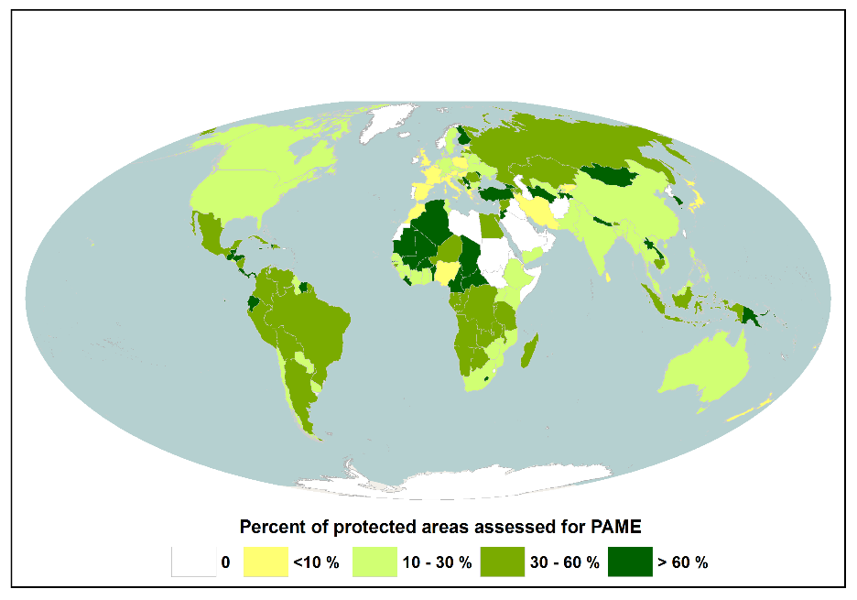
- Figure 19 shows the progress being made towards the 60 per cent (by area) PAME assessment target, globally, from data held in the GD-PAME as of January 2015. The GRULAC region has carried out the most PAME assessments; two thirds of GRULAC Parties have met the older 30 per cent Target, while 30.3 per cent (10 countries) have assessed at least 60 per cent of their protected area networks (by area). Africa also has a high number of Parties meeting the target, with 15 out of 54 (or 27.8 per cent) having assessed at least 60 per cent. Among biomes (not shown), the frequency of PAME assessments is the highest in tropical forests, where 45 per cent of protected areas have been assessed.
Figure 19 National progress towards the 60% PAME assessment target, assessed as percentage of total area.
- The GEF ensures that a minimum number of METT assessments are carried out in all protected areas which are funded by the agency; during the course of a GEF-funded project, at least three METT assessments will be completed. For a recent evaluation study of GEF projects, 2,440 METT assessments were analysed from 1,924 protected areas in 104 countries. At the time, out of these 1,924, only 352 protected areas had multiple METT assessments completed; 20 per cent of the assessments had half, or less than half, of the 30 questions answered. Some 46 per cent of the METT assessments were from Latin America and the Caribbean, predominantly in Mexico, while Asia was the least represented region, with only 11 per cent of the assessments.
- In the GEF evaluation study, standardizing only METT assessments that had more than half of the questions answered (which was only 20 per cent of all assessments), the overall mean METT score was 0.47, which is below the level considered as ‘effectively managed’. Only 275 GEF supported protected areas, out of the total 1,924, had repeated assessments that could be used to analyse changes in management effectiveness over time. Of these 275 areas, 70 per cent recorded improvements in the total score, 27 per cent experienced declines and 3 per cent saw no change. Recently approved and ongoing GEF projects continue to evaluate and improve management effectiveness. Table 3 summarizes the expected outcomes of GEF 5 Project Identification Forms (PIFs) for several countries.
Table 3 Summary of management effectiveness (ME) components from the expected outcomes of GEF projects in select countries
Country | GEF Project Outcome
Bangladesh | METT scores of 70% for 3 new PAs
Costa Rica | ME improves in 20% of MPAs as measured by METT scores
Costa Rica | The ME of 7 internationally important wetland PAs increases by 20%
Fiji | Improved ME of existing protected area system
Fiji | Improved ME of 1 new terrestrial (18.44 km²) and 5 new marine PAs (53.54 km²)
Georgia | Increased METT scores over baseline by at least 5%
India | Improve ME of 7 mountain PAs (266 km²)
India | Enhanced ME in 3 protected wetlands
Mexico | Improved ME of existing and new protected areas, as measured by METT
Mexico | Increased ME of 18 key PAs
Mexico | 10 PAs (5600 km²) meet or exceed their ME targets (80%)
Peru | Increase the ME of islands and peninsulas
Peru | Improved ME of underrepresented areas
Peru | Improved ME of existing and new PAs.
Peru | Improved ME of marine PAs.
Swaziland | Increasing METT score to at least 60
Tanzania | METT scores increase from current average of 53 to at least 60
Tuvalu | Improved ME of system of conservation areas
Uruguay | Increased METT scores of 5 PAs by 20%
- In the GD-PAME in 2015, of the 196 CBD Parties, excluding overseas territories (which are treated separately in the WDPA and GD-PAME), the majority (131 Parties) had overall average PAME scores between 0.33 and 0.67, considered ‘basic management’. Eighteen Parties had scores above 0.67 (sound management) and 12 had scores below 0.33 (management is inadequate), while 35 Parties had no score assigned (26 of which had no PAME assessments conducted at all). This parallels the results of the GEF evaluation study, where a majority of protected areas had overall METT scores below the level considered as ‘sound management’. Since 2010, agency-led assessments have come to dominate the number of PAME assessments being conducted, now accounting for more than the number of NGO-led, academic and international programme led assessments combined.
- A recent analysis was conducted on METT assessments collected in the GD-PAME, for protected areas in which multiple assessments in different years had been completed, and with at least ten of the 30 questions answered. This included 722 protected areas from 74 countries, of which 69.5 per cent (502 protected areas) saw improvements in total METT score, while 5.4 per cent (39 protected areas) saw no change, and 25.1 per cent (181 protected areas) saw a decrease in score. This finding is similar to the GEF evaluation study. It also highlights the fact that assessment of management effectiveness is only the first step; there is a need for repeat assessments in order to track changes in management, and a need for implementing measures to improve management effectiveness. It also draws attention to the importance of implementing both aspects of this element: the assessment of management effectiveness, and the improvement in the actual effectiveness in the management of each protected area.
- Management effectiveness of protected areas requires an assessment at each protected area or protected area system and then using the information to operationalize management plans. Of the 55 responses collected in the workshop Questionnaire, 45 Parties have reported the completion of management effectiveness assessments, while only 38 parties have implemented the results into the corresponding protected areas (Figure 20). This indicates that there is some disparity between the actual assessment of management effectiveness, and the operationalization of the outcomes of the assessments. Additionally, regarding Parties’ questionnaire responses, there was also some discrepancy between the number protected areas with up-to-date management plans (1816), and the number of these plans that are in operation (675).
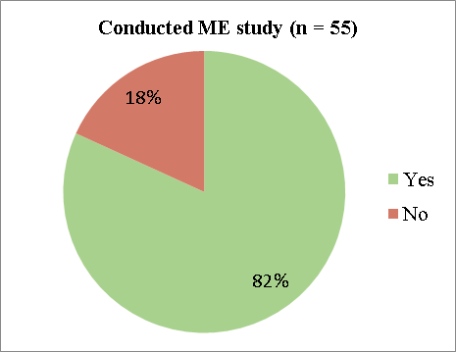
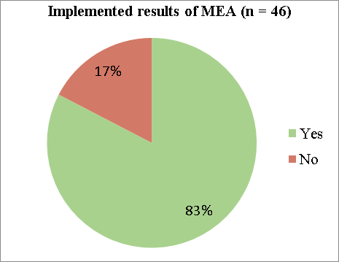
Figure 20 Results from the workshop Questionnaire regarding the number of Parties who have conducted any management effectiveness (ME) studies, and those who have implemented the results of the management effectiveness assessment (MEA).
- Following the six completed regional workshops, 93 countries have identified a total of 236 priority actions addressing both the assessment of management effectiveness and improvement of protected area management. For example, the Ministry of Environment and Forestry of Indonesia has conducted management effectiveness studies on 33 per cent of all protected areas, of these, in 2014, 32 per cent of protected areas had endorsed management plans. As part of their priority actions, the country aims to improve the METT index to at least 0.7 for 260 protected areas. In addition, two approved GEF projects (#4867 and #4892) include the improvement of protected areas management effectiveness.
- Several countries have identified updating or assigning protected areas to the applicable IUCN management categories as part of their priority actions. Currently, 33 per cent of protected areas in the WDPA do not have an assigned IUCN management category assigned (down slightly from 36 per cent in 2014). A sizeable portion of the area covered by protected areas without IUCN management categories assigned corresponds to Ramsar Sites, World Heritage Sites and UNESCO-MAB Biosphere Reserves, for which IUCN management categories are not applicable.
- In Egypt, since 2007, management effectiveness evaluations have been completed for 11 protected areas (39 per cent of the protected areas in Egypt). Seven of those evaluations were done using METT (management effectiveness tracking tool) and cover an area of 17,794 km². Management effectiveness assessments have been facilitated through several GEF-funded projects (#3209 and 5073). Priority actions identified by Egypt include the completion of management effectiveness assessments for a further 10 protected areas in order to improve protected area performance; as well as designing and implementing a performance monitoring system to allow for proper follow-up for management activities within each protected area.
- Priority actions identified by Malawi include the implementation of the results of PAME tracking scores done for assessments which have been completed for six protected areas under GEF 5. They also plan to complete further PAME assessments in another 20 per cent of protected areas (both number and area). A recent assessment was completed at the mid-term review for the Shire River Basin Management Program, a project which aims to, among other activities; strengthen institutional capacities and the tools for monitoring, planning and management along the Basin, and protecting and enhancing ecosystem services in the area.
- In Botswana, as of 2016, two management effectiveness evaluations had been completed for two protected areas. A GEF project (#4544) for improving the management effectiveness of the Chobe-Kwando-Linyanti Matrix of Protected Areas is also already underway. Botswana’s priority actions include the institutionalization of management effectiveness assessments for protected areas, to move towards assessing 60 per cent of protected areas by 2020, while also ensuring that the management effectiveness assessment results are being implemented.
- In Lesotho, management effectiveness evaluations have not yet been implemented for protected areas, though five protected areas (out of nine) have management plans. Lesotho has identified several different priority actions for addressing management effectiveness in their protected area network. Priority actions include properly assigning/designating the existing protected areas to the appropriate IUCN management categories and governance types, and establishing functional protected area management bodies, which consist of representations form all community structures. Priority actions also include capacity-building for the implementation of management effectiveness assessment (MEA) tools, and the adoption of the MEA tools for use in all protected areas in the country. Finally, they also aim to undertake capacity building for the country’s conservation professionals, in order to have them effectively carry out ecological assessments and provide updates for CBD databases, as well as establishing protected area management structures which will exist as autonomous bodies, for which a feasibility study has already been completed.
- In Sierra Leone, management effectiveness evaluations have been performed for three protected areas (Outamba-Kilimi and Loma Mountains National Parks, and Kambui Hills Forest Reserve). In all three cases there was an improvement in assessment scores between the project baseline and the third year assessment; however, in all three sites the scores decreased from year two to year three. For their priority actions, Sierra Leone intends to work to enhance coordination and collaboration between key government structures (EPA, NPAA, MAFFS MFMR and CSO, etc.), in order to legitimize protected areas and the enforcement of the protected area laws.
- The Integrated Management Effectiveness Tool (IMET), developed in the frame of the EU funded Biodiversity and Protected Areas Management (BIOPAMA) programme, has so far been applied to support and strengthen management effectiveness in over 50 protected areas in Africa and Bolivia. With further assessments ongoing in several Central and Western African countries, it is expected that 100 protected areas will complete IMET assessments by the end of 2016. The countries involved are: Benin, Burkina Faso, Burundi, Cameroon, Chad, Congo, Côte d’Ivoire, Democratic Republic of the Congo, Gabon, Guinea Bissau, Mauritania, Niger and Senegal. Both Burundi and Gabon intend to apply IMET to their whole national protected area networks. Most recently the tool was also tested in the transboundary Mount Elgon ecosystem between Kenya and Uganda. Further IMET assessments are planned for the next phase of the BIOPAMA programme commencing in 2017.

G. Equitably managed
Element | Status as of 2016 | What is needed for achievement? | What are the chances of reaching the target by 2020?
Equitably managed | Lack of detailed information.  More guidance is needed. | Mapping of all governance types for all protected areas.  Increasing the number of co-managed and Indigenous and local community managed protected areas.  Recognition of the rights of Indigenous persons, and local community areas, and mechanisms for equitable distribution of costs and benefits to them.  Governance and social assessments at protected area system and site levels to establish baseline and identify relevant actions | Seventy-nine countries, following the six regional workshops, have submitted 161 priority actions addressing equity and governance issues in protected areas.
- In the context of Aichi Biodiversity Target 11, the concept of “equitably managed” has not been clearly defined, bringing a certain level of uncertainty in how to assess the status and achievement of this element of the target. Information regarding progress for this element of the Target, at the global level, is also lacking. Further guidance is therefore required.
- Protected areas bring important environmental, social and economic benefits at the local, national and global level; however, there may be an unequal distribution of these benefits, and the protected areas may also carry costs outweighing benefits for local communities. The concept of equity is linked to the notion of fairness and the sharing of both benefits and costs of protected areas. Understanding of what is equitable can however change depending on one’s perception, but also, in time and place. Equity is generally assessed through three main aspects, or dimensions: recognition, procedure, and distribution; where “recognition” is the acknowledgement of the legitimate rights, values, interest and priorities of individuals and communities; “procedure” refers to how protected areas are being implemented and managed, where communication and public participation is key; finally, “distribution” implies that costs and benefits resulting from the implementation and management of protected areas must be equitably shared amongst relevant actors.
- A recent global assessment of protected areas, and the factors affecting both social and conservation outcomes, found that those sites directly incorporating local peoples, bringing them in as active stakeholders, were generally more effective, with respect to both biodiversity conservation and socio-economic development. There will always be cases where strict protection is needed, though where feasible and appropriate, protected areas that lie at the nexus of conservation and development, and pay respect to the needs of, and the participation of local communities may be most successful; though there is a need to take account of the local social, economic and political contexts, providing support for co-management arrangements, especially those empowering local communities, as well as making efforts to reduce potential inequalities in the distribution of costs and benefits, and helping to ensure the maintenance of benefits from local protected areas.
- The IUCN WCPA-SSC Joint Task Force on Biodiversity and Protected areas also recently conducted a global analysis of the factors influencing biodiversity in protected areas, finding that both the social and the economic context of a protected area are vital for its success. Importantly, sites will be most successful when local communities are supportive of them, and see the benefits of protected areas, in addition to other management related factors (sufficient funding, adequate staffing and management capacity); while ecological factors (size, fragmentation and connectivity) are central for long term successes, they may be overcome by social and economic factors in the short-term.
Box 4: Goal 2.1 of the Programme of Work on Protected Areas

PoWPA Goal 2.1 has six key activities to promote equity and benefit sharing in protected areas:
- Assess the costs, benefits and impacts of establishing and maintaining protected areas Recognize and promote a broad set of protected area governance types.
- Establish policies and mechanisms to legally recognize Indigenous and local community conserved areas (ICCAs).
- Use protected area benefits to reduce poverty.
- Engage Indigenous and local communities in participatory planning.
- Establish and strengthen policies to address fair and equitable benefits from access to genetic resources.

Source: CBD (2004). Programme of Work on Protected Areas. Available at https://www.cbd.int/protected/default.shtml
- Aside from equity, this element also relates to protected area governance. Governance refers to “the interactions among structures, processes and traditions that determine how power and responsibilities are exercised, how decisions are taken and how citizens or other stakeholders have their say”. The IUCN principles of good governance for protected areas highlight the need for legitimacy and voice; direction; performance; accountability; and fairness and rights. Categories of protected area governance type include: governance by government (at various levels and possibly combining various institutions); governance by various rights-holders and stakeholders together (shared governance); governance by private individuals and organizations; and governance by Indigenous peoples and/or local communities. Decision X/31 invited Parties to diversify and strengthen protected area governance types; in the time since, the amount of protected areas (by area) governed by non-government actors or through co-management arrangements has increased, from 23 per cent in 2010, to 26 per cent in 2016. Figure 21 shows the changes in the amount of protected areas (by area) under different governance types over a longer time period.
- COP 10, decision X/31 recommended, inter alia, that Parties conduct assessments of governance of protected areas using toolkits prepared by the Secretariat and other organizations. From the workshop Questionnaire, 32 Parties have reported completing some form of protected area governance assessment. As of August 2016, more than 90 per cent of protected areas in the WDPA had their governance type assigned; this corresponds to 75 per cent of the total area under protection. Table 4 presents the IUCN Protected Area Matrix, completed with data for protected areas in the August release of the WDPA.
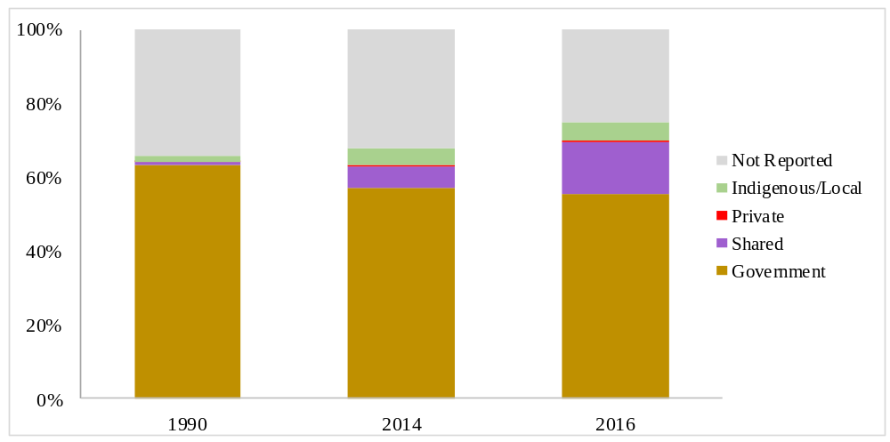

Figure 21 Changes in the percentage of area covered by different governance types for protected areas in the WDPA from 1990 to 2016.
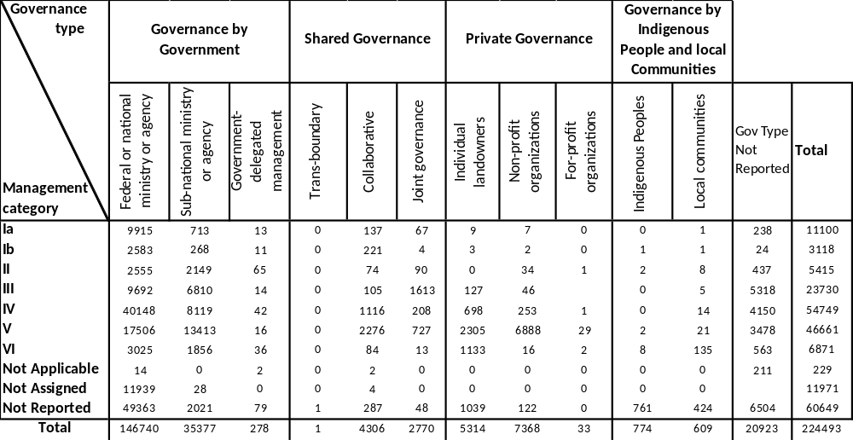
Table 4 IUCN Protected Area Matrix for protected areas in the August release of the WDPA.
- The Conference of the Parties, in decision X/31, also invited Parties to include information on governance and social impacts into the management effectiveness evaluation process. As noted in the previous section, there are a large number PAME evaluation tools in use, however, the two most common (METT and RAPPAM) include only a very superficial assessment of social impacts; others may include a more detailed assessment of governance and social impacts, but they still have significant gaps. Similar to the various tools available for the assessment of protected area management effectiveness, methodologies for governance assessment have been developed; however, global evaluations of the results of these governance assessments are not widely available. Additionally, a recently developed Social Assessment of Protected Areas (SAPA) tool was developed to cover issues relating to equity and the distribution of social impacts from protected areas (box 5); however, it has not yet been widely applied, so a global assessment at this stage is not feasible.
Box 5: Social Assessment of Protected Areas

The Social Assessment for Protected Areas (SAPA) methodology was designed to assess the impacts of protected areas (both positive and negative), and their associated conservation and development activities, on the wellbeing of communities living within and near-to the protected area. The multi-stakeholder assessment tool is designed to help increase positive social impacts, reduce negative impacts, and help to ensure that the impacts are more equitably shared; it is meant for use by protected area managers working with communities (and/or other local stakeholders), and national-level supporting organizations. SAPA makes use of a combination of: community workshops, meant to identify significant social impacts; short household surveys, designed to further explore these impacts and the related governance issues in more depth; and a stakeholder workshop, which is carried out to validate the survey results, as well as explore other important issues and formulate opportunities for action. The SAPA tool was released in 2016; it was piloted in five countries, but is not yet in wider use.

Source: Franks, P. & Small, R. (2016), Understanding the social impacts of protected areas: a community perspective. IIED Research Report. IIED, London.
- Seventy-nine countries, following the six regional workshops, have submitted 161 priority actions addressing equity and governance issues in protected areas. For example, Bangladesh’s Wildlife Act of 2012 recognizes collaborative and private management, as well as Community Conservation Areas as official governance types for protected areas. This has allowed for the implementation of co-management in most protected areas. Furthermore, Bangladesh has established financial mechanisms to increase equity through grants, and has established social forestry programmes in forest reserves. As part of Bangladesh’s priority actions, the country aims to carry out community capacity-building to increase shared management responsibilities as well as to develop new infrastructures in protected areas.
- In Costa Rica, the importance of public participation has been recognized by the Environmental Law 7554 and the Biodiversity Law 7778, which clearly states the obligation to ensure mechanisms for active public participation. Costa Rica has established stakeholder participation bodies and institutional structures to coordinate equity and participation matters. Furthermore, a sustainable biodiversity fund has been established to provide incentives in areas of high biodiversity and social vulnerability. Costa Rica’s priority actions for the next four years include the recognition of different types of governance for protected areas, and the recognition of 13 areas as “other effective area-based conservation measures” to be incorporated in its national system of protected areas.
- In the case of the Central Africa Republic, the Wildlife Code includes provisions for benefit sharing and uses taxes and other sources of revenue to invest in health, education, roads, social infrastructure and community participation in wildlife conservation. The most common type of governance structure in the Central African Republic’s protected areas system is shared governance. The Forest Code addresses matters involving rights of use and the distribution of forested areas and community forests. There are action plans in place to define good governance and equity, strengthen protected area governance by involving all stakeholders; integrating benefit sharing in national wildlife legislation and defining clear legislation for the role of stakeholders.
- The Marshall Islands have conducted a governance assessment on the Woja marine protected areas in the Majuro with the information supplied by the Coastal Management Advisory Council. The Marshall Islands’ Protected Area Network (PAN) Act of 2015 and Local Government Act (1986) are the national legislations used to determine the type(s) of governance systems available for protected areas. They intend to develop planning actions that would allow transparency in the operations of sectors relevant for protected areas.
- Morocco has action plans developed for three governance committees: the Management Committee, Participation Committee, and the Scientific Committee. Local management committees are involved in management decisions, and the development of local cooperatives includes preferential rights for the harvesting of wood and aromatic plants. Morocco’s current action plan seeks to strengthen the regulatory framework for these governance committees and enhance the power of local populations, local management and local cooperatives.
- Eritrea has divided protected area governance into six regions, where communities improve perception of their livelihood stake in the good stewardship of biological resources. These ‘Zoba’ regions are key implementing agencies for all agriculture and rural development programs, and natural resource management. Their Action Plan is to create norms and standards for protected area management including co-management between relevant institutions.
- Uganda has conducted governance studies in nine protected areas, and enacted collaborative natural management programmes in six protected areas. For their priority actions, they plan to: provide capacity-building and aid in the sensitization of stakeholders to governance and equity issues within protected areas; assess and evaluate the effectiveness of existing collaborative forest management and collaborative natural resource management programs; and to promote protected areas as core drivers for nature-based tourism and the achievement of sustainable development goals.

H. Well connected systems of protected areas
Element | Status as of 2016 | What is needed for achievement? | What are the chances of reaching the target by 2020?
Well connected systems of protected areas | More information is needed, although global assessments of protected area connectivity are recently available.  More guidance is needed | Each country develops one connectivity corridor, including exploring the possibilities of using OECMs as stepping stones, or other forms of connectivity. | Eighty-eight countries have identified 168 priority actions addressing connectivity in their protected area networks.
- More information on the status of connectivity and of connectivity management measures within protected area networks at the global level is needed. The limited availability of global assessments of the status of connectivity and of connectivity management measures within protected area networks is due partly to the fact that connectivity is both a species-specific and landscape dependent property, and so are the required conservation actions and their effects on protected area functioning. Several studies have however, recently been conducted (see below), and there is work currently underway towards a global indicator for protected area connectivity. As well, there is a wealth of information on the need for, and benefits of, well-connected protected area systems, to enhance biodiversity conservation and as a nature-based solution to global environmental problems, like anthropogenic climate change. Additionally, the IUCN’s Protected Area Governance and Management document provides an elaborate account of the recent state of science for connectivity conservation management and governance. Figure 22 and Table 5 present the distribution, as of 2015, of Connectivity Conservation Initiatives (CCIs); these are initiatives contributing to the maintenance and improvement of ecological structure and function at the landscape or seascape level, through the improvement of connectivity.
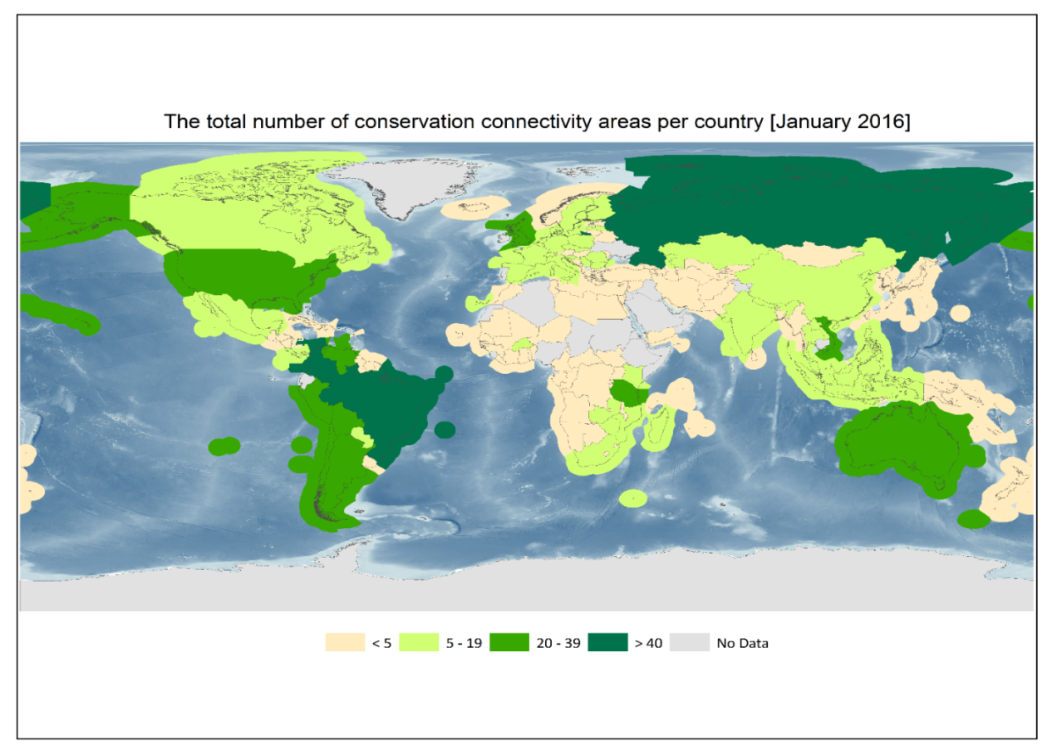
Figure 22 The total number of CCIs per country and territory as reported in the current working version (Jan 2016) of the Global Connectivity Conservation Database (GCCD).
Table 5 The distribution of CCIs across UN regions.
UN Regions (# of countries & territories within the region) | Count of CCIs per region | % of CCIs belonging to transboundary initiatives | Average number of countries within transboundary CCIs | % of countries & territories within UN regions for which CCIs reported
GRULAC (51) | 216 | 25% | 3 | 49%
Europe (56) | 107 | 36% | 8 | 86%
Asia (44) | 103 | 26% | 3 | 70%
Africa (58) | 94 | 36% | 3 | 78%
North America (4) | 40 | 10% | 2 | 75%
Oceania (31) | 31 | 1% | 3 | 19%
Total/ Overall average | 591 | 28% | 4 | 63%
- Earlier this year, the first global assessment of terrestrial protected area (PA) connectivity was conducted, assessing the current levels of connectivity at both the level of protected area networks within countries and at the continent-wide level, considering protected areas of IUCN categories I-IV. This was done using the normalized Equivalent Connected Area (ECA), which summarizes the proportion of some area (country or continent) that is reachable within the protected area network, compared to the total area of the country (or continent); ECA accounts for both intra-PA connectivity (the area reachable within each protected area) and inter-PA connectivity (the area that can be reached by dispersal, direct or indirect, between protected areas). Connectivity was assessed for a range of potential dispersal distances, to attempt to account for the variations among terrestrial vertebrates. Current levels of connectivity within the global protected area network vary a great deal between continents and between individual countries (most countries with high levels of connectivity are found in Africa, North and South America). Connectivity in Africa is driven primarily by the size of protected areas (intra-PA connectivity), where there are many large protected areas with large expanses of space between them, while in Europe it is driven mainly by inter-PA connectivity. The results also show that continental networks performed worse than national scale protected area networks, indicating that more effort needs to be placed on enhancing transboundary connectivity.
- The approach for assessing protected area connectivity was recently further developed, and globally applied at the terrestrial ecoregion level, in the form of the Protected Connected land (ProtConn) indicator. ProtConn (i) quantifies the percentage of a study region covered by protected connected lands, (ii) differentiates several categories of land (unprotected, protected or transboundary) through which movement between protected locations may occur (Figure 23), (iii) is easy to communicate, to compare with protected area coverage and to use in the assessment of Aichi Target 11 on well-connected protected area systems. ProtConn was used to evaluate protected area connectivity in the world´s terrestrial ecoregions as of June 2016, considering all IUCN protected area categories (I-VI) and a range of median dispersal distances (1 to 100 km) encompassing the dispersal abilities of the large majority of terrestrial vertebrates. Results showed that 9.3 per cent of the world is covered by protected connected lands for a reference dispersal distance of 10 km, increasing up to 11.7 per cent for a dispersal distance of 100 km. These percentages are considerably smaller than the global protected area coverage of 14.7 per cent, indicating that the spatial arrangement of protected areas is only partially successful in ensuring connectivity of protected lands (Figure 23). The connectivity of protected areas largely differed across ecoregions (Figure 24). Only about a third of the world’s ecoregions currently meet the target of having 17 per cent of the terrestrial realm covered by well-connected systems of protected areas. The detailed results of the ProtConn indicator at the country and ecoregion level will be available in the Digital Observatory for Protected Areas of the European Commission in December 2016.

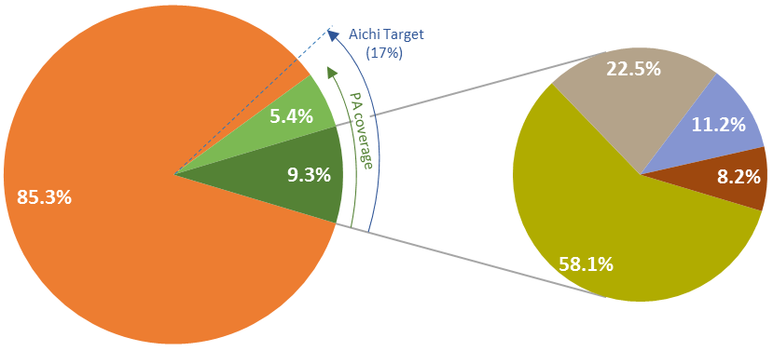

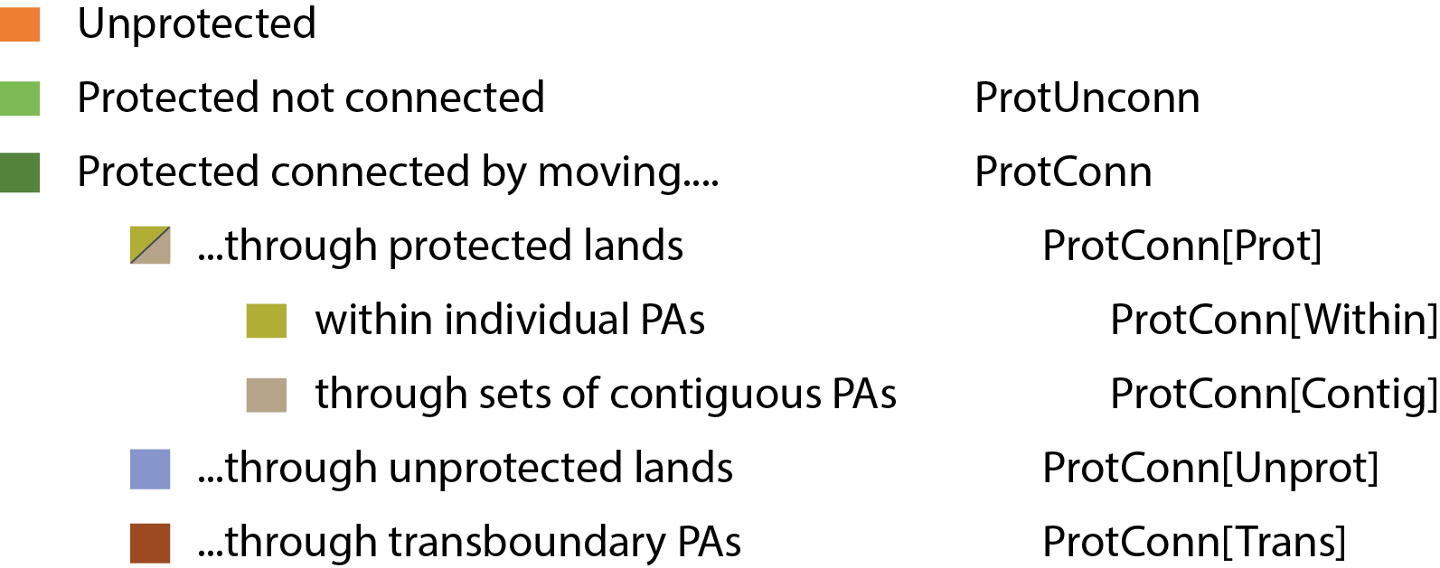

Figure 23 Global average of the Protected Connected land indicator (dark green slice in the left pie chart) and its fractions (right pie chart) for all the world´s terrestrial ecoregions and a median species dispersal distance of 10 km. Global PA coverage (sum of protected connected and protected not connected land: 14.7%) and the Aichi Target 11 for year 2020 are indicated next to the left pie chart.
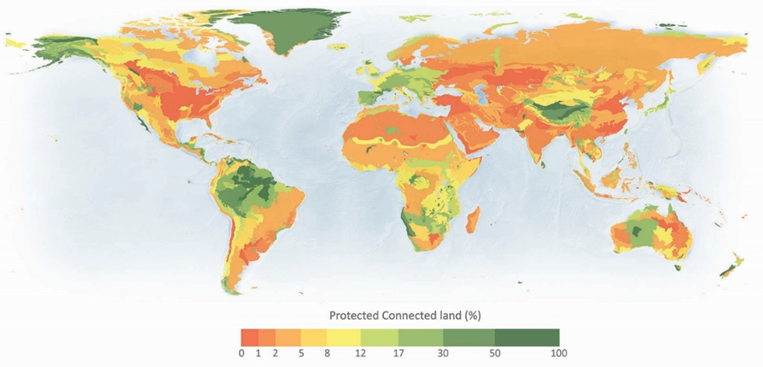
Figure 24 Protected Connected land (% of ecoregion area) for all of the world’s terrestrial ecoregions as of June 2016 for a reference median dispersal distance of 10 km.

- Conservation (or wildlife) corridors, are one of the three general features that can contribute to landscape connectivity (the others being stepping stones, and a ‘soft’ matrix); these corridors provide physical links between habitat patches, both within and between core protected areas, they contribute to landscape level connectivity and can facilitate increased habitat connectivity for certain species. Some notable national conservation corridor networks include the Green Network in Estonia; the Ruseconet of Russia; the Ecological Network of Netherlands; the Guadiamar green corridor in Spain; the Bow Valley Wolf Corridor in Canada; corridors in Yunnan province in China; the Terai Arc landscape corridor in Nepal; the Mata Atlantic Forest corridor in Brazil; and the Kibale Forest Game Corridor in Uganda.
- As species’ ranges and ecological processes transcend administrative boundaries, transboundary corridors will often be necessary; however, establishing shared governance and cooperative management may entail a “long-term dynamic and complex process”. Some notable transboundary corridors include the Cameroon-Gabon-Congo Tri-Dom ecological network; the Mesoamerican Biological Corridor; the Vilcabamba-Amboró Conservation Corridor; the East Asian–Australasian Shorebird site network; the Green Belt Programme of the European Union, connecting Natura 2000 sites; and the Pan-European Ecological Network in Central and Eastern Europe. GEF and other international funding agencies are involved in a number of transboundary protected areas projects.
- Eighty-eight countries have identified 168 priority actions addressing the level of connectivity in their protected area networks. For example, Argentina has four biological corridors and has been promoting the sustainable multiple-use of resources in areas important for connectivity. Argentina has identified four priority actions to increase and strengthen connectivity in the next five years. These include analysis of the current status of corridors, analysis of new corridor projects in the Chaqueña region and in other ecoregions, and analysis of the legal and regulatory frameworks to integrate biological corridors in territorial planning. Furthermore, Argentina will continue to promote a sustainable multiple-use of resources in connecting areas between protected areas.
- Belize is part of the Mesoamerican Biological Corridor and has established the Central Belize Wildlife Corridor for which an action plan was completed in 2015. As part of its priority actions, the country aims to establish two new biological corridors in the northern and southern parts of the country. Belize has also identified, as a future opportunity, the reduction of pressures on biological corridors by revising its existing land-use regulations currently imposing higher property taxes on properties where development does not occur. The Mesoamerican Biological Corridor is considered to be one of the most ambitious transboundary conservation and sustainable development projects globally, and includes all other Central American nations. Though covering only 2 per cent of Earth’s surface, the Mesoamerican isthmus houses more than 12 per cent of known species; the MBC contains myriad protected areas, and at least 10 transboundary corridor projects.
- One of the priority actions for addressing protected area connectivity proposed by Togo involves the creation of several transboundary protected area systems. These include: connecting Fazao-Malfakassa National Park (Togo) and Kyabobo National Park (Ghana); WAPOK, which will connect Oti-Keran Mandouri (Togo) and the existing WAP system (Benin, Burkina Faso, Niger); the connection of Togodo NP (Togo) and Adjamé community reserve (Benin); as well as work on a transboundary Marine Protected Area between Togo and Benin. One of these projects, the Transboundary Biosphere Reserve in the Mono Delta, is currently funded by the GIZ.
- In Malawi, priority actions for connectivity include the creation for two corridors, in order to develop spatial connectivity between existing protected areas. One corridor is planned to connect Liwonde National Park, Mangochi Forest Reserve and Namizimu Forest Reserve, while another corridor is planned to connect Lengwe National Park, Mwabvi Wildlife Reserve and Matandwe, with the Elephant Marsh Wetland to be used as a stepping stone, which is to be managed by local communities.
Box 6: UNEP initiative on connectivity conservation

The United Nations Environment Programme (UNEP) has launched a new initiative called “Strengthening biodiversity conservation at a landscape and seascape scale” which aims to tackle the problem of increasing habitat fragmentation through the development of a global connectivity conservation strategy that will support countries and regions to integrate connectivity conservation within their national land use and seascape planning. To achieve this, the initiative seeks to promote an understanding of the priorities for connectivity and the use of connectivity as a conservation tool to strengthen the protection of biodiversity, enhance the provision of ecosystem services, and increase resilience to climate change. This will provide policy and legislative tools and resources to national governments, non-governmental organizations and other stakeholders. UNEP-WCMC, with the collaboration of the International Union for Conservation of Nature World Commission on Protected Areas (IUCN-WCPA) and other partners worldwide, is in the process of producing a global database of connectivity conservation initiatives that will include case studies, lessons learned and best practices. The next phase of the project will involve the analysis of relevant policies and legislation gathered in the global database, and the development of practical guidelines. The final phase will be to scale up implementation, working to provide technical support and capacity building for decision makers and other stakeholders.

Source: UNEP-WCMC, personal communication.
- Liberia currently has a conservation corridor within the Wonegisi–Ziama Forest and has formulated a project (with aid of KFW-German Government) for the Sapo National Park-Grebo-Krahn National Park-TAI Corridor. Liberia has recently completed the enactment of another terrestrial protected area, the Gola Forest National Park which serves as a Peace Park, or transboundary park, that will link Sierra Leone and Liberia. The proposed draft Protected Areas Management and Wildlife Law has also been enacted into Law, which will further help to implement protected areas and conservation connectivity. For its priority actions, Liberia plans to establish biological corridors between Mano River Union States, especially within the river basins, national forests, and protected areas.
- Burundi’s priority actions to address the issue of connectivity in their protected area network include the creation of a corridor between the mountains of Inanzegwe, Kibimbi and Muyange. They also plan to establish ecological connectivity between several of the forests in eastern Burundi; this includes connecting Inanzegwe and Nkoma, along with the connection of Birime and Murore.
- In Fiji, spatial maps of the protected area network have already been created for terrestrial areas, while further mapping is underway for marine areas. They have been using connectivity corridors as one of the selection criteria for the establishment of new conservation areas. For their priority actions, they plan to further incorporate the principles of conservation connectivity into their marine protected area prioritization process.
- Slovakia currently rates the level of connectivity within their protected area network as good, due to the Spatial System of Ecological Stability (SSES), however they recognize that greater awareness of the concept of ecological connectivity is still needed among stakeholders and decision making bodies. For priority actions, they plan to implement two Danube Transnational Programme projects (Transgreen and Connectgreen) that will support the concept of ecological connectivity within the country and the broader Danube region. The Danube Transnational Programme is a financing tool of the European Territorial Cooperation, which assists in structuring the implementation of joint projects and policy exchange between actors in different EU member states; one of its programme priorities is to “foster the restoration and management of ecological corridors”.

I. Integrated into the wider landscapes and seascapes
Element | Status as of 2016 | What is needed for achievement? | What are the chances of reaching the target by 2020?
Integrated into wider land and seascapes | Lack of detailed information.  More guidance is needed. | At a minimal level, each country integrates their PAs into local, regional, and national spatial planning and also into important sectors (fisheries, animal husbandry, agriculture, mining, infrastructure, energy etc.) | Fifty countries have identified 85 priority actions to address the integration of protected areas into the wider land-and-seascape.
- Protected areas established in isolation (geographical as well as sectoral) may not fully yield their expected benefits. In spite of continued protected area expansion, biodiversity may still decline (even within protected areas) when attention is not paid to the larger landscape context. As well, it has been shown that protected areas that consider broader socioeconomic development, often demonstrate more positive conservation strategies. By integrating protected areas into the wider land- and seascape, and by incorporating protected areas into sectoral plans and strategies, the investments in protected areas will pay biodiversity and societal dividends well into future. The need to integrate protected areas into wider landscapes, seascape and sectors is all the more important and imperative, in order to address the adverse impacts of climate change.
- Integration of protected areas into wider landscapes, seascapes and sectoral plans and strategies, can yield numerous benefits, including: reduced fragmentation, conservation benefits outside of protected areas, maintenance of ecological processes occurring over large spatial scales (which are often larger than protected area sizes), maintain and enhance ecosystem services, increase climate change resilience.
- Although there is a large number of regional networks and large regional corridors around the world, many Parties have yet to systematically act on integrating protected areas into the wider land- and seascapes. In 105 Action Plans for Implementation of the CBD PoWPA, only 15.6 per cent of countries reported significant or greater progress in integrating protected areas into broader landscapes, seascapes or sectors so as to maintain ecological structure and function. Therefore, in particular, progress on integrating protected areas into the broader landscape, seascape or sectoral plans and strategies has lagged far behind. Such integration is essential if protected areas are to become relevant and seen as essential elements of each country’s effort to achieve sustainable development.
- Following the six regional capacity-building workshops, 50 different countries submitted 85 priority actions to address the integration of protected areas into the wider land-and-seascape. For example, Colombia has created biosphere reserves and sectoral plans integrating biodiversity and protected areas into wider land-and-seascapes. For their priority actions, they aim to create legal and political tools to incorporate social and environmental considerations in mining activities and their impact on 10,000 km² of land. The country also aims to adopt sectoral plans in critical sectors (agriculture, mining, etc.) to reduce their pressure on forests and biodiversity. High conservation value areas in regions of palm oil cultivation would be protected and restored with the participation of local communities.
- Meanwhile, El Salvador has integrated a sustainable tourism strategy into its protected areas, as well as local plans for the sustainable use of natural resources. As part of its priority actions, by 2020, the country aims to have created standards for agricultural development and conservation in order to achieve sustainable use of these resources. El Salvador also plans on implementing alternative local development in areas important for biodiversity to minimize the negative impacts caused by anthropogenic activities.
- The Government of Malawi plans to mainstream sectors responsible for wildlife, forest, water and fisheries management, in order to effectively manage protected areas whose corridors have been created and integrated into one of the ecological corridors. Priority actions in Malawi also include integrating six protected areas into the wider landscape along the Shire River Basin.
Box 7: Vilcabamba Amboró Conservation Corridor

The Vilcabamba Amboró Conservation Corridor (VACC) is a trans-boundary conservation corridor that includes portions of the center south Andes Amazon regions of Bolivia and Peru. It was formed in December 2000, after years of groundwork by stakeholders in both countries, and is considered a pioneering approach in landscape-scale conservation in South America. The development and expansion of the corridor has been an ongoing process in which the Bolivian and Peruvian national governments, Conservation International (CI), other NGOs and local communities have been heavily involved. The VACC is a conservation strategy that seeks to articulate multiple categories of protected areas into schemes that integrate management and sustainable land use. The protected areas in the VACC provide critical environmental services to local communities, and are integrated into the local, regional and national economies. The conservation corridor thus proposed a concept that goes beyond the biological connectivity of the protected areas by proposing a land use system that organizes use and management systems that reconcile protection with economic development. Beyond the formal protected areas there are many other conserved areas that were created which allow do sustainable use, including: Indigenous reserves, conservation concessions, ecotourism concessions, and production concessions, among others. A number of strategies and actions were developed to account for the complexity and diversity of land use and land cover that occur across the corridor, including: the promotion of transboundary coordination, developing robust municipal land use plans, strengthening planning and management capacities, developing land uses compatible with biodiversity, promoting community-based ecotourism, and promoting payment for ecosystem services.

Source: Ervin, J. et al. (2010). Making Protected Areas Relevant: A guide to integrating protected areas into wider landscapes, seascapes and sectoral plans and strategies. CBD Technical Series No. 44. Montreal, Canada: Convention on Biological Diversity, 94pp.
- Eritrea’s Operationalized Protected Area Management Systems (OPAMS) will be integrated with other programmes and projects, in order to reinforce the activities that have already been undertaken by the Government emphasizing common and complementary approaches to food security, biodiversity conservation, climate change adaptation and combatting land degradation and desertification. In Eritrea, all projects that have been conducted or are ongoing, and the protected area system itself, will be directed based on several factors: community participation; integrated management systems and a multi-sectoral approach; socially and economically sustainable development; consideration of gender sensitivities; soil and water conservation; rehabilitation and restoration of degraded lands; Sustainable Natural Resources Management (SNRM); poverty alleviation; human and institutional capacity building; enhanced research and education as well as awareness raising programmes, sharing past experiences and lessons learned; and consideration of the traditional knowledge.
- Additionally, several other Parties are making use of GEF funding for improving the integration of protected areas within their country. For example, Cambodia’s CAMPAS Project will improve protected area management effectiveness and secure forest carbon through improving inter-sectoral collaboration, landscape connectivity and sustainable forest management. Botswana plans to utilize GEF 6 STAR allocations to begin a project aimed at developing an integrated management plan for dry- land ecosystems, while Malawi has its Shire River Basin Management Project, with an integrated catchment management plan, which proposes inter-departmental management of adjoining protected areas, funded through GEF-6. Eritrea has an approved project for an Integrated Semenawi and Debubawi Bahri-Buri-Irrori- Hawakil Protected Area System, which will create policy and institutional conditions for the operationalization of the protected area system in Eritrea, aiding both biodiversity conservation and mitigating land degradation. Others include Madagascar’s project employing a landscape approach funded through GEF, and Honduras, which plans to integrate the Department of Protected Areas with GEF programmes and projects to achieve the integration of marine ecosystems in SINAPH (National System of Protected Areas and Wildlife of Honduras).
- For the Solomon Islands, integration of protected areas into the wider landscape, seascape and sectoral plans is being made a key emphasis of their GEF6 National Prioritization discussions. Their priority actions involve, among other activities, supporting provincial level Ridges to Reefs initiatives within additional provinces, which will support at least four more Provincial land-use planning and profiling projects. Vanuatu’s priority actions involve the implementation of their GEF 5 projects, and planning for the formation of protected area integration project under GEF 6; their ongoing “Integrated Sustainable Land and Coastal Management” project employs a Reefs to Ridges (R2R) approach.
- The Reefs to Ridges (R2R) concept is one which is applied in many GEF-funded biodiversity projects, especially in Asia-Pacific and the Caribbean. It is a comprehensive approach to managing all activities within a watershed, ensuring sustainability and biodiversity conservation. The R2R approach is expected to achieve sustainable management of terrestrial, coastal and marine resources by reducing or eliminating damaging activities and promoting rehabilitating and sustaining activities by resource users who live in or visit the catchment area. It aims for the integrated management of complete catchment areas or the whole island for smaller mountainous and coral islands. The R2R concept encapsulates both Integrated Coastal Management (ICM) and Integrated Water Resources Management (IWRM) to cover all activities within the selected area and conserve biodiversity.
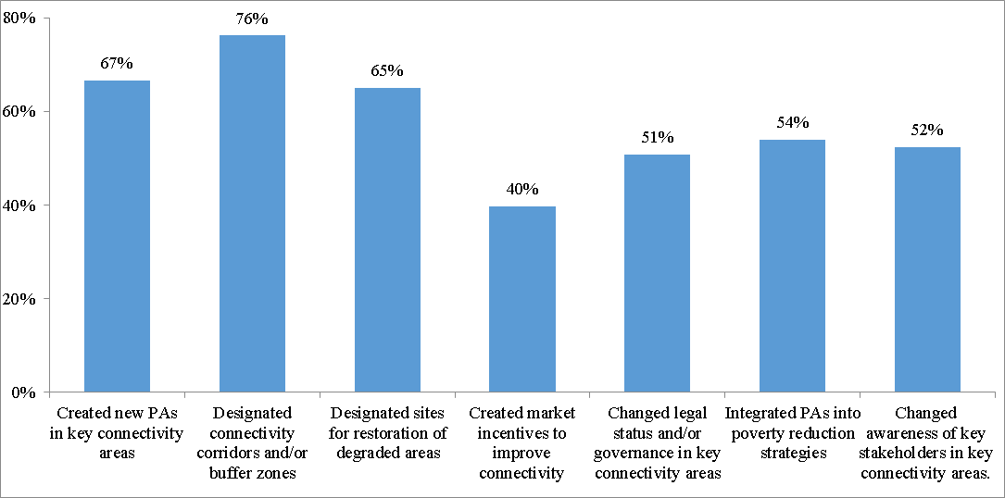
- Sixty-three Parties provided a response in the Questionnaire, to the question regarding actions being taken nationally to address issues of connectivity and integration within their protected area systems. Figure 25 presents the responses to this question; the three most common actions being taken to promote the integration and connectivity of protected areas include the designation of connectivity corridors and/or buffer zones (76%), followed by the creation of new protected areas in key connectivity areas (67%) and site restoration for degraded areas (66%).
Figure 25 Percent of respondents to the workshop Questionnaire (n = 63) who reported taking various actions to improve the integration and connectivity of protected areas in their country.
- Figure 26 presents responses from the workshop Questionnaire regarding the most important sectors for integration with the protected area system. Sixty-two countries provided an answer to the question regarding to the most important sectors for integration with their protected area networks; of these, 57 gave responses specific enough for analysis (two countries mentioned that all sectors were important, while three provided answers that did not include any specific sectors). The responses highlight the importance Parties have placed on the integration of biodiversity conservation with agriculture, forestry and water resources.
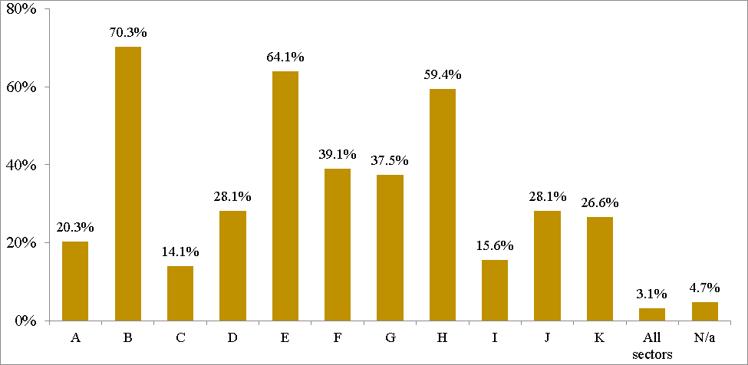
Figure 26 Responses from the workshop Questionnaire regarding the most important sectors for integration with the protected area system: A = Indigenous & Local Communities, sustainable use; B = agriculture, aquaculture, livestock grazing; C = education, health, scientific research; D = tourism; E = forestry; F = energy (production), G = mining, resource extraction; H = water resources; I = transportation/infrastructure; J = economy, development, manufacturing; K = fisheries; N/a = No specific sectors mentioned.

J. Other effective area-based conservation measures
Element | Status as of 2016 | What is needed for achievement? | What are the chances of reaching the target by 2020?
Other Effective Area Based Conservation Measures | Lack of detailed information.  More guidance is needed. | At least, each party maps OECMs and their potential benefits with relation to other elements of Target 11. | Eighty-one countries have identified 153 priority actions addressing OECMs.  Areas tentatively assigned as OECMs (not including identified ICCAs) add 388,981 km².
- As there is a lack of concrete information on what constitutes “Other Effective Area Based Conservation Measures”, concern has been raised that a loose interpretation of this term could result in the inclusion of areas under such divergent management approaches that this element of the Target becomes meaningless. In the context of Target 11, it is important to make a distinction between areas that are managed primarily for conservation and those managed for other benefits. In addition to formally designated protected areas that governments recognize and report to the World Database on Protected Areas (WDPA) or the UN List of Protected Areas, some other areas logically qualify as “other effective area based conservation measures”; however such sites are not always listed in the WDPA, thus their contribution to global assessments of protected area coverage may be missed. This may be because governments only recognize and report on state-owned areas or because the owners of such sites do not wish to be recognized officially. Examples of OECMs may include, inter alia, private protected areas and various forms Indigenous Peoples and community conserved Areas (ICCAs). Some countries have started including these non-state protected areas in their official statistics, and once final guidance on OECMs is provided by the IUCN-WCPA Task force on OECMs, these areas will be included in the WDPA, with a separate field added to indicate whether or not the site meets the definition of a protected area. Both the Programme of Work on Protected areas and successive decisions of the CBD COP (IX/16 and X/31) accord recognition to private protected areas and ICCAs.
- ICCAs provide myriad values and benefits, among other things, they provide “the context and means for the socio-cultural, economic, political, spiritual, and physical well-being of thousands of Indigenous peoples and local communities, involving hundreds of millions of people; conserve critical ecosystems and threatened species; maintain essential ecosystem functions; provide crucial lessons for participatory governance; [and] build on and validate sophisticated local ecological knowledge system”. ICCAs help conserve critical ecosystems and threatened species, maintain essential ecosystem functions (e.g. water security); as well, they may provide corridors and linkages for animal and gene movement between formally designated protected areas, and help to synergize the links between agricultural biodiversity and wildlife, providing larger land or seascape level integration, especially in cases where formal protected areas are not an option.
- Figure 27 presents the area covered by ICCAs for a number of countries around the world. Though this list of ICCAs is certainly incomplete, it does represent a significant amount of terrestrial area, covering more than 10 per cent of the extent of the current global terrestrial protected area estate. For several countries ICCA extent has only been assessed for a small subset of states or provinces (India, Mexico, etc.), while many more countries were not included in the assessment. Numerous ICCAs would fit the definition of a protected area, and as such, some are currently included in the WDPA (like Indigenous areas in Brazil, or Indigenous protected areas in Australia). Although many ICCAs are considered as part of national protected area systems, most ICCAs are not yet formally recognized as sites important for conservation. A large portion of these sites would, however, fit the tentative definition of an OECM. Removing those areas where the conservation value is uncertain (hence its inclusion as an ICCA is unclear), as well as those areas where there is a known overlap with existing national protected areas, results in an addition of almost 2 million km² compared to the national status information provided by Parties during the workshops, where several countries did not include these Indigenous areas in their reporting on the status of terrestrial protected area coverage (like Brazil, and others). A significant proportion of marine ICCAs (referred to as locally managed marine areas, or LMMAs) have not yet been recorded in this assessment; the one country with a substantial LMMA network, Fiji, has included these in its reporting on marine protection; in fact 100 per cent of Fiji’s marine protected areas are LMMAs. Continued assessment and mapping of ICCAs and LMMAs, especially in relation to ecological representation and the protection of areas important for biodiversity and ecosystem services will increase the possibility of achieving many of the elements of Target 11; additionally, the unique governance arrangements in ICCAs will also contribute to the equitable management element of the Target.
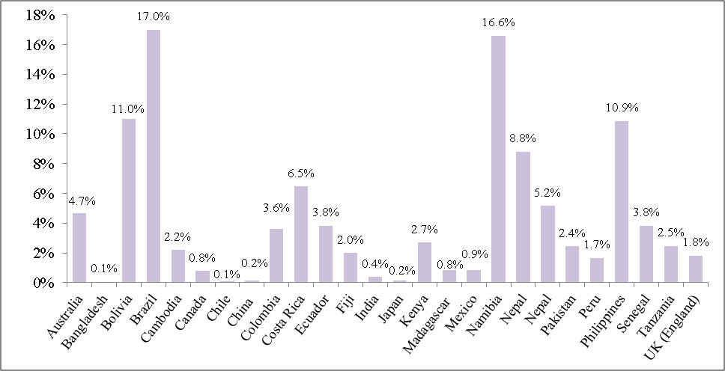
Figure 27 Area of ICCAs, compared to the total terrestrial area of the country; where conservation status is unclear or undocumented, or there was an overlap with formal protected areas, these ICCAs were not included.

Box 8: IUCN-WCPA Task force on OECMs

Following paragraph 10 of decision XI/24, in which COP requested the Executive Secretary, in partnership with relevant organizations, to make available tools and technical guidance to, inter alia, define other effective area-based conservation measures (OECMs), IUCN’s World Commission on Protected Areas established a taskforce to develop guidance on OECMs. The Taskforce held its first meeting in January and its second meeting in July of 2016 and discussed, among other topics, a draft screening tool for OECMs, the potential types of OECMs, and the similarities and differences between protected areas and OECMs. A presentation of the Taskforce’s progress and preliminary, draft guidance will be presented at a side event at COP-13, while final guidance is expected in 2018.

Some examples of the general types of areas that could be considered OECMs include:
- Areas meeting the definition of a protected area, but whose designation is rejected by the governing authorities;
- Areas meeting the definition of a protected area, where the area’s governing authority does not want it recognized, listed or designated as a protected area by the relevant national government.
- Areas that do not meet some element of the definition of a protected area, yet still provide secondary voluntary conservation value (i.e. where biodiversity conservation is a management objective, but is not the primary one);
- Areas that do not meet some element of the definition of a protected area, but provide ancillary conservation value (i.e. where biodiversity conservation will result as a by-product of other management actions, even if it is the intent, or where no management activities occur).

These examples are subject to ongoing discussion within the Task Force, and the findings are not yet definitive.
Source: Jonas, H. & MacKinnon, K. (eds.) (2016). Advancing Guidance on Other Effective Area-based Conservation Measures: Report of the Second Meeting of the IUCN -WCPA Task Force on Other Effective Area-based Conservation Measures. Bundesamt für Naturschutz, Bonn

- From 47 responses to the workshop Questionnaire, over two-thirds (68%) replied that they had maps of OECMs available or in the process of being created. Continued work on this activity is needed, as it will be important for assessing their representativeness and connectivity, and their contributions to the conservation of areas important for biodiversity and areas important for ecosystem services. Additionally, mapping of OECMs will allow for possible overlaps with other protected areas to be detected, and a more concrete estimate of the global coverage of conserved and protected areas will emerge.
- Eighty-one countries that attended a workshop or submitted documents (status gaps and opportunities matrix, road map, etc.) have identified a total of 153 focused priority actions addressing OECMs. Adopting or amending legislation is a common priority action to address this element, as is the creation or recognition of community conservation areas (or some similar community managed area) and/or private protected areas.
- The certification, promotion or creation of private protected areas has been identified as a priority action for OECMs by six different countries, while private protected areas (PPAs) were identified by 16 countries when reporting on the status of this element of Target 11. Additionally, the completion of a national registry of legal reserves on private rural lands and the identification of complementary landscape-scale conservation strategies in priority regions in concert with civil society and the private sector have been identified as priority actions by two more countries (Brazil and Colombia). Private protected areas may play a role in forming an ecologically representative global protected area system, and may also prove beneficial in allowing for quicker responses to rapid changes in land or water use, or in situations where additional state-run protected areas are opposed for political or economic reasons. From the 17 countries reviewed by PPA Futures for a 2014 publication, upwards of 293,000 km² exist in these countries, though the definitions being used to declare these PPAs would need to be confirmed, as would their spatial location with respect to other formal protected area categories.
- Reporting on the status of the OECM element of the Target, 33 different countries listed some form of community conservation area, community forest, community wildlife conservancy, sacred place managed by local or Indigenous communities or some other community-based area. As for priority actions, 13 countries identified 16 different actions relating to different forms of community conservation area (ICCAs, community forests, community managed hunting zones, etc.); with documenting and mapping existing areas, establishing new ones, or supporting communities in the creation of new community conservation areas, as some of the proposed priority actions.
- Figure 28 presents the increase in coverage afforded by the inclusion of tentative OECMs as given by 12 countries. For example, in Uzbekistan, national protected area category 6 (protected landscapes - water protection zones, coastal strips of water bodies, etc.) and category 7 (SFE and forest hunting areas) are not included in their total count of national protected area coverage; including these sites alongside the other protected areas, brings the total coverage to over 28 per cent. In Mongolia, as per decisions of the Citizens Delegation Council of the local soums (district) and provinces, a total of 911 Local Protected Areas (LPA), covering over 163,000 km² of land (about 10.3 per cent of the total territory of Mongolia), has been declare. However, since the registration procedures of LPAs are incomplete and the regimes to protect them are obscure, the issue of including them in the list of protected areas is unregulated. For this reason, LPAs have not been considered the same as SPAs (Specially Protected Areas). If these areas would meet the definition of an OECM, the extent of both LPAs and SPAs taken together would bring the total territory of Mongolia under state protection to 27.7 per cent. Excluding the two countries which included OECMs within their priority actions for the terrestrial area-based element (Guyana and Cameroon), the ten other countries providing the extent of areas tentatively assigned as OECMs would add 377,645 km² to the 19.6 million km² already under formal protection.

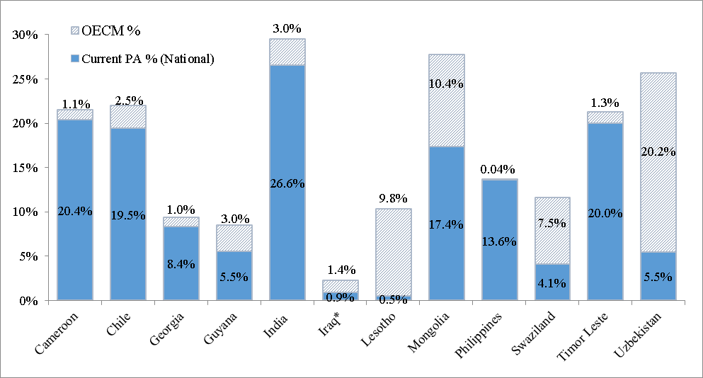
Figure 28 Increase in coverage when incorporating OECMs alongside protected areas.
- Guyana’s Amerindian Act and Protected Areas Act allow for the establishment of Amerindian Protected Areas as Community Conservation Areas (CCAs) as well as their integration in the national protected area system if desired. The Konashen Community Conservation Area represents 3 per cent of the country’s area and is currently the only community conservation area in Guyana. The community has applied to be included in the national system of protected areas and its application is under review. Furthermore, Guyana has established a code of conduct for forest operations requiring all large logging operations to set aside a percentage of their lease for protection, and has listed this initiative as another effective area-based conservation measure. One of Guyana’s priority actions in the next four years is to compile information about forest areas being protected by this initiative.
- Lebanon has identified natural parks, natural sites and monuments, Himas (community based natural resources management systems), and sites recognized by international organizations and conventions (Ramsar, etc.) as other effective area-based conservation measures. Lebanon has already established 11 terrestrial Himas and 3 Himas protecting inland water resources. Within the next four years, as part of its priority actions, Lebanon aims to increase the number of community conserved areas by establishing new Himas.
- Cameroon has identified supporting communities in the creation the community-managed hunting areas (ZICGC - Zone d’intérêt cynégétique à gestion communautaire) and community hunting areas, particularly around protected conservation areas, as priority actions for meeting this element of the Target. They aim to increase the extent of these areas by an average of 1000km² per year, or 5000km² by 2020, which would increase protection by 1.1 per cent (Figure 25). Cameroon has also included the identification and classification of cultural sites reserved for customary or traditional practices as a priority action for this element of the Target.
- Madagascar has identified the operationalization of KoloAla sites as a priority action. KoloAla sites involve a form of decentralized, sustainable community-based forest management (CBFM), designed to combine biodiversity conservation with poverty alleviation and timber production. The governance structure of these KoloAla sites means that their implementation may also assist with the equitable management element of the Target, while their role in poverty alleviation could support the achievement of sustainable development goals.
- Mozambique has identified the creation of conservancies around the Gorongosa protected area complex, as one of their priority actions for OECMs. The recently passed law on protection, conservation and sustainable use of biodiversity in Mozambique (2014) outlines the establishment of Sustainable Use Conservation Areas, which include a variety of different forms of protection and conservation, including community conservation areas. The establishment of these conservancies will help to restore degraded ecosystems, while bringing the benefits of sustainable land and forest management to local communities, generating and maintaining livelihoods. Additionally, for the Gorongosa protected area complex, the conservancies will act as a buffer zone, effectively increasing the area under some form of protection, and improving integration with the broader landscape.
- Timor-Leste plans to protect more than 200 km² of traditional lands, through the implementation of “Tara Bandu”, a traditional legal practice and law enforcement system, which involves, inter alia, bans on environmentally destructive practices, like illegal logging, and the promotion of a participatory approach to environmental management. These areas will allow for the mutual achievement of conservation and sustainable use of the country’s natural resources, including forests and other biodiversity-rich ecosystems.
- Lesotho currently lists at least two community botanical gardens, one community wetland conservation project at Mokema Wetlands Area and one Private Snake Park, all managed by communities with external funding, as part of their network of OECMs. Additionally, they also employ temporary protection through the establishment of Managed Resource Areas (MRAs) for the management of grazing areas in the highlands. For their priority actions, Lesotho plans to declare community MRAs (which currently cover an area of 3000 km², nearly 10 per cent of the territory) as formal protected areas under IUCN Category VI; this would increase the coverage of protected or conserved areas in the country to 25 per cent, exceeding the quantitative element of Target 11.
- Kiribati currently employs a number of community based management programs, including, Community Based Fisheries Management and a Community Based Mangrove Management Plan. As part of its priority actions, Kiribati will further develop community-based management programmes which will be produced and endorsed on the government level. These community-based management programmes will contribute both to biodiversity conservation and sustainable local development.
- Reporting on the status of OECMs within their country, Solomon Islands noted the presence of LMMAs (locally managed marine areas), taboos, CBRM (community based resource management), open-close seasons, cultural sites, East Rennell (a World Heritage Site), and community conservation areas. Furthermore, their 2010 Protected Areas Act provides for five different management categories as general guidance. For its priority actions over the next four years, among other activities, Solomon Islands plans clarify protected area categories (under the Fisheries Act, Forestry Act, Protected Areas Act, and Provincial Ordinances) and develop case studies for more clarity and guidance on what are “other effective area based conservation measures”.
- Including the area covered by tentative OECMs provided by Parties during the workshops, as well as those yet to be identified, alongside known ICCAs and those still unreported, would increase the outlook for achievement of the area-based targets (sections II.A and II.B). It will be important to map these existing and new OECMs to assess their contribution to other elements of the target, including ecological representation and coverage of areas of importance for biodiversity and ecosystem services.

III. CONCLUSIONS
- The previous section has provided a summary of each element of Aichi Biodiversity Target 11, using globally available data and national information submitted by Parties, including case studies. The results from the six regional workshops have provided a platform for a number of countries to increase their understanding of the different elements of Target 11, what information is needed for planning their contributions towards its achievement, and what actions they can undertake to bring the elements and the Target as a whole to fruition.
- In sum, countries in mainland Asia, Latin America and the Caribbean, Africa, Central and Eastern Europe and the Pacific Island regions have identified priority actions addressing all elements of Target 11, as shown in Table 6. Further, they have committed to increasing terrestrial protected areas by 0.53 per cent and coastal marine protected areas within national jurisdiction by 0.71 per cent, this excludes recent communications from Chile, Palau, New Zealand, the United Kingdom, United States, French Polynesia and CCAMLR for the development of large-scale marine protected and marine managed areas (adding over 10 million km²), as well as increases from approved GEF projects.
Table 6 Summary of priority actions received following six capacity-building workshops (in total, 124 countries attended one of the six workshops, while 11 more countries did not attend, but did submit some information). The table provides the number of countries proving at least one priority action for a given element, as well as the total number of priority actions received for each element of Target 11.

Element of Target 11 | # of Countries submitting at least one action | # of Priority Actions submitted
Terrestrial Quantitative | 90 | 186
Marine Quantitative | 48 | 62
Ecological Representation | 92 | 172
Areas Important for Biodiversity & Ecosystem Services | 91  (33) | 207  (37)
Effective Management | 94 | 238
Equitable Management | 80 | 163
Connectivity | 90 | 172
Integrated into Wider Landscape and Seascapes | 52 | 92
Other Effective Area Based Conservation Measures | 83 | 157

- Given the presentation of country road maps and status, gaps and opportunities matrices, from these regions, it is estimated that, for some elements of the target, progress may show an improvement compared to the midterm assessment in the fourth edition of the Global Biodiversity Outlook. Specifically, it is estimated that one element of Aichi Biodiversity Target 11 has already been achieved (coastal and marine areas within national jurisdiction conserved) while a second can be achieved before 2020, and may even exceed the target by 2020 (terrestrial and inland water areas conserved). Three other elements (ecological representation, protection of areas important for biodiversity and effective management) may be achieved by 2020; while the remaining elements will need some supplementary efforts to be achieved by 2020 (see Table 7 for a comparison of the updated status projection for each element, compared to the projections in the GBO-4).

Table 7 Summary of changes in the estimation of the chances of achieving each of the ten elements of Target 11 by 2020, from the assessment made for the fourth Global Biodiversity Outlook (GBO-4) to the assessment made based on the implementation of priority actions presented throughout this document.

 | At least 17% terrestrial and inland water areas conserved | At least 10% coastal and marine areas conserved | Conserved areas are ecologically representative | Areas of particular importance for biodiversity conserved | Areas of particular importance for ecosystem services conserved
GBO-4
Status if Actions are implemented as proposed
 | Protected areas are effectively managed | Protected areas are equitably managed | Well connected systems of protected areas | Integrated into the wider landscapes and seascapes | Other effective area-based conservation measures
GBO-4
Status if Actions are implemented as proposed
__________

* UNEP/CBD/COP/13/1.
Target 11: By 2020, at least 17 per cent of terrestrial and inland water, and 10 per cent of coastal and marine areas, especially areas of particular importance for biodiversity and ecosystem services, are conserved through effectively and equitably managed, ecologically representative and well connected systems of protected areas and other effective area-based conservation measures, and integrated into the wider landscapes and seascapes.
Secretariat of the Convention on Biological Diversity (2014). Global Biodiversity Outlook 4, Montréal, 155 pages.
As analyzed for the Protected Planet Report 2016 [UNEP-WCMC (2016). Global statistics from the World Database on Protected Areas (WDPA), April 2016. Cambridge, UK: UNEP- WCMC.]
UNEP-WCMC (2016). Global statistics from the World Database on Protected Areas (WDPA), April 2016. Cambridge, UK: UNEP- WCMC.
There was only one participant at the workshops from WEOG.
This information is presented using global data from the April 2016 release of the WDPA, as analysed for the 2016 Protected Planet Report (UNEP-WCMC, 2016). National status of terrestrial protected coverage was submitted by 91 countries during the six workshops (from 2015 and 2016, see Table 1); to get regional and global status figures, data from the WDPA was used for countries which did not make submissions.
United Nations Statistics Division (2016). Composition of macro geographical (continental) regions, geographical subregions, and selected economic and other groupings. Available at: http://unstats.un.org/unsd/methods/m49/m49regin.htm.
WDPA data from UNEP-WCMC (2016) and ‘National status’ data from 91 country submissions. To get the ‘National Status’ subregional coverage, WDPA data was used for countries which did not submit any information during the workshops.
National status based on data submitted by 92 countries during the six workshops; for those countries that did not submit national status information, data from the April release of the WDPA was used.
As analyzed for the Protected Planet Report 2016 (UNEP-WCMC, 2016). ‘National status’ accounts for the submissions by 60 Parties during one of the six workshops regarding the national status of marine protected area coverage.
Ibid.
Ibid.
WDPA data from UNEP-WCMC (2016) and ‘National status’ data from 60 country submissions. To get the ‘National Status’ subregional coverage, WDPA data was used for countries which did not submit any information during the workshops.
Current MPA extent is based on information from National Status submissions from 60 Parties, with data from the WDPA used for those who did not submit this information. Global status includes all countries, not just workshop attendees, includes seas around Southern Ocean Islands (but not Antarctica), and is based on National Status information where available (60 Parties), hence the higher value than relying solely on WDPA values.
UNEP-WCMC and IUCN (2016). Protected Planet Report 2016. UNEP-WCMC and IUCN: Cambridge UK and Gland, Switzerland.
UNESCO World Heritage Centre (2016). World Heritage in the High Seas: An Idea Whose Time Has Come. World Heritage Reports, 44. United Nations Educational, Scientific and Cultural Organization, Paris.
Further information on Ecologically or Biologically Significant Marine Areas is available at: https://www.cbd.int/ebsa/about
Current MPA extent is based on National Status submissions where available, with data from the WDPA used for all others (marked with an asterisk).
Jenkins, C. & Joppa, L.N. (2009). Expansion of the global protected area systems. Biological Conservation, 142:2166-74; Butchart, S. et al. (2015). Shortfalls and Solutions for Meeting National and Global Conservation Area Targets. Conservation Letters, 8(5): 329-337; UNEP-WCMC and IUCN (2016). Protected Planet Report 2016. UNEP-WCMC and IUCN: Cambridge UK and Gland, Switzerland
Olson, D. et al. (2001). Terrestrial ecoregions of the world: a new map of life on Earth. Bioscience, 51: 933-938.
Olson, D. et al. (2001).
World Wildlife Fund (2006). WildFinder: Online database of species distributions, ver. Jan-06. www.worldwildlife.org/WildFinder.
Spalding, M. et al. (2007). Marine ecoregions of the world: a bioregionalization of coastal and shelf areas, BioScience 57: 573-83; Spalding M.D. et al. (2012) Pelagic provinces of the world: a biogeographic classification of the world’s surface pelagic waters, Ocean and Coastal Management 60: 19-30.
European Commission Joint Research Centre (JRC) and UNEP-WCMC (2016). Global analyses of protected area coverage of marine and terrestrial ecoregions.
Ibid.
Ibid.
Juffe-Bignoli, et al. (2014). Protected Planet Report 2014. UNEP-WCMC: Cambridge, UK.
JRC and UNEP-WCMC (2016).
JRC and UNEP-WCMC (2016). The protected area coverage for all terrestrial and marine ecoregions can be accessed at: https://protectedplanet.net/c/protected-planet-report-2016/protected-planet-report-2016--data--maps-figures
Swaziland’s Fifth National Report to CBD (2014). Available online: https://www.cbd.int/doc/world/sz/sz-nr-05-en.pdf.
(JRC) and UNEP-WCMC (2016).
As assessed by BirdLife International using the April 2016 WDPA release, for the Protected Planet Report 2016.
IUCN (2016) A Global Standard for the Identification of Key Biodiversity Areas, Version 1.0, First Edition. Gland, Switzerland: IUCN; which was approved by IUCN’s Council in April 2016.
Adapted from Table 3.7 (pg. 70) in Worboys, G.L. et al. (eds.) (2015). Protected Area Governance and Management, ANU Press, Canberra. Biodiversity hotspots were updated in 2016, with the addition of the North American Coastal Plains hotspot, and the adjustment of several boundaries. The number of IBAs is regularly updated; information provided here is based on the data used by BirdLife International for the analysis presented in the Protected Planet Report 2016. As well, for the most recent analysis, a new category for other KBAs has also been included.
For total land area (and percentage of global land area) this refers only to terrestrial areas; however, the number of sites, for IBAs, AZEs and other KBAs includes both marine and terrestrial sites.
As assessed by BirdLife International using the April 2016 WDPA release, for the Protected Planet Report 2016.
Ibid.
Ibid
As assessed by BirdLife International using the April 2016 WDPA release, for the Protected Planet Report 2016.
Ibid
As assessed by BirdLife International using the April 2016 WDPA release, for the Protected Planet Report 2016.
Bertzky, B., et al. (2015).
As assessed by BirdLife International using the April 2016 WDPA release, for the Protected Planet Report 2016.
Ibid.
It should be noted that the dossiers were based on protected area coverage and KBA listings from 2014.
Vačkář, D. et al. (2016). Human transformation of ecosystems: Comparing protected and unprotected areas with natural baselines. Ecological Indicators, 66:321–328.
Manhães, A.P., et al. (2016). Spatial associations of ecosystem services and biodiversity as a baseline for systematic conservation planning. Diversity and Distributions, 22(9): 932-943.
Naidoo, R. et al. (2008). Global mapping of ecosystem services and conservation priorities. Proceedings of the National Academy of Sciences of the United States of America, 105(28):9495–9500.
Manhães, A.P., et al. (2016).
Melillo, J.M. et al. (2015). Protected areas’ role in climate-change mitigation. Ambio, 45(2):133–145.
Ibid.
US Environmental Protection Agency (n.d.). Greenhouse Gas Equivalencies Calculator. Available at: https://www.epa.gov/energy/greenhouse-gas-equivalencies-calculator
Melillo, J.M. et al. (2015).
Ibid.
Hauck, J., et al. (2016). Developing and applying ecosystem service indicators in decision-support at various scales. Ecological Indicators, 61: 1–5.
Coad, L. et al. (2015). Measuring impact of protected area management interventions: current and future use of the Global Database of Protected Area Management Effectiveness. Philosophical Transactions of the Royal Society B, 370(1681), DOI: http://dx.doi.org/10.1098/rstb.2014.0281.
Coad et al. (2015) indicated that 95 different PAME assessment methodologies are recorded in the GD-PAME.
In 2004, goal 4.1 of the PoWPA suggested Parties implement management effectiveness evaluations in at least 30 per cent of each Party's protected areas by 2010. As this target was reached, decision X/31 paragraph 19(a) invites Parties to continue to expand and institutionalize management effectiveness assessments to work towards assessing 60 per cent of the total area of protected areas by 2015 using various national and regional tools and report the results into the GD-PAME maintained by the World Conservation Monitoring Centre of the United Nations Environment Programme (UNEP-WCMC).
Coad, L. et al. (2015).
Ibid.
Ibid.
Ibid
Ibid.
GEF (2015). Impact Evaluation of GEF Support to Protected Areas and Protected Area Systems (Final Unedited Report). Available at www.thegef.org/
GEF (2015).
Leverington, F., et al. (2010). A Global Analysis of Protected Area Management Effectiveness. Environmental Management, 46(5):685–698.
Only ‘approved projects’ are included in the table.
This is an average against 36 separate indicators of management effectiveness.
Coad, L., et al. (2015).
Geldmann, J., et al. (2015). Changes in protected area management effectiveness over time: A global analysis. Biological Conservation 191:692–699.
Numbers refer to GEF Project ID’s.
UNEP-WCMC and IUCN (2016).
Juffe-Bignoli, et al. (2014).
JRC (2016), personal communication.
Franks, P. & Small, R. (2016), Understanding the social impacts of protected areas: a community perspective. IIED Research Report. IIED, London.
Ibid.
Oldekop, J.A., et al. (2015). A global assessment of the social and conservation outcomes of protected areas. Conservation Biology, 30(1): 133–141
Ibid.
UNEP-WCMC and IUCN (2016). Protected Planet Report 2016. UNEP-WCMC and IUCN: Cambridge UK and Gland, Switzerland.
Borrini-Feyerabend, G., et al. (2013). Governance of Protected Areas: From understanding to action. Best Practice Protected Area Guidelines Series No. 20, Gland, Switzerland: IUCN
Ibid.
Bertzky, B., et al. (2012). Protected Planet Report 2012: Tracking progress towards global targets for protected areas. IUCN, Gland, Switzerland and UNEP-WCMC, Cambridge, UK. Governance type was not assigned for 49% of PAs.
IUCN and UNEP-WCMC (2016). The World Database on Protected Areas (WDPA), [August, 2016], Cambridge, UK: UNEP-WCMC. Available at: www.protectedplanet.net. From 230,833 initial sites, 3608 with no reported area and no spatial boundary, 186 with a status of ‘not reported’, 1963 with a status of ‘proposed’, and 583 UNESCO-MAB reserves were removed.
CBD Decision X.31, para. 32 (f), COP 10, Nagoya, 2010.
IUCN and UNEP-WCMC (2016).
With 6340 sites removed (IUCN and UNEP-WCMC, 2016).
Values for 1990 and 2014 from Juffe-Bignoli, et al. (2014); data for 2016 from the August release of the WDPA (IUCN and UNEP-WCMC, 2016), with 6340 sites removed.
With 6340 sites removed (IUCN and UNEP-WCMC, 2016).
CBD decision X.31, para. 19 (b), COP 10, Nagoya, 2010.
Franks, P. & Small, R. (2016), Understanding the social impacts of protected areas: a community perspective. IIED Research Report. IIED, London.
Borrini-Feyerabend, G., et al. (2013).
Pulsford, I., et al. (2015). Chapter 27: Connectivity Conservation Management. In Protected Area Governance and Management, Worboys, G. L. et al. (eds.). ANU Press, Canberra.
UNEP-WCMC, personal communication.
Ibid. Caution should be taken when interpreting this figure, as the GCCD is still in the early stages of development and based on only a short period of data collection. It is anticipated that there are still many existing CCIs for which information has not yet been gathered.
Ibid.
Santini, L., et al. (2016). Connectivity of the global network of protected areas. Diversity and Distributions, 22(2):199 – 211.
Ibid
Ibid.
Saura, S., et al. (2016). Protected areas in the world’s ecoregions: how well connected are they? Submitted.
Ibid.
Which can be accessed at: http://dopa.jrc.ec.europa.eu/
Saura, S., et al. (2016).
Ibid.
Pulsford, I., et al. (2015).
Ibid.
Holland, M.B. (2012). Mesoamerican Biological Corridor, In Climate and Conservation, Hilty, J.A., et al. (eds.). Island Press, Washington, DC.
Ibid.
GIZ (n.d.). Transboundary Biosphere Reserve in the Mono Delta. Available at: https://www.giz.de/en/worldwide/27427.html
Danube Transnational Programme, Programme Priorities. Available online: http://www.interreg-danube.eu/about-dtp/programme-priorities#environment-and-culture-responsible
Hill, R. et al. (2015). Why biodiversity declines as protected areas increase: the effect of the power of governance regimes on sustainable landscapes. Sustainability Science, 10(2):357–369.
Oldekop, J.A. et al. (2015).
Ervin, J. et al. (2010). Making Protected Areas Relevant: A guide to integrating protected areas into wider landscapes, seascapes and sectoral plans and strategies. CBD Technical Series No. 44. Montreal, Canada: Convention on Biological Diversity.
All PoWPA Actions submitted are available at: https://www.cbd.int/protected/implementation/actionplans/
UNEP-WCMC (2016). World Database on Protected Areas User Manual 1.2. UNEP-WCMC: Cambridge, UK. Available at: http://wcmc.io/WDPA_Manual
Worboys, G.L. (2015). Chapter 2: Concept, Purposes and Challenges, In Protected Area Governance and Management, Worboys, G. L. et al. (eds.). ANU Press, Canberra.
Kothari, A., et al. (eds.) (2012). Recognising and Supporting Territories and Areas Conserved By Indigenous Peoples And Local Communities: Global Overview and National Case Studies. Secretariat of the Convention on Biological Diversity, ICCA Consortium, Kalpavriksh, and Natural Justice, Montreal, Canada. Technical Series no. 64. This has subsequently been updated with the addition of several other countries, between June and September 2013.
Ibid.
Worboys, G.L. (2015).
Kothari, A., et al. (eds.) (2012).
Kothari, A., et al. (eds.) (2012).
Terrestrial country areas from the World Vector Shoreline, 3rd edition, and National Geospatial-Intelligence Agency, as used by UNEP-WCMC (2016) for the assessment of progress towards Target 11 for the Protected Planet Report 2016.
Stolton, S. et al. (2014). The Futures of Privately Protected Areas. Gland, Switzerland: IUCN.
Ibid.
Protected area coverage levels are taken from national status submissions (except for Iraq, where the coverage is taken from WDPA 2016). For Lesotho, Timor-Leste and Cameroon, this represents increases that will occur within the next four years, if priority actions area implemented as planned; for all other Parties, the increase represents the current status of OECM coverage, as indicated in their Status, Gaps and Opportunities Matrix.
Urech, Z.L., et al. (2013). Challenges for Community-Based Forest Management in the KoloAla Site Manompana. Environmental Management, 51 (3):602–615.
Timor-Leste’s Fifth National Report. Available at: https://www.cbd.int/doc/world/tl/tl-nr-05-en.pdf
These values do not include the protected area additions (both terrestrial and marine) being made through approved GEF projects.
Some of these protected areas may already be enacted, but they nonetheless represent an increase over the current status as assessed from the April 2016 release of the WDPA, or from national status submission made to the Secretariat by workshop participants throughout 2015 and 2016 (see Table 1 for a timeline of the workshops).
Many priority actions relating to the quantitative elements (terrestrial and marine) included the creation, expansion, restoration or management of protected areas, but did not specify whether these referred to terrestrial or marine areas; therefore, the number of actions affecting marine conservation may be higher.
Actions for implementing protection of areas important for biodiversity and ecosystem services were combined (xx refer directly to ecosystem services); many, or most, of the actions would have positive outcomes for both elements.

