 |  | CBD
 |  |  |  | Distr.  GENERAL  UNEP/CBD/COP/13/INF/27  20 November 2016  ENGLISH ONLY
CONFERENCE OF THE PARTIES TO THE CONVENTION ON BIOLOGICAL DIVERSITY
Thirteenth meeting
Cancun, Mexico, 4-17 December 2016
Item 10 of the provisional agenda

Scoping study on Environmental-Economic Accounting towards the production of an integrated information system and indicators for the three Rio Conventions
- In paragraphs 3 (b) and (c) of decision XII/4, on integrating biodiversity into the post-2015 United Nations development agenda and the sustainable development goals, the Conference of the Parties requested the Executive Secretary to continue the collaboration with key partners to actively contribute to the discussions on the post-2015 United Nations development agenda and the sustainable development goals; and to support Parties by continuing to engage in the ongoing processes to ensure the appropriate integration of biodiversity and ecosystem functions and services in the post-2015 United Nations development agenda and sustainable development goals and related targets and indicators.
- In the same decision, the Conference of the Parties also requested continuation of the work requested in decision XI/22, in the context of the implementation of the Strategic Plan for Biodiversity 2011-2020 and the Aichi Biodiversity Targets – taking into account the outcomes of the United Nations Conference on Sustainable Development, the final reports of the Open Working Group on Sustainable Development Goals and the Intergovernmental Committee of Experts on Sustainable Development Financing to the United Nations General Assembly – and the negotiations towards a post-2015 United Nations development agenda (para. 3 (a)). This earlier decision included a request to the Executive Secretary to collaborate, taking into account the outcomes of the Rio+20 Conference, in the process of developing sustainable development goals, as appropriate, with the United Nations Department of Economic and Social Affairs, the secretariats of the two other Rio conventions and multilateral environment agreements, and relevant international organizations and specialized agencies (para. 11 (c)).
- In decision XI/30, on incentive measures, the Conference of the Parties requested the Executive Secretary, with a view to supporting progress towards the achievement of several Aichi Biodiversity Targets, including Targets 2, to continue and further strengthen its cooperation with relevant organizations and initiatives, with a view to catalysing, supporting and facilitating further work in assessing and mainstreaming the values of biodiversity and associated ecosystem services.
- Further to these requests, and with a view to continue contributing actively to the discussions in collaboration with relevant partners, the Executive Secretary commissioned a technical expert study on the potential contribution of Environmental-Economic Accounting towards the production of an integrated information system and indicators for the three Rio Conventions, in the context of the 2030 Sustainable Development Agenda. Prepared by Mr. Jean-Louis Weber with financial support from the Government of France, the design and preparation of the study was undertaken in consultation and collaboration with a group of United Nations partner organizations, namely, UNDESA, UNEP, UNEP-WCMC, as well as the UNFCCC and UNCCD secretariats.
- The conclusions of the study can be summarized as follows:
- There are potentially high benefits relying on fully integrated Environmental-Economic Accounts and in particular on ecosystem accounts;
- Given however that Environmental-Economic Accounts are overall at early implementation stages, it is unclear how such integration can happen in the short term;
- Yet, three domains can be identified where short term progress would seem feasible and potentially effective: (i) material flows accounts (in the broader sense, including material use, waste, emissions of GHGs etc.) disaggregated by economic activities as defined in the standard ISIC classification; (ii) expenditure for environment protection and sustainable management of resources, and (iii) land cover accounts.
- The final study is provided for information of the Conference of the Parties and in the format received from the technical expert. While representatives of the organizations above provided guidance to its design and preparation, the views expressed in the study are those of the technical expert and cannot be attributed to the organizations above or to the Convention secretariat.

Scoping study on Environmental-Economic Accounting
towards the production of an integrated information system and indicators
for the three Rio Conventions

Towards a first set of potential indicators
based on Environmental-Economic Accounting

Final draft
(31 May 2016)

Table of Contents
Summary 2
1. Context 3
2. Recent developments 4
2.1. SDG Indicators and the SEEA 5
2.2. A particular point is the SDG indicator 15.3.1 on land degradation promoted by UNCCD. 8
2.3. Discussion 10
3. Ecosystem approach and environmental accounting 11
3.1. The ecosystem approach 11
3.2. Indicators and accounting 13
3.3. Macro and micro scales, and geospatial issues 14
3.4. Fuelling existing indicator frameworks and enhancing information systems 15
The ontological approach 15
Improvement of the reporting to the 3 Conventions and SDG stated targets: ontological and accounting approaches 17
4. The SEEA and related accounting methodologies 17
4.1. The SEEA Central Framework (SEEA-CF) and related frameworks 18
4.2. The SEEA Experimental Ecosystem Accounting (SEEA-EEA) and related frameworks 18
5. What in the 3 Conventions reporting and SDGs indicators can benefit from/to environmental accounting? 20
5.1. UNFCCC 20
5.2. UNCCD 22
5.3. CBD 26
5.4. SDGs 28
6. Identification of short term indicators: being SMART 43
6.1. Material/energy flows aligned to SNA definitions and classifications 43
6.2. Accounts of national expenditure related to the implementation of the 3 Conventions and in support to SDGs. 44
6.3. Land cover accounts 45
7. A research agenda 46
Conclusive remarks 47

Summary
Benefits for the 3 Rio Conventions and the SDG indicators of relying on fully integrated Environmental-Economic Accounts and in particular on ecosystem accounts are potentially very high in terms of assessing their performance, of better cross integrating their implementation and assessing their relation to the economy. However, because Environmental-Economic Accounts are at an early stage of implementation, it is unclear how such integration can happen in the short term. Yet, three domains have been identified (or confirmed) for short term action: 1) material flows accounts (in the broader sense, including material use, waste, emissions of GHGs etc.) disaggregated by economic activities as defined in the standard ISIC classification; 2) Expenditure for environment protection and sustainable management of resources, a much requested information; 3) land cover accounts. Other domains have been identified for further research. The first of all relates to integration of the social dimension into ecosystem accounting. 15 other domains have been listed.
- Context

The present scoping study on Environmental-Economic Accounting Towards the production of an integrated information system and indicators for the three Rio Conventions was commissioned by the Secretariat of the Convention on Biological Diversity (CBD) in October 2015.
The need for such integrated information is broadly understood, both in policy terms and considering the effectiveness and efficiency of statistics and data collection at the global scale (see Figure 1). In addition to the needs of the three Rio Conventions considered individually and collectively, the SDGs indicators requirements come now to high priority. Concerns have been expressed in particular in the context of the Inter-Agency and Expert Group on SDG Indicators (IAEG-SDGs), about data gaps and inconsistencies between data sources, which are obstacles to the implementation of the set of indicators that countries are asked to provide. Proposals for a data revolution are tabled and include speeding up conventional statistics development, making broader use of geo data and of progress in information technology, including use of the so-called “big data”. In this context, UNEP has started the development of a Sustainable Development Goals Interface Ontology (SDGIO) with “the aim to provide a semantic bridge between 1) the Sustainable Development Goals, their targets, and indicators and 2) the large array of entities they refer to.” and “promote interoperability.”
The assessment of the potential contribution of environmental accounting to respond to these demands in conceptual and operational terms is an important component of this process. From the CBD perspective, it grounds heavily on an ecosystem approach.
Figure 1: Close interconnection between the 3 Conventions targets

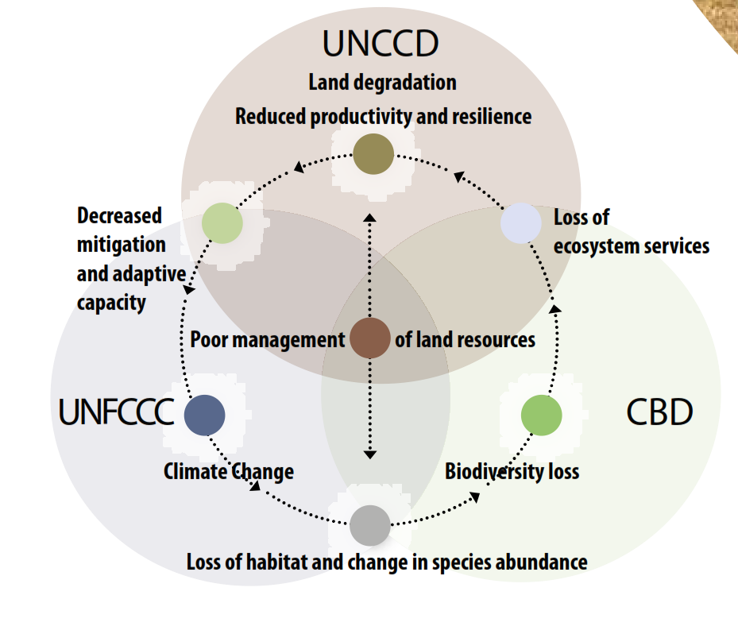
Source : UNCCD

As figure 1 suggests, there are many commonalities and connections between the approaches of the three Conventions.
In the UNCCD language, “land” or “land resource” has the meaning of “ecosystem” in CBD’s terms. The recognition by the CBD that ecosystems include people reinforces the harmony with the UNCCD vision where social and natural (land) systems are entangled. The role of biodiversity (and particularly soil biodiversity) to sustain food security in the long run is in this regard essential, common to the two Conventions. The joint impacts of climate change and poor land management are other critical issues.
The UNFCCC has addressed primarily global warming mitigation, with a subsequent focus on the relation between the economic system on the one hand and the atmosphere/ocean system on the other hand, and a particular concern regarding fossil fuels. However, the forestry sector was included in reporting since 1996 in terms of emissions and removals, the approach to land issues is broadening stepwise, with a milestone in 2006 with a more comprehensive integration of agriculture and other carbon pools in the AFOLU (for Agriculture, Forestry, and Other Land Use) sector. The development of programmes such as REDD+ to stimulate carbon sequestration has fostered the development of land based monitoring and verification procedures based in particular on remote-sensing by satellite. Many variables collected for UNFCCC reporting correspond to what is requested by the other conventions regarding in particular soils and forestry, directly or after improvements in terms of better spatial distribution. The progress on land cover change monitoring and accounting is an illustration of the possibility of putting in place a platform common to the three Conventions.
In recent years, concerns of global warming mitigation are increasingly joined by adaptation issues. Obviously, adaptation requires approaches based on socio-ecological systems in terms of risk assessment and responses. This is precisely the approach of CBD and UNCCD.
A particular subject relates to the seas and oceans which are part of the global climate system, an important source of proteins for a large part of the global population, and constitute ecosystems under high stress because of excessive exploitation. Important scientific programmes are carried out in order to have better understanding of oceans dynamics, in particular regarding acidification issues related to concentrations of CO₂. From a biodiversity perspective, the outcome of such studies is essential regarding issues like the future of zooplankton or coral bleaching and its catastrophic consequences.
- Recent developments

A meeting of the Steering Committee of the present study was hold on 18 January 2016 as a Telephone Conference. The Steering Committee involved UNDESA, UNEP, UNEP-WCMC, UNFCCC, UNCCD and the CBD. The tele-conference confirmed the relevance of the approach taken. Due to the policy agenda and the discussion on the SDG indicators taking place at the UN Statistical Commission meeting of 8-11 March, most of the time was devoted to the subject, in general and considering the particular case of the SDG 15.3 indicator on land degradation.
  - SDG Indicators and the SEEA
Between 23 December 2015 and 15 Feb 2016, the IAEG-SDGs carried out four more rounds of consultations among members on further refinements and additional proposals on some of the indicators. UNCEEA secretariat carried out a study on the relevance of the SEEA for environment related SD Goals. Conclusions are presented in a note on The System of Environmental Economic Accounts (SEEA): A Statistical Framework to Support the SDG Indicators (in annex) and a paper submitted to the endorsement of the UN Committee of Experts on Environmental Economic Accounting (UNCEEA) seminar of June 2015: The SEEA as the Statistical Framework in meeting Data Quality Criteria for SDG indicators. These papers are based on detailed screening of SDG indicators and contain recommendations for compliance to the SEEA.
The UNCEEA document starts with a distinction between statistical frameworks and indicator frameworks. “Statistical frameworks represent internationally standardized definitions, classifications and related methods for compiling statistics which, among other things, support the calculation of methodologically robust indicators. In contrast, indicator frameworks develop organizing principles to facilitate the choice of indicators for different thematic aspects of sustainable development. Such indicator frameworks provide a policy-relevant organizational framework which indicators could be selected.” It states that “An overarching measurement framework such as the SEEA provides the overall coherent and mutually consistent statistical framework across a large and multi-dimensional range of thematic statistical domains of sustainable development.” This is particularly important because: “By using the same accounting conventions, SEEA-based statistics can therefore be combined and/or related to statistics from national accounts to calculate important ratios. These ratios offer a methodologically consistent way to measure tradeoffs between the economy and environment.” It relates in particular to the definition of domestic economy (therefore the GDP aggregate) in the SNA as the sum of units having their residence (main economic interest) on the economic territory as opposed to definitions based on a physical definition of countries’ territory. Another issue relates to sector disaggregation. Environment agencies in charge of implementing policies generally refer to technological processes while national accounts refer instead to economic activities and products. Therefore, for comparing resource use or emissions of pollutants to value added by sectors to calculate environmental performance, it is extremely important to reclassify physical data by technical sectors into SNA activities. Four “Disaggregation Dimensions of SEEA-based Statistics and Indicators” are put forward: Industry Level Disaggregation (in accordance with standard industry classifications (ISIC)), Institutional Sector Disaggregation (for a clear distinction between government, corporations and households), Disaggregation by Product or Asset Type (to assess depletion or the fuel mix and other compositional issues) and Spatial Disaggregation (to understand spatial variations)”. Examples given relate to emissions of GHG and to the draft energy account.
The role of the SEEA in terms of organisation of the environmental information system is as well highlighted: “responsibilities for the collection of environmental and economic data are often dispersed among different agencies, each employing their individual practices and methods for the collection and compilation of data. The result is that each agency collects the data specific to their policy agenda, based on definitions and classifications most appropriate to their needs. This level of fragmentation can occur at the agency and/or geographical level. By adopting the SEEA as the national accounting framework for the environment, there is impetus for data from different agencies’ collection initiatives to be consolidated into one set of information which can be understood and used by all.” The institutional arrangements put in place in Brazil for implementing SEEA water accounts are given as an example of achievement in that sense. Ultimately, the SEEA based approach fostered by UNCEEA secretariat is summarised in Figure 2:

Figure 2: SEEA to foster integration of environmental data collection and policy decisions
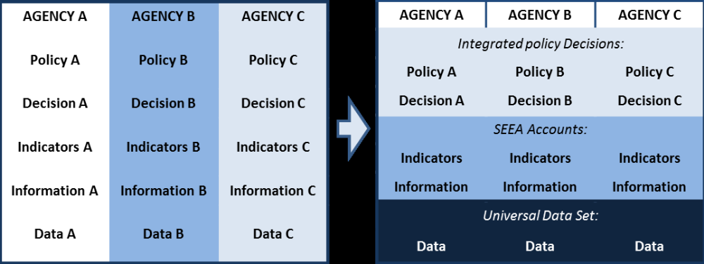
(Source: UNCEEA 2015, Paper 3b, op. cit.)
We should note that other options are also proposed. For example, “The Ultimate Earth Project” proposed jointly by the British Geological Survey and the École Polythechnique Fédérale de Lausanne for a Future and Emerging Technology Flagship programme of the European Union acknowledges the multiplicity of possible data sources and their integration is foreseen stepwise, with a central role given to geoscience data hubs and computing interfaces allowing access to data and knowledge to the broader range of users, for applications or research. In such a setting, socio-economic statistics and environment related statistics could constitute a hub.

Figure 3: the Ultimate Earth Project’s Model
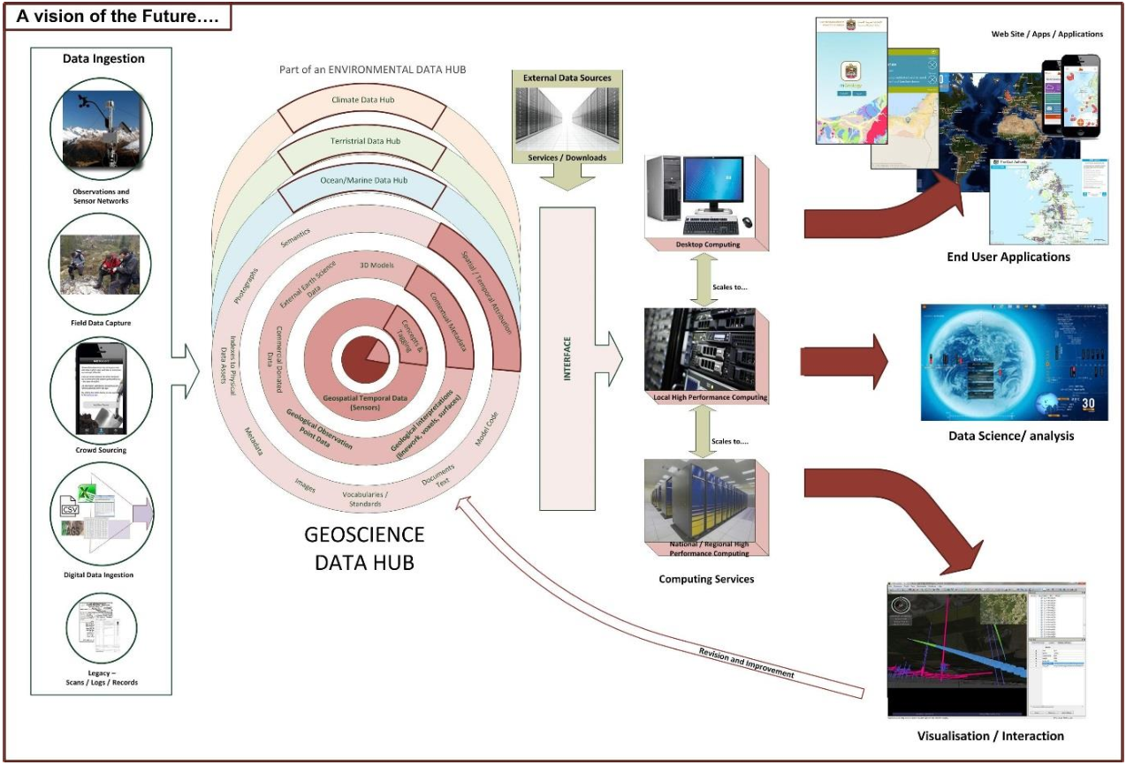
Source: The Ultimate Earth Project as an FET Flagship, https://ec.europa.eu/futurium/en/system/files/ged/ultimate_earth_fet_jl_pg.pdf

- A WAVES Policy Briefing

In their Policy Briefing on Natural capital accounting and the Sustainable Development Goals, the WAVES Partnership steered by the World Bank advocates that “Natural capital accounting can help deliver the SDGs by making explicit the links between the economy and the environment, enabling sustainable policy decisions and actions, and monitoring progress”. “The role of NCA in delivering the SDGs is recognized in the SDG targets. SDG target 15.9 calls for ecosystem and biodiversity values to be integrated into national and local planning, development process, poverty reduction strategies and accounts.”
“NCA (Natural capital accounting) and the SDGs have a shared purpose and philosophy, both advocating integrated policies to achieve sustainable development.” “While the SDGs provide a policy framework, NCA provides the necessary data to move towards sustainable development.” “Implementing the SDGs requires a solid framework of indicators and statistical data to inform policymaking, monitor progress and ensure accountability. Natural capital accounting, which expands the scope of traditional reporting, can meet this need. The SEEA is a flexible tool that can be used to address priority issues in each country, addressing a range of policy questions that cut across the SDGs. Basing the SDG indicator framework on statistical standards such as the SEEA helps ensure internationally comparable, high quality indicators that can be integrated into mainstream information systems.”
Two aspects are addressed in the WAVES briefing: on the one hand the usefulness of NCA for SDGs implementation and on the other hand the aptitude of the SEEA to supply (part of) the requested SDG Indicators. This second aspect is less developed and from the rather comprehensive water account example, only one specific metrics is presented, for SDG Target 6.3 “Improve water quality by reducing pollution”. In this case a “Global indicator aligned on the SEEA” could have the format of “Percentage of wastewater that undergoes primary/ secondary/tertiary treatment”. Without discussing here the relevance of the proposal regarding the target, we can note that this indicator is rather standard in hydrology and therefore, the value added of having it in an accounting framework is not demonstrated as long as it is not explicitly related to water quality.

Despite these perspectives, practical difficulties arise considering the recent stage of implementation of the SEEA. “Establishing an integrated system will require a national institutional mechanism to drive integration as well as the sustained commitment by multiple data holding agencies. Key ministries and agencies will need to be strengthened for this to happen.” This has to be linked to the acknowledgement of the SEEA “flexibility”, meaning that it can be implemented according to national priorities. This is certainly an advantage regarding SDG policies but is an issue in terms of supporting the SDG reporting, in particular considering international comparability. Finally, the WAVES Briefing concludes that “Due to the lack of immediate SEEA-based data on a global scale, a gradual transition to SEEA processes is necessary. In the short term, indicators can be derived based on the best available data and where possible aligned with the SEEA, with capacity to report on SEEA-based accounts developed over time.”

  - SDG indicator 15.3.1 on land degradation

SDG Goal 15 reads: “Protect, restore and promote sustainable use of terrestrial ecosystems, sustainably manage forests, combat desertification, and halt and reverse land degradation and halt biodiversity loss”, Target 15.3 : “By 2030, combat desertification, restore degraded land and soil, including land affected by desertification, drought and floods, and strive to achieve a land degradation-neutral world” and Indicator 15.3.1 (at this stage, the only proposed indicator for 15.3) : “Percentage of land that is degraded over total land area”.
A workshop was organised in Washington DC on the possible format of this indicator. A comprehensive working document was circulated to participating organisations for comments and inputs. It included in particular detailed comments by the FAO, and a presentation of a similar approach under preparation at IPBES. The meeting was attended by more than 60 people including representatives of UNDESA, FAO, GEF, EC, FCCC, CBD, the WB, regional bodies such as the Sahara and Sahel Observatory, several national governments and various scientific agencies (including USGS, NASA, ESA, the EC’s JRC...). Two days of thorough discussions illustrated the interest for the subject. Indicator 15.3.1 is on the “green list” and practical solutions have to be found now. The minutes of this meeting are in Annex 2. The idea in the UNCCD proposal is to start with a composite indicator made of 3 “metrics”: land cover, land productivity and above ground and below ground (soil) stocks of organic carbon. The discussions addressed therefore each of the metrics and then their aggregation into a composite. This composite is acknowledged not to cover all aspects of land degradation (e.g. water issues) but it is considered as meaningful enough to provide a very first response to the requirements of Target 15.3.
The discussion of “trends in land cover” raised several questions. One is that assessing trends means monitoring with satellite images land cover change, not only stocks. As a matter of fact, land cover change cannot be estimated as the simple difference between land cover maps at different dates; instead, independent measurement of change is required. They are only few examples of systematic monitoring of change (CORINE land cover in Europe, forthcoming land cover change by ESA CCI project) and important efforts have still to be undertaken. The issue of classification seems to have been addressed more easily, with a consensus on the SEEA land cover classification in 15 classes instead of the more aggregated IPCC 5 classes. The questions of consistency as well as additional breakdowns (e.g. at the national scale) will be facilitated by the reference to the FAO LCCS3 classification system and its Land Cover Meta Language (LCML). A third point relates to scales, acknowledging that the indicator should be useful for national authorities, not only for international reporting. Lastly, a major difficulty arose from the fact that land cover describes categories, not variables. To produce an indicator some kind of value needs to be attached to each category and to the various conversions from one to the other. The exercise might be in practice difficult, for example when the detail between pristine forests, managed forests and tree plantations is not provided by the classification. The possibility of adopting a rating system has not been discussed at this stage. Instead, the assessment of degradation (or not) due to land use change is left to countries. Despite these difficulties, land cover is kept as priority item, for the information it reveals, for its role in structuring other datasets and because change in soil organic carbon will be assessed in a first instance in relation to land cover (e.g. soil sealing).
The discussion on above and belowground organic carbon addressed mainly soil. Above ground organic carbon can be assessed in relation to IPCC reporting and to Indicator 15.1.1. “Forest area as a percentage of total land area”. Soil organic carbon content can be derived at the global scale from soil maps (Harmonized World Soil Database v 1.2 and the Global Soil Organic Carbon Estimates by the JRC ) and at the national scales from maps and in situ monitoring. Loss of soil organic carbon is more difficult to monitor. It will be in a first instance derived from land cover change or in the case of soil erosion from models combining soil types, land cover change, relief and hydro-meteorological variables.
Land productivity is measured in terms of biomass. In principle, the indicator chosen is NPP (Net Primary Production of biomass); tests have been carried out in several African countries by the JRC, using NDVI (Normalized Difference Vegetation Index) as a proxy. NPP modelled from satellite imagery is still imprecise but in progress. The NASA will do a comparative test of the global products available (the 2 products based on MODIS, the novel BETHY product of the Earth Observation Centre of the German Aerospace Center - DLR…). The relevance of NPP change was questioned during the meeting. A first issue is the relation of NPP to climate conditions and the need to do the necessary corrections as long as the purpose is to monitor degradation trends. A second issue is that NPP increase is not necessarily a signal of absence of land degradation. In some cases, it can be the result of more intensive land management; in other cases, increase in NPP fostered by climate change or nitrogen depositions can be a sign of degradation of ecosystem functions (such as in the of case shrub encroachment of dunes or grassland).
The discussions acknowledged the variety of data which can be used (e.g. satellite imagery) and noted that metrics will change over time while we need to keep the same indicators. A practical way of starting is to establish a baseline using the best information at country level on land degradation, derive slopes of change in the baseline year and in a second step record observed changes. No conclusion was reached regarding the way to integrate the three metrics into one indicator, the prevailing opinion being that the final assessment would be done by the countries themselves.
  - Discussion

The discussion of the feasibility of the SDG 15.3.1 indicator is a fair illustration of where we are now in many areas. In a short term perspective, when proposing methodologies, it is important to give due consideration to their prior testing and validation of both soundness and feasibility. In the longer term, integrated environmental-economic accounts will be important tools for SD policies, implying that more advanced issues related to consistency, comparability and standardisation will have to be solved.
This is particularly important regarding the three tiers approach taken in SDGs (following the IPCC scheme). “32. Based on their level of methodological development and overall data availability, the indicators contained in the current proposal will be grouped into three different tiers: (a) A first tier for which an established methodology exists and data are already widely available (tier I); (b) A second tier for which a methodology has been established but for which data are not easily available (tier II); (c) A third tier for which an internationally agreed methodology has not yet been developed (tier III).” The SEEA contribution mostly relates to tier II (as regards SEEA volume one, the Central Framework) and tier III (as regards SEEA volume two, on Experimental Ecosystem Accounting).
The tension between formal soundness and actual feasibility can be perceived in the Data Quality Criteria for Indicators proposed in the UNCEEA secretariat document for UNCEEA (see above, note 7). These criteria are very comprehensive and demanding but at the present stage, they may remain in the background, as a conceptual more than practical guidance. For example, criterion 7 reads “Be compliant with international standards” while criteria 9 and 10 read “Be constructed from well-established data sources which are of known quality and adequately documented” and “Be supported by data which is readily available or attainable at a reasonable cost/benefit ratio”. In many cases, the data needed to meet the international standards will not be adequate. They will have to be rectified and even supplemented with estimations for producing the appropriate information. From an accounting perspective, this should be considered as a test of these datasets, an assessment of the possibility to use them after necessary modifications.
Moreover, in the present context of fast evolution of data systems and data revolution, procedures can be expected to change swiftly. Big data is in essence not prone at been standardised. The algorithmic extraction of data will generate the datasets required for different purposes. The quality of data will not be judged from the inputs but considering the outcomes obtained.
Progress in SEEA implementation is noticeable but still at an early stage. The note on “SEEA: A Statistical Framework to Support the SDG Indicators” indicates that “To date, more than 50 countries have a programme on the SEEA, and the UN Statistical Commission has called for a scaling up of the global implementation programme.” Out of these 50 countries, circa 36 are involved in the work by Eurostat (28 EU Member States plus associated countries) which develop since many years the only regional programme on environmental accounting. European environmental accounts are codified in law under Regulation (EU) No 691/2011 on European environmental economic accounts, which so far includes three modules, namely (a) air emissions accounts, (b) environmental taxes and (c) material flow accounts. Three additional modules have been added in 2014: (d) a module for environmental protection expenditure accounts, (e) a module for environmental goods and services sector accounts, and (f) a module for physical energy flow accounts. This scope is rather narrow as compared to the one of the SDG indicators. Moreover, the May 2015 Eurostat’s report to the Conference of European Statisticians of the UNECE on “Eurostat's role in the development and implementation of a comprehensive monitoring framework for Sustainable Development Goals” refers to the “GDP and Beyond” process for Quality of Life issues, not for the environment, and the SEEA is not even mentioned.
It is therefore important to keep the focus on what can be actually achieved so far in terms of contribution of environmental accounting to the SDG indicators and the reporting to the 3 Rio Conventions.
- Ecosystem approach and environmental accounting
  - The ecosystem approach
The ecosystem approach promoted by the CBD has been given broad recognition.
“The ecosystem approach is a strategy for the integrated management of land, water and living resources that promotes conservation and sustainable use in an equitable way.” https://www.cbd.int/ecosystem/
The ecosystem approach is a holistic view of biodiversity conservation. It encompasses specific methodologies and, as stated in COP 7 Decision VII/11.8: “in addition to sustainable forest management, some existing approaches, which are also relevant to other environmental conventions, including "ecosystem based management", "integrated river-basin management", "integrated marine and coastal area management", and "responsible fisheries approaches", may be consistent with the application of the Convention's ecosystem approach, and support its implementation in various sectors or biomes. Implementation of the ecosystem approach in various sectors can be promoted by building upon the approaches and tools developed specifically for such sectors;” and Decision VI/11.10(c) recommends to : “Promote the application of the ecosystem approach in all sectors with potential impacts on biodiversity and ecosystems, as well as inter-sectoral integration;”
Ecosystem-based approaches go beyond biodiversity conservation and are recognized important in domains such as adaptation to climate change, combat against desertification, disaster risk reduction in many places, poverty reduction and more broadly sustainable development.
Box 1: PRESS RELEASE, CBD, Montreal/Paris, 9 December 2015 (extract)
Governments encouraged to use biodiversity and ecosystem services as strategy for climate change adaptation and disaster risk reduction

At a side event held in Le Bourget, Paris, at the 21st session of the Conference of the Parties to the United Nations Framework Convention on Climate Change, current and former executives of the Convention on Biological Diversity, the United Nations Convention to Combat Desertification, and the Global Environment Facility, along with the Minister of Water and Sanitation of South Africa, urged Governments to consider using ecosystem - based approaches to climate change adaptation and disaster risk reduction to provide communities with safety nets in times of climate shocks and natural disasters.
[…]
“Taking ecosystem-based approaches to adaptation and ecosystem-based approaches to disaster
risk reduction enables people to adapt to the impacts of climate change by using opportunities created by
sustainably managing, conserving and restoring ecosystems to provide ecosystem goods and services. It is clear that these approaches should be integrated into broader adaptation and development strategies.” said Braulio Ferreira de Souza Dias, Executive Secretary of the Convention on Biological Diversity.
[…]

Moving ahead on the way of integrating biodiversity into mainstream policies, the CBD has adopted in 2010 a Strategic Plan for Biodiversity 2011-2020 and its Aichi Targets. Goal A addresses the “underlying causes of biodiversity loss by mainstreaming biodiversity across government and society” and contains the Aichi Biodiversity Target 2 which states: “By 2020, at the latest, biodiversity values have been integrated into national and local development and poverty reduction strategies and planning processes and are being incorporated into national accounting, as appropriate, and reporting systems”. This explicit requirement for integration of biodiversity and socio-economic information has been recently confirmed by the SDG in: “15.9 by 2020, integrate ecosystems and biodiversity values into national and local planning, development processes and poverty reduction strategies, and accounts”.
Ecosystem based environmental accounting, integrated to national accounts and related accounts of economic natural resource can produce data, indicators and support analysis which “can serve as unifying elements of a common approach for UNFCCC, UNCCD and CBD. Furthermore, these may in turn be related to other sustainable development issues central to the post-2015 development agenda and the Sustainable Development Goals (SDGs), like poverty eradication (contribution of ecosystems to sustainable livelihoods) and food security (long term fertility and productivity of soil and agro-ecosystems) or water availability. This work will contribute to the post-2015 Inter-Agency Expert Group on SDG indicators (IAEG-SDG).” (from the ToR of the present study)
  - Indicators and accounting

Not all indicators can be derived from accounting frameworks. When it can be done, indicators can be more robust and stable and have higher analytical potential as individual variables are formally interconnected within a given framework and, in the case of environmental-economic accounts, through frameworks integration.
Environmental accounting is an attempt to enlarge the scope of the accounting frameworks used to assess the economic performance in order to take stock of elements which are not adequately recorded in books. Although national accounting has been the driving force, all accounting frameworks are potentially covered by environmental accounting: national accounts, financial accounting standards as well as accounts established to assess the costs and benefits of plans and projects. Although giving priority to the national level for short term outcomes, the assessment of environmental accounts potential to deliver indicators should envisage further extensions of different scales and operational nature.
Technically, the purpose of accounting is to produce indicators useful for performance, results and wealth assessment, management and analysis and policy and decision making. Accounts summarize very large numbers of recordings into results called balancing items. “Balancing items are meaningful measures of economic performance in themselves. When calculated for the whole economy, they constitute significant aggregates. ”
Accounting basic principles of double entry accounting (and quadruple entry in the case of national accounts) allow controlling statements by companies, by public institutions or for countries. More, this strict interconnectedness provides a sketch of key interactions within the reporting entity as well as between this entity and its partners in transactions (clients, shareholders, government institutions, taxpayers...). Standards of financial or corporate as well as national accounting include also physical data on staffing or employment, inventories, reserves of subsoil assets, surfaces of estates etc. Although not strictly recorded within the double accounting scheme (which requires a single common unit of measurement), they are tightly integrated to it, which allows more assessments and analyses. Defining indicators in the context of an integrated accounting framework enhances their power regarding cross-analyses between themselves as well as with the whole set of economic and socio-economic data presented in accordance with accounting standards.
  - Macro and micro scales, and geospatial issues
Macro indicators are expected firstly to be evidences for macro policy making. Beyond that, they are expected to give guidance to local governments and economic actors, as clearly stated in the CBD ecosystem approach. Although the Kyoto protocol has started on the basis of a sector approach where economic sectors and enterprises are assigned specific objectives derived from macro assessments and targets, a land based accounting is intended and under development in particular related to the measurement of carbon sequestration. Because of statistical adjustments between data from not fully consistent sources, national accounts are not the exact sum of individual transactions. However, they are sufficiently intelligible by economic agents to be used as important contextual information for their own analysis and decision. For example, increase in GDP, consumers prices index or change in the tax rate are interpreted for market analyses. As long as accounts are prone at being downscaled from national to local and individual units’ levels, they can facilitate better assimilation of contextual variables and subsequent behavioural change by economic actors.
Geospatial information has now important place in the 2030 Agenda for Sustainable Development (g) “They will be rigorous and based on evidence, informed by country-led evaluations and data which is high-quality, accessible, timely, reliable and disaggregated by income, sex, age, race, ethnicity, migration status, disability and geographic location and other characteristics relevant in national contexts.”

Figure 4: Typical users of Socio-economic and Geo-spatial information

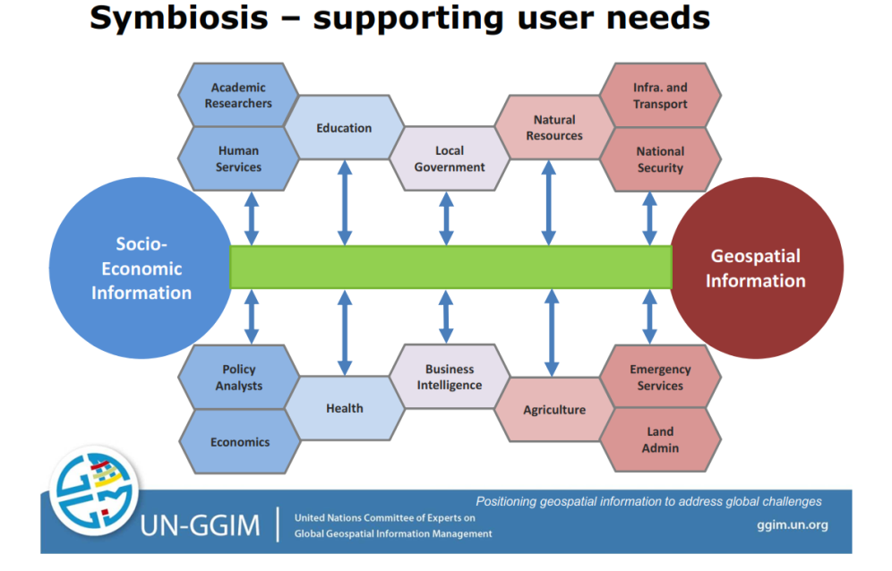
Source: UN-GGIM

Working with geographical information is particularly important when working with ecosystem accounting as firstly specific statistical units have to be defined from spatial analysis: land cover units, rivers, socio-ecological units, river sub-basins… Then, accounts have to address horizontal and vertical spatial interactions (which mean that when degradation in one ecosystem is caused by an event in another one, it has to be recorded in an appropriate way). Lastly, aggregation of ecosystems does not follow for a large part the additive model on which national accounts are based. These issues can be dealt with only with geospatial information.
In addition, monitoring systems used for data collection deliver now abundant geo-referenced information. Comparisons of commonly used sources for this or that indicators might be necessary to assess the reality of correspondence between variables beyond the conceptual definition.
  - Fuelling existing indicator frameworks and enhancing information systems

Distinction between sourcing existing indicators with environmental accounts and improving reporting with the use of environment accounts are close connected but different tasks.

The ontological approach

To decide how existing variables recorded in accounting tables can be used by the 3 Conventions and SDG indicators, there is firstly a need to assess precisely how concepts and methodologies match, exactly, approximately (and to which extent) or not at all. Such assessment is the purpose of the development by UNEP, in collaboration with experts in the field of ontology, of “a Sustainable Development Goals Interface Ontology (SDGIO) so that entities relevant to the SDGs can be logically represented, defined, interrelated, and linked to the corresponding terminology in glossaries and resources such as the UN System Data Catalogue and SDG Innovation platform.”
As an illustration of the issues to address, the example of catastrophic losses can be used. Disasters are of general concern and part of the recent discussion at UNFCCC COP21 relate to disaster mitigation and needed adaptation. At present, the IPCC guideline deals for example with forest fires with criteria to make a distinction between those which are directly induced by human activities (and which resort therefore from the CDM mechanism) and other which are assumed to be “natural”. UNCCD focus on onset risks and biological carbon stocks above and below ground leads to think that all vegetation fires are considered in the making of the related “Impact Indicator”. The SEEA Central framework makes explicit distinction between depletion or normal loss of stocks on the one hand and catastrophic losses on the other hand. In turn, catastrophic losses are split between “due to human activities” and “due to natural events”. A first important point to note here is that only major disasters have to be recorded (as it is in the SNA 2008). A second point is that in the case of forests, only the timber which cannot be removed is considered, the removed one being considered as a withdrawal. This can be compared to the position taken in the Draft Disaster-Related Statistical Framework presently developed by the UN ESCAP in support to the Sendai Framework on Disaster Risk Reduction post-2015, where direct impacts of all natural disasters are recorded in addition to large events. The SEEA-EEA adopts the same definition as the CF for assets losses with additional distinction in the carbon account of “fires deliberately lit to reduce the risk of uncontrolled wild fires.” which matches probably better current (but evolving) IPCC definitions. ENCA-QSP includes as well a distinction between “deterioration” resulting from natural disturbances (of which natural hazards, with no criteria of size) and “degradation” from anthropogenic factors. This is similar to one or the other previous definitions but more clarity in definitions should be made explicit in each case to list carefully matches and differences. Lastly, SDG indicator related to “Target 11.5 By 2030, significantly reduce the number of deaths and the number of people affected and substantially decrease the direct economic losses relative to global gross domestic product caused by disasters” is still in “grey” which means that further developments are still needed; would they lead to an alignment on the new statistical framework of the Sendai Process as suggested in the Results of the list of indicators reviewed at the second IAEG-SDG meeting, Bangkok, 26-28 October 2015 , the scope of direct impacts of disasters and subsequent damages and losses would need to be made explicit and bridges established with other definitions.
An ontological assessment of environmental accounting variables has to be carried out with the purpose of identifying those indicators (probably a small number) which can possibly be produced with existing environmental accounts. Examples are given below.

Improvement of the reporting to the 3 Conventions and SDG stated targets: ontological and accounting approaches

As a general matter of facts, indicators used or proposed are presently too numerous and at the same time often incomplete regarding their targets. Incompleteness is for example detected by UNEP from their work on SDG ontologies. For example, “Target 6.3 By 2030, improve water quality by reducing pollution, eliminating dumping and minimizing release of hazardous chemicals and materials, halving the proportion of untreated wastewater and substantially increasing recycling and safe reuse globally.” Has “indicators 6.3.1 and 6.3.2 that do not address all elements of the target 6.3, particularly "minimising release of hazardous chemicals and materials”. http://unstats.un.org/sdgs/files/meetings/iaeg-sdgs-meeting-02/Statements/UNEP%20-%20Clarifying%20terms%20in%20the%20SDGs.pdf
Such gaps can be detected from an ontological approach and from an accounting approach.
Approaching issues of definition and completeness through an accounting angle has similarities and differences with what is done on ontologies. Beyond similarities in terms of clear definitions and metadata to guarantee correct understanding and use of the data, there are differences. They relate to the objectives of securing interoperability of databases (or subsets within a database) on the one hand and a more normative approach with accounts which are structured according to a standard model which summarizes data in a given way and integrated with other accounting frameworks. In principle, accounts should provide comprehensive and synthetic views, with endogenous aggregated indicators and facilitate comparisons in space (e.g. between countries) and time (time series). The price to pay for that is some rigidity.
In fact, accounting framework should be submitted to the ontology treatment so that their variables can be part of the broader system of databases. This is particularly important considering the increasing use of geographical information and so-called micro data for statistics and accounting, in particular for ecosystem accounting.
- The SEEA and related accounting methodologies

The SEEA is composed of two methodological volumes. The first one, the SEEA-CF has a main focus on integration to the economic national accounts, at the scale of economic accounting units which are institutional units and their breakdowns. The second one, the SEEA-EEA is built up on the description of natural statistical units as geographical units: land is taken as a metaphor of ecosystems, as inland areas to which should be added linear elements (rivers...), which should be extended to coastal water (mappable as land cover), and to oceans and atmosphere which are more volumes than surfaces.
  - The SEEA Central Framework (SEEA-CF) and related frameworks

The revision of the System of Economic and Environmental Accounts (SEEA 2003), agreed in 2007 by the UN Statistical Commission, led to the creation of an international statistical standard for accounts for which sufficient experience exists. In 2008, the UN Statistical Commission decided to supplement the standard accounts, now called the SEEA Central Framework, with a second volume on Experimental Ecosystem Accounts. The 2012 SEEA Central Framework represents an international statistical standard on a par with the Systems of National Accounts (SNA); it does not cover accounting for ecosystems. The Central Framework covers physical resource flows, natural assets and their depletion (physical and monetary), and expenditure on environmental protection and resource management.
The implementation of the SEEA-CF by UN Regional Commissions has started from this year on the basis of ad hoc selections of tables according to country priorities. The OECD is implementing some aspects of the SEEA, in particular regarding material flows accounting in the context of its “Green Growth” policy.
The SEEA-CF is supplemented by specific manuals for particular issues. They are the SEEA-Water which was adopted in 2007 as an “interim standard” and contains more developments than the SEEA-CF, in particular regarding issues such as accounting for water quality and for environmental protection expenditure. Another manual is the SEEA-Energy which is a reclassification of energy statistics of assets and flows to ensure full compatibility with the SNA concepts and classifications. Recently, a draft SEEA-Agriculture (covering also forestry and fisheries and water) has been sent for consultation. Edited by the FAO, it consists in agriculture and environment statistics in a SEEA-CF presentation.
  - The SEEA Experimental Ecosystem Accounting (SEEA-EEA) and related frameworks

- SEEA-CF and SEEA-EEA
“Accounting for degradation and other measurement topics associated with ecosystems are not covered in the SEEA Central Framework. The relevant material is discussed in SEEA Experimental Ecosystem Accounts”. The SEEA-EEA endorsed as an experimental framework by the UN Statistical Commission presents and discusses the broad principles of ecosystem accounting. It includes the spatial characteristics of ecosystem statistical units, the description of flows of ecosystem services stocks of ecosystem assets and their measurement in physical units and valuation in money.
Because its purpose is to connect environmental variables to the core area of economic accounts, geographical breakdowns in the SEEA-CF are essentially based on administrative boundaries and priority given to the national level. Ecosystem accounting starts instead from spatial analysis of ecosystems with appropriate bio-physical geographical breakdowns, outcomes being grouped for reporting by administrative units and ultimately integration to the national accounts.

At this stage, “The SEEA Experimental Ecosystem Accounting provides a broad conceptual framework for ecosystem accounting. However, notwithstanding the important steps that have been taken, a number of conceptual and practical issues remain to be addressed. To advance ecosystem accounting, work is required to research the conceptual issues that remain to be elaborated or are the subject of discussion. In addition, testing of the conceptual framework will provide valuable inputs in the ongoing development of concepts, methods and classifications on ecosystem accounting”.
- SEEA-EEA experiments
Several experiments are presently carried out in various projects such as WAVES of the World Bank, the ISLANDS project of the Indian Commission and other regional projects supported e.g. by the Gaborone Declaration/ Conservation international or the Global Development Network, the European Commission projects on Natural Capital Accounting/ Mapping and Assessment of Ecosystem Services (steered by the Joint Research Centre and the European Environment Agency and Eurostat in the context of the Knowledge Innovation Project on Accounting for Natural Capital and ecosystem services - KIP INCA), by countries on their own or with support of UNDP or UNEP (e.g. VANTAGE and ProEcoserv with GEF support), and by the UNSD itself (in relation to UNEP and the CBD) with its ANCA (Advancing Natural Capital Accounting), now AEEA (Advancing Experimental Ecosystem Accounting). To support the implementation of the SEEA-EEA, the SCBD has published in 2014 a “Quick Start Package” which focuses on physical accounts.
- The Ecosystem Natural Capital Accounts Quick Start Package (ENCA-QSP)
In 2014, the Secretariat of the CBD has published “A QUICK START PACKAGE for implementing Aichi Biodiversity Target 2 on Integration of Biodiversity Values in National Accounting Systems in the context of the SEEA Experimental Ecosystem Accounts”. Restricted to accounts of the ecosystem capital stocks, productivity and resilience, the QSP is an integrated methodology which addresses the issues of measurement of ecosystem depletion and degradation (or improvement) in physical units and proposes a structured set of tables. To note, the development of ENCA-QSP has benefited from the experience gained at the European Environment Agency, in particular from the Land and Ecosystem Accounts (LEAC) produced and regularly updated from 1990 up to 2012 (2018 under preparation) for the 34 EEA member countries.
Instead, the ENCA-QSP methodology does not deal nor with the assessment of individual ecosystem services nor with monetary valuation issues which are indicated to be developed in further steps. The ENCA guide suggests using for these purposes existing methodologies such the Mapping and Assessment of Ecosystem Services (MAES) developed by the Joint Research Centre of the European Commission, implemented at the European scale and tested at national scales or the various guidance manuals for ecosystem service valuation published by the World Bank or UNEP (see ENCA-QSP Chapter 9).
Mid- December 2015, the UNSD has launched a global consultation on Technical Recommendations for the SEEA Experimental Ecosystem Accounting. This new report will be assessed in detail in the context of the 3 Conventions scoping study. At this stage, it is possible to note that there are several cross references with the CBD TS77 ENCA-QSP guidelines and that it is mentioned that “Overall, its detailed proposals for the estimation of accounts with national coverage for land, carbon and water and various high-level indicators concerning ecosystem function are important contributions and should be of direct support to compilers of ecosystem accounts as described in the SEEA EEA.” It is likely that when coming to specific individual modules, solutions proposed in the two manuals will be in many cases identical or very similar or at least compatible. Instead, there will be some differences – as previously explained – regarding the overall model and its integration. These points will have to be discussed.

- What in the 3 Conventions reporting and SDGs indicators can benefit from/to environmental accounting?

  - UNFCCC

The UNFCCC reporting system organized alongside the IPCC guidelines is an accounting system, albeit not fully integrated or articulated with the national accounts.
Regarding data on emissions of Green House Gases, discrepancies are well known. Their result on the one hand from an approach by IPCC of national economies in terms of territory when the SNA 2008 (and the SEEA CF) considers countries as the sum of resident units. As a consequence, emissions from resident units out of their territory of reference are not properly or completely recorded, in particular regarding international transport activities (maritime, air as well as international road transport). In addition, the technical approach by IPCC results in differences in industries classification with that used for national accounting which are of more economic nature. The consequences of these gaps are difficulties in compiling relevant ratios of GHG/GDP. To bridge this gap, methodologies have been developed in particular in the context of the SEEA 2003 and continued in the SEEA CF. These methodologies are well established and the GHG emissions account has been put on top of the modules of the European Regulation on economic-environmental accounting which makes this compilation compulsory for EU member states.
Important parts of the IPCC so called AFOLU sector (for Agriculture, Forest and Land Use) are covered by the agriculture/forestry system coordinated at the global level by FAO. The recent release by FAO of the draft manual of the SEEA-Agriculture/Forestry/Fisheries suggests exploring this approach in priority.
Another point where progress in UNFCCC reporting is desirable relates to the treatment of soil carbon. Several countries are working the subject but this is not yet sufficiently reflected in IPCC guidelines where soil carbon balance of losses and gains in agriculture can be kept by convention at a zero default value. This is serious deficiency resulting both from gaps in data and knowledge and from priorities given to forest carbon sinks and sequestration. Improvements in soil carbon measurement are very important for UNCCD reporting, ecosystem accounting and biodiversity assessments, soil biodiversity being a very critical variable.
From the point of view of the relation between UNFCCC (IPCC) reporting methodologies and ecosystem accounting, the SEEA-CF refers to differences in the section 3.6.3 on Accounting for air emissions. On more practical grounds, there is an invitation to compile air emission accounts on the basis of the SEEA-Energy, as fossil energy is the main source of such pollution. Carbon in asset accounts is just mentioned in a short paragraph 5.8.5 on carbon accounts for timber resources, forwarding the task to the SEEA-EEA. Soil carbon is considered as an input on par with other elements of nutrient cycling in material flow accounting (SEEA-CF Section 3.6). The SEEA-EEA itself mentions briefly in the section on carbon accounts that: “For example, carbon stock accounts can complement the existing flow inventories developed under the UNFCCC (UN Framework Convention for Climate Change) and the Kyoto Protocol. The carbon stock accounts presented here also align with the accounting approach of REDD (Reducing Emissions from Deforestation and Degradation)”. (SEEA-EEA 4.92) However, it is clear that the approach taken has similarities with the IPCC methodologies.
Because of its operational nature and the need to extract as much as possible from existing data sources the ENCA Quick Start Package refers frequently to the relations between ecosystem accounts, the IPCC guidelines, AFOLU in particular, REDD+ methodologies and the data sources available at the FAO. It includes a section 5.2 on “Mining biocarbon data in other accounting and statistical frameworks” (pp 137-148).
Box 2 Example of comparison between IPCC, FAO and ENCA-QSP definitions
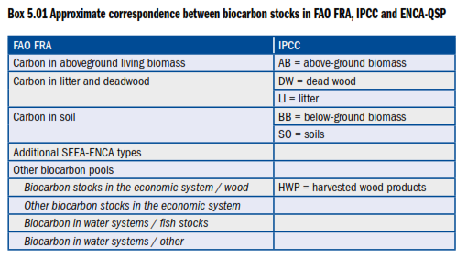
Source: ENCA-QSP p. 110

At the UNFCCC COP 21 in Paris, cross-cutting elements have been agreed upon such as:
- Para. 55. “…the importance of adequate and predictable financial resources, including for results-based payments, as appropriate, for the implementation of policy approaches and positive incentives for reducing emissions from deforestation and forest degradation, and the role of conservation, sustainable management of forests and enhancement of forest carbon stocks; as well as alternative policy approaches, such as joint mitigation and adaptation approaches for the integral and sustainable management of forests; while reaffirming the importance of non-carbon benefits associated with such approaches”.

- Article 5 GHG sinks:
“1. Parties should take action to conserve and enhance, as appropriate, sinks and reservoirs of greenhouse gases as referred to in Article 4, paragraph 1(d), of the Convention, including forests.”
- Article 7 Adaptation:
“9.(e) Building the resilience of socioeconomic and ecological systems, including through economic diversification and sustainable management of natural resources.”
Biodiversity is mentioned once; Water and Desertification not at all.
Ecosystem accounts correctly connected or bridged to UNFCCC concepts can be of important usefulness for future climate change policies.

  - UNCCD

“As the environmental realities of the 21st century become clear, we must recognize the stark fact that our global lands are fixed in quantity although not in quality. This simple fact is a compelling argument for us to become agents of change and begin managing our land in a manner that reflects its central importance to our future survival on this planet. Land and land resources (i.e., soil, water and biodiversity) underwrite the ability to grow, prosper, and sustain our very existence.”

The UNCCD overarching target of Land Neutral Development is very close to the measurement objective of ecosystem accounts. Land is firstly considered in the broad sense as a potential to deliver food, sustain populations and habitats. The systemic, holistic vision is highlighted in Figure 2, above. One major attribute of land is soil which fertility supports agriculture, populations, and natural habitats and biodiversity, which corresponds closely to the concept of socio-ecological systems central in ENCA-QSP. The emphasis on soil and soil carbon is taken in ENCA-QSP with the recording of the balancing item of “Net Ecosystem Carbon Balance” and its double calculation in terms of stocks and of flows, needed to overcome present data limitations.
“Ensuring full accounting of soil organic carbon as a terrestrial carbon sink under a future climate agreement is both essential and feasible.
- Soil organic carbon as an indicator contributes an essential but elusive component to the measurement of progress towards the implementation of all three Rio conventions as well as meeting the Sustainable Development Goals (SDG) on Land Degradation Neutrality (LDN) and climate change.
- The necessary local, national and global soil organic carbon assessment methods and models currently under development need to be implemented in a coordinated, harmonized fashion, and contributing data collection, analysis and reporting networks need to be established.
- Even though the approaches to monitoring and assessment of each of the three Rio conventions differ, the integrative potential of soil organic carbon has been demonstrated, and achieving that integration is operationally feasible.”

The relatively small set of CCD “progress indicators” is prone at being derived in most cases for from ENCA-QSP, and if relevant detailed according to needs.
- Trends in access to safe drinking water in affected areas
- Trends in land cover
- Trends in land productivity or functioning of the land Indicator
- Trends in carbon stocks above and below ground
- Trends in abundance and distribution of selected species

Box 2 UNCCD Progress Indicators 2013
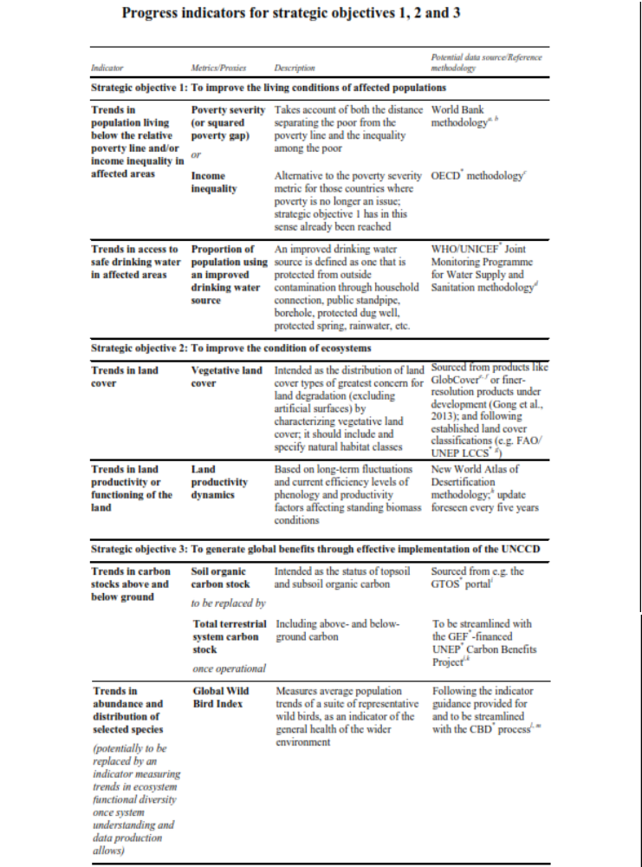
Source: UNCCD COP11, Windhoek 2013, ICCD COP(11)/23/Add.1, pp. 82, 83

The UNCCD is paying high attention to the interactions between their targets and those of the two other Rio Conventions and the SDG.
With the Paris climate agreement (UNFCCC COP 21), the UNCCD secretariat together with the Science-Policy Interface (SPI) has released two publications, highlighting the potential for and benefits of land-based action in the fight against climate change.
"Land matters for climate: Reducing the gap and approaching the target" highlights the significant (and only marginally tapped) potential of the land sector for reducing emissions and sequestering carbon in soils and biomass. Achieving Land Degradation Neutrality (LDN) through sustainable land management and the restoration of degraded lands holds a mitigation potential of up to 3.3 GtCO2e per year. Exploiting this potential could be a key element for future climate action. Current climate policies and reduction pledges (INDCs) unfortunately fall short of halting climate change. Additional emission reductions of 13 GtCO2e/yr are needed to limit global warming to 2°C - this is the so-called emissions gap. Harnessing the climate benefits of LDN could reduce the emissions gap by 25%. It emphasizes that land-based mitigation comes at comparatively low costs and offers significant benefits for food security and climate change adaptation.
"Pivotal Soil Carbon", the first Science Policy Brief by the Science-Policy Interface (SPI)​, gives a brief overview of the key role of soil carbon in climate change mitigation and adaptation, soil fertility and biodiversity conservation. Soils are by far the largest terrestrial store of carbon, however soils of the world´s agroecosystems have lost up to 75% of their original organic carbon. This loss can be restored through sustainable land management and rehabilitation activities, giving multiple benefits; including climate change mitigation and adaptation, biodiversity and food security.
Soil and land role in achieving the SDGs has been analyzed comprehensively by the UNCCD. It is summarized in Figure 4.

Figure 4 Roles and interlinkages of soils and land in the Sustainable Development Goals
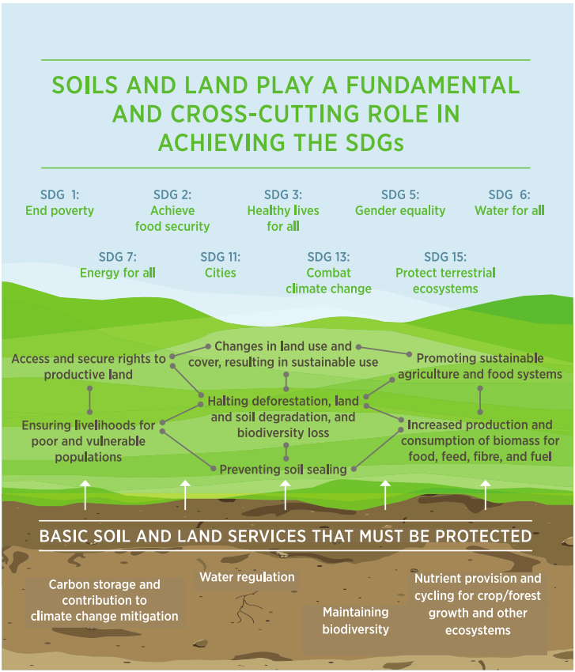
Institute for the Advancement of Sustainability Studies (IASS) (2015) – Policy Brief
presented at Global Soil Week, Berlin, 2015, quoted in

  - CBD

In a first instance, the analysis restricts to the presentation of a box extracted from the CBD TS77 on ENCA-QSP. In addition to that, ecosystem services mapping following the EU MAES methodology could be a suggestion.

Box 4 Implications of the CBD guidance for the design of ENCA-QSP
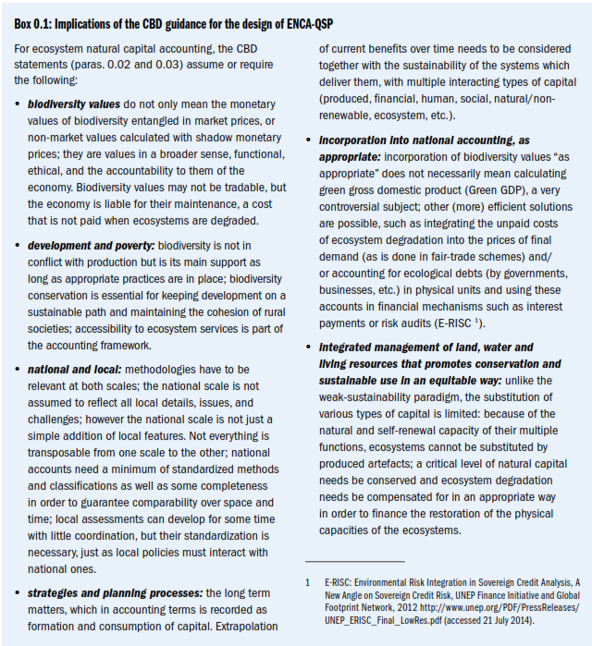

Biodiversity indicators are a domain where ecosystem accounts are clients of observation networks. The specific contribution of accounts here is in integration with the other data needed to understand biodiversity condition and trends.
GEO BON (the Group on Earth Observations / Biodiversity Observation Network) has recently presented “Global Biodiversity Change Indicators/ Model-based integration of remote-sensing & in situ observations that enables dynamic updates and transparency at low cost” to the CBD AHTEG, (the Ad Hoc Technical Expert Group on Indicators for the Strategic Plan for Biodiversity 2011-2020 (Aichi Targets).
The indicators, developed in collaboration with GEO BON partners Map of Life and CSIRO, were the Species Habitat Indices (Target 5 and 12), the Biodiversity Habitat Index (Target 5), the Species Protection Index Target 11), the Protected Area Representativeness and Connectedness Indices (Target 11), the Global Ecosystem Restoration Index (Target 15), and the Species Status Information Index (Target 19). They are based on global datasets for 4 EBVs: Species Distributions, Taxonomic Diversity (gamma diversity), Ecosystem Extent, and Primary Productivity. The indicators were very well received at the AHTEG, and were adopted as specific examples of indicators for these targets. They also illustrate the power of EBVs as a modelled layer between direct observations and indicators and its potential to generate global indicators and spatial explicit datasets.
  - SDGs

Beyond the general interest of being able to interpret SDG indicators within a comprehensive framework (see sections 2 and 3, above), an analysis of the correspondence of individual SDG indicators and SEEA variables shows where synergies exist and should be considered for a cost effective implementation of both frameworks. Where the SEEA has gained sufficient empirical achievement (emissions of GHGs by ISIC branches, material flow accounts, environmental protection and management expenditures…) an alignment can be considered. In other cases, the same data source (e.g. IUCN Red Lists) is proposed and further integration has to be considered in the context of ongoing research, in particular when it relates to the SEEA-EEA which is not a standard at this stage.
The analysis below makes an extensive use of the assessment carried out by the UNCEEA secretariat in their “Comments to the IAEG” on SDG indicators en of 2015. The list of SDG indicators is not yet fixed and the table below refers to that which has been presented to the UN Statistical Commission meeting of March 2016. This (long) list of SDG indicators have been assessed by the Atkinson Group which presents indicators according to domains and purposes, with a clear identification of what relates to “green economy”.
The Atkinson Group Blue Paper comes to the summary table of Box 5:
Box 5 – Proportion of “Green Economy” indicators in SDG indicators.
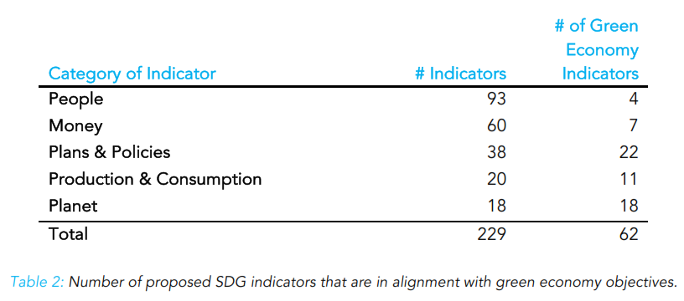
(Source: AtKinson Group Blue Paper, op. cit.)

In the AtKinson Group typology, “People” are indicators expressed in terms of human beings, “Money” are indicators expressed in terms of their monetary value, “Plans & Policies” are indicators that check for the presence of a plan, policy, law, etc., and/or its level of implementation, “Production & Consumption” are indicators expressed in units related to the flow of energy and materials in the global economy and “Planet” are indicators measuring the actual physical systems of the Earth, such as water, land, and species.

Box 6 - Indicative correspondence of SDG Indicators (green list) to SEEA definitions.
(Table based on the UNCEEA secretariat analysis and the AtKinson Group Blue Paper presentation)

AtKisson Group “Green Economy Indicators” | Relevance to SEEA accounts | UNCEEA secretariat  Comments on IAEG-SDG Indicators | Remarks
INDICATORS MEASURED IN TERMS OF PEOPLE
5.a.1 (a) Percentage of people with ownership or secure rights over agricultural land (out of total agricultural population), by sex; and (b) share of women among owners or rights- bearers of agricultural land, by type of tenure | NO
6.1.1 Percentage of population using safely managed drinking water services | MAYBE |  | This should be put for consideration in a future SEEA revision.
6.2.1 Percentage of population using safely managed sanitation services, including a hand- washing facility with soap and water | NO
7.1.2 Percentage of population with primary reliance on clean fuels and technology | NO
INDICATORS MEASURED IN TERMS OF MONEY
6.a - ODA for water and sanitation related activities and programmes | NO | The indicator should be defined as:  Total environmental subsidies or similar transfers paid by the government and received by the rest of the world related to water and sanitation.  CEA: classification of environmental activities:  -- CEA class 2: Wastewater management (=CEPA3)  -- CEA class 14: Management of water resources (=CReMA14) | The UNCEEA Comment is very appropriate and highlights the interest of an Environmental Protection Expenditures Account (EPEA).
7.3.1 Energy intensity measured in terms of primary energy and gross domestic product (GDP) | YES | The indicator should be defined as:  Ratio of energy end-use by industries to gross value added by industries at constant prices. Energy end use is defined as the use of energy products in producing goods and services (intermediate consumption of energy by industry). | No comment.
7.a - Mobilized amount of USD per year starting in 2020 accountable towards the USD 100 billion commitment  (not in AtKinson) | YES | The Classification on spending on climate and air emissions as part of the 100 billion dollar commitment should use the Classification of Environmental Activities (see SEEA 2012) | Part of a conventional satellite account of environmental protection expenditures (EPEA).  CEA/CEPA class need to be specified.
11.4 - Share of national (or municipal) budget which is dedicated to preservation, protection and conservation of national cultural and natural heritage including World Heritage sites | YES | The indicator should be defined as:  Total environmental protection expenditure by the government for protection of biodiversity and landscapes  CEA class 6: Protection of biodiversity and landscapes (=CEPA6) | Part of a conventional satellite account of environmental protection expenditures (EPEA).  Surprisingly, UNCEEA COMMENT states that cultural heritage sites are ecosystem assets; they are certainly part of some of them but cultural heritage is going beyond that. Anyway, an EPEA for Natural heritage sites would be extremely useful and meet BioFin requests.
11.c - Percentage of financial support that is allocated to the construction and retrofitting of sustainable, resilient and resource-efficient buildings | YES | The Indicator could be aligned with the SEEA methodology. | And the SEEA-CF methodology detailed to make more explicit these expenditures... Another area for a comprehensive EPEA.
12.c.1 Amount of fossil-fuel subsidies per unit of GDP (production and consumption) and as a proportion of total national expenditure on fossil fuels | YES | No proposal | Fossil fuel subsidies could (should) be recorded in an EPEA covering resource management expenditure.
14.6.1* Dollar value of negative fishery subsidies against 2015 baseline | YES | Indicator could be aligned with the SEEA where possible. Although the SEEA Central Framework does not provide a definition for negative or potentially environmental damaging subsidies, it provides a measurement framework to record the subsidies for environment protection and resource management purpose. Further disaggregation may be needed for negative fishery subsidies depending on how they are defined. | Negative fishery subsidies are “subsidies… for resource management purpose”. They can be recorded in an appropriate EPEA.
14.7 Fisheries as a % of GDP | YES | No change to indicator name suggested. The SNA and SEEA Central Framework provide information on the contribution to GDP of fisheries. | No comments
14.a - Budget allocation to research in the field of sustainable marine technology as a percentage of all research in field of marine technology | YES | Indicator should be aligned with the SEEA, but there is a need to further develop the term "sustainable marine technology", because currently it is not available in the Classification of Environmental Activities (CEA). | Another area where EPEA would be helpful.
15.7.2* Proportion of detected trade in wildlife and wildlife products that is illegal | MAYBE
15.a.1 Official development assistance and public expenditure on conservation and sustainable use of biodiversity and ecosystems | YES | Suggest changing indicator to:  Expenditures for the protection and conservation of biodiversity and ecosystems.  Expenditures would include both ODA as well as national expenditures covering protection of biodiversity and ecosystem.  One module of the SEEA is the Environmental Protection and Resource Management Accounts which will provide information on total expenditures for biodiversity and ecosystems. | Excellent proposal which shows again the value added of an EPEA for the SDGs and beyond.
15.b.1* Forestry official development assistance and forestry foreign direct investment | YES | The indicator should be defined as:  Total subsidies or similar transfers paid by the government and received by the rest of the world related to forestry ( COFOG 4.2.2, CEA11) | Should be recorded in the same way as 15.a.1 in the EPEA.
15.c.1* Proportion of detected trade in wildlife and wildlife products that is illegal | MAYBE
17.19.2* Inclusive Wealth Index | NO |  | This is the result of an economy assessment making use of statistics and accounts (where they exist) and of a model with strong assumption. It is not accounting as such.
17.9.1* The dollar value of financial and technical assistance, including through North-South, South- South and triangular cooperation, committed to developing countries’ designing and implementing a holistic policy mix that aims at sustainable development in three dimensions (including elements such as reducing inequality within a country and governance) | NO
INDICATORS MEASURED IN TERMS OF PLANS AND POLICIES
1.b.1* Number of national action plans related to multilateral environmental agreements that support accelerated investment in actions that eradicate poverty and sustainably use natural resources | NO
5.a.2 Percentage of countries where the legal framework (including customary law) guarantees women’s equal rights to land ownership and/or control | NO
6.5 By 2030, implement integrated water resources management at all levels, including through transboundary cooperation as appropriate | MAYBE | Not mentioned | Appropriate water accounts including correct assessment of exploitable water including limitations due to legal constraints (e.g. environment protection) and international water sharing agreements can efficiently support such cooperation. See AQUASTAT for definitions. ENCA-QSP follows the same approach as FAO for calculating exploitable (or accessible) resource.
6.5.1* Degree of integrated water resources management implementation (0-100) | NO
6.b.1 Percentage of local administrative units with established and operational policies and procedures for participation of local communities in water and sanitation management | NO
12.1.1 Number of countries with sustainable consumption and production (SCP) national action plans or SCP mainstreamed as a priority or target into national policies | NO
12.4.1 Number of parties to international multilateral environmental agreements on hazardous and other chemicals and waste that meet their commitments and obligations in transmitting information as required by each relevant agreement | NO
12.6.1 Number of companies publishing sustainability reports | NO
12.7.1 Number of countries implementing sustainable public procurement policies and action plans | NO
12.8.1* Percentage of educational institutions with formal and informal education curricula on sustainable development and lifestyle topics | NO
12.a.1* Number of qualified green patent applications over total | NO
13.2.1* Number of countries that have formally communicated the establishment of integrated low- carbon, climate-resilient, disaster risk reduction development strategies (e.g. a national adaptation plan process, national policies and measures to promote the transition to environmentally friendly substances and technologies) | NO
13.3.1* Number of countries that have integrated mitigation, adaptation, impact reduction and early warning into primary, secondary and tertiary curricula | NO
13.b.1* Number of least developed countries and small island developing States that are receiving specialized support for mechanisms for raising capacities for effective climate change-related planning and management, including focusing on women, youth, local and marginalized communities | NO
14.2.1* Percentage of coastal and marine development with formulated or implemented integrated coastal management/maritime spatial planning plans (that are harmonized where applicable), based on an ecosystem approach, that builds resilient human communities and ecosystems and provides for equitable benefit sharing and decent work | NO
14.b.1* Proportion of national fishery production by country that are catches by small medium fishery businesses OR Progress by countries in adopting and implementing legal/regulatory/policy/institutional framework which recognizes and protects access rights for small-scale fisheries | MAYBE |  | It should be considered as a subdivision of fish catches in fisheries accounts.
14.c.1* Number of countries implementing either legally or programmatically the provisions set out in regional seas protocols and ratification and implementation of the ILO maritime and fisheries conventions | NO
15.4.1 - Coverage of protected areas of important sites for mountain biodiversity | YES | This indicator should be defined as :  Mountain protected areas as a percentage of total mountain area. | It is unclear what can be the SEEA contribution here as protected areas data come from exogenous sources (WDPA...) and that there is no definition of mountains in the SEEA.
15.6.1* Number of permits or their equivalents made available to the Access and Benefit sharing Clearing- House established under the Nagoya Protocol on Access and Benefit sharing and number of standard material transfer agreements, as communicated to the Governing Body of the International Treaty on Plant Genetic Resources for Food and Agriculture 15.8.1* Adoption of national legislation relevant to the prevention or control of invasive alien species | NO
15.9.1* Number of national development plans and processes integrating biodiversity and ecosystem services values | NO | The topic "biodiversity and ecosystem values" is strongly related with the SEEA Experimental Ecosystem Accounting and their implementation. This indicator could be developed where the SEEA can provide important contextual information but further work is needed. The SEEA Experimental Ecosystem Accounting provides methodology in integrating biodiversity and ecosystem services values into standard economic data including the national accounts. | Unclear. The SDG indicator refers to “plans and processes”, not to the value of ecosystem services.
17.14.1* Number of countries that have ratified and implemented relevant international instruments under the International Maritime Organization (safety, security, environmental protection, civil liability, and compensation and insurance) and the fundamental conventions and recommendations of ILO, and that have adopted carbon pricing mechanisms | NO
INDICATORS MEASURED IN TERMS OF PRODUCTION AND CONSUMPTION
2.4 - Percentage of agricultural area under sustainable agricultural practices. | MAYBE | The land use classification in the SEEA Central Framework provides an agreed method in classifying agricultural area. | The SEEA land use classification has been defined by FAO and is at the core of the SEEA-Agriculture/Forestry/Fisheries under development.  Sustainable agriculture practices are not defined in the SEEA CF or EEA. Degradation of agriculture land is addressed in the SEEA-EEA and in ENCA-QSP. However, all degradation cannot be assigned to practices. FAO statistics are the only source at this stage.
2.4.3* Percentage of agricultural households using eco-friendly fertilizers compared to all agricultural households using fertilizers | NO | Not addressed | Unclear. Why only agricultural households?
2.5.2* Percentage of local crops and breeds and their wild relatives, classified as being at risk, not-at-risk or at an unknown level of risk of extinction | MAYBE | Not addressed | Part of a biodiversity index of agriculture systems.
6.3.1 Percentage of wastewater safely treated | YES | Safely treated should be defined according to SEEA treatment ladders (of primary, secondary and tertiary treatment). Disaggregation should be according to ISIC. The indicator should be calculated as follows: Total Wastewater Generated that undergoes [primary/secondary/tertiary] treatment / Total Wastewater Generated.
6.4.1* Percentage change in water use efficiency over time | YES | The indicator should be defined in terms of value added across all "sectors". Similarly the same measure for "water use" should be applied to all "sectors'. The indicator should be disaggregated by economic activity according to ISIC.  We recommend the following definitions: Sectoral: Total Water Use (by ISIC) / Value Added (by ISIC) Aggregate: Total Water Use / GDP  Note that Total Water Use can be replaced with 'Total Water Consumption' or 'Total Water Abstraction' depending on policy preference, BUT the same should be applied to all sectors.
7.2.1 Renewable energy share in the total final energy consumption | YES | 7.2 The indicator should be defined as:  Share of the supply of energy from renewable sources in gross energy input | Consumption not specifically addressed by UNCEEA COMMENT but can be defined as well as 7.2.1 from the SEEA and Energy balances.
8.4 Improve progressively, through 2030, global resource efficiency in consumption and production and endeavour to decouple economic growth from environmental degradation,  8.4.1 Material footprint, material footprint per capita, and material  footprint per GDP  8.4.2 Domestic material consumption, domestic material consumption per capita, and domestic material consumption per GDP |  | 'Resource productivity' as well as 'national material efficiency (consumption approach)' should be defined as:  Gross domestic product in market prices (GDP) / Domestic Material Consumption (DMC)  The unit is $ per kilogram.  DMC represents the material actually used in a national economy. | The SDGs approach in terms of Material Footprint or synonymous Raw Material Consumption (RMC) is more appropriate than DMC. See ongoing work at Eurostat or a recent and conclusive paper on “The material footprint of nations” by Wiedman et al. in the PNAS http://www.pnas.org/content/112/20/6271.full  DMC is misleading as only the mass of imported products is recorded, not the mass of the intermediate consumption needed in the exporting country. The SEEA CF should be revised on this point. [NB: for 12.2.1 below, the possibility of deriving RMC from the SEAA is acknowledged by UNCEEA COMMENT]
11.6.1 Percentage of urban solid waste regularly collected and with adequate final discharge with regard to the total waste generated by the city |  | The indicator should be defined as follows: Percentage of solid waste that is (regularly) collected and (well) managed = Total use of waste by the waste collection, treatment and supply industry / Total Generation of Solid Waste  To define this indicator, 'urban', 'regularly collected' and 'well managed' would need to be further clarified. | The SEEA CF waste account is relevant although clarifications are still needed. The term “municipal” should be preferred to “urban”.
12.2.1* Material footprint and material footprint per capita |  | The 'material footprint (MF)' may be defined as the raw material extraction equivalents (RME) necessary to produce goods and services for domestic final use (final household consumption, final government consumption, gross fixed capital formation). At economy-wide level indicator has been termed raw material consumption (RMC) and it can be considered aligned to SEEA-CF although it is not explicitly mentioned.  Another more SEEA aligned indicator would be domestic material consumption (DMC), which is derived from economy-wide material flow accounts (see SEEA-CF section 3.6.6). | Preference has to be given to RMC. See discussion of 8.4
12.3.1 Global food loss index | NO
12.4.2* Treatment of waste, generation of hazardous waste, hazardous waste management, by type of treatment | YES | No addressed in UNCEEA cooments | Difficult issue which should be part of the SEEA-CF waste account.
12.b - Residual flows generated as a result of tourism direct GDP (derived from an extended version of the System of Environmental-Economic Accounting (SEEA) for tourism) | MAYBE | Suggest changing this indicator to:  Air emissions in (selected) tourism industries  and if data allows:  Direct air emissions intensity for (selected) tourism industries | Not in the March 2016 SDGs indicators list, 12.b. Anyway, proposal incomplete as solid waste and waste water are issues with tourism.
12.5 - National Recycling Rate, tonnes of material recycled. | YES | The indicator should be defined as follows: National Recycling Rate = Recycling and reused amounts of solid waste / Total Generation of Solid Waste  -- The amounts of recycled and reused solid waste still need to be defined in the SEEA. One possibility is to use well defined 4-digit classes of CPC division 39.  -- The total generation of waste is derivable from SEEA-CF Table. 3.9, left hand p. 90. | A well known issue when defining recycling which depends from prices and demand of raw materials.
12.5.1 National recycling rate, tons of material recycled | YES | Same as above
14.1.1* Nitrogen use efficiency composite indicator | MAYBE | In SEEA, efficiency indicator relates the use of input to the related economic output. Nitrogen use efficiency indicators can be categorized as intensity indicators (i.e. ratio of the nitrogen use to the measure of economic activity such as volume of agriculture product) or the productivity indicators (reverse of intensity). | Unclear proposal.
INDICATORS MEASURED IN TERMS OF THE PLANET (BIOPHYSICAL SYSTEMS)
2.4.1* Percentage of agricultural area under sustainable agricultural practices | MAYBE | The land use classification in the SEEA Central Framework provides an agreed method in classifying agricultural area. | The SEEA land use classification has been defined by FAO and is at the core of the SEEA-Agriculture/Forestry/Fisheries under development.  Sustainable agriculture practices are not defined in the SEEA CF or EEA. Degradation of agriculture land is addressed in the SEEA-EEA and in ENCA-QSP. However, all degradation cannot be assigned to practices. FAO statistics are the only source at this stage.
6.3.2 Percentage of bodies of water with good ambient water quality | YES | Not addressed in UNCEEA Comment | Addressed in ENCA-QSP
6.4.2* Percentage of total available water resources used, taking environmental water requirements into account (level of water stress) | YES | Not addressed in UNCEEA Comment | Addressed in ENCA-QSP as “accessible water”(which corresponds to FAO AQUASTAT exploitable resource)
6.6.1 Percentage of change in the extent of water- related ecosystems over time | YES | 6.6. 'Freshwater ecosystems' include wetlands, rivers, lakes, reservoirs etc, each of which needs specific consideration for estimating a proper indicator, related to ecosystem extent or condition, or both.  Land accounts address 'inland water bodies'. Ecosystem extent accounts can differentiate further rivers, lakes and wetlands. The exact parameters for measuring extent and condition of each of the freshwater ecosystems need further work.  Standard definitions of "river ecosystem" and "lake ecosystem” need to be agreed. | 6.6 Target refers to “By 2020, protect and restore water-related ecosystems, including mountains, forests, wetlands, rivers, aquifers and lakes”. The reference to the very extensive Ramsar definition of wetlands is not fully appropriate regarding coastal water and very artificial reservoirs that it includes.  Standard definition: The SEEA-Water, in its water quality chapter includes a definition of rivers as a hierarchical set of connected reaches. It includes as well a metric to measure them. This definition and methodology is used in the ENCA-QSP manual in the chapters which cover “water” and “river systems”.
9.4 - Carbon emission per unit of value added |  | Agreement in UNCEEA Comment | 9.4 addressed in UNCEEA Comment as “carbon” emissions, not by AtKins. Beyond the terminology simplification (CO2eq being the right concept), the distinction between “net” emissions and other anthropogenic losses of carbon is not done here (soil sealing, soil erosion, some “involuntary” forest fires...) . It is done in ENCA-QSP.
9.4.1 CO2 emission per unit of value added | YES
11.3.1 Ratio of land consumption rate to population growth rate | YES | Not addressed | Can be derived from land cover accounts and demographic statistics. Land consumption need be specified. Development of artificial land in every case. Agriculture?
11.6.2 Annual mean levels of fine particulate matter (e.g. PM2.5 and PM10) in cities (population weighted) | YES |  | This is an indicator of the condition of urban ecosystems.
11.7.1 The average share of the built-up area of cities that is open space for public use for all, disaggregated by age group, sex and persons with disabilities | YES (for part) |  | Not clear. Access to open space in cities can be derived from ecosystem accounts as presented in ENCA-QSP; public use by categories requires additional information.
14.3.1 Average marine acidity (pH) measured at agreed suite of representative sampling stations | NO
14.4.1* Proportion of fish stocks within biologically sustainable levels |  | Fish stocks - The International Standard Statistical Classification of Fishery Commodities (ISSCFC) provides an exhaustive list of fish products categorized by 12 major groups.  Biologically sustainable level : Sustainable yield is the surplus of excess of animals or plants that may be removed from a population without affecting the capacity of the population to regenerate itself (SEEA 2012 Central Framework) | Developed in the FAO SEEA-Agriculture/Forestry/Fisheries.
14.5.1 Coverage of protected areas in relation to marine areas |  | This indicator should be defined as  Coastal and marine protected areas as a percentage of total coastal and marine area.  Reference done to the SEEA Land use classification | In this domain, the SEEA is the user of data and classifications produced by others, at national level and compiled into international databases, in particular the IUCN and UNEP/WCMC World Data Base on Protected Areas WDPA. The indicator target is marine areas. A clear distinction is needed between coastal marine areas and open sea. Last, the SEEA Land Use classification covers only land and inland water, not the marine coastal areas.
15.1.1* Forest area as a percentage of total land area |  | Indicators should be developed in alignment with SEEA Land Cover or Land Use Account depending on which definition is used .The land cover and land use classification in the SEEA Central Framework provides an agreed method in classifying land cover dominated by natural tree plants of more than 10 percent or more and land use for forestry respectively. Through these accounting entries, the indicator on forest area as a percentage of total land area can be derived as well as the change for a given period of time. | Forests assessments by FAO (FRA) are important sources of information, available every 5th year at the global scale. FAO definitions have been retained in the SEEA and are a good source for SDG 15.1.
15.2.1* Forest cover under sustainable forest management | YES | Forest areas can be measured in the context of SEEA Land Cover or Land Use Account depending on which definition is used .The land cover and land use classification in the SEEA Central Framework provides an agreed method in classifying land cover dominated by natural tree plants of more than 10 percent or more and land use for forestry respectively. Through these accounting entries, the indicator on forest area as a percentage of total land area can be derived as well as the change for a given period of time.
15.2.2 Net permanent forest loss | MAYBE | Not addressed | Unclear what means “permanent”. If it means “deforestation” (forest replaced permanently by another land cover) as opposed to felling followed by replantation, the indicator can be derived form a series of land cover accounts.
15.3.1* Percentage of land that is degraded over total land area | YES | Indicator could be aligned with SEEA methodology but further work is needed. The ecosystem conditions account in the SEEA Experimental Ecosystem Accounting provides methodology in measuring conditions for and the services generated by ecosystem assets (defined as designated spatial areas). This in turn can provide time series information on ecosystem conditions and services of the designated spatial areas and thereby informing trends in land degradation. | Unclear UNCEEA secretariat comment which acknowledges that further work is needed. Their definition of ecosystem designated spatial areas is unusual and in contradiction with the SEEA-EEA which aims at covering all ecosystems.  Land degradation in the UN CCD sense includes biomass productivity and stocks. In the narrow sense, land degradation can be measured as a loss of potential of ecological landscapes. This is proposed in the ENCA-QSP manual as Net Landscape Ecosystem Potential. ENCA-QSP proposes the calculation of a more comprehensive composite indicator of ecosystem total capability which in addition to landscape degradation includes biomass stocks and productivity
15.4.1 - Coverage of protected areas of important sites for mountain biodiversity | YES | This indicator should be defined as  Mountain protected areas as a percentage of total mountain area. | It is unclear what can be the SEEA contribution here as protected areas data come from exogenous sources (WDPA...) and that there is no definition of mountains.
15.4.2 Mountain Green Cover Index | MAYBE | Indicators should be developed in alignment with the Ecosystem Conditions and Extent Account of the SEEA Experimental Ecosystem Accounting, which accounts for changes in ecosystem conditions and extent including the characteristics of vegetation for the mountain areas.  Land occupied by 'green' land cover types such as forest, shrublands, grasslands can be potentially applied for this index. | Unclear proposal. What about conversion of forests to grassland? No definition of a mountain in the SEEA.
15.5.1 Red List Index | MAYBE | Indicator should be developed in alignment with the Biodiversity Account of the SEEA Experimental Ecosystem Accounting, which accounts for the status of threaten species as defined by IUCN Red List categories and related criteria | In this case, SEEA-EEA is client of IUCN data. There is no value added.
15.7.1* Red List Index for species in trade | NO

This assessment shows interestingly where the SEEA is prone at making its most genuine contribution. They are basically two:

- The indicators which need be related to industrial activities, therefore to ISIC and which are supply and use of materials: material flows derived indicators, waste generation, GHG emissions, water use, energy use…
- Indicators of actual expenditures for environmental protection and (sustainable) resource management, which can be identified 9 times in the table. In an analysis focused on policies (instead of variables as in the present table), more applications could resort from expenditure accounts, which are a very practical way to assess the efforts undertaken by society.
- Identification of short term indicators: being SMART

“The proposed indicators will need to meet the usual SMART criteria (Specific, Measurable, Attainable, Relevant, Time bound) in addition to demonstrating methodological soundness, and be easy to understand and communicate.” (TOR of this study)

Because they correspond at some stage to a policy process, indicators generate long discussions, negotiations... and frequent revisions. The reference to SMART may help easing the trap if not escaping it. Particular attention in this exercise should be given to the possibility of achieving practical results, even though in a limited number of domains only. Three conditions (at least) must be met:

- Policy relevance, checked against explicit policy targets, with the purpose of being effective on the particular point, not simply illustrative.
- Existence of fairly developed methodologies: in the case of accounting, it means having at disposition accounting tables with explicit balancing items (which policy relevance needs being assessed) and clear measurement units allowing computing totals.
- Data available for producing and updating accounts (statistics, geo-data, monitoring data...). At this stage, perfection should not be seek, robustness and clarity instead. With time, progress comes, sometimes more quickly than expected, alongside unexpected ways such as algorithmic extraction of information from “big data”.

A first list of short term indicators can be set at the end of this feasibility study. They correspond to 3 types of accounts:

  - Material/energy flows aligned to SNA definitions and classifications

This group of variables is presented here to a large part per memory as they are defined in the SEEA-CF context in relation to economic sectors, not to ecosystems.

- Emissions of GHGs by economic industries (ISIC) to bridge IPCC to SNA; Eurostat methodology or similar.
- Energy use (SEEA-CF 3.4 Physical flow accounts for energy).
- Material Flows Accounts: OECD-Eurostat methodologies are available and referenced in the SEEA-CF. The Raw Material Consumption index also called Material Footprint, has to be preferred to the Direct Material Consumption index which ignores the impacts on land from countries from which products are imported.
- Supply and Use of water can be added to this list, under the reservation of clarification of possible differences between the calculation of the water resource in the SEEA and in FAO AQUASTAT.
  - Accounts of national expenditure related to the implementation of the 3 Conventions and in support to SDGs.

As mentioned at the end of the SDGs/SEEA analysis, there is a clear demand for expenditure data as a way to assess policies implementation and societal efforts. This is confirmed by the implementation of UNDP BioFin programme which aims at accounting for habitats protection costs. Environmental protection expenditures are for a large part spent on specific areas (parks, reserves, river basins etc...) and can be usefully combined with ecosystem accounts for policy analysis. On that line, BioFin intends to supplement biodiversity protection expenditure with biophysical indicators to assess the effectiveness of the money spent for that purpose.
Reading the planned SDGs indicators for expenditure shows that the issue is addressed on an ad hoc basis, with insufficient consideration for the broad picture. This is an area where accounts have important value added as they oblige to have a systematic recording of all economic flows. Therefore, if an activity is financed one year by a government, the year after by an international programme and later on by a company or a foundation, tack will be kept. It might not be the case if the focus is on governmental expenditure only, for example.
The clear added value of the SEEA here is to shift from partial measurement to a systematic compilation of all expenditure from central and local government as well as companies, households and non-profit organizations, including relations to the rest of the world. Domestic expenditure by private and public sectors, including inter-sector transfers (including taxes and subsidies) and transfers between country and the RoW are all recorded which allows calculation of aggregates such as the National Expenditure. The EPEA (Environmental Protection Expenditures Account) could be detailed to cover the needs of the 3 Rio Conventions and include prevention and management costs, nature monitoring and protection, disaster risk reduction.
Expenditures on biodiversity and ecosystems are included in the SEEA, in the Classification of Environmental Activities. In particular included are the following CEA (Environmental Protection and Resource Management) classes:

EP 4: Protection and remediation of soil, groundwater and surface water refers to measures and activities aimed at the prevention of pollutant infiltration, cleaning up of soils and water bodies and the protection of soil from erosion and other physical degradation as well as from salinization.
4.1 Prevention of pollutant infiltration
4.2 Cleaning up of soil and water bodies
4.3 Protection of soil from erosion and other physical degradation
4.4 Prevention and remediation of soil salinity
4.5 Measurement, control, laboratories and the like
4.6 Other activities

EP 6: Protection of biodiversity and landscape refers to measures and activities aimed at the protection and rehabilitation of fauna and flora species, ecosystems and habitats as well as the protection and rehabilitation of natural and semi-natural landscapes.
6.1 Protection and rehabilitation of species and habitats
6.2 Protection of natural and semi-natural landscapes
6.3 Measurement, control, laboratories and the like
6.4 Other activities

RM 13 Management of other biological resources (excluding timber and aquatic resources)
Includes the activities and actions aiming at minimizing the intake of biological resources other than timber and aquatic resources through in-process modifications as well as the use of alternative resources and any other kind of measure.
13.1 Reduction of the intake of biological resources
13.2 Replenishment of biological resources stocks
13.3 Measurement, control, laboratories and the like related to biological resources stocks
13.4 Other activities for the management of biological resources

The CEA could be detailed to cover the needs of the 3 Rio Conventions and include specific expenditure for prevention and management, nature monitoring and protection, or disaster risk reduction.
Implementation of SEEA-EPEA by National Statistical Offices, as an extension of their current activity in National Accounting should be considered as a (the) priority. The UN System of National Accounts 2008 (SNA 2008) includes a “Chapter 29: Satellite accounts and other extensions” where the SEEA is presented. Paragraphs 29.102 to 29.127 present the environment satellite account with some detail, forwarding for more to the SEEA manual.
  - Land cover accounts
Land cover monitoring plays a very specific role in information systems. Land cover is an image on what is on Earth, entangled ecosystems and anthropogenic systems. It can be monitored in many ways, from in situ monitoring, conventional statistical surveys by sampling, administrative data (cadastre), from aerial photos and last but not least, remote sensing by earth observation satellites. This last approach allows assessing land cover exhaustively, consistently and repeatedly – with spatial resolutions ranging from 1 km to a few meters and temporal resolutions from 1 month to 1 day. Land cover is important dimension of IPCC guidelines when coming to AFOLU (agriculture and forestry land use), UNCCD (as part of the indicator on land degradation) and CBD in several places.
The SEEA methodology for land cover accounting relies on the experiences of FAO on the one hand and of the European Environment Agency on the other hand and on the outcomes of their effort done during the SEEA revision to come to a unified view of land cover classification. An important point of agreement of FAO and the EEA is the need to monitor land cover change per se and not as the difference of two maps. The land cover types classification presented in the SEEA-CF is supplemented by a land cover ecosystem functional units (LCEFU) classification presented in the SEEA-EEA.
The ENCA-QSP manual follows the classification of land cover ecosystem units of the SEEA-EEA. Land cover accounts of stocks and flows and derived indicators, are developed following (and simplifying) the Land and Ecosystem Accounts (LEAC) methodology of the European Environment Agency. Land cover accounts for 34 countries are routinely produced since 2006 and cover years 1990, 2000, 2006, 2012 (an update for 2018 is in preparation). Out of Europe, the methodology has been successfully adopted in Burkina Faso with few modifications of the classification. Accounts at the country scale and for protected areas have been produced for two dates, 1992 and 2002. An update is foreseen with the high resolution land cover produced for year 2012.
In terms of indicators, ENC-QSP type accounts provide descriptive data of stock and changes of individual land cover types and in addition, a methodology to combine them altogether (using weighting factors differentiating types according to their greenness) and with data on high nature value (assessed from nature protection) and fragmentation by roads and railways. The resulting indicator is called Net Landscape Ecosystem Potential (NLEP). Change in NLEP is a way to measure landscape degradation or enhancement. The indicator can be mapped (at the scale of the land cover map) and aggregated by regions or countries. The methodology has been tested and meaning, advantages and limitations can be SMARTLY assessed on the basis of real data. NLEP is a third candidate for short term implementation.
- A research agenda

There is a SEEA research agenda and in parallel experiments taking place in different places and in contexts. These researches should pay priority attention to monitoring at the global scale the following variables which are highly important to supply ecosystem accounts meeting the needs of the 3 Rio Conventions and the SDGs.
- Land cover: monitoring land cover change is the key issue. Although it is possible to start with existing data, improvements are still needed and possible. FAO and the European Environment Agency do monitor land cover change separately from land cover stocks. Developing automated methodologies for land cover change detection, making full use of spatial and time resolutions is a priority.
- NPP and NEP. These are two essential variables of biomass productivity. NPP data at low resolution are provided by NASA or DLR. NEP, the Net Ecosystem Production is more problematic to estimate as it requires measuring the “heterotrophic respiration” (mostly the respiration of soil decomposers) for sampling is still insufficient. In agriculture, NEP is important element to assess net carbon sequestration from flows.
- Soil degradation by erosion and leakage of nutriments resulting from inappropriate land management (including some agriculture practices). This point is linked to the previous, soil science being at the core. Big data on farming practices may supplement traditional soil survey.
- Linked to b and c, carbon sequestration measurement (gross and net) should be unified.
- Atmosphere as ecosystem. The interactions atmosphere-land ecosystems mentioned for the measurement of ecosystem respiration and carbon sequestration is important cross-cutting domain.
- Forest monitoring is progressing fast, both with improved FAO FRA surveys and with remote sensing, globally (JAXA “Forest-Non Forest” products, University of Mariland + NASA “Global Forest Change”) and high resolution monitoring of REDD+ sites. Unification of approaches could deliver high quality data for SEEA and indicators.
- Water accounts: developing accounts for water bodies by river sub-basins, integrating quantity and quality, Blue/Green/Grey water (FAO-AQUASTAT, UNESCO Water-Footprint); measurement of water stress.
- Landscape/riverscape/seascape integrity, fragmentation
- Biodiversity – data mining of “big data” such as GBIF to go beyond conventional measurements of species biodiversity change.
- Natural disasters in particular linked to climate change
- Loss of critical ecosystem services: pollination, protection against floods, waste and waste water assimilation, provision of good quality fresh water...
- Social dimension of ecosystem accounting in relation to their use in support to the 3 Rio Conventions and the SDGs.

Concluding remarks
Beyond particular items, the overall perspective should be considered. The first point is that ecosystem accounting is at an experimental phase and that SEEA-CF accounts, regularly updated, exist only for a limited part of the scope and for a limited number of countries. Therefore, practical alignment is not easy to imagine as long as the accounting side has mostly to propose abstract definitions to actual data holders. The value added of the overall framework is therefore more important. When the overall purpose of measuring ecosystem degradation and the liability of economic sectors is accepted, then standards and norms on data exchange can be more easily shared. One particular characteristic of the ecosystem approach to natural capital accounting is that socio-ecological systems (SES) play an important role. SES is a broadly accepted paradigm in ecology and it echoes a range of settings, a famous one being in Japan the twin concepts of Satoyama and Satoumi. The status of such statistical units is unclear in the SEEA-EEA which considers only land cover functional ecosystem units and river basins. The ENCA-QSP manual introduces Socio-Ecological Units as a pivotal concept and proposes to start quickly a proxy methodology to map them from dominant landscape types. This methodology needs certainly further refinements. This point is not anecdotic as it poses the question of the integration of the social dimension in the SEEA from where it is broadly absent. This is reflected in the top of Box 5 where indicators in terms of People cannot be addressed. The same deficiency can be noted for the IPCC reporting (although we may expect that it will change when addressing adaptation issues). For obvious reasons UNCCD is attentive to the social dimension and recent publication highlight the linkage between migrations, conflicts and droughts in Africa and the Middle-East. The same could be said for the CBD which has acknowledged the place of people in ecosystems and achieved the adoption of the ABS protocol; however the scope could be enlarged to include more social behaviour.

Annex 1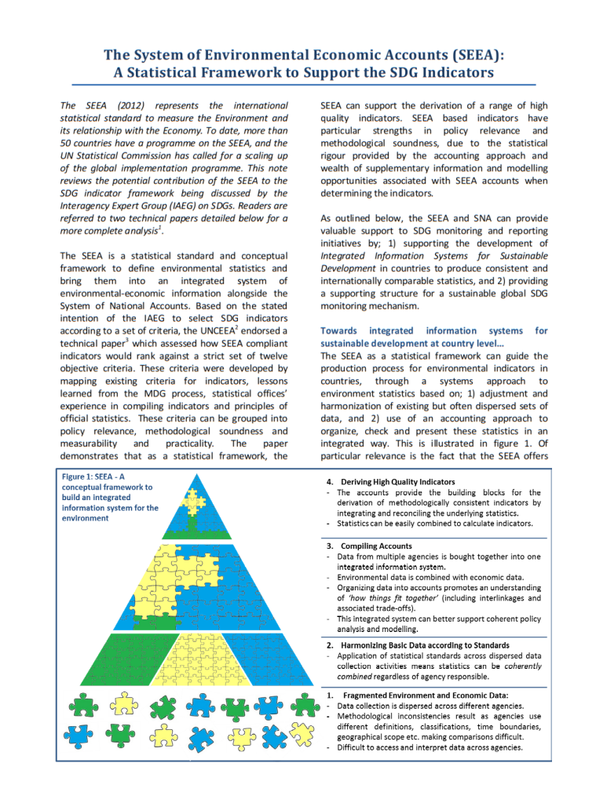
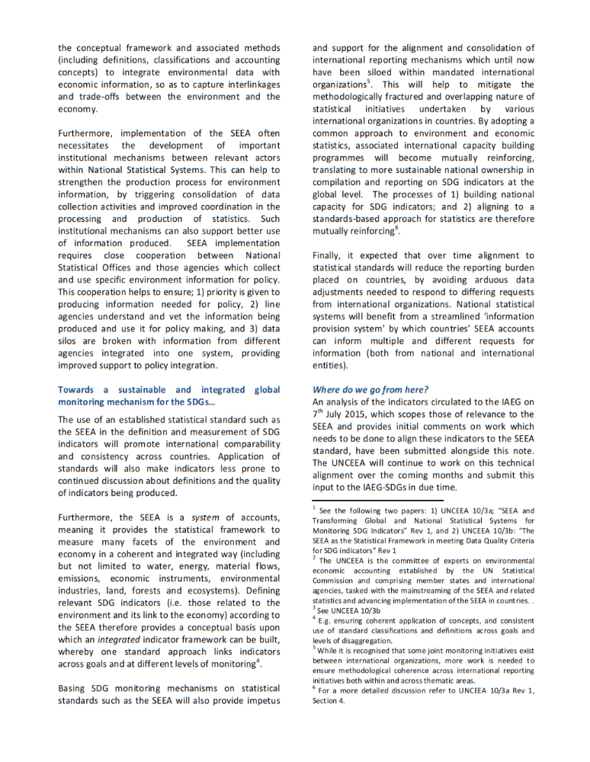

Annex 2
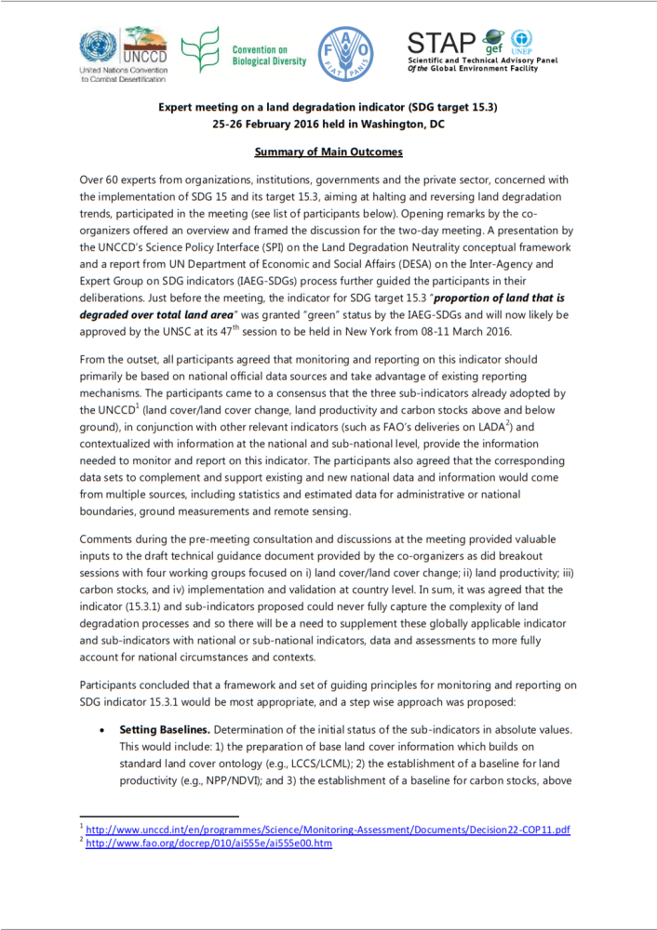
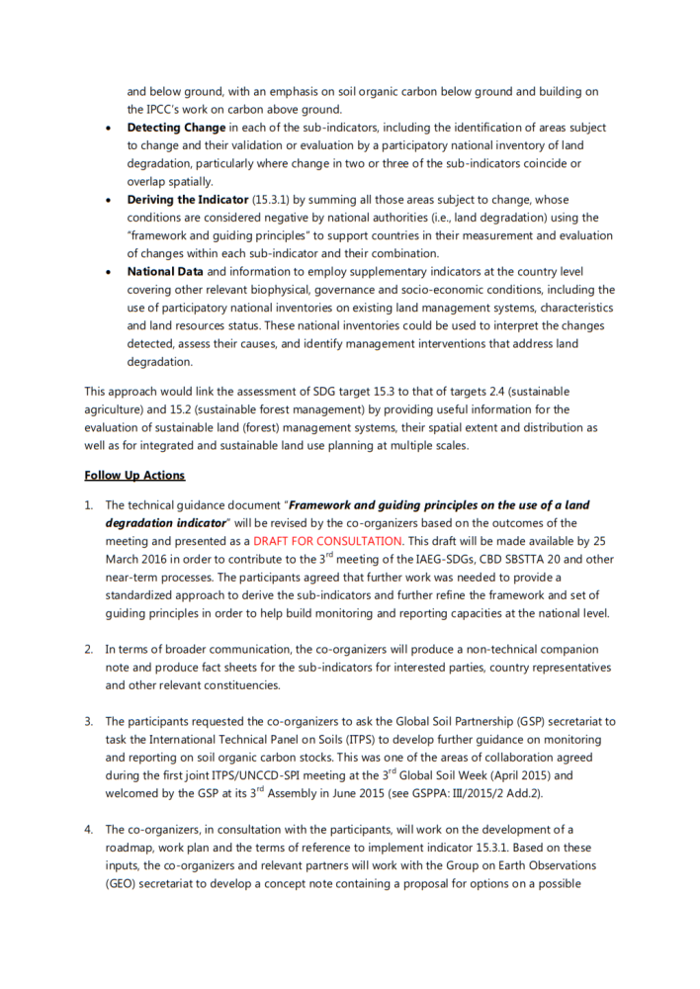
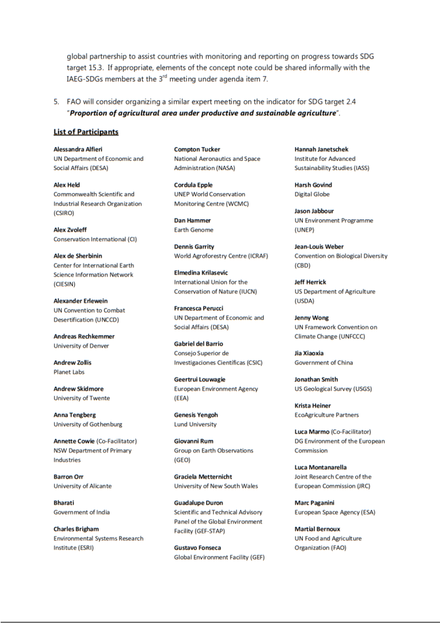
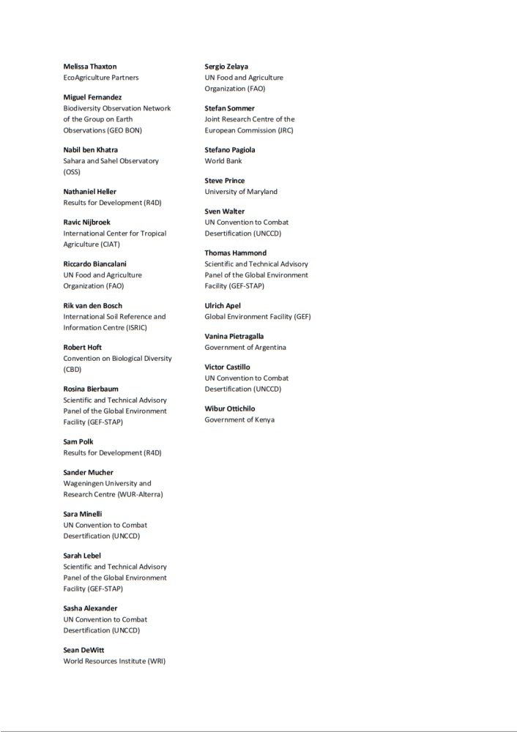
__________

UNEP/CBD/COP/13/1.
Prepared by Jean-Louis Weber, Consultant
https://github.com/SDG-InterfaceOntology/sdgio
Source: UNCCD http://www.unccd.int/Lists/SiteDocumentLibrary/Publications/2015Nov_Land_matters_For_Climate_ENG.pdf
In particular, but not only, regarding coastal socio-ecological systems.
http://unstats.un.org/unsd/statcom/47th-session/documents/2016-2-IAEG-SDGs-Rev1-E.pdf
http://unstats.un.org/unsd/statcom/47th-session/documents/BG-3-Update-finalize-proposals-for-SDG-global-indicators-E.pdf
http://unstats.un.org/unsd/envaccounting/ceea/meetings/tenth_meeting/Paper3b.pdf
A well known issue is companies transport for own account which is entangled in the SNA into the main activity of the industrial branches while in IPCC guidelines, a complete transport sector is considered.
https://ec.europa.eu/futurium/en/content/ultimate-earth-project-fet-flagship
https://www.wavespartnership.org/sites/waves/files/kc/WAVES_NCAandSDGs_Brief%20final%20web.pdf Prepared by Camille Bann, Consultant, International Institute for Environment and Development
This relation is done in the SEEA-ENCA-QSP report where waste water is linked to the “grey water” defined as the water resource which has to be kept in water bodies in order to dilute pollution down to legal standards. It is not done in the SEEA CF and SEEA Water.
“Depending upon the specific environmental issues faced, a country may choose to implement only a selection of the accounts included in the SEEA Central Framework.” Introduction to the SEEA Central Framework, paragraph 1.3.3 Flexibility in implementation, bullet point 1.55.
HWSD is the result of a collaboration between the FAO with IIASA, ISRIC-World Soil Information, Institute of Soil Science, Chinese Academy of Sciences (ISSCAS), and the Joint Research Centre of the European Commission (JRC)
http://esdac.jrc.ec.europa.eu/resource-type/soil-threats-data
Eurostat Environmental Statistics and accounts 2014 http://ec.europa.eu/eurostat/documents/4031688/5932212/KS-01-13-750-EN.PDF/a453d2b1-8872-40f6-bd74-f99e01048693
“environmental goods and services sector” means the production activities of a national economy that generate environmental products. They should not be confused with ecosystem services or ecosystem goods and services. Environmental products are (industry) products that have been produced for the purpose of environmental protection, and resource management. Resource management includes the preservation, maintenance and enhancement of the stock of natural resources and therefore the safeguarding of those resources against depletion.
https://www.unece.org/fileadmin/DAM/stats/documents/ece/ces/2015/33-Eurostat_role_in_development_of_SDG_monitoring_framework.pdf
Seventh Meeting of the Conference of the Parties to the Convention on Biological Diversity Kuala Lumpur, Malaysia , 9 - 20 February 2004
CBD Aichi Biodiversity Targets: http://www.cbd.int/sp/targets
UN System of National Accounts (SNA 2008), 2.73
SNA 2008, 1.63, 2.50, 2.51
Integration of geospatial information for SDG monitoring, 2nd meeting of the IAEG-SDGs Bangkok 26-28 October 2015, Laura Poulsen, Danish Geodata Agency. http://unstats.un.org/sdgs/files/meetings/iaeg-sdgs-meeting-02/Statements/IAEG-SDGs-GGIM.pdf
http://unstats.un.org/sdgs/files/meetings/iaeg-sdgs-meeting-02/Statements/UNEP%20-%20Clarifying%20terms%20in%20the%20SDGs.pdf
“Losses due to catastrophic and exceptional events are recorded when large-scale, discrete and recognizable events occur that may destroy a significantly large number of assets within any individual asset category. Such events will generally be easy to identify. They include major earthquakes, volcanic eruptions, tidal waves, severe hurricanes, and other natural disasters;” SEEA-CF 5.49
https://www.unisdr.org/we/coordinate/wcdrr
“The conclusion of the Sendai process will provide the final formulation of the indicator.” Page 4 of: Results of the list of indicators reviewed at the second IAEG-SDG meeting, Bangkok, 26-28 October 2015. http://unstats.un.org/sdgs/files/meetings/iaeg-sdgs-meeting-02/Outcomes/Agenda%20Item%204%20-%20Review%20of%20proposed%20indicators%20-%202%20Nov%202015.pdf
SEEA 2012 Central Framework: http://unstats.un.org/unsd/envaccounting/seeaRev/SEEA_CF_Final_en.pdf
SEEA-Central Framework, op. cit. para. 14
SEEA-EEA, Annex I: Research agenda for SEEA Experimental Ecosystem Accounting
http://ec.europa.eu/environment/nature/capital_accounting/index_en.htm
CBD Technical Series No. 77, “Ecosystem Natural Capital Accounts: A Quick Start Package” (ENCA-QSP) http://www.cbd.int/doc/publications/cbd-ts-77-en.pdf
Land accounts for Europe 1990–2000, Towards integrated land and ecosystem accounting, EEA Report No 11/2006 (EN) http://www.eea.europa.eu/publications/eea_report_2006_11
COP21 FCCC/CP/2015/L.9/Rev.1 ADOPTION OF THE PARIS AGREEMENT http://unfccc.int/resource/docs/2015/cop21/eng/l09r01.pdf
http://www.unccd.int/Lists/SiteDocumentLibrary/Publications/2015_PolicyBrief_SPI_ENG.pdf
Id.
ELD report on The Value of Land, 2015, http://www.unccd.int/Lists/SiteDocumentLibrary/Publications/2015_The%20Value%20of%20Land%20-%20ELD%20Initiative%20%282015%29.pdf
http://www.geobon.org/Downloads/brochures/2015/GBCI_Version1.2_low.pdf
UN Inter Agency and Experts Group
AtKisson Group Blue Paper - The SDG Indicators: What Are We Measuring? Version 1.0 - 11 Feb 2016 www.AtKisson.com
Thomas O. Wiedmann et. al., 2015, The material footprint of nations, Proceedings of the National Academy of Sciences of the US, Washington D.C. http://www.pnas.org/content/112/20/6271.full.pdf
http://unstats.un.org/unsd/nationalaccount/sna2008.asp
Land cover classification for ecosystem accounting, Issue paper prepared by Antonio di Gregorio (FAO), Gabriel Jaffrain (IGN-FI) and Jean-Louis Weber (EEA), Expert Meeting on Ecosystem Accounts, 5 - 7 December 2011, London, UK http://unstats.un.org/unsd/envaccounting/seeaLES/egm/Issue3_EEA_FAO.pdf

