 |  | CBD
 |  |  |  | Distr.  GENERAL  UNEP/CBD/ECR/WS/2016/2/1  21 October 2016  ENGLISH ONLY
Capacity-building workshop for selected subregions of Asia on the restoration of forest and other ecosystems to support the achievement of the Aichi Biodiversity Targets
Bangkok, 27 June to 1 July 2016
Report of the capacity-building workshop for selected subregions of Asia on the restoration of forest and other ecosystems to support the achievement of the Aichi Biodiversity Targets

INTRODUCTION
- In decision X/2, the Conference of the Parties (COP) to the Convention on Biological Diversity (CBD) adopted the Strategic Plan for Biodiversity 2011-2020, in which 20 headline Aichi Biodiversity Targets to be achieved by 2015 or 2020 are organized under five strategic goals. Aichi Biodiversity Targets 5, 14 and 15, set global targets to reduce the loss of natural habitats, ensure ecosystem services and restore degraded areas. Progress on these targets complements progress towards many other targets.
- In response to decision XI/16 and the Hyderabad Call for a Concerted Effort on Ecosystem Restoration, the Government of the Republic of Korea through the Korea Forest Service established the Forest Ecosystem Restoration Initiative (FERI) to support Parties in achieving Aichi Biodiversity Targets 5, 14 and 15 in an integrated manner. Through a Memorandum of Understanding with the Korea Forest Service signed in March 2015, the CBD Secretariat is implementing the FERI, which was welcomed by the Conference of the Parties to the Convention at its twelfth meeting in decision XII/19, paragraph 5. FERI support to Parties includes direct support to country projects as well as capacity-building, including through a series of sub-regional workshops.
- The capacity-building workshop for selected subregions of Asia on the restoration of forest and other ecosystems to support achievement of the Aichi Biodiversity Targets was held in Bangkok from 27 June to 1 July 2016. Conducted in English, this workshop is one of a series being organized through the implementation of the FERI through the financial assistance of the Korea Forest Service of the Government of the Republic of Korea.
- The overall aim of the workshop was to support Parties in developing and implementing national plans on ecosystem restoration, including with a focus on forests towards achieving Aichi Biodiversity Targets 5, 14 and 15 and related targets. Towards this aim, the workshop enabled:
- Review of national commitments and their stages of implementation;
- Learning about best practices from experts in the field, including on approaches taken to incorporate biodiversity into national plans and frameworks for implementation;
- Review of relevant global and regional initiatives and relevant tools in support of country commitments;
- Exchange of experiences and knowledge;
- Exploring opportunities for resource mobilization.
- The workshop was attended by 22 country-level experts from 18 countries. 19 experts were nominated by CBD focal points from the following 17 countries: Bangladesh, Bhutan, Cambodia, China, India, Indonesia, Japan, Lao People’s Democratic Republic, Malaysia, Maldives, Mongolia, Myanmar, Nepal, Singapore, Sri Lanka, Singapore, Timor-Leste, and Viet Nam. Four country-level forestry experts were nominated via processes of the Food and Agriculture Organization of the United Nations (FAO) from Cambodia, Indonesia, the Lao People’s Democratic Republic and the Philippines. It was also attended by two representatives of indigenous peoples and local communities.
- Experts from United Nations Environment Programme, the FAO regional office for Asia, the International Tropical Timber Organization, Birdlife Indonesia, the World Resources Institute, the International Union for Conservation of Nature, the Society for Ecological Restoration, SERVIR- Mekong, the Indonesian Peatland Restoration Agency, the Asia-Pacific Forest Network, the Royal Forest Department of Thailand, and the World Wide Fund for Nature also attended and contributed to the workshop.
- Experts from the private sector, including Asia Pulp and Paper and Asia Pacific Resources International Limited (APRIL) also contributed to the workshop.
- A copy of presentations and other documents for this workshop can be found on the CBD website at: https://www.cbd.int/doc/?meeting=ECRWS-2016-02.
- This report provides an overview of the workshop sessions, discussions, and next steps. The list of participants is presented in annex I, the programme is presented in annex II, and key messages are presented in annex III.

ITEM 1. Opening of the meeting AND day 1 activities: Sessions 1-4
- The workshop was opened at 9 am on 27 June 2016.
- Ms. Lisa Janishevski, on behalf of the Executive Secretary of Convention, made a statement highlighting efforts in Asia to restore and recover degraded forest lands. She described the Strategic Plan for Biodiversity 2011-2020 and its 20 Aichi Biodiversity Targets adopted by the Conference of the Parties at its tenth meeting, focusing on Aichi Biodiversity Targets 5, 14 and 15. She described a global momentum on ecosystem restoration ranging from the Hyderabad Call for a Concerted Effort on Ecosystem Restoration to major global goals and initiatives including the Bonn Challenge, the New York Declaration on Forests and the Sustainable Development Goals. She outlined this workshop and CBD processes in the context of the upcoming thirteenth meeting of the Conference of the Parties to the Convention, to be held in Cancun, Mexico, in December 2016. She thanked the Government of the Republic of Korea through the Korea Forest Service for generously providing the necessary financial support for the workshop, through the Forest Ecosystem Restoration Initiative, and FAO for supporting delegates from the forestry sector. She also gave special thanks to the experts for sharing their experience.
- Ms. Christophe Besacier of FAO drew attention on the importance of restoration of forest and other ecosystems to ensure a sustainable provision of goods and services such as food, water and energy security, climate change adaptation and mitigation, poverty alleviation, combating desertification and biodiversity conservation. He also emphasized the importance of using landscape approaches as the most relevant scale for addressing restoration issues and including all the key stakeholders involved in the various land use sectors. He described global restoration targets launched by Governments to restore degraded forests and other lands including: the Bonn Challenge, the New York Declaration on Forests, the Aichi Biodiversity Target 15 and the recently adopted the Sustainable Development Goals. He explained that building on those multiple international commitments, at the 22nd meeting of the Committee on Forestry, FAO, with the support of the Korea Forest Service, launched the Forest and Landscape Restoration (FLR) Mechanism, in order to support countries in their efforts to meet those global targets. He outlined the outcomes of a high-level regional consultation to develop an action plan for forest and landscape restoration in the Asia-Pacific region and expressed that this workshop is an opportunity for country representatives to exchange on their respective experiences and success stories and to collectively analyse existing gaps in term of resources mobilization and capacity development needs for the many stakeholders involved in Forest and Landscape Restoration efforts in Asia.
- Ms. Janishevski of the CBD Secretariat explained the purpose and outcomes of the workshop and the participants considered and adopted the proposed agenda.
Session 2
Introduction and setting the scene
- Mr. Thomas Enters of UNEP facilitated a session wherein the participants introduced a neighbouring participant.
- Mr. Blaise Bodin, a consultant for the CBD Secretariat, made a presentation on the Aichi Targets 5, 14 and 15 of the Strategic Plan for Biodiversity, stocktaking of commitments across other fora, and preparations for COP 13. The presentation consisted of an analysis of individual country efforts on Aichi Targets 5 and 15, based on National Reports to CBD and National Biodiversity Strategies and Action Plans (NBSAPs). It highlighted the gaps in data on ecosystem loss, degradation and fragmentation encountered in many national contexts and discussed the elements of SMART national targets under Targets 5 and 15.
- During the discussion participants sought clarity on the multiple-goals being set under various environmental agendas at the global level and how they overlap. They also highlighted the need for clarity on definitions of forest, natural forest, degradation and restoration. FAO highlighted the efforts of the Forest Resource Assessment to collect and collate data, reaffirmed the relevance of this data source for monitoring and reporting on forests.
Session 3
Country presentation on ecosystem restoration: scope, approaches, experiences and lessons learned
- Pak Budi Wardhana of the Indonesian Peatland Restoration Agency (Badan Restorasi Gambut - BRG) made a presentation on the national restoration plan for peatlands and legislation of Indonesia. The agency has been established and working for six months and reports directly to the President. It is mandated to restore 2 million ha of peatlands, develop criteria for degraded peatland, and provide guidelines. Restoration priority areas have already been identified in three provinces with support from WRI on mapping. The REDD+ agency is responsible for quantifying the carbon impact of the restoration plan. A six-month assessment period is currently beginning.
- Jun Wen Tong of China made a country presentation on the National Plan of Restoration of China. With regards to desertification, initiative one belt one road in collaboration with the UNCCD secretariat. Proposed two years ago with neighbouring countries. Capacity building activities have started. The ensuing discussion centred on the differences between afforestation and reforestation, relevant initiatives, and how they are establishing the red lines and the different zoning for the restoration plan.
Session 4
Global and regional initiatives to support national commitments for natural conservation and restoration of ecosystems
- Nigel Tucker, of the Society for ecological Restoration (SER) made a presentation providing an overview of ecosystem restoration efforts in the region including key determinants of success. He provided information about the Society for Ecological Restoration, its role and influence within Australasia. A definition of restoration was proposed – “The process of repairing damage caused by humans to the diversity and dynamics of indigenous ecosystems” – while emphasizing that restoration depends on both social and ecological factors. Although restoration is closely defined, actual on-ground approaches vary and the spectrum of techniques applied nationally depend on social and ecological factors. A successful example of ecological restoration in Thailand was detailed, as well as the challenges facing implementation of Aichi Target 15. The presentation summarized these challenges by detailing the problem of Imperata grassland restoration across Asia, and concluded by detailing four key requirements for successful restoration to occur:
- Goal(s) are clearly stated;
- Government forms effective partnerships with the private sector and landholders/participants;
- All stakeholders are engaged;
- Projects are monitored and evaluated across a range of measures.
- Adam Gerrand of FAO made a presentation on REDD+ readiness and how implementation of efforts in Asia can contribute to national and global biodiversity objectives.
- David Ganz, of the SERVIR-Mekong programme, presented the outputs of the USAID LEAF Programme and lessons learned for the planning and implementation of forest conservation and restoration actions. He emphasized the role of local partners in the pricing of services in PES agreements.
- Raquibul Amin of IUCN, presented the outputs of the regional initiative, “Mangrove for the Future (MFF) – building resilience in coastal zones”. The presentation outlined threats to mangrove habitats and mangrove restoration approaches, challenges and opportunities, including information on mangrove polyculture and other models that incentivize stakeholders, particularly the challenges around land tenure and property rights of restoration efforts. Shrimp farming and erosion are the main drivers of mangrove destruction. The presentation introduced the MFF’s approaches and work on mangrove restoration in project countries. Polyculture, including with aquaculture, and the replanting of mangroves were some of the solutions presented. The work also extends to sea grass, estuaries, coral reef and sand dunes. Each member country has their own national coordinating body and has developed a Mangrove Strategy and Action Plan.
- Li Jia of IUCN delivered a presentation on the preliminary results of a global study: How Forest Landscape restoration can support countries to achieve further progress on forest relevant Aichi Targets.
- A panel discussion, facilitated by Thomas Enters of UNEP, was conducted to discuss the high potential for forest and landscape restoration (FLR) in Asia versus the current level of commitments and reliable indicators. The panel was composed of: Ria Saryanthi (BirdLife International), Christophe Besacier (FAO), Satrio Wicaksono (WRI), Li Jia (IUCN), Budi Wardhana (Indonesian Peatland Restoration Agency (BRG)), and Hwan-ok Ma (ITTO). In the discussion several points were made:
  - It was emphasized that if countries have not made a commitment under the Bonn Challenge it does not mean that no FLR is being undertaken. FAO discussed its proposed regional initiative for Asia and relevant events to promote and discuss it. Questions were raised on how to scale up the efforts on FLR, how to mainstream the targets citing that more detail is needed on the restoration targets, including specifying different restoration techniques involved;
  - The example of Indonesia was provided: political commitment is there but not translated into global level commitments. Some actions are not captured in the reporting to the conventions, including to the CBD, because the Ministry is “siloed” and coordination is lacking. Mangroves for the Future set up national working groups to ensure involvement of all the right people in the Ministry. This type of forum will differ country by country but is really useful and can also help iron out issues related to definitions;
  - It was noted that if we look at current FLR related targets, plans and commitments, there is hope. We can see a lot of targets and plans at the national level for restoration. Targets in national programmes are more likely to already have funding than new global commitments. We need to be aware that large restoration plans can be of low quality. The FLR approach can help here, to reach scale and to mainstream. The Restoration Opportunities Assessment Methodology (ROAM) provides an interactive, participatory process that brings stakeholders together to achieve restoration results;
  - The Indonesian Government representative highlights that there is a huge political commitment for restoration in Indonesia. UNEP-WCMC supports a process for harmonization of reporting. We need to combine efforts for a better impact, both internally in the government and among international organizations. In Indonesia, there is a need to develop a clearer policy for land use. Currently the link between terrestrial and marine ecosystems is not emphasized and in fact there was a large mistake in the 1970s to reclaim land from wetlands;
  - There is confusion not only on the definition of restoration but also on the definition of success of restoration projects;
  - Christophe Besacier of FAO mentioned that there is an official definition of FLR on the GPFLR’s website, noting that with respect to measuring success you need a monitoring system and a baseline;
  - Good indicators to monitor success are needed, not just in terms of area but also social and economic indicators for restoration.
ITEM 2. Day 2 Activities: sessions 5-6
Session 5
Prioritizing and planning restoration- integrating biodiversity considerations in land and seascape approaches
- The participants reported back and elaborated on what they learned the previous day:
- It was noted that indigenous peoples and local communities struggle against extractive industries, and that there should be a balance of where restoration vs extraction is done;
- The participants emphasized the need to address drivers of loss before doing restoration or else there is no point. For example, in some areas, the encroachment and illegal logging is still happening even inside protected areas. In other areas, industries are encroaching, including causing coastal destruction, despite having government policies, projects with communities, and standard management. There was a request for success stories of dealing with encroachment (by migrants/industry);
- The issue of deforestation is complex: the balance between food security and land use, and improving current farm land could be supported through incentives for farmers to use sustainable farming systems to allow recovery of the land – there is a need to review policies. Community involvement needs to play an important role in the conservation of forests;
- Reiterating the need to involve communities, an example was given where industry threatens mangroves and the government has limited land, it is owned by communities who may sell it if they want money;
- One solution was noted that has had previous success; give money directly to people for land to become a protected area, noting that the people also need ownership to protect the area or else other people come in and destroy. The community needs the entitlement and ownership, and the government can set requirements for community ownership. The government needs also to adhere to their planning and not sell to concessions;
- Regarding restoration post-earthquake and landslides: restoration planning needs to occur both upstream and downstream;
- Each country needs to make its own determination of forest and assess the improvement of biodiversity. FAO does not insist on countries using the FAO definition of forest, it is only agreed, but countries need to determine their own. For example, Australia does not use the FAO definition of forest as they include short woody vegetation;
- Lisa Janishevski of the CBD Secretariat made a presentation describing the process and background of the SBSTTA Recommendation XX/12 including the “short term action plan on ecosystem restoration” to be considered for adoption at COP 13.
- Ria Saryanthi of BirdLife International made a presentation on prioritizing and planning ecosystem restoration in reef and coastal ecosystems. Birdlife will also work in other countries to develop key biodiversity area maps, for example in Timor-Leste. These maps can also cover threatened corals.
- Li Jia of IUCN provided an introduction of the Restoration Opportunities Assessment Methodology (ROAM) methodology - using multi-criteria analysis to map priority areas for restoration. She described the phases of the methodology including links with the InVest and the restoration opportunities optimization tool (ROOT), and explained how these tools and methodologies can help resolve complex trade-offs in decision-making.
- Li Jia of IUCN and Satrio Wicaksono of WRI conducted an interactive exercise for the ROAM. Participants were asked to consider various spatially explicit criteria for restoration and simulate the selection of priority areas using transparent layers.
- Mr. Htun of Myanmar made a presentation on the status of degradation and methods being used to reduce logging including a ban on log exports, and reduction of teak and hardwood harvesting. Forest cover in Myanmar is continuously declining, from 58 per cent in 1990 and 49.25 per cent in 2010 to 43 per cent in 2015. The forest loss has resulted in decreasing timber and other forest products, loss of ecosystem services, and environmental degradation and natural disasters such as floods and landslides. Myanmar has conducted several activities to reduce deforestation and forest degradation including imposing a log export ban since 1 April 2014, the cessation of logging for the 2016-17 fiscal year, the cessation of timber extraction in Bago Mountain Range (home of teak in Myanmar), for ten years (2016-2017 to 2025-2026), and the promotion of reforestation through private and community engagements. Myanmar is working on real-time forest cover assessments and a National Forest Monitoring System (NFMS) to be compliant with IPCC guidelines and Measurement, Reporting and Verification (MRV) for REDD+. The forest department is preparing a 10-year national reforestation programme, which includes the development of a forest plantation policy, identification of drivers and underlying causes of deforestation and forest degradation, establishment of state owned forest plantation of 12,145 ha annually, private plantation 8,097 ha annually, restoring degraded forest of 8,097 ha annually and 0.5 million ha under community forestry.
- Mr. Karma Nyedrup of Bhutan made a presentation on protected areas and biological corridors of Bhutan, showcasing the connectivity of the system. He described the national targets under Aichi Targets 5, 14 and 15 and the strategies and actions to meet those targets, emphasizing the need for a holistic approach. He outlined the relevant national policies and acts in place. This includes the nationalization of extractive industries (no private sector mining nor logging). He outlined the actions on the ground to sustain the appreciation and conservation of biodiversity, in particular of trees.
- Adrian Loo of Singapore made a presentation on the biodiversity of Singapore and the strategies for its conservation and restoration. The distinctiveness of Singapore as a ‘garden-city’ state was underlined, distinguishing the actions taken from the context of most other countries in the region. Solutions developed (e.g. wildlife overpasses) might be most relevant for urban areas.
Session 6
Clarifying commitments and setting national targets
- Blaise Bodin presented in further detail the national targets set under Aichi Targets 5 and 15 in the region and the extent to which they met SMART (Specific, Measurable, Achievable, Realistic, and Time bound) criteria, with examples of good practice.
- Lisama Sabry of the Maldives made a presentation on the Maldives NBSAP 2016-2025. She described the NBSAP revision process and how it was adopted as a policy instrument and aims to make the entire country a biosphere reserve. The NBSAP considers the status, threats, progress so far, and the challenges, gaps and constraints. Biodiversity is the backbone of the economy of Maldives. The NBSAP was prepared by extensive stakeholder consultation under the UNEP Umbrella Project funded by GEF which involved all sectors, society and local communities from all the 20 administrative atolls. A technical committee was formed involving high-level technical experts from relevant organizations. This 10 year action plan was formulated by taking into account status of biodiversity and progress made so far in biodiversity conservation, and seeks to address the threats, challenges, gaps, and constraints in biodiversity conservation in Maldives. Six broad areas of concern were identified which formed the 6 strategies of the NBSAP 2016 – 2025. For each strategy, SMART targets were developed. Each of the 26 targets of the NBSAP has broad suggestive actions with indicators for each action, baseline, a responsible agency for implementing the action and is time bound. The Ministry of Environment and Energy of the Maldives is responsible for monitoring progress and conducting its reviews. Maldives is developing a GEF 6 project for implementation of this strategy.
- Thi Tuoi Dang of Vietnam made a presentation on the biodiversity and national targets in Viet Nam. She described the role of biodiversity in Viet Nam including provisioning services and contribution to gross domestic product, cultural services, regulatory and support services. She described the threats, integration into sectoral and inter sectoral development and the conservation of natural ecosystems, and the activities undertaken to meet the targets, and progress achieved in forest cover increase to date.
- The participants were divided into groups and discussed the SMART-ness of their national targets, and why some targets are not SMART, and also discussed specific data needs that would help the setting and monitoring of targets. Constraints to setting and measuring targets included lack of baseline data, no national legislation on wetlands, difficulty in getting data from different sectors, and lack of inter-agency coordination. Priority data needs included a need for extent of forest, better methodology for coastal and wetland data/surveys, data to support assessment of contribution of natural ecosystems to disaster risk reduction. To fill the gaps they need technical expertise and human resource capacity. Some examples showed that open ended statements in NBSAPs may be culturally more acceptable (for example when asking other departments for implementing measures it would be counter-productive to make demands on them). They also identify a lack of awareness of NBSAPs in other departments. If set in the department, sometimes vagueness is better for them. There is a trade-off between time spent monitoring vs implementing. Traditional knowledge of indigenous peoples and local communities could be better incorporated. Countries with a decentralized administration can have difficulties with setting and implementing national targets. Methodologies to assess ecosystem vulnerability are lacking or unknown. Gaps in data are often caused by lack of funding for research and it was noted that the target can be to fill data gaps. The point was made that the FAO Global Forest Resources Assessments (FRA) has contact people available in each country that can be used as resource persons for data on forests. Participants can make use of the FRA country reports online at: http://www.fao.org/forest-resources-assessment/current-assessment/country-reports/en/.

ITEM 3. Day 3 Activities: session 7 - Field Excursion
Session 7
Field excursion
- The participants were taken on a field visit to Samut Sakhon, “The City of Sea and River”, located approximately 50 km from Bangkok.
- Owing to its proximity to the capital, coastal development in Samut Sakhon began in the 1970s. As there were no legislative restrictions on coastal development, poorly planned coastal developments were carried out up to the very edge of the coast; this practice is now prohibited by law. Inland damming at the upper reaches was also actively conducted. Sediment is transported from the upper to lower lands and accumulates there. Reduced flux of sediment due to the hydraulic dam had severe impacts on Samut Sakhon coastlines. Under the influence of direct wave/wind attack and without protection from mangrove forests, unprecedented coastal erosion has occurred in this region.
- Mangrove plantations in vulnerable areas are considered to be beneficial for long-term coastal protection from erosion and severe weather events. The presence of mangroves as well as continuous riverine sediment flux is essential to maintain coastal stability. Over the years, a number of mangrove planting projects have been carried out to restore the degraded mangrove forests, some of which were aimed at protecting the shoreline against storm and cyclone damage. However, planting mangroves within eroded areas is much more difficult than planting in other areas because of the harsh physical conditions.
- In Samut Sakhon, local communities have applied traditional knowledge and experimentation to develop an innovative process for restoring mangroves in areas of heavy coastal erosion. This methodology uses bamboo ‘fencing’ to create a sediment trap that provides stable, protected conditions within which mangrove restoration can take place.
- During the field visit the participants had the chance to see the areas and the efforts being made to restore mangrove habitat and coastal shoreline stability and to discuss with both government officers (Department of Marine and Coastal Resources (DMCR)) and community leaders about their experiences. The research of DMCR on a case study of coastal erosion is available at http://www.dmcr.go.th/elibrary/elibraly/book_file/Book20121116095209.pdf in Thai and English.
- As a result of the restoration efforts, increased protection and active community management, the area has also become regularly frequented by dolphin populations.

ITEM 4. Day 4 activities: sessions 8-10
- The field trip excursion was discussed and relevant messages and lessons to be learned from this project.
- An exercise was conducted wherein the participants discussed key messages from the workshop and each table reported back on their priority key message. The key messages are presented in annex III.
Session 8
Monitoring systems and reporting, country experiences
- Beau Damen of FAO made a presentation of outcomes and conclusions from the workshop: “Understanding capacity needs for the Paris Agreement on enhanced transparency framework in agriculture and land use sectors in Asia and the Pacific.” Full results including country planning files is available at http://faounfcccagworkshop.wix.com/etfforndcworkshop.
- Dany Chheang of Cambodia made a presentation on Cambodia’s status and actions on national biodiversity monitoring and REDD+. Cambodia is aligning work on the Aichi Biodiversity Targets with work on the Sustainable Development Goals. The forestry Strategic Plan is from 2014-2018 and has 3 main indicators. He outlined some community outreach plans linked to the forestry work. The national REDD+ plan is being planned, although the strategy and monitoring remain to be finalized, and emission levels are being studied and will be adopted. He raised the issue of forest restoration – they do not have incentive policies for forest restoration, economically and spiritually. There is a technical working group on forestry reform but has incompatible planning with ministry of rural development. The forestry proposes to keep forests as 60per cent as part of the land, but the others want to give to community land titles. Ministry of mining wants areas to be mined, and others want industrial parks – policies need to be harmonized before the work on restoration can start.
- Suwan Tangmitcharoen of the Royal Forest Department of Thailand made a presentation on the importance of genetic diversity and the best practices in selection of seeds for restoration for production. They have a target to bring the forests to 40 per cent of the land. He outlined the forest biodiversity of Thailand, where over 2000 species have been identified as endemic. He presented relevant lessons learned including: seed sources from improved plantations are better than those from natural resources. With respect to climate change, they need to develop a specific breeding programme for species well adapted to the changing environment and ensure quality and quantity of the seed source. Florence Daguitan, IPLC representative, emphasized the value of the practices of traditional knowledge used in restoration in local Thai communities. Cambodia and Thailand find a common problem in that they would like to find incentives for the public to plant some high value species that are also protected other than the usual commercial species.
- The question and answer session that followed highlighted the potential for fast-growing commercial species to ‘prepare the ground’ for native species of importance for biodiversity. Once they have reached maturity, commercial species can be harvested for timber and native species growing underneath can take over. Various technologies for seed dispersal were also discussed, including emerging drone-based technologies (more information can be found in the materials from a workshop at https://www.dropbox.com/sh/u5jfx88yrzlrvg7/AABivNeSC1_9_5v9ijof7xTEa?dl=0).
- Blaise Bodin introduced an exercise on identifying the data gaps and next steps to fill them. Countries were asked to fill out an online form with a series of questions:
- Priority data gap to be addressed
- Based on the presentations given this week, where could you find support to address this gap?
- With which agencies/institutions is coordination required to address this gap?
- What aspects of your national target will be improved by filling this gap?
- The individual results of the exercise have been shared with participants and can be downloaded from an online folder at https://www.dropbox.com/sh/1vgwh5vl5gy6prk/AABH3VCLFq-JCt1WOR3KQy9Da?dl=0.
- Florence Daguitan, representative for IPLCs, provided an example of perverse incentives involving fertilizers, and Bangladesh informed of positive incentives to farmers that result in less area converted and increased production on less land. In Timor-Leste they introduced cover crops, supported by FAO, which improve crops, as well as more efficient cook stoves that reduce wood use. In Cambodia they have the concept of red carbon and green carbon but it actually does not make a difference effectively. Nguyen Ngoc Thang of WWF provided an example of payment for forestry and ecosystem services in Viet Nam, which works better than REDD+ as the household owners can receive funds from the hydropower dam and companies directly.
Session 9
Country exercises – assessing next steps for implementation
- Blaise Bodin presented a review of responses from the pre-workshop questionnaire on implementation measures for achieving Aichi Biodiversity Targets 5 and 15.
- Blaise Bodin and Lisa Janishevski then introduced an interactive exercise for countries to explore potential implementation measures. The exercise was conducted in three steps:
- First, countries were asked to match relevant actions toward achieving Target 5 from the GBO 4, to how they contribute to the different elements of Target 15 using the template in figure 1 below, as a way to understand how single actions can help pursue several elements of Target 15;
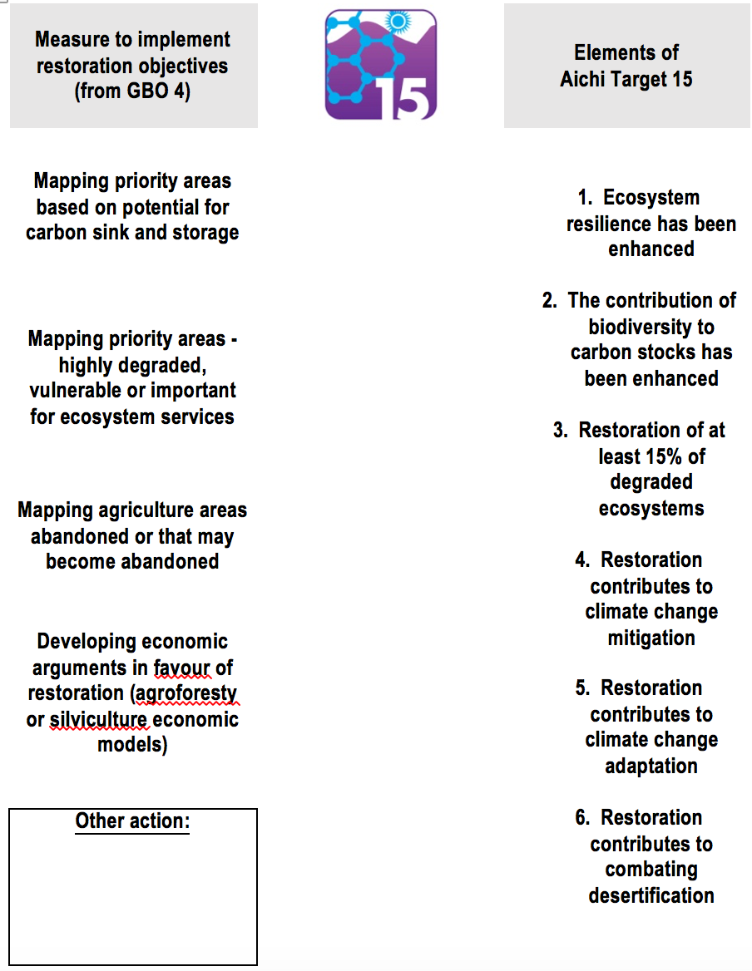
Figure 1. Measure to implement restoration objectives for matching with Elements of Aichi Biodiversity Target 15
- Second, countries were asked to place implementation actions, on a two-dimensional prioritization chart, with one axis related to the relevance of the action in their national context and the other related to the need for technical support for the implementation of this action. The exercise was conducted in two groups, one focusing on actions related to economic instruments and one on actions related to legal and enforcement instruments (figure 2). Actions located in the top right corner are therefore those where future technical support from the Secretariat and partners could focus in priority.
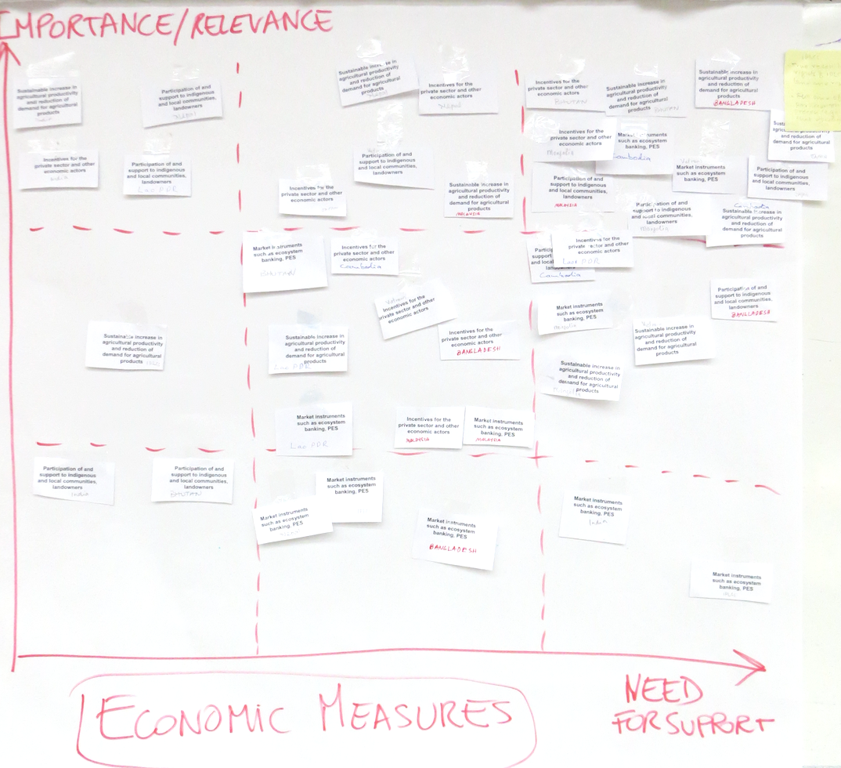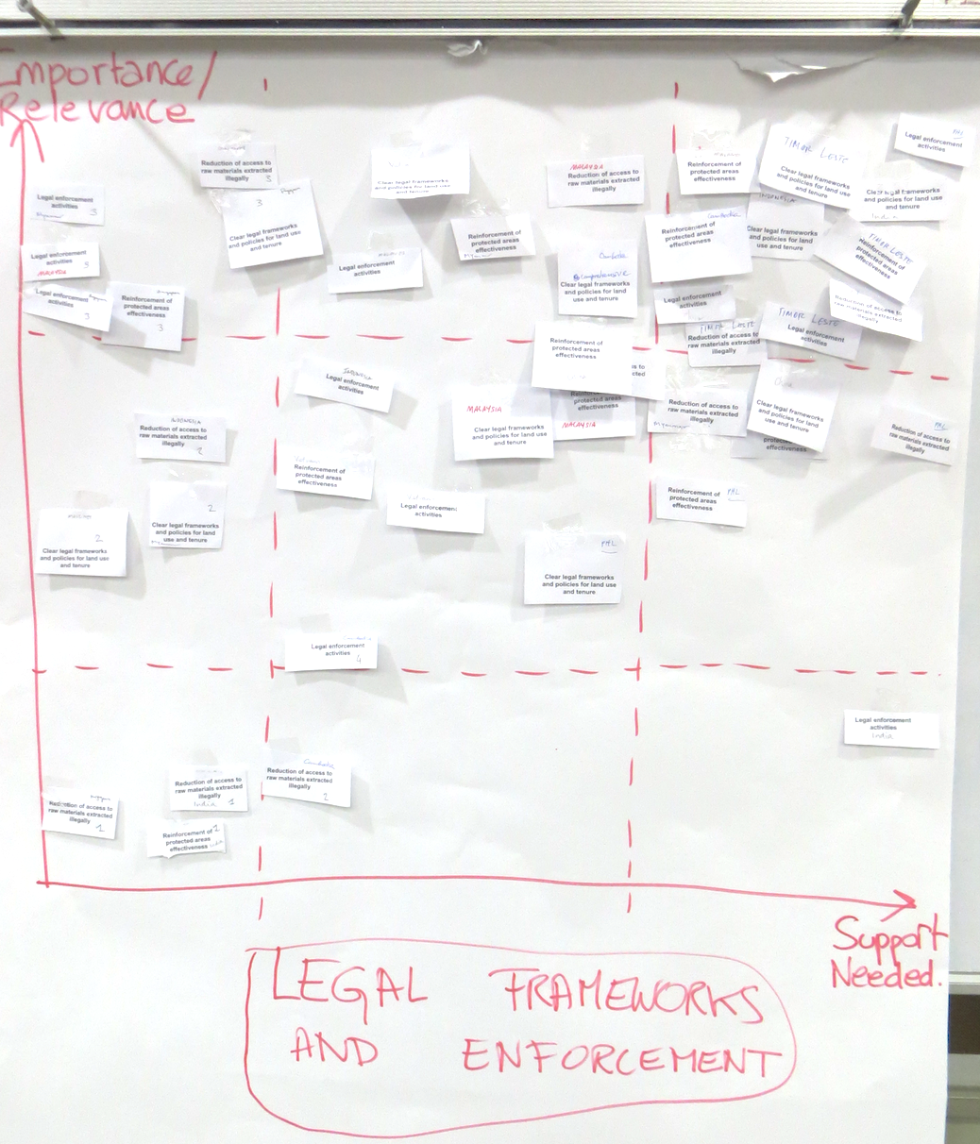
Figure 2. Two-dimensional prioritization charts
Notes: The X-axis denotes the relevance of the action in the national context; the Y-axis denotes the need for technical support for the implementation of this action.
The charts were completed for economic measures (left) and for legal frameworks and enforcement (right).
Using a scoring system based on their placement on the chart, actions were then ranked by order of priority. The results, presented in figure 3, show that the actions that were most prioritized were the “sustainable increase in agricultural productivity of demand for agricultural products” and the “reinforcement of protected areas effectiveness”;
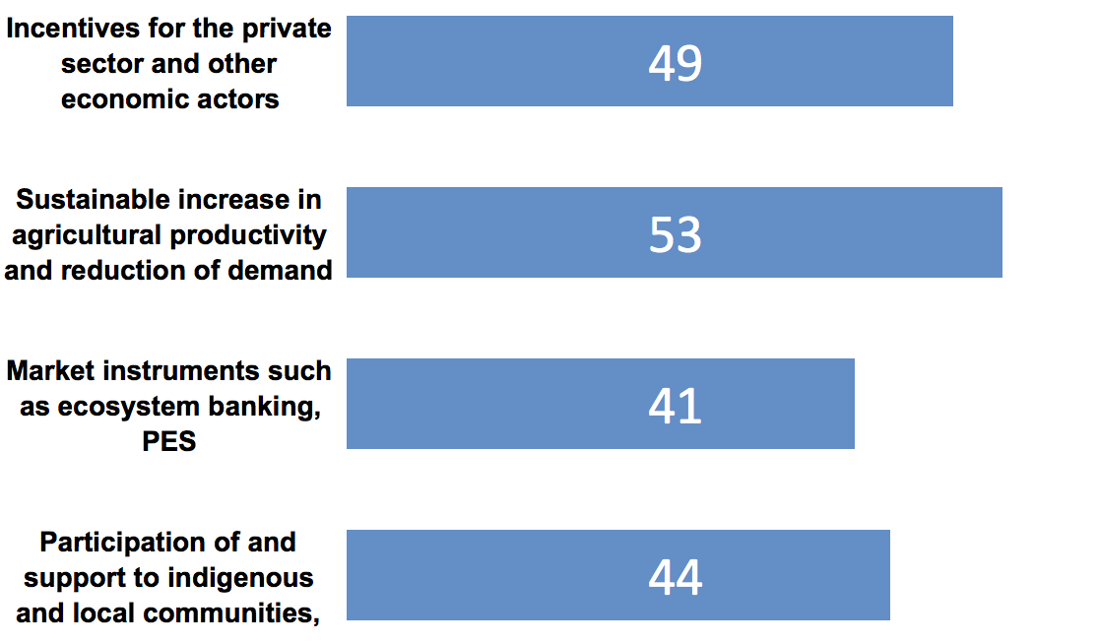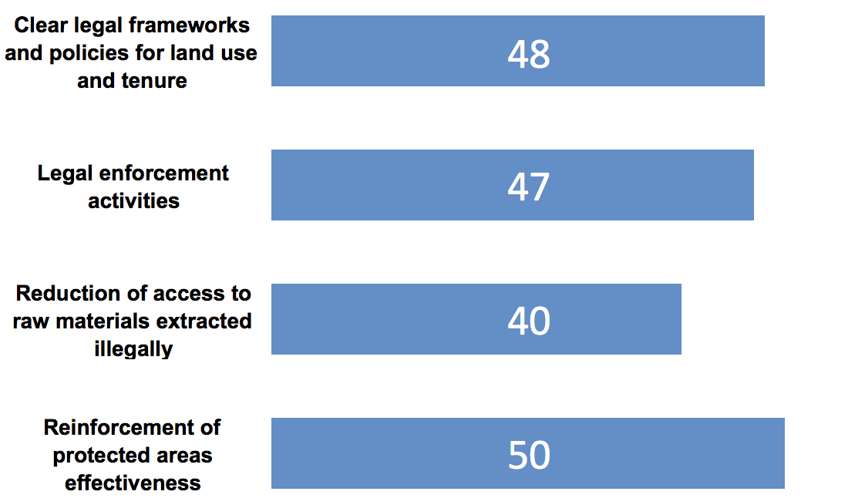
Figure 3. Summary results of interactive exercise on prioritizing actions in ecosystem restoration
- In a third step, countries’ representatives were then asked to identify next steps for at least one of the actions and outline what steps they could take to start implementation and the kind of support they might need. The individual results of the exercise have been shared with participants and can be downloaded from an online folder.
Session 10
Addressing ecosystem restoration through trans-boundary biodiversity conservation and community-based actions
- Nguyen Ngoc Thang of WWF Viet Nam made a presentation on the lessons learned from implementing ecosystem restoration in Viet Nam. A discussion on financing and sustainability issues followed.
- Florence Daguitan and Kamal Kumar Rai, representatives of indigenous peoples and local communities, made a presentation on the local community action on ecosystem conservation and restoration - review of land tenure and rights based approaches. It was outlined that the best channels of funding are at the local level to avoid negative impacts. Each situation is different, and so best practices are context-specific but it is important not to divide the community or create discord. The ensuing discussion elaborated on how to determine compensation for or cost of projects in the communities. To obtain free prior and informed consent, it is faster and more democratic to go through customary rules. As for migrant communities, it depends on national legislation on how to best handle and accommodate them while protecting the environment.
- Petch Manopawitr of IUCN made a presentation addressing forest degradation through community-based action in support of Aichi Targets 5 and 11. He highlighted an example of an FLR project in Thailand in two settings, one in the north in the watershed area of Doi Mae Salong and one in the buffer zone of Dong Phayayen-Khao Yai (DPKY) World Heritage site. Both sites place strong emphasis on community engagement and promotion of sustainable land use to restore the ecosystem in the wider landscape. In the DPKY landscape, transboundary cooperation with Cambodia was also initiated.
- Hwan-ok Ma of ITTO made a presentation on promoting cooperation for trans-boundary biodiversity conservation between Thailand, Cambodia and Laos – the Emerald Triangle Case Study. He described the expected outputs of the phase III and multiple Aichi Biodiversity Targets, and the ITTO-CBD Joint Initiative. He also presented the key messages for the regional conference on biodiversity conservation of the Greater Mekong Subregion. He explained that transboundary cooperation is difficult but a common framework can be established if a common vision is arrived and agreed. He also described the sustainability of this partnership – technical cooperation has been strengthened and he plans to showcase these efforts at CBD COP 13.
- An ensuing discussion centred on fire management in areas including fire suppression actions versus engaging and investing in the local communities for fire avoidance.
ITEM 5. Day 5 Activities: sessionS 11 and 12
- Blaise Bodin provided a summary of the exercises from the previous day. It was highlighted that the private sector can make a much greater contribution to conservation than is perceived and that countries should consider that option. Bhutan could use more information on degraded areas — is there a tool with relevant agencies, a rapid assessment for example? Li Jia of IUCN provided information on the ROAM, and global forest watch was mentioned.
Session 11
Resource mobilization for ecosystem restoration
- Dolly Priatna of Asia Pulp and Paper (APP) made a presentation on the sustainability of restoration practices including the four main pillars of forest conservation policy. APP is one of the largest pulp and paper companies in the world. Four years ago APP announced its Sustainability Roadmap Vision 2020, which was developed to guide APP to become a respected industry leader by operating in a sustainable and responsible way. A year after, in February 2013, following input from its key stakeholders, APP launched its Forest Conservation Policy (FCP), which includes a commitment to immediately end the clearance of natural forest throughout its entire supply chain. APP is applying free prior and informed consent (FPIC) in their methodology of “no deforestation and sustainable forest management”. Using a landscape approach, 1 million ha of protection and restoration over 10 sites is planned in collaboration with WWF and Greenpeace. In this context, they have made a pledge to the Bonn Challenge and committed to the New York Declaration on Forests. He outlined the APP forest conservation policy, which had been vetted by an independent organization, and the highlights of achievements so far. New government regulations in Indonesia establish that peat is no longer allowed to be drained past a certain level. With WRI and IUCN they are testing ROAM in certain areas. One challenge is that sometimes local government is not agreeable to having restoration concessions. He outlined how their actions were contributing to Aichi Biodiversity Targets 5, 14 and 15:
- The four key pillars of APP’s FCP are:
  - No deforestation – APP and its suppliers will only develop areas that are not forested, as identified through High Conservation Value (HCV) and High Carbon Stock (HCS) assessments;
  - To protect and maintain HCV and HCS forests and to implement peatland best management practices to reduce and avoid of greenhouse gas (GHG) emissions, in support of the Government of Indonesia’s low emission development goal;
  - Social and community engagement – through the implementation of Free Prior and Informed Consent (FPIC) and responsible conflict resolution;
  - Ensuring that our global wood fibres are also sourced from areas that are managed sustainably and responsibly;
- In April 2014, APP announced a commitment to support the Government of Indonesia by protecting and restoring one million hectares of rainforest. This ground-breaking initiative has been developed to create significant impacts in landscapes both in and around forest plantations in APP’s supply chain. APP then started working on producing a Master Plan to guide the ground implementation of its efforts to protect and restore forests in the ten identified landscapes;
- In order to implement this commitment on the ground, APP initiated the formation of an independent foundation that was launched in December 2015 during the COP 21 event in Paris. APP has committed a total of US$ 50 million seed money, which will be managed by the foundation to finance forest protection and restoration programs, as well as other community-based conservation activities conducted by NGOs within targeted landscapes;
- In 2015, APP took another step forward when introducing its Integrated Forestry & Farming System (IFFS) / Desa Makmur Peduli Api (DMPA) program that has identified 500 villages for community and economic development over the next five years;
- Beyond all these commitments, APP has also been managing an ecosystem restoration concession in South Sumatra Province since 2014 and is processing another license to manage another ecosystem restoration concession. The primary objective of APP’s efforts is to develop a “new business model” in the forestry industry and in Indonesia that protects the forests and embraces the community as an integral part of its supply chain.
- Herry Subagiadi of Indonesia made a presentation on the moratorium commitment and ecosystem restoration in Indonesia and correlation and contribution to the Aichi Biodiversity Targets. He outlined the coverage of forested areas, the conservation areas and the high level of biodiversity. He reported that they are close to achieving their target on Target 5, and he outlined achievements on restoration, and the approaches the government is using for these targets (combatting illegal logging; fire control; forest moratorium to reduce conversion and so reduction of emissions, development of a forest management unit; a forest restoration plan; carbon absorbed through restoration to be measured by reducing greenhouse gases by 21.7per cent. With respect to the moratorium, vital national developments related to geothermal, oil and gas are exempted. The Ministry of Environment and Forestry has specific instructions for implementing the moratorium, including an evaluation every 6 months. All governors and heads of districts also have instructions on implementing the moratorium. Support is also expected from the private sector.
- Petrus Gunarso of APRIL made a presentation discussing conservation and integrated landscape management which impacts just less than 1 M ha in Indonesia. The challenge is to work and mainstream restoration and conservation in production areas. APRIL is working with The Nature Conservancy, Bidara and Flora and Fauna International. Assessments are completed first, and areas to restore are determined based on high conservation value. APRIL has signed commitment agreements with the government. They are using a collaborative landscape approach with support of the Minister, who allowed revoking of concession permits. APRIL is supporting the government to achieve its commitments. The communities are allowed to do fisheries activities and collect dead wood, over- exploitation is avoided, and the local population receives employment opportunities in the plantations and as rangers.
- A panel discussion with private sector companies was facilitated by Nigel Tucker of SER. The panel comprised Dany Chheang of Cambodia, Petrus Gunarso of APRIL, Herry Subagiadi of Indonesia, Satrio Wicaksono of WRI, and Dolly Priatna of APP.
  - The first question was on implementation of one-to-one conservation with restoration, and how restoration is accomplished with guidelines. As restoration needs financing, support is needed from a national planning board. The process in Indonesia was from bottom up as they collected all existing data from local agencies and invited them to find solutions. Satrio Wicaksono agreed that in Indonesia the strategies, multiple schemes, the entire effort has its own Director General; there are critical areas under different Directors General; and the majority of restoration work is accomplished under social forestry schemes.
  - The next question was “what role do regulatory vs voluntary approaches have?” In Indonesia, details on regulations up to the field come from the President. At provincial level, some governors have issued regulations to encourage the private sector on a vision of green growth best practices to mainly mitigate greenhouse gases. Dany Chheang explains that this model is inclusive, including private sector in ecosystem restoration; the government cannot be relied on alone for it to work; it has to include the community and employment opportunities, as well as trust and belief in the efforts. Fiscal reform is needed to simplify the process for the public and private sectors to invest in restoration; it can generate incomes but can also raise corporate responsibility.
  - The next question was “how can the private sector assist government to undertake land tenure reform, and how can they help overcome resistance?” With respect to spatial planning in Indonesia, Java is completed, and Bali has no forest. The forest holds interest for all parties (e.g. palm oil, mining interests). The areas have high value, and so all stakeholders have to sit together to discuss. There is a major European bank that will be providing investments; participants should look for an announcement later this year. Even having one map agreed on by all parties is difficult, and so Indonesia has a “one map initiative” and WRI has an important role in this at subnational level. Non-governmental and civil society organizations can support the funding mechanisms for restoration. A comment was made on the high level of commitment from the President of Indonesia, noting that timber companies are under scrutiny, and asking if the restoration was done voluntarily or not and what were the profits versus costs. It was explained that support and pressure come from different sectors and improve success. There is a land tenure rights issue, in some areas indigenous peoples and local communities (IPLCs) are losing land to palm oil plantations. APP has done social mapping for conflict resolution, and they commit to implementing FPIC for all the plans. In Indonesia, there will be different treatments of IPLCs versus migrants, and there are some conflicts in the concessions. Different peoples have different rights and land tenure. Ten per cent of APP profits are going to restoration. APRIL is not considering profit for the first 10 years, but eventually they do expect profits from REDD+ or another mechanism. APRIL is also outreaching to other players in the landscape to also manage sustainably, and they put the government at the forefront. APP makes agreements with local governments to support their green growth vision in the landscape, and they create one vision in the landscape by creating a forum led by the head of the provincial forestry office, holding regular stakeholder meetings, and working with other donors to lead a sustainable way forward for agricultural products (citing an example of compensating to replant palm oil with improved seedlings, to reduce demand for land).
- Christophe Besacier of FAO made a presentation on sustainable financing for Forest and Landscape Restoration: The role of policymakers and how to mobilize the private sector.
- Thomas Enters of UNEP made a presentation on the economic valuation of forest benefits as a tool for decision-making, including country experiences from Mongolia and Cambodia.
- Countries that have managed to reverse forest loss have all put substantial funds from national budgets and so there are lessons to be learned from China and other such countries. A framework mechanism is needed to foster collaboration on restoration between countries and the private sector.
- Yoshihisa Kimura of Japan made a presentation on the national plan of Japan on ecosystem restoration. In 2002, the law for the promotion of nature restoration was enacted. The Japan Biodiversity Outlook 2 was released in March 2016. He described the status and loss of natural forest toward artificial forest over time, and the forest resource volume and absorption of CO₂. He illustrated the production of firewood, showing the reduction of wood use for fossil fuels, and the urbanization of land use. He explained the current challenges in promoting nature restoration including connectivity in landscape, and small nature restoration.
Session 12
Workshop summary and closing
- The participants discussed and edited the key messages from the workshop. The finalized key messages are presented in annex III.
- Christophe Besacier of FAO and Lisa Janishevski of the SCBD closed the workshop, thanking all of the participants for their hard work and strong participation during the week of the workshop.
Annex I. List of participants

 | Country or agency | Participant | Qualification |  | e-mail address |  | Phone number |  | CBD focal point |  | Affiliation
 | Country representatives
 | Bangladesh | Sukur Ali | Deputy Secretary  Ministry of Environment and Forests  Government of Bangladesh |  | sukurbd@gmail.com  dsadmin@moef.gov.bd |  | Tel: 8801712663124  Fax: 8802 9540210 |  | N |  | CBD
 | Bhutan | Karma C. Nyedrup | Specialist  National Environment Commission Secretariat (NECS) |  | kc@nec.gov.bt |  | +975 02 323384 |  | Y |  | CBD
 | Cambodia | Meng Monyrak | Director of Department of  Biodiversity, General Secretariat of National Council for Sustainable Development |  | mmonyrak@gmail.com |  | (855) 78 800 816 |  | N |  | CBD
 | Cambodia | Dany Chheang | Deputy Director  Department of Wildlife and Biodiversity, Forestry Administration - Cambodia |  | wpo@online.com.kh |  | +855 12 867477 |  |  |  | FAO
 | China | Jun Wen Tong | Research Associate  Nanjing Institute of Environment Sciences, MEP  Jiangsu, China |  | tongwenjun01291990@163.com |  | （86）15951956086 |  | N |  | CBD
 | India | Sandhya Chandrasekharan | Fellow on Multilateral Environmental Agreements  Centre for Biodiversity Policy and Law (CEBPOL)  National Biodiversity Authority,  Tharamani, Chennai, India |  | fmeacebpol@nbaindia.org |  | ph. 91-44-22542777 ext.56 |  | N |  | CBD
 | Indonesia | Agus Priambudi | Deputy Director  Ecosystem Restoration of Conservation Area |  | agus.priambudi61@gmail.com |  | 0062-81218783833 |  | N |  | CBD
 | Indonesia | Herry Subagiadi | Herry Subagiadi  Director of Conservation Area  Jakarta,Indonesia |  | hsubagiadi@gmail.com |  | Mobile: +6282119538961 |  |  |  | Self; 30-1
 | Indonesia | Resi Diniyanti | Conservation Officer of Ecosystem Restoration Directorate of Conservation Area – Ministry of Environment and Forestry - Indonesia |  | residiniyanti83@gmail.com |  | 0062-81342059752 |  |  |  | FAO
 | Japan | Yoshihisa Kimura | Ministry of the Environment Japan |  | YOSHIHISA_KIMURA@env.go.jp |  |  |  | N |  | CBD
 | Lao People’s Democratic Republic | Lampane Kommadam | Director of Protected Areas Management  Department of Forest Resource Management  Ministry of Natural Resources and Environment |  | lampkom@hotmail.com  lpkommadam@gmail.com |  | Tel: (856)21 2221187  Fax: (856) 21 2221187 |  | Y |  | CBD
 | Lao People’s Democratic Republic | Khamnoui Chanthalasy | Deputy Director  Promotion Forest Plantation and Investment Division - Ministry of Agriculture and Forestry - Laos |  | Knctls@hotmail.com |  | +856 20 56998422 |  |  |  | FAO
 | Malaysia | Khairul Na’im Bin Ya’akub | Assistant Director (Mangrove Forests  Silviculture and forest biodiversity conservation division  Forestry Department Peninsular |  | khairulnaim@forestry.gov.my |  | 6012-9610685 |  | N |  | CBD
 | Maldives | Lisama Sabry | Environment analyst  Ministry of environment and energy |  | Lisama.sabry@environment.gov.mv |  | 9603018356 |  | N |  | CBD
 | Mongolia | Javzandulam Batbeleg | Officer  Division of Cadastre on Forest, Water and Protected Areas  Ministry of Environment, Green Development and Tourism |  | b.jawzaa86@yahoo.com |  | 976-88020617 |  | N |  | CBD
 | Myanmar | Naing Zaw Htun | Assistant Director  Nature and Wildlife Conservation Division  Forest Department |  | nwcdfdmof@gmail.com |  | 95-67-405002 |  | N |  | CBD
 | Nepal | Bishnu Kumari Adhikari | Assistant Planning Officer, Ministry of Forests and Soil conservation |  | bishnu.add70@gmail.com |  | +977-9841885978 |  | N |  | CBD
 | Philippines | Felixberto P. Lansigan | Senior Forest Management Specialist  Department of Environment and Natural Resources – Forest Management Bureau - Philippines |  | klansigan@yahoo.com |  | (632) 9282891 and 9272491 |  |  |  | FAO
 | Singapore | Adrian LOO Hock Beng | Director (Terrestrial)  National Biodiversity Centre  National Parks Board |  | Adrian_LOO@nparks.gov.sg |  | +65 64651965 |  | N |  | CBD
 | Sri Lanka | Menik Ranaweera | Ministry of Mahaweli Development and Environment  Program Assistant on Information of Natural Forests, Protected Areas, Biodiversity Values and Performance Indicators. |  | menikranaweera@gmail.com |  | 94 11 2883374 |  | N |  | CBD
 | Timor-Leste | Marcal Gusmao | Lecturer  Department of Agronomy, Faculty of Agriculture  National University of East Timor |  | marcalgusmao@gmail.com |  | +670 7789 4147 |  | Y |  | CBD
 | Vietnam | Thi Tuoi Dang | Officer  Agency for Biodiversity Conservation (BCA)  Vietnam Environment Administration (VEA)  Ministry of Natural Resources and Environment (MONRE)  Hanoi, Vietnam |  | dangthituoi@gmail.com |  | (+84) 985 444 246 |  | N |  | CBD

Indigenous peoples and local communities
 | IPs Society for Wetland Biodiversity Conservation Nepal | Kamal Kumar Rai |  | ILC’s Research and Conservation Advocacy Officer  Indigenous Knowledge and Peoples Network  IPs Society for Wetland Biodiversity Conservation Nepal |  | ipskirantsampang@gmail.com |  | +977-9841322054 |  |  |  | CBD
 | Tebtebba Foundation | Florence Daguitan |  | Program Coordinator  Indigenous Peoples’ and Biodiversity (IP-Bio) Program  Indigenous Peoples’ International Centre for Policy Research and Education |  | flor@tebtebba.org |  | 639998145336 |  |  |  | CBD

Experts from UN and other agencies and organizations

 | FAO | Christophe Besacier |  | Forestry Officer  Forest and Landscape Restoration Mechanism  Forest Assessment, Management and Conservation Division  Forestry Department  FAO  Rome, Italy |  | christophe.besacier@fao.org |  | Phone : + 39 06 570 55508  Mobile : + 33 6 24 20 20 11 |  |  |  | FAO
 | FAO | Kenichi Shono |  | Forest Resources Officer  FAO Regional Office for Asia and the Pacific (RAP)  Bangkok, Thailand |  | kenichi.shono@fao.org |  | Tel: 662 697 4259 |  |  |  | FAO
 | Convention on Biological Diversity | Lisa Janishevski |  | Programme Assistant  Ecosystem restoration  Secretariat of the Convention on Biological Diversity |  | lisa.janishevski@cbd.int |  | +1 514 287 7013 |  |  |  | CBD
 | Convention on Biological Diversity | Blaise Bodin |  | Consultant  Secretariat of the Convention on Biological Diversity |  | blaise.bodin.consultant@cbd.int; Blaise.bodin.d@gmail.com |  | +55(21) 98 997 9219 |  |  |  | CBD
 | UNEP-UN REDD | Thomas Enters |  | UN-REDD Regional Coordinator  United Nations Environment Programme  Regional Office for Asia and the Pacific  Bangkok, Thailand |  | Thomas.Enters@unep.org |  | Tel: +66 2 288 2126  Fax: +66 2 280 3829 |  |  |  | UNEP
 | ITTO | Hwan-ok Ma |  | Projects Manager, Division of Forest Management  International Tropical Timber Organization (ITTO)  Yokohama, Japan |  | ma@itto.int |  | Skype: hwan21  Tel:+81(0)45-223-1110 Dial-in: +81(0)45-223-1112(Ext.16) |  |  |  | ITTO
 | FAO | Adam Gerrand |  | Forest Officer UN-REDD  FAO Regional Office for Asia and the Pacific |  | Adam.Gerrand@fao.org |  |  |  |  |  | FAO
 | FAO | Beau Damen |  | Natural Resources Officer - Climate Change & Bioenergy  FAO Regional Office for Asia and the Pacific |  | Beau.Damen@fao.org |  |  |  |  |  | FAO
 | FAO | Lin Chen |  | Intern, Natural Resource Management Support Group  FAO Regional Office for Asia and the Pacific |  | Lin.Chen@fao.org |  |  |  |  |  | FAO
 | FAO | Soojin Kim |  | JPO Natural Resources  FAO Regional Office for Asia and the Pacific |  | Soojin.kim@fao.org |  | +66 2 697 4499 |  |  |  | FAO
 | BirdLife Indonesia | Ria Saryanthi |  | Head of Communication and Knowledge Center  Burung Indonesia |  | rsyanthi@burung.org ; rsyanthi@gmail.com |  | Tel. +62 251 8357222  Fax. +62 251 837961  Mobile phone: +62 811 1150154 |  |  |  | CBD-d
 | WRI | Satrio Adi Wicaksono |  | Associate, Forests Program  World Resources Institute Indonesia  Jakarta, Indonesia |  | satrio.wicaksono@wri.org |  | Office: +62 21 7226395 | Cell: +62 813 18118988 | Skype: swicaksono |  |  |  | CBD - d
 | IUCN | Jia Li |  | Forest Landscape Restoration Coordinator, Asia  IUCN, International Union for Conservation of Nature  Bangkok, Thailand |  | Jia.Li@iucn.org |  | Tel: (+66) 2 6624029 ext. 402 |  |  |  | IUCN
 | IUCN | Petch Manopawitr |  |  |  | Petch.Manopawitr@iucn.org |  |  |  |  |  | Iucn
 | IUCN | Raquibul Amin |  |  |  | Raquibul.AMIN@iucn.org |  |  |  |  |  | iucn
 | APFNet | Alexandra Ka Wing Wu |  | Program Manager  APFNet  Beijing, China |  | Alexandra_Wu@apfnet.cn |  | Tel: +86 (10) 6600 7866 ext. 8019 |  |  |  | FAO
 | APFNet | Xia Jun |  | Assistant Executive Director  APFNet  Beijing, China |  | xia_jun@apfnet.cn |  | + 86-10 84159139 |  |  |  | APFN
 | Asia Pulp and Paper | Dolly Priatna |  | Head of Conservation  Sustainability and Stakeholder Engagement  Asia Pulp and Paper Indonesia  Jakarta, Indonesia |  | Dolly_Priatna@app.co.id |  | +62 81389001566;  Phone: (62-21) 2965 0800 Ext. 21092, Fax: (62-21) 316 2617 |  |  |  | APP
 | APRIL | Petrus Gunarso |  | Conservation Director  APRIL |  | Petrus_Gunarso@aprilasia.com |  |  |  |  |  | april
 | SERVIR-Mekong | David Ganz |  | Chief of Party  SERVIR-Mekong, a Joint USAID NASA Initiative |  | david.ganz@adpc.net |  | Tel: +66 2 298 0682-92 ext. 505 | Fax: +66 2 298 0012-13  Mobile: +66 8 19361631 |  |  |  | servir
 | SER | Nigel Tucker |  | Principal Environmental Scientist  Biotropica Australia  Queensland, Australia |  | nigeltucker@biotropica.com.au |  |  |  |  |  | CBD
 | Indonesian Peatland Restoration Agency (BRG) | Budi Wardhana |  | Deputy Head for Planning and Cooperation  Indonesian Restoration Agency (BRG) |  | budi.wardhana@gambut.id; shaliha.anistia@gambut.id |  |  |  |  |  | CBD
 | Indonesian Peatland Restoration Agency (BRG) | Shaliha Afifa Anistia (Fifa) |  | Program Assistant to Deputy Head of Planning and Cooperation  Badan Restorasi Gambut Jakarta, Indonesia |  | shaliha.anistia@gambut.id; shaliha.afifa@gmail.com |  | Phone: +62 (0) 8111667776 |  |  |  | BRG
 | WWF | Nguyen Ngoc Thang |  | Project Manager  WWF-Việt Nam  Hanoi, Viet Nam |  | thang.nguyenngoc@wwfgreatermekong.org |  | Tel: (84.4) 3719 3049 / ext. 123  Mobile: 0989 998 215  Skype: ngngocthang  Fax: (84.4) 379130 48 |  |  |  | wwf
 | WWF | Michael Victor Galante |  | REDD+ Consultant  WWF-Việt Nam  Hanoi, Viet Nam |  | michael.galante@climateforestry.com |  |  |  |  |  | wwf
 | Royal Forest Department of Thailand | Suwan Tangmitcharoen |  | Forest Research and Development Bureau,  Royal Forest Department  Bangkok |  | suwantang@hotmail.com |  | Tel. 02 561 4292 ext.5429
 | Biotropica | Tracey Marshall |  |  |  |  |  |  |  |  |  | self

Annex II. Workshop programme
Time | Day 1: Monday, 27 June | Day 2: Tuesday 28 June | Day 3: Wednesday 29 June | Day 4: Thursday 30 June | Day 5: Friday 1 July
09:00 - 10:30 | Session 1. Opening of the Meeting  - Opening remarks on behalf of the Executive Secretary of the CBD, FAO  - Adoption of the agenda, purpose and learning outcomes  - Working agreements for the workshop | 10 min round table - Review of key points  Session 5. Prioritizing and planning restoration- integrating biodiversity considerations in land and seascape approaches  - Key elements of a short term action plan on ecosystem restoration (SBSTTA Recommendation XX/12)  - Prioritizing and planning in reef and coastal ecosystems  - Integrated solutions at landscape scales - working across multi-disciplinary boundaries  - Open Discussion | Session 7. Field Excursion | 10 min round table - Review of key points  Session 8. Monitoring systems and reporting, country experiences  - Presentation of outcomes and conclusions from the workshop: Understanding capacity needs for the Paris Agreement on enhanced transparency framework in agriculture and land use sectors in Asia and the Pacific  - National Biodiversity Monitoring and REDD+ National Forest Monitoring System  - Ecosystem restoration in protected areas – monitoring, evaluation and disseminating results  - Open Discussion | 10 min round table - Review of key points  Session 11. Resource mobilization for ecosystem restoration  - Key topic discussion: Mobilizing resources for ecological restoration in landscapes.  - Sustainable financing for Forest and Landscape Restoration: The role of policymakers and how to mobilize the private sector.  - The economic valuation of forest benefits as a tool for decision making – country experiences (Mongolia, Cambodia – tbc  - Open Discussion
Coffee/tea break
10:45 -12:30 | Session 2. Introduction and setting the scene  - Self-introduction/ interest in the workshop  - Aichi Targets 5, 14 and 15 of the Strategic Plan for Biodiversity, stocktaking of commitments across other fora, and preparations for COP 13  - Analysis of country efforts on Aichi Targets 5 and 15, based on National Reports to CBD and National Biodiversity Strategies and Action Plans (NBSAPs)  - Open discussion | Session 5. (cont’d). Prioritizing and planning restoration to integrate ecosystem and landscape approaches  - Introduction of the ROAM methodology- mapping multi-criteria priorities for restoration (example Nepal)  - ROAM introduction - interactive exercise  - Report back and key points  Session 5. (cont’d). Country Experiences  - Country spatial analysis- Integration of biodiversity and ecosystem services in the planning of REDD+ and restoration  - Selection and application of indicators to prioritize degraded ecosystems and habitats  - Open Discussion |  | Session 9. Country exercises – assessing next steps for implementation  - Review of responses from the pre-workshop questionnaire on implementation measures  - Exercise: three short term actions to:  - improve information on the state/trends of natural ecosystems and on measures to avoid further loss of natural habitats, within and across sectors;  - Advance national restoration targets as a part of countries’ NBSAPs. (Criteria to ensure that restoration efforts do not prompt degradation.)  - Open discussion on next steps and key actions | Session 11. (cont’d) Resource mobilization  - Panel discussion with private sector companies: What kind of actions can business take to contribute to Aichi Targets 5 and 15, other commitments, including SDG 15, as well as the Bonn Challenge?  - identify systemic approaches for business engagement to contribute to ecosystem restoration;  - business actions that are already making a contribution;  - what type of business engagement is most needed and where;  - how UN and other agencies can foster public-private engagement.  - Open Discussion
Lunch
13:30- 14:15 | Session 3. Country presentation on ecosystem restoration: scope, approaches, experiences and lessons learned  - Country presentations: national restoration plan and legislation`  - Country presentation: National Plan for Peatland Restoration, strategy, costing and indicators  Open Discussion  Session 4. Global and regional initiatives to support national commitments for natural conservation and restoration of ecosystems  - Overview of ecosystem restoration efforts in the region: key determinants of success  - How REDD+ readiness and implementation efforts in Asia can contribute to national biodiversity objectives  - Outputs of the LEAF Programme and lessons learned for the planning and implementation of forest conservation and restoration actions  - Outputs of the Regional initiative: Mangrove for the Future – building resilience in coastal zones  - Open Discussion | Session 6. Clarifying commitments and setting national targets  - Interpretation of the Aichi Targets and country examples of setting national targets to reach elements of Aichi Targets 5 and 15  - Setting targets for restoration as part of a climate mitigation and adaptation strategy  - Open Discussion |  | Session 9. Country exercises (cont’d)  - Exercise and discussion: how the three short term actions advance implementation on specific elements of Aichi Targets 5 and 15.  - Discussion on possible tools and support required | Session 12. Workshop summary and closing  Group Discussion: Elaborating key points from the workshop for presentation at CBD COP 13  - Adoption of the provisional report  Closing of the workshop
Coffee/tea break
14:15 -17:00 | Session 4 (cont’d)  - Overview of global initiatives and programmes that contribute to Aichi Biodiversity Targets 5, 14 and 15.  - Preliminary results of a global study: How Forest Landscape restoration can support countries to achieve further progress on forest relevant Aichi Targets.  - Panel discussion with experts: Describe the type of support provided to countries to avoid deforestation and to assess the restoration potential as a contribution to global commitments under the CBD and other Rio Conventions.  - Reception courtesy of FAO in the Rajapruek Lounge on Ground floor, UNCC | Session 6. (cont’d).  Country exercises - Clarifying commitments and national targets  - Status of country reporting on progress under Aichi Targets 5 and 15  - Exercise based on “Country files” - summarizing the current state of national reporting and target setting under Targets 5 and 15, as well as key indicators of progress under these two targets (1 hr)  - Discussion on challenges, opportunities, enhanced coordination and access to tools and resources (1 hr) |  | Session 10. Addressing ecosystem restoration through trans-boundary biodiversity conservation and community based actions  - Promoting cooperation for trans-boundary biodiversity conservation between Thailand, Cambodia and Laos – Emerald Triangle Case  - Addressing forest degradation through community-based action (Cases of Doi Mae Salong (Chiang Rai) and Dong Phayayen-Khao Yai Forest Complex in support of Aichi Target 5 and 11)  - Local community action on ecosystem conservation and restoration- review of land tenure and rights based approaches  - Panel Discussion: measures to reduce risks of displacing habitat loss and degradation as well as other risks to biodiversity and IPLCs.

Annex III.
Key messages
Setting of national targets
- In order to be effective policy documents, National Biodiversity Strategies and Actions Plans (NBSAPs) must have relevant indicators and their targets meet the ‘SMART’ criteria (Specific, Measurable, Achievable, Realistic and Time-bound). Many national biodiversity targets in the region related to ecosystem loss, degradation and restoration could be improved to be more specific, measureable and time-bound.
- Learning about national targets in other countries is useful to reflect on how they can be improved.
- Technical capacity is not the only determinant of SMART targets. Sometimes the weakness of the targets is deliberate because there is no political will or buy-in from decision-makers.
- Studies demonstrating the importance of biodiversity for the national economy can help foster political will and lead to more ambitious targets and detailed implementation plans.
- Capacity-building on biodiversity is needed across government agencies, institutions and a wide range of stakeholders, including indigenous peoples and local communities, beyond the division or agency responsible for the implementation of the Convention on Biological Diversity (CBD).
- The ‘country files’ provided at the workshop can be used as a reminder of some of the elements of a SMART target under Targets 5 and 15.
- Further templates for the NBSAPs, guidelines for the setting of national targets and SMART indicators need to be developed; available ones need to be better disseminated and standardized.
- Gaps in data continue to be a limitation the setting of such targets, especially the lack of baseline data on the state and trends of loss, degradation and fragmentation in the whole range of natural ecosystems present at the national scale. Where data is lacking, it is better to acknowledge that gap in the target or make the target conditional to the collection of specific data.
- More research is needed into how governance and institutional setup at the national scale affects the implementation of national targets under the Strategic Plan for Biodiversity 2011-2020.
Baseline data collection and monitoring
- More guidance is required in order to understand how the collection of baseline data can help with target setting for addressing various degraded landscapes and elements of the Targets (including social forestry). The “country files” provide a starting point through a checklist of relevant data.
- Monitoring progress on national targets enables the continuous adaptive management of implementation efforts and provides essential content for national reports to the CBD.
- Reporting to the CBD is an essential element of transparency in the implementation of the convention. This transparency is in turn essential to maintain political will and create a sense of emulation between parties. Further use and promotion of the content of the national reports by the CBD Secretariat would be a good incentive for national teams in charge of reporting.
- Increased coordination is needed at the national scale between various agencies to ensure that available data is reflected in national reports and used for the definition of national targets and implementation plans.
- Further coordination is also needed between multilateral environmental agreements and with other initiatives gathering data on ecosystems (e.g. FAO FRA, SDGs, REDD) to streamline reporting requirements and reduce the burden on national Governments.
Restoration planning
- Participatory spatial planning methodologies and spatial analysis tools can help understand trade-offs between the priorities of various stakeholders and make informed decisions.
- ROAM is a relevant framework to design actions and prioritize restoration. However, it is not a one-size-fits-all assessment tool and requires stakeholder engagement to refine national priorities and criteria for restoration.
- Involvement and integration of private sector and communities is key for effective restoration planning.
- Communication and coordination among government agencies is fundamental to define national priorities and criteria for restoration.
- Ambitious, broad-brushed political commitments and declarations need to be translated into concrete implementation actions.
- Restoration planning requires the setting of specific targets to be achieved, not just in terms of area but also in terms of recovery of ecosystem services and functions. More guidance and criteria would be useful to understand how these aspects can be included in the planning of restoration.
Restoration techniques and implementation techniques
- In peat lands, natural regeneration aided by simple ecosystem engineering using local materials (e.g. compressed peat dams in Indonesia) can make for cost-effective restoration solutions.
- Specific breeding programmes can be developed for species used in restoration projects, with adaptation to climate change in mind.
- The field site visit offered a striking example that a lot of effort and time is needed for mangrove restoration to happen, a reminder that avoiding degradation and conversion is often cheaper.
- Exchanges of experiences among countries provide useful lessons learned on restoration techniques and implementation of restoration projects. Examples of restoration experiences by national institutions at a large scale remain rare and would be especially useful.
- Guidance for the development of national-scale restoration strategies is available in the short term action plan on ecosystem restoration (SBSTTA recommendation XX/12). Further guidance can also be found in the material developed by the Society for Ecological Restoration.
Private sector engagement and resource mobilization
- Ecosystem restoration takes place over long timescales and requires strong commitments from private actors.
- Private sector actors are aware that conservation actions will not provide financial returns in the short term but economic incentives for sound ecosystem management are still part of their long term strategy.
- Adapting the regulatory framework is needed to enable and further support sustainability commitments from the private sector. Consumer demand and advocacy by civil society organizations can also play a role to push private sectors beyond regulatory requirements.
- The assessment and designation of High Conservation Value areas in production forest is a key tool used by the private sector to implement Aichi Targets 5 and 15.
- In order to manage expectations, it is important to bear in mind that if economic valuation studies of forest can give general indication of how costs compare to benefits, those benefits may not be realized financially until the right policy instruments (e.g. payments for ecosystem services (PES)) are in place.
- Forest and Landscape Restoration (FLR) contributes to joint mitigation and adaptation, which gives access to many financing windows. To attract investments, public policymakers are encouraged to mainstream FLR in the state budget and set up appropriate financing mechanisms (national funds) and incentive schemes (such as PES) at the national and local scale.
- Further capacity-building on financing for FLR is needed and could be provided through e-learning modules. The FLR team at FAO can also support the preparation of bankable projects and act as a clearing house to match impact funds with FLR projects.
- Regional processes on restoration will be presented during COFO, building a coalition of actors leading hopefully to an action plan for Asia-Pacific on restoration.
__________

https://www.dropbox.com/sh/1vgwh5vl5gy6prk/AABH3VCLFq-JCt1WOR3KQy9Da?dl=0

