 |  | CBD
 |  |  |  | Distr.  GENERAL  UNEP/CBD/CEPA-IAC/2016/1/INF/5  22 July 2016  ENGLISH ONLY
Informal Advisory Committee on communication, education and public awareness
Montreal, Canada, 28-29 July 2016
MESSAGING ON THE SUSTAINABLE DEVELOPMENT GOALS
Note by the Executive Secretary
- In decision XII/2 C, the Executive Secretary was requested, subject to the availability of resources, to carry out a number of activities in support of communication, education and public awareness, and of the United Nations Decade on Biodiversity, including conducting a workshop, on the basis of a review of existing knowledge and a gap analysis and in collaboration with representatives of different stakeholder groups and taking into account behavioural analysis studies, to develop and utilize messaging approaches for the specific target groups in the context of the different Aichi Biodiversity Targets and to report on the outcomes of the workshop to the Conference of the Parties at its thirteenth meeting;
- The Executive Secretary is circulating the present document for the information of participants in the Messaging workshop organized in the context of the meeting of the Informal Advisory Committee on Communication, Education and Public Awareness, scheduled for 28 and 29 July 2016.
- The document has two parts. The first part includes a presentation of the latest messages on the linkage between biodiversity and the sustainable development goals as created by the Secretariat of the Convention on Biological Diversity. The online version of the CBD document can be found at: https://www.cbd.int/development/doc/sdg-jul2016-flyer.pdf. The second part contains a compilation of two fact sheets on the Sustainable Development Goals and Goals 14 and 15 as created by the United Nations Department of Public Information (UNDPI). The document is meant to inform the discussion by the workshop on messaging for the Sustainable Development Goals.
- The document was compiled by the Secretariat, drawing upon resources available on the CBD website and the Trello board of UNDPI for communication on the sustainable development goals.
PART 1 – BIODIVERSITY AND THE 2030 AGENDA FOR SUSTAINABLE DEVELOPMENT
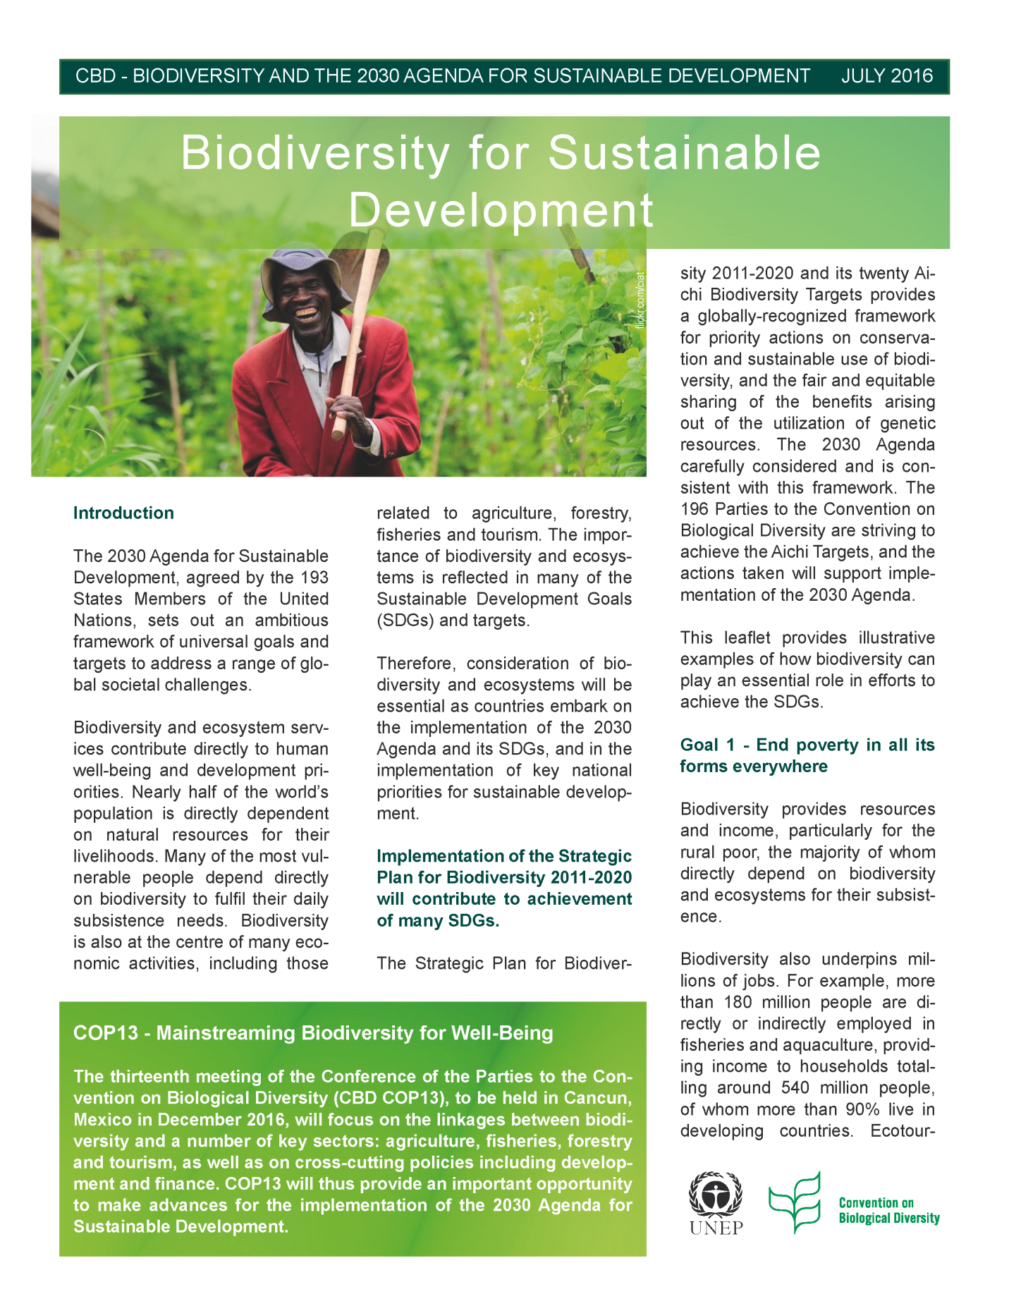
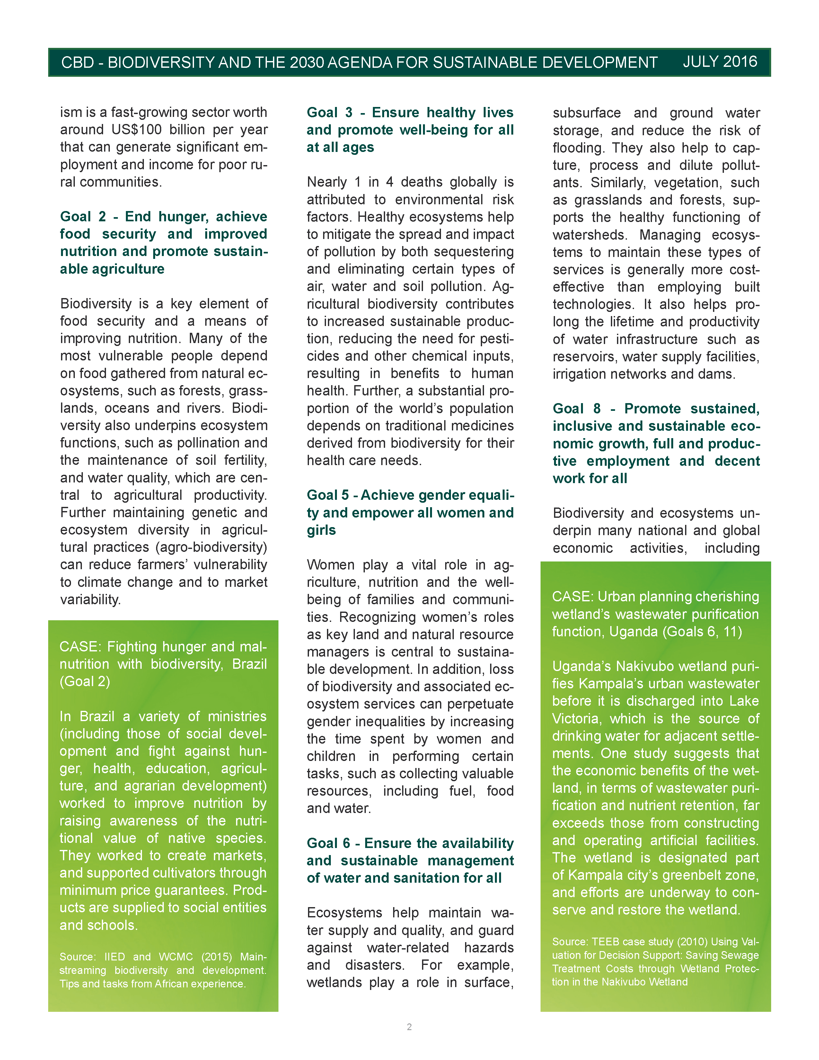

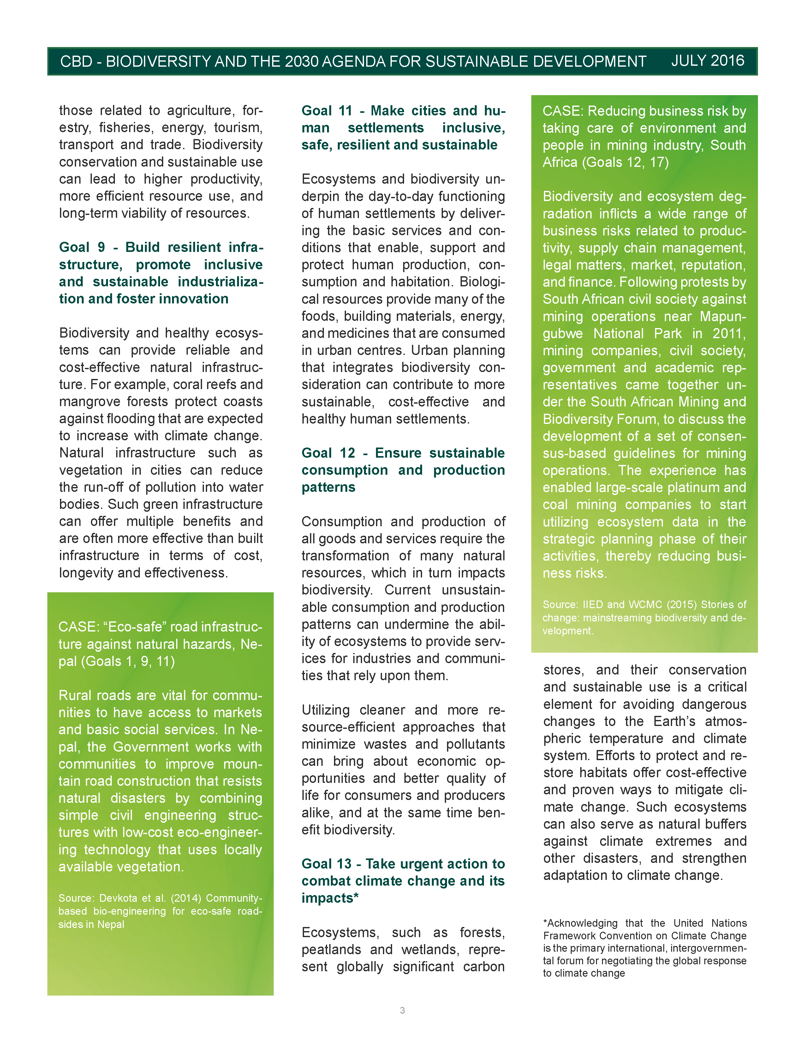

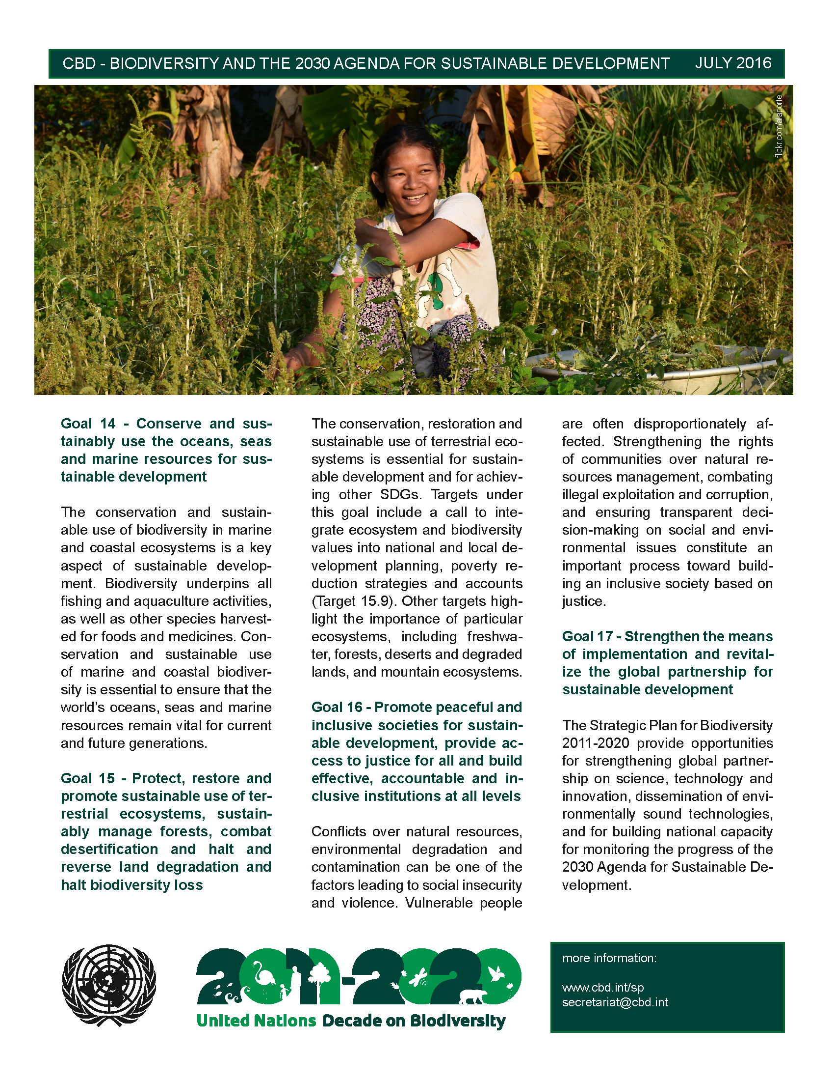
The online version of the CBD document above can be found at https://www.cbd.int/development/doc/sdg-jul2016-flyer.pdf
PART 2 – Why it Matters: UNDPI material for SDGS 14 and 15



