 |  | CBD
 |  |  |  | Distr.  GENERAL  UNEP/CBD/RM/WS/2014/4/2  25 September 2014  ORIGINAL: ENGLISH
REGIONAL WORKSHOP ON RESOURCE MOBILIZATION FOR EASTERN EUROPE AND CENTRAL ASIA
Isle of Vilm, Germany, 26-28 May 2014

REPORT OF THE WORKSHOP

I. INTRODUCTION
- Further to the request expressed by the Conference of the Parties to the Convention, this workshop was one of a series of regional workshops to support Parties in the establishment of robust baselines and reporting framework, and the preparation of national financial plans for biodiversity (see decision XI/4, paragraph 27).
- The present workshop was organized by the Secretariat of the Convention on Biological Diversity, the United Nations Development Programme, through its Biodiversity Finance Initiative (BIOFIN), and the United Nations Environment Programme (UNEP), through the UNEP World Conservation Monitoring Centre (UNEP-WCMC), with financial support provided by the Government of Denmark and the European Union (EU). The workshop was hosted by the Government of Germany, through its International Academy for Nature Conservation.
- The specific objectives of the workshop were:
(a) To enhance capacity of participants to apply pertinent methodologies, frameworks and tools for identifying, assessing, and reporting existing biodiversity finance, in order to develop robust financial baselines and for developing national finance plans, including financial targets, for effective implementation of revised NBSAPs; and
(b) To enhance the understanding of participants on the importance, for effective mobilization of financial resources, of identifying relevant biodiversity values and incorporating these values in policy planning, including in revised national biodiversity strategy and action plans (NBSAPs); and of existing case studies and good practices on pertinent approaches and measures for such identification and incorporation.
- The workshop was attended by government-nominated resource mobilization experts from the following countries: Albania, Belarus, Bosnia and Herzegovina, Georgia, Kyrgyzstan, Republic of Moldova, Tajikistan and Ukraine. A number of United Nations organizations as well as relevant international and national organizations were represented: UNEP World Conservation Monitoring Centre (UNEP-WCMC), United Nations Development Programme (UNDP), United Nations Development Programme - Global Environment Facility, United Nations Environment Programme, WWF Danube-Carpathian Programme and the Stockholm Resilience Centre. The list of participants is provided in annex VI to the present report. The documents prepared for the workshops and the presentations held can be accessed at http://www.cbd.int/doc/?meeting=RMWS-2014-04. The meeting was held in English and Russian.
ITEM 1. OPENING OF THE WORKSHOP
- The opening ceremony started at 8.30 p.m. on Sunday, 25 May 2014.
- Mr. Markus Lehmann, from the Secretariat of the Convention on Biological Diversity (SCBD), made opening remarks and welcomed participants to the workshop on behalf of the Executive Secretary of the Convention. He expressed his appreciation towards the international support that is being provided by UNDP and the BIOFIN programme. He proceeded with an overview of the workshop objectives and agenda of the three-day workshop, explaining that UNDP’s BIOFIN methodology would be presented and specific exercises would help participants discuss how this methodology, as well as the work from UNEP-WCMC, could be used for making the case for biodiversity. He also underlined the importance of revising NBSAPs to take into account biodiversity values, including economic values, so that they could be used to convince relevant Ministries to invest in biodiversity. He closed his opening remarks by thanking the Government of Germany for hosting the workshop and the European Union for financing it, as well as UNDP, UNEP and UNEP-WCMC for co-organizing the workshop.
- Ms. Jamison Ervin, from the BIOFIN initiative of the United National Development Programme (UNDP), emphasized the importance of viewing biodiversity as an investment, rather than a cost, by highlighting biodiversity’s links with issues such as food security, livelihoods and disaster risk reduction. Ms. Ervin also introduced the steps to be covered in the development trajectory: (i) awareness of the current trajectory and the value of nature; (ii) national policies; (iii) practices (business as usual vs. sustainable management); and (iv) outcomes and results. She also stressed that a “virtuous cycle” was what we were supposed to strive towards.
- Thierry Lucas, representing UNEP and as the biodiversity focal point for Europe, stated that he was very interested in this workshop because there was a need for significant funds in order to achieve the revised NBSAPs. He expressed the desire of his office to support implementation of NBSAPs and leveraging of the financial investment required to fulfill their objectives. He closed his opening remarks by stating that he looked forward to a good exchange of country experiences and to learning more on what the UNEP European Office could do to assist participating countries.
- Subsequently, participants of the workshop were invited to introduce themselves and present where their country currently stood in terms of the NBSAP revision process:
- Ms. Milena Kozomara (UNDP-GEF) stated that Serbia had developed a strategy in 2011 that now needed to be further developed;
- Mr. Umutbek Raimov (Kyrgyzstan) said that his government had new biodiversity guidelines and priorities for 2024 which also included a national plan that went to 2020, both of which had recently been adopted;
- Ms. Tatiana Novikova (Tajikistan) stated that there was a green section in their national plan to raise resources reflected in the 2013 version. She said that it was a very useful learning experience in that they did the calculations and tried to show biodiversity as an asset. However, many issues, related to synergy and cooperation among agencies, were faced in the process. She finished by saying Tajikistan planned to submit the strategy by this August and the process should be completed by this year;
- Ms. Lilia Eladii (Republic of Moldova) said that her country was in the final stages and that by the end of this year she hoped to get the feedback from all the agencies and submit it for approval to the executive committee and the cabinet;
- Mr. Andrei Kuzmich (Belarus) said that his country had a biodiversity strategy for the period 2010-2020 and a NBSAP plan which was in effect until 2020 as well;
- Mr. Adi Habul (Bosnia and Herzegovina) stated that the country’s fifth national report had been sent to the Secretariat and the final document, containing a section on resource mobilization, would be submitted by September of this year;
- Ms. Odeta Çato (Albania) said that the NBSAP would be revised by this September. She also noted that Albania was a changing country so a lot of the information and data in the current NBSAP was outdated but the issues remain the same. Most of the environment budget had been dedicated to protected areas;
- Ms. Nona Khelaia (Georgia) said that she looked forward to this workshop because her country recently adopted a revised NBSAP, developed in collaboration with the GIZ (Deutsche Gesellschaft für Internationale Zusammenarbeit), which took into consideration objectives of the Convention on Biological Diversity (CBD). Her colleague Ms. Natia Kobakhidze (GIZ) said that the Georgian Ministry had asked for assistance in revising the NBSAP and it was in line with the Aichi Biodiversity Targets and the global Strategic Plan. The strategy had an activity plan but it needed to elaborate an annual implementation plan to determine the resources required to implement the strategy;
- Ms. Olena Legka (Ukraine) said that her country had a strategy until the year 2020. The current plan had all the major targets for biodiversity for the period up to 2016; the second stage was for 2016-2020. They were currently collecting the materials for the next stage of the implementation plan.
- Ms. Gisela Stolpe, representing the International Academy for Nature Conservation, welcomed all participants on the Isle of Vilm and presented a brief historical background of the island. She also provided some logistical information and wished the participants fruitful discussions.

ITEM 2. UNDERSTANDING THE BROADER CONTEXT: identifying and integrating biodiversity benefits and values
- Ms. Maria Schultz, member of the High-level Panel on Global Assessment of Resources for Implementing the Strategic Plan for Biodiversity 2011-2020, presented the main conclusions of the second phase of the work of the panel. She outlined key messages from the first phase of the panel regarding the achievement of the Aichi Biodiversity Targets and described the approach adopted in the second phase of the Panel. Ms. Schultz explained that the emphasis in the second phase was to identify the range of costs of implementing the activities needed to achieve the targets as well as the opportunities to most cost-effectively secure such benefits through actions both within and outside the biodiversity sectors. With regard to the emerging key messages of the Panel, she noted the need to improve participation, institutions and governance as a challenge of particular importance.
- Focusing on the European and Asian regions, Ms. Schultz presented an overview of the regional findings, including the following: (i) there was substantial evidence on the benefits of conservation and sustainable use of biodiversity in these two regions; (ii) for most countries, there was likely to be a substantial gap between available and required resources for achieving the Aichi Biodiversity Targets; and (iii) countries needed to invest in stronger enforcement and institutional frameworks as a basis for implementing environmental management. NBSAPs of Eastern European countries could further improve their information basis regarding necessary investments/actions/measures. Among new EU Member States, there was a need to focus on capacity-building with regard to the uptake of financing opportunities and awareness raising, whereas in non-EU Eastern European countries, priority needed to be given to fundamental activities, such as basic studies on the state of ecosystems, the designation of protected areas, and addressing legal and compliance issues. In Asia, major challenges in achieving effective environmental policy were the lack of public awareness and political will, as well as insufficient capacity to enforce existing laws and an absence of adequate scientific knowledge and research skills. She concluded by saying that more resources were needed but that the availability of quantifiable data on resource needs and costs was very weak.
- The following points were made and issues raised in the subsequent discussion:
- There were demonstrated direct benefits of job creation and income growth in the nature conservation area, with cases from Hungary and Poland, while addressing harmful incentives could increase the availability of financial resources and decrease pressure on biodiversity. According to the panel, reaching Aichi Targets like 2 and 3 would significantly assist in reaching other Aichi Targets, such as Target 11;
- Understanding the linkage between GDP and biodiversity policies was important for politicians who wanted to see tangible economic benefits, such as insurance values (the contribution of biodiversity to resilience). However, it was important to avoid aggregating too much because some values could not be captured in monetary terms. And while some links could be made comparatively easily, as least in qualitative terms, such as the economic contribution of ecotourism, other linkages could be more challenging to demonstrate or quantify.
- Mr. Abisha Mapendembe (UNEP-WCMC) presented on the NBSAP revision process and the various entry points and approaches that supported inclusion of biodiversity values. He provided the background of the pertinent project undertaken by UNEP-WCMC and the Institute of European Environmental Policy, in collaboration with the CBD Secretariat and funded by the Department for Environment, Food and Rural Affairs of the United Kingdom of Great Britain and Northern Ireland. After summarizing different biodiversity values (economic, cultural, intrinsic and social) and their importance for achieving mainstreaming, he explained the different entry points for incorporating values along the stages of the NBSAP revision process. A range of supporting approaches could be used, including stakeholder engagement, ecosystem assessment, ecosystem service mapping, ecosystem service indicators, monetary valuation, and accounting. He concluded by pointing to country case studies on common lessons of good practices. The UNEP-WCMC provided guidance on how to a “business case for biodiversity”, a diagnostic tool when you embarked on the mainstreaming of biodiversity at the national level.
- Ms. Nona Khelaia and Ms. Natia Kobakhidze (Georgia) complemented Mr. Mapendembe’s presentation by providing an overview of the process of reviewing the NBSAP in their country as well as the challenges faced. Coordinated by the Ministry and in consultation with a wide range of stakeholders, including politicians, NGOs and experts from the scientific and academic communities, the strategy was elaborated in a collaborative manner, engaging also all relevant ministries and communicating with them on a regular basis in order to facilitate the process of political agreement.
- Participants agreed that fostering communication and coordination with the different ministries was critical. For instance, Ms. Tatiana Novikova (Tajikistan) noted that her government had conducted three national workshops with various ministries, stressing the importance of a bottom-up and comprehensive approach, including the need to raise public awareness in particular at the local level.
- The morning session continued on the subject of ecosystems and biodiversity and included a scenario-building exercise. Mr. Markus Lehman presented the TEEB stepwise approach to valuation. He emphasized the importance of (i) identifying which ecosystem services are the most relevant and possible scenarios (business as usual vs. sustainable management alternative); (ii) defining the information needs and selecting appropriate methods, criteria and indicators; (iii) assessing the expected changes on the flow of ecosystem services; and (iv) assessing distributional impacts of policy options. Many valuation tools were costly, time-consuming to apply and require considerable technical expertise. One must apply a cost-benefit criterion to the valuation exercise itself.
- Steps in the TEEB approach consisted of the following: (i) specify and agree on the decision-making problem at hand, which may involve the definition of stylized scenarios for different options; (ii) identify the most important ecosystems services in the specific context; (iii) consider using tools such as existing market data, cost-based approaches; and (iv) use indicators for human well-being that are meaningful and practicable in the present context.
- Building on this approach, participants engaged in an interactive scenario-building exercise on the valuation of ecosystems and biodiversity and building a business case for biodiversity, the full results and tables of which are provided the exercise can be found in annex I below. Responding to the exercise, participants stressed the importance of speaking the language of the authorities that made funding decisions with regard to biodiversity, by “translating” tools and ideas into messages that were understandable and “sellable” for politicians. Participants noted that the concept of ecosystem services was perhaps providing the common ground between the Ministry of Environment and the Finance Ministry to convince the latter that investing in biodiversity would result in benefits.

ITEM 3. UNDERSTANDING THE BROADER CONTEXT: ACTORS and INSTITUTIONS
- Ms. Jamison Ervin (UNDP) presented UNDP’s BIOFIN methodology, which was based on four conceptual frameworks: (i) public and private expenditure review; (ii) pressure state response framework; (iii) pressure and state with root causes analysis; and (iv) valuation methodology.
- Ms. Ervin explained the stylized steps towards developing a national resource mobilization strategy as follows: (i) identifying drivers of loss of biodiversity; (ii) identifying relevant institutions and actors, including from different economic sectors; (iii) reviewing biodiversity-related expenditures; (iv) assessing costs of prioritized strategies and actions; (v) calculating the financial gap; (vi) identifying potential finance mechanisms and associated actors; and (vi) synthesizing this into a resource mobilization plan.
- Participants were subsequently invited to participate in an exercise designed to gain an aggregated overview of the region in regards to the status of NBSAP revision and the elaboration of a resource mobilization plan. The results of this exercise are presented in annex IV to this report.
- After Ms. Ervin’s presentation, participants were invited to break into small groups to do an exercise on identifying relevant financial actors and institutions. The two groups presented the following results:
- The first group examined the mining sector and its impact on food production and water quality and supply. They explained that the root causes could be traced to policies, including weak environmental assessments or weak coordination and/or policies among sectors regarding land use and restoration policies;
- The second group examined the forestry sector and identified practices in forestry that degraded biodiversity, notably logging. With regard to illegal logging, the group noted that there were legal instruments to enforce laws; however, the negative factor particularly influencing biodiversity was the economic drive towards the export of lumber. Mitigation measures could include developing financial mechanisms that made organizations responsible for logging, conserving regions that were particularly rich in biodiversity or planting forests. Other actions that could reduce the impact were regulations on licences that obliged reforestation, complemented with awareness raising and enforcement activities.
- Mr. Abisha Mapendembe (UNEP-WCMC) presented the UNEP project on improving cooperation among biodiversity-related multilateral environmental agreements (MEAs), including on resource mobilization. He explained that the fragmented system of international environmental governance, including the various biodiversity-related conventions, had led to widespread calls for greater efficiency, effectiveness and coherence among MEAs at all levels. The objective of the project (2013-2015), to be implemented through four work packages, was to analyse and provide non-prescriptive guidance on opportunities for enhancing cooperation among the biodiversity-related MEAs at all levels, including on synergies in resource mobilization. According to questionnaire-based research undertaken by the project, there was a good deal of overlap in the experiences of participants, particularly among the Convention on Biological Diversity, the Convention on International Trade in Endangered Species of Wild Fauna and Flora (CITES) and the Convention on Migratory Species (CMS).
- After the presentation, participants noted (i) the merits of improving subregional cooperation, such as under the Convention on Migratory Species; and (ii) the need to achieve synergies based on practical cases and with support from conventions.

ITEM 3. Baselining and reporting
- Ms. Jamie Ervin (UNDP) presented on biodiversity-related expenditure review on biodiversity. She stressed the importance of this phase, as it established the baseline of for public and private expenditures on biodiversity-related activities and determined the financial gap between what was currently being spent and what would need to be spent to implement the NBSAP. She provided an overview of the following steps in an expenditure review: (i) identify relevant finance actors; (ii) extract budgetary data from relevant finance actors; (iii) develop a single coherent system for coding and processing all data; (iv) analyse all relevant expenditures from the past, and project into the future.
- Ms. Ervin also presented the three key issues in expenditure review: (i) relevance (some expenditures were more relevant to biodiversity than others); (ii) effectiveness (some expenditures were more effective in conserving biodiversity than others); and (iii) environmentally harmful expenditures (some expenditures harmed biodiversity).
- In the subsequent discussion, participants pointed to (i) the importance of an appropriate evaluation of subsidies and expenditures, given that some subsidies were positive and others had negative impacts on biodiversity; (ii) the need to capture all sources and entities, including governmental, donors, and private investors; (iii) the need to align expenditure reviews with existing processes, such as procurement plans or endorsement letters; (iv) the role of capturing the efficiency and effectiveness of expenditures.
- Mr. Markus Lehmann (SCBD) presented on the linkages between resource mobilization for NBSAP implementation and the global resource mobilization agenda. He provided the global context and the elements of global guidance, including the preliminary global resource mobilization targets adopted by the eleventh meeting of the Conference of the Parties (decision XI/4) using 2006-2010 as the benchmark. He also provided a summary of the first insights from the reporting of domestic expenditures, noting that there was a gradient in number of submissions from direct to indirect sources and central to state and municipal governments, and that information was even patchier for other sources such as the private sector and NGOs. The central expenditures directly related to biodiversity tended to be small, but expenditures indirectly related to biodiversity could be significant, and were sometimes much higher. A range of methodologies exist and the roles of country-specific governance structures and non-monetary or non-financial “expenditures” also had to be considered. He concluded by explaining the dual role of baselining: it formed the basis for an effective resource mobilization plan for a revised NBSAPs and fed into the global process (through the reporting framework), thereby helping to sustain the political momentum generated at the global level.
- The presentation was followed by an in-depth exchange of information on national policy development processes and how the associated financial needs were identified, which included the following points being made: (i) the role of NGO was providing funding as well as financial information: while some longer-term projects, such as biodiversity monitoring, had funds allocated from the state budget, other did not, and in these cases, it was critical to assure high-level decision makers that other funding sources were available for suggested activities; (ii) short-term budget cycles sometimes put limitations on longer-term financial planning; (iii) in other cases, state programmes, such as on protected areas, on environmental monitoring and forestry, including restoration issues, had a 5-year finance plan to ensure that the financial resources were allocated for those activities. Making the NBSAP a legal obligation could help in ensuring that funding was given due consideration, for instance by appropriate budget allocations; (iv) the overall importance of developing a financial strategy that detailed how financial estimates were determined and that provided a scheme for allocating financial resources in the budget.

ITEM 4. COSTING AND IDENTIFYING FINANCE GAPS
- Ms. Jamison Ervin (UNDP) presented the second stage in NBSAP resource mobilization, namely identifying the cost of strategies in the NBSAP. Noting that costing was a crucial step towards determining financial gaps against available resources, she subsequently provided an overview of the six key issues in costing: (i) one-time costs vs. recurring; (ii) timing (not all costs will occur at once); (iii) sequencing and prioritizing (not all strategies and related costs are equal); (iv) return on investment using an activity-based cost accounting model; (v) cost of inaction (planners may consider multiple investment scenarios, but should also consider the costs of inaction); and (vi) time horizon for analysis.
- The presentation was followed by an exchange of experiences in costing, in breakout groups. The groups reported the following:
- The first group (Bosnia, Georgia, Albania) reported that they did not itemize costs for each budget item; it was mostly only for salary and some taxes. A detailed budget was elaborated for each activity. For instance, while the financial amount allocated for protected areas was known, the detailed provisions were only developed at later stages. In Georgia for example, the director of budget and technical directors identified and prioritized the major issues every year and, based on this analysis, the budget was allocated for specific areas. The director of protected areas was responsible for developing a detailed financial plan for the protected area’s budget allocation. Each project would have an analysis of benefits accruing from the investment and the expected short-term results over five years;
- The second group noted that determining budget allocations was often a challenge, for instance because of frequent changes in the administrative management system. While it was important, for the sake of efficiency, to prioritize activities and to develop indicators that assisted in evaluating progress, these elements were not included in the strategy itself for the sake of keeping flexibility: if the figures provided were too detailed, there would be a risk that they would be outdated by the time of implementation.

ITEM 5. Closing finance gaps
- After a guided tour of the Isle of Vilm, Ms. Jamison Ervin (UNDP) presented an overview of different biodiversity finance mechanisms. She explained that the High-level Panel on Biodiversity Finance estimated a cost of $150 billion to $450 billion annually through 2020 to achieve the Aichi Targets. However, official overseas development assistance (ODA) was less than $5 billion annually (less than 5%). The global cost estimate for protected areas was $34 billion per year and only about half the costs were currently funded (~$17 billion per year). She referred to the financial gap for protected areas in Belize as an example of how to calculate finance gaps and, based on this calculation, devise a plan to close these gaps. She subsequently reviewed the range of finance mechanisms available, such as positive tax incentives, fiscal reform, procurement policies, cap and trade, payments for ecosystem services (PES) schemes, market certification and biodiversity offsets. She also underscored the importance of choosing the right mechanism and ensuring that appropriate safeguards were in place. Feasibility screening criteria took financial, legal, administrative, social, political, environmental factors into consideration.
- Ms. Maya Bankova-Todova, Regional Green Economy Coordinator at the WWF Danube - Carpathian Programme, presented practical experiences on implementing payments for ecosystem services (PES) schemes in countries of the Lower Danube, based on a 2010-14 WWF project implemented in the four countries of the lower Danube (Serbia, Ukraine, Romania and Bulgaria), with financial assistance provided through the Global Environment Facility (GEF) and UNEP. The four schemes were: (i) market payments for wetland restoration and management (Persina pilot); (ii) payments for sustainable fishpond management (Ciocanesti pilot) located in Romania; (iii) payments for cultural ecosystem services (Rusenski Lom Pilot); and (iv) conservation and sustainable development fund for ecosystem services (Maramures pilot).
- Participants reviewed a number of finance mechanisms and discussed their applicability in the countries of the subregion. The full results and tables of the exercise can be found in annex II. While it was noted that the situation varied according to country and depended on the national institutional set-up and how projects were being approved, some skepticism was expressed towards biodiversity financial mechanisms. In the current economic climate, priority would be given to development, and increased government allocations would often remain of critical importance, although specific tools such as airport fees earmarked for conservation efforts, biodiversity offsets or other forms of compensation/redress, for instance stumpage fees, as well as donations, would offer interesting avenues. The importance of corporate social responsibility was also noted in some cases, as large foreign investors normally came with an array of policies, including internal environmental and safeguard mechanisms which helped drive the environmental agenda forward. Participants also underscored the importance of developing legal enforcement mechanisms and tools to ensure that corporations remained in legal compliance.
- Specifically on payments for ecosystem service schemes, the group noted there was general awareness that these mechanisms existed, but practical experiences in implementation remained scarce. The discussion underscored the importance of achieving long-term financial sustainability. While payment schemes could alleviate start-up cost, whenever there was a business plan this plan had to be made viable in the medium term. Awareness raising and active promotion of innovative products with local governments and public institutions could help. Such promotion could use studies on the social and economic benefits accruing from the projects, based on the data received under the monitoring framework that was put in place.
- Mr. Thierry Lucas (UNEP) presented the work of the UNEP Regional Office for Europe on Ecosystem Management and Pan-European Biodiversity. Mr. Lucas presented (i) the priority areas; (ii) outcomes of the Steering Committee established at the end of 2013 to assist in the Pan-European activities and Central Asia; (iii) projects in Central Asia; (iv) the work programme and activities for 2014-2017; and (v) TEEB. The work programme includes capacity-building for NBSAPs, biodiversity monitoring, mapping and assessment of ecosystem and their services (MAES), knowledge mapping TEEB studies, capacity-building for market-based instruments (MBI), and streamlined implementation and reporting.
- In the subsequent discussions, participants sought, and were given, further information on imagery data and mapping under MAES.
- Mr. Thierry Lucas subsequently delivered a presentation on the EU financial framework and application in Pan-Europe. He reviewed the different geographic instruments (in particular, Development Cooperation instrument, European Neighborhood instrument, Pre-Accession instrument and Partnership Instrument), their respective budgets over time, and the projections up to 2020. He underlined the importance of the Country Environmental Profile (CEP), which was a description of the country’s environmental situation, including the implications of biodiversity loss, and was used to inform the preparation of the CSP/National Indicative Programme (2014-17, 2017-20). It could be used as reference for environmental integration in programmes and projects by EC staff and cooperation partners. In conclusion, he noted that only few countries had prioritized biodiversity in their national strategic plan so far, and emphasized that more countries needed to follow suit and examine how decision-making mechanisms and biodiversity could feed into these processes.

ITEM 6. Towards national finance plans
- Ms. Jamison Ervin (UNDP) delivered her final presentation on developing a resource mobilization plan. She explained that the first step was to identify the steps you could take now to integrate the NBSAP revision process, such as by identifying sectors that might pay for biodiversity and identifying potential finance actors and mechanisms. The second step was to identify potential synergies and entry points based on key issues. The third step was to develop an action plan that could help advance you toward a resource mobilization plan, including valuation of biodiversity and ecosystems, identifying policy and practice drivers of change, key actors and institutions and financial gaps. Ms. Ervin concluded with the last step in the process, which was to develop a full resource mobilization plan, as time and finances allowed, including the following components: background and overview; policy and institutional analysis; expenditure review; strategies, actions and costs; projected future states with investment; opportunities for mobilization resources; making the case for biodiversity investments; and consolidated resource mobilization plan with finance mechanisms, actors, and timelines.
- The subsequent group discussion focused on the potential synergies and entry points within each of the countries of the subregion. Participant noted the importance of, and the practical difficulties associated with, earmarking funds mobilized for biodiversity and ecosystem services, pointing to the examples of water fees where funds collected all too often were not earmarked towards maintaining watershed-related ecosystem services. Participants also underlined the importance of communicating regularly with those in charge of implementing national development plans, in particular focal points of various conventions. For instance, investments made in the restoration of wetlands could generate multiple beneficial effects, including increasing biodiversity, stabilizing hydrological areas and carbon sequestration, increasing livelihood opportunities as well as decreasing fire hazards. The discussion concluded with the observation that public safety could be used as an entry point to convince finance ministries to take action.
- Before concluding the workshop, participants engaged in a role-play exercise on making the case for biodiversity to finance ministers, based on the model of the “Dragons’ Den” television series. The directions for the exercise are provided in annex III. Participants were divided into two groups and, based on the results and the cases developed at the initial stage of the workshop, were tasked with defending biodiversity conservation vs. different developing plans being approved by the government to be presented to the finance and economic development ministers. Speakers selected by the groups were given three minutes for their presentation and had to respond to the questions from the “ministers”.
- In conclusion, participants expressed their appreciation for the need to make a convincing case for biodiversity as well as noting the difficulties of framing the arguments in economic terms, such as in the form of return on investment.

ITEM 7. CLosure of the workshop
- Participants were invited to complete a workshop evaluation questionnaire. The results of the survey are provided in annex V.
- After an exchange of courtesies, the workshop was officially closed on 28 May 2014 at 4 p.m.

Annex I

RESULTS FROM THE SCENARIO BUILDING EXERCISE
Group no. 1: Construction of a road in a protected area (PA)
 | Scenario 1  Protected Area | Scenario 2  PA with road | Scenario 3  Best scenario
Ecosystem service 1  Tourism | ++ | 1. +++  2. + | +++
Ecosystem service 2  Carbon sequestration | ++ | ++ | ++
Ecosystem service 3  Use of forests (timber/ wood, wetlands) | ++ | - | +
Ecosystem service 4  Object to be conserved (PA/species) | +++ | - | ++
The third scenario provides a balanced approach, in which the government recognizes both the necessity of building a road and conserving species and other benefits derived from the protected area. In this best-case scenario, a road would be built in such a way that it circumvents the protected area or, at least, minimizes the impacts on the protected area. The road will thereby provide a “linking tool” to allow locals to sell and export their goods, while taking into account the need to balance environmental needs.
The group emphasized that there is no general solution to finding a “net-positive result” and there is only a case-by-case approach.
Group no. 2: Construction of a hydroelectric power plant in a protected area
 | Scenario 1  Protected Area | Scenario 2  PA with hydro plant | Scenario 3  Controlled development
Ecosystem service 1  Food supplies | ++ | - | +
Ecosystem service 2  Carbon storage | ++ | - | +
Ecosystem service 3  Ecotourism | ++ | - + | ++
Ecosystem service 4  Energy | - - | ++ | +  Technology of the dams will create less power
Ecosystem service 5  Cultural value | ++ | - - | +
Due to the technical specificities of the scenario 3 type dam, the impact on fish biodiversity and the amount of water that is flooded in the protected area is much lower compared to the scenario 2 type dam. The group concluded by saying that the third scenario was the best possible scenario because it is a balanced approach in which a hydroelectric power plant is constructed to produce energy, at a lower level, but with a much lower environmental impact on the protected area and its surroundings.
The group emphasized the importance of demonstrating the value of building a hydroelectric power plant with a lower energy production capacity and that mitigates the negative impacts on biodiversity.

Annex II

RESULTS FROM THE EXERCISE ON FINANCE MECHANISMS
Finance mechanisms | Feasibility |  |  | Notes
Finance mechanisms | H | M | L | Notes
Payment for ecosystem services |  |  | X | Still have a “long way to go”
Biodiversity offsets |  |  | X | Voluntary measures (corporate social responsibility)
Royalties/stumpage fees/concession fees |  |  | X | Upfront payments for water subsidies
Fines | ✓ |  | X
Donations |  |  | X | Perhaps to be used occasionally (NGO activities 50/50)
Compensation/redress | ✓ |  | X | Logging fees/ compensation
Increased Government allocations | ✓
Voluntary programs |  |  |  | RFPs by company’s guidelines
Legal frameworks/policies

Annex III

DIRECTIONS FOR THE “DRAGONS’ DEN” EXERCISE
Group 1 (Russian-speaking group)
In the last decade, country X doubled the export volume, in physical terms, of its main export product. A recent market study, commissioned by the ministry for economic development and transport, expects further significant increases in the future. As a result, traffic on the main road connecting the principal production area with the main port, where the product is shipped for export, also doubled. This led to severe congestions, a significant increase in deadly accidents, as well as complaints about unbearable noise and pollution levels by the populations in the villages and small towns through which the road passes.
The ministry of economic development and transport was tasked to urgently remedy this situation and is currently contemplating to build a new highway bypassing the current road and providing a direct transportation link between the production center and the port city. This highway would solve the issues above while providing enough transportation capacity for the foreseeable future. However, it would, as per current planning, cut through one of the important national parks of the country.
Group 2 (English-speaking group)
Due to strong economic development in country Y, national energy demand, in particular demand for electricity, has increased significantly in the past decade. However, because of underinvestment in the energy sector, the country is increasingly experiencing shortages in electricity supply, leading to occasional blackouts in particular in rural mountain areas (as priority is given to cities and production zones). In order to remedy this situation, the ministry for economic development and energy is contemplating to not just address the investment backlog, but to fundamentally re-orient the national energy system by tapping the country’s considerable hydropower potential. This would not just enhance energy security by addressing the current capacity constraints, but would also generate potential export opportunities, and – a fact particularly highlighted by the energy ministry – would at the same time contribute to mitigate global climate change.
Unfortunately, the majority of the country’s significant protected areas are also located in the mountains, and the current planning, based on relatively few but major hydropower dams, would imply major impacts on most of these and the outright destruction of a few.
Both groups:
After considerable wrangling over suitable dates, the office of the environment minister managed to secure an appointment of the environment minister with the minister for economic development and transport/energy and the finance minister, to voice concerns and discuss constructive solutions. However, due to their tight calendars, the time together in person is just 5 minutes.
Thus, the environment minister has five minutes to “make the case for biodiversity”. But what exactly is her case?
Your task as a group:
- Elect your environment minister.
- Prepare the brief for the environment minister to present at the meeting (the environment minister is part of the team). You have 20 minutes to prepare the brief.

Annex IV
Overview of progress made in revising NBSAPS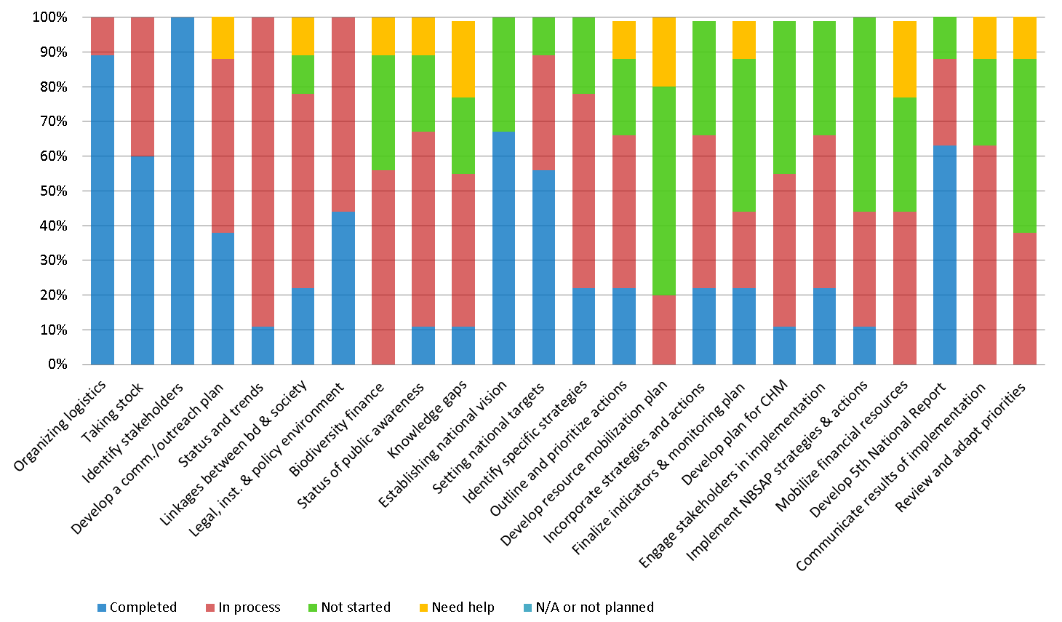

Overview of progress made in developing national finance plans

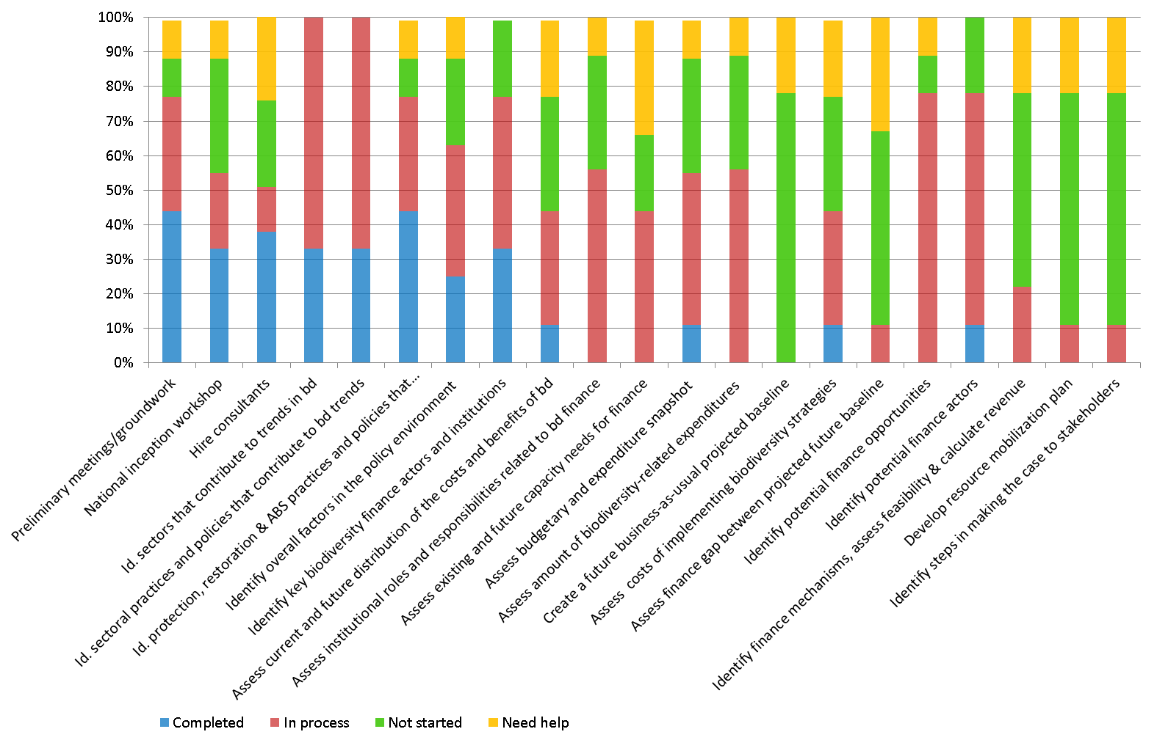

Annex V

RESULTS OF THE WORKSHOP EVALUATION QUESTIONNAIRE
Questions | Very low | Low | Average | High | Very high | Comments
How do you rate the overall usefulness of the workshop? |  |  |  | 25% | 75%
How well has this workshop contributed to your ability to prepare/update your resource mobilization strategy? |  |  | 12.5% | 25% | 62.5% | Not enough, more is needed.
How would you rate the usefulness of the programme on resource mobilization and valuation? |  |  |  | 12.5% | 87.5%
In your opinion, was enough time allowed for discussion and interaction? |  |  | 12.5% | 25% | 62.5% | More is needed.
Did you consider the daily time schedule to be appropriate? |  |  |  | 12.5% | 87.5%
Please rate your satisfaction on the overall logistical organization of the workshop? |  |  |  | 25% | 75% | Special thanks to Gisela and Lydia.
Please rate your satisfaction on the venue and its facilities? |  |  |  | 12.5% | 87.5%
Please describe one main thing that you have experienced or learned here in the workshop that will be particularly helpful in your work. | Making a case and approach to different mechanisms. Heightened my understanding; practice in groups. Means (tools of Biofin).  Making the case for biodiversity to non-biodiversity ministries.  Heightened my understanding; practice in groups. Means (tools of Biofin).
Is there anything that we could have done differently to enhance the usefulness of the workshop? | More examples.  More time, resource people should have more time to deliver all they have.  Well organized meeting, venue was excellent. Lydia was great.
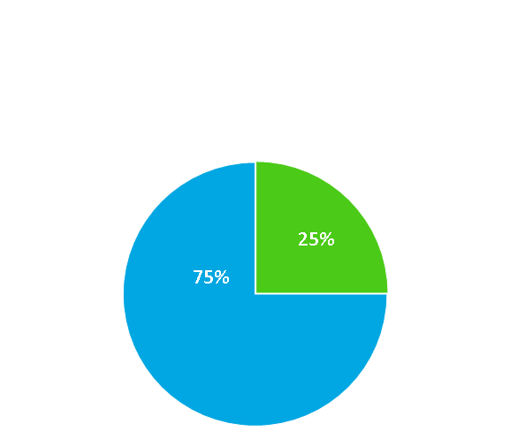
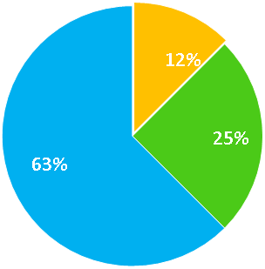
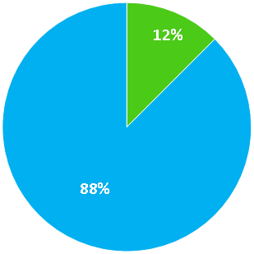
Graphical results of the workshop evaluation questionnaire
1. How do you rate the overall usefulness of the workshop?
2. How well has this workshop contributed to your ability to prepare/update your resource mobilization strategy?
3. How would you rate the usefulness of the programme on resource mobilization and valuation?

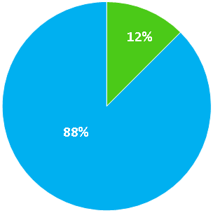
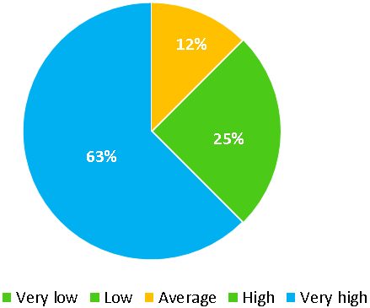
5. Did you consider the daily time schedule to be appropriate?

4. In your opinion, was enough time allowed for discussion and interaction?
6. Please rate your satisfaction on the overall logistical organization of the workshop?

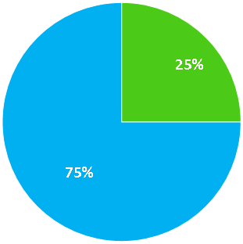

7. Please rate your satisfaction on the venue and its facilities?

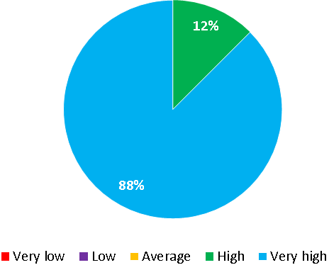

Annex VI

WORKSHOP PARTICIPANTS
CBD Parties
Albania  1. Ms. Odeta Çato  Director  Biodiversity and Forests Directorate  Ministry of Environment  Rruga e Durresit No.27  Tirana  Albania  Tel.: +355 4 2243578  Fax: + 355 4 2270623  Email: odeta.cato@moe.gov.al, odeta.cato@gmail.com  Belarus  2. Mr. Andrei Kuzmich  Head  Department of Lands and Landscapes,  Biological and Landscape Diversity Division  Ministry of Natural Resources and Environmental Protection  10, Kollektornaya Str.  Minsk 220048  Belarus  Tel.: +375-29-794-63-04  Fax: +375-17-200-64-20  Email: a.kuzmich.belarus@gmail.com, landscape2011@bk.ru  Bosnia and Herzegovina  3. Mr. Adi Habul  Senior Associate  Biodiversity Conservation and Protected Areas  Federal Environmental Protection Fund  Hamdije Čemerlića 39A  Sarajevo 71000  Bosnia and Herzegovina  Tel.: +387 (0)33 723 680  Fax: +387 (0)33 723 688  Email: Adi.Habul@fzofbih.org.ba | Georgia  4. Ms. Nona Khelaia  Chief Specialist  Biodiversity Protection Service  Ministry of Environment and Natural  Resources Protection  6 Gulua Street  Tbilisi 0114  Georgia  Tel.: +995 32 272 72 32  Fax: +995 32 272 72 31  Email: nonakhelaia@yahoo.com  5. Dr. (Ms.) Natia Kobakhidze  Project Component Coordinator  ("Sustainable Management of  Biodiversity, South Caucasus")  Deutsche Gesellschaft für Internationale Zusammenarbeit (GIZ)  Ministry of Environment and Natural Resources Protection  6, Gulua St.  Tbilisi 0114  Georgia  Tel.: +995 32 201827  Email: natia.kobakhidze@giz.de  Germany  6. Ms. Gisela Stolpe  Head of Unit  International Academy for Nature Conservation  Federal Agency for Nature Conservation (Branch Office - Isle of Vilm)  D-18581 Putbus  Schulstrase 18  Isle of Vilm  Germany  Tel.: +49 38301 86 113  Fax: +49 38301 86 117  Email: gisela.stolpe@bfn-vilm.de

Kyrgyzstan  7. Mr. Umutbek Raimov  Chief Specialist  Department of ecological strategy and policy  Forest State Service  Kyrgyzstan  Tel.: +99631 2549 152  Email: Min-eco@elcat.kg, envforest@elcat.kg  Republic of Moldova  8. Ms. Lilia Eladii  Advisory Officer  Natural Resources and Biodiversity Department, Protected Areas,  Biodiversity and Biosecurity Unit  Ministry of Environment  Chisinau  Republic of Moldova  Tel.: +373 22 204 528  Email: eladii@mediu.gov.md  Sweden  9. Ms. Maria Schultz  Director  The Resilience and Development Programme (SwedBio)  Stockholm Resilience Centre  Stockholm University  Stockholm SE-106 91  Sweden  Tel.: +46 734 025 412  Email: maria.schultz@stockholmresilience.su.se, | Tajikistan  10. Ms. Tatiana Novikova  Deputy Head  National Biodiversity & Biosafety Center  44 Aini Street  Dushanbe 734024  Tajikistan  Tel.: +992 372 221 53 51  Fax: +992 372 221 89 78  Email: tnovikova@biodiv.tojikiston.com; Tatiana_Novikova@mail.ru, biodiv@biodiv.tojikiston.com  Ukraine  11. Ms. Olena Legka  Chief Specialist  Division of Land Resources  Ministry of Ecology and Natural Resources  35 Uritskogo Street  Kyiv 03035  Ukraine  Email: olegka@menr.gov.ua

United Nations and Specialized Agencies
UNEP World Conservation Monitoring Centre 12. Mr. Abisha Mapendembe  12. Mr. Abisha Mapendembe  Ecosystem Assessment Programme  UNEP World Conservation Monitoring Centre  219 Huntingdon Road  Cambridge CB3 ODL  United Kingdom of Great Britain and Northern Ireland  Tel.: +44 (0) 1223 814665  Fax: +44 (0) 1223 277136  Email: abisha.mapendembe@unep-wcmc.org  Web: http://www.unep-wcmc.org/ | United Nations Environment Programme  15. Mr. Thierry Lucas  Programme Officer, PEBLDS  Division of Regional Cooperation  United Nations Environment Programme  Liaison Office to the European Union  Rue Montoyer 14  1000 Brussels  Belgium  Tel.: +32 2 213 30 56  Fax: +32 2 213 30 51  Email: thierry.lucas@unep.org
United Nations Development Programme  13. Ms. Jamison Ervin  Senior Technical Adviser  Ecosystems and Biodiversity  United Nations Development Programme  1061 Mountainview  Duxbury 05676 Vermont  United States of America  Tel.: 1.802.244.5875  Fax: 1.802.244.5875  Email: jamison.ervin@undp.org, jervin@sover.net | United Nations Development Programme - Global Environment Facility  14. Ms. Milena Kozomara  Portfolio Manager  United Nations Development Programme -  Global Environment Facility  Ministry of Environment and Spatial Planning  Omladinskih brigada 1, office 610  11000 Belgrade  Serbia  Tel.: +381 (11) 2160956  Email: milena.kozomara@undp.org
Non-Governmental Organizations
WWF Danube-Carpathian Programme
16. Maya Bankova-Todorova
Regional Green Economy Coordinator
WWF Danube-Carpathian Programme
Palmotićeva 17
Belgrade 11000
Serbia
Email: mtodorova@wwfdcp.bg
Secretariat of the Convention on Biological Diversity
17. Markus Lehmann  Secretariat of the Convention on Biological Diversity  United Nations Environment Programme  413 St. Jacques Street West, Suite 800  Montreal, QC Canada H2Y 1N9  Tel. + (514) 288 2220 | 18. Lydia Zemke  Secretariat of the Convention on Biological Diversity  United Nations Environment Programme  413 St. Jacques Street West, Suite 800  Montreal, QC Canada H2Y 1N9  Tel. + (514) 288 2220
__________

TEEB = The Economics of Ecosystems and Biodiversity.

