 |  |  | CBD
 |  | CONVENTION ON  BIOLOGICAL DIVERSITY |  |  | Distr.  GENERAL  UNEP/CBD/AHTEG-2010-Ind/1/2  27 September 2004  ENGLISH ONLY
AD HOC TECHNICAL EXPERT GROUP ON INDICATORS FOR ASSESSING PROGRESS TOWARDS THE 2010 BIODIVERSITY TARGET
Montreal, 19 - 22 October 2004
Item 3.1 of the provisional agenda*
Indicators for assessing progress towards the 2010 target:
indicators for immediate testing
Note by the Executive Secretary
Introduction
- In its decision VII/30, the Conference of the Parties (COP) to the Convention on Biological Diversity adopted a framework for assessing progress at the global level towards the 2010 target, and for communicating effectively trends in biodiversity related to the three objectives of the Convention. The Conference of the Parties agreed that a limited number of trial indicators, for which data are available from existing sources, be developed and used in reporting, inter alia, through the Global Biodiversity Outlook (paragraph 3). The table on indicators adopted in annex I of decision VII/30 is reproduced in annex I to this note.
- The Conference of the Parties requested SBSTTA, with the assistance of an ad hoc technical expert group, to:
- Review the use of the indicators listed in column B of the indicators table (indicators for immediate testing), inter alia, by reviewing a draft of the second Global Biodiversity Outlook;
- Identify or develop indicators listed in column C of the indicators table (possible indicators for development), ensuring that the full set of indicators is limited in number;
and report on the results to the Conference of the Parties at its eighth meeting.
- The current document summarizes available information on the eight indicators for immediate testing (indicators listed in column B). More detailed information on each of these indicators is provided in relevant information documents. Possible indicators for development (indicators listed in column C) are addressed in document UNEP/CBD/AHTEG-2010-Ind/1/3. An outline of the Second Global Biodiversity Outlook is contained in document UNEP/CBD/AHTEG-2010-Ind/1/4.

- To facilitate the review of the use of the indicators for immediate testing, the Secretariat, with support of the UNEP World Conservation Monitoring Centre, has prepared background documents on each of the eight indicators. These documents have been posted in an electronic discussion forum and, during a period of two months, experts and focal points of the Convention on Biological Diversity were invited to submit review comments.
- On the basis of the comments received the documents were revised and are presented as information documents to the AHTEG meeting. The key messages for all eight indicators have been extracted and are presented in this document.
I. Focal area: Status and trends of the components of biological diversity
- In accordance with Article 2 of the Convention, biological diversity includes living organisms from all sources and the ecological complexes of which they are part. This includes diversity within species, between species and of ecosystems.
- Indicators on trends in extent of selected ecosystems and trends in abundance and distribution of selected species have been considered ready for immediate testing since sufficient information is available on selected examples of ecosystems and species. Trends at the genetic level are more difficult to assess. This has been recognized by placing the indicator on trends in genetic diversity into the list of possible indicators for development (column C).
- In addition to the indicators on trends of the components of biological diversity an indicator on protected area coverage is included under this focal area. This is an indicator of a response option to biodiversity loss. Furthermore, based on information in the Red List of Threatened Species of the World Conservation Union (IUCN), the change in status of threatened species is included as an indicator to be developed. Significant progress has been made on this indicator since the seventh meeting of the Conference of the Parties and the AHTEG may wish to recommend its promotion to column B (see document UNEP/CBD/AHTEG-2010-Ind/1/3 and UNEP/CBD/AHTEG-2010-Ind/1/INF/9).
- Monitoring status and trends of the components of biological diversity allows making statements on the rate of biodiversity loss. The level of confidence increases with the number and representativeness of the components included in the analysis and the number of observations.

A. Indicator 1: Trends in extent of selected biomes, ecosystems and habitats
- In accordance with Article 7 of the Convention, a monitoring system should include the biomes, ecosystems and habitats identified as important for their conservation and sustainable use. In the long term, it is desirable to include monitoring information relevant to all thematic areas considered by the Convention and all major ecosystem types. Currently, however, time series information or data suitable as baseline for future observations are not available for all ecosystem types. Table 1 summarizes the suitability and feasibility of ecosystem types within the seven thematic areas for the delivery of an indicator by 2010. / Currently, the most complete data on trends in any major ecosystem type are available for forests. A number of other ecosystem types, including coral reefs, mangroves, seagrass beds, seamounts, peatlands, large water bodies, and certain dryland attributes can probably be delivered by 2010.
Table 1. Suitability of area-based indicators for the thematic areas under the Convention
Biome/thematic area | Suitability for monitoring | Data availability
Agricultural lands | For the purposes of monitoring trends in biodiversity, it would not be suitable to monitor the extent of all lands used for agricultural production without qualification. This thematic area is better addressed under the focal areas on sustainable use and ecosystem goods and services. | Time series data on land used for agriculture are available from FAO; selected data on agricultural land managed consistent with biodiversity conservation are available.
Dry and sub-humid lands / | Trends in extent of dry and sub-humid lands are not meaningful without qualification. The extent of dry and sub-humid lands which maintain certain biodiversity values are difficult to define. Trends in pressures to biodiversity values in dry and sub-humid lands could be analysed and quantified. However, such an analysis might be considered under the focal area on threats to biodiversity. | Data on the extent of dry and sub-humid lands are available. Data on the extent of dry and sub-humid lands with certain biodiversity characteristics are sketchy. Biomass data could be generated through remote sensing. Data on pressures on biodiversity in dry and sub-humid lands can be extrapolated for a coarse resolution analysis. Prototype vulnerability maps exist.
Forests | The extent of natural and semi-natural forest area is related to the maintenance of biodiversity values in those areas and is therefore a suitable biodiversity indicator. | Data on the extent of natural forest are available, inter alia through the FRA process. Data on the extent of major forest types are available from different remote sensing/land use mapping exercises using different methodologies, algorithms, and classification units.
Inland waters | Trends in extent of inland waters are meaningful only for certain types of wetlands, e.g. peatlands. Biodiversity-relevant trends in extent would need to include qualifiers, such as integrity of watershed and vegetation bordering the inland water. | Data on the extent of peatlands are based on estimates. Data on structural elements, e.g. length of unmodified rivers can be generated. Data on the integrity of inland waters are sketchy.
Islands | Trends in extent of islands are not meaningful without qualification. Monitoring might be appropriate by assessing trends in forests on islands, marine and coastal ecosystems around islands etc. | Data on the extent of various biomes on islands are sketchy.
Marine and coastal zones | Trends in extent of ecosystems in marine and coastal environments are particularly meaningful for mangroves, seagrass beds and area of live coral reefs. Areas impacted by aquaculture/mariculture developments might be relevant under the focal area on threats. | Times series data on mangroves exist (these may be included under forests). Baseline information on the extent of seagrass beds exists and trends may be available by 2010. Information on the percentage of live corals exists as part of an ongoing monitoring programme.
Mountains | Trends in extent of mountains are not meaningful without qualification. Monitoring might be appropriate by assessing trends in mountain forests and alpine meadows. | Baseline data on the extent of mountain forests are available from land use/land cover analyses based on remote sensing.  Data on the extent of other ecosystem types in mountains is sketchy.

1. Forest area
- Forests are critically important for maintaining biological diversity. Estimated to contain half of the world's terrestrial biological diversity, natural forests / have the highest species diversity levels of any terrestrial ecosystem type.
- Forests provide a number of functions that are vital for mankind. These include the provision of wood and non-wood goods and the provision of services such as biological diversity, carbon sequestration, watershed protection, soil conservation and recreation. The extent and composition of forests have varied greatly in prehistoric times, due to climatic and geologic fluctuations. In historic times, it is mainly the expansion of human civilizations that have affected large areas of forests in all regions.
- FAO / estimated that the world's forest cover in the year 2000 was about 3.9 billion hectares: more than 60 per cent of tropical land and approximately 30 per cent of non-tropical land was classified as forests. About 95 per cent of the forest cover was considered as natural forest. The loss of natural forest in the 1990s was estimated at 16.1 million hectares per year (equivalent to 0.42 per cent per year). This loss was partially offset by natural expansion of forests amounting to 3.6 million hectares per year. The net change in natural forest cover was a loss of 14.2 million hectares annually in tropical forests, and an expansion of 1.7 million hectares annually in non-tropical areas (see figure 1). This decrease was partially offset, particularly in non-tropical areas, by natural expansion or planting of forests. However, the rapid loss of tropical forests remains a main feature and concern, contributing to losses of biological diversity, increases of atmospheric carbon and spreading of desertification.
Figure 1. Trends in natural forest area (in million hectares)

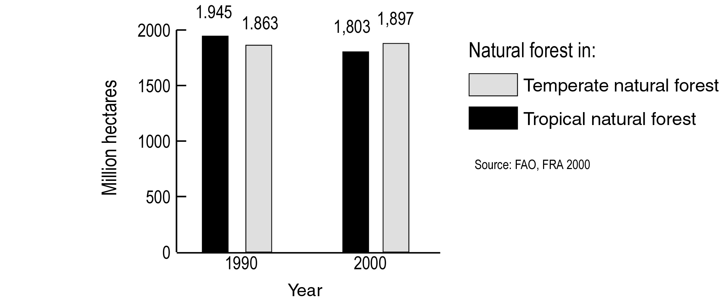
- Once more disaggregated information on trends in different forest types becomes available it will be desirable to use this. Among some of the forest types under threat and with usually a high conservation value—such as mangroves, cloud forests and dry tropical forests—only information on the trends in the extent of mangrove coverage is currently available (figure 2). It shows that the rate of loss of these forests may be higher than the average forest loss and that specific activities and measures might be necessary to change this trend.

Figure 2. Trends in extent of mangrove area
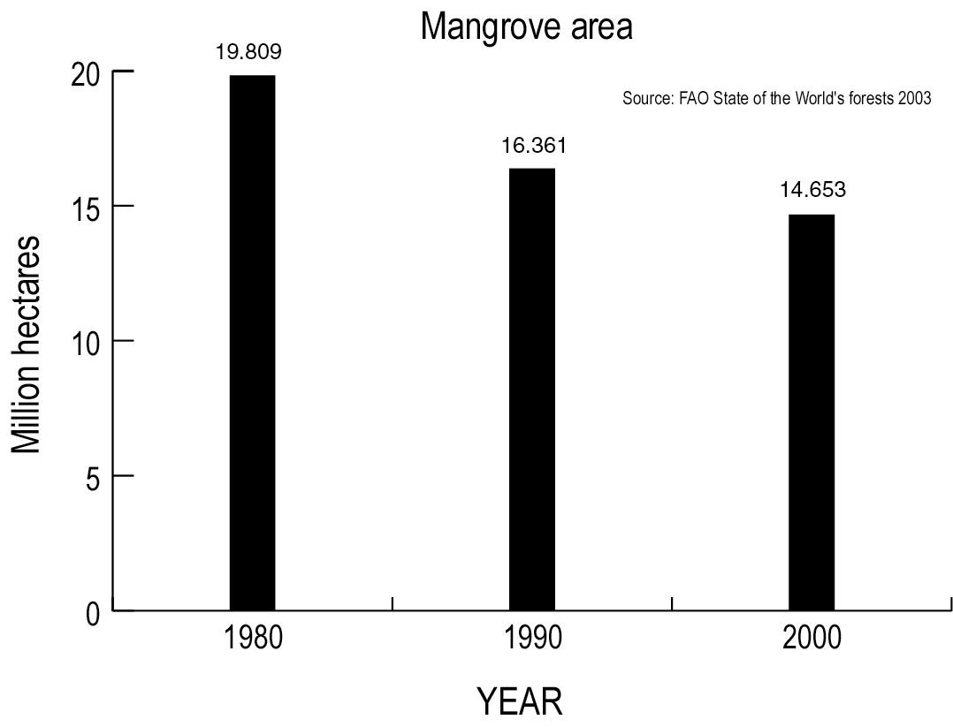

- Degradation and fragmentation are important factors determining the health of forest ecosystems. These are addressed through other complementary indicators, including indicators on trends in species populations and indicators under the focal area on integrity of ecosystems.
- The value of the data, and their actuality could be improved by combining land-based data and remote sensing. Drawing from the progress of inter-governmental processes related to forests and the global forest resources assessment process such indicators could include: (a) area of “primary” forest by forest type, (b) forest area designated for conservation of biological diversity by forest type, (c) area of intensively managed forest by forest type, (d) consumption of fuelwood, (e) forest carbon content.

2. Peatlands
- Trends in extent of inland waters are meaningful only for certain types of wetlands, e.g. peatlands. Peatlands are areas that are characterized by a a soil consisting mainly of partly decomposed plant material that has accumulated in situ (rather than being deposited as a sediment) as a result of water-logging. They cover about 50 per cent of all the world’s wetlands (over 4 million km²), or 3 per cent of the land and freshwater surface of the planet, and store 10 per cent of all freshwater and over 30 per cent of the earth’s surface soil carbon (or up to 70 per cent of all carbon stored in biotic systems).
- Peatlands dominate the landscape in large parts of the world, particularly northern Europe, north Siberia, Alaska and Canada, and also form extensive landscapes in the tropics (e.g. lowlands of South-east Asia, low and high-mountain wetlands of New Guinea, high mountain wetlands in southern, eastern and central Africa and in the Andes) as well as on the southern hemisphere (e.g. Patagonia).
- Much of the human use of peatlands involves their conversion or “amelioration”. This includes drainage to facilitate access and enable agricultural practices, grazing and forestry activities. Impacts of drainage are subsidence of the soil as well as the oxidation of the dried peat layers, causing emission of carbon and eventually the disappearance of the peat layer. Conversion of peatlands for intensive agriculture has been a common feature in most parts of the world for many centuries, particularly in Europe, but also – more recently - in the highlands of the Andes, China and parts of Africa. It has resulted in the loss of natural peatlands in large parts of western Europe (with less than 10 per cent remaining), and a significant reduction in central and eastern Europe (with less than 50 per cent remaining). The most dramatic impact has been in some of the countries with a rich peatland heritage, such as Finland, the Netherlands, Estonia, Denmark and the United Kingdom. The Netherlands (once one-third peatland) lost virtually all (>99 per cent) of its natural peatlands over the last two centuries. Only five European countries have maintained more than 50 per cent of their peatlands in relatively natural condition.
- In South-East Asia most of the once extensive (over 40 million ha) tropical peat swamp forests have been heavily degraded and large extents have been lost over the last four decades (remaining area 25-30 million ha). The main cause of this has been logging of the forests for timber and pulp as well as conversion to agriculture and particularly oil palm plantations. In Sumatra and Kalimantan, reoccurring fires have peaked during El Niño events. In 1997/98 a total of at least 2.1 million ha of peatland was burnt in Indonesia.
- A recent inventory of Patagonian peatlands has produced detailed maps of the peatlands of Argentina (about 240,000 ha) and Chile (1,047,000 ha). Agriculture and forestry are identified as the main causes for peatland disturbance (50 and 30 per cent, respectively) and peat mining (mainly for use in agriculture and horticulture) as a third (10 per cent) with increasing trends.
- In southern Africa a peatland inventory shows conversion of substantial areas of natural peatswamp forest habitat to subsistence agriculture, with over 60 per cent having a high impact from drainage and even more deforested.

3. Coral reefs
- Coral reefs support remarkable biodiversity. As one of the most ecologically complex ecosystems on Earth, coral reefs are home to over 4,000 different species of fish, 700 species of coral, and hundreds of thousands of other animals and plants: according to conservative estimates, one quarter of all marine species occur in coral reefs. / The health and biodiversity of coral reefs are critical to the cultural values and economic livelihoods of millions of people living in coastal environments.
- Reefs are the major source of income and food (e.g. tourism and fishing) to these coastal communities, and also afford shoreline protection from the forces of the ocean. Unfortunately, human activities threaten coral reefs the world over / and continue to degrade coral reefs through sedimentation, coastal development, destructive fishing practices and pollution. Ocean warming and the increased acidification of seawater is also precipitating a decline in the health of coral reefs requiring a greater understanding of trends. Assessments, which have suggested that 11 per cent of the historical extent of coral reefs has been lost and another 16 per cent is severely damaged,/ are necessarily qualitative because the means to quantify global changes in coral reef extent are not available.
- However a host of small-scale studies have recorded the coverage of live corals on reefs worldwide, and recently methods were tested statistically to combine these disparate studies into a regional indicator:/ changes in absolute percentage coral cover. This research demonstrated a region-wide decline in average hard coral cover from about 50 per cent to 10 per cent in three decades (figure 3).
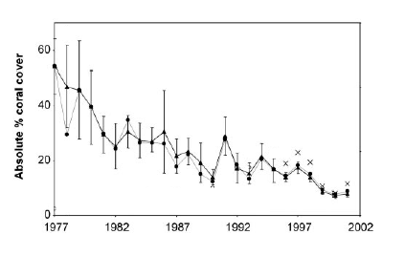
Figure 3. Total observed change in per cent coral cover across the Caribbean basin during the past 2.5 decades: absolute per cent coral cover from 1977 to 2001. Annual coral cover estimates () are weighted means with 95% bootstrap confidence intervals. Also shown are unweighted mean coral cover estimates for each year (•) and the unweighted mean coral cover with the Florida Keys Coral Monitoring Project (1996–2001) omitted (x). Source: Gardner et al. (2003).

- The data from across the Caribbean demonstrate a clear decline in the absolute proportion of reef benthos covered by living coral tissue, and a related negative mean annual rate of change. In other words the living coral fabric of reefs in the region has decreased year on year: the baseline starts in 1977 and the data analysed by Gardner et al. (2003) extend to 2001, though much more data has become available since then. /
- Coral cover has been mapped in most regions worldwide. Although there would be gaps in the data for reefs which have not been thoroughly, recently or regularly surveyed, regional coral cover indicators could be amalgamated to produce a global indicator.

4. Drylands
- An additional indicator that addresses the area and distribution of different dryland ecosystems, could be developed using a combination of (a) existing remote sensing measures of vegetation cover and distribution and (b) existing degradation information including soil degradation, vegetation change and livestock densities and human settlement. A pilot analysis could serve as a baseline./

B. Indicator 2: Trends in abundance and distribution of selected species
- Species population trend indices such as the Living Planet Index are valuable ways for monitoring and communicating biodiversity change at global, regional and (sub-) national scales or within biogeographic units. These indices can be built using existing biological data to show clearly understandable trends in species abundance and, by implication, the condition of the ecosystems in which they occur. Since the 1970s, the Living Planet Index, which reflects a change in population size of more than 700 species of vertebrates has dropped by over 30 per cent (figure 4).

Figure 4. Living planet index for species groups

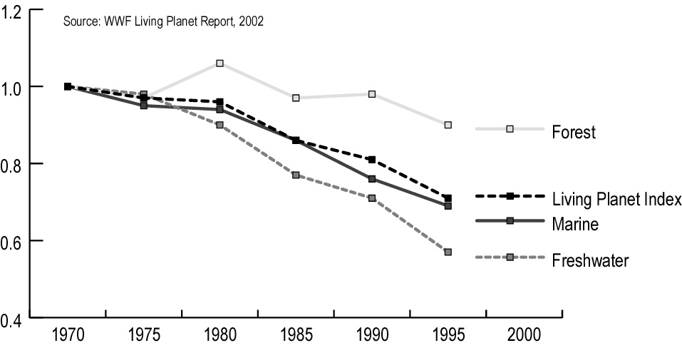
- Similar trends have been observed for abundant and widespread bird species breeding on farmland throughout Europe. / It is widely accepted that these declines have been driven by agricultural intensification and the resulting deterioration of farmland habitats, and it is likely that the trends observed are mirrored by other farmland taxa.
- In the United Kingdom, butterfly species have disappeared from 13 per cent of their previously occupied 10-kilometer squares and over 70 per cent have declined in population size in the last 20 years. Declines in birds and plants were less pronounced but insect populations typically respond more rapidly to adverse environmental change. /
- The third edition of Waterbird Population Estimates / summarizes waterbird populations of 868 species compared with only 840 in the second edition and 833 in the first edition. A total of 2,271 biogeographic populations are now recognized, compared with only 1,924 in the second edition and 1,824 in the first. Population estimates are presented for 1,725 of the 2,271 populations, a total of 76 per cent. This compares with 1,342 of the 1924 populations (70 per cent) presented in the second edition.
- In every region, the proportion of known populations exhibiting a decreasing trend exceeds the proportion exhibiting an increasing trend. In Europe and North America, where data quality are best and where waterbird conservation policy is most advanced, the proportion of decreasing populations is only a little higher than the proportion which are increasing. In the Neotropics and Africa, more than twice as many known populations are decreasing rather than increasing, whilst in both Asia and Oceania, nearly four times as many known populations are decreasing rather than increasing. At global level, the fact that 41 per cent of known populations are declining, 36 per cent are stable and only 19 per cent increasing gives considerable cause for concern and highlights the need for an increase in efforts to conserve these species.
- A big asset of the species trends indices such as the Living Planet Index is that it can be produced for different functional groups and species assemblages as well as ecosystem types for which these are representative. However, there are currently no clear criteria for selection of species or populations included in the calculation of the index. International NGOs and their networks of experts hold time series data for many additional populations, which could be used to increase the confidence level of the LPI. Systematic efforts could be made to incorporate this information to generate policy-relevant species trends indices. Plants are currently a major gap. Moreover, species trends indices provide information on numbers of individuals within populations but not on species distribution.

C. Indicator 3: Coverage of protected areas
- The establishment of protected areas reflects measures taken to safeguard biodiversity. Globally, the number of protected areas has been increasing significantly over the past few decades and is now more than 100,000 sites. The total area has also increased continuously from less than 3 million km² in 1970 to more than 20 million km² in 2004 (figure 5). However, ecoregional and habitat representation remains uneven, and coastal and marine ecosystems are particularly under-represented.
- The most comprehensive dataset on protected areas world-wide is the World Database on Protected Areas (WDPA) managed by the UNEP World Conservation Monitoring Centre in partnership with the IUCN World Commission on Protected Areas and the WDPA Consortium. As of July 2004, globally there are 104,791 protected areas recorded in the WDPA. This figure includes all nationally designated sites that comply with the IUCN definition of a protected area (see below). The total global surface area covered by these sites is about 20,235,834 km², representing 3.5 per cent of the planet’s surface. In reality most of these areas are on land and the total terrestrial surface covered by protected areas is some 18,382,225 km², or 12.2 per cent of the total land surface. About 1,893,609 km² of world’s ocean surface falls within protected areas, which is 0.5 per cent of the total ocean surface.
- By using geographical information systems, these data can be assigned approximately to different biomes or ecological regions, allowing analysis of coverage and gaps. For most protected areas information exists on the primary management objectives. Accordingly, they can be assigned to one of the six IUCN management categories.
- The statistical measurement of protected area numbers and extent does not tell us how effective those protected areas are in actually conserving biodiversity and reducing its rate of loss. This requires two additional pieces of information: an understanding of how well biodiversity is covered by these sites, and an understanding of the effectiveness of their management. It may therefore be desirable to consider development of a measure of the effectiveness of management in achieving objectives for which protected areas are established and to carry out an analysis of areas of high biodiversity value that are not currently protected.
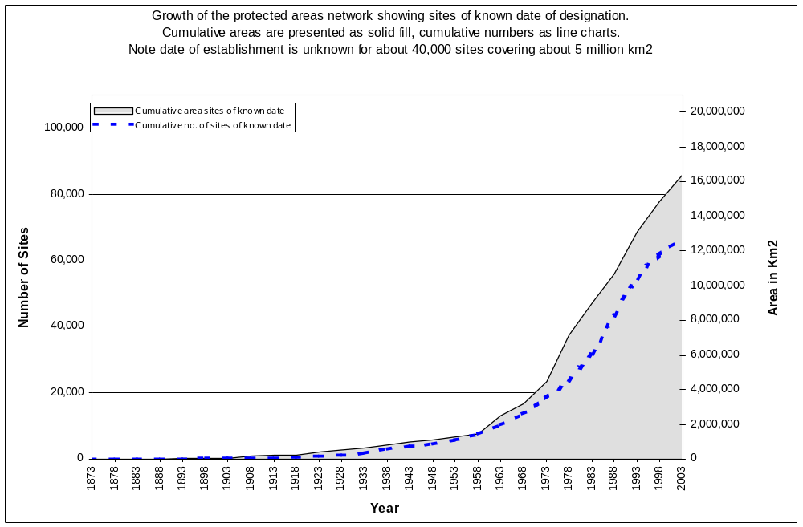Figure 5. Development of the protected areas network since 1873 (from UNEP-WCMC, unpublished).

II. Focal area: Sustainable use
- One of the objectives of the Convention is the sustainable use of the components of biodiversity (Article 1). Articles 6, 7 and 10 provide additional elements and obligations for Parties to ensure the sustainability of projects and policies and to monitor the use of components of biodiversity that are important for their conservation.
- Through a series of three regional workshops and a fourth open-ended workshop a set of practical principles, operational guidelines, and associated instruments have been developed leading to the adoption, through decision VII/12, of the Addis Ababa Principles and Guidelines for the Sustainable Use of Biodiversity. The workshops developed an indicative list of indicators for measuring the decline in the status of categories of biodiversity components contained in document UNEP/CBD/SBSTTA/9/INF/8.
- Criteria and indicators for sustainable management of ecosystems are discussed in a document on provisional global indicators for assessing progress towards the 2010 biodiversity target (UNEP/CBD/COP/7/INF/33).
- These possible indicators require further development and are therefore considered in column C of the indicators table.

III. Focal area: Threats to biodiversity
- Article 14 of the Convention requires Parties, inter alia, to avoid or minimize adverse effects on biodiversity. Among the direct drivers of change that potentially threatened biodiversity, invasive alien species and the anthropogenic production of reactive nitrogen have been recognized as particularly threatening. Unlike for example climate change, ozone and persistent organic pollutants, these are not addressed in other intergovernmental processes.
- Information on quantities and effects of nitrogen deposition on ecosystems is available and an indicator is ready for testing and use. Numbers and costs of invasive alien species are more difficult to ascertain and no recognized methodology exists for this indicator. This indicator is therefore treated in column C of the indicators table.

Indicator 4: Nitrogen deposition
- Nitrogen in reactive forms is essential for life. Use of nitrogen fertilizers is necessary to produce sufficient food for a growing human population. However, excessive levels of reactive nitrogen in the biosphere and atmosphere constitute a major threat to biodiversity in terrestrial, aquatic and coastal ecosystems. Reactive nitrogen from anthropogenic sources (mainly fertilizer production, fossil fuel use, and widespread cultivation of legume crops, and crops such as rice which stimulate biological Nitrogen fixation) has increased markedly following the discovery of the Haber-Bosch process for fertilizer manufacture (figure 1). Anthropogenic sources now exceed natural terrestrial sources and hence more than half of all reactive Nitrogen in ecosystems globally is from human sources.

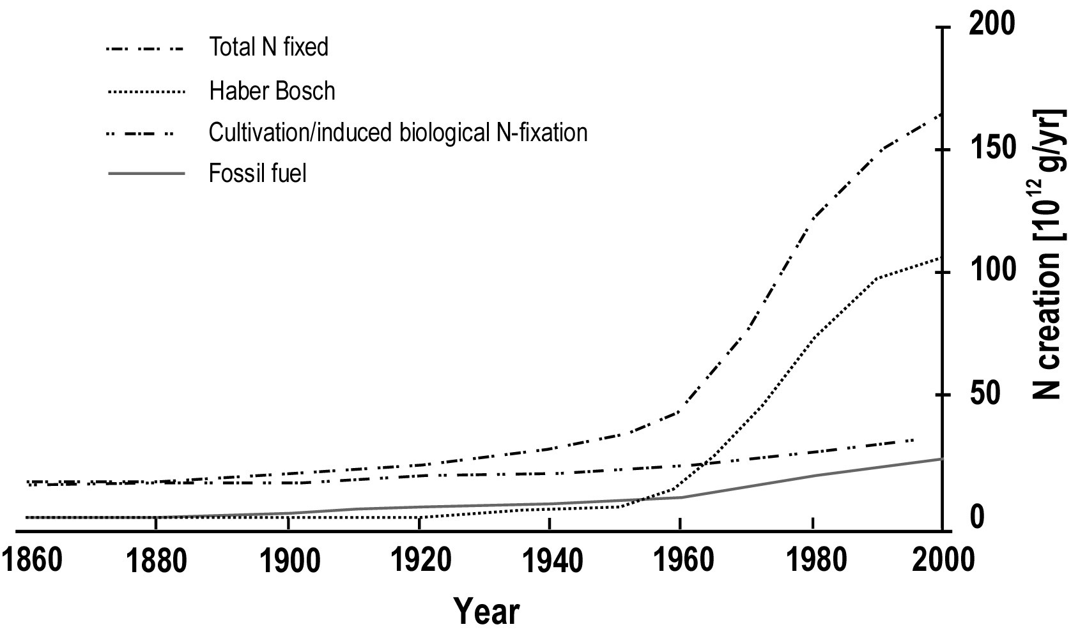

Figure 6: Anthropogenic production of reactive nitrogen (N_{r})
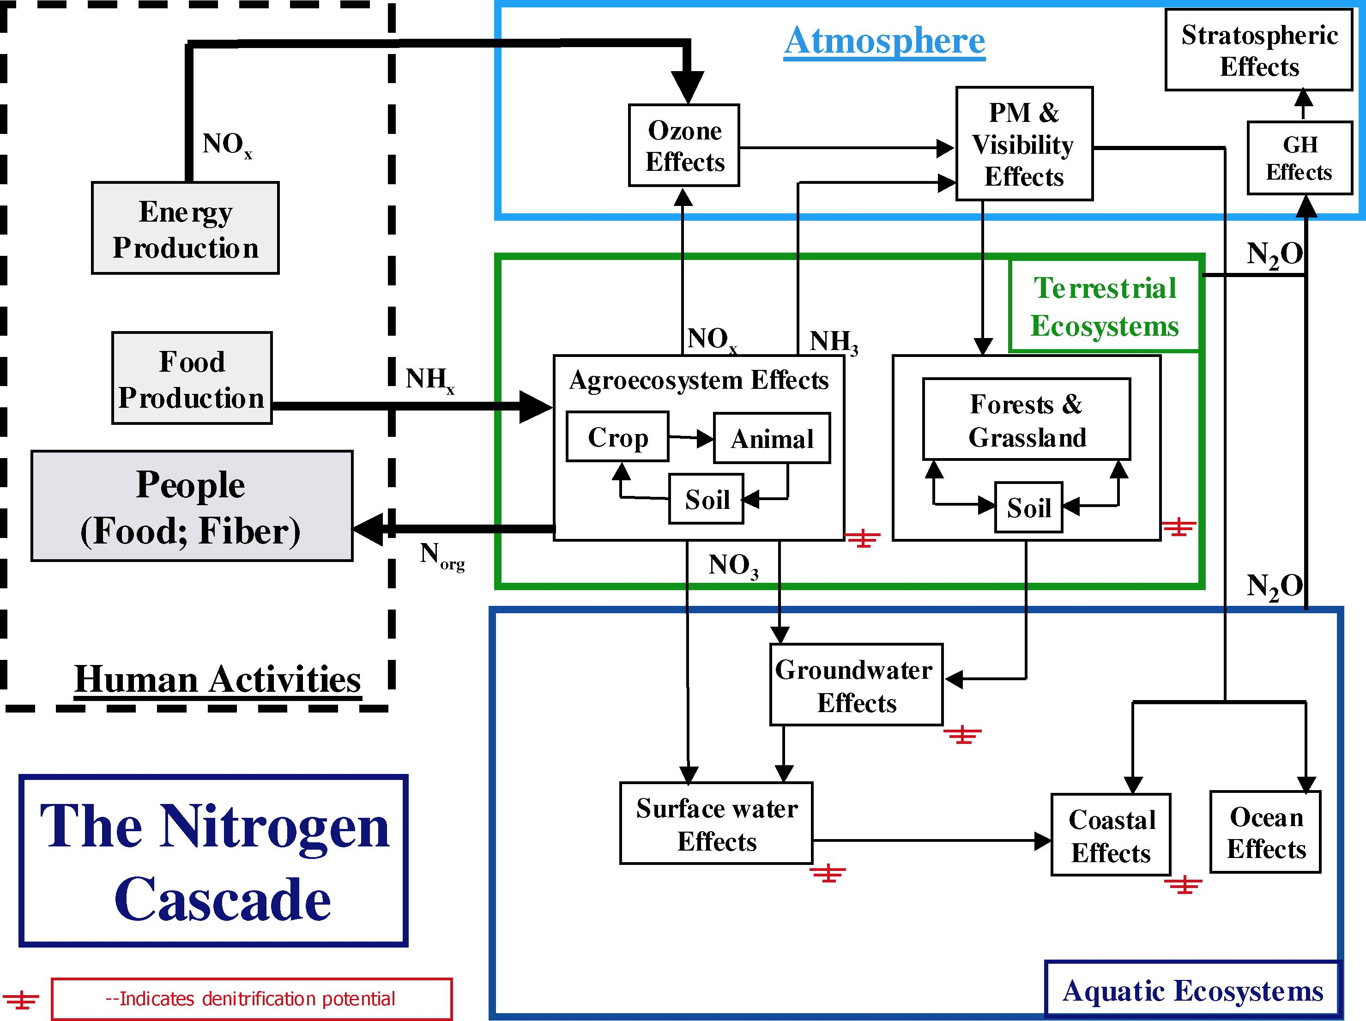
- Higher than natural levels of reactive nitrogen in natural terrestrial ecosystems, especially temperate grasslands, shrublands and forests leads directly to lower plant diversity, as slow-growing species are out-competed by a small number of faster-growing species. The major source of reactive nitrogen affecting terrestrial ecosystems is fuel combustion, industrial processes and the use of fertilizers, which release nitrogen compounds into the atmosphere, which are subsequently deposited onto the biosphere (see figures 2 and 3). Excessive levels of reactive nitrogen in water bodies, including rivers, coastal zones and other wetlands frequently leads to algal blooms and eutrophication, including low-oxygen conditions which causes major damage to biodiversity including fisheries. The main source is run-off of nitrates and other nitrogenous compounds from agricultural lands and atmospheric deposition (see figure 3). In addition to the above effects nitrous oxide is a potent greenhouse gases, and in the upper atmosphere can damage the ozone layer.

IV. Focal area: Ecosystem integrity and ecosystem goods and services
- Ecosystem integrity reflects the capability of a system to support services of value to humans. / Indicators under the focal area on ecosystem integrity and ecosystem goods and services provide information on the quality and health of ecosystems and their productive capacity. This information complements the information on the area coverage of ecosystems addressed through the indicator on trends in extent of selected biomes, ecosystems and habitats.
- While two indicators on the integrity of inland water and marine ecosystems are considered ready for testing and use, a range of additional indicators related to terrestrial ecosystems require further development.

A. Indicator 5: Marine trophic index
- The marine trophic index measures the change in mean trophic level / of fisheries landings by region and globally. Trophic level is defined as the position of an organism in the food chain, and ranges from a value of 1 for primary producers up to a level of 5 for marine mammals and humans. Trophic level also changes through the life history of fish, with juveniles having lower trophic levels than adults. The preferred fisheries catches consist of large, high value, high trophic level predatory fish, such as tuna, cod, and swordfishes. As a result, unsustainable fishing leads to depletion of these large predatory fish so that the relative numbers of low trophic level small fish and invertebrates increase.
- The intensification of fishing to unsustainable levels has already led to effective removal of species from marine food webs. The biomass of top predators in the North Atlantic has decreased by two-thirds in approximately 50 years and the mean trophic level of fisheries landings globally has declined at a rate of approximately 0.1 per decade. Figure 7 presents the strong declining trend in mean trophic levels of fisheries landings between the years 1950 and 2000. The decline in mean trophic levels results in shortened food chains, leaving ecosystems less able to cope with natural or human-induced change. The long-term sustainability of fisheries is, in turn, directly linked to human livelihoods and well-being.
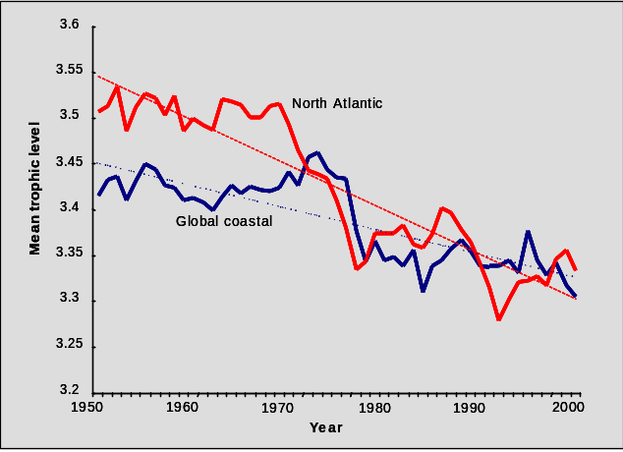
Figure 7. Decline of mean trophic level of fisheries landings reported by FAO. (Graph by R. Watson, Sea Around Us Project, Fisheries Centre, UBC, Vancouver). /

B. Indicator 6: Water quality in aquatic ecosystems
- Water quality is systematically monitored at the local level, particularly for urban water supply and major water bodies. Water quality data therefore represent one of the most comprehensive sources of indicator data for aquatic systems. They are multi-functional and indicate both major threats to the sustainability of freshwaters and unsustainable activities outside that ecosystem. The health and integrity of freshwaters is an excellent indicator of the health of terrestrial ecosystems. / The indicator is also very useful in that it can, and in some cases already does, indicate the impact of responses to environmental problems (e.g., successful policy interventions leading to improved water quality). Limitations include the indicator being composed of a multitude of potential sub-indicators, for which data vary widely regionally, in quality and availability.
- While such a composite index is under development it may be appropriate to concentrate on one or possibly a few key indicators.
- Biological oxygen demand (BOD) is an indicator of the organic pollution of freshwater. In comparing the past two decades, rivers in Europe and Australasia show a statistically significant reduction in BOD concentrations. / Although the reduction is not particularly large, it is indicative of positive trends in the quality of inland waters (figure 8).

Figure 8. Changes in biological oxygen demand (BOD) of major water bodies on a regional basis
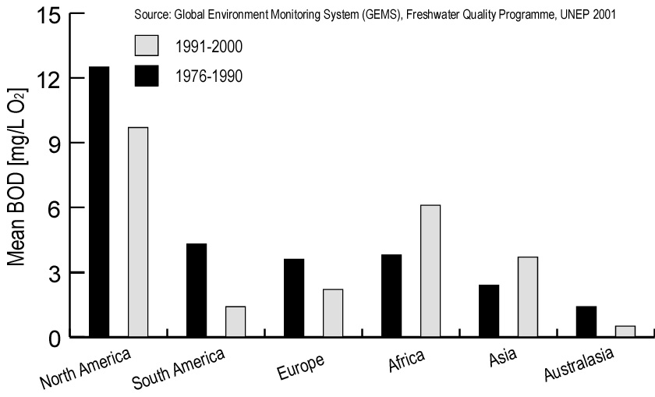
- Other indicators of water quality include sediment loads in rivers, concentration of pollutants in water, and quantity of water abstracted from inland waters. /

V. Focal area: Status of traditional knowledge, innovations and Practices
- In accordance with article 8(j) of the Convention, Parties should, inter alia, respect, preserve and maintain knowledge, innovations and practices of indigenous and local communities, embodying traditional lifestyles relevant for the conservation and sustainable use of biodiversity. This provision and related guidance provided by the Conference of the Parties recognize the role of indigenous and local communities in managing and maintaining biodiversity.
- The close association between language and cultural knowledge and practices, including traditional ecological knowledge and associated biodiversity management practices, is widely recognized. / While additional indicators need to be developed the Conference of the Parties decided to use trends in indigenous languages and speakers as a proxy for trends in traditional knowledge, innovations and practices. The development of additional indicators on the status of traditional knowledge, innovations and practices has been assigned to the Ad hoc Open-ended Working Group on Article 8(j) and Related Provisions.

Indicator 7: Status and trends of linguistic diversity and numbers of speakers of indigenous languages
- There are an estimated 5,000 to 7,000 languages spoken today on the five inhabited continents. Of these, about 250 are spoken by 97 per cent of the world’s people. Conversely, about 96 per cent of the world’s languages are spoken by about 3 per cent of the world’s people. Indigenous and local communities speak the vast majority of these languages. More than half of the world’s languages are spoken by less than 10,000 people. There is also a comparable magnitude and pace of the current extinction rates affecting biological diversity and human languages. Nevertheless, it is difficult to establish a functional or cause/effect linkage between the loss of languages and that of biodiversity.
- Geographically, analyses have shown a large overlap between regions that are rich in biodiversity and those rich in languages. Linguists and anthropologists have suggested that the diversity of ideas carried by different languages and sustained by different cultures is as necessary as the diversity of species and ecosystems is for the survival of humanity and of life on the planet. The extinction of each language results in the irrecoverable loss of unique cultural, historical, and ecological knowledge. Each language is a unique expression of the human experience of the world. Every time a language dies, we have less evidence for understanding patterns in the structure and function of human language, human prehistory, and the maintenance of the world’s diverse ecosystems. According to the most pessimistic predictions, the world may lose 90 per cent of languages in the next century.
- While no accurate data about trends in language loss are available as yet, current information on numbers of languages and numbers of speakers can serve as baseline information. This information can also be used as a proxy for the current state of traditional knowledge, innovations, and practices, because of the close association between language and cultural knowledge, including traditional ecological knowledge.
- Through UNESCO’s Atlas of the World's Languages in Danger of Disappearing, which is currently being made available online, / information on trends in language loss can be analysed and publicized.

Vi. Focal area: Status of Access and benefit-sharing
- The fair and equitable sharing of benefits arising out of the utilization of genetic resources is one of the objectives of the Convention (article 1). The development of indicators on the status of access and benefit-sharing has been assigned to the Ad hoc Open-ended Working Group on Access and Benefit-Sharing.

VII. Focal area: Status of resource transfers
- The need for financial, technical and technological resources for the implementation of the Convention is reflected in a number of provisions. Paragraph 2 of article 20 of the Convention, inter alia, requests developed country Parties to provide new and additional financial resources to enable developing country Parties to meet the incremental costs of implementing the provisions and obligations of the Convention. Article 21 establishes a financial mechanism for the Convention. In accordance with paragraph 2 of article 16, access to and transfer of technology relevant to the attainment of the objectives of the Convention to developing countries should be provided and/or facilitated under fair and favourable terms.
- The Conference of the Parties adopted an indicator on official development assistance provided in support of the Convention, which can draw on official statistics provided by relevant bodies , such as OECD-DAC-Statistics Committee, and an indicator on technology transfer, which needs to be developed.

Indicator 8: Official development assistance provided in support of the Convention
- An adequate access to resources is essential for the effective implementation of the Convention on Biological Diversity. Bilateral assistance provided to developing countries, as measured by Official Development Assistance (ODA), is an important component of the financial resources available for the implementation of the Convention. ODA commitments are reported by OECD member States to the OECD Development Assistance Committee (DAC). Using a “biodiversity marker” jointly developed by the OECD/DAC Secretariat and the Secretariat of the Convention on Biological Diversity, ODA activities targeting the objectives of the CBD have been reported on between 1998 and 2000. The figures reported were 1.09, 1.03 and 0.87 billion US$ respectively (figure 9).
- However, only 16.5 per cent of the reported assistance is spent on biodiversity projects and a separate analysis of 1,489 biodiversity projects contained in the OECD Credit Reporting System (OECD/CRS) database showed that 60 per cent of projects could be identified to correspond to thematic areas or cross-cutting issues of the Convention. / The data assembled to date are insufficient to identify clear trends over time. However it has recently been decided to continue use of the biodiversity marker for at least another three years and it is envisaged that this will give rise to useful information on both status and trends of resource transfers.
Figure 9. Biodiversity-related aid, commitments 1998-2000 by 19 members of the OECD Development Assistance Committee.
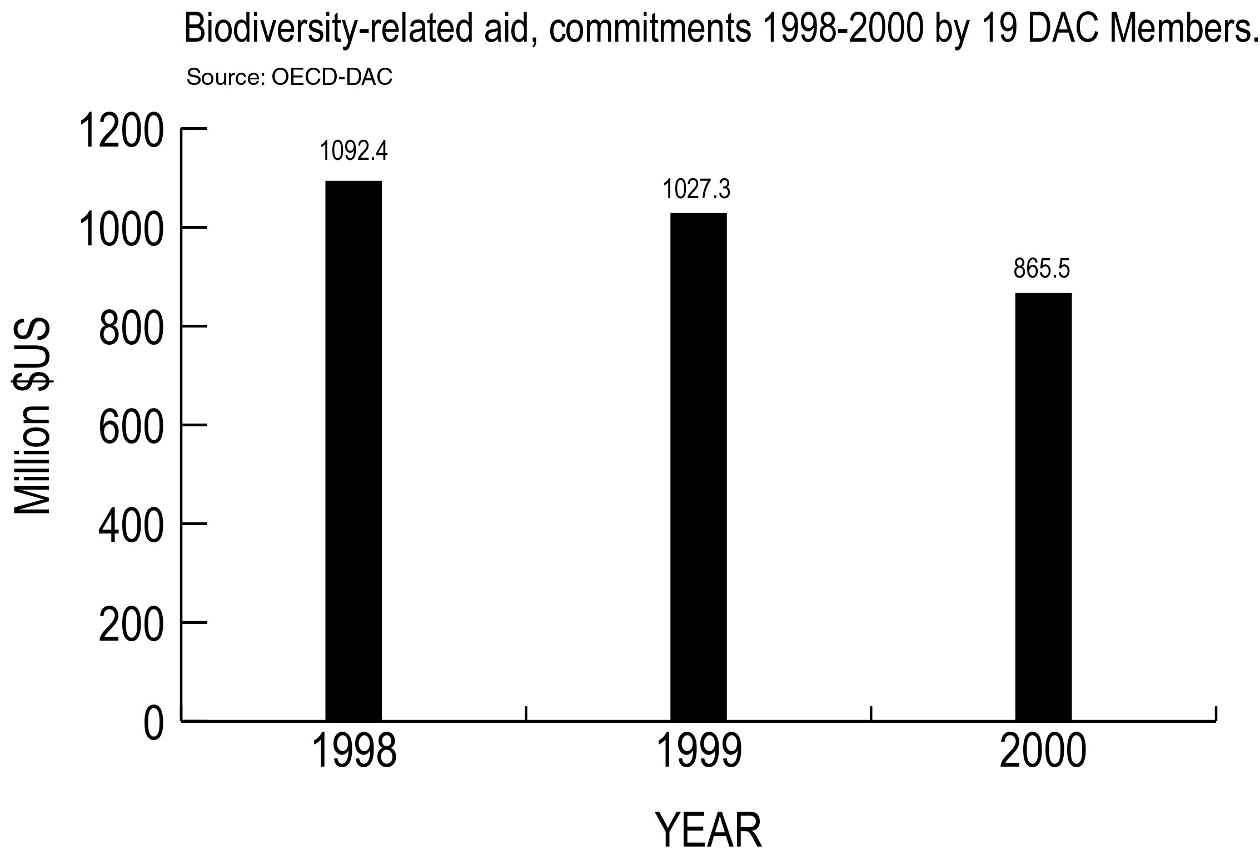
- As the designated institutional structure to operate the financial mechanism of the Convention, the Global Environment Facility (GEF) has emerged as a principal source of financial assistance in direct response to guidance from the Conference of the Parties in relation to the implementation of the Convention by the developing country Parties. The commitments to GEF in the three replenishment cycles that were achieved in 1994, 1998 and 2002 amounted to 959, 1,451 and 1,773 million Special Drawing Rights (SDR), respectively (figure 10).
Figure 10. Commitments made to the Global Environment Facility.
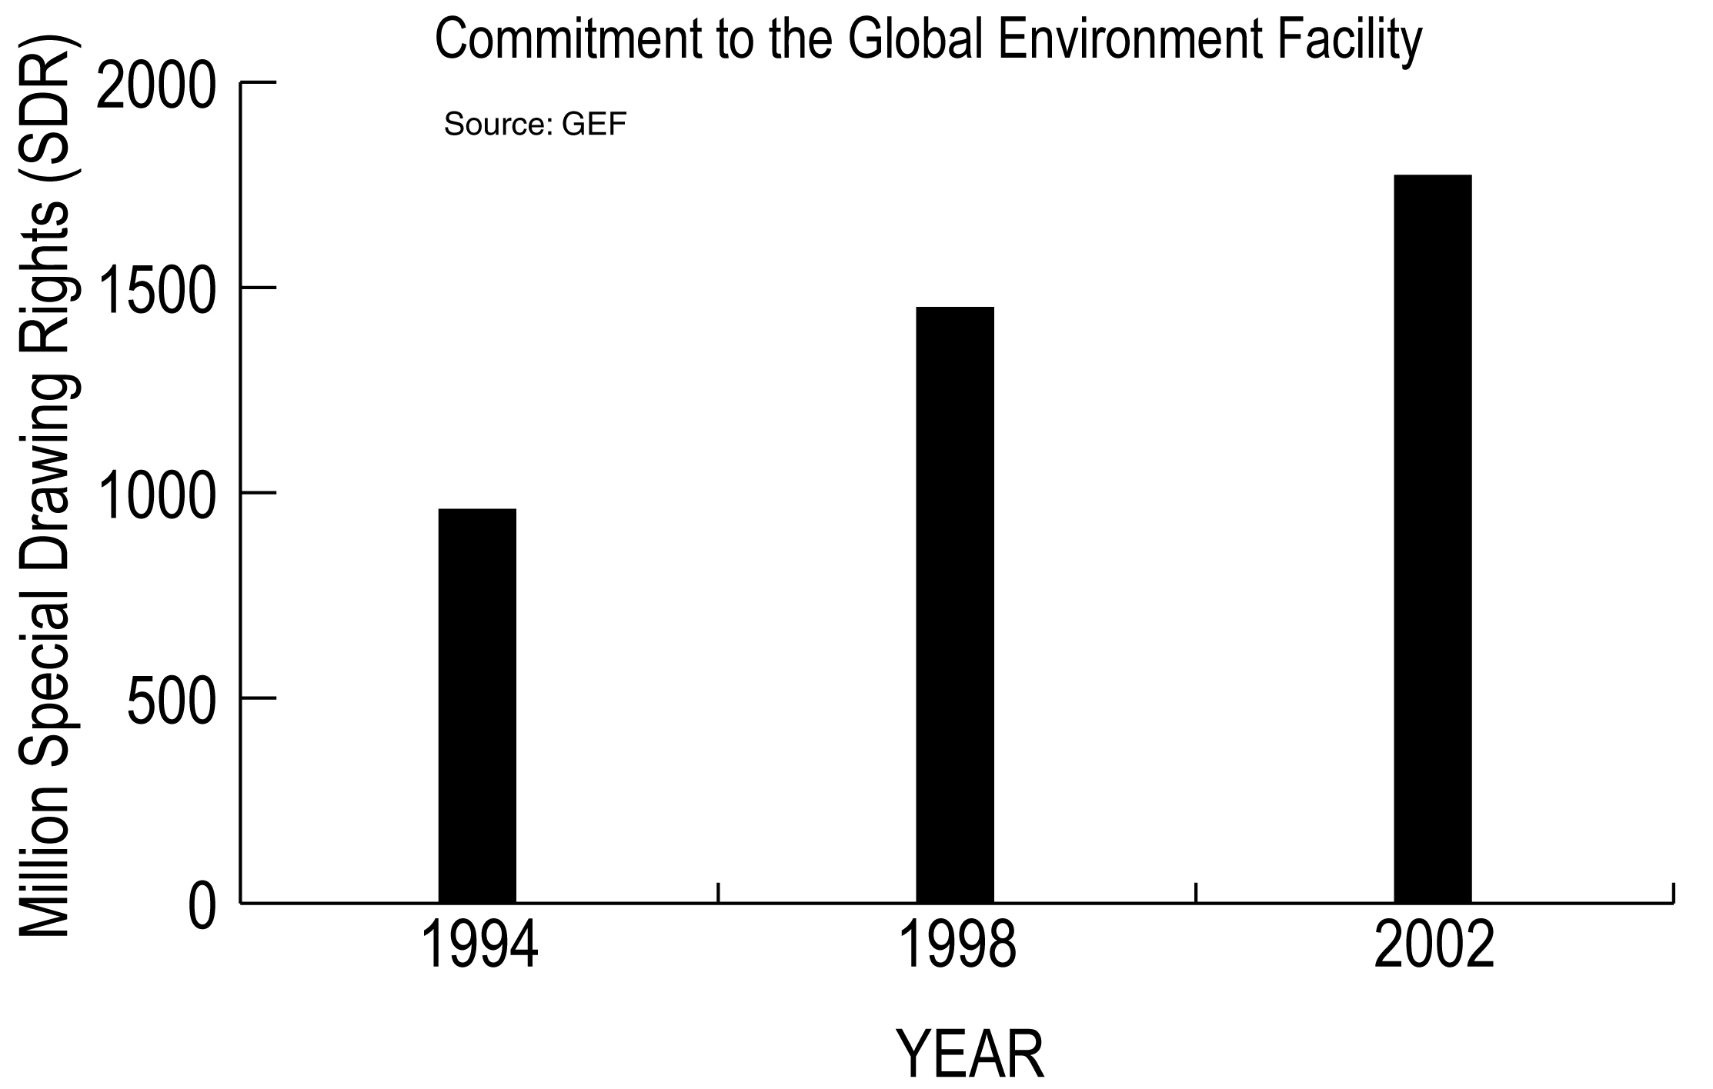

Annex I
PROVISIONAL INDICATORS FOR ASSESSING PROGRESS TOWARDS THE 2010 BIODIVERSITY TARGET
A: Focal area | B: Indicator for immediate testing | C: Possible indicators for development by SBSTTA or Working Groups
Status and trends of the components of biological diversity | Trends in extent of selected biomes, ecosystems and habitats
Status and trends of the components of biological diversity | Trends in abundance and distribution of selected species
Status and trends of the components of biological diversity |  | Change in status of threatened species (Red List indicator under development)
Status and trends of the components of biological diversity |  | Trends in genetic diversity of domesticated animals, cultivated plants, and fish species of major socioeconomic importance
Status and trends of the components of biological diversity | Coverage of protected areas
Sustainable use |  | Area of forest, agricultural and aquaculture ecosystems under sustainable management
Sustainable use |  | Proportion of products derived from sustainable sources
Threats to biodiversity | Nitrogen deposition
Threats to biodiversity |  | Numbers and cost of alien invasions
Ecosystem integrity and ecosystem goods and services | Marine trophic index | Application to freshwater and possibly other ecosystems
Ecosystem integrity and ecosystem goods and services |  | Connectivity/fragmentation of ecosystems
Ecosystem integrity and ecosystem goods and services |  | Incidence of human-induced ecosystem failure
Ecosystem integrity and ecosystem goods and services |  | Health and well-being of people living in biodiversity-based-resource dependent communities
Ecosystem integrity and ecosystem goods and services | Water quality in aquatic ecosystems
Ecosystem integrity and ecosystem goods and services |  | Biodiversity used in food and medicine
Status of traditional knowledge, innovations and Practices | Status and trends of linguistic diversity and numbers of speakers of indigenous languages | Further indicators to be identified by WG-8j
Status of access and benefit-sharing |  | Indicator to be identified by WG-ABS
Status of resource transfers | Official development assistance provided in support of the Convention (OECD-DAC-Statistics Committee)
Status of resource transfers |  | Indicator for technology transfer
-----

* UNEP/CBD/AHTEG-2010-Indicators/1/1.
/ See the final report from the group working on habitats and biomes at the Royal Society Workshop (22 July 2004) for a more detailed analysis http://www.twentyten.net/Powerpoints/Habitats_final_report.ppt
/ This includes Mediterranean, arid, semi-arid, grassland and savannah ecosystems (see decision V/23).
/ To be considered by the eighth meeting of the Conference of the Parties.
/ In this document the definitions of FRA 2000 are adopted: forests includes natural forests and forest plantations characterized by a minimum size of 0.5 ha, a minimum tree canopy cover of 10 per cent, trees with a potential to reach 5 m height and the absence of other predominant land uses. Natural forests are composed of indigenous trees and not classified as plantations.
/ Global Forest Resources Assessment 2000 Assessing State and Change in Global Forest Cover: 2000 and Beyond. Forest Resources Assessment Programme. Working Paper 31. Rome: FAO.
/ Groombridge B, Jenkins M (2002) World Atlas of Biodiversity. California University Press, Berkeley and Los Angeles.
/ Bryant D, Burke L, McManus J, Spalding, M (1998) Reefs at Risk: A Map-Based Indicator of Potential Threats to the World’s Coral Reefs. World Resources Institute, Washington; International Center for Living Aquatic Resource Management, Manila; United Nations Environment Programme-World Conservation Monitoring Centre, Cambridge.
/ C. R. Wilkinson, Status of Coral Reefs of the World: 2000 (Global Coral Reef Monitoring Network and Australian Institute of Marine Science, Townsville, Australia, 2000).
/ Toby A. Gardner, Isabelle M. Côté, Jennifer A. Gill, Alastair Grant, Andrew R. Watkinson (2003) Long-Term Region-Wide Declines in Caribbean Corals, Science 301, 958-960.
/ Status of Coral Reefs in the Western Atlantic: Results of Initial Surveys, Atlantic and Gulf Rapid Reef Assessment (AGRRA) Program (2003). Edited by J.C. Lang. Atoll Research Bulletin 496.
/ Pilot analysis of Global Ecosystems: Grassland Ecosystems; White et al., 2000 http://pdf.wri.org/page_grasslands.pdf.
/ BirdLife International 2004. State of the world’s birds 2004: indicators for our changing world. Cambridge, UK: BirdLife International.
/ Thomas, J. A., M. G. Telfer, D. B. Roy, C. D. Preston, J. J. D. Greenwood, J. Asher, R. Fox, R. T. Clarke, and J. H. Lawton. 2004. Comparative Losses of British Butterflies, Birds, and Plants and the Global Extinction Crisis. Science 19 (303): 1879-1881.
/ Waterbird Population Estimates. Third edition 2002. Edited by Simon Delany and Derek Scott. Wetlands International, Netherlands.
/ See for example http://www.ozestuaries.org/indicators/Def_ecosystem_integrity.html for more detailed definitions.
/ See definition of trophic level in box 1 in document UNEP/CBD/AHTEG-2010-Ind/1/INF/5.
Watson, R., A. Kitchingman, A. Gelchu and D. Pauly (2004) Mapping global fisheries: sharpening our focus. Fish and Fisheries 5: 168-177.
/ For example, an increase in sediment loads indicates soil erosion in the catchment area. An increase in pollutants indicates increased runoff of harmful substances.
/ http://www.unep.org/vitalwater/09.htm.
/ See document UNEP/CBD/AHTEG-2010-Ind/1/INF/6 for further details.
/ See for example document UNEP/CBD/WG8J/1/INF/4 http://www.biodiv.org/doc/meetings/tk/wg8j-01/information/wg8j-01-inf-04-en.pdf; Posey, D.A. 1999. Cultural and spiritual values of biodiversity. UNEP Nairobi, 731p.
/ http://www.malmusse.com/hugues/unesco/languenet/.
/ See UNEP/CBD/COP/7/18

