 |  |  | CBD
 |  | CONVENTION ON  BIOLOGICAL DIVERSITY |  |  | 9 May 2001
WORKSHOP ON LIABILITY AND REDRESS IN THE CONTEXT OF
THE CONVENTION ON BIOLOGICAL DIVERSITY
Paris, France, 18-20 June 2001

Information for Participants

Venue
The Workshop on Liability and Redress in the context of the Convention on Biological Diversity will be held in Paris from Monday, 18 June to Wednesday, 20 June 2001 at:

CENTRE DE CONFERENCES INTERNATIONALES (CCI)
19, avenue Kléber (entrance : 5, avenue des Portugais)
(Métro : Kléber)
75016 PARIS
A map indicating the location of the meeting as well as the hotels in the vicinity is attached as annex I.

Opening and registration
The meeting will be opened at 10:00 a.m. on Monday, 18 June 2001. Registration will take place at the venue of the meeting from 8 –10 a.m. the same day.

Services to delegates
Delegates will have access to e-mail and Internet services free-of-charge during the meeting.

If they so wish, delegates may have lunch either at the self-service cafeteria of the Ministry of Foreign Affairs (approximate price for lunch: 50 FF per person) or at the Ministry restaurant (price per person is 140 FF with wine).

HoteI information
Delegates are kindly reminded that they are responsible for making their own hotel accommodation arrangements. A list of hotels in Paris is attached as annex II. It should be noted that June is a busy month for hotels in Paris and delegates are kindly requested to make their hotel reservations as soon as possible.

Time Zone
In June, the time in Paris is GMT + 2 hours.

Weather
The average daytime temperature in the month of June is about 20ºC.

Electricity
220 volts, 50 Hertz.

Visas
Delegates are advised to check with the nearest French diplomatic or consular mission regarding visa and vaccination requirements.

Official language
The official language in France is French, but English is widely understood and spoken in hotels and restaurants.

Currency
The currency in France is the French franc (FF). The current exchange rate against the US dollar stands at approximately FF 7,40 for one US dollar.

Credit cards
Major credit cards are accepted in most hotels and restaurants in the city.

Further information
Other useful information can also be found on: http://www.paris-france.org.

Annex I

Hotel locations

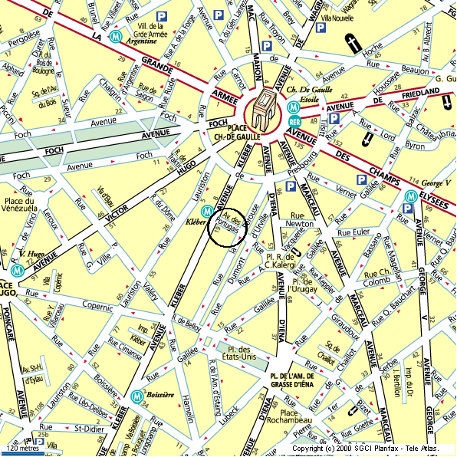
2
4
5
7
1
6
10
3
8
9
11
12
13
14

Metro - RER
X
Hotels

Conference centre

Annex II

LIST OF HOTELS
(Numbers refer to the numbers on the map in annex I)
Category ****

1- HOTel Garden ElysEEs ****
Rue Saint-Didier
Paris
Tel.: +33 1 47 55 01 11 - Fax: +33 1 47 27 79 24
Single occupancy: 900 / 1250FF

2- HOTel Libertel d’ARgentine ****
Rue d'Argentine
Paris
Tel.: +33 1 45 02 76 76 - Fax: 01 45 02 76 00
Single occupancy: 920 / 980FF

Category ***
3- rESidence Bouquet de Longchamp ***
Rue du Bouquet de Longchamp
Paris
Tel.: +33 1 47 04 41 71 - Fax: +33 1 47 27 29 09
Single occupancy: 476 / 676FF

4- HOTel du Bois ***
Rue du Dome
Paris
Tel.: +33 1 45 00 31 96 - Fax: +33 1 45 00 90 05
Single occupancy: 550 / 585FF

5- HOTEL STELLA ETOILE ***
Avenue Carnot - 75017 PARIS - FRANCE
Tel.: + 33 1 43 80 84 50 - Fax: + 33 1 47 66 01 94
Informations : reception@hotelstella.com
Single occupancy: 540 / 690 FF

6- HOTEL FERTEL ETOILE ***
Rue des Acacias - 75017 PARIS - FRANCE
Tel.: +33 1 47 66 77 75 - Fax: +33 1 47 66 47 90
Informations : hotel@ferteletoile.com
Single occupancy: 620 / 740 FF

7- HOTEL DE SEVIGNE CHAMPS-ELYSEES ***
Rue de Belloy - 75116 PARIS - FRANCE
Tel.: +33 1 47 20 88 90 - Fax: +33 1 40 70 98 73
Informations : paris@hoteldesevigne.com
Single occupancy: 680 / 850 FF

8- HOTel Chambellan - Morgane ***
Rue Keppler
Paris
Tel.: +33 1 47 20 35 72 - Fax: +33 1 47 20 95 69
Single occupancy: 700 / 900FF

9- HOTEL CENTRE VILLE ELYSEES ETOILE ***
Rue des Acacias - 75017 PARIS - FRANCE
Tel.: +33 1 58 05 10 00 - Fax: +33 1 47 54 93 43
Informations : hcv@centrevillehotels.com
Single occupancy: 890 FF

10- HOTel GalilEO ***
Rue Galilée
Paris
Tel.: +33 1 47 20 66 06 - Fax: +33 1 47 20 67 17
Single occupancy: 800FF

Category **

11- HOTel Marmotel Etoile **
Avenue de la Grande Armée
Paris
Tel.: +33 1 47 63 57 26 - Fax: +33 1 45 74 25 27
Single occupancy: 400FF

12- HOTel d’Angleterre Etoile **
Rue Copernic
Paris
Tel.: +33 1 47 27 80 67 - Fax: +33 1 47 27 34 71
Single occupancy: 460FF

13- HOTel au Palais de Chaillot **
Avenue Raymond Poincaré
Paris
Tel.: +33 1 53 70 09 09 - Fax: +33 1 53 70 09 08
Single occupancy: 470FF

14- HOTel Ambassade **
Rue Lauriston - 75116 Paris
Tel.: +33 1 45 53 41 15 - Fax: +33 1 45 53 30 80
Single occupancy: 485 / 505FF

------

