Action Plan for Implementing the Convention on Biological Diversity’s Programme of Work on Protected Areas
CAMBODIA PROTECTED AREAS
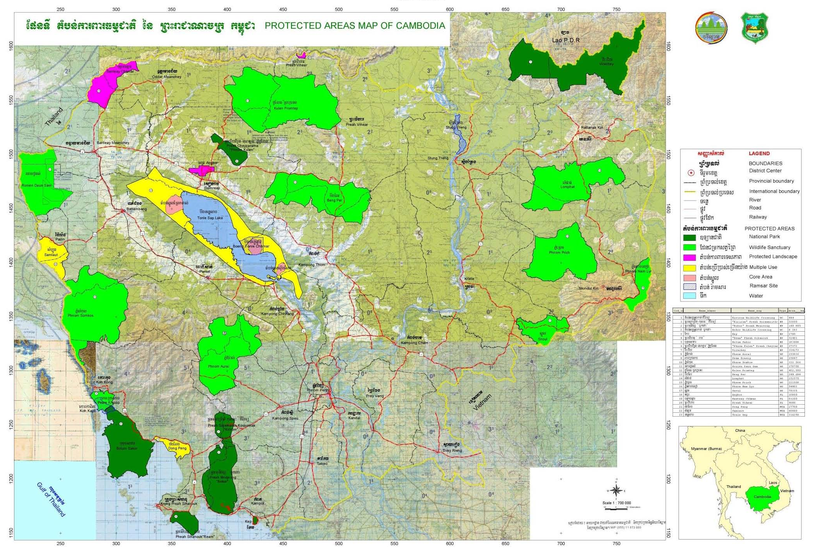

CAMBODIA

Submitted to the Secretariat of the Convention on Biological Diversity 10 December 2011

Protected area information:
PoWPA Focal Point
Ms. Somaly CHAN
Director of International Conventions and Biodiversity Department
General Department of Administration for Nature Conservation and Protection (GDANCP)
Ministry of Environment, Cambodia
Email: somalychan@hotmail.com; icbd@gdancp-moe.org
Tel: (855) 23 644 5222; H/P: (855) 12 45 77 99
Fax: (855) 23 721 073

Lead implementing agency
General Department of Administration for Nature Conservation and Protection (GDANCP)
Ministry of Environment, Cambodia

Multi-stakeholder committee: (Add description)
- National Biodiversity Steering Committee (NBSC)

Description of protected area system

National Targets and Vision for Protected Areas
(Insert national targets for protected areas/Target 11 of the Aichi Targets. Include rationale from protected area gap assessment, if completed, along with any additional information about the vision for the protected area system, including statements about the value of the protected area system to the country)
N/A, will develop
Coverage
(Amount and % protected for terrestrial and marine; maps of protected area system)
The protected areas system in Cambodia includes 7 national parks (4 are coastal and marine protected areas), 10 wildlife sanctuaries, 3 protected landscapes, 3 multiple use areas (one of which is a coastal and marine area), and Protection Forests and Fish Sanctuaries under the management of Ministry of Agriculture. In addition, the Ministry of Agriculture Forestry and Fisheries (MAFF) covering about 1.63 million hectares (FA, 2007 and 2010) as shown in table 2. The total coverage PAs land areas are around 25% of country total land area.
Table 1: Protected Area
N | PA NAME | TYPE | LOCATION | AREA (HA) | (%)
1 | Kirirom | NP | Kampong Speu and Koh Kong | 33,855 | 1.02
2 | Bokor | NP | Kampot | 149,895 | 4.51
3 | Kep | NP | Kampot | 2,795 | 0.09
4 | Ream | NP | Sihanoukville | 32,401 | 0.98
5 | Botum- Sakor | NP | Koh Kong | 183,408 | 5.52
6 | Phnom Kulen | NP | Siem Reap | 37,373 | 1.12
7 | Virachey | NP | Stung Treng and Ratanakiri | 334,173 | 10.05
Area of NP, Sub-total: |  |  |  | 773,900 | 23.29
8 | Phnom Aural | WS | Koh Kong, Pursat, Kampong Chhnang | 255,036 | 7.67
9 | Peam Krasop | WS | Koh Kong | 25,897 | 0.78
10 | Phnom Samkos | WS | Koh Kong | 332,566 | 10
11 | Roniem Daun Sam | WS | Battambang | 178,750 | 5.38
12 | Kulen-Promtep | WS | Siem Reap and Preah Vihear | 402,500 | 12.11
13 | Beng Per | WS | Kampong Thom | 249,694 | 7.51
14 | Lomphat | WS | Ratanakiri and Mondulkiri | 252,575 | 7.6
15 | Phnom Prich | WS | Mondulkiri and Kratié | 222,500 | 6.69
16 | Phnom Nam Lyr | WS | Mondulkiri | 54,903 | 1.65
17 | Snoul | WS | Kratié | 75,335 | 2.27
Area of WS, Sub-total: |  |  |  | 2,049,756 | 61.66
18 | Angkor | PL | Siem Reap | 10,800 | 0.32
19 | Banteay Chhmar | PL | Banteay Meanchey | 81,200 | 2.44
20 | Preah Vihear | PL | Preah Vihear | 5,000 | 0.15
Area of PL, Sub-total: |  |  |  | 97,000 | 2.91
21 | Dong Peng | MUA | Koh Kong | 27,700 | 0.83
22 | Samlaut | MUA | Battambang | 60,000 | 1.8
23 | Tonle Sap | MUA | Kampong Chhnang, Kampong Thom, Siem Reap, Battambang, Pursat | 316,250 | 9.51
Area of MUA, Sub-total: |  |  |  | 403,950 | 12.14
Area of 23 PAs, Grand total: |  |  |  | 3,324,606 | 100
Note:
- National Park (NP) classified in category II of IUCN
- Wildlife Sanctuary (WS) classified in category IV of IUCN
- Protected Landscape (PL) classified in category V of IUCN
- Multiple Use Area (MUA) classified in category VI of IUCN

Table 2: Protection Forest and Fish Sanctuary
No | Name Province/Municipality Definition Year | Area (ha)
1 | Ang Trapang Thmor Sarus Crane Conservation Area 2000 | 12,650
2 | Kbal Chay (freshwater river) Sihanoukville Sub-Decree 1997 | 6,027
3 | Mondulkiri Protected Forest for Genetic Conservation of Plants and Animals 2002 | 429,438
4 | Preah Vihear Protected Forest for Genetic Conservation of Plants and Animals 2002 | 190,027
5 | Central Cardamon Protected Forest for Watershed and Biodiversity Conservation 2002 | 401,313
6 | Phnom Tamoa Zoological and Wildlife Rescue Center 1996 | 1,200
7 | Seed Source of Dalbergia bariensis Preah Vihear 2001 | 13
8 | Seed Source Kampong Thom Declaration 2002 | 117
9 | Seima Protected Forest for Biodiversity Conservation 2009 | 305,440
10 | South West Elephant Corridor 2004 | 144,275
11 | Bengal Florican Biodiversity of Ecological Management (Ministerial Declaration) 2010 | 38,775
12 | Protected Forest for Conservation and Game Hunting (Sub degree) 2009 | 101,348
13 | Boeung Prek Lapov Management and Conservation Areas for Sarus Crane and Other Birds (Sub-degree) 2007 | 8,305
Total Protected Forest |  | 1,638,928
Source: MoE,2004; FA, 2007 and 2010

Description and background
(Summary description)
Cambodia was the first country in South-East Asia to establish a protected areas system when the area surrounding Angkor Wat temple was declared national parks in 1925. This temple is now designated as a World Heritage Site. In 1957, 173 forest reserves total covering 3.9 million ha, and 6 wildlife reserves total covering 2.2 million ha or 12 % of the total land area, were designated as protected areas of wildlife, in particular large mammals. In 1993 Cambodia designated 23 protected areas covering about 3,273,300 ha, and new amendment is up to 3,324,606 ha (see table 1) or around 18% of the Cambodia’s PA under the authority of the Ministry of Environment. In addition, there is Protection Forests and Fish Sanctuaries under responsible of Ministry of Agriculture Forestry and Fisheries (MAFF).
Governance types
(Summary matrix of governance types)
See matrix in the workshop exercises
Key threats
(Description of key threats, and maps, if available)
Despite being under conservation and sustainable use, these protected areas have been under many threats. The main threats are logging, hunting, and over collecting of NTFP and over consumption. For instance, continued logging at the family scale and, illegally, at the medium scale or large scale for agro industry plantation, and illegal hunting have been occurring inside or within these protected areas. Most Cambodian people rely directly on biological resources for their livelihoods, however biological resources have been privatised and, in many cases, over harvested.
Land speculation and encroachment present further threats to protected areas. These activities have been occurring and wide-spreading into the protected areas as a consequence of the increase in demand for human settlement and small-scale agricultural land and illegal expansion of large-scale agro-industrial land.
Moreover, another challenge for PA management is continuing biodiversity loss, due to the increasing population pressure, global trading, climate change, lack of participation from others, a lack of planning and law enforcement in natural resource management and conservation, as well as uncertainties in land tenure in those areas, etc.
Despite this tremendous progress, protected forested areas in remote locations continues to be threatened by poachers and deforestation. Unfortunately, the status of biodiversity in most of the protected areas is poorly documented, making it difficult to determine the impact of these activities to the country’s biodiversity. In addition, biodiversity researches often involve several ministries. Owing to the lack of coordination and data exchange, much of what little data is available is spread among the agencies and is not easily accessible.
Conservation measures to prevent further decline of habitats and wildlife protected areas have been greatly hampered by the lack of sufficient biodiversity information. One of the gaps highlighted in the report is the need for biodiversity conservation studies to be initiated in majority of the country’s protected areas to build the knowledge base and improve on the conservation initiatives.
Barriers for effective implementation
(Description of key barrier s for effective implementation)
The Government has attempted to mitigate threats to biodiversity in the country through increased community development management and good governance.
Several policy frameworks have been developed and implemented to address these threats and reduce biodiversity loss, thereby contributing to achieving Cambodia’s obligations under the Convention on Biological Diversity (CBD). The policy frameworks, for instance, include National Biodiversity Strategic Action Plan (NBSAP), National Capacity Self-Assessment (NCSA), PA and Biodiversity Framework (2011), National Environmental Action Plan (NEAP) and site management plans. Some projects have also been initiated to deal with protected areas and address the issues of capacity building and species management such as Tonle Sap Biodiversity Management Project, Coastal Zone Management Project, Mangrove Forest Management Project, etc.
However, the threats have not been successfully minimized and biodiversity loss continues due to several barriers. In 2006 WWF conducted a Rapid Assessment and Prioritization of Protected Area Management (RAPPAM) in Cambodia.
Status, priority and timeline for key actions of the Programme of Work on Protected Areas

Status of key actions of the Programme of Work on Protected Areas
Status of key actions of the Programme of Work on Protected Areas | Status
- Progress on assessing gaps in the protected area network (1.1) | 4
- Progress in assessing protected area integration (1.2) | 2
- Progress in establishing transboundary protected areas and regional networks (1.3) | 2
- Progress in developing site-level management plans (1.4) | 1
- Progress in assessing threats and opportunities for restoration (1.5) | 1
- Progress in assessing equitable sharing of benefits (2.1)  - Progress in assessing protected area governance (2.1) | 0  2
- Progress in assessing the participation of indigenous and local communities in key protected area decisions (2.2) | 3
- Progress in assessing the policy environment for establishing and managing protected areas (3.1)  - Progress in assessing the values of protected areas (3.1) | Yes  1
- Progress in assessing protected area capacity needs (3.2) | 1
- Progress in assessing the appropriate technology needs (3.3) | 0
- Progress in assessing protected area sustainable finance needs (3.4) | 1
- Progress in conducting public awareness campaigns (3.5) | 2
- Progress in developing best practices and minimum standards (4.1) | 0
- Progress in assessing management effectiveness (4.2) | 0
- Progress in establishing an effective PA monitoring system (4.3) | 0
- Progress in developing a research program for protected areas (4.4) | 1
- Progress in assessing opportunities for marine protection | 3
- Progress in incorporating climate change aspects into protected areas | 3
Status: 0 = no work, 1 = just started, 2 = partially complete, 3 = nearly complete, 4 = complete
(Insert notes as appropriate)

Priority actions for fully implementing the Programme of Work on Protected Areas:
(See attached Appendix)

Timeline for completion of key actions
(See attached Appendix)

Action Plans for completing priority actions of the Programme of Work on Protected Areas
(See attached Appendix)

Action 1: (Describe action)
Key steps | Timeline | Responsible parties | Indicative budget

Action 2: (Describe action)
Key steps | Timeline | Responsible parties | Indicative budget

Action 3: (Describe action)
Key steps | Timeline | Responsible parties | Indicative budget

(Insert more as needed)

Key assessment results
Ecological gap assessment (insert summary findings if available)
N/A
Management effectiveness assessment (Insert summary findings if available)
N/A
Sustainable finance assessment (Insert summary findings if available)
N/A
Capacity needs assessment (Insert summary findings if available)
The Cambodia National Capacity Self-Assessment Project is a process in which relevant government organizations and individuals in Cambodia determine for themselves how much the country, at this time, is able to fulfill its obligations to three (3) United Nations conventions on the environment:
- The United Nations Convention on Biological Diversity (UNCBD)
- The United Nations Framework Convention on Climate Change (UNFCCC)
- The United Nations Convention on Combating Desertification (UNCCD)
Cambodia is a signatory and a party to each convention. The country is obligated to contribute toward achieving their goals. It is expected that Cambodia will implement measures, and in collaboration with other countries, address the environmental concerns of the conventions in Cambodia, to the extent that is expected (in eachconvention) of countries in development stages like itself.
The NCSA process involves constant validation of findings. No findings on Cambodian capacities (and capacity needs) are established unless reviewed and concurred to by different RGC agencies, experts in academe and NGOs, and stakeholders. The final validation is with the Council of Ministers.
The goal of the project is to develop and strengthen national capacities for sustainable management and use of natural resources and of the environment, for the benefit of the Cambodian poor.
The primary objective is to identify country level priorities and needs for capacity development, to address global environmental management requirements, particularly the thematic concerns of the three UN conventions.

Policy environment assessment (Insert summary findings if available)
N/A
Protected area integration and mainstreaming assessment (Insert summary findings if available)
N/A
Protected area valuation assessment (Insert summary findings if available)
NO
Climate change resilience and adaptation assessment (Insert summary findings if available)
N/A
(Insert other assessment results if available)

