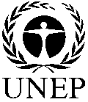 |  | CBD
 |  |  |  | Distr.  GENERAL  UNEP/CBD/COP/11/26  23 July 2012  ORIGINAL: ENGLISH
CONFERENCE OF THE PARTIES TO THE CONVENTION ON BIOLOGICAL DIVERSITY
Eleventh meeting
Hyderabad, India, 8-19 October 2012
Item 13.4 of the provisional agenda*

PROTECTED AREAS: Progress IN THE IMPLEMENTATION OF the programme of work AND ACHIEVEMENT OF AICHI BIODIVERSITY TARGET 11

Note by the Executive Secretary
- INTRODUCTION
- With a view to strengthen implementation of the programme of work on protected areas (PoWPA) and to align implementation with available funding and technical support, the Conference of the Parties at its tenth meeting adopted several measures in decision X/31. These include, inviting Parties to develop a long-term action plan for the implementation of the PoWPA (or to reorient, as appropriate, relevant existing plans), contributing to the implementation of the Strategic Plan for Biodiversity 2011-2020 (paragraph 1(b)) and to use the protected area biodiversity allocations included in the fifth replenishment period of the Global Environment Facility (GEF 5) in a timely and appropriate manner, as well as bilateral, multilateral and other financial support relevant for protected areas, and to use their PoWPA action plans as the basis for accessing these funds (paragraph 10(b)).
- The Conference of the Parties also urged the GEF and its implementing agencies to streamline their delivery for expeditious and proportionate disbursement and to align the projects to the PoWPA action plans for appropriate, focused, sufficient and harmonious interventions and continuity of projects (paragraph 13(b)) and requested the Executive Secretary to continue holding regional and sub-regional capacity-building workshops (paragraph 7(a)). Finally, the Conference of the Parties requested the Executive Secretary to submit a report on the preparation of PoWPA national action plans for its consideration at its eleventh meeting (paragraph 1(b)).
- The Executive Secretary has prepared this note in response to the latter request. As of 26 June 2012, 105 action plans were formally submitted to the Secretariat. These action plans are available at http://www.cbd.int/protected/implementation/actionplans/. Section II of this note provides details of technical support facilitated by the Secretariat. Section III compiles an analysis of the action plans featuring the status of PoWPA implementation at the global and regional levels; national targets identified by Parties to respond to Aichi Biodiversity Target 11; priority actions identified by Parties and their relation to the goals of the PoWPA, the elements of Target 11 and other Aichi Biodiversity Targets; and protected area projects approved under GEF 4 and GEF 5 as they contribute to achieving the elements of Target 11. Section IV provides an update of progress towards Aichi Biodiversity Target 11, based on this information as well as information in the World Database of Protected Areas. Section V suggests next steps based on lessons learned from the process of developing PoWPA Action Plans. Finally, a draft decision is provided in section VI for the consideration of the Conference of the Parties.
- TECHNICAL SUPPORT FOR THE DEVELOPMENT of action plans
- The Secretariat, over a period of a year (May 2011 to June 2012) organized eight subregional capacity-building workshops with the generous funding from the European Union and funding from the Governments of the Netherlands and Spain (partially for the workshops in West Africa, Latin America and Pacific regions); West Africa (Dakar, Senegal, 22 to 26 May 2011); Pacific (Nadi, Fiji, 3 to 7 October 2011); South, East, and South-East Asia (Dehradun, India , 6 to 9 December 2011); Central, Southern and East Africa (Cape Town, South Africa, 30 January to 3 February 2012); Latin America (Bogota, Colombia 12 to 16 March 2012); the Caribbean (Christ Church, Barbados 1 to 5 April 2012); West Asia and North Africa (Dubai, United Arab Emirates, 16 to 20 April 2012); and Central and Eastern Europe and Central Asia (Belgrade, Serbia, 4 to 8 June 2012). These workshops covered over 100 countries.
- After the first workshop, it was identified that a unified approach to developing national action plans for the implementation of the PoWPA was necessary for inter alia increased national coordination and regional cooperation as well as comprehensive reporting. Therefore, an action plan template was developed taking these issues into consideration. It is specifically structured to present information sequentially, with the following sections (and subsections): protected area agency information (PoWPA focal point, lead implementing agency, and multi-stakeholder committee), description of protected area system (coverage, description and background, governance types, key threats, barriers for effective implementation, and national targets and vision for Target 11 ), progress in and plans for achieving the goals of the PoWPA and Target 11 (priority activities for full implementation and detailed steps for completing them), and key assessment results (assessments of: ecological gaps, management effectiveness, sustainable financing, capacity needs, policy environment, protected area integration and mainstreaming, protected area valuation, and climate-change resilience and adaptation). The template serves as a comprehensive means to avoid a piecemeal approach to national implementation of the PoWPA and to increase management synergies for transnational protected areas and regional and subregional projects.
- In response to the request contained in paragraph 1(b) of decision X/31, the Secretariat issued notification 2012-018 dated 26 January 2012 requesting Parties to formally submit their PoWPA action plans by 31 March 2012. A reminder notification 2012-070 dated 15 May 2012 was issued with a new deadline of 31 May 2012.
- Prior to each capacity workshop, country representatives were emailed background information documents and materials, including (where available) applications under the UNDP/GEF project Supporting Country Action on the CBD PoWPA, national biodiversity strategies and action plan (NBSAP) documents, fourth national reports to the Convention on Biological Diversity, 2009 PoWPA Reporting Frameworks completed during the 2008-2009 workshop series, GEF 4 protected area project applications, and ecological gap analyses/assessments. Country delegates were also sent other preparation material, including the PoWPA action plan template, the PoWPA reporting framework (in annex to decision X/31) and notifications 2012-018 and 2012-070. Country delegates were requested to work on identifying actions based on those PoWPA goals that are lagging behind and the elements of Aichi Target 11, and then to prioritize them, identifying timelines and budget requirements, with a view to discussing these issues in the workshop. They were asked to submit a draft of their results using the PoWPA action plan template at or immediately after the workshop. Country delegates were then requested to finalize the draft action plans upon return to their countries and to submit them through official channels to the Secretariat. In each workshop participants were provided a CD or USB key with the documents listed above as well as other relevant tools, resources and information documents.
- At the end of each workshop country delegates were encouraged to consult with their colleagues and relevant stakeholders to finalize the PoWPA action plans before formally submitting them by the deadlines in notifications 2012-018 and 2012-070. In between the issuance of the two notifications and following the latter one, personalized reminder emails were sent to country delegates that had submitted draft action plans requesting them for formal submission. As noted above, as of 26 June 2012, 105 action plans were formally submitted to the Secretariat. Some of them are formal drafts (e.g., South Africa, Philippines, Indonesia, and Bhutan, etc.) in which countries are further working to align them with revised NBSAPs. These action plans are uploaded on the PoWPA webpage and can be accessed at http://www.cbd.int/protected/implementation/actionplans/.
III. Analysis of action Plans

3.1. Status of implementation of the PoWPA
- Progress in achieving the goals of the programme of work on protected areas was measured using a five point Likert scale, where 0 indicates that work has not begun and 4 indicates that the activity is complete. Figure 1 summarizes this progress globally for the 16 goals of the PoWPA as well as progress in marine protected areas and in incorporating climate change. Figure 1 illustrates that many activities are under way and that some progress has been made.
- The global data reveals that three goals have seen significant progress: establishing and strengthening national and regional systems of protected areas (1.1); strengthening communication, education and public awareness (3.5); and building capacity for the planning, establishment and management of protected areas (3.2). Some countries have noted progressive initiatives in one or more of these goals. For example, in Grenada, an ecological gap assessment conducted in 2006 in partnership with The Nature Conservancy identified the degree of representation of existing and proposed protected areas. A lack of comprehensive assessments on heritage, recreation and tourism was noted and to address this limitation a workshop was held in 2009 to update the gap analysis by incorporating aspects of goal 3.1, assessing the contribution of protected areas to local and national economies.
- Following the three above mentioned goals, Parties next identified some progress in: applying and transferring appropriate technologies for protected areas (3.3); promoting equity and benefit-sharing (2.1); and integrating protected areas into broader landscape and seascapes and sectors so as to maintain ecological structure and function (1.2). In some cases the need for more efforts in these areas can be linked to the key threats and barriers listed by countries.
- Data on the status of implementation was also collated according to sub-regions. The subregional data revealed that there is significant progress for nine goals for Central and Eastern Europe and Central Asia, followed by eight goals for the Pacific. Significant progress was revealed for one goal for South, East and South East Asia and for two goals for West Africa.
- Six out of 10 countries (60 per cent) in the Pacific reported significant progress in enhancing and securing involvement of indigenous and local communities and relevant stakeholders (goal 2.2) and in strengthening communication, education and public awareness (goal 3.5). The Cook Islands noted that although a “multi-stakeholder committee is established to oversee all biodiversity related projects” there is a need for the “government and groups of landowners to work together to develop a national system of protected areas on the land and in the sea”, therefore their priority actions include the formalization of a National Biodiversity Stakeholder Steering Committee and ensuring consultations on the development of new management authorities (i.e. Suwarrow National park Authority) as well as in corresponding regulations (i.e. Biodiversity Conservation Regulations). This suggests that there is an opportunity to build on existing participatory methods to enhance related PoWPA goals, such as promoting equity and benefit-sharing and assessing and implementing diverse protected area governance types (goal 2.1).

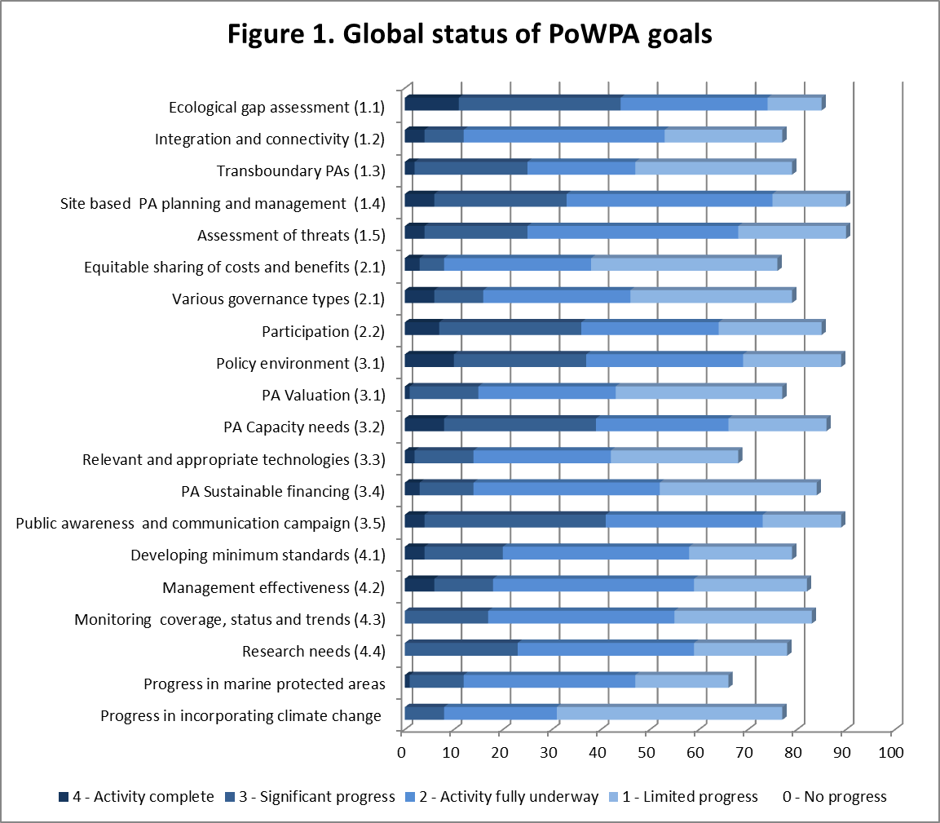
- Nine out of 15 countries (60 per cent) in Central, South and East African reported significant progress in establishing and strengthening regional networks, transboundary protected areas and collaboration between neighbouring protected areas across national boundaries (goal 1.3). Mozambique noted significant progress in this goal with the Transfrontier Conservation Areas Program and Tourism Development Project and plans to build upon it with the “creation of transfrontier conservation areas between Mozambique, Zambia and Zimbabwe and between Mozambique and Tanzania” which they listed as a priority action. This denotes a possibility to build upon existing cooperation within the subregion, potentially opening up greater opportunities for subregional transboundary protected area projects and to improve upon establishing and strengthening national and regional systems of protected areas (goal 1.1).

National targets for Aichi Biodiversity Target 11
- Practical training and examples were provided in the eight workshops held in the 2011-2012 series of CBD capacity-building workshops for the PoWPA which supported over 90 Parties to identify national targets responding to Aichi Biodiversity Target 11 as requested by the Conference of the Parties in paragraph 3 (b) of decision X/2. Some of the identified targets were qualitative, such as listing future protected areas, and others were quantitative, such as determining the area to be protected. Most commonly, Parties provided quantifiable targets in per cent of area to be protected. For terrestrial areas 70 Parties identified quantitative protected area targets ranging from 10 to 30 per cent, with 46 Parties setting goals at or above the Target 11 terrestrial goal of 17 per cent protected coverage. For marine areas 44 countries identified protected area targets ranging from 3 to 15 per cent, with 41 Parties setting goals at or above the Target 11 marine goal of 10 per cent protected coverage.
- Figures 2 and 3 display the proportion of each country’s terrestrial and territorial water area under protection in 2010, based on data from the WDPA, as well as proposed protected area targets, based on information gathered during the 2011-2012 series of capacity-building workshops for the PoWPA under the Convention on Biological Diversity. This information suggests that the world community is aiming to make good progress towards the quantitative components of Target 11. 86 Parties, representing nearly half of the world’s terrestrial area, have proposed terrestrial protected area targets which would amount to over 16 per cent of their combined area being protected. This is well on the way to achieving the global target of protecting 17 per cent of terrestrial areas, bearing in mind that this target also requires the area protected to be ecologically representative. With regards to the marine environment, 70 Parties whose combined territorial waters add up to nearly half of the world’s territorial waters have proposed marine targets which would amount to over 11 per cent of their territorial waters (up to 12 nautical miles) being protected. This would surpass the global marine and coastal target of 10 per cent protection without taking ecological respresentativity into account. Interestingly, several small island developing States have set ambitious marine protected area targets of 25 per cent or more although collectively they currently only have 2.8 per cent marine protected areas (Figure 6).
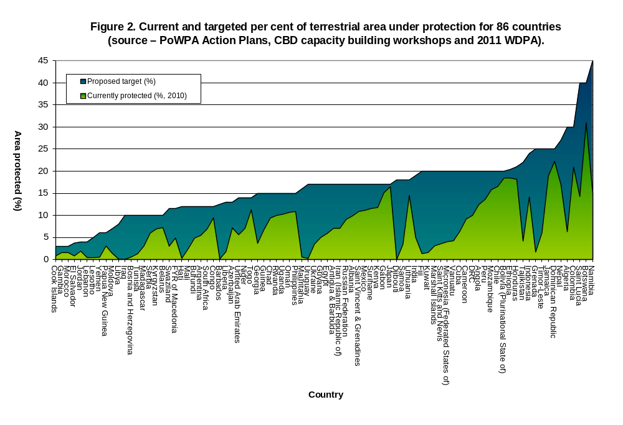

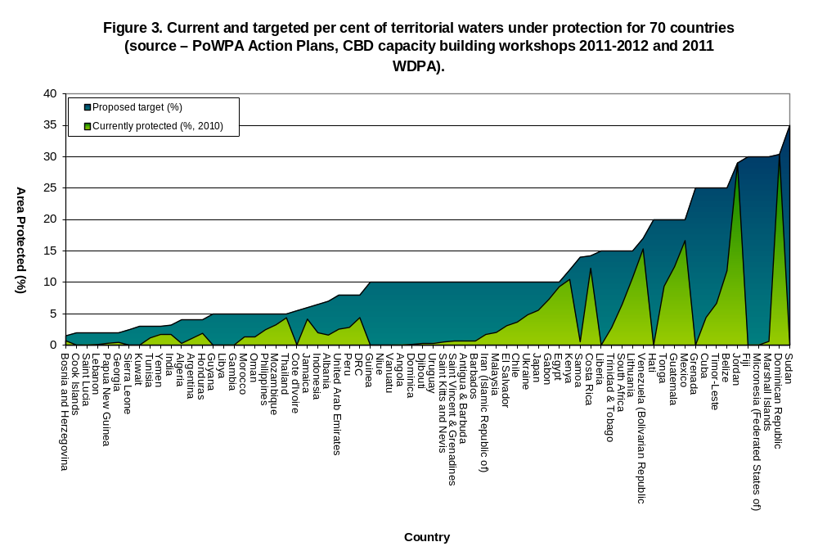

3.3 Priority actions identified in PoWPA action plans
- Countries identified priority actions as part of their national action plans for implementing the goals of the programme of work on protected areas and achieving Target 11. In 100 plans a total of 583 actions from approximately 84 countries were categorized in three ways: their relationship to the goals of the programme of work on protected areas, the elements of Target 11 and to other Aichi Biodiversity Targets. Actions were classified in one or more categories depending on if they were cross-cutting.
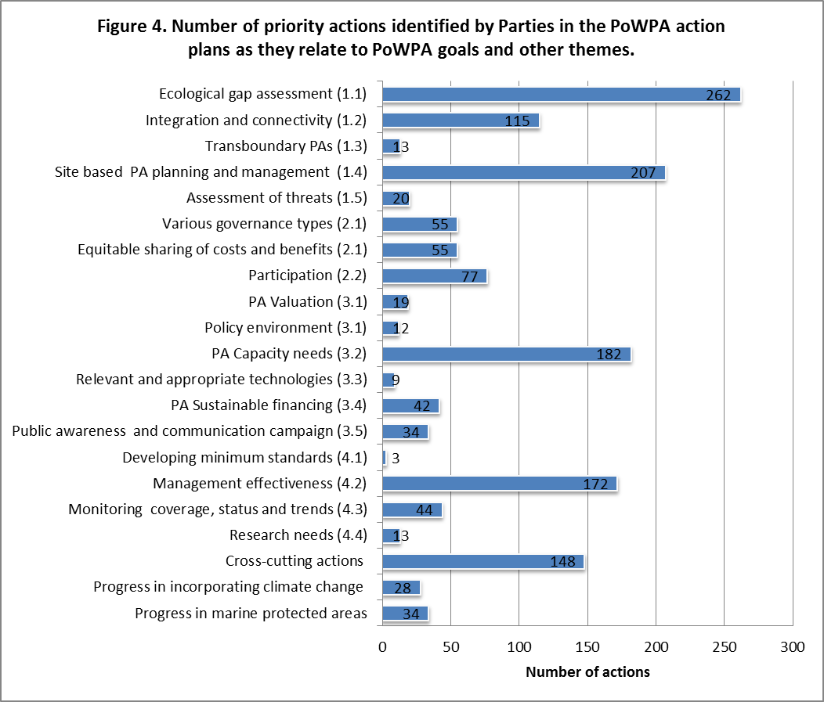
- The priority actions identified by countries were matched with PoWPA goals based on key words of the goals and summarized (Figure 4). Actions that did not contain key words but fit across multiple PoWPA goals were compiled into “Cross-cutting actions”. Over 200 priority actions correspond to goals 1.1 and 1.4 and over 100 actions correspond to goals 3.2, 4.2, and 1.2. Countries also determined some actions on developing and adopting minimum standards and best practices for national and regional protected area systems (4.1); developing, applying and transferring appropriate technologies for protected areas (3.3); providing an enabling policy, institutional and socio-economic environment for protected areas (3.1); ensuring that scientific knowledge contributes to the establishment and effectiveness of protected areas and protected area systems (4.4); establishing and strengthening regional networks, transboundary protected areas (TBPAs) and collaboration between neighbouring protected areas across national boundaries (1.3); assessing the contribution of protected areas to local and national economies (3.1); and preventing and mitigating the negative impacts of key threats to protected areas (1.5).
- Comparing this data to Figure 1 (Global Status of PoWPA Goals), progress in integrating protected areas into broader landscapes, seascapes and sectors so as to maintain ecological structure and function (goal 1.2) can possibly be improved through the 115 priority actions that 58 countries have identified. For example, Swaziland reported an established network of seven terrestrial protected areas covering 3.7 per cent of the country, however this figure rises to 11.3 per cent when considering areas that are not yet proclaimed but under conservation management within the regional Transfrontier Conservation and Resource Area programme. Swaziland reported that the “active involvement of the different tourism authorities from the three countries in the initiative successfully complements their implementation.” Reporting less progress in assessing protected area integration, Swaziland’s second priority action is to integrate protected area management into the wider landscape (biosphere) and other sectors and includes a key step to “review and identify eco-tourism opportunities in the wider production landscape through community/private/public partnerships in areas such as the Lubombo region, building upon management plans proposed under the Critical Ecosystem Partnership Fund (CEPF).”
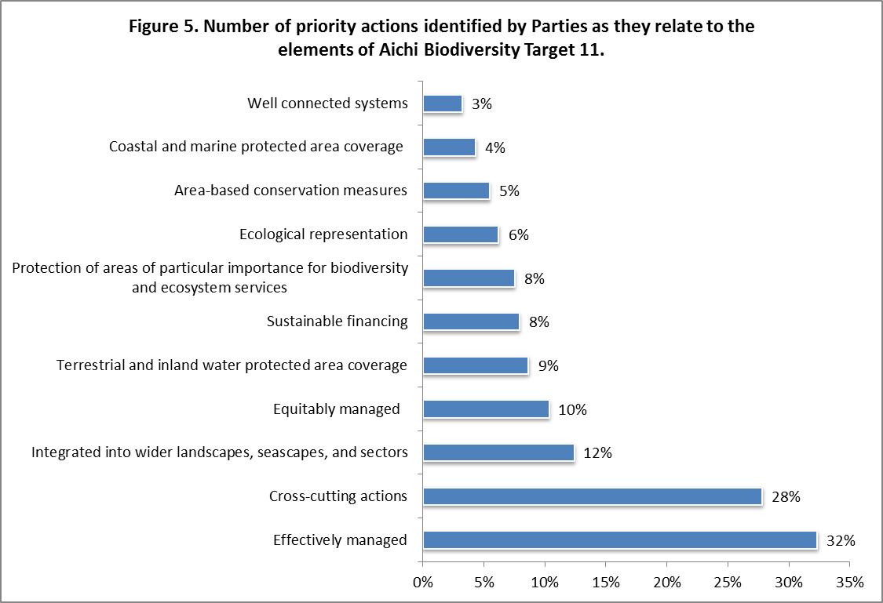
- Target 11 can be separated into elements based on its key terms although the implication is that all terms should be addressed comprehensively to achieve the target. “at least 17 per cent of terrestrial and inland water areas” translates to terrestrial and inland water protected area coverage; “10 per cent of coastal and marine areas” corresponds with coastal and marine protected area coverage; “areas of particular importance for biodiversity and ecosystem services” translates to protection of areas of particular importance for biodiversity and ecosystem services; and “integrated into wider landscapes and seascapes and sectors”, “ecologically representative”, “effectively managed”, “equitably managed”, “other area-based conservation measures” and “well connected systems” are self-termed. The area target is qualified by the complementary terms.
- The actions identified by countries correspond to the elements of Target 11 and are compiled in Figure 5. The most common action was management effectiveness cited by 73 countries and an average timeframe for implementation of 2013 to 2016. Countries also identified priority actions for protected area connectivity (16 countries), coastal and marine protected area coverage (20 countries), area-based conservation measures (23 countries), and ecological representation (27 countries). Timeframes given for completing these priority actions range from 2015 to 2017.
- Ten per cent of the actions are directed toward promoting equity and benefit-sharing and in assessing and implementing diverse protected area governance types (goal 2.1) as reported by 40 countries with an average timeframe for implementation of 2013 to 2016. These actions can improve the global status of goal 2.1 conveyed in Figure 1 (Global Status of PoWPA Goals). Madagascar reported that progress in goal 2.1 is “just beginning” and listed two interrelated priority actions—that also correlate with goals 2.2 (participation) and 3.1 (protected area policy environment and valuation)—for implementation of this element of target 11: establishing technical tools for the valuation of biodiversity and protected areas, such as payments for ecosystem services and environmental services; and improving benefit-sharing in protected areas along with research studies for monitoring activities. Both of which are connected to the key steps of strengthening new approaches to participatory community management and diversification of protected area governance types, including the identification of indigenous and community conservation areas, with recognition in national legislation. Madagascar aims to implement these key steps by 2018.
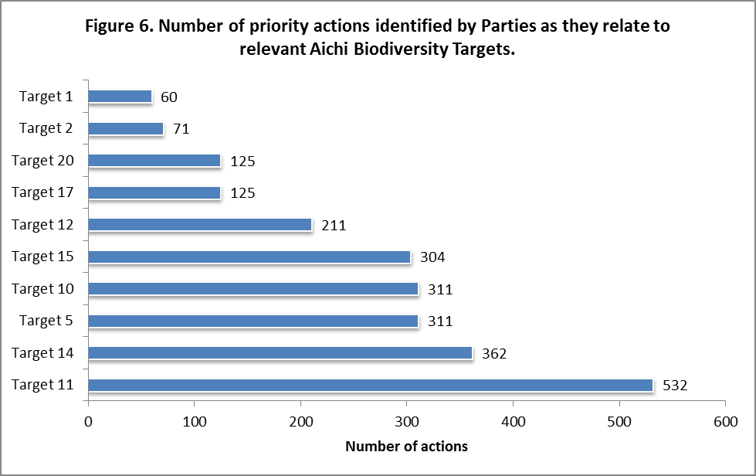
- Country actions relate to achieving other Aichi Biodiversity Targets and contribute to monitoring their progress. Actions are classified into 10 targets that correspond to the goals of the programme of work on protected areas and are compiled in Figure 6: environmental awareness (Target 1), biodiversity for development (Target 2), natural habitats (Target 5), coral reef (Target 10), threatened species (Target 12), ecosystem services (Target 14), landscape restoration (Target 15), national policies (Target 17), and finance (Target 20).
- Eighty-one countries have prioritized 362 actions for implementation related to ecosystem services (Target 14), ranging an average timeframe for implementation of 2013 to 2016. Approximately 80 countries have prioritized actions on natural habitats (Target 5), coral reef (Target 10) and landscape restoration (Target 15), with the same average implementation timeframe. Sixty countries have 125 actions ranging an average timeframe for implementation of 2013 to 2016 that relate to finance (target 20) and national policies (Target 17). Forty-eight countries have prioritized 60 activities on environmental awareness (Target 1) within the same average timeframe of implementation.
- Country action plans demonstrate cross-cutting action for achieving multiple targets. South Africa divides action for implementation of “PoWPA and for achieving Target 11” into three phases. The potential outcomes for phase I includes completing a “master plan” for protected areas, which incorporates promoting governance arrangements, and “studies and assessments” (as input for the “master plan”), which includes socio-economic contributions of protected areas. The outcomes for phase II include securing sufficient financial resources.
- Careful monitoring and reporting of these activities and other countries priority actions can contribute to assessing progress for Aichi Biodiversity Target 11 as well as targets, 2, 5, 10, 12, 14, 15, 17 and 20.In the implementation of country actions establishing synergies between PoWPA goals and the Aichi Biodiversity Targets promotes integration of opportunities and reporting.

Protected area projects under the fourth and fifth replenishments of the Global Environment Facility and their relation to elements of Aichi Biodiversity Target 11 and actions identified in action plans
- The Global Environment Facility (GEF) is the largest funding mechanism for protected areas worldwide and has provided 2.2 billion US$ to fund protected area management, leveraging an additional 7.35 billion US$ in co-financing from project partners. Under its fourth replenishment cycle (GEF 4), GEF formulated a comprehensive strategy on protected areas that focused on catalyzing sustainable protected areas systems. The GEF defines a sustainable protected area system as one that possesses: a) sufficient and predictable revenue, including external funding, available to support protected area management costs; b) includes coverage of ecologically viable representative samples of ecosystems; and c) has adequate individual, institutional and systematic capacity in place to manage protected areas such that they achieve their management objectives. In the fifth replenishment (GEF 5) under the biodiversity focal area, strategic objective BD1 “Improve the sustainability of protected area systems” activities included are: improve sustainable financing of protected area systems; expand marine and terrestrial ecosystem representation; expand threatened species representation; and improve management effectiveness of existing protected areas.
- GEF has funded 324 protected area projects (261 in GEF 4 and 63 in GEF 5). These projects are broadly categorized under objective 1(GEF 4) and BD1 and BD1+BD2 (GEF 5). Invariably these projects will contribute to achieving Target 11 at the global and at national levels. To understand their relation to the elements of Target 11, the project documents from the GEF website are examined and the numbers of projects are identified as they correspond to various elements of Target 11.
- Figures 7 and 8 reveal that the effectively managed component of Target 11 has the highest number of projects (108) followed by sustainable financing (85 projects). Integration into wider landscape and seascapes, ecologically representative and equitably managed elements have more than 30 projects each.
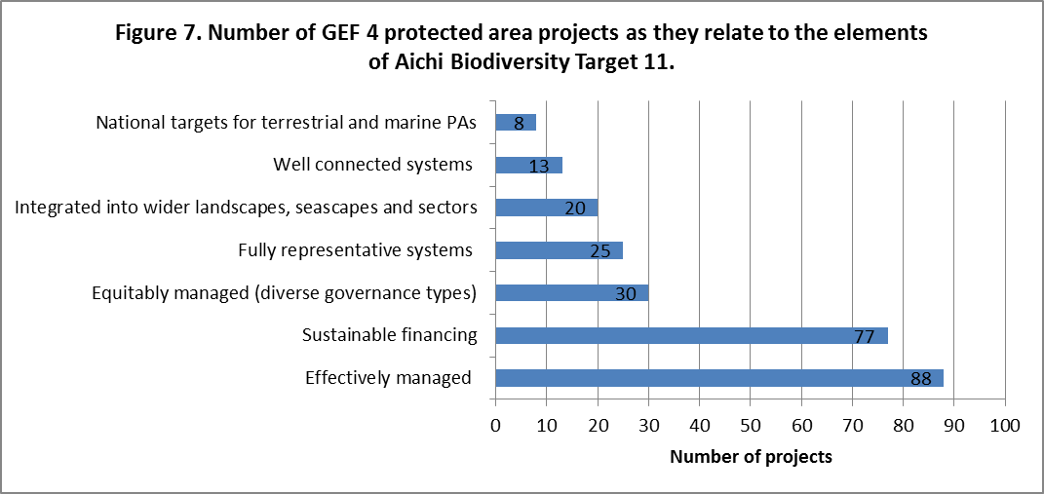
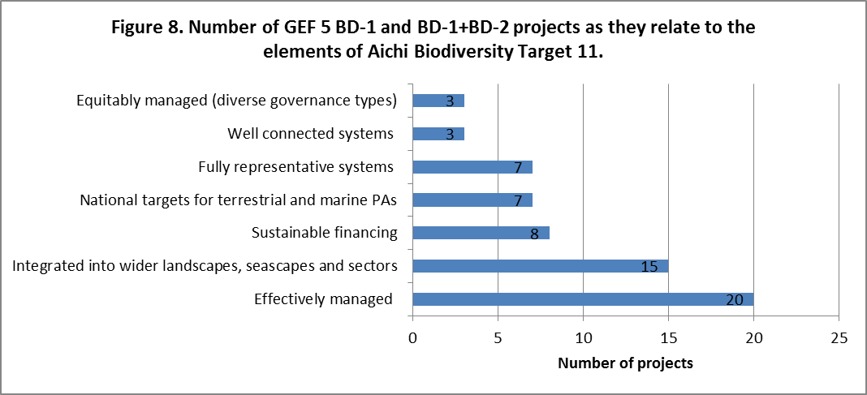
- If one looks into the suggested activities in the action plans as they relate to elements of Target 11, given in the previous section, and corresponding GEF 4 and 5 protected area projects, some of the countries have already accessed GEF funding on the suggested activities. For example Liberia, Cook Islands, Fiji, Indonesia, Kenya, Zambia, Argentina, Colombia, Costa Rica on effective management; Egypt, Trinidad and Tobago, Jamaica, Antigua & Barbuda, Bolivia, Colombia on sustainable finance; India, Ecuador and Tunisia on integration into wider landscape and seascapes; Honduras and South Africa on equitable management; Mexico on well-connected systems of protected areas.
- In the full and medium sized projects approved by GEF following the tenth meeting of the Conference of the Parties, very few projects made any reference to the Strategic Plan for Biodiversity 2011-2010 and the Aichi Biodiversity Targets. But all these projects directly contribute towards achieving various elements of Target 11 and other Aichi Targets and implementing the Strategic Plan. Monitoring the implementation of these projects and their evaluation also contributes to monitoring progress of Target 11. Integration of implementation and monitoring of GEF projects and PoWPA action plans provides greater opportunity for systematic monitoring and reporting back on achieving Target 11. It is essential to include the results of the implementation of these projects in the PoWPA reporting framework and in the fifth national reports.

IV. PROGRESS TOWARDS AICHI BIODIVERSITY TARGET 11

4.1 Current status
- According to the World Database on Protected Areas (2011) dataset, 12.7 per cent of the world’s terrestrial surface and 7.2 per cent of its coastal waters (0-12 nautical miles) are protected. Considering the total marine area under national jurisdiction (from shoreline to 200 nautical miles, the limit of Exclusive Economic Zone), protection amounts to only 4 per cent of this area. So, while terrestrial protected areas are within sight of reaching of the global target of 17 per cent by 2020, marine protected areas have a long way to go, and especially to reach the 10 per cent global target within the total marine area up to 200 nautical miles.
- In the case of “ecological representation” element of target 11, the target of having 10 per cent of each of the world's ecological regions effectively conserved adopted in decision VII/28, 50 per cent or 414 out of the 823 terrestrial ecoregions meet this target and a further 149 ecoregions are close to it with between 5 to 10 per cent of their area under protection. However, in 84 terrestrial ecoregions, less than one per cent of the area is protected and the focus must shift to proactively identify in which countries and areas these gaps can be addressed. In the case of marine ecoregions, 30 of the 232 marine ecoregions attained the 10 per cent marine target. However more than 50 per cent (137 out of 232) have less than one percent of their area protected. Considering areas of particular importance for biodiversity, 49 per cent of Alliance for Zero Extinction sites and 51 per cent of Important Bird Areas are entirely protected, still leaving large gaps.
- Considering the “effectively managed” element of Target 11, less than 30 per cent of the world’s protected areas have a management plan and only 24 per cent of protected areas of 4,151 assessments undertaken in a 2010 global study have sound management in place. In 13 per cent of these 4,151 assessments management is clearly inadequate and 27 per cent recorded basic management with major deficiencies. Information on other elements of Target 11 (equitably managed, other effective area-based conservation measures, well-connected and integrated into wider land- and seascapes) is not yet available in a comprehensive manner. Indigenous Peoples’ and Community Conserved Areas (ICCAs) are recognized in the PoWPA and in decisions of the Conference of the Parties and, by mid-2011, the WDPA had included some 700 ICCAs covering over 1.1 million square kilometres. Some studies indicate that this represents only a fraction of the total area of these sites. For example, it has been estimated that at least 3.7 million square kilometres of the total forest area in Latin America, Africa, East and South Asia fall under community conservation.
- Further review of progress in achieving Target 11 was provided in an information document for the fourth meeting of the Working Group on the Review of Implementation (WGRI 4) (UNEP/CBD/WGRI/4/INF/5).

4.1 Commitments to achieve Aichi Biodiversity Target 11
- From the preliminary information gathered during the course of a series of regional and subregional capacity-building workshops, 86 Parties, representing nearly half of the world’s terrestrial area, have proposed terrestrial protected area targets which would amount to over 16 per cent of their combined area being protected (Figure 2). This is well on the way to achieving the global target of protecting 17 per cent of terrestrial areas. With regards to the marine environment, 70 Parties whose combined territorial waters add up to nearly half of the world’s territorial waters have proposed marine targets which would amount to over 11 per cent of their territorial waters (up to 12 nautical miles) being protected (Figure 2). This would surpass the global marine and coastal target of 10 per cent protection for territorial waters.
- Given the above information, the world community is on track to meet the terrestrial area component of Target 11. However an increased focus on expanding marine protected areas beyond territorial waters, together with efforts on achieving the other requirements of target 11 including representativity, management effectiveness, connectivity and integration into wider land- and seascapes, and equitable management including other effective area based conservation will be required to achieve Target 11. Some countries have already surpassed the global target and therefore will be able to achieve targets higher than the global average. Indeed, this will be necessary to reach the global target. For most of these countries, however, the focus for terrestrial areas is likely to be on the need for improved management effectiveness and other elements of Target 11. Actions suggested in the PoWPA action plans address these aspects and their effective implementation holds the key for achieving Target 11.

V. LESSONS LEARNED AND Next steps
- The preparation of over 100 PoWPA action plans in a span of 15 months is a remarkable achievement. This is the first step towards achieving Target 11 and it showcases the commitment of Parties. These action plans are not standalone plans for PoWPA implementation but are part of revised national biodiversity strategies and action plans and conduits for achieving Target 11 and other related Aichi Biodiversity Targets. The factors of success for this achievement are: (i) a straight forward, simple but focused requirement in decision X/31 paragraph 1 (b), to develop action plans and to report back to the next meeting of the Conference of the Parties; (ii) systematic technical support in terms of providing background information to Parties, showcasing the funding opportunities linked to preparation of action plans as well as their linkages to revised national biodiversity strategies and action plans prior to and during PoWPA capacity-building workshops; (iii) ample time in the capacity-building workshops for protected area focal points to work on draft action plans in the company of peers and technical experts facilitating exchange of experiences and lessons learned in other countries; and (iv) follow up by the Secretariat to encourage formal submission.
- So what is required to facilitate implementation of these action plans? Strategic Goal E of the Strategic Plan for Biodiversity 2011-2020 calls for enhancing implementation through participatory planning, knowledge management and capacity-building. The means of implementation of the Strategic Plan calls for broadening political support, partnerships, reporting by Parties and support mechanisms such as capacity-building for effective national action, effective dissemination of tools and best practices, initiatives to enhance cooperation partnerships, and financial resources. All these parameters are also enshrined in the Executive Secretary’s Strategic Priorities in his address to the fourth meeting of the Ad Hoc Open-ended Working Group on Review of Implementation. Simply put, focused action (emanating from goals and decisions) linked with available funding and structured capacity development leads to implementation on the ground. Taking cognizance of these parameters and the factors of success in achieving the development of 105 PoWPA action plans, the following enabling factors are suggested for facilitating the implementation of PoWPA action plans.
Broadening political support and commitment
- As the PoWPA comprehensively addresses all the elements of Target 11, an action plan for its effective implementation will make a significant contribution to achieving Target 11 and other related Aichi targets. Taking this into account, in paragraph 1(c) of decision X/31 the Conference of the Parties invited Parties to integrate the PoWPA action plans into revised National Biodiversity Strategies and Action Plans (NBSAPs), and into relevant sectoral plans and budgets and requested the Executive Secretary to report on their integration at its twelfth meeting. Following paragraph 3 (c) of decision X/2, all countries are in the process of developing national targets for Aichi Targets and revising their NBSAPs. Pursuing this, the PoWPA action plans should be integrated into revised NBSAPs, adopted as national policy instruments, and serve as the primary framework of action for implementation and the basis for accessing national budgets, as well as bilateral, multilateral and other financial support. There is a need for inter-agency and intersectoral coordination, especially for achieving mainstreaming, and integration of protected areas into wider land and seascapes. There is a need for systematic reporting by Parties on the implementation of PoWPA action plans including incorporation of the results of implementation of Global Environment Facility and other funded protected area projects through the PoWPA reporting framework integrated into fifth and sixth national reports to the Convention as stated in paragraphs 33 (a) and (e) of decision X/31 for tracking the progress in achieving Target 11and implementation of the PoWPA.
- Indigenous Peoples and Community Conserved Areas (ICCAs) help conserve critical ecosystems and threatened species, maintain essential ecosystem functions (e.g. water security), and provide corridors and linkages for animal and gene movement between formally designated protected areas. They help synergize the links between agricultural biodiversity and wildlife, providing larger land/waterscape level integration. ICCAs play a vital role in sustaining agro-biodiversity as well as inherent wild biodiversity values, ensuring ecosystem function, and supporting livelihoods and food security. From the food security point of view ICCAs contribute to the conservation of: important crop wild relatives; traditional and threatened landraces, particularly those reliant on traditional cultural practices; and/or traditional and threatened livestock races, especially if they are reliant on traditional cultural management systems and if such systems are compatible with ‘wild biodiversity’. There is a need to strengthen the recognition and support to ICCAs and similar initiatives led by indigenous and local communities that fulfill the objectives of Target 11. There is also a need to give due attention to the conservation of crop wild relatives of agricultural biodiversity in protected areas and in ICCAs, thereby contributing to Aichi Biodiversity Target 13 on food security.
- All relevant partners, including relevant government ministries and departments, GEF implementing agencies, regional organizations, bilateral and multilateral funding agencies, private foundations, private sector, and conservation and community organizations, should consider aligning their activities towards supporting implementation of action plans as the primary framework of action at, national, regional and global levels and, thus, approach implementation in a concerted manner. In other words, broadening political support and commitment to broach implementation in a concerted manner will involve comprehensive coordination between all stakeholders that can be facilitated by common actions prioritized by country plans.
Aligning the available funding with action plans
- The Global Environment Facility (GEF) has supported 324 protected area projects under GEF 4 and thus far under GEF 5. Although very few projects approved after the tenth meeting of the Conference of the Parties made reference to Target 11 all these projects directly contribute towards achieving various elements of Target 11 and other Aichi targets and implementing the Strategic Plan. Monitoring the implementation of these projects and their evaluation also contributes to monitoring the progress of Target 11. There is a need to clearly articulate the linkages of the projects approved in the remaining period of GEF 5 in the project documents, and align the projects in the next replenishment cycle with actions identified in the action plans for systematic monitoring and reporting the results of their implementation on achieving Target 11. Parties, national and regional offices of GEF Implementing agencies and other funding agencies should take note of this requirement while formulating future project proposals. Bilateral and multilateral funding agencies, private foundations, the private sector and other donor agencies should also consider aligning their funding programmes with PoWPA action plans and revised NBSAPs.
- The PoWPA action plans provide a greater opportunity to identify funding needs, financial planning and funding strategies at national, subregional and regional levels. They provide the basis for organizing donor round table meetings by the LifeWeb Initiative involving relevant funding institutions to support mobilization of funding for more coherent and systematic implementation.
Strengthened partnerships, technical support networks, regional support agencies and continuation of capacity development initiatives
- Regional initiatives, challenges, organizations and agencies catalyzed support to the implementation of the POWPA. The IUCN Global Protected Areas Programme, the IUCN World Commission on Protected Areas, organizations of indigenous and local communities, relevant international organizations and technical networks collectively called the Friends of PoWPA played an important role in facilitating implementation of the PoWPA at national and regional levels. Adopting PoWPA implementation as the primary framework of action, they fostered regional cooperation and implementation strategies, and working with PoWPA focal points promoted PoWPA implementation. Increased cooperation to provide regional support for Parties through better established regional and national networks of Friends of PoWPA and partnerships to highlight best practices, develop professional capacity, provide advice, develop better enabling environments and support implementation of action plans is needed.
- There is also a need for PoWPA national focal points to establish sub-regional and regional PoWPA Focal Point networks to exchange best practices, implementation highlights of action plans, implementation of GEF and other funded projects, lessons learned, tools etc., for promoting technical cooperation including South-to-South and North-to-South to achieve Target 11 and report progress.
- All partner agencies and the Secretariat should continue and enhance capacity development initiatives inter alia organization of sub-regional and regional workshops on common priority actions identified in the action plans, e-learning, training of trainer workshops, making available tools for implementation, and providing technical guidance on those areas where lacking e.g. mainstreaming.

VI. suggested recommendations
The Conference of the Parties at its eleventh meeting may wish to adopt a decision along the following lines:
The Conference of the Parties,
Welcomes the progress made by Parties in developing action plans for the implementation of the programme of work on protected areas (PoWPA) contributing to the achievement of Aichi Biodiversity Target 11, noting that further concerted efforts are needed to achieve the marine component and other elements of Aichi Biodiversity Target 11;
Welcomes with appreciation the efforts of the Secretariat and partner organizations to enhance the support to Parties for the implementation of the PoWPA, and the achievement of Aichi Biodiversity Target 11, through inter alia the organization of capacity-building workshops, creating a comprehensive website, providing e-learning and training modules, and related initiatives, and expresses its appreciation to the European Union, other donor countries and host countries of workshops for their support to these capacity-development activities;
- Invites Parties to:
- Integrate the PoWPA action plans into updated revised national biodiversity strategies and action plans, to adopt these as policy instruments at national level, and to use them as the primary framework of action for implementation and as the basis for securing the necessary financial support, including from national budgets, as well as from bilateral, multilateral and other sources;
- Undertake major efforts to achieve all elements of Aichi Biodiversity Target 11 and in particular to improve marine protected areas in all areas within their jurisdiction, ensuring that marine protected areas and terrestrial protected areas are: representative - by completing ecological assessments and implementing the results; managed effectively and equitably; connected and integrated into wider land- and seascapes; and inclusive of other effective area-based conservation measures, and make efforts to achieve those goals of the PoWPA that are lagging behind in order to achieve Aichi Biodiversity Target 11 and other related Aichi Biodiversity Targets;
- Improve inter-agency and inter-sectoral coordination, especially for mainstreaming protected areas and biodiversity and integrating protected areas into wider land- and seascapes, including addressing the enabling policy requirements;
- Strengthen the recognition and support to community based approaches for biodiversity, including community conservation areas, extractive reserves, and similar initiatives led by indigenous and local communities that fulfill the objectives of Aichi Biodiversity Target 11;
- Give due attention to the conservation of crop wild relatives of agricultural biodiversity in protected areas and in community conserved areas, thereby contributing to achieving Aichi Biodiversity Target 13 to contribute to food security;
- Align the protected area projects approved in the fourth, fifth and sixth replenishment periods of the Global Environment Facility, with the actions identified in the PoWPA action plans for systematic monitoring and reporting on progress in achieving Aichi Biodiversity Target 11 and other related targets;
- Establish subregional and regional PoWPA Focal Points networks to exchange inter alia best practices, implementation highlights of action plans, experiences in implementation of Global Environment Facility and other funded projects, lessons learned, tools, for promoting technical cooperation including South-to-South and North-to-South to achieve Aichi Biodiversity Target 11 and for reporting progress; and
- Report on the implementation of PoWPA action plans including incorporation of the results of implementation of Global Environment Facility and other funded projects through the PoWPA reporting framework integrated into fifth and sixth national reports as called for in paragraphs 33 (a) and (e) of decision X/31 to track the progress in achieving Aichi Biodiversity Target 11 and implementation of PoWPA;
- Invites relevant partners, regional agencies, bilateral and multilateral funding agencies, private foundations, the private sector, and conservation organizations, to create synergies and partnerships and to consider aligning their activities towards supporting implementation of PoWPA action plans as the primary framework of action at national, regional and global levels, including aligning their funding programmes with PoWPA action plans and revised national biodiversity strategies and action plans to support implementation in a concerted manner;
- Invites the Global Environment Facility and its Implementing Agencies to facilitate the alignment of the development and implementation of protected area projects with the actions identified in the PoWPA action plans, for example by clearly articulating the linkages with elements of Aichi Biodiversity Target 11 in the project documents with a view to facilitating the systematic monitoring and reporting of the results of the implementation of those projects in achieving Aichi Biodiversity Target 11 and other related targets by Parties, and to maximize their contribution to the Strategic Plan for Biodiversity 2011-2020;

- Encourages Parties to make use of the LifeWeb Initiative as a platform to communicate funding needs for the implementation of PoWPA action plans and encourages public and private donors to match these needs with targeted support;
- Requests the Executive Secretary through the Secretariat’s LifeWeb Initiative and encourages bilateral and multilateral donors, Parties and countries in a position to do so, subject to availability of funding, to support mobilization of funding for implementation of PoWPA action plans by holding national, subregional and regional donor round table meetings taking into account funding needs assessments, financial planning and funding strategies in PoWPA action plans;
- Invites the UNEP World Conservation Monitoring Centre and its many partners, including IUCN and the World Commission on Protected Areas, to continue to report progress on achievement of the Aichi Biodiversity Target 11 (and related targets) through the “Protected Planet Report” that includes information on the size of the protected area estate, its representativeness, effectiveness and other relevant elements of Aichi Biodiversity Target 11;
- Invites regional initiatives, challenges, organizations and agencies, the IUCN Global Protected Areas Programme, the IUCN World Commission on Protected Areas, and organizations of indigenous and local communities, to coordinate their activities and to foster regional cooperation partnerships and implementation strategies, to support implementation of PoWPA action plans by supporting PoWPA national focal points, developing professional capacity, making available tools and best practices, providing advice, and promoting the development of better enabling environments;
- Invites the IUCN Global Protected Areas Programme, the IUCN World Commission on Protected Areas, and IUCN regional offices to align their initiatives including inter alia with capacity-building under the Biodiversity and Protected Areas Management project (BIOPAMA) by supporting implementation of PoWPA action plans, and developing further technical guidance to achieve the full scope of Aichi Biodiversity Target 11 in conjunction with the Secretariat of the Convention on Biological Diversity and other contributing organizations;
- Requests the Executive Secretary, in partnership with relevant organizations, subject to the availability of funding, to continue supporting implementation of the PoWPA action plans and progress towards achieving Aichi Biodiversity Target 11 and other related targets, at the national, subregional and regional levels. These activities inter alia include the organization of subregional and regional workshops on common priority actions identified in the PoWPA action plans; e-learning; training of trainer workshops; organization of online course rooms using the trainers as mentors in different languages and on different themes; making available tools and technical guidance on those areas where progress is lacking e.g. mainstreaming of protected areas;
- Urges Parties, and invites other Governments, organizations and donors in a position to do so to provide adequate financial technical and other support to the Executive Secretary for undertaking the requested activities.

-----

*UNEP/CBD/COP/11/1.
The sample size is 96 countries; some countries did not complete the status table in their submission.
Sample sizes for the sub-regions used in the analysis are as follows: Central, South and East Africa, 16; Latin America, 14; Central and Eastern Europe and Central Asia, 12; West Asia and North Africa, 12; South, East and South East Asia, 10; Pacific, 10; and West Africa, 10.
Cook Islands PoWPA Action Plan available at http://www.cbd.int/protected/implementation/actionplans/
Mozambique national action plan for PoWPA available at http://www.cbd.int/protected/implementation/actionplans/
Swaziland action plan for PoWPA available at http://www.cbd.int/protected/implementation/actionplans/
Ibid
See the Explanatory Guide on Target 11 of the Strategic Plan for Biodiversity for an explanation of key terms at http://www.cbd.int/database/attachment/?id=1520.
Madagascar action plan for the PoWPA available at http://www.cbd.int/protected/implementation/actionplans/
South Africa Action Plan for Implementing the Convention on Biological Diversity’s Programme of Work on Protected Areas available at http://www.cbd.int/protected/implementation/actionplans/ ; applies to next quote.
Ibid.
Behind the numbers: A closer look at GEF achievements. March 2012.www.theGEF.org
Presentations on GEF focal area strategies in GEF Expanded Constituency Workshops: http://www.thegef.org/gef/node/4452
IUCN and UNEP-WCMC (2011). The world Database on Protected Areas (WDPA):January 2011
Leverington, F.et al (2010a). Management Effectiveness Evaluation in Protected Areas – a global study. Second edition. The University of Queensland, Brisbane,Australia
Paragraphs 6(a) and (b) of decision IX/18 and paragraph 31(b) of decision X/31
Molnar, A. Scherr, S.J., Khare, A..(2004) Who conserves the World’s Forests? Community–Driven Strategies to Protect Forests and Respect Rights. Forest Trends and Ecoagriculture Partners, Washington DC, USA.
Section V of decision X/2
Amend, T., Brown J., Kothari A., Philips, A., and Stolton S. (eds.) (2008) Protected Landscapes and Agrobiodiversity values. IUCN & GTZ. Kasparek Verlag, Heidelberg.

