Action Plan for Implementing the Convention on Biological Diversity’s
Programme of Work on
Protected Areas

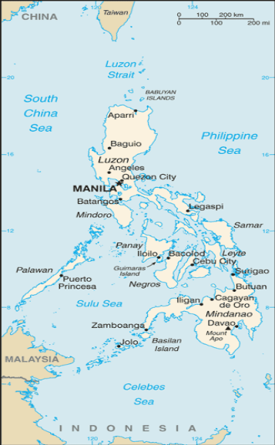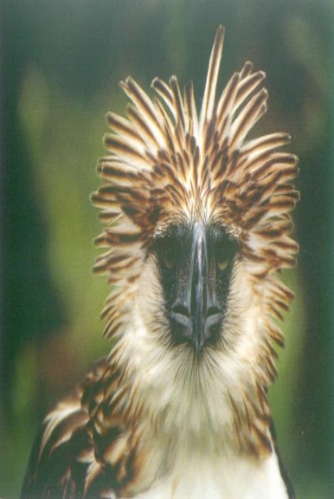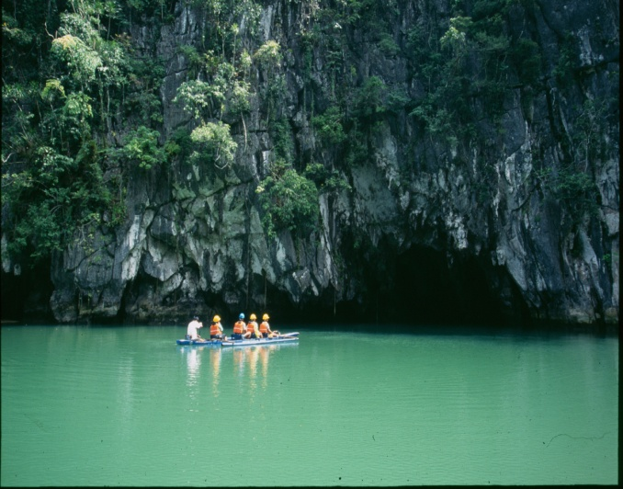
PHILIPPINES
Submitted to the Secretariat of the Convention on Biological Diversity on 31 May 2012

PROTECTED AREA INFORMATION:
PoWPA Focal Point: (Name, contact details)
Dr. Theresa Mundita S. Lim
Director, Protected Areas and Wildlife Bureau (PAWB)
Department of Environment and Natural Resources (DENR)
Ninoy Aquino Parks and Wildlife Center
Quezon City, Philippines
E-Mail: munditalim@yahoo.com/planning@pawb.gov.ph

Lead implementing agency: (Add name of primary government agency)
Protected Areas and Wildlife Bureau
Department of Environment and Natural Resources (DENR)
Philippines

Multi-stakeholder committee: (Add description)
Sub-Committee on Biodiversity of the Committee on Conservation, Management and Resources Development was created in 1994 for the coordination of the various activities on the implementation of the Philippine Agenda 21. The Committee is chaired by the Department of Environment and Natural Resources and co-chaired by the National Economic Development Authority, the national planning agency of the Philippine Government.

The Sub-Committee on Biodiversity is chaired by the Protected Areas and Wildlife Bureau and composed of representatives from relevant national government agencies, non-government organizations and research and academic institutions which have stakes on biodiversity conservation.

Description of protected area system

National Targets and Vision for Protected Areas

The National Vision:

The Philippines adopts Target 11 of Aichi Targets which states that “By 2020, at least 17% of terrestrial and inland water, and 10% of coastal and marine areas, especially areas of particular importance for biodiversity and ecosystem services, are conserved through effectively and equitably managed, ecologically representative and well connected systems of protected areas and other effective area based conservation measures, and integrated into the wider landscapes and seascapes”.

Ttranslating this global target, the Philippines envisions to achieve the following by 2020:

50% of the protected areas established under the National Integrated Protected Areas System are joined by at 3 ecological corridors and that new protected areas cover 80% of threatened species;

50% of protected areas have full time Protected Area Superintendents and core staff implementing effectively their respective management plans through the active and capable direction of their respective protected area management boards;

Policy environment and mechanism for recognition of community conserved areas as other mode of protecting biodiversity are in place and that 10 of these community conserved areas are duly registered in the world database and monitored;

At least 75% of the core funding for protected areas is secured and sustainably managed through a trust fund and that other modes of funding mechanisms are initiated in at least 30 protected areas; and

At least 10 of the priority protected areas are integral component of the national climate adaptation strategy

The marine protected area gap analysis for the Philippines focused on identifying gaps in the representation of species and ecosystems within protected areas and ecological gaps (adequacy of protected area to sustain species populations, ecological functions, and ecosystem services through the range of natural variation). The report collated the extent to which species-specific information has been collected by experts and the degree to which these were used in the identification of Marine Key Biodiversity Areas (MKBA) and the selection of marine protected areas in the Philippines.

The Coral Triangle Initiative (CTI) target agreement of having at least 20 percent of each major marine and coastal habitat type across the region to be placed in strictly protected “no-take, replenishment zones” was adopted by the Philippines. However, for the gap analysis, an interim target to be achieved by 2020 of at least 10 percent of each major marine and coastal habitat type across the region was used while an interim target of 10 percent was adopted in the analysis. If all the identified MKBAs in the Philippines are protected, then, this translates into 19 percent of the Philippine Exclusive Economic Zone (EEZ) under protection or some form of management. As for coral reefs and mangroves, the 10 percent target is estimated to be around 800 and 156.9 square kilometers, respectively. The country fell short in achieving the target with only 84.25 square kilometers of coral reefs and 92.28 square kilometers of mangroves currently placed under some form of protection.

Identification of the MKBAs for the Philippines has facilitated the identification of representation and ecological gaps. The MKBAs that do not overlap with established marine protected areas are considered as representation gaps. The key biodiversity areas that have incomplete overlap with marine protected areas are considered as ecological gaps as it is assumed that the MKBAs cover the critical habitats of the target species. Limitations of the MKBA approach were also discussed in the report. Since only species are categorized as threatened under IUCN, endemics and restricted range are used to trigger MKBAs. Species that are not threatened globally but are important nationally are not covered.

The gap analysis report also demonstrated the dearth in data needed for proper marine protected area establishment and management in the Philippines. Only half of identified marine protected areas have proper documentation. Some have been established outside marine biodiversity conservation and fisheries objectives, and a majority is without the benefit of management plans. The Celebes (Sulawesi) and the Pacific side of the Philippines have been found to have the least information and this has led to only a few MKBAs identified in the region. Despite the large number of marine protected areas found
in the Visayan Seas, there remains a considerable area that needs to be placed under management.

In Philippines 228 KBAS, 106 IBAs and 5 AZEs have been identified. Out of 228 KBAs only 50 are fully protected, 41 are partially protected and 137 have no protection what so ever.

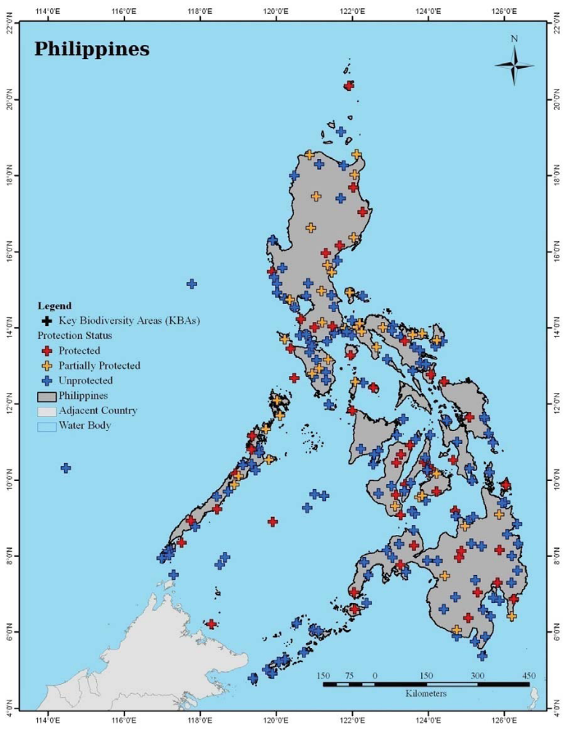

Coverage
As per, WDPA 2010 data 10.97% of Philippine territory and 1.5% of its territorial waters are protected. However, as of 2011, the two hundred and forty (240) protected areas in the Philippines comprised of about 5.44 Million hectares, 1.38 Million hectares of which are marine areas while 4.06 Million hectares are terrestrial protected areas. These are the formal protected areas placed under the National Integrated Protected Areas System (NIPAS) pursuant RA 7586 which is the legal frame for the establishment and management of protected areas in the Philippines. The NIPAS has to be reviewed in terms of representativeness of the biogeographic zones of the country and more specifically the Key Biodiversity Areas of the Philippines.

Description and Background

The Philippines’ 240 protected areas are classified such as follows:

- Natural Parks/National Parks (61)
- Protected Landscapes (35)
- Protected Landscapes and Seascapes (21)
- Protected Seascapes (8)
- Natural Monument/Landmark (4)
- Resource Reserves (2)
- Natural Biotic Areas (4)
- Game Refuge and Bird/Wildlife Sanctuaries (14)
- Watershed Forest Reserves/Areas (56)
- Wilderness Areas (12)
- Mangrove Swamp Forest Reserves (23)

These areas are currently under various stages of establishment under the NIPAS. About twenty (20) of these sites have been identified as priority for management under various completed and on-going conservation projects. These include: Batanes Protected Landscapes and Seascapes, Northern Sierra Madre Natural Park, Peñablanca Protected Landscape and Seascape, Mt. Pulog National Park, Subic-Bataan National Park, Apo Reef Natural Park, Mts. Iglit-Baco National Park, Tubbataha Reefs Natural Park, Mts. Guiting-Guiting Natural Park, El Nido Managed Resource Protected Area, Malampaya Sound Protected Seascape, Puerto Princesa Underground River Natural Park, Mts. Banahaw-San Cristobal Protected Landscape, Mt. Isarog Natural Park, Samar Island Natural Park, Mt. Kanlaon Natural Park, Mt. Kitanglad Range Natural Park, Mt. Malindang Natural Park, Mt. Apo Natural Park, Siargao Island Protected Landscapes and Seascapes, Agusan Marsh Wildlife Sanctuary, and Turtle Islands Wildlife Sanctuary.

These sites were chosen because of high level of species and ecosystem diversity and endemism in some (e. g, Mt. Apo NP, Mt. Kitanglad NP, Northern Sierra Madre NP), unique ecosystems in others (e.g., Northern Sierra Madre NP, Tubbataha Reefs NP, Pto. Princesa Underground River NP, Batanes PLS), and ecolological roles and importance (e. g, Agusan Marsh WS, Samar Island NP, Mt. Pulog NP) or a combination of these values (e.g. NSMNP, SIWS, MKNP).

Governance types

Significantly, the areas included in the NIPAS are managed through shared responsibilities among the representatives of local government units, non-government organizations, other government agencies, indigenous and local communities, academe and research institutions with the Department of Environment and Natural Resources as the lead national agency. Each protected areas under the NIPAS has its own Protected Areas Management Board which serves as the on-site policy making body of the protected area. Guided by the management plan, the Management Board provides the direction for the administration and management of protected areas.

Currently, the Philippines is also pilot testing other governance modes of protected areas to widen strategies for protecting biodiversity and this is done through a 5-Year Project funded by Global Environment Facility through the United Nations Development Programme. The Project aims to expand and diversify protected areas system by developing modes of governance of protected areas apart from the NIPAS while at the same time building the capacities at the individual, systemic and institutional levels for effective management of the protected areas system. The Project is working on co-management of areas rich in biodiversity with the local government units as a model and the other one, is on community conserved areas within the ancestral domain of indigenous communities. The Project will cover nine (9) new conservation areas in ten (10) Key Biodiversity Areas of the Philippines with about 400,000 hectares.

Key threats

The Philippines is one of the 17 mega diverse countries which host about 70-80% of the world’s biodiversity. While the country holds the greatest concentration of native plants and animals, the Philippines is also one of the hottest of biodiversity hotspots in the world.

The global significance of the Philippines as a treasure of throve of biodiversity is highlighted by the following facts:

- Harbors more diverse life forms than any other country on earth on a per hectare basis;
- Has more than 52, 100 described species of which more than one half are found nowhere else on earth; 491 of these area threatened as listed in the IUCN Red List;
- More than 1,130 terrestrial wildlife species have been recorded; half of these are endemic; 157 are threatened; and 128 are threatened endemic species;
- One of the most important centers of amphibians (101 species) and reptiles (258 species) in Southeast Asia; 68 are endemic;
- Home to an astounding 576 species of birds, of which 195 are endemic and 126 are restricted range species, making the Philippines the 4th leading country in the world in bird endemism;
- With 174 indigenous mammalian specie, 111 of which are endemic , it has the greatest concentration of terrestrial mammalian diversity in the world; but it also ranked 8th among the most threatened;
- Rate of discovery of new species in the country is one of the highest in the world, with a total of 36 new species of herpetofauna discovered in the last 10 years

These important biodiversity are threatened by the following:

- Illegal logging which has been a source of habitat degradation and land conversion. Its damage to country’s forest areas and biodiversity is exemplified by a 2.1% annual loss in forest cover during the period 2000-2005 – the second fastest in Southeast Asia, and the 7th fastest in the world.

- Land conversion is also caused by burgeoning population against a limited land and resource base. With an annual population growth rate of 2.04%, poverty, landlessness and absence of secured tenure rights over secondary forest areas are prevalent. Such areas have become attractive to agricultural conversion, thereby permanently changing the forest landscape.

- Overharvesting of resources for trade and domestic use has contributed to habitat degradation and dramatic reductions in species populations. Exploitation of some of by-products of wildlife species also contributes to biodiversity loss.

- Indiscriminate mining operations threaten ecological sustainability. Many of the country’s conservation areas sit on top of huge mineral reserves. Since 2007, some 124 mineral production sharing agreements and around 4 financial or technical assistance agreements have been issued. Thus, there are many biodiversity rich areas with overlapping tenurial instruments, and with conflicting land uses and management objectives.

- Infrastructure development such as major industries, road networks, irrigation, power and energy projects also affect biodiversity and ecological stability.

Barriers for effective implementation
There are 3 main barriers that limit the effectiveness of the Protected Areas System of the Philippines in conserving globally significant, namely:

- Biogeographical representativeness – significant ecological gaps exist. There is a need to consider innovative governance of protected areas to fill these gaps and conserve biodiversity ultimately;

- Limited capacity for protected area management – there are limited resources for demarcation; enforcement is weak; there are deficiencies in management systems and tools; the structure and functioning management boards of protected areas need improvement; and there is no systematized framework for monitoring and evaluation for keeing track of the management effectiveness; and

- Inadequate systems for financial planning, budgetary management and revenue generation – most of the protected areas are financed entirely out of government revenues; systems to capitalize on alternative revenue streams from ecotourism and ecosystem services are not fully developed; trust fund mechanism exists but revenue generation has been limited

The following management gaps are also recognized:

- Social-ecosystem integration and the poverty trap;

- Information and policy gaps; and

- Gaps in good governance, capacity building of the management groups, and resource capacity

The Philippines’ next steps in the short term would be to establish sustainable management mechanisms within each seascape or biogeographic region and implement local actions that will redound to achieving coordinated actions leading to scaled-up synergy at the municipal (or district) level and at the marine key biodiversity areas. The next steps in the medium and long terms would be to achieve significant ecological impacts and attain sustainable benefi ts showing impacts to a reasonable degree, respectively. More specific recommendations include: (1) having an adaptive ecosystem based management embedded with a social reform agenda; (2) facilitating an enabling learning environment and empowered constituency; (3) advocating the institutionalization of good governance; (4) building capacity among stakeholders; and (5) developing ways to leverage funds to sustain management.

Status, priority and timeline for key actions of the Programme of Work on Protected Areas

Status of key actions of the Programme of Work on Protected Areas

Status of key actions of the Programme of Work on Protected Areas | Status
- Progress on assessing gaps in the protected area network (1.1) | 3
- Progress in assessing protected area integration (1.2) | 2
- Progress in establishing transboundary protected areas and regional networks (1.3) | 2
- Progress in developing site-level management plans (1.4) | 3
- Progress in assessing threats and opportunities for restoration (1.5) | 2
- Progress in assessing equitable sharing of benefits (2.1)  - Progress in assessing protected area governance (2.1) | 2  2
- Progress in assessing the participation of indigenous and local communities in key protected area decisions (2.2) | 2
- Progress in assessing the policy environment for establishing and managing protected areas (3.1)  - Progress in assessing the values of protected areas (3.1) | 3  2
- Progress in assessing protected area capacity needs (3.2) | 2
- Progress in assessing the appropriate technology needs (3.3) | 1
- Progress in assessing protected area sustainable finance needs (3.4) | 2
- Progress in conducting public awareness campaigns (3.5) | 2
- Progress in developing best practices and minimum standards (4.1) | 2
- Progress in assessing management effectiveness (4.2) | 3
- Progress in establishing an effective PA monitoring system (4.3) | 2
- Progress in developing a research program for protected areas (4.4) | 2
- Progress in assessing opportunities for marine protection | 3
- Progress in incorporating climate change aspects into protected areas | 2
Status: 0 = no work, 1 = just started, 2 = partially complete, 3 = nearly complete, 4 = complete
(Insert notes as appropriate)

Priority actions and Timeline for fully implementing the Programme of Work on Protected Areas:

Action | Priority | Timeline | Budget  (US D)
Ecological Gap Assessment | 1 | 2013 | 500,000.00
Management Effectiveness Assessment | 2 | 2013 | 2,000,000.00
Sustainable Financing Assessment and Implementation | 1 | 2013 | 1,350,000.00
Capacity Needs Assessment | 2 | 2012 | 150,000.00
Policy Environment Assessment | 2 | 2012 | 500,000.00
PA Integration and Mainstreaming | 2 | 2014 | 600,000.00
PA Valuation | 2 | 2013 | 750,000.00
Climate Change Resilience and Adaptation | 3 | 2015 | 1,000,000

Action Plans for completing priority actions of the Programme of Work on Protected Areas

Action 1: Ecological Gap Assessment
Key steps | Timeline | Responsible parties | Indicative budget
KBAs Review, PA Gap Analysis, and NIPAS Assessment | 2013 | DENR, academic and research institutions,  LGUs, NGOs | 200,000.00
Documentation and Improvement of Database | 2013 | DENR | 50,000.00
Establishment, designation/recognition of new protected areas | 2013-16 | DENR, LGUs, NGOs, OGAs | 50,000.00
Establishment of new NIPAS areas | 2013-2016 | DENR,ACADEME,  NGOs | 200,000.00

Action 2: Management Effectiveness Assessment
Key steps | Timeline | Responsible parties | Indicative budget
NIPAS-wide management effectiveness assessment | 2013 | DENR, OGAs, PAMBs, CSOs | 200,000.00
Individual Protected Area Management Effectiveness Assessment | 2012-2020 | DENR, PAMBs | 350,000.00
PA Indicators and Standards Development | 2013 | DENR, academic and research institutions, PAMBs | 150,000.00
PA Monitoring and Evaluation | 2013 | DENR, CSOs | 100,000.00
National State of Protected Areas Report | 2012 (every 3 years) | DENR | 200,000.00
Management Plan Preparation/Updating | 2013-2020 | DENR, PAMB, SCOs,academic and research institutions | 1,000,000.00

Action 3: Sustainable Financing
Key steps | Timeline | Responsible parties | Indicative budget
PA Fiscal Gap and Financing Analysis | 2012 | DENR, SCOs | 500,000.00
PA Business Plan Preparation | 2013 | DENR, DOT, SCOs, PAMBs | 250,000.00
Innovative funding mechanism Development | 2013 | DENR, OGAs | 250,000.00
Sustainable Financing Plan | 2013 | DENR, DOT, SCOs, PAMBs | 350,000.00

Action 4: Capacity Needs Assessment
Key steps | Timeline | Responsible parties | Indicative budget
Training Needs Assessment | 2012 | DENR | 50,000.00
Capacity Development Programming | 2013 | DENR, academe | 100,000.00
Career development Program for PASus | 2013 | DENR, academe | 50,000.00

Action 5: Policy Environment Assessment
Key steps | Timeline | Responsible parties | Indicative budget
Community Conserved Areas Policy Review and Approval | 2012 | DENR | 200,000.00
NIPAS Act Review and Amendment | 2012 | DENR, House and Senate of the Philippines | 100,000.00
KBA Recognition and integration in development planning and EIA System | 2013 | DENR | 200,000.00

Action 6: PA Integration and Mainstreaming
Key steps | Timeline | Responsible parties | Indicative budget
Integration and Mainstreaming of Management Plans into the comprehensive land use planning of Local Governments | 2014 | DENR, DILG, LGUs | 500,000.00
Development of Monitoring Mechanism | 2013 | DENR, DILG | 100,000.00

Action 7: PA Valuation
Key steps | Timeline | Responsible parties | Indicative budget
PA Cost and Benefits Sharing assessment | 2012 | DENR | 450,000.00
Assessment of values and contribution of protected areas to the national and local economies and to achieving MDGs | 2013 | DENR, NEDA | 300,000.00

Action 8: Climate Change Resilience and Adaptation
Key steps | Timeline | Responsible parties | Indicative budget
Integration of protected areas into wider land and seascapes to showcase mainstreaming of biodiversity with other sectors and ecosystem based approaches to adaptation to climate change adaptation and leading to mitigation through carbon sequestration | 2013 | DENR | 1,000,000.00
Key assessment results
Ecological gap assessment (insert summary findings if available)

Management effectiveness assessment (Insert summary findings if available)

Sustainable finance assessment (Insert summary findings if available)

Capacity needs assessment (Insert summary findings if available)

Policy environment assessment (Insert summary findings if available)

Protected area integration and mainstreaming assessment (Insert summary findings if available)

Protected area valuation assessment (Insert summary findings if available)

Climate change resilience and adaptation assessment (Insert summary findings if available)

(Insert other assessment results if available)

