 |  | CBD
 |  |  | Distr.  GENERAL  UNEP/CBD/EBSA/WS/2015/1/4*  16 March 2016  ORIGINAL: ENGLISH
North-east indian ocean Regional Workshop to Facilitate the Description of Ecologically or Biologically Significant Marine Areas
Colombo, 23-27 March 2015

report of the north-east indian ocean regional workshop to facilitate the description of ecologically or biologically significant marine areas

INTRODUCTION
- At its tenth meeting, the Conference of the Parties to the Convention on Biological Diversity requested the Executive Secretary to work with Parties and other Governments as well as competent organizations and regional initiatives, such as the Food and Agriculture Organization of the United Nations (FAO), regional seas conventions and action plans, and, where appropriate, regional fisheries management organizations (RFMOs) to organize, including the setting of terms of reference, a series of regional workshops, with a primary objective to facilitate the description of ecologically or biologically significant marine areas (EBSAs) through the application of the scientific criteria given in annex I of decision IX/20 as well as other relevant compatible and complementary nationally and intergovernmentally agreed scientific criteria, as well as the scientific guidance on the identification of marine areas beyond national jurisdiction, which meet the scientific criteria in annex I to decision IX/20 (see decision X/29, para. 36).
- In the same decision, the Conference of the Parties requested that the Executive Secretary make available the scientific and technical data, and information and results collated through the workshops described above to participating Parties, other Governments, intergovernmental agencies and the Subsidiary Body on Scientific, Technical and Technological Advice (SBSTTA) for their use according to their competencies.

- Subsequently, at its eleventh and twelfth meetings, the Conference of the Parties reviewed the outcomes, respectively, of the first and second set of regional workshops and requested the Executive Secretary to further collaborate with Parties, other Governments, competent organizations, and global and regional initiatives, such as the United Nations General Assembly Ad Hoc Working Group of the Whole on the Regular Process for Global Reporting and Assessment of the State of the Marine Environment, including Socio-economic Aspects, the International Maritime Organization (IMO), the Food and FAO, regional seas conventions and action plans, and, where appropriate, regional fisheries management organizations, with regard to fisheries management, and also including the participation of indigenous and local communities, to facilitate the description of areas that meet the criteria for EBSAs through the organization of additional regional or subregional workshops for the remaining regions or subregions where Parties wish workshops to be held, and for the further description of the areas already described where new information becomes available (decisions XI/17 and XII/22).
- Pursuant to the above requests and with financial support from the Government of Japan, through the Japan Biodiversity Fund, the Secretariat of the Convention on Biological Diversity convened, in collaboration with the South Asia Cooperative Environment Programme (SACEP) and the Bay of Bengal Large Marine Ecosystem (BOBLME) Project, the North-East Indian Ocean Regional Workshop to Facilitate the Description of Ecologically or Biologically Significant Marine Areas (EBSAs). This workshop was hosted by the Government of Sri Lanka and held in Colombo, from 23 to 27 March 2015. It was held immediately following a training session on the description of EBSAs as well as other relevant areas of the CBD's work on marine and coastal biodiversity, convened by the Secretariat of the Convention on Biological Diversity, in collaboration with the Commonwealth Scientific and Industrial Research Organization (CSIRO) of Australia and the Global Ocean Biodiversity Initiative (GOBI), in Colombo, on 22 March at the same venue.
- Scientific and technical support for this workshop was provided by CSIRO, with funding provided by the BOBLME Project. This support included technical preparation for the workshop, which was made available in the meeting document entitled “Data to Inform the CBD North-East Indian Ocean Regional Workshop to Facilitate the Description of Ecologically or Biologically Significant Marine Areas” (UNEP/CBD/EBSA/WS/2015/1/3).
- The meeting was attended by experts from India, Indonesia, Maldives, Sri Lanka and Thailand as well as the International Maritime Organization, SACEP, BirdLife International, GOBI, International Collective in Support of Fishworkers (ICSF), Manta Trust, WWF-India and CSIRO. Some experts who were nominated by the national focal points from Parties in this region were unable to attend the workshop for logistical reasons, although they had been invited and their travel had been arranged by the Secretariat. Some Parties did not nominate an expert, although they were invited to do so by the Secretariat. The full list of participants is attached as annex I.

ITEM 1. OPENING OF THE meeting
- Mr. N.K.G.K. Nemmawatta, Additional Secretary, Ministry of Mahaweli Development and Environment, Government of Sri Lanka, welcomed participants to the workshop on behalf of the Government of Sri Lanka. Thanking the Secretariat of the Convention on Biological Diversity for collaborating with Sri Lanka as the host country for this workshop, he noted that this was the first time that his Ministry had hosted a CBD workshop. He pointed out that, despite its relatively small size, Sri Lanka’s varied climate and topography create the conditions to host rich biodiversity, distributed across a wide range of ecosystems. Sri Lanka has a wide range of coastal and marine ecosystems, including salt marshes, sand dunes, beaches, mud flats, seagrass beds, lagoons, estuaries and coral reefs. He also pointed out the importance of Sri Lanka’s marine and coastal biodiversity for the country’s burgeoning tourism industry, as well as its fishing industry, which has a high export value and provides an important source of nutrition for the people of Sri Lanka. He noted that conservation efforts in Sri Lanka precede its ratification of the Convention on Biological Diversity in 1994. According to the legend of the four prehistoric tribes from which the Sri Lankan people descended, one tribe was solely dedicated to caring for aquatic and marine ecosystems. They were the custodians of the ocean known as the “Naga” tribe, and their livelihoods were based on fishing, navigation, storing water for irrigation and international trade. He noted that, in more recent times, Sri Lanka has learned from global experiences, and begun to set in place adequate policies, strategies and programmes for marine conservation. He noted that, as part of its efforts to meet the Aichi Biodiversity Targets, specifically Target 6 on sustainable fisheries and Target 11 on protection of at least 10 per cent of marine and coastal areas by 2020, Sri Lanka has identified national actions in its National Biodiversity Strategy and Action Plan (NBSAP) that give high priority to marine and coastal biodiversity. He noted that this regional workshop is an opportunity for Sri Lanka’s scientists and policy-makers to enhance their knowledge and strengthen collaboration. He thanked participants, including the staff of SCBD, SACEP officers and the staff of the Biodiversity Secretariat of his Ministry, for their efforts to make this workshop a success. He wished participants a fruitful workshop and encouraged them to experience the hospitality, culture, and values of the people of Sri Lanka.
8. On behalf of Mr. Braulio Dias, Executive Secretary of the Convention on Biological Diversity, Ms. Jihyun Lee (Environmental Affairs Officer for marine and coastal biodiversity at the CBD Secretariat) delivered the opening statement. In his statement, Mr. Dias welcomed participants and thanked them for participating in this important workshop, the tenth regional workshop to facilitate the description of EBSAs being convened by the CBD Secretariat. He thanked the Government of Sri Lanka for hosting this important workshop and the Government of Japan, through the Japan Biodiversity Fund, for providing financial support, which enabled the convening of this regional workshop and the participation of experts from the region. He also thanked SACEP and the BOBLME Project for their collaboration and support in the convening of this workshop, as well as CSIRO for providing the scientific and technical support for this workshop, which was also facilitated through the support of the BOBLME Project. Mr. Dias noted that the biodiversity of the Indian Ocean contributes centrally to the social and cultural well-being, economic development and environmental health of the people of the region. He also noted that in order to protect and conserve marine biodiversity, we have to know where to take action. He outlined that, through an inclusive and science-driven process, the regional EBSA workshops have sought to describe the “special places” of the oceans that are most important to the healthy functioning of the global marine ecosystem. He reminded participants that, in decision X/29, the Conference of the Parties to the CBD noted that the application of the EBSA criteria is a scientific and technical exercise, that areas found to meet the criteria may require enhanced conservation and management measures, and that this can be achieved through a variety of means, including marine protected areas and impact assessments. He also stressed that Parties emphasized that the identification of EBSAs and the selection of conservation and management measures is a matter for States and competent intergovernmental organizations. In closing, he expressed his wish for a successful workshop that will lead to the development of partnerships and networks among the experts from this region to further enhance knowledge of the “special places” of the Indian Ocean and provide a sound basis for future action.
9. Mr. Weddikkara Kanknamge Rathnadeera, Senior Programme Officer, SACEP, delivered an opening statement on behalf of Mr. Anura Jayatilake, Director General, SACEP. He began by introducing SACEP, whose eight member countries include five maritime countries: Bangladesh, India, Maldives, Pakistan and Sri Lanka. These five countries have formed the South Asian Seas Programme (SASP), a cooperative partnership hosted by SACEP, with the objective of protecting and managing the region’s shared marine waters and associated coastal ecosystems. The South Asian Seas Action Plan, adopted in 1995, provides the basis for SASP, and is one of 18 regional seas programmes under the United Nations Environment Programme (UNEP). He noted that the large, biologically-rich marine ecosystems of the South Asian Seas region provide habitats for a large number of endangered marine species, including whales, dolphins and marine turtles. Yet, the survival of this rich biological wealth is threatened by many factors, including anthropogenic impacts. He outlined the multiple challenges faced by the countries in the region, due to unprecedented biodiversity loss arising from overfishing and other unsustainable fishing practices, as well as the emerging threats of global-scale climate change, which are exacerbated by their high population density, low income, low development indicators, and high dependence upon marine biodiversity-based natural resources for their livelihoods. He noted that SACEP and UNEP have jointly initiated a process to develop a Regional Marine and Coastal Biodiversity Strategy for the South Asian Seas Region, the aim of which is to facilitate the achievement of the Aichi Biodiversity Targets that are most relevant to marine and coastal environments at national and regional levels. The Strategy will be used as a framework for coordination and collaboration among South Asian countries in their efforts towards developing and implementing National Biodiversity Strategies and Action Plans and applying ecosystem approaches for the protection and sustainable use of marine and coastal biodiversity and ecosystem services. He wished participants a fruitful and successful workshop, the outcomes of which will provide input to the finalization and implementation of the region’s Marine and Coastal Biodiversity Strategy.

ITEM 2. ELECTION OF THE CHAIR, ADOPTION OF THE AGENDA AND ORGANIZATION OF WORK
10. After a brief explanation by the CBD Secretariat on procedures for electing the workshop chair, Mr. P.B. Terney Pradeep Kumara (Sri Lanka), as offered by the host Government and seconded by experts from India and Maldives, was elected as the workshop chair.
11. Participants were then invited to consider the provisional agenda (UNEP/CBD/EBSA/WS/2015/1/1) and the proposed organization of work, as contained in annex II to the annotations to the provisional agenda (UNEP/CBD/EBSA/WS/2015/1/1/Add.1), and adopted them without any amendments.
12. The workshop was organized in plenary sessions and break-out group sessions. The chair nominated the following rapporteurs to assist the CBD Secretariat in preparing the draft workshop report, taking into consideration the expertise and experience of the workshop participants and in consultation with the CBD Secretariat:
- Agenda item 3 (Workshop background, scope and output): Ms. Nishanthi Perera (SACEP)
- Agenda item 4 (Review of relevant scientific information): Mr. Nic Bax (CSIRO)
- Agenda item 5 (Description of EBSAs): Break-out session group coordinators
- Agenda item 6 (Identification of gaps): Ms. Nishanthi Perera (SACEP) and Mr. David Johnson (GOBI)

ITEM 3. Workshop background, scope and output
13. Ms. Jihyun Lee (CBD Secretariat) briefed the meeting on the workshop objectives and expected outputs, building on her presentation on the CBD's EBSA process that she delivered during the training day.
14. The workshop participants noted the following points regarding the COP guidance on the regional workshop process as well as the potential contribution of scientific information produced by the workshops:
- The Conference of the Parties to the Convention, at its tenth meeting, noted that the application of the scientific criteria in annex I of decision IX/20 for the identification of ecologically or biologically significant areas presents a tool which Parties and competent intergovernmental organizations may choose to use to progress towards the implementation of ecosystem approaches in relation to areas both within and beyond national jurisdiction, through the identification of areas and features of the marine environment that are important for conservation and sustainable use of marine and coastal biodiversity (paragraph 25, decision X/29);
- The application of the EBSA criteria is a scientific and technical exercise, and the identification of EBSAs and the selection of conservation and management measures is a matter for States and competent intergovernmental organizations, in accordance with international law, including the United Nations Convention on the Law of the Sea (paragraph 26, decision X/29);
- The EBSA description process is open-ended, and additional regional or subregional workshops may be organized when there is sufficient advancement in the availability of scientific information (paragraphs 9 and 12, decision XI/17);
- Each workshop is tasked to describe areas meeting the scientific criteria for EBSAs or other relevant criteria based on best available scientific information. As such, experts at the workshops are not expected to discuss any management issues, including threats to the areas;
- The EBSA description process facilitates scientific collaboration and information-sharing at the national, subregional and regional levels;
- Areas falling within the national jurisdiction of States should only be proposed by or with the knowledge or consent of the Party or Parties concerned in line with paragraph 5, decision XII/22.
- Differences with regard to the respective management implications of the CBD's work on EBSAs, the FAO's work on vulnerable marine ecosystems (VMEs) and the IMO's work on particularly sensitive sea areas (PSSAs), as guided by their own governing bodies, in spite of their apparent similarity, and current efforts being made by the CBD Secretariat, FAO and IMO to share scientific information and expertise to create synergies among these international processes; and
- That the summary reports on the description of areas meeting the scientific criteria for ecologically or biologically significant marine areas from previous EBSA regional workshops considered by COP 11 and 12 were submitted to the United Nations General Assembly and particularly its Ad Hoc Open-ended Informal Working Group to Study Issues Relating to the Conservation and Sustainable Use of Marine Biological Diversity Beyond Areas of National Jurisdiction and also its Ad Hoc Working Group of the Whole on the Regular Process for Global Reporting and Assessment of the State of the Marine Environment, including Socio-economic Aspects, as well as to Parties, other Governments, relevant international organizations and the United Nations specialized agencies, pursuant to decisions X/29, XI/17 and XII/22.
15. The workshop also noted the following regarding the application of the EBSA criteria:
- The EBSA criteria can be applied on all scales from global to local. Once a scale has been selected, however, the criteria are intended to be used to evaluate areas and ecosystem features in a context relative to other areas and features at the given scale;
- There are no thresholds that must be met and judgements are comparative to adjacent areas, and the current ranking system (e.g., high, medium, low, no information) for assessing the areas meeting each of the EBSA criteria is devised to facilitate better understanding of available scientific information in describing the areas with regard to the extent to which they meet different criteria. The current ranking system, however, does not intend to compare the importance of each criterion;
- Relative assessments are necessarily scale dependent; relative significance of areas has generally been viewed from regional or large subregional scales;
- Areas may meet multiple criteria, and that is important, but meeting just one criteria strongly also is important;
- Areas described to meet the EBSA criteria have ranged from relatively small sites to very extensive oceanographic features; and
- Areas described to meet the EBSA criteria can be overlapped or nested.
16. Ms. Nishanthi Perera (SACEP) delivered a presentation on the South Asian Marine Biodiversity Strategy and its relevance for the description of EBSAs in the North-East Indian Ocean.
17. The workshop noted the following regional programme activities and initiatives being undertaken by SACEP and the BOBLME Project that are relevant to the CBD's work on EBSAs, as presented during presentations delivered under this agenda item and during the training day:
- SACEP’s work for the development and future implementation of the Marine and Coastal Biodiversity Strategy for South Asia (MCBS), which serves as a framework for coordination and collaboration among countries and relevant agencies in the implementation of National Biodiversity Strategic Action Plans;
- Work under the BOBLME Project on the development of a comprehensive ecological characterization that provides a hierarchical and systematic regionalization of biophysical systems for the BOBLME region, as well as descriptions of system and subsystem structure and systems.
18. Mr. Brian Smith (GOBI) gave a presentation on migratory species in the North-East Indian Ocean and means by which the available data on these species can inform the description of EBSAs in the region.
19. Mr. Piers Dunstan (CSIRO) provided a regional overview of biogeographic information on open-ocean and deep-sea habitats in the region and discussed potential options for the geographic scope of the workshop.
20. Summaries of the above presentations are provided in annex II.
21. The workshop participants noted the work on the ecosystem characterization undertaken for the BOBLME Project (See the map of the provincial bioregions in the Bay of Bengal Large Marine Ecosystem developed by this ecosystem characterization in annex III). In particular, the workshop noted the following:
- This was the first ecosystem characterization of its kind in the region;
- The ecological characterization of 29 subsystems, and their associated physical drivers and ecological features, provides a useful framework for integrating established knowledge with the latest expert knowledge and opinion for describing the ecological systems of the BOBLME region, its species groups, habitats and their connectivity; and
- Although very robust, there are still gaps in the information compiled for the ecosystem characterization that require additional research, data compilation and related capacity-building.
22. Workshop participants noted the information describing the Bay of Bengal Large Marine Ecosystem as extracted from the report of the workshop on the ecosystem characterisation of the Bay of Bengal (see annex IV for excerpts from the report).
23. Workshop participants highlighted that conservation of areas meeting the EBSA criteria in this region needs to take into account sustainable fisheries and local livelihoods.
24. The geographic scope of the workshop was defined based on the above-mentioned ecosystem characterization of the Bay of Bengal, and is illustrated in the map in annex V.
25. Workshop participants noted that additional scientific information in the waters surrounding Maldives, Sri Lanka and Indonesia was available for the workshop over and above that which was available for the Southern Indian Ocean Regional Workshop to Facilitate the Description of EBSAs, held in Flic en Flac, Mauritius, from 31 July to 3 August 2012 which was attended by experts from these three countries. The workshop therefore agreed to overlap the workshop scope with that of the Southern Indian Ocean workshop, and extended the southern limit of the workshop scope to 10 degrees south, while the northern limit of the Southern Indian Ocean workshop was defined at 10 degrees north.

ITEM 4. Review of relevant scientific data/information/maps compiled and submitted for the workshop
26. For the consideration of this item, the workshop had before it two information notes by the Executive Secretary: document UNEP/CBD/EBSA/WS/2015/1/3 containing data to inform the CBD North-East Indian Ocean Regional Workshop to Facilitate the Description of Ecologically or Biologically significant Marine Areas, which was prepared in support of the workshop deliberations, and document UNEP/CBD/EBSA/WS/2015/1/2, containing a compilation of the submissions of scientific information to describe ecologically or biologically significant marine areas in the North-East Indian Ocean, submitted by Parties, other Governments and relevant organizations in response to the Secretariat’s notification (2014-130) (dated 11 November 2014). The documents/references submitted prior to the workshop were made available for the information of workshop participants on the meeting website (http://www.cbd.int/doc/?meeting=EBSAWS-2015-01).
27. For this agenda item and the subsequent agenda item, participants were provided with a series of presentations during the training day, including presentations on the scientific aspects of the EBSA criteria, the description of areas meeting the EBSA criteria, and potential use of the EBSA information to support implementation of the ecosystem approach. Participants also took part in a group exercise focused on the use of scientific information to describe areas meeting the EBSA criteria, with a focus on examples in the North-East Indian Ocean region.
28. Mr. Piers Dunstan provided a presentation on “Review of relevant scientific data/information/maps compiled to facilitate the description of EBSAs in the North-East Indian Ocean,” based on document UNEP/CBD/EBSA/WS/2015/1/3. A summary of his presentation is provided in annex II.
29. Site-based submissions of scientific information on areas meeting the EBSA criteria were presented by experts from Indonesia, Maldives, Sri Lanka, Thailand, Global Ocean Biodiversity Initiative, and the International Collective in Support of Fishworkers. The information provided in these presentations was considered by the break-out groups in the description of areas meeting the EBSA criteria. Each presentation describing areas meeting the EBSA criteria provided an overview of the areas considered, the assessment of the area against the EBSA criteria, scientific data/information available and other relevant information.
30. Geographic information system (GIS) data compiled for this workshop was available to the workshop participants, in hard-copy maps as well as in GIS database with open-source GIS software, for their use and analysis.

ITEM 5. description of areas meeting THE ebsa criteria through THE application of the scientific criteria FOR EBSAs and other relevant compatible and complementary nationally and intergovernmentally agreed scientific criteria
31. Building upon the theme presentations and site-based presentations provided under the previous agenda items and noting the work on ecosystem characterization undertaken for this region, the workshop participants exchanged their views on possible ways of organizing their work on assessing the scientific information compiled and submitted for the consideration of the workshop. The meeting noted that the BOBLME ecosystem characterization provided the workshop with a strong basis for understanding the biogeography of the region as a whole, thus supporting a systematic approach to describing EBSAs in a way that was not possible at many of the previous regional EBSA workshops.
32. For effective review of available scientific information and assessment of potential areas meeting the EBSA criteria, the workshop participants were then split into break-out groups, building on the information discussed during the presentations of the site-based submissions under the previous agenda item.
33. Participants were assisted by the technical support team. who made hard/electronic copies of the maps available for the deliberation of the break-out group discussions, provided data in GIS format and supported the break-out groups in their analysis and interpretation of the data as well as mapping of potential areas meeting the EBSA criteria.
34. During the breakout group discussions, and especially in the delineation of the boundaries of the areas meeting the EBSA criteria participants kept track of opportunities to extend or merge areas and to identify areas that had yet to be considered.
35. The breakout groups reported on their discussions during a plenary session. At the plenary session, workshop participants reviewed the description of areas meeting the EBSA criteria, as proposed by the break-out groups, including the draft descriptions, using templates provided by the CBD Secretariat, and considered them for inclusion in the final list of areas meeting EBSA criteria.
36. The workshop participants agreed on descriptions of 10 areas meeting the EBSA criteria. These areas are listed in annex VI and described in its appendix. The map of described areas is contained in annex V.

ITEM 6. Identification of gaps and needs for further elaboration in describing AREAS MEETING the ebsa CRITERIA, including the need for the development of scientific capacity and future scientific collaboration
37. Building on the workshop deliberation, the workshop participants were invited to identify, during the break-out group and plenary discussions, gaps and needs for further elaboration in describing areas meeting the EBSA criteria, including the need to develop scientific capacity and scientific collaboration. The results of the break-out group and plenary discussions on this topic are compiled in annex VII.
38. The workshop participants also took note of some areas that have the potential to meet the EBSA criteria, but could not be described at this workshop due to data paucity and lack of analysis or due to the absence of experts from relevant countries. These areas are presented in annex VIII as potential areas for future consideration by either national or regional EBSA processes.

ITEM 7. OTHER MATTERS
39. Under this agenda item, participants exchanged some views and suggestions regarding the work within CBD on facilitating the description of EBSAs through regional workshops. In response, the Secretariat informed the participants that the Secretariat will be compiling suggestions on further enhancing scientific methodologies and approaches used in the current EBSA process, pursuant to COP decision XII/22, as follows:
- Decision XII/22 (paragraph 10): "Also requests the Executive Secretary, building upon the existing scientific guidance and drawing upon the lessons learned from the series of regional workshops to facilitate the description of areas meeting the EBSA criteria and views gathered from Parties and other Governments, to develop practical options to further enhance scientific methodologies and approaches on the description of areas meeting the EBSA criteria, ensuring that the best available scientific and technical information and traditional knowledge of various users of marine resources, including fishers, are used and that the products are scientifically sound and up-to-date, and to report on progress to a meeting of the Subsidiary Body on Scientific, Technical and Technological Advice prior to the thirteenth meeting of the Conference of the Parties"
40. Queries were made also regarding the possible funding opportunities to enhance conservation and management measures in areas meeting the EBSA criteria, once the workshop results are considered by SBSTTA and COP. Some examples from other regions were shared, in this respect, and the Secretariat informed the participants of paragraph 38 of COP decision X/29, as follows:
- Decision X/29, paragraph 38: "Invites the Global Environment Facility and other donors and funding agencies, as appropriate, to extend support for capacity-building to developing countries, in particular the least developed countries and small island developing States, as well as countries with economies in transition, in order to identify ecologically or biologically significant and/or vulnerable marine areas in need of protection, as called for in paragraph 18 of decision IX/20 and develop appropriate protection measures in these areas, within the context of paragraphs 36 and 37"
41. The Secretariat also informed the participants of its efforts to provide capacity-building opportunities through the framework of the Sustainable Ocean Initiative, which addresses to address priority issues identified for respective regions concerning the achievement of the Aichi Biodiversity Targets in marine and coastal areas, pursuant to decisions X/29, XI/17, XI/18, XII/22, and XII/23. The workshop participants, in particular, noted paragraph 19 of decision XII/23:
- Decision XII/23, paragraph 19: "Requests the Executive Secretary to facilitate, through technical training and the information-sharing mechanism on ecologically or biologically significant marine areas, the use of scientific information compiled for the description of areas meeting the scientific criteria for ecologically or biologically significant marine areas to support efforts, at the regional or national level, on the use of marine spatial planning by Parties and competent intergovernmental organizations."
42. The workshop participants requested the Secretariat to prepare information materials on the EBSA process, including a frequently asked questions (FAQ) brochure and a diagram/infographic, and to make further efforts to enhance awareness about the areas that have been described as meeting the EBSA criteria in a simple, scientific manner.

ITEM 8. ADOPTION OF THE REPORT
43. Participants considered and adopted the workshop report on the basis of a draft report prepared and presented by the Chair with some changes.
44. Participants agreed that any additional scientific information and scientific references would be provided to the CBD Secretariat by the workshop participants within two weeks of the closing of the workshop in order to further refine the description of areas meeting the EBSA criteria contained in annex VI and its appendix.

ITEM 9. CLOSURE OF THE MEETING
45. In closing the workshop, Mr. P.B. Terney Pradeep Kumara congratulated the participants on their hard work and excellent collaboration throughout the week. He commended the excellent scientific and technical support by the technical support team, and the efficient and effective servicing by the CBD Secretariat members as well as the contributions of all the rapporteurs to the report preparation. He also acknowledged, with appreciation, the various organizations that provided access to data and/or supported the participation of experts in the workshop. Workshop co-chairs and participants expressed their sincere thanks to the Government of Sri Lanka for its warm hospitality and excellent logistical support, which had enabled the workshop discussions to be very fruitful.
46. The workshop was closed at 1:10 p.m. on Friday, 27 March 2015.
Annex I

LIST OF participants

CBD Parties

India
1. Mr. Jaivardhan Ramanlal Bhatt
Advisor
Ministry of Environment, Forests and Climate Change
Indira Paryavaran Bhavan, Jor Bagh Road
New Delhi 110003, India
Tel.: +91 11 24362543
Email: jrbhatt@nic.in
Indonesia
2. Mr. Augy Syahailatua
Researcher
Research Center for Oceanography/Deep Sea
Indonesia Institute of Sciences
Jakarta, Indonesia
Email: augy001@lipi.go.id; augy.lipi@gmail.com
Maldives
3. Mr. Musthafa Mohamed
Director
Environmental Protection Agency
Ministry of Environment and Energy
Ameenee Magu, Maafannu 20392
Malé, Maldives
Email:
mohamed.musthafa@epa.gov.mv

Sri Lanka
4. Mr. Haputhantrige Sujeewa sisira Kumara Haputhantri
Principle Scientist
Marine Biological Resource Division
National Aquatic Resources Research and Development Agency
Colombo 15, Sri Lanka
Email: sisirahaputhantri@yahoo.com
5. Mr. P.B. Terney Pradeep Kumara
General Manager
Marine Environment Protection Authority
University of Ruhuna, Sri Lanka
Matara 81 000, Sri Lanka
Email: terneypradeep@yahoo.co.uk, terney@fish.ruh.ac.lk
Thailand
6. Mr. Kongkiat Kittiwattanawong
Marine Biologist
Marine Endangered Species Unit
Phuket Marine Biological Center
51 Sakdidet Road, Tambon Vichit Muang District
Phuket, Thailand
Email: kkongkiat@gmail.com

Local Observer
7. Mr. Hewawasam Bentotage Jayasiri
Principal Scientist
National Institute of Oeanography and Marine Science
Colombo, Sri Lanka
Email: hbjayasiri@gmail.com

Organizations

International Maritime Organization (IMO)
8. Ms. Annukka Pekkarinen
International Maritime Organization/ World Maritime University
Malmo, Sweden
Email: ap@wmu.se, ncharala@imo.org

South Asia Co-operative Environment Programme
9. Mr. Weddikkara Kankanamge Rathnadeera
Senior Programme Officer
South Asia Co-operative Environment Programme
#64/4, Maya Avenue
Colombo 6, Sri Lanka
Tel.: +94 11 250 4708; 259 6443
Email: rathnadeera.wk@sacep.org
10. Ms. Nishanthi Perera
Programme Officer
South Asia Co-operative Environment Programme
#64/4, Maya Avenue
Colombo 6, Sri Lanka
Tel.: +94 11 536 2851
Email: Nishanthi.perera@sacep.org

BirdLife International
11. Mr. Deepak Apte
Chief Operating Officer
Bombay Natural History Society
Hornbill House, Opp.Lion Gate Shaheed Bhagat Singh Road
Mumbai 400 001,
Maharashtra, India
Tel.: +91-22-2282 1811
Fax: -22837546
Email: da.apte@bnhs.org; spiderconch@gmail.com

Global Ocean Biodiversity Initiative Secretariat (GOBI)

12. Mr. David Johnson
Global Coordinator, GOBI
Seascape Consultants Ltd.
Belbins Valley Belbins
Romsey, Hampshire
United Kingdom of Great Britain and Northern Ireland
Tel.: +44 0 1794 368245
Email:
david.johnson@seascapeconsultants.co.uk
13. Ms. Asha de Vos
Founder
The Sri Lankan Blue Whale Project
Postdoctoral Scholar
The University of California Santa Cruz
Colombo, Sri Lanka
Email: asha.devos@lincoln.oxon.org, whalesrilanka@gmail.com
14. Mr. Brian D. Smith
Director
Asian Freshwater and Coastal Cetacean Program
Wildlife Conservation Society
2300 Southern Blvd
Bronx, NY 10460
United States of America
Email: bsmith@wcs.org

International Collective in Support of Fishworkers (ICSF)
15. Ms. Ravadee Prasertcharoensuk
Executive Director, Sustainable Development Foundation
International Collective in Support of Fishworkers
86, Soi Ladpro 110 (Sonthiwattana 2) Ladprao Road, Wangthongland
Bangkok, Thailand
Email:
ravadee.prasertcharoensuk@gmail.com

16. Mr. Vriddagiri Vivekanandan
International Collective in Support of Fishworkers
27 College Road
Chennai 600 006, India
Email: vivek@siffs.org, icsf@icsf.net
Manta Trust
17. Mr. Daniel Fernando
Associate Director
Manta Trust
Colombo, Sri Lanka
Email: daniel@mantatrust.org, info@mantatrust.org
WWF India
18. Mr. Vinod Malayilethu
Senior Coordinator, Marine Conservation Programme
WWF India
WWF India Marine Conservation Programme 28/799,
Prasanthi Kadavanthra,
Kochi 682020, India
Tel.: (0484) 6562760
Email: vinodm@wwfindia.net

Technical Support Team

Commonwealth Scientific and Industrial Research Organisation (CSIRO)
19. Mr. Nicholas John Bax
Director
NERP Marine Biodiversity Hub
Commonwealth Scientific & Industrial Research Organization
CSIRO Marine Laboratories, GPO Box 1538,
Hobart 7001, Australia
Tel.: 61 3 62325341
Email: nic.bax@csiro.au
Web: www.csiro.au

20. Mr. Piers Dunstan
Research Scientist
Marine and Atmospheric Research
Commonwealth Scientific and Industrial Research Organisation
Castray Esplanade
Hobart, Australia
Email: piers.dunstan@csiro.au
21. Mr. Mike Fuller
Spatial Analyst
Marine and Atmospheric Research
Commonwealth Scientific and Industrial Research Organisation
Castray Esplanade
Hobart, Australia
Email: michael.fuller@csiro.au

Secretariat of the Convention on Biological Diversity

Secretariat of the Convention on Biological Diversity
22. Ms. Jihyun Lee
Environmental Affairs Officer
Marine and Coastal Biodiversity
Science, Assessment and Monitoring
Secretariat of the Convention on Biological Diversity
413, Saint-Jacques Street W. Suite 800
Montreal, H2Y 1N9, Quebec
Canada
Email: jihyun.lee@cbd.int

23. Mr. Joseph Appiott
Associate Programme Officer
Marine and Coastal Biodiversity
Science, Assessment and Monitoring
Secretariat of the Convention on Biological Diversity
413, Saint-Jacques Street W. Suite 800
Montreal, H2Y 1N9, Quebec
Canada
Email: joseph.appiott@cbd.int

24. Ms. Jacqueline Grekin
Programme Assistant
Science, Assessment and Monitoring
Secretariat of the Convention on Biological Diversity
413, Saint-Jacques Street W. Suite 800
Montreal, H2Y 1N9, Quebec
Canada
Email: jacqueline.grekin@cbd.int

Annex II

summary of theme presentations
Agenda item 3
South Asia’s Marine Biodiversity Strategy and its Relevance to EBSAs (by Nishanthi Perera, SACEP)
Ms. Perera explained that the South Asian Seas Region includes the marine and coastal environment of Bangladesh, India, Maldives, Pakistan and Sri Lanka, which is bordered by two large marine ecosystems: the Bay of Bengal and the Arabian Sea. She stressed that marine ecosystems are truly transboundary, and thus effective management and conservation of these resources requires collaboration between these countries.
She noted that the aim of the Marine and Coastal Biodiversity Strategy for South Asia (MCBS) is to enhance national and regional interventions for achieving the Aichi Biodiversity Targets, particularly those addressing marine and coastal issues, serving as a framework for coordination and collaboration among countries and relevant agencies in the implementation of National Biodiversity Strategies and Action Plans. It covers six main themes: Ensuring Ecosystem Services and Well-being (Aichi Biodiversity Targets 5, 10, 14, and 15); Prevention of Species Extinction (Aichi Target 12); Control of Alien Invasive Species (Aichi Target 9); Sustainable Fisheries and Aquaculture (Aichi Target 6 and 7); Prevention of Marine Pollution (Aichi Target 8); and Effective and Equitable Governance of Marine and Coastal Protected Areas (Aichi Target 11).
The development of the MCBS was approved by the South Asian Sea’s (SAS) Inter-ministerial Meeting in 2013, and the First Order Draft, which was prepared based on thematic desk review studies conducted during 2013/2014 and a regional technical workshop held in Colombo in July 2014, provides initial identification of Regional Targets and Action Plans for the SAS region. An additional regional workshop will further improve the strategy, before the final version is presented for endorsement at the next Inter-ministerial Meeting of SASP. Therefore, this EBSA workshop provides an opportunity to further improve the present draft.
Migratory Species in the North-East Indian Ocean (by Mr. Brian D. Smith, Global Ocean Biodiversity Initiative)
Mr. Smith explained that mobile species such as seabirds, marine mammals, sea turtles, sharks, rays, tuna and billfishes are long-lived and slow to reproduce, making them particularly vulnerable to anthropogenic pressures and environmental change. They are wide-ranging, using multiple habitats year-round, seasonally and periodically; exhibit a range of critical behaviours (e.g., breeding, raising young, foraging); and often undergo long seasonal migrations using specific routes, corridors and bottlenecks. To identify the location of critical areas and coherent networks of habitat needed to ensure their long-term survival, criteria for the identification of Important Bird and Biodiversity Areas (IBAs) and Important Marine Mammal Area (IMMAs) have been developed and are being applied globally.
He discussed BirdLife’s IBA programme, which has been used to set conservation priorities for over 30 years, has informed the description of EBSAs. To date over 13,000 IBAs have been identified globally, including more than 3,000 marine sites (www.birdlife.org/datazone/marine). For seabirds, IBAs are identified for congregations (areas holding >1% global population), threatened species (IUCN Red Listed), and biome- and range-restricted species. IMMAs are currently being identified by the IUCN Joint Species Survival Commission (SSC)/World Commission on Protected Areas (WCPA) Marine Mammal Protected Area Taskforce (MMPTF), and they will assist in the collation, categorisation and awareness-building of evidence relating to discrete habitat of specific importance to one or more marine mammal species. The IMMA layer of sites will also assist in the use of management tools, such as marine protected areas (MPAs) and marine spatial planning.
IBA and IMMA criteria have significant overlap and congruence with the EBSA criteria, particularly in relation to sites that are particularly important for the life history of threatened species, and they can be used to inform the description of areas meeting the EBSA criteria. When considering the best available evidence on wide-ranging species in areas that may meet the EBSA criteria, IBA and IMMA sites, practitioners should consider a suite of datasets and techniques, including systematic surveys, tracking data and statistical model predictions. Seabird data have been compiled through generous contributions from seabird scientists and submitted for consideration at this EBSA workshop (www.seabirdtracking.org). Species predictive distribution models based on Relative Environmental Suitability (RES) for a range of marine mammals are available from the AquaMaps project (www.aquamaps.org) with additional empirical data on species distribution and densities accessible in submitted references.
Regional Overview of Biogeographic Information on Open-ocean Water and Deep-sea Habitats and Geographic Scope of the Workshop (by Mr. Piers Dunstan, CSIRO)
Mr. Dunstan presented the work to develop an ecosystem characterisation for the Bay of Bengal. The process resulted in the identification of 29 subsystems, referred to as “provinces”. These are used to describe a range of ecological systems within the Bay of Bengal Large Marine Ecosystem (BOBLME) region, and include shallow shelf, slope, deep abyssal and offshore ridge systems. Each is defined by a unique range of physical drivers, ecological features and their place within a broader hierarchical, regional framework to ensure representation and regional context. He suggested using the ecosystem characterisation to define the geographic scope of the workshop, to ensure that it encompasses all the provinces present in the Bay of Bengal. He suggested that the workshop could attempt to describe an area meeting the EBSA criteria within each of the provinces identified.
Agenda item 4
Review of Scientific Information Compiled for the Workshop (by Mr. Piers Dunstan, CSIRO)
Mr. Dunstan presented the data collated for the workshop and described how this information can be used in applying the EBSA criteria in the region. He presented a summary of each of the EBSA criterion and the types of data that could be used to address it. He also presented a summary of the different types of features that can be described as meeting the EBSA criteria, including spatially stable features that are spatially resolved and known (e.g., a single seamount), features that are known and grouped (e.g., a seamount chain), and features that are known but are not spatially defined. He also discussed the description of features that are not spatially stable (e.g., oceanic fronts). Mr. Dunstan then presented a brief summary of the data collated for this workshop, as contained in document UNEP/CBD/EBSA/WS/2015/1/3 (http://www.cbd.int/doc/meetings/mar/ebsaws-2015-01/official/ebsaws-2015-01-03-en.pdf), to support the work of the participants in applying the EBSA criteria in the region.

Annex III

MAP OF PROVINCIAL BIOREGIONS IN THE BAY OF BENGAL LARGE MARINE ECOSYSTEM
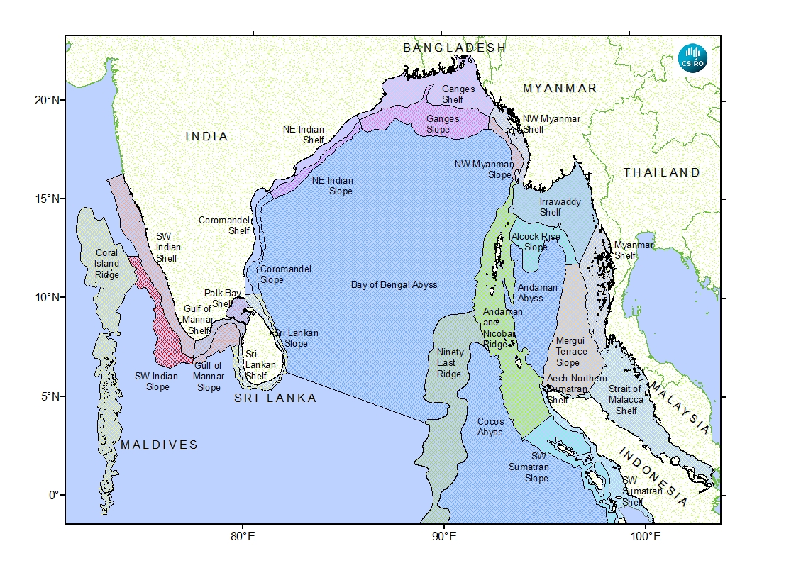
Annex IV

Description of the Bay of Bengal large marine ecosystem (LME) as extracted from a workshop report ENTITLED, "An Ecosystem Characterisation of the Bay of Bengal"

The workshop participants noted the ecosystem characteristics of the Bay of Bengal, as provided in Brewer et al. (2015). The following are the excerpts from the report:

"The Bay of Bengal Large Marine Ecosystem (BOBLME) sits within the Indian Ocean Basin. This basin is geographically bound by landmasses to the north and east, and to the west by the countries and islands of South‐East Asia and the Australian west coast. The southern boundary is oceanographic and driven by global circulation. However, these boundaries are fluid due to their seasonal and longer term cyclical patterns. The resulting circulation is complex due to the seasonal reversal of the monsoons. The major large-scale (Indian Ocean) ecosystem drivers include ocean circulation, climate, water masses, tectonics, continental drift and basin evolution.
At the finer scale of the Bay of Bengal most of these broad‐scale drivers remain important. However, additional more local drivers such as bathymetry, geomorphology, terrestrial and riverine input, and productivity become critical. These drivers create a wide range of unique biophysical conditions that support different and unique ecological communities.
The BOBLME region is a highly productive marine ecological system containing a wide range of highly valuable, species‐rich and diverse ecological systems, and subject to substantial inputs and inflows from eight highly populated countries that share the region. It is one of the most unique and at‐risk marine ecological systems in the world when evaluated based on the confluence of these features.
The ecological characterisation process resulted in the identification of 29 subsystems, referred to as ‘provinces’. These are used to describe the range of ecological systems within the BOBLME region, and include shallow shelf, slope, deep abyssal and offshore ridge systems. Each is defined by a unique range of physical drivers and ecological features and their place within a broader hierarchical, regional framework to ensure representation and regional context. The major physical drivers included depth, major geomorphic characteristics, terrestrial and river input, and water mass characteristics. The presence of major ecological communities (e.g. mangrove forests, coral reefs, seagrass beds, canyon systems) were also used to define system boundaries, especially in some coastal shelf provinces. Provinces vary from globally significant deltaic coastal systems with major freshwater influences, to highly oligotrophic waters dominated by coral reefs, open ocean pelagic communities and large areas of deep abyssal plains.
Fisheries are an important source of protein and livelihood for coastal communities in the BOBLME
region. Catches from the region were the fifth largest among the FAO fishery statistical regions in
2006. The total catch from the east Indian Ocean FAO region (BOBLME comprising ~66% of this catch) was over seven million tonnes in 2011 (FAO 2014). This catch was made up of mostly small‐ and medium‐sized pelagic fishes such as sardines, mackerels, hilsa shad, sharks, tunas and other scombrids and demersal fishes such as perches, sciaenids, ribbonfish and cephalopods. These species groups are caught by all countries in the BOBLME region and are taken in both coastal and oceanic waters. The other important components of the reported FAO catch include miscellaneous coastal fishes and crustaceans. Most coastal species are taken by demersal trawl and gillnet fisheries adjacent to the estuaries of the major rivers in the north and eastern parts of the BOBLME region. There is also a very large proportion of the reported FAO catch that is unidentified (>45%), suggesting most groups are under‐reported in the FAO regional catch statistics. It is clear that small pelagic fishes, such as Indian mackerel (Rastrelliger kanagurta) and hilsa (Tenualosa toli), form the major component of the overall fisheries catch. Medium‐sized pelagic species such as the smaller tunas are the second‐most important group, followed by medium‐sized demersal species such as sciaenids and grunters.
The Bay of Bengal is home to a diverse range of marine animals, including groups of species that are endangered or vulnerable to human impacts. Included among these threatened species are cetaceans, seabirds, turtles, sea snakes, fish, dugongs, gastropods, sea cucumbers, sponges, sea fans
and corals. At least 20 cetaceans have been sighted in the Bay of Bengal. Cetaceans occur throughout the BOBLME region. The larger species, including whales, mostly occur in the south. These species are mostly found in the pelagic zone in deeper shelf and slope waters. Smaller species of cetacean, such as dolphins, occur in most coastal waters of the Bay of Bengal. In these regions, they interact with fisheries and a significant number are caught in gillnet fisheries (Smith and Than Tun 2008; Mansur et al. 2012). Dugongs also occur within the Bay of Bengal, being found in shallow water around seagrass habitats in the Andaman Sea and Palk Bay in south‐eastern India.
The teleost fish fauna of the BOBLME region is diverse. It includes coral reef, mangrove and seagrass dependent communities as well as large pelagic and demersal fishes of economic interest. Among the threatened fishes, syngnathids are the most widely known. A range of endangered seahorses (Syngnathidae) occur in the Bay of Bengal and many of these have been recorded to be harvested by both targeted fisheries and as bycatch from prawn trawl fisheries in India (Salin et al. 2005).
Elasmobranchs are widespread in the Bay of Bengal. The list includes the rare endangered megamouth shark (Megachasma pelagios) recorded from northern Sumatra (White et al. 2004). Many of the larger species, such as whale shark, may also be hunted in parts of the BOBLME region (Riley et al. 2010). Lucifora et al. (2011) undertook a global analysis of shark diversity. They found that south‐western BOBLME contained a high diversity of shark species with populations that were mostly targeted for shark‐fin collection. Within the BOBLME region, shark species endemism was highest in the Nicobar and Andaman Islands. Shark functional diversity was higher in coastal areas throughout the region.
At least five species of sea turtle have been recorded nesting in the BOBLME region. All species are cosmopolitan and occur in most of the major oceans of the world. Turtles have been recorded nesting on island and coastal beaches within the BOBLME region of all member countries except Indonesia (OBIS 2014). Most turtle nesting has been recorded within the jurisdiction of India, Maldives and Sri Lanka. The largest numbers of records pertain to the olive ridley turtle Lepidochelys olivacea that can nest in large aggregations on the east coast of India (Shanker et al. 2004).
Little is known about sea snake diversity in the BOBLME region, but at least 10 species occur (Bohm et al. 2013). This is about 40% of the global diversity of sea snakes. Many of these species are mostly found around coral reefs and seagrass habitats along the eastern side of the region (Figure 5‐10). Other more abundant species occur in the open sediments of the northern and western Bay of Bengal and are often caught in demersal trawl fisheries of coastal waters in the region (Bohm et al.
2013).
There is limited information on the seabirds of the BOBLME region, but Mondreti et al. (2013) found
that seven species of tern and noddy breed there. Almost all records are from the Nicobar and Andaman Islands (Mondreti et al. 2013). All species are either widespread tropical seabirds or seasonal migrant or vagrants from the Northern Hemisphere. Jouanin’s petrel is the only species of seabird recorded in the BOBLME that is potentially threatened.
Mangroves form an important habitat for coastal fisheries and ecological communities in the Bay of
Bengal. The region supports about 12% of the global area of mangroves (Giri et al. 2008). A total of
45 species of mangroves occur in the Bay of Bengal. These species are distributed across all countries in the region with the highest diversity along the eastern margin in Myanmar, Thailand and Malaysia. Myanmar also has the highest percentage of mangrove forest of the countries in the BOBLME region (Polidoro 2010).
Coral reefs are one of the most diverse ecosystems in the world (Reaka‐Kudla 1997) and up to 300
species of reef‐building coral are distributed throughout most of the countries in the BOBLME region (Keesing and Irving 2005). These coral reefs are globally significant, representing 8% of the of the world’s coral reef area. The Maldives contains the largest area of coral reefs (4513 km²; Naseer and Hatcher 2004), followed by India, Myanmar, Indonesia and Thailand (SAUP 2011). Coral reefs in the BOBLME region support upwards of 800 fish species (Keesing and Irving 2005). They are a key habitat for many finfish and crustacean fisheries and provide critical nursery habitat for many other commercially important species.
Besides the well‐known shallow‐water coral reefs in the Bay of Bengal, the BOBLME region has extensive areas of deep‐sea corals. These mostly occur on the continental shelf below 200 m in the Andaman Sea and the inter‐reefal areas in the Maldives.
The BOBLME region has one of the highest seagrass diversities in the Indo‐Pacific, with up to 15 species known to occur (Green and Short 2003; Waycott et al. 2009). The greatest seagrass diversity occurs in the Palk Bay ‐ Gulf of Mannar region in southeastern India and adjacent Sri Lanka. Other areas of high seagrass diversity include the Strait of Malacca and the Nicobar and Andaman Islands. In these areas, seagrass diversity and biomass are highest in shallow, open sandy areas (Jagtap et al. 2003). In these coastal environments, seagrass provides highly productive habitats that support a high diversity of fishes and invertebrates (Jagtap et al. 2003). Threatened species of marine turtle, seahorse, dugong and other marine animals in the area rely heavily on seagrass for food and protection. Seagrass also stabilises coastal sediments and traps and recycles nutrients (Waycott et al. 2009), thus playing an important role in maintaining ecosystem functions.
The dispersal ability of most marine organisms and plants and the seasonal and interannual differences in prevailing currents and wind direction in the BOBLME region mean that there are trans‐boundary movements of eggs and larvae or migration of adults of most species. Vivekanandan (2010) summarised the different types of shared stocks that occur in the BOBLME region. Our analysis demonstrates that there are greater trans‐boundary interactions than currently recognised. The Connie2 hydrodynamic model examples for two locations in the eastern BOBLME region highlight that all countries in this region share populations of most species, especially those with pelagic eggs and larvae. Regional governance of most exploited populations and their key habitats needs to be strengthened as part of any plans to improve fisheries sustainability in the BOBLME region.”

References
Bohm, M., Collen, B., Baillie, J.E.M., Bowles, P. and 100 others (2013). The conservation status of the world’s reptiles. Biological Conservation 157: 372‐385.
FAO (2014). Fisheries catch statistics database. Download 2 Feb 2014. Food and Agriculture Oranization of the United Nations, Rome. http://fao.org/fishery/collection/asfis/en.
Giri, C., Zhu, Z., Tieszen, L.L., Singh, A., Gillette, S. and Kelmelis, J.A. (2008). Mangrove forest distributions and dynamics of the tsunami‐affected region of Asia (1975‐2005). Journal of Biogeography 35: 519‐528.
Green, E.P. and Short, F.T. (2003). World Atlas of Seagrasses. UNEP World Conservation Monitoring Centre.University of California Press, Berkeley, USA. 298 pp.
Jagtap, T.G., Komarpant, D.S. and Rodrigues, R.S. (2003). Status of a seagrass ecosystem: An ecologically sensitive wetland habitat from India. Wetlands 23: 161‐170.
Keesing, J. and Irving, T. (2005). Coastal biodiversity in the Indian Ocean: The known, the unknown and the unknowable. Indian Journal of Marine Sciences 31: 11‐26.
Lucifora, L.O., Garcia, V.B. and Worm, B. (2011). Global diversity hotspots and conservation priorities for sharks. PLOS One 6: e19356.
Mansur, R.M., Strinberg, S. and Smith, B.D. (2012). Mark‐resight abundance and survival estimation of Indo‐Pacific bottlenose dolphins, Tursiops aduncus, in the Swatch‐of‐No‐Ground, Bangladesh. Marine Mammal Science 28: 561‐578.
Mondreti, R., Davidar, P., Peron, C. and Gremillet, D. (2013). Seabirds in the Bay of Bengal large marine ecosystem: Current knowledge and research objectives. Open Journal of Ecology 3: 172‐184.
Naseer, A. and Hatcher, B.G. (2004). Inventory of the Maldives coral reefs using morphometrics generated from Landsat ETM+ imagery. Coral Reefs 23: 161‐168.
Polidoro, B.A., Carpenter, K.E., Collins, L., Duke, N.C., Ellison, A.M., Farnsworth, E.J., Fernando, E.S.,
Kathiresan, K., Koedam, N.E., Livingstone, S.R., Miyagi, T., Moore, G.E., Nam, V.N., Ong, J.E., Primavera, J.H.,Salmo III, S.G., Sanciangco, J.C., Sukardjo, S., Wang, Y. and Yong, J.W.H. (2010). The loss of species: Mangrove extinction risk and geographic areas of global concern. PLoS ONE 5: e10095.
Reaka‐Kudla, M.L. (1997). The global biodiversity of coral reefs: A comparison with rainforests. pp. 83‐108. In: Reaka‐K udla, M.L. Wilson, D.E. and Wilson, E.O. (eds.). Biodiversity II: Understanding and protecting our biological resources. Joseph Henry Press, Washington, DC, USA.
Riley, M.J., Hale, M.S., Harman, A. and Rees, R.G. (2010). Analysis of whale shark Rhincodon typus aggregations near South Ari Atoll, Maldives Archipelago. Aquatic Biology 8: 145‐150.
Salin, K.R., Yohannan, T.M. and Mohanakumaran Nair, C. (2005). Fisheries and trade of seahorses,
Hippocampus spp., in southern India. Fisheries Management and Ecology 12: 269‐273.

SAUP (2011). Sea Around Us Project. http://www.seaaroundus.org.
Shanker, K. Pandav, B. and Choudhury, B.C. (2004). An assessment of the Olive Ridley turtle (Lepidochelys olivacea) nesting population in Orissa, India. Biological Conservation 115: 149‐160.
Smith, B.D. and Than Tun, M. (2008). A note on the species occurrence, distributional ecology and fisheries interactions of cetaceans in the Mergui (Myeik) Archipelago, Myanmar. Journal of Cetacean Research and Management 10: 37‐44.
Vivekanandan, E. (2010). Dynamics of shared stocks in the Bay of Bengal region. Draft presentation to Technical Committee for Establishment of a Regional Fisheries Management Organisation in the Bay of Bengal. 25‐26 November, 2010. Chennai, India.
Waycott, M., Duarte, C.M., Carruthers, T.J., Orth, R.J., Neenison, W.C., Olyarnik, W.C., Calladina, A.,
Fourqurean, J.W., Heck, K.L.Jr., Hughes, A.R., Kendrick, G.A., Kenworthy, W.J., Short, F.T., Williams, S.L. (2009). Accelerating loss of seagrass across the globe threatens coastal ecosystems. Proceedings of the National Academy of Sciences of the United States of America 106: 12377‐12381.
White, W.T., Fahmi M. A. and Sumadhiharga, K. (2004). A juvenile megamouth shark Megachasma pelagios (Lamniformes: Megachasmidae) from northern Sumatra, Indonesia. Raffles Bulletin of Zoology 52: 603‐607."

Annex V

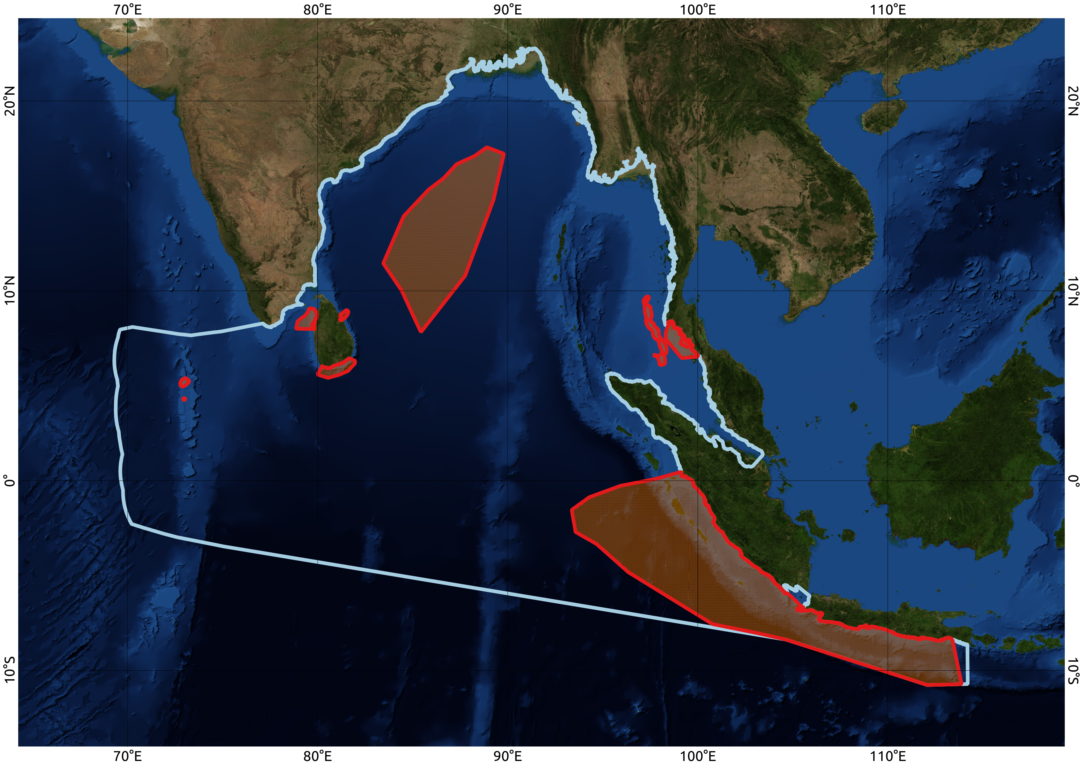
MAP OF THE WORKSHOP'S GEOGRAPHIC SCOPE AND AREAS MEETING EBSA CRITERIA IN THE NORTH-EAST INDIAN OCEAN AS AGREED BY THE WORKSHOP PLENARY

Note:
• Blue polygon indicates the geographic scope of the area considered by the workshop
• Polygons in red indicate areas described as meeting the EBSA criteria by the workshop

Annex VI

DESCRIPTION OF AREAS MEETING THE EBSA CRITERIA IN THE NORTH-EAST INDIAN OCEAN AS AGREED BY THE WORKSHOP PLENARY

Area Number | Areas meeting the EBSA criteria  (See the detailed description of compiled areas in appendix to annex VI)⁴
1 | Shelf Break Front
2 | Lower Western Coastal Sea
3 | Trang, Home of the Dugongs
4 | The Southern Coastal and Offshore Waters between Galle and Yala National Park
5 | Coastal and Offshore Area of the Gulf of Mannar
6 | Trincomalee Canyon and Associated Ecosystems
7 | Rasdhoo Atoll Reef
8 | Baa Atoll
9 | Upwelling Zone of the Sumatra-Java Coast
10 | Olive Ridley Sea Turtle Migratory Corridor in the Bay of Bengal

Appendix to Annex VI
DESCRIPTION OF AREAS MEETING THE EBSA CRITERIA IN THE NORTH-EAST INDIAN OCEAN REGION AS AGREED BY THE WORKSHOP PLENARY

Area No. 1: Shelf Break Front
Abstract
In the Shelf Break Front, a hydrodynamic process generated by internal waves plays an important role in transporting water that is rich in inorganic nutrients into the Andaman Shelf Sea. This process creates an area of elevated phytoplankton production related to fish larvae abundance due to the intrusion of deep water over the shelf. At the shelf front and its surrounding areas, phytoplankton biomass and production are three times greater than in shelf flat water, and fish larvae abundance is two times greater. The high biological productivity of the “Shelf Break Front” provides substantial spawning and feeding grounds, supporting, in particular, a potential fishery ground.
Introduction
In the "Shelf Break Front", a hydrodynamic process generated by internal waves plays an important role in transporting water that is rich in inorganic nutrients into the Andaman Shelf Sea. This process creates an area of elevated phytoplankton production related to fish larvae abundance due to the intrusion of deep water over the shelf. At the shelf front and its surrounding areas, phytoplankton biomass and production are three times greater than in shelf flat water, and fish larvae abundance is two times greater (Nielsen et al., 2004; Vudhichai et al., 2005). The high biological productivity of the Shelf Break Front provides substantial spawning and feeding grounds, supporting, in particular, a potential fishery ground (Vudhichai et al., 2005).
Climate
The area is within a tropical monsoon climate and receives a large amount of precipitation throughout the year, with an average precipitation of 2,300mm per year. Due to the influence of the tropical monsoon climate and the area’s location in the Andaman Sea close to the equator, the south-western and north-eastern monsoons have a great impact on the climate in this area. The south-western monsoon brings moisture from the sea during the months of May and October. The north-eastern monsoon, influenced by the wind blowing from the north of China from November to April, causes low precipitation and temperature, especially during December and January (CHARM, 2010).
Bathymetry
The shelf flat is at an approximate depth of 100 metres, which is between 32 and 150 km from the shore. The shelf break front occurs at a depth of 100-200 metres in a steep slope sea floor (Vudhichai et al., 2005).
Location
The area is located between 9.683ºN, 97.364ºE and 6.089ºN and 98.073ºE, off the coast of Thailand, at a depth of 100 to 200 m, and covers 13,176 km².
Feature description of the area
On the shelf, the water is mixed inshore of the region, where the strong pycnocline meets the bottom. Hence, a frontal zone is established in this area, which is apparent from declining isopycnals observed in areas where bottom depths are 55 to 65 m. The nutrient-rich Shelf Break Front increases the area’s species diversity and productivity. The other prominent hydrographic feature is the oscillating pycnocline at the shelf slope. Apparently, an internal wave is amplified when the bottom is of a certain depth-range, and this feature was seen in areas of 250 to 350 m bottom depth. Both the frontal zone and the internal wave oscillations induce upward transport of deeper water, detectable by increased salinity in the surface waters and an associated increase in phytoplankton (Nielsen et al. 2004).
Munk, et al. (2004) reported that plankton biomass and production were veritably pronounced and it was likely that a number of fish larvae and their diversity seemed to aggregate here as well. Growth rate of phytoplankton is 3 times greater at the front than shelf area, while growth of fish larvae is twice as great. It is suggested that the frontal region in the Andaman Sea may provide substantial spawning and feeding grounds, in particular, a potential fishery ground.
Feature condition and future outlook of the area
The Thai-Danish Deep Sea Research Programme was carried out from 1996 to 1997 (Vudhichai et al., 2005). The area might be targeted as a new fisheries site in the future, thus further investigation will be conducted and a management plan prepared (Vudhichai et al., 2005).

Assessment of the area against CBD EBSA Criteria
CBD EBSA Criteria  (Annex I to decision IX/20) | Description  (Annex I to decision IX/20) |  | Ranking of criterion relevance  (please mark one column with an X)
CBD EBSA Criteria  (Annex I to decision IX/20) |  |  | No information |  |  |  | Low |  | Medium |  |  |  | High
Uniqueness or rarity | Area contains either (i) unique (“the only one of its kind”), rare (occurs only in few locations) or endemic species, populations or communities, and/or (ii) unique, rare or distinct, habitats or ecosystems; and/or (iii) unique or unusual geomorphological or oceanographic features. |  |  |  |  |  |  |  |  |  |  |  | X
Explanation for ranking
The unique bottom topography contributes to an upwelling phenomenon, elevating nutrients and enhancing the growth and species richness of marine organisms in the area (Peter et al., 2004).
Special importance for life-history stages of species | Areas that are required for a population to survive and thrive. |  |  |  |  |  |  |  |  |  | X
Explanation for ranking
Due to the high abundance and productivity of plankton and fish larvae (Nielsen et al., 2004; Vudhichai et al., 2005), the area is important to the marine ecosystem as it supports early life stages of various organisms.
Importance for threatened, endangered or declining species and/or habitats | Area containing habitat for the survival and recovery of endangered, threatened, declining species or area with significant assemblages of such species. | X
No information available
Vulnerability, fragility, sensitivity, or slow recovery | Areas that contain a relatively high proportion of sensitive habitats, biotopes or species that are functionally fragile (highly susceptible to degradation or depletion by human activity or by natural events) or with slow recovery. | X
No information available

Biological productivity | Area containing species, populations or communities with comparatively higher natural biological productivity. |  |  |  |  |  |  |  |  |  | X
Explanation for ranking
At the shelf front and its surrounding areas, phytoplankton biomass and production are three times greater than in shelf flat water, and fish larvae abundance is two times greater (Nielsen et al., 2004; Vudhichai et al., 2005).
Biological diversity | Area contains comparatively higher diversity of ecosystems, habitats, communities, or species, or has higher genetic diversity. |  |  |  |  |  |  |  |  |  | X
Explanation for ranking
According to Vudhichai et al. (2005), the diversity of plankton and fish larvae is significantly higher at the shelf break front than at the shelf flat. More than 125 families of fish larvae have been identified in the shelf break front area.
Naturalness | Area with a comparatively higher degree of naturalness as a result of the lack of or low level of human-induced disturbance or degradation. |  |  |  |  |  |  |  |  |  |  | X
Explanation for ranking
The area is quite far offshore, and the area is not yet well known to fishers. Thus, there is a low potential for human impact.

References
Buranapratheprat, A., Laongmanee, P., Sukramongkol, N., Prommas, R., Promjinda, S. and Yanagi, T. 2010. Upwelling induced by meso-scale cyclonic eddies in the Andaman Sea. Coastal Marine Science 34(1): 68–73.
CHARM. 2010. Vulnerability Mapping and Quality Status of Phang Nga Bay and Ban Don Bay in Southern Thailand, Final report. Coastal Habitat and Resources Management Project, 137 pages.
Nielsen, T.G., Peter Koefoed Bjornsen, Pensri Boonruang, Michael Fryd, Per Juel Hansen, Vudhichai Janekarn, Vitthaya Limtrakulvong, Peter Munk, Ole Schou Hansen1, Suree Satapoomin, Suchat Sawangarreruks, Helge Abilhauge Thomsen, Jette Buch Ostergaard. 2004. Hydrography, bacteria and protist communities across the continental shelf and shelf slope of the Andaman Sea (NE Indian Ocean). Marine Ecology Progress Series, 274: 69–86.
Peter M., K.B. Peter, B. Pensri, F. Michael, J.H. Per, J. Vudhichai, L. Vitthaya, G.N. Torkel, S.H. Ole, S. Suree, S. Suchat, A.T. Helge and Ø.B. Jette. 2004. Assemblages of fish larvae and mesozooplankton across the continental shelf and shelf slope of the Andaman Sea (NE Indian Ocean). Marine Ecology Progress Series, Vol. 274: 87–97.
Vudhichai J., S. Suchat, L.Vitthaya, S. Suree, C. Sutharat, M, Prajuab and P. Khodeeyoe. 2005. Recent Fishery Resource Discovery in the Andaman Shelf Sea: Indirect Biological Evidence. Proceeding of the Annual Conference on Fisheries, Department of Fisheries, 41 pages.

Maps and Figures
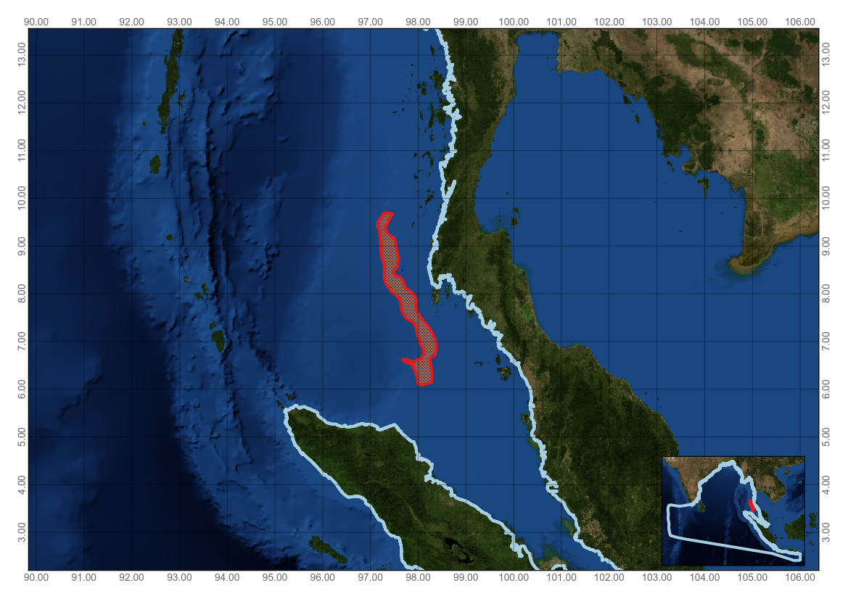
Figure 1. Area meeting the EBSA criteria

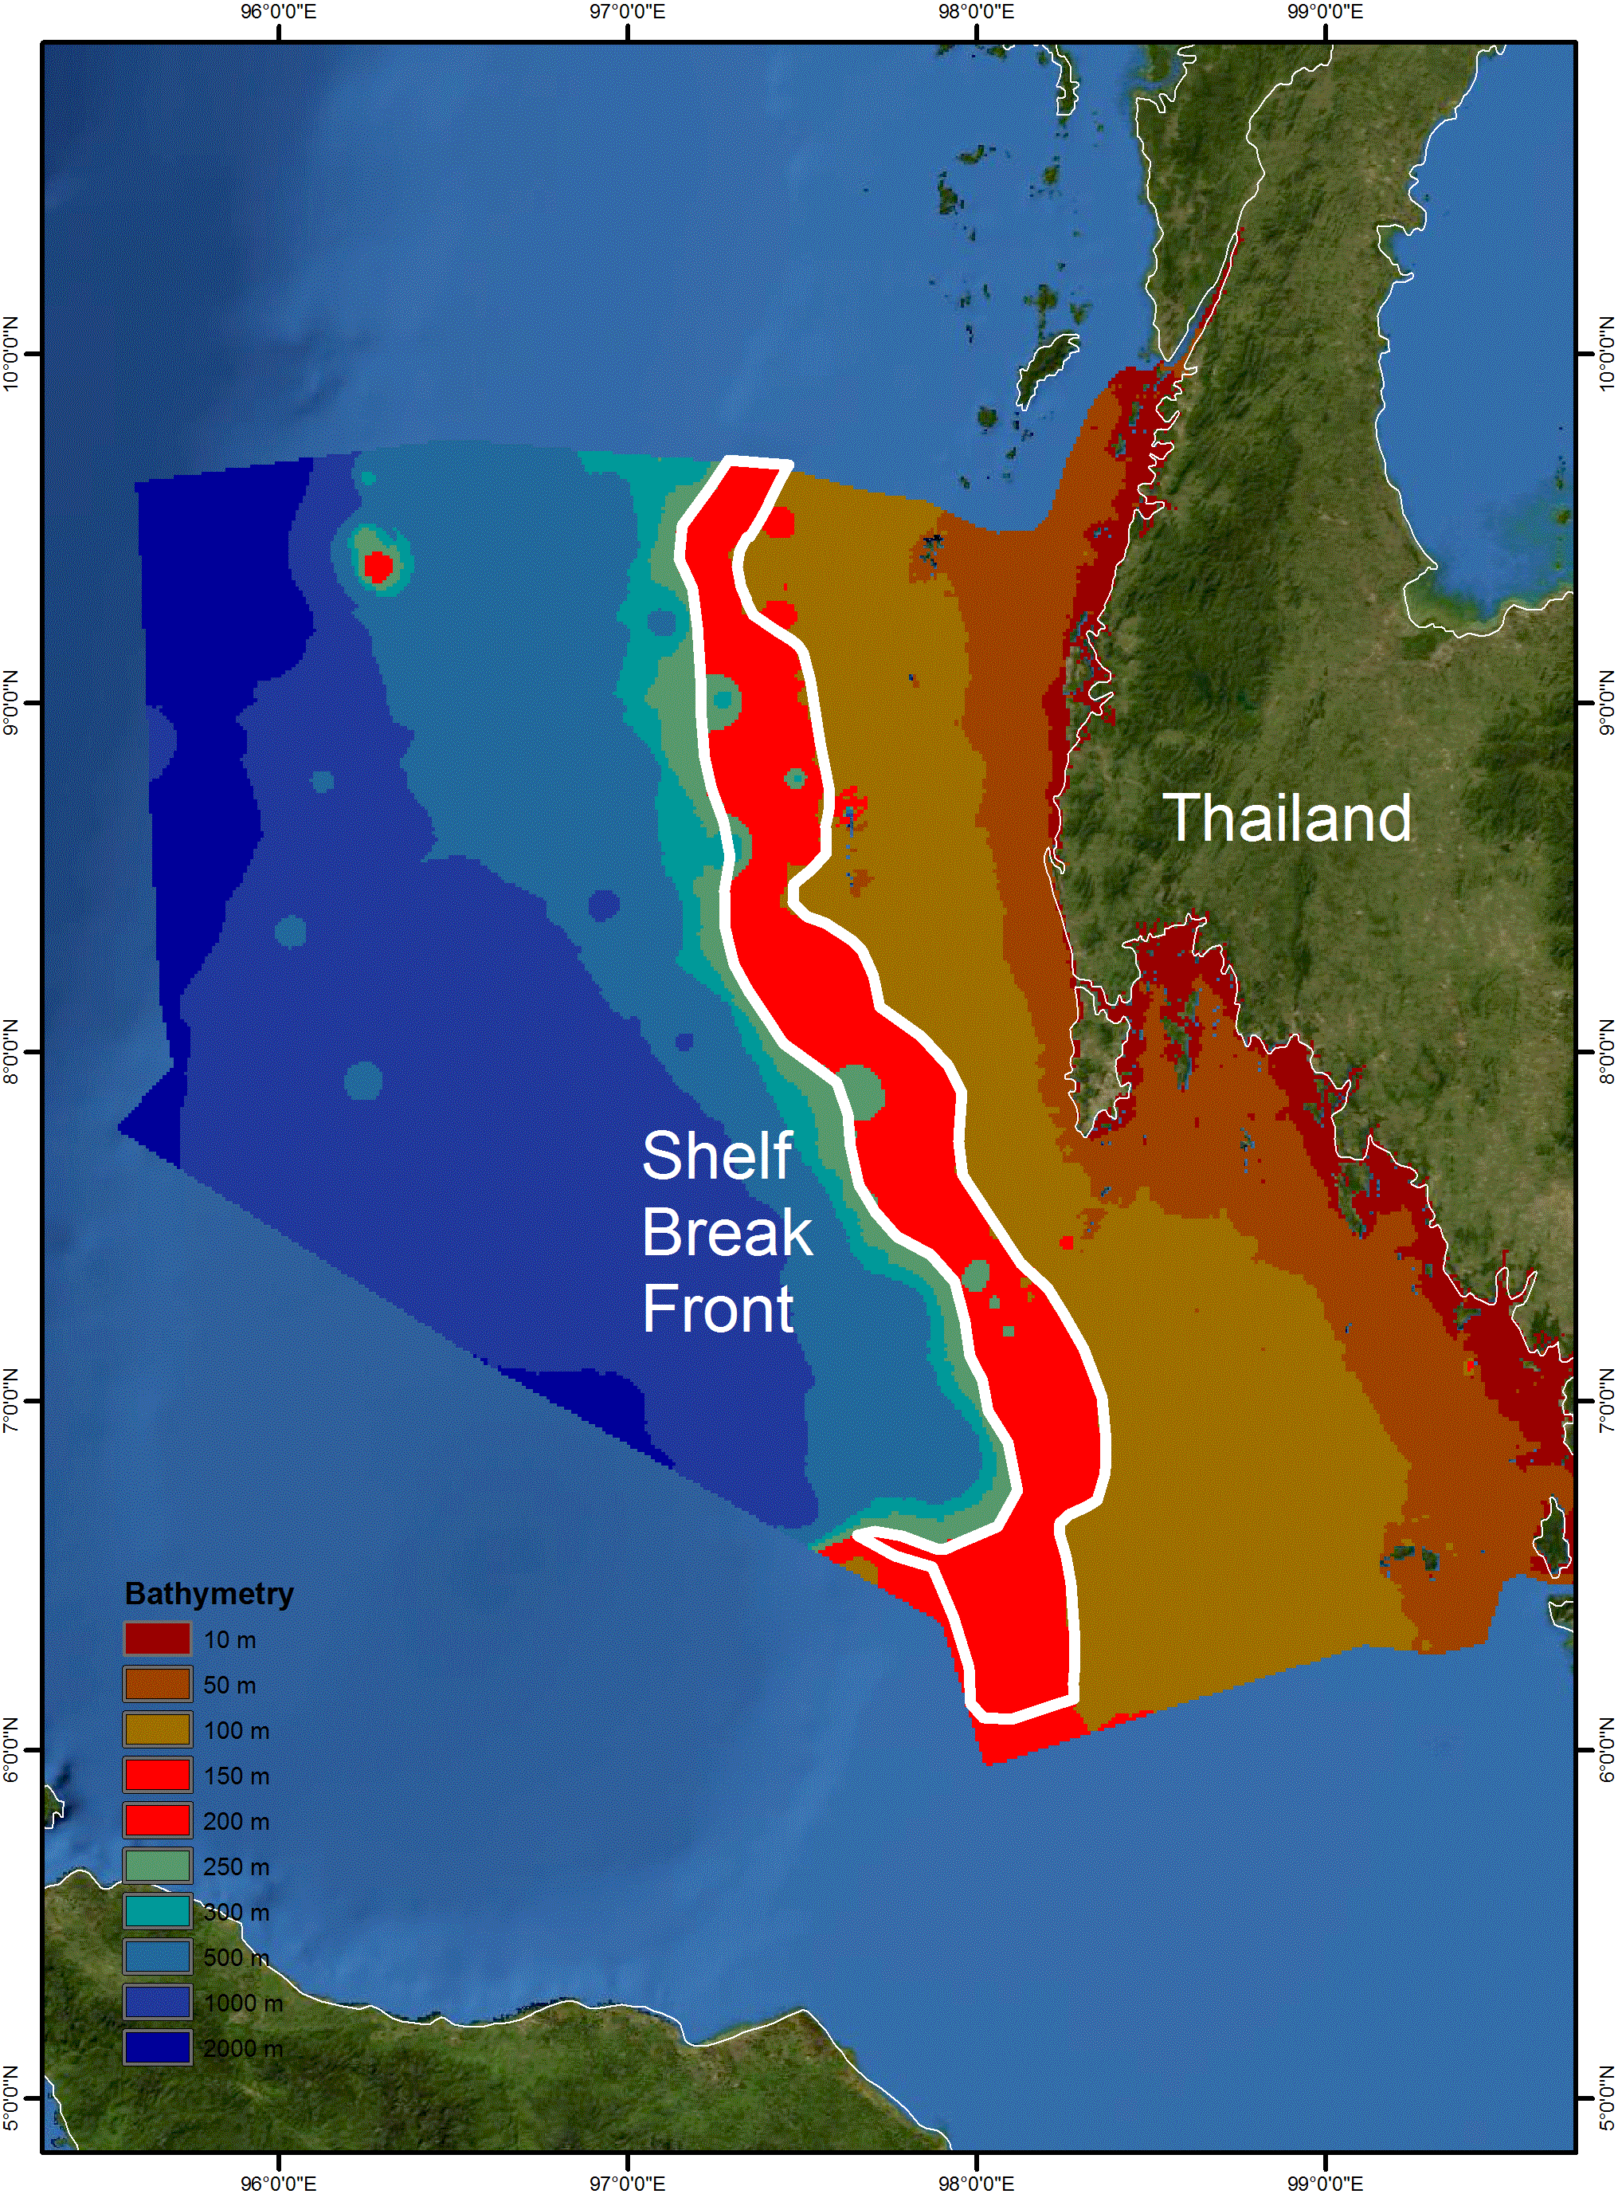

Figure 2. Bathymetry at the Shelf Break Front area.

Rights and permissions
No part of this document shall be used as any other referencing than for the use of CBD EBSA workshop report.
Area No. 2: Lower Western Coastal Sea
Abstract
The Lower Western Coastal Sea comprises diverse ecosystems covering 10 river mouths, 1,263 km² of mangroves, 80 km² of seagrass and 68 km² of coral reefs. All (11) species of seagrass in Thailand are found in the area. There are more than 269 species of corals and 96 species of reef fish. The area is also home to many endangered marine species, such as dugongs, sea turtles, whales, dolphins, whale sharks and manta rays.
Introduction
The Lower Western Coastal Sea of Thailand is a shallow marine ecosystem, which extends to a depth of 30 metres. The area comprises diverse ecosystems covering 10 river mouths, 1,263 km2 mangrove, 80 km2 seagrass and 68 km2 coral reefs. All (11) species of seagrass in Thailand are found in the area. There are more than 269 species of corals and 96 species of reef fish (DMCR, 2014). The area is also home to many endangered marine species, such as dugong, sea turtles, whales, dolphins, whale sharks and manta rays (Kittiwattanawong, 2015).
Climate
The area is within a tropical monsoon climate, and receives a large amount of precipitation throughout the year, with an average precipitation of 2,300mm per year. Due to the influence of the tropical monsoon climate and the area’s location in the Andaman Sea close to the equator, the south-western and north-eastern monsoons have a great impact on the climate in this area. The south-western monsoon brings moisture from the sea during the months of May and October. The north-eastern monsoon, influenced by the wind blowing from the north of China during months of November and April causes low precipitation and temperature, especially during December and January (CHARM, 2010).
Tidal
The tidal pattern of the area is semidiurnal, whereby the highest high water and the lowest low water occur twice a day. Consequently, the direction and velocity of the water current vary throughout the day. Water flows into the area during high tide and out of the area during low tide. As monsoons also influence the water current, the direction of residual currents changes seasonally (CHARM, 2010).
Topography
The topography of the area is submerged coast associated with a narrow continental shelf. There are many capes and bays. Sediments found on the seabed include mud, muddy shore and muddy beaches. There are major 10 waterways running through the area (CHARM, 2010).
Location
The centre of the area is 99.081°E and 7.213°N, in the coastal area of Thailand, covering 17,500 km² and including 643 km² of coastline.
Feature description of the area
Seagrass
The Department of Marine and Coastal Resources of Thailand reported that there are 11 species of seagrass in Thailand: Enhalus acorides, Syringodium isoetifolium, Halodule uninervis, Halodule pinifolia, Cymodocea rotundata, Cymodocea serrulata, Halassia hemprichii, Halophila ovalis, Halophila minor, Halophila decipiens and Halophila beccarii (DMCR, 2014). The total area of seagrass is 80km², and it is considered to be the largest seagrass bed in Thailand. The dominant species are Enhalus acorides, Halophila ovalis and Cymodocea serrulata. Most seagrass areas were in Krabi and Trang Provinces. The large and important areas of seagrass beds were Ko Sri Boya, Ko Talibong, and Ko Muk. The seagrass beds in the area were in good condition in 2015 and abundant with marine organisms, including organisms of commercial importance and marine endangered species (i.e., dugongs, sea turtles and dolphins).
Poovachiranon and Adulyanukosol (2000) reported that there were 149 species of seagrass fish belonging to 51 families in the Andaman Sea. Siganus, Atherinomoms and Leiohnathus were dominant genera. Marine algae of 333 species belonging to 132 genera were also reported.
Coral reef
DMCR (2014) reported that there are more than 269 species of corals in the described area. According to the survey, live and dead coral coverage were recorded in the area. These data were then used to analyze coral reef condition by comparing the ratio of live to dead coral coverage in each area. The ratios used to classify coral reef condition are as follows: (a) 3:1 refers to a very healthy reef, (b) 2:1 refers to a healthy reef, (c) 1:1 refers to a reef in fair health (d) 1:2 refers to a reef in poor health, and (e) 1:3 (or higher) refers to a reef in very poor health.
Mangrove
DMCR (2014) reported 78 species of mangroves in Thailand. Shrimps, shellfish, crabs, fish, birds, mammals, reptiles and insects are found within mangroves as well as other types of small animals such as protozoan, worms, flat worms and polycheates. Those animals can be classified by their living patterns as free-living animals, sessile animals, filter feeders and infauna. Most of the fish found in the mangroves are abundant and economically important, including Milkfish and Silver Perch. The type and abundance of fish vary by seasons, currents, salinity and temperature of seawater, and types and numbers of predators. Fish in the mangroves can be categorized into three groups: resident, temporary, and seasonal.
There are approximately 15 types of shrimp found in the mangroves, including economically important species, such as tiger prawn and banana shrimp. Some species spawn in brackish water mangroves, including giant freshwater prawn and other freshwater prawns.
Mollusks found in the mangroves include bivalves, such as oyster and cockle, which may live in the substrate or attach to the stems, roots, branches and leaves of mangrove plants, and shipworms, which live within the dead trunk or submerged woods. In addition, the gastropod genus Cerithidea is also found in the mangroves. About 30 types of crab are found in the mangroves, including the well-known meder’s mangrove crab and fiddler crab, both of which are colourful. Giant mud crabs found in these mangrove areas are often caught for food.
There are both resident and migratory birds found in the mangroves. The resident birds that inhabit and build their nests in the mangrove area include little egrets, little cormorant and red-backed sea eagles, whereas migratory birds seasonally fly from other areas through the same route along the continents to the mangroves in order to halt and rest since the mangroves provide food and shelter from storms and predators. These migratory birds include giant birds, spoon-billed sandpipers, and seagulls.
Endangered Marine Species
Kittiwattanawong (2015) reported that there are seven species of marine mammals in this area: dugong (Dugon dugon), Indo-pacific bottlenose dolphin (Tursiop aduncus), Indo-pacific humpback dolphin (Sousa chinensis), Irrawaddy dolphin (Orcaella brevirostris), finless porpoise (Neophocaena phocaenoides), spinner dolphin (Stenella longirostris) and spotted dolphin (Stenella attenuata). There are three resident species of sea gurtles: green turtles (Chelonia mydas), olive ridley (Lepidochelys olivacea) and hawksbill turtle (Eretmochelys imbricata). In addition, manta rays and whale sharks are often reported in the area.
Feature condition and future outlook of the area
Status of the marine resources
According to an annual monitoring report on marine resources (DMCR, 2015), seagrass beds and coral reefs were still in good condition with quite stable trends in 2015. However, the dugong population has been declining, with an average of six dugong mortalities every year over the past 10 years (Kittiwattanawong, 2015).
Protection Areas
Within the area, there are 11 protected areas (i.e., national park, no-hunting zone, Ramsar site, seagrass protection zone) as well as at least five areas in the process of being declared as local protected areas.
Assessment of the area against CBD EBSA Criteria

CBD EBSA Criteria  (Annex I to decision IX/20) |  | Description  (Annex I to decision IX/20) |  | Ranking of criterion relevance  (please mark one column with an X)
 |  |  |  | No information |  |  |  | Low |  | Medium |  |  |  | High
Uniqueness or rarity |  | Area contains either (i) unique (“the only one of its kind”), rare (occurs only in few locations) or endemic species, populations or communities, and/or (ii) unique, rare or distinct, habitats or ecosystems; and/or (iii) unique or unusual geomorphological or oceanographic features. |  |  |  |  |  |  |  |  |  |  |  | X
Explanation for ranking
The area is the home to the largest dugong population in Thailand, as well as six cetacean species and three sea turtle species (Kittiwattanawong, 2015). The range of habitat types, especially seagrass beds and coral reefs, also makes this area unique, providing a high diversity and abundance of marine organisms.
Special importance for life-history stages of species |  | Areas that are required for a population to survive and thrive. |  |  |  |  |  |  |  |  |  | X
Explanation for ranking
Habitats such as mangroves, seagrass beds and coral reefs in the area provide both shelter and food sources for early stage marine organisms, in addition to direct food sources for large marine animals.
Importance for threatened, endangered or declining species and/or habitats |  | Area containing habitat for the survival and recovery of endangered, threatened, declining species or area with significant assemblages of such species. |  |  |  |  |  |  |  |  |  | X
Explanation for ranking
There are seven species of marine mammals in the area: Dugong (Dugon dugon), Indo-pacific bottlenose dolphin (Tursiop aduncus), Indo-pacific humpback dolphin (Sousa chinensis), Irrawaddy dolphins (Orcaella brevirostris), finless porpoise (Neophocaena phocaenoides), spinner dolphin (Stenella longirostris) and spotted dolphin (Stenella attenuata). The seagrass and coral habitats also serve as feeding grounds for green turtles (Chelonia mydas), olive ridley turtles (Lepidochelys olivacea) and hawksbill turtles (Eretmochelys imbricata). In addition, manta rays and whale sharks are often reported in the area annually. Kittiwattanawong (2015) reported that there are about 150 dugongs in the area and that the population has been declining over the past 10 years.
Vulnerability, fragility, sensitivity, or slow recovery | Areas that contain a relatively high proportion of sensitive habitats, biotopes or species that are functionally fragile (highly susceptible to degradation or depletion by human activity or by natural events) or with slow recovery. |  |  |  |  |  |  |  |  |  |  | X
Explanation for ranking
The coral reefs in the area are very fragile and take a long time to recover. Brown (2002) reported a slow recovery rate (over a period of 17 years) due to siltation associated with coastal development. Habitats such as mangroves and seagrass beds located near the community are vulnerable to the impacts of local human activities.
Biological productivity | Area containing species, populations or communities with comparatively higher natural biological productivity. |  |  |  |  |  |  |  |  |  |  | X
Explanation for ranking
As mangroves, seagrasses and coral reef ecosystems are important developmental habitats for a large number of coastal marine organisms, the area supports aggregations of early-staged and adult marine organisms. Poovachiranon and Adulyanukosol (2000) reported high biodiversity of marine organisms, including 149 species of seagrass fish, living in seagrass beds in the area. DMCR reported more than 269 species of corals and 96 species of reef fish. There were 78 species of the mangrove plant, with associated animals, such as shrimps, shells, crabs, fish, birds, mammals, reptiles and insects (DMCR, 2014).
Biological diversity | Area contains comparatively higher diversity of ecosystems, habitats, communities, or species, or has higher genetic diversity. |  |  |  |  |  |  |  |  |  |  | X
Explanation for ranking
The area comprises mangrove, river mouth, coral and seagrass habitats. In addition to species found in these habitats, the area also harbours seven marine mammals: dugong (Dugon dugong), Indo-pacific bottlenose dolphin (Tursiop aduncus), Indo-pacific humpback dolphin (Sousa chinensis), Irrawaddy dolphins (Orcaella brevirostris), finless porpoise (Neophocaena phocaenoides), spinner dolphin (Stenella longirostris) and spotted dolphin (Stenella attenuata) (Kittiwattanawong, 2015). The seagrass and coral habitats also serve as feeding grounds for sea turtles, such as green turtles (Chelonia mydas), olive ridley turtles (Lepidochelys olivacea) and hawksbill turtles (Eretmochelys imbricata). In addition, manta rays and whale sharks are frequently reported in the area. There are more than 269 species of corals and 96 species of reef fish, as well as 11 species of seagrasses (DMCR, 2014).
Naturalness | Area with a comparatively higher degree of naturalness as a result of the lack of or low level of human-induced disturbance or degradation. |  |  |  |  |  | X
Explanation for ranking
Since the area is coastal, it has been disturbed by the activities of local villages, coastal development as well as tourism. Some parts of the mangrove area have been invaded and converted either into shrimp farms or for coastal development (EJF, 2006). The unintended catches of sea turtles and dugongs by fishing gear has been frequently reported (Kittiwattanawong, 2015). Swimming crab were reported to be overfished based on the use of a size index (Kittitornkool et al., 2012).

References
Brown, B., K. Clarke and R. Warwick. 2002. Serial patterns of biodiversity change in corals across shallow reef flats in Ko Phuket, Thailand, due to the effects of local (sedimentation) and regional (climatic) perturbations. Marine Biology, 141 (1) 21-29.
Coastal Habitat and Resources Management Project (CHARM). 2010. Vulnerability Mapping and Quality Status of Phang Nga Bay and Ban Don Bay in Southern Thailand, Final report. 137 pages.
DMCR. 2015. Annual monitoring report on marine recourses status. Department of Marine and Coastal Resources.
DMCR. 2014. Central Database System and Data Standard for Marine and Coastal Resources. Department of Marine and Coastal Resources, Thailand. http://marinegiscenter.dmcr.go.th
EJF. 2006. Mangroves: Nature’s defence against Tsunamis — A report on the impact of mangrove loss and shrimp farm development on coastal defences. Environmental Justice Foundation, London, UK
Kittitornkool J., K. Kittiwattanawong and N. Srichai. 2012. Toward Community-based Resource Management: the Development and Mobilization of Fisheries Resource Indicators at Koh Sarai, Thailand.
Kittiwattanawong, K. 2015. Annual report on status and change of marine endangered species in Thailand. Department of Marine and Coastal Resources.Janekarn, V. and T. Kiorboe. 1991. Temporal and spatial distribution of fish larvae and their environmental biology in Phang-Nga Bay, Thailand.
Poovachiranon, S. and K. Adulyanukosol. 2000. Seagrass community and marine algae in Thailand. Phuket Marine Biological Center Research Bulletin 12 (2000): 84-96.

Maps and Figures

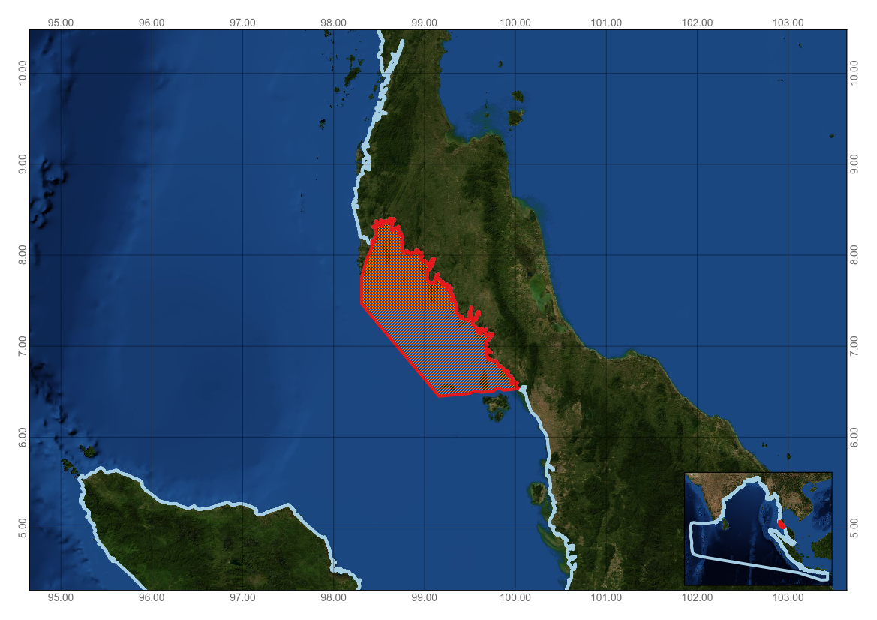
Figure 1. Area meeting the EBSA criteria

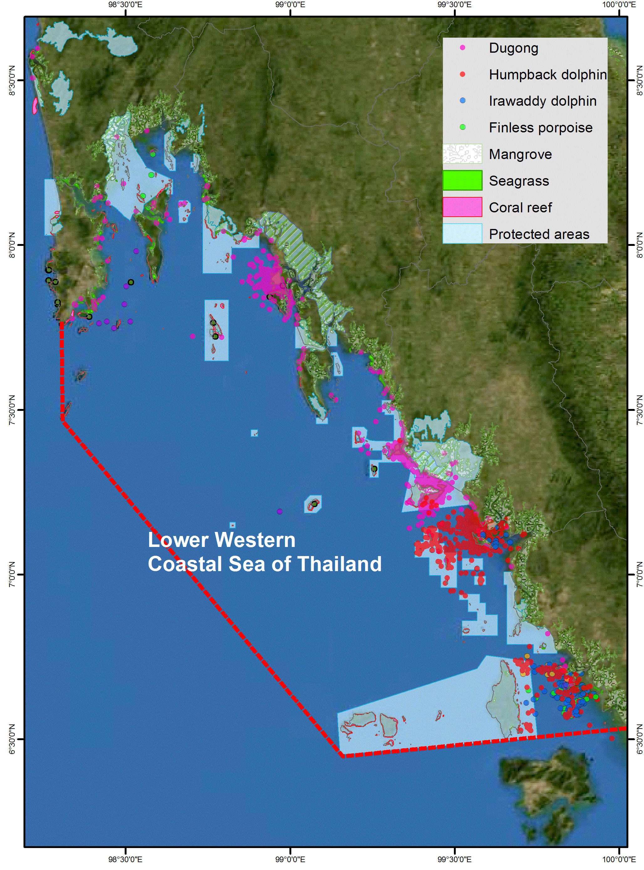
Figure 2. Distribution of important habitats in the described area

Rights and permissions
This document shall not be referenced in whole or in part outside of its use in the CBD EBSA regional workshop.
Area No. 3: Trang, Home of the Dugongs
Abstract
Trang, Home of the Dugongs harbours the largest aggregation of dugongs in Thailand. There are about 150 dugongs in the area, with declining abundance. Over the past 10 years, there was an average of five dugong mortalities annually. This area is located within area no. 2 (above) but described separately as an individual area meeting the EBSA criteria as it focuses on the particular ecological importance of this system for dugongs.
Introduction
The dugong is a protected animal in Thailand based on the Wildlife and Plants Protection Act B.C.2535. Dugongs in Thailand can be divided into six geographical populations, with the largest population (about 150 individuals) located in Trang province, on the south-western coast of Thailand (Kittiwattanawong, 2015). Annual aerial monitoring surveys conducted by the Department of Marine and Coastal Resources reveal the home range of this dugong population is between 200 and 300 km². This range covers the 34 km² of seagrass bed located at a maximum of 10 metres deep during low tide.
Although the dugong is protected by law, they are vulnerable to impacts from coastal activities. Over the past 10 years, there was an average of five dugong mortalities annually. An attempt to protect this dugong population in Thailand has led to cooperation among local villagers, NGOs and governmental agencies.
Location
The area is located off the south-western coast of Thailand and covers 1,619 km². The area is centered at 99.349°E and 7.284°N.
Feature description of the area
The area has diverse marine ecosystems that include mangroves, a river mouth, seagrasses, and coral reefs.
Dugongs
Dugongs in Thailand can be divided into six geographical populations with the largest population (about 150 individuals) in Trang province located on the south-western coast of Thailand (Kittiwattanawong, 2015). Annual aerial monitoring surveys conducted by the Department of Marine and Coastal Resources reveal that the home range of this dugong population is 200-300 km².
Seagrasses
DMCR (2014) reported that there are 11 species of seagrass in the area (i.e., Enhalus acorides, Syringodium isoetifolium, Halodule uninervis, Halodule pinifolia, Cymodocea rotundata, Cymodocea serrulata, halassia hemprichii, Halophila ovalis, Halophila minor, Halophila decipiens and Halophila beccarii). The total coverage of seagrass in the area is 34 km², and it is considered the largest seagrass bed in Thailand. The dominant species are Enhalus acorides, Halophila ovalis and Cymodocea serrulata. The seagrass beds were in good condition in 2015, and the beds were shown to be abundant with marine organisms, including economically important organisms and endangered marine species (i.e., dugongs, sea turtles and dolphins).
Poovachiranon and Adulyanukosol (2000) reported that there were 149 species of seagrass fish belonging to 51 families present in the area, with the dominant genera being Siganus, Atherinomoms and Leiohnathus. Three hundred and thirty-three species of marine algae belonging to 132 genera were also reported in the area.

Coral reefs
DMCR (2014) reported that there are more than 269 species of corals in an area of 8 km² within the described area. According to the survey in 2015, the average ratio between live and dead coral is 1:1 which is equivalent to a ‘fair’ status.
Mangroves
DMCR (2014) reported 65 species of mangrove in the area. There are approximately 15 types of shrimp found in the mangroves, including economically important species, such as tiger prawn and banana shrimp. Some species spawn in brackish water mangroves, including giant freshwater prawn and other freshwater prawns. Mollusks found in the mangroves include bivalves such as oyster and cockle, which may live in the substrate or attach to the stems, roots, branches and leaves of mangrove plants, while shipworms live within the dead trunks or submerged wood. In addition, the gastropod genus Cerithidea is found in the mangroves. About 30 types of crab are found in the mangroves, including the well-known meder’s mangrove crab and fiddler crab, both of which are colourful. Giant mud crabs found in these mangrove areas are often harvested for food.
There are both resident and migratory birds in the mangroves. The resident birds that inhabit and build their nests in the mangrove area include little egrets, little cormorants and red-backed sea eagles, whereas migratory birds seasonally fly from other areas through the same route along the continents to the mangroves in order to halt and rest since the mangroves provide food and shelter from storms and predators. These migratory birds include giant birds, spoon-billed sandpipers and seagulls.
Other Marine Endangered Species
Kittiwattanawong (2015) reported that there are four resident species of cetaceans in the area: Indo-pacific bottlenose dolphin (Tursiop aduncus), Indo-pacific humpback dolphin (Saousa chinensis), Irrawaddy dolphins (Orcaella brevirostris), finless porpoise (Neophocaena phocaenoides). There are two resident species of green turtles (Chelonia mydas) and hawksbill turtles (Eretmochelys imbricata). In addition, manta rays and whale sharks are often reported in the deeper parts of the area.
Feature condition and future outlook of the area
Status of the marine resources
According to the annual monitoring report on the status of marine resources (DMCR, 2015), seagrass beds and coral reefs were still in good condition, with quite stable trends. However, the population trend for dugongs has been declining, with an average of five dugongs mortalities every year over the past 10 years (Kittiwattanawong, 2015).
Protected areas
Within the area, there are three government-declared protected areas (national parks, no-hunting zone and seagrass protection zone), as well as more than three areas in the process of being declared as local protected areas.

Assessment of the area against CBD EBSA Criteria

CBD EBSA Criteria  (Annex I to decision IX/20) | Description  (Annex I to decision IX/20) | Ranking of criterion relevance  (please mark one column with an X)
CBD EBSA Criteria  (Annex I to decision IX/20) | Description  (Annex I to decision IX/20) | No information |  |  | Low |  |  | Medium |  |  |  | High
Uniqueness or rarity | Area contains either (i) unique (“the only one of its kind”), rare (occurs only in few locations) or endemic species, populations or communities, and/or (ii) unique, rare or distinct, habitats or ecosystems; and/or (iii) unique or unusual geomorphological or oceanographic features. |  |  |  |  |  |  |  |  |  |  | X
Explanation for ranking
The dugong is the only herbivorous mammal that is strictly marine and is only extant species of the family Dugongidae (Reynolds and Odell, 1991); it is listed as vulnerable to extinction (Anon, 1996). Kittiwattanwong (2015) indicates that the area hosts the largest dugong population (about 150 individuals) in Thailand. The loss of dugongs in this area would mean the loss of up to 60 of the total population of dugongs in Thailand. In addition, the dugong population in Trang is the largest aggregation of dugongs in Southeast Asia (Adulyanukosol, 2004). This area is highlighted as a special area within area no. 2 (above) for its particular importance to dugongs.
Special importance for life-history stages of species | Areas that are required for a population to survive and thrive. |  |  |  |  |  |  |  |  |  | X
Explanation for ranking
Kittiwattanawong (2015) conducted an aerial monitoring survey from 2011 to 2016, which revealed that the distribution of dugongs was mainly confined to the area. This indicates that the area serves as an important role for the entire life cycle for dugongs. The dugongs give birth, feed in seagrass beds and spend more of their time in the area (local community interview, unpublished data).
Importance for threatened, endangered or declining species and/or habitats | Area containing habitat for the survival and recovery of endangered, threatened, declining species or area with significant assemblages of such species. |  |  |  |  |  |  |  |  |  | X
Explanation for ranking
Kittiwattanawong (2015) reported that there were five dugong mortalities each year over the past 10 years. Model estimation for the dugong population revealed that dugong in the area should have a non-natural mortality rate of no more than five individuals per year (Kittiwattanawong, unpublished data). He also proposed that if there were 10 mortalities per year, the population in this area would be wiped out within 20 years. In contrast, if non-natural mortality were to be eliminated, the population would increase from 135 to 200 individuals within 10 years.
Vulnerability, fragility, sensitivity, or slow recovery | Areas that contain a relatively high proportion of sensitive habitats, biotopes or species that are functionally fragile (highly susceptible to degradation or depletion by human activity or by natural events) or with slow recovery. |  |  |  |  |  |  |  |  |  | X
Explanation for ranking
The population biology of dugongs makes them particularly vulnerable to mortality as adults (Marsh et al. 2011). Unexploited dugong populations are characterized by long lifespans (greater than 70 years), long gestation (12–14 months), single offspring, long intervals between births (more than 2.5 years), prolonged periods until sexual maturity (6–17 years), and high and temporally stable adult survival (Marsh et al. 1984). Adult survival is the most important determinant of population growth. The maximum rate of population increase under optimum conditions when natural mortality is low is approximately 5 per cent per year. The maximum sustainable mortality rate of adult females killed by human activities is approximately 1 or 2 per cent (Heinsohn et al. 2004; Marsh et al. 1997, 2004), and lower when food supplies are low (Marsh et al. 2002; Marsh and Kwan 2008 . Dugongs are vulnerable to various human activities that destroy seagrass beds and coral reefs.
In Thailand, the locations and populations of dugongs are not sufficiently known to estimate the effects of habitat loss or modification, or incidental mortality, much less stochastic environmental events. The combination of specialized habitat needs and a low birth rate make the dugong especially vulnerable to anthropogenic disturbances (Adulyanukosol and Poovachiranon, 2006).
Biological productivity | Area containing species, populations or communities with comparatively higher natural biological productivity. |  |  |  |  |  |  |  |  |  | X
Explanation for ranking
Dugongs have a specialized need for seagrass habitats, as this is their only source of food. The seasgrasses and mangroves in this area provide habitats for various species at high biological productivity. DMCR (2014) reported that there are 11 species of seagrass in the area (i.e., Enhalus acorides, Syringodium isoetifolium, Halodule uninervis, Halodule pinifolia, Cymodocea rotundata, Cymodocea serrulata, halassia hemprichii, Halophila ovalis, Halophila minor, Halophila decipiens and Halophila beccarii). The total coverage of seagrass in the area is 34 km², and it is considered the largest seagrass bed in Thailand. The dominant species are Enhalus acorides, Halophila ovalis and Cymodocea serrulata. The seagrass beds were in good condition in 2015, and the beds were shown to be abundant with marine organisms, including economically important organisms and endangered marine species (i.e., dugongs, sea turtles and dolphins). Poovachiranon and Adulyanukosol (2000) reported that there were 149 species of seagrass fish belonging to 51 families present in the area, with the dominant genera being Siganus, Atherinomoms and Leiohnathus. Three hundred and thirty-three species of marine algae belonging to 132 genera were also reported in the area.
DMCR (2014) reported 65 species of mangrove in the area. There are approximately 15 types of shrimp found in the mangroves, including economically important species, such as tiger prawn and banana shrimp. Some species spawn in brackish water mangroves, including giant freshwater prawn and other freshwater prawns. Mollusks found in the mangroves include bivalves such as oyster and cockle, which may live in the substrate or attach to the stems, roots, branches and leaves of mangrove plants, while shipworms live within the dead trunks or submerged wood. In addition, the gastropod genus Cerithidea is found in the mangroves. About 30 types of crab are found in the mangroves, including the well-known meder’s mangrove crab and fiddler crab, both of which are colourful. Giant mud crabs found in these mangrove areas are often harvested for food.
Biological diversity | Area contains comparatively higher diversity of ecosystems, habitats, communities, or species, or has higher genetic diversity. |  |  |  |  |  |  |  | X
Explanation for ranking
The largest seagrass beds in Thailand are located around Muk Island and Talibong Island, where there is a large diversity of species of seagrass. The area is also a spawning and nursery ground of various species of fauna and flora. According to an annual monitoring report on marine resource status (DMCR, 2015), seagrass and coral were in good condition with quite stable trends as of 2015. Since the areas are natural and harbour a wide variety of habitats and wildlife, the island was declared the Ko Libong Non-hunting Area under the auspices of the National Park, Wildlife and Plant Conservation Department (formerly a part of the Royal Forest Department). Mangrove forests, seagrass beds and coral reefs are major coastal features of the island. Coral reefs, which occur as shallow-water fringing reefs developing down to two to four metres depth, are distributed along the west and south coasts of the island. Mangroves, chiefly Rhizophora apiculata, fringe most of the wave-protected coastline, especially in the northern and southeastern parts of the island. Extensive intertidal sand flats, sand dunes and patches of seagrass extend out from these wave-protected areas. Of the ten species of seagrasses found in the area, Halophila ovalis and Enhalus acoroides are among the most common, with H. ovalis widely distributed in both intertidal and subtidal zones and E. acoroides dominant in the subtidal zone.
Naturalness | Area with a comparatively higher degree of naturalness as a result of the lack of or low level of human-induced disturbance or degradation. |  |  |  |  |  | X
Explanation for ranking
Despite its status as a conserved area (national park and no-hunting zone), this area has high degree of human activities, such as fishing and tourism. There have been reports of reduced of seagrass in the area starting in 2008 from the Southern Regional Center of Marine and Coastal Resource Conservation located in Trang province due to impacts from inappropriate trawler and push net fishing gear.

References
Adulyanukosol, K. and S. Poovachiranon, Phuket Marine Biologigal Center. 2006. Department of Marine and Coastal Resources, Proceedings of the 3rd International Symposium on SEASTAR 2000 and Asian BIO-logging Science (the 7th SEASTAR 2000 workshop), 41-50
Brown, B., K. Clarke and R. Warwick. 2002. Serial patterns of biodiversity change in corals across shallow reef flats in Ko Phuket, Thailand, due to the effects of local (sedimentation) and regional (climatic) perturbations. Marine Biology, 141 (1) 21-29.
Coastal Habitat and Resources Management Project (CHARM). 2010. Vulnerability Mapping and Quality Status of Phang Nga Bay and Ban Don Bay in Southern Thailand, Final report. 137 pages.
Department of Marine and Coastal Resources (DMCR) 2014. Central Database System and Data Standard for Marine and Coastal Resources. Department of Marine and Coastal Resources, Thailand. http://marinegiscenter.dmcr.go.th
DMCR. 2015. Annual monitoring report on marine recourses status. Department of Marine and Coastal Resources.
Environmental Justice Foundation (EJF) 2006. Mangroves: Nature’s defence against Tsunamis— A report on the impact of mangrove loss and shrimp farm development on coastal defences. Environmental Justice Foundation, London, UK
Kittiwattanawong, K. 2015. Annual report on status and change of marine endangered species in Thailand. Department of Marine and Coastal Resources.
Kittitornkool J., K. Kittiwattanawong and N. Srichai. 2012. Toward Community-based Resource Management: the Development and Mobilization of Fisheries Resource Indicators at Koh Sarai, Thailand.
Poovachiranon, S. and K. Adulyanukosol. 2000. Seagrass community and marine algae in Thailand. Phuket Marine Biological Center Research Bulletin 12 (2000): 84-96.
Janekarn, V. and T. Kiorboe. 1991. Temporal and spatial distribution of fish larvae and their environmental biology in Phang-Nga Bay, Thailand
Saalfeld, K. 2000. Distribution and abundance of dugong in the coastal waters of the Northern Territory, technical report, Parks and Wildlife Commission of the Northern Territory, Darwin.
Saalfeld, K. and Marsh, H. 2004. Dugong. In National Oceans Office. Description of Key Species Groups in the Northern Planning Area. National Oceans Office. Hobart, Australia.
Walsh, K.J.E. and Ryan, B.F. 2000. ‘Tropical cyclone intensity increase near Australia as a result
of climate change’, Journal of Climatology, vol. 13, pp. 3029–3036.
Waycott, M., Collier, C., McMahon, K., Ralph, P., McKenzie, L., Udy, J. and Grech, A. 2007. ‘Vulnerability of seagrasses in the Great Barrier Reef to climate change’, in JE Johnson &
PA Marshall (eds), Climate change and the Great Barrier Reef, Great Barrier Reef Marine
Park Authority, Townsville, and Australian Greenhouse Office, Canberra, pp. 193–299.

Maps and Figures

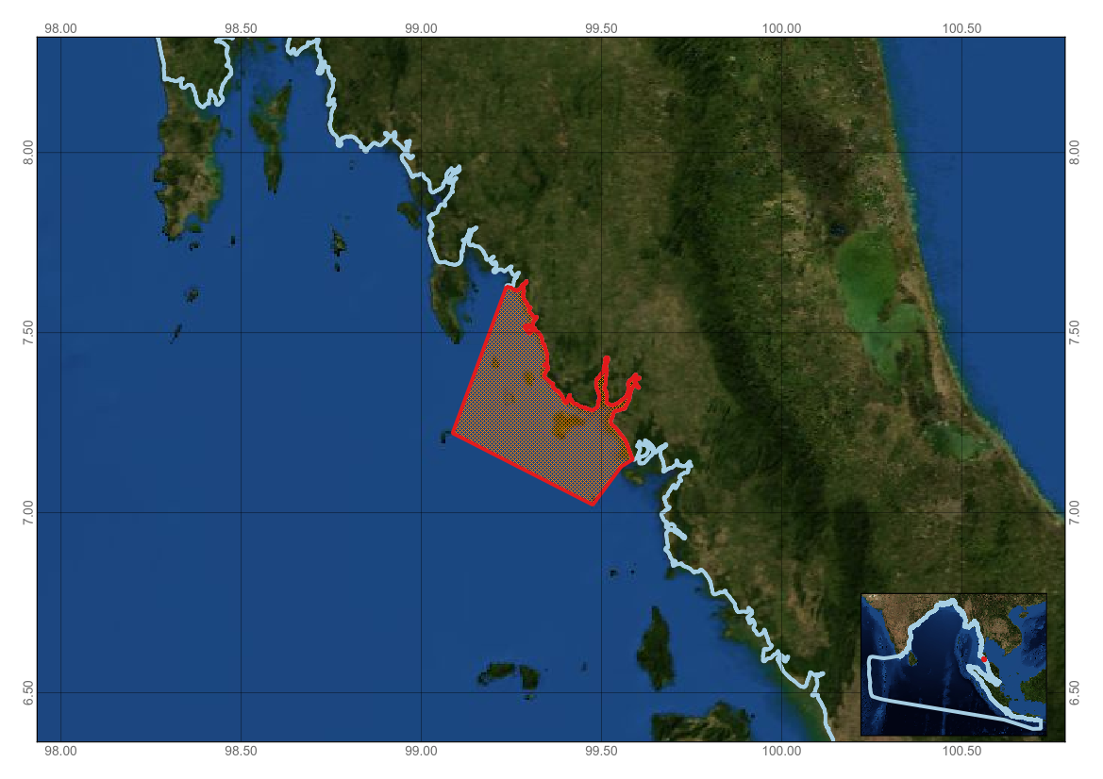

Figure 1. Area meeting the EBSA criteria

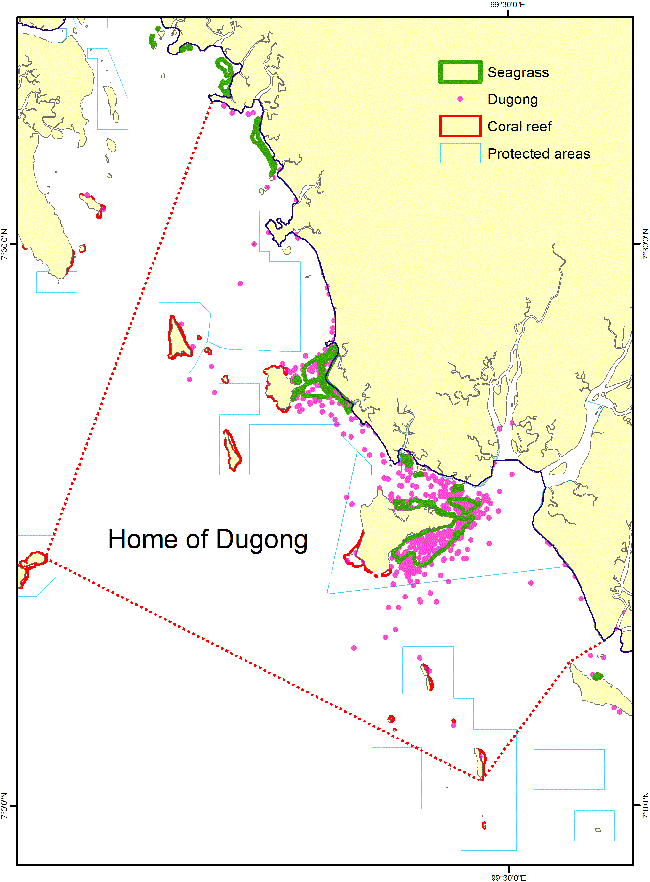
Figure 2. Distribution of seagrasses, dugongs, coral reefs and protected areas within the area meeting the EBSA criteria.

Rights and permissions
This document should not be referenced in whole or in part outside of its use in the CBD EBSA regional workshop.

Area No. 4: The Southern Coastal and Offshore Waters between Galle and
Yala National Park
Abstract
This is an area of high primary productivity within the northern Indian Ocean. It encompasses two submarine canyons known for enhancing productivity off the southern coast of the island, hosts high numbers of blue whales throughout the year, supports a number of other species of marine megafauna and covers a range of bathymetric contours ranging across the continental slope (important habitat for blue whales) to the abyssal plain. In particular, this area contains habitats supporting a year-round population of non-migratory blue whales; supports regular occurrences of 20 other cetacean species, five species of turtles, whale sharks, manta rays and four species of mobula ray; hosts the critically endangered hawksbill, endangered green and loggerhead turtles, and vulnerable olive ridley and leatherback turtles; and supports other marine predators such as tuna, billfish species and a number of species of sharks, including the bull and silky sharks.

Introduction
Ocean processes fundamentally determine the distribution, abundance and behaviour of marine organisms, including mobile species such as seabirds and cetaceans. In particular, the coastline of southern Sri Lanka has a combination of unique physical characteristics due to (1) the curvature of the coastline; (2) the narrow continental shelf that lies adjacent to one of the steepest continental slopes in the world (Sahini, 1982; Swan, 1983; Wijeyananda, 1997), which ranges from 0 to over 2,500 m in depth; (3) the presence of a submarine canyon at Dondra that potentially plays a role in enhancing local productivity (de Vos et al., in preparation-b); (4) a monsoonal regime with seasonally reversing currents; that, (5) lead to water exchange between the Bay of Bengal and the Arabian Sea, which have different temperature and salinity characteristics. Recent research by de Vos et al. (de Vos et al., 2014a) showed that the southern coast of Sri Lanka is unusually productive throughout the year. As a result, this environment poses questions regarding the influence of these topographical and physical features on resultant biological processes on blue whales and other megafauna inhabiting the region, particularly in its role as a biological hotspot.
This area also encompasses three of Sri Lanka’s six marine protected areas (Figure 3), namely, Rumassala Marine Sanctuary, Polhena Fishery Managed Area, and Great and Little Basses Fishery Managed Area (Perera and de Vos, 2007), as well as Rekawa and Godawaya sanctuaries, which extend 500 m into the ocean, further emphasizing the ecological and biological value of this area. Currently the main legislation governing these protected areas is the Fauna and Flora Protection Ordinance of 1993, which is administered under the Department of Wildlife Conservation (Perera and de Vos, 2007). As such, blue whales and all other cetaceans and sea turtles are protected within and outside the confines of these MPAs.

The feature description that follows reports on the physical oceanography of this uniquely productive equatorial zone and summarizes current knowledge about its biological diversity. It emphasizes the importance of this coastline as a feeding, breeding and calving area for a unique population of blue whales. The area is also located adjacent to the nesting beaches of five of the world’s marine turtle species and may also support juvenile manta rays and whale sharks, in addition to being a manta ray birthing ground. Furthermore the area contains a relatively understudied population of Brydeor a unique population of blue whales.feeding and calving area.
Location
The area extends along the south coast of Sri Lanka from Galle to the furthermost extent of Yala National Park (terrestrial) and offshore to the start of the abyssal plain.

Feature description of the area
Physical description
The climate in the Northern Indian Ocean is governed by two monsoon seasons that result from the unequal heating and cooling of the landmass to the north of the Indian Ocean. The Southwest monsoon occurs between June and October while the Northeast monsoon occurs between December and April, with two inter-monsoonal periods from April to May and October to November. As a result, there is a seasonal reversal in the open ocean currents that flow between the Arabian Sea and Bay of Bengal via Sri Lanka (Shankar, 2002), making the southern coast of the island a crucial mixing point for waters of two different temperature-salinity characteristics.
The seasonal difference in sea surface salinity (> 2 ppt) around Sri Lanka is highly significant compared to other regions (Levitus et al., 1994). Salinity in the Bay of Bengal is generally lower (< 33 ppt), whilst salinities in the Arabian Sea are higher, with maxima up to 36.5 ppt due to high evaporation and negligible freshwater input. The Bay of Bengal receives ~1500 km³yr⁻¹ of freshwater through run-off whilst the total freshwater input into the Arabian Sea is ~190 km³yr⁻¹ (Jensen, 2001). Including evaporation and rain, the Arabian Sea experiences a negative freshwater supply of about 1 myr⁻¹, whereas there is a positive freshwater supply of about 0.4 myr⁻¹ to the Bay of Bengal (Sengupta et al. 2006).
During the Southwest monsoon, the southern coast is influenced by the eastward flowing Southwest Monsoon Current. The winds during this period are shore-parallel and thus favourable to upwelling. Elevated nutrient and chlorophyll (Michisaki et al., 1995) levels during the Southwest monsoon provide evidence for the strong upwelling that develops between April and July (Shree Ram and Rao, 2005). During the Northeast monsoon, the southern coast is influenced by the westward flowing Northeast Monsoon Current, which while not favourable to upwelling, through an island-mass effect does give rise to localized upwelling. The major upwelling region, during both monsoon periods, is located along the south coast and results from flow convergence and associated offshore transport of water. Higher surface chlorophyll concentration values were observed during the Southwest monsoon. The location of the flow convergence and hence the upwelling centre is dependent on the relative strengths of wind-driven flow along the east and west coasts: during the Southwest (Northeast) monsoon the flow along the western (eastern) coast is stronger, and hence the upwelling centre is shifted to the east (west) (de Vos et al., 2014a).
The continental shelf around Sri Lanka is narrower, shallower and steeper than the world average (Wijeyananda, 1997). Its mean width is 20 km, and it is narrowest on the southwest coast, where it is less than 10 km (Shepard, 1963; Swan, 1983; Wijeyananda, 1997). The continental slope around Sri Lanka is a concave feature that extends from 100 m to 4,000 m in depth. The continental slope on the southern and eastern coasts has an inclination of 45º, which is one of the steepest recorded globally (Sahini, 1982). The abyssal plain around the island is 3,000-4,000 m deep (Swan, 1983).
Submarine canyons are more important sources of habitat heterogeneity, higher biodiversity, and biological productivity than their surroundings (Hickey, 1997). In Sri Lanka, the deep canyons adjacent to the coast create heterogeneous environments that attract marine megafauna (de Vos et al., 2012). The described area also encompasses two key submarine canyons, namely, the Dondra Submarine Canyon and the Little Basses Submarine Canyon (Swan, 1983). The head of the former canyon is 5 km from shore while the head of the Little Basses canyon begins 10 km from shore (Swan, 1983).
All these physical features combine to create an area where productivity is higher than in surrounding tropical waters, making it a distinct biological habitat of unique value.
Biological communities
The year-round productivity off the south coast of Sri Lanka provides habitats, migratory pathways and food sources for a number of species of charismatic megafauna (Table 1), many of which are listed as data deficient in the IUCN Red List of Threatened Species (The IUCN Red List of Threatened Species, 2014) and economically important species such as tuna (Table 3).
Blue whale habitat
The area is particularly important for its population of pygmy blue whales (Figure 5). The endangered blue whales in the Northern Indian Ocean (NIO) are a poorly studied subspecies (Brownell and Donahue, 1994; SMM Committee on Taxonomy, 2014). They breed six months out of phase with pygmy blue whales in the Southern Indian Ocean (Mikhalev, 2000), are morphologically distinct, and have unique acoustic calls (McDonald et al., 2006). Unlike other blue whale populations, the NIO population does not migrate annually to cooler waters, but remains in warm tropical waters year-round where they feed (Alling et al., 1991; de Vos et al., 2012). As such, its confinement to the Northern Indian Ocean makes it vulnerable to human activities.
A number of regions where pygmy blue whales aggregate have been identified (Best, 2003; Gill, 2002; Zemsky and Sazhinov, 1994), however sightings, strandings and acoustic data suggested that a portion of the population of the non-migratory NIO pygmy blue whales remain in Sri Lankan waters year-round (de Vos et al., 2014b). Within the waters of the south coast, blue whales have been documented engaging in courtship displays and in mother-calf pairs (de Vos, unpublished). More unusually, however, they form aggregations typical of feeding areas during the Northeast monsoon, where they are also seen defecating (de Vos et al., 2012). This observation provides good evidence for the fact that the blue whales are feeding in these lower latitude areas (Fiedler et al., 1998; Schoenherr, 1991), with the red colouration of their faeces indicating that they are feeding on sergestids (shrimps) (de Vos et al., in preparation).
Bryde’s whale habitat
Feeding Bryde’s whales and mother-calf pairs have been documented off the south coast within the described area (de Vos, unpublished). The population is currently understudied.
Turtle habitat
The southern coast of Sri Lanka supports populations of five species of sea turtles (Figure 4). Of these, the hawksbill turtle is considered critically endangered, and the green and loggerhead turtles are listed as endangered (The IUCN Red List of Threatened Species, 2014). Because the described area lies adjacent to key nesting beaches along the south coast of Sri Lanka, it represents important migratory paths for these species. Further, mating sea turtles (olive ridley and green turtles) are frequently recorded within these waters (de Vos, unpublished). A number of these species are regularly recorded entangled in fishing gear within these waters. Sri Lanka’s small nesting population of loggerhead turtles is potentially a separate genetic stock and has been severely depleted since the 1930s-1940s (Fitzsimmons and Limpus, 2014).
Manta and mobula ray habitat
Oceanic manta rays are occasionally sighted off the continental shelf edge within the described area (de Vos, unpublished; Wu, pers. comm.), occasionally encountered feeding on surface krill (Fernando, pers. comm.) and in some cases in close association with blue whales (de Vos, unpublished). Manta rays caught as either bycatch or target fisheries within this area have been juvenile sub-adults (Fernando and Stevens, 2011) representing some of the smallest (by disc-width) recorded manta rays in the world, leading to the suspicion that this region supports a birthing or nursery ground for this species (Fernando and Stevens, 2011) (Fernando et al., In prep). At least four species of Mobula have been recorded from fisheries operating within the described area.
Whale shark habitat
Little is known about the whale shark population in Sri Lankan waters. However, a number of sightings of juveniles within the described area make it particularly significant given the lack of data on these age classes (Michele Thums per. comm.)
Feature condition and future outlook of the area
As the main east-west route through the Northern Indian Ocean (NIO), the southern coast of Sri Lanka is home to some of the busiest shipping lanes in the world (Kaluza et al., 2010). Over 5,000 cargo ships greater than 10,000 GT transit this area every year—one cargo ship every two hours (Kaluza et al., 2010; Figure 2). Based on satellite-derived commercial shipping density data, it has been determined that southern Sri Lanka is in the top 0.2 per cent globally in terms of ship traffic (Eiden and Martinsen, 2010). This is approximately double the shipping traffic off of California’s Santa Barbara Channel, where measures are currently being taken to mitigate the risk of ship strikes with the Californian population of blue whales (Dettmer and Teufel, 2014; Redfern et al., 2013).
Tournadre (2014) noted a dramatic fourfold increase in global ship traffic between the early 1990s and present, with largest growth in the Indian Ocean and western Pacific Ocean. Increases within this region reflect the redistribution of international trade. This also highlights the growing threat to this unique population of non-migratory and potentially endangered blue whales. Thus, increased ship strikes could limit the recovery of this population, particularly due to increased economic activity in Sri Lanka following the end of secessionist hostilities (Ondaatjie, 2011), the construction of a new international port in Hambantota closer to blue whale foraging areas (Aneez, 2012) and the projected global doubling of large vessel traffic within the next two decades (Southall, 2005).
Besides the threat of ship strikes (a risk to all large whale species), this area also supports extensive tuna fisheries and an unregulated and growing whale-watch and whale diving tourism industry. Given all the cumulative anthropogenic activities occurring in this area, it could become a high-risk area for much of the megafauna species listed in this section should these activities not be effectively managed.
With respect to planned research, the Sri Lankan Blue Whale Project, the longest running research project on Northern Indian Ocean blue whales, has been conducting annual research in these waters since 2008. These research surveys collect data on all megafauna sighted and further document the potential threats occurring across the area of study. It is anticipated that this research will continue into the foreseeable future. Additionally, the Sri Lanka Mobulid Ray Project has been conducting surveys on mobulid fishery landings since 2011, and will continue into the foreseeable future with expansions to focus on the living populations of mobulid species and other elasmobranchs documented within this described area.

Assessment of the area against CBD EBSA Criteria

CBD EBSA Criteria  (Annex I to decision IX/20) | Description  (Annex I to decision IX/20) |  |  | Ranking of criterion relevance  (please mark one column with an X)
CBD EBSA Criteria  (Annex I to decision IX/20) |  |  |  | No information |  |  |  | Low | Medium |  |  |  | High
Uniqueness or rarity | Area contains either (i) unique (“the only one of its kind”), rare (occurs only in few locations) or endemic species, populations or communities, and/or (ii) unique, rare or distinct, habitats or ecosystems; and/or (iii) unique or unusual geomorphological or oceanographic features. |  |  |  |  |  |  |  |  |  |  |  | X
Explanation for ranking
Blue whales have been documented feeding on dense patches of krill in areas of cold, well-mixed and productive water that has upwelled along the coast due to wind driven alongshore currents (Fiedler et al., 1998; Gill, 2002; Palacios, 1999) or in offshore upwelling areas (Palacios, 1999; Reilly and Thayer, 1990). A clear relationship is seen between the development of these seasonal upwelling systems, enhanced productivity and the presence of blue whales (Gill, 2002). Off Sri Lanka, however, the major upwelling region, during both monsoon periods, is located along the south coast and results from flow convergence and associated offshore transport of water. Higher surface chlorophyll concentration values were observed during the Southwest monsoon (June-October) when shore parallel winds are favourable to upwelling, and in the Northeast monsoon (December-April) period enhanced chlorophyll concentrations occurred as a result of the island-mass effect. The location of the flow convergence and hence the upwelling centre was dependent on the relative strengths of wind-driven flow along the east and west coasts: during the SW (NE) monsoon the flow along the western (eastern) coast was stronger, and hence the upwelling centre was shifted to the east (west) (de Vos et al., 2014a). It is evident that Sri Lanka’s location within the heart of the Indian Ocean, leading to its monsoonal climate, coupled with the narrow continental shelf, steep slope and presence of submarine canyons, enables year-round productivity within its waters. This is evidenced by the fact that Northern Indian Ocean pygmy blue whales have been documented through sightings, strandings and acoustic detections year-round along the coastline (de Vos et al., 2014b).

This area is only one of two globally suspected oceanic manta ray nursery grounds, the other suspected to be along the Pacific coast of South America (Fernando, unpublished).
Special importance for life-history stages of species |  |  | Areas that are required for a population to survive and thrive. |  |  |  |  |  |  |  | X
Explanation for ranking
Within the waters of the south coast, blue whales have been documented engaging in courtship displays and in mother-calf pairs (de Vos, unpublished). The calves are considered some of the smallest recorded from around the world, indicating that this is potentially a calving ground for blue whales (John Calambokidis, pers. comm.). More unusually however, they form aggregations typical of feeding areas during the Northeast monsoon, where they are also seen defecating (de Vos et al., 2012). This observation provides good evidence for the fact that the blue whales are feeding in these lower latitude areas (Fiedler et al., 1998; Schoenherr, 1991). As such the area contains critical habitat for Northern Indian Ocean pygmy blue whales, including feeding, breeding and calving areas (de Vos, unpublished).
This area also supports the highest number of juvenile sub-adult manta rays recorded in the Indian Ocean (Fernando and Stevens, 2011; Fernando, in prep) and forms an important migratory corridor for five species of marine turtle that nest on the adjacent beaches throughout the south coast (Figure 4).
Importance for threatened, endangered or declining species and/or habitats |  | Area containing habitat for the survival and recovery of endangered, threatened, declining species or area with significant assemblages of such species. |  |  |  |  |  |  |  |  | X
Explanation for ranking
The physical processes occurring off this coast as a result of the unique physical characteristics of this coastline give rise to year-round high productivity areas (de Vos et al., 2014a) that support an endangered population of blue whales and vulnerable manta rays. Additionally, it provides a migratory path for one species of critically endangered and two species of endangered marine turtles (The IUCN Red List of Threatened Species, 2014).
Pygmy blue whales are listed as endangered by the IUCN Red List as well as Appendix I of the Convention on Migratory Species (CMS) and the Convention on the International Trade of Endangered Species (CITES). Hawksbill turtles are listed as critically endangered by the IUCN Red List and are an Appendix I species under both the CMS and CITES agreements.
The area provides further habitats for a range of other threatened and endangered species (Table 1 and 2).

Vulnerability, fragility, sensitivity, or slow recovery |  | Areas that contain a relatively high proportion of sensitive habitats, biotopes or species that are functionally fragile (highly susceptible to degradation or depletion by human activity or by natural events) or with slow recovery. |  |  |  |  |  |  | X
Explanation for ranking
Little research has focused on the current population status and ecology of NIO pygmy blue whales.
However, the decreased number of population due to previous whaling operation, can further aggravated by their vulnerability to ship strikes and underwater noise.
Their numbers are thought to be severely reduced due to illegal hunting in the Southern Ocean between 1963/64 and 1966/67 (Mikhalev, 1996). During these four seasons a total of 1,294 individuals were taken in the waters off the Seychelles, the Maldives, in the Gulf of Aden and off the west coast of southern India and Sri Lanka (Mikhalev, 1996) (Figure 6). Due to a lack of pre-exploitation and current population estimates, the impact of the removal of this number of individuals from the population is unclear. However, given the sizeable decrease in catch sizes following the 1964/65 season (during which 986 individuals were taken) (Mikhalev, 1996), it is likely that population size was quickly reduced to a low level. There has been no commercial or artisanal direct harvest since 1967. Before the catches in the 1960s, they were not hunted except for occasional individuals taken in the late 19th century (de Vos et al., in preparation-a).

The most significant threat faced by this population is the heavy ship traffic that navigates through the south coast of Sri Lanka on a daily basis. These shipping lanes overlap with prime blue whale habitat off the south coast, and deaths by ship strike have been documented (de Vos et al., 2013). While these incidents represent clear evidence of ship strike, confirmation of this nature is rare: it is often difficult to ascertain the cause of death of decomposed beached carcasses, and it is likely that most struck individuals do not strand or sink offshore without being documented (Allison et al., 1991). Williams et al. (2011) estimated that actual vessel strike mortality to baleen whales could be as much as ten times higher than observed, depending on location. Given this, it is likely that the events reported by de Vos et al. (2013) are a fraction of actual ship strikes, which may be a significant cause of mortality to this population. Based on the large number of whales killed by the whaling in the 1960s, the population should be considered depleted. Therefore, there is an urgent need to reduce any human-related mortality, especially ship strikes, as much as possible. It is also important to consider the cumulative pressures placed on this population by the significant number of human threats occurring in these nearshore waters.

Further, de Vos et al. (2012) documented consistently high levels of shipping noise, particularly off the south coast of Sri Lanka. The impact of this noise on NIO pygmy blue whales is unknown, however, studies on blue whales in the southern California Bight show that in the presence of ships their songs are disrupted, particularly foraging-related D-call production (Melcón et al., 2012), with the amplitude of calls increased in closer proximity to ships (McKenna et al., 2009; Melcón et al., 2012). Similarly, one blue whale has been recorded killed by ship strike within this area as a result of the heavy ship traffic (de Vos et al., 2013).

The critically endangered hawksbill turtle and the endangered green and olive ridley turtles are regularly recorded in these waters and quite often found entangled in fishing nets. As such they are highly susceptible to human activities occurring within this area.

Manta and mobula rays have some of the most conservative life history characteristics of shark and ray species recorded, and their very low productivity means that even a moderate level of fishing mortality would severely deplete their populations (Dulvy et al., 2014). Sri Lankan fisheries currently account for almost 50 per cent of global manta and mobula landings (Mundy-Taylor and Crook, 2013), with fishers reporting declines in manta ray landings over the past five years (Fernando, unpublished), highly indicative of imminent population collapse.
Biological productivity | Area containing species, populations or communities with comparatively higher natural biological productivity. |  |  |  |  |  |  |  |  |  | X
Explanation for ranking
Because of the physical processes occurring within this area, it is unusually productive relative to other tropical waters (de Vos et al., 2014a). During both monsoon periods, the major upwelling region off Sri Lanka is located along the south coast and results from flow convergence and associated offshore transport of water. Higher surface chlorophyll concentration values were observed during the Southwest monsoon (June-October), when shore-parallel winds are favourable to upwelling, and in the Northeast monsoon (December-April) period enhanced chlorophyll concentrations occurred as a result of the island-mass effect. The location of the flow convergence and hence the upwelling centre was dependent on the relative strengths of wind-driven flow along the east and west coasts: during the SW (NE) monsoon the flow along the western (eastern) coast was stronger and hence the upwelling centre was shifted to the east (west) (de Vos et al., 2014a). It is evident that Sri Lanka’s location within the heart of the Indian Ocean leading to its monsoonal climate coupled with the narrow continental shelf, steep slope and presence of submarine canyons enables year-round productivity within its waters. Similarly it is a calving area for blue and Bryde’s whales (de Vos, unpublished) – two species about which little is known about their breeding and calving habits. This area encompasses a potential manta nursery ground. Also lies adjacent and therefore is a transitory corridor for five of the world’s seven marine turtle species.

Biological diversity | Area contains comparatively higher diversity of ecosystems, habitats, communities, or species, or has higher genetic diversity. |  |  |  |  |  |  |  | X
Explanation for ranking
The area supports a wide range of megafauna species and their habitats, many of which are protected under CMS, CITES and IOTC (Table 2). These include pygmy blue whales, sperm whales, humpback whales, Risso’s dolphins, hawksbill turtles, olive ridley turtles, leatherback turtles, whale sharks, oceanic manta rays and thresher sharks. Additionally, it supports many species that are important to the wider Sri Lankan fishery (Table 3). These include skipjack and yellowfin tunas, swordfish, sailfish and marlins.
Naturalness | Area with a comparatively higher degree of naturalness as a result of the lack of or low level of human-induced disturbance or degradation. |  |  |  | X
Explanation for ranking
The naturalness of the area needs to be further explored, given the high levels of anthropogenic activities occurring within the area.

References

Maps and Figures

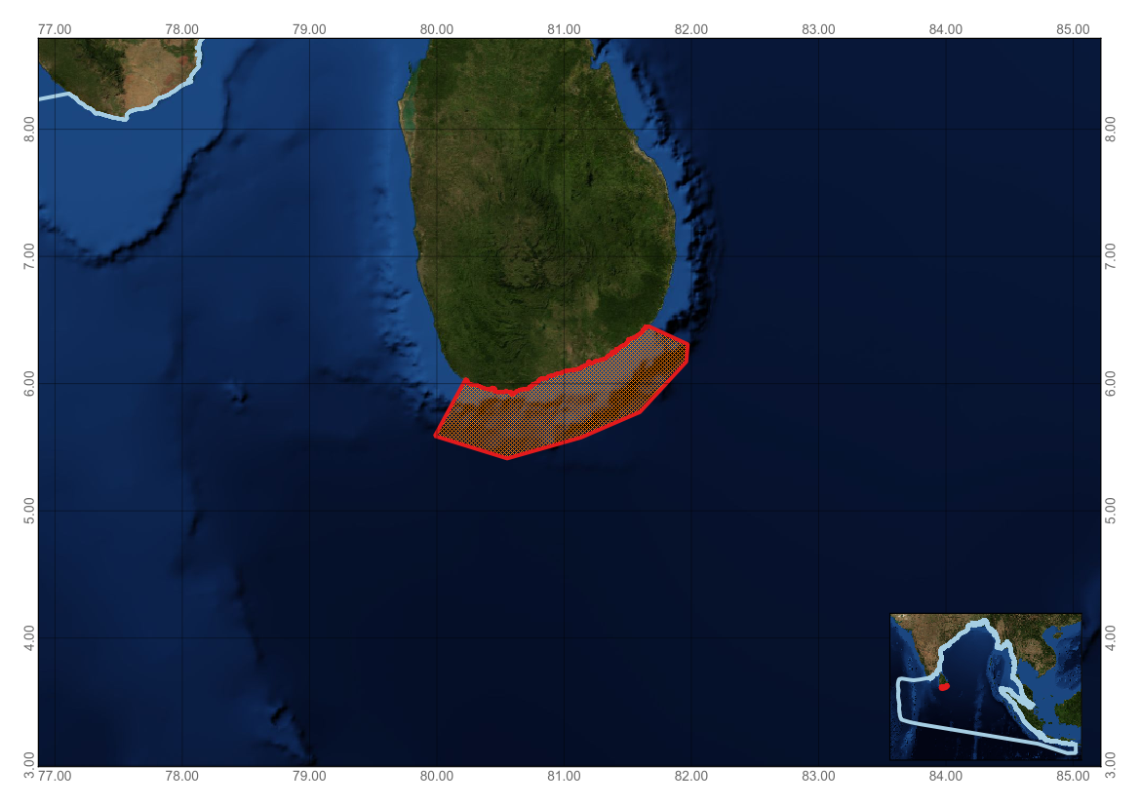

Figure 1. Area meeting the EBSA criteria

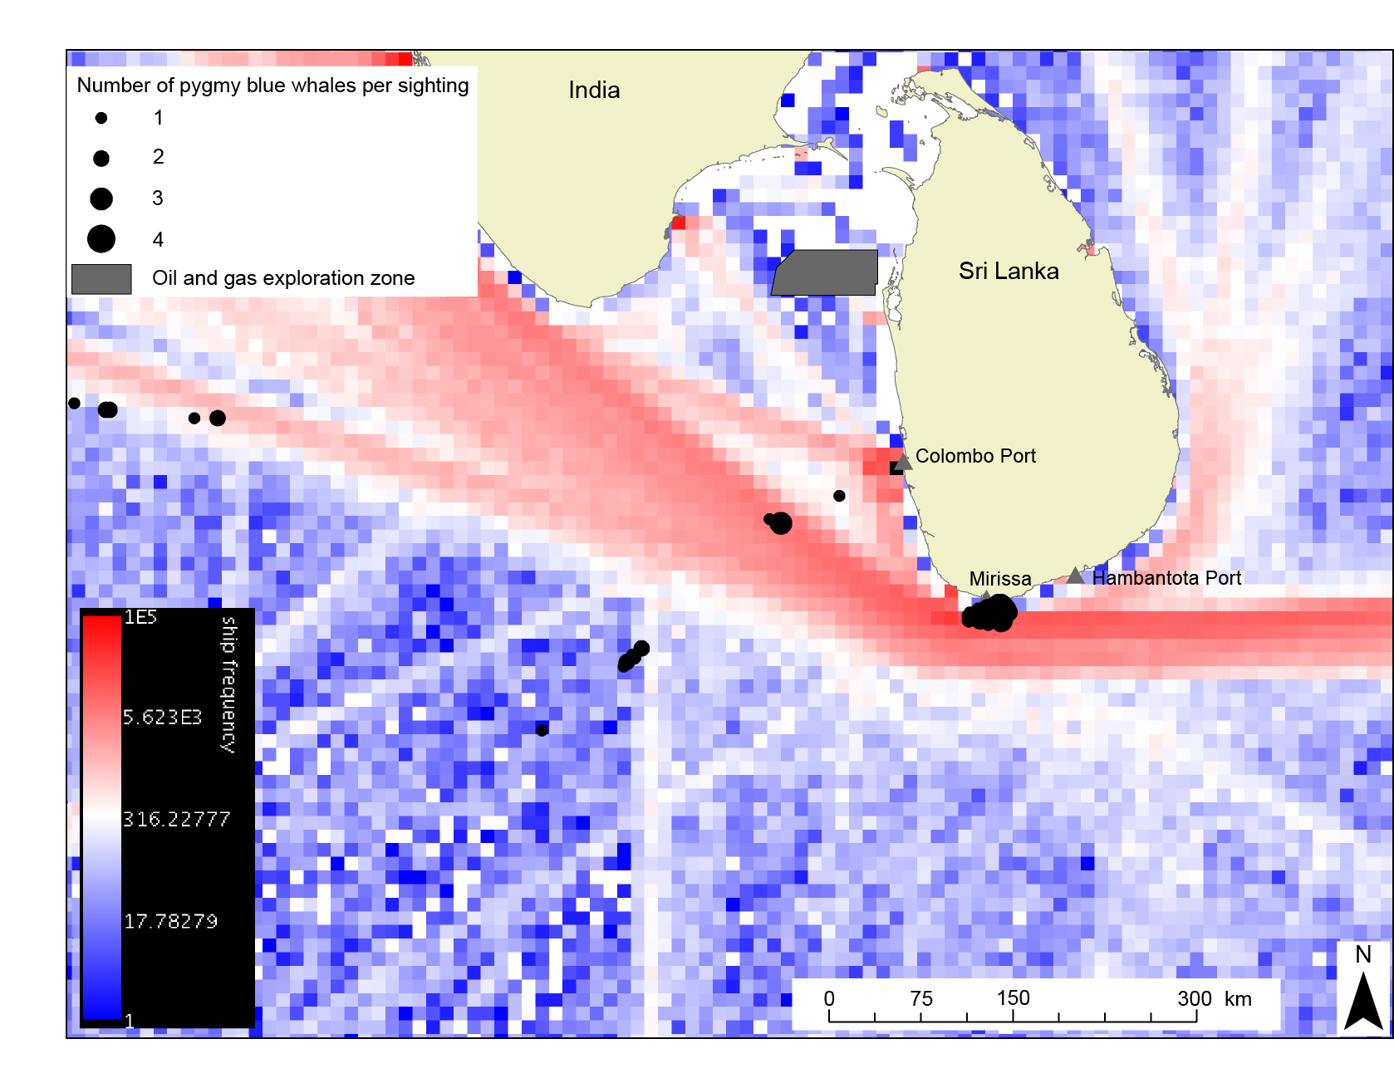Figure 2. Map showing ship traffic frequency (red-blue), seismic exploration zones within the Mannar Basin (grey box) and pygmy blue whale sightings (black dots) and areas of relevance around Sri Lanka. Data sources include Potemra (2012), National Aquatic Resources Research and Development Agency (2009), Ballance and Pitman (1998) and de Vos, unpublished data.

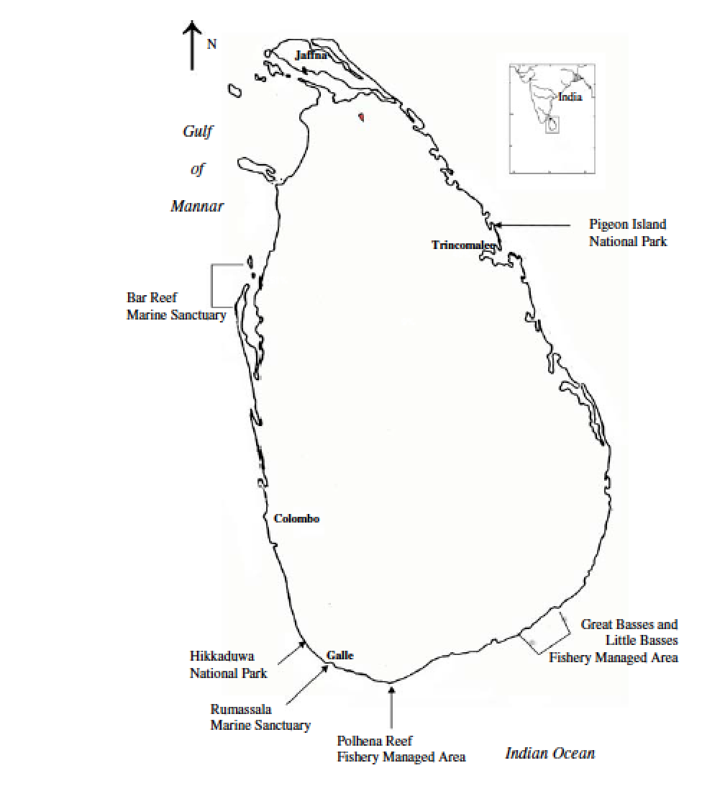
Figure 3. Location of MPAs in Sri Lanka (Perera and de Vos, 2007)
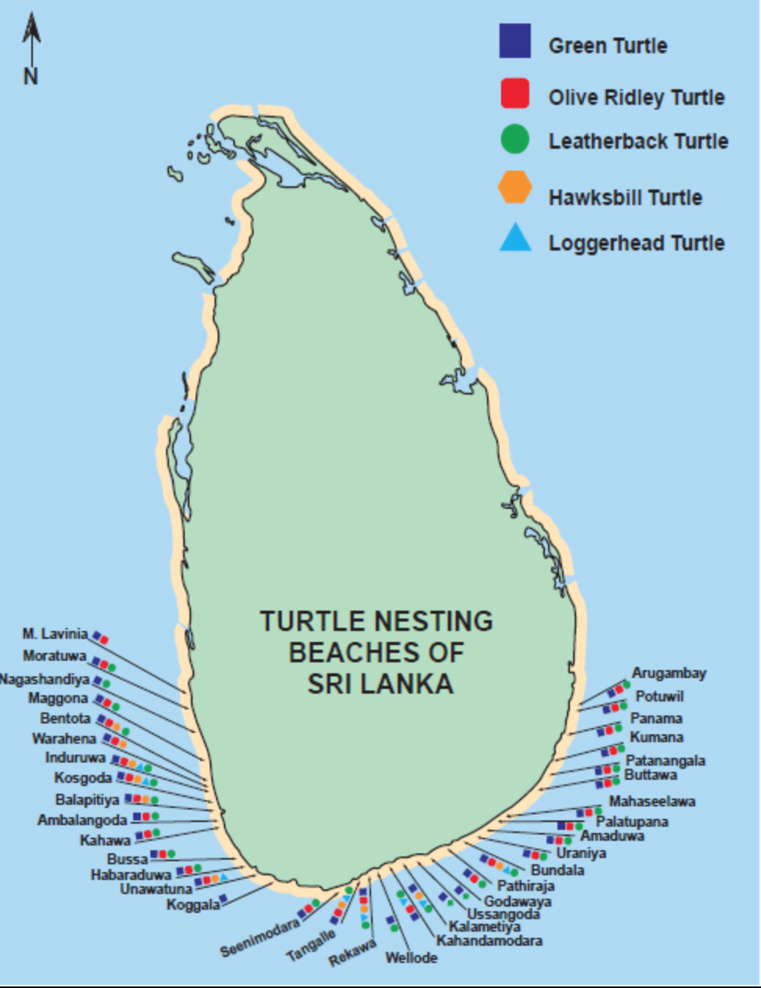

Figure 4. Sea-turtle nesting beaches around Sri Lanka. Map courtesy of The Turtle Conservation Project 2004.

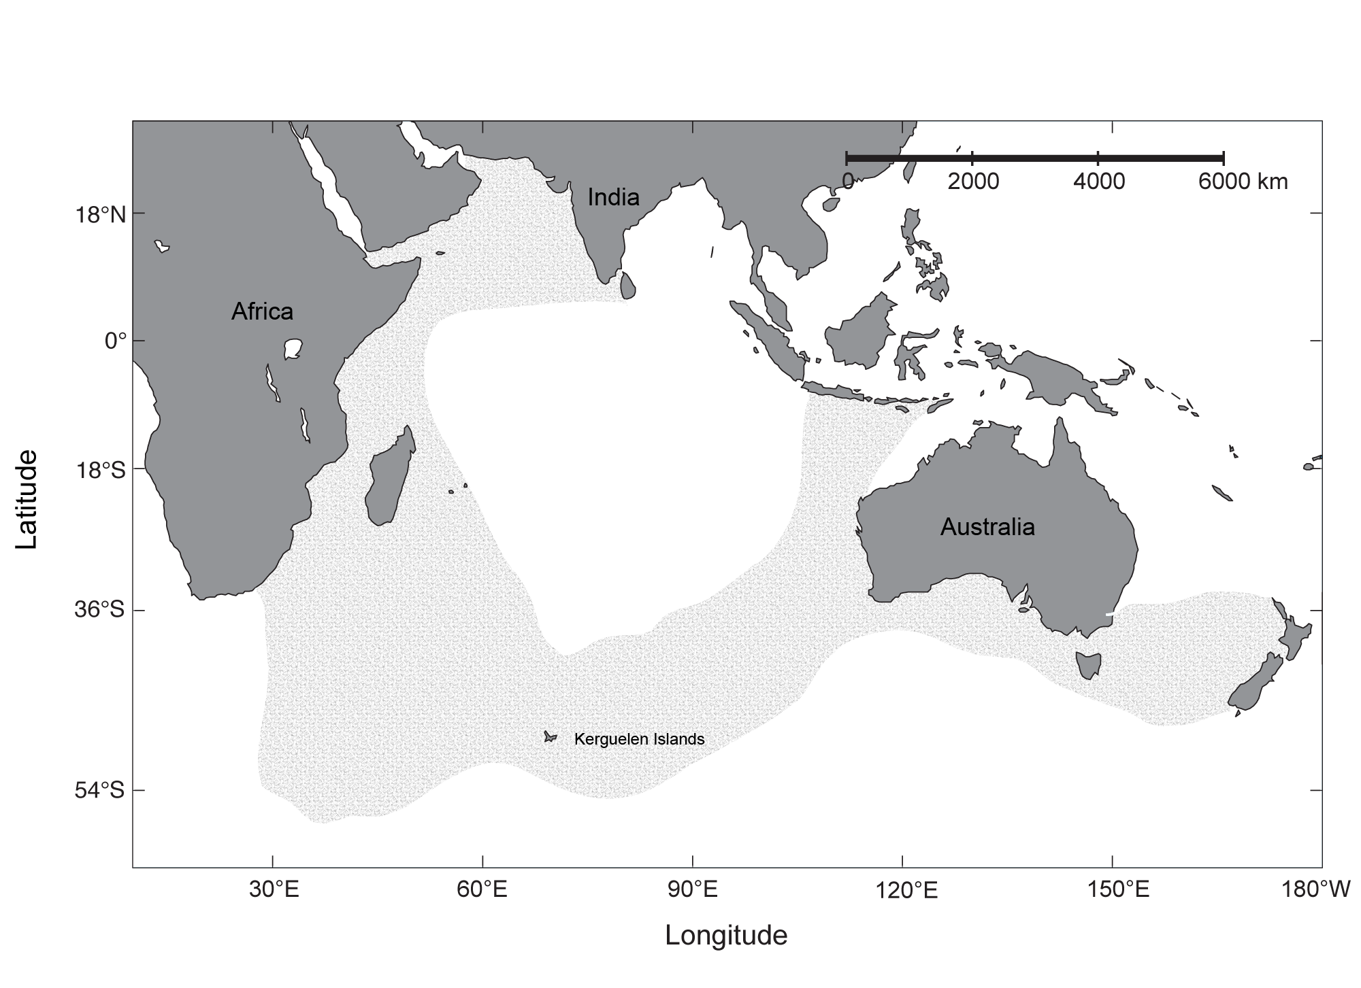

Figure 5: Distribution of pygmy blue whales (redrawn from Zemsky and Sazhinov, 1994).
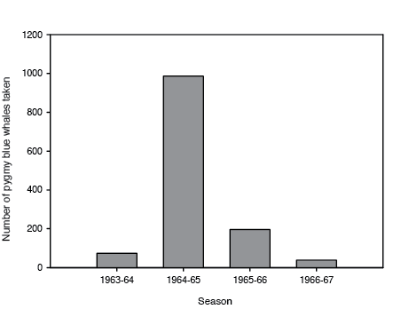
Figure 6. Number of pygmy blue whales taken during illegal whaling operations in the Northern Indian Ocean during the 1963/64 – 1966/67 seasons (Mikhalev, 1996).

Table 1. Table of significant megafauna species recorded off the southern coast of Sri Lanka (de Vos unpublished, Fernando unpublished, de Vos et al., 2012)
Common name | Scientific name | Red List Category
Cetaceans
Pygmy blue whale | Balaenoptera musculus indica | Endangered
Brydegeredale | Balaenoptera edeni | Data deficient
Humpback whale | Megaptera novaengliae | Least concern
Sperm whale | Physeter macrocephalus | Vulnerable
Bottlenose dolphin | Tursiops truncatus | Least concern
False killer whale | Pseudorca crassidens | Data deficient
Frasernt dolphin | Lagenodelphis hosei | Least concern
Melon-headed whale | Peponocephala electra | Least concern
Pantropical spotted dolphin | Stenella attenuata | Least concern
Risso’s dolphin | Grampus griseus | Least concern
Spinner dolphin | Stenella longirostris | Data deficient
Striped dolphin | Stenella coeruleoalba | Least concern
Pygmy sperm whale | Kogia breviceps | Data deficient
Dwarf sperm whale | Kogia simus | Data deficient
Short-finned pilot whale | Globicephala macrorhynchus | Data deficient
Killer whale | Orcinus orca | Data deficient
Cuviereficientd whale | Ziphius cavirostris | Least concern
Marine turtles
Hawksbill turtle | Eretmochelys imbricata | Critically endangered
Green turtle | Chelonia mydas | Endangered
Loggerhead turtle | Caretta caretta | Endangered
Olive Ridley turtle | Lepidochelys olivacea | Vulnerable
Leatherback turtle | Dermochelys coriacea | Vulnerable
Rays
Spine-tail devil ray | Mobula japanica | Near threatened
Sickle-fin devil ray | Mobula tarapacana | Data deficient
Bent-fin devil ray | Mobula thurstoni | Near threatened
Short-fin pygmy devil ray | Mobula kuhlii | Data deficient
Oceanic manta ray | Manta birostris | Vulnerable
Sharks
Leafscale gulper shark | Centrophorus squamosus | Vulnerable
Crocodile shark | Pseudocarcharias kamoharai | Near threatened
Bull shark | Carcharhinus leucas | Near threatened
Silky shark | Carcharhinus falciformis | Near threatened
Thresher shark | Alopias spp. | Vulnerable
Oceanic white tip shark | Carcharhinus longimanus | Vulnerable
Fish
Whaleshark | Rhincodon typus | Vulnerable

Table 2. Table of specific megafauna species recorded off the southern coast of Sri Lanka and status in Red List, CMS, CITES and Sri Lankan national legislation.

Common name | Scientific name | Red List Category | CMS | CITES | Sri Lankan legislation
Pygmy blue whale | Balaenoptera musculus indica | Endangered | Appendix I | Appendix I | Flora and Fauna Protection Ordinance (FFPO)
Sperm whale | Physeter macrocephalus | Vulnerable | Appendix I | Appendix I | FFPO
Brydedix Iale | Balaenoptera edeni | Data deficient | Appendix II | Appendix I | FFPO
Cuvierix Ieaked whale | Ziphius cavirostris | Least concern | Appendix I (includes all beaked whales) |  | FFPO
Hawksbill turtle | Eretmochelys imbricata | Critically endangered | Appendix I | Appendix I | FFPO
Green turtle | Chelonia mydas | Endangered | Appendix I | Appendix I | FFPO
Loggerhead turtle | Caretta caretta | Endangered | Appendix I | Appendix I | FFPO
Leatherback turtle | Dermochelys coriacea | Vulnerable | Appendix I | Appendix I | FFPO
Spine-tail devil ray | Mobula japanica | Near threatened | Appendix I & II | ---
Sickle-fin devil ray | Mobula tarapacana | Data deficient | Appendix I & II | ---
Bent-fin devil ray | Mobula thurstoni | Near threatened | Appendix I & II | ---
Short-fin pygmy devil ray | Mobula kuhlii | Data deficient | Appendix I & II | ---
Oceanic manta ray | Manta birostris | Vulnerable | Appendix I & II | Appendix II
Leafscale gulper shark | Centrophorus squamosus | Vulnerable
Thresher sharks | Alopias spp. | Vulnerable
Oceanic whitetip shark | Carcharhinus longimanus | Vulnerable | Appendix I & II | Appendix II
Whale shark | Rhincodon typus | Vulnerable |  | Appendix II

Note to Table 2: Blue whales worldwide, including in the NIO, are protected by a commercial hunting moratorium established by the International Whaling Commission (IWC), and trade is prohibited under The Convention on International Trade in Endangered Species of Wild Flora and Fauna (CITES). Sri Lanka is also located in the Indian Ocean Sanctuary (area north of 55ºS) established by the IWC in 1979 (Leatherwood and Donovan, 1991), but this does not provide any additional protection for these whales.

All cetaceans in Sri Lankan waters are protected under two laws: (1) the Fauna and Flora Protection Ordinance (Amendment) Act, No. 22 of 2009 and (2) the Fisheries and Aquatic Resources Act, No. 2 of 1996. While both Acts consider injury, removal and trade, and the sea mammal observation act outlines some regulations for maneuvering in the presence of marine mammals, none of them consider threats from vessel strike, entanglement and bycatch, oil and gas development and pollution — all activities that pose potential threats to the whales in these waters. This highlights the need for proper implementation of existing legislation and further development in light of known and predicted threats.

All sea turtles have been protected under the Flora and Fauna Protection Ordinance since 1974. Since 1979, Sri Lanka has also been a member of CITES, which prohibits the import or export of sea turtles and their products (Table 2).

Table 3. Part 1 - Commercially targeted species in Sri Lankan waters (Statistical unit, Ministry of Fisheries and Aquaculture).

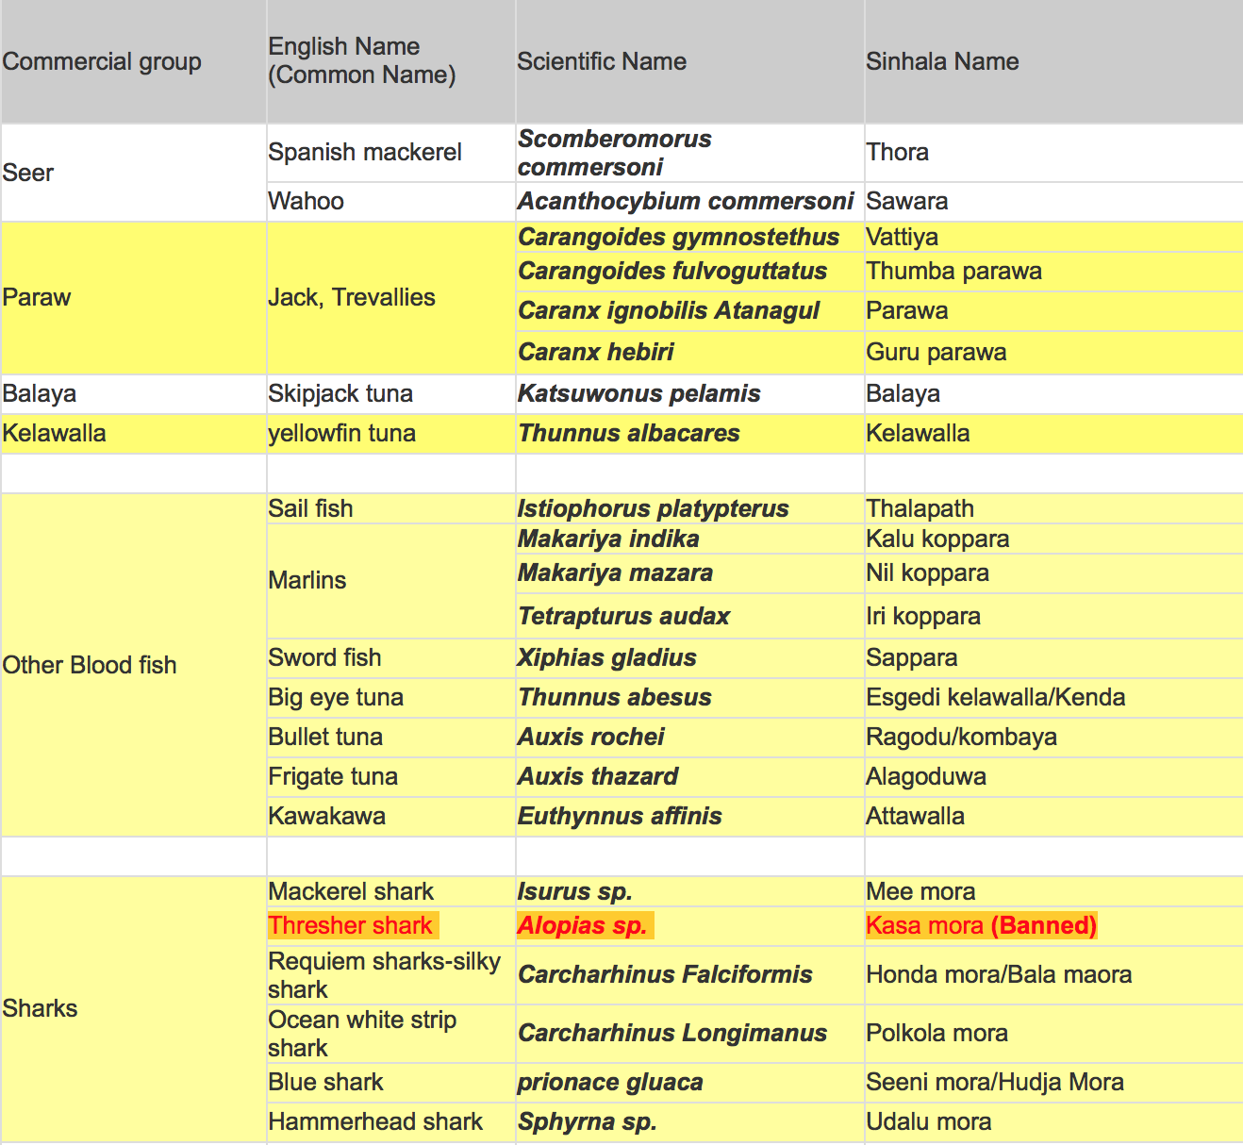
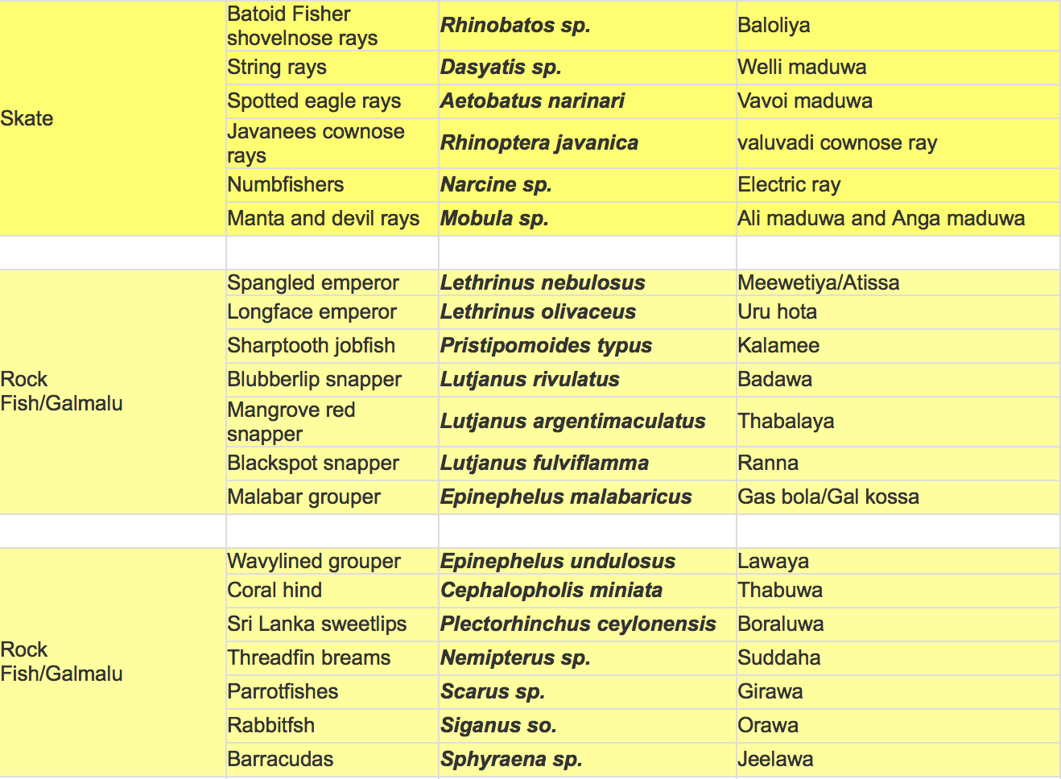

Table 3. Part 2 - Commercially targeted species in Sri Lankan waters (Statistical unit, Ministry of Fisheries and Aquaculture).

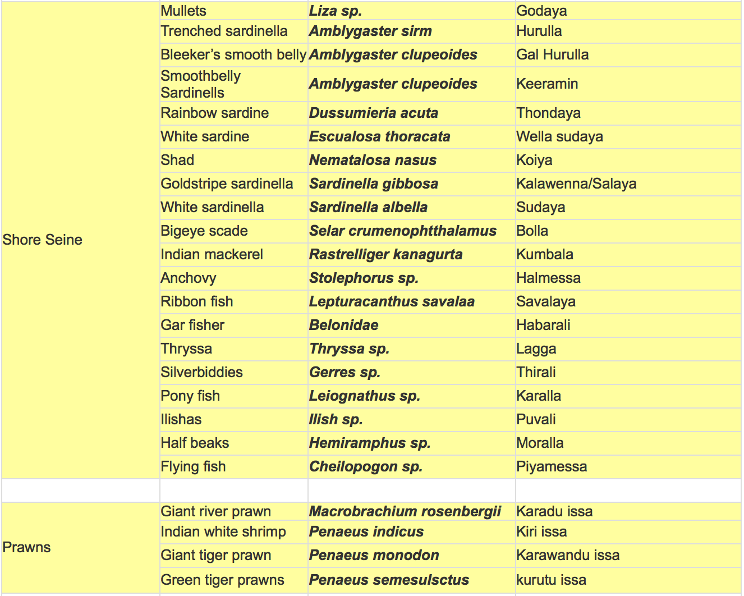
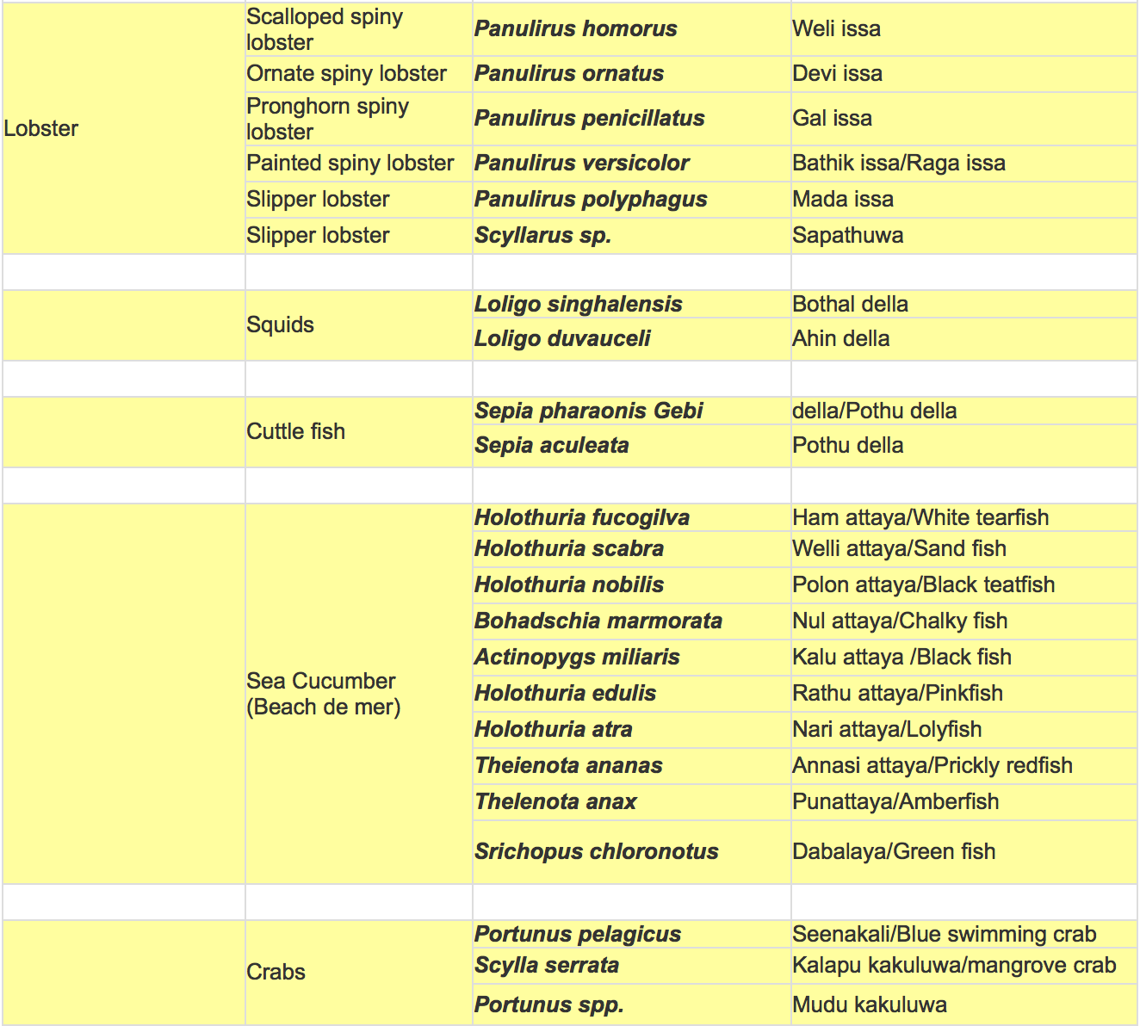

Area No. 5: Coastal and Offshore Area of the Gulf of Mannar
Abstract
The Gulf of Mannar (GoM) is one of the most biologically diverse coastal regions in the world. It is also among the largest remaining feeding grounds for the globally endangered dugong. Five different species of endangered marine turtles, mammals, innumerable fish, mollusks and crustaceans are also found here. The Gulf of Mannar region supports a variety of habitats within the main ecosystems of coastal lagoons, seagrass beds and coral reefs. Due to the high productivity of the area, it is an important fishing ground both for India and Sri Lanka.
Introduction
The GoM is an ecologically important critical habitat. The biodiversity of the ecosystems in the GoM is high and supports economically important resources, such as finfish, crustaceans, mollusks and marine plants. It is also the area of distribution of endangered dugong and sea turtles (Rajasooriya et al., 1995). The Indian part of the GoM was declared a marine biosphere reserve in 1989. The coral reef known as “Bar Reef”, located on the Sri Lankan side of the GoM, was declared a marine sanctuary in 1992. The Bar Reef Marine Sanctuary (BRMS) is the largest marine protected area (MPA) in Sri Lanka, covering an area of 306 km², located west of the Kalpitiya Peninsula in the northwestern coastal waters, bordering the Puttalam Lagoon ((Rajasooriya et al., 1995). Direct movement of several species of fish between the coral reefs of BRMS and the Puttalam Lagoon has been noted. Recent scientific information on the coastal and marine environment of the Sri Lankan side of GoM is scanty at best, and there are large information gaps, as the area was out of bounds for scientific research due to the internal conflict that prevailed in Sri Lanka during the last three decades.
An area situated in the coastal waters of the GoM was described as an area meeting the EBSA criteria at the Sothern Indian Ocean EBSA workshop (EBSA Area No. 33: Sri Lankan side of Gulf of Mannar, http://www.cbd.int/doc/meetings/mar/ebsa-sio-01/official/ebsa-sio-01-04-en.doc). Since that area covers only a few of the many sensitive marine habitats and species of the Sri Lankan part of the GoM, the previously described area has been enlarged here.
Location
The area is located off the coast of Sri Lanka, from Thalaimannar (9˚ 05̒ N, 79˚ 42̒ E) in the north to (8˚ 03̒ N, 79˚ 42̒ E), on the Kalpitiya peninsula, including Puttalam Lagoon.
Feature description of the area
The GoM generally has tropical weather conditions throughout the year due to its geographical location. This is the only location in Sri Lanka that has diverse coastal ecosystems (e.g., coral reefs, mangroves, seagrass beds, coastal sand dunes / spits and a large lagoon) in a single area. The shallow sea area in the northern parts comprises islands, sand dunes, forests, beaches and a nearshore environment, including a marine component with algal communities, seagrasses, coral reefs, pearl banks, salt marshes and mangroves. The nearshore ecosystems in the area are considered the most productive marine ecosystems, sustaining a large number of species and eco-sensitive habitats. Since the Gulf of Mannar comprises a variety of sensitive marine habitats, it could be considered one of the most productive ecosystems in Sri Lanka. Both finfish and shellfish species are rich in this area. This includes export-oriented fishery resources largely taken from this ecosystem, including spiny lobster, sea cucumber, chank (conch), shrimps and crabs. The finfish resources mainly comprise small pelagics (i.e., clupeids, mackerels, anchovies and flying fish) and large pelagics (i.e., tuna and tuna-like species). The demersal finfish resources mainly associated with the coral reefs include threadfin bream (Family: Nemipteridae), grouper (Family: Serranidae), snapper (Family: Lutjanidae), emperor (Family: Lethrinidae). Apart from that, the Gulf provides shelter for a number of endangered, threatened and protected (ETP) species (Table 1) (Haputhantri et al., 2014). In Sri Lanka, the largest coral reefs are found in the Gulf of Mannar from Kalpitiya Peninsula to Mannar Island. There are four large coral reefs, namely the Bar Reef on the west of the Kalpitiya Peninsula, Silavathurai, Arippu and Vankalai (Rajasuriya & White 1995). The dominant forms are branching, foliose and massive corals belonging to the generas Acropora, Montipora, Echinopora, Pocillopora and Porites (Rajasuriya et al. 1998). However, the overall species diversity of these reefs is very high, with more than a 100 species of reef-building corals recorded for the Bar Reef alone (Rajasuriya et al. 1998). The famous pearl banks of Sri Lanka are located to the west of the reef system, from Silavathurai to Vankalai.
The largest brackish water body, Puttalam Lagoon and Dutch Bay, along with Portugal Bay, with a total water surface of approximately 32,700 ha in Sri Lanka) is located within the GoM region (IUCN, 2003). The salt marshes and seagrass beds of Puttalam Lagoon and Dutch Bay provide feeding grounds for avifauna, especially for migratory waders (IUCN, 2003). Seagrass ecosystems are recognized as nursery grounds and habitats of a large number of marine aquatic organisms, including the threatened marine mammal, dugong (Dugong dugong). Seagrass beds in Mannar Bay, Portugal Bay and Dutch Bay have been reported to provide habitats for dugong (Colin & Bertram, 1970).

Table 1. Endangered, threatened and protected (ETP) marine species in the Gulf of Mannar*

Scientific Name | Common name | Abundance  (Very rare, Rare, Average, Common)
Family: Chelonidae
Chelonia mydas | Green turtle | Rare
Lepidochelis olivacea | Olive ridley turtle | Average
Eretmochelys imbricata | Hawksbill turtle | Rare
Caretta caretta | Loggerhead turtle | Rare
Family: Dermochelyidae
Dermochelys coriacea | Leatherback turtle | Rare
Family: Alopidae
Alopias sp | Thresher shark | Rare
Family: Dugonidae
Dugong dugong | Dugong | Very rare
Family: Kogiidae
Kogia sima | Dwarf sperm whale | Rare
Kogia breviceps | Pygmy sperm whale | Rare
Family: Delphinidae
Peponocephala electra | Melonheaded whale | Rare
Feresa attenutta | Pygmy killer whale | Rare
Delphinus capensis | Long beaked common dolphin | Average
Stenella coeruleoalba | Striped dolphin | Rare
Sousa plumbea | Indian Ocean hump-back dolphin | Rare
Stenella longirostris | Spinner dolphin | Common

* This is not an exhaustive list of all marine species in the area.
Source: Haputhantri et al., 2014
Important turtle foraging sites and migratory routes are located in the GoM. The GoM is known to be an important foraging site and a migratory route of the olive ridley population inhabiting the South Asian marine region (Kapurusinghe and Cooray, 2002).
Feature condition and future outlook of the area
The marine environment and the aquatic species on the Sri Lankan side of the GoM are threatened at present mainly due to use of harmful fishing methods/gear and extensive use of marine resources. Destructive fishing gear and methods are widely used for resource exploitation, and law enforcement was found to be weak (IUCN, 2003).
Assessment of the area against CBD EBSA Criteria
CBD EBSA Criteria  (Annex I to decision IX/20) | Description  (Annex I to decision IX/20) | Ranking of criterion relevance  (please mark one column with an X)
CBD EBSA Criteria  (Annex I to decision IX/20) | Description  (Annex I to decision IX/20) | No information |  |  | Low |  |  | Medium |  |  |  |  | High
Uniqueness or rarity | Area contains either (i) unique (“the only one of its kind”), rare (occurs only in few locations) or endemic species, populations or communities, and/or (ii) unique, rare or distinct, habitats or ecosystems; and/or (iii) unique or unusual geomorphological or oceanographic features. |  |  |  |  |  |  |  |  |  |  |  | X
Explanation for ranking
The only location in Sri Lanka that has a high diversity of coastal habitats (coral reefs, mangroves, seagrass beds, coastal sand dunes / spits, and a large lagoon) in a single area (IUCN, 2003).
Special importance for life-history stages of species | Areas that are required for a population to survive and thrive. |  |  |  |  |  |  |  | X
Explanation for ranking.
The GoM is known to be an important foraging site and a migratory route of the olive ridley population inhabiting the South Asian marine region (Kapurusinghe and Cooray, 2002). Seagrass ecosystems are recognized as nursery grounds and habitats of a large number of marine aquatic organisms, including the threatened marine mammal, dugong (Dugong dugong) (Colin & Bertram, 1970). Further research is needed to identify spawning and nursery grounds of the key species.
Importance for threatened, endangered or declining species and/or habitats | Area containing habitat for the survival and recovery of endangered, threatened, declining species or area with significant assemblages of such species. |  |  |  |  |  |  |  |  |  | X
Explanation for ranking
Presence of endangered and threatened dugong, turtles, dolphins and whales has been reported (Haputhantri et al., 2014), but detailed research is required to study the distribution and abundance of these species.
Vulnerability, fragility, sensitivity, or slow recovery | Areas that contain a relatively high proportion of sensitive habitats, biotopes or species that are functionally fragile (highly susceptible to degradation or depletion by human activity or by natural events) or with slow recovery. |  |  |  |  |  |  |  |  |  | X
Explanation for ranking
Almost all the reefs in the Gulf of Mannar region are very vulnerable and were negatively affected by the coral bleaching event in 1998 (Wilkinson et al. 1999, Rajasuriya 2002). The major climate-related bleaching events during the first half of 1998 destroyed many of the shallow-water corals in the reefs around Sri Lanka and in the Gulf of Mannar (Rajasooriya et al., 1995). Coral reefs in the Gulf of Mannar and in the east were also severely damaged because of a population explosion of the Crown-of-thorns starfish (Acanthaster planci), which is a predator of live corals (Rajasooriya, 2014).

Biological productivity | Area containing species, populations or communities with comparatively higher natural biological productivity. |  | X
Explanation for ranking
There are no publications related to the area’s biological productivity, and hence studies are required. Northern waters, including Gulf of Mannar and Palk Bay, show high chlorophyll concentrations (> 0.8 mg m⁻³) throughout the year (Yapa, 2000; Jayasiri and Priyadarshanie, 2007).

Biological diversity | Area contains comparatively higher diversity of ecosystems, habitats, communities, or species, or has higher genetic diversity. |  |  |  |  |  |  |  |  |  | X
Explanation for ranking
The described area is characterized by a number of sensitive ecosystems that support high species diversity. Bar reef supports a large species diversity and abundance of fish, invertebrates and other organisms (Ohman et al., 1993). A total of 138 species of stony corals and more than 300 reef and reef-associated fish have been reported in Bar Reef Sanctuary (Rajasooriya et al., 1995). A high diversity of phyto- and zooplankton has been reported in the Gulf of Mannar (Jayasiri and Priyadarshanie, 2007). A survey conducted in the Gulf reported 16 species of holothurians. Holothuria atra is one of the most common species in the pearl banks (Dissanayaka and Wijeratne, 2007). Three species of commercially important crabs, Portunus pelagicus, Portunus sanguinolentus (blue swimming crab) and Scylla serrata (lagoon crab), are found in the area (De Bruin et al., 1997).

Naturalness | Area with a comparatively higher degree of naturalness as a result of the lack of or low level of human-induced disturbance or degradation. |  |  |  |  |  | X
Explanation for ranking
The area is subject to a high level of human-induced disturbances, land-based pollution, climatic impacts and bio-invasion.

References
Colin, C. & Bertram, K., 1970. The dugongs of Ceylon. Loris, 12 (1): 53 - 55 pp
Dissanayaka. D.C.T and Wijeratne, M.J.S 2007. Studies on Seacucumber fisheryin the northwestern region of Sri Lanka. Sri lanka Journal of Aquatic Sciences. 12:19-38.
IUCN, 2003. Biodiversity in Puttalam Lagoon with special reference to poverty alleviation in coastal villages of Vanathagilluwa.
Haputhantri, S.S.K., M.G.I. Rathnasuriya and M. Jayathilaka, 2014. Conduct a rapid survey on the extractive uses of living resources in the Gulf of Mannar. In V. Pahalawaththaarachchi and Haputantri S.S.K. (eds.). Living resources in the Gulf of Mannar: Assessment of key species and habitats for enhancing awareness and for conservation policy formulation. Report submitted to IUCN Sri Lanka.
Jayasiri, H.B. and Priyadarshanie, W.N.C. 2007. Diversity and abundance of marine plankton and benthos of selected locations of Gulf of Mannar and Palk Bay, Sri Lanka, Journal of National Aquatic Resources Research & Development Agency, 38:45-59.
Kapurusinghe, T.R. and Cooray, 2002. Marine Turtle by-catch in Sri Lanka. Survey report: ISBN 955-8758-01-9.
Rajasooriya, A., 2014. Field guide to reef fishes of Sri Lanka. Vol. 2 Colombo: IUCN Sri Lanka
Rajasuriya, A. 2002. Status Report on the Condition of Reef Habitats in Sri Lanka 2002. pp.139-148. In: O. Linden, D. Souter, D. Wilhelmsson & D. Obura (ed.) Coral Reef Degradation in the Indian Ocean: Status Report 2002, CORDIO, Department of Biology and Environmental Science, University of Kalmar, Sweden
Rajasuriya, A., Karunarathna, M.M.C., Vidanage, S. and Gunarathna, A.B.A.K. 2000. Status of coral reefs in Sri Lanka; community involvement and the use of data in management. National Aquatic Resources Research and Development Agency, Colombo, Sri Lanka. Paper presented to the 9ICRS
Rajasuriya, A., M.C. Ohman & S. Svensson. 1998. Coral and Rock Reef Habitats in Southern Sri Lanka: Patterns in the Distribution of Coral Communities. AMBIO 27: 8: 723-728.
Rajasuriya, A, Zahir, Hmuley, . E.V. Subramanian, B.R. Venkataraman, K. wafar, M.V.M. Munjurul Hannan Khan, S.M. and Whittingham, E. 2000. Proceedings of the Ninth International Coral Reef Symposium, Bali, 23-27 October 2000. Vol. 2. eds. by: Moosa, M.K.; Soemodihardjo, S.; Soegiarto, A.; Romimohtarto, K.; Nontji, A.; Soekarno; Suharsono. 841-845p.
Rajasuriya, A., M.W.R.N. De Silva & M.C. Ohman. 1995. Coral reefs of Sri Lanka: Human distrubance and management issues. AMBIO 24: 428-437EN.REFLISTRajasuriya, A. & A.T. White. 1995. Coral reefs of Sri Lanka: Review of their extent, condition and management status. Coastal Management 23: 77-90.
Wilkinson, C., O. Linden, H. Cesar, G. Hodgson, R. J & A.E. Strong. 1999. Ecological and Socioeconomic Impacts of 1998 Coral Mortality in the Indian Ocean: An ENSO Impact and a Warning of Future Change? AMBIO 28, 2: 188-196.
Yapa, K.K.A.S. 2000. Seasonal variability of sea surface chlorophyll-a of waters around Sri Lanka, Proc. Indian Acad. Sci. (Earth. Planet. Sci.), 109, 427-432pp.

Maps and Figures

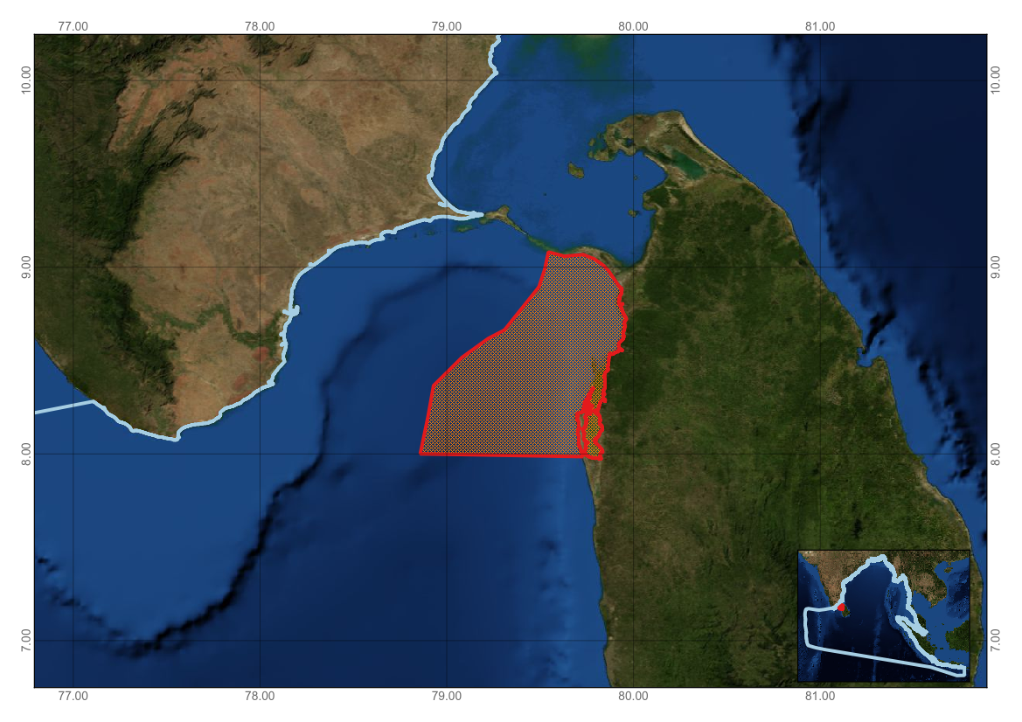

Figure 1. Area meeting the EBSA criteria

Area No. 6: Trincomalee Canyon and Associated Ecosystems
Abstract
Trincomalee is a multiple submarine canyon complex, the largest in the country, and one of the twenty largest submarine canyons in the world. Trincomalee Bay is unique and hosts one of the world’s largest natural harbours connected to a deep canyon located on the east coast of Sri Lanka. Trincomalee Canyon and associated ecosystems are biologically rich and important areas, especially for globally endangered sperm whales and blue whales. Adjacent ecosystems include coral reef ecosystems.
Introduction
Trincomalee Bay is unique and hosts one of the world’s largest natural harbours connected to a deep canyon located on the east coast of Sri Lanka. The submarine canyon extends more than 40 km with an average slope of about 1/18. The volume of the bay is approximately 1000 km³ (Wijeratne and Pattiarachi, 2010; Wijayananda, 1985). Associated environments include coral reef ecosystems that are located at Nilaveli (Pigeon Island and Coral Island), Dutch Bay, Back Bay, Coral Cove and Foul Point. There are also some small coral patches within the Trincomalee Harbour and in embayments along the eastern coast outside of the harbour. Coral reefs in Trincomalee are the only known reefs in Sri Lanka that escaped a major coral bleaching event in 1998 (Rajasuriya et al., 2005).
Location
The area is located between 81.17E 8.43N and 81.63E, 9.02N in nearshore waters adjoining the Trincomalee Harbour, in the Eastern Province of Sri Lanka. It covers 1,500 km².
Feature description of the area
Koddiyar Bay and the inner harbour of Trincomalee Bay are exceptionally deep protected natural harbours with exceptional depths (30 metres) close to shore. Large portions of the area are protected from oceanic waves. The west coast of the Bay of Kinniya is home to a wide sand beach formed by monsoon waves in November. The opening of the Trincomalee Bay is a large, 2- 3-metre- deep water body (Thampalagamam Bay), which is said to hold water of fairly stable salinity (NECCDEP (2010).
High concentrations of cetaceans, including sperm whales, have been reported in the Trincomalee Bay area (Gordon, 1991). Other significant species recorded in the area include pygmy blue whales, sea turtles and whale sharks. The whales of Trincomalee have become world famous as they were featured in two award-winning documentaries, "Whales Weep Not" and les Weep Not"ee have bec, featuring blue whales and sperm whales in their natural habitats. However, both research and commercial whale watching in Trincomalee diminished in the late 1980s due to escalating internal conflicts in Sri Lanka. Following the cessation of this conflict, the whales of Trincomalee have gained increased attention (Ilangakoon, 2002; Nanayakkara, 2014).
The area is home to important foraging sites and migratory routes for sea turtles, and nesting has been recorded in Pigeon Island National Park (IUCN/CEA, 2006).

Table 1. Endangered, threatened and protected (ETP) marine species in Trincomalee Canyon and Associated Ecosystems

Scientific Name | Common name | Abundance  (Very rare, Rare, Average, Common)
Chelonia mydas | Green turtle | Average
Lepidochelis olivacea | Olive ridley turtle | Average
Eretmochelys imbricata | Hawksbill turtle | Rare
Caretta caretta | Loggerhead turtle | Rare
Dermochelys coriacea | Leatherback turtle | Rare
Balaenoptera musculus | Blue whale | Common
Balaenoptera edeni | Bryde’s whale | Average
Kogia sima | Dwarf sperm whale | Common
Feresa attenutta | Pigmy killer whale | Rare
Delphinus delphis | Short beak common dolphin | Average
Stenella coeruleoalba | Striped dolphin | Rare
Sousa chinensis | Indo-Pacific humpbacked dolphin | Rare
Stenella longirostris | Spinner dolphin | Common
Source: Nanayakara, 2014;
Feature condition and future outlook of the area
Trincomalee is home to the following protected areas: Pigeon Island National Park (471 ha), which protects coral reefs, and Little and Greater Sober Island Sanctuary (71 ha), which protects seabird colonies.
Presently there is virtually no information about the offshore pelagic environment of Trincomalee (NECCDEP 2010), and further study is needed for this area.
Assessment of the area against CBD EBSA Criteria
CBD EBSA Criteria  (Annex I to decision IX/20) | Description  (Annex I to decision IX/20) | Ranking of criterion relevance  (please mark one column with an X)
CBD EBSA Criteria  (Annex I to decision IX/20) | Description  (Annex I to decision IX/20) | No information |  | Low |  |  | Medium |  | High
Uniqueness or rarity | Area contains either (i) unique (“the only one of its kind”), rare (occurs only in few locations) or endemic species, populations or communities, and/or (ii) unique, rare or distinct, habitats or ecosystems; and/or (iii) unique or unusual geomorphological or oceanographic features. |  |  |  |  |  |  |  | X
Explanation for ranking:
Trincomalee is a multiple submarine canyon complex, the largest in the country, and one of the 20 largest submarine canyons in the world. The canyon begins in the Koddiyar and Trincomalee bays. The walls of the canyon are 1350 metres high and are made of hard granitic and quartzitic rocks. It runs seaward as a gorge for over 60nusual geomorphological of 3350-3600 metres as a fan valley with natural levees of debris. The Trincomalee Canyon is created by the runoff from the largest river in Sri Lanka, the Mahaweli. The area is home to a number of coral reef habitats, mud flats, fjords and feeding grounds for sperm whales (Wijeratne and Pattiarachi, 2010; Wijayananda, 1985; Swan, 1983; Stewart, 1964).
Special importance for life-history stages of species | Areas that are required for a population to survive and thrive. | X
Explanation for ranking.
Research is needed to identify spawning and nursery grounds of key species in the area. The area is home to important feeding and breeding sites for a large number of marine vertebrates and invertebrates (NECCDEP 2010; Ilangakoon 2012; Rajasuriya 2010).
Importance for threatened, endangered or declining species and/or habitats | Area containing habitat for the survival and recovery of endangered, threatened, declining species or area with significant assemblages of such species. |  |  |  |  |  |  |  | X
Explanation for ranking
A total of 11 species of cetaceans have been identified in the area, including two species of baleen whales (Mysticeti), namely, blue whale (Balaenoptera musculus) and brydel of 11 spBalaenoptera edeni), and nine species of toothed whales (Odontoceti), namely, sperm whale (Physeter macrocephalus), killer whale (Orcinus orca), dwarf sperm whale (Kogia sima), longmanperm whale ( tootIndopacetus pacificus), false killer whale (Pseudorca crassidens), rough-toothed dolphin (Steno bredanensis), bottlenose dolphin (Tursiops truncates), striped dolphin (Stenella coeruleoalba), and spinner dolphin (Stenella longirostris) (Nanayakakra, 2014).
Vulnerability, fragility, sensitivity, or slow recovery | Areas that contain a relatively high proportion of sensitive habitats, biotopes or species that are functionally fragile (highly susceptible to degradation or depletion by human activity or by natural events) or with slow recovery. | X
Explanation for ranking
More research is required to assess the vulnerability of species and ecosystems in the area.

Biological productivity | Area containing species, populations or communities with comparatively higher natural biological productivity. | X
Explanation for ranking
Research on the biological productivity of the area is needed.
Biological diversity | Area contains comparatively higher diversity of ecosystems, habitats, communities, or species, or has higher genetic diversity. |  |  |  |  |  |  |  | X
Explanation for ranking
The area is characterized by number of sensitive ecosystems that support high species diversity, including globally threatened whale sharks, blue and sperm whales, and marine turtles (NECCDEP 2010; Ilangakoon 2012; Rajasuriya 2010).
Naturalness | Area with a comparatively higher degree of naturalness as a result of the lack of or low level of human-induced disturbance or degradation. |  |  |  |  |  |  | X
Explanation for ranking
The area is affected by uman-induced disturbances, including land-based pollution and coral bleaching (Rajasuriya A. 2012).

References
Gordon J.C.D., (1991): The World Wildlife Fund’s Indian Ocean Sperm Whale Project: An Example of Cetacean Research within the Indian Ocean Sanctuary.
Ilangakoon A.D. (2012): A review of cetacean research and conservation in Sri Lanka. J. CETACEAN RES. MANAGE. 12(2): 177–183
Illangakoon A (2002): Whales and Dolphins, Sri Lanka. WHT Publications (Private) Limited, Sri Lanka.
IUCN Sri Lanka and the Central Environmental Authority (2006) National Wetland Directory of Sri Lanka, Colombo, Sri Lanka. http://www.cea.lk/web/images/pdf/7-1.Book-National-Wetland-Directory-Low%20res%281%29.pdf
Nanayakkara R.P., Herath J., de Mel R.K (2014): Cetacean Presence in the Trincomalee Bay and Adjacent Waters, Sri Lanka. Journal of Marine Biology, Volume 2014, Hindawi Publishing Corporation
NECCDEP (2010). Trincomalee District Coastal Resources Profile. Final. January 2010. Pp. 168. ANZDEC Ltd., Resource Development Consultants. ADB LOAN 2027 SRI (SF): North East Coastal Community Development Project (NECCDEP).
Rajasuriya A (2012). Provisional Checklist of Corals in Sri Lanka. In: The National Red List 2012 of Sri Lanka; Conservation Status of the Fauna and Flora. Weerakoon, D.K. & S. Wijesundara Eds., Ministry of Environment, Colombo, Sri Lanka.
Rajasuriya A (2010): Survey Report on Marine Biodiversity of Shell Bay, Trincomalee. National Aquatic Resources Research and Development Agency.
Rajasuriya, A., Perera Nishan and Fernando Malik (2005) Status of Coral Reefs in Trincomalee, Sri Lanka. In: Souter D and Linden O, eds. Coral Reef Degradation in the Indian Ocean: Status Report 2005.
Rajasuriya A. ( 2005). Status of coral reefs in Sri Lanka in the aftermath of the 1998 coral bleaching event and 2004 tsunami. In: Souter D and Linden O, eds. Coral Reef Degradation in the Indian Ocean: Status Report 2005. University of Kalmar, Sweden: CORDIO, Department of Biology and Environmental Science, University of Kalmar, Sweden. 83 - 96.
Status of coral reefs of Sri Lanka. http://www.cordio.org/reports/cordio_report_2005_part1.pdf
Stewart, H.B., Shepard, F.P., and R. S. Dietz (1964): Submarine canyons off Eastern Ceylon,” Geological Abstracts America, vol. 82, article 197.
Swan B. (1983): An Introduction to the Coastal Geomorphology of Sri Lanka, National Museums of Sri Lanka, Colombo, Sri Lanka.
Wijayananda N.P (1985): Geological setting around the heads of the Trincomalee canyon, Sri Lanka. j. Natn. Sci. Coun. Sri Lanka 1985 13(2): 213 – 226.
http://thakshana.nsf.ac.lk/pdf/JNSF1-25/JNSF13_2/JNSF%2013_2_213.pdf
Wijeratne E.M.S and Pattiarachi C.B (2010): Impact of Internal Tides on Sound Propagation and Sea Levels in Trincomalee Bay/Canyon, Sri Lanka. Proceedings of the 15th Physics of Estuaries and Coastal Seas (PECS) Conference, Colombo, Sri Lanka, 14-17 September 2010
Maps and Figures
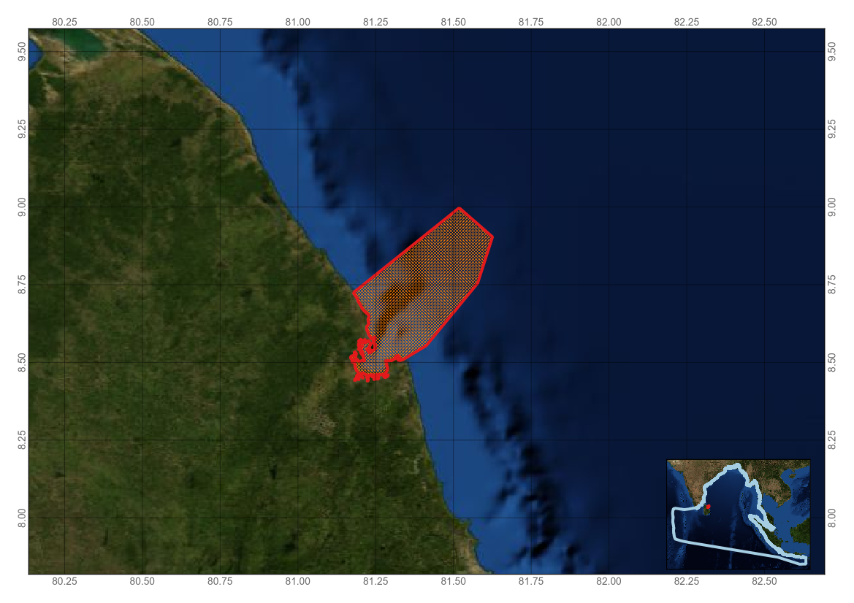
Figure 1. Area meeting the EBSA criteria
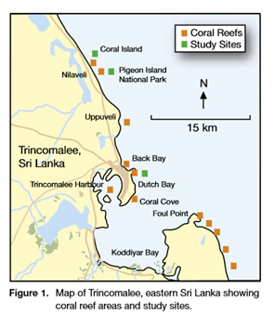
Figure 2. Map of Trincomalee, eastern Sri Lanka, showing coral reef and study areas (Source: Rajasuriya et al. 2005).
Area No. 7: Rasdhoo Atoll Reef
Abstract
Rasdhoo Atoll is among the few small atolls in Maldives with special ecological features. The atoll has four islands and three sandbanks. The channel between Rasdhoo Island and Madivaru Island is known as a famous diving site to spot hammerhead sharks, which can be seen in abundance throughout the year at depths of 25 to 60 metres. Since the atoll is isolated and surrounded by deep sea, it acts as a sanctuary for the juvenile fishes to grow in safety at its shallow atoll rim. For this reason the atoll is famous for its large number of reef fish and frequent visits by their predators like the hammerhead shark. Due to its rich biodiversity and unique value, the Environmental Protection Agency of Maldives has also included this atoll on its list of Environmentally Sensitive Areas.
Introduction
Rasdhoo is a circular micro-atoll located at the North-Eastern tip of Ari Atoll; it is isolated from the main body of the atoll and has four islands and three sandbanks of its own. Of the four islands, Rasdhoo Island is the only inhabited island, with a population of 867 people. Of the other three islands, Kuramathi Island and Veligandu Island have been developed as resorts, while Madivaru is mostly untouched. However, Madivaru and the other three sandbanks are used by both locals and tourists for recreational activities.

Location
The area is located at the North-Eastern tip of Ari Atoll, Maldives, at 4°15′46″N, 72°59′29″E.
Feature description of the area
Brewer et al. (2015) note up to 300 species of reef-building coral in the Bay of Bengal Large Marine Ecosystem (BOBLME) region, recognising this as globally significant, with the Maldives containing the region’s largest area of coral reefs. The total number of coral species recorded for the Maldives to date is approximately 200 (Nasser, 1997). Rasdhoo Atoll is one of the few micro-atolls in Maldives and has special environmental features. The channel between Rasdhoo Island and Madivaru Island is known throughout the world as a famous diving site (Figure 2) to spot hammerhead sharks, which are recorded in abundance throughout the year at depths of 25 to 60 metres (Maldives EPA, 2015). At one time hammerhead sharks were seen in schools exceeding 100 individuals. Hammerhead Point at Rasdhoo Atoll, north-east of Ari, is the location most often visited to view schooling hammerhead sharks.
The Rasdhoo-Madivaru channel is a site where white tips and grey reef sharks, along with eagle rays, massive Napoleon wrasse, camouflaged stonefish, schooling jacks and large dogtooth tunas, coupled with healthy corals, clouds of anthias and red tooth trigger fish are seen (Rifath Naeem, EPA, pers. comm.).
Since this is an isolated atoll surrounded by deep sea, it acts as a sanctuary for juvenile fish to grow in the safety of the shallow atoll rim; for this reason the atoll is famous for its large number of reef fish and frequent visits by their predators, like the hammerhead shark (Maldives EPA, 2015). Due to its rich biodiversity value, the Environmental Protection Agency (EPA) of Maldives had also included this atoll on the list of Environmentally Sensitive Areas of Maldives. The various types of fisheries practiced in the area includes snapper fisheries, lobster fishery, sea cucumber harvesting and bait fishery. Other uses include picnicking, diving, harbouring tourist safari vessels, and sand mining.
Feature condition and future outlook of the area
Residents of this atoll and throughout the Maldives use the resources of this area for different economic and personal purposes. The demand for these resources is expected to increase as the industries boom and with rising population.
Resource use map
A resource use map was formulated using data collected from a community consultation that took place in March 2015. Ninety people, including resort management, fishers, famers, atoll council, island council and NGOs, participated in the workshop. Each stakeholder, including tuna fishers, reef fishers, farmers and resort managers, highlighted the importance of the area for each of them. A referenced map with the recommendations from each stakeholder, as shown below, was made using Arc GIS software (Figure 3). This traditional knowledge is considered valuable and complementary to the limited scientific survey work that has thus far been conducted.
Socioeconomic survey
Survey questionnaires were prepared to get the stakeholders’ opinions regarding three major areas. The questions in the survey were focused on how and for what purpose stakeholders utilize the natural resources and sought their opinion regarding the conservation and protection of the habitats, and the conservation efforts that had previously taken place at the atoll/island level to utilize the resources in a sustainable manner. Meanwhile, the rich biodiversity of the atoll and stakeholders’ opinions regarding the protection of the habitats and the changes that could bring about to their income were also addressed in the survey.
Reef survey
Five reef transect surveys (Figure 4) were also conducted across the atoll rim to record substrate types and condition.

Assessment of the area against CBD EBSA Criteria

CBD EBSA Criteria  (Annex I to decision IX/20) | Description  (Annex I to decision IX/20) | Ranking of criterion relevance  (please mark one column with an X)
CBD EBSA Criteria  (Annex I to decision IX/20) | Description  (Annex I to decision IX/20) | No information |  |  |  | Low |  | Medium |  |  |  | High
Uniqueness or rarity | Area contains either (i) unique (“the only one of its kind”), rare (occurs only in few locations) or endemic species, populations or communities, and/or (ii) unique, rare or distinct, habitats or ecosystems; and/or (iii) unique or unusual geomorphological or oceanographic features. |  |  |  |  |  |  |  |  |  |  | X
Explanation for ranking:
This area covers part of a globally significant coral area and one of the few known sites in Maldives where hammerhead sharks have been seen in abundance in the past, representing a significant percentage of the population size. Hammerhead sharks can be seen in abundance throughout the year in depths of 25- 60 metres (Maldives EPA, 2015).
Special importance for life-history stages of species | Areas that are required for a population to survive and thrive. |  |  |  |  |  |  |  |  | X
Explanation for ranking:
Large aggregations of hammerhead sharks are found year round in Rasdhoo Atoll, particularly at Rasdhoo Madivaru channel. The hammerhead shark population seen in large numbers at one sighting in the past has decreased in recent years (Rifath Naeem, EPA, pers. comm., 25 March 2015) but is still significant. This aggregation indicates the importance of the habitat for all life history stages of hammerhead sharks, including spawning, breeding and feeding.
Importance for threatened, endangered or declining species and/or habitats | Area containing habitat for the survival and recovery of endangered, threatened, declining species or area with significant assemblages of such species. |  |  |  |  |  |  |  |  | X
Explanation for ranking:
Both species of hammerhead shark known to occur in the Maldives (Sphyrna lewini and S. makarrah) are listed as endangered on the IUCN Red List. The presence of a large aggregation of one or both of these species in the waters of Rasdhoo Atoll indicates the vital importance of this habitat for these endangered species. Since this is an isolated atoll surrounded by deep sea, it acts as a sanctuary for the juvenile fishes to grow in the safety of a shallow atoll rim; for this reason the atoll is famous for its large number of reef fish and frequent visits by their predators, like the hammerhead shark (Maldives EPA, 2015)
Vulnerability, fragility, sensitivity, or slow recovery | Areas that contain a relatively high proportion of sensitive habitats, biotopes or species that are functionally fragile (highly susceptible to degradation or depletion by human activity or by natural events) or with slow recovery. |  |  |  |  |  |  |  |  | X
Explanation for ranking:
By nature, coral atolls are vulnerable to both natural perturbation (e.g., bleaching and tsunamis) and human activities. Coral reef surveys conducted in Rasdhoo Atoll by Maldives EPA (2015) indicate the extreme vulnerability of this site and the anthropogenic reef damage as a result of tourism-based activities.
There was an observation that hammerhead sharks were seen in numbers greater than 100 (Zahir, Hussein, personal communication, 10 February 2015). However, the hammerhead shark population has decreased in recent years (Naeem, Rifath, personal communication, 25 March 2015). Shark species are highly migratory so targeting by fishers outside the area is the likely cause of this decline, which mirrors decline in abundance globally (50-90% over a period of up to 32 years (IUCN, 2015)). All life stages are vulnerable to capture as both target and bycatch. These species also show low resilience to exploitation due to life history characteristics, including late-age maturation (15 years).
Biological productivity | Area containing species, populations or communities with comparatively higher natural biological productivity. |  |  |  |  |  |  |  |  | X
Explanation for ranking:
The presence of large numbers of hammerhead sharks occurring year round in the area indicates high abundance of prey, which in turn implies high productivity. Rasdhoo-Madivaru channel is a site where white tips and grey reef sharks, along with eagle rays, massive Napoleon wrasse, camouflaged stonefish, schooling jacks and large dogtooth tunas, coupled with healthy corals, clouds of anthias and red tooth trigger fish are seen (Rifath Naeem, EPA, pers. comm.).
Biological diversity | Area contains comparatively higher diversity of ecosystems, habitats, communities, or species, or has higher genetic diversity. |  | X
Explanation for ranking:
Comprehensive surveys for all species in this area have not yet been undertaken. However, based on the available information, it is likely that this area will support highly diverse varieties of fish and rich coral reef ecological systems.

Naturalness | Area with a comparatively higher degree of naturalness as a result of the lack of or low level of human-induced disturbance or degradation. |  |  |  |  |  |  |  | X
Explanation for ranking:
This reef, located at the entrance of Madivaru Channel, has some superb overhangs between 26 and 30m, before a breathtaking drop-off. However, excessive fishing by local fishers and tourist encounters have negatively impacted the biodiversity, including damage to coral reefs (EPA 2015).

References
Brewer, D., Hayes, D., Lyne, V., Donovan, A., Skewes, T., Milton, D. and Murphy, N. (2015). An Ecosystem Characterisation of the Bay of Bengal. Report for the Bay of Bengal Large Marine Ecosystem Project. CSIRO, Australia, ISBN: 978-1-4863-0521-6. 288 pp.
EPA (2014), Technical Report for Rasdhoo Atoll Protection, Government of Maldives
www.epa.gov.mv, Government of Maldives
IUCN (2015) http://www.iucnredlist.org/details/39385/0 [Accessed 26.3.15].
Nasser, A. (1997) Profile and status of coral reefs in Maldives and approaches to its management. In: Proceedings of the Regional Workshop on the Conservation and Sustainable Management of Coral Reefs No.22. CRSARD, Madras.

Maps and Figures

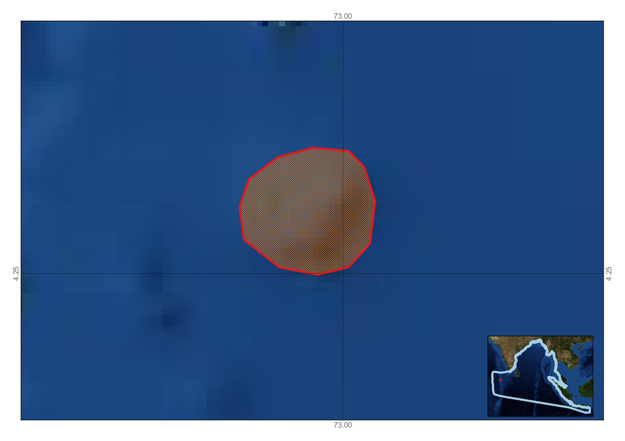

Figure 1. Area meeting the EBSA criteria

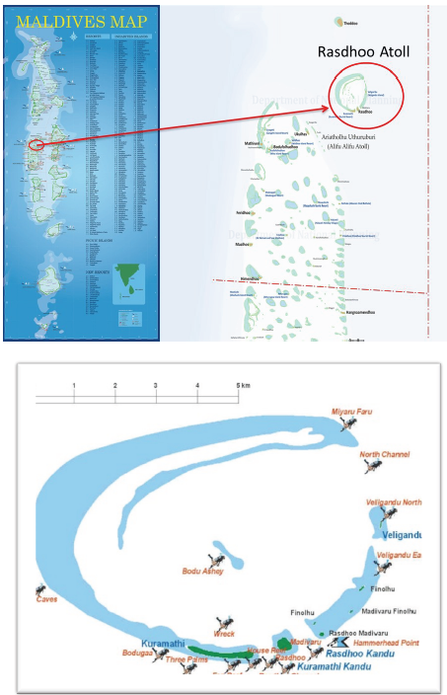

Figure 2: Dive sites in Rasdhoo Atoll

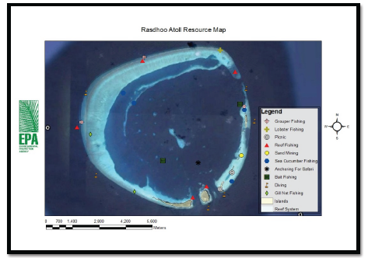

Figure 3. Rasdhoo Atoll Resource Map (EPA 2015)

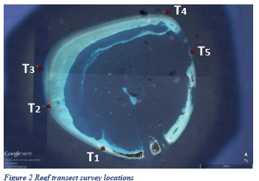

Figure 4. Reef transect survey locations (EPA 2015)
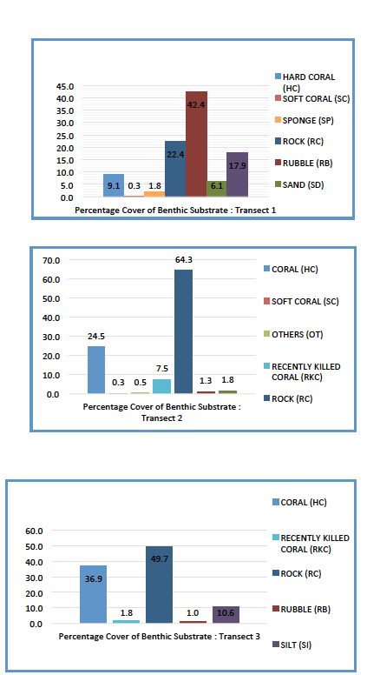

Figure 5. Reef transect surveys (EPA 2015)
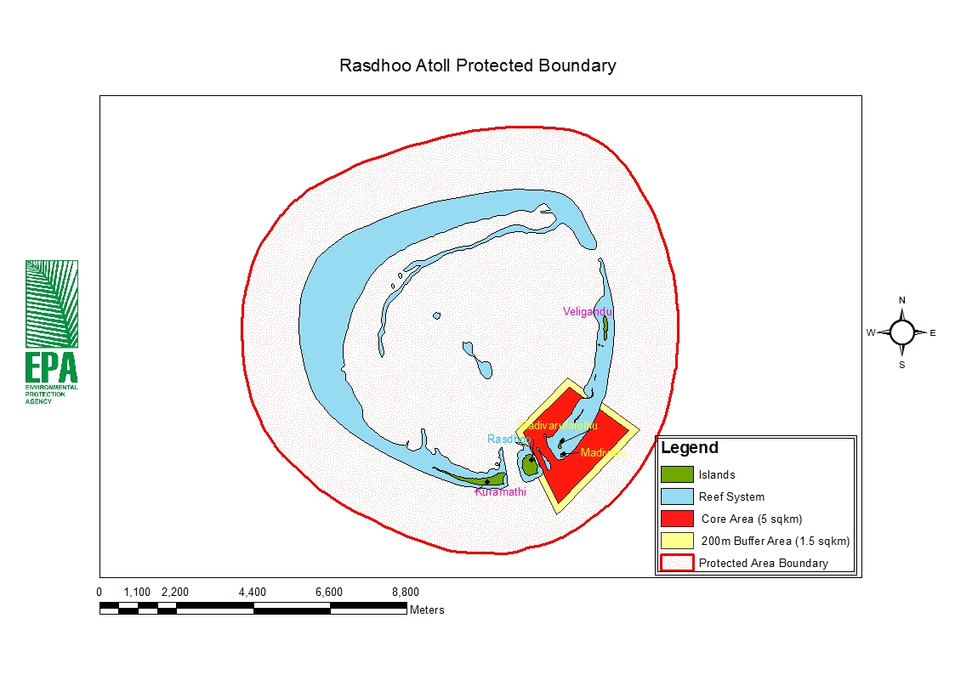
Figure 6. Zoning map (EPA 2015)

Rights and permissions
Prior to publication, please obtain permission from Environmental Protection Agency, Maldives. Contact: Mohamed Mustafa, mohamed.musthafa@epa.gov.mv

Area No. 8: Baa Atoll

Abstract
The unique biophysical system of Baa Atoll and its core area, Hanifaru Bay, seasonally concentrates plankton, attracting large numbers of planktivorous megafauna. The area is of world class importance for endangered reef manta rays. This atoll has been a focus of an Atoll Ecosystem Conservation project (AEC) co-funded by GEF. The AEC work examined taxa inventories and yielded 178 species of macrophytes, 173 species of coral, 350 species of fish, 115 species of hydrozoans, 182 species of other selected invertebrates, for a total of 998 species combined on all 29 sites. On the 18 sites with exhaustive inventories, 941 species were recorded. A map of biodiversity for the entire atoll was created combining point biological census data with habitat maps. Baa Atoll was declared a UNESCO Biosphere Reserve in 2011. A core area, Hanifaru Island, was designated a Maldives MPA in 2009.
Introduction
Maldives consists entirely of coral reefs, the most diverse of all marine ecosystems. Maldives includes 26 geographical atolls, composed of approximately 1,190 coral structures (islands, faro, patches, and knolls) (Hoon et al., 1997). Biogeographically, these atolls lie within the Coral Island Ridge Province, as defined by the Bay of Bengal Large Marine Ecosystem (Brewer et al., 2015).
Baa Atoll comprises 53 individual reef and faro, for a total area of approximately 1200 km², of which land accounts for only 5.5 km² (Naseer and Hatcher, 2004). Of the 53 islands, 13 of these are inhabited, with an approximate population of 12,000 people. Nine islands have been developed as resorts, and tuna and reef fishing are also important economic activities.
Location
The area is located in the western chain of atolls in the central part of the Maldives, just north of Kaashidhoo Kandu channel.
Feature description of the area
Baa Atoll comprises three separate natural atolls on the west of the Maldives atoll chain. It receives swell from the south-east and west.
This atoll has been a focus of an Atoll Ecosystem Conservation project (AEC) co-funded by GEF. The AEC work examined taxa inventories and yielded 178 species of macrophytes, 173 species of coral, 350 species of fish, 115 species of hydrozoans, 182 species of other selected invertebrates, for a total of 998 species combined on all 29 sites. On the 18 sites with
exhaustive inventories, 941 species were recorded. A map of biodiversity for the entire atoll was created combining point biological census data with habitat maps (Hamel & Andrinventories, .
Feature condition and future outlook of the area
The resilience of coral reefs is compromised by rising sea-level temperatures and bleaching events. Baa Atoll was particularly affected by the Indian Ocean Dipole (IOD) and El Niño-Southern Oscillation (ENSO) events of 2007 and 2010. Surveys in 2005 to examine reef recovery following the 2004 Indian Ocean tsunami indicated vulnerability of upper-reef slopes and crests due to cascading of coral rubble.
Baa Atoll was declared a UNESCO Biosphere Reserve in 2011. A core area, Hanifaru Island, was designated a Maldives MPA in 2009, and a management plan was published in 2012 prescribing zoning for different levels of access, with restrictions on fishing and SCUBA diving (see Figure 2). Studies have been undertaken by the Maldivian Manta Ray Project since 2007.

Assessment of the area against CBD EBSA Criteria

CBD EBSA Criteria  (Annex I to decision IX/20) | Description  (Annex I to decision IX/20) | Ranking of criterion relevance  (please mark one column with an X)
CBD EBSA Criteria  (Annex I to decision IX/20) | Description  (Annex I to decision IX/20) | No information |  | Low |  |  | Medium |  | High
Uniqueness or rarity | Area contains either (i) unique (“the only one of its kind”), rare (occurs only in few locations) or endemic species, populations or communities, and/or (ii) unique, rare or distinct, habitats or ecosystems; and/or (iii) unique or unusual geomorphological or oceanographic features. |  |  |  |  |  |  |  | X
Explanation for ranking
Unique diversity of benthic fauna (only recorded in Baa Atoll), including rare pink hydrozoan coral (Distichopora nitida) Bryozoans (Bugula) and sea slugs (Tambja olivaria). The atoll has a high density of ring-shaped reef forms (faroes) unique to Maldives.
Hanifaru Bay, at the core of Baa Atoll, has a unique, dynamic water circulation system driven by the South-West monsoon. Under certain monsoonal conditions, this water circulation leads to an increase of plankton density within Hanifaru Bay, attracting the largest aggregation of manta rays in the world. Along with manta rays, other species, including whale-sharks and mobula rays, are drawn to feed inside the bay. The complex relationship between monsoonal activities (windspeed and direction linked to oceanic currents), mixing eddies, localized upwelling and tidal exchange provides the locally unique ecosystem attraction to planktivorous megafauna (Anderson et al., 2011)
Special importance for life-history stages of species | Areas that are required for a population to survive and thrive. |  |  |  |  |  | X
Explanation for ranking
Whilst this is not a recognized breeding ground for manta rays in terms of population survival, its importance as a feeding area cannot be underestimated and in turn provides the required conditions for manta rays to thrive and breed (Steven et al., in prep).
Importance for threatened, endangered or declining species and/or habitats | Area containing habitat for the survival and recovery of endangered, threatened, declining species or area with significant assemblages of such species. |  |  |  |  |  |  |  | X
Explanation for ranking
Seasonal visiting whale sharks (Rhincodon typus) and reef manta rays (Manta alfredi) are listed as vulnerable on the IUCN Red List. From May to December 2014, a total of 2,636 manta ray sightings were recorded, equating a total of 690 unique individuals (The Manta Trust, 2015). Since records began in 2006, a total of 1,743 unique manta rays (almost 50% of the identified Maldivian population) have been recorded in Baa Atoll, highlighting the importance of this region as an aggregating site.
Hawksbill turtles occur throughout the atoll, and green turtle distribution is limited to south and centre of the atoll. Other relevant species observed in Hanifaru Bay arerMobula trapacana (1 sighting in 2013),sM. japanica (fairly regularly sighted), and sailfish (Istiophorus platypterus). Cetaceans observed in or around Baa Atoll are humpback whales (Arabian Sea population Red-listed as endangered), Risso's dolphins, false killer whales, spinner and bottlenose dolphins.
Vulnerability, fragility, sensitivity, or slow recovery | Areas that contain a relatively high proportion of sensitive habitats, biotopes or species that are functionally fragile (highly susceptible to degradation or depletion by human activity or by natural events) or with slow recovery. |  |  |  |  |  |  |  | X
Explanation for ranking
The reef manta rays, Manta alfredi, have extremely conservative life histories. They are known to mature at around 15 years of age, live up to 40 years and give birth to one single pup every 5 years in the Maldives (Stevens, pers. comms.). These extremely slow life cycles make them highly susceptible to any pressures and slow to recover from depletion. The fishing of manta rays outside the core area in neighbouring Lakshadweep has the potential to put pressure on the population of Baa Atoll manta rays. These species are also susceptible to depletion by other human activities (for example oil pollution or tourism pressure).
Biological productivity | Area containing species, populations or communities with comparatively higher natural biological productivity. |  |  |  |  |  | X
Explanation for ranking
Seasonal phytoplankton and zooplankton concentrations driven by the monsoons raise biological primary productivity for part of the year and attract vulnerable megafauna. Manta rays and whale sharks are frequently observed in the waters of Baa Atoll due to the conditions created by the South Asian Monsoon, which provide an abundant source of food for these planktonic creatures in this region during the Southwest Monsoon (Anderson et al., 2011).
Biological diversity | Area contains comparatively higher diversity of ecosystems, habitats, communities, or species, or has higher genetic diversity. |  |  |  |  |  | X
Explanation for ranking
Baa Atoll is an oceanic coral atoll, and the diversity of habitats is low compared to systems with well-defined land outer-reef gradients, however, high numbers of endangered megafauna (see Table 2) together with a complexity of other habitats, including seagrasses and mangrove areas, make the biodiversity globally significant. The taxa inventories yielded 178 species of macrophytes, 173 species of coral, 350 species of fish, 115 species of hydrozoans, 182 species of other selected invertebrates, for a total of 998 species combined on all 29 sites. On the 18 sites with exhaustive inventories, 941 species were recorded. A map of biodiversity for the entire atoll was created combining point biological census data with habitat maps (Hamel & Andréfouët, 2012).
Naturalness | Area with a comparatively higher degree of naturalness as a result of the lack of or low level of human-induced disturbance or degradation. |  |  |  |  |  |  | X
Explanation for ranking
Whilst this is an isolated natural feature, it is a popular dive site for ecotourism (Rifath Naeem, pers. comm., March 2015.

References
Anderson, R.C.., Adam, M.S., and Goes, J.I. (2011) From monsoons to mantas: seasonal distribution of Manta alfredi in the Maldives. Fisheries Oceanography 20: 104-13
Brewer, D., Hayes, D., Lyne, V., Donovan, A., Skewes, T., Milton, D., and.Murphy, N. N.hy,,MAnN.hy,,Maldives. Fisheries Oceanography 20: 104-1.nN.hy,,Maldives Bay.hy,,Maldiveargees Oceanography 20: 104-1 104-13,ay.hy,,Maldiveargees Oceanography 20:288.hy,n
Hawel, M.A. and Andrefouet, S. (2012) Biodiversity-based propositions of conservation areas in Baa Atoll, Republic of Maldives.
Hoon, V., Chong, K-C., Roy, R., Bierhuizeu, B., Kanviude, J.R. (1997) Regional Workshop on the Conservation and Sustainable Management of Coral Reefs. Project Reports (cited in Hawel and Andrefort, 2012).
Le Berre, T., Emanuelli, E., Roussel, E., Guignard, C., Sirad, A., Saleem, M. and Zahir, H. (2008) Rapid Marine Ecological Baseline Assessment of Islands of Baa Atoll. SEAM RC.
Naseer, A. and Hatcher, B.G. (2004) Inventory of the Maldives Coral Reefs using morphometrics generated from Landsat ETM+ imagery. Coral Reefs 23: 161-168
Stevens, G., J. Hawkins, C. Roberts (in prep). Observations of manta ray (Manta alfredi and Manta birostris) feeding behaviour in the Maldives.
The Manta Trust (2015) Maldivian Manta Ray Project 2013 Season Survey. A report for the Ministry of Environment Maldives; EPA and AEC Project.

Maps and Figures
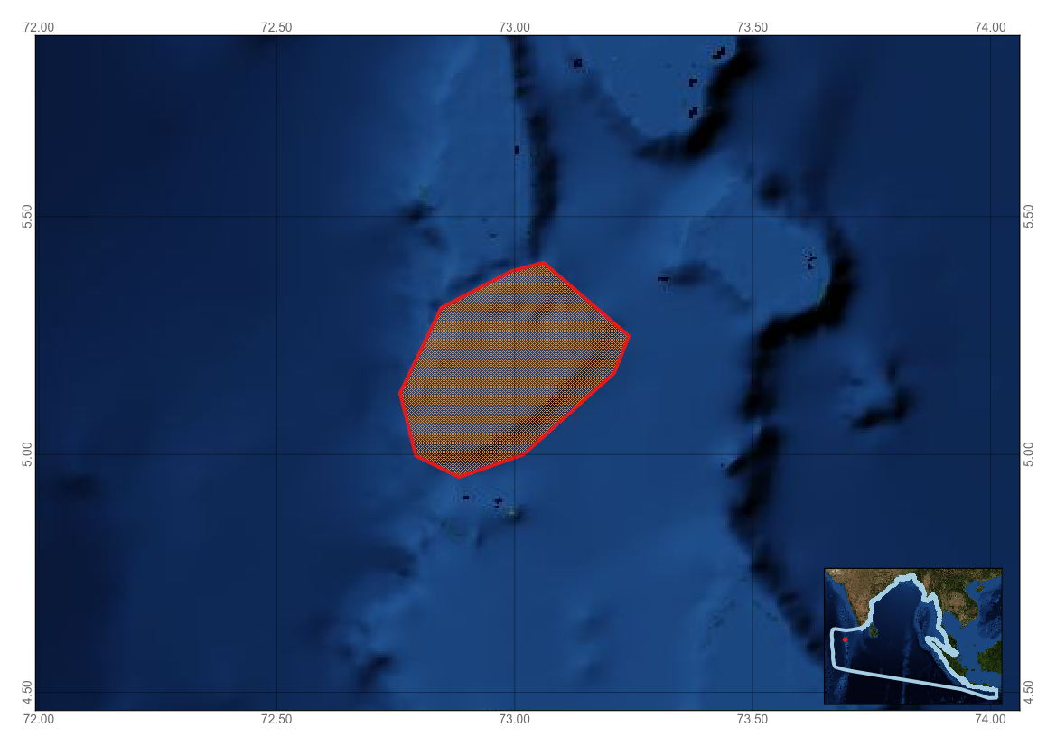
Figure 1. Area meeting the EBSA criteria

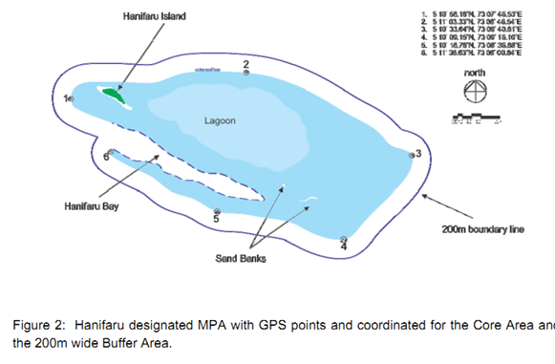

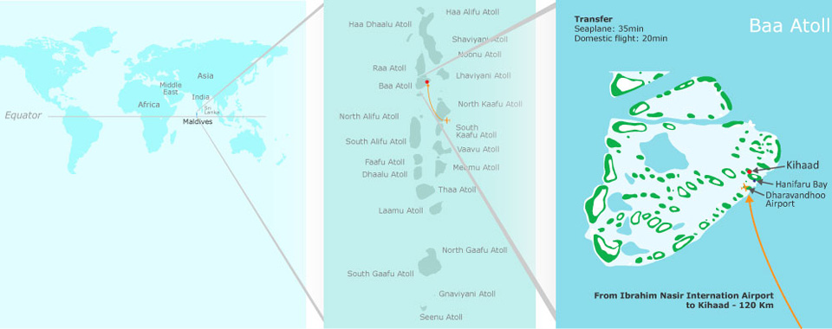
Figure 3. Location of Baa Atoll and Hanifaru Bay

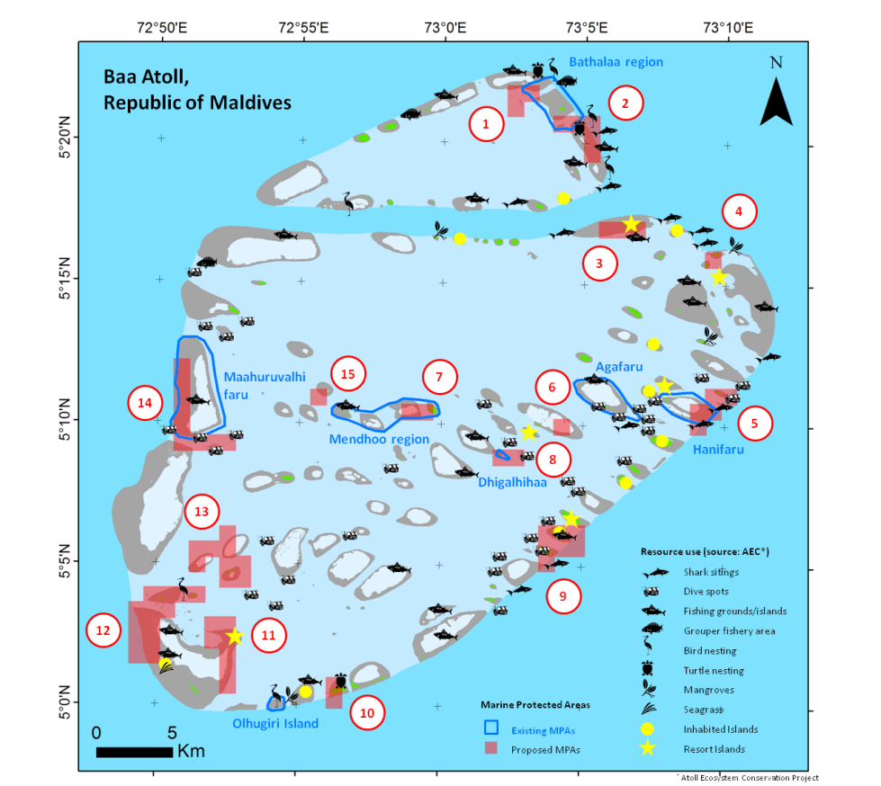
Figure 4. Biodiversity map for Baa Atoll (Taken from: Hamel & Andréfouët, 2012)

Table 1 Table of specific megafauna species recorded in the area and status in Red List, CMS and CITES.
Common name | Scientific name | Red List Category | CMS | CITES
Rissoist Catego | Grampus griseus | Least concern | --- | Appendix II
False killer whale | Pseudorca crassidens | Data deficient | --- | Appendix II
Spinner dolphin | Stenella longirostris | Data deficient | --- | Appendix II
Bottlenose dolphin | Tursiops truncatus | Least concern | --- | Appendix II
Hawksbill turtle | Eretmochelys imbricata | Critically endangered | Appendix I | Appendix I
Green turtle | Chelonia mydas | Endangered | Appendix I | Appendix I
Loggerhead turtle | Caretta caretta | Endangered | Appendix I | Appendix I
Leatherback turtle | Dermochelys coriacea | Vulnerable | Appendix I | Appendix I
Spine-tail devil ray | Mobula japanica | Near threatened | Apppendix 1 & II | ---
Sickle-fin devil ray | Mobula tarapacana | Data deficient | Apppendix 1 & II | ---
Short-fin pygmy devil ray | Mobula kuhlii | Near threatened | Apppendix 1 & II | ---
Reef manta ray | Manta alfredi | Vulnerable | Apppendix 1 & II | Appendix II
Whaleshark | Rhincodon typus | Vulnerable | Appendix II | Appendix II
Table 2. Key Indicator Species (taken from: Le Berre et al., 2008). 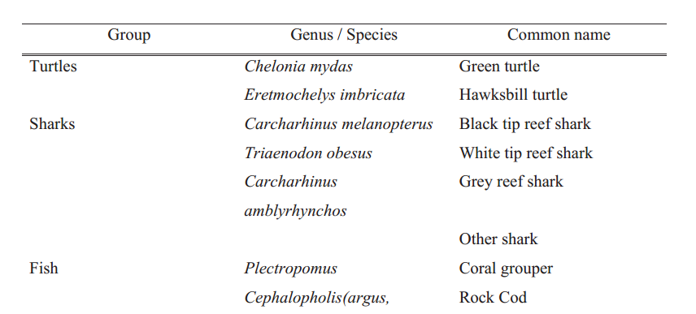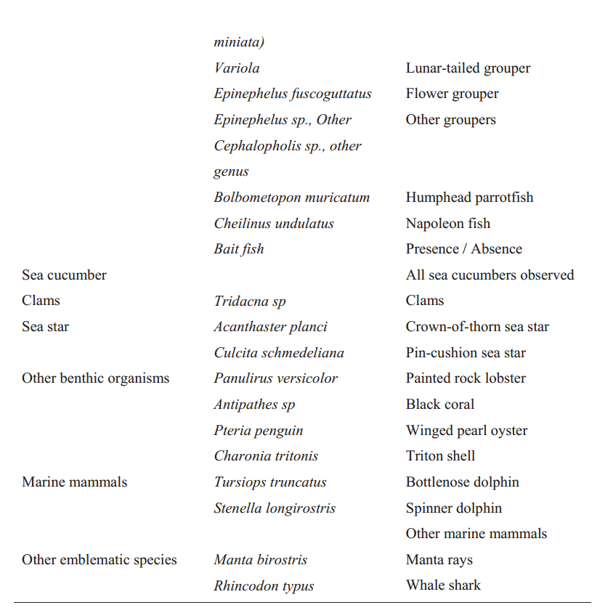
Rights and permissions
Prior to publication, please obtain permission from the Environmental Protection Agency, Maldives. Contact: Mohamed Mustafa at EPA, Maldives, mohamed.musthafa@epa.gov.mv

Area No. 9: Upwelling Zone of the Sumatra-Java Coast
Abstract
Wind-driven upwelling occurs in the coastal areas of Sumatra-Java during the southeast monsoon and is related to the El Nino Southern Oscillation (ENSO) and the Indian Ocean Dipole Mode (IODM). The upwelling zone is nutrient enriched, attracting fish and other marine animals to use this area as a feeding, spawning and nursery ground. The productive upwelled waters are expected to support high levels of marine biodiversity, including some endemic marine species such as sharks and rays, as well as new species that are still being discovered. The area supports an active pelagic fishery. This area off the Sumatra coast consists of a seismogenic zone in the subduction zone, the Sumatran Fault Zone, and the fracture zone contributing to earthquake and tsunami along the Sumateran margin. Corals in the area recovered quickly from the 2004 tsunami, suggesting the importance of the area to longer-term coral health.
Introduction
An oceanographic characteristic of water in the Indian Ocean is the influence of transported low- latitude water masses from the Pacific Ocean through Indonesian waters to the Indian Ocean, which is known as the Indonesian Through Flow (ITF). This process could play an important role in ocean productivity (i.e., geochemical and upwelling processes) and the health of coastal ecosystems (coral biodiversity and coral reef resilience). In addition, the equatorial zone of the Indian Ocean is affected by oscillation and perturbation processes, such as the Wyrtki Jet current (Qui and Yu, 2009), Madden-Julian Oscillation (Kiladis et al., 2005) and Indian Ocean Dipole Mode (IODM) (Li et al., 2003). These processes influence marine life and coastal communities along the Indian Ocean coastal zone, including western Sumatra and southern Java. Therefore, understanding oceanographic processes, such as the upwelling event (Susanto et al., 2001, Hendiarti et al., 2004), and how it is related to marine and coastal resources, is very important in characterizing this area.
Fishing and tourism are the main economic activities in this area (Blaber, et al., 2009; Lumban Gaol, 2015). The fishery industry in this area largely focuses on tuna and shark, and the region contributed at least 23 per cent (on average) of tuna (including skipjack tuna) production in Indonesia from 2008 to 2012 (General Directorate for Capture Fishery, 2015). Marine tourism is growing slowly due to limited infrastructure, magnified by large-scale earthquakes and tsunamis that have occurred in the region a few times in the last decade, destroying built structures and natural areas.
Since 2004, reef monitoring has taken place in several areas along the west coast of Sumatra. The results of this monitoring show that coral has grown well and increased in coverage, while the coverage of dead coral has decreased (COREMAP, 2015).
Location
The area runs along the western coast of Sumatra (Indonesia) to the southern coast of Java, where upwelling occurs seasonally, enhancing marine productivity in the area. This area extends beyond national jurisdiction off the coast of Sumatra-Java, based on the location of the seasonal upwelling.
Feature description of the area
The coasts of west Sumatra and south Java have narrow continental shelves dominated by a deep-sea ecosystem. Coastal ecosystems that include coral reefs, seagrass beds and mangrove forests are found along the coast and around several small islands (e.g., Nias, south Nias and Mentawai) located off the coast of west Sumatra. Several endangered marine species inhabit the areas, including napoleon wrasse, whale sharks, manta rays and turtles (Ministry of Marine Affairs and Fisheries, 2015). However, there is no data on their individual numbers or abundance.
Feature condition and future outlook of the area
These areas are likely to be developed in the near future, due to the Indonesian Government’s plan to improve maritime facilities and infrastructure. Therefore, several programmes have been established for research in these areas, such as the Expedition of Widya Nusantara (Research Centre for Oceanography, Indonesian Institute of Sciences), Mentawai Gap Tsunami Risk Assessment (known as MegaTera), a joint geological survey among the Schmidt Ocean Institute (SOI), the Earth Observatory of Singapore (EOS), the Indonesian Institute of Sciences (LIPI) and the Institut de Physique du Globe de Paris (IPGP), coral-reef monitoring and community-based management (COREMAP and Ministry of Marine Affairs and Fisheries. The Coral Reef Rehabilitation and Management Program – Coral Triangle Initiative (COREMAP-CTI) and The Expedition of Widhya Nusantara are operating around several small islands (e.g., Nias, south Nias and Mentawai) off the coast of west Sumatra, which are inhabited by several endangered marine species. Community-based management of coral reefs in these areas is continuing under the new COREMAP-CTI programme.
Fishing and tourism are the main economic activities in the area, especially tuna fishing (General Directorate of Capture Fishery, 2015). Fishing ports in the west Sumatra region are located in Bungus, and in the south Java region in Palabuhanratu and Cilacap. A deep-sea fishery has not developed yet in these regions although several deep-sea research expeditions had already occurred by 1970, indicating that the region has potential for a deep-sea fishery (Pauly & Martosubroto, 1996; Sumiono, 2009). In addition, Siberut Island off the west Sumatra coast has been declared a Biosphere Reserve (www.portal.unesco.org).
Assessment of the area against CBD EBSA Criteria

CBD EBSA Criteria  (Annex I to decision IX/20) | Description  (Annex I to decision IX/20) | Ranking of criterion relevance  (please mark one column with an X)
CBD EBSA Criteria  (Annex I to decision IX/20) | Description  (Annex I to decision IX/20) | No information |  | Low |  |  | Medium |  | High
Uniqueness or rarity | Area contains either (i) unique (“the only one of its kind”), rare (occurs only in few locations) or endemic species, populations or communities, and/or (ii) unique, rare or distinct, habitats or ecosystems; and/or (iii) unique or unusual geomorphological or oceanographic features. |  |  |  |  |  |  |  | X
Explanation for ranking
This area hosts unique ecosystems due to wind-driven upwelling occurring in the coastal areas of Sumatra-Java during the southeast monsoon, which is related to the El Nino Southern Oscillation (ENSO) and the Indian Ocean Dipole Mode (IODM). The upwelling zone is nutrient enriched, attracting fish and other marine animals to use this area as a feeding, spawning and nursery ground. Understanding these oceanographic processes, such as the upwelling event (Susanto et al., 2001, Hendiarti et al., 2004), and how it is related to marine and coastal resources, is very important in characterizing this area.
Special importance for life-history stages of species | Areas that are required for a population to survive and thrive. |  |  |  |  |  |  |  | X
Explanation for ranking
Coral-reef monitoring data show that, after a tsunami hit the coastal area of west Sumatra in 2004 at several coral reef locations, live coral cover was reduced by 50 per cent. However, after four years, the live coral increased to almost the same percentage that was present before the disaster (COREMAP, 2015). Moreover, in several studies on tuna larvae, spawning of tuna tended to occur close to the coast, especially near coral reefs. Since tuna is among the most important fisheries in these areas, tuna may spawn in locations near coral reefs and in the proximity of upwelling events. However, there is no data to confirm that tuna larvae from these areas contribute to the early life stages of tuna in the region.
Importance for threatened, endangered or declining species and/or habitats | Area containing habitat for the survival and recovery of endangered, threatened, declining species or area with significant assemblages of such species. |  |  |  |  |  | X
Explanation for ranking
Several endangered marine species have been found along the coast of west Sumatra and south Java, such as napoleon wrasse, whale shark, manta rays and turtles (Ministry of Marine Affairs and Fisheries, 2015). However, they were not found to be present in significant numbers. Blaber et al. (2009) noted six distinct shark species from the Indian Ocean, however, further studies are needed regarding these endangered species in this area.

Vulnerability, fragility, sensitivity, or slow recovery | Areas that contain a relatively high proportion of sensitive habitats, biotopes or species that are functionally fragile (highly susceptible to degradation or depletion by human activity or by natural events) or with slow recovery. |  |  |  |  |  |  |  | X
Explanation for ranking
Due to the geomorphological conditions off western Sumatra (Huchon and Le Pichon, 1984; Diament et al., 1992), this area contains sensitive habitats, vulnerable to earthquakes and tsunami. Large earthquakes and tsunamis in 2004 and 2007 destroyed coral reef in Nias Island and changed the coastal morphology in some coastal areas.

Biological productivity | Area containing species, populations or communities with comparatively higher natural biological productivity. |  |  |  |  |  | X
Explanation for ranking
Upwelling occurs along these regions (Susanto et al., 2001), and biological productivity is expected to be high (Hendiarti et al., 2002). The productivity of this area is indicated by the presence of an important pelagic fishery (Lumban Gaol et al. 2015). Tuna and shark fisheries are most prominent in the western Sumatra region, and fishers land the catch either in Padang, Pelabuhan Ratu or Cilacap (south Java).

Biological diversity | Area contains comparatively higher diversity of ecosystems, habitats, communities, or species, or has higher genetic diversity. |  |  |  |  |  | X
Explanation for ranking
These areas have a significant number of marine ecosystems (including both coastal and deep-sea areas) (Pauly and Martosubroto, 1996; COREMAP, 2015). Study results from deep-sea fishery surveys show that the area has high species diversity (Pauly & Martosubroto, 1996, Blaber et al., 2009).However, the data on marine life from this area is very limited due to the limited number of studies taken from the regions.

Naturalness | Area with a comparatively higher degree of naturalness as a result of the lack of or low level of human-induced disturbance or degradation. |  |  |  |  |  |  |  |  | X
Explanation for ranking
Increase of live coral cover and the reduction of dead coral cover in Nias Island could indicate that human-induced disturbance is low in this area.

References
Blaber, S.J.M., C.M. Dichmont, W. White. R. Buckworth., L.Sadiyah. B. Iskandar. S. Nurhakim, R. Pillands, R. Andamari, Dharmadi, and Fahmi. 2009. Elasmobrachs in southern Indonesia fisheries: the fisheries, the status of the stock and management options. Rev. Fish. Biol. Fisheries, 19:367-391.
COREMAP, 2015. www.coremap.or.id (25/03/2015)
Diament, M. H. Harjono, K. Karta, C. Deplus, D. Dahrin, M.T. Zen, Jr., M. Gerard, O. Lassal, M. Marthin, and J. Malod. 1992. Mentawai Fault Zone off Sumatera: A new key to the geodynamic of western Indonesia. Geology, V. 20: 259-262.
General Directorate of Capture Fishery. 2015. Statistic Data of Fishery. http://statistik.kkp.go.id. (26 March 2015).
Gloerfelt-Tarp, T. and P.J. Kailola. 1985. Trawled Fishes of Southern Indonesia and Northwestern Australia. Australian Development Assistance Bureau, Canberra. 406 p.
Hendiarti, N., H. Siegelb, T. Ohdeb. 2004. Investigation of different coastal processes in Indonesian waters using SeaWiFS data. Deep Sea Research II, 51: 85a. 406Huchon, P. and X. Le Pichon. 1984. Sunda Strait and Central Sumatera Fault. Geology, v 12: 668-672.
Kiladis, G.N., K.H. Straub, & P.T Haertel. 2005. Zonal and Vertical Structure of the Madden 2005. nd Central SumJournal of the Atmospheric Sciences, Vol. 62: 2790-2809.
Li, T., B. Wang, C.-P. Chang, & Y. Zhang. 2003. A Theory for the Indian Ocean Dipole-Zonal Mode. Journal of the Atmospheric Sciences, Vol. 60: 2119-2135.
Lumban Gaol, J., I.W. Nurjaya, and K. Amri. 2014. Impact Climate Change on Oceanographic Condition and Catch Rate of Bigeye Tuna (Thunnus obesus) in Eastern Indian Ocean. Presented in the Symposium on Sustainability of Tuna Fishery in Indonesia, Bali, 11-12 December 2014.
Ministryof Marine Affairs and Fisheries. 2015. Conservation on Area and Fish Species. http://kkji.kp3k.kkp.go.id (25 March 2015)
Pauly, D. and P. Martosubroto (eds.). 1996. Baseline Studies of Biodiversity: The Fish Resources of Western Indonesia. ICLARM Stud. Rev., 23. 321 p.
Qiu Y., L. Li, and W. Yu. 2009. Behavior of the Wyrtki Jet observed with surface drifting buoys and satellite altimeter. Geophysical Research Letters, vol. 36, l18607, doi:10.1029/2009gl039120.
Sumiono, B. 2009. Deep-sea Demurral and Prawn Resources Exploration Surveys in Indonesia. Paper presented at the workshop on the standard operating procedure and development / Improvement of sampling gear for the deep-sea resources exploration. SEAFDEC, Bangkok.
Susanto, R.D., A.L. Gordon and Q. Zheng. 2001. Upwelling along the coasts of Java and Sumatra and its relation to ENSO. Geophysical Research Letters, Vol. 28, No. 8: p 1599-1602.

Maps and Figures

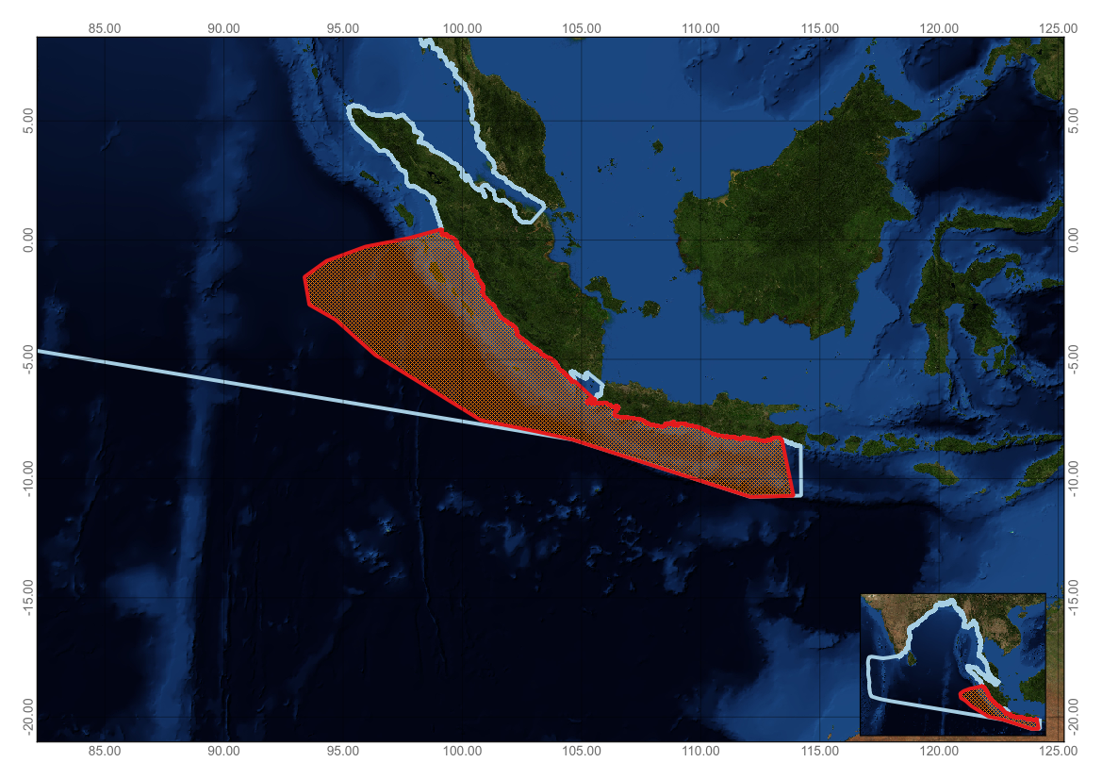
Figure 1. Area meeting the EBSA criteria
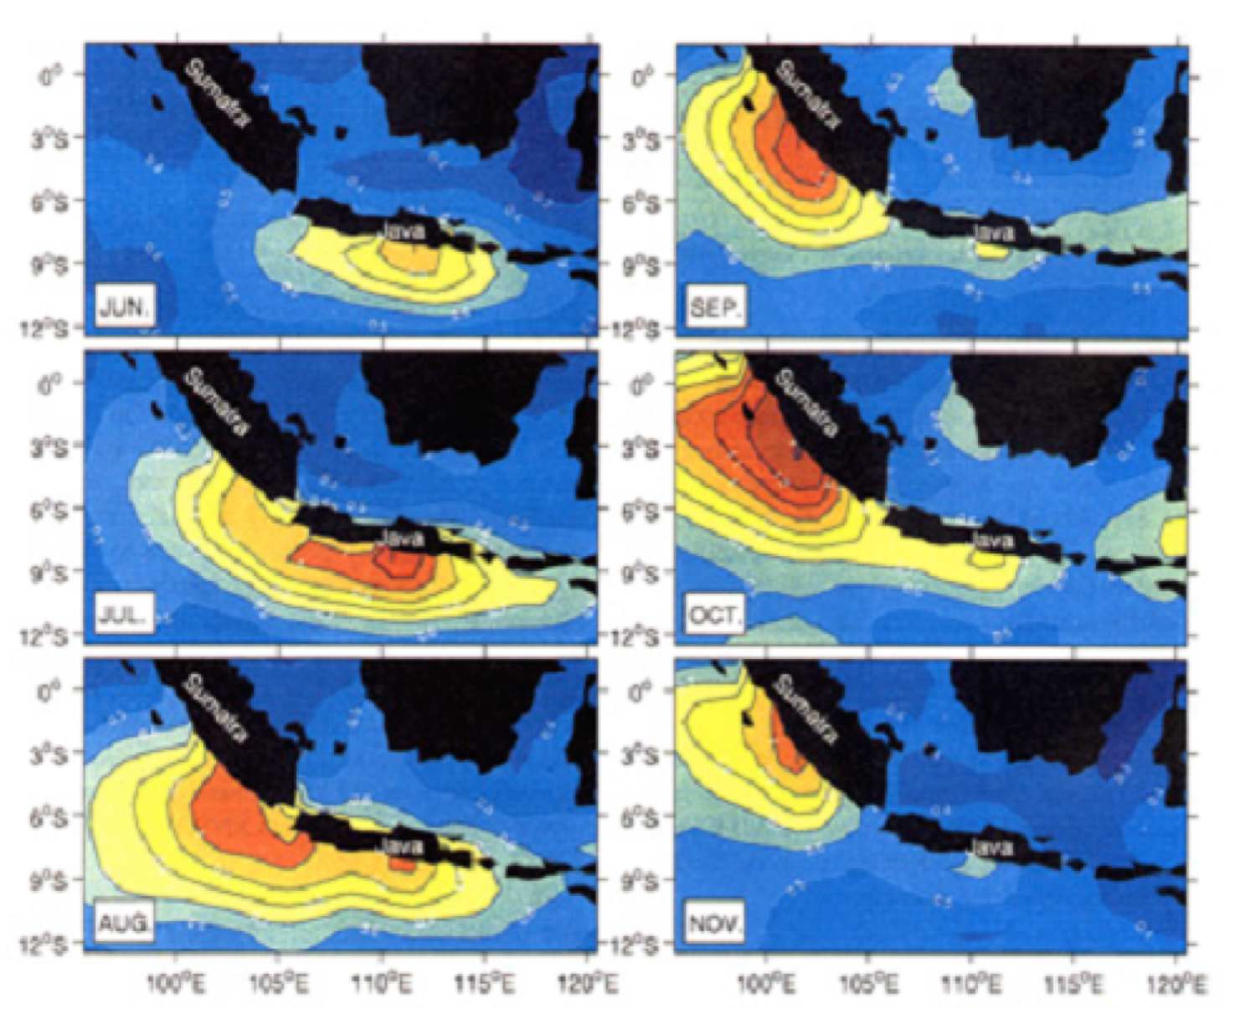
Figure 2. An image of standard deviation of monthly average SST (1981-1999) during the SE monsoon from July to November. Contour is 0.1 standard deviation of monthly average.
Area No. 10: Olive Ridley Sea Turtle Migratory Corridor in the Bay of Bengal

Abstract
The coast of the Indian state of Odisha is the world's largest nesting site for olive ridley turtles. The mouths of the Devi, Rushikulya and Bhitarkanika rivers hold the world's largest nesting congregation of this species. Satellite telemetry studies have demonstrated that the majority of turtles migrate north-south∕south-north to and from Sri Lanka. However, beyond this point no pattern has been established. The congregation and nesting of the olive ridley turtles within the Indian EEZ are protected by the environmental laws/acts of the country, however, the corridors in which they move for feeding and mating are unprotected. A major segment of the olive ridley population visiting the Odisha coast is from southern Sri Lanka. Genetic studies confirmed the results from tagging and satellite telemetry studies and showed that there is no genetic difference between nesting populations in each of the mass nesting beaches. More significantly, the results revealed the distinctiveness of the population on the east coast of India and Sri Lanka, and suggested that this population is the ancestral source of contemporary global populations of olive ridley sea turtles.
Introduction
The coast of the Indian state of Odisha hosts the world's largest breeding area for olive ridley sea turtles (Lepidochelys olivacea) near the mouths of the Rushikulya, Devi and Gahiramatha rivers. Besides Odisha, a few olive ridley sea turtles nest in northern Andhra Pradesh, Tamil Nadu, and the Andaman and Nicobar islands on the east coast and in Gujarat, Maharashtra, Goa, Kerala and Lakshadweep on the west coast (Tripathy and Choudhary, 2003; Bhupathy, S. and Saravanan, 2002; Andrews, et al. 2001). They are known to breed between October and May. They migrate en masse from the Indian Ocean south of Sri Lanka with the onset of winter. Based on evidence from tagging studies, the migration of breeding olive ridley turtles takes a northerly course through the coastal waters off Tamil Nadu and Andhra Pradesh prior to the arrival of the turtles in Odisha (Das and Kar, 1990; Pandav and Choudhury, 2000), where they spend a considerable amount of time in the shallow waters off the continental shelf of Odisha. Large concentrations of olive ridley sea turtles have been reported in the coastal waters of Sri Lanka, migrating northwards during September and November (Etnoyer et al. 2006).
In a recent study by the Wildlife Institute of India (unpublished data), of the 68 tagged turtles (63 females and 5 males), most of the tracks suggest north-south movement (Figure 2). Despite a significant quantity of work on the biological behaviour of olive ridley sea turtles (Tripathy et. al., 2008; IOSEA, 2014) a major gap still exists in the knowledge of what happens and where all these turtles move to once they reach Sri Lanka. In the past all the ridleys tagged at all the three mass nesting beaches as well as in the coastal waters off Gahirmatha have been recaptured from Sri Lanka (Pandav and Choudhury, 2000). This clearly indicates the movement of the olive ridley sea turtles through the Bay of Bengal. The nesting and nearshore feeding areas are protected as national parks and sanctuaries under the Wildlife Protection Act of India (1972).
The areas beyond national jurisdiction that are used by migratory olive ridleys have not, however, been well studied for the biological or oceanographical setting of this species. The area described here, which is entirely beyond national jurisdiction, recognizes the significance of this migratory corridor for olive ridley sea turtles.
Location
The area is located beyond national jurisdiction, in the Bay of Bengal (see Figure 1).
Feature description of the area
Mishra et al. (2011) studied the movement of olive ridley sea turtles in coastal regions and their nesting behaviour in India between 2003 and 2007, and related them to oceanographic parameters. The impact of oceanographic parameters, including potential environmental influences on their movements and nesting, was compared on the west and east coasts with remotely sensed variables, including sea surface temperature (SST), sea surface current (SSC), surface chlorophyll concentration (Chl-a), sea surface height (SSH) and mixed layer depth (MLD). The movement has been observed on the east coast, including the oceanic migration for pelagic and mass nesting that increased gradually southward from the west coast and then northward, with mass nesting on the east coast of Odisha. The movement results from the potential mean surface Chl-a concentration of 3 mgm⁻³ with threshold limitation of mean surface temperature at 25⁰C off the east coast of Odisha. Although the mean surface Chl-a and SST were maintained on the west coast, there was a distinct variation in MLD, WSC with SSH characteristics. The study revealed the favourable oceanographic condition for mass nesting of olive ridley turtles on the east coast of Odisha. The data provided by Brewer et al (2015) clearly suggests that for much of the year, high productivity only occurs near the coast and off the mouths of rivers. In the area described as meeting the EBSA criteria, however, high productivity was noted for a very limited period from January to April each year, which is also peak olive ridley migratory period and consistent with the findings of Mishra et al. (2011) and BOBLME (2012).
Olive ridley sea turtles, like other species of sea turtles, act as navigators and travel long distances, from hundreds to thousands of kilometres, between their feeding and nesting habitats (Akesson 1996). They frequently travel in open sea areas, where the sea currents are likely to favour their movement patterns (Nichols et al, 2000). The navigational pattern indicates that this is linked to certain oceanographic parameters, like SST and SSC, and hence they perform in response to geomagnetic cues (Luschi et al, 2003).
Fitzsimmons and Limpus (2014) note the considerable progress that has been made to define population boundaries and migratory behaviour of marine turtles within the Indo-Pacific. They identify the relative size of rookeries and identify the olive ridley population on the east coast of India and northern Sri Lanka as a discrete genetic stock.
The eleventh meeting of the Conference of the Parties to the Convention on Migratory Species, in Quito, Peru stated that habitats for migratory species are becoming increasingly fragmented across terrestrial, freshwater and marine biomes and recognized the need for transboundary area-based conservation measures for animals that migrate for long distances across or outside national jurisdictional boundaries.
The results of recent surveys to investigate the Cetacean Community Ecology in the Waters of Sri Lanka and the Bay of Bengal site (Baumgartner 2014), should provide substantial additional information regarding the ecological and biological significance of this area.

Feature condition and future outlook of the area
The area is located within the Bay of Bengal Abyssal Province (Brewer et al., 2015), which is characterized as a low productivity pelagic zone, where seasonal monsoon events, combined with the high sediment load from the Ganges and Bengal Fan, create seasonal variation in this unique province among deep-ocean abyssal systems. It is a stable, extremely deep-water offshore area and a major component of the Bay of Bengal biogeography.

Assessment of the area against CBD EBSA Criteria

CBD EBSA Criteria  (Annex I to decision IX/20) | Description  (Annex I to decision IX/20) | Ranking of criterion relevance  (please mark one column with an X)
CBD EBSA Criteria  (Annex I to decision IX/20) | Description  (Annex I to decision IX/20) | No information |  | Low |  |  | Medium |  | High
Uniqueness or rarity | Area contains either (i) unique (“the only one of its kind”), rare (occurs only in few locations) or endemic species, populations or communities, and/or (ii) unique, rare or distinct, habitats or ecosystems; and/or (iii) unique or unusual geomorphological or oceanographic features.  . |  |  |  |  |  |  |  | X
Explanation for ranking
The annual mass movement of olive ridley turtles for nesting and their return through the area is just one of two such occurrences in the world and also the largest (Tripathy and Choudhary, 2003; Bhupathy, S. and Saravanan, 2002; Andrews et al. 2001).
Special importance for life-history stages of species | Areas that are required for a population to survive and thrive. |  |  |  |  |  |  |  | X
Explanation for ranking
This area is very important for the life cycle of the olive ridley sea turtle. The mass movement of the adult turtles through the area beyond national jurisdiction of the Bay of Bengal is an important part of their life cycle, as they appear to disperse after reaching the seas off the Sri Lankan coast (Das and Kar, 1990, Pandav and Choudhury, 2000).

Importance for threatened, endangered or declining species and/or habitats | Area containing habitat for the survival and recovery of endangered, threatened, declining species or area with significant assemblages of such species. |  |  |  |  |  |  |  | X
Explanation for ranking
Olive ridley turtles are listed as vulnerable on the IUCN Red List (Abreu-Grobois, A & Plotkin, 2008).

Vulnerability, fragility, sensitivity, or slow recovery | Areas that contain a relatively high proportion of sensitive habitats, biotopes or species that are functionally fragile (highly susceptible to degradation or depletion by human activity or by natural events) or with slow recovery. |  |  |  |  |  |  |  | X
Explanation for ranking
Olive ridley sea turtles are highly vulnerable in near shore-breeding congregation areas. Eggs and young hatchlings are vulnerable to predation, while nesting sites are vulnerable to shore plantations, armoring and beach illumination (Tripathy and Rajasekhar, 2009). However, the degree of vulnerability is unknown during movement through this area.

Biological productivity | Area containing species, populations or communities with comparatively higher natural biological productivity. | X
Explanation for ranking
No information available.

Biological diversity | Area contains comparatively higher diversity of ecosystems, habitats, communities, or species, or has higher genetic diversity. |  |  |  | X
Explanation for ranking
The biodiversity of the area beyond national jurisdiction in the Bay of Bengal is relatively low (Mishra et al. 2011; BOBLME 2012; and Brewer et al. 2015).

Naturalness | Area with a comparatively higher degree of naturalness as a result of the lack of or low level of human-induced disturbance or degradation. |  |  |  |  |  |  | X
Explanation for ranking
Area beyond national jurisdiction with limited shipping lanes and industrial fishing.

References
Akesson, S (1996). Geomagnetic map used for long-distance navigation? Trends Ecol Evol 11:398-399.
Andrews, H.V., Krishnan, S., Biswas, P., (2001). The Status and Distribution of Marine Turtles around the Andaman and Nicobar Archipelago, Madras Crocodile Bank Trust, Tamil Nadu, India.
Abreu-Grobois, A & Plotkin, P. (IUCN SSC Marine Turtle Specialist Group) (2008). Lepidochelys olivacea. The IUCN Red List of Threatened Species. Version 2014.3. www.iucnredlist.org Downloaded on 25 March 2015.

Baumgartner, M. 2014. Cetacean Community Ecology in the Waters of Sri Lanka and the Bay of Bengal. Woods Hole Oceanographic Institution, Biology Department, Woods Hole, MA.

Bhupathy, S. and Saravanan, S. (2002). Status Survey of Sea Turtles along the Tamil Nadu Coast. Kachhapa 7, 7-13
BOBLME (2012). Transboundary Diagnostic Analysis (TDA) Confirmation Workshop held in Phuket Thailand from 13 to 14 February 2012, Vol 2, pp. 108.
Das, M.C., and Kar, C.S. (1990). The Turtle Paradise-Gahiramatha. Interprint, New Delhi.
Deraniyagala, P.E.P. (1953), A coloured atlas of some vertebrates from Ceylon. Vol. 2. Tetrapod Reptilia, Ceylon National Museum Publication. 101pp.
Brewer, D., Hayes, D., Lyne, V., Donovan, A., Skewes, T., Milton, D. and N. Murphy (2015). An Ecosystem Characterisation of the Bay of Bengal. Report for the Bay of Bengal Large Marine Ecosystem Project. CSIRO, Australia, ISBN: 978-1-4863-0521-6. 288 pp.
Etnoyer, P., Canny, D., Mate, B.R., Morgan, L.E., Ortega-Ortiz, J.G and Nichols, W.J (2006). Sea surface temperature gradients across Blue Whale and sea turtle foraging trajectories off the Baja California Peninsula, Mexico. Deep-Sea Res II 53:340-358.
Fitzsimmons, N.N. and Limpus, C.J. (2014). Marine turtle genetic stocks of the Indo-Pacific: Identifying boundaries and knowledge gaps. Indian Ocean Turtle Newsletter No. 20: 2-18.
IOSEA (2015) Bibliography. Available online at: http://www.ioseturtles.org/bibliography.php [Accessed 26.3.15]
Luschi, P, Hays G.C and Papi F (2003). A review of long distance movement by marine turtles, and the possible role of ocean currents. Oikos 103:293-302.
Mishra, R. K., S. M. Marale, S. Mishra, and S. Naik (2011). Olive Ridley Sea Turtle Movement in Relation to Oceanographic Parameters in India. IJEP Vol.1 No. 3, pp 49-54.
Nichols, W.J, Resendiz, A, Seminoff, J.A, Resendiz B. (2000). Transpacific migration of loggerhead turtle monitored by satellite telemetry. Bull Mar Science, 67:937-947.Tripathy, B., R. S. Kumar, B. C. Choudhury, K. Sivakumar & A. K. Nayak. 2008. Compilation of Research Information on Biological and Behavioural Aspects of Olive Ridley Turtles along the Orissa Coast of India ninsula, Mexico. Deep-Sea Res II 53:340-358.p. Areas of Research. Wildlife Institute of India, Dehra Dun.
Tripathy, B., Shanker, K. & Choudhury, B.C. (2003) Important nesting habitats of olive ridley turtles along the Andhra Pradesh coast of eastern India. Oryx 37: 454 – 463.
Valverde, R.A., Gates, C.E., 1999. Population surveys on mass nesting beaches. In: Eckert, K.L., Bjorndal, K.A., Abreu-Grobois, F.A., Donnelly, M. (Eds), Research and Management Techniques for Conservation of Sea Turtles. Publication No-4. IUCN/Marine Turtle Specialist Group, pp.56-60.
Tripathy, B. and Rajasekhar, P.S. (2009). Natural and anthropogenic threats to olive ridley sea turtles (Lepidochelys olivacea) at the Rushikulya rookery off Orissa coast, India. Indian Journal of Marine Sciences, Vol 38 (4), pp. 439-443.

Maps and Figures
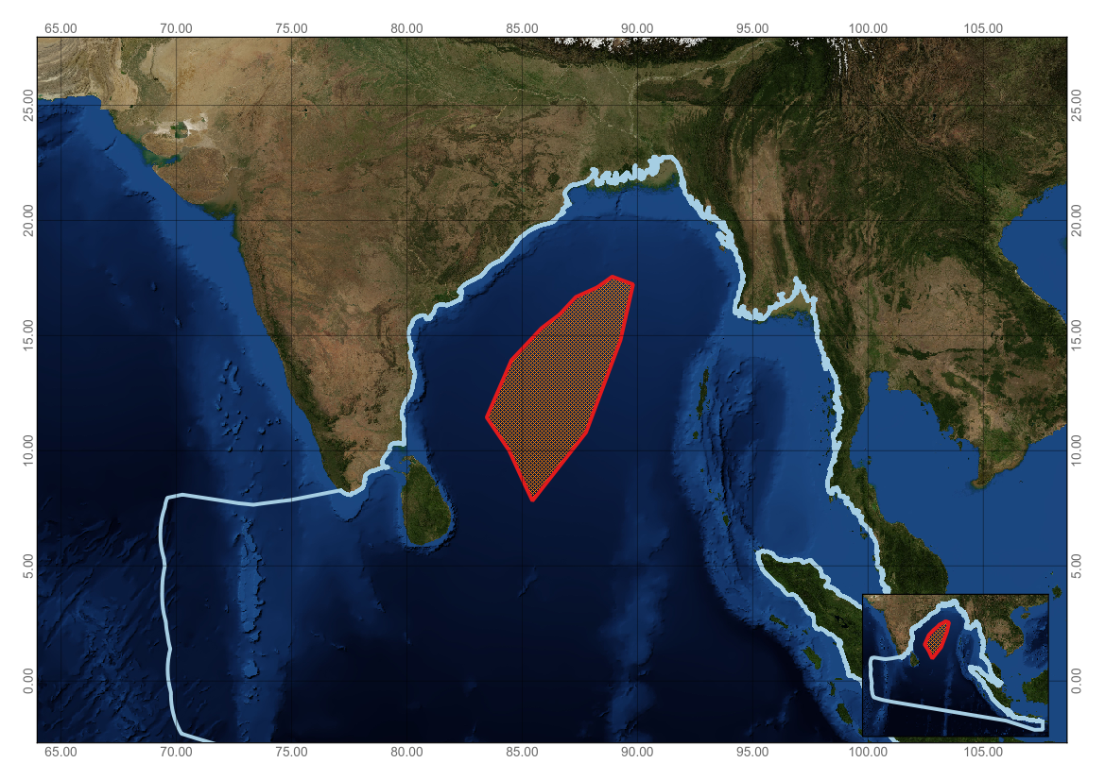
Figure 1. Area meeting the EBSA criteria

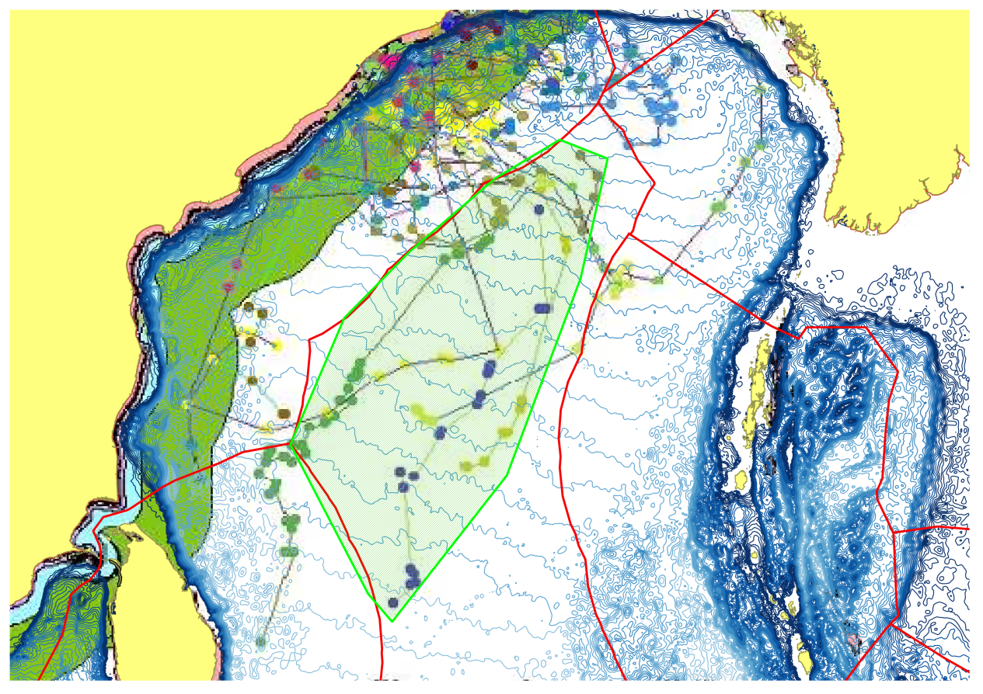
Figure 2. Source map for Figure 1, with turtle tracks. ©Wildlife Institute of India (WII), India.

Rights and permissions
Sea turtle satellite track maps shared and data provided in the document not to be reproduced without permission from Wildlife Institute of India (WII), India.
Contact: Dr. Siva Kumar sivakumarwii@gmail.com

Annex VII

SUMMARY OF THE WORKSHOP DISCUSSION ON IDENTIFICATION OF GAPS AND NEEDS FOR FURTHER ELABORATION IN DESCRIBING ECOLOGICALLY OR BIOLOGICALLY SIGNIFICANT MARINE AREAS, INCLUDING THE NEED FOR THE DEVELOPMENT OF SCIENTIFIC CAPACITY AS WELL AS FUTURE SCIENTIFIC COLLABORATION

Data/Information gaps
- Most of the scientific information on marine biodiversity in nearshore areas is managed by different institutions at the national level, yet there is inadequate data sharing. Systematic integration of national data would be advantageous, in this regard. Data on marine biodiversity in offshore areas or marine areas beyond national jurisdiction are relatively scarce. In some countries, up to-date information are lacking in both near and offshore areas. For example, along the north-east coast of Sri Lanka and in adjoining ocean waters, very little research has been undertaken for the past 30 years, and presently many new research activities are being proposed or carried out. Most of this new information, however, is not yet publically accessible. This is also the case with distant atolls of Maldives. Data gaps identified for Rasdhoo Atoll (area no. 7) include detailed bathymetric surveys, detailed marine ecological surveys and studies on the recent rapid decrease in the hammerhead shark population.
- Specifically, data gaps were noted regarding:
  - Productivity data for the region as a whole, including the abundance of phytoplankton and zooplankton;
  - Migratory patterns and congregations (for feeding and/or breeding) of species, especially cetaceans, dugongs, turtles, and shared fishery resources;
  - Impacts of climate change on oceanographic features such as upwelling and salinity, and their subsequent impacts on marine fauna and flora;
  - Oceanographic data, especially in offshore areas;
  - Life history of key species;
  - Detailed ecological surveys and mapping on marine protected and sensitive areas, especially in the Maldives;
  - Biological productivity, spawning/nursery/feeding grounds and migration roots of endangered and threatened species, particularly sharks, dugongs and turtles, and studies in relation to water exchange, current patterns and salinity variation in the Gulf of Mannar, Sri Lanka;
  - Inter-tidal areas, seagrasses and mudflats;
  - Geological information and seabed profiles for the region; and
  - Commercial fish resources, spawning sites/periods, feeding areas, migratory paths, etc.
Specific areas in need of further elaboration for EBSA descriptions
Habitats
3. Deep-sea habitats, such as deep-sea corals, known to be present in the Andaman Sea and the inter-reef areas in the Maldives. Deep-sea areas of the Bay of Bengal and Andaman Abyss Provinces may contain regions of unique and rare species (highly adapted deep-water organisms), but more research is needed to identify specific hotspots, as these areas are not well studied.
4. The workshop noted sensitive Maldivian coral sites, where areas may be described as meeting the EBSA criteria in the future, but for which further site-specific studies and baseline surveys are needed. Specific areas that may be described as meeting the EBSA criteria in the future include:
- K. Bolidhuffaru Corner, located West of the Velassaru resort, which is known to be a highly diverse area supporting white tip sharks, eagle rays and dolphin species;
- Dh. Kihaafankandu Olhi, located North of Kihaafankandu, which is also known to be highly diverse, supporting populations of grey shark, white tip shark, nurse shark, snapper, rays and gutter shark; and
- G.Dh Dhigulaabadhoo, located East of Fiyori Island, which is similarly known for sharks and ray fish populations.
5. Seamounts in the Indian Ocean are less-researched than those in the Pacific or Atlantic. Research on Andaman seamounts (Sautya et al., 2011) has begun to consider substrates, benthic community structure and species richness and diversity. However, the workshop noted that there was insufficient data available to describe any seamount(s) as meeting the EBSA criteria and that further research would be needed, in this regard.
Species
6. Although a great deal of information on cetaceans in the Bay of Bengal, especially in Bangladesh (Smith et al. 2008; Mansur et al. 2012), Sri Lanka (de Vos et al. 2012) and the Maldives (Anderson et al. 2012), has become available in recent years, there remain significant gaps in basic knowledge needed to evaluate potential areas meeting the EBSA criteria. For cetaceans, information from systematic surveys is particularly lacking for pelagic waters; the southern and eastern coasts as well as Andaman and Nicobar Islands (Union Territory of India); the coast of Myanmar with the exception of the Rhakine coast in the far north (Smith et al. 1997) and the Mergui Archipelago in the far south (Smith and Tun 2008); the coast of Sumatra, Indonesia; and the coast of Malaysia facing the Malacca Straits. With the exception of Bangladesh, no rigorous estimate of abundance exists for any cetacean species in the Bay of Bengal. Uncertainty about the identity of cetacean species and populations also hinders the description of areas meeting the EBSA criteria in the Bay of Bengal. For example, recent genetic evidence indicates that humpback dolphins (Sousa chinensis) occupying the northern head of the bay are genetically distinct from all other species in the genus (Mendez et al. 2013).
7. Major gaps in knowledge also exist about the status of dugongs in the Bay of Bengal. High quality information is limited to the Andaman coast of Thailand (Hines et al. 2005) and the Gulf of Mannar in India and Sri Lanka (Ilangakoon et al. 2005), with preliminary information available for the Rakhine coast in northern Myanmar (Ilangakoon and Tun. 2007) and coastal waters of the Kalpitiya area in Sri Lanka (Karunarathna et al. 2011)
8. There is an even greater lack of information on seabirds in the Bay of Bengal. Major knowledge gaps exist regarding breeding populations, at-sea distribution, community composition, inter-specific interactions (prey-predator) and oceanographic parameters in all of the Bay of Bengal (Mondreti 2013). In a global database of seabird tracking data (http://www.seabirdtracking.org), the Bay of Bengal is one of the few major marine areas where no tracking data are available for any seabird species.
9. There is a similar lack of information on the distribution of sea turtles, despite the fact that the region supports the world’s largest nesting sites of olive ridley turtles (Lepidochelys olivacea) as well as significant numbers of green (Chelonia mydas) and hawksbill (Eretmochelys imbricata) turtles (Shanker et al. 2004; Varghese et al. 2012). Many areas are either poorly surveyed or lack specific reported nesting census data for beaches. Future research should take advantage of the IOSEA Online Reporting Facility: http://iosea-reporting.org/test/reporting/Index.asp to run searches for nesting and foraging sites within specific geographic areas. The workshop participants discussed an EBSA description for a migratory corridor of olive ridley turtles in the Bay of Bengal, with a focus on marine areas beyond national jurisdictions (ABNJ), but noted the need for more research into vulnerability of the species while migrating and the lack of knowledge about where these animals migrate to beyond Sri Lanka.
10. EBSA descriptions for areas on the southern coast of Sri Lanka and in marine areas beyond national jurisdiction in the Bay of Bengal recognized genetically discrete marine turtle stocks. For marine turtles, conservation of stocks is important, regardless of the size of the nesting population — small populations representing separate stocks are also significant.
11. The workshop was not able to consider a number of marine turtle areas that could potentially be described as areas meeting the EBSA criteria, such as Thameehla (Diamond Island) in Myanmar. 100 years ago, this was one of the most important nesting sites in the Bay of Bengal, however, there have been two orders of magnitude decline in green and olive ridley nesting and extinction of hawksbill nesting there.
12. In the Maldives, the description of Rasdhoo Atoll Reef noted an apparent decline in the numbers of hammerhead sharks. More research is needed to substantiate this and to determine the underlying causes.
13. The workshop noted that the IUCN Marine Mammal Protected Area Task Force (formed in 2013 to foster a ”community of practice”) intends to run a series of Important Marine Mammal Area regional workshops to collate further data, perform further analysis and provide support for future surveys. This will be supported by updating the world database on marine mammal survey effort and density estimates. More information is available at http://research-repository.st-andrews.ac.uk/bitstream/10023/3074/1/Kaschner2012pone0044075.pdf and http://research-repository.st-andrews.ac.uk/bitstream/10023/4068/5/Ecography2013.pdf. Information compiled through these initiatives could help address the data gaps identified by the workshop participants.
Gaps related to workshop participation
14. A novel advantage available for this workshop was the access to a comprehensive regional biogeography for the Bay of Bengal, provided in Brewer et al. (2015). However, due to the absence of experts from a number of Parties, it was not possible to consider potential areas meeting the EBSA criteria in several of the biogeographic provinces.
15. The area known as the Swatch of No-Ground submarine canyon, and its interaction with the Bengal Fan, the largest submarine fan on Earth, comprising a thick layer of benthic sediments, and associated coastal waters supporting key mobile species, was described as an area meeting the EBSA criteria, using the template for this purpose. However, given that there was not a participant from Bangladesh present at the workshop, it was decided to include this information only for future consideration as an area meeting the EBSA criteria.
16. Similarly, the Irrawaddy Shelf Province, located within the exclusive economic zone (EEZ) of Myanmar and fed by freshwater input and sediment discharge from the Irrawaddy River, is another major regional ecosystem feature that is not described as an area meeting the EBSA criteria, due to the absence of a participant from Myanmar.
17. Furthermore, some key subregions were not considered. For example, the Andaman and Nicobar ridge within the Indian EEZ, a complex mix of shallow and deep-water habitat types, was not described. Waters around the Andaman Islands are considered to be “one of the prominent biodiversity hot spots in the Indian Ocean” (Brewer et al., 2015, p.191). Amongst other attributes, these waters are suggested to be particularly important for elasmobranchs (Lucifora et al., 2011), where shark species endemism is likely to be highest within the Bay of Bengal.
Capacity-building needs
18. The following areas were identified as priorities for capacity-building:
- Physical oceanography and marine geology, including island geomorphology and reef formation
- Taxonomy and marine biology
- GIS and remote sensing to generate scientific data and to develop maps
- Application of the EBSA criteria at national scale
- Marine spatial planning
- Sustainable tourism and associated surveillance and environmental enforcement
- Ecosystem approach to species conservation
- Sharing of inter-regional expertise and experiences
- Incorporation of traditional knowledge into the EBSA process
- Diving for underwater observations
- Strengthening of research infrastructure by providing survey equipment (e.g., global positioning system, professional underwater cameras, diving gears, research vessels)
Scientific collaboration for the EBSA process
19. The following needs and opportunities for further scientific collaboration for the EBSA process were identified:
- Network-building and further collaboration among relevant organizations at the international, regional, national, and local levels that can contribute to the improved understanding of marine and coastal biodiversity in the region
- Scientific coordination and collaboration at the national level prior to EBSA regional workshops
- EBSA training to be provided at least a month prior to EBSA regional workshops in order to enable participants attending the workshop to be prepared to contribute to delivering the required workshop outputs
- Comprehensive scientific research and assessment for improved descriptions of areas meeting the EBSA criteria
- Further refinement of the EBSA descriptions using advancements in scientific understanding of marine biodiversity in different marine areas
References
Anderson, R.C., Sattar, S.A. and Adam, M.S. 2012. Cetaceans in the Maldives: a review. J. Cetacean Res. Manage. 12(2): 219–225.
Brewer, D., Hayes, D., Lyne, V., Donovan, A., Skewes, T., Milton, D. and Murphy, N. (2015). An Ecosystem Characterisation of the Bay of Bengal. Report for theBay of Bengal Large Marine Ecosystem Project. CSIRO, Australia, ISBN: 978-1-4863-0521-6. 288 pp.
Hines, E. M., Adulyanukosol, K. and Duffus, D. A. (2005), Dugong (Dugong Dugon) Abundance along the Andaman Coast of Thailand. Marine Mammal Science, 21: 536–549.
Ilangakoon, A. D., Sutaria, D., Hines, E. and Raghavan, R. (2008), Community interviews on the status of the dugong (Dugong dugon) in the Gulf of Mannar (India and Sri Lanka). Marine Mammal Science, 24: 704–710.
Ilangakoon, A. and T. Tun. 2007. Rediscovering the dugong (Dugong dugon) in Myanmar and capacity building for research and conservation. Raffles Bulletin of Zoology 55:195– 199. Mansur, R.M., Strindberg, S., Smith, B. 2012. Mark-resight abundance and survival estimation of Indo-Pacific bottlenose dolphins, Tursiops aduncus, in the Swatch-of-No-Ground, Bangladesh. Marine Mammal Science 28(3): 561–578.
Karunarathna, D.M.S.S., M.A.J.S. Navaratne, W.P.N. Perera & V.A.P. Samarawickrama (2011). Conservation status of the globally Vulnerable Dugong Dugong dugon (Müller, 1776) (Sirenia: Dugongidae) in the coastal waters of Kalpitiya area in Sri Lanka. Journal of Threatened Taxa 3(1): 1485-1489.
Lucifora, L.O., Garcia, V.B., and Worm, B. (2011) Global diversity hotspots and conservation priorities for sharks. PLoS ONE 6: e19356
Mendez, M., Jefferson, T.A., Kolokotronis, S., Krützen, M., Parra, G., Collins, T., Minton, G., Baldwin, R., Berggren, P., Särnblad, A., Amir, O., Peddemors, V., Karczmarski, L., Guissamulo, A., Smith, B., Amato, G., Rosenbaum, H. 2013. Integrating multiple lines of evidence to better understand the evolutionary divergence of humpback dolphins along the entire distribution range: a new dolphin species in Australian waters? Molecular Ecology. 22: 5936–5948,
Mondreti, R., Davidar, P. , Péron, C. and Grémillet, D. (2013) Seabirds in the Bay of Bengal large marine ecosystem: Current knowledge and research objectives. Open Journal of Ecology, 3, 172-184.
Sautya et al., (2011) Megafaunal Community Structure of Andaman Seamounts including the Back-Arc Basin – A Quantitative Exploration from the Indian Ocean. PLoS One 2011: 6(1): e16162
Shanker, K., Pandav, B. and Choudhury, B. C., (2004). An assessment of the olive ridley turtles (Lepidochelys olivacea) nesting population in Orissa, India. Biol. Conserv., 115, 149–160.
Smith, B.D., Thant, H., Lwin, J.M., et al. 1997. Preliminary investigation of cetaceans in the Ayeyarwady River and northern coastal waters of Myanmar. Asian Marine Biology 14:173-194.
Smith, B. D., Ahmed, B., Mansur, R., et al. 2008. Species occurrence and distributional ecology of nearshore cetaceans in the Bay of Bengal, Bangladesh, with abundance estimates for Irrawaddy dolphins Orcaella brevirostris and finless porpoises Neophocaena phocaenoides. Journal of Cetacean Research and Management. 10(1):45–58.
Smith, B.D. and Mya, T.T. 2008. Species occurrence, distributional ecology and fisheries interactions of cetaceans in the Mergui (Meik) Archipelago, Myanmar. Journal of Cetacean Research and Management. 10(1):37–44.
Varghese, S. P., Varghese, S. and Somvanshi, V. S. 2010. Impact of tuna longline fishery on the sea turtles of Indian seas. Current Science 98(10): 1378-1384.
de Vos A, Clark R, Johnson C, Johnson G, Kerr I, et al. (2012) Sightings and acoustic detections of cetaceans in the offshore waters of Sri Lanka: March - June 2003. Journal of Cetacean Research and Management 12: 185-193.

Annex VIII
AREAS WITH POTENTIAL TO BE DESCRIBED AS MEETING THE EBSA CRITERIA IN THE FUTURE
The workshop participants noted that the following areas have the potential to meet the EBSA criteria, with the availability of further scientific information or by involving experts from respective countries:
Bangladesh
Swatch-of-No-Ground submarine canyon and estuarine waters of the Ganges-Brahmaputra-Meghna Delta in Bangladesh (see appendix to Annex VIII for details of the proposed description).
Maldives
- K. Bolidhuffaru Corner, located West of the Velassaru resort, which is known to be a highly diverse area supporting white tip sharks, eagle rays and dolphin species;
- Dh. Kihaafankandu Olhi, located North of Kihaafankandu, which is also known to be highly diverse, supporting populations of grey shark, white tip shark, nurse shark, snapper, rays and gutter shark; and
- G.Dh Dhigulaabadhoo, located East of Fiyori Island, which is similarly known for sharks and ray fish populations.

Appendix to Annex VIII

Area for future consideration 1.
Swatch-of-No-Ground submarine canyon and estuarine waters of the Ganges-Brahmaputra-Meghna Delta in Bangladesh
Abstract
This area covers 22,416 km² in the upper Bay of Bengal encompassing the Bangladesh side of the outflow of worldwaters of the Ganges-Brahmaputra-Meghna Delta in BangladeshTechniques for Conservatioduction in the worldblication No-4. IUCN/Marine Turtleical Review for Identifying Gap A canyon which sustains the world’s largest sediment fan and upwells productivity into a seasonally reversing current gyre with associated eddies. The area supports unique and rare marine species with populations living in rare habitats defined by unusual geomorphic and oceanographic features. The area includes priority habitat for threatened megafauna assemblages such as cetaceans, turtles, and chondrichthyans. It has a high proportion of sensitive habitats susceptible to degradation or depletion especially due to non-selective fishing and climate change. However, the area also supports greater natural productivity, diversity of ecosystems and species, and naturalness than most marine waters in the region and globally.
Introduction
The Bay of Bengal (BoB) is bounded in the west by the eastern coasts of Sri Lanka and India, in the north by the Ganges-Brahmaputra-Meghna (GBM) Delta, and in the east by the Myanmar coast. The coastal drainage system of the GBM Delta includes the tidal channels and creeks of the Sundarbans mangrove forest as well as the mouth of the Meghna and Hooghly rivers which contribute flow from the world’s third-largest river system to the BoB. Waterways of the Sundarbans form an inter-connected drainage network of large trunk channels connected by distributaries and confluences, strongly affected by tides and seasonal freshwater regimes, and fed by leaf litter and nutrient-rich sediments before emptying into the Bay of Bengal. Sandbars and ridges on the sea bed point towards the river-eroded Swatch-of-No Ground Submarine Canyon (SoNG) on the route to forming the world’s largest sediment fan.
Location
This area covers 22,416 km² of marine waters in Bangladesh offshore of the outlet of the GBM river system in the northern head of the BoB between the Raimangal and Meghna rivers and offshore to the estimated extent of the turbidity plume during the monsoon season, when high freshwater flow is at its highest, and including the head of the SoNG submarine canyon (Figure 1). The total perimeter is about 1,028 km. The western boundary originates at the border between Bangladesh and India and heads southeast at 166of the BoB between t 180aimangal and Meghna rivers and offshore to the estimated extent of the turbidity plume during the monsoon season, when high freshwater flow is at its highest, and including the coastline and river mouths, of which about 199 km are lined by the Sundarbans mangrove forest. The northern boundary starts at the border between Bangladesh and India, following the coast to the eastern edge of the Meghna River with the eastern boundary extending south to Coxrn boundary then heads 80ume during the monsoon season, when high freshwater flow is at its highest, and including thtion of cetaceans, marine turtles and sharks in 1,738 km² of open estuarine and submarine canyon waters between the SoNG and the Sundarbans.
Feature description of the area
Physical
The Bay of Bengal is a tropical ocean basin influenced by discharge from the third-largest river system in the world ary then heads 80° east for 280 km to Cox’s Bazar. The ses an estimated freshwater flow of 1,400 km³ yr^{–r} (Shiklomanov 1993) and sediment load of more than 10⁹ tons yr^{–o} (Milliman and Syvitski 1992) supplying the physical elements and hydraulic forces to sustain the worldliman and Syvitski 1992) supplying the Hussain and Archarya 1994) and eroding a submarine canyon leading to the world’s largest undersea sediment fan (Unger et al. 2003). This fan contains at least 1,130 trillion tonnes of sediment and ranges up to 16.5a submarine canyon leading to the world’s 65 million tons of sediment per year over the last 17 million years (Wasson 2003). Maximum flows into the BoB are slightly less than 140,000 m³/s during high floods which makes the GBM River the largest single outlet to the sea, about 1.5 times that of the Amazon (http://www.fao.org/nr/water/aquastat/basins/gbm/index.stm)
The GBM supplies about 133 X 10⁹ mol yr^{–o} of nutrients to the Bay of Bengal —of nutrients t per cent of the total riverine input to the worldns/gbm/index.stm)et al., 1989). This enormous supply of freshwater, sediments and nutrients is circulated by a seasonally reversing, wind-driven, basin-scale gyre with adjacent mesoscale eddies rotating in the opposite direction (Somayajulu et al. 2003). These combine to produce a highly stratified and productive sea-surface layer in shallow coastal waters, with depths less than 10 m covering about 24,000 km² (Kabir et al. 2004).
From the western border of Bangladesh the coast is dominated by the Sundarbans mangrove forest. The primary source of freshwater input to the Sundarbans is the Gorai River, which is a tributary of the Ganges, before it splits into the five major rivers (Raimangal, Bal, Sibsa, Passur, Sela Gang and Baleswar) that meet the BoB within the first 100 km of coast, heading east from the border. In the east, the Baleswar River marks the end of the Sundarbans and begins a zone of sandy shoals with large and small emergent islands offshore of the massive freshwater input of the GBM mouth, where the 10 metre-deep contour is located more than 100 km offshore (Smith et al. 2008).
Coastal waters are generally shallow, and the 50 m contour ranges from 40 to 165 km offshore. The minimum 50 m contour distance is located in the far west, where the 900+ metre-deep SoNG submarine canyon incises approximately 130 km inside the continental shelf in a northeasterly direction to within about 35 km of the edge of the Sundardans mangrove forest at about 40 m water depth (Smith et al. 2008). The canyon has relatively steep walls (12-15°2008). The canyon has relatively steep walls (12-15 water depth (Smith 0 to 165 km offshore. The minimum 50 m contour distance is located in the far west, where ast from the border. In and begins a zone of sandy shoals with large and smut 125,000 years ago, and it acts as a conduit for sediment dispersal giving rise to the world’s largest sediment fan (Michels et al. 2003).
Coriolis acceleration and forcing in the geographic cul-de-sac of the northern land boundary of the head of the BoB produces tidal amplitudes of up to 6 m, with associated currents of up to 3.8m/s (Kottke et al. 2003). Strong winds from the southwest lead to maximum rainfall over most of the South Asian subcontinent from June to September, with lighter northeast winds from December to February (Ramage 1971). Relatively light northeast winds drive clockwise currents of the winter monsoon, and much stronger southeast winds drive counter-clockwise currents of the summer monsoon (Kottke et al. 2003).
The highest sea surface temperature (SST) is generally 33°C in September and lowest 22.8°C in January and February, with the depth of the thermocline varying from 30 to 70 m deep (Mahmood et al.1994). Oxygen concentration ranges from 4.8 ppm at the surface to 4.0 ppm at 35 m deep, with the isoline for 1 ml/l⁻¹ situated at about 80 m in the summer compared to about 60 m in winter. The deep layer oxygen content decreases to less than 0.2 ml/l⁻¹, with the minimum oxygen concentration reached at between 200 and 400 m in depth (Rahman et al. 2003).
Biological
Coastal and marine environments at the head of the Bay of Bengal support among the world discharge from one of the worldthan 0.2 ml/lhe winter monsoon, and muc by unique mangrove influences including the regular flushing of nutrient-rich silts and organic matter from mangrove litter falls (Islam 2003). The biological features of this area reflect the spatial complexity and temporal dynamism of the interface between freshwater discharge from one of the world’s largest river basins and a basin-scale gyre and submarine canyon in an ecological “cul-de-sac” at the head of the BoB. This “dead end” feature of the area has important implications for the ecological value of the SoNG submarine canyon as a thermal refuge for mobile marine species such as cetaceans and chondrichthyans with warming temperatures in the northern Indian Ocean and pole-ward range shifts precluded by the Asian Continent. This situation is in contrast to that of mobile marine species in the Pacific and Atlantic Oceans whose ability to shift their range is generally not impeded by similar land barriers with exceptions on a smaller scale such as in the Gulf of California.

The Sundarbans mangrove forest is the transitional zone between the terrestrial and marine, and the feeding, breeding and nursery grounds for marine, estuarine and freshwater fish, crustaceans and bivalves. The net-like spread of mangrove roots stabilizes and binds sediments, inhibiting erosion and promoting deposition in waterways of the forest. Other soft substrate ecosystems include algal beds, salt marshes, sandy beaches and mudflats (Kabir et al. 2004). Little is known about the biodiversity and ecological pathways of these coastal environments but together they provide the habitat complexity that supports much of the tremendous biological diversity and productivity found in the area being described.
The waterways of the mangrove forest provide seasonal habitat for many freshwater and marine species, including the breeding components of 53 pelagic fishes belonging to 27 families, and 124 demersal fishes belonging to 49 families. Low salinity waters are dominated by diadromous species such as Hilsa ilisha, Lates calcarifar and Pangasius pangasius; moderately saline waters by Coilia spp., Johnius spp., Pomadasys hasta, Polynemus spp., and Hilsa ilisha; and highly saline water by Harpodon nehereus, Pampus spp., Salar spp., Sardinella spp., Setipinna spp., and Trichiurus savala (Hussain 1994).
Twenty four shrimp species belonging to five families are reported as occurring in coastal waters at the head of the BoB (Blower 1985). The tiger shrimp Penaeus monodon is the target species of bottom trawlers operating in coastal waters. About 50 crab species have been identified in coastal and marine habitats, of which 11 are purely marine. Only three, Scylla serrata (mud crab or mangrove crab), Portunus pelagicus, and P. sanguinolentus, are commercially important (Hussain and Archarya 1994). There are reportedly 301 mollusk species in the coastal waters of the upper Bay of Bengal, including bivalves, clams, oysters, scallops, snails and slugs, cuttlefish, squids and octopuses (Ahmed 1990).
Based on records in FishBase (http://www.fishbase.org/), IUCN Red List (http://www.iucnredlist.org/) and Hoq et al. (2011), marine and estuarine waters of the upper BoB support at least 48 sharks, 25 rays and three sawfishes, of which three are considered critically endangered, seven endangered, 24 vulnerable, and 23 as near threatened in the IUCN Red List. A recently declared marine protected area in the SoNG and adjacent coastal waters in Bangladesh (see below) supports the critically endangered sawfish (Pristis pristis, P. zijsron), endangered hammerhead sharks (Sphyrna lewini, S. mokarran), and numerous near-threatened or vulnerable sharks and rays (including Eusphyra blochii, Chiloscyllium punctatum, C. griseum, Stegostoma fasciatum, Carcharhinus falciformis, C. limbatus, Scoliodon laticaudus and Chaenogaleus macrostoma).
During 36 days of cetacean survey effort in the SoNG between December 2006 and March 2007, 23 single live and 13 mating pairs of olive ridley turtles (Lepidochelys olivacea) were recorded, along with numerous floating dead ones in waters >100 m. In just four days spread one week apart in January 2007 the survey team recorded 36 dead turtles. Mating turtles were sighted mostly during the last week of December (WCS Bangladesh, in prep-a).
This area supports a great diversity of cetaceans (the scientific grouping of dolphins, porpoises and whales), including species at immediate risk of extinction but in numbers generally much higher than other populations in the region. Cetacean distribution is closely tied to environmental gradients, with Irrawaddy dolphins and finless porpoises occurring most often in nearshore, turbid, low-salinity waters, Indo-Pacific humpback dolphins in slightly deeper waters where the colour turns from brown to green and Indo-Pacific bottlenose dolphins and Bryde’s whales in deep, clear, high-salinity waters of the SoNG (Figure 2).
Abundance estimates using distance sampling from a line-transect survey covering 780 km of trackline indicate 5,383 Irrawaddy dolphins (CV=39.5%, 95% CI = 2,385-4,020) and 1,382 finless porpoises (CV=54.8%, 95% CI = 475-4,020) in the Bangladesh side of the upper Bay of Bengal. A generalised additive model of environmental and presence-absence data indicated that Irrawaddy dolphin distribution was conditionally dependent (p<0.05) on low salinity and shallow depth, which explained 36 per cent of the variance (Smith et al. 2008).
During three winter seasons 2010-2013, a survey team recorded 88 humpback dolphin sightings, with a mean group size of 17.5 individuals (SD=23.6, median=11, range=1-160) while searching along 6,234 km of trackline in open estuarine waters of the Bay of Bengal between the Sundarbans mangrove forest and the SoNG, covering depths between 2 and 36 m and salinity between 9 and 28 parts per thousand (ppt). The large standard deviation and range reflects occasional sightings (once each year) of extraordinarily large groups estimated in the field as 95, 110, 160 dolphins, respectively (Mansur, in prep).
From 42,730 photographs, a total of 468 humpback dolphins were identified with an average re-sighting rate of 0.85/individuals. Abundance estimates were 132 (SE=10, 95% CI = 115-153), 131 (SE=3, 95% CI = 124-137), and 636 (SE=58, 95% CI = 531-761) for 2010-2013, respectively, with the substantial jump in population size in the third year explained by the large number of animals observed for the first time in a single group with 205 photo-identifications in combination with the relatively low re-sighting rate for this sampling occasion. Comparing re-sighting rates among seasons, the estimated probability of remaining in an unobservable state in the next survey when in an unobservable state in the previous survey was about 55 per cent. These findings indicate that the humpback dolphin population in the coastal/estuarine area offshore of the Sundarbans in Bangladesh is likely part of a superpopulation that occupies more extensive coastal waters across the border in India and in the mouth of the Meghna (Mansur et al. in prep).
Throughout their range, humpback dolphins are generally found in groups of less than 10 individuals. The maximum group sizes reported for the chinensis-type of Indo-Pacific humpback dolphins is 30 individuals (Parra and Ross 2009). Through dorsal fin photographs 205 individuals were identified in a single group. This count, combined with information on the proportion of unmarked non-calf individuals (26.0%) plus the proportion of calves (12.0% - derived from field observations) suggests that the actual group size was around 330 individuals. This makes it more than ten times larger than the maximum group sizes reported elsewhere for the species.
Differences in the social behaviour of humpback dolphins inhabiting waters offshore of the Sundarbans might be expected, given recent genetic evidence indicating a unique population in the upper Bay of Bengal with no shared haplotypes among extensive samples analyzed from other members of the genus (Mendez et al. 2013; WCS Bangladesh, in prep - b). The ecological and/or social reason(s) for these sporadic sightings of large groups are unknown but they appear to be related to travel, probably to take advantage of the clumped nature of estuarine prey driven by the complex dynamics of freshwater flow, and marine currents and tides.
Abundance estimates from a photo-catalogue of 1,144 Indo-Pacific bottlenose dolphin individuals identified during winter seasons surveys of the Bangladesh side of the SoNG in 2005–2009 indicated a population of 1,701 (95% confidence interval = 1,533–1,888), 1,927 (95% CI = 1,851–2,006), 2,150 (95% CI = 1,906–2,425), and 2,239 (95% CI = 1,985–2,524) for each year of the study, and an overall apparent survival estimated as 0.958 (95% CI = 0.802–0.992). Inter-seasonal probabilities of temporary emigration were estimated as 0.045, 0.363, and 0.300 for years 1–2, 2–3, and 3–4, respectively, and the overall probability of remaining in an unobservable state was 0.688. These probabilities, together with an apparent increase in abundance during the study period, indicate that the identified dolphins are part of a larger superpopulation moving throughout a more extensive geographic area almost certainly including adjacent waters in India.
Indo-Pacific bottlenose dolphins have been described as a coastal, warm-water species found in estuaries and along open coasts (Wells and Scott, 2002). Relationships have been documented between feeding and submarine habitat characteristics in common bottlenose dolphins, with certain types of feeding occurring primarily over steep seabed gradients (Hastie et al., 2004). Indo-Pacific bottlenose dolphins living along the margins of the SoNG appeared to take advantage of the high productivity created by upwelling currents found along the canyon edge and were found straddling fairly shallow (19m) and deep-water (>200m) habitat. The general absence of Indo-Pacific bottlenose dolphins in nearshore waters more strongly affected by freshwater flow may reflect inter-specific competition with Irrawaddy and Indo-Pacific humpback dolphins and possibly finless porpoises, species that are probably better adapted to estuarine conditions (Smith et al 2008).
Indo-Pacific bottlenose dolphins share habitat with a population of the small form of Bryde’s whales (Balaenoptera edeni edeni), which are endemic to the northern Indian Ocean, with 29 genetic samples from the SoNG in Bangladesh included in a recent analysis that confirmed sub-specific differences between the small (B. edeni edeni) and large (B. edeni brydei) forms of the species, and population-level differences in the small form between the northern Indian Ocean and Sea of Japan (Kershaw et al. 2013). An average group size of 2.2 whales (range = 1-15) was estimated based on records from 146 sightings at an average depth of 97 m (range = 12-449) in the SoNG between 2004 and 2012 (WCS Bangladesh 2014). Bryde’s whales are considered to be data deficient by the IUCN. However, if the large and small forms were evaluated separately, the small form especially might be classified as near threatened or even vulnerable due to intensive threats in its nearshore habitat.
Large groups of pantropical spotted (Stenella attenuata) dolphins averaging 84 individuals (range=20-350, N=29) and spinner dolphins (S. longirostris) averaging 97 individuals (range = 4-550, N=37) also occur in waters of the SoNG farther offshore and greater than 100 m deep. Pantropical spotted and spinner dolphins are not believed to be facing critical threats in Bangladesh. However, little is known about interactions with fisheries. False killer whales (Pseudorca crassidens) and rough-toothed dolphins (Steno bredanensis) are also occasionally found in these waters.
Elevated cetacean diversity and abundance has been associated with the steep topography of submarine canyons (e.g., The Gully in eastern Canada; Hooker et al., 1999), and these areas may be especially important as refuges for prey when biological productivity is reduced in surrounding waters by oceanographic perturbations (e.g., the submarine canyon of Monterey Bay, California, during the 1997-98 El Niño; Benson et al., 2002). In Monterey Bay, Croll et al. (2000) demonstrated the ecological linkages between upwelling, primary production, availability of euphausid prey and the distribution, abundance and foraging behaviour of the blue whale, B. musculus. Papastavrou and VanWaerbeek (1997) suggested that a regime of strong seasonal or permanent upwelling in tropical and subtropical waters could allow humpback whales, Megaptera novaeangliae, to remain in the northern Indian Ocean and forgo their typical seasonal migration to high-latitude waters, where productivity is generally much higher.
Feature condition and future outlook of the area
Marine megafauna are threatened in the upper Bay of Bengal by fatal entanglements in fishing gear, depletion of prey from unsustainable fisheries, and ecological changes due to increasing salinity, warming ocean temperatures, and altered currents caused by climate change and upstream freshwater withdrawals.
Of the dolphins photo-identified during WCS studies, more than 28 per cent of bottlenose dolphins (N=1,144) and 15 per cent of humpback dolphins (N=407) exhibited injuries related to entanglements with fishing gear. This implies a strong potential for fatal interactions that could jeopardize the conservation status of both dolphin populations, which otherwise appear favourable (Mansur et al. 2012, Mansur et al. in prep).
During 90 medium-mesh (9-10 cm) and 15 large-mesh (18-20 cm) gillnetting trips between June 2013 and December 2015, a WCS initiative that aims to protect small coastal cetaceans while improving safety conditions at sea for coastal fishers in Bangladesh (http://www.sospecies.org/sos_projects/mammals/coastal_cetaceans_bangladesh/) documented four Irrawaddy dolphin mortalities (three in medium-mesh nets and one in a large-mesh net); one Indo-Pacific humpback dolphin mortality (in a large-mesh gillnet); two finless porpoise mortalities (during a single incident in a medium-mesh); and two Indo-Pacific bottlenose dolphin mortalities (both in medium-mesh gillnets). Medium-mesh gillnetters target hilsa (Tenualosa ilisha), and large-mesh gillnetters target lakhua or Indian salmon (Polynemus indicus) as well as miscellaneous bass and groupers (Family Serranidae) and tuna (Family Scrombridae).
Many entanglements reportedly occur when the fishers are pulling up their nets. About 10 per cent of 60 Irrawaddy and 88 Indo-Pacific humpback dolphin sightings were directly associated with net pulls. The same fishers also reported catching a whale shark (Rhincodon typus) (~4 m long) in a large-mesh gillnet, as well as 12 turtles in medium mesh gillnets and 13 turtles in large mesh gillnets, with four deaths and the rest released alive (WCS Bangladesh, in prep - a).
As part of the same dolphin/fishers safety network, between July and December 2014 eight medium mesh gillnetters reported 973 sharks bycaught per trip during 42 trips (range = 544-7,550) and two large-mesh gillnetters reported 127 sharks bycaught per trip during two trips (range = 1-1,616). Sharks reportedly averaged 33 cm long ranging between 25 and 350 cm. Sharks are not a target of either the medium- or large-mesh gillnetters due to their low economic value. However, sharks are generally kept if landed (WCS Bangladesh, in prep - a).
Large, mobile predators, cetaceans may be able to shift their ranges in response to warming ocean temperatures. However, in some areas they occupy ecological “cul-de-sacs predators, cetaceans may be able to shift their ranges in response to warming ocean temperatures. However, in some areas they occupy ecological er trip during two trips (range = 1-1,616). Sharksrom cetacean range shifts during oceanographic perturbations suggest that submarine canyons may serve as ecological refuges from the impact of warming ocean temperatures. The refuge role of these relatively circumscribed environments may be especially important for protecting species populations from extirpation in ecological cul-de-sacs, such as in the northern Indian Ocean where northern range shifts by mobile species to cooler waters are impossible due to the geographic barrier of the Asian continent. Cool, upwelled waters in the SoNG may provide an ecological refuge for marine species in the BoB that cannot adapt to increasing ocean temperatures and declines in biological productivity that could accompany predicted changes in thermal/current regimes.
The warming trends associated with human-induced climate change will be greater over continental interiors compared to oceans, causing strong convection winds that may result in increased upwelling and nutrient availability in coastal waters associated with steep bottom topography. However, increased thermal stratification and a deepening thermocline could also prevent nutrient-rich waters from being upwelled in some cases (Roemmich and McGowan 1995; Harley et al. 2006).
The Swatch of No-Ground (SoNG) Marine Protected Area was signed into law by the Ministry of Environment and Forest (MoEF) in Bangladesh on October 27, 2014 to safeguard dolphins, whales, sea turtles, sharks, and other oceanic species (Figure 3). The MPA covers 1,738 km². It includes deep waters at the head of the submarine canyon from which it gets its name and coastal waters offshore of the Sundarbans mangrove forest that provide priority habitat for seven cetacean species as well as sharks, marine turtles and seabirds at conservation risk.

The boundaries of the MPA were determined according to sightings of Irrawaddy dolphins (114), finless porpoises (43), Indo-Pacific humpback dolphins (104), Indo-Pacific bottlenose dolphins (412), Bryde’s whales (128), spinner dolphins (34) and pantropical spotted dolphins (29) made during winter season surveys between 2004-2012 along almost 13,000 km of transect line between Katka Island in the east and the Bangladesh/India border in the west, and coastal waters adjacent to the Sundarbans mangrove forest in the north and waters as deep as 500 m deep in the SoNG in the south. For each species, a nearest neighbour approach was used to test for sighting clusters. A minimum convex polygon was created for each species that encompassed all sighting clusters (Figure 4). For bottlenose, spinner and spotted dolphins, and Bryde’s whales in the SoNG, the polygons were enlarged, if needed, to ensure that they encompassed 90 per cent of all sightings in the smallest possible space. A similar technique was used for Irrawaddy and humpback dolphins and finless porpoises in coastal waters. However, the sighting clusters were overlaid on a point density map. This map assigns density values to 250 X 250 m cells according to the number of sightings within a 5 km radius. The smallest possible polygon, which encompassed 50 per cent of all sightings in the highest density areas of the point density map, was used to determine the polygon for that species. All seven species polygons were then overlaid. A single five-sided polygon was then created around the perimeter to designate the MPA boundaries. As a cross check, a point density map using sightings of all species combined (867) was overlaid on the composite polygon for designating the boundaries of the MPA (Figure 4). Conservation measures have not yet been put in place for this new MPA. However, establishing conservation management in it is among the primary aims of a Global Environmental Facility project currently being developed with the UNDP Bangladesh Programme.
Assessment of the area against CBD EBSA Criteria

CBD EBSA Criteria  (Annex I to decision IX/20) | Description  (Annex I to decision IX/20) | Ranking of criterion relevance  (please mark one column with an X)
CBD EBSA Criteria  (Annex I to decision IX/20) | Description  (Annex I to decision IX/20) | No information | Low | Medium | High
Uniqueness or rarity | Area contains either (i) unique (“the only one of its kind”), rare (occurs only in few locations) or endemic species, populations or communities, and/or (ii) unique, rare or distinct, habitats or ecosystems; and/or (iii) unique or unusual geomorphological or oceanographic features. |  |  |  | X
Explanation for ranking:
The unique diversity of marine habitat in the area includes shallow estuarine waters fed by the world’s largest river system flowing through the world’s largest mangrove forest and eroding a deep submarine canyon which maintains the world’s largest sediment fan. The canyon in turn provides abundant nutrients upwelled, redistributed and recycled by seasonally reversing currents and their associated eddies. This extreme infusion and redistributive dynamism of biological productivity is a rare condition of significant global significance from geomorphic, oceanographic, ecological, and threatened species diversity and abundance perspectives.
The coastal waters of the area support the world’s largest population by more than an order of magnitude of vulnerable Irrawaddy dolphins, among the world’s largest populations of vulnerable finless porpoises, and a genetically unique subpopulation of Indo-Pacific humpback dolphins, a species currently being reassessed according to IUCN Red List criteria as probably vulnerable or endangered.
The rare global occurrence of freshwater inputs of this scale combined with the patchy distribution of even small sources of freshwater input south of the Meghna River mouth has produced a unique biological assemblage in a relatively small space with a high potential for endemism. For instance, mtDNA analysis of 15 humpback dolphins from coastal waters offshore of the Sundarbans in Bangladesh indicates no shared haplotypes with other members of the Sousa genus (WCS Bangladesh, in prep - b).

Special importance for life-history stages of species | Areas that are required for a population to survive and thrive. |  |  |  |  |  |  | X
Explanation for ranking :
Cetaceans living in coastal waters at the head of the Bay of Bengal (BoB) partition themselves according to salinity and turbidity gradients, which shift along an inshore-offshore axis according to freshwater inputs. Threatened Irrawaddy dolphins occupy inshore and nearshore waters and occur far upstream into the Sundarbans mangrove forest before being replaced by the Ganges River dolphin Platanista gangetica, a true freshwater specialist that ranges upstream to the Himalayan foothills. Irrawaddy dolphins are closely associated with freshwater inputs, and the described area supports an estimated 5,400 individuals. This compares extremely favourably to other populations in the region of a few hundred or less. Farther offshore in the area described, but in waters still affected by freshwater input, are some of the world the region of a fions of more than 600 Indo-Pacific humpback dolphins and about 1,400 finless porpoises (Mansur et al. in prep).
The second-largest known population of Indo-Pacific bottlenose dolphins occurs in upwelled waters at the head of the SoNG, with an estimated 1,701 to 2,239 individuals living east of the Bangladesh/India border. A robust mark-resight analysis of a photo-identification catalogue of 1,144 individuals estimated a maximum 0.36 probability of temporary emigration per year, indicating that the population estimate for the Bangladesh side of the SoNG is only a portion of a larger super-population also occurring in unsurveyed areas of India (Mansur et al. 2012).
Bottlenose dolphins share habitat at the head of the SoNG submarine canyon with a probably resident population of a small form of Bryde’s whale that is part of an Indian Ocean population that is genetically discrete from the same subspecies occurring in nearshore waters of the western Pacific. Large groups of pantropical spotted dolphins and spinner dolphins are common; false killer whale and rough-toothed dolphins are occasionally seen farther offshore in the SoNG in waters greater than 100m deep.
The productive and diverse habitat types of the area also support at least 77 chondrichthyan species, including the Ganges sharkea (Glyphis gangeticus), large-tooth sawfish (Pristis microdon, Pristis pristis), and narrow-snout sawfish (Pristis zijsron), which are considered critically endangered, and the longheaded eagle ray (Aetobatus flagellum), mottled eagle ray (Aetomylaeus maculates), pointed sawfish (Anoxypristis cuspidate), speartooth shark (Glyphis glyphis), broadfin shark (Lamiopsis temminckii), scalloped hammerhead (Sphyrna lewini) and great hammerhead (Sphyrna mokarran), which are considered endangered.
Importance for threatened, endangered or declining species and/or habitats | Area containing habitat for the survival and recovery of endangered, threatened, declining species or area with significant assemblages of such species. |  |  |  |  |  |  | X
Explanation for ranking:
The area supports priority habitat for the survival of significant assemblages of threatened marine megafauna. Seven common cetaceans include Irrawaddy dolphins and finless porpoises, both considered vulnerable to extinction in the IUCN Red List, with Indo-Pacific humpback dolphins currently considered near threatened but likely vulnerable when S. chinensis in the eastern Indian and western Pacific oceans and S. plumbea in the central and western Indian Ocean are evaluated separately (previously they were lumped together as a single species under S. chinensis); Indo-Pacific bottlenose dolphins, Bryde’s whales and spinner dolphins are currently considered data deficient, and pantropical spotted dolphins as least concern. The data deficient category should not be interpreted as the absence of conservation risk, and efforts are underway to reassess both Indo-Pacific bottlenose dolphin and Bryde’s whales according to IUCN Red List criteria, which could result in one or both being classified as vulnerable or near threatened. The area also supports a rich assemblage of three critically endangered, seven endangered, 24 vulnerable, and 23 near threatened chondrichthyans as well as vulnerable olive ridley and endangered green turtles.
Vulnerability, fragility, sensitivity, or slow recovery | Areas that contain a relatively high proportion of sensitive habitats, biotopes or species that are functionally fragile (highly susceptible to degradation or depletion by human activity or by natural events) or with slow recovery. |  |  |  | X
Explanation for ranking:
Much of the biological productivity of this area is driven by the ecology of the mangroves that line about 34 per cent of its northern inland boundary. These mangroves are increasingly at risk from declining freshwater flows due primarily to upstream dam construction in India and rising sea-levels. These two factors combine to cause increasing salinity and sedimentation in estuarine waters. The rich ecology of fish and crustacean communities in the upper Bay of Bengal is also subject to depletion from indiscriminate fishing gears. Marine megafauna, including cetaceans, sharks and turtles (the first two with a particularly slow recovery potential) are highly susceptible to human activity, particularly entanglement in fishing gears.

Biological productivity | Area containing species, populations or communities with comparatively higher natural biological productivity. |  |  |  |  |  |  | X
Explanation for ranking:
The extreme spatial complexity and temporal dynamism of the area results in much higher biological productivity compared to most global marine environments. The large size of the GBM river system and its associated nutrient input upwelled at the head of the SoNG and then redistributed by seasonally reversing currents, makes this natural productivity plume the most extensive in the Indian Ocean. It also supports populations of priority threatened species at levels generally much higher than in the surrounding waters in the region and also compares favourably to coastal marine ecosystems in a global context.
Biological diversity | Area contains comparatively higher diversity of ecosystems, habitats, communities, or species, or has higher genetic diversity. |  |  |  |  |  |  | X
Explanation for ranking:
This area contains a large diversity of coastal habitat types in a relatively small space extending offshore from (i) freshwater plumes of the Raimangal, Bal, Sibsa, Passur, Sela Gang, Baleswar, and Meghna rivers and the fringes of the Sundarbans mangrove forest; to (ii) shallow open estuarine waters where freshwater, sediments and nutrients from the Himalayan watershed mix with seasonally reversing sea-water currents in the Bay of Bengal; and (iii) to deep, upwelled marine waters at the head of the SoNG submarine canyon. This diversity of habitat types in the relatively narrow belt averaging about 80 km wide of coastal waters promotes diverse biological communities, including threatened marine megafauna such as cetaceans and chondrichthyans. The relative rarity of freshwater inputs to the world’s oceans at this scale combined with seasonally reversing currents and upwelling at the head of the SoNG submarine canyon makes this area biologically unique and points to its potential for protecting threatened marine megafauna in the context of changing environmental conditions from declining freshwater flows, sea-level rise, warming ocean temperatures, as well as intensive and growing pressure from fisheries using gears that entangle and kill cetaceans and chondrichthyans.
Naturalness | Area with a comparatively higher degree of naturalness as a result of the lack of or low level of human-induced disturbance or degradation. |  |  |  |  | X
Explanation for ranking:
Most of the coastline bordering the Sundarbans mangrove forest is located within a UNESCO World Heritage Site (http://whc.unesco.org/en/list/798). This factor, along with the extreme exposure of the coast to cyclones and storm surges, limits human-induced disturbance or degradation. However, coastal fisheries, involving the use of set-bag nets, gill nets and bottom trawls, are intense. The remoteness of the SoNG gives it some protection from small-scale gill netters but the common occurrence of large-scale commercial trawlers as well as larger gill netters concentrated around the edge of the submarine canyon may be entangling and killing threatened small cetaceans, turtles and chondrichthyans at unsustainable rates.

References
Ahmed A.T.A. 1990. Studies on the identity, abundance of molluscan fauna of the Bay of Bengal. Final report, BARC Contract Research Project, Department of Zoology, University of Dhaka.
Blower J.H. 1985. Sundarbans forest inventory project. Bangladesh Wildlife Conservation in Sundarbans. Overseas Development Administration (ODA), England.
Benson, S.R., Croll, D.A., Baldo, B., Marinovic, B., Francisco, P., Chavez, C., James, T. and Harvey, A. 2002. Changes in the cetacean assemblage of a coastal upwelling ecosystem during El Niiames, T. and Harvey, A. 200 Prog. Oceanogr. 54: 279-91.
Croll, D.A., Marinovic, B., Benson, S., Chavez, F.P., Black, N., Termullo, R. and Tershy, B.R. 2000. From wind to whales: trophic links in an upwelling ecosystem. Mar. Ecol. Prog. Ser. 289: 117-30. Final report to the Monterey Bay National Marine Sanctuary, Contract no. 50ABNF500153.
Harley, C.D., Hughes, A. R., Hultgren, K.M., Miner, B.G.. Sorte, C. J., Thornber, C.S., Rodriguez, L.F., Tomanek, L. and Williams, S.L. 2006. The impacts of climate change in coastal marine systems. Ecology Letters, 9: 228-241.
Haroon, A.K.Y. 2010. Shark fishery in the Bay of Bengal, Bangladesh. pp. 11-32. In: M.E. Hoq, A.K.Y. Haroon and M.G. Hussain (eds.) Shark fisheries in the Bay of Bengal, Bangladesh: Status and potentialities. Support to Sustainable Management of the BOBLME Project, Bangladesh Fisheries Research Institute, Bangladesh. 76 p.
Hooker, S.K., Whitehead, H. and Gowans, S. 1999. Marine protected area design and the spatial and temporal distribution of cetaceans in a submarine canyon. Conserv. Biol. 13(3): 592-602.
Hoq, M.E., A.K.Y. Haroon and M.G. Hussain (eds.). 2011. Shark fisheries in the Bay of Bengal, Bangladesh: Status and potentialities. Support to Sustainable Management of the BOBLME Project, Bangladesh Fisheries Research Institute (BFRI), Bangladesh. 76 p.
Hussain, M.A. 1994. Prospects, strategies for development of sea farming in Bangladesh. A Paper Presented at the Workshop on Sustainable Development of Marine Fisheries Resources in Bangladesh, held at Coxevelopment of Marine Fisheries Resources in Bangladesh, /89/012.
Hussain, Z. and Acharya, G. (eds.), 1994. Mangroves of the Sundarbans: Volume Two. IUCN Bangkok.
Islam, M.S. 2003. Perspectives of the coastal and marine fisheries of the Bay of Bengal, Bangladesh
Ocean & Coastal Management 46 763 the
Kabir, D.S., S.B. Muzaffar, R.K. Devnath and M.M. Haque. 2004. The state of biodiversity in the Eastern Coast of Bangladesh. In: Proceeding of coastal wet lands in Bangladesh: Nature, livelihoods and participation held in Coxesh, /89/012. oxd at Coxat Coxesh. 76 p. H on 14th February. 7-9.
Kershaw F., Leslie M.S., Collins T., Mansur R.M., Smith B.D., Minton G., Baldwin R., LeDuc R.G., Anderson R.C., Brownell Jr. R.L. and Rosenbaum H.C. 2013. Population differentiation of 2 forms of Bryde's whales in the Indian and Pacific Oceans. Journal of Heredity 104(6), 755-764.
Kottke, B., et al. 2003 Acoustic facies and depositional processes in the upper submarine canyon Swatch of No Ground (Bay of Bengal). Deep Sea Research Part II: Topical Studies in Oceanography: Nature, livelihMahmood, N. 1994. Bangladesh. In: An environmental assessment of Bay of Bengal region.
BOBP/REP/67. 75-94.
Mansur, R.M., Strindberg, S., Smith, B. 2012. Mark-resight abundance and survival estimation of Indo-Pacific bottlenose dolphins, Tursiops aduncus, in the Swatch-of-No-Ground, Bangladesh. Marine Mammal Science 28(3): 561urvivaMansur et al. in prep. Estimating the demographic parameters of a humpback dolphin superpopulation in the northern Bay of Bengal using robust mark-resight models.
Mendez, M., Jefferson, T.A., Kolokotronis, S., Krof a humpback dolphin superpopulation in the northern Bay of Bengal using robust mark-resight modeleddemors, V., Karczmarski, L., Guissamulo, A., Smith, B., Amato, G., Rosenbaum, H. 2013. Integrating multiple lines of evidence to better understand the evolutionary divergence of humpback dolphins along the entire distribution range: a new dolphin species in Australian waters? Molecular Ecology. 22: 5936 EcologyMichels, K. H., et al. 2003. Sediment transport in the shelf canyon Krof a humpback dolphin superpopulation in the northern Bay of Bengal using robust mark-resight modeleddemors, V., Karcz
Milliman, J.D. and Syvitski, P.M. 1992. Geomorphic/tectonic control of sediment discharge to the ocean. J. Geology 100: 524-44.
Papastavrou, V. and Van Waerebeek, K. 1997. A note on the occurrence of humpback whales (Megaptera novaengliae) in tropical and subtropical areas: the upwelling link. Rep. int. Whal. Commn 47: 945- 47.
Pandav, B., Choudhury, B.C., Shanker, K., 1998. The olive ridley sea turtle (Lepidochelys olivacea) in Orissa: an urgent call for an intensive and integrated conservation programme. Current Science 75, 1323., KarczParra G, Ross G.J.B. (2009) Humpback dolphins. In: Perrin W.F., Wursig B., Thewissen J.G.M. (eds) Encyclopedia of marine mammals. Academic Press, San Diego
Rahman M.M, Z.A Chowdhury and M.N.U Sada. 2003. Coastal resources management, policy and planning in Bangladesh, p. 689 - 756. In G. Silvestre, L. Garces, I. Stobutzki, M. Ahmed, R.A. Valmonte-Santos, C. Luna, L. Lachica-Alia ofP. Munro, V. Christensen and D. Pauly (eds.) Assessment, Management and Future Directions for Coastal Fisheries in Asian Countries. WorldFish Center Conference Proceeding 67(1).
Ramage, C. S..A Chowdhury and M.N.U Sada. 2003. Coastal resources management, policy and pRoemmich, D. and McGowan, J. 1995. Climatic Warming and the Decline of Zooplankton in the California Current. Science 267: 1324-1326.
Sarin, M.M., Krishnaswami, S., Dilli, K., Somayajulu, B.L.Y. and Moore, W.S. 1989. Major ion chemistry of the Ganges-Brahmaputra river system: weathering processes and fluxes to the Bay of Bengal. Geochim. Cosmochim. Acta 53: 997-1009.
Shankera, K., Pandav, B., Choudhury, B.C. 2003. An assessment of the olive ridley turtle (Lepidochelys olivacea) nesting population in Orissa, India Biological Conservation 115: 149ive riShiklomanov, I.A. 1993. World freshwater resources. pp.13-24. In: Gleick, P. (eds). Water in Crises, a Guide to the Worldes, a Guide to the World Oxford University Press, New York. 473pp.
Smith, B. D., Ahmed, B., Mansur, R., et al. 2008. Species occurrence and distributional ecology of nearshore cetaceans in the Bay of Bengal, Bangladesh, with abundance estimates for Irrawaddy dolphins Orcaella brevirostris and finless porpoises Neophocaena phocaenoides. Journal of Cetacean Research and Management. 10(1):45 nearSubrahmanyam, V., K. S. Krishna, M. V. Ramana and K. S. R. Murthy. 2008. Marine geophysical investigations across the submarine canyon (Swatch-of-No-Ground), northern Bay of Bengal. Current Science 94:507–513.
Somayajulu, Y.K., Murty, V.S.N. and Sarma, Y.V.B. 2003. Seasonal and inter-annual variability of surface circulation in the Bay of Bengal from TOPEX/Poseidon altimetry. Deep-Sea Res. I 50(5): 867-80.
Unger, D., Ittekkot, V., Sch.N. and Sarma, Y.V.B. 2003. Seasonal and inter-annual variability of surface circulation in the Bay of Bengal from Bay of Bengal: its sources and exchange with the atmosphere. Deep- Sea Res. I 50(5): 897-924.
Wasson, R. 2003. A sediment budget for the Ganga. 2003. Seasonal and inter-annual variability of surface ciWells, R.S. and Scott, M.D. 2002. Bottlenose dolphins Tursiops truncatus and Tursiops aduncus. pp.122-28. In: Perrin,W.F., W2. Bottlenose dolphins . Seasonal and inter-annual variability of surface circulation in the Bay ofWCS Bangladesh 2014. Proposal to establish a marine protected area in the Swatch-of-No-Ground submarine canyon and surrounding coastal waters in the Bay of Bengal, Unpublished. Copy available on request from bsmith@wcs.org.
WCS Bangladesh, in prep - a. Marine megafauna bycatch in a dolphin/fishermen safety network with gillnet fishermen in the Bay of Bengal, Bangladesh.
WCS Bangladesh, in prep - b. Investigation on the population identity of Indo-Pacific humpback dolphins (Sousa chinensis) in the northern Bay of Bengal, Bangladesh and implications for population-level conservation and taxonomy of the species.
WCS/BCDP 2014. Research on freshwater dolphin ecology and human activities in three wildlife sanctuaries in the Eastern Sundarbans mangrove forest, Bangladesh. Background document prepared by the Wildlife Conservation Societyree wildlifeh Cetacean Diversity Project, Khulna, Bangladesh.

Maps and Figures
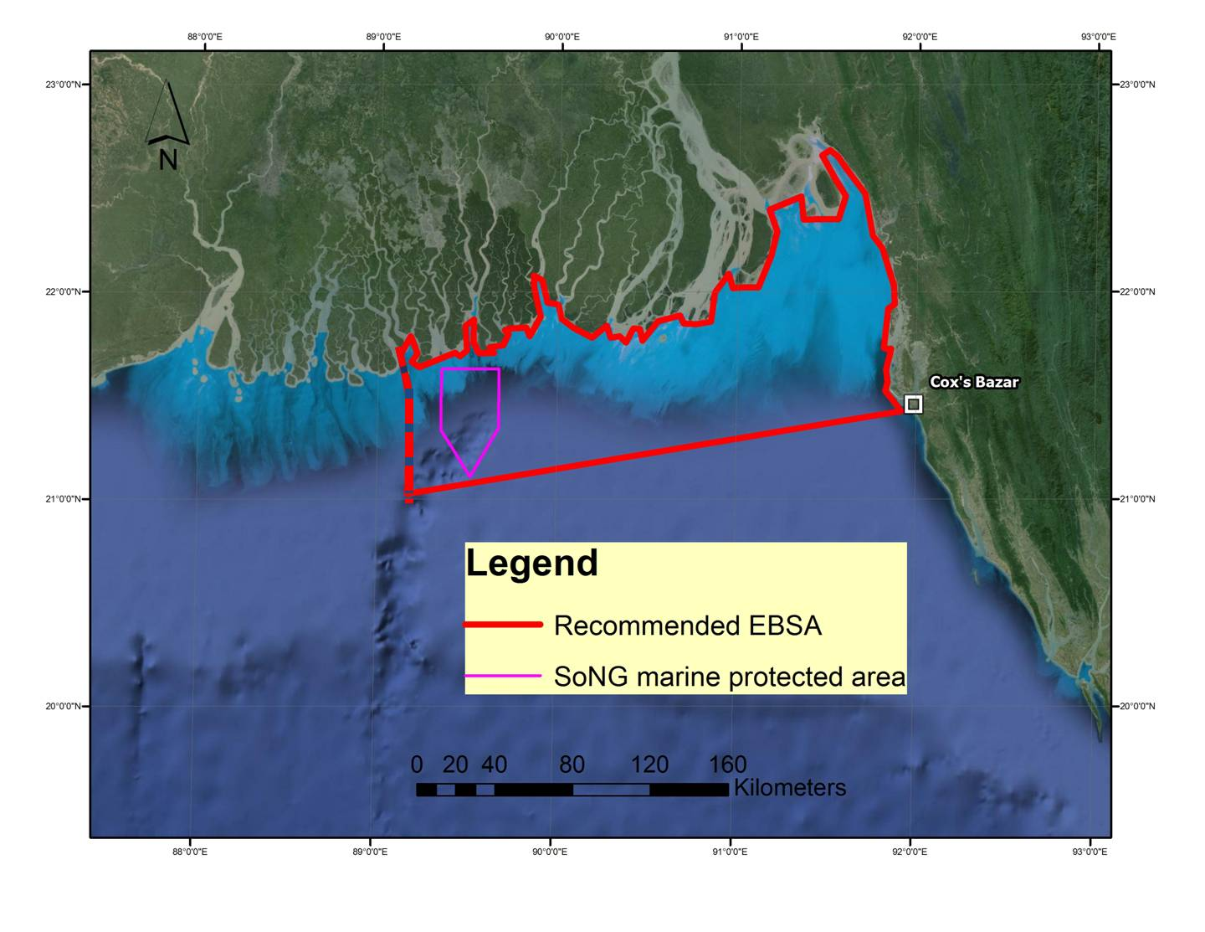
Figure 1. Map of the area, bounded in red in the upper Bay of Bengal of Bangladesh inclusive of the freshwater plume of the Ganges-Brahmaputra-Meghna river system and the head of the Swatch-of-No-Ground submarine canyon. The downward pointing box in purple shows the scope for Bangladesh’s first marine protected area declared for the protection of threatened cetaceans, turtles, sharks and rays. The dashed line at the western boundary of the area coincides with the national border of Bangladesh. It does not indicate discontinuity or lack of ecological connectivity.

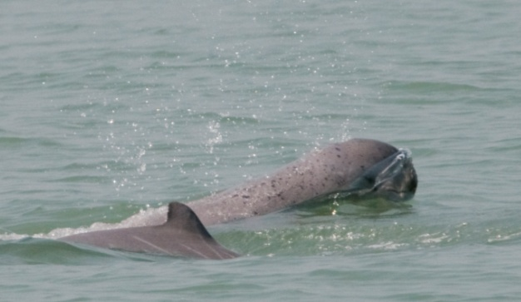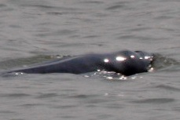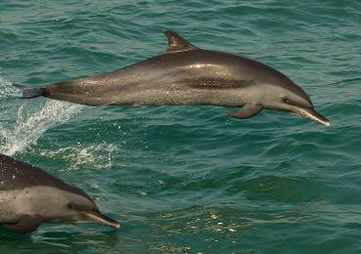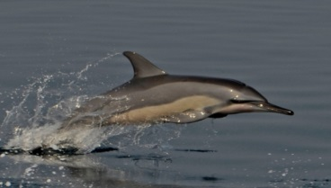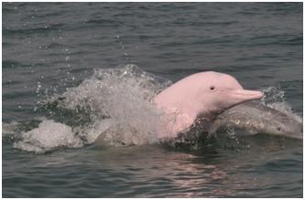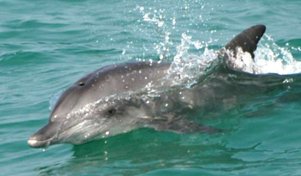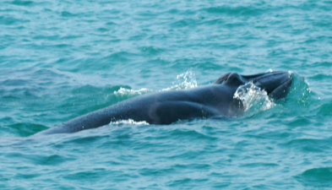

Figure 2. Map of the area (outlined in red) showing the rough distribution of its cetacean assemblage according to increasing salinity and depth, and decreasing turbidity. The newly declared SoNG MPA is outlined in purple. From top to bottom the species include the Irrawaddy dolphin, finless porpoise, Indo-Pacific humpback dolphin, Indo-Pacific bottlenose dolphin, small form of Bryde’s whale, spinner dolphins and pantropical spotted dolphin.

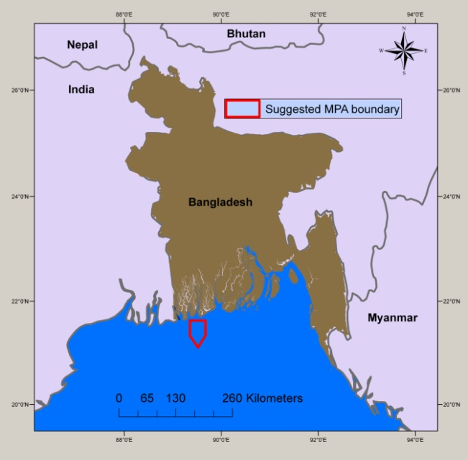

Figure 3. Location of Bangladesh’s first marine protected area in the Swatch-of-No-Ground submarine canyon and adjacent coastal waters for the conservation of cetaceans, turtles, sharks and rays.

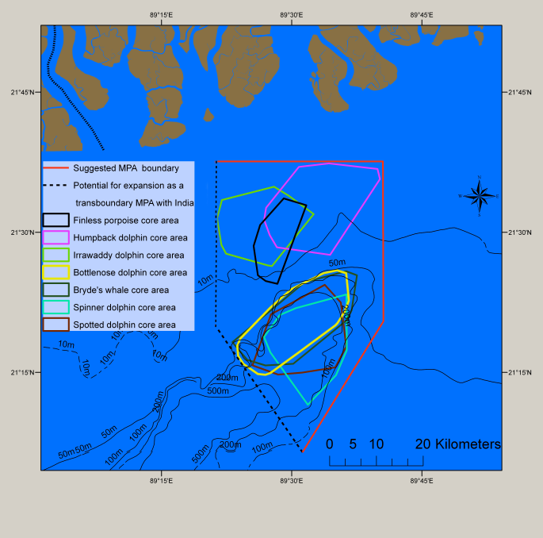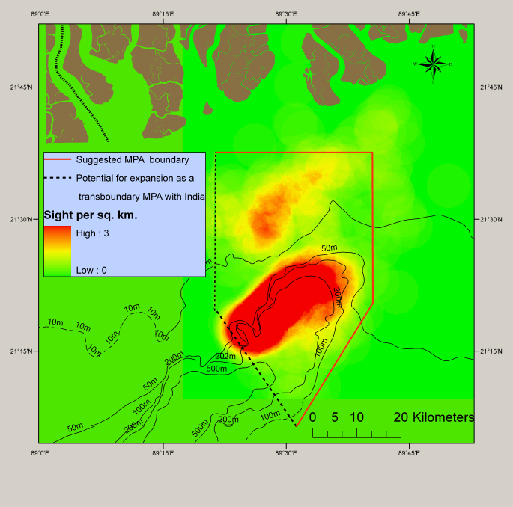

Figure 4. Minimum convex polygons for each species with the SoNG MPA shown outlined in red (left) and point density map of all sightings combined (right).

Rights and permissions
There are no known issues with giving permission to share or publish these data, with the exception of publishing results that are cited as WCS Bangladesh in prep. For permission to publish this content, please contact the authors, Brian D. Smith (bsmith@wcs.org), and Rubaiyat Mowgli Mansur (rmansur@wcs.org).

__________

* Also issued as UNEP/CBD/SBSTTA/20/INF/22.
The designations employed and the presentation of material in this note do not imply the expression of any opinion whatsoever on the part of the Secretariat concerning the legal status of any country, territory, city or area or of its authorities, or concerning the delimitation of its frontiers or boundaries.
Brewer, D., D. Hayes, V. Lyne, A. Donovan, T. Skewes, D. Milton and N. Murphy (2015). An Ecosystem Characterisation of the Bay of Bengal. Draft report for the Bay of Bengal Large Marine Ecosystem Project. CSIRO, Australia, ISBN: 978-1-4863-0521-6. 288 pp.
Brewer, D., D. Hayes, V. Lyne, A. Donovan, T. Skewes, D. Milton and N. Murphy. (2015). An Ecosystem Characterisation of the Bay of Bengal. Draft report for the Bay of Bengal Large Marine Ecosystem Project. CSIRO, Australia, ISBN: 978-1-4863-0521-6. 288 pp.
Brewer, D., D. Hayes, V. Lyne, A. Donovan, T. Skewes, D. Milton and N. Murphy. (2015). An Ecosystem Characterisation of the Bay of Bengal. Draft report for the Bay of Bengal Large Marine Ecosystem Project. CSIRO, Australia, ISBN: 978-1-4863-0521-6. 288 pp.

