CBD Scientific Criteria for Identifying Ecologically or Biologically Significant Areas (EBSAs) (annex 1 to decision IX/20): Draft Manual

Learning objectives:

In this section, you will go through a description of each of the EBSA criteria and consider how they can be applied. The purpose of this discussion is to present a variety of ways in which the scientific community understands these criteria and how they can be used as a foundation for informing future efforts regarding open-ocean waters and deep-sea habitats.

There has been substantial experience at the national and regional level with the application of some or all of the criteria for identification of EBSAs for multiple uses, including protection. This experience was consolidated at a CBD expert workshop in Ottawa, Canada in 2009, and this discussion draws on some of that experience and material.

Criterion 1: Uniqueness or rarity

Definition ( COP decision IX/20,annex 1)
The area contains either (i) unique (the only one of its kind), rare (occurs only in few locations) or endemic species, populations or communities, and/or (ii) unique, rare or distinct, habitats or ecosystems; and/or (iii) unique or unusual geomorphological or oceanographic features.

Comments on the definition
This criterion is established to identify unique or rare occurrences of species or habitats for consideration. The uniqueness or rarity of a given feature may be determined at a variety of scales, including the global, ocean basin, regional, or local scale. While “uniqueness” by definition cannot be judged on a relative scale (i.e. an object is either unique, or it isn’t), “rarity” may be judged relative to other species or habitats.

Comments on the application of this criterion
Uniqueness and rarity are strongly influenced by the scale at which the policy and management jurisdiction is functioning. Global rarity should be taken into account when applying this criterion at regional or local scales, such that a globally rare or unique property is identified as significant even if it is relatively common within the specific region or locality for which the evaluation is conducted. However, a feature that is depleted, rare or unique at the scale of a specific jurisdiction’s evaluation should also be considered, even if the feature may be more common elsewhere.
In areas where biological information is scarce, physical data may provide the only basis for application of this criterion. Areas that have unique substrates and bathymetries may be appropriate as EBSAs based on this criterion, even without data on the biological communities present in the physically unique sites. For example, in a survey of the eastern Australian margin, where multibeam bathymetry was used to map >25,000km² of the seabed, only 31 km² (0.12%) of seabed comprised hard substrata, while the remaining seabed comprised bioturbated soft-sediment plains. In such a circumstance, it is appropriate to assume that the biotic community, because it is supported by rare physical geography (i.e. hard substrata in this case), is also rare and should be considered as ecologically or biologically significant.
For most of the deep sea, many species may be fairly rare, and thus rarity may be common. If this is true, this part of the criterion for deep-sea areas may pose some initial difficulties. That said, some deep-sea species are likely to be more rare than others.

Methods (for more detail, see section 2(c))
Application of the uniqueness or rarity criterion may be based on biological, ecological and oceanographic information from peer-reviewed literature, technical reports and data sets. Areas containing similar features may be compared to assess the ways in which one area is different or unique. Uniqueness or rarity can also be based on similar comparisons of survey data.
Approaches that seek to identify different morphological features and seascapes can also indicate unusual features which may satisfy this criterion. However, care must be taken to ensure that unusual classes that emerge from such work are not artifacts of the analysis and meaningfully reflect features in the sea.

Examples

1. The Saya de Malha Banks
The Saya de Malha Banks (fig. 15) are the largest submerged banks in the world, containing a unique seagrass biotope in the open ocean. Due to their remoteness, the Saya de Malha Banks are host to some of the least explored shallow tropical marine ecosystems globally, completely detached from land boundaries and providing an ecologically important oasis of high productivity in the Indian Ocean (M. Vierros, United Nations University Institute for Advanced Studies).

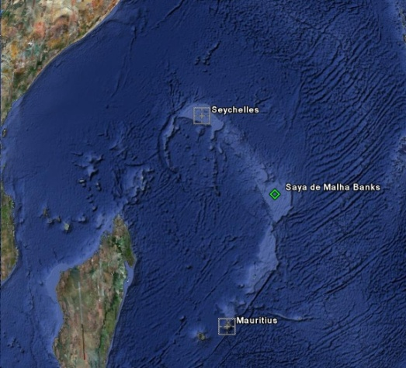

Figure 15: Location of the Saya de Malha Banks in the Western Indian Ocean
Source: Google Earth.

2. Sargasso Sea
Alone in supporting the centre of distribution for a holopelagic (continuously pelagic) drift algae (Sargassum spp.) community, the Sargasso Sea (fig. 16) is a globally unique marine ecosystem whose entire water column provides a range of critical services When the drift algae clumps together into mats, it provides structural habitat for a range of fauna, including endemic, threatened and commercially important species, particularly for the juveniles of the species. While Sargassum occurs globally, it is only in the Sargasso Sea where these characteristic large mats are found (S.A. McKenna, IUCN WCPA Marine - Caribbean Working Group, IUCN WCPA, High Seas MPA Task Force Deep Search Foundation and A. H. Hemphill, IUCN WCPA, High Seas MPA Task Force, Center for Ocean Solutions, Stanford University; S. Gulick, S. Brooke, and J. Ardron, Marine Conservation Institute).

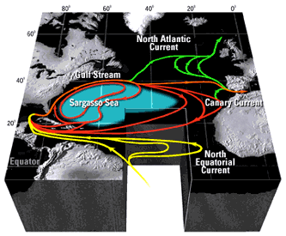

Figure 16: Location of the Sargasso Sea.
Source: xx

Criterion 2: Special importance for life-history stages of species

Definition (COP decision IX/20, annex 1)
Areas that are required for a population to survive and thrive.

Comments on the definition
This criterion is intended to identify specific areas that support critical life-history stages of individual species. This is an inclusive definition that incorporates all life-history stages of a species or population, but which leaves open the question of how an area can be determined to be required for survival and reproduction.

Comments on the application of this criterion
The application of this criterion will focus on the reliability and exclusivity of use of an area for a particular life-history function of one or more species. The “significance” of an area increases as either factor (reliability over time, exclusivity relative to alternative areas) increases; i.e., “significance” increases as a greater percentage of the species use an area more regularly (in time and space) for an important life-history function. It is also noted that sex, age and other biological variables can influence where these important areas exist within a single species (i.e., females with nursing offspring vs. single males), so caution should be taken when looking at this criterion across one species or population.
Application of this criterion for deep-sea species can be difficult because specialized sampling gears are needed to sample early life stages of deep-water species such that they are without contamination from other depths. Species identifications of immature life-history stages of deep-water species are also poorly described in many areas, making it hard to identify areas of special significance at the species level when dealing with immature stages.

Methods
This EBSA criterion, Special importance for life-history stages of species, is similar in nature to Importance for threatened, endangered or declining species and/or habitats, sharing the same examples listed in annex I to decision IX/20: “(i) breeding grounds, spawning areas, nursery areas, juvenile habitat or other areas important for life-history stages of species; or (ii) habitats of migratory species (feeding, wintering or resting areas, breeding, moulting, migratory routes).” Due to this similarity, they will be considered together to aid understanding of the analytical techniques necessary to identify important areas related to a species or habitat.
The primary data sources data for application of these criteria are either survey data or satellite tracking data. Where coverage is adequate, survey data can be used directly to determine abundance and density of animals within a particular area. In evaluating whether data are adequate for direct evaluation of the functional importance of an area, consideration must be given to how well the data capture the likely degree of natural variation in a species’ distribution and behaviour. Areas of occupancy or performance of specific life-history activities may vary greatly from year to year, season to season or at even shorter time scales. Consequently, the degree to which the available data are merely “snapshots” (i.e., representative of conditions at a single point in time) affects whether observed absences can be used as justification that an area is not used by a species, or observed presences can be used as justification that an area is necessary for that life-history function. The less representative in space and time the available data are considered to be, the more likely it is that an evaluation should at least augment direct observational data with tested models. Where there are insufficient data or knowledge for direct estimates, models can be used to predict the likelihood of occurrence or abundance of a species from physical and biological oceanographic data.
Satellite tracking data offers more detailed information about a single organism’s movement and can be used to identify core use areas for individuals or aggregated to better understand the importance of areas to a population(s). The more consistent the data are from multiple tracked animals, the more valuable such data are for identifying core use areas for individuals or populations through home range analyses, predictive habitat models or resource selection models. Some general techniques that can be used on tracking data are listed below in order from the least complex and least data-intensive, to the most complex and most data-intensive methods:
- Sinuosity Analysis (Bell 1991; Grémillet et al. 2004)
- Fractal Analysis (Laidrea et al. 2004)
- First-Passage Time Analysis (Fauchald and Tveraa 2003)
- Kernel Analyses (Laver and Kelly 2008)
- Regression, Autocovariate and other Habitat Modelling (Guisan and Zimmermann 2000, Dormann et al. 2007)
- State-Space Models (SSM) (Morales et al. 2004, Jonsen et al. 2005)

Examples

- Areas of importance for northern elephant seals
Many wide-ranging marine animals have an amphibious life history. For example, sea turtles, seabirds, sea lions, and seals spend part of their lives feeding at sea and part of their lives on land, breeding, caring for young, or molting. In the North Pacific, the northern elephant seal is a wide-ranging top predator with such a life history. Female northern elephant seals undertake a long foraging migration in the North Pacific each year, building a reserve for subsequent months spent fasting on land while giving birth, nourishing a pup, and breeding. Using data from the Tagging of Pacific Predators project (www.topp.org), figure 17 identifies an area of high female northern elephant seal density during their annual six-to-eight-month foraging migration, indicating it is an area of special importance for life history stages of this species (A-L. Harrison, University of California at Santa Cruz,).

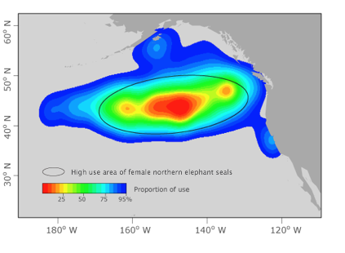
Figure 17: Area of importance for northern elephant seals
Source: Tagging of Pacific Predators (TOPP) project, University of California at Santa Cruz.

- Area of special importance for the Antipodean albatross in the Tasman Sea
The antipodean albatross (Diomedea antipodensis) is one of the largest seabirds on Earth, and a member of the great albatross (Diomedea spp.) group. It is endemic to New Zealand, breeding on Antipodes Island, the Auckland Islands group, Adams, Disappointment and Auckland, Campbell Island, and Pitt Island in the Chatham Islands. Declines in adult survival, productivity and recruitment are largely due to bycatch in longline tuna fisheries, and the Antipodean albatross is currently listed as vulnerable by IUCN. Data from satellite tracking show that during different life-history stages birds utilize different areas (fig. 18) (Ben Lascelles and Lincoln Fishpool, BirdLife International).

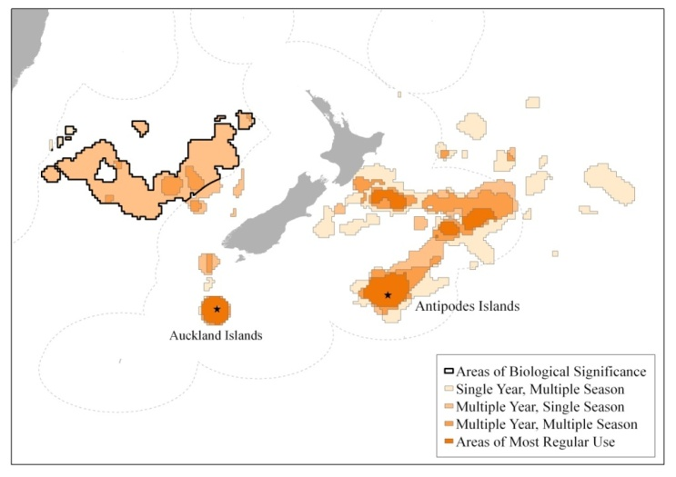

Figure 18: Map showing areas regularly used by the Antipodean albatross during different life-history stages and the location of the Tasman Sea area of biological significance.
Source:

- Areas of importance for Pacific white sharks
Due to infrequent, yet often sensational interactions with people, white sharks have long captured the imagination of humans. Most of the studies of white sharks have centreed around pinniped (seal and sea lion) rookeries, where adult white sharks feed on elephant seals and sea lions. Off the coast of northern California, the interactions between pinnipeds and white sharks have been studied at the Farallon Islands and Año Nuevo Island for decades (Ainley et al. 1985). White sharks are present at these islands predominately in the late summer through winter when they feed on young elephant seals and sea lions. Although pinnipeds are present throughout the year, white sharks are apparently only present for a portion of the year, and their movement patterns after leaving remained a mystery for decades. With the advent of new electronic tagging technologies, it has since been possible to track white sharks for periods of up to one year and shed light on their movement patterns after departing pinniped colonies.

As illustrated in figure 19, adult white sharks were tracked travelling from several sites along the North American coast, to a region in the northeastern Pacific, equidistant between Baja California and Hawaii, where they remain for up to six months. It remains unclear whether these represent breeding or feeding migrations (A. Boustany, Duke University Marine Geospatial Ecology Lab).

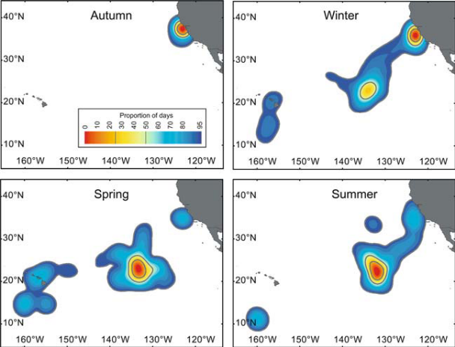

Figure 19: Seasonal densities of white sharks tagged off the northern California coast, USA
Source: Weng et al. 2007

Criterion 3: Importance for threatened, endangered or declining species and/or habitats

Definition (COP decision IX/20, annex 1)
Area containing habitat for the survival and recovery of endangered, threatened or declining species or area with significant assemblages of such species.

Comments on the definition
This criterion targets threatened, endangered or declining species and their habitats for consideration. As in the above criterion, the linkage between the area of concern and the endangered species is one of the relative factors in the application of this criterion. The greater the persistence of use of an area, and the greater the number of individuals from a threatened population that use the area, the more important the area must be considered. The definition of a “significant assemblage” is not made explicit in the definition of the criterion.

Comments on the application of this criterion
In the deep seas, assessment of species against criteria for risk of extinction is still in early stages, and the ecological requirements of most such species are poorly known. As studies to determine the population trend of a species are long-term, data-intensive processes, the application of this criterion must be based on pre-existing determinations of the population status of a given species. In particular, use of the IUCN Red List (http://www.iucnredlist.org) is clearly fundamental to understanding to which species this criterion applies. In data-deficient situations, the listing for organisms with similar life-history traits should be used until further information on the status of the species is available.

Methods
See discussion under previous criterion, Special importance for life-history stages of species.
Examples

1. Areas of importance for the Pacific leatherback turtle
Studying pelagic species on the high seas has traditionally been difficult. The long distances from shore, coupled with the highly mobile nature of the organisms, have precluded direct observation. Recent technological advances have permitted researchers to track highly migratory pelagic species by allowing data collection and transmission remotely (Eckert 2006). These novel electronic tags have been particularly useful for studies involving air-breathing animals in the open ocean, as frequent surfacing allows for direct uplinks to satellites, and animals can therefore be tracked in near real time. While the data these tags have returned is invaluable in shedding light on the basic biology of pelagic species, they gain even more importance when addressing questions pertaining to conservation of severely threatened and endangered species. A prime example of this is the recent electronic tracking conducted on leatherback turtles in the eastern Pacific Ocean.

Like many marine turtle species, the slow growth and low reproductive potential of leatherback turtles makes them particularly sensitive to excessive mortality of adult life stages. Leatherbacks in the eastern Pacific Ocean have suffered through illegal poaching and egg collecting on the nesting beaches, resulting in severe population declines. Figure 20 illustrates how new tracking technologies have allowed researchers to examine the movements of the critically endangered Pacific leatherback turtle. Several years of tracking have revealed a consistent foraging area for leatherback turtles in the South Pacific Gyre (A. Boustany, Duke University Marine Geospatial Ecology Lab).

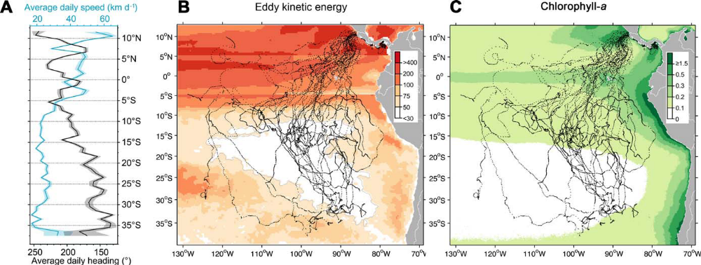

Figure 20: Panel A: daily swimming speed of tracked turtles as they move to the south from the tagging area in Costa Rica. Panel B: Tracks of tagged turtles plotted over eddy kinetic energy, red indicates high energy regions and white indicates low energy regions. Panel C: Turtle tracks plotted over chlorophyll concentration, green areas indicating highest chlorophyll levels.
Source: Reproduced from Shillinger et al. 2008.

2. Areas of importance for the Short-tailed albatross
BirdLife International is the IUCN Red List authority for birds and conducts a comprehensive review of the status of all species every four years, with annual reviews of the most threatened. The BirdLife Important Bird Areas (IBA) Programme uses the Red List assessment to define one of the global IBA criteria for identifying IBAs (category A1), such that sites critical for the conservation of the most threatened species are identified.

The short-tailed albatross (Phoebastria albatrus), a threatened seabird, breeds on the island of Torishima (Japan), and on Minami-kojima in the Senkaku Islands (claimed by Japan, the People's Republic of China and the Republic of China on Taiwan), and its range extends throughout the Bering Sea. Satellite tracking data and vessel survey data have been used to identify areas of importance based on habitat preferences for the albatross (fig. 21) (B. Lascelles and L. Fishpool, BirdLife International).

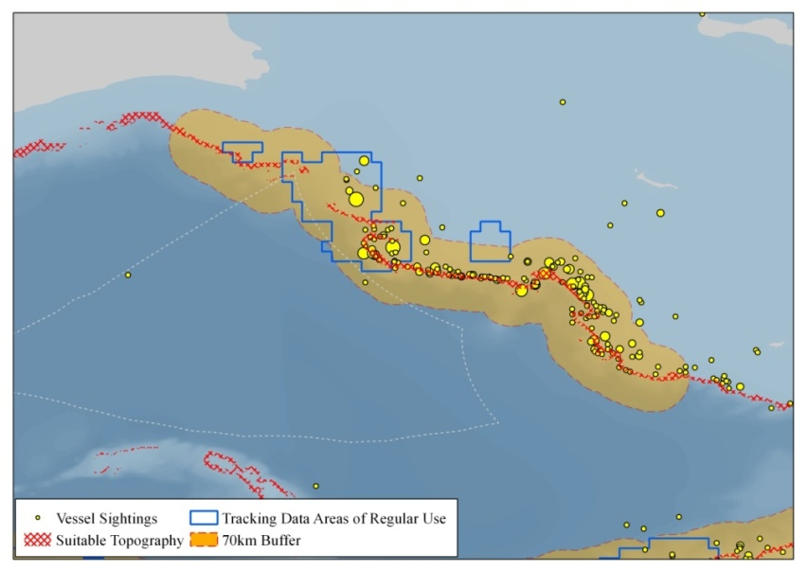

Figure 21: Map of candidate IBA for the short-tailed albatross at the Bering Sea shelf break. This map shows areas of regular use identified from satellite tracking data, vessel survey data, and a 70km buffer around suitable topography.
Source: Birdlife International, 2004 and 2009.

Criterion 4: Vulnerability, fragility, sensitivity, or slow recovery

Definition (COP decision IX/20, annex 1)
Areas that contain a relatively high proportion of sensitive habitats, biotopes or species that are functionally fragile (highly susceptible to degradation or depletion by human activity or by natural events) or with slow recovery.

Comments on the definition
This EBSA criterion focuses on the inherent sensitivity of habitats or species to disruption. The core concept here is that resilience to perturbations (physical or chemical) varies amongst habitats and species; for example, species with low reproductive rates exhibit an inherently higher level of risk to impacts than other species. Assessing vulnerability of benthic ecosystems in relation to bottom contact fisheries has been elaborated upon by the FAO (2009).

Comments on the application of this criterion
“Fragility” and recovery time can be quantified by examining the life-history characteristics of a species or the inherent properties of the ecosystem features themselves in the face of adverse impacts of any type (physical, chemical, biological). In general, maximum lifespan and age-at-first-reproduction are positively correlated, and those species that also produce few offspring are likely to be considered sensitive and require long time periods to recover from perturbation. Structure-forming organisms, or habitats that require geologic time periods to form, are also likely to be slow to recover. “Vulnerability” can only be evaluated relative to threats, which makes this aspect of this criterion different from all other EBSA criteria that address intrinsic properties of an ecosystem independent of threats. However, ecosystem features that are fragile, sensitive, or slow to recover are likely to be vulnerable to a wide range of threats. Viewed in that context, this criterion can be applied in the absence of information about threats. Expert advice and the literature should be sought to explain the nature of the features’ properties that are considered sensitive, vulnerable, fragile or slow to recover (e.g., FAO 2009).

Ideally, maps of the potentially sensitive or vulnerable features would be available. Lacking adequate data for such mapping, it would still be possible to identify the areas where features that were sensitive, vulnerable, fragile or slow to recover were known or likely to occur, based on predictive modelling or extrapolation of expert knowledge from better known areas.

Methods
Information on which species or biomes qualify as vulnerable, fragile, sensitive or slow to recover should be based on peer-reviewed scientific literature to the extent possible. Regardless, the fragility of certain features to certain pressures (e.g., ice-dependent communities to the effects of climate change) can be taken as self-evident, unless data indicating the contrary are produced. In some cases, expert opinion can be used where vulnerabilities or sensitivities are only just beginning to enter the peer-review process. As with previous criteria, this criterion can be informed by survey data and models by using physical features known to be associated with biotic features that are sensitive or slow to recover.
Application of models that extrapolate results of studies in one area to other areas of similar features will be particularly helpful for evaluating sensitivity or recovery rate. In cases of particularly sensitive benthic features, such as deep-water corals, merely documenting the presence of the feature using the best applicable method above may be sufficient to conclude that the area would be highly relevant to this criterion. Although such inferences seem obvious for features such as corals, similar evaluations are not straightforward for some other features of marine communities, including communities composed of a range of co-existing life-history strategies. In such applications, models that predict the sensitivity or fragility of particular community types would be helpful.

Example

Global habitat suitability for reef-forming cold-water corals
Reef-forming cold-water corals create structural habitat with a range of ecosystem functions in the deep sea, including promoting local biodiversity and supporting commercially important fisheries. They are known to be very sensitive to anthropogenic activities, are expected to be heavily impacted by ocean acidification, and are known to have very slow recovery rates. These scleractinian (or “stony”) corals form reef-like habitats, which are fragile and have been impacted by human activities that make contact with the seafloor, such as bottom fisheries. They are known to have very slow recovery rates, on the order of hundreds to thousands of years, if at all (Roberts et al. 2006).

Figure 22 shows global-scale predictions of habitat suitable for reef-forming corals. Using known locations of the six reef-forming cold-water coral species, amassed from research and cruise databases, coral habitat suitability predictions were made based on more than 30 different environmental conditions, such as bathymetry, ocean chemistry, temperature and productivity. (J. Guinotte, Marine Conservation Institute, A. Davies, University of Bangor, Wales, and J. Ardron, Marine Conservation Institute).
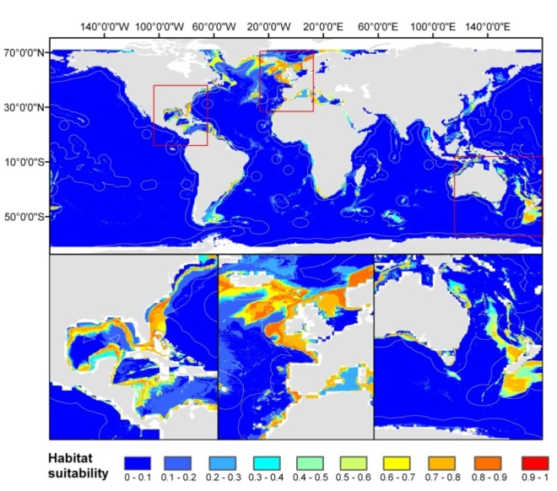

Figure 22: Habitat suitable for reef-forming corals.

Source: J. Guinotte, Marine Conservation Institute, A. Davies, University of Bangor, Wales, and J. Ardron, Marine Conservation Institute

Criterion 5: Biological productivity

Definition (COP decision IX/2, annex 1)
Area containing species, populations or communities with comparatively higher natural biological productivity.

Comments on the definition
This criterion is specified to identify regions in the open oceans which regularly exhibit high primary or secondary productivity. These highly productive regions are here assumed to provide core ecosystem services and are also generally assumed to support significant abundances of higher trophic-level species. The phrase “comparatively higher” highlights the relative (rather than absolute) nature of this criterion. How much “higher” is left open to interpretation.

Comments on the application of this criterion
Productivity is not the same as abundance, but in many instances, abundance could be used as a surrogate for productivity. For this criterion, remote sensing data may be especially helpful, because methods for quantifying primary productivity are well developed. Centres of high primary and secondary productivity are known to vary between years, seasonally, and on short time scales, but overall core centres can be spatially identified.
High primary productivity near the surface may not necessarily mean higher secondary productivity near the seafloor, as currents may transport animals and nutrients hundreds of kilometres before they settle to the bottom, and thus such transport mechanisms should be considered.
Some ecosystems in the deep sea, such as hydrothermal vents and cold seeps, are also areas of high biological productivity through the conversion of specific chemicals into energy that directly supports complex communities and often endemic species.

Methods
A variety of pre-processed biological productivity analyses are available. As such, little analysis needs to be performed in order to apply this criterion to specific areas. For example, global datasets are available for Chlorophyll-a, primary productivity, and secondary productivity. Analytical techniques may be required to identify the patterns of spatial gradients from areas of high productivity to areas of low productivity, or such information may be found in peer-reviewed literature.
The identification of oceanographic features related to higher levels of biological productivity is a more difficult task that does require analysis of oceanographic datasets. Complex algorithms exist to identify sea surface temperature fronts (e.g., Cayula and Cornillon 1992) and warm- and cold-core eddies (e.g., Isern-Fontanet et al. 2003). Fortunately for managers and practitioners, some of these algorithms have been implemented in a user-friendly tool package, Marine Geospatial Ecology Tools, which is freely available online (http://code.env.duke.edu/projects/mget.

For more information on methods, see section (c) of this module.

Examples

1. Pacific Equatorial Upwelling high productivity area
Primary production does not occur uniformly throughout the ocean. The rate of production depends mainly on the quantity of phytoplankton already in the water, the availability of light and required nutrients such as nitrogen and phosphorus, and the water temperature. Light availability is regulated mainly by geographic location and the annual solar cycle. Primary production in the open ocean only occurs in the euphotic zone, the layer of the ocean that light can penetrate. Nutrient availability and water temperature are regulated by the flow of ocean currents. Patterns in light and ocean currents lead to patterns in primary productivity. Oceanographers estimate primary production worldwide from satellite observations. Using these data, we can identify one such area of high productivity around the Pacific equatorial upwelling.

In figure 23, the area identified is still very large. In order to further refine EBSA identification in this region, this criterion could be combined with other relevant criteria so as to highlight particularly significant areas (Global Ocean Biodiversity Initiative, GOBI, team).

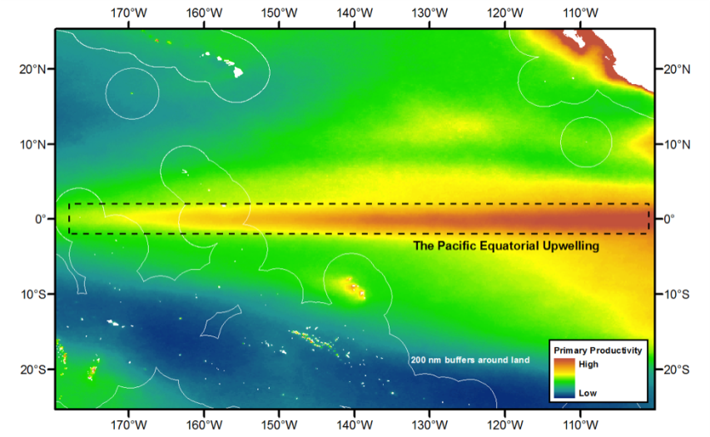

Figure 23: An area from which an EBSA could be identified in the Pacific Equatorial Upwelling.
Source: GOBI Team.

2. Sea-surface temperature fronts

Dynamic physical ocean processes, such as upwellings, currents and eddies, promote biological productivity and structure marine ecosystems by aggregating and dispersing nutrients and organisms. Phytoplankton can be detected at the ocean surface by satellites that measure specific wavelengths of reflected sunlight. But current satellite technology cannot detect animals. Until this is possible, scientists must infer the presence of animals by looking for patterns in satellite images that are correlated with the presence of animals, such as fronts visible in images of the sea surface temperature (SST). In figure 24, an algorithm was applied to estimate the frequency of SST fronts in the eastern tropical Pacific Ocean near Central America, and identify EBSAs in two zones of high frontal frequency: one south of the Gulf of Tehuantepec and one east of the Gulf of Papagayo (Jason Roberts, Duke University Marine Geospatial Ecology Lab).

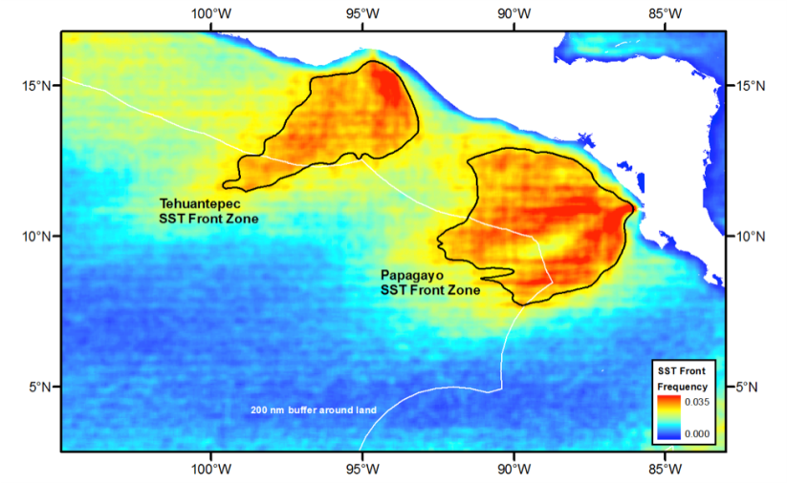

Figure 24: Sea surface temperature fronts.

Source: Jason Roberts, Duke University Marine Geospatial Ecology Lab.

Criterion 6: Biological diversity

Definition (COP decision IX/20, annex 1)
Area contains comparatively higher diversity of ecosystems, habitats, communities, or species, or has higher genetic diversity.

Comments on the definition
The question of measuring biological diversity has generated a whole literature base of its own, with no single agreed-upon definition of “diversity.” Hence, this criterion could be considered in a number of different ways.

Comments on the application of this criterion
Measures of diversity generally consider one or more of the following factors: 1) number of different elements (i.e., species, communities, also referred to as “richness”); 2) the relative abundance of the elements (“evenness” and other related measures); and 3) how different or varied the elements are when considered as a whole (e.g., taxonomic distinctness). In applying this EBSA criterion, all three factors could be taken into consideration. When comparing measures of species diversity among areas, sampling should be sufficient to statistically support such comparisons, for example, by ensuring that species accumulation curves (when considering richness) are saturated prior to conducting pair-wise comparisons. Otherwise there is a danger of identifying areas with more research effort.
When species survey data are lacking, habitat characteristics can provide indications of diversity. Owing to the greater number of possible niches, habitats of higher complexity (heterogeneity) are believed to also harbour higher species diversity. For benthic habitats, this can be approximated by measuring physical topographic complexity or rugosity (e.g., Ardron 2002, Dunn and Halpin 2009). For pelagic habitats, this can be estimated by identifying convergences of differing water masses. Interactions of differing water masses generally support higher biological diversity than the individual water masses, and areas of high physical energy may also have relatively high biological diversity, consistent with the diversity-disturbance relationship that has been established for many terrestrial systems. However, because of the complexity of the concept of biological diversity, and the large variance around the often statistically significant relationships between diversity and specific features of the physical environment, application of this criterion will probably be most usefully conducted with biological data, rather than by relying on physical covariates of diversity.

Methods
Analytical techniques to measure of biodiversity have been a recurrent theme in ecology for many years. A number of indices exist to examine this concept:
- Berger-Parker Index (Berger and Parker 1970, May 1975)
- Simpson’s Index (Simpson 1949)
- Shannon-Wiener Index (Shannon 1948)
- Pielou’s Evenness Index (Pielou 1969)
- Hurlbert (ES50) Index (Hurlbert 1971)
- Rank Abundance Curves (Foster and Dunston 2009)
For more information on methods, see section 2(c).

Examples

1. Global patterns of species diversity
Several indices measuring species diversity have been proposed. This example shows a calculation of global patterns of species diversity using one of these indices, Hurlbert’s index, for a sample size of 50 specimens. Figure 25 was based on publicly available data holdings of the Ocean Biogeographic Information System, an initiative of the Census of Marine Life and now adopted by the Intergovernmental Oceanographic Commission of UNESCO. (E. Vanden Berghe, OBIS).

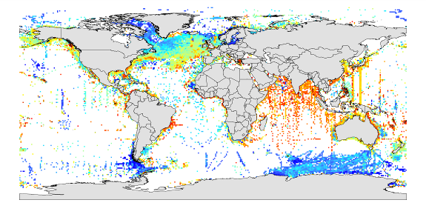
Figure 25: Global species diversity patterns.
Source: E. Vanden Berghe, OBIS.

2. Overlap between hotspots of marine mammal biodiversity and global seamount distributions
Species are not uniformly distributed on Earth. Heterogeneous physical features and community evolution drive the mix of species found in a given location. AquaMaps is a species distribution model available as an online web service that generates standardized range maps and the relative probability of occurrence within that range for currently more than 11,000 marine species from available point occurrences and other types of habitat usage information (Kaschner et al., 2006, Ready et al, accepted). Figure 26, a global map of biodiversity patterns that shows the co-occurrence of predicted hotspots of marine mammal species richness and off-shore seamounts, was produced by overlaying AquaMaps predictions for a subset of individual species (115 marine mammals) (K. Kaschner, J. Ready, E. Agbayani, P. Eastwood, T. Rees, K. Reyes, J. Rius and R. Froese).

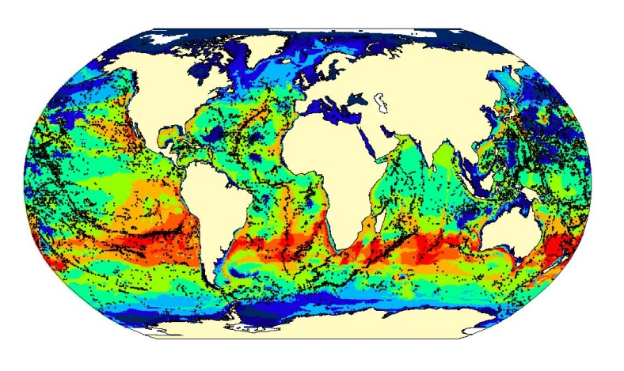

Figure 26: Co-occurrence of predicted hotspots of marine mammal species richness and off-shore seamounts.
Source: Modified from Kaschner, 2007.

3. Prediction of biodiversity – richness and evenness
Patterns in biodiversity can be illustrated by variation in the number of species (richness) and whether these species are evenly distributed or dominated by a minority (evenness). Combining these two properties of biodiversity leads to the identification of uncommon communities that deserve greater protection. Figure 27, from Western Australia, shows the results of a statistically rigorous analysis of species ranks combined with physical samples to predict patterns in biodiversity through the physical space. This extends our information from known biological samples to the broader environment, with measured uncertainty (Piers Dunstan, CSIRO).

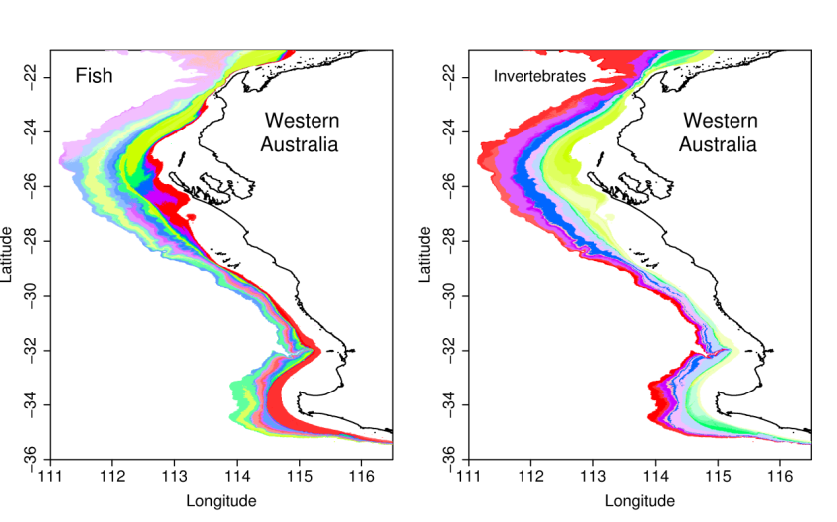
Figure 27: Analysis of species ranks combined with physical samples to predict patterns in biodiversity
Source: Piers Dunstan, CSIRO.

Criterion 7: Naturalness

Definition (COP decision IX/20, annex 1)
Area with a comparatively higher degree of naturalness as a result of the lack of or low level of human-induced disturbance or degradation.

Comments on the definition
This criterion measures the relative “naturalness” of open-ocean and deep-sea areas compared to other representative examples of the habitat type. This criterion is a relative measure, and it is not required that an area be pristine in order for it to be identified as an EBSA. “Comparatively higher” highlights the relative (rather than absolute) nature of this criterion. How much “higher” is left open to interpretation, but presupposes that one has at least some information or indications on historic states of the ecosystems where the criterion is being applied.

Comments on the application of this criterion
The “natural” state of ecosystems, communities or features in an area is often unknown, even for many well-studied areas, but inferences of this status can be gleaned from other areas. There is even less information on the “natural” state of open-ocean and deep-sea ecosystems. In practice, application of this criterion will probably consider the history of human activity in an area where EBSA evaluations are being conducted. Areas where there is a documented or suspected history of human activities associated with certain impacts will be considered less “natural” than areas where there has been little human activity. Application of the criterion will also require taking account of what is known of the impacts of each human activity on specific ecosystem features – such as the impacts of bottom trawling on benthic habitats, populations, and communities; the effects of shipping noise and ship strikes on wildlife aggregations and migrations; and collisions.
Methods
Mapping and analysing the cumulative effects of human maritime activities is a new and emerging field of research. Recent studies have paved the way for analyses of human impacts globally (Halpern et al. 2007, 2008a, 2008b), and regionally (Eastwood et al. 2007; Ban and Alder 2008; Tallis et al. 2008; Halpern et al. 2009). Though methodologies are still developing, promising approaches stratify effects according to their type (i.e., physical, chemical, biological), taking into consideration both intensity and effect-distance of the given stressor on a given habitat type (Ban et al. 2010).
In most studies to date, stressors are considered additive or incremental when impacts are repeated. However, stressors can be synergistic or interactive when the combined effect is larger than the additive effect each stressor would predict (Folt et al. 1999; Cooper 2004; Vinebrooke et al. 2004). Stressors can also be antagonistic when the impact is less than expected (Folt et al. 1999; Vinebrooke et al. 2004).
Given the largely unpredictable nature of cumulative effects (Crain et al. 2008; Darling & Cote 2008), in the absence of additional information, assuming an additive mechanism is perhaps the best way forward, though it could underestimate some effects. Bearing in mind that naturalness is a relative measure, regardless of the analytical details, the mapping of cumulative stressors should reveal overall patterns that would be useful to identify possibly (more) natural areas of a given habitat type. Stressors can be mapped using a GIS and overlaid on habitat maps to predict the ‘naturalness’ of an area.

Example

South East Atlantic Seamounts
Seamounts have been characterized as oases of productivity and diversity in the deep sea that also influence the productivity of the water column above (White et al. 2007). Formed by tectonic and volcanic activity, seamounts may act to disrupt normal oceanographic conditions across the abyssal plain, leading to an increase in vertical mixing and circulation (Roden 1987). Such mixing, coupled with relative isolation, can encourage the development of productive and often unique ecosystems, as well as productive seamount fisheries. Beginning in the late 1960s, seamount fisheries have seen major expansions both in terms of fishing effort and their geographic range over time (Watson et al. 2007). However, many seamounts are uncatalogued scientifically and untouched by fishing gears.
As fishing is the single largest human disruption affecting most seamounts, a comparison of reported seamount fishing effort, known seamount locations, and their proximity to other anthropogenic impacts can inform the evaluation of the “naturalness” of a given seamount or seamount group. Figure 28 shows how global datasets of predicted large seamount locations (created from ocean bathymetry) were combined with historical catch data from seamount fisheries and other anthropogenic marine impacts to identify areas of low impact, including the waters around the Discovery tablemount group in the South East Atlantic (J. Cleary, Duke University Marine Geospatial Ecology Lab; A. Rowden, M. Clark, & M. Consalvey, New Zealand National Institute of Water and Atmosphere and CenSEAM).

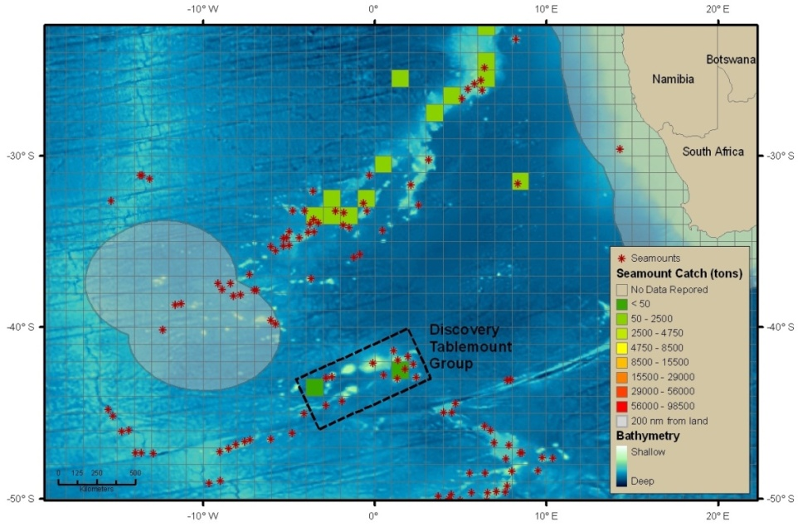

Figure 28: Seamounts with low human impact.
Source: J. Cleary, Duke University Marine Geospatial Ecology Lab; A. Rowden, M. Clark, & M. Consalvey, New Zealand National Institute of Water and Atmosphere and CenSEAM.

Summary

This section has provided an introduction to each of the seven CBD EBSA criteria and their application. The information presented is extensive, and the examples highlighting the criteria have been touched upon only in passing. In the next sections, we will go further in-depth with the methods, analytical approaches and data considerations that need to be taken into account when applying the criteria.

Check for understanding
You can check your understanding by answering the following questions, the answers for which can be found in the text above:
- How would you define a “rare” feature?
- What factors do measures of diversity generally consider?
- What kinds of physical features in the oceans are generally areas of high productivity?
- Why is the “naturalness” criterion difficult to apply?

References

Ainley DG, R. P. Henderson, H. R. Huber, R. J. Boekelheide, S. G. Allen, T. L. McElroy.1985. Dynamics of white shark/pinniped interactions in the Gulf of the Farallones. Mem South Calif Acad Sci 9:109–122

Ardron, J.A. 2002. A Recipe for Determining Benthic Complexity: An Indicator of Species Richness. In, Marine Geography: GIS for the Oceans and Seas (ch. 23, pp 196-175), Joe Breman (ed.). Redlands, CA, USA: ESRI Press.

Ardron, J., D. Dunn, C. Corrigan, K. Gjerde, P. Halpin, J. Rice, E. Vanden Berghe, M. Vierros. 2009. Defining ecologically or biologically significant areas in the open oceans and deep seas: Analysis, tools, resources and illustrations. A background document for the CBD expert workshop on scientific and technical guidance on the use of biogeographic classification systems and identification of marine areas beyond national jurisdiction in need of protection, Ottawa, Canada, 29 September – 2 October 2009.

Aquamaps: http://www.aquamaps.org/

Ban N. and J. Alder. 2008. How wild is the ocean? Assessing the intensity of anthropogenic marine activities in British Columbia, Canada. Aquatic Conservation: marine and freshwater ecosystems, 18 (1). pp. 55-85.

Ban, N., H. Alidina, and J. A. 2010. Cumulative impact mapping: advances, relevance and limitations to marine management and conservation, using Canada’s Pacific waters as a case study. Marine Policy 34: 876-886.

Bell W.J. 1991. SearchingBehaviour: The behavioural ecology of finding resources. Chapman & Hall.

Berger, W H; and F. L. Parker 1970. Diversity of planktonic Foramenifera in deep sea sediments. Science 168:1345-1347.

Birdlife International 2004. Tracking Ocean Wanderers: the global distribution of albatrosses and petrels. Results from the Global Procellariiform Tracking Workship, 1-5 September 2003, Gordon’s Bay, South Africa. Cambridge, UK: Birdlife International.

Birdlife International 2009. Using seabird satellite data to identify marine IBAs. Report of a workshop 1-3 July 2009. CNRS, Chize, France, UK: Cambridge Birdlife International internal report.

Cayula, J.-F. and P. Cornillon 1992. Edge detection algorithm for SST images. Journal of Atmospheric and Oceanic Technology 9: 67-80

Cooper, L.M. 2004. Guidelines for cumulative effects assessment in SEA of plans. In: EPMG Occasional Paper 04/LMC/CEA. Imperial College of London London, pp. 1-50.

Crain C.M., K. Kroeker, and B. S. Halpern. 2008. Interactive and cumulative effects of multiple human stressors in marine systems. Ecol Lett, 11, 1304-1315.

Darling E.S. and I. M. Côté. 2008. Quantifying the evidence for ecological synergies. Ecol Lett, 11, 1278-1286.Eastwood P.D., Mills C.M., Aldridge J.N., Houghton C.A. & Rogers S.I. (2007). Human activities in UK offshore waters: an assessment of direct, physical pressure on the seabed. ICES Journal of Marine Science: Journal du Conseil, 64, 453.

Dormann C.F., J. M. McPherson, M. B. Araújo, R. Bivand, J. Bolliger, G. Carl, R. G. Davies, A. Hirzel, W. Jetz, W. D. Kissling, I. Kühn, R. Ohlemüller, P. R. Peres-Neto, B. Reineking, B. Schröder, F. M. Schurr, and R. Wilson. 2007. Methods to account for spatial autocorrelation in the analysis of species distributional data: a review. Ecography 30(5): 609-28.

Dunn, D.C., and P.N. Halpin. (2009) Rugosity-based regional modeling of hard-bottom habitat. Marine Ecology Progress Series 377:1–11.

Eastwood, P. D., C. M. Mills, J. N. Aldridge, C. A. Houghton, and S. I. Rogers. 2007. Human activities in UK offshore waters: an assessment of direct, physical pressure on the seabed. ICES Journal of Marine Science 64: 453–463.

Eckert, S.A. 2006. High-use oceanic areas for Atlantic leatherback sea turtles (Dermochelys coriacea) as identified using satellite telemetered location and dive information. Mar Biol 149: 1257–1267

Fauchald, P., and T. Tveraa. 2003. Using first-passage time in the analysis of area-restricted search and habitat selection. Ecology 84 (2): 282-288.

FAO. 2009. International guidelines for the management of deep-sea fisheries in the high seas. Food and Agriculture Organization of the United Nations, Rome.

Folt C.L., C. Y. Chen, M. V. Moore, and J. Burnaford. 1999. Synergism and antagonism among multiple stressors. Limnol Oceanogr 44, 864-877.

Foster, S.D. and P.K. Dunstan 2010. The Analysis of Biodiversity Using Rank Abundance Distributions. Biometrics66, Issue 1: 186–195, March 2010 DOI: 10.1111/j.1541-0420.2009.01263.x

Grémillet, D., G. Dell’Omo, P. G. Ryan, G. Peters, Y. Ropert-Coudert, and S. Weeks. 2004. Offshore diplomacy, or how seabirds mitigate intraspecific competition : a case study based on GPS tracking of cape gannets from neighbouring breeding sites. Marine Ecology Progress Series 268: 265-279.

Guisan, A. and N. E. Zimmermann. 2000. Predictive habitat distribution models in ecology. Ecological Modelling 135: 147-186.

Halpern B.S., C. V. Kappel, K. A. Selkoe, F. Micheli, C. Ebert, C. Kontgis, C. M. Crain, R. Martone, C. Shearer, and S. J. Teck. 2009. Mapping cumulative human impacts to California Current marine ecosystems. Conservation Letters 2 (3): 138–148.

Halpern B.S., K. A. Selkoe, F. Micheli, and C.V. Kappel. 2007. Evaluating and Ranking the Vulnerability of Global Marine Ecosystems to Anthropogenic Threats. Conserv Biol, 21, 1301-1315.

Halpern B.S., S. Walbridge, K. A. Selkoe, C. V. Kappel, F. Micheli, C. D'Agrosa, J. F. Bruno, K. S. Casey, C. Ebert, H.E. Fox, R. Fujita, D. Heinemann, H.S. Lenihan, E.M.P. Madin, M. T. Perry, E.R. Selig, M. Spalding, R. Steneck, and R. Watson. 2008. A Global Map of Human Impact on Marine Ecosystems. Science 319 no. 5865 pp. 948-952 DOI: 10.1126/science.1149345.

Hurlbert, S.H. 1971. The non-concept of species diversity: a critique and alternative parameters. Ecology 52, 577–586.

Isern-Fontanet, J., E. García-Ladona, and J. Font. 2003: Identification of Marine Eddies from Altimetric Maps. J. Atmos. Oceanic Technol., 20, 772–778.

Jonsen, I.D., J. M. Flemming, and R. A. Myers. 2005. Robust state-space modelling of animal movement data. Ecology 86 (11): 2874-2880

Kaschner, K. 2007. Air-breathing visitors to seamounts. Section A: Marine mammals. Pages 230-238 in T. Pitcher, T. Morato, P.J.B. Hart, M.R. clark, N. Haggan and R.S. Santos, editors. Seamounts: Ecology, Fisheries & Conservation.

Kaschner, K., R. Watson, A. W. Trites, and D. Pauly. 2006. Mapping worldwide distributions of marine mammals using a Relative Environmental Suitability (RES) model. Marine Ecology Progress Series 316:285-310.

Laidre, K.L., M. P. Heide-Jorgensen, M. L. Logsdon, R. C. Hobbs, R. Dietz, and G. R. VanBlaricom. 2004. Fractal analysis of narwhal space use patterns. Zoology. 107: 3-11.

Laver, P. N. and M. J. Kelly. 2008. A Critical Review of Home Range Studies. Journal of Wildlife Management 72: 290-298.

May, R.M. 1975. Patterns of species abundance and diversity. In: M.L. Cody and J.M. Diamond, Editors, Ecology and Evolution of Communities, The Belknap Press of Harvard University Press, Cambridge, MA , pp. 81–120.

Morales, J. M., D. T. Haydon, J. Friar, K. E. Holsinger, and J. M. Fryxell. 2004. Extracting more out of relocation data: building movement models as mixtures of random walks. Ecology 85: 2436-2445.

OBIS: http://www.iobis.org/

Pielou, E.C. 1969. An Introduction to Mathematical Ecology. Wiley, New York.

Ready, J., K. Kaschner, A.B. South, P.D. Eastwood, T. Rees, J. Rius, E. Agbayanii, S. Kullander and R. Froese (accepted) Predicting the distributions of marine organisms at the global scale. Ecological Modelling.

Shannon, C.E. 1948. A mathematical theory of communication. Bell System Technical Journal 27: 379–423 and 623–656

Shillinger G.L., D. M. Palacios, H. Bailey, S. J. Bograd, A. M. Swithenbank, P. Gaspar, B. P. Wallace, J. R. Spotila, F. V. Paladino, R. Piedra, S. A. Eckert, B. A. Block.2008. Persistent leatherback turtle migrations present opportunities for conservation. PLOS Biol 6: 1408-1416.

Simpson, E.H. 1949. Measurement of diversity, Nature 163 (1949), p. 688.

Ready, J., K. Kaschner, A. B. South, P. D. Eastwood, T. Rees, J. Rius, E. Agbayanii, S. Kullander, and R. Froese. 2010. Predicting the distributions of marine organisms at the global scale. Ecological Modelling 221: 467–478.

Roden, G.I., 1987. Effects of seamounts and seamount chains on ocean circulation and thermohaline structure. Pages 335-354 in B.H. Keating et al., editors. Seamounts, Islands, and Atolls, Geophysical Monograph Series, Vol XXXXIII. AGU, Washington, D.C.

Tallis H., Z. Ferdana, and E. Gray. 2008. Linking Terrestrial and Marine Conservation Planning and Threats Analysis. Conserv Biol, 22, 120-130.

Vinebrooke R.D., K. L. Cottingham, J. Norberg, M. Scheffer, S. I. Dodson, S. C. Maberly, and U. Sommer. 2004. Impacts of multiple stressors on biodiversity and ecosystem: the role of species co-tolerance. Oikos, 104: 451-457.

Watson, R., A. Kitchingman, and W. Cheung. 2007. Catches from world seamount fisheries. Pages 400-412 in T.J. Pitcher, et al., editors. Seamounts: Ecology, Fisheries & Conservation. Fish and Aquatic Resources Series, 12. Blackwell Publishing, Oxford, United Kingdom.

Weng K. C. , A. M. Boustany, P. Pyle, S. D. Anderson, A. Brown, B. A. Block. 2007. Migration and habitat of white sharks (Carcharodon carcharias) in the eastern Pacific Ocean. Mar Biol 152:877–894.

White, M., I. Bashmachnikov, J. Arístegui, and A.R. Martins. 2007. Physical processes and seamount productivity. Pages 65-84 in T.J. Pitcher, et al., editors. Seamounts: Ecology, Fisheries & Conservation. Fish and Aquatic Resources Series, 12. Blackwell Publishing, Oxford, United Kingdom.

