 |  |  | CBD
 |  |  |  | Distr.  GENERAL  UNEP/CBD/SOI/WS/2016/3/2/Rev.1  23 June 2017  ENGLISH ONLY

Report of the sustainable ocean initiative / pacific ocean alliance regional workshop for the pacific islands

Apia, 31 October - 4 November 2016

INTRODUCTION
1. The Conference of the Parties to the Convention on Biological Diversity (CBD), at its tenth meeting, adopted the Strategic Plan for Biodiversity 2011-2020, with its Aichi Biodiversity Targets (see decision X/2). The mission of the Strategic Plan is to take effective and urgent action to halt the loss of biodiversity in order to ensure that, by 2020, ecosystems are resilient and continue to provide essential services, thereby securing the planet’s variety of life, and contributing to human well-being and poverty eradication. The Conference of the Parties at its tenth meeting also emphasized the need for training and capacity-building for developing country Parties through regional workshops that contribute to sharing experiences and knowledge related to the conservation and sustainable use of marine and coastal biodiversity.
2. Recognizing this urgent need, the Sustainable Ocean Initiative (SOI) was born in the margins of the tenth meeting of the Conference of the Parties, with the support of Japan, and in collaboration with various partners. The Sustainable Ocean Initiative (SOI) is a global capacity development partnership, coordinated by the Secretariat of the Convention on Biological Diversity, which is focused on addressing capacity needs to facilitate progress towards achieving the Aichi Biodiversity Targets in marine and coastal areas. SOI focuses on achieving a balance between conservation and sustainable use of marine and coastal biodiversity by applying an action-oriented, holistic and integrated capacity-building framework. The execution of SOI activities is coordinated by the Secretariat of the Convention on Biological Diversity.
3. The Pacific Ocean Alliance (POA), facilitated by the Pacific Ocean Commissioner, is a partnership that was launched at the Third International Conference on Small Island Developing States in 2014. The POA is an open-ended and voluntary information-sharing and coordination partnership, between stakeholders with an interest in the sustainable development, management and conservation of the Pacific Ocean and its resources. The Office of the Pacific Ocean Commissioner has been established within the Forum Secretariat to support the Commissioner in her role, particularly in facilitating the Pacific Ocean Alliance. The POA works to:
- Foster understanding and integrated approaches between partners involved in different sectors of ocean development (e.g. fisheries, tourism, transport, energy, conservation, extractive industry, coastal zone development and land use planning, pollution control) to ensure that decisions taken in one sector are considerate in their implications in other areas;
- Provide a network of capacity and experience upon which Pacific Small Island Developing States (SIDS) are able to draw the necessary support in implementing integrated approaches;
- Provide a vehicle for advocacy of the region’s ocean and a vehicle for monitoring and evaluating the progress of the regions priorities;
- Maximize sustainable development outcomes by fostering collaboration and joint programming, and supporting informed decision-making on resource allocation.
4. Building upon the above, the Sustainable Ocean Initiative (SOI) / Pacific Ocean Alliance (POA) Regional Workshop for the Pacific Islands was convened in Apia, Samoa, with financial support from the Government of Japan, through the Japan Biodiversity Fund, the Government of France, through the Agence des aires marines protégées, and Commonwealth Scientific and Industrial Research Organisation (CSIRO/Australia) and the Secretariat of the Pacific Regional Environment Programme (SPREP). The workshop was hosted by the Government of Samoa, and was organized by the Secretariat of the Convention on Biological Diversity, the Secretariat of the Pacific Regional Environment Programme (SPREP), the Office of the Pacific Ocean Commissioner (OPOC) and the Pacific Islands Forum Secretariat (PIFS), the Commonwealth Scientific and Industrial Research Organisation (CSIRO/Australia) and the French Marine Protected Areas Agency (Agence des aires marines protégées), as well as various other relevant international and regional organizations and initiatives.
5. The workshop took a thematic approach of focusing on experiences, lessons-learned, challenges and opportunities in facilitating the achievement of Sustainable Development Goal 14 and the Aichi Biodiversity Targets in the Pacific islands. The first two days of the workshop were focused, in particular, on the theme of Sustainable Development Goal 14 Target 7 (“By 2030, increase the economic benefits to Small Island developing States and least developed countries from the sustainable use of marine resources, including through sustainable management of fisheries, aquaculture and tourism”). Overall, the workshop aimed to:
- Facilitate dialogue and experience-sharing;
- Identify bright spots and success factors, as well as common challenges;
- Identify and discuss opportunities to increase the economic benefits to Pacific islands from the sustainable use of marine resources;
- Discuss tools and approaches to enhance cross-sectoral management and use of marine resources;
- Identify tangible steps that Pacific islands can take to enhance sustainable development in the oceans.
6. Participants in the workshop were a diverse range of officials and experts from different sectors and backgrounds, which includes fisheries management, marine biodiversity conservation, foreign affairs, tourism, the private sector, civil society and other areas of marine resource planning and management.
7. The workshop was organized according to thematic days, with each day focusing on specific theme. These thematic days were as follows:
- Day 1—New and emerging opportunities to increase economic benefits to Pacific islands from the sustainable use of marine resource;
- Day 2—Means to enable Pacific islands to economically benefit from the sustainable use of marine resources;
- Day 3—Linking regional priorities with national implementation;
- Day 4—Decision-making processes to support cross-sectoral planning and management; and
- Day 5—Approaches to operationalize cross-sectoral planning and management.
8. The workshop seeks to enhance the capacity of countries in the region to conserve and sustainably use marine and coastal biodiversity to support the achievement of the Aichi Biodiversity Targets. The workshop will provide a valuable opportunity for dialogue and experience-sharing across different sectors, and aims to: (a) identify and consolidate common priorities among different sectors and stakeholders for conservation, management and sustainable economic growth in marine and coastal areas; (b) identify means to enable sustainable economic growth from marine resources, (c) identify common challenges to sustainable management of marine and coastal resources; (d) identify successful experiences that can be supported and scaled up to overcome these challenges; (e) outline ways to enhance cross-sectoral coordination, planning and management (including through tools such as marine spatial planning); and (f) produce tangible strategies for developing/enhancing cross-sectoral planning and management in each country.
9. The emphasis of the workshop was on exchange of information and experiences, active learning of skills and tools, and building regional-level networking and partnerships for continuous information-sharing and capacity-building to facilitate progress towards the achievement of the Aichi Biodiversity Targets in marine and coastal areas. With this in mind, the workshop format featured a mix of theme presentations with question-and-answer sessions, plenary discussion, interactive group exercises, discussions in breakout groups, and participatory forums. The workshop was chaired by Mr. Joe Brider (Cook Islands). The workshop programme, as well as an agenda map, is provided in annex I.
10. The workshop was attended by experts from American Samoa, Australia, Cook Islands, Fiji, French Polynesia, Kiribati, Marshall Islands, Micronesia, New Caledonia, Palau, Papua New Guinea, Samoa, Tonga, Tuvalu, Vanuatu, Wallis and Futuna, Agence française des Aires Marines Protégées, Atoll Beauties, CSIRO/Australia, Conservation International, Fiji Fishing Industry Association (FFIA), Food and Agriculture Organization (FAO) Subregional Office for the Pacific Islands, IUCN, Pacific Islands Forum Fisheries Agency (PIFFA), Pacific Islands Forum Secretariat (PIFS), Pacific Islands Tuna Industry Secretariat, Secretariat of the Pacific Community (SPC), SPREP, South Pacific Tourism Organization (SPTO), University of the South Pacific (USP), UN Environment—Pacific Sub-regional Office, WWF-Pacific, GIZ-MACBIO (Marine and Coastal Biodiversity Management in the Pacific Island Countries) . The full list of participants is provided in annex II.

ITEM 1. Opening of the workshop
11. M. Taefu Lemi, Associate Minister of Natural Resources and Environment of Samoa delivered opening remarks on behalf of Samoa. He welcomed participants to Samoa and imparted his best wishes for a successful workshop. He highlighted that, over generations, Pacific islands had developed and cultured an intimate relationship with, and a unique dependency on the ocean, which provided both opportunities and challenges. He noted the range of resources and opportunities presented by the ocean, including food security, employment and income for communities, businesses and Governments, as well as its key role in carbon and nutrient cycles as key aspects of the earth’s life support systems. He noted that, for the Pacific islands, anchoring ‘oceans’ in the 2030 agenda was important as the new vision of sustainability had to include conservation, sustainable management, balanced harnessing, and equitable share of economic returns, from the utilization of marine and ocean resources. He urged participants to bear in mind the Overarching Framework for Pacific Regionalism, the Regional Roadmap for Sustainable Pacific Fisheries, and all other pertinent regional mechanisms that existed, to guide their work in and as a region, and to consider ways to ensure that all Pacific people led free, healthy and productive lives and that no one was left behind.
12. Dame Meg Taylor, Pacific Ocean Commissioner, provided an opening statement in which she highlighted the importance of finding an appropriate balance between preserving their ‘common heritage’ for future generations and attending to the present responsibility bequeathed to their peoples to harness and share the benefits within and from the ocean. She stressed that the hard won progress on issues relating to oceans’ sustainability was neither novel nor new to the Pacific. Indeed, Pacific islands peoples had peaceably coexisted with the ocean and sea of islands for millennia. And, for endless generations, the question of sustainability was neither asked, nor relevant, as Pacific islanders lived within the means of natural resources. She cited the Pohnpei Oceans Statement, which declared: “The inseparable link between our ocean, seas and Pacific island peoples has been illustrated by their values, traditional practices and spiritual connections. The invaluable methods and principles passed down from our fore bearers are key to a sustainable future for our ocean.” She noted that her appointment as the Pacific Ocean Commissioner and the establishment of the Office of the Pacific Ocean Commissioner, was a response by Pacific Leaders to their acknowledged commitment to finding a new equilibrium between present rights and future obligations to the Pacific. She stressed that the international policy environment that now informed regional and national actions concerning the world’s oceans was sufficiently nuanced so that it supported conservation and construction of ecological resilience, while at the same time catering for their current economic needs and those of future generations. In pursuit of the balance sought, she urged participants to challenge themselves to assess and re-assess the relevance and currency of the conventional wisdom that informed their decision-making. As a region, the Pacific islands had to look to and beyond fisheries, to the limitless potential of their oceans, and their almost infinite range of under-explored and un-tapped resources. The potential returns from these sectors, far exceeded the developmental impacts that could be realized from the fisheries sector. In closing, she emphasized that the Oceans Economy was not a zero sum proposition, and that Pacific islands could and had to preserve its common heritage for yet unborn generations, but that it was also their responsibility to sustainably harness the full potential and bounty of our Pacific Ocean.
13. Mr. Roger Cornforth, Deputy Director-General of SPREP, delivered an opening statement. He stressed that, although most of the Pacific island economies were small, they were all Large Ocean States, noting, as an example, Kiribati with a population of around 100,000, had jurisdictional responsibilities over an exclusive economic zone larger than India. He emphasized that the challenge, and the vision, for achieving sustainable development in the Pacific islands with all its connectedness and complexity, had been well recognized in the Framework for a Pacific Oceanscape. As a core mechanism for implementing the Framework for a Pacific Oceanscape, the initiative to establish the Pacific Ocean Alliance had come from the Office of the Pacific Ocean Commissioner, and was a very timely development for a rapidly-changing ocean. He referred to the importance of fisheries resources in the region, but also stressed that the full extent of ecosystem services provided by the oceans were of even greater significance on a planetary scale. He noted that the future was asking much of them, but given the relatively strong unity that Pacific island States had, there was nowhere else in the world where it could be accomplished better than in the Pacific. He urged the workshop participants to be courageous in their visions and discussions on what truly-sustainable development might look like, in so far as it had to be based on conserving the biodiversity and ecosystems that supported our economies and societies. He also urged them to holistically work collaboratively and respect each others’ perspectives, to explore how to achieve truly-integrated, ocean management across multiple sectors and systems.
14. Mr. Joseph Appiott, delivered opening remarks on behalf of the Executive Secretary of the Convention on Biological Diversity. He offered sincere thanks to the Government of Samoa for hosting the workshop as well as to the Ministry of Foreign Affairs and Trade and the Ministry of Natural Resources and Environment for their cooperation and hospitality. He also thanked SPREP, OPOC/PIFS, CSIRO, the French Marine Protected Areas Agency and many other collaborators for providing valuable technical inputs to the workshop. He also acknowledged, with great appreciation, the financial contribution of the Government of Japan, through the Japan Biodiversity Fund, the Government of France, through the French Marine Protected Areas Agency, CSIRO and SPREP which supported the organization of the workshop. He noted that biodiversity was an integral part achieving sustainable development in the region and highlighted the forthcoming thirteenth meeting of the Conference of the Parties to the Convention and its focus on mainstreaming biodiversity for well-being. He also highlighted the importance of the Sustainable Development Goals (SDGs) and stressed the close linkages between the Aichi Biodiversity Targets and the SDGs. He emphasized the importance of building on regional collaboration and initiatives to enhance collective efforts and implementation towards achieving the Aichi Biodiversity Targets in marine and coastal areas. He stressed the need to abandon business-as-usual approaches and to mainstream biodiversity into their development planning, governance and decision-making.

ITEM 2. Workshop background, approach and expected OUTCOMES
15. Mr. Joseph Appiott (CBD Secretariat) briefed the participants on the workshop objectives, scope and expected outputs/outcomes. He also informed the participants of the meeting documents as well as background information documents made available for the workshop, as made available on the meeting website (https://www.cbd.int/doc/?meeting=SOIWS-2016-03).
16. Ms. Cristelle Pratt (Deputy Secretary General of PIFS), in consultation with other regional organizations, provided remarks on the focus of the workshop from the perspective of the Pacific Islands Forum.
17. Summaries of the above presentations are provided in annex III.
18. Following the presentations, there were self-introductions and a group discussions on the participants’ needs and expectations from the workshop.

ITEM 3. Marine and coastal resources as opportunities to increase the economic benefits to Pacific islands from the sustainable use of marine resources
19. First, there was breakout group session in which participants, in small groups, discussed Sustainable Development Goal 14, Target 7 (“By 2030, increase the economic benefits to Small Island developing States and least developed countries from the sustainable use of marine resources, including through sustainable management of fisheries, aquaculture and tourism”). Each group was asked to provide a one-word answer to the question “What does SDG 14.7 mean for the Pacific?” The results of this exercise were synthesized in a “word cloud,” which is provided in annex IV.
20. Then, Mr. Stephen Fevrier (PIFS) delivered a theme presentation on the role of the private sector in sustainable ocean development. A summary of this presentation is provided in annex III.
21. This was followed by a series of presentations on opportunities for new economic developments in the region. The presentations were asked to address (a) the most important factor(s) for success, (b) the most significant obstacle(s), (c) the role of the government, (d) engagement with communities/other stakeholders and (e) means of ensuring social and environmental sustainability/mitigating adverse impacts on environment and biodiversity. Summaries of these presentations are provided in annex III. Presentations were provided by the following:
- Mr. Michael Savins (Atoll Beauties, Kiribati);
- Mr. John Maefiti (Pacific Islands Tuna Industry Secretariat);
- Mr. Anare Raiwalui (Fiji Fishing Industry Association).
22. Then, the participants underwent a breakout group exercise. Based on the issues and opportunities highlighted in the opening statements and the participants’ responses to the previous breakout group discussion on SDG 14.7, the following priority areas were identified:
- Transport / transshipment;
- Aquaculture;
- Bioprospecting;
- Fisheries;
- Deep-sea minerals;
- Marine-based energy;
- Tourism;
- Value-chain opportunities / services;
- Disruptive opportunities / possible technologies / innovation.
Small groups were formed for each of these issues and participants were asked to self-select a group to join, based on their interests and backgrounds. Each group was asked to discuss (a) potential sectors or concepts within their respective area that are untapped or underexplored, (b) opportunities presently being undertaken that could be scaled up or adapted to other contexts, and (c) new opportunities that the recent global or regional priorities may enable. The groups were asked to consider the three pillars of sustainable development (environment, society, economy) in their discussions and to consider the three principles of sustainable development articulated by UN Environment: (a) leave no one behind and provide a life of dignity for all, (b) live within our means and achieve greater prosperity in an inclusive manner within the capacity of the Earth’s life support system, and (c) leave something behind by increasing natural, social and economic capital to achieve greater resilience and secure future generations’ livelihoods. The results of these discussions are provided in annex V.
23. There were then a series of presentations on the role of regional organizations and collaborators in supporting sustainable development in the oceans. Summaries of these presentations are provided in annex III. Presentations were provided by the following:
- Warren Lee Long (SPREP);
- Lindsay Chapman (SPC);
- Mike Batty (PIFFA);
- Filipe Tuisawau (South Pacific Tourism Organization);
- Ribanataake Awira and Stephen Fevrier (PIFS);
- Jeremy Hill (University of the South Pacific);
- Pascale Salaun (French MPA Agency);
- Frank Chopin (FAO Subregional Office for the Pacific Islands).

ITEM 4. MEANs to enable sustainable ocean development
24. Under this item, the participants underwent a series of breakout group exercises. Facilitators synthesized the main ideas and opportunities that were identified in the previous breakout group session in 39 key ideas/opportunities. Then, these 39 ideas/opportunities were laid out along a wall. Participants were then asked to “vote”, using stickers, on three issues/opportunities that had the greatest potential to facilitate progress towards the achievement of SDG 14.7 in the Pacific. The ideas/opportunities that garnered the most votes were synthesized into nine key areas, as shown below. The full results of this exercise are provided in annex VI.
- Sustainable management / fish as luxury / closed ocean area;

Protection of genetic resources and traditional knowledge;
- Tourism;
- Aquaculture;
- “One Pacific”;
- Recreational fishing;
- Ocean-based energy;
- Using renewable energy in shipping;
- Branding and value chain.
25. Then, participants were asked to identify, in small groups two or three things that needed to change for the ideas/opportunities to be realized.
26. Then, groups were organized according to the nine ideas/opportunities and participants were asked to self-select which group to join. Then, each group was asked to identify assets that already existed in the region to achieve the respective ideas/opportunities. These assets could include natural resources, human resources (e.g., people, skills, knowledge), assets related to the implementing environment (e.g., regulations), organizations, agencies, associations and/or financial resources.
27. Then, each group was asked to identify a pathway for means to utilize the assets that they had identified in order to enable the change needed to realize the respective ideas/opportunities.
28. The results of the above breakout group discussions are provided in annex VI.

ITEM 5. Working towards the achievement of global and regional goals and priorities for conservation and sustainable use of marine and coastal biodiversity
29. First, there was a theme presentation by Mr. Jeremy Hill (USP) on regional targets and the interlinkages among them. The presentation addressed the main aspects of the regional institutional landscape for oceans, some of the main ocean-related regional goals and targets and the main themes among them, and the need for coordination and alignment among these processes. A summary of this presentation is provided in annex III.
30. Participants from each country in the region were then invited to share their experiences in the implementation of the Strategic Plan for Biodiversity 2011-2020 and on achieving Aichi Biodiversity Targets in marine and coastal areas. Participants from national governments were asked to present an initiative/policy/project/process in their country that was supporting cross-sectoral dialogue/planning and/or management, and to focus on (a) issues being addressed, (b) objectives, (c) enabling factors for implementation, (d) main challenges, (e) lessons learned, and (f) outcomes. Participants from organizations were asked to address, in their presentations, major regional goals/targets and progress towards them, and tangible activities to support implementation, especially cross-sectoral approaches.
31. Next, participants underwent a breakout group exercise in which each group was asked to select three national experiences (including those presented earlier in the session) and identify which global and regional targets they contributed to and how, considering activities that contributed to multiple targets/goals. Then, each group was tasked with selecting indicators for each of the targets that it selected, highlighting what the outcome would be for each specific case. The results of that exercise are provided in annex VII.

ITEM 6. Integrated planning and management to support conservation and sustainable use of marine and coastal biodiversity
32. Under this item, Mr. Piers Dunstan (CSIRO/Australia) provided a theme presentation on elements of multi-sectoral planning and integrated management, following by brief plenary discussion on this topic.
33. Then, Mr. Nicholas Bax (Australia) delivered a theme presentation on the enabling factors for integrated planning and management, including issues related to governance, stakeholder engagement, communication and outreach, knowledge to support management and sustainable financing.
34. Next, participants underwent a breakout group exercise focused on challenges to planning and implementation and solutions to address these challenges. Each group was first asked to select a facilitator. Each person in the group stated the biggest challenge that their government/organization was facing. Then, other members of the group discuss whether they had faced similar challenges and whether there were tangible solutions, based on their experiences, to address this challenge. This was done for each person in the group. The results of this exercise are presented in annex VIII.
35. Participants undertook a simulation exercise in which they were presented with a hypothetical scenario in which competing uses and conservation priorities for a given coastal area had to be reconciled using cross-sectoral collaboration for multi-sectoral planning. The exercise approach and results are presented in annex IX.

ITEM 7. Developing strategies and action plans for enhancing the application of integrated planning and management
36. Under this item, small groups or individuals, with the support of the resource persons/mentors, focused on identifying specific strategies and actions to enhance the application of integrated planning and management in their respective countries, in response to their particular needs, building on previous workshop discussion. Participants/groups were asked to first identify an outcome to pursue that incorporates different sectors and the three pillars of sustainable development (an opportunity, challenge or priority identified earlier in the workshop). Then, participants/groups were asked to identify the steps that would need to be taken to enable this outcome and the assets/resources identified earlier in the week to do so.

ITEM 8. Conclusion AND CLOSURE OF THE WORKSHOP
37. Under this agenda item, participants discussed opportunities for future collaboration, including in the context of SOI activities, building on the workshop discussions and outputs.

38. Participants noted that the outputs of this workshop will prove useful to regional consultations related to Sustainable Development Goal 14 and the United Nations Conference to Support the Implementation of Sustainable development goal 14. Based on the workshop discussions, a synthesis of the strengths, challenges, opportunities and threats for the Pacific Islands was developed by the Pacific Ocean Alliance. This is provided in annex XI.
39. Participants then provided their views on the effectiveness of the workshop itself to be considered in future SOI capacity development activities.
40. Brief closing statements were given by the workshop chair and by various representatives of the collaborating organizations.
41. The workshop closed at 2 p.m. on Friday, 4 November 2017.

Annex I

WORKSHOP PROGRAMME
Monday, 31 October
Time | Workshop activities
9 to 9.30a.m. | Arrival/Registration
9.30 to 10.30a.m. | Agenda item 1. Opening of the workshop  - Hon. Taefu Lemi, Associate Minister of Natural Resources and Environment of Samoa  - Dame Meg Taylor, Secretary-General of the Pacific Island Forum and Pacific Ocean Commissioner  - Roger Cornforth, Deputy Director-General of the Secretariat of the Pacific Regional Environment Programme  - Representative of the CBD Executive Secretary
10.30 to 11a.m. | Coffee/tea break
11 a.m. to 12.30p.m. | Agenda item 2. Workshop background, objectives, scope and expected outcomes  Context, objectives, approaches and expected outputs/outcomes of the workshop  - Presentation by Joe Appiott (CBD Secretariat) and Cristelle Pratt (PIFS) (on workshop scope, approaches, and expected outcomes)  Global Context: Sustainable Development Goal 14 and the Aichi Biodiversity Targets  - Presentation by Joe Appiott (CBD Secretariat)  Regional Context: Regional priorities for sustainable and productive oceans  - Presentation by Cristelle Pratt (PIFS)  Group discussions  - What do you hope to achieve/learn this week?
12.30 to 1.30 p.m. | Lunch
1.30 to 2.15 p.m. | Agenda item 3. Marine and coastal resources as opportunities to increase the economic benefits to Pacific islands from the sustainable use of marine resources  BREAKOUT GROUP DISCUSSION — Regional experiences  - What would SDG 14.7 mean for the Pacific?  “By 2030, increase the economic benefits to Small Island developing States and least developed countries from the sustainable use of marine resources, including through sustainable management of fisheries, aquaculture and tourism”
2.15 to 3 p.m. | Theme Presentation  Stephen Fevrier (PIFS) delivered a theme presentation on the role of the private sector in sustainable ocean development.  Role of the private sector in sustainable ocean development  Short presentations on new economic developments in the region  - Mr. Michael Savins (Atoll Beauties)  - Mr. Anare Raiwalui (Fiji Fishing Industry Association)  - Mr. John Maefiti (Pacific Islands Tuna Industry Secretariat)  Each presentation will focus on:  - Most important factor(s) for success  - Most significant obstacle  - Role of the government  - Engagement with communities/other stakeholders  - Means of ensuring social and environmental sustainability / mitigating adverse impacts on environment and biodiversity  Q and A and plenary discussion on experiences that worked well  - Enabling factors for sustainable use and linkages to integrated planning/management
3 to 3.30 p.m. | Coffee/tea break
3.30 to 4.30 p.m. | BREAKOUT GROUP DISCUSSION —Opportunities to increase the economic benefits to Pacific islands from the sustainable use of marine resources  Based on the presentations, each group will address the following, in the context of issues and experiences in their country:  - What are the opportunities for increasing the economic benefits to Small Island developing States and least developed countries from the sustainable use of marine resources in the following areas?  1. Transport / transshipment  2. Aquaculture  3. Bioprospecting  4. Fisheries  5. Deep sea minerals  6. Marine based energy  7. Tourism  8. Value-chain opportunities / services  9. Disruptive opportunities / possible technologies / innovation  Discussion questions  - Potential sectors or concepts that are untapped or under-explored?  - Ideas from the private sector presentations that could be scaled up or adapted to other contexts?  - New opportunities that the recent global or regional priorities may enable?  End of day wrap up session
6 to 8 p.m. | WELCOME DINNER (Hosted by CSIRO and SPREP)

Tuesday, 1 November
Time | Workshop activities
9.30 to 11 a.m. | Role of regional organizations and collaborators in supporting sustainable development in the oceans  Short presentations on the activities of regional agencies and collaborators to support the achievement of regional commitments/priorities  - Warren Lee Long (SPREP)  - Lindsay Chapman (SPC)  - Mike Batty (PIFFA)  - Filipe Tuisawau (South Pacific Tourism Organization)  - Ribanataake Awira and Stephen Fevrier (PIFS)  - Jeremy Hill (University of the South Pacific)  - Pascale Salaun (French MPA Agency)  - Frank Chopin (FAO Subregional Office for the Pacific Islands)  Q and A and plenary discussion
11:00 to 11:30a.m. | Coffee/tea break
11.30 a.m. to 12.30 p.m. | Agenda item 4. Means to enable sustainable ocean development  BREAKOUT GROUP DISCUSSION  Dotmocracy: Select 3 ideas you think could have the most impact for SDG14.7  - Based on ideas and opportunities identified in previous breakout group session, each person will indicate which of these ideas could have most impact towards achieving SDG 14.7
12.30 to 1.30 p.m. | Lunch
1.30 to 2 p.m. | BREAKOUT GROUP SESSION  - What are two or three things that need to change for the [ideas] to be realized?
2 to 3 p.m. | BREAKOUT GROUP SESSION  What assets already exist in the region to achieve [idea/s]?  Each group consider what assets can help achieve these ideas, such as the following types of assets:  - Natural resources  - Human resources (people, skills, knowledge)  - Implementing environment / regulations  - Organizations, agencies, associations  - Financial resources  - Cultural resources
3 to 3.30 p.m. | Coffee/tea break
3.30 to 4.30 p.m. | BREAKOUT GROUP SESSION  How will we achieve the [idea/s]? What is the pathway?  Each group will consider:  - How do will we change ‘what needs to change’?  - How will we leverage our assets to achieve it?  - What gaps need to be filled? How will we address them?  End of day wrap up session

Wednesday, 2 November
Time | Workshop activities
9.30 to 10.15 a.m. | Agenda item 5. Working towards the achievement of global and regional goals and priorities for conservation and sustainable use of marine and coastal biodiversity  - Presentation by Jeremy Hill (USP) on regional targets and interlinkages among them  Q and A and plenary discussion  - What the goals/targets are and how were they developed?  - What has progress been thus far in implementation?  - What have been the main obstacles to achievement?  - What is needed to facilitate achievement?
10.15 a.m. to 12.30 p.m.  Coffee/tea provided | National-Level efforts towards integrated planning and management  Each government will discuss an initiative/policy/project/effort towards cross-sectoral planning and management and address the following questions:  - What issues did this seek to address/what are the objectives?  - What was the most successful factor?  - What were the main challenges?  - What lessons were learned?
  - American Samoa  - Australia  - Cook Islands  - Fiji  - French Polynesia  - Kiribati  - Marshall Islands  - Micronesia | - New Caledonia  - Palau  - Papua New Guinea  - Samoa  - Tonga  - Tuvalu  - Vanuatu  - Wallis and Futuna
12.30 to 1.30p.m. | Lunch  1 to 1.30pm Side event by Conservation International on the Ocean Health Index
1.30 to 2 p.m. | National-level efforts towards integrated planning and management  (Continued)
2 to 2.30 p.m. | Coffee/tea
2.30 to 3.30 p.m. | BREAKOUT GROUP SESSION  - Each group picks 3 national experiences (including those presented in the morning) and identifies which global and regional targets they contribute to and how, considering activities that contribute to multiple targets/goals
3:30 to 5 p.m. | BREAKOUT GROUP SESSION  - Each group then selects indicators for each target selected for each of the experiences, highlighting what the outcome would be for each specific case; How will you know when the target is achieved?  End of day wrap up session

Thursday, 3 November
Time | Workshop activities
9.30 to 10 a.m. | Agenda item 6. Integrated planning and management to support conservation and sustainable use of marine and coastal biodiversity  - Presentation on elements of multi-sectoral planning and integrated management by Piers Dunstan (CSIRO)  - Presentation on enabling factors for integrated planning and management by Nic Bax (Australia)  Plenary discussion
10 to 11 a.m. | BREAKOUT GROUP SESSION—Successes and challenges  - Each person in each group states the biggest challenge they are dealing with  - Then, the group pulls from the successful experiences to identify solutions to address each challenge
11 to 11.30 a.m. | Coffee/tea
11.30a.m. to 12.30 p.m. | Presentation of group results and plenary discussion
12.30 to 1.30 p.m. | Lunch
1.30 to 4.30 p.m.  Coffee/tea provided | SIMULATION EXERCISE—Cross-sectoral, multi-stakeholder consultation for multi-sectoral planning  End of day wrap up session

Friday, 4 November
Time | Workshop activities
9.30 to 10.30 a.m. | Agenda item 8. Developing strategies and action plans for enhancing the application of integrated planning and management  Participants work individually, in countries, or in groups to identify tangible next steps for enhance implementation of integrated planning/management  BREAKOUT GROUP SESSION  STEP 1: IDENTIFY AN INTEGRATED ACTION  This can be an ‘opportunity’ from day 1, a current integrated action you are having trouble progressing, and/or related to the ‘main challenge’ identified on day 4
10.30 to 11 a.m. | Coffee/tea
11 a.m. to 12.30p.m.  Coffee/tea provided | BREAKOUT GROUP SESSION  STEP 2: MAP OUT HOW TO GET THERE—How will we achieve the action? What is the pathway?  This should identify what needs to change, means to leverage assets to achieve it, and identify what gaps need to be filled and how to address them
12.30 to 1.30 p.m. | Lunch break
1.30 to 3 p.m. | BREAKOUT GROUP SESSION  STEP 3: ENGAGE RESOURCES  This includes identifying an ‘asset’, actions and opportunities, and identifying what needs to be done in the next 4 weeks to progress on this
3 to 3.30 p.m. | Coffee/tea
3.30 to 4.30 p.m. | Presentation of results
4.30 to 5 p.m. | Agenda item 9. Conclusion and Closure of the Workshop  - Key conclusion  - Future collaboration  - Feedback on the workshop from participants  Closing remarks by co-chairs

WORKSHOP AGENDA MAP

Image produced for the workshop by Connie Donato-Hunt (SPC)

Annex II

LIST OF PARTICIPANTS
- Governments

American Samoa*
1. Ms. Mia Theresa Comeros
Research Scientist
Environmental Protection Agency
Email: mia.comeros@epa.as.gov
Australia
2. Mr. Nic Bax
Senior Principal Research Scientist
Oceans & Atmosphere
Commonwealth Science and Industry Research Organisation
Email: nic.bax@csiro.au

Cook Islands
3. Mr. Koroa Raumea
Director
Inshore and Aquaculture Division
Ministry of Marine Resources
Email: K.Raumea@mmr.gov.ck

4. Mr. Joe Brider
Director
Cook Islands National Environment Service – Tu ’anga Taporoporo
Email: joseph.brider@cookislands.gov.ck

5. Ms. Jacqueline Evans
Cook Island Marine Park
Email: jacqui.evans@cookislands.gov.ck

Fiji
6. Ms. Sarah Tawaka
Senior Environment Officer
Department of Environment
Ministry of Local Government, Housing and Environment
Email: sarah.tawaka@govnet.gov.fj

7. Ms. Tevita Vodivodi
Fisheries Assistant MRIS
Department of Fisheries
Ministry of Fisheries and Forest
Email: Texvodivodi50@gmail.com

French Polynesia*
8. Ms. Faimano D’Hauteserre
Marine Biologist
Direction of Environment
Ministry of Promotion of Languages, Culture, Communication and Environment
Email: Faimano.boulet@environnement.gov.pf

9. Mr. Manuel T Terai
Delegate for International European & Pacific Affairs
Delegation for International European & Pacific Affairs (DAIE)
Email: Manuel.TERAI@presidence.pf

10. Mr. Engel Raygadas
Présidence de la Polynésie française
Délégation aux affaires internationales, européennes et du Pacifique
Chef du Bureau des affaires internationales
Email : Engel.RAYGADAS@presidence

Kiribati
11. Mr. Mika Bita
Environmental Inspector
Environment and Conservation Division
Ministry of Environment, Lands and Agricultural Development
Email: Biita.miika920@gmail.com

12. Ms. Rateiti Vaimalie
Fisheries Officer
Fisheries Division
Ministry of Fisheries and Marine Resources Development
Email: rateitiu@gmail.com

Marshall Islands
13. Ms. Emma Kabua-Tibon
Coastal Fisheries Conservation Advisor
Coastal Fisheries – Policy, Planning and Statistics
Marshall Islands Marine Resources Authority
Email: Ekabua.tibon@mimra.com

14. Ms. Candice M. Guavis
Deputy Chief, Monitoring and Compliance
Coastal and Community Affairs
Marshall Islands Marine Resources Authority
Email: Candice@mimra.com

15. Mr. Bruce Kijiner
Secretary of Foreign Affairs
Ministry of Foreign Affairs
Email: kijinerb@gmail.com

16. Ms. Rina Keju
Foreign Services Officer
Ministry of Foreign Affairs
Email: rmtareo@gmail.com

Micronesia
17. Mr. Dave Mathias
Marine Conservation Management Specialist
Department of Resources and Development
Division of Resource Management and Development – Fisheries Unit
Email: Dave.mathias@fsmrd.fm

18. Mr. Eugene Joseph
Executive Director
Conservation Society of Pohnpei
Email: cspdirector@serehd.org

New Caledonia*
19. Mr. Eric Mevelec
Director of Marine Affairs
Department of Marine Affairs
Email: eric.mevelec@gouv.nc

Palau
20. Ms. Umai Basilius
Manager
Policy and Planning Program
Palau Conservation Society
Email: ubasilius@palauconservation.org

Papua New Guinea
21. Mr. Bonaventure Hasola
Department of Justice
International Law Division
Email: Bonaventure.Hasola@justice.gov.pg;

22. Ms. Naomi Nati
Department of Justice
International aw Division
Email: Naomi.Nati@justice.gov.pg

Samoa
23. Ms. Noumea Simi
Chief Executive Officer
Ministry of Foreign Affairs & Trade
Email: noumea@mfat.gov.ws

24. Ms. Samantha Kwan
Senior Marine Conservation Officer
Ministry of Natural Resources and Environment
Email: samantha.kwan@mnre.gov.ws

25. Ms. Telesia Sila
Senior Mapping Officer
Ministry of Natural Resources and Environment
Email: telesia.sila@mnre.gov.ws

26. Mr. Autalavou Tauaefa
Principal Fisheries Officer
Fisheries Division
Ministry of Agriculture and Fisheries
Email: autalavou.tauaefa@maf.gov.ws

27. Ms. Maria Sapatu
Senior Fisheries Officer
Fisheries Division
Ministry of Agriculture and Fisheries
Email: maria.sapatu@maf.gov.ws

28. Mr. Dimary Stowers
Senior Fisheries Officer
Fisheries Division
Ministry of Agriculture and Fisheries
Email: stowers@maf.gov.ws

29. Mr. Justin Aiafi
Senior Fisheries Officer
Fisheries Division
Ministry of Agriculture and Fisheries
Email: justin.aiafi@maf.gov.ws

30. Mr. Robert Aiono
Ministry of Foreign Affairs and Trade
Email: robert@mfat.gov.ws

Tonga
31. Ms. Dorothy Foliaki
Senior Conservation Financial Analyst
Department of the Environment
Ministry of Meteorology, Energy, Information, Disaster Management,
Environment, Climate Change and Communication
Email: eritakwan@gmail.com

32. Mr. Latu Silatolu Aisea
Fisheries Officer
Ministry of Fisheries
Email: latua@tongafish.gov.to

Tuvalu
33. Ms. Moeo Finauga
Senior Fisheries Officer
Department of Fisheries
Ministry of Foreign Affairs, Trade, Tourism, Environment and Labour
Email: mfinauga@gmail.com

34. Mr. Feagaiga Penivao
Local Marine Management Area Officer
Ridge to Reef Project, Department of Environment
Ministry of Foreign Affairs, Trade, Tourism, Environment and Labour
Email: penivaofeagaiga@gmail.com

35. Mr. Lale S Petaia
NAPA 2 Fisheries LMMA & MPA Officer
Fisheries Department
Ministry of Natural Resources and Lands
Email: tafauli7@gmail.com

36. Mr. Tupulaga Poulasi
Principle Fisheries Officer
Ministry of Fisheries, Natural Resources
Email: Etuati.ptauia@gmail.com

Vanuatu
37. Mr. Tony Tevi
Maritime and Ocean Affairs
Email: ttevi@vanuatu.gov.vu

38. Mr. Vatumaraga Molisa
IUCN Project Liaison Officer
Ministry of Climate Change, Department of Environmental Protection and Conservation
Email: molisav@vanuatu.gov.vu

39. Mr. Jayven Ham
Fisheries Biologist
Fisheries Department, Ministry of Agriculture, Forestry, Fisheries and Biosecurity
Email: jham@vanuatu.gov.vu

Wallis and Futuna*
40. Mr. Atoloto Malau
Chef du Service
Service de l’Environnement
Administration supérieure
Email : senv@mail.wf

41. Mr. Marc Levaufre
Ingénieur divisionnaire de l’agriculture et de l’environnement
Service d’Etat de l’agriculture, de la forêt et de la pêche
Email : ecoru@mail.wf

- Organizations

Agence française des Aires Marines Protégées
42. Ms. Pascale Salaun
Agence française des Aires Marines Protégées, Brest
Ministère de l’écologie, du développement durable et de l’énergie
Email: pascale.salaun@aires-marines.fr
Atoll Beauties, Kiribati
43. Mr. Michael Savins
Atoll Beauties
Email: michaelsavins@hotmail.com
Commonwealth Science and Industry Research Organization (CSIRO)
44. Mr. Piers Dunstan
Research Scientist
Marine and Atmospheric Research
Commonwealth Science and Industry Research Organization
Email: Piers.Dunstan@csiro.au
45. Ms. Donna Hayes
Marine and Atmospheric Research
Commonwealth Science and Industry Research Organization
Email: Donna.Hayes@csiro.au
Conservation International
46. Ms. Lagipoiva Cherelle Jackson
Pacific Ocean Health Index Manager
Ocean Health Index, Pacific Islands Programme
Conservation International Pacific
Email: cjackson@conservation.org
Fiji Fishing Industry Association (FFIA)
47. Mr. Anare Raiwalui
Executive Officer
Fiji Fishing Industry Association (FFIA)
Email: raiwalui.anare@gmail.com
Food and Agriculture Organization (FAO) Subregional Office for the Pacific Islands
48. Mr. Francis Chopin
Senior Fisheries and Aquaculture Officer
Food and Agriculture Organization Subregional Office for the Pacific Islands
Email: Francis.Chopin@fao.org
IUCN
49. Ms. Taimil Taylor
Policy Analyst
IUCN
Email: taimil.taylor@iucn.org
Pacific Islands Forum Fisheries Agency (PIFFA)
50. Mr. Mike Batty
Director Fisheries Development,
Pacific Islands Forum Fisheries Agency (FFA)
Email: mike.batty@ffa.int
Pacific Islands Forum Secretariat (PIFS)
51. Dame Meg Taylor, DBE
Secretary General
Pacific Ocean Commissioner
Email megt@forumsec.org
52. Ms. Cristelle Pratt
Deputy Secretary General
Email: christellep@forumsec.org
53. Mr. Ribanataake Awira
Natural Resources Adviser
Email: Ribanataakea@forumsec.org
54. Mr. Stephen Fevrier
Investment Consultant, Hub & Spokes Project
Email: stephenf@forumsec.org
55. Mr. Lelei Lulaulu
Adviser to the Pacific Ocean Commissioner
Email: 4lelei@gmail.com
Pacific Islands Tuna Industry Secretariat
56. Mr. John Maefiti
Executive Officer
Email: pitia.secretariat@gmail.com
Secretariat of the Pacific Community (SPC)
57. Mr. Lindsay Chapman
Deputy Director
FAME/Coastal Fisheries Programme
Email: LindsayC@spc.int
58. Ms. Connie Donato-Hunt
Monitoring, Evaluation and Learning Adviser (Fisheries, Aquaculture and Marine Ecosystems)
Email: connied@spc.int
Secretariat of the Pacific Regional Environment Programme (SPREP)
59. Mr. Roger Cornforth
Deputy Director-General
Email: rogerc@sprep.org
60. Mr. Warren Lee Long
Coastal and Marine Adviser
Biodiversity and Ecosystem Management
Email: warrenl@sprep.org
61. Mr. Michael Donoghue
Threatened and Migratory Species Adviser
Biodiversity and Ecosystem Management
Email: michaeld@sprep.org
62. Mr. Anthony Talouli
Pollution Adviser
Email: anthonyt@sprep.org
63. Ms. Tiffany Straza
Communications Consultant
Email: tiffanys.ext@sprep.org
64. Mr. Tommy Moore
Pacific Islands Global Ocean Observing System Officer
Email: tommym@sprep.org
Secretariat of the Convention on Biological Diversity
65. Mr. Joseph Appiott
Associate Programme Officer
Conservation and Sustainable Use
Email: joseph.appiott@cbd.int

66. Ms. Johany Martinez
Programme Assistant
Conservation and Sustainable Use
Email: johany.martinez@cbd.int

67. Mr. Eduardo Klein
Associate Professor
Center for Marine Biodiversity
Universidad Simon Bolivar
Email: eklein@usb.ve
South Pacific Tourism Organization (SPTO)
68. Mr. Filipe Tuisawau
Acting Manager Corporate/Sustainable Tourism Development
Email: ftuisawau@spto.org
University of the South Pacific (USP)
69. Mr Jeremy Hills
Director
Institute of Marine Resources
Email: Jeremy.hills@usp.ac.fj
UN Environment Pacific Sub-regional Office
70. Mr. Sefanaia Nawadra
UN Environment Pacific Sub-regional Office
Email: sefanaia.nawadra@unep.org
71. Ms. Bronwen Burfitt
UN Environment Pacific Sub-regional Office
Email: bronwen.burfitt@gmail.com
WWF-Pacific
72. Ms. Sally Bailey
Conservation Director
WWF Pacific
Email: sbailey@wwfpacific.org
GIZ-MACBIO
73. Mr. Jan H Steffen
Project Director,
Marine and Coastal Biodiversity Management in the Pacific Island Countries – MACBIO
GIZ
Email: jan.steffen@giz.de
74. Mr. Phillip Gassner
Junior Adviser
Marine and Coastal Biodiversity Management in the Pacific Island Countries – MACBIO
GIZ
Email: phillip.gassner@giz.de
75. Mr. Riibeta Abeta
Regional Planning Officer
Marine and Coastal Biodiversity Management in the Pacific Island Countries – MACBIO
GIZ
Email: riibeta.abeta@giz.de

Annex III

SUMMARIES OF THEME PRESENTATIONS
Agenda item 2. Workshop background, objectives, scope and expected outcomes
Context, objectives, approaches and expected outputs/outcomes of the workshop; and global context of the workshop (Sustainable Development Goal 14 and the Aichi Biodiversity Targets)
Joe Appiott (CBD Secretariat)
Mr. Appiott delivered a presentation outlining the context of the workshop and its focus on building on and facilitating regional scale cooperation. He discussed the objectives of the workshop as (a) facilitating dialogue and experience-sharing, (b) identifying bright spots and success factors, as well as common challenges, (c) identifying and discussing opportunities to increase the economic benefits to Pacific islands from the sustainable use of marine resources, (d) discussing tools and approaches to enhance cross-sectoral management and use of marine resources and (e) identifying tangible steps that Pacific islands can take to enhance sustainable development in the oceans. He noted the focus of the workshop on bringing together diverse expertise and experiences through cross-sectoral and interdisciplinary approaches, sharing knowledge, experiences, and lessons-learned and facilitating technical and financial partnerships at national, subregional, and regional scales. Mr. Appiott also discussed the global context for the workshop, in particular with regard to the Aichi Biodiversity Targets and the Sustainable Development Goals. He discussed the key aspect of the Aichi Targets with regard to marine and coastal biodiversity. He noted the focus of the thirteenth meeting of the Conference of the Parties (COP 13) to the CBD on mainstreaming biodiversity for well-being and the importance of mainstreaming and cross-sectoral approaches to counteract the multiple pressures on marine ecosystems and support marine ecosystems in providing essential services. He highlighted the importance of biodiversity to sustainable development and stressed the close interlinakges between the SDGs and the Aichi Targets. He also noted the various ongoing global intergovernmental processes with relevance to ocean issues. He stressed that global-level commitments reflect the will of Governments and that only on-ground implementation will facilitate their achievement. He also stressed that individual targets and global goals cannot be achieved in isolation and that actions to achieve the Aichi Targets will also help to achieve the SDGs, and vice versa.

Regional Context: Sustainable Priorities for Sustainable and Productive Economies
Cristelle Pratt (PIFS)
Ms. Pratt highlighted that, in Oceania, the nexus between ‘sustainability’ and the ‘Our Ocean and Seas’ is one that demands actions that secures inter-generational equity – ensuring that policy-decisions today do not undermine our collective future, and that the workshop is an opportunity to determine what it means to the Pacific and its peoples. She stressed that sustainability is not a zero-sum game dominated by any one side of a dynamic conversation. Achieving ‘sustainable’ and productive economies requires ongoing conversation and dialogue that takes account of the legitimate interests of all. For that to be achieved policy coordination is critical that does not lead to any ‘position’ co-opting the dialogue but one that takes a big Fale approach wherein all legitimate positions and interests are considered, vetted and interrogated in a coordinated and constructive way. She highlighted some emerging opportunities for the region, including renewable ocean-based energy, bio-prospecting for marine genetic resources, strengthening of value chains connected to the oceans, and the development of regional maritime or multimodal hubs that also enable the provision of incidental services. She stressed the Framework for Pacific Regionalism as an opportunity to identify Ocean-related regionalism priorities and wherein such interactive processes would be needed to effectively implement and achieve their objectives, and which are intended to - ultimately - enable Our region and Our peoples to realize the Leaders Vision of “a region of peace, harmony, security, social inclusion and prosperity so that all Pacific people can lead free healthy and productive lives.” She reflected on the words of Epeli Hau’ofa - Our Sea of Islands – one of his selected works in his book “We are the Ocean,” stating that “No single country in the Pacific can by itself protect its own slice of the oceanic environment; the very nature of that environment prescribes regional effort and to develop the ocean resources sustainably, a regional unity is required.”
Agenda item 3. Marine and coastal resources as opportunities to increase the economic benefits to Pacific islands from the sustainable use of marine resources

Role of the private sector in sustainable ocean development
A Path to Success: Atoll Beauties, Abatao Islet, Tarawa, Republic of Kiribati
Michael Savins (Atoll Beauties)
Mr. Savins presented the experiences of his company, Atoll Beauties, which is a community-based clam farming company in Kiribati established in 2008. He noted that the technology to enable farmed clam has significantly improved in the past decade, and practices have evolved to overcome high mortality from predation. He also described how small grants from New Zealand and Germany have been instrumental to provide the capital to expand. He highlighted how the project provides income to outer island communities. He cited some trade barriers in reaching international markets and ways in which regional organizations can help to address these issues. He cited major factors of success as the good quality of the marine environment in close proximity to communities, high value marine species that can survive transport, and the long-term vision with the preparation to take losses in the inception phase. He noted some constraints as (a) high cost of airfreight to international markets and numerous transit stopovers, (b) lack of financing mechanisms for exporter, classified high risk industry and (c) documentation and certification under international compliance, extremely complicated. He highlighted the role of government to monitor, regulate, certify sustainable development initiatives, ensure regional and international standards for target markets are developed and maintained in country, and nurture and support social benefit business opportunities that meet sustainable development goals. He also stressed the need for all actors to be given realistic time frames, and to ensure that target communities are able to understand and relate to all aspects of new and ongoing programmes. He stressed the need for published guide and assistance packages to assist small business and entrepreneurs.

Tuna Fishing in the Pacific Islands
John Maefiti (Pacific Islands Tuna Industry Association Secretariat)
Mr. Maefiti introduced the Pacific Islands Tuna Industry Association as the regional body composed of national associations representing the domestic tuna industry in the region. He noted that 2.8 million tonnes of tuna worth around 6.1 billion USD is caught in the Western Central Pacific Ocean and 1.6 million tonnes worth around 3.1 billion USD is caught in the EEZs of Pacific island countries. He noted that Pacific island countries get around 400 million USD of revenue on access. He highlighted some of the factors that impact the tuna industry, including political will and stability, economic constrains such as weak economies, and the need for conservation and management, including through market regulations. He cited an example of how some of these factors are embodied, in particular through the licensing policy. He explained how the existence of too many boats flooded the market and affected the price, resulting in a catch per unit effort (CPUE) that was much higher than maximum economic yield (MEY), which was exacerbated by subsidies and lack of effective management. He stressed that policy needs to create an environment that is conducive to investment and that conservation and management measures should not only focus on sustainability but also on the viability of the industry. He closed by stressing that the sustainable, rational domestication of the tuna industry is the most effective way for Pacific island countries to maximize their economic benefits from tuna resources.

Fiji Fishing Industry Association
Anare Raiwalui (Fiji Fishing Industry Association)
Mr. Raiwalui discussed the experiences of the Fiji Fishing Industry Association, which was formed by the combination of the The Fiji Tuna Boat Owners Association (FTBOA) and the Fiji Offshore Fisheries Association (FOFA). He discussed some of the key factors of the success of the fishing industry in Fiji, in particular, the existence of enabling policies, nation laws aligned to global and regional legal and policy frameworks, and national capacity in terms of funding and human resources for enforcement. He noted that Fiji is outside of the main tuna zone and ecolabeling has helped to maximize value from the limited catch. He added that Fiji longline tuna fishing targeting albacore is currently certified by the Marine Stewardship Council (MSC). He highlighted some key challenges, namely the low catch of albacore tuna in Fiji’s EEZ and decline in catch even despite the science saying that the stock is healthy. He noted that a possible cause of this is the longline fishing for albacore by Chinese vessels in the high seas. He noted the difficulty of competing with highly subsidized fleets and stressed the need for the industry to be involved in the formulation of national policy frameworks. He highlighted that the Fiji Fishing Industry Association supports Fiji’s commitment to have 30% of its EEZ under MPAs. He also stressed that Fiji should determine its own type of management measures within the MPAs to ensure that they are aligned with international law.

Role of regional organizations and collaborators in supporting sustainable development in the oceans
SPREP Support to Sustainable Development
Warren Lee Long (SPREP)
Mr. Long discussed the various means by which SPREP (Secretariat of the Pacific Regional Environment Programme) supports its member countries in working towards sustainable development. He highlighted the Year of the Whale campaign. He also noted SPREP’s Regional Guide for Threatened Species Conservation, which is an action plan for the conservation of iconic marine vertebrates, in particular for cetaceans, dugongs and turtles. He stressed the importance of integrated coastal zone management, emphasizing that multiple uses of the resources require an integrated solution. He also discussed multi-sectoral planning and the elements of both the planning and implementation aspects of this process. He discussed experiences with marine managed areas (MMAs) in the region as well as the Micronesia Regional Shark Sanctuary. He also highlighted the threat of waste dumping at sea, including from fishing and shipping vessels, which affect marine mammals, turtles and fisheries food chains, among other impacts. He also discussed SPREPs collaboration with IMO to help to address the threat of marine pollution in the SPREP area, including ship waste management, port waste management and ballast water management. He noted the need for better science and information to support natural resource management, development planning and decision making.

Fisheries, Aquaculture and Marine Ecosystems (FAME) Division of SPC—The role of FAME in supporting sustainable ocean development
Lindsay Chapman (SPC)
Lindsay noted some key subregional agreements in place, such as the Melanesian Spearhead Group “Roadmap for inshore fisheries management and sustainable development” and the Micronesian Challenge, each with their own targets. He also noted that donors have their targets for different projects, which all need to link back to the regional and global targets. There were also the Regional Roadmap for Sustainable Pacific Fisheries covering both oceanic and coastal fisheries, and the 2016 Forum Leaders decision on coastal fisheries, where SPC has been tasked to coordinate with National Fisheries Agencies, CROP Agencies and Community Groups, to strengthen support and resourcing for coastal fisheries management. In looking at the big picture, there were three separate mapping exercises going on, to identify linkages and gaps in all the targets from the various agreements, and these needed to join up into a single mapping exercise. Of equal if not more importance is the need to identify indicators on how to actually measure progress, and these also need a benchmark starting point. In regard to SDG 14, of the 10 targets, only two had agreed indicators. The other eight targets had draft indicators that would not be agreed for years through the international process, and many of these targets were for 2020, with no agreed indicator. This meant that the Pacific needed to come up with their own indicators. In doing this, care needs to be taken on how to collect the data needed, and some of this may be collected through existing processes, such as Household Income and Expenditure Surveys (HIES) or national census, provided the correct questions are being asked. To conclude, Lindsay suggested the need to develop standard targets and indicators for the Pacific, and link these from projects up the subregional and regional arrangement. These also needed to be cross-sectoral to bring the different targets and indicators together. There was also a need to move away from ‘development’ in coastal fisheries to a more management focused approach. Data collection systems also needed to be thought through with the use of HIES and census or other routine data collecting activities at the national or regional level. Collecting specific data is a very expensive process across the 22 PICTs, so thinking through workable and measureable targets and indicators from the start was essential.

FFA’s Role in Supporting Sustainable Ocean Development
Mike Batty (FFA)
Mike Batty (FFA) outlined the Regional Roadmap for Sustainable Pacific Fisheries as it relates to tuna fisheries. He commented that, while this is a sector specific plan, it is sometimes better to address important issues and keep it simple, rather than get distracted by more complex concepts (citing FFA's experience with the Ecosystem Approach to Fisheries Management). It is also important to avoid re-inventing the wheel - many of the ideas for improving fisheries in the context of ocean management are already part of approved regional and national policies and plans. The Roadmap sets four clear goals for the region’s tuna fisheries, as well as six strategies for their achievement over the next ten years. It was developed following a broad consultative process and approved by the Forum Leaders in 2015; however the Leaders further directed that a taskforce (comprising FFA, SPC, PIFS and PNAO) develop a five year programme to increase economic returns. This identifies four key programmes: (a) gaining control of the tuna longline fishery; (b) increasing worthwhile employment in the sector; (c) facilitating investment and trade; and (d) value chain participation - with measurable targets for each. FFA reports annually on progress in implementing the roadmap.

Pacific Islands Tourism
Filipe Tuisawau (South Pacific Tourism Organization)
Mr. Tuisawau discussed the work of the South Pacific Tourism Organization, an intergovernmental body with the mandate to “Market and Develop Tourism in the South Pacific.” It addresses sustainable tourism, small and medium-sized enterprise development, niche tourism product development, tourism investment promotion and tourism development plans and strategies. Australia and New Zealand are the major source markets, followed by Europe and North America. The World Trade Organization reported a 6% growth in visitor arrivals in Oceania, with Palau experiencing 34% growth. Tourism accounts for roughly percentages of GDP in the following countries: Vanuatu-49%, Fiji-37%, Kiribati-23%, Solomon Island-11%, and Tonga-17%. Cruise shipping is also growing rapidly. China is the fastest growing source market accounting for 13% of global tourism receipts. The WTO forecasts (2019) visitor arrivals in the region to reach 2.25 million with tourism value to be around US$4.4billion. SPTO has forecasted a visitor arrival (2016-2019) at an average growth rate of 4.5%. Challenges include inadequate support infrastructure, investment environment not fully conducive to business, geographical isolation with limited flights and vulnerability to natural disasters with climate change. He stressed the need for a suitable balance between the economic, environmental and sociocultural elements of tourism. He highlighted integrated tourism planning, including integrated coastal zone management, as an example of management tools to enhance sustainable tourism in the Pacific; which the SPTO will be pursuing with regional partners such as SPREP.

Seeking the Middle Ground in Maximizing Economic and Social Benefits from Ocean Resources
Ribanataake Awira and Stephen Fevrier (PIFS)
The title of the presentation reflects the overarching vision of the Framework for the Pacific Oceanscape, which is to achieve “A secure future for Pacific Island Countries and Territories based on sustainable development management and conservation of our Ocean.” The presentation focused on outlining the value of different sectors in fisheries (as shown below), drawing on from the finding of the report commissioned by the Pacific Community titled Fisheries in the economies of PIC and Territories by Robert Gillet, 2016.
Sector | Value (USD)
Coastal commercial | 218 M
Coastal subsistence | 236 M
Offshore locally based | 739 M
Offshore foreign based | 2.3 B
Freshwater | 46 M
Aquaculture | 116 M

The Pacific Leaders’ decision on Fisheries and Oceans was discussed and the role of the Pacific Islands Forum Secretariat on these issues was explained. The comparison between the biological traits of pelagic fish and coastal reef fish species was discussed to highlight the importance of the different life traits that will make informed decision on management and conservations for the sustainable development of both offshore and coastal fisheries. The MEY and MSY Schaefer model was used to explain the Leaders’ decision for the maximization of social and economic benefits from fisheries where MEY was advocated as the point that needs to be targeted if benefits and wealth are to be sustainable. MEY is more conservative in terms of the level of catch as compared to MSY and since the points are adaptable to the level of stock size (not fixed) they can provide better tool in the sustainable management of fisheries resources. Also discussed was the Programme to Increase the Sustainable Economic Returns from Fisheries and the Fisheries Task Force work programme which was divided into four (4) programmatic components with responsibility for each component assigned to respective competent agencies. The following reflects the allocation of responsibility:

Component 1: Reform of the management of the long line fisheries.
FFA: Regional advice and coordination; support for subregional management under the Tokelau Arrangement;
PNA: Subregional management under the PNA longline VDS;
SPC: Scientific advice and technical support for fishery monitoring and data monitoring and management.
Component 2: Increase the value of employment and ensuring effective labour standards are in place.
FFA: Regional advice, development of standards, training;
SPC: Fisheries observer programme training support, certification and standards, and capacity-building in fisheries science, data acquisition and data management
Component 3: Facilitating investment and trade.
FFA and PIFS: Coordinated support and advice for improving the business environment and enabling private sector investment at national level.
PIFS: Trade policy and agreements that contribute to improving access to existing markets and facilitating access to new markets by securing tariff preferences/favourable terms of trade, and promoting and facilitating exports in international markets.
FFA: Securing/maintaining market access to key markets (notably EU) by supporting national compliance with certification requirements (SPS and IUU).
SPC: Provision of fisheries resource information.
Component 4: Value chain participation.
FFA and PNA Office: Advice and coordination for extending Pacific Islands’ management control.
PNA Office: Implementation under PNA subregional management arrangements.
FFA, PNA Office and PIFS: support for branding, certification and eco-labelling.
SPC: Technical support.

Role of the University of the South Pacific (USP) in Supporting Sustainable Ocean Development
Jeremy Hill (University of the South Pacific)
Mr. Hill discussed relevant work under USP for sustainable ocean development in the region. USP is a CROP (Council of Regional Organizations in the Pacific) member, and has 14 campuses in 12 countries. He noted that the Strategic Theme of USP for 2013-2018 is the Pacific Oceanscape. He discussed the different types of services and support that USP provides to regional-scale deliberations on these issues, including research on regional diplomacy, low-carbon shipping, fish stocks genetics, oceans and El Nino, marine conservation and sustainable financing.

The Role of the French Marine Protected Area Agency in supporting Sustainable Ocean Development
Pascale Salaun (French MPA Agency)
Ms. Salaun discussed the role of the French Marine Protected Area Agency in supporting Sustainable Ocean Development. The Agence des aires marines protégées is a public body created in 2006 under the governance of the ministry in charge of Ecology and mandated to implement national strategy. Its main assignments are (1) to support public policies for the creation and management of MPAs (with Marine Parks in French-administrated areas); (2) to facilitate an MPA network (and a network of MPA managers); (3) to provide technical and financial support for Natural Marine Parks and (4) to reinforce French potential in international deliberations concerning marine biodiversity. The Pacific territories have their own MPA or biodiversity or fisheries strategy/policy and their own tools for protection and management. The Agency based both in Noumea and Papeete is providing them with analysis, expertise, research, awareness, capacity-building; in kind or funding or contracting or raising funds for partners. The Agency is also involved in regional projects and willing to develop more projects deserving the Pacific Oceanscape Framework or any regional plan along with CROPS agencies. The Agency already has an MoU with SPREP. Regarding sustainable ocean development, MPAs promoted by the Agency are aligned with regard to multi-uses planning and management. The Agency is involved in several dimensions reflecting the sustainable development pillars, like:
- Environment and conservation with survey, campaigns, inventory, monitoring, restoration dealing with species (Dugong in NC, REMMOA), habitats, and ecosystems services, etc.
- Culture with studies dealing with traditional knowledge and practices related to the sea (e.g., Palimma in Marquesas Islands).
- Uses and industries in marine areas with planning and sustainable management support.
- Awareness with educational marine managed areas (EMMA) which is a Marquesas initiative.

FAO and Collaboration in the Pacific Subregion
Frank Chopin (FAO Subregional Office for the Pacific Islands)
Achieving food security for all is at the heart of FAO’s efforts to make sure people have regular access to enough high-quality food to lead active, healthy lives. Accordingly, FAO’s three main goals are: the eradication of hunger, food insecurity and malnutrition; the elimination of poverty and the driving forward of economic and social progress for all; and, the sustainable management and utilization of natural resources, including land, water, air, climate and genetic resources for the benefit of present and future generations. FAO Technical Assistance commences with identification and elaboration of the specific technical gaps. With respect to the Pacific oceanscape and sustainable development, the 2016 FAO Asia Pacific Regional Conference (APRC) noted that priorities for FAO assistance should be centred around: (a) resilience-proofing fisheries and aquaculture production systems, (b) empowerment of small-scale and subsistence fishers, (c) building capacity to eliminate IUU Fishing, (d) developing cost-effective aquaculture production systems and (e) capacity development to effectively implement fisheries instruments developed through FAO processes. Moreover, the APRC also recommended that FAO work with relevant regional organizations, including the Pacific Community (SPC), the Forum Fisheries Agency (FFA) and the South Pacific Regional Environment Programme (SPREP), to improve the management of small-scale fisheries and aquaculture. In closing, Mr. Chopin proposed that priority areas for fisheries development be centered on strengthening community-based fisheries management and reducing stress on traditional inshore fisheries resources by moving fishing effort outside lagoons and away from shallow water reefs. He also noted that safety was an issue when moving further offshore and that safe boats (fit for purpose), professional and certified crews coupled with use of Low Impact Fuel Efficient [LIFE] gears were critical elements of development.

Agenda item 5. Working towards the achievement of global and regional goals and priorities for conservation and sustainable use of marine and coastal biodiversity

Regional Targets and Interlinkages
Jeremy Hill (USP)
The presentation gave a general overview of the range of relevant targets for the Pacific region and consequence moving forward to integrated governance. A range of policies, targets and Declarations were noted and >90 targets could be identified from within a selected range of policy documents (Pacific Islands Regional Ocean Policy, Framework for a Pacific Oceanscape, 2015 Pacific Islands Forum Leaders Decisions on Oceans, Millennium Development Goals 7.a and 7.b, Sustainable Development Goal 14, SAMOA Pathway and Aichi Targets). It was noted that targets had been developed from bottom-up as well as top-down processes and some involved regional influence on a global stage, such as for SDG14.7.

Various attempts at target harmonization were outlined and superficial targets could be grouped across different instruments to achieved smaller number of targets. However, while possibilities for harmonization were apparent to simplify the landscape, there would be a need to do this in a comprehensive and consensual way to ensure regional appropriateness. The region seems to have moved forward in some of the identified international lessons on ocean policy: such as implementing common ocean principles, achieving an integrated outcome through formal coordination institution and maintaining political support. However, although there would seem to be a need for harmonization of the plethora policies to help coordination, there is also a need to strive for selection of particularly appropriate targets which benefit the region.

Agenda item 6. Integrated planning and management to support conservation and sustainable use of marine and coastal biodiversity

Elements of Multi-Sectoral Planning and Integrated Management
Piers Dunstan (CSIRO)
Mr. Dunstan discussed the multi-sectoral planning and integrated management, noting that integration is necessary where there is a need to change existing sectoral management approaches. And, when in doing so, there is a need for clear decision-making guidelines involving all levels, development of trust among Partners, representatively of collaboration and respect for culture, clear roles and policy guidelines, resource allocation guidelines, and open and frequent communication among sectors. He noted that integrated approaches can be broken down into three levels of activity: (1) aspirational policy outcomes – (What we want to achieve, and what limits we put on the outcomes); (2) delivery through inclusive and transparent processes focused on balancing often competing interests (How we decide to make the policy work) and (3) implementing through appropriate management tools for the values (economic, environmental and/or social/cultural) that will achieve the policy outcomes (The things we will use to actually do something). He described integrated ocean management (IOM) as a policy approach by the responsible authority to achieve integration of one or all of the following:
a) Spatial integration (e.g. across jurisdictions and ecosystems);
b) Vertical integration of the interests and uses of different sectors;
c) Integration of social, economic and environmental objectives.
Fully integrated ocean management would apply these considerations to all aspects of ocean governance, including planning through to decision-making, management, implementation and enforcement. He discussed how marine spatial planning (MSP) is a process to operationalize an integrated ocean policy approach, which is based on inclusive consultation and produces an operational framework for decision makers to balance the often competing interests associated with social/cultural value of particular marine areas, biodiversity conservation and sustainable development. Other planning and management processes that support integrated ocean management include ecosystem based management or a community based or ecosystem approach to fisheries management. Often these processes can be used to identify appropriate area based management tools. He stressed that integrated planning and management in an iterative and adaptive process, focused on finding the right balance among competing uses.

Enabling Factors for Integrated Planning and Management
Nic Bax (Australia)
Mr. Bax began by highlighting a historical context for managing marine resources in the face of multiple uses. He noted that many existing international approaches to ocean and coastal management lacked important components, including an initial scoping of goals, clear objectives, identification of gaps and effective monitoring. Addressing issues in marine and coastal spaces was complicated because of the intersection of biodiversity, ecosystem values and human use. He then discussed the key elements of marine spatial planning, based on the discussions of the CBD expert workshop on MSP, held in September 2014. He reviewed the main stages of developing, adopting, implementing and reviewing MSP, noting that it is a cyclical and iterative process with a focus on continuous stakeholder engagement and a common understanding of the overarching goals of the process. He noted the governance challenges of MSP, highlighting important enabling factors such as having a cross-sectoral coordination mechanism, and he reviewed different approaches to improving the information base for MSP, including through participatory mapping. He stressed that MSP is a balancing act that must consider the unique nature of conflicts, compatibilities, present and future uses and competing priorities. He noted that there are many different experiences and approaches to look to, but stressed that MSP must be tailored to the unique context in which is it implemented. He further noted that the discussions at the workshop related to spatial mapping of values and cross-sectoral dialogue are an important starting point for MSP.

Annex IV

WORD CLOUD BASED ON PARTICIPANTS’ RESPONSES TO THE QUESTION, “WHAT DOES SDG 14.7 MEAN FOR THE PACIFIC?” ARTICULATED NEEDS AND EXPECTATIONS FOR THE WORKSHOP
Sustainable Development Goal 14 Target 7 (SDG 14.7)—By 2030, increase the economic benefits to Small Island developing States and least developed countries from the sustainable use of marine resources, including through sustainable management of fisheries, aquaculture and tourism

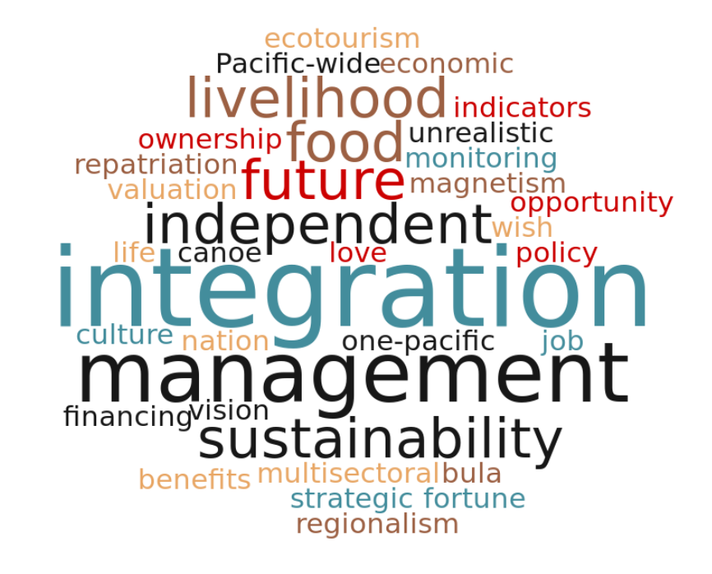

Annex V

RESULTS OF BREAKOUT GROUP DISCUSSIONS ON OPPORTUNITIES AND ASSETS TO INCREASE THE ECONOMIC BENEFITS TO PACIFIC ISLANDS FROM THE SUSTAINABLE USE OF MARINE RESOURCES

Growth Area | Options for a Path to Sustainable Growth | Regional Assets
Oceanic fisheries | - Total allowable catch, moving from maximum sustainable yield (MSY) to maximum economic yield (MEY)  - Marine Stewardship Council (MSC) or Eco-certification  - Strong monitoring and enforcement with industry compliance  - Increase domestic effort and reduced foreign effort with more local processing, targeting high price markets, post-harvest product development with cost lowered, energy efficient, low impact transportation and local use of by-catch. | - Good tuna resource  - Good support – Council of Regional Organizations of the Pacific (CROP) agencies  - Good management within EEZ – Parties to the Nauru Agreement (PNA) Vessel Day Scheme (VDS), FFA-surveillance, WCPFC Conservation and Management Measures (CMMS)  - Value of tuna resource Environmentally friendly method –pole and line  - Good research – inform better or best practices  - Enforcement and compliance – some cost, good financial support-donors
Coastal fisheries | - Recreational fishing – link to tourism, ecotourism, limit expats/quotas through regulations  - Need for better management  - Strengthening coastal governance – learn from offshore, local communities, subnational, other fishers, aquarium trade, aquaculture, other nearshore fisheries – squid.  - Monitoring and surveillance - use communities, user fishers  - Protect critical habitats and species  - Post-harvest activities using sustainable energy and value-adding | - Technology/knowledge for Aquaculture – CROP support, part of tradition and culture  - Community based approaches  - Food security - small scale livelihoods, direct income for communities, more integration with terrestrial.  - Marine managed areas (MMAs) / Marine protected areas (MPAs)  - National/subnational responsibility  - MSP –support tools  - Coral reefs – tourist potential
Protection and use of genetic resources and traditional knowledge of those resources | - Policy – control, monitor, assess, financial market, transportation law, surveillance, monitoring and enforcement  - Governance – communication, transparency, Treaties, Regional Guidelines  - Information Dissemination  - Improved and accessible Regional approach to funding (e.g., GEF)  - Project sustainability –capacity-building in countries | - Traditional knowledge  - Natural resources (e.g., coral, sponges, trees, plants recognized hot spot of biodiversity)  - National, regional and international institutions (e.g., SPC, SPREP, IUCN, CSIRO, International Relief and Development (IRD), UNESCO
Tourism | - Improved access to community attractions  - Improved access to financial resources  - Provision of capacity to support community desire to engage in the sector  - Legislation to support community investment, mechanism for agency, organisations and partner direct support to communities  - Sustainable financing mechanisms to support community tourism,  - Regional approaches for bundle packaged tourism | - Multitude of attractions (e.g., beaches, biodiversity, forest, mountain, ocean deep)  - Several Islands have good human capacity for tourism opportunities for South-South cooperation exists to help other.  - Pacific nature of sharing and cooperation  - Traditional knowledge and culture is a way of life, it is practiced daily  - Cultural practice, arts, significant sites are still relevant today.  - Regional/national tourism plans exist  - SPTO  - PATA (Pacific Travel Association)  - Tourism ministry and expo  - National tourism authorities  - Airline, cruise, yacht, shipping associations  - Tourism activity associations  - Potential for partnership investment  - Government investment in sector  - Revolving financial mechanism (i.e., Having tourism users reinvest revenue to increase tourism sustainability)
Aquaculture | - Increasing local capacity to support aquaculture development  - Leveraged regional assets through effective partnerships  - Niche markets and branding/marketing  - Gaps to be filled through policies, environmental impact assessments (EIAs), etc.  - Meet the market demand | - Vast amount of ocean and lagoons  - High value species  - Traditional knowledge  - Willing communities  - FAO, SPC, Australian Centre for International Agricultural Research (ACIAR)  - Government ministries  - Local NGOs  - Local business  - Government assistance/schemes  - Regional/international donors –EU, SPC, FAO, banks  - Traditional knowledge an practices  - Integrated farming practices
One Pacific | 3 regions into 1 region into 1 Pacific, which requires a paradigm shift and cultural change.  This could be done step-by-step through developing a shared currency, increased movement of labour, increased purchasing power resulting in regional negotiations on fuel, shared airlines, telecommunications, satellite and fibre optics  “The Pacific has to work together to land a big fish.” | - 40% of the world’s tuna  - Pristine environment  - Marine assets (Sea cucumber, live fish trade, Aquarium fish, non-tuna pelagic and reef species)  - Aquaculture potential  - Charismatic species  - Banks/ADB/GEF/GCF (Green Climate Fund)  - Commercial - tuna licenses  - Tourism revenues  - Traditional knowledge and approach to management  - Maritime knowledge  - Rich cultural diversity  - CROP agencies, NGOs, academia, UN/World Bank, donors/aid, Subregional Melanesian Spearhead Group (MSG), Pacific Island Tuna Industry Association (PITIA) and Pacific Islands PIDF
Recreational fishing | - Use the tourism department to do a market survey  - Canvas the local fishermen  - Use existing cross-sectoral bodies to develop the activity ensuing maximum benefit  - Promote natural and human resources to attract fishermen  - SPC to help upgrade boat and technology  - Specialised transporting  - Harmonize traditional knowledge with specialized techniques (consultation with overseas fishing associations)  - Assist government to setup small grant schemes  - Tourism and fishing association to organise competitors  - Commercial sponsorship | - Fishermen, Scientists  - We have the fish!!  - Renewable resources  - Boats, fish aggregating devices (FADs)  - SPC, FFA, Local fisher associations, Fisheries and Tourism Department  - Development Banks  - Private sector  - Small-scale fishing grant schemes  - Traditional knowledge of fishing  - Education about the opportunities  - Research market surveys  - Baseline assessment incorporating local and scientific knowledge  - Capacity-building and entrepreneurship
Ocean thermal energy conversion | - Trial ocean thermal energy conversion (OTEC) (engage private sector)  - Develop or enhance technology through feasibility study  - Regional mapping of resources (e.g., by University of the South Pacific) | - Natural energy resources are abundant and available (e.g., Deep water close to shore and temperature differences, some geothermal sources)  - Pacific Power Association, SPC, SPREP  - Institutional resources  - GCF, Private sector, Pacific Energy Summit
Building improved branding and value chains | - Broaden the discussion with private sector and civil society  - Make decision-making process inclusive and transparent  - Capacity-building at the community level  - Regional/national monitoring to ensure capacity-building and transparency  - Financing mechanisms for the sector (potential new instruments)  - Scaling up capacity and skills  - Coordination and branding strategy at a regional level  - Demonstrate commercial opportunities and increase returns  - Utilize available knowledge (retired/semi-retired experts)  - Broaden certification and branding (e.g., MSC) for tuna  - Strengthen capacity of national associations  - Better utilize trade and promotion assets in the region  - Strengthen standards and compliance  - Strengthen industry legislation, which can also support branding  - Integrate cultural dimension into branding  - Increase training capacity  - Address the following gaps: ownership, community capacity, training, compliance, finance, financial markets, product marking, legislation, standards, national and regional coordination, market access. | - Tuna and other species  - Aquaculture products/aquaria/mariculture (i.e., seaweed farming)  - Ocean derived energy  - Marketing specialists  - Promotion  - Traditional skills  - Technical skills  - National fisheries associations  - Regional fisheries associations  - Regionals fisheries organisations  - International bodies  - Policy frameworks  - National legislation/ international commitments  - Private sector  - Traditional leadership and management  - Gender mainstreaming  - Youth  - Commercial banks  - Development banks  - Credit unions  - Aid/donors

Annex VI

RESULTS OF VOTING EXERCISE ON OPPORTUNITIES FOR SUSTAINABLE OCEAN DEVELOPMENT

Workshop facilitators synthesized the main ideas and opportunities identified in the earlier breakout group session in 39 key ideas/opportunities, as follows:

- Pacific brand similar to pure New Zealand branding
- Close ocean area to outside to dev resources ourselves
- Better transport to promote multi-country tours
- Use renewable energy in shipping
- Single currency for pacific - like EU
- Internet connectivity -Pacific’s own satellite
- Negotiate as one unit
- Ports and associated services
- Tourism – make culture known / cultural components
- Transport for waste management
- Trans-shipment to make use of by-catch for local
- Aquaculture fish farming for subsistence and export
- Aquaculture feed production
- Marine product & aquaculture access to markets
- Protect genetic resources and traditional knowledge
- Research body to oversee bioprospecting research
- Pharmaceutical research on potential for seaweed, corals, sponges
- Value-chain opportunity for fish processing
- Mandatory processing in Pacific
- Increase Pacific nationals in vessel crews
- Improve conditions on foreign vessels
- Improve transportation - capitals to overseas
- Improve sustainable infrastructure
- Insurance, financial, legal services for domestic flag vessels
- Ocean based energy government incentives
- Strategic import substitutions
- Marine tourism –marine parks
- Provisioning for fishing vessels, cruise ships
- Increase value of fish as high luxury item
- Develop recreational fishing
- Investigate the knowledge base around deep sea, including indigenous knowledge
- Investment in technology for deep sea mining
- Marine based energy
- Investment capital into marine based energy
- Allowing peer to peer (PTP) projects to feed into grid potential to include community if near shore
- Strategic plan for tourism-marine with all sectors
- Tourism ‘Blue days’
- Ecotourism
- Participant science for tourism

Participants were then asked to “vote”, using stickers, on the issues/opportunities that have the greatest potential to facilitate progress towards the achievement of SDG 14.7 in the Pacific. The results of this voting exercise are shown below.
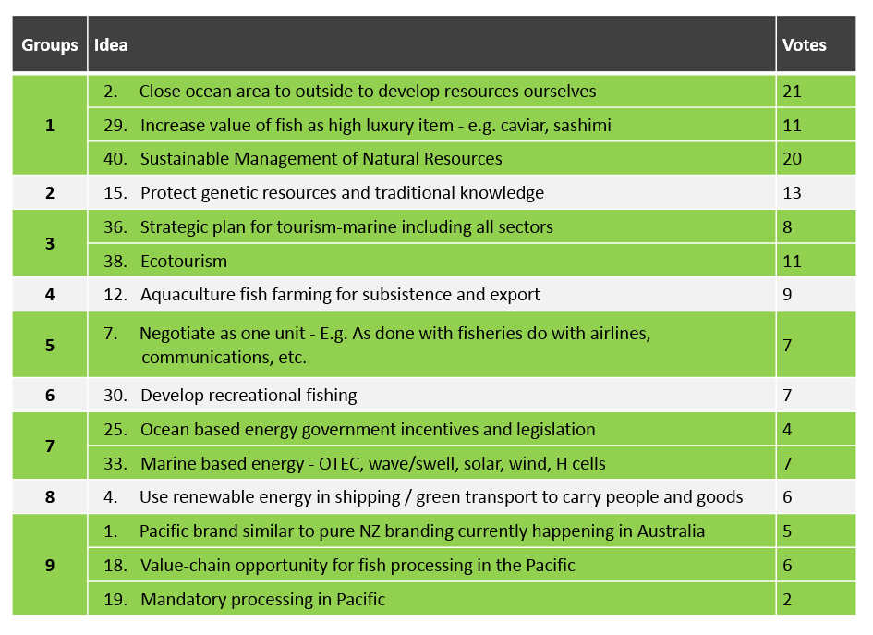

The ideas/opportunities that garnered the most votes were synthesized into nine key areas, as follows:
1. Sustainable Management/Fish as luxury/closed ocean area

2. Protection of genetic resources and traditional knowledge
3. Tourism
4. Aquaculture
5. One Pacific
6. Recreational Fishing
7. Ocean-based energy
8. Use Renewable energy in shipping
9. Branding and value chain

Annex VII

SELECTED RESULTS OF GLOBAL AND REGIONAL TARGET EXERCISE

The following table shows some results of the breakout group discussion on identifying how national and subnational experiences contribute to the achievement of global and regional goals/targets. Please note that many groups did not have time to complete the exercise, so the below lists of relevant goals/targets and potential indicators is not exhaustive.

PIROP = Pacific Islands Regional Ocean Policy and Framework for Strategic Integrated Action
FPO = Framework for a Pacific Oceanscape
SAMOA = SIDS Accelerated Modalities of Action Pathway
SDG = Sustainable Development Goal
Aichi = Aichi Biodiversity Targets

EXPERIENCES | SELECTED RELEVANT REGIONAL TARGETS/  GOALS | POTENTIAL INDICATOR  (HOW DO WE KNOW WHEN THE GOAL IS ACHIEVED?) | SELECTED RELEVANT GLOBAL TARGETS | POTENTIAL INDICATOR  (HOW DO WE KNOW WHEN THE GOAL IS ACHIEVED?)
LMMA network | PIROP 1d  PIROP 3b  PIROP 3c | PIROP 3c  By 2020 10% of inshore coastal fisheries under community led management tools: Community consultation GIS/mapping # of management plans | SDG 14.2  SDG 14.5  SDG 14.7 | SDG 14.7  by 2020 20% increase in community disposable income at LMMA participating community - Tools household income survey /expenditure
Responsible tourism framework | FPO 56  SAMOA 58H | SAMOA 58H  By 2020 25% decrease in commercial inshore fisheries.  By 2020 50% increase in pelagic fish consumption in the tourism sector | SDG 14.2  SDG 14.7b  Aichi 2  Aichi 4  Aichi 14 | SDG 14.2  by 2020 reduce tourism numbers by 30%
Artisanal fishing | PIROP 2B  PIROP 2C | PIROP 2B  Equitable share of marine resources; Gender empowerment; Improved fiscal security in urban population  PIROP 2C  Fishers associations representative in decisions-making committees; Number of small scale fishers engaged in national policy development | SDG14b  SDG 14.7 | SDG14b  Increase of young fishers recruiting to livelihood; Stable income/fisher  SDG 14.7  Equitable share of marine resources; Gender empowerment; Improved food security in urban population.
Effective traditional management of coastal marine resources | PIROP1D  PIROP2C | PIROP1D  Number of breaches documented | Aichi 1  Aichi 18 | Aichi 1  Interviews; youth knowledge intergenerational transfer of knowledge observer practices  Aichi 18  Legislation recognizes traditional management and vice versa
Eco-tourism accreditation scheme | FPO 2C  PIROP 4A | FPO 2C  Sustainable income from ecotourism  PIROP 4A  National legislation developed and effective | SDG 14.7  Aichi 3  Aichi 10 | SDG 14.7  increase in numbers of operations in compliance (accredited)  Aichi 3  Polluter pays policy in place  Aichi 10  Ecosystem health improved
Micronesia Challenge | PIROP 2C  PIROP 2D  PIROP 1C  PIROP 3A  PIROP 3C  PIROP 3D  FPO 1A | PIROP 3D  UC measures number of measures and meetings  FPO 1A  Number of maritime areas declared | SGT 14.5  SGD 14.2  Aichi 1  Aichi 11  Aichi 18 | Aichi 11  % of terrestrial and marine areas conserved and managed  Aichi 18  Number of traditional managed areas

Annex VIII
RESULTS OF BREAKOUT GROUP DISCUSSION ON CHALLENGES AND SOLUTIONS
CHALLENGES | SOLUTIONS
Governance challenges
Lack of political will | - Unified position for climate change and climate financing  - Leaders appreciate urgency of the situation  - Affects all Pacific people  - Need to better manage oceans, especially by informing politicians (parliamentary caucuses etc.).
Poor coordination (regional and national) | - Improve/revise coordination mechanisms on oceans to involve regional agencies, academia, private sector (e.g., OPOC National SD boards, MSWG and Tuna task force)
Policy flip-flops  Identifying shared needs  Integrating international, regional and national agencies | - Make national compromises in the regional interest  - Provide good information to decision makers  - Accept short-term pain for long-term gain  - Best to address shared problems
Failure to make national compromises in regional interest | - Provide good information for decision makers  - Accept short-term pain for long-term gain  - Best to address shared problems
Fisheries → government change | - Use of chief secretary to endorse engagement  - Demonstrate the benefit to the reluctant sectors  - Find the national interest to use as a ‘way in’ for an ocean policy
Developing national oceans policy for the country by 2018 | - Common goal between cabinet and highest political support and doing it often as politicians change
Difficulty in cooperation with other agencies/interest/sectors (e.g., oil/gas/minerals) | - Strengthen weaker agencies (e.g., Learning from fisheries)  - Provide same information to all sectors  - Build networks and personal connections between colleagues across sectors
Fragmentation in national/regional/international commitments/obligations, exacerbated by limited resources | - Urge regional and international organizations to work together and simplify achievable visions and realistic objectives for simple translation into actions  - Workshops/planning to move on actions and implementation / monitoring and evaluation
Poor understanding of roles and responsibilities of NGO’s and government leading to conflict over jurisdiction and “turf” | Local NGOs  - Long-term plan  - Reliable over long term  - Strong community inclusion  - Accountable for project implementation  - Audited financial records  - Open communication reports  - Government should include local NGOs in their planning processes where appropriate.
International NGOs
- Need to be responsive
- Need to be invited
- Need to collaborate with other NGOs
- Align with community and government timelines.
- Development needs to be country driven and country owned
- Needs to be regional coordination of engagement for NGO and donors/development partners-stop sales man approach
- CROP agencies/GEF/GCF
Technical challenges
Challenges in data-sharing, which is often due to silo belief systems and incompatible systems | - Break down silos  - Shares commitment  - Standardize shared data collection aims and systems  - High-level direction
Limited capacity | - Balance capacity between different sectors  - Build traditional practices  - Regional organizations to supplement capacity  - Learning competencies – on ground training  - Broad applicability of all successes
Capacity/skill retention and transfer | - Regional steering committee  - Share info across country region  - Consultation at the local and national levels  - Incentive knowledge through hiring of local graduates (e.g., job placements with the government)  - Training with local colleges  - Promote and develop conservation mindset by integrating into curriculum
Lack of enforcement monitoring and surveillance in the long-term | - Retain interest, monitoring important to report progress
Technical advice that doesn’t align with local context | - Establish a regional steering committee that works with local and national levels/organized groups  - Develop protocol for outside consultants/organizations to work with existing local/national groups in going about work
Limited resources and livelihoods | Alternative livelihoods: Fish aggregating devices (FADs), giant clam farming– success is limited  - Start feasibility study  - Plan it out  - Establish and define Niche in feasibility studies  - Partners –local, state and national; funding agencies; private sector  - Breaking barrier to shift to other activities – communicate results of feasibility study in local context or something that can be scalable  - Identify funding agencies through partnerships formed  - Expand to other markets that leverage existing resource (knowledge, culture, etc.)  - Provide training and leverage existing partnerships to provide support
Implementation challenges
Lack of resources for implementation | - Under- resourcing  - Shift in traditional funding from governments established international to new agencies and private foundations  - More cost- recovery at national level  - Governance issues around private sector funding
Governments– take up of initiatives  Non- inclusive policies (lack of consultation) | - Reporting of progress and success very important to encourage governments of worthwhile efforts
Lack of collaboration | - Take time to introduce what everyone is up to in different sectors  - Outreach activities including meetings should share results from meetings and to properly brief everyone on objectives to lay a baseline and for partners to speak common language
Lack of communication and knowledge sharing | - Create transparency by sharing meeting minutes, reports, back-to-office trip reports  - Some overlaps from lack of collaboration solutions
Poor communication of objectives leading to conflict | - Broad early engagement among technical people  - Common understanding of terms – clarity of language  - Clarity of roles and responsibilities  - Common understanding of national commitments to national, regional, global agreements –what is trying to be achieved?  - Promote effective and inclusive communication.  - Commitment from leaders  - Develop cross sectorial network and dialogues to identify commonalities that can lead to a common vision/objective through consensus
Mobilising sustainable financial mechanisms/resources | - Private/public partnerships / user pays fees  - Taxes, global donors, establishment of trust funds
Development mindset vs. conservation mindset | - Use the people -> start with communities (e.g., pledge in Fiji for Groupers ‘4FJ campaign )  - Future scenarios (as above))  - Media attention on areas of high biodiversity/conservation to promote formalising.
Community Challenges
Department of human capacity local people/expert | - Explore community involvement and incentives
Expansive areas, logistical challenges for management | - Support on-island training/skill facilities to save money and time (i.e., rather than sending people to main island from far islands)
Transformation to remote Island | - Use of coast guard vehicles -> sharing resources across agencies  - Donor sponsored infrastructure  - Shipping subsidies  - Using technologies/iPads to connect/collect data
Common goal between grassroots to the top levels/public support -> industry support to persuade government | - Increased awareness for all levels  - Bringing the voice of community with their realities to up to government face-to-face
Tailoring approaches to national contexts | - Linking levels of government to work together  - Locally managed marine areas (LMMAs)  - National level monitoring of MMAs  - Recognizing the value of local management for regional targets

Annex IX
SUMMARY AND OUTCOMES OF marine spatial planning SIMULATION EXERCISE
Objectives
Under agenda item 6, participants undertook a simulation exercise, led by Mr. Eduardo Klein (Simon Bolivar University), in which participants were presented with a hypothetical scenario of competing uses and conservation priorities for a given coastal area must be reconciled using cross-sectoral collaboration for marine spatial planning. In particular, the goals of the exercise are:

- To demonstrate the use of a GIS as a tool for visualizing geographical information in the context of a Marine Spatial Planning process.
- To demonstrate approaches to structuring multi-stakeholder discussions to reconcile different uses and priorities regarding marine resources in a spatial context.
- To encourage participants to make justified trade-offs to maximize achievement of priorities of various stakeholders to the greatest extent possible.
- To encourage participants to define a set of management actions to support long-term conservation and sustainable development of marine biodiversity in the area, in particular taking into account Aichi Biodiversity Targets.
Methodology
The exercise focuses on a hypothetical scenario in the southern Caribbean. The exercise was designed with open and free GIS software (http://qgis.org) and all of the data layers are made available for the participants in the form of printed maps and overlay transparencies. The following data layers were made available for the exercise:
- Base layers: Coastline, urban areas polygon, roads, small populated sites, submarine cables, hydrology, bathymetry, shaded relief of the terrain;
- Oil industry: Offshore bidding blocks polygons, offshore production wells, offshore exploration wells, underwater pipelines, oil refineries;
- Maritime transport: Main shipping routes, anchoring areas, ports, shipping density;
- Fisheries: 2014 fishing boat locations, summary of daily visits by quadrants, density model of fishing boats presence;
- Biodiversity: Declared protected areas polygons, priority areas for conservation of marine biodiversity, OBIS marine biodiversity records, locations and cover of mangrove forests, coastal lagoons, seagrass meadows, rocky shores, turtle feeding areas, marine crocodile habitat, cetaceans habitat, bird nesting and feeding areas, large and small pelagic fish habitat, soft bottom benthic communities, hard bottom benthic communities;
- Oceanography: Seasonal maps of sea surface temperature and chlorophyll A concentration

The group work was divided in several working teams. During the first session the participants was grouped in order to represent one of the following types of stakeholder with interest in the area:
- Oil industry
- Artisanal fisheries
- Private tourism industry
- NGO for biodiversity conservation
Each team was allowed to study the available information and discuss the strategy of their respective stakeholder group for use and/or management of the area. Also they were asked to evaluate all the possible trade-offs they are willing to accept during the negotiation with the other sectors. Then, during the second session, one or more participants of each sector participated in a small round table discussion with the representatives of the others sectors. During those discussions, they were tasked with agreeing on the best approaches to spatial management of area and produce a document with the trade-offs and agreements made. They were also tasked with producing a document with a set of management actions to support long-term conservation and sustainable development of marine biodiversity in the area, in particular taking into account Aichi Biodiversity Targets.
Rules
There are some conditions that all groups were required follow in the process of defining the spatial plan and supporting management measures for the area:
- Each of the stakeholders must make decisions that guarantee the continuity of its activities, but at the same time they should be prepared to make some trade-offs.
- Spatial plans for the broader area can utilize any types of management tools/approaches (e.g., MPAs, functional use zoning of marine waters/coastal lands, fishery reserves, reference areas for research and monitoring, EIAs, etc.). Cross-sectoral management actions are preferred
- There must be at least one managed area with a higher level of protection than surrounding areas, in particular considering Aichi Target 11. Groups must decide the ideal shape and size of this managed area. Within this managed area, the following rules apply:
- The maritime transit of commercial vessels will be allowed through the managed area, but no anchoring inside the area
- No activity related to the extraction, transport or transformation of oil or gas will be allowed inside the managed area
- Fishing activities inside the managed area will be allowed but it should be reduced to 25% of the fishing effort related to the actual effort (or 25% of the actual fishing grounds).
DESRIPTION OF THE DATA LAYERS
The exercise setting comprises an area of 21,500 km², located in the Gulf of Venezuela, Southern Caribbean Sea. The data layers are real and obtained from several sources. The case presented in this exercise is purely hypothetical.
Base Layers and Oceanography
These layers comprise the coastline, rivers, roads and populated centers. The footprints of highly populated areas are also provided. The terrestrial and coastal environment is dry and xerophitic with almost no human development to the north of “Los Taques”. The wind is normally from the north-east with a mean velocity of about 6 m/s with frequent gusts of more than 20 m/s. The rivers are intermittent with flowing water only during the short rainy season. The annual precipitation is less than 400mm and the air temperature is between 24-35°C.
The bathymetry is very regular with a depth of 70m in some areas. Major bathymetry lines are shown in the map. A coastal and southward surface current (not shown) is present all year round, transporting sediments and nutrients from the rich upwelling areas. The tidal range is about 30cm but in several places the intertidal zone could be of tens of meters, as the beach profile is very flat. As a proxy descriptor of the upwelling phenomena, seasonal maps of surface chlorophyll concentration are provided.
Urban Infrastructure
Human populated places are generally concentrated near the coast. The main city, “Punto Fijo” has a population of roughly 300,000. The economy of the area is related to the oil industry, fisheries, tourism and goat farming. The tourism sector is not very well-developed, with generally small hotels and few tourist services available, but there is a regional plan for the expansion of the sector in the near future on the northwest coast of the peninsula.
Oil and Gas
The area has two large refineries, which together represent the third largest refinery complex in the world. These refineries employ more than 5000 workers during the peak operating season. They receive crude oil from near Maracaibo Lake fields. There is also very active offshore development of gas and oil. The crude oil is transported by tankers and some products are delivered by pipelines. The refineries have a combined processing capacity of 940,000 barrels of oil per day. For the exercise, there is only one gas field developed offshore (“Perla” field), which is also serviced by a submarine pipeline to a nearshore gas plant.
Shipping
Both commercial and oil-related shipping are present in the area. Roughly 350 vessels per month enter and exit the port of Guaraguao and the maritime terminals of Amuay and Cardon refineries. There is also a shipyard at “Los Taques”. The traffic depends greatly on the oil-related activities and in the near future, and, with the new offshore developments, the frequency and number of ships are expected to rise.
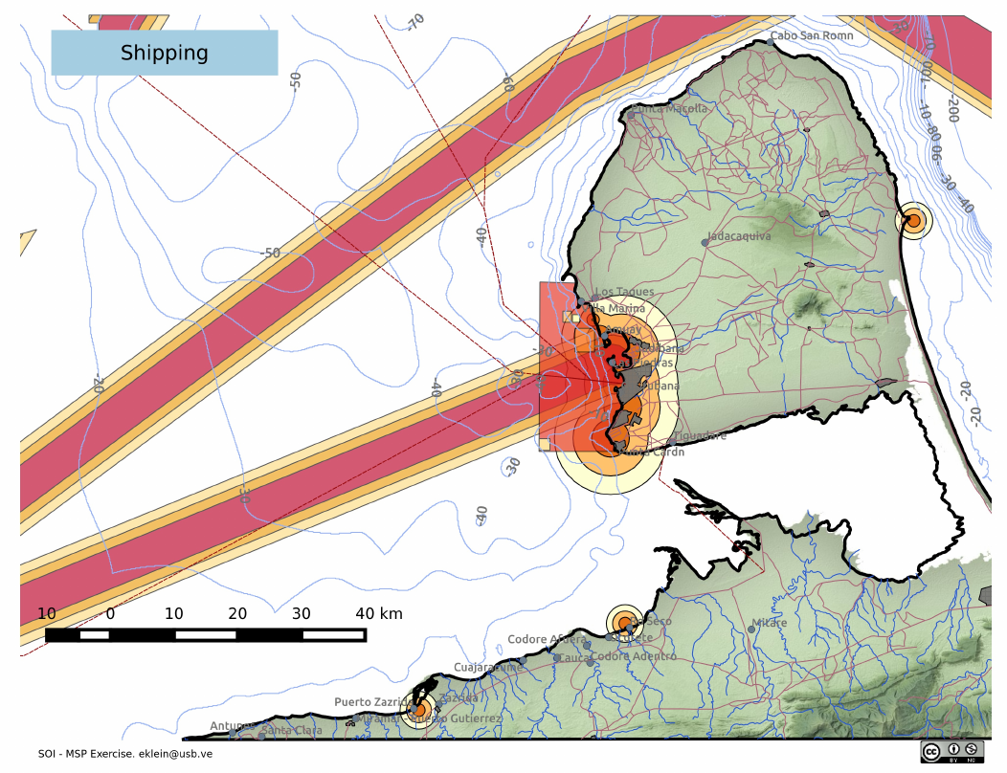

Figure 1. Data layers for shipping in the area, with the shipping lanes indicated.

Fisheries
No commercial fisheries are present in the area. Artisanal fisheries are well developed with roughly 500 registered small fishing boats (5-7 meters long with 3-4 fishermen per boat). The average monthly production per boat is 34 tons, but varies depending on the target species. Demersal species and shrimps comprise more than 60% of the landings. Although comprising a small volume, pelagic species have a higher high market price.
Biodiversity
There are many coastal and marine ecosystems in the area. Mangrove forests in the south are very important as nurseries, bird nesting areas and habitats of the endangered coastal crocodile. Some ecosystems are very well represented, such as sandy beaches, but others are quite unique and located in very small patches (coastal lagoons or rocky shores). The information about the biodiversity in open waters is mostly related to benthic organisms, which are predominately detritivorous animals. The dynamics of the water column are governed by a seasonal upwelling process that occurs normally between January and April and provides a good source of nutrients from the bottom waters.

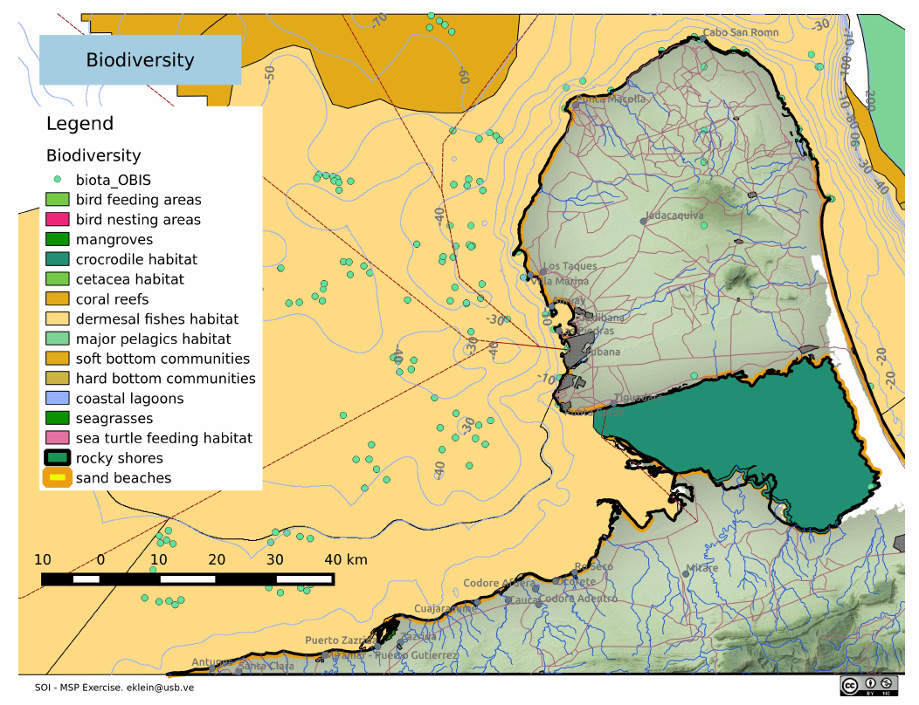

Figure 2. Data layer showing important habitats in the area.
A recent study identified several areas considered important to the conservation of marine biodiversity, due to the ecosystems that it contains and its conservation status. There is a plan to incorporate those areas (or at least parts of them) into the national system of MPAs.
Pressures
Previous studies had identified and categorized six main types of pressures on the marine environment and its biodiversity: Impacts from the oil and gas industry, aquaculture farms, maritime transport, coastal urban development, inland runoff and ports and marinas. Each of the pressures is mapped according the source and a buffer is also provided to measure the extent of the impact. Each of the pressures is classified as low, medium or high intensity. Also, a map of aggregated threats is provided.
All the data layers, information and description of the exercise is available at the Ocean Teacher Global Academy (OTGA, http://oceanteacher.org/) site, under the section of Marine Spatial Panning Courses (http://classroom.oceanteacher.org/course/view.php?id=206).
Results of the simulation exercise
Please note that this is a hypothetical exercise and the deliberations of the various groups and compromises discussed and agreed to are fictional and do not represent the opinions of the Secretariat or the countries with regard to how this actual area should be managed.
During the exercise, six groups of stakeholders were organized: fishers, oil industry, wave and wind energy, aquaculture private tourism sector, and conservation NGO. During the first session, individual stakeholder groups met in in order to study the provided maps and data, and plan their strategy for the cross-sectoral negotiation. In the second session, six negotiation tables were formed, composed of one participant from each sector, which discussed cross-sectoral management options for the area and the final configuration of a plan for the management of the area. At the end, all work groups reached a sound agreement to manage the area, and made several compromises to guarantee the long term operations of their activities.
After carefully analysing the information provided, and the future developments plans of each of the sector, all groups reached a set of sound solutions for the management of the marine area. Some examples of arrangements that were common across the negotiating tables are as follows:
- New protected areas would be created in the area, extending the existing national park or nominating already identified conservation important areas as new MPAs
- The oil industry and the wind and wave energy sector would move some of their existing infrastructure to allow the establishment of marine managed areas
- The oil industry further would agree to provide aid to the fishers communities to help guide then to a sustainable use of the resources
- The conservation group would lead the monitoring of the marine environment. Also, the sector would help to develop sustainable (blue) aquaculture farms, raise the awareness on the biodiversity and introduce biodiversity conservation themes into the school curricula

The below table lists the types of various measures and agreements reached by the groups and the sectors/stakeholder groups of relevance:
Sector / Stakeholder group Affected | Management Action
Oil and Gas, NGO | Oil and gas activities relocated away from areas rich in biodiversity
Oil and Gas, Wind and Wave energy, Tourism, NGO | Wind and wave energy activities moved away from areas with high tourism
Aquaculture, NGO | Aquaculture plant sites to be developed to provide in care for fishing communities, reduced from their fishing priority conservation areas.
NGO | Promote educational programmes in schools regarding management of marine ecosystems
NGO | Develop low risk (blue) aquaculture farms inside MMA
Oil and Gas, Fishers | Transport anchoring areas moved further offshore
Oil and Gas, NGO, Fishers | Increase protection of biodiversity by moving oil and gas activities
NGO, Fishers | Fishing closure of some areas rich in biodiversity
NGO, Fishers | Reduction in fishing effort. Fishermen move to alternative incomes: aquaculture, ecotourism, recreation
All sectors | Complete closure in some high biodiversity areas
Fishers, Aquaculture | Reduce the fishing effort by 25% in other priority areas
Wind and Wave energy, Fishers, NGO | Extend the MMA further North in order to create a biodiversity protection area
NGO, Oil and Gas | Relocate the port facilities to a less sensitive area
Oil and Gas, Aquaculture | Provide technological support for the treatment of aquaculture farm waters
Oil and Gas, Tourism | Horizontal drill methods to avoid impacts on sensitive areas
Fishers, Tourism, NGO | Promote ecotourism fishing
Wind and Wave energy, Fishers, Aquaculture, Tourism, NGO | Promote small sustainable aquaculture farms, including to provide alternative employment for fishers
Wind and Wave energy, Tourism, NGO | Move wave generating plants offshore to avoid high biodiversity areas
Oil and Gas | Conduct proper EIA studies prior to any new offshore development and promote inclusive management for planned developments
Oil and Gas | Support infrastructure for ecotourism development
Fishers | Promote the revision of current legislation to update protection measures for biodiversity
Fishers, Tourism | Promote co-monitoring of the biodiversity with the tourism sector
Aquaculture | Develop stock assessments and promote realistic quota levels
The maps produced by the groups are as follows:
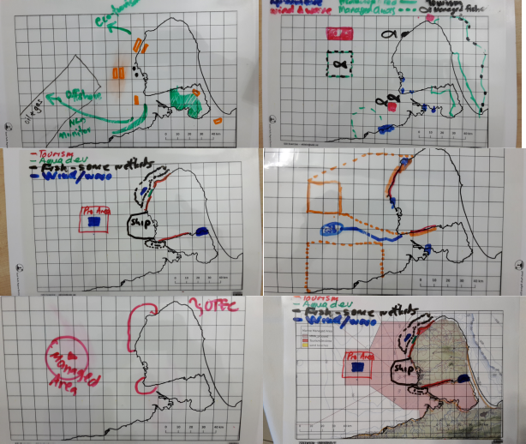

Annex X

STRENGTHS, CHALLENGES, OPPORTUNITIES AND THREATS FOR THE PACIFIC ISLANDS
Strengths
The Sustainable Ocean Initiative - Pacific Ocean Alliance Regional Workshop for the Pacific Islands acknowledged both the long ancestral history and considerable assets relevant to the vast Pacific Ocean that makes up the Pacific Islands Ocean Region - Oceania. The Region’s ocean assets include significant natural resources such as tuna, minerals and genetic resources, member country-owned institutions such as CROP and subregional agencies, valuable traditional knowledge and a strong affinity for community-based approaches based on local tenure rights (user rights) and, viable opportunities to enhance sustainable development such as ecotourism, bioprospecting and aquaculture.
The workshop also recognized that the region has evidence of sound and progressive management such as the region’s Monitoring Control and Surveillance system (MCS) operated effectively by the Forum Fisheries Agency (FFA), the Parties to the Nauru Agreement’s (PNA) Vessel Day Scheme (VDS) for the purse seine tuna fishery, and implemented locally managed marine areas (LMMAs). The lessons from these experiences serve as a valuable template for future sustainable management and use of island, coastal and ocean resources.

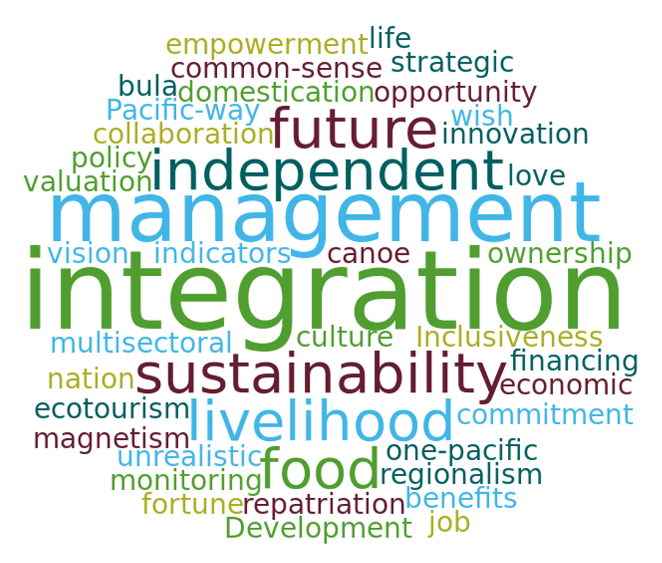
Word cloud generated from delegates’ responses to the question “What does SDG14.7 mean for the Pacific?”

Weaknesses
Workshop delegates made clear that while some Pacific island countries and territories are progressing their national efforts towards integrated ocean management, including diverse initiatives such as declaring large MPAs, and ensuring participatory, strategic planning and developing legislative and regulatory instruments; these efforts were largely standalone, unconnected and based on local specificities. Missed opportunities and weak or unsustainable management, coupled with low-levels of economic benefits flowing to the people of the Pacific, was more typical. Improved coordination, cooperation and collaboration was identified as vital to allow more coherent, integrated ocean management and sustained meaningful outcomes to be achieved.

The need to coalesce the fragmented nature of development and management in the region is highly apparent. Efforts to align strategic priorities in the Our Sea of Islands – Our Livelihoods – Our Oceania: Framework for a Pacific Oceanspace – a catalyst for implementation of ocean policy (FPO) such as good ocean governance, as ratified by Pacific Leaders in 2010, with national and other regional approaches, would bring rapid and greater benefits.
Appreciation of the linkages of the FPO to sector-based policies such a New Song for Coastal Fisheries - Pathways to Change - needs further elaboration.

Opportunities
The potential opportunities for Transport, Aquaculture, Bioprospecting, Fisheries, Deep Seas Minerals, Marine-based energy, Tourism, Value Chain Opportunities/Services and Disruptive Technologies/Practices to contribute to increasing the economic benefits to PICTs were discussed. Sustainable Management through Fish as a luxury, Closed Ocean Areas to limit access, Protection of genetic resources and traditional knowledge, Tourism, Aquaculture, One Pacific as a brand, Recreational Fishing, Ocean Thermal Energy Conversion (OTEC), Branding and Value chain adding as having potential for growth were proposed as possible innovations and initiatives to consider. All of these proposed initiatives would be predicated on sound management of our natural ocean assets and resource base. Other less direct economic benefits were also noted, such as disaster risk reduction and public health.

Threats
The workshop identified a range of challenges and successes in categories of Governance, Technical, Implementation and Community. In this regard participants identified where they had faced challenges and the various solutions reached by different PICTs. Participants also discussed the roles of NGOs and other regional agencies, including CROP agencies, and identified criteria that would ensure more constructive engagement between external parties and national governments and communities.
Technical challenges included data sharing, thin capacity and limited or unsustainable capacity development, as well the need to ensure that technical programmes were aligned with national and community needs, were emphasized. Implementation challenges included under-resourcing, mobilization of financial resources, lack of collaboration and communication and differing approaches to development. Challenges to communities included targeted capacity development, transportation costs and engagement with government, external agencies and donors/finances.

Summary
The workshop re-emphasized the central importance of SDG 14 and in particular SDG14.7, which focus on sustainable economic benefits, as a hub for future efforts in the region. The need to pursue and perceive SDGs 14.a to 14.c and 14.1 to 14.7 together is needed – otherwise the optimization of the sustainable economic benefits so needed by the region will not be reached.
Emerging from the workshop was a need for more integrated thinking and doing, improved existing policy traction and a clearer institutional positioning to build the asset base of the region to pursue integrated ocean management and sustainable maximization of income streams. Such change is necessary to move from present reticent path-dependency, and is actually demanded by leaders who have declared the need for the Region to “embrace transformative change and action now”.
__________

See http://web.unep.org/post2015
* Unincorporated territory of the government of the United States of America
* Overseas collectivity of the Government of France
* Special collectivity of the Government of France
* Overseas collectivity of the government of France
Note: Due to length considerations, the entire results of the group exercises is not provided
Produced by the Pacific Ocean Alliance
By 2030, increase the economic benefits to Small Island Developing States and least developed countries from the sustainable use of marine resources, including through sustainable management of fisheries, aquaculture and tourism.
Pohnpei Ocean Statement: a course to sustainability (2016).

