DRAFT REVIEW OF THE IMPLEMENTATION OF THE CBD PROGRAMME OF WORK ON PROTECTED AREAS
September 2009

INTRODUCTION
In paragraph 15 of decision IX/18 A, the Conference of the Parties (COP) to the Convention on Biological Diversity (CBD) requested the Executive Secretary, to convene regional and subregional capacity-building and progress-review workshops for the programme of work on protected areas (PoWPA). In paragraph 25 of the same decision, the Conference of the Parties, while deciding on the process for preparation of in-depth review of the programme of work on protected areas at the tenth meeting of the Conference of the Parties, requested the Executive Secretary to prepare the in-depth review using inter alia information contained in the fourth national reports, relevant global and regional data bases and the results of the above-mentioned regional and sub-regional workshops and to propose ways and means for strengthening the implementation of the PoWPA for consideration by the Subsidiary Body on Scientific, Technical and Technological Advice (SBSTTA).
Accordingly, the Executive Secretary, with the generous financial assistance of Canada Belgium, Colombia, Czech Republic, the European Commission, Germany, India, the Netherlands and Spain, and, has convened regional workshops in Asia and the Pacific, Africa, Latin America and the Caribbean and Central and Eastern Europe regions in October, November 2009.
This note has been prepared, which synthesizes the information, inter alia, contained in annex III of 65 fourth national reports and information gathered from Parties and organizations in the regional workshops, to facilitate the review of implementation of the programme of work on protected areas by SBSTTA at its fourteenth meeting. Section II contains a synthesis of information on progress towards achieving targets of the programme of work. Section III describes the main obstacles encountered by the countries in implementing the programme of work. Section IV flags issues that need consideration by SBSTTA 14 and the Conference of the Parties for strengthening implementation, new target dates and time tables and issues that became prominent since the PoWPA was adopted such as climate change, protected area values and benefits, governance etc.
II. PROGRESS TOWARDS ACHIEVING TARGETS OF THE PROGRAMME OF WORK
It should be noted that the percentage used in this report is that out of the total Parties for which information is available, either from the reports received or information gathered. In describing general progress, “nearly all” indicates at least 90 per cent, “most” indicates at least 70 per cent, “many” indicates at least 40 per cent, “some” indicates at least 15 per cent and “few” indicates less than 15 per cent. For assessing the progress a five star notation is used: ♣ very little progress; ♣♣ some progress; ♣♣♣ fair progress; ♣♣♣♣ good Progress; ♣♣♣♣♣ excellent Progress. A global snapshot of progress is described in Table 1 below.
Table 1: Assessment of progress in goals of the PoWPA at global level
Goal | Target | Progress to Date
1.1 | Target: To establish and strengthen national and regional systems of protected areas integrated into a global network as a contribution to globally agreed goals (timeline 2010 for terrestrial and 2012 for marine) | ♣♣♣♣ Good progress to date globally for terrestrial areas;  ♣ very little progress for marine areas
1.2 | Target: By 2015, all protected areas and protected area systems are integrated into the wider land- and seascape, and relevant sectors, by applying the ecosystem approach and taking into account ecological connectivity / and the concept, where appropriate, of ecological networks | ♣♣ Some progress to date. Can possibly be achieved by the target date provided more systematic efforts are put in place in the next five years.
1.3 | Target: Establish and strengthen by 2010/2012 transboundary protected areas, other forms of collaboration between neighbouring protected areas across national boundaries and regional networks, to enhance the conservation and sustainable use of biological diversity, implementing the ecosystem approach, and improving international cooperation | ♣♣♣ Fair to good progress to date globally,34% increase in number of transboundary protected areas complexes, could be achieved partially.
1.4 | Target: All protected areas to have effective management in existence by 2012, using participatory and science-based site planning processes that incorporate clear biodiversity objectives, targets, management strategies and monitoring programmes, drawing upon existing methodologies and a long-term management plan with active stakeholder involvement. | ♣♣♣ Fair progress to date with about 30%of national protected areas has management plans in place and another 30 % are under development, but effective implementation of plans are lagging behind. Likely to achieved partially by the target date of 201 at global level.
1.5 | Target: By 2008, effective mechanisms for identifying and preventing, and/or mitigating the negative impacts of key threats to protected areas are in place. | ♣♣♣ Fair to good progress to date in identifying the threats, but threat mitigation and prevention are lagging behind globally
2.1 &2.2 | Target 2.1: Establish mechanisms for the equitable sharing of both costs and benefits arising from the establishment and management of protected areas (Timeline 2008)  Target 2.2: Full and effective participation of indigenous and local communities, in full respect of their rights and recognition of their responsibilities, consistent with national law and applicable international obligations, and the participation of relevant stakeholders, in the management of existing, and the establishment and management of new protected areas (Timeline 2008) | ♣♣Some progress to date in both the targets but way behind meeting the targets at global level
3.1 | Target: By 2008 review and revise policies as appropriate, including use of social and economic valuation and incentives, to provide a supportive enabling environment for more effective establishment and management of protected areas and protected areas systems. | ♣♣♣ Fair to good progress to date, partially achieved at global level
3.2 | Target: By 2010, comprehensive capacity building programmes and initiatives are implemented to develop knowledge and skills at individual, community and institutional levels, and raise professional standards | ♣♣♣ Fair to good progress to date, could be partially achieved at global level.
3.3 | Target: By 2010 the development, validation, and transfer of appropriate technologies and innovative approaches for the effective management of protected areas is substantially improved, taking into account decisions of the Conference of the Parties on technology transfer and cooperation | ♣♣♣ Fair progress to date, could be partially achieved at global level.
3.4 | Target: By 2008, sufficient financial, technical and other resources to meet the costs to effectively implement and manage national and regional systems of protected areas are secured, including both from national and international sources, particularly to support the needs of developing countries and countries with economies in transition and small island developing States. | ♣♣Some progress to date but way behind meeting the target at global level
3.5 | Target: By 2008 public awareness, understanding and appreciation of the importance and benefits of protected areas is significantly increased | ♣♣♣♣ Good progress to date partially achieved at global level
4.1 | Target: By 2008, standards, criteria, and best practices for planning, selecting, establishing, managing and governance of national and regional systems of protected areas are developed and adopted | ♣♣♣ Fair progress to date in developing standards, criteria and best practices but lagging behind in adopting them at global level
4.2 | Target: By 2010, frameworks for monitoring, evaluating and reporting protected areas management effectiveness at sites, national and regional systems, and transboundary protected area levels adopted and implemented by Parties | ♣♣ Some progress to date, could be partially achieved at global
4.3 | Target: By 2010, national and regional systems are established to enable effective monitoring of protected-area coverage, status and trends at national, regional and global scales, and to assist in evaluating progress in meeting global biodiversity targets | ♣♣♣Fair to good progress to date, in monitoring coverage and trends at national, regional and global scales through the World Database on Protected Areas (WDPA), but monitoring status is lagging behind
4.4 | Target: Scientific knowledge relevant to protected areas is further developed as a contribution to their establishment, effectiveness, and management. | ♣♣♣♣ Good progress to date

Goal 1.1: To establish and strengthen national and regional systems of protected areas integrated into a global network as a contribution to globally agreed goals

Target 1.1: To establish and strengthen national and regional systems of protected areas integrated into a global network as a contribution to globally agreed goals (timeline 2010 for terrestrial and 2012 for marine)

Fair progress to date globally for terrestrial; very little progress for marine areas : There are significant improvements in the terrestrial protected area coverage reaching 12.2% of the global terrestrial area; more than half of world’s terrestrial eco-regions, 12 of the14 terrestrial biomes and nine of the 15 WDPA’s regions have more than 10% of their area under protection; out of the 114 countries for which information is available, 68 countries have kept aside more than 10% of their territory under protection; about 50 countries have either completed or in the process of completing a comprehensive gap analysis and are taking actions to implement the results of gap analysis.

Key issues considered for assessing global progress: Gap analysis; Creation of new protected areas:

Nearly all reporting countries indicated progress towards target 1.1. By 2008 there are more than 120,000 nationally designated protected areas covering 21 million square kilometres of land and sea (Figure 1). While the terrestrial protected areas listed in World Database on Protected Areas cover 12.2% of the planet’s surface area; the marine protected areas occupy only 5.9% of the world’s territorial seas and only 0.5% of the extraterritorial seas. Out of the 15 regions of the world recognized by the UNEP-WCMC, nine regions (Americas, East and Southeast Asia, Eastern and Southern Africa, Western and Central Africa, Europe, and the Caribbean) have 10% of their terrestrial area under protected areas, whereas only three (Australia/New Zealand, South America and North America) of the 15 regions have more than 10% their marine areas protected. Based on the information available from National Biodiversity Strategy and Action Plans and national reports, coverage of protected areas as a percentage of a country’s terrestrial area is available for 114 CBD Parties. 68 countries out of this total 114 have kept more than 10% of their territories under protection (with 33 countries having more than 15% of their terrestrial area protected); 23% ( 26 countries) have 5 to 10% and only 14.5% of countries ( 6 in number) have less than 5% of their land designated as protected areas.

An overlay of nationally designated protected areas with the world’s terrestrial ecoregions reveals that 12 out of the 14 terrestrial biomes have more than 10% of their area protected. Flooded grassland & Savannas biome with 42% of its area under protected coverage is the highest protected biome.. Only tropical & sub-tropical coniferous forests biome and temperate grasslands, savannas& scrublands biome recorded less than 10% protection with the latter has just about 5% of its area under protection. However, the degree of protection to the ecoregions within these biomes vary, as out of the 825 terrestrial ecoregions more than 5% are completely protected, 50% have 10% of their area protected and 8% have less than 1% of their area under protection . Out of the 232 marine ecoregions, only 39% of them have 10% of their area under protection, whereas 50% have less than 1% of their area under protection. Considering the current annual growth rate of marine protected areas (4.6%) achieving the 10% target of the CBD strategic plan and the PoWPA marine target may well be nigh impossible within the next 20 years
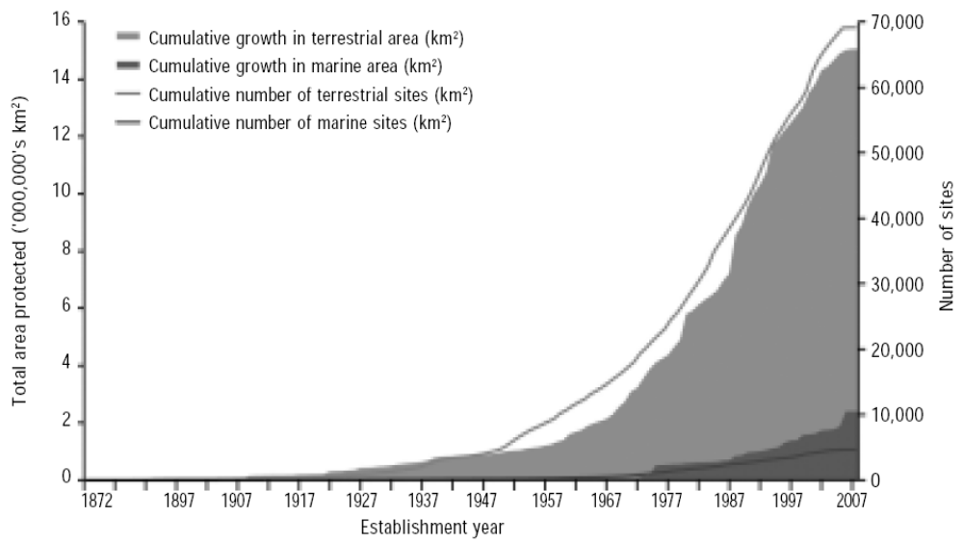
Figure 1 Global growth in area and number of nationally designated PAs

More than 15 countries have completed a comprehensive ecological gap analysis and are in the process of implementing the results, whether by establishing new protected areas, extending existing protected areas, or by other means. In about 23 countries, attempts are underway to undertake comprehensive gap analyses (Box). In some developed countries (Australia, Finland, Canada, and Germany) and in some developing countries (Brazil, Bhutan, Costa Rica) the protected area network is near comprehensive and ecologically representative covering major biomes (forests, pastures, deserts, grasslands, mountains, and wetlands) and includes public, private and community protected areas. Under-represented ecosystems typically include: coastal areas, oases, cave systems, karsts, grasslands, rivers and river canyons, marshes, and most significantly, marine systems.

27 countries reported the establishment of about 5900 new protected areas - national parks, nature reserves, nature conservation areas, nature parks, landscape reserves, natural monuments, protected landscapes, ecological lands, scientific reserves and areas of community importance and 50 marine protected areas, covering approximately 60 million ha of terrestrial and marine areas, since 2004 ( table 1 ). A majority of reporting countries have indicated plans to establish additional protected areas and to adopt targets for protected areas. These targets have been included in relevant environmental policies, national strategies for sustainable development, national biodiversity strategies, national wildlife action plans and programmes. The planned expansion of coverage ranges from 5.74% to 30% of the total geographical area of countries.

Progress in the Province of Quebec in Canada

From 2002 to 2009, Quebec added almost 12.4 million ha of protected areas through two strategic plans. More than 5.3 million ha were added in 2008-09 alone, taking the protected area coverage to 8.12% of its territory, representing all the 13 natural provinces. In three of the Quebec’s natural provinces, over 10% of the area and in one province over 25% of the area is under protection. The Boreal forest natural province recorded exponential increase from 2.38 million ha in 2002 to 9.73 million ha in 2009.On March 2009, 2009 the Provincial Government committed to protecting 12% of its territory by 2015.
Designing Protected Areas for Newfoundland and Labrador’s Woodland Caribou, Canada
NL’s protected areas strategy provides for the establishment of six wilderness reserves, each greater than 1,000 km2, specifically targeted for the conservation of the province’s woodland caribou.

Source: 4th National report

The recent growth of the national system of protected areas in Brazil

The Brazilian system of protected areas at both national and sub national levels composed of 12 different categories comprises 600 protected areas totalling 99.85 million ha distributed in all the Brazilian biomes. Adding the current private reserves and the recognition and recording of all the state protected areas is completed; the coverage of terrestrial and marine protected areas includes 130 million ha.

Between 2004 and 2007, 54 new federal protected areas ware established and other 9 existing areas were expanded adding 19.6 million ha , about 40% increase in the size of federal Pas than that 2003.
Source: Implementation of the CBD in Brazil: Issues on the agenda of COP 9. Ministry of Environment , Brazilin Government.

Status of Gap analysis of the PoWPA within Parties to the CBD

Several Parties have completed gap analyses of their protected area systems for completing ecologically representative networks of protected areas (Australia, Bahamas, Belize, Bolivia, Costa Rica, Ecuador, Finland, Grenada, Guatemala, India, Madagascar, Marshall Islands, Mexico, Peru, and St. Vincent and the Grenadines). Under the UNDP GEF “Supporting Country Action on the CBD Programme of Work on Protected Areas” project, Afghanistan, Albania, Antigua and Barbuda, Armenia, Bosnia and Herzegovina, Comoros, Djibouti, Dominican Republic, East Timor, Fiji, Mongolia, Maldives, Micronesia, Mauritania, Nicaragua, Panama, Papua New Guinea,, Samoa, SieraLeone, Solomon Islands and Tonga are currently undertaking the gap analysis.

Mexico Gap analysis

In 2008 CONAP published an analysis of gaps and omissions in the conservation of terrestrial and marine biodiversity of Mexico ( http://www.conanp.gob.mx/analisis_vacios.html). Findings from gap analysis highlighted that the out of the 96 terrestrial ecoregions of Mexico, 11 are completely protected and 50 ecosrgions are under represented in
protected area systems.. The study made it possible to identify terrestrial ecoregions requiring priority conservation efforts for not being sufficiently represented in existing systems of protected areas and have a high biological significance. In particular, there is a serious lack of protected areas in dry forests, scrub Tamaulipas and thorny forests of pine-oak, and those ecosystems that have been severely affected by human activities, such as rainforests and cloud forests of the mountain. The analysis indicated that 78 priority sites are represented with less than 20% coverage in the system Protected Areas. Of these, 21 sites of coastal and continental margin and the deep sea sites are not protected whatsoever..

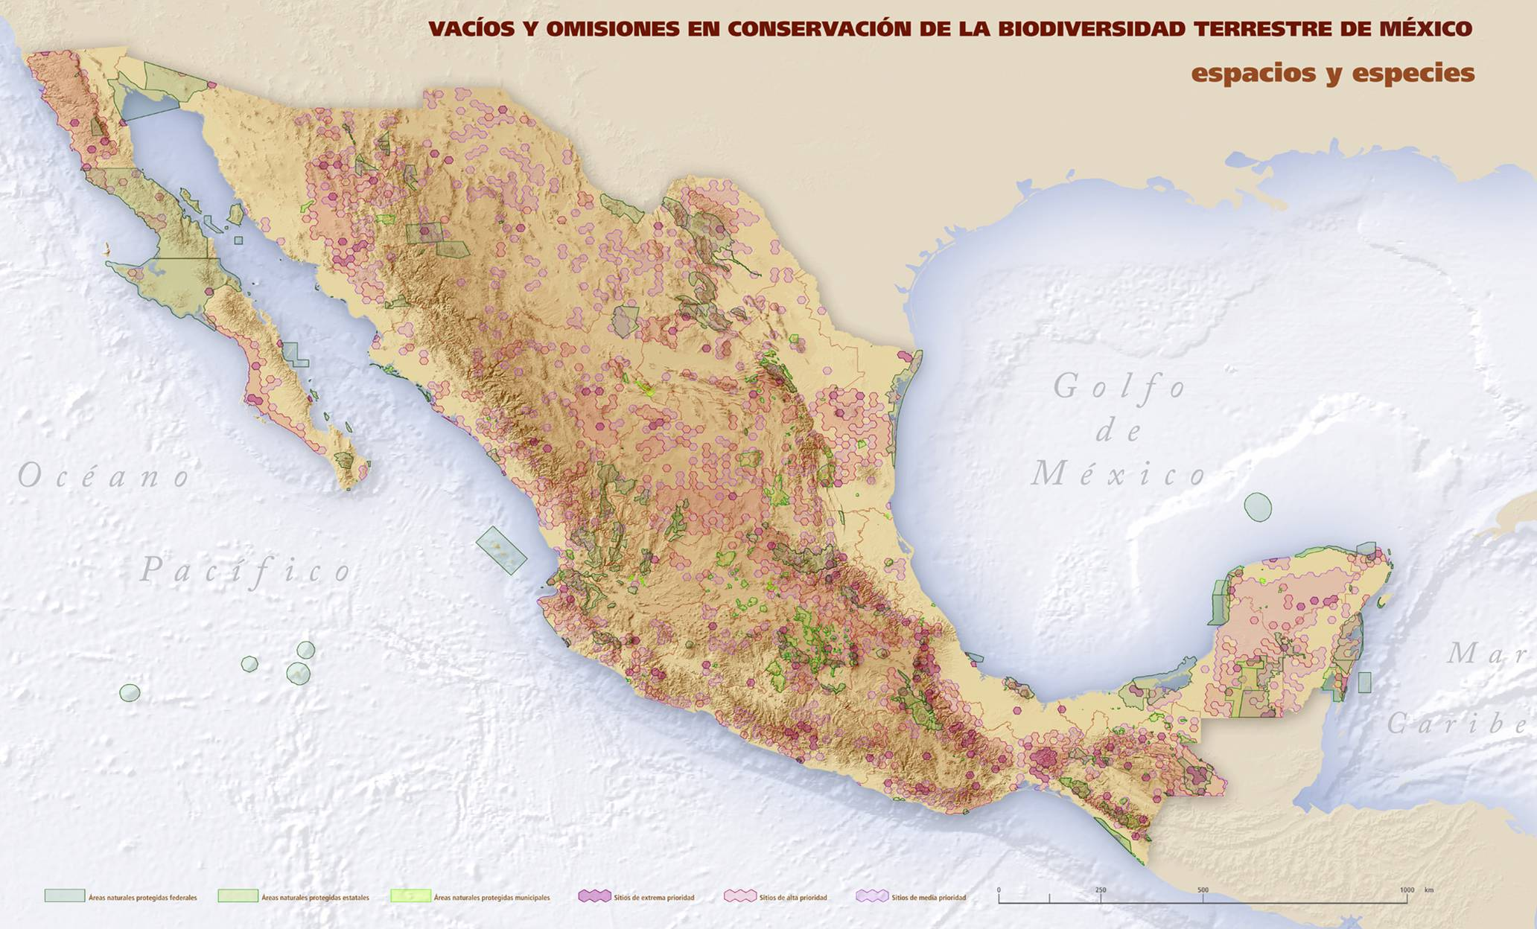

Gap analysis in Finland

There have been two main measures in identifying the gaps within the PA network in Finland.
Assessment of threatened habitat types in Finland. The first assessment (2008) of threatened habitat types in Finland functions as a major tool to estimate the representativeness and to identify gaps of Finland’s PA network. The assessment considered all natural habitat types, which were divided into seven main groups: the Baltic Sea and its coast, inland waters and shores, mires, forests, rocky habitats, traditional rural biotopes, and the fell area.
The SAVA Project, coordinated by the Finnish Environment Institute in 1997-2002, assessed the ecological representativeness of Finland’s network of protected areas with regard to forests, mires and inland waters. The need for conservation in the forests of Southern Finland and Ostrobothnia was also examined in detail by a subsequent working group. The state of natural environment for each broad habitat type was evaluated as part of the first National Action Plan for Biodiversity in Finland (1997–2005), also assessing how comprehensively and representatively the network of protected areas conserves the remaining biodiversity of Finland’s ecosystems.
Table 2. Number and coverage (where available) of protected areas established since 2000/2004 in 27 countries (from the reports submitted to the Secretariat of the Convention on Biological Diversity).

Country | Pa coverage as % of country’s land areas | Protected area (s)
Brazil | 7% | 54 new federal PAs established and 9 existing Pas expanded covering 19.6 million ha. From 2000-05 State Pas increased 28.3% in number and 64.7% increase in size approximately 11.8 million ha.
India | 4.7% | 14 new Pas or an increase of 15% in number covering 0.1 million ha.
Hungary | 9.4% | 93 new Pas (21 nature reserves, 71 protected natural areas of local significance, 1 landscape protection area) covering 26953 ha area. In addition 6 new Ramsar sites covering 79,000 ha area.
Poland | 32.3% | 1029 new protected areas ( Natural Reserves 116, documentation sites 50; ecological sites 572; natural landscape complexes 37; protected landscapes 5; Special Bird protection areas 69; special areas under habitat conservation 180
Mexico | 11.8% | 47 new national parks covering 7.2 million ha
Australia | 10.52% territorial area and 7% of marine areas | National Reserve system has grown from 10.52% in 2004 to 11.6% in 2006 an increase of 9.11 million ha with 1280 new PAs.  43 new MPAs covering 24 million ha
Canada | 9.4% terrestrial  0.64% marine area | About 15 million ha increase in area from 2005 to 2009
China | 15% | 136 new pas from the end of 2006 to the end of 2007 covering 34 million ha.
Spain | 8.8% | 184 new Pas covering 6.9 million ha (72 new SPAs for birds; 96 new protected natural areas; 16 new Ramsar sites). Area under Natura 2000 doubled from 5.5 to 11 million ha.
France | 12% | 1201 new Pas including Natura 2000 sites, National Parks, regional nature reserves, prefectoral protection biotopes, forest biological reserves covering 6.84 million ha
Sweden | 10% | 21 new MPAs. 280000 ha of productive forests protected by the end of 2008. Proposals to establish 17 new national parks, extension of 7 existing parks and 28 new MPAS by 2010.
Philippines | 13.8% | 730 new MPAS from 1997-2007 with 48% increase in the area. A 5.3% increase in the proportion of terrestrial protected areas to total land area from 1992 to 2008. The proportion of forest cover to land area increased from 23.9% in 2003 to 52.6% in 2006.
Czech Republic | 18% | 43 new Pas (2 national nature monuments, 1 national nature reserves, 9 nature monuments, 14 natural reserves, 1 SPA and 16 SCI.
Germany | 13.5% land  41% marine | 749 new PA ( 588 nature conservation areas, 2 national parks – Eifel and Kellerwald, 152 landscape reserves and 7 nature parks) covering 0.7 million ha
Finland | 15% | Since 2004 added 845000 ha of new protected areas in national parks, strict nature reserves, protected peat land areas and herb rich forest areas.
Rwanda | 10% | 2 new Pas (Ramsar site –Rugezi-Bulera-Ruhondo complex and Buhanga reserved forest area)
Norway | 14.3% | 234 new Pas covering 1.2 million ha.
Madagascar | 10% | 2 million ha of new Pas including 5 new MPAs
Albania | 9.8% | 6 new Pas since 2004 ( 2 managed nature reserves coastal wetlands, 1 protected ) ; expansion of Dajti national park and Mali me Gropa-Bize-Martanesh protected landscape
Algeria | 24% | 2 new Pas ( one terrestrial national park and one marine nature reserve)
United Kingdom | 10.9% | 814 new Pas ( 19 special protection areas, 47 special areas of conservation, 2 Ramsar sites, 62 SSSIs +ASSIs, 6 national nature reserves, 668 local reserves, 9 areas of outstanding natural beauty, and 1 national park)covering 0.8million ha.
Cameroon | 15% | 8 new Pas since 2001
Estonia | 18% | 62 new Pas with an increase of 6% in the coverage of Pas as percentage of territory.
Kyrgyzstan | 5.2% | 143000 ha increase in PA coverage from 2005-2008
Mongolia | 14.1% | An increase of 3% in the coverage of Pas as percentage of territory.
Belgium | 12.6% | 77 new Pas ( 66 reserve areas, 6 Natura 2000sites and 5 wetlands) covering 48,470 ha

Goal 1.2: To integrate protected areas into broader land- and seascapes and sectors so as to maintain ecological structure and function
Target: By 2015, all protected areas and protected area systems are integrated into the wider land- and seascape, and relevant sectors, by applying the ecosystem approach and taking into account ecological connectivity / and the concept, where appropriate, of ecological networks.

Some progress to date may likely to be achieved by the date provided more systematic effort are put in place in next five years.

Key issues considered for assessing global progress: measures taken for developing enabling environment for integrating protected areas into broader land and seascapes and sectors; application of ecosystem approach.

Progress towards achieving this target is more evident in Europe and a few other developed countries. The majority of reporting countries indicated enabling legislative, policy measures and tools for integrating protected areas into broader land and seascapes and sectoral interests. Some examples include: the Protected Areas Act in Albania; the Directions for the National Reserve System-A Partnership Approach in Australia; Directives under beyond sites requirement of the European Commission Bird and Habitat Directives -Natura 2000 in European Community member States; Article 3 of the Federal Nature Conservation Act in Germany; the National Natural Heritage Plan in France; Strategic Environmental Assessment in Lebanon; and the Ecological Network Act in Ukraine.
In many countries, protected areas are integrated into surrounding areas through regional development planning, spatial planning, including establishment of ecological corridors, core areas, buffer zones and Biosphere Reserves. Many reporting countries indicated they had taken steps to improve connectivity and ecological networks. Some examples include: Australian Alps to Atherton (A2A connectivity conservation corridor); Greater Mekong sub region Biodiversity conservation corridor in Viet Nam; ecological green corridors in Hungary; eco-tunnels and eco-passages in Belgium. Many developing countries reported that on a conceptual level, the need for adopting the ecosystem approach and establishing/managing protected areas in the regional context is well understood; however, in practice the sectoral interests and competing land uses make it difficult to integrate protected areas into broader land and seascapes. Information on efforts to integrate marine and coastal protected areas into surrounding seascapes has not been well reported.

Vilcabamba Amboró Conservation Corridor
The Vilcabamba Amboró Conservation Corridor (VACC) is a trans-boundary conservation corridor that includes portions of the center south Andes Amazon regions of Bolivia and Peru. It was formed in December 2000, after years of groundwork by stakeholders in both countries, and is considered a pioneering approach in landscape-scale conservation in South America. The development and expansion of the corridor has been an ongoing process in which the Bolivian and Peruvian national Governments, Conservation International (CI), other NGOs and local communities have been heavily involved.

The VACC is a conservation strategy that seeks to articulate multiple categories of protected areas into schemes that integrate management and sustainable land use. The protected areas in the VACC provide critical environmental services to local communities, and are integrated into the local, regional and national economies. The conservation corridor thus proposed a concept that goes beyond the biological connectivity of the protected areas by proposing a land use system that organizes use and management systems that reconcile protection with economic development.

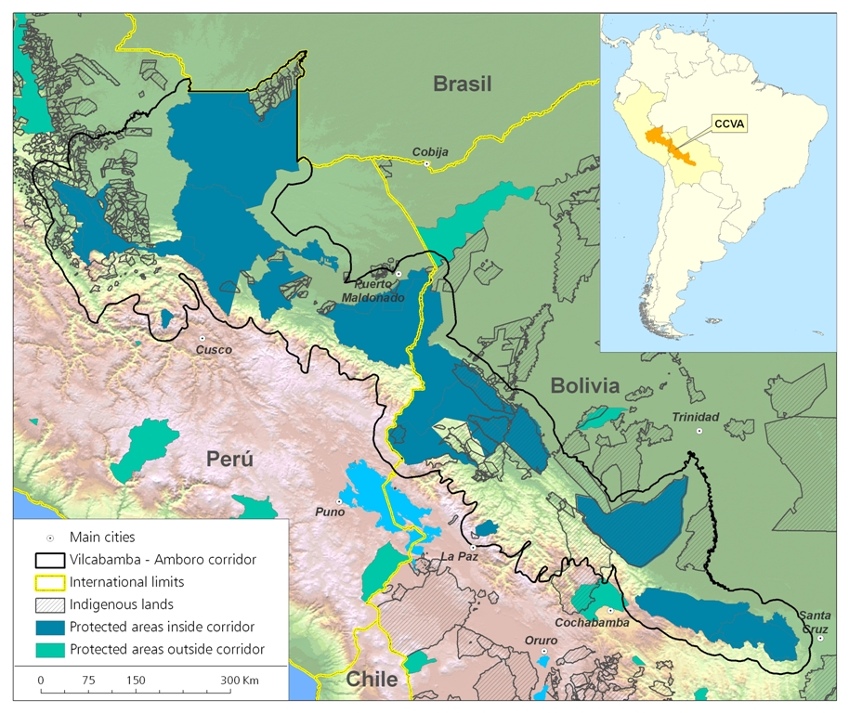

The corridor covers more than 30 million hectares, stretching from Vilcabamba Cordillera in central Peru to Amboró National Park in south-eastern Bolivia. Nineteen formal protected areas, covering 13 million hectares, are nested within the corridor as a core area, the first of which, Tambopata National Park, was created in 1990. Beyond these formal protected areas there are many other conserved areas that were created which allow for sustainable use, including: indigenous Reserves; conservation concessions; ecotourism concessions; and production concessions, among others. The corridor has an immense altitudinal range (from 200 meters to more than 6,000 meters), providing an array of corresponding ecosystems. It plays an essential role in the regulation of ecosystem functions and hydrological processes at a regional level, as well as provides habitat for 145 globally threatened species and an estimated 6,000 plant species. The area includes the wetlands and grasslands of Beni and Heath, the tropical moist forest of the Amazon Southwest, Puna highlands, dry forests in the Cacho, and the Yungas. The corridor is also home to over one million people, both indigenous and non-indigenous, many of whom rely on ecosystem services from the protected areas.
Taking into account the need for considering an array of biological, social and political factors as well as the competing interests of politicians, landowners, activists and farmers, a variety of strategies and actions has been developed, by engaging stakeholders in the planning process and outlining clear conservation priorities. These include: promoting trans-boundary coordination; identifying and mitigating threats; developing robust land use management plans for municipalities; strengthening planning and management capacities; developing land uses that are compatible with biodiversity; Community-based ecotourism; and promoting payment for ecosystem services.

Key outcomes

The ongoing process of developing and managing the VACC initiative has provided lessons learned, both for policy creation and implementation of a large scale protected area integration process. One of the biggest challenges has been the integration of corridor planning into policies and planning instruments for local and regional government and local partners. Another key lesson learned has been the importance of integrating stakeholders into every level of corridor planning and ensuring that there is inter- and intra- regional coordination. Similarly, the importance of exchanging ideas and sharing knowledge throughout the corridor has been a recurring theme.

To fully understand the strengths, weaknesses and potential of the corridor and its management regime, a landscape-scale monitoring and evaluation plan is required. Proper evaluation of the corridor will provide the necessary feedback on how to enhance the corridor’s ability to address conservation and human well-being issues. The development of the corridor has been a learning process, and as more knowledge is produced on the region, the corridor strategy will be revised accordingly.

Goal 1.3: To establish and strengthen regional networks, transboundary protected areas (TBPAs) and collaboration between neighbouring protected areas across national boundaries

Target: Establish and strengthen by 2010/2012 transboundary protected areas, other forms of collaboration between neighbouring protected areas across national boundaries and regional networks, to enhance the conservation and sustainable use of biological diversity, implementing the ecosystem approach, and improving international cooperation.

Fair to good progress to date globally, 34 % increase in number of transboundary protected areas complexes, partially achieved at global level. Can be

Key issues considered for assessing global progress: Increase in the number of transboundary protected areas established; the kinds of collaboration across national boundaries.
The UNEP-WCMC transboundary protected areas inventory -2007, based on reviewing the digital maps of WDPA, identified 227 Transboundary Protected Areas Complexes (TBPA) incorporating 3,043 individual protected areas. Based on GIS analysis the total area TBPA was estimated as 4,626,601.85 Km² with 63% of this occurring in both continents of America. Africa and Asia recorded about 32% and the Europe has only 5% of this total area. The TBPA complex “Ellesmere/Greenland between Canada and Greenland is the biggest TBPA complex in size covering 1,008,470.127 km2. With 169 TBPA in 2001 their number increased to 188 in 2005 and to 227 in 2007 a 34% increase in number since 2001.
Zbicz (2005) identified six “hierarchical, increasing levels of transboundary cooperation between adjoining protected areas”: (i) no cooperation, (2) communication, (3) consultation, (4) collaboration, (5) coordination of planning, and (6) full cooperation. A global survey of managers working in TBPA according to this system found that at the extremes, 18 percent responded that there was no cooperation at all, while 7 percent were cooperating at the level of “full cooperation.” 39 percent of respondents indicated that they at the level of “communication.” Zbicz drew out four “factors” correlated to the level of cooperation. In essence, higher levels of cooperation occurred (1) if the idea of transfrontier cooperation and ecosystem-based management was important to the protected area managers and personnel, (2) if there were adequate communication technologies in place, (3) if there were individuals willing to take leadership roles, and (4) if land managers were able to make personal contact across the border. Not surprisingly, it was the latter factor that correlated most strongly with the level of cooperation achieved.
Nearly all reporting countries indicated collaboration with neighbouring countries in establishing transboundary protected areas and regional networks, as well as cross-boundary management agreements. Multilateral environmental agreements such as the Convention on Migratory Species, the Convention on International Trade on Endangered Species, the Ramsar Convention on Wetlands, along with the Convention on Biological Diversity, as well as many other regional instruments, including the Protocol Concerning Specially Protected Areas and Wildlife, the Barcelona Convention, and the Alpine Convention provided suitable frameworks for regional cooperation that facilitated the achievement of this target.
Important regional protected area networks include the Meso-America Regional Network, the Alpine Protected Area network, the Pan European Ecological Network, the Central Africa Network of Protected areas, the Marine Protected Areas Network for the Western Indian Ocean Countries, and Transnational River Basin Districts on the Eastern Side of the Baltic Sea Network. Transboundary initiatives include inter alia: ZIMOZA (Zimbabwe, Mozambique and Zambia) Trans-boundary initiative; KAZA (Namibia, Botswana, Zimbabwe, and Zambia) initiative; the Gobi desert reserves and Altai mountain reserves between China and Mongolia; trans-frontier marine conservation between Tanzania and Mozambique; Danube Delta and Prut river initiative between Romania, Ukraine and Moldova; Eastern Carpathian migratory corridor (Polish-Slovak-Ukrainian Biosphere Reserve); transboundary protected areas between Eritrea, Djibouti and Somalia; the intercontinental Biosphere Reserve of the Mediterranean Andalusia (Spain) established in 2006 and The East Asian-Australasian Flyway.

Goal 1.4: To substantially improve site-based protected area planning and management
Target: All protected areas to have effective management in existence by 2012, using participatory and science-based site planning processes that incorporate clear biodiversity objectives, targets, management strategies and monitoring programmes, drawing upon existing methodologies and a long-term management plan with active stakeholder involvement.
Fair progress to date with about 30%of national protected areas has management plans in place and another 30 % are under development, but effective implementation of plans are lagging behind. Likely to achieved partially by the target date of 2012.
Key issues considered for assessing global progress: Percentage of protected areas (area and number ) have science based management plans; their preparation through stakeholder involvement; and implementation

In general, reports indicated that science-based management plans exist for at least 30% of protected areas and management plans are under development for an additional 30%. Some examples are given below. In some reporting countries, development of management plans is a statutory requirement and almost all of their protected areas either already have management plans or plans are under development. However, in nearly all developing countries, and in some developed countries, lack of sufficient human and financial resources is a major impediment to the effective implementation of management plans. Most of the reporting countries developed guidelines and approaches for developing management plans and used participatory approaches that included the input of various stakeholders while developing the management plans.
Country | Number of protect areas having management plans (MPs)
Australia | All jurisdictions seek to develop PA management plans. South Australia State recorded an increase from 42.8% to 61.7% in the last ten years and planning to achieve state wide coverage by 2011. Victoria State approved MPs for 13 MPAS and 11 marine sanctuaries by 2007.
Albania | 3 national parks have MPs
Bhutan | 6 out of the 9 national parks have MPs
China | Many protected areas developed MPs but many of them have not been implemented due to various impediments.
Colombia | 50 out of 51 protected areas have MPs and they are being implemented
EC | 5312 of Natura 2000 sites have MPs, for another 3250 sites MPs are under development
Estonia | For 25 protected areas MPs are under effective implementation, for 35 protected areas MPs are under development.
India | For national parks 39 % have MPs; 22% are under preparation. 39% have no management plans. For wildlife sanctuaries 34% have plans; 16% under preparation and 50% no plans. Annual plan of operations are prepared for all protected areas.
Spain | 40% of protected areas have MPs
Sweden | 75% of Natura 2000 sites have conservation plans

Protected Area Managements Plans- Finnish Experience

Management planning guidelines have been written in Finland (by Metsähallitus) in 2003 and updated several times. The latest revision has just been completed in spring 2009 in which the focus is more on adaptive management planning approach where the appropriate changes to the plan are easily integrated without too heavy and resource demanding processes. The planning process and documentation is uniform and always involves stakeholder and public participation. Science-based determination of site values (also other values in addition to those listed in the Habitats and Birds Directives, including socioeconomic ones when relevant), threat analysis and establishment of conservation (as well as socioeconomic and governance) objectives and targets, are part of the process. Planning of necessary actions and the monitoring of both their implementation and impacts are also involved. According to the legislation (Nature Conservation Act and Wilderness Act) each National Park, Wilderness area and some National Hiking Areas are obliged to make management plans that are being evaluated by the Ministry of Environment. This has also led to the process where Metsähallitus NHS are constantly renewing and improving the quality of the management planning process. Since 2004, the number of management plans (MPs) has doubled and the area covered by MPs nearly tri-pled. Of the MPs required by law in Finland, about two-thirds are completed. New MPs are drafted annually on average for 30 Natura 2000 sites. A detailed work plan for the drafting of the necessary MPs for Finnish sites was established in 2007. The objective is to complete the required plans for PAs on state land by 2012.

Finland 4th National Report

Goal 1.5: To prevent and mitigate the negative impacts of key threats to protected areas
Target: By 2008, effective mechanisms for identifying and preventing, and/or mitigating the negative impacts of key threats to protected areas are in place.
Fair to good progress to date in identifying the threats, but threat mitigation and prevention are lagging behind globally.
Key issues considered for assessing global progress: status of threat assessment; actions to improve threat prevention and mitigation.
Nearly all reporting countries have established at least some measures to identify prevent and/or mitigate the negative impacts of threats to protected areas, however, the level of detail varied considerably. In general, threats to protected areas are identified through threat reduction analysis as part of the management plan for individual protected areas. Threats are also identified through routine field patrols by staff, community members or members of the public. Threats to protected areas and their levels vary from country to country. Prevalent threats include habitat fragmentation, conflicting adjoining land use, invasive alien species, mining and oil drilling, pollution, altered fire and hydrological regimes, legal and illegal logging, visitor impacts, hunting, and farming practices. Many countries in the 4th national reports highlighted climate change as one of the most significant threats.
Regarding prevention and mitigation measures, many countries reported that they have developed legislative, policy and regulatory measures, including mandatory environmental impact and strategic environmental assessment of development projects and incentive schemes. Some countries indicated that prevention and mitigation of threats is accomplished through pre-emptive actions in the threat-reduction analyses, including sharing of responsibility between protected-area staff and local communities, and conflict resolution. Many countries reported that they were undertaking measures to restore and rehabilitate the ecological integrity of protected areas. Some examples include: boundary demarcation; selective salvage operations in forest reserves; replanting with indigenous species; strict law enforcement; conversion of water balance in bogs and fens; establishment of grazing systems in grasslands; removal of shrubs and trees from high value grasslands, bogs and fens; and coral-reef mooring.
Assessing Threats to Environment Canada’s Protected Areas
A survey of managers of National Wildlife Areas (NWAs) and Migratory Bird Sanctuaries (MBSs) has concluded that many of Environment Canad’s 143 protected areas are under threat:
Tourism and recreation is affecting 56 NWAs & MBSs.
Human disturbance is affectiing 29 NWAs & MBSs.
Pesticides and fertilizers are affecting 32 NWAs & MBSs.
Exotic vegetation is affecting 30 areas.
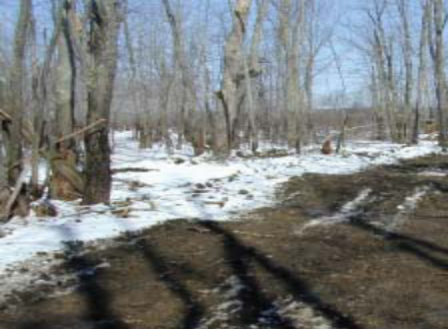
Illegal wood cutting Purple Loose strife( Lythrus saicaria)
Canadian Protected Areas Status Report: http://www.cws-scf.ec.gc.ca/publications/habitat/cpa-apc/pdf/chap5-7_e.pdf

Goal 2.1: To promote equity and benefit-sharing and Goal 2.2: To enhance and secure involvement of indigenous and local communities and relevant stakeholders
Target 2.1: Establish mechanisms for the equitable sharing of both costs and benefits arising from the establishment and management of protected areas (Timeline 2008)
Target 2.2: Full and effective participation of indigenous and local communities, in full respect of their rights and recognition of their responsibilities, consistent with national law and applicable international obligations, and the participation of relevant stakeholders, in the management of existing, and the establishment and management of new protected areas (Timeline 2008)
Some progress to date in both the targets but way behind meeting the targets at global level and also at regional level except pacific islands region.
Key issues considered for assessing the progress: assessment of socio cultural costs and benefits of protected for indigenous and local communities; recognition of governance types and community conserved areas; mechanisms for full and effective participation of indigenous and local communities.
Although one can conclude that these two targets of the Programme Element 2 are not achieved at the global level, but the principles of equity, participation, governance and sharing of costs and benefits are increasingly being considered at national levels and being incorporated into national policies.
Nearly all countries reported having legislative and policy frameworks for the equitable sharing of costs and benefits arising from the establishment and management of protected areas. However, few countries provided details and many countries indicated gaps in terms of equitable sharing of costs and benefits. One country (Australia) indicated that all its states and territories have enabling legislation related to conservation covenants on the title of private lands. Some countries established joint/collaborative/ participatory forest management programmes, tourism ventures etc, to share revenues with local communities. Assessments of economic and socio- cultural costs and benefits of protected areas for indigenous and local communities have not been undertaken in the majority of reporting countries. Some countries reported undertaking measures to avoid and mitigate negative impacts on indigenous and local communities through the establishment of protected areas, which inter alia include alternate livelihood options; acquisition compensation grants; covenanting programmes and revolving funds; and development of regulations to protect the rights and interests of indigenous and local communities.

A majority of responding countries reported that their relevant laws and policies incorporate a clear requirement for the participation of stakeholders and indigenous and local communities in the planning, establishment and management of protected areas ( Box 1 ). A few countries also reported that a process of public consultation particularly with local communities is undertaken at national or local level before protected areas are established. In general, multi-stakeholder protected areas advisory committees or conservation boards are important mechanisms to facilitate participation of all stakeholders. Many countries indicated measures taken to support indigenous and community conserved areas (ICCAs), which inter alia include training, assistance through non-governmental organizations, dissemination of information, and funding. However, not much information is available regarding how many countries accorded recognition to ICCAs and co managed protected areas. A survey of 16 countries by IUCN-WCPA TILCEPA found six countries (Australia, Brazil, Guyana, India, South Africa and Vanuatu) enacted legislation recognizing ICCAs as part of the country protected area network. Another six countries (Canada, Costa Rica, Indonesia, Mauritania, Tanzania and Taiwan) provided legal backing to ICCAs, but as part of more general laws providing recognition of indigenous or community territories, rather than as protected areas or specific conservation mechanisms. Four countries (China, Morocco, Nepal and Nigeria) had no legal backing for ICCAs, but provided some level of administrative support. While there is some progress in terrestrial ICCAs, community managed marine protected areas, except the Locally Managed Marine Areas (LMMAs) (Box ) in the Pacific, are not well developed in other regions.

Documenting Best Practices in PE 2 of PoWPA- Canadian experience

In 2007, Parks Ministers released a series of case studies profiling leading collaborative work between Aboriginal peoples and Canada’s park agencies. These case studies highlight best practices in Aboriginal engagement across the country in a variety of areas including: cooperative involvement in park planning and management, participation in broader regional planning initiatives, incorporation of traditional knowledge into park planning and management, creation of economic opportunities such as tourism ventures, and the use of parks as cultural learning opportunities for Aboriginal youth. The case studies can be found at http://www.parks-parcs.ca/english/cpc/aboriginal.php.

Kusawa Park in the Yukon Territory was established through a cooperative effort by a number of First Nations and the Yukon Government. The park, which represents extremely important historic and cultural values for First Nations communities, is identified as a settlement agreement park within both the Kwanlin Dun First Nation and the Carcross Tagish First Nation Final Agreements. The Champagne Aishihik First Nation is also involved in park planning efforts, given that the site is also part of their traditional territory.

The park management plan under development also reflects the importance of First Nations participation in determining the overall direction, management policies and practices for the site. The Kusawa Park Steering Committee is composed of representatives of three First Nations and Yukon Government. It is addressing a full range of park management issues as it develops a recommended park management plan for the area.

Locally Managed Marine Areas (LMMAs)

More than 12,000 km² in the South Pacific came under LMMAs – a community based marine resource management over the last decade, involving 500 communities in 15 Pacific Island Sates. This includes 1,000 km² of ‘no take areas’ and has facilitated the achievement of widespread livelihood and conservation objectives based on traditional knowledge, customary tenure, governance, combined with local awareness of the need for action and likely benefits. These benefits includes recovery of natural resources, food security, improved governance, access to information and services, health benefits, improved security of tenure, cultural recovery, and community organization.

Results of LMMA implementation in Fiji since 1997 have included: a 20-fold increase in clam density in the tabu areas; average of 200-300% increase in harvest in adjacent areas; tripling of fish catches; and 35-45% increase in household income

Govan H. 2009: Achieving the potential of locally managed marine areas in the South pacific. SPC Traditional Marine Resource Management and Knowledge Information Bulletin # 25; 16-25

An internationally recognized typology recognizes four governance types which can be applicable to IUCN protected area categories, as given in the following Table.
Table 1: Matrix of IUCN protected area management types and governance approaches

IUCN category (primary management objective) | IUCN Governance type
IUCN category (primary management objective) | A. Governance by governments |  |  | B. Shared governance |  |  | C. Private governance |  |  | D. Governance by indigenous peoples and local communities
IUCN category (primary management objective) | Federal or national ministry or agency in charge | Local ministry or agency in charge | Management delegated by the government (e.g. To an NGO) | Transboundary protected area | Collaborative management (various pluralist influences) | Collaborative management (pluralist management board | Declared and run by private individual | Declared and run by non-profit organisations | Declared and run by for-profit individuals | Declared and run by indigenous peoples | Declared and run by local communities
I – Strict nature or wilderness protection
II – Ecosystem protection and recreation |  | A
III – Protection of natural mon-ument or feature
IV – Protection of habitats and species |  |  |  |  | B |  |  | C
V – Protection of landscapes or seascapes |  |  |  |  |  |  |  |  |  |  | D
VI – Protection and sustainable resource use

Some examples of different governance types in four IUCN protected area categories are:
- A. Girraween National Park, Queensland Australia. Owned and managed by the state government of Queensland to protect species unique to the area;
- B. Dana Nature Reserve, Jordan. Managed by the state in cooperation with local communities to reduce grazing pressure and restore desert vegetation and wildlife;
- C. Alto Fragua Indiwasi National Park, Colombia. Proposed by the Ingano people on their traditional forest lands and managed according to shamanic rules;
- D. Sečovlje Salina Natural Park, Slovenia. Important area of salt works and wetland, funded as a private reserve by Slovenia’s largest mobile phone company.

Information on how countries strengthened and diversified their governance types is not available barring few. For example, Colombia has moved towards much greater participation of indigenous peoples, peasant communities, and others. It also encouraged the creation and incorporation of a complex set of regional and local reserves, collaboratively managed PAs, indigenous territories, private protected areas, and community conserved areas. Australia has established 22 indigenous protected areas covering 14 million hectares and implementing new forms of conservation and covenanting programmes. Canada has established First Nations protected areas. Madagascar has also moved into diversifying PA governance types and India extended its PA types to include those that could be managed in a collaborative manner with various government departments and local communities, and those to be managed by local communities themselves. India has established 43 conservation reserves and community reserves. Brazil has reported that there are 65 indigenous lands in the community conserved areas of which 38 are demarcated and 28 are legally established. Under UNDP/GEF PoWPA project currently 19 countries (Afghanistan, Antigua Barbuda, Armenia, Benin, Burundi, Cambodia, Comoros, DR Congo, Guatemala, Guinea, Honduras, Kiribati, Maldives, Mali, Mauritania, Micronesia Federated states, Samoa, Gambia and Uganda) are assessing and diversifying protected area governance types.

Diversifying the governance of protected areas, into collaborative and community based regimes, will be a significant step towards achieving the objectives of POWPA but such diversification itself requires considerable effort on part of Governments, international agencies, indigenous peoples and local communities, other civil society organizations, donors, scientific groups, and others. Grater documentation of best practices, facilitation of learning across countries and regions, utilizing and building on existing guidance, commitment to translate the policy into concrete actions, will ensure effective implementation of Programme element 2.

Goal 3.1: To provide an enabling policy, institutional and socio-economic environment for protected areas
Target: By 2008 review and revise policies as appropriate, including use of social and economic valuation and incentives, to provide a supportive enabling environment for more effective establishment and management of protected areas and protected areas systems.

Fair to good progress to date, partially achieved the target at global level

Key issues considered for assessing the progress: assessment of policy, institutional environment; kind of social and economic valuation methods and incentives to support enabling environment.
The majority of reporting countries indicated that they had already put in place appropriate policy, institutional and socio-economic frameworks for effective establishment and management of protected areas. Some countries have already enacted specific legislation for protected areas and some countries have done so specifically for marine areas. Though some countries indicated that they carry out valuation of goods and services of protected areas, and use various types of socio-economic valuation methods, information on how those values have been captured into national accounts has not been provided. A number of tools are now available to asses the values and benefits of protected areas (see box on PA-BAT). Some countries developed and tested social and economic valuation methods concerning the effects of protected areas for regional development. Many countries indicated a lack of expertise and capacity in evaluating goods and services of protected areas and their reflection in national accounts, e.g., gross domestic product and national budgets.
From the information provided, some of the main impediments for effective establishment and management of protected areas include lack of financial resources; lack of trained manpower and capacities; competing needs on land; lack of intersectoral coordination, lack of clear-cut roles and responsibilities; jurisdictional conflicts; compensation issues and land tenure rights and ownership regimes; high rates of human population growth and resource consumption; lack of political support; lack of public awareness and support; boundary disputes between traditional leaders; wildlife damage and strained relations between local communities and management authorities.
PA-BAT Tool
Under the Arguments for Protection project being run by WWF, The World Bank and other partners developed a Protected Area – Benefit Assessment Tool (PA-BAT) for assessing of the wider benefits that protected areas provide to human well-being. This tool can fill an important gap in the toolbox of protected area agencies and conservation institutions, to help collate and build information about the overall benefits from protection and to help implement Goal 3.1 of PoWPA. The PA-BAT aims to help collate information on the full range of current and potential benefits, of individual protected areas. The PA-BAT has been primarily designed for use by protected area managers to work with stakeholders to identify important values and the benefits that they bring to a range of stakeholders, from local to global. The PA-BAT can also be used by local communities to identify values/benefits and by protected area advocates, such as NGOs, to help promote the range of benefits a protected area can bring. As PA-BAT has developed a standard typology of values and benefits, the results from the tool can be aggregated to provide an overview of a portfolio of protected areas (e.g. regional groups, national systems, biome groups etc). This can be used as a planning tool at system level (e.g. developing policies for specific resource uses) or as an advocacy tool for supporting protected areas.

http://www.equilibriumconsultants.com/upload/document/PA_BAT_- Final_Feb_2008_revised_April_2009.doc

Goal 3.2: To build capacity for the planning, establishment and management of protected areas
Target: By 2010, comprehensive capacity building programmes and initiatives are implemented to develop knowledge and skills at individual, community and institutional levels, and raise professional standards.
Fair to good progress to date, could be partially achieved at global level.
Key issues considered for assessing the progress: comprehensive capacity needs assessments; programes implemented for capacity building

Nearly all countries reported advancement toward achieving this target. Nearly all countries reported undertaking capacity needs assessments and establishing capacity building programmes. In the majority of countries capacity building is an integral part of protected area management plans. In some countries, premier specialized training institutions have been established for conducting regular and customized training programmes for managers and frontline staff. Some of these institutions have been recognized as regional training institutions for the countries of the region. In some countries, training programmes are also developed for non-governmental organizations and community groups as well as government protected-area staff. In many reporting countries, project-based training programmes are implemented. A few countries indicated that they are undertaking multidisciplinary approaches in the management of protected areas by incorporating information from natural sciences, social, economic and political sciences, and traditional knowledge.

PoWPA Friends informal consortium of partners and regional workshops
At its eighth meeting, the COP, in decision VIII/24, recognized that developing countries were facing capacity-building constraints in the implementation of PoWPA and requested the Executive Secretary to organize regional capacity building workshops in partnerships with relevant organizations. Towards this a vibrant partnership through an informal and effective consortium of partners- PoWPA Friends has been established. This consortium over the last two years has been working to increase governmental capacity to implement the PoWPA by providing training and technical support through regional workshops in Caribbean, East Caribbean States, Latin America, South and West Asia, Southeast Asia, Eastern Europe, Anglophone Africa, Francophone Africa, and Central Asia and Caucasus, and Pacific regions. These workshops provided practical, hands-on-tools and training on priority activities including ecological gap assessments, management effectiveness and capacity assessments, and sustainable finance planning, identified by the eighth meeting of the Conference of the Parties at its eighth meeting (decision VIII/24, paragraph 9).
These workshops covered 120 countries and were attended by nearly 600 protected area planners, practitioners and policy makers. These workshops have resulted in the following benefits:
(a) Provision of outreach to countries, opening a dialogue to better understand key obstacles;
(b) Development of a comprehensive set of learning materials and case studies, including nearly 100 country-specific case studies;
(c) Provision of a forum for regional-level discussions, cooperation and future collaboration;
(d) Presentation to policy makers of an introduction to and overview on key issues;
(e) Creation of awareness about funding opportunities espicialy UNDP/GEF PoWPA project 40 out of the 48 successful GEF grants came from participants at one of the workshops and provided technical know how for implementing those projects.
(f) Improved motivation for taking on-the-ground actions.

Goal 3.3: To develop, apply and transfer appropriate technologies for protected areas
Target: By 2010 the development, validation, and transfer of appropriate technologies and innovative approaches for the effective management of protected areas is substantially improved, taking into account decisions of the Conference of the Parties on technology transfer and cooperation.
Fair progress to date, could be partially achieved at global level.
Key issues considered for assessing the progress: development and transfer of technologies for protected areas.
Most countries reported the application of innovative approaches and technologies in the establishment and management of protected areas. In general these technologies include, remote sensing and Geographic Information Systems, habitat and landscape mapping, satellite telemetry, and camera traps. Some new approaches include public-private partnerships, management effectiveness-tracking tools, rapid assessment and prioritization of protected areas management, and the IUCN Management Effectiveness Framework. Some countries reported development of new concepts and technologies such as “field biotope network planning”, “ecological security”, and “landscape security”. Some countries reported development of integrated information management systems for protected areas for dissemination of information and approaches for effective management of protected areas. Many reporting countries indicated collaboration and sharing of information and technologies within the country and/or with other countries. Many developing countries called for regional collaboration, capacity and know how, and financial support for using innovative and new technologies

Goal 3.4: To ensure financial sustainability of protected areas and national and regional systems of protected areas

Target: By 2008, sufficient financial, technical and other resources to meet the costs to effectively implement and manage national and regional systems of protected areas are secured, including both from national and international sources, particularly to support the needs of developing countries and countries with economies in transition and small island developing States.

Some progress to date but way behind meeting the target at global level and also at regional level.
Key issues considered for assessing the progress: financial needs estimates and status of development and implementation of sustainable finance plans; funding from bilateral and multi lateral sources.

Financial needs assessment and status of sustainable finance plans: The PoWPA requires Parties to develop and implement country-level sustainable plans for ensuring financial sustainability of national systems of protected areas. Assessment of financial needs and gaps is one of the first steps in developing sustainable finance plans. With a few exceptions, most of the reporting countries have not undertaken these assessments. Information on financial needs assessment is available for only 19 least developed countries, Small Island developing States, other developing countries and countries in economies in transition. Estimated annual funding gap for implementing PoWPA by these 19 countries ranged from US$ 3.28 million to 142.25 million. For developed countries information is available only for Australia and ECError: Reference source not foundError: Reference source not found. A majority of responding countries indicated that a major source of funding for protected areas are national and provincial budgets. With only few exceptions, most countries, including developed countries, find resources limited or very limited for the establishment and management of protected areas. None of the reporting countries elaborated on the strategies that are in place or under development to secure long-term funding for their national protected area system. Very few countries indicated the nature of supplementary funding mechanisms. To date only few countries are in the process of completing country –level sustainable financing plans (see box 1 for information on financial and business plan for the National System of Protected Areas (SNAP) of Ecuador. Under UNDP/GEF PoWPA project 8 countries (Antigua & Barbuda, Belize, Djibouti, Dominican Republic, Honduras, Lao PDR, Micronesia, Mongolia, are currently developing sustainable finance plans

Funding from bilateral, multilateral and other sources: Based on the available information, international financing for biodiversity conservation in recent years is estimated to be around US $ 4 to 5 billion annually with some 30% to 50% of it going to protected areas. Out of this, as much as 2 billion dollars - comes from high income countries’ Overseas Development Assistance (ODA) in the form of country-to-country bilateral aid, and in the form of multilateral aid managed by the GEF, other UN agencies, the International Development Agency and multilateral development banks. Not-for-profit funding, coming from international conservation NGOs, private foundations and businesses-related foundations, may contribute over 1 billion dollars annually but precise figures are difficult to estimate. Market-based sources include (a) international ecotourism and tourism, (b) markets for environment–friendly products (organic, certified, fair trade, etc) and (c) the incipient field of international payments for ecosystem services (IPES), like bio-prospecting and bio-carbon, may contribute to 1 to 2 billion US $.

Box 1. Financial and Business Plan for SNAP Ecuador

From 2004-2007, the Ministry of Environment of Ecuador undertook a process to improve financial sustainability of the National System of Protected Areas (SNAP). A system wide financial needs assessment was undertaken for assessing gaps based on current financial status and a 10 year projection of needs through analysis of barriers and structural limitations to increase resources for SNAP. Based on the needs assessment, firstly, a financial sustainability strategy consisted of macro-level strategic planning for the SNAP, including supply and demand of resources. This strategy proposed alternative financing mechanisms, and identified legal, political, institutional elements the required enabling environment for financial sustainability. Thereafter specific business plans were developed for each of the promising mechanisms identified in the financial strategy. Finally, implementation plans and evaluation systems were developed to measure the progress. The plan facilitated participation of different stakeholders who have committed their support for implementation of the plan.
Source : flores,M., Rivero, G (2008)Business- Oriented Financial Planning for National Planing for National Systems of Protected Areas – Guidelines and early Lessons. TNC, Arlington, Virginia, US.

Also www.ambiente.gov.ec/paginas_espanol/4ecuador/areas.htm

The Global Environment Facility is the largest funding mechanism for protected areas worldwide. GEF has invested in over 1,600 protected areas, covering more than 360 million hectares. The GEF has provided more than $1.56 billion to fund protected areas, leveraging an additional $4.15 billion in co-financing from project partners. In addition, the resources allocated to supporting PA system projects have increased during each successive GEF replenishment cycle In GEF -4 (2007-2010) approximately 450 million is allocated for protected area system. In addition other GEF initiatives such as the Small Grants Programme and the Critical Ecosystem Partnership Fund have also contributed significantly to protected areas (see box 2). As per the guidance given by the COP in decision VII/28 the GEF launched a UNDP/GEF project to support implementation of PoWPA (see box 3).
Box 2. GEF
As the largest financial supporter for protected areas globally, between 1991 and June 2006, the GEF invested in more than 1,600 protected areas, covering more than 360 million hectares. During the same period, the GEF also provided more than $1.56 billion to fund protected areas, leveraging an additional $4.15 billion in co-financing from project partners. In addition, the resources allocated to supporting PA system projects have increased during each successive GEF replenishment cycle. In GEF-4 (2007-2010), approximately $1 billion has been allocated to the biodiversity program, of which $450 million is nominally directed to strategic programs supporting the management of protected area systems.

GEF-4 support to catalyzing sustainable protected area systems is being channeled through three strategic programs: a) sustainable financing of protected area systems at the national level; b) increasing representation of effectively managed national marine protected area networks in protected area systems; and c) strengthening terrestrial protected area networks.

The GEF has been supporting developing countries to establish and implement various innovative financial mechanisms. In particular, the GEF is recognized as a pioneer in supporting more than 26 conservation trust funds worldwide, investing more than $300 million in total. In addition, the GEF has supported the diversification of revenue streams to fund protected area management costs through the use of payments for environmental services (PES), tax incentives and other mechanisms.
Source: Financing the Stewardship of Global Biodiversity; Global Environment Facility (2008)

Box 3. UNDP/GEF Project on PoWPA
- First grants were awarded in October 2007.
- As of December 2008, 57 grants were approved for 47 countries, for which the project committed USD 7.9 million, and leveraged USD 7.4 million in co-financing.
- 43 grants were issued to Small Island Development States (SIDS) and Least Developed Countries (LDCs), which is 75% of all approved grants.
- Preparation of framework plans for PoWPA implementation - in 26 LDCs and SIDS (i.e. 46% of the world’s LDCs, and 21% SIDS).
- Protected area ecological gap analysis (PoWPA Activity 1.1.5) - in 23 countries.
- Vocational training courses for protected area professionals (3.2.1) are expected to be established in 20 countries.
- New or amended legislation on protected areas (3.1.1) is expected to be adopted in 16 countries.
- Demonstration and trial activities will be supported at 93 existing or potential protected areas in 33 countries, helping to test innovative forms of PA governance including community and private reserves (2.1.2), promote better site-level biodiversity conservation forms (1.1.4), and introduce site-level financial mechanisms to engage communities in PA conservation and management (3.1.6 and 3.4.1).
- Assessment of the contribution of protected areas to national economy (3.1.2) - in 12 countries.
- Scorecards and databases for the measurement in a systemic way, of the management effectiveness of protected areas (4.2.1) - in 9 countries.
- Assessment of the effectiveness of the protected area financing will be conducted, and measures to improve funding will be put in place (3.4.1) - in 8 countries.
- Evaluation of the experience on integration of protected areas into broader landscapes and into poverty reduction plans (1.2.1) - in 3 countries.
Source: www.protectedareas.org

While there is increase in allocation under each GEF cycle, the share of biodiversity conservation under bilateral aid has remained fairly constant, between 2.4% and 2.8% of total bilateral ODA through the last 15 years. During the last meeting of the COP, the Government of Germany launched the LifeWeb, as a means to support and strengthen implementation of the PoWPA through new and additional financial resources. The Government of Germany has committed approximately 120 million Euros over three years to support projects brokered through this initiative, within the framework of the International Climate Initiative. . The Government of Spain has also recently committed 5 million Euros. A number of other donors have expressed interest in supporting projects brokered by the LifeWeb Initiative. The vision is LifeWeb will over time combine a diversity of donors, including public bilateral and multilateral agencies, foundations, and the private sector and become a ‘one stop shop’ for information and opportunity on protected areas financing. A small LifeWeb Coordination Office has been recently established within the CBD Secretariat in order to develop and manage the initiative.

Goal 3.5: To strengthen communication, education and public awareness
Target: By 2008 public awareness, understanding and appreciation of the importance and benefits of protected areas is significantly increased.
Fair to good progress to date partially achieved at global level.
Key issues considered for assessing the progress: Awareness raising activities; communicating benefits

Most countries reported undertaking at least some communication, education and awareness-raising activities for enhancing public understanding and appreciation of protected areas. In many countries conservation foundations and NGOs are supplementing governmental efforts in public-awareness activities. In some countries both federal and provincial governments are engaged in education strategies and programmes in communicating the biodiversity and other values of protected areas. Public-awareness activities included publication of brochures, booklets, posters, websites, CD-ROMs; organization of guided tours; engagement of folk art and cultural shows; construction and maintenance of nature trails, camping, mountain biking, recreational vehicle driving; competitions; observance of important days and festivals; establishment of conservation education/interpretation centres in protected areas, visitor centres, and “discovery ranger programmes” aimed at families gaining a first-hand experience of reserve values. One country reported development of a communication strategy for its national protected area system, including its marine protected areas. In many reporting countries, environmental education is introduced in the school curriculum. Information specifically on the inclusion of protected areas in the formal school curricula has not been provided.

Value of Nature

Protected areas, besides being cornerstones of biodiversity conservation, constitute an important stock of natural, cultural and social capital, yielding flows of economically valuable goods and services that benefit human populations. The positive contribution of protected areas to the livelihoods of the poorest and most vulnerable sectors of the society is very high indeed. Protected areas also provide key support to the maintaining of cultural traditions and building social capital. Moreover, as unprecedented climate change becomes a reality, protected areas are key to buffering the inevitable, yet unpredictable impacts. In fact, evidence shows that well managed protected areas yield significant benefits, which can be translated into cumulative advantages across a national economy. Without these important components, sustainable development and achievement of the Millennium Development Goals may well be an insurmountable task.

Land and sea areas dedicated to conservation are the world’s shining green emeralds and blue sapphires. Unfortunately their value is poorly understood and greatly undervalued by markets, politicians, and the general public. Their value does not register in conventional markets and they are therefore not considered to be real economic assets by policy makers. As a result, protected areas do not receive crucial national budget prioritization, and lamentably, more often than not, funding is lacking for their creation and management. There is a need to stimulate political will, enhance human and financial resources. One way to promote that is to describe in a more comprehensive and convincing way the many benefits of protected areas. To illustrate the ecological, economic, social and cultural benefits of protected areas, in order to generate a stronger call to action for policy makers and other stakeholders, the Secretariat of the Convention on Biological Diversity invited a number of authors to contribute case studies and published a brochure.
https://www.cbd.int/doc/publications/cbd-value-nature-en.pdf

WWF’s Arguments for protection Series

The Argument for Protection project, being run by WWF, The World Bank and other partners, is based on the premise that ethical or emotional arguments about saving biodiversity are not enough to persuade Governments or communities of the necessity to set aside large areas – or large enough areas – of land and water from development in perpetuity. The project therefore has a number of complementary objectives including: to identify and where possible quantify a wide range of benefits derived from protected areas; to increase support for protection by developing new and innovative partnerships; to broaden and strengthen protected area management strategies; to help integrate protected areas into broadscale conservation strategies and to reach new audiences and thus raise awareness of protected areas’ wider role. Seven reports have been produced - on drinking water, agrobiodiversity, faiths and religions, poverty reduction strategies, disaster mitigation, health and climate change (the last two are being published in 2009). The reports can be downloaded from: www.panda.org/protection/arguments.

Goal 4.1 - To develop and adopt minimum standards and best practices for national and regional protected area systems
Target: By 2008, standards, criteria, and best practices for planning, selecting, establishing, managing and governance of national and regional systems of protected areas are developed and adopted.
Fair to good progress to date in developing standards, criteria and best practices but lagging behind in adopting them at global level and also at regional level.
Key issues considered for assessing the progress: development of standards and criteria for planning, selecting establishing and managing protected areas and adopting best practices.
A few countries (15%) reported having comprehensive standards, criteria and best practices for site selection, management and governance of protected areas. In some countries, monitoring protocols for some categories of protected areas have been formalized. With regard to the Natura 2000 network, a number of guidelines for site management have been developed at the level of the European Union. . One reporting country indicated the approach undertaken in the systematic protection of marine areas and standards and best practices for new activities in terrestrial reserves. IUCN-WCPA has produced an extensive series of “ best practice” guides for protected area establishment and has proposed a set of minimum standards for protected area management. As of now 16 best practice guidelines covering inter alia sacred natural sites to indigenous and community conserved areas, transboundary protected areas, mountain protected areas, management effectiveness, sustainable financing etc,.
Australian experience in standards
The Directions for the National Reserve System – A Partnership Approach (NRMMC 2005) sets out 38 strategic directions for the on-going development and implementation of site selections, management, governance, and long-term monitoring of outcomes. The directions fall into four broad streams:
- improving, monitoring and reporting on the comprehensiveness, adequacy and representativeness of the national reserve system
- reviewing and implementing with more consistency models and mechanisms for protection
- improving frameworks and standards for protected area management
- exploring partnerships for funding, protection, engaging the public and implementing the Directions for the National Reserve System - A Partnership Approach.
Australia 4th National Report.
Planning National Parks for Climate Change
Parks Canada is developing climate change scenarios for each geographic region and every national park as part of the suite of indicators that are used to monitor the ecological integrity of the park system. From the scenarios and monitoring, park scientists will be better able to predict the impacts on plant and animal communities. Park managers can then take measures to adapt to the inevitable changes. Climate change considerations are increasingly being used to design boundaries of proposed national parks.

Goal 4.2: To evaluate and improve the effectiveness of protected areas management
Target: By 2010, frameworks for monitoring, evaluating and reporting protected areas management effectiveness at sites, national and regional systems, and transboundary protected area levels adopted and implemented by Parties
Some progress to date, but unlikely achieving the target at global and regional level by 2010.
Key issues considered for assessing the progress: status of management effectiveness assessment; measures taken to implement results of assessment to improve management effectiveness.

Significant inter- and intra-regional differences among countries can be discerned in tracking the progress in this target. Within a region, some countries indicated significant advancement in carrying out management effectiveness evaluations. However in a number of countries within the same region management effectiveness assessment has yet to be undertaken. Most of the reporting countries indicated adoption of the IUCN-WCPA management effectiveness framework, and have adopted either the WWF Rapid Assessment and Prioritization of Protected Area Management (RAPPAM) methodology, or a scorecard approach, for carrying out assessments. Some countries strongly articulated the need for availability of these methodologies and tools in local languages and increased technical capacity for undertaking management effectiveness evaluations. Information on the percentage of the overall surface of protected areas that have been evaluated, or conclusions of evaluations and incorporation of the results of evaluations into management plans of protected areas, is not made available in the reports. However a global study undertaken by the University of Queensland with support from WWF, TNC, IUCN-WCPA, UNEP-WCMC, provides detailed information on about 6,800 management effectiveness assessments from 100 countries. Detailed information on the outcome of the Global Study based upon the 2008 report and a paper provided by the UNEP-WCMC for the GBO 3 is given below.

Global Study on Management Effectiveness Evaluation in Protected areas

Introduction: Over the past three years, the University of Queensland has undertaken a global study on evaluation of management effectiveness in protected areas, covering over 6,800 assessments across 100 countries. By obtaining original data, analyzing about 50% of the total assessments and reviewing 50 evaluation reports, the Global Study developed a database, which is being linked to the WDPA. UNEP–WCMC in partnership with the Global Study created a webpage within WDPA to enable viewing of the methodologies and study locations
(www.wdpa/org/ME/Default.aspx). The majority of these assessments are from Latin America and the Caribbean region (over 2500), followed by Oceania, largely due to three extensive ‘State of Parks’ studies in Australia (two in NSW and one in Victoria), Asia, Europe and Africa. To date few studies have been included from North America.

Methodologies for assessing management effectiveness: By reviewing over 40 methodologies in management effectiveness evaluation, the study identified that the RAPPAM (over 1,500 protected areas assessed) and the Management Effectiveness Tracking Tool or METT (over 1,100 protected areas assessed) are the most widely used methodologies across the world. These methodologies have been widely applied across Asia, Africa, and Eastern Europe and to a lesser extent Latin America and the Caribbean. Other methodologies, including the Parks in Peril Site Consolidation Scorecard, PROARCA, have been applied extensively in Latin America and the Caribbean.

Progress in implementing activity 4.2.2 of PoWPA: Activity 4.2.2 of the PoWPA requires Parties to implement management effectiveness evaluations in at least 30% of their national PA systems. Given this requirement, and that the total number of assessments used in the Global Study comprise only 6% of the over 100,000 PAs included in the WDPA, achievement of the 30% requirement of the PoWPA by 2010 will fall short and the gap is substantial. However the Global Study found that assessments available for over 6,800 PAs represent significant progress over the position of just a few years previously and there is evidence of many more countries commencing ambitious programs of evaluation of management effectiveness of their protected area systems in all regions of the world. The pproportion of each country with known assessments of management effectiveness of its PAs are given in Figure X. Work is continuing to find and collect further information to update this map.

Effectiveness of PA management: Protected areas have been assessed using many different methodologies. In order to gain an overall picture, the Global Study developed a ‘common reporting format’, defining headline indicators which represent the major themes and elements of the thousands of indicators used in the various assessment systems. Data was then ‘translated’ into the common reporting format, combined into one database and analysed. The average score of 2,488 ‘most recent’ assessments with available data was calculated at 0.53 on a zero to one scale. It was considered that overall scores of less than 0.33 indicate clearly inadequate management, while average scores above 0.66 represent sound management. Only 14% were in the clearly inadequate range while 22% were in the sound management range. Most protected areas were therefore clustered in the middle third (basic management), with 27% of the total in this range but below 0.5 (Figure X). Mean results vary significantly between UN regions and a more meaningful difference can be seen when the scores are analysed according to the Human Development Index (HDI), with protected areas from low-HDI countries scoring on average 30% lower than those from high-HDI countries, underscoring the need for greater support for management of protected areas in developing countries.
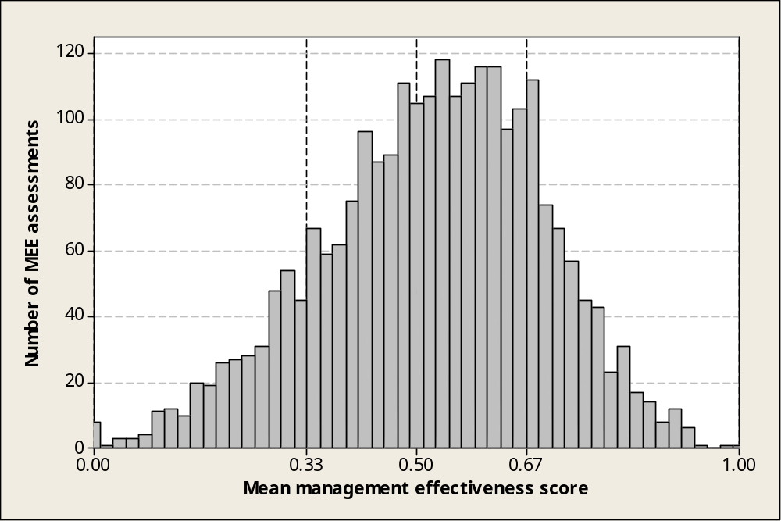
Figure x. Mean scores for 2,488 most recent assessments

Strongest and weakest aspects of management: The thousands of different indicators used to evaluate management effectiveness have been combined into 14 summary indicators. These indicators on the basis of the WCPA framework include: Context – 1 values and significance; 2 threats and constraints; Planning - 3 site design and establishment; 4 management planning; Inputs - 5 management resources; 6 information base; Processes – 7 internal management systems and processes; 8 law enforcement; 9 stakeholder relations; 10 visitor management; 11 natural and cultural resource management systems ; Outputs – 12 achievement of work program; Outcomes- 13 conservation outcomes; 14 community outcomes.

There were clear patterns in the strengths and weaknesses of management, and these patterns were consistent across most methodologies and regions. The highest scoring headline indicators overall were park gazettal, marking of boundaries, resolution of tenure issues, effectiveness of governance and leadership and the skill level of staff and other management partners. Weakest areas related to programs of community benefit, funding reliability and adequacy, , maintenance, communication, and community involvement. Many protected areas lack basic requirements to operate effectively, and do not have an effective management presence. Outcome indicators, relating to achievement of objectives, values, conservation and effect on the community, also scored relatively well, indicating that even where ‘inputs’ and many ‘processes’ are weak, protected areas were still performing a valuable function for conservation and in the community.

Threats: The most commonly nominated threats in most regions were hunting, killing and collecting animals; logging and wood harvesting; gathering non-timber forest products; recreational activities; and the management of adjacent lands. These show some consistency across regions, though differences are seen in countries like Australia, where invasive species and fire are more serious threats.

Conclusions and recommendations: The Global Study recommended the following:

Management agencies, partners and donors continue to cooperate to help protected areas achieve minimum basic standards. Protected areas in low-HDI countries are most in need of assistance to improve management effectiveness.

The provision and maintenance of adequate facilities, equipment and infrastructure needs to be improved, as these factors score poorly and are very strongly liked to effective management.

Protected area establishment and design – the first building blocks of the systems – are relatively effective in most places, with serious problems recorded in a few. However, it is essential that national governments provide better policy support for tenure resolution where this remains an issue, and for appropriate development planning and control around protected areas across all regions.

A greater effort should be put into communication, community involvement and programs of community benefit, as these factors show very strong links to effective management and outcomes.

A boost to the specific programme areas of resource management and research and monitoring is also required, especially to achieve conservation of protected area values.

Visitor management stands out as another area of management which needs to be improved for those areas where tourism is a significant function of protected areas, as it scores poorly in most regions and is strongly linked to effective management.

Managers need to build better pro-active management capacity, linking management planning, actions, research and monitoring, and evaluation. All these factors scored poorly and are correlated with effective management overall.

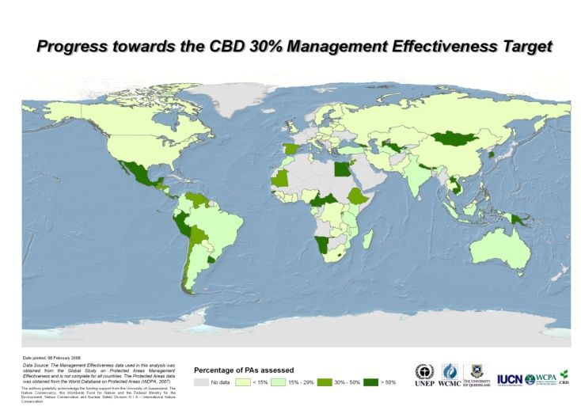

Figure x. The proportion of each country with known assessments of management effectiveness of its protected areas.

Goal 4.3: To assess and monitor protected area status and trends
Target: By 2010, national and regional systems are established to enable effective monitoring of protected-area coverage, status and trends at national, regional and global scales, and to assist in evaluating progress in meeting global biodiversity targets.

Fair to good progress to date, in monitoring coverage and trends at national, regional and global scales through the World Database on Protected Areas (WDPA), but monitoring status is lagging behind.
Key issues considered for assessing the progress: mechanisms for monitoring and reporting; inputs to WDPA

A few countries (15%) reported having mechanisms in place for monitoring the coverage, status and trends at national level. All reporting countries indicated that Environment Ministries are responsible for annually collating national protected area statistics and submitting information to WDPA, to other site based conventions and treaties such as Ramsar, World Heritage, Man and Biosphere Programme of UNESCO, CMS and CITES.. Some countries also indicated that monitoring programmes for rare and endangered species, trade in endangered species through TRAFFIC etc are put in place. At the level of the EU, a regional system of monitoring the coverage, status and trends of Natura 2000 network based on the data provided by the Member States when submitting the lists of potential sites and later in the periodic national reports.

Monitoring Mexican experiences

The Mexican protected Area agency CONANP has a Geographic Information System (GIS) available on the website of the Commission (www.conanp.gob.mx ), which aims to integrate and maintain geographic information on federal protected areas, including coverage with their metadata. Currently being strengthened regional GIS, which act as nodes, with the aim of having the mapping of all the national parks in the country. Additionally there is a project of Digital Aerial Photography for obtaining high-resolution images to work on environmental monitoring and management in 10% of the national parks.

Monitoring and Reporting – Canadian experience

Ontario Parks has developed a structured monitoring framework including criteria and indicators for monitoring the status and health of Ontario’s system of provincial parks and conservation reserves. Based on these criteria and indicators, Ontario Parks has assembled and analysed information on ecological, social and economic aspects of Ontario’s provincial parks and conservation reserves. The information is used to support the sustainable planning and management of Ontario’s protected areas, and to report to the public on the state of Ontario’s protected areas.
State of Ontario’s Protected Areas: Healthy by Nature is a series of four technical reports that are nearing completion. Collectively, these reports describe the state of Ontario’s system of provincial parks and conservation reserves during the period January 2001 to January 2006. The four technical reports will be used as the basis for preparing a plain-language State of Ontario’s Protected Areas summary report to be released in 2009.

The World Database on Protected Areas (WDPA)
WDPA is the most comprehensive global spatial dataset on marine and terrestrial protected areas available. Since 1981 UNEP-WCMC, through its Protected Areas Programme, has been compiling this information and making it available to the global community. The WDPA is a joint project of UNEP and IUCN, produced by UNEP-WCMC and the IUCN World Commission on Protected Areas working with Governments and collaborating NGOs.
The WDPA is a spatial database, it holds key attributes or fields of information such as name, designation, area, establishment date, IUCN protected area management category, establishment date etc as well as the delineated boundary or location (latitude and longitude) for the site. The data is held within a Geographical Information System (GIS) enabling users to display the data in desktop mapping programmes or view online in 3D globes like Google Earth or ESRI ArcGIS Explorer.
The WDPA is continually being updated, which includes increasing the number of sites in the WDPA with delineated boundary data.
http://www.wdpa.org/Default.aspx

Goal 4.4: To ensure that scientific knowledge contributes to the establishment and effectiveness of protected areas and protected area Systems
Target: Scientific knowledge relevant to protected areas is further developed as a contribution to their establishment, effectiveness, and management.
Fair to good progress to date.

Key issues considered for assessing the progress: Use of scientific knowledge and identification of research priorities for protected areas

Many reporting countries indicated extensive and appropriate use of scientific knowledge in establishment and management of protected areas including dissemination of information and knowledge to protected area mangers and field staff. The IUCN-WCPA, other major conservation organizations are constantly incorporating the scientific developments in conservation biology, ecosystem science and remote sensing applications in the best practice guidelines, tools and resources. Some countries have established specialized institutions for carrying out research in protected area related aspects. Some reporting countries indicated establishment of scientific advisory bodies and development of frameworks with scientific institutions. In some countries specialized courses at under graduate and graduate levels have been established in universities.
A Master of Science Programme at the University of Klagenfurt
"Gain access to an attractive and future-oriented occupational field with two-years postgraduate education!"
.
In co-operation with international institutions such as IUCN, WWF, CBD, RAMSAR, and prominent Protected Areas, the University of Klagenfurt and E.C.O. Institute of Ecology designed the MSc programme "Management of Protected Areas". A detailed schedule for this unique programme was developed under the perspective of creating a maximum of benefits.
http://mpa.e-c-o.at/index.php/plain/home

Wildlife Institute of India (WII)

Established in 1982, Wildlife Institute of India (WII) is an internationally acclaimed Institution, which offers training program, academic courses and advisory in wildlife research and management. The Institute is actively engaged in research across the breadth of the country on biodiversity related issues.

Mission.: is to nurture the development of wildlife science and promote its application in conservation, in consonants with our cultural and socio-economic milieu.

Vision: We strive for recognition as a ‘centre of excellence’ for Wildlife Conservation in National and International forum.

Aims and Objectives
- Build up scientific knowledge on wildlife resources.
- Train personnel at various levels for conservation and management of wildlife.
- Carry out research relevant to management including the development of techniques appropriate to Indian conditions.
- Provide information and advice on specific wildlife management problems.
- Collaborate with international organizations on wildlife research, management and training.
- Develop as a regional centre of international importance on wildlife and natural resource conservation
http://www.wii.gov.in/

III OBSTACLES ENCOUNTERED DURING THE IMPLEMENTATION OF THE PROGRAMME OF WORK ON PROTECTED AREAS,

The subregional workshops provided an important platform for the participating countries to identify real challenges and constraints in their respective situations and capacity-building needs in order to more efficiently implement the programme of work. Challenges and obstacles identified include:
(a) Lack of political commitment: lack of leadership, political will and commitment; lack of clear understanding of country commitments and obligations; low national priority for protected areas; lack of understanding about protected area benefits, goods and services and their contribution to sustainable development; unstable political situation; lack of regional cooperation;
(b) Institutional and policy obstacles: lack of vision, attitude and perceptions; lack of inter-sectoral coordination; conflicting legislations; contradictory government policies limiting opportunities; lack of multi-stakeholder coordination mechanisms; limited marketing strategies for protected area goods and services; low willingness of Governments to implement assessment results; bureaucratic hurdles; lack of transparency in decision-making process; communication gap between Convention focal points and protected area personnel; inadequate law enforcement; lack of legislative and policy measures to retain revenue generated by protected areas; lack of cooperation between non-governmental organizations and government institutions; resistance to create new taxes; lack of framework for transboundary protected area management;
(c) Insufficient human resources and capacity: inadequate staffing; lack of committed and enthusiastic personnel; lack of incentives for dedicated staff; non-continuity of trained personnel and change of staff; lack of qualified staff; limited capacity, lack of local capacity to generate revenue;
(d) Limited funding: highly limited financial resources; insufficient government allocations- low priority for protected areas; lack of compensatory mechanisms; high reliance on one source of funding;
(e) Lack of suitable data: weak linkages in data collection and analysis; lack of standardized data collection and management;
(f) Lack of suitable guidelines and tools: lack of simple, easily understandable methods and guidance; non-availability of guidelines and methods in local languages; lack of access to available information; inadequate methods for valuation of protected areas; lack of resource mobilization techniques; lack of GIS and mapping tools;
(g) Lack of awareness: limited public awareness; lack of awareness among protected area functionaries about CBD requirements;
(h) Limited or low involvement of indigenous and local communities and various stakeholders: inadequate involvement of indigenous and local communities; inadequate participation of scientific and academic community; local community resistance; limited public participation.

IV. POWPA FUTURE

Ways and Means to strengthen implementation: Strengthening implementation of protected areas (PAs) will require concerted effort and the combined strength of all sectors of society, as well as alliances at national, regional and international levels between policy makers, civil society, indigenous and local communities and business. Six key elements for successful implementation of PAs are required: human and societal capacity, financial capital, coordination among multiple agencies and sectors, cooperation among key stakeholders at multiple levels, national and regional-level commitment, and communication at all levels. In addition, there is a need for a strong enabling policy framework for protected areas.

Capacity: A structured and systematic professional and institutional capacity building effort is required. This effort should focus on the array of protected area themes, and be based on national and regional needs and a coherent national or regional plan of action. This includes 1) enabling a regional technical support network of professionals such as the IUCN-WCPA membership, 2) leadership by national and international non-governmental organizations (NGOs) in developing and strengthening capacity-building efforts; 3) the full engagement of indigenous and local communities in these efforts; 4) the collaboration of university and training programs to incorporate key issues into their curricula for protected area practitioners; and 5) the establishment and maintenance of learning resources and libraries, organized by protected area theme and readily accessible through electronic media; and 6) the establishment of a global network of capacity-building experts and initiatives to coordinate efforts. Such a network can be instrumental in providing technical support, making tools and guidance available, and sharing information and knowledge and organizing technical clinics to address specific protected area issues.

Capital: Bilateral and multilateral donor support represents a major proportion of financial resources available for PAs in developing countries. However, these resources are insufficient at their current and projected future levels to enable the effective establishment and management of protected areas. Governments, donors, international NGOs and the private sector should seek opportunities to create synergies and partnerships for protected area finance, and approach the lack of funding through concerted efforts. In particular, they should seek to develop a diversified portfolio of traditional and innovative approaches to meet funding gaps and to develop and compelling and economically-viable business plans. Such plans will require a full assessment of the costs and benefits of protected areas (see Flores et al., 2009).

Co-ordination: In order to mainstream protected areas into broader sectors, there must be coordination among key institutions, agencies and sectors, yet such coordination is typically absent at regional, national and local levels. To achieve such co-ordination, policy makers should ensure that: 1) natural resource agencies (e.g., forestry, wildlife, fisheries) work toward common goals and objectives, rather than at cross purposes; 2) key economic sectors that rely on the benefits of protected areas (e.g., tourism, fisheries) are involved in planning processes; 3) there is coordination with key funding agencies, such as the Global Environment Facility and bilateral aid agencies; 4) there is coordination among national focal points of international conventions, such as the United Nations Framework Convention on Climate Change, Ramsar, the CBD Programme of Work on Protected Areas, the World Heritage Convention and the UN Convention to Combat Desertifcation, among others. Finally, such coordination is greatly enhanced by a multi-stakeholder coordination committee, and by a single, designated focal point that is responsible for leading this committee.

Co-operation: Co-operation among the stakeholders who support protected areas is also critical in order to avoid duplication cooperation and deliver the most efficient and cost-effective support. This is particularly true among donor agencies, which often provide funding for the same activities within the same country at the same time, and among NGOs, who often provide overlapping services. Ideally, donors and NGOs will co-operate at international and regional levels, to ensure that their financial and technical support at national and local levels is well co-ordinated.

Commitment: Strong local, national and regional leadership is critical for effective protected area implementation. At a local level, committed and motivated protected area managers can become catalysts in encouraging innovation and kindling the dynamic spirit needed for success. At a national level, individual countries can demonstrate their strong leadership by openly declaring and committing to ambitious protection goals (e.g., Madagascar, The Bahamas, Costa Rica and Palau). Examples of regional-level commitments, in which neighbouring countries develop regional ‘challenges’ to achieve ambitious protection goals (e.g., the Micronesian Challenge, the Caribbean Challenge; the Pan Amazon Challenge; the Dinaric Arc ”Big Win” initiative, and the Coral Triangle Initiative). Such regional commitments demonstrate the potential of countries collaborating in order to catalyse national and regional action and to leverage national and international funding. Commitment to empower communities, facilitating secure land tenure and resource rights, recognition of community conservation initiatives and promoting implementation of diversified governance types is also very important.

Communication: There is a critical need for policy makers to communicate with all key stakeholders. Effective communication for protected areas includes: 1) establishing mechanisms for public involvement in protected area planning; 2) ensuring broad public access to the outcomes of planning exercises, such as ecological gap assessments; 3) reporting on the status of implementation. In addition, Governments can generate a stronger call to action for policy makers and other stakeholders a case for protected areas by clearly communicating their importance in addressing climate change issues, their contribution to the achievement of Millennium Development Goals and their broader ecological, economic, social and cultural benefits. Communication also incorporates collecting and managing information; monitoring and reporting the results of implementation.

Figure : The Six Key Elements
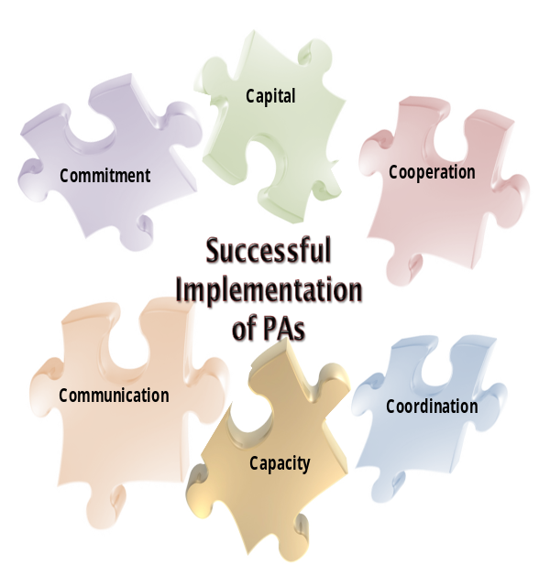

There is clear international policy incorporating these key elements ( CoP decision IX/18) ; and that policy should be translated into concrete actions on ground in a coherent and mutually supporting manner.They should be implemented at national and regional levels based on a long-term strategic plan with committed and motivated regional champions. Then only we can achieve ecologically representative, effectively managed, sustainably funded national and regional protected areas for safeguarding the life on our planet

Future funding challenges and opportunities: The estimated total annual cost for effective management of existing protected areas in developing countries ranged from US $ 1.1 to 2.5 billion per year and the funding shortfall ( total cost minus current funding) to vary between US $ 1.0 and 1.7 billion .

- If we take into account, the available resources - bilateral, multilateral, not for profit funding, market based sources foundations and national budgets, the world is currently investing around 30% to 40% of the requirement leaving a gap of 60% to 70%, warranting enhanced funding to meet the 60% to 70% gap for effective implementation of PoWPA.
- There is a huge opportunity to work to develop, test business–oriented financial strategies and expand the protected-area financing mechanisms that have started to be piloted over recent years. Such mechanisms, framed within strategic system-wide financial plans may provide significant potential to ensure that protected-area funding is increased in the future, and is targeted more at the diverse needs and conditions that will improve protected area financial sustainability.
- In recent years, increased attention has been given to identify and implement new and innovative national and international financial mechanisms to diversify and increase revenue and reduce funding gap for protected areas. These mechanisms inter alia include taxation systems, joint implementation, payments for ecosystem services and biodiversity offsets.
- There is a need to build the necessary awareness, infrastructure and disseminate information on lessons learned, experiences, opportunities and constraints of these new sources. Investments in building capacity and organization of training workshops to implement conservation finance initiatives should therefore be a high priority for donors, Governments, and international conservation organizations
- The COP in decision IX/18 B paragraph 3 invited Parties to uundertake completion of, as a matter of priority, country–level financial needs assessments, and develop sustainable financing plans including a diversified financial portfolio, incorporating innovative mechanisms , payments for ecosystem services and exploring the potential of biodiversity offsets as a financing mechanism.
- As the institutional structure operating the financial mechanism of the Convention, GEF has a central role to play in providing international funding support for the programme of work. Since the GEF funding is directed towards developing financial sustainability, ( 90 projects dealing with conservation trust funds, PES, revolving funds, and other innovative financial mechanisms to facilitate reliable and steady funding), follow up projects need to be planned properly and implemented effectively to achieve financial sustainability.
- As per an information document for GEF Council’s 35th meeting, as on 13 May 2009, countries have only used about 60% of the allocation available under biodiversity portfolio of GEF 4 Resource Allocation Framework. So the problem is not only adequate funding, but timely and appropriate use of available funding, continuity of funding proposals based upon problem analysis.
- Climate finance, including protected areas as a key component of markets for emission permits, offsets and adaptation funds, and using ecological gap analysis to help identify priority investments. This should stress “other” sequestration, such as marine, peat, freshwater, grasslands and soil.
- Expanded public funding will be fundamental to financial sustainability. Building strong institutional arrangements for financing the implementation of the programme of work is essential. Institutions, including Governments, donors, international non-governmental organizations, and the private sector, need to create synergies and partnerships and approach the issue through a concerted effort.

Climate Change: Protected areas can serve as important elements of climate change adaptation as unbroken blocks of intact habitat which can increase the resilience of ecosystems to climate change since ecosystems with high biodiversity and intact structural components recover more easily from climatic disturbances. Shifting upward or pole-ward is predicted to be one of the most common responses of species to the impacts of climate change. Protected areas and their surrounding landscapes, particularly ecological corridors, will have an important role to play in providing habitat to facilitate such shifts so as to maximize the natural adaptive capacity of biodiversity. Better managed, better connected, better governed and well financed protected areas are recognized as key to both mitigation and adaptation responses to climate change.

Marine Protected Areas: Although the terrestrial protected areas coverage exceeds 12% of the world’s terrestrial surface, marine protected areas (MPAs) cover only 5.9% of the world’s territorial waters, growing in a mean annual growth rate 4.6% per annum. Taking this into account the 2012 marine target of WSSD and the PoWPA is well nigh possible to meet.

Benefits and values of protected areas: Protected areas, besides being cornerstones of biodiversity conservation, constitute an important stock of natural, cultural and social capital, yielding flows of economically valuable goods and services that benefit human populations. The positive contribution of protected areas to the livelihoods of the poorest and most vulnerable sectors of society is very high indeed. Protected areas also provide key support to the maintenance of cultural traditions and the building of social capital. Unfortunately, their value is poorly understood and greatly undervalued by markets, politicians and the general public. Their value does not register in conventional markets and they are therefore not considered to be real economic assets by policy-makers. As a result, protected areas do not receive crucial national budget prioritization. There is a need to improve understanding of the significance and importance of benefits and values, particularly of the ecosystem services that protected areas provide; showcase best practices in assessing and promoting PA values and integration into national economies and in creating innovative finance mechanisms.

Emphasis on effective management (Target 4.2): while progress has been made on assessment and capacity building, there has been less success in applying results to adaptive management. Efforts are needed to encourage national adoption and to develop expertise in assessing biodiversity outcomes..

Reporting: existing reporting frameworks do not look at accountability or progress against specific targets. This could be addressed by developing a reporting framework for adoption at COP-10.

The need for restoration (Activities 1.2.5 etc): restoration is becoming increasingly important inside and outside protected areas due to both development and climate change. Restoration needs to address the challenge of maintaining connectivity in the wider landscape.

Promoting the full suite of protected area governance types (Activity 2.1.2 etc): most states still look solely at state-run protected areas and a wider vision has yet to manifest especially for indigenous and community conserved areas and private reserves; although there are encouraging developments.

A new initiative with indigenous peoples (Programme element 2): the rights of indigenous peoples were well covered in POWPA but delivery has been variable. There should be common cause between conservation and indigenous peoples, yet this is often lacking. Emphasis on building partnerships both generally around protected area values and specifically with respect to potential climate finance.

Target and timetable issues: it is proposed that member states set their own targets, within a national consortium, under a framework of regional and global targets (i.e. a new 2020 deadline)
-----

UNEP-WCMC(2008). State of the world’s protected areas: an annual review of global conservation progress. UNEP-WCMC, Cambridge.
Lauren Coad et al (2008) Progress towards the convention on Biological Diversity terrestrial 2010 and marine 2012 targets for protected area coverage. Parks 17(2)35-42. IUCN, Gland, Switzerland.
Some examples are the Sudd-Sahelian swamps, Zambezian flooded grasslands (including the Okavango Delta), Lake Chad flooded savanna and Nile Delta flooded savanna (all in Africa). The Everglades in the USA , the Orinoco and Pantanal wetlands in South America, and the marshes of Southern Iraq are examples outside Africa.
UNEP-WCMC(2008)
Dan Laffoley et al 2008. Progress with Marine Protected Areas since Durban, and future directions. Parks 17(2) 13-22. IUCN, Gland, Switzerland
http://www.tbpa.net/tpa_inventory.html
Global list of Transboundary Protected Areas UNEP-WCMC 2007.
Zbicz, Dorothy C. 2003. Imposing Transboundary Conservation: Cooperation Between Internationally Adjoining Protected Areas. In Transboundary protected areas: The viability of regional conservation strategies, ed. Urami Manage Goodale, Marc J. Stern, Cheryl Margoluis, * Ashley G. Lanfer and Matthew Fladeland: 21-37. New York: Food Products Press (published simultaneously in the Journal of Sustainable Forestry, 17: 1/2).
Chester, Charles (Lead Author); James Dontje and William C.G. Burns (Topic Editors). 2008. "Transboundary protected areas." In: Encyclopedia of Earth. Eds. Cutler J. Cleveland (Washington, D.C.: Environmental Information Coalition, National Council for Science and the Environment). [First published in the Encyclopedia of Earth November 17, 2006; Last revised September 24, 2008; Retrieved August 26, 2009]. <http://www.eoearth.org/article/Transboundary_protected_areas>
http://www.iucn.org/about/union/commissions/ceesp/topics/governance/icca/ceesp_icca_legislation/
Dudley, N (editor) (2008) Guidelines for applying protected area management categories. IUCN, Gland, Switzerland.
Grazia Borrini-Feyerabend (2007)
Kothari. A. Protected areas and people: the future of the past. Parks 17(2)23-34.IUCN, Gland, Switzerland.
Implementation of the CBD in Brazil: Issues on the agenda of COP 9. Ministry of Environment , Brazilin Government
www.protectedareas.org
Economic Values of protected areas . Guidelines for protected area Managers, -IUCN-WCPA www.iucn.org/themeswcpa/pubs/pdfs/Econbomic_values.pdf.
UNEP/CBD/WG-PA/2/4
UNEP/CBD/WG-PA/2/INF/7
www.testprotectedareas.org
UNEP/CBD/WG-PA/2/INF/8
OECD. 2007. Statistic on Biodiversity-Related AID. OECD Paris. Online at www.oecd.org/dac/stats/crs
http://ec.europa.eu/environment/nature/nature_conservation/natura_2000_network/manging_natura_2000/exchange_of_good_practice/index.htmal;
http://www.gbrmpa.gov.au/corp_site/management/zoning/planners_info.html http://www.parks.tas.gov.au/publications/tech/management_code/summary.html
The documents can be downloaded from http://www.iucn.org/about/union/commissions/wcpa/wcpa_puball/wcpa_bpg/index.cfm?
Fiona Leverington, Marc Hockings and Katia Lemos Costa(2008). Management Effectiveness Evaluation in Protected areas: Report for the project ‘Global study into management effectiveness evaluation of protected areas’ The University of Queensland, Gatton, IUCN WCPA, TNC, WWF, Australia.
http://ec.europa.eu/environment/nature/nature_conservation/useful_info/barometer/barometer.htm
Bruner,A.,Gullison,R.E., Balmford,A.2004. Financial costs and shortfalls of managing and expanding protected area systems in developing countries. Bioscience 54:1119-1126;
http://www.thegef.org/uploadedFiles/Documents/Council_Documents__(PDF_DOC)/GEF_35/C.35.Inf.2(5).pdf

