 |  | CBD
 |  |  |  | Distr.  GENERAL  UNEP/CBD/LG-GSPC/4/2  1 August 2011  ORIGINAL: ENGLISH
LIAISON GROUP ON THE GLOBAL STRATEGY FOR PLANT CONSERVATION
Fourth meeting*
St. Louis, Missouri, United States of America, 8-9 July 2011

report of the fourth meeting of the LIAISON GROUP ON THE GLOBAL STRATEGY FOR PLANT CONSERVATION
I. BACKGROUND
- In decision X/17 the Conference of the Parties adopted the updated Global Strategy for Plant Conservation (GSPC) 2011-2020 and invited Parties and other Governments to develop or update national and, regional targets as appropriate, and, where appropriate, to incorporate them into relevant plans, programmes and initiatives, including national biodiversity strategies and action plans, and to align the further implementation of the Strategy with national and/or regional efforts to implement the Strategic Plan for Biodiversity 2011-2020. In the same decision the Conference of the Parties inter alia:
- stressed the urgent need to mobilize the necessary financial, technical and human resources and strengthen capacity and partnerships in order to achieve the targets of the Strategy
- decided to undertake a mid-term review of the implementation of the consolidated update of the Strategy and its targets in 2015;
- called for the further development of the technical rationales, milestones and indicators for the updated Strategy, consistent with the Strategic Plan for Biodiversity 2011-2020;
- requested the development, by 2012, of an online version of the toolkit for the Global Strategy for Plant Conservation in all United Nations official languages;
- requested the organization of regional capacity-building and training workshops on national, subregional and regional implementation of the Strategy; and
- called for raising awareness about the contribution of the activities carried out as part of the implementation of the Strategy beyond 2010 in achieving the Millennium Development Goals, and contributing to human well-being and sustainable development.
- Furthermore, decision X/17 acknowledged the role of the Global Partnership for Plant Conservation (GPPC) and other partners and relevant organizations as well as the flexible coordination mechanism for the Global Strategy for Plant Conservation.
- The flexible coordination mechanism has been established through decision VII/10 and serves to facilitate and promote implementation, and monitoring, of the Strategy at all levels (national, regional and global), and comprises:
- meetings of liaison groups;
- national GSPC focal points;
- the Global Partnership for Plant Conservation (currently http://www.plants2010.org/ and to be moved to http://www.plants2020.net); and
- the CBD Secretariat.
- To advance the agenda, the Chair of the Global Partnership for Plant Conservation, in association with the Secretariat of the Convention on Biological Diversity and Botanic Gardens Conservation International, organized and hosted the second International Conference of the Global Partnership for Plant Conservation (Missouri Botanical Garden, St. Louis, USA, 5-7 July 2011). The Conference was attended by 94 experts from 23 countries. In addition to presentations on the implementation of the Global Strategy for Plant Conservation, participants considered the following subjects in a series of eight workshops:
- The ‘World Flora’: possibilities and perspectives – a stakeholder consultation;
- The GSPC toolkit – a discussion workshop;
- Red listing & achieving Target 2;
- Ecological restoration and the GSPC;
- Technical rationales, milestones for the GSPC targets – linking with the Strategic Plan for Biodiversity;
- Linking the GSPC targets at an institutional level – a discussion workshop;
- The GSPC, ABS and the Nagoya Protocol; and
- Raising public awareness of plant conservation and the GSPC.
- The conclusions from the workshops were available as an input to the discussions of the Liaison Group. Short summaries are contained in Annex 1 to this report.
- A business meeting of the Global Partnership for Plant Conservation, held on 7 July 2011, inter alia made the following decisions:
- The Chair of the Global Partnership for Plant Conservation, Peter Wyse Jackson, was re-elected;
- Botanic Gardens Conservation International was confirmed as the Secretariat for the Partnership;
- The Partnership would establish a number of working groups, possibly one for each of the five objectives, to promote and facilitate the implementation of the Strategy.
- The full report of the business meeting of the Global Partnership for Plant Conservation is available from the web pages of the Partnership (www.plants2020.net) and of the Conference (www.mobot.org/gppc2011).
II. OPENING THE MEETING
- Robert Höft welcomed participants on behalf of the Executive Secretary and thanked Missouri Botanical Garden for the initiative to hold the International Conference of the Global Partnership for Plant Conservation just prior to the Liaison Group meeting as this had provided excellent inputs. He proposed that Peter Wyse Jackson (Chair of the Global Partnership for Plant Conservation and President of Missouri Botanical Garden) and Hesiquio Benítez Díaz (Mexico) jointly chair the meeting. The list of participants is contained in Annex 2 to this report.
- Peter Wyse Jackson welcomed participants on behalf of Missouri Botanical Garden. He noted that Liaison Group meetings enabled balancing the views of Parties and of members of the Global Partnership for Plant Conservation and recalled the previous meetings:
- the first expert meeting on the Global Strategy for Plant Conservation (County Kerry, Ireland, 5 - 7 October 2003) had established the need for a flexible coordination mechanism for the Global Strategy for Plant Conservation and led to the formation of the Global Partnership for Plant Conservation;
- the second Liaison Group meeting (Dublin, Ireland, 23 - 25 October 2006) provided guidance on the preparation for the in-depth review of the Global Strategy for Plant Conservation;
- the third Liaison Group meeting (Dublin, Ireland, 26 - 28 May 2009) had prepared the consolidated update of the Global Strategy for Plant Conservation beyond 2010; and
- the focus of this fourth meeting would be on implementation of the updated Strategy.
- He referred to the outcomes of the workshops organized over the previous days and reaffirmed his commitment, as well as that of Missouri Botanical Garden, to the Global Partnership for Plant Conservation, noting that the Global Strategy for Plant Conservation is central to the mission of the Garden.
- In welcoming participants, Hesiquio Benítez Díaz noted that the success of the Global Partnership for Plant Conservation lay in the initiative and engagement of its partners and their ability to support Parties in the implementation of the Global Strategy for Plant Conservation. He then introduced the items on the agenda.
III. ORGANIZATIONAL MATTERS
- The meeting agreed to work on the basis of the provisional agenda for the meeting (UNEP/CBD/LG-GSPC/4/1) while maintaining flexibility with regard to the order in which items would be discussed.
IV. REVIEW OF PROGRESS IN IMPLEMENTATION OF THE GLOBAL STRATEGY FOR PLANT CONSERVATION
- The meeting noted that an in-depth review of progress in implementation of the Global Strategy for Plant Conservation was carried out in 2008. At the request of the Conference of the Parties, the Global Partnership for Plant Conservation took a lead on this and progress was reviewed target by target. The results of the review were published as the Plant Conservation Report in 2009 in all the official UN languages. The next in-depth review of the GSPC will be carried in 2015.
- The Plant Conservation Report was considered to be a very useful communication tool, providing a review of progress to date. It had for example led to decisions of both the Conference of the Parties to the CBD and to CITES to work together on promoting the implementation of the GSPC, particularly with regard to target 11 ("No species of wild flora endangered by international trade"), and to jointly conduct technical work as appropriate. However, the Plant Conservation Report was felt to be less strong on highlighting priorities for the future. While it was agreed that greater clarity on prioritizing activities target by target would be helpful, it was recommended that this should be kept separate from reviewing progress.
- It was agreed that the Plant Conservation Report provides a good model for the next progress report and information for the report could be drawn from a range of sources, including:
- information provided by the Global Partnership for Plant Conservation, including through its working groups;
- the fifth national reports, which are due by 31 March 2014 (decision X/10); and
- regional assessments.
- In preparing the mid-term review, it was agreed that a critical assessment of how well priorities are being addressed should be carried out and gaps in implementation should be highlighted.
- The meeting discussed the critical role of GSPC focal points in providing the linkage between government institutions and plant conservation actors in the respective countries and regions. It was noted that, despite repeated invitations to do so, to date only 87 of 193 Parties had designated GSPC focal points. In some countries the institutions that are most active on plant conservation are not informed of communications between the CBD Secretariat and GSPC focal points and are therefore unable to assist their focal points on technical matters.
- Drawing on the experiences of GSPC focal points who had successfully mainstreamed the GSPC in national planning and decision making processes the meeting felt that it would be helpful to compile these and prepare terms of reference for GSPC focal points that could serve as guidance and facilitate their work.
- It was suggested that the Global Partnership for Plant Conservation could help to identify suitable institutions or individuals in those countries that have not yet designated a GSPC focal point and these could then offer the CBD focal points to support their work with regard to the implementation of the GSPC.
- The meeting noted that the update of Strategy should not have significant implications on the activities required to pursue the achievement of individual targets. A comparison showing the changes with commentary on the implications is contained in Annex 3 to this report.
Key recommendations to promote the effective implementation of the Global Strategy for Plant Conservation
- The experiences of GSPC focal points who have successfully mainstreamed the GSPC in national planning and decision making processes should be compiled and used to prepare terms of reference to provide guidance and facilitate the work of other GSCP focal points.
- The Global Partnership for Plant Conservation could attempt to identify suitable institutions or individuals in those countries that have not yet designated a GSPC focal point and these could then offer the CBD focal points to support their work with regard to the implementation of the GSPC.
V. OPTIONS FOR FACILITATING CAPACITY-BUILDING, TECHNOLOGY TRANSFER, AND FINANCIAL SUPPORT PROGRAMMES FOR THE EFFECTIVE IMPLEMENTATION OF THE STRATEGY
- The meeting noted that there is a need for capacities (institutional, technical and financial) for the development of national targets related to the GSPC and linked to the Strategic Plan for Biodiversity as well as a need for capacity building for the implementation of each target. A table showing the links between the 16 GSPC targets and the 20 Aichi targets is contained in Annex 4 to this report.
- The meeting focused on the identification of options for facilitating capacity-building, technology transfer and financial support for the implementation of the GSPC targets. The following observations were made in relation to the objectives and targets of the Strategy, noting that many elements are relevant to several targets:

Objective I: Plant diversity is well understood, documented and recognized
- Major institutions (botanical gardens, herbaria, museums and taxonomic research centres) with international programmes are committed to pursuing this objective and to building capacities on plant taxonomy, conservation assessments and promoting access to information about plants. Several of these institutions are members of the Consortium of Scientific Partners on Biodiversity and of the GPPC. They could be encouraged to establish collaborative programmes with relevant institutions that have more limited capacities including by involving them in activities in the respective regions. Their presence in workshops, including where appropriate workshops on the revision of NBSAPs should also be considered.
- Brazil has developed a taxonomic information system for national purposes covering targets 1, 2 and 3 of the GSPC, including a Virtual Institute of Biodiversity, and this technology could be of interest and made available to other countries.
Target 1: An online flora of all known plants.
- An assessment of taxonomic needs has been conducted as part of the Global Taxonomy Initiative (see http://www.cbd.int/gti/needs.shtml) and a number of regional initiatives (for example those supported by the ASEAN Centre for Biodiversity - see example) could serve as examples of best practices. A document on a Draft Comprehensive Capacity-Building Strategy for the Global Taxonomy Initiative, currently open for peer review, will be considered by SBSTTA-15 and document UNEP/CBD/SBSTTA/15/5.
- Taxonomic capacity needs are best defined through a specific flora project. This includes the support of efforts to fill gaps in the world flora.
- While the primary focus of capacity-building activities is on higher plants there are also noteworthy activities on other groups of plants (mosses, lichens, algae) and on fungi.
- The promotion of access to all literature and type specimens should be promoted as part of technology transfer and it was noted that significant initiatives are underway with regard to the facilitation of access to journals (e.g. JSTOR subscriptions for scientists in developing countries through the Andrew W. Mellon Foundation) digitizing literature (e.g. the Biodiversity Heritage Library, a project sponsored by ten natural history museum libraries, botanical libraries, and research institutions) and digitizing specimens information (e.g. the Global Plants Initiative at the Royal Botanic Gardens, Kew, and Tropicos initiated by Missouri Botanical Garden).
- The Plant List, a working list of all known plant species, jointly developed by Royal Botanic Gardens, Kew and Missouri Botanical Garden, is an example of technology transfer. A lot of attention has been given to enable users to make use of this resource efficiently (How to use this site).
Target 2: An assessment of the conservation status of all known plant species, as far as possible, to guide conservation action.
- CITES requires an assessment for each amendment proposal to its Appendices as well as for the Periodic Review of plants species included in the Appendices and Review of Significant Trade in specimens of Appendix-II species. This could provide information relevant to GSPC as well as opportunities to jointly access funding, including from the GEF (also relevant to target 11);
- Kew has developed a rapid assessment of the conservation status of plants based on herbariums specimens and their locations, which can help prioritize species for full IUCN Red List assessment. Methods and tools, such as Vizzuality should be included in the GSPC toolkit;
- South Africa has developed a simple database for Red Listing which is linked to IUCN Species Information Service while being more user friendly. The database structure could be made available through the GSPC toolkit.
- IUCN offers training and support on Red Listing in multiple languages and is considering how to best leverage the existing capacity within national lead institutions for Red Listing. IUCN could draw on its network to provide training, where appropriate linked to NBSAP workshops.
- The GEF could be invited to give orientation on how to prepare projects that include components of taxonomy.
Target 3: Information, research and associated outputs, and methods necessary to implement the Strategy developed and shared.
- The Australian Taxonomy Research & Information Network (TRIN) addresses critical gaps in taxonomic knowledge of key Australian animal and plant groups and builds capacity, in part through a WIKI approach.
- The UK Darwin Initiative facilitates access to examples of technology transfer through its project database including examples of projects responding directly to the Global Strategy for Plant Conservation.
- The Kew Science Directory provides information about research projects and scientists involved.
- Language provides a barrier to information sharing. The programme Sud Expert Plantes offers support to francophone countries on inventorying, conserving and adding value to plant resources, including through two-year courses offered by a consortium of universities on biodiversity and tropical vegetation and tropical plant biodiversity. The Muséum national d'Histoire naturelle (Paris) also offers e-learning courses on biodiversity as well as course materials at various levels.
- Significant opportunities exist with regard to citizen science and the experience made with various approaches should be shared to maximize the potential. Examples include the New Zealand Plant Conservation Network and the Australian Network for Plant Conservation which provide a forum for people who are active in plant conservation.
- With regard to ecosystem restoration, the Society for Ecological Restoration shared information and examples of restoration.
- There are multiple opportunities for training in plant conservation (e.g. Kew diploma courses, graduate courses etc.) and the GSPC toolkit should maintain a list of training opportunities as it relates to the individual GSPC targets.
- Bioversity International is active in capacity building for the conservation of plant genetic resources as well as promoting research and offers various training opportunities (also relevant to target 9).
- The Second Report on the State of the World’s Plant Genetic Resources for Food and Agriculture includes sections on capacity needs in each of its eight chapters.
- Within the framework of the fledgling Biodiversity Technology Initiative under the CBD a gap analysis is currently being undertaken and the Convention already operates an online database on technology transfer and scientific cooperation which can be searched for entries related to plant conservation.

Objective II: Plant diversity is urgently and effectively conserved
Target 4: At least 15 per cent of each ecological region or vegetation type secured through effective management and/or restoration.
- The CBD programme of work on protected areas offers a series of e-learning modules on key subjects addressed through the programme of work. These are relevant to several GSPC targets and links should be provided in the GSPC toolkit. The GPPC, through its working groups, should examine if the curricula fully address plant conservation concerns. In particular it is important to examine if management effectiveness addresses the effectiveness of protected area management for plant conservation and if the protected area networks, biological corridors and other conservation initiatives cover key areas of importance for plant conservation (drawing on the concept of Important Plant Areas and similar sets of criteria relevant to the specific country context) (also relevant to targets 5 and 6). Also initiatives like Mexico´s Conservation GAP Analyses can provide informed guidance for strengthening national conservation schemes.
- The workshop on restoration (see Annex 1) made a number of recommendations concerning the effectiveness of communicating messages on ecological restoration, including the preparation of summaries for different target audiences.
- Technology transfer is of particular relevance and a range of technologies exist that could be made available in support of effective management and restoration efforts. Examples are systems, developed in Brazil and Mexico, to monitor fire and deforestation using satellite imagery and interactive GIS platforms which alerts the authorities of significant events and enables them to rapidly verify the situation and react to it as appropriate.
Target 5: At least 75 per cent of the most important areas for plant diversity of each ecological region protected with effective management in place for conserving plants and their genetic diversity.
- The management of sites that are important areas for plant diversity, both inside and outside protected areas, is in many cases done with limited botanical expertise. It is important to enable agencies responsible for the management of such areas to draw on and build the relevant expertise. This could include the increased awareness about courses in wildlife management (see also under target 3).
- Universal standards to define and designate areas important for plant conservation may not be useful as circumstances differ between countries (for example Ireland and Canada have few if any areas that fulfil the criteria for Important Plant Areas, while almost the entire area of South Africa qualifies). A set of agreed principles under which countries can develop their own standards may be a good way to proceed and capacity building is required to develop such national standards.
Target 6: At least 75 per cent of production lands in each sector managed sustainably, consistent with the conservation of plant diversity.
- The regional initiatives on criteria and indicators for sustainable forest management and certification schemes provide agreed frameworks for forest management in which plant conservation is a consideration. The most consistent reporting in this regard is through the FAO Global Forest Resources Assessment which increasingly takes biodiversity considerations into account.
- It was noted that the reporting burden from different conservation or sustainable management initiatives provides a barrier to their acceptance and that there is a need for increasingly harmonized indicators.
- The range of approaches on managing land outside strict protected areas should be included in the GSPC toolkit. These include biological corridors and community conserved areas (e.g. Indigenous protected areas managed by indigenous rangers in Australia; stewardship programmes enabling landowners to manage land consistent with plant conservation; NGO participation in supporting protected area management and other approaches to foster participation etc.) (also relates to target 7).
- The toolkit should also provide links to initiatives such as the Roundtable on Sustainable Palm Oil, the Roundtable on Sustainable Biofuels, the Satoyama Initiative, the South African Biodiversity and Wine Initiative, the Mesoamerican Biological Corridor, as well as best practices information from the oil and energy as well as the mining and minerals industries (these are also relevant to target 14).
Target 7: At least 75 per cent of known threatened plant species conserved in situ.
- The observations related to targets 2 and 4 also apply to this target. There is a major need for capacity building and for the preparation of identification guides and materials. An example are the French Conservatoires botaniques nationaux which contribute significantly to in situ conservation by relying on networks of botanists and by contributing to capacity building on plant conservation.
- Other tools and approaches in which capacity needs to be further developed include the application of remote microscopy for plant identification, molecular genetics for preserving genetic variation, or the capacity to assess impacts of climate change on plant biodiversity.
Target 8: At least 75 per cent of threatened plant species in ex situ collections, preferably in the country of origin, and at least 20 per cent available for recovery and restoration programmes.
- The Botanic Gardens Ecological Restoration Initiative established through the New York Declaration was agreed by eleven organizations at a meeting in New York, USA. The initiative aims to support the restoration of 100 sites using inter alia material held by the participating botanical gardens (also relevant to target 4). It includes a significant capacity-building component.
- The Global Crop Diversity Trust is a public-private partnership operating in line with the International Treaty on Plant Genetic Resources and the Global Plan of Action for the Conservation and Sustainable Utilization of Plant Genetic Resources for Food and Agriculture by advancing a global system of ex situ conservation by promoting the rescue, use and long-term conservation of valuable plant genetic resources.
- The European Native Seed Conservation Network (ENSCONET) project on seed banking focuses on enhancing the co-ordination of the activities of 24 independent institutes working locally on seed collections, their long-term storage and associated germination and location data. It initially focused on wild plants and is now open to crop relatives and contributes to and complements the FAO ex situ conservation strategies.
Target 9: 70 per cent of the genetic diversity of crops including their wild relatives and other socio-economically valuable plant species conserved, while respecting, preserving and maintaining associated indigenous and local knowledge.
- Bioversity International has prepared a manual on the in situ conservation of crop wild relatives which is accompanied by a set of E-learning modules.
- A series of educational modules is being developed by the International Treaty on Plant Genetic Resources for Food and Agriculture with the aim to build the capacity of their contracting parties and stakeholder group in translating its provision in to effective measures at national level. The objectives of the Treaty is the achievement of food security through the the conservation and sustainable use of crop genetic resources and the fair and the eauitable sharing of benefits arising from the use of these resources. The legally binding Treaty has entered in force since 2004 and has been ratified by 127 countries as at 1st June 2011. The first module “Introduction of the International Treaty on Plant Genetic Resources for Food and Agriculture” was published on the occasion of the fourth session of the Governing Body of the Treaty in March 2011.
- The Millennium Seed Bank Partnership is an international conservation project coordinated by the Royal Botanic Gardens, Kew. It has a significant component on international partnerships, capacity building and technology transfer, including the production of manuals and best practice guidance applicable for smaller seed banks. Phase2 of the Millennium Seed Bank Partnership (2011-2020) is placing greater focus on facilitating use of seeds for achievement of Target 8, in addition to continuing storage, technology transfer and capacity building.
Target 10: Effective management plans in place to prevent new biological invasions and to manage important areas for plant diversity that are invaded.
- There is a general need to build capacities for the development and enhancement of early warning, early detection and biosecurity/biosafety systems for invasive alien species, including in collaboration with the International Plant Protection Convention and regional and national phytosanitary services. There is also a need to recognize that it is economically sound to invest in prevention and early detection and removal where possible instead of having to deal with control and eradication of invasives.
- There is a need to increase awareness and capacities in institutions, organizations and sectors involved in trade with ornamental plants (including associated plant pests) with regard to the impacts of these species if they are released into the wild. The UK Department for Environment, Food and Rural Affairs has produced a ‘Horticulture Code of Practice’ for helping to prevent the spread of invasive non-native species through the horticulture trade. This was the product of a multi-sector consultative process.
- The Global Invasive Species Programme (GISP) has played a significant role in capacity building on the impacts of invasive alien species and tools to prevent and control introductions. Its closure, including the removal of training modules from the internet are a significant drawback to the achievement of target 10.
- Bilateral exchanges between countries with different capacities to control invasive alien species can enable countries with limited capacities to avoid mistakes and focus on priority issues.
- The ability to correctly identify alien species that could become invasive is a constant challenge (see also target 3).
- A number of resource could be added to the GSPC toolkit including an inventory of experts on invasive alien species (individuals and institutions), guidance on DNA fingerprinting, reference to botanic gardens with expertise in IAS management (accessible through GardenSearch); information and tools compiled by the GB non-native species secretariat; approaches to gathering information on plants that have been introduced to other environments (e.g. New Zealand's Expat Plants project), actions to control and to eradicate IAS and relevant information such as National Invasive Species Strategies (e.g. Mexico’s IAS Strategy), etc.

Objective III: Plant diversity is used in a sustainable and equitable manner
Target 11: No species of wild flora endangered by international trade.
- COP decision VI/9, recognized the relevance of many ongoing initiatives that are already under way or envisaged and which contribute to the achievement of the GSPC. It makes specific reference to the Strategic Plan and work of the Plants Committee of the Convention on International Trade in Endangered Species of Wild Fauna and Flora (CITES). Decision X/20 recalls CITES resolution Conf. 10.4 (Rev. CoP14) on cooperation and synergy with the Convention on Biological Diversity and calls for the development of working arrangements that promote the coherent and mutually supportive implementation of the two conventions and their respective strategies. In CITES decision 15.19 on the Global Strategy for Plant Conservation the CITES COP instructed the Plants Committee to collaborate with the Global Strategy for Plant Conservation (GSPC) of the Convention on Biological Diversity (CBD), and with any processes established to develop the Strategy beyond 2010, provided it is related to CITES, as well as on other issues related to flora species included in the CITES Appendices, and the Secretariat shall communicate the contributions of CITES in the context of its Memorandum of Understanding with the CBD Secretariat. Capacity building activities relating to this mandate have been referred to under target 2 and also relate to target 12. Lastly, in April 2011 the CITES Plants Committee at its 19th meeting established and inter-sessional Working Group to prepare a draft resolution for collaboration between CITES and CBD on implementation of the updated GSPC.
Target 12: All wild harvested plant-based products sourced sustainably.
- There is a continuing need to enable agencies to identify plant species in order to enforce the provisions of CITES. The CITES Secretariat and non-governmental organizations such as TRAFFIC offer relevant training material which is available in various languages.
- There are initiatives in CITES to increase the capacities of range State in the formulation of non-detriment-findings (NDFs).
- TRAFFIC has produced a prototype of a State of the World's Wildlife Trade reportand is seeking funding for the publication of a report in 2012. It will include information on the status of timber species and medicinal plants.
- There are many voluntary tools (e.g. sustainable and fair trade systems and labels on various plant products) and major awareness raising is required to make these better known. This includes the FairWild Standard, a set of guidelines for socially and environmentally sustainable use of wild plant resources that allows verifying sustainable and ethical sourcing of plants from the wild. Such tools should be included in the GSPC implementation toolkit and recommended for use by Parties, other government and private sector. It further includes the Guidelines for legal and responsible sourcing of timber as established by the WWF Global Forest and Trade Network (GFTN).
Target 13: Indigenous and local knowledge innovations and practices associated with plant resources maintained or increased, as appropriate, to support customary use, sustainable livelihoods, local food security and health care.
- The interest in capacity building in relation to target 13 depends on the willingness of communities to develop registers and share knowledge beyond the community. This must also seen in the light of discussions on customary use at the forthcoming seventh meeting of the Ad Hoc Open-ended Working Group on Article 8(j) and Related Provisions as well as discussions on ABS regulations.
- In Australia, work on research protocols has helped to clarify the mutual expectations and obligations. It would be useful to invite Parties to provide information and case studies on their experiences, including on the role of private sector engagement in this field.

Objective IV: Education and awareness about plant diversity, its role in sustainable livelihoods and importance to all life on earth is promoted
Target 14: The importance of plant diversity and the need for its conservation incorporated into communication, education and public awareness programmes.
- There is a need to engage with the programme on Communication, Education and Public Awareness (CEPA) and its informal advisory committee. Detailed recommendations are contained in the report of the workshop contained in Annex 1 to this report.

Objective V: The capacities and public engagement necessary to implement the Strategy have been developed
- Progress in targets 15 and 16, alongside target 3, is considered to be a key for the successful implementation of the Strategy. Progress, both in strengthening institutions and training individuals, is most frequently achieved through projects/programmes that include a sustainability component (e.g. the work in Madagascar supported by Missouri Botanical Garden or the work of FRIM in Malaysia).
- Both targets depend on sustainable financing and the Strategy for resource mobilization in support of the achievement of the three objectives of the Convention, contained in section B of decision IX/11 and the guidance on sustainable financing for protected areas, contained in the e-learning curriculum module 11, provide useful guidance. Political will is critical in ensuring the sustainability of institutions and trained personnel for the implementation of the Strategy. This also applies to the ability to draw on, and make effective use of, resources available through the Global Environment Facility.
Target 15: The number of trained people working with appropriate facilities sufficient according to national needs, to achieve the targets of this Strategy.
- Training people is a long-term investment and there is need to fully recognize that these investments are lost unless positions are offered and maintained in which trained people can be productive. Political change, going along with new regulations, often requires significant capacity building and it is important to plan this. Moreover, people trained in botany, conservation or environmental sciences usually need to learn how to engage with the productive sectors as well as with policy and planning requirements.
Target 16: Institutions, networks and partnerships for plant conservation established or strengthened at national, regional and international levels to achieve the targets of this Strategy.
- There are cases of loss of reputable institutions due to budget cuts although these institutions are critical for the sustainability of a country's ability to respond to plant conservation challenges.
Key recommendations on training and capacity building
- Several of the large institutions that have international programmes related to building capacity on plant taxonomy, conservation assessments and promoting access to information about plants are members of the Consortium of Scientific Partners on Biodiversity and the GPPC. It was recommended that these institutions be encouraged to establish collaborative programmes with relevant institutions that have more limited capacities including by involving them in activities in the respective regions.
- The need for Parties to incorporate the GSPC targets into updated NBSAPs was emphasised during the meeting and in this respect it was recommended that relevant experts (for example IUCN for target 2,) should be invited to participate in national and regional workshops on updating NBSAPs.
VI. STATUS OF DEVELOPMENT OF THE TOOLKIT FOR THE GLOBAL STRATEGY FOR PLANT CONSERVATION
- At its seventh meeting, the Conference of the Parties to the Convention on Biological Diversity requested the Executive Secretary, with the support of members of the Global Partnership for Plant Conservation, to elaborate proposals for a toolkit for the Global Strategy for Plant Conservation, including a checklist to assist Parties in integrating the targets into their strategies, plans and programmes (paragraph 7 of decision VII/10). This request was reiterated in paragraph 6 of decision IX/3. The fourteenth meeting of the Subsidiary Body on Scientific, Technical and Technological Advice considered the outline for a toolkit developed by the third meeting of the GSPC Liaison Group contained in document UNEP/CBD/LG-GSPC/3/4.
- In decision X/17 the Conference of the Parties requested that the GSPC toolkit should be developed as online version by 2012 in all United Nations official languages if possible and that it should draw on a workshop to define the purpose, context, producers, users and evaluation of implementation, taking into account the earlier work.
- An initial consultation workshop on the format and priority contents of the toolkit was held at the Linnean Society, London on 27 September 2010. Twelve participants attended the meeting including representatives from Plantlife International, the National Trust, Royal Horticultural Society and UNEP-WCMC. This was followed up with an online survey to identify user needs and existing available resources to include in the toolkit. The results of this survey are contained in Annex 5 to this report.
- The draft toolkit (www.plants2020.net), being developed by Botanic Gardens Conservation International (BGCI) with financial support provided by the Governments of Spain and Japan through an agreement with the CBD Secretariat, was demonstrated during the meeting (see Annex 6) and it was agreed that this will provide very useful support for both the development of national responses to the GSPC and for the implementation of the individual targets.
- A number of suggestions were made with regard to the proposed structure and content of the toolkit, and these will be taken into account in finalising the website:
- it was agreed that the GPPC and its working groups would be well placed to provide information, advice and guidance on the contents of the toolkit;
- GSPC focal points should also be invited to contribute to the toolkit and the CBD Secretariat will send a notification to all GSPC focal points to this effect once the main elements have been incorporated into the toolkit. The aim is that this should be done by early September 2011;
- it was noted that the toolkit should not be a ‘clearing house’ and should focus on providing practical tools and best practice examples rather than an exhaustive collection of information of varying quality;
- it was emphasized that the toolkit should provide clear guidance to Parties on the linkages between the GSPC targets and the targets of the Strategic Plan for Biodiversity 2011-2020;
- the toolkit should provide advice, guidance and case studies to help Parties develop national responses to the GSPC, including the inclusion of GSPC targets in the development and updating of NBSAPs and the development of national GSPC targets.
- Although the toolkit is being developed as an on-line resource, it was noted that off-line access, via printed materials and/or CD-Rom is also important. Printed materials will be developed by BGCI as part of the toolkit development.
- While the toolkit will not be a static product and will continue to evolve over time, the basic website will be made publicly accessible within the next few weeks and a well-populated, useable version will be available for demonstration at SBSTTA-16 in 2012.
- The toolkit will be available in a range of languages. Basic text will be translated and tools and resources will be made available in the language in which they are prepared.
- Search functions will allow users to identify resources by country, theme and language.
Key recommendations on training and capacity building
- A wide range of relevant tools, resources, guidelines and training opportunities relevant to the implementation of the GSPC targets were identified during the meeting. It was recommended that these be made available via the GSPC toolkit
- In developing the GSPC toolkit, it was recommended that the GPPC and its working groups, together with other partners and relevant organizations, should provide information, advice and guidance on the contents of the toolkit and that GSPC Focal Points should also be invited to contribute.
VII. DEVELOPMENT OF THE TECHNICAL RATIONALES, MILESTONES AND INDICATORS FOR THE UPDATED GLOBAL STRATEGY FOR PLANT CONSERVATION
- The meeting took note of the discussions that had taken place in the workshop on the development of the technical rationales, milestones and indicators for the updated Global Strategy for Plant Conservation. The report of the workshop is contained in Annex 1.
- It was noted that the proposed revised GSPC targets were adopted by COP10 without any significant changes from the recommendation agreed by SBSTTA14. It was therefore agreed that the technical rationales as provided in UNEP/CBD/COP/10/19 and UNEP/CBD/SNSTTA/14/INF/16 were relevant to the adopted targets and would not require significant updating.
- The meeting considered the rationales as an important element enabling the communication of the Strategy. A brochure on the updated Strategy should therefore include the text of the Strategy with the rationales reformulated to be accessible to non-specialist audiences. It should also include an explanation of the linkages between each target and the Strategic Plan for Biodiversity 2011-2020 as contained in Annex 4, as well as an analysis of the suitability of the proposed indicators for the Strategic Plan for Biodiversity 2011-2020 (see document UNEP/CBD/SBSTTA/15/2) that could serve to monitor the implementation of the updated Global Strategy for Plant Conservation.
- The meeting considered the suggested milestones listed in document UNEP/CBD/COP/10/19 as unhelpful. Some of the suggestions were not really milestones and others were unrealistically ambitious. Moreover, the purpose of the suggested milestones was unclear and they could be interpreted as binding for Parties and would therefore be rejected. The meeting agreed that information on milestones for the national or regional application of the updated Global Strategy for Plant Conservation should be compiled and included in the toolkit for the Strategy as it becomes available. These milestones would provide better guidance to Parties as they would be the result of national/regional consultations and analyses.
- The analysis of the suitability for the updated Global Strategy for Plant Conservation of the proposed indicators for the Strategic Plan for Biodiversity 2011-2020 would consider, in collaboration with the Biodiversity Indicators Partnership, the ability of disaggregating the indicators for information relevant to plants. Members of the Global Partnership for Plant Conservation would review this analysis.
- The refined technical rationales, explanation on the process for compiling guidance on milestones and the indicators analysis would be included in documentation for the Subsidiary Body on Scientific, Technical and Technological Advice at its sixteenth meeting.
Key recommendations on the technical rationales, milestones and indicators
- It was noted that the reporting burden from different conservation or sustainable management initiatives provides a barrier to their acceptance and it was recommended that increasingly harmonized indicators should be developed.
- The meeting considered the suggested milestones listed in document UNEP/CBD/COP/10/19 as unhelpful. It was recommended that these be removed from documentation to be prepared for consideration by SBSTTA. Information on milestones for the national or regional application of the updated Global Strategy for Plant Conservation should be compiled and included in the toolkit for the Strategy as it becomes available.
- It was recommended that members of the Global Partnership for Plant Conservation should consider, in collaboration with the Biodiversity Indicators Partnership and with other partners and relevant organizations, the analysis of the suitability of the proposed indicators for the Strategic Plan for Biodiversity 2011-2020 to monitor the implementation of the updated Global Strategy for Plant Conservation.
- The refined technical rationales, explanation on the process for compiling guidance on milestones and the indicators analysis should be included in documentation for the Subsidiary Body on Scientific, Technical and Technological Advice at its sixteenth meeting.
VIII. OPPORTUNITIES FOR RAISING AWARENESS ABOUT THE GLOBAL STRATEGY FOR PLANT CONSERVATION
- This agenda item focused on the need to raise the profile of the GSPC, particularly at the political level nationally and within the CBD itself, but also amongst the wider community.
- In terms of awareness-raising materials, it was agreed that a brochure on the GSPC would be very important. This should include the text of the targets, the updated and edited technical rationales for each target, and clear and explicit links to the CBD Strategic Plan. The brochure should maintain the same general appearance as the brochure on the first phase of the GSPC and should include a strongly-worded forward which makes explicit links to other conventions and international agreements.
- Other suggestions for public awareness materials included:
- posters;
- generic PowerPoint presentations;
- bookmarks;
- video / TV / radio; and
- use of social networking tools.
- At the national level, it was considered important to promote the GSPC during the process of updating NBSAPs and making clear linkages to the GSPC targets in the development of national targets. The need for more countries to appoint national GSPC focal points was also noted. Communication is also a part of the implementation of NBSAPs and efforts should also be made to involve CEPA focal points in communicating the GSPC.
- While the members of the GPPC do already promote the GSPC, further efforts could be made by this group to promote the GSPC in wider stakeholder fora.
- Other communities where efforts should be focused include:
- The scientific community - events such as the upcoming symposium on the GSPC which will be held at the International Botanical Congress in Australia in July 2011 are important in this regard.
- Students – it was suggested that small regional / national conferences might be a useful mechanism to bring students together. Seizing opportunities to include the GSPC in university courses was also recommended.
- Private sector – the focus should be on helping this sector to understand how and where they can be involved.
- The wider conservation community – side events at appropriate meetings and conferences, such as the World Conservation Congress and Rio+20 in 2012. Members of the GPPC and other partners and relevant organizations can play an important role in this regard.
- It was suggested that a GPPC working group that could be established with a focus on education and public awareness (see paragraph 6 (c) above) might consider developing a communications strategy for the GSPC and making this available on the GSPC toolkit.
- It was also noted that the workshop on public awareness held during the GPPC Conference immediately before the Liaison Group meeting had produced a number of recommendations that could be taken into account.
Key recommendations on awareness raising
- In relation to raising awareness of the GSPC, it was recommended that efforts should be made to engage with the programme on Communication, Education and Public Awareness (CEPA) and its informal advisory committee.
- It was recommended that a brochure on the updated Strategy should be published. This should include the text of the Strategy with the technical rationales for each target reformulated to be accessible to non-specialist audience. It should also include an explanation of the linkages between each target and the Strategic Plan for Biodiversity 2011-2020.
- It was recommended that members of the GPPC should make further efforts to promote the GSPC amongst their stakeholders.
IX. OTHER MATTERS
- The meeting discussed the mid-term review of the Global Strategy for Plant Conservation in 2015 and noted that the fifth national report to the CBD would provide a key source of information for this review, including the contribution of the GSPC to the achievement of the Millennium Development Goals. The guidance manual for the national report should be developed accordingly.
- In addition to the recommendation to form working groups under the GPPC the question of accreditation of partners was discussed. The meeting noted that the Biodiversity Indicators Partnership distinguishes different types of partnership (key indicator partner; associate indicator partner and affiliate partner) in accordance with their contribution to the partnership.
- The meeting was informed of the declaration of Sixth Planta Europa Conference (23-27 May 2011, Krakow, Poland) which welcomed the updated Global Strategy for Plant Conservation as well as the Aichi targets.
- The meeting agreed that Parties, members of the GPPC and other and other partners and relevant organizations have made a significant investment in implementation of the Strategy to date and there is a need to define more clearly how the Strategy should be pursued until 2020. Options discussed included an overall plan of action for the Strategy as well as a senior academic review of the specific needs and priorities to use limited resources most effectively.
- With regard to monitoring implementation of the Strategy and the mid-term review, the meeting recommended that this should be clearly linked to the preparation of the fourth edition of Global Biodiversity Outlook and draw on the information in the fifth national report to the CBD. A second edition of the Plant Conservation Report should complement GBO-4.
- The role of GPPC members in assessing the achievement of the GSPC was also raised. For example, Plantlife assessed the achievement of GSPC for Europe.
- And it was agreed that future meetings of the Liaison Group should keep an open eye to issues of significance to the achievement of the GSPC that are currently not addressed, akin to the agenda item on emerging issues under the CBD. This could be a standing agenda item for future meetings.
Key recommendations on other issues
- It was recommended that the mid-term review of the GSPC which will take place in 2015 should draw on the fifth national reports to the CBD including the contribution of the Global Strategy for Plant Conservation to the achievement of the Millennium Development Goals. The guidance manual for the national report should therefore be developed accordingly. The mid-term review should also be clearly linked to the preparation of the fourth edition of Global Biodiversity Outlook.
- It was recommended that future meetings of the Liaison Group should keep an open eye to issues of significance to the achievement of the GSPC that are currently not addressed, akin to the agenda item on emerging issues under the CBD. This could be a standing agenda item for future meetings.
X. ADOPTION OF THE REPORT
- The meeting agreed that a draft agreed by the co-chairs should be made available within a period of two weeks following the conclusion of the Liaison Group meeting (i.e. 23 July 2011) and that a period until 25 August 2011 should be allocated for the review by Liaison Group members. This would allow the release of a revised report in early September 2011. The report would then be made available to SBSTTA-16 as an information document and serve as the basis of preparation of the official documentation on this agenda item.
- It was also agreed that it would be useful to have a number of annexes including the edited summary reports from the workshops of the GPPC Conference, a table mapping GSPC targets against the Aichi targets of the Strategic Plan for Biodiversity 2011-2020 and a table showing the modifications from the original Global Strategy for Plant Conservation adopted in 2002 to the updated Strategy 2011-2020.
XI. CLOSURE OF THE MEETING
- In closing the meeting Peter Wyse Jackson thanked all participants, his co-chair, the CBD Secretariat, Botanic Gardens Conservation International and his colleagues from Missouri Botanical Garden for contributing to and enabling a productive meeting. He thought the meeting had provided good input and guidance to Parties on the effective implementation of the Strategy as well as a clear way forward for the Global Partnership for Plant Conservation.
- Hesiquio Benítez Díaz joined his co-chair in acknowledging the constructive contributions from participants. He paid tribute to Peter Wyse Jackson's leadership over the years in promoting the Global Strategy for Plant Conservation, including in his positions heading Botanic Gardens Conservation International, National Botanic Gardens of Ireland and now Missouri Botanical Garden - as well as through his guidance as Chair of the Global Partnership for Plant Conservation.
- A participant acknowledged the financial support made available through the CBD Secretariat and Botanic Gardens Conservation International to facilitate the participation of a number developing country participants.
- The meeting closed at 12:15 on Saturday, 9 July 2011.

Annex 1
Summaries of workshops from GPPC Conference

Workshop No. 1

The World Flora: possibilities & perspectives – a stakeholder consultation

The purpose of the workshop was to discuss the best approach towards the successful delivery of Target 1 by year 2020 and consider important factors that could help in the accomplishment of the Target, such as the definition of a clear project scope and deliverables, the review of assets, and the need to maintain a flexible backbone of core information, the importance of building partnerships with institutions and others within the plant science community, and the definition of measurable progress for project activities.

Key outcomes and recommendations

1) Major assets to complete a World Flora by 2020 include existing data and frameworks:
- The Plant List can be used to define the list of species to include in the Flora
- More than 250 years of published floras, treatments, and monographs
- An APG3 classification system that can be used to define family-level framework

2) A major constraint for this Target is the 2020 deadline for delivery. Attendees acknowledged that achieving 100% completeness may be impossible but believe that 80% completeness with 100% confidence in product could possibly be achieved. They also agreed that the project must leverage existing floras and datasets and do new fieldwork and taxonomic research only where data gaps occur.

3) The World Flora should include a minimum set of required fields while maintaining high-quality, trustworthy data. The content should be defined by a working group who will take under consideration the audience for the project.

4) Human capacity building is a key activity in delivering the World Flora, as the project has the potential to engage hundreds, if not thousands, of taxonomists, parataxonomists, students, and citizen scientists from all over the world. It is important to consider the human resources needed to execute the project as well as the resources needed post-2020.

5) Building networks will be a key factor to achieve this Target, and participating institutions should work in areas of the world where they have regional or monographic focus.

6) Tools for collaborative work should be developed, such as an interactive web site and APIs for data use.

Workshop No. 2

The GSPC toolkit – a discussion workshop

The purpose of the workshop was to present the results of an online survey on the GSPC toolkit that had been carried out in early 2011 and to demonstrate the draft toolkit. In particular, the workshop intended to discuss the best way to move the toolkit project further, by identifying resources relevant to each of the Targets, and yet keep the toolkit user-friendly, by discussing the how to manage different languages, how to ensure quality of materials available through the toolkit, how to put in place feedback mechanisms, how to generate “ownership” of the toolkit by information providers, how to ensure longer-term sustainability and how to address needs for off-line access.

Key outcomes and recommendations

1) The toolkit should include clear links to the CBD Strategic Plan Targets and show the relevance of the GSPC in the context of national biodiversity strategies. Also, include basic information to explain why individual countries need to develop implementation strategies.

2) The toolkit should encourage individual organizations to take responsibility for specific Targets and to help with “peer review” and quality control.

3) The toolkit should provide different entry points for different users to help them navigate more efficiently around the site.

4) Off-line access is important therefore, consider generating a series of short publications that would be practical to produce and to update. Although a wiki-based approach and smart-phone accessibility are not taken initially, consider them in the longer term.

5) Stakeholders could help to translate materials that are useful to make them available in different languages, although most resources should be made available in the language in which they are prepared.

Workshop No. 3

Red Listing and achieving Target 2

The purpose of the workshop was to discuss progress towards achieving Target 2 and consider options for consolidation of the information resulting from the use of different assessing systems. The workshop also examined the participation of the world’s herbaria in the conservation assessment process.

Key outcomes and recommendations

1) Much greater progress towards achieving Target 2 has been made than is currently realized, i.e., as perceived only through the lens of the IUCN Red List, which includes just 14,118 plant species, or still only 3.7% of the estimated total. In fact, well over 100,000 plant species have been assessed at either the global or national level for their conservation status in the past 25 years, many using the IUCN Red List Categories and Criteria, but also many others using different assessment systems. There is an urgent need to record and synthesize all of these assessments in an accessible online database to better inform conservation actions.

2) Assessors should be strongly encouraged to use the IUCN Red List Categories and Criteria for future assessments. However, the minimum documentation standards required for inclusion on to the Red List should be reviewed, revised, and clarified in order to expedite the incorporation of future assessments on to the IUCN Red List of Threatened Species.

3) The world’s herbaria, in particular the national herbaria of all signatory Parties, need to be engaged more proactively in the process of conservation assessment. National herbaria should be the focal point for the assessment of all national endemic plant species. As specimen data are critical for the assessment process, the Parties should strongly consider institutionalizing conservation assessment work within national herbaria. Large “northern” herbaria can and should assist “southern” herbaria through the repatriation of specimen data information.

4) Wild plants that contribute directly to human livelihoods, i.e., that are utilized as food, fuel, housing and medicine, as well as non-harvested crop wild relatives, should be of the highest priority for conservation assessment.

5) For the majority of plant species that are most likely of lesser conservation concern, more rapid assessment of their non-threatened status can and should be achieved.

6) The online World Flora (Target 1) is the most appropriate place to attach and/or link conservation assessments of all plant species. Therefore, as development of the World Flora moves forward, it is essential that considerations on how to link to existing online databases of conservation status (IUCN Red List, NatureServe, etc.), as well as how to incorporate assessments that are not online, be addressed.

Workshop No. 4

Ecological restoration and the GSPC

The purpose of the workshop was to examine how ecological restoration could contribute to the implementation of the Global Strategy for Plant Conservation, considering that conservation and restoration happen locally at various scales up to the whole landscape and that they succeed only when integrated into a larger vision of a transition to sustainability.

Key outcomes and recommendations

1) Follow The Economics of Ecosystems and Biodiversity (TEEB) strategy of producing documents explaining the GSPC for five audiences: a) scientists and professionals; b) national and international policy-makers, c) corporate leaders and decision-makers, d) local and regional administrators, and e) private consumers and citizens.
2) Develop a framework to summarize, assess, promote, and multiply broad, integrated plant conservation and ecological restoration efforts that contribute to achieving the GSPC Targets. A summary of current efforts is needed to engage organizations, corporations, and institutions and to help leverage resources for additional efforts and collaborations.
3) Promote and link the long-standing efforts of the Society for Ecological Restoration, the GPPC, and others to develop, document, and expand an international network of Long-term Ecological Restoration areas, and encourage links with the work of the World Commission on Protected Areas in the area of ecological restoration.
4) The tools developed for implementing the GSPC Targets and for achieving the GSPC Objectives should encourage and promote the use of the terms ecological restoration and restoring natural capital (RNC) as used by TEEB.

Workshop No. 5

Technical rationales, milestones for the GSPC Targets – linking with the CBD Strategic Plan

This workshop focused on addressing the technical rationales developed for the GSPC 2020 Targets, and the discussion centered on two key points:

- What are the technical rationales useful for and who will use them?
- How can the technical rationales be made more accessible?
Key outcomes and recommendations
1) The rationales are very useful to practitioners in explaining the Targets to other stakeholders, including donors and policy makers, in particular as they explain the importance of the individual Targets while also showing how the Targets link together into a plan.
2) The rationales help users to define indicators and identify relevant stakeholders.
3) Rationales should include explicit links to the CBD Strategic Plan. They should also provide the entry point for more detailed information as will be available, for example, on the GSPC toolkit.
4) Rationales should be kept brief and should be included in key materials about the GSPC (brochures and posters).
5) Rationales need to be made available as soon as possible in all the official languages of the CBD.
6) If possible, rationales should include information on progress to date, suggested milestones, and indicators of success.

Workshop No. 6

Linking the GSPC at an institutional level – a discussion workshop

The workshop was envisioned as a discussion group to share ideas and experiences on the implementation of the GSPC at an institutional level. As well, to provide an opportunity to discuss available resources and funding possibilities to accomplish the GSPC Targets. The institutions that have the tools and expertise to make the GSPC happen, such as botanical gardens, conservation organizations, museums, plant research institutes, etc., have a great challenge ahead: to place the GSPC high in their list of institutional priorities in order to raise the likelihood of resources becoming available for the Strategy’s implementation. Perhaps important strides in this direction can be accomplished by demonstrating the linkages between current institutional activities and the GSPC Targets, and by discussing the ways in which the connections between and among those GSPC-related activities that are inter-institutional may be strengthened and deepened.

Key outcomes and recommendations
1) Insofar as possible, institutions should use, the GSPC Objectives as a guide to help recognize their strengths and the work they are already doing in the conservation arena.

2) Institutions should also use, as possible, the GSPC as a framework to build on these strengths and to set institutional priorities for the future, with the understanding that individual institutions need not necessarily address each Target.

3) Institutions should make special efforts to work with their government representatives to raise awareness of and enlist support for advancing the GSPC.

4) Institutions should use, as they can, the GSPC as a framework to integrate programs across the institution.

5) Request that the CBD Secretariat invite the Parties to comply with the decision they have adopted to include the GSPC as part of their commitment to the CBD. Also, encourage the Parties to include the GSPC Targets in their national biodiversity strategies and action plans.

6) Develop networks, partnerships or other types of collaborations, adapted to the particular situation of each country and capable of carrying out work in plant conservation to help realize the GSPC Targets. To implement these collaborations, it will be important to find ways to support individuals who will spur the formation of these collaborations.

Workshop No. 7

The GSPC, ABS, and the Nagoya Protocol

The purpose of the workshop was to discuss the ways in which the GPPC and individual organizations can play a role in building trust in order to facilitate the sharing of genetic material at the community level, at the government level, and among peers. The workshop participants also discussed how best to identify non-monetary benefits of conservation work that could serve as negotiating tools for securing genetic material and to facilitate benefit sharing.
Key outcomes and recommendations
1) The GPPC and individual organizations could provide educational opportunities around the operations and the documentation necessary for compliance and best practices. The GPPC could also play a role, through the member organizations, in the education of decision makers.
2) The GPPC could play a greater role in representing the plant conservation community at meetings of parties and negotiations. In addition, individual organizations should monitor and lobby to ensure that national laws remain open to scientific exchange of material.
3) With regard to article 10 /11 of the Nagoya Protocol, the GPPC could play an important role in advocating for simplification to make securing prior informed consent easier.
4) There is a need to focus efforts on the opportunities presented by the ABS framework, rather than on the challenges of obtaining genetic material.
5) Benefits derived from existing projects should be outlined to provide a context for negotiations for securing genetic material. It would also be important to develop case studies as examples to help decision makers, in particular, cases illustrating work conducted by those countries with large plant diversity that can provide guidance to others on maintaining open exchange of material.
6) Institutions should be more cognizant as a group not to make mistakes with negotiations and handling of material. In recognizing that a single institution can have a wider effect on the way in which institutions from an entire country could be viewed, the GPPC and individual institutions could help in raising awareness and providing guidance and support.

Workshop No. 8

Public awareness & the GSPC

This workshop was intended to discuss the connection between plant diversity and the general public, examining the gap in understanding the way in which plants play an integral role in basic life. The workshop participants also discussed the role that botanical gardens are playing in developing environmentally literate publics.

Key outcomes and recommendations
1) If botanical gardens are already collectively playing host to 250 million visitors a year, they should invest in ensuring that those 250 million visitors have as enriching, enlightening, and inspiring an experience as possible.
2) Botanical gardens should “meet people where they are.” They should personalize learning opportunities and give people the opportunity to connect with the message in ways relevant to them. To make bigger impacts in the communities that they serve, botanical gardens should focus their message on their targeted audiences and on specific groups whose decisions/actions can have long-term, significant conservation impacts.
3) Botanical gardens should mobilize themselves in a way that leverages their collective reach. If botanical gardens had email addresses for all 250 million visitors in one massive email list, they (perhaps through BGCI) could communicate and share discussions with patrons/visitors in entirely new ways.
4) Create a global campaign. With all of the media channels available today (social and traditional), mount and disseminate a global campaign focused on the role of plants in human life.

Annex 2

List of participants in the fourth meeting of the Liaison Group on the Global Strategy for Plant Conservation

Name | Country/Organization | Email
Miguel d'Àvila de Moraes | Brazil | miguel@cncflora.net
Senka Barudanovic | Bosnia and Herzegovina | sebarudanovic@gmail.com
Hesiquio Benítez Díaz | Mexico | hesiquio.benitez@conabio.gob.mx
Belinda Brown | Australia | belinda.brown@environment.gov.au
Colin Clubbe | United Kingdom/Kew | c.clubbe@kew.org
Maïté Delmas | France | delmas@mnhn.fr
Ehsan Dulloo | Bioversity | e.dulloo@cgiar.org
Kassahun Embaye Yikuno | Ethiopia | ddg-ibc@ethionet.et; ddg@ibc-et.org
David A. Galbraith | Canada | dgalbraith@rbg.ca
Hernando Garcia | Colombia | hgarcia@humboldt.org.co
Alberto Gomez Mejia | Colombia | algomezmejia@gmail.com
Robert Höft | CBD Secretariat | robert.hoft@cbd.int
Eija Kemppainen | Finland | eija.kemppainen@ymparisto.fi
Michael Kiehn | Austria | michael.kiehn@univie.ac.at
Saw Leng Guan | Malaysia | sawlg@frim.gov.my
Gustavo Martinelli | Brazil | gmartine@jbrj.gov.br
Olga Martha Montiel | Missouri Botanical Garden | OlgaMartha.Montiel@mobot.org
Sara Oldfield | Botanic Gardens Conservation International | sara.oldfield@bgci.org
Ewa Pisarczyk | Poland | ewa.pisarczyk@gdos.gov.pl
Domitilla Raimondo | South Africa | d.raimondo@sanbi.org.za
Andrew Rodrigues | IUCN | andrew.rodrigues@iucn.org
John Sawyer | New Zealand | jsawyer@doc.govt.nz
Suzanne Sharrock | Botanic Gardens Conservation International | Suzanne.Sharrock@bgci.org
Anastasiya Timoshyna | TRAFFIC | anastasiya.timoshyna@wwf.hu
Peter Wyse Jackson | Global Partnership for Plant Conservation | Peter.Wysejackson@mobot.org

Annex 3

Comparison of GSPC 2002-2010 with updated GSPC 2011-2020

 | Old target text | New target text | Commentary
1 | A widely accessible working list of known plant species, as a step towards a complete world flora | An online flora of all known plants | The original target has been largely achieved. The new wording represents a further step towards the ultimate outcome for the target, as was recognised in the original adopted text: ‘a step towards a world flora’.
2 | A preliminary assessment of the conservation status of all known plant species, at national, regional and international levels | An assessment of the conservation status of all known plant species, as far as possible, to guide conservation action | The in-depth review and the Plant Conservation Report recognised that there had been limited progress in global assessments, whilst there had been more positive progress in national and regional assessments. The new target text has removed the need for assessments at all levels, as it is recognised that conservation action can proceed following any relevant assessment. The words ‘to guide conservation action’ have been added to emphasise the linkage to action, and to suggest that prioritisation, as detailed in the technical rationale will be appropriate.
3 | Development of models with protocols for plant conservation and sustainable use, based on research and practical experience | Information, research and associated outputs, and methods necessary to implement the Strategy developed and shared | This has been recognised as a useful cross-cutting target, but the wording was perceived as unclear. The new wording clarifies the target without changing the intent, and emphasises that sharing of information is fundamental.
4 | At least 10 per cent of each of the world’s ecological regions effectively conserved | At least 15 per cent of each ecological region or vegetation type secured through effective management and/or restoration | This target was identified during the consultation as requiring change. Identifying the best change has proven difficult, and the suggested wording is intended to be complementary to that within the new Strategic Plan, whilst strengthening the call for restoration, by moving this from the technical rationale and into the target text.
5 | Protection of 50 per cent of the most important areas for plant diversity assured | At least 75 per cent of the most important areas for plant diversity of each ecological region protected with effective management in place for conserving plants and their genetic diversity | The target proposes an increase in the percentage as a further step towards the ultimate outcome as given in the original target rationale. Effective management has been brought into the target text, in line with the Programme of Work on Protected Areas.
6 | At least 30 per cent of production lands managed consistent with the conservation of plant diversity | At least 75 per cent of production lands in each sector managed sustainably, consistent with the conservation of plant diversity | An increase in the percentage is proposed as a step towards ensuring that production is fully sustainable. The technical rationale clarifies that this should promote good agricultural practice to prevent negative externalities.
7 | 60 per cent of the world’s threatened species conserved in situ | At least 75 per cent of known threatened species conserved in situ | An increase in the percentage is proposed as a step towards conserving all threatened species.
8 | 60 per cent of threatened plant species in accessible ex situ collections, preferably in the country of origin, and 10 per cent of them included in recovery and restoration programmes | At least 75 per cent of threatened plant species in ex-situ collections, preferably in the country of origin, and at least 20 per cent available for recovery and restoration programmes | An increase in the percentage is proposed as ex situ conservation is becoming more urgent given climate change. The second part of the target has been clarified to indicate that it is not intended to set an arbitrary percentage for reintroduction, but to show how ex situ conservation can support in situ recovery and restoration.
9 | 70 per cent of the genetic diversity of crops and other major socio-economically valuable plant species conserved, and associated indigenous and local knowledge maintained | 70 per cent of the genetic diversity of crops and other socio-economically valuable plant species conserved, while respecting, preserving and maintaining associated indigenous and local knowledge | The word ‘major’ has been removed to show the added ambition within the target for 2020. This is important for ensuring that locally important species are included in the target, as these can be vital for particular communities, and in maintaining traditional knowledge.
10 | Management plans in place for at least 100 major alien species that threaten plants, plant communities and associated habitats and ecosystems | Effective management plans in place to prevent new biological invasions and to manage important areas for plant diversity that are invaded | This target was identified in all reviews and consultations as requiring change. The new wording is intended to facilitate national implementation. The focus is now on a combination of prevention and management within critical areas.
11 | No species of wild flora endangered by international trade | No species of wild flora endangered by international trade | No change
12 | 30 per cent of plant-based products derived from sources that are sustainably managed | All wild harvested plant-based products sourced sustainably | This target was identified as not having achieved good progress. The review has suggested narrowing the focus to wild-sourced plant products, recognising that sustainable agriculture and plantation production is covered by target 6. This new focus should facilitate progress.
13 | The decline of plant resources, and associated indigenous and local knowledge, innovations and practices that support sustainable livelihoods, local food security and health care, halted | Indigenous and local knowledge, innovations and practices associated with plant resources, maintained or increased, as appropriate, to support customary use, sustainable livelihoods, local food security and health care | This was identified as requiring greater clarity. The review has focussed the target on supporting livelihoods through preventing decline in traditional knowledge, recognising that other targets within the strategy are tackling the decline in plant resources.
14 | The importance of plant diversity and the need for its conservation incorporated into communication, educational and public-awareness programmes | The importance of plant diversity and the need for its conservation incorporated into communication, education and public awareness programmes | No changes in content
15 | The number of trained people working with appropriate facilities in plant conservation increased, according to national needs, to achieve the targets of this Strategy | The number of trained people working with appropriate facilities sufficient according to national needs, to achieve the targets of this Strategy | The new target states that the number of trained workers should be ‘sufficient’ to achieve the Strategy, rather than the previously undefined ‘increased’.
16 | Networks for plant conservation activities established or strengthened at national, regional and international levels | Institutions, networks and partnerships for plant conservation established or strengthened at national, regional and international levels to achieve the targets of this Strategy | The new target clarifies that the partnerships and networks are intended to achieve the targets of the Strategy.

Annex 4

Links between the 16 GSPC targets (decision X/17) and the 20 Aichi targets of the Strategic Plan for Biodiversity 2011-2020 (decision X/2)

UPDATED GSPC target 2011-2020 | Relevant target(s) from the Strategic Plan for biodviersity 2011-2020
T1: An online flora of all known plants | T19: By 2020, knowledge, the science base and technologies relating to biodiversity, its values, functioning, status and trends, and the consequences of its loss, are improved, widely shared and transferred, and applied
T2: An assessment of the conservation status of all known plant species, as far as possible, to guide conservation action | T19: By 2020, knowledge, the science base and technologies relating to biodiversity, its values, functioning, status and trends, and the consequences of its loss, are improved, widely shared and transferred, and applied
T3: Information, research and associated outputs, and methods necessary to implement the Strategy developed and shared | T19: By 2020, knowledge, the science base and technologies relating to biodiversity, its values, functioning, status and trends, and the consequences of its loss, are improved, widely shared and transferred, and applied
T4: At least 15 per cent of each ecological region or vegetation type secured through effective management and/or restoration | T5: By 2020, the rate of loss of all natural habitats, including forests, is at least halved and where feasible brought close to zero, and degradation and fragmentation is significantly reduced  T11: By 2020, at least 17 per cent of terrestrial and inland water areas, and 10 per cent of coastal and marine areas, especially areas of particular importance for biodiversity and ecosystem services, are conserved through effectively and equitably managed, ecologically representative and well connected systems of protected areas and other effective area-based conservation measures, and integrated into the wider landscapes and seascapes  T15: By 2020, ecosystem resilience and the contribution of biodiversity to carbon stocks has been enhanced, through conservation and restoration, including restoration of at least 15 per cent of degraded ecosystems, thereby contributing to climate change mitigation and adaptation and to combating desertification
T5: At least 75 per cent of the most important areas for plant diversity of each ecological region protected with effective management in place for conserving plants and their genetic diversity | T11: By 2020, at least 17 per cent of terrestrial and inland water areas, and 10 per cent of coastal and marine areas, especially areas of particular importance for biodiversity and ecosystem services, are conserved through effectively and equitably managed, ecologically representative and well connected systems of protected areas and other effective area-based conservation measures, and integrated into the wider landscapes and seascapes
T6: At least 75 per cent of production lands in each sector managed sustainably, consistent with the conservation of plant diversity | T7: By 2020 areas under agriculture, aquaculture and forestry are managed sustainably, ensuring conservation of biodiversity
T7: At least 75 per cent of known threatened plant species conserved in situ | T12: By 2020 the extinction of known threatened species has been prevented and their conservation status, particularly of those most in decline, has been improved and sustained
T8: At least 75 per cent of threatened plant species in ex situ collections, preferably in the country of origin, and at least 20 per cent available for recovery and restoration programmes | T12: By 2020 the extinction of known threatened species has been prevented and their conservation status, particularly of those most in decline, has been improved and sustained
T9: 70 per cent of the genetic diversity of crops including their wild relatives and other socio-economically valuable plant species conserved, while respecting, preserving and maintaining associated indigenous and local knowledge | T13: By 2020, the genetic diversity of cultivated plants and farmed and domesticated animals and of wild relatives, including other socio-economically as well as culturally valuable species, is maintained, and strategies have been developed and implemented for minimizing genetic erosion and safeguarding their genetic diversity
T10: Effective management plans in place to prevent new biological invasions and to manage important areas for plant diversity that are invaded | T9: By 2020, invasive alien species and pathways are identified and prioritized, priority species are controlled or eradicated, and measures are in place to manage pathways to prevent their introduction and establishment
T11: No species of wild flora endangered by international trade | T4: By 2020, at the latest, Governments, business and stakeholders at all levels have taken steps to achieve or have implemented plans for sustainable production and consumption and have kept the impacts of use of natural resources well within safe ecological limits  T6: By 2020 all fish and invertebrate stocks and aquatic plants are managed and harvested sustainably, legally and applying ecosystem based approaches, so that overfishing is avoided, recovery plans and measures are in place for all depleted species, fisheries have no significant adverse impacts on threatened species and vulnerable ecosystems and the impacts of fisheries on stocks, species and ecosystems are within safe ecological limits
T12: All wild harvested plant-based products sources sustainably | T4: By 2020, at the latest, Governments, business and stakeholders at all levels have taken steps to achieve or have implemented plans for sustainable production and consumption and have kept the impacts of use of natural resources well within safe ecological limits  T6: By 2020 all fish and invertebrate stocks and aquatic plants are managed and harvested sustainably, legally and applying ecosystem based approaches, so that overfishing is avoided, recovery plans and measures are in place for all depleted species, fisheries have no significant adverse impacts on threatened species and vulnerable ecosystems and the impacts of fisheries on stocks, species and ecosystems are within safe ecological limits
T13: Indigenous and local knowledge innovations and practices associated with plant resources maintained or increased, as appropriate, to support customary use, sustainable livelihoods, local food security and health care | T18: By 2020, the traditional knowledge, innovations and practices of indigenous and local communities relevant for the conservation and sustainable use of biodiversity, and their customary use of biological resources, are respected, subject to national legislation and relevant international obligations, and fully integrated and reflected in the implementation of the Convention with the full and effective participation of indigenous and local communities, at all relevant levels
T14: The importance of plant diversity and the need for its conservation incorporated into communication, education and public awareness programmes | T1: By 2020, at the latest, people are aware of the values of biodiversity and the steps they can take to conserve and use it sustainably
T15: The number of trained people working with appropriate facilities sufficient according to national needs, to achieve the targets of this Strategy | T20: By 2020, at the latest, the mobilization of financial resources for effectively implementing the Strategic Plan for Biodiversity 2011-2020 from all sources, and in accordance with the consolidated and agreed process in the Strategy for Resource Mobilization, should increase substantially from the current levels. This target will be subject to changes contingent to resource needs assessments to be developed and reported by Parties
T16: Institutions, networks and partnerships for plant conservation established or strengthened at national, regional and international levels to achieve the targets of this Strategy | T17: By 2015 each Party has developed, adopted as a policy instrument, and has commenced implementing an effective, participatory and updated national biodiversity strategy and action plan

Annex 5

Developing a toolkit for the  Global Strategy for Plant Conservation  Survey report | 
Introduction
Botanic Gardens Conservation International (BGCI) has been commissioned by the CBD Secretariat to develop a toolkit to support the implementation of the Global Strategy for Plant Conservation. An on-line survey was carried out during January and February 2011 to identify user needs and existing available resources to include in the toolkit.
Number of responses
A total of 345 people responded to the survey of whom 251 (73%) completed the survey. Responses were received from 68 countries around the world – see map below (countries in red are those from where responses were received):

Organizations represented
The majority of responses were received from people working in the academic sector (35%), and non-governmental organisations (27%), but the public sector was also well represented. See Chart 1:

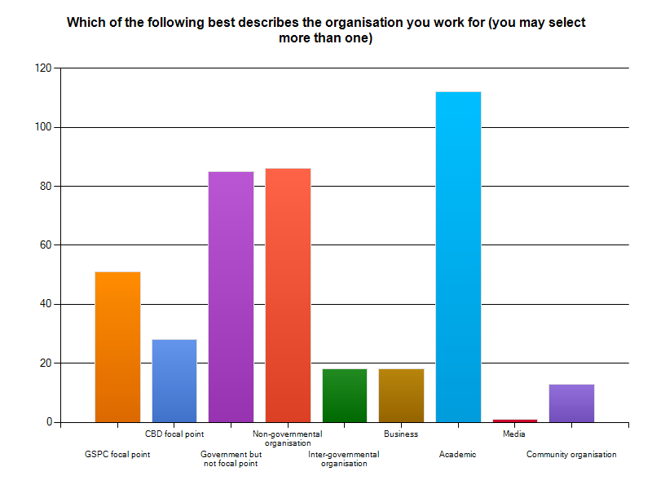

Area of specialization
Respondents were asked to indicate their main areas of expertise. The majority of respondents selected ‘in situ conservation’ (54%), but 46% of respondents were also involved in ‘ex situ conservation’ and 45% in ‘education and public awareness’. Relatively few respondents were involved in ‘biodiversity informatics’ (18%), ‘policy’ (17%) or ‘networking’ (15%). See chart 2:
Chart 2:
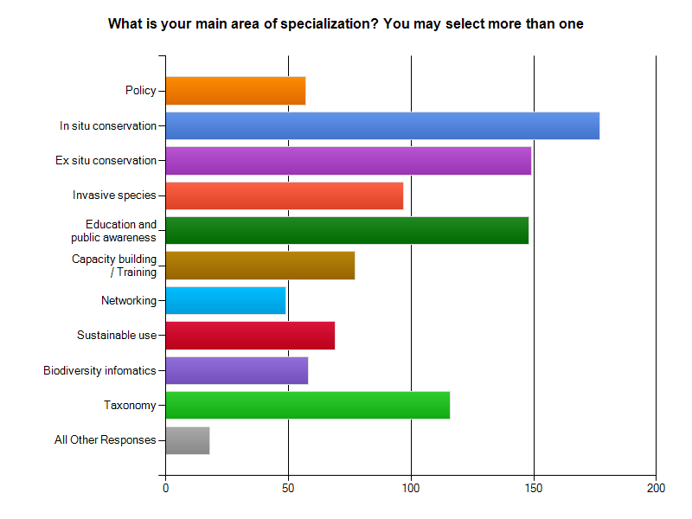

Which parts of the toolkit will be most important to you?
Respondents considered that most of the proposed elements of the toolkit would be ‘very important’ or ‘important’. The topics that were considered to be ‘very important’ by the majority of respondents were those related to how to develop targets at the national and regional level and the provision of information and resources on how to implement the targets. Elements considered as ‘important’ were those more focused on the provision of background information on the GSPC and how its implementation relates to the achievement of other targets and strategies. See Chart 3.

Chart 3
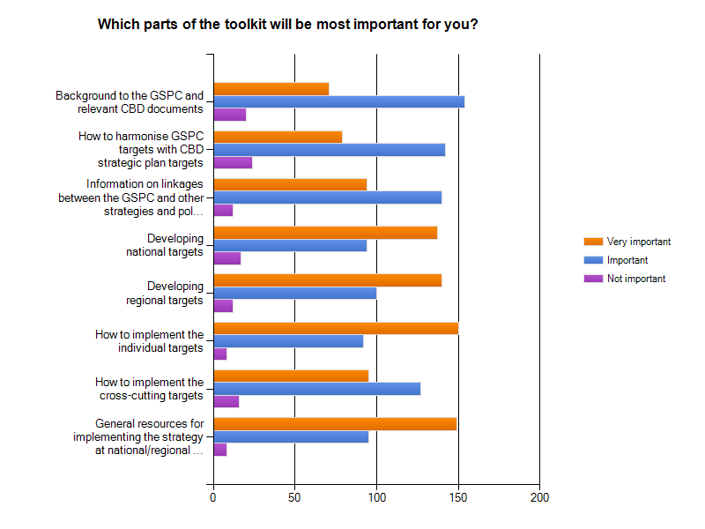

Developing national targets
With regard to the development of national targets, the majority of respondents (70%) indicated that the most important role for the toolkit will be to provide guidance on how to develop national targets in the framework of a national strategy for plant conservation. Guidance on the development of regional targets was also considered ‘very important’ by 63% of respondents – see Chart 4:
Chart 4
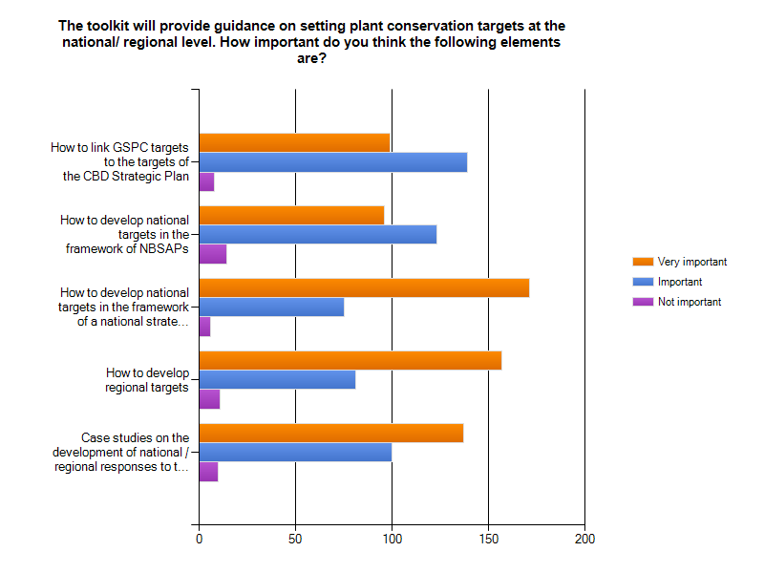
Implementing the GSPC targets
When asked what would be the most important parts of the toolkit to support the implementation of the individual targets of the GSPC, over 70% of respondents indicated that a ‘Step-by-step’ guide to implementing the targets and the provision of relevant tools and resources would be ‘very important’. Case studies were also considered to be ‘very important’ by 55% of respondents and ‘important’ by 43%. All other proposed elements were considered to be ‘important’ – see Chart 5

Chart 5
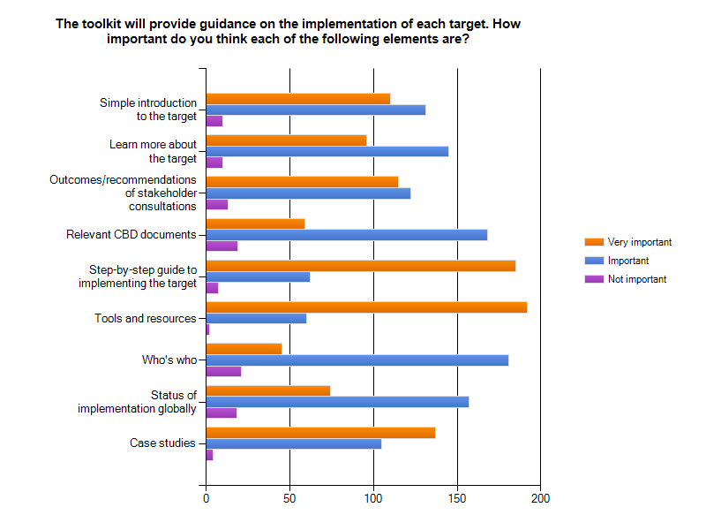

Other elements to include in the toolkit
Respondents were asked to indicate how important they considered the inclusion of databases of tools and resources and of expertise to be. While 76% of respondents considered a database to tools and resources to be ‘very important’, only 59% felt the same for a database of expertise (see Chart 6). In response to this question, some respondents noted how difficult it can be to keep a database of experts up-to-date and that out-of-date information can be very misleading. Furthermore, it was suggested that such a database could provide information on an eco-regional basis and that there should be a good regional balance of information. Other suggestions for elements to include in the toolkit included the following:
- Real time indicators to allow continued updating of the Global Plant Conservation Report;
- Mapping tools;
- Database of relevant meetings
- A database of relevant of funders or organizations interested in supporting plant conservation
- Database / collection of case studies – including both success stories and failures
- Database, or listings of relevant publications, links and other sources of information

Chart 6
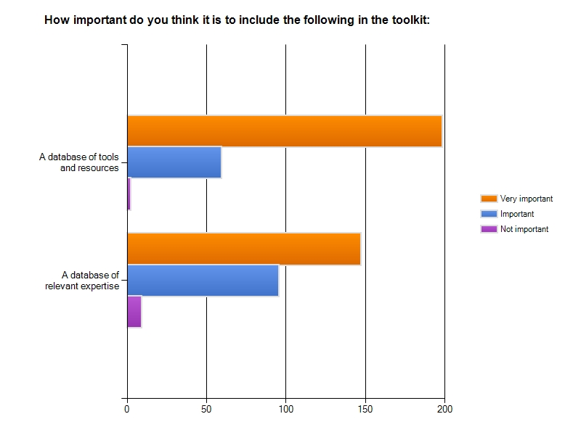

Accessing the toolkit
The vast majority of respondents (85%) indicated that they would prefer to access the toolkit via the internet (as the survey was internet-based, this is probably to be expected). See Chart 7. However, some respondents did note the need to ensure the toolkit would also be available to those with no or poor internet connections.
Chart 7
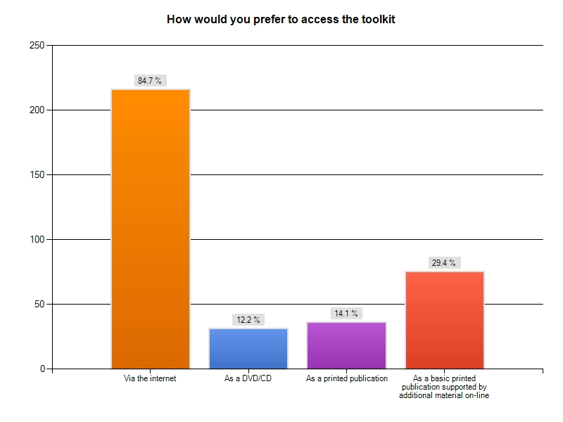

Tools and resources to contribute
71 respondents indicated that they had relevant case studies, tools and/or resources that they would like to contribute to the toolkit. These relate to all targets of the GSPC, with the majority being related to Targets 2, 5, 7 and 8 – see Chart 8. Furthermore, 6 respondents mentioned case studies and experiences related to national implementation of the GSPC as a whole, rather than individual targets.
Chart 8
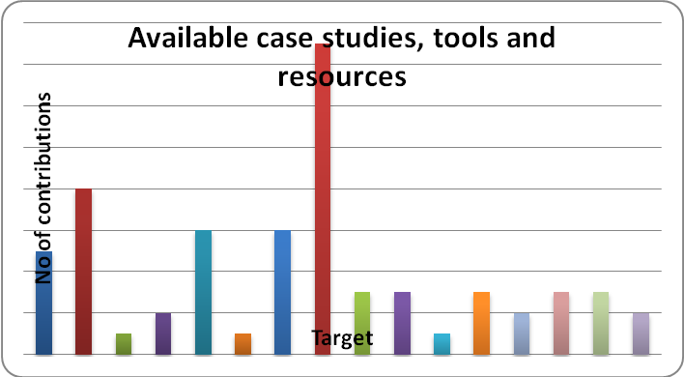
Other issues
A number of other issues were raised by survey respondents and these will be taken into account in development of the toolkit. These include:
- Identification of either actual case studies or worked examples for data rich and data poor countries, or those with high species biodiversity in mainly unfragmented habitats, and those with mainly fragmented habitats or with lower species diversity;
- How to incorporate plant conservation strategies into regional and national development plans (to reveal possibilities of cooperation with other sectors e.g. forestry, agriculture, water management etc.);
- The toolkit might take into account recent scientific results in population restoration;
- Knowledge of who is doing what so that there is no duplication Opportunities for partnerships e.g. we have space to grow trees if someone is undertaking germination/propagation trials;
- Need to provide leverage to practitioners to convince the needs of implementation (and long term commitment) of the GSPC to politicians.

Annex 6

Outline structure for the GSPC toolkit

- Introduction to the GSPC – to include:
- Importance of plants
- Need for a GSPC
- The GSPC and the CBD – links to other programmes of work, the strategic plan etc.
- The GSPC and other MEAs, including the Millennium Development Goals
- Status of implementation at the global level
- Developing a national response to the GSPC –national responses and links to CBD Strategic plan, NBSAPS and national targets – to include:
- How to identify stakeholders
- How to hold a stakeholder consultation
- Examples and case studies
- Implementing the targets- to include for each target:
- Introduction to the target (link to GSPC popular guide)
- Learn more about the target – definitions, justification, background etc.
- How to implement – a step-by-step guide
- Tools and resources – links to other sources of information and case studies
- Status of implementation
- Share information
- Searchable database of tools and Resources

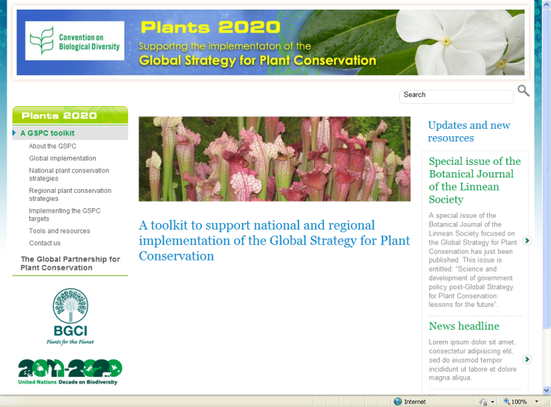

- - - -

* Organized jointly by the Secretariat of the Convention on Biological Diversity and the Global Partnership for Plant Conservation.
Could not attend due to visa problems

