 |  | CBD
 |  |  |  | Distr. GENERAL  UNEP/CBD/SBI/1/INF/23  8 April 2016  ORIGINAL: ENGLISH
SUBSIDIARY BODY ON IMPLEMENTATION
First meeting
Montreal, Canada, 2-6 May 2016
Item 15 of the provisional agenda*
New Structure of the Secretariat of the Convention on Biological Diversity

Note by the Executive Secretary
INTRODUCTION
- In its decision XII/32, paragraph 4, the Conference of the Parties requested the Executive Secretary to notify the Parties when each of steps 1, 2, and 3 as set out in the annex to document UNEP/CBD/COP/12/28, was completed and to consult the Bureau on the progress of the functional review. The steps are aimed at putting in place within the Secretariat new managerial tools and an updated organizational structure through an iterative process and to sharpen the results focus of the Secretariat to ensure the optimization of the use of the human and financial resources allocated by the Parties.
- The three steps outlined actions in fulfilment of the functional review of the Secretariat are as follows: Step 1: Planning of the biennial work of the Secretariat based on the Strategic Plan of the Convention and its Aichi Targets, the Strategic Plan of the Biosafety Protocol and decisions from COP 12 of the Convention, COP-MOP 7 of the Cartagena Protocol and COP-MOP 1 of the Nagoya Protocol; Step 2: Organizational design based on the Medium-term Operational Results Framework (MTORF) and Article 24 of the Convention, design of work plans (results-based framework), development of internal operating policies, operationalization of the result-based frameworks and policies and new Secretariat-wide approaches; and Step 3: Reorientation and/or design of functions (posts) to address new approaches which involves post descriptions for all positions, regularization of functions according to United Nations rules and regulations in collaboration with the UNEP/United Nations Office at Nairobi (UNON), preparation of report on lessons learned on progressive evolution and post-by-post organizational design based a proactive design targeted toward strengthening the capacity of the Secretariat for the balance of the decade, presentation of budget based on the renewed Secretariat and report to COP and COP-MOPs.
- In the light of the continuing outputs of the Functional Review, a new structure of the Secretariat was re-designed with the aim of providing an integrated and efficient support to Parties, across the Convention and its Protocols, as established in Article 24 of the Convention and the medium term operational results framework (MTORF) of the Secretariat.
NEW STRUCTURE OF THE SECRETARIAT
- The planning phase of the functional review articulated the roles and responsibilities of the Secretariat based on the biennium programme of work in response to the decisions of the Parties to the Convention and its Protocols. The Medium-Term Operational Results Framework with its complementary Results-based Management Framework of activities has summarized the functions of the Secretariat and facilitated an organizational redesign that enhances effectiveness of the Secretariat support to the Parties.
- In developing a new organizational design of the Secretariat, the following guidelines were taken into consideration: (i) Breaking silos of related sets of responsibilities; (ii) Optimizing the use of human resources to avoid overlaps and duplications; (iii) Ensuring that the organizational design fits purpose; “form (organizational design) follows function (niche or comparative advantages)”; (iv) Improving cross-divisional coordination; (v) Finding innovative ways of structuring the Secretariat to enable staff to work across subject matter areas; (vi) Optimizing use of available skill sets; (vii) Taking cognizance of the organizational learning phase; and (viii) Ensuring managerial responsibility for these cross-cutting teams; (ix) Devolving responsibilities to middle-level staff (P-4 and P-5) to lead the Units and be able to work with other colleagues in a fluid manner; and (x) recognizing Secretariat work outputs as closely related and interlinked but divided among divisions and Units to enable easy management and monitoring.
- The structure of the Secretariat combines both process and functional structures in a matrix design. The model prioritizes an organizational management based on cross-cutting processes while preserving some level of the functional structure by subject/thematic area. This offers the necessary flexibility to the Secretariat for better use of its resources than a purely functional model. Principal Officers will act as divisional leaders and are responsible for managing programmes whereas Unit leaders will be responsible for managing projects within and across divisions.
- A project is usually to be triggered by one of the thematic divisions based on the decision by Parties and is enabled by the different process units working together or in sequence. Internal operating policies are to ensure standardization and successful completion of projects. This structure combines many of the advantages of both process and functional designs. In the adopted structure, the aim is to improve cross-divisional coordination and integration of Secretariat activities to improve efficiency. The establishment of a small internal monitoring unit reporting directly to the Executive Secretary is to ensure that any lag in activity execution can be brought quickly to the attention of the Executive Secretary for redress.
Assumptions
- All the divisions and structures need to be considered open for review and restructuring so as to promote a more integrated and effective Secretariat (breaking silos), making better use of existing posts funded by the core budgets of the Convention and its Protocols and fulfilling the expectations of both Parties and staff with the functional review;
- The new divisions are to coordinate the implementation of the key functional objectives agreed in the functional review process;
- Principal Officers will coordinate and facilitate the activities of all the Divisions but providing a level of autonomy to the Units in the delivery of their targets; act as the first reporting officer of leads of the Units and second reporting officer to all staff ; and provide day-to-day solutions to challenges of the Division;
- The heads of units will be responsible for delivery targets set at the beginning of the biennium in the RBMF and act as first reporting officers to staff they work with directly;
- Some programme officers will have additional reporting officers depending on the work distribution.
- Structure is currently base on available human resources: 42 programme posts (38 programme officers and 4 principal officers);
- The contribution of Project staff is recognized and will be factored into a medium term human resource strategy to be presented to the Parties
- General Service staff are placed to meet strategic demands to optimize the use of the staff in the new structure;
- Operating the new structure demands assignment of clear goals and delivery targets immediately after each planning phase of the biennium according to the RBMF;
- All work to be done in accordance with standard operating procedure;
- A planning phase of the biennium work of the Secretariat will be undertaken prior to the meetings of all COPs and COP-MOPs to assess resource needs and reviewed immediately after the COP and COP-MOP meetings;
- A medium term human resource strategy will be developed as part of the functional review as a proposal to the COP and COP-MOPs for additional human resource needs spread over 6 years, 3 concurrent meetings;
(Please refer to the organigram below)
The mandates of the divisions:
- Office of the Executive Secretary:
The Executive Secretary, assisted by the Deputy Executive Secretary and the Management Committee provides strategic planning and management of the Secretariat to ensure its effectiveness in support of the Parties. The Office of the Executive Secretary will ensure coordination of the Secretariat’s activities and monitor progress in the implementation of the Secretariat’s work programme, in line with the Medium-term Operational Framework and decisions of the Conference of the Parties and meetings of the Parties. The Office of the Executive Secretary will also house the corporate legal services and ensure the coherence of the concurrent meetings, organization of work and consistency of procedures with the aim of improving the efficiency and the effectiveness of processes and structures under the Convention and the Protocols, It will also house a unit to help integrate reporting across the Convention and the Protocols and focus on improving the monitoring and review of implementation of the Convention.
Management Committee: The committee, chaired by the Executive Secretary, and made up of the Heads of Divisions and co-opted members, is to advise the Executive Secretary through a collective decision making process on strategic planning, operational issues and setting priorities for the effective management and execution of the work at the Secretariat.
The Administration, Finance and Conference Services Division, the Legal and Intergovernmental Unit and the Monitoring, Review and Reporting Unit will function directly under the Office of the Executive Secretary.
Legal and Intergovernmental Unit, in agreement with Heads of Divisions, will be responsible for the coordination of agenda of the COP, COP-MOPs and the subsidiary bodies. The unit will ensure the coherence of the concurrent meetings, organization of work and consistency of procedures with the aim of improving the efficiency and the effectiveness of processes and structures under the Convention and the Protocols in achieving full integration. The Unit will also ensure legal consistency across the Secretariat and provide legal advice to all staff in their work.
The Monitoring, Review and Reporting Unit will be responsible for all work that has been formulated under functional objective 5.1 and 5.2, inter alia, developing a holistic approach to national reporting and facilitating review and evaluation. The development of a holistic report system covering the Convention and its Protocol will be one of the main goals of the Unit.
- Scientific and Policy Support Division (MTORF 1.3, 3.4, (1.2.3),(2.1.2)
Mandate:
Provide support for the Convention and its Protocols through (a) provision of scientific and technical analyses to facilitate decision-making and implementation; (b) provision of support for the implementation of the Protocols; (c) integrating ABS and biosafety in the work of the Convention; and (d) provision of inputs to Secretariat-wide integrated processes.
Responsibilities of the Division:
- Facilitate policy development by the Parties, taking into account the objectives of the Convention and its implementing Protocols;
- Facilitate the review and evaluation of national, regional and other actions, in particular targets and indicators established in accordance with the Strategic Plans, in achieving the Aichi Biodiversity Targets; including biosafety;
- Provide substantive inputs on issues regarding SBSTTA, capacity-building, information sharing, scientific and technical issues, outreach and public participation, compliance committees;
- Maximize the use of personnel in an efficient manner where staff complement each other in processes under (c);
- Provision of substantive inputs into Secretariat-wide processes;
- Staff working in a cohesive manner in responding to items in proximity during concurrent COP and COP-MOP meetings.
2.1 Conservation and Sustainable Development Unit: (MTORF 1.3, 3.4)
Mandate:
Provide support to Parties, stakeholders and partner organizations in improving scientific understanding of conservation and sustainable use of biodiversity in support of evidence-based decision-making with emphasis on Goals B and C of the Strategic Plan for Biodiversity.
Responsibilities of the Unit:
- Coordination of scientific work in areas that include Targets 5 through 13, 17 and 19 of the Strategic Plan for Biodiversity including through support to implementing the following thematic and cross cutting issues: marine and coastal biodiversity, forest biodiversity, dry and sub-humid lands biodiversity, mountain biodiversity, agricultural biodiversity, inland waters biodiversity, island biodiversity ecosystem restoration; climate change and biological diversity, Global Strategy for Plant Conservation; ecosystem approach, Global Taxonomy Initiative, protected areas, impact assessment, sustainable use, technical and scientific cooperation, new and emerging issues among others in line with Articles 7, 8, 9, 10, 12, 14, 18 and 25 of the Convention;
- Provision of support to SBSTTA, organization of scientific and technical meetings and workshop; preparing of background documentation;
- Representing the CBD Secretariat in intergovernmental and technical and scientific meetings and partnership within the areas listed in (a);
- Provision of scientific and technical inputs in support of Secretariat-wide activities;
- Oversight of the CBD Technical Series.
2.2 Access and Benefit Sharing and Traditional Knowledge Unit: (MTORF 1.3, 3.4, (1.2.4) (5.1.3, 5.1.4)
Mandate:
Promote and support ratification of the Nagoya Protocol by all CBD Parties and provide support to Parties, indigenous peoples and local communities, and relevant stakeholders in implementing access and benefit-sharing and the Nagoya Protocol, as well as Article 8 (j) and related provisions of the Convention.
Responsibilities of the Unit:
- Promote and support ratifications of the Nagoya Protocol by all CBD Parties;
- Support the operationalization of the Nagoya Protocol including through the ABS Clearing-House, capacity-building, and awareness-raising;
- Carrying out intersessional processes and activities as decided by COP-MOP on issues such as the need for and modalities of a global multilateral benefit-sharing mechanism (Article 10); Articles 19 and 20; procedures and mechanisms to promote compliance with the Protocol (Article 30); and assessment and review of the effectiveness of the Protocol (Article 31);
- Support the implementation of the work programme on Article 8(j) and related provisions, as well as the provisions of the Nagoya Protocol relevant for indigenous peoples and local communities, including by building the capacity of Parties and indigenous peoples and local communities;
- Support effective participation and representation of indigenous peoples and local communities in CBD processes and activities;
- Collaborating with partners and following developments in other international organisations related to ABS and traditional knowledge;
- Promoting regular, adequate and appropriate linkages and communication with other activities and processes under the Convention.
2.3 Biosafety and Invasive Alien Species Unit (MTORF 1.3, 3.4 (5.1.3, 5.1.4)
Mandate:
Provide support to Parties in their implementation of the Strategic Plan for the Cartagena Protocol on Biosafety, 2011–2020 as well as the invasive alien species programme under the Convention; and promote ratification of the Cartagena Protocol and its Supplementary Protocol on Liability and Redress.
Responsibilities of the Unit:
- Provide support for the implementation of core areas such as (i) policy and legal development; (ii) information-sharing and scientific issues; (iii) Biosafety clearing-house (BCH); (iv) capacity building, and (v) outreach and public awareness under the Cartagena;
- Provide support for the promotion and implementation of the Nagoya-Kuala Lumpur Supplementary Protocol on Liability and Redress;
- Contribute towards Aichi Biodiversity Targets 4, 7, 9, 11, 13, 17 and 19 as well as responding to the demands of Articles 7, 8, 10, 14 and 19 of the Convention on Biological Diversity for the re-integration of biosafety into the relevant activities of the Convention;
- Promoting regular, adequate and appropriate linkages with other activities under the Convention;
- Provide support to the invasive alien species programme;
- Mainstreaming and Outreach Division
Mandate:
Provide support to the Parties by leading and coordinating the Secretariat’s work on mainstreaming of biodiversity, collaboration with partners in support of the Convention and its Protocols, and communications and outreach. It will include the Secretariat’s work on gender, economics and resource mobilization, including engagement of the private sector.
Responsibilities of the Division:
- Provide support for implementing Goal A of the Strategic Plan for Biodiversity 2011-2020, as well as other Aichi Targets including Aichi Target 20;
- Develop and coordinate implementation of a Secretariat-wide strategy on mainstreaming of biodiversity;
- Lead the work of the Secretariat on cross-cutting policies including development policies and processes, economics and finance issues, and engagement of key actors including subnational governments and the business sector;
- Lead the Secretariat’s engagement in international processes, and the development of strategic partnerships, including through the elaboration of a Secretariat-wide strategy;
- Lead engagement of a broad range of stakeholders, and in ensuring mainstreaming of gender;
- Coordinate the Secretariat’s communications and outreach work;
- Contribute to the preparation of documents and support to Parties at meetings of the Conference of Parties of the Convention and COP-MOPs of the Protocols, and meetings of subsidiary bodies (MTORF 1.3).
  - Partnerships and Cooperation Unit (MTORF 2.1, 2.2, 4.2, and 6.1.6)
Mandate:
Facilitate the integration of the biodiversity agenda into all relevant international intergovernmental processes, and develop strategic partnerships to support implementation of the Convention and its Protocols.
Responsibilities of the Unit:
- Lead and facilitate engagement with international processes, conventions, organizations and initiatives relevant to the Convention to seek the mainstreaming and integration of biodiversity into their processes;
- Facilitate engagement and strategic partnership with key entities to support the Convention and its Protocols;
- Lead on the development, coordination and implementation of Secretariat-wide strategy for strategic partnerships;
- Facilitate the organization of high-level segments of CBD meetings, and high-level events in other fora; and engage in relevant summits of regional bodies and ministerial meetings, subnational and local governments;
- Ensure effective engagement of stakeholders in the work of the Convention and its Protocols, and ensure the inclusion of gender considerations in the work of the Secretariat.
3.2 Communications and Outreach Unit (MTORF 4.1 and 4.2)
Mandate:
Lead and coordinate the work of the Secretariat with respect to all communications and outreach activities and supports Parties in their efforts to implement the Convention and its Protocols.
Responsibilities of the Unit:
- Develop and implement a communications strategy to guide Secretariat corporate communications, as well as a global communications strategy for the United Nations Decade on Biodiversity;
- Foster increased recognition of the importance of biodiversity, biosafety and access and benefit sharing related issues;
- Prepare, promote and disseminate communications products to raise awareness among target audiences;
- Network with partners and mobilize them to disseminate biodiversity, biosafety and access and benefit sharing related information, tools and raise awareness;
- Foster awareness and coverage of biodiversity in the media;
  - Economic Policy and Resource Mobilization Unit (MTORF 2.4, 3.3, 5.1.)
Mandate:
Lead and implement the financial, economic, business engagement, and trade-related work under the Convention and its Protocols.
Responsibilities of the Unit:
- Promote, in cooperation with partners, the development, implementation, and assessment of tools, measures, and mechanisms for integrating the value of biodiversity into public and private sector policies and programmes, including national development plans, economic policies, national resource mobilization strategies; corporate strategies, decision-making, policies and reporting; national reporting systems, including national accounting; and environmental safeguards;
- Undertake research and analytical work on relevant issues to support the implementation of the Convention and its Strategic Plan, including on incentive measures and biodiversity finance mechanisms;
- Support mainstreaming of biodiversity by the business sector, including through the Global Partnership for Business and Biodiversity;
- Monitor implementation progress against the strategy and the globally agreed targets for resource mobilization, including by providing support to the reporting of Parties against the financial reporting framework, and by preparing input into relevant reports;
- Monitor and evaluate the operations of the financial mechanism of the Convention, and service the review of its effectiveness and the preparation of guidance;
- Implementation Support Division
Mandate:
Provide support for the implementation and review of the Convention and its Protocols through (i) coordination of the implementation, monitoring and evaluation of the SCBD capacity-building strategy across the Secretariat (ii) responsible for supporting the clearing house mechanisms (iii) facilitate the servicing of the meetings of the Subsidiary Body on Implementation and relevant processes (iv) provision of inputs to Secretariat-wide integrated processes.
Responsibilities of the Division:
- Provide support for national planning and implementation processes to achieve the objectives of the convention and its strategic plan;
- Facilitating the review and evaluation of national, regional and other actions, in particular targets and indicators established in accordance with the Strategic Plans, in achieving the Aichi Biodiversity Targets;
- Maximizing use of personnel in an efficient manner where staff complement each other in SBI and COP processes;
- Provision of substantive inputs into Secretariat-wide processes.
4.1 Capacity Development Unit (MTORF 3.1, 5.1.5)
Mandate:
Coordinate, facilitate and support the planning, delivery, monitoring and evaluation of the Secretariat’s capacity-building support to Parties for the effective implementation of the Convention and its Protocols, in accordance with the relevant decisions of the COP and COP-MOPs.
Responsibilities of the Unit:
- Coordinate the development and implementation of the Secretariat’s biennial work plans on capacity-building after each COP and COP-MOP meetings, Coordinate the development of Standard Operating Procedures and Quality Assurance Standards for capacity-building; Provide support to staff in the implementation of the capacity-building activities mandated, including through development of e-learning modules, and identify opportunities for outsourcing the delivery of capacity-building;
- Coordinate the development and maintenance of the capacity-building web portal to serve as a one-stop-shop for linkages to information on capacity-building initiatives, tools and resources, e-learning modules/courses, country needs and available technical assistance; with links to the match-making facility, interactive discussion forums, and other tools;
- Monitor and assess the effectiveness and impact of capacity-building activities supported and facilitated by the Secretariat as well as those delivered on its behalf by partners in accordance with the decisions of the COP and COP-MOPs;
- Coordinate the preparation of bi-annual progress reports and pre-sessional documents for COP and SBI meetings and service the agenda items on capacity-building.
4.2 Clearing-House Mechanisms Unit (MTORF 3.2)
Mandate:
Provide support to achieve the mission, goals and objectives of the Clearing-House Mechanism for the period 2011-2020, as adopted by decision X/15, as well as support to achieve the successful implementation and operations of the BCH and ABSCH in a coherent and integrated manner.
Responsibilities of the Unit:
- Coordinate the implementation of the CHM work programme and of the work programme of the Protocols Clearing-Houses (BCH and ABSCH);
- Prepare progress reports and other documents related to the CHM, BCH and ABSCH;
- Service the meetings of the Informal Advisory Committees of the CHM, BCH and ABSCH (CHM-IAC) and the components of major CBD, CP and NP meetings related to the CHM, BCH and ABSCH;
- Provide support to Parties on matters related to the CHM, BCH and ABSCH, including the further development of national CHMs;
- Collaborate with Parties and partners to promote further exchange of relevant biodiversity-related information and knowledge.
4.3 Information Technology Unit (MTORF3.2.1)
Mandate:
Develop and implement the ICT work plan based on priorities agreed by the SCBD management group:
Responsibilities of the Unit:
- Servicing the internal customers (users and business units) and external “clients” (Parties, NGOs, website visitors, CBD meeting participants, etc.) based on the ICT work plan;
- Aligning the organization’s IT infrastructure and product architecture with its strategic priorities following UN regulations and SCBDS’s ICT strategy;
- Supporting the administration by identifying and managing vendors and contractors that supply infrastructure solutions and services;
- Developing strategies to increase the organization’s efficiency and the quality of products offered to internal and external clients;
- Working to streamline business processes with technology;
- Managing the technology architecture of the Secretariat.
- Finance, Administration and Conference Services Division
Mandate:
Within the rules and regulations of the United Nations and under the guidance of Parties, provide fund management, financial services and logistics support and efficient administrative and human resources support for the Secretariat of the Convention and its Protocols.
Responsibilities of the Division:
- Establishment of and compliance with internal controls in keeping with the UN Rules and Regulations and Administrative Instructions in providing fund management, administration, financial, personnel and logistic support to Secretariat staff and Parties towards the successful implementation of the programme of work of the Convention and its Protocols within the budgets approved by the Parties;
- Provision of timely and accurate reports to donors, and Secretariat staff on the use of contributions received;
- Guidance to the Executive Secretary, senior management and staff on all administrative and financial matters;
- Liaison with the Lead UN Agency and Host Government regarding the security of SCBD staff and premises.
  - Finance Unit:
Responsibilities of the Unit:
- Ensure compliance with the Financial Regulations and Rules of the United Nations and financial directives issued by UNON and the UN Controller in the expenditure and recording of expenditure of the funds administered by the Secretariat;
- Prepare and present the biennium budgets of the various trust funds managed by the Secretariat to the Conference of the Parties;
- Monitor Secretariat resources and their effective use in accordance with the approved programme, including travel arrangements for staff and meeting participants;
- Ensure that the accounts of the Secretariat are in compliance with IPSAS and properly reflected in Umoja;
- Provide timely information to programme managers regarding the funding status of their project budgets.
5.2 Administration and Human Resources Unit:
Responsibilities of the Unit:
- Provision of administrative and personnel support to Secretariat staff through the interpretation and implementation of staff rules and regulations, the necessary actions in Umoja and Inspira and the provision of guidance to staff regarding all human resources issues, including training;
- Timely preparation of necessary documentation for the recruitment of staff, consultants, contractors, and interns, and necessary follow-up actions with UNEP and UNON;
- Liaison with the Host Government regarding the official status of staff members, (issuance, renewal and cancellation of official documents);
- Office management and provision and maintenance of services for the operation of the Secretariat- (procurement; building management etc.).
5.3 Conference Services Unit:
Responsibilities of the Unit:
- Ensure the successful organization of meetings under the Convention and its Protocols by arranging for suitable facilities, and staffing (interpreters, security staff, room attendants etc.) and the timely production and distribution of pre-session, in-session and post-session documentation;
- Liaison with host countries to negotiate appropriate host country agreements;
- Logistical arrangements for the smooth functioning of meetings, including arrangements for side events and catering of functions, as required, and ensuring reduction of the carbon footprint of SCBD meetings;
- Provision of editorial services for the Secretariat, including liaising with Division and Unit Heads and with translators and/or authors, and posting documents in final form;
- Managing the translation of Secretariat documents, including compiling and maintaining a roster of translators for the six official languages of the United Nations.

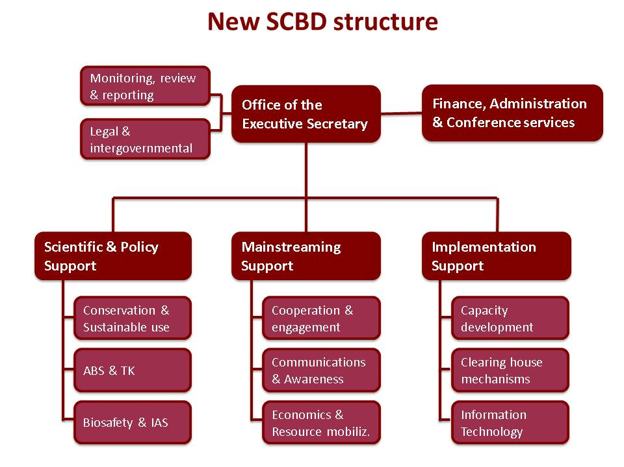
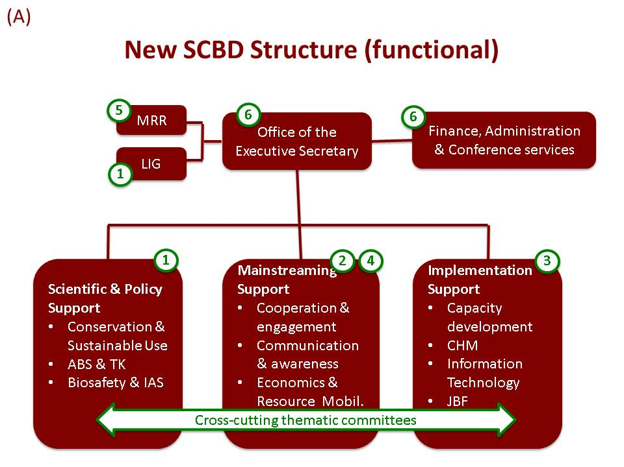

__________

* UNEP/CBD/SBI/1/1/Rev.1.

