 |  | CBD
 |  |  |  | Distr.:  GENERAL  UNEP/CBD/SBI/I/INF/28  23 March 2016  ENGLISH ONLY
Subsidiary Body on IMPLEMENTATION
First meeting
Montreal, Canada, 2-6 May 2016
Item 14 of the provisional agenda*

INFORMATION CONCERNING MATTERS RELATED TO AGENDA ITEM 14

OPTIONS FOR ENHANCING INTEGRATION AMONG THE CONVENTION AND ITS PROTOCOLS AND THE ORGANIZATION OF MEETINGS
Note by the Executive Secretary
In the context of agenda item 14 of the meeting, the Executive Secretary circulates herewith the following information:
(a) Information on the level of participation of developing country Parties and Parties with economies in transition at the last two meetings of the Conference of the Parties to the Convention and the meetings of the Parties to the Protocols (as referred to in document UNEP/CBD/SBI/12/Add.1, para. 42), in section I;
(b) The distribution of national focal points of the Convention and the Protocols (as referred to in UNEP/CBD/SBI/1/12/Add.1, para. 27), in section II;
(c) Letters of offer to host the fourteenth and fifteenth meetings of the Conference of the Parties (as referred to in UNEP/CBD/SBI/1/Add.2, para. 9), in section III.
I. InFORMATION ON THE LEVEL OF PARTICIPATION OF DEVELOPING COUNTRY pARTIES AND pARTIES WITH ECONOMIES IN TRANSITION AT THE last two meetings of the Conference of the Parties to the Convention and the meetings of the Parties to the Protocols

Table 1: Representation of developing country Parties and Parties with economies in transition at the sixth meeting of the Conference of the Parties serving as the meeting of the Parties to the Cartagena Protocol (COP-MOP 6) and the eleventh meeting of the Conference of the Parties to the Convention (COP 11) in 2012*:

 | Number of representatives to the
 | COP-MOP 6 |  |  | COP 11
 | Total | MOP 6 only | MOP 6 + COP 11 | Total
AFGHANISTAN* |  |  |  | 3
ALBANIA
ALGERIA |  |  |  | 5
ANGOLA |  |  |  | 1
ANTIGUA AND BARBUDA | 1 |  | 1 | 2
ARGENTINA* | 2 |  | 2 | 9
ARMENIA | 1 |  | 1 | 1
AZERBAIJAN |  |  |  | 1
BAHAMAS
BAHRAIN | 2 |  | 2 | 6
BANGLADESH | 1 |  | 1 | 5
BARBADOS
BELARUS |  |  |  | 1
BELIZE
BENIN | 2 |  | 2 | 3
BHUTAN | 1 |  | 1 | 5
BOLIVIA | 3 |  | 3 | 6
BOSNIA AND HERZEGOVINA |  |  |  | 7
BOTSWANA | 3 | 2 | 1 | 6
BRAZIL | 13 | 7 | 6 | 33
BRUNEI DARUSSALAM* |  |  |  | 3
BULGARIA |  |  |  | 7
BURKINA FASO |  |  |  | 12
BURUNDI | 1 |  | 1 | 3
CABO VERDE |  |  |  | 1
CAMBODIA | 6 | 2 | 4 | 10
CAMEROON | 2 | 1 | 1 | 3
CENTRAL AFRICAN REPUBLIC | 1 |  | 1 | 2
CHAD | 1 |  | 1 | 3
CHILE* |  |  |  | 5
CHINA | 15 | 12 | 3 | 29
COLOMBIA | 4 | 4 |  | 11
COMOROS | 1 |  | 1 | 5
CONGO | 3 | 2 | 1 | 2
COOK ISLANDS* |  |  |  | 1
COSTA RICA | 2 | 2 |  | 10
COTE D'IVOIRE* |  |  |  | 3
CROATIA | 1 |  | 1 | 7
CUBA | 1 | 1 |  | 3
CYPRUS | 4 |  | 4 | 8
CZECH REPUBLIC | 1 | 1 |  | 9
DEMOCRATIC PEOPLE'S REPUBLIC OF KOREA | 2 |  | 2 | 2
DEMOCRATIC REPUBLIC OF CONGO | 1 |  | 1 | 10
DJIBOUTI
DOMINICA
DOMINICAN REPUBLIC | 1 | 1 |  | 4
ECUADOR | 2 | 1 | 1 | 18
EGYPT | 1 |  | 1 | 3
EL SALVADOR |  |  |  | 1
EQUATORIAL GUINEA* |  |  |  | 2
ERITREA
ESTONIA |  |  |  | 5
ETHIOPIA | 1 |  | 1 | 4
FIJI | 2 |  | 2 | 3
GABON |  |  |  | 3
GAMBIA |  |  |  | 5
GEORGIA | 1 |  | 1 | 2
GHANA | 2 | 1 | 1 | 10
GRENADA | 2 |  | 2 | 4
GUATEMALA | 2 | 1 | 1 | 5
GUINEA | 1 | 1 |  | 2
GUINEA-BISSAU | 1 |  | 1 | 2
GUYANA | 1 |  | 1 | 2
HAITI* | 1 | 1 |  | 2
HONDURAS | 1 | 1 |  | 1
HUNGARY | 2 | 1 | 1 | 4
INDIA | 68 | 5 | 63 | 273
INDONESIA | 2 | 1 | 1 | 26
IRAN (ISLAMIC REPUBLIC OF) |  |  |  | 4
IRAQ* | 6 |  | 6 | 17
JAMAICA
JORDAN | 1 |  | 1 | 1
KAZAKHSTAN |  |  |  | 1
KENYA | 10 | 9 | 1 | 18
KIRIBATI | 1 |  | 1 | 4
KUWAIT* | 3 |  | 3 | 8
KYRGYZSTAN |  |  |  | 2
LAO PEOPLE'S DEMOCRATIC REPUBLIC | 1 | 1 |  | 3
LATVIA |  |  |  | 2
LEBANON* |  |  |  | 1
LESOTHO | 1 |  | 1 | 6
LIBERIA | 1 |  | 1 | 8
LIBYAN ARAB JAMAHIRIYA | 1 | 1 |  | 4
LITHUANIA | 2 | 2 |  | 4
MADAGASCAR | 1 | 1 |  | 7
MALAWI |  |  |  | 3
MALAYSIA | 5 | 3 | 2 | 20
MALDIVES | 1 |  | 1 | 5
MALI | 1 |  | 1 | 5
MARSHALL ISLANDS |  |  |  | 3
MAURITANIA | 1 |  | 1 | 1
MAURITIUS |  |  |  | 3
MEXICO | 14 | 13 | 1 | 8
MICRONESIA (FEDERATED STATES OF)* |  |  |  | 3
MONGOLIA | 1 | 1 |  | 3
MONTENEGRO |  |  |  | 1
MOROCCO | 1 |  | 1 | 6
MOZAMBIQUE | 2 |  | 2 | 10
MYANMAR |  |  |  | 1
NAMIBIA | 7 | 1 | 6 | 21
NAURU | 2 |  | 2 | 2
NEPAL* |  |  |  | 7
NICARAGUA | 1 | 1
NIGER | 1 | 1 |  | 9
NIGERIA | 1 | 1
NIUE
OMAN | 3 | 1 | 2 | 7
PAKISTAN | 2 | 2 |  | 2
PALAU
PANAMA | 1 | 1 |  | 1
PAPUA NEW GUINEA
PARAGUAY | 11 | 10 | 1 | 2
PERU | 1 | 1 |  | 13
PHILIPPINES | 6 | 6 |  | 14
POLAND | 2 | 2 |  | 7
QATAR | 2 | 2 |  | 4
REPUBLIC OF MOLDOVA | 1 |  | 1 | 2
ROMANIA
RUSSIAN FEDERATION* |  |  |  | 4
RWANDA |  |  |  | 3
SAINT KITTS AND NEVIS | 1 |  | 1 | 1
SAINT LUCIA | 1 |  | 1 | 2
SAINT VINCENT AND THE GRENADINES
SAMOA |  |  |  | 2
SAO TOME AND PRINCIPE* |  |  |  | 1
SAUDI ARABIA | 8 | 7 | 1 | 15
SENEGAL | 1 | 1 |  | 7
SERBIA | 1 |  | 1 | 3
SEYCHELLES | 2 | 1 | 1 | 4
SIERRA LEONE* |  |  |  | 3
SINGAPORE* |  |  |  | 3
SLOVAKIA | 1 |  | 1 | 4
SLOVENIA |  |  |  | 1
SOLOMON ISLANDS | 1 |  | 1 | 2
SOMALIA | 1 |  | 1 | 3
SOUTH AFRICA | 9 | 7 | 2 | 53
SRI LANKA | 3 |  | 3 | 9
SUDAN | 2 |  | 2 | 6
SURINAME
SWAZILAND | 1 | 1 |  | 1
SYRIAN ARAB REPUBLIC | 1 |  | 1 | 1
TAJIKISTAN | 2 |  | 2 | 3
THAILAND | 6 | 5 | 1 | 37
THE FORMER YUGOSLAV REPUBLIC OF MACEDONIA |  |  |  | 1
TIMOR-LESTE* |  |  |  | 4
TOGO | 1 |  | 1 | 4
TONGA | 1 | 1 |  | 1
TRINIDAD AND TOBAGO | 1 |  | 1 | 1
TUNISIA | 2 | 1 | 1 | 4
TURKEY | 5 | 5 |  | 8
TURKMENISTAN
TUVALU* |  |  |  | 1
UGANDA | 6 | 1 | 5 | 7
UKRAINE
UNITED ARAB EMIRATES* |  |  |  | 2
UNITED REPUBLIC OF TANZANIA | 5 |  | 5 | 14
URUGUAY | 2 | 2 |  | 3
UZBEKISTAN*
VANUATU*
VENEZUELA |  |  |  | 2
VIET NAM | 1 | 1 |  | 5
YEMEN | 1 |  | 1 | 3
ZAMBIA | 5 | 5 |  | 13
ZIMBABWE | 2 | 2 |  | 4
 | 334 | 148 | 186 | 1122

Table 2: Representation of developing country Parties and Parties with economies in transition at the seventh meeting of the COP-MOP to the Cartagena Protocol, the twelfth meeting of the COP and the first meeting of the COP-MOP to the Nagoya Protocol held in 2014^:

 | Number of representatives to the
 | COP-MOP 7 (CP) |  |  | COP 12 | COP-MOP 1 (NP)
 | Total | COP-MOP 7 only | COP-MOP 7 + COP 12 | Total | Total | COP-MOP 1 only | COP12 + COP-MOP1
AFGHANISTAN |  |  |  | 2
ALBANIA | 1 |  | 1 | 7 | 1 |  | 1
ALGERIA |  |  |  | 7
ANGOLA | 1 |  | 1 | 8
ANTIGUA AND BARBUDA |  |  |  | 1
ARGENTINA* | 2 | 1 | 1 | 5 | 8 | 3 | 5
ARMENIA
AZERBAIJAN
BAHAMAS
BAHRAIN |  |  |  | 4 | 4 |  | 4
BANGLADESH |  |  |  | 2 | 1 |  | 1
BARBADOS
BELARUS^ | 1 |  | 1 | 4 | 2 |  | 2
BELIZE
BENIN^ | 1 |  | 1 | 4 | 1 |  | 1
BHUTAN^ | 2 |  | 2 | 12 | 1 |  | 1
BOLIVIA | 3 | 2 | 1 | 8 | 7 |  | 7
BOSNIA AND HERZEGOVINA |  |  |  | 3
BOTSWANA^ | 1 | 1 |  | 2 | 2 |  | 2
BRAZIL | 12 | 5 | 7 | 38 | 35 |  | 35
BRUNEI DARUSSALAM* |  |  |  | 3
BULGARIA | 1 | 1 |  | 3
BURKINA FASO^ | 1 |  | 1 | 7 | 6 | 1 | 5
BURUNDI^ | 4 |  | 4 | 7 | 1 |  | 1
CABO VERDE |  |  |  | 2
CAMBODIA | 6 | 4 | 2 | 7
CAMEROON | 3 | 2 | 1 | 5 | 2 |  | 2
CENTRAL AFRICAN REPUBLIC | 1 |  | 1 | 1
CHAD |  |  |  | 3
CHILE* |  |  |  | 3 | 2 |  | 2
CHINA | 14 | 9 | 5 | 27 | 7 | 1 | 6
COLOMBIA | 7 | 6 | 1 | 5
COMOROS | 1 |  | 1 | 4 | 2 |  | 2
CONGO |  |  |  | 4
COOK ISLANDS
COSTA RICA | 1 |  | 1 | 4 | 2 |  | 2
COTE D'IVOIRE |  |  |  | 2 | 1 |  | 1
CROATIA | 1 | 1 |  | 3
CUBA | 2 | 1 | 1 | 1
CYPRUS
CZECH REPUBLIC |  |  |  | 6
DEMOCRATIC PEOPLE'S REPUBLIC OF KOREA
DEMOCRATIC REPUBLIC OF CONGO | 1 |  | 1 | 8 | 1 |  | 1
DJIBOUTI | 1 |  | 1 | 1
DOMINICA | 1 |  | 1 | 1
DOMINICAN REPUBLIC | 2 | 1 | 1 | 1
ECUADOR | 2 | 1 | 1 | 12 | 2 | 1 | 1
EGYPT^ | 4 | 1 | 3 | 4 | 4 |  | 4
EL SALVADOR | 1 |  | 1 | 1
EQUATORIAL GUINEA
ERITREA
ESTONIA | 2 | 2 |  | 3 | 1 |  | 1
ETHIOPIA^ |  |  |  | 5 | 5 |  | 5
FIJI^ | 2 |  | 2 | 3 | 1 |  | 1
GABON
GAMBIA^ | 1 | 1 |  | 3 | 1 |  | 1
GEORGIA | 2 |  | 2 | 5 | 1 |  | 1
GHANA | 2 |  | 2 | 5
GRENADA | 2 | 1 | 1 | 2
GUATEMALA^ | 1 | 1 |  | 3 | 3 |  | 3
GUINEA | 1 |  | 1 | 1
GUINEA-BISSAU^ | 1 |  | 1 | 5 | 1 |  | 1
GUYANA^ | 1 |  | 1 | 2 | 1 |  | 1
HAITI* |  |  |  | 1
HONDURAS^ | 5 | 5 |  | 3 | 3 |  | 3
HUNGARY^ | 2 | 2 |  | 4 | 3 |  | 3
INDIA^ | 5 | 4 | 1 | 3 | 2 |  | 2
INDONESIA^ | 3 | 3 |  | 38 | 13 | 1 | 12
IRAN (ISLAMIC REPUBLIC OF) | 5 | 5 |  | 1
IRAQ | 2 | 2 |  | 8
JAMAICA |  |  |  | 1
JORDAN^ | 1 |  | 1 | 4 | 1 |  | 1
KAZAKHSTAN
KENYA^ | 6 | 6 |  | 19 | 17 |  | 17
KIRIBATI | 1 | 1 |  | 3
KUWAIT* | 3 |  | 3 | 7
KYRGYZSTAN |  |  |  | 1
LAO PEOPLE'S DEMOCRATIC REPUBLIC^ |  |  |  | 2 | 2 |  | 2
LATVIA | 2 | 2 |  | 4 | 4 |  | 4
LEBANON
LESOTHO |  |  |  | 1
LIBERIA | 1 |  | 1 | 2
LIBYAN ARAB JAMAHIRIYA
LITHUANIA |  |  |  | 4 | 4 |  | 4
MADAGASCAR^ | 1 |  | 1 | 6 | 1 |  | 1
MALAWI | 1 |  | 1 | 7 | 4 |  | 4
MALAYSIA | 6 | 5 | 1 | 26 | 24 |  | 24
MALDIVES | 1 |  | 1 | 3
MALI | 3 |  | 3 | 6 | 4 |  | 4
MARSHALL ISLANDS |  |  |  | 2
MAURITANIA | 4 | 1 | 3 | 6
MAURITIUS^ |  |  |  | 1 | 1 |  | 1
MEXICO^ | 17 | 14 | 3 | 32 | 25 | 1 | 24
MICRONESIA (FEDERATED STATES OF)*^ |  |  |  | 4 | 3 |  | 3
MONGOLIA^ | 1 |  | 1 | 15 | 9 |  | 9
MONTENEGRO
MOROCCO |  |  |  | 13 | 9 |  | 9
MOZAMBIQUE^ | 3 |  | 3 | 12 | 1 |  | 1
MYANMAR^ | 1 |  | 1 | 3 | 1 |  | 1
NAMIBIA^ | 4 | 3 | 1 | 16 | 6 |  | 6
NAURU
NEPAL* |  |  |  | 8 | 1 |  | 1
NICARAGUA
NIGER^ | 3 |  | 3 | 10 | 3 |  | 3
NIGERIA | 2 | 2 |  | 13 | 1 |  | 1
NIUE
OMAN | 2 | 1 | 1 | 6 | 4 |  | 4
PAKISTAN
PALAU | 1 |  | 1 | 2 | 2 |  | 2
PANAMA^ | 1 |  | 1 | 2 | 2 |  | 2
PAPUA NEW GUINEA
PARAGUAY | 6 | 6
PERU^ | 2 | 1 | 1 | 8 | 3 | 2 | 1
PHILIPPINES | 9 | 8 | 1 | 14 | 5 |  | 5
POLAND | 2 | 2 |  | 4 | 4 |  | 4
QATAR | 2 |  | 2 | 2
REPUBLIC OF MOLDOVA | 1 | 1
ROMANIA |  |  |  | 5
RUSSIAN FEDERATION* | 1 |  | 1 | 6
RWANDA^
SAINT KITTS AND NEVIS | 1 |  | 1 | 1
SAINT LUCIA | 1 |  | 1 | 1
SAINT VINCENT AND THE GRENADINES |  |  |  | 1
SAMOA^ |  |  |  | 1 | 1 | 1
SAO TOME AND PRINCIPE
SAUDI ARABIA | 10 | 9 | 1 | 20
SENEGAL | 3 | 1 | 2 | 7 | 5 |  | 5
SERBIA |  |  |  | 1
SEYCHELLES^ | 1 |  | 1 | 2 | 1 |  | 1
SIERRA LEONE* |  |  |  | 2
SINGAPORE* |  |  |  | 4 | 4 |  | 4
SLOVAKIA | 3 | 3 |  | 5
SLOVENIA | 1 | 1 |  | 1 | 1 |  | 1
SOLOMON ISLANDS | 1 |  | 1 | 1
SOMALIA
SOUTH AFRICA^ | 14 | 1 | 13 | 47 | 16 |  | 16
SRI LANKA | 1 |  | 1 | 2
SUDAN^ | 1 |  | 1 | 5 | 3 |  | 3
SURINAME | 1 | 1
SWAZILAND
SYRIAN ARAB REPUBLIC^ | 1 |  | 1 | 1 | 1 |  | 1
TAJIKISTAN^ | 3 | 1 | 2 | 2 | 2 |  | 2
THAILAND | 9 | 8 | 1 | 56 | 41 |  | 41
THE FORMER YUGOSLAV REPUBLIC OF MACEDONIA |  |  |  | 1
TIMOR-LESTE* |  |  |  | 10
TOGO | 1 |  | 1 | 3
TONGA | 1 |  | 1 | 1
TRINIDAD AND TOBAGO
TUNISIA | 1 | 1 |  | 1 | 1 | 1
TURKEY | 4 | 3 | 1 | 11
TURKMENISTAN
TUVALU* |  |  |  | 3
UGANDA^ | 9 |  | 9 | 15 | 1 |  | 1
UKRAINE
UNITED ARAB EMIRATES | 1 | 1 |  | 3 | 3 |  | 3
UNITED REPUBLIC OF TANZANIA | 10 |  | 10 | 20 | 8 |  | 8
URUGUAY^ | 2 |  | 2 | 6 | 6 |  | 6
UZBEKISTAN* |  |  |  | 4
VANUATU*^ |  |  |  | 3 | 1 |  | 1
VENEZUELA | 1 |  | 1 | 2 | 1 |  | 1
VIET NAM^ | 4 | 3 | 1 | 8 | 2 | 1 | 1
YEMEN | 1 |  | 1 | 2
ZAMBIA | 6 | 5 | 1 | 11 | 1 |  | 1
ZIMBABWE | 1 | 1 |  | 2
 | 296 | 154 | 142 | 873 | 367 | 13 | 354

II. DISTRIBUTION OF NATIONAL FOCAL POINTS OF THE Convention AND THE PROTOCOLS
Table 1: Distribution of national focal points (NFPs) of the Cartagena Protocol (CP) and the Nagoya Protocol (NP) across national competent authorities in relation to the NFPs of the Convention
Party | CBD | CP |  |  | NP
 |  | The same as CBD NFP | Different NFP from the same competent authority | Different NFP - from different competent authority | The same as CBD NFP | Different NFP from the same competent authority | Different NFP -from different competent authority
Afghanistan | National Environmental Protection Agency |  | √ |  | √
Albania | Ministry of Environment | √ |  |  |  | √
Algeria | 3 FPs from: 1 - Ministère de l'Aménagement du Territoire, de l'Environnement et de la Ville; 2- Ambassade d'Algérie à Ottawa; 3- Ministère des Affaires Etrangères | √ ( 1 FP - same as Ministère des Affaires Etrangères) |  |  |  |  | √ (1 FP from Ministère de l'Agriculture et du Developpement Rural)
Andorra | 2 FPs from Ministry of Environment, Agriculture and Sustainability | No CPB FP | No CPB FP | No CPB FP | No NP FP | No NP FP | No NP FP
Angola | Ministry of Environment |  | √ |  |  | √
Antigua and Barbuda | Environment Division, Government of Antigua and Barbuda | √ |  |  | √
Argentina | Ministerio de Relaciones Exteriores y Culto | √ |  |  | √
Armenia | Ministry of Nature Protection | √ |  |  | √
Australia | Department of the Environment |  |  | √ (Department of Health) |  | √ (same as CBD Secondary FP)
Austria | Federal Ministry of Agriculture, Forestry, Environment and Water |  |  | √ (Department of Landuse and Biosafety) | √
Azerbaijan | Ministry of Ecology and Natural Resources |  | √ |  | √
Bahamas | Ministry of the Environment and Housing | √ |  |  | No NP FP | No NP FP | No NP FP
Bahrain | Supreme Council for Environment |  | √ |  |  | √
Bangladesh | Ministry of Environment and Forests | √ |  |  |  | √
Barbados | Ministry of the Environment and Drainage | √ |  |  | √
Belarus | Ministry of Natural Resources and Environmental Protection | √ |  |  | √
Belgium | Royal Belgian Institute of Natural Sciences |  |  | √ (Federal Public Service Health, Food Chain Security and Environment) |  |  | √ (Federal Public Service Health, Food Chain Security and Environment)
Belize | Ministry of Forestry, Fisheries and Sustainable Development |  |  | √ (Belize Agricultural Health Authority) | No NP FP | No NP FP | No NP FP
Benin | Ministère de l’Environnement, de l’Habitat et de l’Urbanisme |  |  | √ (Direction des Eaux et Forêts) |  | √
Bhutan | National Environment Commission | √ |  |  | √
Bolivia | 2 FPs: 1- Ministerio de Medio Ambiente y Agua; 2- Ministerio de Relaciones Exteriores | √ (Same FP only from Ministerio de Relaciones Exteriores) |  |  | √ (same 2 FPs)
Bosnia and Herzegovina | Federal Ministry of Environment and Tourism |  |  | √ (Food Safety Agency of Bosnia and Herzegovina) |  |  | √ (University of Sarajevo)
Botswana | Ministry of Environment, Wildlife and Tourism | √ |  |  | √
Brazil | 2 FPs: 1- Ministry of External Relations; 2- Permanent Delegation of Brazil to International Organizations located in Montreal | √ (1 FP- same as from Ministry of External Relations) |  |  | √ (1 FP - same as from Ministry of External Relations)
Brunei Darussalam | Ministry of Industry and Primary Resources |  |  | √ (Ministry of Development) | No NP FP | No NP FP | No NP FP
Bulgaria | 2 FPs: 1- Ministry of Environment and Water; 2- Embassy of the Republic of Bulgaria (Ottawa) |  | √ (1 FP from Ministry of Environment and Water) |  |  | √ (1 FP from Ministry of Environment and Water )
Burkina Faso | Ministère de l'Environnement et du Developpement Durable |  |  | √ (Ministère de la Recherche Scientifique et de l’Innovation) |  | √
Burundi | Office Burundais pour la Protection de l'Environnement (OBPE) |  | √ |  |  | √
Cambodia | Ministry of Environment |  | √ |  |  | √
Cameroon | Ministry of Environment, Protection of Nature and Sustainable Development |  | √ |  |  | √
Canada | Environment Canada |  | √ |  |  | √
Cape Verde | Ministério do Ambiente e Agricultura |  |  | √ (National Directorate of Environmental – DGA) | √
Central African Republic | Ministère de l'Environnement, de l'Ecologie et du Développement Durable |  | √ |  |  | √
Chad | Ministère de l'Agriculture et de l'Environnement |  | √ |  |  | √
Chile | 4 FPs: 3 from MFA (including Consulate General in Montreal); 1 from Ministerio del Medio Ambiente |  | √ (1 FP from Ministerio del Medio Ambiente) |  |  | √ (1 FP from Ministerio del Medio Ambiente)
China | Ministry of Environmental Protection | √ |  |  |  | √
Colombia | Ministerio de Relaciones Exteriores | √ |  |  |  |  | √ (Ministerio de Ambiente y Desarrollo Sostenible)
Comoros | Ministère de la Production, de l’Environnement, de l’Energie, de l’Industrie et de l’Artisanat | √ |  |  |  | √
Congo | Ministère du développement durable, de l’économie forestière et de l’environnement |  | √ |  |  | √
Cook Islands | Ministry of Foreign Affairs and Immigration | No CPB FP | No CPB FP | No CPB FP |  |  | √ National Environment Service
Costa Rica | 2 FPs from: 1) MFA 2) Ministerio de Ambiente y Energía |  |  | √ ( 1 FP from Ministerio de Agricultura y Garadería) |  | √ (1 FP from Ministerio de Ambiente y Energía)
Côte d'Ivoire | Ministère de l’Environnement, de la Salubrité Urbaine et du Développement Durable | √ |  |  |  | √
Croatia | Ministry of Environment and Nature Protection |  | √ |  |  | √
Cuba | Ministerio de Ciencia, Technología y Medio Ambiente | √ |  |  | √
Cyprus | 2 FPs from Ministry of Agriculture, Rural Development and Environment | √ ( 1 FP) |  |  | √ (1 FP)
Czech Republic | Ministry of the Environment |  | √ |  |  | √
DR Korea | National Coordinating Committee for Environment (NCCE) | √ |  |  | √
DR Congo | Ministère de l'Environnement, Conservation de la Nature et Tourisme | √ |  |  | √
Denmark | 3 FPs: 1- from MFA; 2 - from Ministry of Environment |  | √ (1FP from Ministry of Environment) |  | √ (1 FP from Ministry of Environment)
Djibouti | 2 FPs from Ministère de l'Habitat, de l'Urbanisme et de l'Environnement | √ (only 1 FP) |  |  |  | √
Dominica | Ministry of Environment, Natural Resources, Physical Planning and Fisheries | √ |  |  | √
Dominican Republic | 3 FPs: 2 from Ministerio de Medio Ambiente y Recursos Naturales; 1 from MFA |  | √ (No Name -Ministerio de Medio Ambiente y Recursos Naturales) |  |  | √ (one FP in Ministerio de Medio Ambiente y Recursos Naturales)
Ecuador | 3FPs: 1 from Ministerio del Ambiente; 2 – from MFA |  | √ (Ministerio del Ambiente) No FPs in MFA |  | √ (the one in Ministerio del Ambiente)
Egypt | Ministry of State for Environmental Affairs, Nature Conservation |  |  | √ (Egyptian Environmental Affairs Agency) |  |  | √ (Egyptian Environmental Affairs Agency)
El Salvador | Ministerio de Medio Ambiente y Recursos Naturales |  | √ |  | No NP FP | No NP FP | No NP FP
Equatorial Guinea | Ministerio de Pesca y Medio Ambiente | No CPB FP | No CPB FP | No CPB FP |  | √
Eritrea | Ministry of Land, Water and Environment | √ |  |  | No NP FP | No NP FP | No NP FP
Estonia | Ministry of Environment |  | √ |  |  | √
Ethiopia | Ethiopian Biodiversity Institute |  |  | √ (Ministry of Environment and Forest) |  | √
EU | DG-Environment, European Commission |  |  | √ (DG Health and Consumers, EC) |  | √
Fiji | Ministry of Local Government, Urban Development, Housing and the Environment |  | √ |  | √
Finland | Ministry of the Environment |  | √ |  |  |  | √ (Finnish Environment Institute, Natural Environment Centre)
France | 2 FPs: 1 from Ministère de l'écologie, du développement durable et de l'énergie; 1 from MFA |  | √ (1 FP from Ministère de l'écologie… ) |  | √ (1 FP same as from MFA)  Total: 2 FPs (from 2 columns) | √ (1 FP from Ministère de l'écologie… )
Gabon | Ministère de la Forêt, de l'Environnement et de la Protection des Ressources Naturelles |  |  | √ (IRET - Ecole Nationale des Eaux et Forêts) | √
Gambia | Department of Parks & Wildlife Management  c/o Ministry of Environment, Parks and Wildlife | √ |  |  |  | √
Georgia | Ministry of Environment and Natural Resources Protection |  | √ |  |  | √
Germany | Federal Ministry for the Environment, Nature Conservation, Building and Nuclear Safety (BMUB) |  |  | √ (Federal Ministry of Consumer Protection, Food and Agriculture) |  | √
Ghana | National Biosafety Authority | √ |  |  | √
Greece | Ministry of Reconstruction of Production, Environment and Energy |  | √ |  | No NP FP | No NP FP | No NP FP
Grenada | Ministry of Agriculture, Lands, Forestry, Fisheries and the Environment |  | √ |  |  | √
Guatemala | Consejo Nacional de Areas Protegidas (CONAP) |  | √ |  |  | √
Guinea | Ministère de l'Environnement, des Eaux et Forêts (MEEF) |  | √ |  |  | √
Guinea-Bissau | Instituto da Biodiversidade e das Áreas Protegidas (IBAP) |  |  | √ (Secretariat State of Environment) |  |  | √ (Secretariat State of Environment)
Guyana | Environmental Protection Agency | √ |  |  |  | √
Haiti | Ministère de l'Environnement | √ |  |  | √
Holy See | Permanent Observer Mission of the Holy See to UNEP and UNCHS | √ |  |  | No NP FP | No NP FP | No NP FP
Honduras | 2 FPs from Secretaría de Energía, Recursos Naturales, Ambiente y Minas |  |  | √ (1 from Secretaria de Agricultura y Ganaderia) |  | √ (1 FP from Secretaría de Energía, Recursos Naturales, Ambiente y Minas)
Hungary | Ministry of Agriculture | √ |  |  | √
Iceland | Ministry for the Environment | No CPB FP | No CPB FP | No CPB FP | No NP FP | No NP FP | No NP FP
India | Ministry of Environment, Forests and Climate Change | √ |  |  | √
Indonesia | Ministry of Environment and Forestry | √ |  |  | √
Iran | Ministry of Foreign Affairs |  |  | √ Agricultural Biotechnolgy Research Institute of Iran | √
Iraq | Ministry of Environment | √ |  |  | √
Ireland | 2 FPs from Department of Arts, Heritage and the Gaeltacht |  |  | √ (Department of Environment, Community and Local Government) | √ (only one)
Israel | 2FPs: 1 from Ministry of Environmental Protection; 1 from Israel Nature and Parks Authority |  |  | √ (Ministry of Agriculture and Rural Development) | √ (1 - same as from Israel Nature and Parks Authority)
Italy | Ministry of the Environment, Land and Sea | √ |  |  |  | √
Jamaica | Ministry of Water, Land, Environment and Climate Change | √ |  |  |  |  | √ (National Environment and Planning Agency)
Japan | 2 FPs from Ministry of Foreign Affairs |  | √ (only 1 FP) |  |  | √ (only 1 FP)
Jordan | 2 FPs from Ministry of Environment | √ (only one) |  |  | √ (only one)
Kazakhstan | 2FPs from Ministry of Environment and Water Resources |  |  | √ (one FP from Ministry of Agriculture) | No NP FP | No NP FP | No NP FP
Kenya | Ministry of Environment, Water and Natural Resources |  |  | √ (National Biosafety Authority  Commission for Higher Education) | No NP FP | No NP FP | No NP FP
Kiribati | Ministry of Environment, Lands and Agricultural Development | √ |  |  | √
Kuwait | Environment Public Authority | √ |  |  |  | √
Kyrgyzstan | 2FPs: 1 from State Agency on Environment Protection and Forestry; 1 from MFA | √ (1 FP - same as State Agency on Environment Protection and Forestry) |  |  |  | √ (1FP from State Agency on Environment Protection and Forestry)
Lao | Ministry of Natural Resources and Environment (MoNRE) |  |  | √ (Ministry of Science and Technology) |  |  | √ (Ministry of Science and Technology)
Latvia | Ministry of Environmental Protection and Regional Development |  |  | √ (Ministry of Agriculture) |  | √
Lebanon | Ministry of Environment | √ |  |  | √
Lesotho | Ministry of Tourism, Environment and Culture | √ |  |  |  | √
Liberia | Environmental Protection Agency (EPA) |  | √ |  |  | √ (total: 2 FPs)
Libya | Environment General Authority (EGA) |  | √ |  |  | √
Liechtenstein | 2 FPs from Office of Environment | No CPB FP | No CPB FP | No CPB FP | No NP FP | No NP FP | No NP FP
Lithuania | Ministry of Environment |  | √ |  |  | √
Luxembourg | 2 FPs: 1 from Ministère du Développement durable et des infrastructures; 1 from MFA | No CPB FP | No CPB FP | No CPB FP | √ (1 FP - same as Ministère du Développement durable et des infrastructures)
Madagascar | Ministère de l'Environnement, de l'Ecologie, de la Mer et des Forêts |  | √ |  |  |  | √ (Service d'Appui a la Gestion de l'Environnement (SAGE))
Malawi | Environmental Affairs Department |  | √ |  |  | √
Malaysia | Ministry of Natural Resources and Environment | √ |  |  | √
Maldives | Ministry of Environment and Energy | √ |  |  | √
Mali | Ministère de l'Environnement, de l'Eau et de l'Assainissement |  | √ |  |  | √
Malta | Minister of Env-t, Office of the Prime Minister | √ |  |  |  |  | √ (Malta Environment & Planning Authority)
Marshall Islands | 3 FPs: 2 from MFA; 1 from Office of Environmental Planning and Policy Coordination (OEPPC) |  | √ (1 FP in MFA) |  | No NP FP | No NP FP | No NP FP
Mauritania | Ministère Délégué auprès du Premier Ministre chargé de l'Environnement et du Développement Durable | √ |  |  | √
Mauritius | National Parks and Conservation Service |  |  | √ (Ministry of Agro-Industry & Food Security) | √ | √
Mexico | 2FPs: 1 from Secretaría de Medio Ambiente y Recursos Naturales (SEMARNAT); 1 from MFA |  |  | √ (1FP from Comisión Intersecretarial de Bioseguridad de los Organismos Genéticamente Modificados (CIBIOGEM)) |  | √ (1 FP from Secretaría de Medio Ambiente y Recursos Naturales-SEMARNAT)
Micronesia | Department of Resources and Development | No CPB FP | No CPB FP | No CPB FP |  | √
Monaco | Département des Relations Extérieures et de la Coopération | No CPB FP | No CPB FP | No CPB FP | No NP FP | No NP FP | No NP FP
Mongolia | Ministry of Environment, Green Development and Tourism |  | √ |  |  | √
Montenegro | Ministry of Sustainable Development and Tourism |  |  | √ (Ministry of Agriculture and Rural Development) | √
Morocco | Ministre de l'Energie, des Mines, de l'Eau et de l'Environnement - Chargé de l'Environnement | √ |  |  | √
Mozambique | Ministry of Land, Environment and Rural Development |  |  | √ (Ministry of Agriculture) |  | √
Myanmar | 2 FPs: 1 from ASEAN National Secretariat, MFA; 1 from Ministry of Environmental Conservation and Forestry | √ (1 FP - same as Ministry of Environmental Conservation and Forestry) |  |  |  |  | √ (National Commission for Environmental Affairs (NCEA),  Ministry of Forestry)
Namibia | Ministry of Environment and Tourism |  |  | √ (University of Namibia) |  | √
Nauru | Department of Commerce, Industry & Environment | √ |  |  | No NP FP | No NP FP | No NP FP
Nepal | Ministry of Forests and Soil Conservation | √ |  |  | √
Netherlands | Ministry of Economic Affairs |  |  | √ (Ministry for Infrastructure and the Environment) |  |  | √ (Centre for Genetic Resources)
New Zealand | Ministry of Foreign Affairs and Trade | √ |  |  | √
Nicaragua | Ministerio del Ambiente y los Recursos Naturales (MARENA) | √ |  |  | No NP FP | No NP FP | No NP FP
Niger | Conseil National de l'Environnement pour un Développement Durable (CNEDD) |  |  | √ (Ministère de l'Hydraulique et de l'Environnement) |  | √
Nigeria | Federal Ministry of Environment |  | √ |  |  | √
Niue | Department of Environment | √ |  |  | √
Norway | Ministry of Climate and Environment |  | √ |  |  | √
Oman | Ministry of Environment and Climate Affairs | √ |  |  | √ (2 FPs - same as CBD Primary and CBD Secondary)
Pakistan | Ministry of Climate Change |  | √ |  |  | √
Palau | Ministry of Natural Resources, Environment and Tourism |  | √ |  | √
Panama | 2 FPs: 1 from MFA; 1 from Autoridad Nacional del Ambiente (ANAM) |  | √ (1 FP from ANAM) |  |  | √ (1 FP from ANAM)
Papua New Guinea | Department of Environment and Conservation | √ |  |  | No NP FP | No NP FP | No NP FP
Paraguay | Secretaría del Ambiente (SEAM) |  |  | √ (Ministerio de Relaciones Exeriores) | No NP FP | No NP FP | No NP FP
Peru | 2 FPs: 1 from MFA; 1 from Ministerio del Ambiente |  | √ ( 1 FP in Ministerio del Ambiente) |  |  | √ ( 1 FP in Ministerio del Ambiente)
Philippines | 2 FPs: 1 from Department of Foreign Affairs; 1 from Embassy of the Republic of the Philippines in Ottawa | √ (1 FP - same as Department of Foreign Affairs) |  |  |  |  | √ (Biodiversity Management Bureau (BMB), Department of Environment and Natural Resources (DENR))
Poland | Ministry of the Environment |  | √ |  | √
Portugal | Instituto da Conservação da Natureza e das Florestas |  |  | √ (Portuguese Environment Agency) |  | √
Republic of Korea | 3 FPs: 2 from MFA including Consulate General in Montreal; 1 from Ministry of Environment | √ (1 FP-same as MFA) |  |  | √ (2 FPs -same as MFA and MoE)  Total: 3 FPs |  | √ ( 1 FP from Korea Forest Service (KFS))
Republic of Moldova | Ministry of Environment |  | √ |  | √
Romania | Ministry of Environment and Forests |  | √ |  |  | √
Russian Federation | Ministry of Natural Resources and Environment |  |  | √ (Ministry of Industry, Science and Technologies) | No NP FP | No NP FP | No NP FP
Rwanda | Rwanda Environment Management Authority (REMA) |  | √ |  |  | √
Saint Kitts and Nevis | Ministry of Sustainable Development | √ |  |  | √
Saint Lucia | Ministry of Sustainable Development, Energy, Science and Technology | √ |  |  |  | √
Saint Vincent and the Grenadines | Ministry of Health, Wellness and the Environment | No CPB FP | No CPB FP | No CPB FP |  | √
Samoa | Ministry of Foreign Affairs and Trade | √ |  |  |  |  | √ (Ministry of Natural Resources and Environment)
San Marino | Environmental and Agricultural Resources Management Office | No CPB FP | No CPB FP | No CPB FP | No NP FP | No NP FP | No NP FP
Sao Tome and Principe | Ministério de Agricultura e Desenvolvimento Rural |  |  | √ (Centre de Recherche Agronomique et Technologique) |  |  | √ (Ministère des Travaux Publiques et Ressources Naturelles
Saudi Arabia | Saudi Wildlife Authority |  |  | √ (King Abdulaziz City for Science and Technology) |  |  | √ (King Abdulaziz City for Science and Technology)
Senegal | Ministèrede l'environnement et du developpement durable |  | √ |  |  | √
Serbia | Ministry of Agriculture and Environmental Protection |  | √ |  |  | √
Seychelles | 2 FPs: MFA and Ministry of Environment, Energy and Climate Change | √ (1 FP - same as Ministry of Environment, Energy and Climate Change) |  |  |  |  | √ (1FP from Seychelles National Botanical Gardens)
Sierra Leone | Ministry of Lands, Country Planning & the Environment |  | √ |  | No NP FP | No NP FP | No NP FP
Singapore | 2 FPs from National Parks Board |  |  | √ (Ministry of National Development) | √ ( 1FP from National Parks Board)  Total: 2 FPs | √ ( 1 FP from National Parks Board)
Slovakia | Ministry of Environment |  | √ |  |  | √
Slovenia | Ministry of the Environment and Spatial Planning |  | √ |  | √
Solomon Islands | Ministry of Environment, Climate Change, Disaster Management and Meteorology | √ |  |  | No NP FP | No NP FP | No NP FP
Somalia | Ministry of the Environment | √ |  |  | √
South Africa | 2 FPs from Department of Environmental Affairs (DEA) | √ (1 FP) |  |  |  | √ (1 FP)
South Sudan | Ministry of Environment | No CPB FP | No CPB FP | No CPB FP | No NP FP | No NP FP | No NP FP
Spain | Ministerio de Agricultura, Alimentación y Medio Ambiente |  | √ |  | √
Sri Lanka | 3 FPs from Ministry of Mahaweli Development and Environment | √ (1 FP) |  |  | √ (1 FP)
State of Palestine | Environment Quality Authority (EQA) | No CPB FP | No CPB FP | No CPB FP | No NP FP | No NP FP | No NP FP
Sudan | Higher Council for Environment and Natural Resources (HCENR) | √ |  |  |  | √
Suriname | National Security/Coordination for Environmental Policy unit in the Cabinet of the President of the Republic Suriname | √ |  |  | √
Swaziland | Swaziland Environment Authority (SEA) |  | √ |  |  | √
Sweden | Ministry of the Environment |  | √ |  |  | √
Switzerland | Federal Office for the Environment (FOEN) |  | √ |  |  | √
Syrian Arab Republic | Ministry of State for Environment Affairs | √ |  |  | √
Tajikistan | National Biodiversity and Biosafety Center | √ |  |  | √
Thailand | Office of Natural Resources and Environmental Policy and Planning |  | √ |  |  | √ (2 FPs)
The former Yugoslav Republic of Macedonia | Ministry of Environment and Physical Planning |  | √ |  | √
Timore-Leste | Secretariat of State for the Environment | No CPB FP | No CPB FP | No CPB FP |  |  | √ (National University of East Timor)
Togo | Ministère de l'Environnement et des Ressources Forestières | √ |  |  |  | √
Tonga | 2 FPs: 1 from Ministry of Meteorology, Energy, Information, Disaster Management, Environment, Climate Change and Communications (MEIDECC); 1 from MFA | √ ( 1FP – same as Ministry of environment) |  |  | No NP FP | No NP FP | No NP FP
Trinidad and Tobago | Ministry of the Environment and Water Resources | √ |  |  | No NP FP | No NP FP | No NP FP
Tunisia | 2 FPs from Ministère de l'Equipement et de l’Environnement |  | √ |  |  | √
Turkey | 2 FPs from Ministry of Forestry and Water Affairs |  |  | √ (1 FP from Ministry of Food Agriculture and Livestock) |  |  | √ (1 FP from Ministry of Food Agriculture and Livestock)
Turkmenistan | Ministry of Nature Protection |  | √ |  | No NP FP | No NP FP | No NP FP
Tuvalu | 2 FPs from Ministry of Foreign Affairs, Trade, Tourism, Environment and Labour | No CPB FP | No CPB FP | No CPB FP |  | √
Uganda | National Environment Management Authority (NEMA) |  |  | √ (National Forestry Resources Research Institute) | √
Ukraine | Ministry of Ecology and Natural Resources | √ |  |  | √
UAE | Ministry of Environment and Water |  | √ |  |  | √
UK | Department for Environment, Food & Rural Affairs (Defra) |  | √ |  |  | √
United Republic of Tanzania | Division of Environment,  Vice President's Office |  | √ |  |  | √
USA | United States Department of State |  | √ |  |  | √
Uruguay | Ministerio de Relaciones Exteriores | √ |  |  |  | √
Uzbekistan | State Committee for Nature Protection | No CPB FP | No CPB FP | No CPB FP |  | √
Vanuatu | Ministry of Lands and Natural Resources | No CPB FP | No CPB FP | No CPB FP |  | √
Venezuela | 2 FPs: 1 from MFA; 1 from Ministerio Del Poder Popular para Ecosocialismo, Hábitat y Vivienda (MINEHV) |  | √ (1 FP from MINEHV) |  |  | √ (1 FP from MINEHV)
Viet Nam | Ministry of Natural Resources and Environment | √ |  |  |  |  | √ (Vietnam Environment Administration)
Yemen | Environment Protection Authority (EPA) | √ |  |  | √ | √  Total: 2 FPs
Zambia | Ministry of Lands, Natural Resources and Environmental Protection |  |  | √ (Ministry of Science, Technology and Vocational Training) |  | √
Zimbabwe | Ministry of Environment, Water and Climate |  | √ |  | No NP FP | No NP FP | No NP FP

Table 2: Summary of the data in Table 1 above
 |  |  | Total
CBD NFPs |  |  | 246
NP/ABS NFPs |  |  | 180
CP NFPs |  |  | 180
CBD = NP/ABS (same NFP for both) |  | 61
CBD and NP/ABS (NP/ABS different person but same institution) |  | 87
CBD and ABS (NP/ABS different person and different institution) |  | 32
 |  |  | 180
CBD = CP (same for both) |  | 80
CBD and CP (CP different person but same organization) |  | 63
CBD and CP (CP different person and different organization) |  | 37
 |  |  | 180
CBD = NP/ABS = CP (same NFP for all 3 instruments) |  | 40

III. Letters of offer to host the fourteenth and fifteenth meetings of the CONFERENCE OF THE PARTIES
As indicated in paragraph 9 of UNEP/CBD/SBI/1/12/Add.2 the letters attached herewith from:
1. Egypt – letter dated 30 November 2015, offering to host COP 14;
2. Turkey – letter dated 26 February 2016, offering to host COP 14;
3. Peru – letter dated 25 February 2016, offering to host COP 15; and
4. China – letter dated 11 March 2016, offering to host COP15

1. Copy of the letter from Egypt
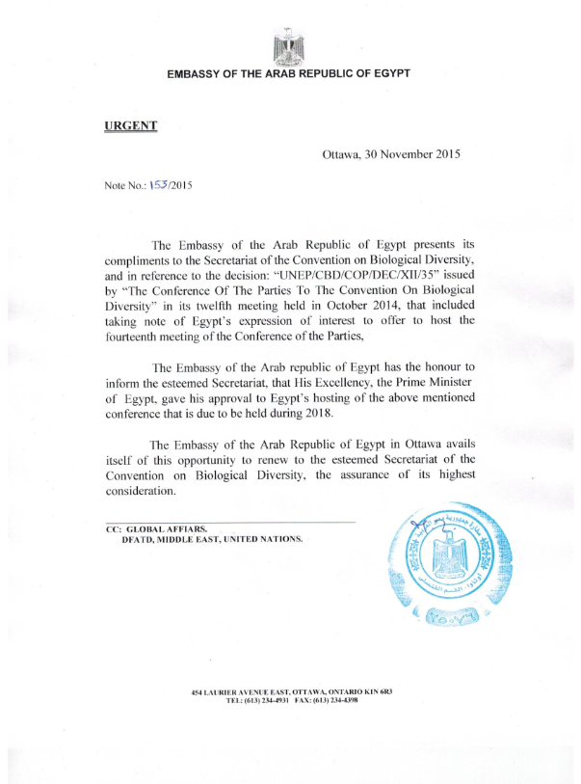

2. Copy of the letter from Turkey
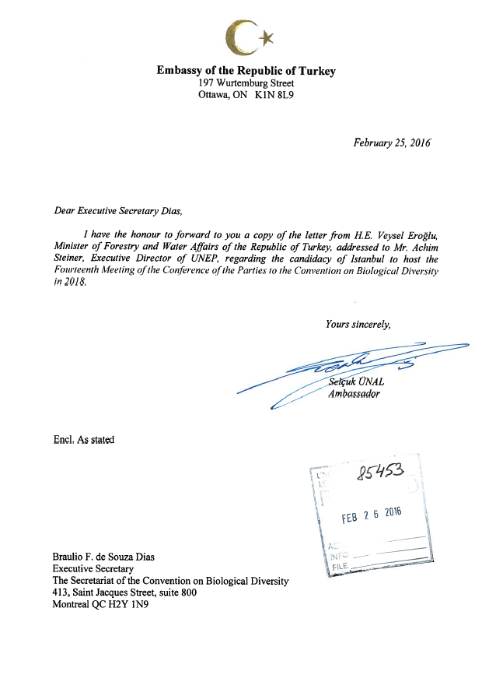

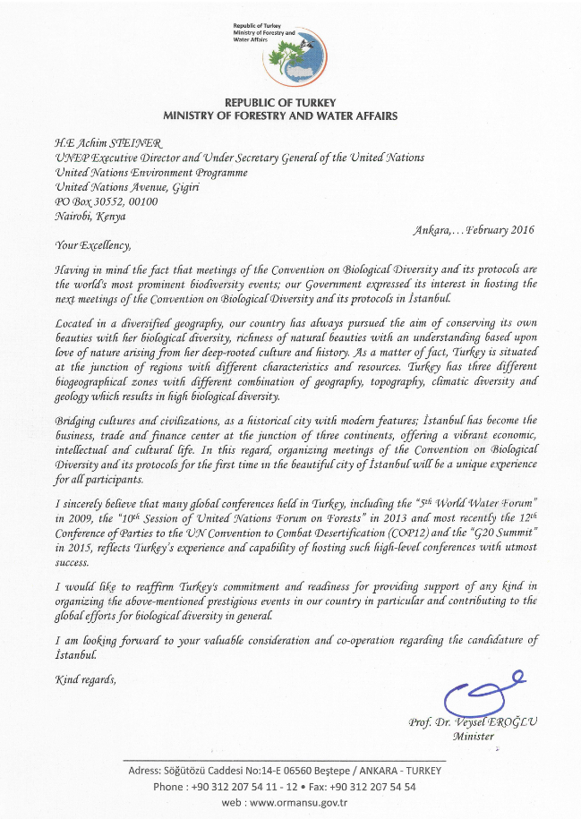

3. Copy of the letter from Peru
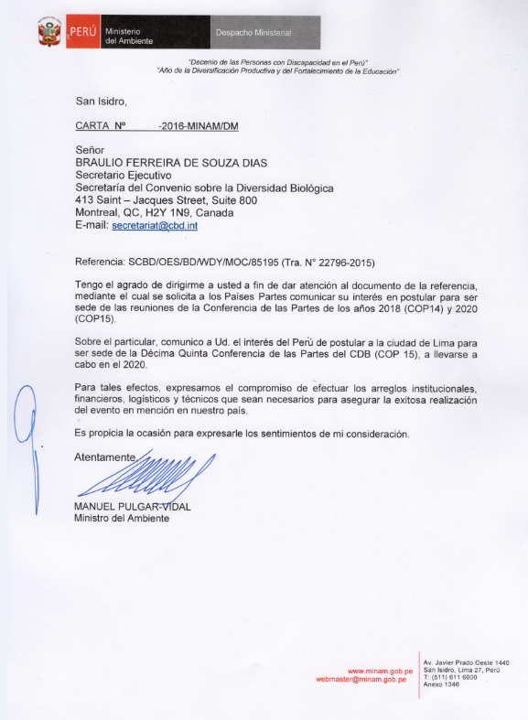

4. Copy of the letter from China
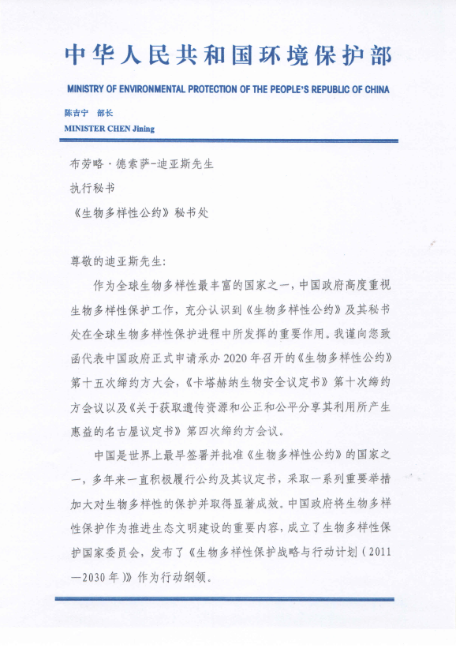
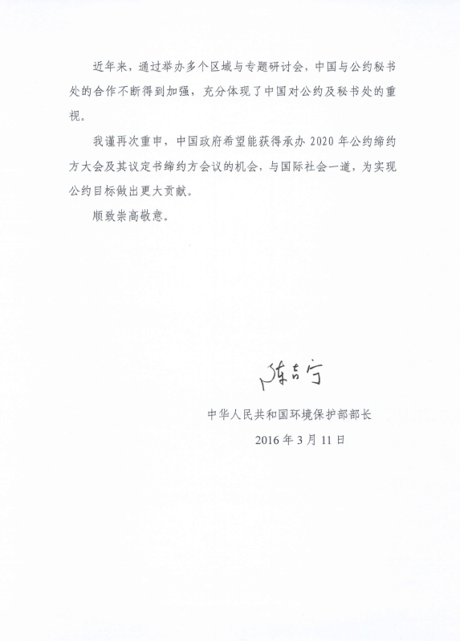

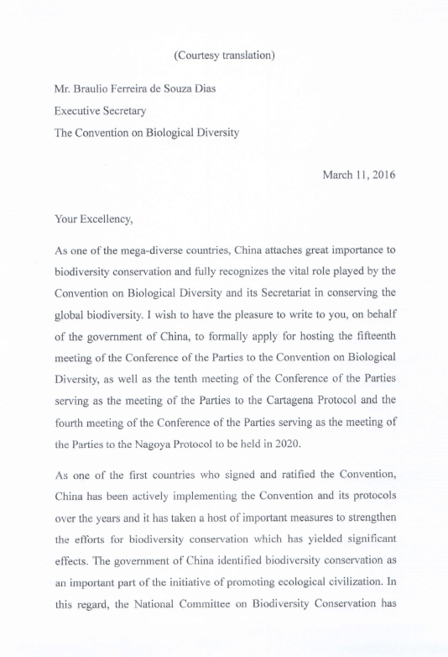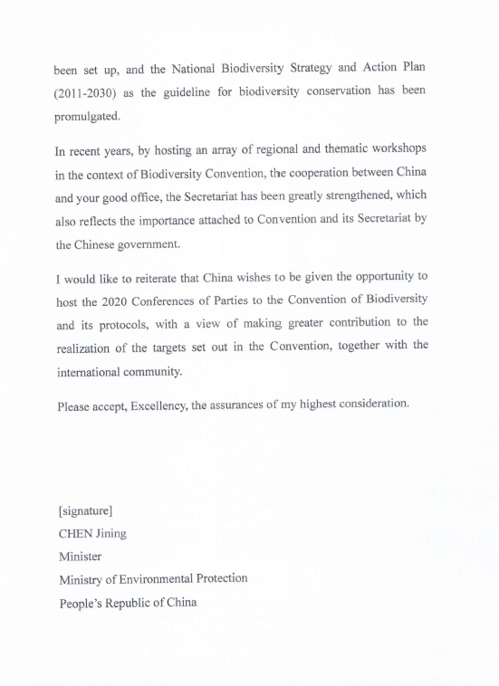

__________

* UNEP/CBD/SBI/1/Rev.1.
* Not Party to the Cartagena Protocol at the date of opening of COP-MOP 6.
^ Party to the Nagoya Protocol at the date of opening of COP-MOP 1

