 |  |  | CBD
 |  | CONVENTION ON  BIOLOGICAL DIVERSITY |  |  | Distr.  GENERAL  UNEP/CBD/SBSTTA/10/INF/14  17 December 2004  ORIGINAL: ENGLISH
SUBSIDIARY BODY ON SCIENTIFIC, TECHNICAL AND TECHNOLOGICAL ADVICE
Tenth meeting
Bangkok, 7-11 February 2005
Item 5.4 of the provisional agenda*

Indicators for assessing progress towards the 2010 target:
Trends in genetic diversity of domesticated animals, cultivated plants, and fish species of major socio-economic importance
Note by the Executive Secretary

I. Summary
- The loss of species and ecosystems often obscures equally large and important threats to genetic diversity within species. Genetic resources have always been essential to agriculture and advances in biotechnology have increased the potential value of the genetic diversity present in genetic resources for improving production and productivity. Genetic diversity in agriculture, including animal production, forestry and fisheries is critical to maintaining high yields, resistance to pests and diseases, and the ability to adapt to changing environmental conditions.
- Genetic diversity may be detected as gross morphological differences easily visible to the naked eye, as differences in performance traits, responses to pest and disease organisms or other properties such as nutritional quality or chemical content. Ultimately this variation exists as differences in DNA sequence. While molecular measures of diversity may be the most accurate and complete, they are often expensive to measure and may not best reflect differences important to producers and users.
- The genetic diversity present in crop and livestock present in farming systems is most commonly structured as distinct varieties either, “local” or “traditional” (landraces) or improved (the result of modern deliberate breeding programmes). Farmers and local breeders frequently have expert knowledge about distinct varieties of plants and animal and their characteristics. Such information, however, is not necessarily shared, the name used locally for a certain variety may differ from one place to the next and the varieties themselves are often dynamic and changing with respect to their genetic constitution and properties. This makes it difficult to ascertain the loss of a particular variety or to determine its significance in respect of the actual loss of genetic diversity.
- Although comprehensive data on the genetic diversity of domesticated animals and many cultivated plants, and their genepools, as well as a few tree and fish species are available, little information is available on trends in situ and development of a direct indicator of genetic diversity for these species requires additional work. /
- Meanwhile, extensive data exist on ex situ collections of crop genetic resources. These could provide a good indicator of the effectiveness of conservation efforts with respect to the genetic diversity available to agriculture.
- The Food and Agriculture Organization of the United Nations (FAO) has established DAD-IS, a clearing-house mechanism for animal genetic resources communication and information tool for implementing the FAO Global Strategy for the Management of Farm Animal Genetic Resources (AnGR). / This central system facilitates documentation of AnGR at national level. The FAO World Watch List for domestic animal diversity / provides information on the current state and recent trends of over 5,000 animal breeds. A global early warning system for AnGR is under development. More information will be generated through the process of the first Report on the State of the World’s Animal Genetic Resources for Food and Agriculture.
- FAO also maintains a database of ex situ collection of crop genetic resources (the World Information and Early Warning System for Plant Genetic Resources for Food and Agriculture). However, there is no global database at present (and no consistent system of recording information at country level) that would provide information on the amount of crop and useful plant diversity in production systems. Nevertheless, various potential indicators have been identified / and could be applied and gradually developed further. Indicators on the quantity and the quality of ex situ material conserved could be delivered. There have also been various attempts to estimate the proportion of total diversity of a crop that is conserved. / More qualitative indicators of in situ maintenance efforts are available using as a baseline reports from countries to first Report on the State of the World’s Animal Genetic Resources for Food and Agriculture / and the report on on-farm management of crop genetic diversity: paper submitted by the International Plant Genetic Resources Institute (UNEP/CBD/SBSTTA/7/INF/7). Figure 1 shows the increasing number of long-term facilities for storing genetic material and the number of accessions.
Figure 1. Global number of genebanks with long-term storage facilities and number of accessions of plant genetic resources (from Fowler & Hodgkin in press).
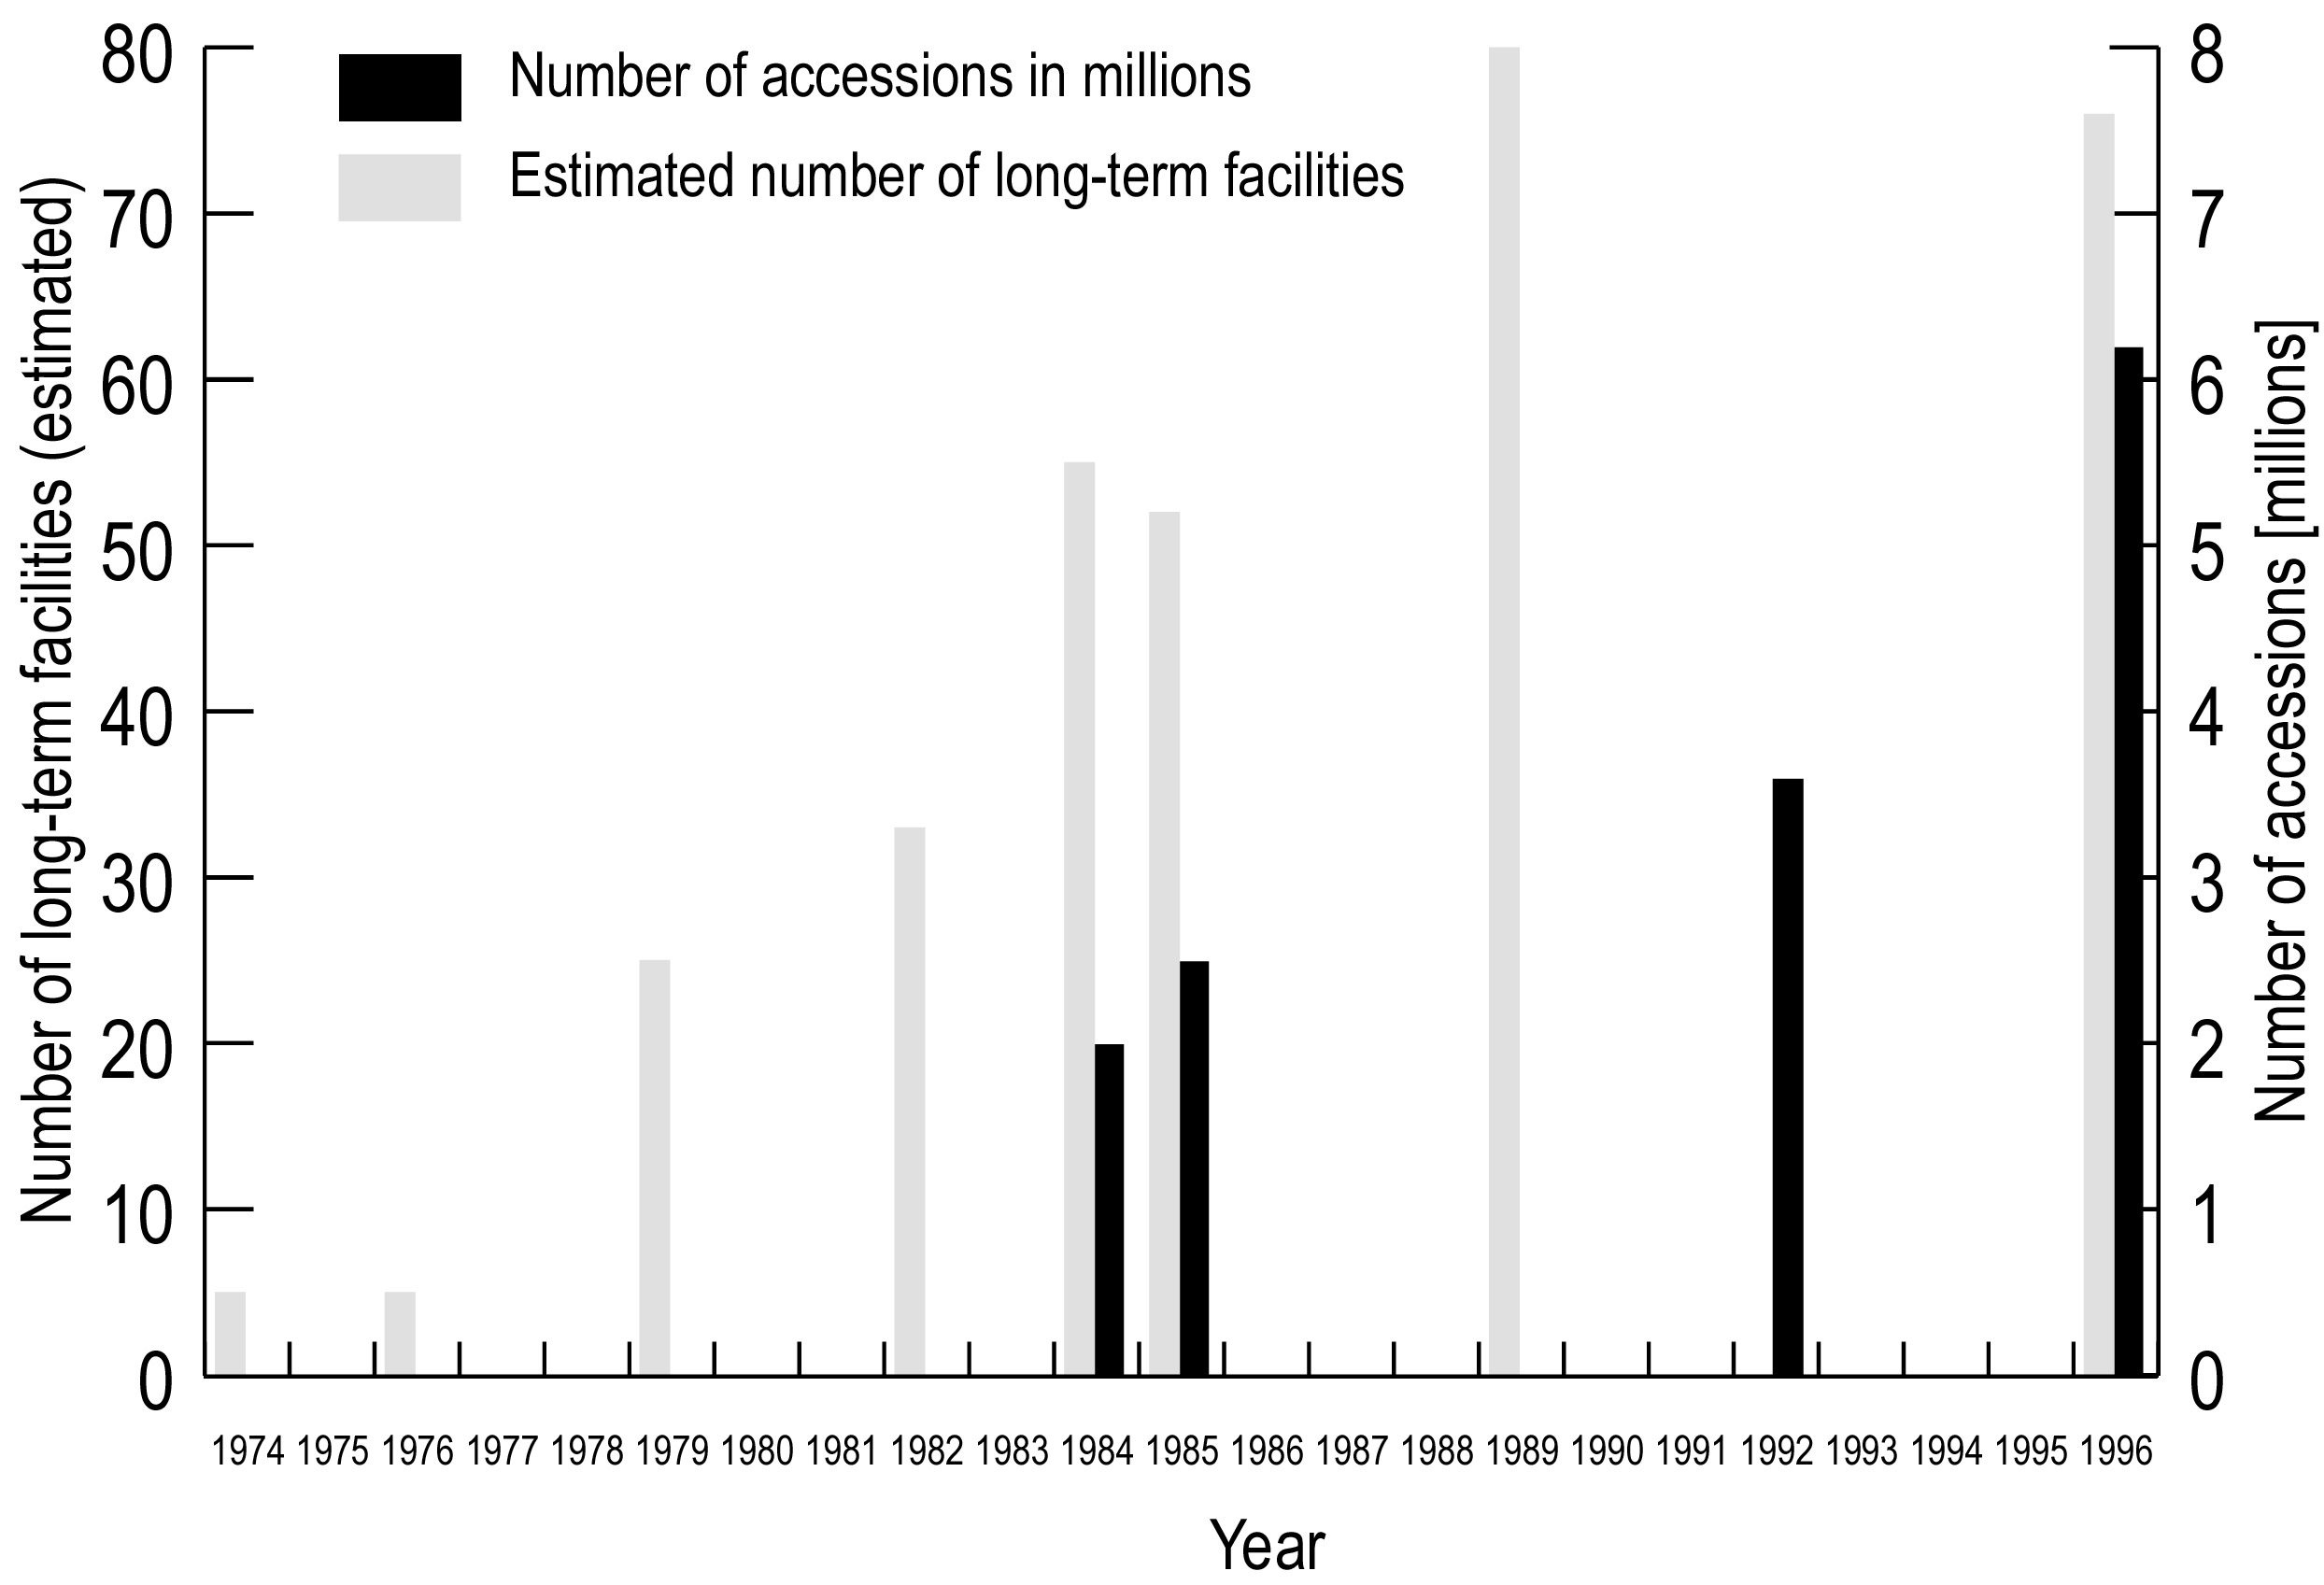
- For aquatic species, data are available particularly for salmonids (salmon and trout), and increasingly for carps and tilapia. This information base is being enhanced through increasing interest in the genetic improvement of cultivated stocks, which often requires investigating and sourcing pure stocks from the wild. FAO has access to data for these species / and the World Fish Centre is a lead agency for the conservation of wild, and the improvement of domesticated, carp and tilapia.
- The AHTEG recognized that most of the approaches have problems in being too complex, not sufficiently representative of the global status, or involving too many measures. A major problem is that the analytical work needed to combine different measures into one or two simple and understandable indicators has yet to be done. Nevertheless, the AHTEG considered the available information and methodologies sufficient to start testing and using this indicator and resolving the problems of analysis and integration.

II. Relation of THE indicator to THE focal area
- The indicator on trends in genetic diversity focuses on species in production systems. This complements information on natural ecosystems and wild species. Efforts to conserve genetic diversity in situ focus on centres of origin and centres of diversity in which complexes of crop ancestors were domesticated. These can be overlapped with protected area maps to identify possible gaps in the conservation of these resources.
- The indicator also relates to sustainable use: in situ loss of genetic resources is a measure of unsustainable management. Threats to biodiversity apply to all levels of biological organization: a reduction in threats to biodiversity increases the likelihood of maintaining and increasing genetic diversity.
- Among the indicators on ecosystem integrity and ecosystem goods and services, the one on biodiversity used in food and medicine is particularly relevant to the indicator on trends in genetic diversity. The reduction in diversity of human diet is a consequence of reliance on fewer crops produced in highly intensive production systems relying on a small number of distinct varieties.
- Much of the knowledge about genetic diversity and the specific characteristics of particular varieties of crops is held by local farmers. An indicator on the status of traditional knowledge, innovations and practices might capture this.

III. General description of THE indicator
- Genetic diversity comprises the total genetic variation present in a population or species, in any given location. It can be manifested in different phenotypes and their different uses. It can be characterized by three different facets: (1) number of different entities (e.g.: the number of varieties used per crop; the number of alleles at a given locus); (2) evenness of the distribution of these entities, and/or (3) the extent of the difference between the entities (as in the case of pedigree date, for example). With crop varieties or livestock it is possible that the overall genetic diversity decreases while the number of varieties or breeds increases in a region. Diversity within varieties or breeds could be gauged by taking into account the population size of the various breeds. The three facets could be combined to result in an indicator analogous to the Species Assemblage Trend Index for wild species (see Global Indicator 2 on Trends in abundance and distribution of selected species.)
- Some data on the genetic diversity of domesticated animals and many cultivated plants, and their genepools, as well as a few tree and fish species are available could be used to provide a indicator of genetic diversity for these species.
- Fact sheets on the number and share of crop varieties and on the number of livestock breeds were presented in documents UNEP/CBD/SBSTTA/9/INF/7 and UNEP/CBD/SBSTTA/9/INF/26. Information on indicators of genetic diversity of plant genetic resources has been provided by FAO and IPGRI. /
- The indicator provides direct information on biodiversity trends within agro-ecosystems and aquaculture, e.g. a decrease in abundance of many (such as traditional varieties, landraces, breeds) and increase of a few others (such as high external input/high productive varieties, living modified organisms). An analysis of farm units with respect to the ratio between registered/certified varieties and locally known crop types in use is an indicator of the type of agricultural system. The share of major varieties in the total production for individual crops describes the evenness of biodiversity in use. It also relates to Global Indicator 7 on biodiversity used in food and medicine.
- In fisheries, the situation is more complex. For example, mixed-stock harvest of wild and enhanced salmon stocks greatly complicates the conservation of salmon diversity. Unless it is possible to selectively harvest different populations, the overall harvest rate must be reduced to ensure the conservation of the vulnerable stocks in a mixed-stock harvest.
- FAO, the International Livestock Research Institute (ILRI), the International Plant Genetic Resources Institute (IPGRI) and various regional and national institutes hold data on specific domesticated resources. Data are particularly good for registered varieties and for some heritage varieties. Reasonable data exist for land races of major crops and are held by specialized institutions, e.g. the International Rice Research Institute (IRRI), International Potato Center (CIP), the International Maize and Wheat Improvement Center (CIMMYT). Information on locally important crops, e.g. tef, various millets, are limited although a substantive body of traditional knowledge exists on these taxa.
- Under the World Information and Early Warning System for Plant Genetic Resources for Food and Agriculture (WIEWS), / FAO is developing national information sharing mechanisms on the implementation of the Global Plan of Action in collaboration with member States. FAO hold data on the numbers and characteristics of ex situ collections and on the total numbers of crop and forage accessions maintained in ex situ collections, which was collected in 1996 and 2003. A new survey is currently being carried out and the data will be published in the second Report of the State of the World’s Plant Genetic Resources for Food and Agriculture, planned for 2008, so that there is a possibility to start a time series. The data can be analysed globally and partitioned by species or by region. One problem to be resolved in developing the indicator is the fact that farmers and genebanks often maintain similar or identical varieties and accessions. Some account of the extent and significance of this would be needed in arriving at overall estimates of total genetic diversity conserved and the changes that have occurred over any chosen time period.
- The FAO World Watch List for domestic animal diversity / provides information on their current state and recent trends (see figure 2 on page 6 below). Nine of the 14 most important species (cattle, horse, ass, pig, sheep, buffalo, goat, chicken, duck) may account for as many as 4,000 breeds worldwide. Of 5,300 breeds, representing 35 species, 30% face extinction. Extinction risk for mammalian breeds is 35 per cent, for bird breeds 63%. Information on 1,671 breeds from eight domesticated species indicates that 448 of these are at risk of extinction.
- Although there is some information on trends in genetic diversity of selected crops and domesticated animals no systematic data are available that would allow deriving trends in genetic diversity in situ. Neither is a methodology in place that could combine different datasets.
- Meanwhile, the indicator may be initially based on ex situ collections of plant genetic resources for food and agriculture (see section I) and on other data sets related to domestic animal genetic diversity..
- At the moment an agreed methodology to measure trends in genetic diversity of forest trees is not yet developed and many of the genetic diversity indicators in current criteria and indicator processes are not effective, or lack practicality. / Very basic indicators on genetic diversity (for example distribution of tree species in different ecological zones) could be developed within the coming years.
Figure 2. Risk status of the world’s mammalian and avian breeds. Comparison of status of breeds recorded up to May 1995 and December 1999 respectively within 16 species of mammals (alpaca, ass, Bactrian camel, buffalo, cattle, deer, dromedary, goat, guanaco, horse, llama, pig, rabbit, sheep, vicuña, yak) and 14 species of birds (cassowary, chicken, duck, emu, goose, Guinea fowl, Muscovy duck, nandu, ostrich, partridge, pheasant, pigeon, quail, turkey).
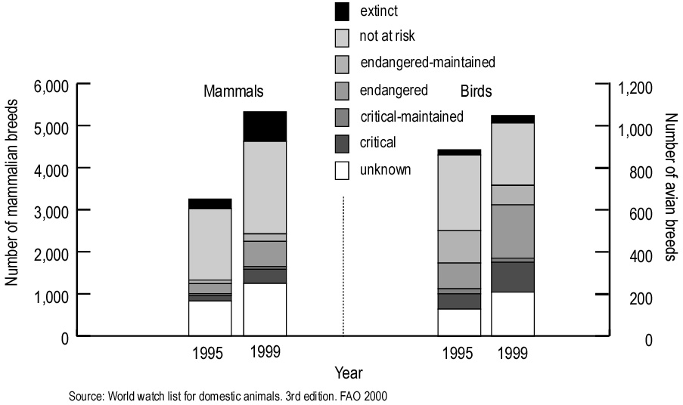

IV. Policy relevance
- The fair and equitable sharing of the benefits arising out of the utilization of genetic resources is one of the objectives of the Convention on Biological Diversity. A precondition to accruing benefits is that these genetic resources are conserved and sustainably used. Articles 8 and 9 contain provisions and list measures for in situ and ex situ conservation, respectively. Article 15 regulates the access to genetic resources, while Article 19 and the Cartagena Protocol on Biosafety contain provisions about the handling and trade of biotechnology and living modified organism.
- The International Treaty on Plant Genetic Resources for Food and Agriculture, adopted in November 2001, will enter into force in early 2005. This legally binding treaty covers all plant genetic resources relevant for food and agriculture. Its objectives are the conservation and sustainable use of plant genetic resources for food and agriculture and the fair and equitable sharing of benefits derived from their use, in harmony with the Convention on Biological Diversity, for sustainable agriculture and food security.
- The Commission on Genetic Resources for Food and Agriculture (CGRFA) is a permanent forum where governments discuss and negotiate matters relevant to genetic resources for food and agriculture. The main objectives of the CGRFA are to ensure the conservation and sustainable utilization of genetic resources for food and agriculture, as well the fair and equitable sharing of benefits derived from their use, for present and future generations. During its tenth regular session, in November 2004, the Commission “adopted the revised indicators and reporting format for monitoring the implementation of the Global Plan of Action”. / The Commission “supported FAO continuing to lead the development of agricultural biodiversity indicators, including indicators on genetic resources for food and agriculture (inter alia of domestic animals, fisheries and plants) to assist in determining progress towards the Convention’s 2010 target for significantly reducing the current rate of biodiversity loss”. The Commission “decided that it would accept the invitation of the Conference of the Parties to the Convention on Biological Diversity, to consider how the Global Plan of Action can contribute to the Global Strategy for Plant Conservation, in particular target 9, / and noted the need for, and importance of higher order indicators in this regard”. /
- The protection and sustainable management of biodiversity—including genetic resources, species and ecosystem services that support human development—is central to achieving the Millennium Development Goals. Paragraphs 44 (n) and (o) of the Plan of Implementation of the World Summit on Sustainable Development calls for the wide implementation of and continued work on the Bonn Guidelines on Access to Genetic Resources and Fair and Equitable Sharing of Benefits arising out of their Utilization and the negotiation of an international regime to promote and safeguard the fair and equitable sharing of benefits arising out of the utilization of genetic resources.
- In decision VI/9, on the Global Strategy for Plant Conservation, the Conference of the Parties adopted the following target 9: “70 per cent of the genetic diversity of crops and other major socio-economically valuable plant species conserved, and associated indigenous and local knowledge maintained”.

V. Technical information
- A number of indicators for agricultural biodiversity and genetic resources have been proposed in various documents and expert meetings. / / / They have been reviewed and discussed in detail. / / In many cases, the indicators that are considered to be particularly policy-relevant and analytically sound are the most difficult to measure. The most reliable data are available on ex situ conservation efforts such as:
- Number of breeds/varieties conserved;
- Number of accessions/doses by breed/variety.
- The information is based on reports from genebanks, field genebanks and botanic gardens on the specimens conserved within their collections. The FAO World Information and Early Warning System database currently lists more than 1300 germplasm collections, ranging in size from the United States National Seed Storage Laboratory with more than 500,000 accessions, to a collection in the United States with a single accession. /
- Globally, over 400 collections—accounting for 60 per cent of all conserved accessions—are maintained under medium- or long-term conditions. / This implies a commitment to the maintenance of collections as well as the maintenance of relevant information relevant to the indicator.

VI. Application of the indicator at national/regional level
- The indicator can be applied to the national/regional level. However, because a significant portion of domesticated animals and crops in a particular country have their origin outside the country and because the same genetic resources are frequently being utilized and stored in more than one country or genebank the relevance of applying the indicator to the national level is questionable. Efforts on both in situ and ex situ conservation of genetic resources therefore tend to have a taxonomic rather than geographic focus.

VII. Suggestions for the improvement of the indicator
- The application of the indicator to ex situ conservation efforts is driven by the unavailability of comprehensive data on the in situ conservation of genetic resources and the difficulties to integrate scattered datasets from various sources. While conservation efforts represent a response to the loss in genetic resources and a commitment to maintain diversity over the long term it is not a measure of trends in genetic diversity. Information on in situ conservation of genetic resources should be incorporated into the indicator once data and a methodology for calculating such an indicator become available.
-----

* UNEP/CBD/SBSTTA/10/1.
/ There are very rarely many, if any, quantitative data on population size changes upon which to monitor variations in the genetic diversity of forest tree species, at least in tropical areas, which account for 80% of the world total forest tree species. The genetic diversity of wild, highly variable, undomesticated forest trees is mainly conserved on site.
/ http://dad.fao.org/en/Home.htm
/ http://dad.fao.org/cgi-dad/$cgi_dad.dll/Reference?Eng#World%20Watch%20List%20for%20Domestic%20Animal %20Diversity
/ Review and development of indicators for genetic diversity, genetic erosion and genetic vulnerability (GDEV): summary report of a joint FAO/IPGRI workshop (Rome, 11-14 September, 2002)
/ See Fowler, C. and T. Hodgkin. 2004. Plant Genetic Resources for Food and Agriculture: Assessing Global Availability. Annual Review of Environment and Resources Vol. 29 (November 2004).
/ FAO. 1997. First Report on the State of the World's Plant Genetic Resources for Food and Agriculture. FAO, Rome.
/ FAOSTAT Fisheries Data: http://faostat.external.fao.org/faostat/collections?subset=fisheries
/ Review and development of indicators for genetic diversity, genetic erosion and genetic vulnerability (GDEV): summary report of a joint FAO/IPGRI workshop (Rome, 11-14 September, 2002).
/ http://apps3.fao.org/wiews/
/ http://dad.fao.org/cgi-dad/$cgi_dad.dll/Reference?Eng#World%20Watch%20List%20for%20Domestic%20Animal %20Diversity
/ FAO (2002) Status and Trends in Indicators for Forest Genetic Diversity. Document prepared by F.H. McKinnell. Forest Genetic Resources Working Paper 38. http://www.fao.org/DOCREP/005/AC786E/AC786E00.HTM
/ FAO. 2004. CGRFA-10/04/Inf.5 “Indicators and reporting format for monitoring the implementation of the Global Plan of Action for the Conservation and Sustainable Utilization of Plant Genetic Resources for Food and Agriculture”
/ Target 9: 70 per cent of the genetic diversity of crops and other major socio-economically valuable plant species conserved, and associated indigenous and local knowledge maintained
/ FAO. 2004. Report of the Tenth Regular Session of the Commission on Genetic Resources for Food and Agriculture, http://www.fao.org/ag/cgrfa/docs10.htm
/ Review and development of indicators for genetic diversity, genetic erosion and genetic vulnerability (GDEV): summary report of a joint FAO/IPGRI workshop (Rome, 11-14 September, 2002)
/ OECD. 2001. Environmental Indicators for Agriculture, Volume 3: Methods and Results. OECD, Paris.
/ OECD. 2002. Report of the OECD Expert Meeting on Agri-Biodiversity Indicators, Zürich 5-8 November, 2001. OECD, Paris.
/ Wetterich, F., 2003. “Biological diversity of livestock and crops: useful classification and appropriate agri-environmental indicators.” In OECD, 2003, Agriculture and Biodiversity: Developing Indicators for Policy Analysis. Proceedings From an OECD Expert Meeting, Zurich, Switzerland, November 2001. pp. 40-55.
/ Eaton, D., J. Windig and S.J. Hiemstra. 2004. Indicators of Biodiversity for Livestock and Crops in Agriculture. Wageningen University & Research Centre
/ S. Diulgheroff, FAO, personal communication, cited in: Fowler, C. and T. Hodgkin. 2004. Plant Genetic Resources for Food and Agriculture: Assessing Global Availability. Annual Review of Environment and Resources Vol. 29 (November 2004).
/ FAO. 1998. The State of the World’s Plant Genetic Resources for Food and Agriculture. Rome, Italy:

