 |  | CBD

 | CONVENTION ON  BIOLOGICAL DIVERSITY |  | Distr.  GENERAL  UNEP/CBD/SBSTTA/10/INF/18  17 December 2004  ENGLISH ONLY
SUBSIDIARY BODY ON SCIENTIFIC, TECHNICAL AND TECHNOLOGICAL ADVICE
Tenth meeting
Bangkok, 7-11 February 2005
Item 5.4 of the provisional agenda*

Indicators for assessing progress towards the 2010 target:
Marine trophic index
Note by the Executive Secretary

I. Summary
- The intensification of fishing to unsustainable levels has led to the effective removal of species from marine food webs. Most preferred fish catches consist of large, high value, high trophic level predatory fish, such as tuna, cod, and swordfish. Overfishing tends to lead to decline in these large predatory fish so that the relative numbers of low trophic level small fish and invertebrates increases, a phenomenon known as “fishing down marine food webs”. The biomass of top predators in the North Atlantic has decreased by two-thirds in approximately 50 years / and the mean trophic level of fisheries landings globally has declined at a rate of 0.05 to 0.1 per decade. The resulting shortened food chains leave the ecosystem increasingly vulnerability to natural and human induced stresses, and reduce the supply of fish for human consumption. Marine trophic index, which can be calculated from existing fish catch data, is therefore a good indicator of both ecosystem integrity and the sustainable use of living resources.

II. Relation of the indicator to the focal area
- An ecosystem is a functional unit comprising all the organisms in a particular place interacting with one another and with their environment, and interconnected by ongoing flows of energy and a cycling of materials. Ecosystem function includes those ecosystem level processes that contribute to the well being of humankind. Beneficial ecosystem functions are called ecosystem services and the oceans account for about two-thirds of the value of ecosystem services on a global basis. / The capacity of ecosystems to sustainably provide goods and services, such as fish and shellfish, depends on their functional integrity including the maintenance within certain limits of the ratio of primary producers (phytoplankton) to primary consumers (zooplankton such as krill), secondary consumers (primary predators such as sardines) and tertiary consumers (higher level predators such as tuna and sharks). The marine trophic index measures the change in mean trophic level of fisheries landings and therefore changes in the ecosystem’s capacity to provide goods and services. Declining trophic levels result in shortened food chains, leaving ecosystems less able to cope with natural or human-induced change. Monitoring average trophic levels of fish catches can also show when stocks of larger, predatory fish are beginning to collapse. Decline in trophic levels compromises human well-being through reduced food supply, loss of livelihoods brought about by scarce resources, and a decline in the economic value of fish catches increasingly composed of lower trophic level species. At the same time, the prices of high trophic level fish increase with scarcity, making them a luxury good that is too expensive for much of the world’s population, particularly in developing countries.

- Measures designed to optimize the natural productivity of groups of target species should therefore include consideration of related populations and their environment. This will provide a balance between maintaining productivity of the ecosystem and optimizing the yield of commercial species.

III. General description of indicator
- The marine trophic index measures the change in mean trophic level of fisheries landings by region and globally. Trophic levels range from a value of 1 for primary producers up to a level of 5 for some marine mammals. / Trophic level also changes through the life history of fish, with juveniles having lower trophic levels than adults. Unsustainable fisheries lead to a depletion of large bodied and higher trophic level species (particularly piscivorous fish) eventually leading to rarity or absence of such species and dominance of small-bodied species with high rates of population turnover, usually from lower trophic levels.
- The marine trophic index can be calculated from a combination of fisheries landings and diet composition data (see box 1).

Change in mean trophic level of fisheries landings
- The intensification of fishing has led to a process of the effective removal of species from marine food webs. Most preferred fish catches consist of large, high value, high trophic level predatory fish, such as tuna, cod, and swordfishes. Overfishing tends to lead to decline in these large predatory fish relative to low trophic level small fish and invertebrates (a phenomenon known as “fishing down marine food webs”, see box 2). It is estimated that the biomass of top predators in the North Atlantic has decreased by about two-thirds in the last 50 years / and that the mean trophic level of fisheries landings globally have declined at a rate of approximately 0.1 per decade. / The impacts on intraspecific genetic diversity are unknown.
- In reply to: addition to being an indicator of the sustainability of fisheries, the marine trophic index provides a measure of ecosystem integrity. Declining trophic levels result in shortened food chains, leaving ecosystems less able to cope with natural or human-induced change. The long-term sustainability of fisheries is, in turn, directly linked to human well-being through diminished food supply and loss of livelihoods.

Box 1: What is a trophic level?

One way to understand the structure of ecosystems is to arrange them according to who eats who along a food chain. Each link along the chain is called a trophic level. Levels are numbered according to how far particular organisms are along the chain from the primary producers at level 1, to the top predators at the highest level. Within marine systems, large predators such as sharks and saithe, are at a high trophic level, cod and sardines are in the middle, and shrimp are at a low trophic level with microscopic plants (mainly phytoplankton) at the bottom sustaining marine life.
The arrows in the figure indicate who is eating who. In this example, cod are at trophic level 5, whereas the large saithe which eat them are on trophic level 6. The small saithe, which feed on smaller prey, are at a lower trophic level. A single species may consume prey from several different levels. In this case, its trophic level is calculated according to the proportion of its diet that comes from the various trophic levels it feeds on, and will not necessarily be a whole number.
Source: Pauly and Watson 2003 as presented in the GEO Yearbook 2003

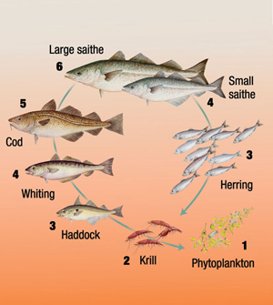
Two alternative marine food chains.
- Based on the Food and Agriculture Organization of the United Nations (FAO) world catch statistics the reduction in mean trophic level has been quantified between the years 1950 and 2000 (figure 1). The first study documenting mean trophic level decline was undertaken in 1998, / with a number of updates, including one in 2004. / The relevant data concern time series of landings of fish taken by fisheries in defined areas from all major aquatic ecosystem types. Based on their diet composition, 220 different estimates of trophic levels have been assigned to commercial fishes and invertebrates, which constitute the bulk of the global catch. The 1998 analysis showed a reduction from 3.3 in the early 1950s to less than 3.1 in 1994 for marine areas and a decrease from just over 3.0 to 2.8 in inland water fisheries. The analysis undertaken in 2004, which used a refined set of methods, showed an even stronger decline in mean trophic level, as illustrated in figure 1. As the 1950s correspond with the start of industrial fisheries, the declining trend illustrated in figure 1 could be attributed to the impacts of large-scale fisheries.

Box 2: Fishing down marine food webs

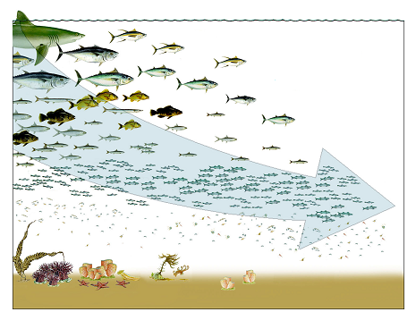

The arrow indicates how, over time, humans have depleted stocks of larger fish, which were originally closer inshore, and are now targeting smaller species, and fishes from deeper water. When bottom fishes are taken using nets dragged on the sea floor (i.e., by trawls), the habitat changes from one rich in organisms living on, or near the sea bottom, to a near-lifeless muddy substrate.
Source: Daniel Pauly, Fisheries Centre, University of British Columbia, Canada

- Several studies have confirmed that the trends in mean trophic level of selected species groups provides a reliable indicator of the integrity of an ecosystem. While this has been demonstrated for soil fauna, / and postulated as a key objective of ecosystem management, / it is considered a particularly effective indicator to assess sustainability of fishing and the integrity of marine ecosystems. /,/
Figure 1. Decline of mean trophic level of fisheries landings reported by FAO, averaged for two strata, the North Atlantic (all waters north of 26 degree North), and globally, for coastal and shelf waters down to 500 m depth. A GIS-based procedure, which overcomes some of the aggregation biases in Pauly et al.(1998), suggests stronger trophic level declines than these authors originally estimated, as has also been found in most publications meant to test the original study (graph by R. Watson, Sea Around Us Project, Fisheries Centre, UBC, Vancouver)/

IV. Policy relevance

A. Relevance to the targets of the Convention on Biological Diversity
- The marine trophic index contributes to measuring progress towards the following targets adopted in decision VII/30:
- Target 2.1: Restore, maintain, or reduce the decline of populations of species of selected taxonomic groups
- Target 4.1: Biodiversity-based products derived from sources that are sustainably managed, and production areas managed consistent with conservation of biodiversity
- Target 4.2: Unsustainable consumption, of biological resources, that impacts upon biodiversity, reduced
- Target 8.1: Capacity of ecosystems to deliver goods and services maintained
- Target 8.2: Biological resources that support sustainable livelihoods, local food security and health care, especially of poor people, maintained

B. Relevance to other processes (Millennium Development Goals, World Summit on Sustainable Development, Commission on Sustainable Development, etc.)
- The marine trophic index is relevant to the following targets in the Millennium Development Goals and the Plan of Implementation of the World Summit on Sustainable Development:
(a) Millennium Development Goals:
- Target 9: to integrate principles of sustainable development into country policies and programmes and to reverse the loss of environmental resources.
- Target 2: to halve, between 1990 and 2015, the proportion of people who suffer from hunger.
(b) Plan of Implementation of the World Summit:
- Paragraph 29 (d): Encourage the application by 2010 of the ecosystem approach, noting the Reykjavik Declaration on Responsible Fisheries in the Marine Ecosystem / and decision V/6 of the Conference of the Parties;
- Paragraph 31 (a): Maintain or restore (fisheries) stocks to levels that can produce the maximum sustainable yield with the aim of achieving these goals for depleted stocks on an urgent basis and where possible not later than 2015;
- Paragraph 32 (c): Develop and facilitate the use of diverse approaches and tools, including the ecosystem approach, the elimination of destructive fishing practices, the establishment of marine protected areas consistent with international law and based on scientific information, including representative networks by 2012 and time/area closures for the protection of nursery grounds and periods, proper coastal land use; and watershed planning and the integration of marine and coastal areas management into key sectors.

C. Significance
- Excessive fishing is the most widespread and dominant human impact on ocean ecosystems and is a major impact on marine biodiversity. According to FAO statistics, total capture fisheries production in 2000 reached 94.8 million tonnes, the highest level ever. / The lowered biomasses and fragmented habitats resulting from the impacts of fishing are predicted to lead to local extinctions especially among large, long-lived, slow growing species and any endemics. In addition, the capacity of component ecosystems and their embedded species to withstand stresses resulting from climate change and other human impacts is likely reduced. As a result, food security and livelihoods of coastal communities, particularly in developing countries, are compromised. Through elimination of destructive fishing practices, and maintenance and restoration of fisheries stocks to sustainable levels, the loss of marine biodiversity in the oceans can be reduced.
- The majority (71 per cent) of the Earth is covered by marine systems. The oceans, besides representing repositories of biodiversity, play a significant role in climate regulation, the freshwater cycle, food provisioning, and energy and cultural services, including recreation and tourism. They are also an important source of economic growth, with capture fisheries alone worth approximately $81 billion in 2000. /
- The current strong downward trend in mean trophic level of fisheries catches (figure 1) indicates that ocean ecosystems globally are being damaged by excessive fishing. Reversing this trend would require a drastic reduction in fishing effort in the context of ecosystem-based management of fisheries.

D. Linkages with other indicators
- This indicator could be linked with all three indicators under status and trends of the components of biological diversity. This indicator would likely also be related to any sustainable use indicator that will be developed in the future, such as the Fish in Balance (FIB) index referred to in the note on indicators for assessing progress towards the 2010 target: possible indicators for development prepared for the meeting of the Ad Hoc Technical Expert Group (UNEP/CBD/AHTEG-2010-Ind/1/3). A computation of the FIB index would require an initial calculation of mean trophic level series, and this work could be undertaken as part of the work on the marine trophic index.
- The marine trophic index can also be linked to other ecosystem integrity indicators (such as nitrogen deposition and water quality) through its ability to contribute to determining the extent of “dead zones” or areas of water that are too low in dissolved oxygen to sustain life. The mean trophic level in dead zones is 1, which the lowest possible trophic level.

E. Targets
- No international targets have been established for this indicator.

F. International conventions and agreements
- Relevant international agreements and conventions include the United Nations Convention on Law of the Sea (UNCLOS), the FAO Code of Conduct for Responsible Fisheries, a variety of fisheries agreements, and the regional seas conventions and action plans.

V. Technical information
- The marine trophic index is a pressure indicator of sustainable use of the world’s fisheries. The mean trophic level of landings is a numerical value. Trophic levels range from a definitional value of 1 for primary producers up to a level of 5 for marine mammals and humans. /
- Trophic level is defined as the position of an organism in the food chain, determined by the number of energy-transfer steps to that level. / The role of fishes within ecosystems is largely a function of their size: small fish are more likely to have a vast array of predators than very large ones. On the other hand, various anatomical and physiological adaptations may lead to dietary specialization, enabling different fish species to function as herbivores, with a trophic level of 2.0, or as carnivores, with trophic levels typically ranging from 3.0 to about 4.5.
- Moreover, trophic levels change during the life history of fishes. Larvae, which usually feed on herbivorous zooplankton (TL= 2.0) consequently have a trophic level of about 3.0. Subsequent growth enables the juveniles to consume larger, predatory zooplankton and small fishes or benthic invertebrates; this leads to an increase in trophic level, often culminating in values around 4.5 in purely piscivorous, large fishes. /
- Because of the close relationship between trophic level and size, mean trophic levels reflect changes in both size composition and position in the food chain, and therefore ecological roles. Overfishing tends to lead to decline in large, high trophic level fish relative to low trophic level small fish and invertebrates. This leads to “fishing down marine food webs”, where fisheries, first having removed the larger fishes at the top of various food chains, must target fishes lower and lower down, and end up targeting very small fishes and plankton. /
- Trophic decline, combined with decreasing biomass, leads to changes in the structure of ecosystems. Long food chains are being replaced by shorter ones, which expose top predators to the strong environmentally-driven fluctuations exhibited by plankton organisms at the base of food webs. Such fluctuations were previously dampened by food webs with a variety of strong and weak links. Thus the biomass of fish species targeted by fisheries will fluctuate more widely than before, making fisheries increasingly difficult to manage and increasingly vulnerable to environmental changes, such as climate change. /
- It should be noted that environmental factors, such as eutrophication of coastal areas, may cause an increase in plankton-eating lower trophic level fish, particularly in semi-enclosed seas / / Upwelling of nutrient-rich water may result in a similar increase in lower trophic level species, as can periods of warmer water temperatures. / In addition, technological developments, such as use of synthetic fibre, have increased our ability to target lower trophic level species. However, environmental and technological effects alone cannot explain the steady decline in global mean trophic levels seen in figure 1, as such effects tend to be restricted to coastal areas and will therefore likely have only a relatively minor impact on the overall trend. This observation is supported by a recent study undertaken in the Celtic Sea, where a significant decline in mean trophic level of both survey catches and landings was observed, implying a substantial change in underlying structure of the Celtic Sea fish community as a result of intensive fishing, though long-term climate variability may have been a contributing factor. The study also demonstrated that market pressures were not a cause of the observed decline in trophic level. /
- It is possible to filter out bottom up environmental and gear-related effects when calculating mean trophic level trends by excluding fish and invertebrates below a certain trophic level from the calculations. Pauly and Watson / have proposed that the marine trophic index of the Convention on Biological Diversity be abbreviated “^{cut}MTI”, with the superscript referring to the lowest (‘cutoff’) trophic level value used in the computation. This approach would emphasize changes in the relative abundance of the more threatened, high-trophic level fishes while eliminating the highly variable and abundant small pelagic fishes. Figure 2 provides a global map of long-term change in ^{3.25}MTI. The value of 3.25 was used as standard cutoff trophic level to eliminate herbivores, detritivores, and especially planktivores. Figure 2 shows changes occurring over an area 1.6 times larger than suggested by using overall mean TL, corresponding to ^{2.0}MTI. This demonstrates that ^{cut}MTI, when the cutoff trophic level is judiciously chosen, is a more powerful indicator than grand mean trophic levels used so far by D. Pauly and his colleagues. Figure 2 also shows, by the same token, that bottom up effects, like the other potential sources of bias, only led to a masking effect.

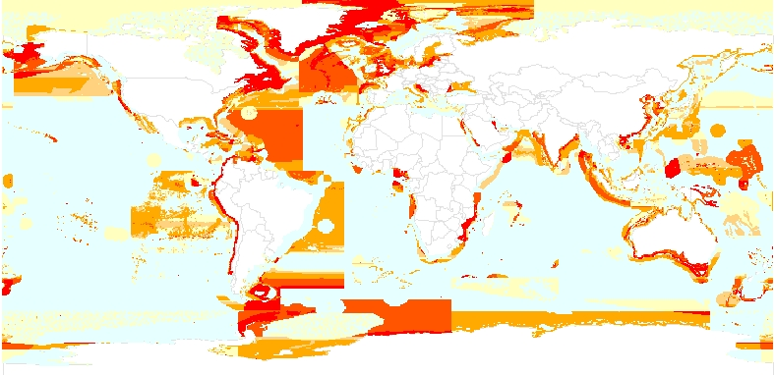

Figure 2A.
Trophic level change
"
≤
-0.5
"
> -0.5 - -0.3
"
> -0.3 - -0.1
"
> -0.1 - -0.05
"
> -0.05 - < 0
"
≥
0

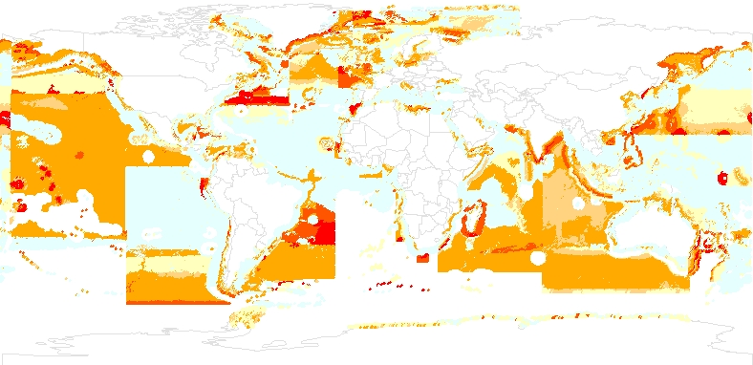

Figure 2B

Figure 2. Maps illustrating changes in marine trophic index (i.e., mean trophic level of fisheries catches from the early 1950s to the present.
A: Changes in grand mean trophic levels, corresponding to ^{2.0}MTI (see text), based on FAO statistics dissagregated using method of Watson et al. (2004);
B: Same data, but with trophic levels below 3.25 not included, and hence with maps representing changes in the values of ^{3.25}MTI. Note increase of the areas with negative changes, indicating that ^{3.25}MTI is more sensitive than ^{2.0}MTI .
[In both panels, the straight borders between colours, and the areas of positive change largely represent artefacts of the underlying FAO statistics; the white areas in panel B represent cells with catches of less than 1000 t.].

Measurement methods
- Two data sets are needed to calculate the indicator: (i) catch data by taxonomic groups, and (ii) one estimate of trophic level for each of these groups.
- One of the sources for (i) (catch data by taxonomic group) are the FAO, which created and maintains a global data set, available online (at www.fao.org). This data set can be used for calculating the indicator, from 1950 to the present minus 2 years, for the landings of individual countries, the landings of 18 statistical areas largely representing ocean basins, and globally. Another source of data for (i) is the online database of the Sea Around Us Project (www.seaaroundus.org), whose geo-referenced data pertain to the exclusive economic zones (EEZ) of all maritime countries, to Large Marine Ecosystems (LME) and to the High Seas, outside of EEZ.
- Trophic level estimates for fish, based on their diet composition, may be found in FishBase, the global online database on fish, and for invertebrates, in the Sea Around Us database. Another source are the ecosystem food web models constructed using the widely used Ecopath software (see www.ecopath.org). Stable nitrogen isotopes of stomach contents, which provide longer-term data on the trophic level of a particular species, have also been used in some studies. /
- By combining these two data sets, mean trophic levels of landings can be estimated for any of the world’s country or area, as illustrated in figure 1.
- The FAO has collected data on capture fisheries from all maritime countries and / analysed global trends in fisheries stocks since 1950. These data are reported in aggregated format, by 18 broad FAO regions, and present a solid basis for undertaking a global analysis of mean trophic level change.
- In an effort to provide fisheries data on a finer scale, the Sea Around Us Project (SAUP) (www.seaaroundus.org) has disaggregated the FAO data into spatial cells measuring ½ a degree latitude by ½ a degree longitude. This procedure makes it possible to report landings taken with a range of statistical boundaries, including by country EEZs, large marine ecosystems, and high seas areas. In this process, the SAUP has also substituted data from regional organizations such as the International Council for the Exploration of the Sea (ICES) (www.ices.int/fish/statlant.htm), the Northwest Atlantic Fisheries Organization (NAFO) (www.nafo.ca/) and others. This provides a finer spatial catch breakdown for most of the Atlantic and the Mediterranean. Where possible, they have also added national datasets, e.g.from Canada’s Department of Fisheries and Oceans (DFO) for Atlantic Canada. Plans are underway to include more national and smaller scale datasets in other areas as well, thus mitigating the problem of taxonomic resolution and incomplete coverage mentioned above.

Limitations of the indicator
- The marine trophic index is a powerful indicator of marine ecosystem integrity and sustainability of fisheries. Its main limitations are (i) the use of catch composition data as index of relative abundance in the ecosystems, and (ii) the quality of the underlying fisheries landings or catch data. The current data quality is sufficient for global and regional level analyses. For some maritime countries, the quality of the data is low (little taxonomic resolution, failure to cover inshore fisheries), and hence the computed index is not as indicative as it could be. Note, however, that no one indicator alone can provide a comprehensive picture of the “health” of the oceans, and that such an assessment would require a number of additional data sources/indicators.

Data quality
- At the present time, the quality of the available data is sufficient for undertaking global and regional level analyses of mean trophic level trends. It should be noted that fisheries catch statistics do not include fish discarded at sea, and other unrecorded (including illegal) catches. Therefore, the actual catches are substantially higher than those reported in the statistics. Data quality is also affected by misreporting driven by perverse incentives of fisheries management regimes. For example, in some cases higher trophic level fish may be misreported as lower level trophic level fish. The effect of such misreporting on calculation of the marine trophic index is difficult to estimate at finer spatial scales. On broader spatial scales, the use of many different landings data sets would minimize the effect of errors in any one particular data set.

Data sustainability
- Data sustainability is excellent, as the FAO collects fisheries statistics on an on-going basis. In addition, data collected by Census of Marine Life and entered into the Ocean Biogeographic Information System (OBIS) may contribute to this work in the future.

Agencies involved in the implementation of the indicator
- Agencies involved in the implementation of the indicator include the Sea Around Us project of University of British Columbia Fisheries Centre and the FAO.

VI. Application of the indicator at national/regional level
- Change in mean trophic level of fisheries landings will be calculated by region and globally. Depending on data quality, this indicator can also be used nationally. However, in many cases, data quality may not, as of yet, be sufficient to support the undertaking of such calculations for each country.

VII. Suggestions for the improvement of the indicator
- The marine trophic index provides a robust indicator of ecosystem integrity and the sustainability of fishing at the global and regional levels. Additional improvement in fisheries catch data would be required before the indicator can be used on the national level by all countries.
-----

* UNEP/CBD/SBSTTA/10/1.
/ Christensen, V., Guénette, S., Heymans, J.J., Walters, C.J. Watson, R., Zeller, D. and D. Pauly, (2003) Hundred-year decline of North Atlantic predatory fishes. Fish and Fisheries, 4: 1-24.
/ http://www.oceansatlas.org/
/ Pauly, D. and J. MacLean (2003). In a perfect ocean: the state of fisheries and ecosystems in the North Atlantic Ocean. Island Press, Washington, D.C.
/ Christensen, V., Guénette, S., Heymans, J.J., Walters, C.J. Watson, R., Zeller, D. and D. Pauly, (2003) Hundred-year decline of North Atlantic predatory fishes. Fish and Fisheries, 4: 1-24.
/ Pauly, D, Christensen, V., Dalsgaard, J., Froese, R., and F. Torres (1998) Fishing Down Marine Food Webs. Science, 279: 860-863.
/ Pauly, D, Christensen, V., Dalsgaard, J., Froese, R., and F. Torres (1998) Fishing Down Marine Food Webs. Science, 279: 860-863.
/ Watson, R., A. Kitchingman, A. Gelchu and D. Pauly (2004) Mapping global fisheries: sharpening our focus. Fish and Fisheries 5: 168-177.
/ Stork, N. E., & P. Eggleton. 1992. Invertebrates as determinants and indicators of soil quality. Am. J. Altern. Agric.7: 38-47.
/ Grumbine, R.E. 1994. What is ecosystem management? Conservation Biology 8(1): 27-38.
/ Pauly, D., Christensen, V., Dalsgaard, J., Froese, R. & Torres Jr., F. 1998. Fishing Down Marine Food Webs. Science 279: 860-863.
/ Measuring biodiversity for conservation. The Royal Society Policy document 11/03, August 2003.
/ Ibid.
/ See Food and Agriculture Organization of the United Nations document C200/INF/25, appendix I.
/ FAO. 2002. The State of World Fisheries and Aquaculture 2002. FAO, Rome
/ Ibid.
/ Pauly, D. and J. MacLean (2003). In a perfect ocean: the state of fisheries and ecosystems in the North Atlantic Ocean. Island Press.
/ http://www.fishbase.org/Glossary/Glossary.cfm
/ Pauly, D., Froese, R. and Palomares, M.L. (2000). Fish On Line: A draft guide for using the FishBase Information System. http://www.fishbase.org/FishOnLine/index.htm
/ Pauly, D. and J. MacLean (2003). In a perfect ocean: the state of fisheries and ecosystems in the North Atlantic Ocean. Island Press, Washington, D.C.
/ Ibid.
/ Caddy, J.F., Csirke, J., Garcia, S.M. and R.J.L. Grainger (1998). How pervasive is “fishing down marine food webs”? Science, 282: 1383-1384.
/ De Leiva Moreno, J.I., Agnostini, V.N., Caddy, J.F. and F. Carocci (2000). Is the pelagic-demersal ratio from fishery landings a useful proxy for nutrient availability? A preliminary data exploration for the semi-enclosed seas around Europe. ICES Journal of Marine Science, 57: 1091-1102.
/ O’Brien, C.M., Fox, C.J., Planque, B. and J. Casey (2000). Climate variability and North Sea cod. Nature, 404:142.
/ Pinnegar, J.K., Jennings, C., O’Brien, M. and N.V.C. Polunin (2002). Long-term changes in the trophic level of Celtic Sea fish community and fish market price distribution. Journal of Applied Ecology, 39: 377-390.
/ Pauly, D. and R. Watson (in press) Background and interpretation of the Marine Trophic Index as a measure of biodiversity. Philosophical Transactions of the Royal Society of Biological Sciences.
/ Ibid.
/ FAO. 2001. The State of World Fisheries and Aquaculture 2000. FAO, Rome.

