 |  |  | CBD
 |  | CONVENTION ON  BIOLOGICAL DIVERSITY |  | Distr.  GENERAL  UNEP/CBD/SBSTTA/11/7/Add.1  31 August 2005  ORIGINAL: ENGLISH
SUBSIDIARY BODY ON SCIENTIFIC, TECHNICAL AND TECHNOLOGICAL ADVICE
Eleventh meeting
Montreal, 28 November – 2 December 2005

Item 5.2 of the provisional agenda*

IMPLICATIONS OF THE FINDINGS OF THE MILLENNIUM ECOSYSTEM ASSESSMENT FOR THE FUTURE WORK OF THE CONVENTION

Addendum

SUMMARY FOR DECISION MAKERS OF THE BIODIVERSITY SYNTHESIS REPORT

Note by the Executive Secretary
- At its seventh meeting, the Conference of the Parties, in its decision VII/6, requested SBSTTA to review the findings of the Millennium Ecosystem Assessment, including the synthesis report on biodiversity, and to prepare recommendations to the eighth meeting of the Conference of the Parties. Accordingly, the draft Summary for Decision Makers, which summarizes the main findings of the biodiversity synthesis report, was made available in all official United Nations languages as a working document for the tenth meeting of SBSTTA (UNEP/CBD/SBSTTA/10/6), and the full draft biodiversity synthesis report was made available as an information document (UNEP/CBD/SBSTTA/10/INF/5).
- At its tenth meeting, SBSTTA welcomed the opportunity to review the draft synthesis report on biodiversity and invited the writing team of the synthesis report on biodiversity and the Panel of the Millennium Ecosystem Assessment to take into account the comments made by delegations when finalizing the report (recommendation X/3). SBSTTA also noted that, at its eleventh meeting, it would consider the final products of the Millennium Ecosystem Assessment, including the synthesis report on biodiversity, in order to prepare recommendations to the Conference of the Parties concerning the implications of the findings of the Assessment for the future work of the Convention.
- The draft of the synthesis report on biodiversity was revised based on comments of SBSTTA, as well as those received during the expert and Government review, and finalized by the Panel of the Millennium Ecosystem Assessment. Along with the other reports of the Millennium Ecosystem Assessment, the synthesis report was formally reviewed and approved by the Assessment Panel and Board in March 2005.
- Annexed to the present note are the Key Messages and the Summary for Decision Makers of the synthesis report on biodiversity, as finalized by the Millennium Ecosystem Assessment Panel and Board and as submitted by the Millennium Ecosystem Assessment Secretariat.
- The implications of the findings of the Millennium Ecosystem Assessment are considered in document UNEP/CBD/SBSTTA/11/7, which also contains further background information and suggested recommendations.

KEY MESSAGES
■ Biodiversity beneﬁts people through more than just its contribution to material welfare and livelihoods. Biodiversity contributes to security, resiliency, social relations, health, and freedom of choices and actions.
■ Changes in biodiversity due to human activities were more rapid in the past 50 years than at any time in human history, and the drivers of change that cause biodiversity loss and lead to changes in ecosystem services are either steady, show no evidence of declining over time, or are increasing in intensity. Under the four plausible future scenarios developed by the MA, these rates of change in biodiversity are projected to continue, or to accelerate.
■ Many people have beneﬁted over the last century from the conversion of natural ecosystems to human-dominated ecosystems and from the exploitation of biodiversity. At the same time, however, these gains have been achieved at growing costs in the form of losses in biodiversity, degradation of many ecosystem services, and the exacerbation of poverty for other groups of people.
■ The most important direct drivers of biodiversity loss and ecosystem service changes are habitat change (such as land use changes, physical modiﬁcation of rivers or water withdrawal from rivers, loss of coral reefs, and damage to sea ﬂoors due to trawling), climate change, invasive alien species, overexploitation, and pollution.
■ Improved valuation techniques and information on ecosystem services demonstrate that although many individuals beneﬁt from biodiversity loss and ecosystem change, the costs borne by society of such changes are often higher. Even in instances where knowledge of beneﬁts and costs is incomplete, the use of the precautionary approach may be warranted when the costs associated with ecosystem changes may be high or the changes irreversible.
■ To achieve greater progress toward biodiversity conservation to improve human well-being and reduce poverty, it will be necessary to strengthen response options that are designed with the conservation and sustainable use of biodiversity and ecosystem services as the primary goal. These responses will not be sufﬁcient, however, unless the indirect and direct drivers of change are addressed and the enabling conditions for implementation of the full suite of responses are established.
■ Trade-offs between achieving the 2015 targets of the Millennium Development Goals and the 2010 target of reducing the rate of biodiversity loss are likely, although there are also many potential synergies between the various internationally agreed targets relating to biodiversity, environmental sustainability, and development. Coordinated implementation of these goals and targets would facilitate the consideration of trade-offs and synergies.
■ An unprecedented effort would be needed to achieve by 2010 a signiﬁcant reduction in the rate of biodiversity loss at all levels.
■ Short-term goals and targets are not sufﬁcient for the conservation and sustainable use of biodiversity and ecosystems. Given the characteristic response times for political, socioeconomic, and ecological systems, longer-term goals and targets (such as for 2050) are needed to guide policy and actions.
■ Improved capability to predict the consequences of changes in drivers for biodiversity, ecosystem functioning, and ecosystem services, together with improved measures of biodiversity, would aid decision-making at all levels.
■ Science can help ensure that decisions are made with the best available information, but ultimately the future of biodiversity will be determined by society.

SUMMARY FOR DECISION-MAKERS
The Millennium Ecosystem Assessment was carried out between 2001 and 2005 to assess the consequences of ecosystem change for human well-being and to analyze options available to enhance the conservation and sustainable use of ecosystems and their contributions to human well-being. The MA responds to requests for information received through the Convention on Biological Diversity and other international conventions (the United Nations Convention to Combat Desertification, the Ramsar Convention on Wetlands, and the Convention on Migratory Species) and is also designed to meet the needs of other stakeholders, including business, civil society, and indigenous peoples. It was carried out by approximately 1,360 experts from 95 countries through four Working Groups and encompassed both a global assessment and 33 sub-global assessments. An independent Review Board has overseen an extensive review by governments and experts. Each Working Group and each sub-global assessment has produced detailed technical assessment reports.
This report synthesizes and integrates findings related to biological diversity (or biodiversity, for short) from the four MA Working Groups. Biodiversity is defined by the MA as the variability among living organisms from all sources, including terrestrial, marine, and other aquatic ecosystems and the ecological complexes of which they are part. The material presented in this report and in the full MA is an assessment of the current state of knowledge. The purpose of the assessment is to:
▪ provide an authoritative source of information,
▪ mobilize knowledge and information to address specific policy questions,
▪ clarify where there are areas of broad consensus within the scientific community and where important controversies remain, and
▪ provide insights that emerge from a broad review of knowledge that might not be apparent in individual studies.
Consistent with the ecosystem approach (see CBD Decision V/6), the MA acknowledges that people are integral parts of ecosystems. That is, a dynamic interaction exists between people and other parts of ecosystems, with the changing human condition serving to drive, both directly and indirectly, change in ecosystems. However, changes in ecosystems cause changes in human well-being. At the same time, many other factors independent of the environment change the human condition, and many natural forces influence ecosystems. The MA places human well-being as the central focus for assessment, while recognizing that biodiversity and ecosystems also have intrinsic value—value of something in and for itself, irrespective of its utility for someone else—and that people make decisions concerning ecosystems based on considerations of their own well-being and that of others as well as on intrinsic value.
Biodiversity can be described as “the diversity of life on Earth” and is essential for the functioning of ecosystems that underpin the provisioning of ecosystem services that ultimately affect human well-being. Although described simply, in practice what biodiversity encompasses can be complex, and there are conceptual pitfalls that need to be avoided (see box 1 on page 19 below). For example, because biodiversity has many components—including the diversity of all organisms, be they plants, animals, or microorganisms, the diversity within and among species and populations, and the diversity of ecosystems—no single component, whether genes, species, or ecosystems, is consistently a good indicator of overall biodiversity, as the components can vary independently.
The MA focuses on the linkages between ecosystems and human well-being and in particular on “ecosystem services”—the benefits people obtain from ecosystems. These include provisioning services such as food, water, timber, and fiber; regulating services such as the regulation of climate, floods, disease, wastes, and water quality; cultural services such as recreation, aesthetic enjoyment, and spiritual fulfillment; and supporting services such as soil formation, photosynthesis, and nutrient cycling. The MA assesses the indirect and direct drivers of change in ecosystems and their services, the current condition of those services, and how changes in ecosystem services have affected human well-being. It uses a broad definition of human well-being, examining how ecosystem changes influence income and material needs, health, good social relations, security, and freedom of choice and action. The MA developed four global scenarios exploring plausible future changes in drivers, ecosystems, ecosystem services, and human well-being (see box 2 on page 20 below). Finally, the assessment examined the strengths and weaknesses of various response options that have been used to manage ecosystem services and identified promising opportunities for enhancing human well-being while conserving ecosystems.
What is the problem?
Finding #1. Human actions are fundamentally, and to a significant extent irreversibly, changing the diversity of life on Earth, and most of these changes represent a loss of biodiversity. Changes in important components of biological diversity were more rapid in the past 50 years than at any time in human history. Projections and scenarios indicate that these rates will continue, or accelerate, in the future.
Virtually all of Earth’s ecosystems have now been dramatically transformed through human actions. More land was converted to cropland in the 30 years after 1950 than in the 150 years between 1700 and 1850. Between 1960 and 2000, reservoir storage capacity quadrupled, and as a result the amount of water stored behind large dams is estimated to be three to six times the amount of water flowing through rivers at any one time. Some 35% of mangroves have been lost in the last two decades in countries where adequate data are available (encompassing about half of the total mangrove area). Already 20% of known coral reefs have been destroyed and another 20% degraded in the last several decades. Although the most rapid changes in ecosystems are now taking place in developing countries, industrial countries historically experienced comparable changes.

Over half of the 14 biomes that the MA assessed have experienced a 20–50% conversion to human use, with temperate and Mediterranean forests and temperate grasslands being the most affected (approximately three quarters of these biome’s native habitat has been replaced by cultivated lands). In the last 50 years, rates of conversion have been highest in tropical and sub-tropical dry forests.
Globally, the net rate of conversion of some ecosystems has begun to slow, although in some instances this is because little habitat remains for further conversion. Generally, opportunities for further expansion of cultivation are diminishing in many regions of the world as the finite proportion of land suitable for intensive agriculture continues to decline. Increased agricultural productivity is also diminishing pressures for agricultural expansion. Since 1950, cropland areas in North America, Europe, and China have stabilized, and they even decreased in Europe and China. Cropland areas in the former Soviet Union have decreased since 1960. Within temperate and boreal zones, forest cover increased by approximately 3 million hectares per year in the 1990s, although about 40% of this increase consisted of forest plantations.
Across a range of taxonomic groups, the population size or range (or both) of the majority of species is declining. Studies of amphibians globally, African mammals, birds in agricultural lands, British butterflies, Caribbean and IndoPacific corals, and commonly harvested fish species show declines in populations of the majority of species. Exceptions include species that have been protected in reserves, that have had their particular threats (such as overexploitation) eliminated, and that tend to thrive in landscapes that have been modified by human activity. Marine and freshwater ecosystems are relatively less studied than terrestrial systems, so overall biodiversity is poorly understood; for those species that are well studied, biodiversity loss has occurred through population extirpation and constricted distributions.
Over the past few hundred years, humans have increased species extinction rates by as much as 1,000 times background rates that were typical over Earth’s history (see figure 1 on page 22 below). There are approximately 100 well-documented extinctions of birds, mammals, and amphibians over the last 100 years—a rate 100 times higher than background rates. If less well documented but highly probable extinctions are included, the rate is more than 1,000 times higher than background rates.
The distribution of species on Earth is becoming more homogenous. By homogenous, we mean that the differences between the set of species at one location and the set of species at another location are, on average, diminishing. Two factors are responsible for this trend. First, species unique to particular regions are experiencing higher rates of extinction. Second, high rates of invasion by and introductions of species into new ranges are accelerating in pace with growing trade and faster transportation. Currently, documented rates of species introductions in most regions are greater than documented rates of extinction, which can lead to anomalous, often transient increases in local diversity. The consequences of homogenization depend on the aggressiveness of the introduced species and the services they either bring (such as when introduced for forestry or agriculture) or impair (such as when loss of native species means loss of options and biological insurance).
Between 10% and 50% of well-studied higher taxonomic groups (mammals, birds, amphibians, conifers, and cycads) are currently threatened with extinction, based on IUCN–World Conservation Union criteria for threats of extinction. Some 12% of bird species, 23% of mammals, and 25% of conifers are currently threatened with extinction. In addition, 32% of amphibians are threatened with extinction, but information is more limited and this may be an underestimate. Higher levels of threat (52%) have been found in the cycads, a group of evergreen palm-like plants. Aquatic (including both marine and freshwater) organisms, however, have not been tracked to the same degree as terrestrial ones, masking what may be similarly alarming threats of extinction (low certainty).
Genetic diversity has declined globally, particularly among domesticated species. Since 1960 there has been a fundamental shift in the pattern of intra-species diversity in farmers’ fields and farming systems as a result of the “Green Revolution.” Intensification of agricultural systems, coupled with specialization by plant breeders and the harmonizing effects of globalization, has led to a substantial reduction in the genetic diversity of domesticated plants and animals in agricultural systems. Such declines in genetic diversity lower the resilience and adaptability of domesticated species. Some of these on-farm losses of crop genetic diversity have been partially offset by the maintenance of genetic diversity in seed banks. In addition to cultivated systems, the extinction of species and loss of unique populations (including commercially important marine fishes) that has taken place has resulted in the loss of unique genetic diversity contained in those species and populations. This loss reduces overall fitness and adaptive potential, and it limits the prospects for recovery of species whose populations are reduced to low levels.
All scenarios explored in the Millennium Ecosystem Assessment project continuing rapid conversion of ecosystems in the first half of the twenty-first century. Roughly 10–20% (low to medium certainty) of current grassland and forestland is projected to be converted to other uses between now and 2050, mainly due to the expansion of agriculture and, second, due to the expansion of cities and infrastructure. The habitat losses projected in the MA scenarios will lead to global extinctions as species numbers approach equilibrium with the remnant habitat. The equilibrium number of plant species is projected to be reduced by roughly 10–15% as a result of habitat loss over the period 1970–2050 in the MA scenarios (low certainty), but this projection is likely to be an underestimate as it does not consider reductions due to stresses other than habitat loss, such as climate change and pollution. Similarly, modification of river water flows will drive losses of fish species.
Why is biodiversity loss a concern?
Finding #2. Biodiversity contributes directly (through provisioning, regulating, and cultural ecosystem services) and indirectly (through supporting ecosystem services) to many constituents of human well-being, including security, basic material for a good life, health, good social relations, and freedom of choice and action. Many people have benefited over the last century from the conversion of natural ecosystems to human-dominated ecosystems and the exploitation of biodiversity. At the same time, however, these losses in biodiversity and changes in ecosystem services have caused some people to experience declining well-being, with poverty in some social groups being exacerbated.
Substantial benefits have been gained from many of the actions that have caused the homogenization or loss of biodiversity. For example, agriculture, fisheries, and forestry—three activities that have placed significant pressures on biodiversity—have often been the mainstay of national development strategies, providing revenues that have enabled investments in industrialization and economic growth. The agricultural labor force currently contains approximately 22% of the world’s population and accounts for 46% of its total labor force. In industrial countries, exploitation of natural resources continues to be important for livelihoods and economies in rural regions. Similarly, many species introductions, which contribute to the homogenization of global biodiversity, have been intentional because of the benefits the species provide. In other cases, humans have eradicated some harmful components of biodiversity, such as particular disease organisms or pests.
Modifications of ecosystems to enhance one service generally have come at a cost to other services due to trade-offs. Only 4 of the 24 ecosystem services examined in this assessment have been enhanced: crops, livestock, aquaculture, and (in recent decades) carbon sequestration. In contrast, 15 other services have been degraded, including capture fisheries, timber production, water supply, waste treatment and detoxification, water purification, natural hazard protection, regulation of air quality, regulation of regional and local climate, regulation of erosion, and many cultural benefits (spiritual, aesthetic, recreational, and others). The impacts of these trade-offs among ecosystem services affect different people in different ways. For example, an aquaculture farmer may gain material welfare from management practices that increase soil salinization and thereby reduce rice yields and threaten food security for nearby subsistence farmers.
Beneficial changes in ecosystem services have not been equitably distributed among people, and many of the costs of changes in biodiversity have historically not been factored into decision-making. Even where the net economic benefits of changes leading to the loss of biodiversity (such as ecosystem simplification) have been positive, many people have often been harmed by such changes. In particular, poor people, particularly those in rural areas in developing countries, are more directly dependent on biodiversity and ecosystem services and more vulnerable to their degradation. Such biodiversity loss is equivalent to the loss of biological insurance or of alternative biological resources important for maintaining the flow of goods and services. Richer groups of people are often less affected by the loss of ecosystem services because of their ability to purchase substitutes or to offset local losses of ecosystem services by shifting production and harvest to other regions. For example, as fish stocks have been depleted in the north Atlantic, European and other commercial capture fisheries shifted their fishing to West African seas, but this has adversely affected coastal West Africans who rely on fish as a cheap source of protein.
Many costs associated with changes in biodiversity may be slow to become apparent, may be apparent only at some distance from where biodiversity was changed, or may involve thresholds or changes in stability that are difficult to measure. For example, there is established but incomplete evidence that reductions in biodiversity reduce ecosystem resilience or the ability of an ecosystem to recover from a perturbation. But costs associated with such reductions in resilience may not be apparent for years until a significant perturbation is experienced and the lost ability to recover manifests itself. An example of where the effect of a change in biodiversity in one location can have impacts in other locations is the conversion of forest to agriculture in one region that affects river flows in downstream areas far removed from the conversion.
Threshold effects—abrupt or nonlinear changes or regime shifts in a system in response to a gradual or linear change in single or multiple drivers—have been commonly encountered in aquatic ecosystems and are often associated with changes in biodiversity. For instance, a steady increase in fishing pressure can cause abrupt changes in species populations in coastal ecosystems. An example of a regime shift in response to changes in multiple drivers is the case of tropical coral reefs, where nutrient loading, declines in herbivorous fish, and reef degradation collectively trigger shifts to algal-dominated systems. An example of instability caused by a change in biodiversity is that of the introduction of the invasive, carnivorous ctenophore Mnemiopsis leidyi (a jellyfish-like animal) in the Black Sea, which caused the rapid loss of 26 major fisheries species and has been implicated (along with other factors) in the continued growth of the oxygen-deprived “dead” zone. The species was subsequently introduced into the Caspian and Aral Seas, where it is having similar impacts.
Biodiversity loss is important in its own right because biodiversity has cultural values, because many people ascribe intrinsic value to biodiversity, and because it represents unexplored options for the future (option values). People from all walks of life value biodiversity for spiritual, aesthetic, recreational, and other cultural reasons. Species extinction at the global level is also of particular significance, since such permanent, irreversible losses of species are a loss in the constitutive elements of well-being. Population extirpation and loss of habitat are particularly important at national and local levels, because most ecosystem services are delivered at the local and regional level and strongly depend on the type and relative abundance of species.
What is the value of biodiversity?
Finding #3. Improved valuation techniques and information on ecosystem services tells us that although many individuals benefit from the actions and activities that lead to biodiversity loss and ecosystem change, the costs borne by society of such changes is often higher. Even in instances where our knowledge of benefits and costs is incomplete, the use of the precautionary approach may be warranted when the costs associated with ecosystem changes may be high or the changes irreversible.
In a number of existing studies of changes in economic value associated with changes to biodiversity in specific locations (such as the conversion of mangrove forests, draining of wetlands, and clear-felling of forests), the total economic cost of ecosystem conversion (including both market and nonmarket values of ecosystem services) is found to be significant and to sometimes exceed the benefits of the habitat conversion. Despite this, in a number of these cases conversion was promoted because the cost associated with the loss of ecosystem services was not internalized, because the private gains were significant (although less than the public losses), and sometimes also because subsidies distorted the relative costs and benefits. Often, the majority of local inhabitants were disenfranchised by the changes.
A country’s ecosystems and its ecosystem services represent a capital asset, but the benefits that could be attained through better management of this asset are poorly reflected in conventional economic indicators. A country could cut its forests and deplete its fisheries and this would show only as a positive gain to GDP despite the loss of the capital asset. When the decline in these “natural capital assets” is factored into the measures of national wealth, the estimates of that wealth decline significantly for countries with economies that are especially dependent on natural resources. Some countries that appeared to have positive growth in the 1970s and 1980s, for example, actually experienced a net loss of capital assets, effectively undermining the sustainability of any gains they may have achieved.
The costs resulting from ecosystem “surprises” can be very high. The United States, for example, spends hundreds of millions of dollars each year controlling alien species that were initially rare and of little consequence but eventually became invasive. Increased insurance premiums for floods, fires, and other extreme events have risen dramatically in recent decades. Changes in ecosystems are sometimes important factors in contributing to the increased frequency and severity of the impacts of these extreme events. Such surprises suggest that the precautionary principle may apply to conserving biodiversity even where data are insufficient to calculate costs and benefits.
The costs and risks associated with biodiversity loss are expected to increase, and to fall disproportionately on the poor. As biodiversity and the provision of some ecosystem services decrease, the marginal value of biodiversity increases. There are also distributional impacts that are not necessarily borne out in economic valuation studies, since the poor have a relatively low “willingness to pay.” Many aspects of biodiversity decline have a disproportionate impact on poor people. The decline in fish populations, for example, has major implications for artisanal fishers and the communities that depend on fish as an important source of protein. As dryland resources are degraded, it is the poor and vulnerable who suffer the most.
Tools now exist for a far more complete computation of the different values people place on biodiversity and ecosystem services. However, some ecosystem services are more difficult to value, and therefore many decisions continue to be made in the absence of a detailed analysis of the full costs, risks, and benefits. Economists typically seek to identify the various reasons why biodiversity and ecosystems are valuable to people. These include the fact that ecosystems directly or indirectly support people’s own consumption (often referred to as use value) or that they support the consumption of other people or other species (often referred to as non-use value). Various valuation methods are now available to estimate these different sources of value. Despite the existence of these tools, only provisioning ecosystem services are routinely valued. Most supporting, cultural, and regulating services are not valued because the willingness of people to pay for these services—which are not privately owned or traded—cannot be directly observed or measured. In addition, it is recognized by many people that biodiversity has intrinsic value, which cannot be valued in conventional economic terms.
There is substantial scope for greater protection of biodiversity through actions justified on their economic merits for material or other benefits to human well-being. Conservation of biodiversity is essential as a source of particular biological resources, to maintain different ecosystem services, to maintain the resilience of ecosystems, and to provide options for the future. These benefits that biodiversity provides to people have not been well reflected in decision-making and resource management, and thus the current rate of loss of biodiversity is higher than it would be had these benefits been taken into account (see figure 2 on page 23 below).
However, the total amount of biodiversity that would be conserved based strictly on utilitarian considerations is likely to be less than the amount present today (medium certainty). Even if utilitarian benefits, such as those associated with provisioning and regulating ecosystem services, were fully taken into account in decision-making, Earth would still be losing biodiversity. Other utilitarian benefits often “compete” with the benefits of maintaining greater diversity, and on balance the level of diversity that would exist would be less than is present today. Many of the steps taken to increase the production of ecosystem services (such as agriculture) require the simplification of natural systems, and protecting some other ecosystem services may not necessarily require the conservation of biodiversity (such as timber from monoculture plantation forestry). Ultimately, more biodiversity will be conserved if ethical, equitable distribution and spiritual concerns are taken into account (the outermost area in Figure 2) than if only the operation of imperfect and incomplete markets is relied on.
What are the causes of biodiversity loss, and how are they changing?
Finding # 4. The drivers of loss of biodiversity and the drivers of changes in ecosystem services are either steady, show no evidence of declining over time, or are increasing in intensity.
In the aggregate and at a global scale, there are five indirect drivers of changes in biodiversity and ecosystem services: demographic, economic, sociopolitical, cultural and religious, and scientific and technological. Although biodiversity and ecosystem services experience change due to natural causes, current change is dominated by these anthropogenic indirect drivers. In particular, growing consumption of ecosystem services (as well as the growing use of fossil fuels), which results from growing populations and growing per capita consumption, leads to increased pressure on ecosystems and biodiversity. Global economic activity increased nearly sevenfold between 1950 and 2000. Under the MA scenarios, per capita GDP is projected to grow by a factor of 1.9 to 4.4 by 2050. Global population doubled in the last 40 years, reaching 6 billion in 2000, and is projected to reach 8.1–9.6 billion by 2050 in the MA scenarios.
The many processes of globalization have amplified some driving forces of changes in ecosystem services and attenuated other forces. Over the last 50 years there have been significant changes in sociopolitical drivers, including a declining trend in centralized authoritarian governments and a rise in elected democracies, which allows for new forms of management, in particular adaptive management, of environmental resources. Culture conditions individuals’ perceptions of the world, and—by influencing what they consider important—has implications for conservation and consumer preferences and suggests courses of action that are appropriate and inappropriate. The development and diffusion of scientific knowledge and technologies can on the one hand allow for increased efficiency in resource use while on the other hand provide the means to increase exploitation of resources.
The most important direct drivers of biodiversity loss and change in ecosystem services are habitat change—such as land use change, physical modification of rivers or water withdrawal from rivers, loss of coral reefs, and damage to sea floors due to trawling—climate change, invasive alien species, overexploitation of species, and pollution. For virtually all these drivers, and for most ecosystems where they have been important, the impact of the driver currently remains constant or is growing (see figure 3 on page 24 below). Each of these drivers will have important impacts on biodiversity in the twenty-first century:
- Habitat transformation, particularly from conversion to agriculture. Cultivated systems (areas where at least 30% of the landscape is in croplands, shifting cultivation, confined livestock production, or freshwater aquaculture) now cover one quarter of Earth's terrestrial surface. Under the MA scenarios, a further 10–20% of grassland and forestland is projected to be converted by 2050 (primarily to agriculture). While the expansion of agriculture and its increased productivity is a success story of enhanced production of one key ecosystem service, this success has come at high and growing costs in terms of trade-offs with other ecosystem services, both through the direct impact of land cover change and as a result of release of nutrients into rivers and water withdrawals for irrigation (globally, roughly 15–35% of such irrigation withdrawals are estimated to be unsustainable (low to medium certainty)). Habitat loss also occurs in coastal and marine systems, though these transformations are less well documented. Trawling of the seabed, for instance, can significantly reduce the diversity of benthic habitats, while destructive fishing and coastal development can lead to losses of coral reefs.
- Overexploitation (especially overfishing). For marine systems, the dominant direct driver of change globally has been overfishing. Demand for fish as food for people and as feed for aquaculture production is increasing, resulting in increased risk of major, long-lasting collapses of regional marine fisheries. Over much of the world the biomass of fish targeted in fisheries (including that of both the target species and those caught incidentally) has been reduced by 90% relative to levels prior to the onset of industrial fishing.About three quarters (75%) of the world’s commercial marine fisheries are either fully exploited (50%) or overexploited (25%).
- Biotic exchange. The spread of invasive alien species and disease organisms has increased because of increased trade and travel, including tourism. Increased risk of biotic exchange is an inevitable effect of globalization. While increasingly there are measures to control some of the pathways of invasive species—for example, through quarantine measures and new rules on the disposal of ballast water in shipping—several pathways are not adequately regulated, particularly with regard to introductions into freshwater systems.
- Nutrient loading. Since 1950, nutrient loading—anthropogenic increases in nitrogen, phosphorus, sulfur, and other nutrient-associated pollutants—has emerged as one of the most important drivers of ecosystem change in terrestrial, freshwater, and coastal ecosystems, and this driver is projected to increase substantially in the future (high certainty). For example, synthetic production of nitrogen fertilizer has been a key driver for the remarkable increase in food production during the last 50 years. Humans now produce more reactive (biologically available) nitrogen than is produced by all natural pathways combined. Aerial deposition of reactive nitrogen into natural terrestrial ecosystems, especially temperate grasslands, shrublands, and forests, leads directly to lower plant diversity; excessive levels of reactive nitrogen in water bodies, including rivers and other wetlands, frequently leads to algal blooms and eutrophication in inland waters and coastal areas. Similar problems have resulted from phosphorus, the use of which tripled between 1960 and 1990. Nutrient loading will become an increasingly severe problem, particularly in developing countries and particularly in East and South Asia. Only significant actions to improve the efficiency of nutrient use or the maintenance or restoration of wetlands that buffer nutrient loading will mitigate these trends.
- Anthropogenic climate change. Observed recent changes in climate, especially warmer regional temperatures, have already had significant impacts on biodiversity and ecosystems, including causing changes in species distributions, population sizes, the timing of reproduction or migration events, and an increase in the frequency of pest and disease outbreaks. Many coral reefs have undergone major, although often partially reversible, bleaching episodes when local sea surface temperatures have increased during one month by 0.5–1º Celsius above the average of the hottest months. By the end of the twenty-first century, climate change and its impacts may be the dominant direct driver of biodiversity loss and changes in ecosystem services globally.

The scenarios developed by the Intergovernmental Panel on Climate Change project an increase in global mean surface temperature of 2.0–6.4º Celsius above preindustrial levels by 2100, increased incidence of floods and droughts, and a rise in sea level of an additional 8–88 centimeters between 1990 and 2100. The impact on biodiversity will grow worldwide with both increasing rates of change in climate and increasing absolute change in climate. Although some ecosystem services in some regions may initially be enhanced by projected changes in climate (such as increases in temperature or precipitation), and thus these regions may experience net benefits at low levels of climate change, as climate change becomes more severe the harmful impacts on ecosystem services are likely to outweigh the benefits in most regions of the world. The balance of scientific evidence suggests that there will be a significant net harmful impact on ecosystem services worldwide if global mean surface temperature increases more than 2º Celsius above preindustrial levels or at rates greater than 0.2º Celsius per decade (medium certainty).

Climate change is projected to further adversely affect key development challenges, including providing clean water, energy services, and food; maintaining a healthy environment; and conserving ecological systems and their biodiversity and associated ecological goods and services:
- Climate change is projected to exacerbate the loss of biodiversity and increase the risk of extinction for many species, especially those already at risk due to factors such as low population numbers, restricted or patchy habitats, and limited climatic ranges (medium to high certainty).
- Water availability and quality are projected to decrease in many arid and semiarid regions (high certainty).
- The risk of floods and droughts is projected to increase (high certainty).
- The reliability of hydropower and biomass production is projected to decrease in some regions (high certainty).
- The incidence of vector-borne diseases such as malaria and dengue and of waterborne diseases such as cholera is projected to increase in many regions (medium to high certainty), and so too are heat stress mortality and threats of decreased nutrition in other regions, along with severe weather traumatic injury and death (high certainty).
- Agricultural productivity is projected to decrease in the tropics and sub-tropics for almost any amount of warming (low to medium certainty), and there are projected adverse effects on fisheries.
- Projected changes in climate during the twenty-first century are very likely to be without precedent during at least the past 10,000 years and, combined with land use change and the spread of exotic or alien species, are likely to limit both the capability of species to migrate and the ability of species to persist in fragmented habitats.

What actions can be taken?
Finding # 5. Many of the actions that have been taken to conserve biodiversity and promote its sustainable use have been successful in limiting biodiversity loss and homogenization to rates lower than they would otherwise have been in the absence of such actions. However, further significant progress will require a portfolio of actions that build on current initiatives to address important direct and indirect drivers of biodiversity loss and ecosystem service degradation.
Less biodiversity would exist today had not communities, NGOs, governments, and, to a growing extent, business and industry taken actions to conserve biodiversity, mitigate its loss, and support its sustainable use. Many traditional cultural practices have served to protect components of biodiversity important for utilitarian or spiritual reasons. Similarly, a number of community-based resource management programs have slowed the loss of biodiversity while contributing benefits to the people by placing community-level benefits as central objectives for sustainable management. Substantial investments have also been made by NGOs, governments, and the private sector to reduce negative impacts on biodiversity, protect threatened biodiversity, and use biodiversity sustainably.
To achieve greater progress toward biodiversity conservation, it will be necessary (but not sufficient) to strengthen response options that are designed with the conservation and sustainable use of biodiversity and ecosystem services as the primary goal.
Responses with a primary goal of conservation that have been partly successful and could be further strengthened include the following:

- Protected areas. Protected areas, including those managed primarily for biodiversity conservation and those managed for a wide range of sustainable uses, are extremely important, especially in environments where biodiversity loss is sensitive to changes in key drivers. PA systems are most successful if they are designed and managed in the context of an ecosystem approach, with due regard to the importance of corridors and interconnectivity of PAs and to external threats such as pollution, climate change, and invasive species. At the global and regional scales, however, the current system of protected areas is not sufficient for conservation of all (or even representative) components of biodiversity. PAs need to be better located, designed, and managed to deal with problems like lack of representativeness, impacts of human settlement within protected areas, illegal harvesting of plants and animals, unsustainable tourism, impacts of invasive species, and vulnerability to global change. Marine and freshwater ecosystems are even less well protected than terrestrial ones, although new developments in marine protected areas and PA networks show promise. Marine protected areas often provide striking examples of the potential synergies between conservation and sustainable use, since appropriately placed ones can significantly increase fishery harvests in adjoining areas. In all cases, better policy and institutional options are needed to promote the fair and equitable sharing of costs and benefits of protected areas at all levels.
- Species protection and recovery measures for threatened species. Considerable scope exists to conserve and use biodiversity sustainably through more effective management of individual species. Although “habitat-based” approaches to species conservation are critical, they are by no means a replacement for “species-based” approaches, and likewise, species-based approaches are insufficient for habitat conservation.
- Ex situ and in situ conservation of genetic diversity. The benefits from ex situ conservation of genetic diversity, such as genebanks, are substantial. While the technology continues to improve, the major constraint is ensuring that an adequate range of genetic diversity is contained within the ex situ facilities and that these remain in the public domain where, for example, they can serve the needs of poor farmers. In addition, significant benefits can be gained through better integration of ex situ and in situ conservation strategies, particularly for species that are difficult to maintain in ex situ facilities.

- Ecosystem restoration. Ecosystem restoration activities are now common in many countries and include actions to restore almost all types of ecosystems, including wetlands, forests, grasslands, estuaries, coral reefs, and mangroves. Restoration will become an increasingly important response as more ecosystems become degraded and as demands for their services continue to grow. Ecosystem restoration, however, is generally far costlier than protecting the original ecosystem, and it is rare that all of the biodiversity and services of a system can be restored.

Responses with a primary goal of sustainable use that have been partly successful and could be further strengthened include the following:
- Payments and markets for biodiversity and ecosystem services. Market mechanisms have helped to conserve some aspects of biodiversity and to support its sustainable use—for example, in the context of ecotourism. In many countries, tax incentives, easements, tradable development permit programs, and contractual arrangements (such as between upstream landowners and those benefiting from watershed services) are becoming more common and have often been shown to be useful for conserving land and ecosystem services. Between 1996 and 2001, for example, Costa Rica provided $30 million to landowners to establish or protect over 280,000 hectares of forests and their environmental services. Similarly, carbon markets, which offer long-term gains in carbon sequestration, can provide incentives for conservation especially if designed well such that they do not harm biodiversity conservation efforts. While more market-oriented approaches such as these show considerable promise, many challenges remain, such as the difficulty of obtaining the information needed to ensure that the buyers are indeed obtaining the services that they are paying for and the need to establish underlying institutional frameworks required for markets to work and ensure benefits are distributed in an equitable manner. Market reforms can be made to work better, and in a world of decentralized decision-making, improving market mechanisms may be essential to both sustainable use and conservation.
- Incorporating considerations of biodiversity conservation into management practices in sectors such as agriculture, forestry, and fisheries. Two types of opportunities exist. First, more diverse systems of production can often be as effective as alternative low-diversity systems, or sometimes even more effective. For example, integrated pest management can increase biodiversity on farms, lower costs by reducing the need for pesticides, and meet the growing demand for organic food products. Second, strategies that promote the intensification of production rather than the expansion of the total area of production allow more area for conservation, as described later. Agricultural policy reforms in a number of countries are now beginning to take biodiversity into account, but much more can be done to reduce harmful impacts on biodiversity and ecosystem services.
- Capture of benefits by local communities. Response strategies designed to provide incentives for biodiversity conservation by ensuring that local people benefit from one or more components of biodiversity (such as products from single species or from ecotourism) have proved to be very difficult to implement. They have been most successful when they have simultaneously created incentives for local communities to make management decisions consistent with overall biodiversity conservation. However, while “win-win” opportunities for biodiversity conservation and local community benefits do exist, local communities can often achieve greater economic benefits from actions that lead to biodiversity loss. More generally, actions to increase income generation from biodiversity can provide incentives for conservation but can also lead to degradation without the appropriate enabling environment, which involves appropriate rights to the resources, access to information, and stakeholder involvement.
Integrated responses that address both conservation and sustainable use that could be further strengthened include the following:
- Increased coordination among multilateral environmental agreements and between environmental agreements and other international economic and social institutions. International agreements are indispensable for addressing ecosystem-related concerns that span national boundaries, but numerous obstacles weaken their current effectiveness. The limited, focused nature of the goals and mechanisms included in most bilateral and multilateral environmental treaties does not address the broader issue of ecosystem services and human well-being. Steps are now being taken to increase coordination among these treaties, and this could help broaden the focus of the array of instruments. However, coordination is also needed between the multilateral environmental agreements and the more politically powerful international legal institutions, such as economic and trade agreements, to ensure that they are not acting at cross-purposes.
- Public awareness, communication, and education. Education and communication programs have both informed and changed preferences for biodiversity conservation and have improved implementation of biodiversity responses. Improved communication and education to the public and to decision-makers are essential to achieve the objectives of environmental conventions, sustainable development (including the Johannesburg Plan of Implementation), and sustainable management of natural resources more generally. While the importance of communication and education is well recognized, providing the human and financial resources to undertake effective work is a continuing barrier.

- Enhancement of human and institutional capacity for assessing the consequences of ecosystem change for human well-being and acting on such assessments. Technical capacity for agriculture, forestry, and fisheries management is still limited in many countries, but it is vastly greater than the capacity for effective management for ecosystem services not derived from these sectors.
- Increased integration of sectoral responses. Biodiversity issues in agriculture, fishery, and forestry management in many countries are the responsibility of independent ministries. In order to encourage sustainable use and conservation of biodiversity, these ministries need to establish a process to encourage and foster the development of cross-sectoral policies.
Many of the responses designed with the conservation or sustainable use of biodiversity as the primary goal will not be sustainable or sufficient, however, unless other indirect and direct drivers of change are addressed and enabling conditions are established. For example, the sustainability of protected areas will be severely threatened by human-caused climate change. Similarly, the management of ecosystem services cannot be sustainable globally if the growth in consumption of services continues unabated. Responses also need to address the enabling conditions that determine the effectiveness and degree of implementation of the biodiversity-focused actions.

In particular, changes in institutional and environmental governance frameworks are often required to create these enabling conditions. Today’s institutions were not designed to take into account the threats associated with the loss of biodiversity and the degradation of ecosystem services. Nor were they well designed to deal with the management of common pool resources, a characteristic of many ecosystem services. Issues of ownership and access to resources, rights to participation in decision-making, and regulation of particular types of resource use or discharge of wastes can strongly influence the sustainability of ecosystem management and are fundamental determinants of who wins and who loses from changes in ecosystems. Corruption, a major obstacle to effective management of ecosystems, also stems from weak systems of regulation and accountability. In addition, conditionality restrictions by multilateral agencies, such as Structural Adjustment Programs, have also created obstacles to effective ecosystem service management.

Responses that address direct and indirect drivers and that seek to establish enabling conditions that would be particularly important for biodiversity and ecosystem services include the following:
- Elimination of subsidies that promote excessive use of ecosystem services (and, where possible, transfer of these subsidies to payments for nonmarketed ecosystem services). Subsidies paid to the agricultural sectors of OECD countries between 2001 and 2003 averaged over $324 billion annually, or one third the global value of agricultural products in 2000. And a significant proportion of this total involved production subsidies that lead to overproduction, reduce the profitability of agriculture in developing countries, and promote overuse of fertilizers and pesticides. Similar problems are created by fishery subsidies, which amounted to approximately $6.2 billion in OECD countries in 2002, or about 20% of the gross value of production. Many countries outside the OECD also have inappropriate input and production subsidies.
Although removal of perverse subsidies will produce net benefits, it will not be without costs. Some of the people benefiting from production subsidies (through either the low prices of products that result from the subsidies or as direct recipients) are poor and would be harmed by their removal. Compensatory mechanisms may be needed for these groups. Moreover, removal of agricultural subsidies within the OECD would need to be accompanied by actions designed to minimize adverse impacts on ecosystem services in developing countries. But the basic challenge remains that the current economic system relies fundamentally on economic growth that disregards its impact on natural resources.
- Sustainable intensification of agriculture. The expansion of agriculture will continue to be one of the major drivers of biodiversity loss well into the twenty-first century. In regions where agricultural expansion continues to be a large threat to biodiversity, the development, assessment, and diffusion of technologies that could increase the production of food per unit area sustainably, without harmful trade-offs related to excessive consumption of water or use of nutrients or pesticides, would significantly lessen pressure on biodiversity. In many cases, appropriate technologies already exist that could be applied more widely, but countries lack the financial resources and institutional capabilities to gain and use these technologies. Where agriculture already dominates landscapes, the maintenance of biodiversity within these areas is an important component of total biodiversity conservation efforts, and, if managed appropriately, can also contribute to agricultural productivity and sustainability through the ecosystem services that biodiversity provides (such as through pest control, pollination, soil fertility, protection of water courses against soil erosion, and the removal of excessive nutrients).
- Addressing unsustainable consumption patterns. Consumption of ecosystem services and nonrenewable resources affects biodiversity and ecosystems directly and indirectly. Total consumption is a factor of per capita consumption, population, and efficiency of resource use. Slowing biodiversity loss requires that the combined effect of these factors be reduced.
- Slowing and adapting to climate change. Significant reductions in net greenhouse gas emissions are technically feasible due to an extensive array of technologies in the energy supply, energy demand, and waste management sectors. Reducing projected emissions will require the development and implementation of supporting institutions and policies to overcome barriers to the diffusion of these technologies into the marketplace, increased public and private-sector funding for research and development, and effective technology transfer. Given the inertia in the climate system, actions to facilitate the adaptation of biodiversity and ecosystems to climate change will also be necessary to mitigate negative impacts. These may include the development of ecological corridors or networks.

- Slowing the global growth in nutrient loading (even while increasing fertilizer application in regions where crop yields are constrained by the lack of fertilizers, such as parts of sub-Saharan Africa). Technologies already exist for reduction of nutrient pollution at reasonable costs, but new policies are needed for these tools to be applied on a sufficient scale to slow and ultimately reverse the increase in nutrient loading.
- Correction of market failures and internalization of environmental externalities that lead to the degradation of ecosystem services. Because many ecosystem services are not formally traded, markets fail to provide appropriate signals that might otherwise contribute to the efficient allocation and sustainable use. In addition, many of the harmful trade-offs and costs associated with the management of one ecosystem service are borne by others and so are not weighed in sectoral decisions regarding the management of that service. In countries with supportive institutions in place, market-based tools could be more effectively applied to correct some market failures and internalize externalities, particularly with respect to provisioning ecosystem services. Various economic instruments or market-based approaches that show promise, in addition to the creation of new markets for ecosystem services and payments for ecosystem services noted earlier, include taxes or user fees for activities with “external costs,” cap-and-trade systems for reduction of pollutants, and mechanisms to allow consumer preferences to be expressed through markets (through certification schemes, for instance).

- Integration of biodiversity conservation and development planning. Protected areas, restoration ecology, and markets for ecosystem services will have higher chances of success if these responses are reflected in the national development strategies or in poverty reduction strategies, in the case of many developing countries. At the same time, development plans can be more effective if they take into account existing plans and priorities for the conservation and sustainable use of biodiversity.

- Increased transparency and accountability of government and private-sector performance in decisions that affect ecosystems, including through greater involvement of concerned stakeholders in decision-making. Laws, policies, institutions, and markets that have been shaped through public participation in decision-making are more likely to be effective and perceived as just. Stakeholder participation also contributes to the decision-making process because it allows for a better understanding of impacts and vulnerability, the distribution of costs and benefits associated with trade-offs, and the identification of a broader range of response options that are available in a specific context. And stakeholder involvement and transparency of decision-making can increase accountability and reduce corruption.

- Scientific findings and data need to be made available to all of society. A major obstacle for knowing (therefore valuing), preserving, sustainably using, and sharing benefits equitably from the biodiversity of a region is the human and institutional capacity to research a country’s biota. The CONABIO initiative in Mexico and INBio in Costa Rica offer examples of successful national models for converting basic taxonomic information into knowledge for biodiversity conservation policies, as well as for other policies relating to ecosystems and biodiversity and for use in education and economic development.

Ecosystem approaches, as adopted by the Convention on Biological Diversity and others, provide an important framework for assessing biodiversity and ecosystem services and evaluating and implementing potential responses. The CBD refers to the ecosystem approach as a strategy for the integrated management of land, water, and living resources that promotes conservation and sustainable use in an equitable way. Application of the ecosystem approach involves a focus on the functional relationships and processes within ecosystems, attention to the distribution of benefits that flow from ecosystem services, the use of adaptive management practices, the need to carry out management actions at multiple scales, and intersectoral cooperation. A number of other established approaches, such as sustainable forest management, integrated river basin management, and integrated marine and coastal area management, are consistent with the ecosystem approach and support its application in various sectors or biomes.

The usefulness of the ecosystem approach is strongly supported by the MA findings since this approach is well suited to the need to take into account the trade-offs that exist in the management of ecosystems and incorporates the need for both coordination across sectors and management across scales. The ecosystem approach also provides a framework for designing and implementing the entire range of necessary responses, ranging from those directly addressing the needs for conservation and sustainable use of biodiversity to those necessary to address other indirect and direct drivers that influence ecosystems.
What are the prospects for the 2010 target of reducing the rate of biodiversity loss, and what are the implications for the CBD?
Finding #6. Unprecedented additional efforts would be needed to achieve, by 2010, a significant reduction in the rate of biodiversity loss at all levels.
The magnitude of the challenge of slowing the rate of biodiversity loss is demonstrated by the fact that most of the direct drivers of biodiversity loss are projected to either remain constant or to increase in the near future. Moreover, inertia in natural and human institutional systems results in time lags—of years, decades, or even centuries—between actions being taken and their impact on biodiversity and ecosystems becoming apparent. The design of future targets, goals, and interventions for the conservation and sustainable use of biodiversity will require significant advances in the methods used for measuring biodiversity and consideration of the importance of key drivers, inertia in natural and human institutional systems, and trade-offs and synergies with other societal goals.
Several of the 2010 sub-targets adopted by the CBD could be met for some components of biodiversity, or some indicators, in some regions. For example, overall the rate of habitat loss—the main driver of species loss in terrestrial ecosystems—is now slowing in certain regions. This may not necessarily translate, however, into lower rates of species loss for all taxa because of the nature of the relationship between numbers of species and area of habitat, because decades or centuries may pass before species extinctions reach equilibrium with habitat loss, and because other drivers of loss, such as climate change, nutrient loading, and invasive species, are projected to increase. While rates of habitat loss are decreasing in temperate areas, they are projected to continue to increase in tropical areas. At the same time, if areas of particular importance for biodiversity are maintained within protected areas or by other conservation mechanisms, and if proactive measures are taken to protect threatened species, then the rate of biodiversity loss of targeted habitats and species could be reduced.
Trade-offs and synergies between achieving the 2015 targets of the Millennium Development Goals and the 2010 target of reducing the rate of biodiversity loss make achieving each of these targets unlikely if tackled independently, but they may be partially achievable if tackled in an integrated manner. Given that biodiversity underpins the provision of ecosystem services, which in turn affects human well-being, long-term sustainable achievement of the MDGs requires that biodiversity loss is controlled as part of MDG 7 (ensuring environmental sustainability). There are potential synergies as well as trade-offs between the shorter-term MDG targets for 2015 and reducing the rate of loss of biodiversity by 2010. For example, improving rural road networks—a common feature of hunger reduction strategies—will likely accelerate rates of biodiversity loss (directly through habitat fragmentation and indirectly by facilitating unsustainable harvests of bushmeat and so on).
Moreover, the MA scenarios suggest that future development paths that show relatively good progress toward meeting the poverty, hunger reduction, and health targets also show relatively high rates of habitat loss and associated loss of species over 50 years (see figure 4 on page 25 below). This does not imply that biodiversity loss is, in and of itself, good for poverty reduction. Instead, it indicates that many economic development activities aimed at income generation are likely to have negative impacts on biodiversity unless the values of biodiversity and related ecosystem services are factored in. For a reduction in the rate of biodiversity loss to contribute to poverty alleviation, priority would need to be given to protecting the biodiversity that is of particular importance to the well-being of poor and vulnerable people. Efforts toward the 2010 targets will help to achieve MDG 7.
Short-term goals and targets are not enough. Given the characteristic response times for human political and socioeconomic systems and ecological systems, longer-term goals and targets (such as for 2050) are needed to guide policy and actions. Differences in inertia among drivers and among different components of biodiversity make it difficult to set goals or targets over a single time frame. For some drivers, such as the over-harvest of particular species, lag times are rather short; for others, such as nutrient loading and climate change, lag times are much longer. Similarly, for some components of biodiversity, such as populations, lag times in the response of populations of many species to changes may be measured in years or decades, while for other components, such as the equilibrium number of species, lag times may be measured in hundreds of years. Thus, scenarios with short time frames may not capture the long-term benefits of biodiversity to human well-being. Further, while actions can be taken to reduce the drivers and their impacts on biodiversity, some change is inevitable, and adaptation to such change will become an increasingly important component of response measures.
Better prediction of the impacts of drivers on biodiversity, ecosystem functioning, and ecosystem services, together with improved measures of biodiversity, would aid decision-making at all levels. Models need to be developed and used to make better use of observational data for determining the trends and conditions of biodiversity. Additional effort is required to reduce critical uncertainties, including those associated with thresholds associated with changes in biodiversity, ecosystem functioning, and ecosystem services. Existing biodiversity indicators are helping to communicate trends in biodiversity and highlight its importance to human well-being. Additional measures, however, especially those that meet the needs of stakeholders, would assist in communication, setting achievable targets, addressing trade-offs between biodiversity conservation and other objectives, and finding ways to optimize responses. Given the multiple components of and values associated with biodiversity, no single measure is likely to be suitable for all needs.
A very wide array of possible futures for biodiversity remains within the control of people and decision-makers today, and these different futures have very different implications for the human well-being of current and future generations. The world in 2100 could have substantial remaining biodiversity or it could be relatively homogenized and contain relatively low levels of diversity. Science can help to inform people about the costs and benefits of these different futures and identify paths to achieve them (plus the risks and thresholds), and where there is insufficient information to predict the consequences of alternative actions, science can identify the range of possible outcomes. Science can thus help to ensure that social decisions are made with the best available information. But ultimately the choice of biodiversity levels must be determined by society.
Box 1. Biodiversity and Its Loss—Avoiding Conceptual Pitfalls

Different interpretations of several important attributes of the concept of biodiversity can lead to confusion in understanding both scientific findings and their policy implications. Specifically, the value of the diversity of genes, species, or ecosystems per se is often confused with the value of a particular component of that diversity. Species diversity in and of itself, for example, is valuable because the presence of a variety of species helps to increase the capability of an ecosystem to be resilient in the face of a changing environment. At the same time, an individual component of that diversity, such as a particular food plant species, may be valuable as a biological resource. The consequences of changes in biodiversity for people can stem both from a change in the diversity per se and a change in a particular component of biodiversity. Each of these aspects of biodiversity deserves its own attention from decision-makers, and each often requires its own (albeit connected) management goals and policies.
Second, because biodiversity refers to diversity at multiple scales of biological organization (genes, populations, species, and ecosystems) and can be considered at any geographic scale (local, regional, or global), it is generally important to specify the specific level of organization and scale of concern. For example, the introduction of widespread weedy species to a continent such as Africa will increase the species diversity of Africa (more species present) while decreasing ecosystem diversity globally (since the ecosystems in Africa then become more similar in species composition to ecosystems elsewhere due to the presence of the cosmopolitan species). Because of the multiple levels of organization and multiple geographic scales involved, any single indicator, such as species diversity, is generally a poor indicator for many aspects of biodiversity that may be of concern for policy-makers.
These two considerations are also helpful in interpreting the meaning of biodiversity “loss.” For the purposes of assessing progress toward the 2010 targets, the Convention on Biological Diversity defines biodiversity loss to be “the long-term or permanent qualitative or quantitative reduction in components of biodiversity and their potential to provide goods and services, to be measured at global, regional and national levels” (CBD COP VII/30). Under this definition, biodiversity can be lost either if the diversity per se is reduced (such as through the extinction of some species) or if the potential of the components of diversity to provide a particular service is diminished (such as through unsustainable harvest). The homogenization of biodiversity—that is, the spread of invasive alien species around the world—thus also represents a loss of biodiversity at a global scale (since once-distinct groups of species in different parts of the world become more similar) even though the diversity of species in particular regions may actually increase because of the arrival of new species.
Box 2. MA Scenarios

The MA developed four scenarios to explore plausible futures for ecosystems and human well-being based on different assumptions about driving forces of change and their possible interactions:
Global Orchestration—This scenario depicts a globally connected society that focuses on global trade and economic liberalization and takes a reactive approach to ecosystem problems but that also takes strong steps to reduce poverty and inequality and to invest in public goods such as infrastructure and education. Economic growth in this scenario is the highest of the four scenarios, while it is assumed to have the lowest population in 2050.
Order from Strength—This scenario represents a regionalized and fragmented world, concerned with security and protection, emphasizing primarily regional markets, paying little attention to public goods, and taking a reactive approach to ecosystem problems. Economic growth rates are the lowest of the scenarios (particularly low in developing countries) and decrease with time, while population growth is the highest.
Adapting Mosaic—In this scenario, regional watershed-scale ecosystems are the focus of political and economic activity. Local institutions are strengthened and local ecosystem management strategies are common; societies develop a strongly proactive approach to the management of ecosystems. Economic growth rates are somewhat low initially but increase with time, and population in 2050 is nearly as high as in Order from Strength.
TechnoGarden—This scenario depicts a globally connected world relying strongly on environmentally sound technology, using highly managed, often engineered, ecosystems to deliver ecosystem services, and taking a proactive approach to the management of ecosystems in an effort to avoid problems. Economic growth is relatively high and accelerates, while population in 2050 is in the mid-range of the scenarios.

The scenarios are not predictions; instead they were developed to explore the unpredictable features of change in drivers and ecosystem services. No scenario represents business as usual, although all begin from current conditions and trends.

Both quantitative models and qualitative analyses were used to develop the scenarios. For some drivers (such as land use change and carbon emissions) and ecosystem services (water withdrawals, food production), quantitative projections were calculated using established, peer-reviewed global models. Other drivers (such as rates of technological change and economic growth), ecosystem services (particularly supporting and cultural services, such as soil formation and recreational opportunities), and human well-being indicators (such as human health and social relations) were estimated qualitatively. In general, the quantitative models used for these scenarios addressed incremental changes but failed to address thresholds, risk of extreme events, or impacts of large, extremely costly, or irreversible changes in ecosystem services. These phenomena were addressed qualitatively by considering the risks and impacts of large but unpredictable ecosystem changes in each scenario.

Three of the scenarios—Global Orchestration, Adapting Mosaic, and TechnoGarden—incorporate significant changes in policies aimed at addressing sustainable development challenges. In Global Orchestration trade barriers are eliminated, distorting subsidies are removed, and a major emphasis is placed on eliminating poverty and hunger. In Adapting Mosaic, by 2010, most countries are spending close to 13% of their GDP on education (as compared to an average of 3.5% in 2000), and institutional arrangements to promote transfer of skills and knowledge among regional groups proliferate. In TechnoGarden policies are put in place to provide payment to individuals and companies that provide or maintain the provision of ecosystem services. For example, in this scenario, by 2015, roughly 50% of European agriculture, and 10% of North American agriculture is aimed at balancing the production of food with the production of other ecosystem services. Under this scenario, significant advances occur in the development of environmental technologies to increase production of services, create substitutes, and reduce harmful trade-offs.

Figure 1. Species Extinction Rates (adapted from C4 Fig. 4.22) “Distant past” refers to average extinction rates as calculated from the fossil record. “Recent past” refers to extinction rates calculated from known extinctions of species (lower estimate) or known extinctions plus “possibly extinct” species (upper bound). A species is considered to be “possibly extinct” if it is believed to be extinct by experts but extensive surveys have not yet been undertaken to confirm its disappearance. “Future” extinctions are model-derived estimates using a variety of techniques, including species-area models, rates at which species are shifting to increasingly more threatened categories, extinction probabilities associated with the IUCN categories of threat, impacts of projected habitat loss on species currently threatened with habitat loss, and correlation of species loss with energy consumption. The time frame and species groups involved differ among the “future” estimates, but in general refer to either future loss of species based on the level of threat that exists today or current and future loss of species as a result of habitat changes taking place roughly from 1970 to 2050. Estimates based on the fossil record are low certainty. The lower-bound estimates for known extinctions are high certainty, while the upper-bound estimates are medium certainty; lower-bound estimates for modeled extinctions are low certainty, and upper-bound estimates are speculative.

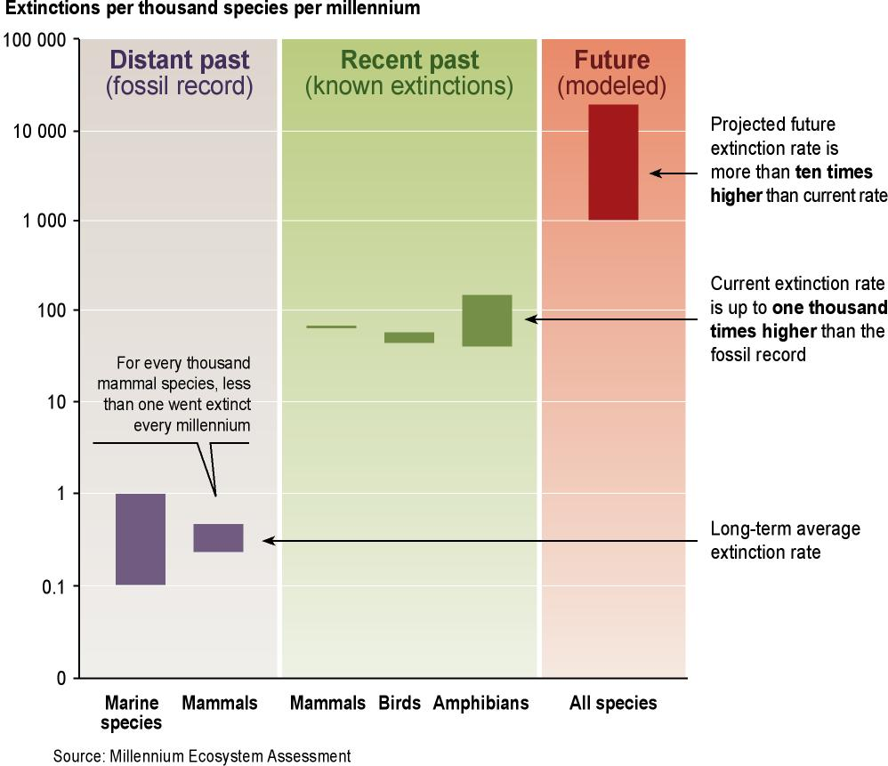
Figure 2. How Much Biodiversity Will Remain a Century from Now under Different Value Frameworks? The outer circle in the Figure represents the present level of global biodiversity. Each inner circle represents the level of biodiversity under different value frameworks. Question marks indicate the uncertainties over where the boundaries exist, and therefore the appropriate size of each circle under different value frameworks.

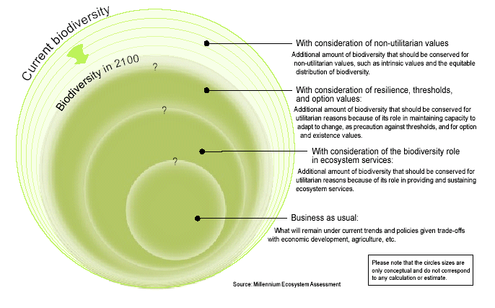

Figure 3. Main Direct Drivers The cell color indicates the impact to date of each driver on biodiversity in each biome over the past 50–100 years. The arrows indicate the trend in the impact of the driver on biodiversity. Horizontal arrows indicate a continuation of the current level of impact; diagonal and vertical arrows indicate progressively increasing trends in impact. This Figure is based on expert opinion consistent with and based on the analysis of drivers of change in various chapters of the assessment report of the Condition and Trends Working Group. This Figure presents global impacts and trends that may be different from those in specific regions.

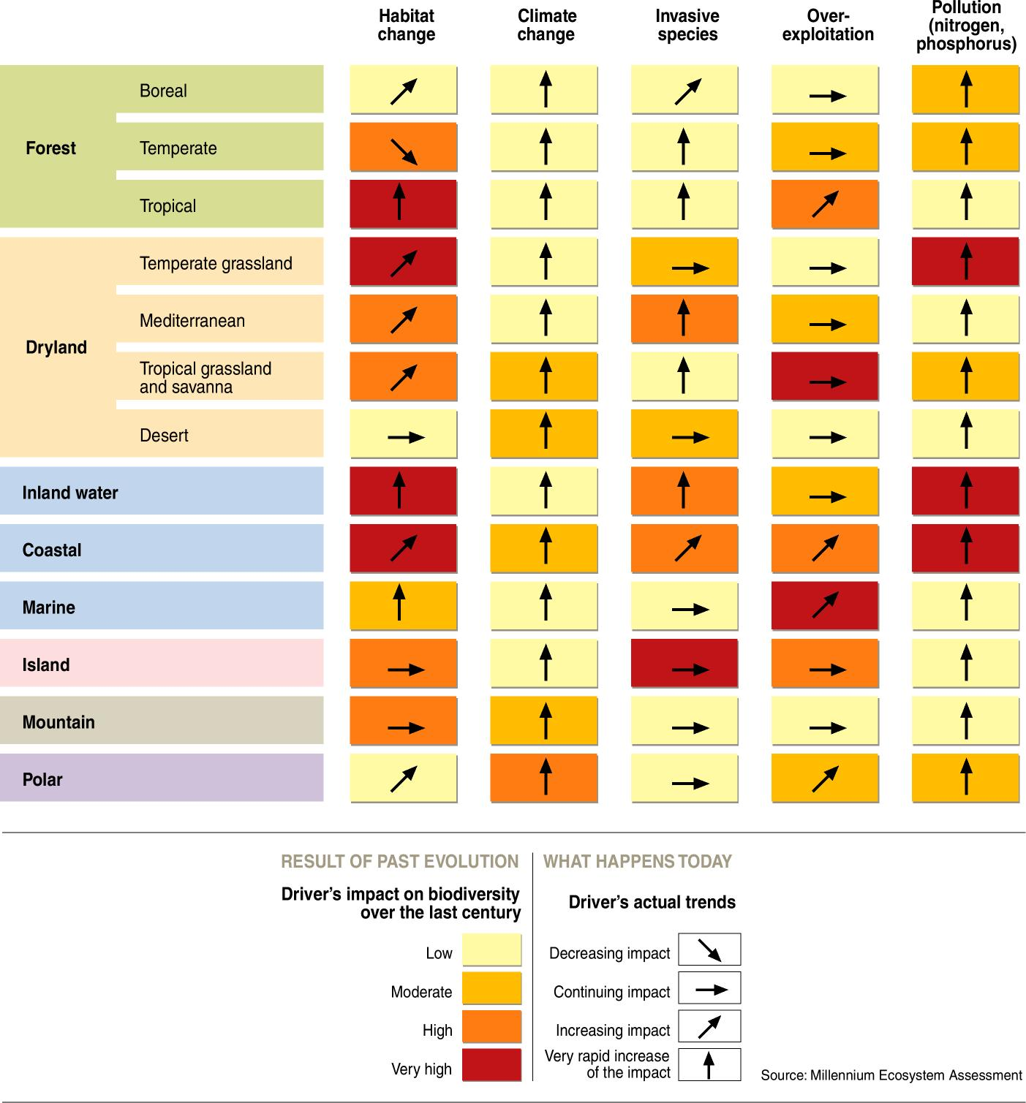

Figure 4. Trade-offs Between Biodiversity and Human Well-being under the Four MA Scenarios. Loss of biodiversity is least in the two scenarios that feature a proactive approach to environmental management (TechnoGarden and Adapting Mosaic). The MA scenario with the worst impacts on biodiversity (high rates of habitat loss and species extinction) is also the one with the worst impacts on human well-being (Order from Strength). A scenario with relatively positive implications for human well-being (Global Orchestration) had the second worst implications for biodiversity.

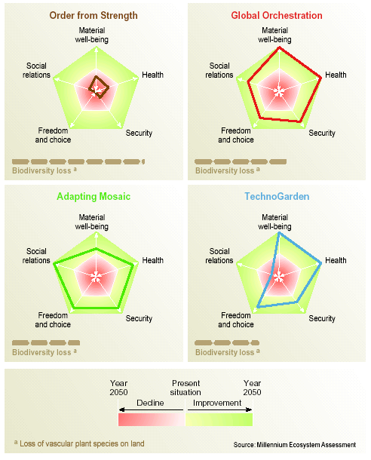

----

* UNEP/CBD/SBSTTA/11/1.
/ Biomes represent broad habitat and vegetation types, span across biogeographic realms, and are useful units for assessing global biodiversity and ecosystem services because they stratify the globe into ecologically meaningful and contrasting classes. Throughout this report, and elsewhere in the MA, the 14 biomes of the WWF terrestrial biome classification are used, based on WWF terrestrial ecoregions (C4.2.2).

