 |  | CBD
 |  |  |  | Distr.  GENERAL  UNEP/CBD/SBSTTA/17/6  28 September 2013  ORIGINAL: ENGLISH
SUBSIDIARY BODY ON SCIENTIFIC, TECHNICAL AND TECHNOLOGICAL ADVICE
Seventeenth meeting
Montreal, 14-18 October 2013

Items 3 and 6 of the provisional agenda*
Progress Report on marine and coastal biodiversity: describing ecologically or biologically significant marine areas (EBSAs)

Note by the Executive Secretary

Introduction
- The Conference of Parties, at its tenth meeting, established a global process for describing ecologically or biologically significant marine areas, through the application of scientific criteria set out in annex I of decision IX/20, other relevant compatible and complementary nationally and inter-governmentally agreed scientific criteria, as well as the scientific guidance on the identification of marine areas beyond national jurisdiction, which meet the scientific criteria in annex I to decision IX/20. The process is based on the organization of a series of regional workshops involving Parties and other Governments, as well as competent organizations and regional initiatives (decision X/29). At its eleventh meeting, the Conference of Parties reviewed the outcomes of the first two regional workshops and requested that additional workshops be organized for the remaining regions or subregions where Parties wish workshops be held (decision XI/17).
- This note has been prepared by the Executive Secretary to provide a brief update on progress made in the organization of the series of regional workshops on the description of areas meeting EBSA criteria (section II). Given the focus of the seventeenth meeting of the Subsidiary Body on the scientific and technical needs for the implementation of the Strategic Plan for Biodiversity 2011-2020 and the achievement of the Aichi Biodiversity Targets, the remaining sections of the note describe scientific and technical information that has been utilized in the Convention’s process of describing areas that met the EBSA criteria. The biographic, biological, physical and oceanographic data sets are described in section III. Section IV describes how these have been compiled, synthesized for the workshops and how the participants in the workshops have analyzed the data to describe the EBSAs. Section V describes the potential use of EBSA-related scientific information to further enhance our efforts toward achieving the Aichi Biodiversity Targets in marine areas. Finally, section VI provides some conclusions and overall lessons learned. An extended and fully referenced version of this note, with additional graphics, is available as an information note (UNEP/CBD/SBSTTA/17/INF/3). The current note and the information note have been prepared on the basis of inputs provided by the technical team members of the Commonwealth Scientific and Industrial Research Organization of Australia (CSIRO) and Duke University (USA) – the two teams that provided scientific and technical support to the various regional workshops.
- As emphasized by the Conference of the Parties at its tenth and eleventh meetings, the application of the scientific criteria for EBSAs is a scientific and technical exercise, while the identification of EBSAs and the selection of conservation and management measures are matters for States and competent intergovernmental organizations, in accordance with international law, including the United Nations Convention on the Law of the Sea (decisions X/29 and XI/17).
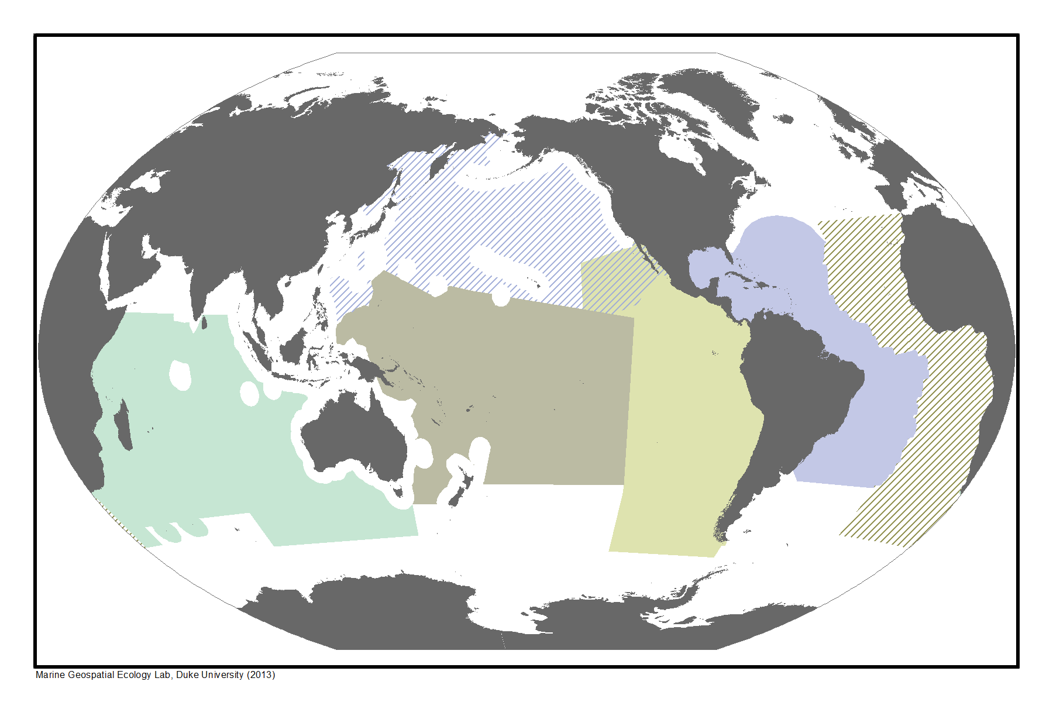
Figure 1. The geographical scope of the six regional workshop areas organized by the CBD Secretariat to facilitate the description of areas meeting EBSA criteria.

II. PROGRESS REPORT ON THE ORGANIZATION OF REGIONAL WORKSHOPS FOR THE DESCRIPTION OF EBSAS
- Pursuant to decisions X/29 (paragraph 36) and XI/17 (paragraph 12), the Secretariat has convened six regional workshops since November 2011. The Secretariat has also been collaborating with ongoing EBSA processes convened by regional organizations in the North East Atlantic and Mediterranean regions.
- The results of the first two workshops, in the Western South Pacific and the Wider Caribbean and Western Mid-Atlantic regions, were considered by the Conference of the Parties at its eleventh meeting and, pursuant to its request in decision XI/17, the summary reports on the description of areas that meet the criteria for EBSAs, prepared by the Subsidiary Body at its sixteenth meeting, were submitted to the United Nations General Assembly as well as its relevant working groups, by means of a letter from the Executive Secretary of the Convention on Biological Diversity addressed to the Secretary-General. This document is now available as document A/67/838 on the Official Document System of the United Nations (ODS), in all six official languages of the United Nations.
- The results of the four other regional workshops will be submitted for consideration by the eighteenth meeting of the Subsidiary Body, scheduled for June 2014, and, subsequently, by the twelfth meeting of the Conference of the Parties to the Convention (COP 12), scheduled for October 2014. These workshops were for the following regions:
  - Southern Indian Ocean (Flic en Flac, Mauritius, 31 July - 3 August 2012);
  - Eastern Tropical and Temperate Pacific (Galapagos, Ecuador, 28 - 31 August 2012);
  - North Pacific (Moscow, Russian Federation, 25 February - 1 March 2013); and
  - South-Eastern Atlantic (Swakopmund, Namibia, 8 - 12 April 2013).
- Figure 1 shows the coverage by the six regional EBSA workshops convened by the Secretariat since the tenth meeting of the Conference of the Parties. Table 1 summarizes key information about the workshops. Ninety-two countries were represented at the six regional workshops organized so far by the Secretariat and they described a total of 172 areas as meeting the EBSA criteria. Further details on the above four workshops can be found in the web links provided in the footnotes below.
Table 1. Six regional workshops convened by the Executive Secretary
CBD Regional Workshop on EBSAs | Date | Host Country | No. of countries | No. of organizations | EBSAs (A) | EBSAs with EEZ (B) | EBSAs with ABNJ (C)
Western South Pacific | Nov 2011 | Fiji | 15 | 10 | 26 | 22 | 11
Wider Caribbean & Western Mid-Atlantic | Feb 2012 | Brazil | 23 | 15 | 21 | 21 | 5
Southern Indian Ocean | July 2012 | Mauritius | 16 | 20 | 39 | 30 | 13
Eastern Tropical & Temperate Pacific | Aug 2012 | Ecuador | 13 | 12 | 21 | 18 | 7
North Pacific | Feb 2013 | Russia | 8 | 7 | 20 | 15 | 5
South-Eastern Atlantic | April 2013 | Namibia | 17 | 15 | 45 | 42 | 7
Total |  |  | 92 | 79 | 172 | 148 | 48
(A) Number of areas described for EBSA criteria by the workshop
(B) Number of areas described for EBSA criteria wholly or partly within national jurisdiction
(C) Number of areas described for EBSA criteria wholly or partly beyond national jurisdiction
Note: A does not equal B+C, because some EBSAs contain areas within and beyond national jurisdiction
- The Secretariat is currently collaborating with various Parties and relevant organizations to organize additional EBSA workshops in the remaining regions, as requested by the Conference of the Parties at its eleventh meeting, in its decision XI/17. This includes the following workshops:
  - Arctic (Helsinki, Finland, 3-7 March 2014, notification 2013-085 (Ref. No SCBD/SAM/JL/JG/82648), issued on 23 September 2013); and
  - North West Atlantic (tentatively planned for Montreal, March 2014)
Additional workshops will be organized in collaboration with Parties and regional organizations concerned.
- Scientific and technical inputs to the regional workshops have been facilitated, in part, through the Global Oceans Biodiversity Initiative (GOBI) established as an initiative of the COP-9 Presidency.
- To provide capacity-building to Parties on marine and coastal biodiversity, including with regard to the description of EBSAs in line with requests of the Conference of the Parties (paragraph 37 of decisions X/29, and paragraph 14 of XI/17), a regional capacity-building workshop under the framework of the Sustainable Ocean Initiative was organized for Western Africa in Dakar, from 4 to 8 February 2013. Another SOI workshop for East and Southeast Asia will be organized in Guangzhou, China, from 9 to 13 December 2013.

III. SCIENTIFIC AND TECHNCIAL DATA on marine biodiversity in open-ocean and deep-sea habitats TO SUPPORT THE EBSA PROCESS
- Advances in scientific understanding of marine biodiversity in open-ocean and deep-sea habitats
- New advances in data collection and analysis have improved our understanding of open-ocean and deep-sea ecosystems and habitats. The technological advances include remote sensing, marine acoustics, deep-sea trawling, genetics and autonomous vehicles, while analytical advances provide scientists with the tools to integrate this rich information resource. In addition, the ten-year (2000-2010) Census of Marine Life programme brought numerous researchers from multiple countries together to focus on marine science in areas both within and beyond national jurisdiction.
- The development of global datasets of oceanographic conditions from satellite remote sensing, in-situ data collections (e.g., Argo drifters) and assimilative models has rapidly advanced our understanding of broad processes in the open oceans and deep seas. Long-term data collection on sea-surface temperature (SST), ocean colour and productivity, salinity, dissolved oxygen, nitrate, silicate as well as ocean surface altimetry have promoted rapid advancements in global oceanographic data products and understanding of open-ocean environments. Data archives such as the World Ocean Atlas and the CSIRO Atlas of Regional Seas now provide open access to these global data products.
- Refinement and analysis of global bathymetric datasets have been providing baseline information on topographic features such as seamounts, ridges and submarine canyons. Newly derived data products for locating and classifying seamounts and cold-water corals, canyons and hydrothermal vents and seeps are providing critical information on these important deep-sea features.

Biogeographical classifications
- Advances in the data and knowledge of open-ocean and deep-sea environments are being used to develop new biogeographic classifications. Biogeographic classifications have been developed for the ocean surface and seabed environments, but classification of pelagic water column regions is only now emerging.
- Biogeographic classification systems divide the ocean into regions using environmental features and – to the extent data is available – their species composition. Generalized environmental characteristics of the benthic and pelagic environments (structural features of habitat, ecological function and processes as well as physical features such as water characteristics and seabed topography) are used to select relatively homogeneous regions with respect to habitat and associated biological community characteristics. These are refined with direct knowledge or inferred understanding of the patterns of species and communities, driven by processes of dispersal, isolation and evolution; ensuring that biological uniqueness found in distinct basins and water bodies is also captured in the classification.
- Biogeographic data provided an essential context for the EBSA assessment process and assisted the design of the regional workshops. Biogeographic maps served two essential purposes for the workshops. Firstly, biogeographical regions were used to help define the regional scope of each workshop. Secondly, biogeographic data were used to help identify features and areas in the regions that met the EBSA criteria.
- The following biogeographic classifications were used in the EBSA workshops:
  - The Global Open Ocean and Deep Seabed (GOODS) biogeographic classification which represents the newest and most comprehensive classification of the open ocean and deep seafloor into distinct biogeographic regions;
  - The Longhurst Marine Province classification, based on the prevailing role of physical forcing as a regulator of phytoplankton distribution. The boundaries of these provinces are not fixed in time and space, but are dynamic and move under seasonal and interannual changes in physical forcing;
  - Two coastal-shelf biogeographic classifications: the Marine Ecosystems of the World (MEOW) and the Large Marine Ecosystems (LME).
- While there has been increased understanding of the benthic areas of the world’s oceans over recent decades, beyond seamounts and the continental shelves there are still vast areas with little information, especially biological information. Data on the deep pelagic zones is very sparse, and these areas have generally not been included to date in monitoring and management schemes or in conservation planning. However, a wealth of new data is now available for deep pelagic realms from programmes of the Census of Marine Life, as well as national efforts. Under the auspices of the Global Oceans Biodiversity Initiative and INDEEP, this data is informing work on a new global deep pelagic biogeography.

Biological data
- Several common biological data layers were collated and used to support the EBSA workshops. These data layers included habitats, protected species, foraging and breeding areas, commercial fisheries, and aggregated biodiversity data. Biological data used in the EBSA workshops includes:
  - The distribution of deep-sea corals. This is a very important indicator, because these are a habitat-forming species that provide critical ecosystem functions in deep-sea ecosystems. Because direct surveys of deep-sea coral habitats are sparse, predictive habitat models are increasingly being used to identify species’ distributions in areas that have not been sampled;
  - Important Bird Areas. BirdLife International made available analyses of Important Bird Areas (IBAs) to assist in the description of important seabird use areas for the EBSA process. Figure 2 provides an example. IBAs are based on four core criteria: globally threatened species; restricted-range species; biome-restricted species; and congregations of species. Together, IBAs form a network of sites of importance to coastal, pelagic, resident and or migratory species. Information from IBA descriptions was particularly relevant to the application of the EBSA criteria for “important for life-history stages”, “threatened species”, “diversity” and “fragility”;
  - Observation records for individual species, and indices of biodiversity. These were collected from OBIS, an open-access global information system, maintained by the UNESCO-IOC/IODE programme that archives and disseminates marine biogeographic information for use in scientific, management and policy analysis. OBIS is the largest single data repository for biological data for the world’s oceans, with more than 30,000,000 geographically registered biological observations online at the time of the EBSA workshops (see for example figure 3 in UNEP/CBD/SBSTTA/17/INF/3). Data products were created for species diversity, IUCN Red List species, marine mammal data and sea turtle data.
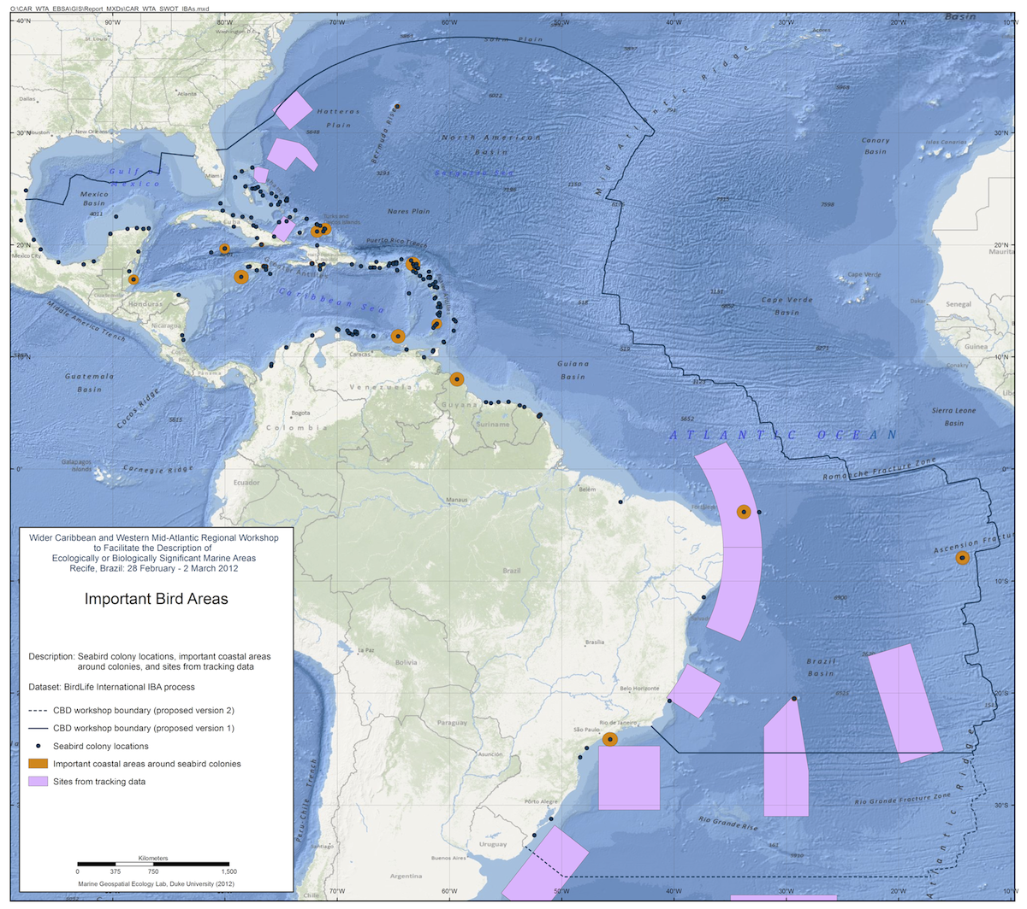
(source: BirdLife International)
Figure 2. Wider Caribbean and Western Mid-Atlantic Regional Workshop - Important Bird Areas.
- For selected geographies, additional derived data products were made available for workshop participants. These included habitat probability models, targeted occurrence records for rare or endangered species, and seasonal/annual utilization distributions generated from tagging and tracking data (see for example figure 4 in UNEP/CBD/SBSTTA/17/INF/3). Data from historical records of whaling from 1780 to 1920 were also used to inform each workshop on the potential historical distributions of four whale species (see for example figure 5 in UNEP/CBD/SBSTTA/17/INF/3). While most of the focus of the EBSA workshops was on open-ocean areas, global data on coral reefs, seagrass and mangroves were aggregated from data sets from the World Conservation Monitoring Centre. Data on sea turtle nesting sites were provided from the State of the World's Sea Turtles information system.

Physical and oceanographic data
- Bathymetric data provides a fundamental data layer for identifying benthic features and interpreting habitats in the open ocean and deep seas. The GEBCO_08 dataset was used at the EBSA regional workshops to provide a common bathymetric surface. This dataset represents a global 30 arc-second grid generated by combining ship depth soundings with interpolation between sounding points guided by satellite-derived gravity data. The following bathymetric features were important inputs to the EBSA processes:
  - Seamounts and undersea knolls. These often rise more than 1000m from the seafloor and provide important habitats for aquatic predators, demersal deep-sea fish and benthic invertebrates. The most recent assessments identify 33,452 seamounts and 138,412 knolls, representing the largest global set of identified seamounts and knolls to date. As only 6.5 per cent of the ocean floor has been surveyed with soundings it is likely that new seamounts will be discovered as surveying improves. Spatial data on the distribution of potential seamount and knoll features were an important input at each of the EBSA regional workshops;
  - Chemosynthetic ecosystems (vents and seeps). These are a unique and globally rare ocean floor feature. Data on chemosynthetic ecosystems were accumulated under the Chemosynthetic Ecosystem Science programme of the Census of Marine Life, available through ChEssBase;.
  - Large submarine Canyons. These are important features influencing the biogeography of the open oceans and deep seas. River-associated or shelf-incising canyons tend to hold greater benthic biomass and biodiversity than non-shelf-incising canyons. The dataset used at the EBSA workshops represented an inventory of 5,849 separate large submarine canyons in the world’s oceans.
- The description of areas meeting the EBSA criteria focuses not only on fixed benthic features, but also dynamic features of the ocean surface and pelagic zones. Oceanographic climatologies (see for example figure 3) provided an essential dataset for the description of these areas. Global oceanographic climatological data were provided from the World Ocean Atlas and the CSIRO Atlas of Regional Seas. These data provided information on surface temperature, salinity, nitrate, silicate, phosphate, oxygen and mixed-layer depth. In addition, the following specific features were used in the workshops:
  - Sea surface temperature fronts. Composite maps of sea surface temperature fronts based on analyses of 9km-resolution data were provided for the EBSA workshops. The composite front technique combines the location, gradient, persistence and proximity of all fronts observed over a given period into a single map;
  - Ocean productivity. Standard Ocean Productivity Products were provided to the workshops to help identify areas of high productivity, one of the seven EBSA criteria (see for example figure 7 in UNEP/CBD/SBSTTA/17/INF/3);
  - Oxygen Minimum Zone (OMZ). The OMZ is the oceanic layer within which dissolved oxygen values are a minimum, due to high rates of oxygen consumption and low rates of advective supply of oxygen-rich waters. This directly affects the vertical stratification and distribution of species and habitats in the open oceans and deep seas;
  - Sea surface height. This helps us interpret important oceanographic features such as the location of upwelling and downwelling eddy features;
  - Mesoscale eddy density. The density and distribution of eddy features can be used to help describe areas that meet EBSA criteria. Depending on the rotational direction of an eddy, it may result in either upwelling of colder, nutrient-rich waters from the deep ocean, or downwelling of surface waters and aggregation of planktonic organisms. In either case, these areas represent zones of higher prey aggregation. Thus, areas with a high density of eddy features are likely to be points of aggregation for many pelagic species;
  - Eddy kinetic energy. Similar to locating eddy features, identification of areas of high eddy kinetic energy allows for interpretation of important surface features and aggregations. It is a measure of turbulence, or the strength of current flow concurrently in the north/south and east/west directions. High values generally indicate strong mixing and increased productivity. As with eddy density, such areas are likely to be points of aggregation for many pelagic species;
  - Drifter climatology of near-surface currents. Information on the position, direction and velocity of ocean currents is important for interpreting ecological and biological features in the open oceans;
  - Surface current velocity. Satellite-based observations of sea surface height, geostrophic currents, wind speed modulus and significant wave height were also provided as common data layers for the EBSA description process.
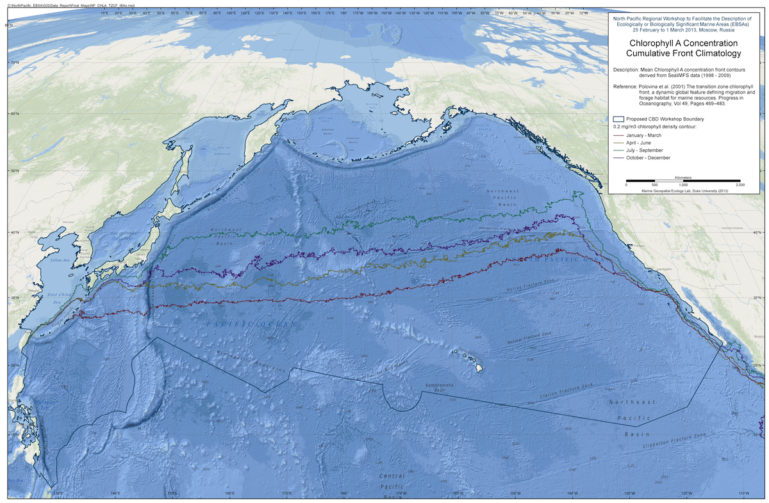
Figure 3. North Pacific Regional Workshop – Chlorophyll A concentration, cumulative front climatology.

IV. Regional-scale analysis, COMPILATION, synthesis and mapping of scientific data IN THE EBSA PROCESS
- To support the EBSA workshops, the scientific data described above were compiled for each region by the technical support groups from either the Commonwealth Scientific and Industrial Research Organisation of Australia (CSIRO) or Duke University (USA) into data reports prior to each workshop. The datasets covered three primary data types outlined in the previous section: biogeographic, biological, and physical/oceanographic. The data reports provided a consistent and comprehensive understanding of environmental conditions across the workshops that could be then supplemented by regionally relevant datasets. These data were obtained from global oceanographic and biogeographic data centres as well as individual researchers active in each workshop’s region of interest.
- The core data were supplemented by the technical support teams to include available data on features, geographies and species of unique interest to each region. Prior to each workshop, an extensive communication effort, based on CBD notifications requesting the submission of relevant scientific information, were facilitated by the Secretariat/technical team with Parties and relevant scientists and institutions that might have data that could contribute to the EBSA workshops. Examples of regionally specific datasets include data on regional migration patterns, distribution of endemic species, and regional oceanographic cycles (e.g. El Nino / Southern Oscillation).
- For each of the regional workshops the regional fisheries management organizations were also contacted to obtain publically available fisheries data and information that could be used to support the description of areas meeting the EBSA criteria. In some cases, maps of pelagic commercial fisheries species catch were extracted from the FAO Tuna Atlas data service. Data were obtained directly from the Western and Central Pacific Fisheries Commission and the Indian Ocean Tuna Commission.
- Some Parties undertook their own national preparatory process to provide inputs to their respective regional workshops, mobilizing scientific collaboration of inter-disciplinary experts at the national level. Notable examples of this include the biogeographic analyses conducted by South Africa to inform their marine management process and the analyses conducted by Brazil for marine areas within their national jurisdiction.
- A number of regional-scale analyses were also made available. An assessment of the potential world heritage areas in the western Indian Ocean conducted by Coastal Oceans Research and Development in the Indian Ocean provided important information for the Southern Indian Ocean workshop and an ecological gap analysis conducted by the Réseau Régional d’Aires Marines Protegées en Afrique de L’Ouest (RAMPAO) facilitated the description of many areas meeting EBSA criteria in the region. Other regional data sets included data on turtle nesting and foraging sites, tuna/seamount interactions and the distributions of Southern Bluefin tuna.
- Finer-scale data was provided prior to the workshops in some cases or supplied during the workshops. The Southern Indian Ocean Deepsea Fishers Association (SIDOFA) provided detailed acoustic imagery of areas in the Indian Ocean (see figure 8 in UNEP/CBD/SBSTTA/17/INF/3). Many of these areas have also been identified as benthic protected areas by SIDOFA. Many of the participants brought detailed information of particular areas within their national waters, which could inform the description of areas meeting EBSA criteria. In addition, many additional scientific papers and analyses that were previously unknown to the technical teams were supplied by the workshop participants. These provided the basis for many of the EBSA descriptions in marine areas within their national jurisdictions.
Data aggregation and presentation at workshops
- The digital data was compiled and collated by the technical support teams of CSIRO and Duke University as requested by the Secretariat, into a Geographic Information System (GIS). The data was then compiled into data reports, which were provided to workshop participants prior to each regional workshop. Each individual dataset was described in the data report with appropriate references, metadata and map representation. The maps within the data reports were also brought to each workshop in large format printed hardcopies for review and discussion by workshop participants. All of the data compiled in the workshop data reports were provided to each workshop in several laptop computers containing GIS mapping and analysis software, and each workshop group discussion was assisted by the technical support teams for mapping and analysis for application of EBSA criteria as needed throughout the workshop plenary and break-out sessions. An overview of the available maps and GIS data was provided during the opening plenary session of each workshop. In addition the large-format printed maps were displayed around the meeting room and several smaller-format map books were circulated for review by the workshop participants.

Discussion of data use by workshop participants
- There were common barriers encountered across all the regional preparations during the analysis, synthesis and mapping of scientific data for each workshop. Not every dataset of interest could be obtained in advance of the meeting. Some were likely to have been missed, underscoring the need for a continuing process and better data infrastructure.
- The open discussions around the scientific data and EBSA criteria provided many opportunities for scientific interaction and networking for the workshop participants, in particular among international, regional and national-scale experts. A key benefit was the intersection of regional and local knowledge with global-scale datasets. This enhanced the workshop’s knowledge about oceanographic and ecological dynamics at larger spatial scales and helped workshop participants better understand their global or regional oceanographic context. This exchange of information and data extended to ongoing post-meeting correspondence between the workshop participants and the technical team members around data and mapping issues. Data exchange of publicly available datasets was a common opportunity taken advantage of by all of the workshops.
- A key problem encountered in each workshop was the inability to identify or access scientific data. The majority of scientific data is currently inaccessible to all but the researchers and institutions that currently hold them. In every region, informative data sets were identified but remained inaccessible due to constraints on access. The success of OBIS indicates that information can be shared. However, to fully meet the needs of the EBSA process, a much more systematic stocktaking of the world’s biodiversity-relevant information needs to be undertaken.

Expert scientific judgment in applying the scientific criteria for EBSAs
- Description of areas meeting the EBSA criteria at the regional workshops was facilitated by both the compilation of scientific data undertaken by the Secretariat with the technical assistance of a team (CSIRO or Duke University), and the submission of scientific information by workshop participants on possible areas meeting EBSA criteria contributed prior to the regional EBSA workshop or at the workshop itself. Compiling scientific information prior to the regional workshop on potential areas meeting the EBSA criteria, using the template provided by the Secretariat through a notification provided the opportunity to gather appropriate data and information supporting those EBSA descriptions, and led in many instances to final EBSA descriptions having been adopted by the workshop plenary, after they were further refined and enhanced through workshop deliberations. On the other hand, workshop participants proposing potential areas for EBSA description prior to the regional workshops sometimes had to adjust, amalgamate or remove their proposed description in response to additional scientific information provided at the workshop and the workshop discussion, in particular the scientific inputs at the regional scale provided by the workshop plenary discussion. Regardless of the information sources for the EBSA description, each regional workshop went through intensive discussion on each potential EBSA description in both subregional group and plenary settings. The list of EBSA descriptions was finalized through the official process of consideration and adoption by the workshop plenary.
- The organizational aspect of the workshop process included an initial plenary session communicating the process developed by the Convention on Biological Diversity to describe areas meeting the criteria for EBSAs, an overview of the data available for the workshop and a summary of relevant regional initiatives and scientific programmes that could benefit or benefit from the EBSA process. To build consensus on the exact areas that would be considered by each workshop, the biogeographic data and maps were presented to and discussed by the workshop participants, especially those nominated by Parties and other Governments, in plenary sessions. Once the spatial extent of the workshop was agreed in plenary, the workshop discussion continued in smaller break-out group session generally involving geographical (e.g., subregional, large marine ecosystems (LMEs), coastal/open-ocean and deep-sea habitats) and/or language-based groupings of workshop participants, assisted by at least one member of the technical support team. Through the break-out group sessions, workshop participants were engaged in substantive scientific discussion of applying EBSA criteria in potential areas. Each break-out group was encouraged to consider areas of transboundary nature that could meet the EBSA criteria, as well as potential areas meeting EBSA criteria beyond national jurisdiction, especially since these areas were not fully considered when the workshop participants had originally submitted descriptions of potential EBSA description focusing on areas within their national jurisdictions. Experts from regional and international organizations supported, depending on their specific expertise and the scientific information they provided, different sub-groups and ensured that the information provided was being interpreted correctly. Proposed areas meeting EBSA criteria were identified in a GIS map and presented at the plenary for its consideration, review and comments. Building upon the comments from the workshop participants, further modifications were made before they were submitted, or re-submitted, together with the text of the EBSA description, for consideration and approval by the workshop's final plenary.
- Experts nominated by Parties played key roles in finalizing the description of the areas meeting EBSA criteria with the scientific and technical assistance of experts nominated by relevant regional and international organizations as well as technical support teams. The nature of scientific input provided by the technical support team included assistance in: data access and interpretation, application of the EBSA criteria, and preparation of EBSA descriptions. Such scientific interaction among different experts facilitated better understanding and interpretation of the regional datasets provided in the background documents. While large-scale printed copies of the maps were the most useful form of regional data at the workshop, the data were also provided in electronic form to all participants after the workshops to benefit their respective future efforts toward enhancing marine biodiversity conservation and sustainable use.
- Some countries did not wish the regional workshop to discuss EBSA descriptions in marine areas within their national jurisdictions as they have their own national processes on EBSAs or similar processes to define areas of importance (e.g., key ecological features in Australia, the national EBSA processes in Canada and Japan and marine bioregional planning in India). On occasions where an area meeting the EBSA criteria overlapped the EEZ of a country that had not wished to define EBSAs within their EEZ, the overlapping portion was marked on the map with a dashed line. Generally EBSAs were not identified in the national waters of countries not represented at the workshop unless a specific request was made by those countries to designate some relevant experts attending the workshop to facilitate the EBSA description within their national waters on their behalf.
- Scientific capacity-building and expert/data networking at the regional scale through the EBSA process
- Various levels of capacity-building opportunities were provided at each of the six regional EBSA workshops. A key element provided through capacity-building was the development of an understanding of the concepts underlying the description of areas meeting EBSA criteria and how the application of EBSA criteria could be undertaken in both coastal waters and open-ocean/deep-sea habitats. In every workshop the full set of data compiled by the Secretariat and the technical teams (more than 50 GIS layers) was available to all the workshop participants during their deliberations. The global data sets used are available for downloading from the Australian Ocean Data Network. In every case, the workshop participants, including the technical teams, left the workshop with an enhanced understanding of the ecological and biological state and dynamics of each region’s marine biodiversity, as well as an improved understanding of the ecological connectivity and scientific links within the region.
- The workshops also provided a useful forum for communication among experts from neighbouring countries and for identifying common values and trans-boundary features that could be applied in developing EBSA descriptions. By focusing on scientific data and information-sharing, which required the workshop participants to provide their best expertise and expert opinions, the regional workshops maintained high levels of scientific engagement, networking and communication throughout.
- During the EBSA training organized by the Secretariat prior to the regional workshops, it was emphasized that the EBSA process is a scientific and technical exercise, and the identification of EBSAs and selection of conservation and management measures (e.g., marine protected areas, impact assessments, fisheries management) are matters for States and competent intergovernmental organizations. This training also enhanced the participants’ understanding of: the EBSA criteria; scientific data and information that could be used to apply EBSA criteria; various considerations to be made in applying EBSA criteria, in particular those areas of data paucity; and biogeographic characteristics of each region. This training therefore provided each participant with a better understanding of the biology and ecology of the region, information on the process of applying EBSA criteria, and approaches to apply scientific information to prepare EBSA descriptions for their respective regions. Participants were also provided with the additional tools and approaches articulated in the EBSA training manual (UNEP/CBD/SBSTTA/16/INF/9). The workshop in the South East Atlantic was supported by the Sustainable Ocean Initiative (SOI) Capacity-Building Workshop for West Africa (Dakar, February 2013), held two months prior to the EBSA regional workshop, held in Namibia.

V. POTENTIAL APPLICATION OF SCIENTIFIC INFORMATION RELATED TO AREAS MEETING EBSA CRITERIA IN SUPPORT OF ACHIEVING AICHI BIODIVERSITY TARGETS RELATED TO MARINE AND COASTAL BIODIVERSITY
- In line with the theme of the seventeenth meeting of the Subsidiary Body, this section explores the possible application of scientific information related to EBSA description in support of countries’ efforts toward achieving the Aichi Biodiversity Targets. This section draws on experiences from the South Pacific region, where the results of the Western South Pacific regional workshop were used for their marine spatial planning practices.
- The areas described as meeting EBSA criteria can be used to prioritize management actions when combined with information on the distribution of pressures. Under this framework the areas described as EBSAs by each workshop can be considered as areas of high ecological or biological value. They are areas where increased attention should be focused to ensure that they are managed sustainably. The distribution of pressures across the ocean is not homogenous, and areas meeting the EBSA criteria overlap with pressures in different ways. Further, as some areas meeting the EBSA criteria refer only to benthic or pelagic habitats, the values that they represent are not necessarily impacted by all pressures to the same extent. Two examples may be given. The first example shows the total number of hooks from longline tuna fisheries over the period from 2001 to 2010, sourced from data from the Western Central Pacific Fisheries Commission (WCPFC). This shows that fishing effort is not distributed evenly across the South Pacific but is concentrated in discrete locations. Of note is the highest concentration associated with the EBSA area described for the New Hebrides Trench (see figure 9 in UNEP/CBD/SBSTTA/17/INF/3).
- The second example overlays climate-change projections for the change in sea-surface temperature (see figure 4). The South West Pacific shows two distinct projected significant warming areas associated with south-east Australia and Central Pacific. The increase in SST in Central Pacific is directly associated with the Equatorial High-Productivity Zone, an EBSA area described by the Western South Pacific workshop.
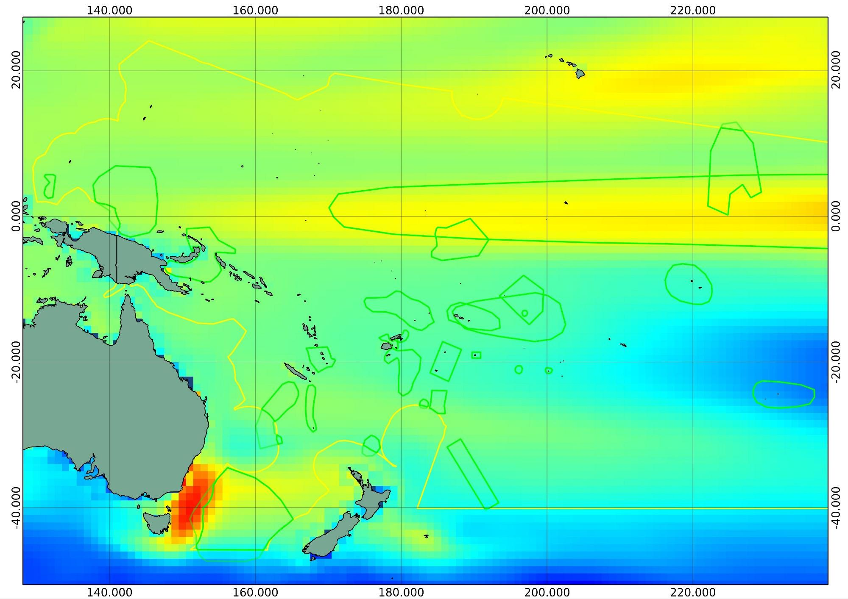
Figure 4. Projected change in sea surface temperature from Pacific Regional model from 1950-2000 mean to 2050-2100 mean temperatures. Areas identified as EBSA are shown in green.
- A number of other pressures can be identified that may potentially impact on the EBSA areas described by the Western South Pacific. These include natural pressures such as cyclones and human-derived pressures such as shipping, mining and benthic fisheries. To demonstrate the utility of EBSA-related scientific information in prioritizing different management measures, the interaction between different pressures and EBSA areas was examined using data on the spatial distribution of each of the pressures (see figure 5). This shows that some EBSA areas may potentially be impacted and that pressures are not evenly distributed across the region and overlap with different EBSA areas.
- There are several other opportunities to use EBSA-related scientific information to support the conservation and sustainable use of marine biodiversity. EBSA descriptions prepared by regional workshops provide information on areas that are relatively more valuable for their ecological systems or biodiversity than surrounding areas. In the long term, EBSA descriptions may directly inform efforts to conserve and sustainably use biodiversity, including a network of MPAs, as indicated in annex II to decision IX/20. EBSA-related scientific information could contribute to: identifying areas that are relatively more important and could therefore be used to focus area-based management; identifying areas where it may be important to exercise a relatively higher level of precaution, including an increased need for environmental impact assessment; and identifying areas where uniqueness or rarity (EBSA criterion 1) or biological diversity (EBSA criterion 6) would indicate an increased probability of finding new genetic diversity.
- It was clear at the regional EBSA workshops that some of the country participants were intending to use the EBSA information agreed to by regional experts to support marine management in areas within their national jurisdictions. For example, EBSA areas described by the Western South Pacific regional workshop provided input to the Cook Islands’ intention to declare a marine reserve within their national jurisdiction.
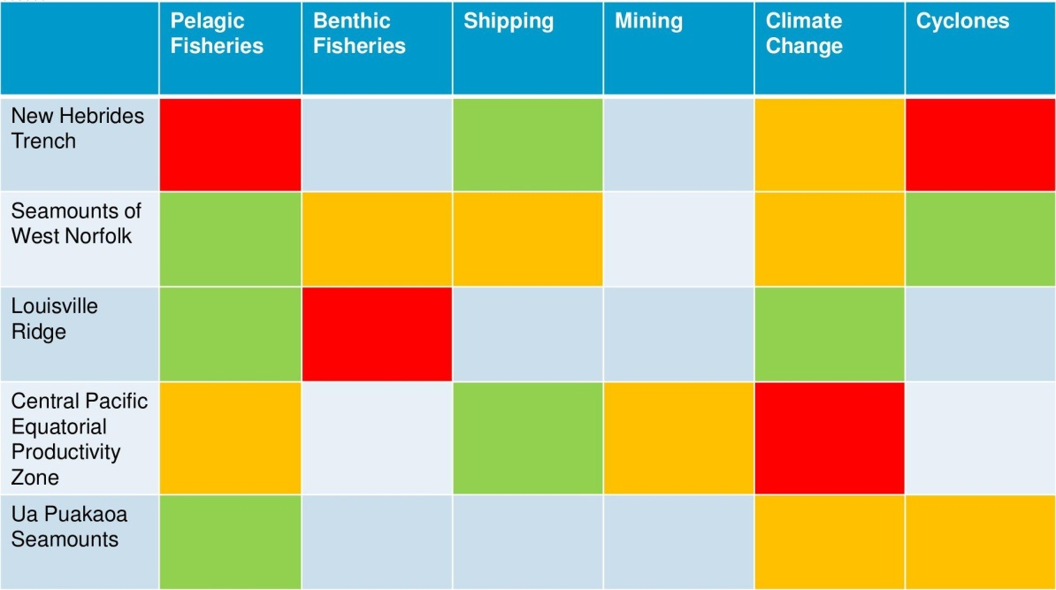
Figure 5. Interaction between EBSA areas described by the Western South Pacific regional workshop and potential pressures. Red indicates a high pressure value in each EBSA area, orange medium pressure, green low pressure, and grey no pressure.
VI. CONCLUSIONS AND LESSONS LEARNED
- Global and regional data networks are critical to the EBSA international process to provide an unbiased open-access information system open to use by all countries and individuals, and to provide contributed data in marine areas both within and beyond national jurisdiction. While the OBIS information system represents the largest marine biological data collection available to support international processes, there are significant gaps and deficiencies that need to be addressed to better meet the rapidly increasing demands of the international community. Data availability for our world’s oceans is unevenly distributed, with significant gaps in the open ocean, in particular in marine areas beyond national jurisdiction, and southern hemisphere regions.
- In many regions, the workshops provided valuable capacity-building opportunities. These workshops supplied a large number of datasets that were previously unknown and often unobtainable by the participants at each workshop. The participants also benefited from an improved scientific understanding of marine areas within their region, in particular open-ocean and deep-sea habitats.
- The regional workshops were most productive when supported by strong regional initiatives and programmes committed to the achievement of the Aichi Biodiversity Targets. For example, the support of the South Pacific Regional Environment Programme was critical in successfully concluding the first regional workshop, including facilitating the necessary coordination among participants and provision of regional expertise. The secretariats of the Nairobi Convention and the Abidjan Convention, in East and West Africa respectively, both provided invaluable support and were key to the success of the Southern Indian Ocean and South East Atlantic Ocean workshops, as were regional and subregional bodies responsible for fisheries management, such as the Southeast Atlantic Fisheries Organizations (SEAFO) in West Africa, while the Caribbean Environment Programme (CEP) Secretariat, the Secretariat of the Permanent Commission of the South Pacific (CPPS), the Northwest Pacific Action Plan (NOWPAP) Regional Coordinating Unit and the North Pacific Marine Science Organization (PICES) played valuable roles for their respective workshops in their regions, together with various other regional organizations and initiatives, including relevant regional fisheries management organizations and bodies.

- The regional workshops to describe areas meeting the EBSA criteria, organized by the Secretariat of the Convention on Biological Diversity as called by the Conference of the Parties to the Convention at its tenth and eleventh meetings, have covered a large portion of the globe (ca. 75 per cent of world oceans) in less than two years, together with parallel processes that have been taking place in North East Atlantic and Mediterranean regions by respective intergovernmental regional organizations. These workshops drew on a broad range of expertise from 92 countries and 79 regional or international bodies, and have described a total of 172 areas that participants considered to be of relatively high ecological or biological value, using the EBSA criteria of the Convention. The EBSA areas described by the regional workshops can already be used by participating countries to enhance their current marine conservation and management efforts and by existing regional and international bodies within their competencies. They indicate areas where it would be appropriate to exercise a higher level of precaution when considering spatial management options for a variety of marine activities. They also indicate areas and attributes that the international marine scientific community can consider when designing and prioritizing global monitoring efforts.
- It should be noted that the workshops used an expert-driven, rather than a systematic approach and thus the areas described for EBSA criteria cannot automatically be expected to be either comprehensive or representative. Each regional workshop identified the need for an additional workshop to progress towards a more systematic approach with the advancement of available scientific information. The regional expert workshops have made rapid progress in describing areas that are relatively more important than surrounding areas for their ecological or biological values, and the Convention’s EBSA process thereby becomes a new vehicle for international- and regional-level scientific collaboration and capacity-building. The end of this first round of regional workshops will be only the start of a longer process that will continue to evolve through advancement of research, monitoring, and data management of marine biodiversity, particularly in open-ocean and deep-sea habitats.
-----

* UNEP/CBD/SBSTTA/17/1.
The designations employed and the presentation of material in this note do not imply the expression of any opinion whatsoever on the part of the Secretariat concerning the legal status of any country, territory, city or area or of its authorities, or concerning the delimitation of its frontiers or boundaries.
http://www.un.org/ga/search/view_doc.asp?symbol=A/67/838.
Report and documentation available at: http://www.cbd.int/doc/?meeting=EBSA-SIO-01.
Report and documentation available at:: http://www.cbd.int/doc/?meeting=EBSA-ETTP-01.
Report and documentation available at:: http://www.cbd.int/doc/?meeting=EBSA-NP-01.
Report and documentation available at: http://www.cbd.int/doc/?meeting=EBSA-SEA-01.
For more information, see: http://www.gobi.org/.
http://www.cbd.int/marine/doc/soi-brochure-2012-en.pdf.
http://unesdoc.unesco.org/images/0018/001824/182451e.pdf.
http://www.birdlife.org/datazone/info/ibacritglob.
http://www.iobis.org/).
http://www.gebco.net/data_and_products/gridded_bathymetry_data/).
http://www.noc.soton.ac.uk/chess/database/db_home.php.
http://www.marine.csiro.au/~dunn/cars2009/).
Southern Indian Ocean: http://www.cbd.int/doc/?meeting=EBSA-SIO-01 (notification: 2012-073); Eastern Tropical and Temperate Pacific: http://www.cbd.int/doc/?meeting=EBSA-ETTP-01 (notification: 2012-073); North Pacific: http://www.cbd.int/doc/?meeting=EBSA-NP-01 (notification 2012-152); and South-Eastern Atlantic: http://www.cbd.int/doc/?meeting=EBSA-SEA-01 (notification 2012-153).
UNEP/CBD/RW/EBSA/WSPAC/1/2, UNEP/CBD/RW/EBSA/WCAR/1/2, UNEP/CBD/RW/EBSA/SIO/1/2, UNEP/CBD/RW/EBSA/ETTP/1/3, UNEP/CBD/EBSA/NP/1/3, UNEP/CBD/RW/EBSA/SEA/1/3.
e.g., notification 2012-153, http://www.cbd.int/doc/?meeting=EBSA-SEA-01.
http://portal.aodn.org.au/aodn/.

