 |  | CBD
 |  |  |  | Distr.  GENERAL  UNEP/CBD/SBSTTA/18/INF/1  18 December 2013  ORIGINAL: ENGLISH
SUBSIDIARY BODY ON SCIENTIFIC, TECHNICAL AND TECHNOLOGICAL ADVICE
Eighteenth meeting

Montreal, 23-28 June 2014
IMPROVING THE EFFICIENCY OF STRUCTURES AND PROCESSES UNDER THE CONVENTION AND ITS PROTOCOLS:
PRELIMINARY EVALUATION OF THE FORMAT OF THE SEVENTEENTH MEETING OF THE SUBSIDIARY BODY ON SCIENTIFIC, TECHNICAL AND TECHNOLOGICAL ADVICE

I. INTRODUCTION
- The format for the seventeenth meeting of the Subsidiary Body on Scientific, Technical and Technological Advice (SBSTTA 17) was in some aspects different from other recent meetings of the Subsidiary Body. The main differences were the holding of all sessions in plenary, the use of panel discussions, introductory presentations and question and answer sessions, and the absence of draft recommendations prepared in advance of the meeting by the Secretariat. The format was developed by the SBSTTA Bureau and the Secretariat in response to calls from the Conference of the Parties and the Subsidiary Body itself to improve the effectiveness of the Subsidiary Body, and in the light of the main item on the agenda of the seventeenth meeting, that is, to identify scientific and technical needs for the implementation of the Strategic Plan for Biodiversity 2011-2020 and achievement of the Aichi Biodiversity Targets.
- The Bureau proposed that a survey be organized at the end of the meeting to solicit the views of participants with regard to the meeting format. In addition, as part of its recommendation XVII/1, the Subsidiary Body requested the Executive Secretary to conduct an evaluation of the approach and format used in SBSTTA 17 as part of his work in response to paragraph 2 of decision XI/10 on improving the efficiency of structures and processes under the Convention and its Protocols, and to report to the twelfth meeting of the Conference of the Parties.
- This Note provides a preliminary evaluation of the approach and format of SBSTTA 17 based upon the results of a survey conducted at the end of the meeting as well as comments made by participants in the course of the meeting. By way of context, part II provides background information on relevant decisions of the Conference of the Parties. Part III provides some general statistics on SBSTTA 17. Part IV provides the results of the questionnaire-based survey of the views of participants in SBSTTA 17. Part V reviews other comments on the meeting expressed during the course of the meeting, and part VI provides some reflections from the Bureau. Finally, part VII provides some overall reflections and conclusions.
- This evaluation will be complemented by further analyses in the light of additional surveys. Together these analyses will contribute to the evaluation of the approach and format used in SBSTTA 17 in response to paragraph 2 of decision XI/10 on improving the efficiency of structures and processes under the Convention and its Protocols which will be considered at the fifth meeting of the Working Group on Review of Implementation of the Convention and the twelfth meeting of the Conference of the Parties.

II. BACKGROUND
- The Conference of the Parties, at its eighth, tenth and eleventh meetings, provided guidance on ways and means to improve the effectiveness of the Subsidiary Body. In paragraph 3 (g) of decision X/2, the COP further underlined the role of the Subsidiary Body in the implementation of the Strategic Plan for Biodiversity, when it urged Parties and other Governments to implement the Strategic Plan and in particular to promote the generation and use of scientific information, develop methodologies and initiatives to monitor status and trends of biodiversity and ecosystem services, share data, develop indicators and measures, and undertake regular and timely assessments, to underpin the proposed new intergovernmental science-policy platform on biodiversity and ecosystem services (IPBES) and an effective Subsidiary Body on Scientific, Technical and Technological Advice in order to strengthen the science policy interface, thereby enhancing the implementation of the Strategic Plan for Biodiversity 2011-2020.
- In decision XI/13 A, the Conference of the Parties repeated its request to the Subsidiary Body, contained in decision X/12, to focus its work on the scientific and technical aspects of the Strategic Plan for Biodiversity 2011-2020 and the multi-year programme of work. Moreover, the Conference of the Parties tasked SBSTTA to identify scientific and technical needs for the implementation of the Strategic Plan for Biodiversity 2011-2020 and achievement of the Aichi Biodiversity Targets.
- SBSTTA 17 provided an opportunity for Parties to take stock of the tools and guidance available for implementing the Strategic Plan and for assessing progress towards the Aichi Biodiversity Targets, and to identify additional needs. This is an important part of the preparation for the mid-term review of progress in implementation of the Strategic Plan for Biodiversity 2011-2020 and achievement of the Aichi Biodiversity Targets to be undertaken by the Conference of the Parties at its twelfth meeting.
- Endorsed by the Conference of the Parties in decision VIII/10, and as recalled in decision X/12, the consolidated modus operandi of the Subsidiary Body (annex III to decision VIII/10), in paragraph 4, states that the Subsidiary Body shall endeavour to constantly improve the quality of its scientific, technical and technological advice by improving scientific, technical and technological input into, debate at, and work of, meetings of the Subsidiary Body. Ways and means of improving the scientific, technical and technological debate, contained in appendix B to the consolidated modus operandi, include raising delegates’ awareness about, and encouraging informal debate on, key issues through the provision of scientific and technical publications, keynote speakers, poster sessions, round-table debates and other side events during meetings of the Subsidiary Body. Annex IV to decision VIII contains options for facilitating the exchange of information and views on items on the agenda of the Subsidiary Body, including keynote speakers and introductory presentations. In paragraph 19 of decision VIII/10, the COP requests the Executive Secretary and the Bureau of the Subsidiary Body to consider these options when preparing for meetings of the Subsidiary Body.
- Paragraph 12 of the consolidated modus operandi of the Subsidiary Body states that the documentation prepared for meetings of the Subsidiary Body would include proposed conclusions and recommendations for consideration of the Subsidiary Body. The COP, in decision X/12, requested the Executive Secretary to streamline the texts of suggested draft recommendations for submission to the Subsidiary Body and encouraged Parties to make these recommendations as short as possible so that the actions required are clear.
- Addressing these needs and requests, the Secretariat, together with the Bureau of the Subsidiary Body, developed the draft agenda, format and proposed organization of work for the seventeenth meeting of the Subsidiary Body, as set out in the annotations to the provisional agenda and as further elaborated in an explanatory note. The format and proposed organization of work also took into account the availability of financial resources that placed a limit on the number of sessions with full interpretation.

III. PARTICIPATION IN SBSTTA 17
- 450 participants from 108 countries (109 Parties, including the EU) attended SBSTTA 17. Table 1 below shows the distribution by region and category (further details are found in appendix I below).
- Table 1 also shows the distribution of interventions made during the course of the meeting by region and category. Interventions were made by a wide range of countries in all regions, and, among the Parties, interventions broadly reflected the level of participation. Interventions by observers were more limited.
Table 1: Participation at SBSTTA 17: distribution within region and by category
Region | Parties | Participants | Interventions | Chairs & panels | Survey
Africa | 27% | 17% | 16% | 18% | 15%
Asia and Pacific | 29% | 34% | 16% | 19% | 20%
Central and Eastern Europe | 12% | 8% | 6% | 2% | 9%
Latin America and Caribbean | 16% | 13% | 22% | 24% | 20%
Western European and Others | 17% | 27% | 33% | 28% | 34%
Parties |  | 60% | 92% | 38% | 73%
Observers |  | 40% | 8% | 43% | 27%
- All regions were represented among the chairs, speakers and panellists (Table 1, column 4). There was also a reasonable gender balance (42% of the chairs, speakers or panellists were women, 58% men). Organizations, in particular international science organizations, made up a substantial share of the speakers, especially among the main presenters.

IV. SBSTTA 17 SURVEY RESULTS
- At the request of the Bureau, a survey on the format, working methods and outcomes of SBSTTA 17 was made available to all participants during the final session of the meeting on 18 October 2013. The survey was distributed in the plenary room in the six official languages of the United Nations. It contained 11 statements and requested participants to indicate their level of agreement with these statements using a five point scale (1=“strongly disagree”, 2=“disagree”, 3=“neutral”, 4=“agree”, and 5=“strongly agree”). Survey respondents identified themselves as representatives of a Party, indicating their region, or as an observer. It was not required that survey respondents identify the specific Party or organization they represented.
Table 2: Results of the survey at SBSTTA 17: Average scores for each statement.
Survey statements | All responses (108) | Party (79) | Africa (12) | Asia and Pacific (16) | CEE (7) | GRULAC (16) | WEOG (27) | Obs. (29)
1. The format used at SBSTTA 17 promoted greater scientific and technical dialogue between Parties and partners | 3.6 | 3.6 | 4.3 | 3.7 | 3.7 | 4.3 | 2.7 | 3.5
2. The format of SBSTTA 17 facilitated providing scientific and technical advice on the needs for implementing the Strategic Plan | 3.8 | 3.8 | 4.3 | 3.9 | 4.1 | 4.3 | 3.2 | 3.6
3. The format of SBSTTA 17 facilitated discussion on the effects of types of measures taken to implement the Convention | 3.4 | 3.4 | 4.2 | 3.6 | 3.6 | 3.6 | 2.8 | 3.4
4. The presentations and panel discussions stimulated scientific and technical exchanges between Parties and partners | 3.8 | 3.7 | 4.0 | 3.8 | 3.7 | 4.3 | 3.2 | 3.9
5. The question and answer sessions stimulated scientific and technical exchanges between Parties and partners | 3.6 | 3.6 | 3.9 | 3.8 | 3.4 | 4.0 | 3.2 | 3.4
6. The use of a small regionally representative Friends of the Chair drafting group increased ownership of the SBSTTA outcomes | 3.4 | 3.5 | 4.3 | 3.9 | 3.6 | 3.7 | 2.6 | 3.4
7. The documentation prepared for SBSTTA 17 provided a good overview of the agenda items under discussion | 3.7 | 3.7 | 4.5 | 3.9 | 3.7 | 4.1 | 3.1 | 3.7
8. The absence of draft recommendations prepared in advance enhanced the effectiveness and transparency of reaching outcomes of the meeting | 3.2 | 3.1 | 4.1 | 3.0 | 3.1 | 3.9 | 2.1 | 3.4
9. The deliberations at SBSTTA 17 were more scientific and technical in nature than previous SBSTTA meetings | 3.5 | 3.4 | 3.5 | 3.6 | 3.4 | 4.0 | 2.9 | 3.5
10. Overall, the format of SBSTTA 17 was effective in achieving desired outcomes | 3.3 | 3.4 | 4.0 | 3.8 | 3.4 | 4.1 | 2.4 | 3.2
11. The outcomes of SBSTTA 17 will facilitate action by Parties and relevant partners | 3.5 | 3.6 | 3.9 | 3.8 | 3.4 | 4.1 | 3.0 | 3.3
Overall average score | 3.5 | 3.5 | 4.1 | 3.7 | 3.6 | 4.0 | 2.8 | 3.5
Note: For the purposes of analysis the categories used in the survey were translated into numerical values where 1 = Strongly Disagree, 2 = Disagree, 3 = Neutral, 4 = Agree and 5 = Strongly Agree. The average score for each question is shown in this table as well as an overall average for all the survey questions. The number in parentheses next to each category of grouping indicates the number of respondents for that group; however; please note that not all survey respondents responded to all the questions.

- In total 108 surveys were completed: 79 by Party representatives and 29 by respondents representing observers. 12 surveys were completed by Party representatives from Africa, 16 from Asia and the Pacific, 7 from Central and Eastern Europe, 16 from Latin America and the Caribbean and 27 from the Western Europe and Others Group.
- The statements contained in the survey were positive statements regarding the format, documentation, and outcomes of the meeting. Overall, respondents were more in agreement than disagreement with the statements made (2.5 would represent a neutral view; all except for two scores are higher).
- Generally, respondents were most positive about the following statements (with the highest overall scores and positive scores for all regions on average):
- The format of SBSTTA 17 facilitated providing scientific and technical advice on the needs for implementing the Strategic Plan (Statement 2);
- The presentations and panel discussions stimulated scientific and technical exchanges between Parties and partners (Statement 4);
- The documentation prepared for SBSTTA 17 provided a good overview of the agenda items under discussion (Statement 7).
- Generally, respondents were also positive about the following statements (with high overall scores and positive scores for all regions on average):
- The question and answer sessions stimulated scientific and technical exchanges between Parties and partners (Statement 5);
- The deliberations at SBSTTA 17 were more scientific and technical in nature than previous SBSTTA meetings (Statement 9);
- The outcomes of SBSTTA 17 will facilitate action by Parties and relevant partners (Statement 11).
- In addition, respondents from most regions were quite positive about the following statement (with generally high overall scores, on average, but some scores below 2.5 for one region):
- The format used at SBSTTA 17 promoted greater scientific and technical dialogue between Parties and partners (Statement 1).
- Although still better than neutral for most regions, scores were less positive for the following statements:
- The format of SBSTTA 17 facilitated discussion on the effects of types of measures taken to implement the Convention (Statement 3);
- The use of a small regionally representative Friends of the Chair drafting group increased ownership of the SBSTTA outcomes (Statement 6);
- Overall, the format was effective in achieving desired outcomes (Statement 10).
- Generally, respondents were least positive about the following statement:
The absence of draft recommendations prepared in advance enhanced the effectiveness and transparency of reaching outcomes of the meeting (Statement 8).
- The results show substantial differences among the regions. On average, respondents from Africa and Latin America and the Caribbean groups were the most enthusiastic about the new format. Respondents from Asia-Pacific and Central and Eastern Europe were also positive, on average. On the other hand, the respondents from the Western Europe and Others Group were somewhat negative (the overall score is a little below “neutral”, on average).
- The average figures, however, conceal a range of views within the regions for some of the statements, and, within the Western Europe and Others Group, an especially wide range of views for all questions.
- Figure 1 depicts all the responses aggregated across regions for each of the questions. This analysis confirms the pattern reported above with statements 2, 4 and 7, receiving both the largest number of positive responses (more than 66%) and the smallest number of negative responses (12% or less), while statement 8 received the smallest number of positive responses (47%) and the largest number of negative responses (28%).
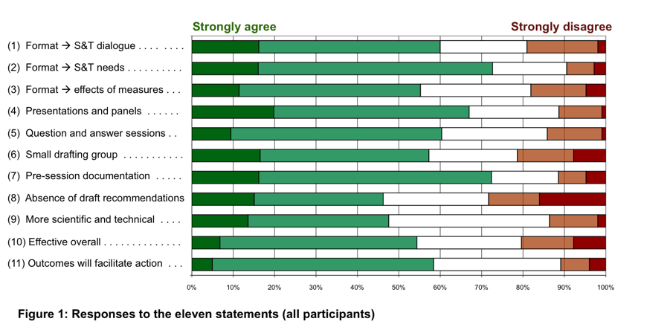
- Figure 2 depicts the overall scores (summing all responses for all eleven statements) across the regions. This analysis confirms the pattern reported above with respondents from Africa and Latin America and the Caribbean groups providing both the largest number of positive responses (79% or more) and the smallest number of negative responses (3% or less). For the Asia-Pacific and Central and Eastern Europe regions, positive responses (more than 60%) outweighed negative ones (less than 5% and 10% respectively). The Western Europe and Others Group, on the other hand, provided more negative responses (40%) than positive ones (32%).
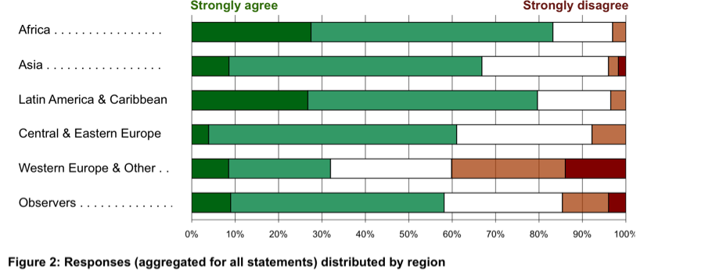

- Further charts, showing the breakdown by region and category for each question, are shown in appendix II.
- Further evidence for the wide range of views is shown by the specific comments of individual respondents, which range from enthusiastically favourable to the format of SBSTTA 17 to definitively opposed (see appendix III).
- Further, the results suggest that the use of the different format was moderately effective in facilitating scientific and technical exchange and in increasing ownership of the outcomes of the meeting. Some parties welcomed the format, including the use of plenary sessions. They considered that the format provided an equal chance for all Parties, allowing everyone to participate and follow the sessions. However the results also indicate that there is significant room for improvement. Some of the specific points raised in the responses to the survey indicated that there were too many panellists on the panels; that panellists should be selected in a more transparent manner; and that advance information on the topics of the presentations would have been helpful. While it was widely noted that the presentations and panel discussions provided interesting information relevant to the implementation of the Strategic Plan for Biodiversity 2011-2020, there was a wide range of views on their effectiveness in promoting dialogue among Parties and partners. Some participants applauded the opportunity to share experiences among Parties. Other respondents noted that the use of question and answer sessions following the panel discussions was not particularly effective as often participants did not ask specific questions but rather made general statements. It was also observed by several respondents that the time available for comments and statements by observers was more limited compared to previous SBSTTA meetings.
- With regards to the small drafting group, it was noted by some respondents that participation in this type of group should be broadened. Lastly, a general comment made by several respondents was that the format used at SBSTTA 17 should have been better and earlier communicated with Parties. It was also suggested that the format used for any particular session of SBSTTA should depend on the issues on its specific agenda.
- With regard to documentation, the results from the survey indicate that, overall, participants agreed that that the documentation prepared for SBSTTA 17 provided a good overview of the agenda items under discussion. By contrast, respondents viewed the absence of draft recommendations less favourably. A number of respondents in their written comments indicated that the absence of draft recommendations prepared in advance of the meeting made it difficult to prepare for the meeting and created some ambiguity about whether or how recommendations would be developed.
- Regarding the outcomes of the meeting, overall, the responses to the survey indicated that participants viewed the deliberations at SBSTTA as slightly more scientific than previous meetings, promoting greater scientific and technical dialogue among Parties and Partners and that the format used during the meeting and that the deliberations at SBSTTA 17 were generally considered effective in providing scientific and technical advice related to the implementation of the Strategic Plan for Biodiversity 2011-2020. By comparison respondents were less positive with regards to the format of SBSTTA 17 facilitating discussions on the effects of types of measures taken to implement the Convention and on the effectiveness of the format in achieving desired outcomes. However, the effectiveness in these cases was still rated between “neutral” and “agree”. Respondents also expressed an overall positive opinion that the outcomes of SBSTTA 17 would facilitate action by Parties and relevant partners. A number of respondents provided further information in their written submissions. Observations included that it would have been easier to develop the outcomes of the meeting if there had been less ambiguity about the nature of the meeting’s expected outcomes.
- In summary, the results of the survey suggest that the majority of respondents were more or less satisfied with the documents prepared for the meeting, the format of the meeting and the effects of the format on the overall outcomes. However, it is important to note that the overall responses from the survey mask a high degree of variability in the survey results, among regions and especially within some regions (see appendix II for a detailed breakdown of the responses per survey questions). Further, it is clear from the survey results, and from the statements made during the closing session of the meeting, that there are a number of issues that need to be addressed if a similar approach is taken for future meetings of SBSTTA. These include the need to better inform participants of changes in the format well in advance of the meeting, the need to provide clarity with regard to the desired outcomes for the meeting, the process to achieve them as well as elements of draft conclusions and recommendations to the Conference of the Parties in advance of the meeting and the need to allocate time efficiently, including to ensure that there is a sufficient amount of time for observers to contribute.

V. COMMENTS FROM DELEGATES DURING SBSTTA 17 AND FOLLOWING THE MEETING
- During the opening and closing sessions of SBSTTA 17 delegates made a number of statements related to the format and outcomes of the meeting. These statements identified a variety of issues that require further consideration when planning future meetings of the Body.
- With regards to the format of the meeting a number of Parties noted the need to ensure more scientific and technical discussions at meetings of the Subsidiary Body and the need to avoid, where feasible, negotiations on political issues. Several Parties noted that the format used at SBSTTA 17 addressed both of these objectives and welcomed the attempt to identify new ways of operation for the Subsidiary Body. Other Parties emphasized that the conduct of SBSTTA should remain in conformity with decisions of the Conference of the Parties.
- The need to provide documentation well in advance of meetings of the Subsidiary Body and the need for this documentation to contain draft conclusions and recommendations for its consideration, in line with the consolidated modus operandi of the Subsidiary Body and decisions of the Conference of the Parties, was noted by several participants. Similarly several Parties noted that the absence of draft conclusions and recommendations to the Conference of the Parties made national consultations in advance of SBSTTA 17 difficult. However some Parties expressed a different opinion, noting that the absence of draft conclusions and recommendations to the Conference of the Parties created an opportunity to consult with national stakeholders and to develop recommendations collectively during the meeting itself.
- In relation to the panels it was observed that the presentations were seen as being of very high quality. However, some delegates called for more balanced representation among the panellists and presenters as well as on the thematic areas or issues they address. It was also suggested that a more transparent process for the selection of presenters and panel members and advance information on the content of the presentations would be useful.
- It was suggested that there is a need to clarify the relationship between SBSTTA and WGRI with regard to their roles in reviewing and supporting the implementation of the Strategic Plan for Biodiversity 2011-2020.
- A small number of Parties and observers have provided additional reflections on SBSTTA 17 to the Chair or Secretariat by letter or email. Generally, they encouraged further innovation while providing suggestions for improvement. One Party, from the Western Europe and Others Group, regarded the new format of SBSTTA as a useful model to enhance discussion on scientific and policy aspects of the Strategic Plan for Biodiversity 2011-2020 and also offered some suggestions that could lead to its further improvement. These suggestions concerned: advance information regarding speakers and their topics, and the possible involvement of Parties in their selection; provision of draft recommendations in advance; greater clarity on the intended outcome of the meeting; and the distribution of issues among meetings of the Subsidiary Body. The CBD Alliance, while appreciating efforts to search for new ways to organize SBSTTA, expressed concern about the exclusion of civil society organizations from the small drafting group and that the opportunities for interventions in the Plenary had been limited through lack of time.

VI. REFLECTIONS FROM THE BUREAU
- During its meeting on the final day of SBSTTA 17, the members of the Bureau met to reflect on the format and outcomes of SBSTTA 17. The purpose of the meeting was to identify those aspects of the meeting that were particularly effective, and those which required modifications.
- Regarding the panel discussions, members of the Bureau highlighted the importance of tailoring the presentations and interventions specifically to the agenda items. They noted the need for the panel presentations and interventions to be focused on the issue being addressed during the session, to contain information that is new for most of the delegates, in particular on national application of practical tools and methods, and not to address procedural issues. It was also recommended to increase the participation of Parties in the selection process for presenters and panellists, through a notification asking for nominations or to have a greater involvement of the Bureau to achieve the best possible representation of different regions, groups of Parties, language groups, and stakeholder groups, as well as gender balance on the panels.
- The Secretariat was asked by members of the Bureau to build on the experience of SBSTTA 17 and continue to further develop the format. Possible negative feedback by some Parties should not necessarily lead to a return to the previous format. An evaluation of the experience of SBSTTA 17 should also consider the experience of SBSTTA 6, which also had been held using a different format.
- Members of the Bureau stressed in particular the success of SBSTTA 17 in enabling the exchange of experiences and views among Parties. Some members stressed the importance of sharing experiences with regards to challenges in implementing the Strategic Plan for Biodiversity 2011-2020 and ways to overcome them.
- More effective and timely communication with Parties was also one of the recommendations from the Bureau. Parties should be informed as early as possible, for example through an explanatory note, about the proposed organization of work for the meeting in order to allow ample time for preparations. In addition, at least some guidance on the nature and scope of the expected outcomes should be provided to Parties before the meeting and to the informal groups working on these outcomes.
- The format of future SBSTTA meetings could be chosen to respond to the items on the agenda and available resources, either more focused on scientific and technical dialogue with a limited set of conclusions or recommendations or more focused on negotiations and preparations of draft recommendations for the Conference of the Parties. It was also suggested that, if there continue to be two meetings of the SBSTTA in the inter-sessional period, the first meeting could be more focused on scientific and technical dialogue, while the second could focus more on preparations for the Conference of the Parties.
- PRELIMINARY CONCLUSIONS AND OPTIONS FOR MOVING FORWARD
- From the foregoing results the following general observations can be made:
        - A large majority of participants in SBSTTA 17 were broadly positive about the changes introduced in the format for the meeting, although there was also a substantial minority who were not. Thus, there was a certain degree of polarization of views among participants. The Western Europe and Others region showed the most negative responses and was also the most polarized. The other regions were mostly positive;
        - Many participants identified both advantages and shortcomings of the format of SBSTTA 17, and many also proposed ways in which the format could be improved for future meetings.
- Among the main advantages identified by participants were:
        - The opportunity for Parties, especially from developing countries, to exchange information and experience on their activities, and their scientific and technical needs;
        - The opportunity for small delegations to participate fully in the discussions because they were held in plenary;
        - More direct involvement of Parties in the development of the outcome of the conclusions and recommendations of the meeting;
        - Closer interaction between Parties and science-based organizations.
- Among the main shortcomings identified by participants were:
        - The lack of a clear and shared understanding on the expected outcomes and working modalities of the meeting;
        - Insufficient time for discussion and for statements by observers;
- Among the main suggestions for improvements identified by participants were:
        - Better advance information on the expected outcomes and working modalities of the meeting;
        - A smaller number of (more focused) presentations and panel discussions;
        - More involvement of the Bureau, and, through the regional representatives on the Bureau or other means, of Parties in the design of the format;
        - More efficient allocation of time to balance statements, discussions, and interventions by all participants.
- The format of future SBSTTA meetings may need to be considered in a flexible manner considering the nature of the items on the agenda as well as available resources. Where two meetings of the SBSTTA are held in the inter-sessional period, the first meeting might be more focused on scientific and technical dialogue, while the second might focus more on preparations for the Conference of the Parties.
- In some ways the agenda of SBSTTA 17 was unique, in that, in line with decision XI/13, it provided an opportunity for Parties to take stock of the tools and guidance available to support implementation and monitoring the Strategic Plan for Biodiversity 2011-2020 in advance of the mid-term review of implementation. SBSTTA 18, in by contrast, will need to address some issues that will require the preparation of recommendations for COP in a more “traditional” manner. Nonetheless there are elements of the new format that might be usefully applied, within the time available at the meeting. In preparing for SBSTTA 18, The Bureau and Secretariat will take into account this evaluation and further considerations.

Appendix I: Distribution of presenters, panellists and chairs by region and category
 | Participation at SBSTTA 17: distribution by region and category |  |  |  |  | Distribution of interventions by region and category |  |  |  |  | Distribution of presenters, panellists and chairs by region and category
 | No. of countries or organizations | % of countries by region | Number of participants | % of category (countries/org.) | % of total | No. of statements | No. of questions | Total interventions | % of category | % of total | Session & group Chairs | Presenters & reporters | Other panellists | Total | % of category (countries/org.) | % of total
Africa | 29 | 27% | 47 | 17% | 10% | 28 | 12 | 40 | 17% | 16% | 2 |  | 2 | 4 | 18% | 10%
Asia and Pacific | 32 | 29% | 93 | 34% | 21% | 38 | 2 | 40 | 17% | 16% | 2 |  | 2 | 4 | 19% | 10%
Central and Eastern Europe | 13 | 12% | 23 | 8% | 5% | 12 | 3 | 15 | 6% | 6% | 1 |  |  | 1 | 2% | 3%
Latin America and Caribbean | 17 | 16% | 35 | 13% | 8% | 45 | 10 | 55 | 24% | 22% | 2 | 1 | 2 | 5 | 24% | 12%
Western European and Others | 18 | 17% | 74 | 27% | 16% | 78 | 4 | 82 | 35% | 33% | 2 | 1 | 5 | 8 | 28% | 21%
Total Parties | 109 |  | 272 |  | 60% | 201 | 31 | 232 |  | 92% | 9 | 2 | 11 | 22 |  | 56%
Indigenous and local communities | 14 |  | 16 | 14% | 4% | 5 | 3 | 8 | 42% | 3% |  | 1 | 1 | 2 | 4% | 5%
Observers other than ILC | 88 |  | 162 | 86% | 36% | 9 | 2 | 11 | 58% | 4% |  | 4 | 11 | 15 | 5% | 38%
Total observers | 102 |  | 178 |  | 40% | 14 | 5 | 19 |  | 8% |  | 5 | 12 | 17 |  | 43%
Grand total | 211 |  | 450 |  |  | 215 | 36 | 251 |  |  | 9 | 7 | 21 | 39
Male |  |  |  |  |  |  |  |  |  |  |  |  |  | 18
Female |  |  |  |  |  |  |  |  |  |  |  |  |  | 14

Appendix II. Responses to the eleven statements showing distribution by region
 | 
1. The format used at SBSTTA 17 promoted greater scientific and technical dialogue between Parties and partners. | 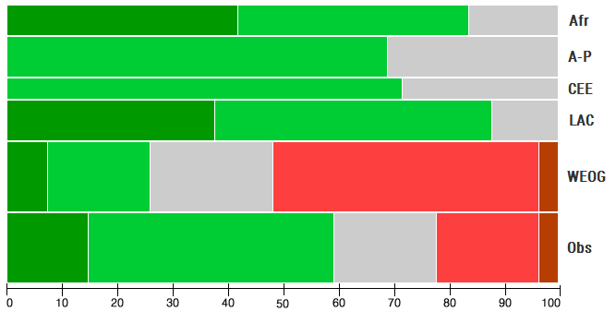
2. The format of SBSTTA 17 facilitated providing scientific and technical advice on the needs for implementing the Strategic Plan. | 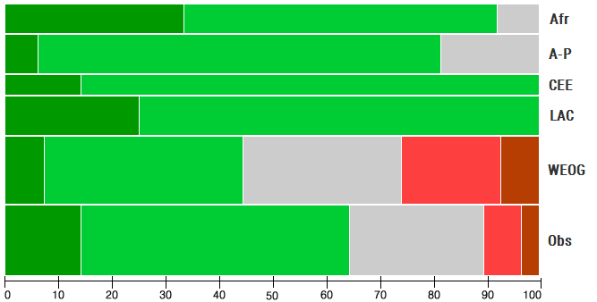
3. The format of SBSTTA 17 facilitated discussion on the effects of types of measures taken to implement the Convention. | 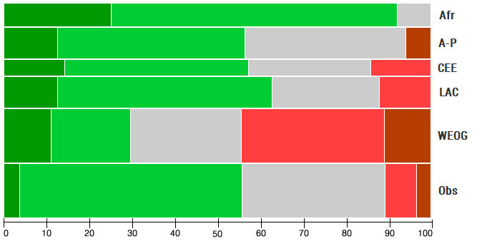
4. The presentations and panel discussions stimulated scientific and technical exchanges between Parties and partners. | 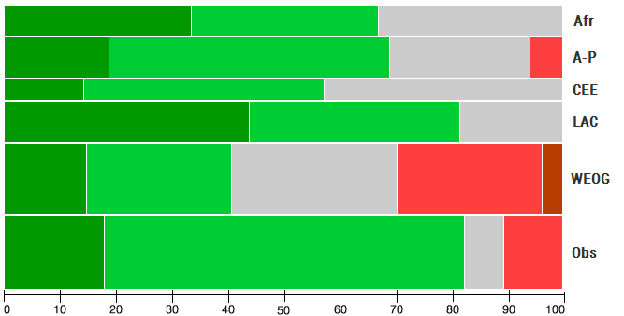
5. The question and answer sessions stimulated scientific and technical exchanges between Parties and partners. | 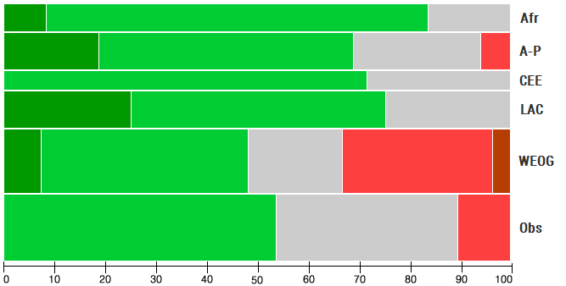

6. The use of a small regionally representative Friends of the Chair drafting group increased ownership of the SBSTTA outcomes. | 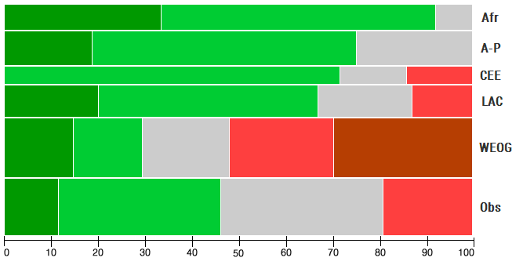
7. The documentation prepared for SBSTTA 17 provided a good overview of the agenda items under discussion. | 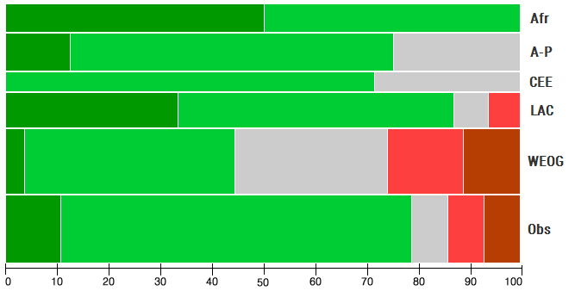
8. The absence of draft recommendations prepared in advance enhanced the effectiveness and transparency of reaching outcomes of the meeting. | 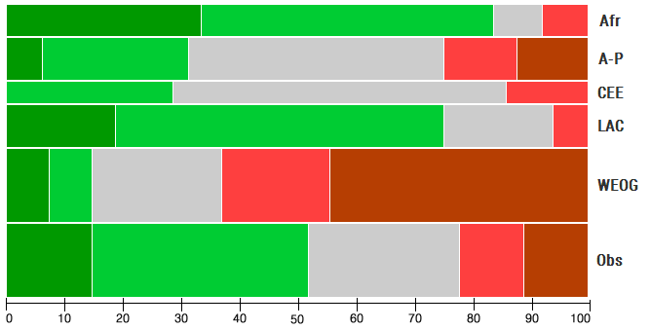
9. The deliberations at SBSTTA 17 were more scientific and technical in nature than previous SBSTTA meetings. | 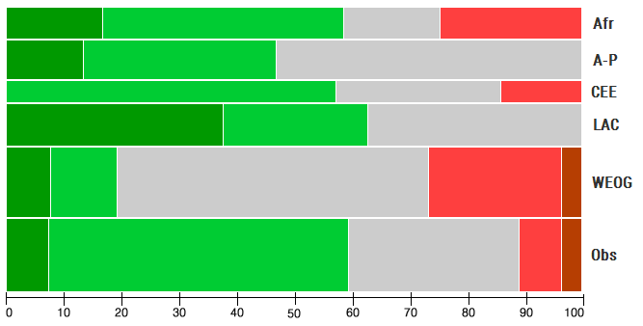
10. Overall, the format of SBSTTA 17 was effective in achieving desired outcomes. | 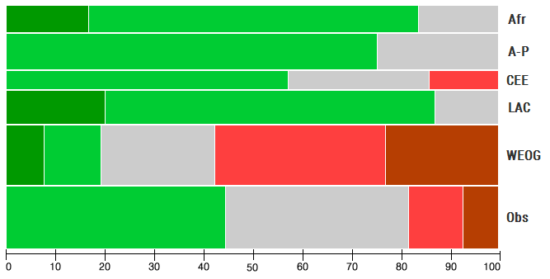

11. The outcomes of SBSTTA 17 will facilitate action by Parties and relevant partners. | 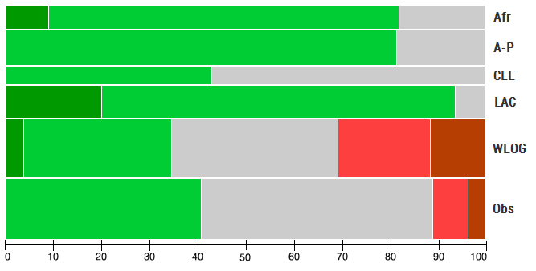

Appendix III. Results of the survey at SBSTTA 17: Written comments provided by individual respondents.
Group | The aspect of this meeting of SBSTTA that was most helpful in achieving the desired outcomes was… | The aspect of this meeting of SBSTTA that was least helpful in achieving the desired outcomes was… | Any other comments
Africa | Focused agenda items  The sessions that allowed Parties to share experiences  It focused on scientific technical and technological advice and not on politics and policy undertones  Presentations and panel discussions  Discussions of all documents in plenary and always interpretation. This assessment has been a very good thing  The experiences of partners: pertinent experiences related by Parties  Having a new format that enables all Parties equal chance to discuss on issues at a place  There were good discussions but there is a need to give more time for observers and not wait to the last minute | The panel has only success stories; future panels should have a balance of challenges encountered in implementation to better help countries in learning/preparing themselves  Informing Parties in a timely manner about this new SBSTTA format  One developed country Party behaving as if their views and texts are more equal than others  Question and Answers  No useful discussion on some elements without important changes by some countries  SBSTTA 17 was a good start for helping Parties/stakeholders in achieving defined outcomes  Not having very strong standard papers or quality presentation paper during plenary sessions (some of the papers are lacking relevant scientific notes) | This new format, for me, was satisfying. It allowed everyone to participate and allowed everyone to follow the work sessions  Though change is difficult to accept for anybody, the new format should be given a chance as it has reduced draft decisions but also moved us away from engaging in negotiations from day one.  We need to worked further on timing for presentations, time for panellists and Q+As to get a good balance of the process  Equal representation of regions on the panel  If you can do more effort to translate notifications, we would have more responses and be more effective  I welcome the modus operandi as it is a more iterative process providing scientific aspects of the issue  Good work of the Secretariat - Keep up
Asia – Pacific  Asia – Pacific (continued) | The documents circulated prior to the meting  The absence of draft recommendations prepared in advance  Panel discussions (2)  Excellent interpreters  Free and open discussion format  Providing a multitude of experiences from the presenters and panellists that have been very useful what tools available out there and what examples Parties are experiencing  A small/minimal number in the drafting group  Identify the technical and scientific needs where preparing the fifth national report and updating NBSAPS to achieve all Aichi Biodiversity Targets and achieve the objectives of the CBD | Presentations and panel interventions  We wasted valuable time on discussing for the recommendation. The Secretariat should present draft recommendations in advance. Additional the Secretariat should manage discussions for the recommendations in an efficient way. E.g. hearing the opinions from Parties in advance, display opinions or propositions on screens during discussions  Small groups for recommendation drafting  Too many side events at the same time limits the activity and benefits  Lack of time for presenters and panellists to provide more details on their subject matter  Parties/observers who are too cautious about issues that are considered in other fora e.g. funding and resource mobilization  Achieve targets 19, 15 and 16 | The meeting rooms were too cold  Since this is a body which is responsible to activate science policy interface, it would help if success stories about effective policy interactions are presented in larger numbers  More time should be given to the presenters because each one of those who presented had a lot more to share than what could be covered in the allocated time  We have identified the technical and scientific needs to achieve the Aichi Targets and CBD objectives as well. But we need scientific and technical and financial support to go ahead
Central & Eastern Europe | Focused more technical interventions by Parties with articulation of aspects specific to each target.  All discussions and negotiations took place in plenary with all Parties  It was excellent  Presentations and panel discussions  Less political negotiations in this SBSTTA  Sharing of experiences of Parties | Useful to clarify well in advance on the type and status of outcomes from the meeting  Late delivering the idea of suggested changes  Unclear procedures before the meeting (How the meeting will be held) | Choice of presenters and their topic to be more transparent to Parties in advance of the meeting.  Presentations to be approved by the Bureau to ensure they strictly to the point of the discussion topic  Forum, organization, expected products/outcomes to be communicated to Parties as early as possible  Make clear for all Parties relevant of new format to the SBSTTA modus operandi  More time for SBSTTA 18 is needed  It would better to inform participants in advance of how the event will be organized. It seems like this time organizational matters were decided in the meeting itself
Latin America & Caribbean  Latin America & Caribbean (continued) | Delegates about the state of art of biodiversity conservation challenges  The flexibility and understanding of participants to an unusual set of events and ways to work; goodwill  The exchange of ideas and the identification of the main needs of Parties for implementation of the Strategic Plan  A good attempt that needs adjustments  Presentations of experts, panel dialogue and documents prepared in experiment to induce Parties comments on focused elements  Being able to have more effective scientific and technical dialogues, strategic, open without previous positions biased towards  Discussions and plenary sessions to reach consensus documents  The work done in the Friends of the Chair  Expert panels, intensive plenary sessions, sharing country experiences  The information presented in plenary at the beginning of the sessions facilitated discussion  The presentations and panels and discussions that followed  The working documents were very well prepared and helped Parties to focus on the needs and additional measures to be taken | The number of panellists could be smaller to let a deeper discussion  Lack of proper control of lengthy discussions on points details (e.g. statements with no real challenge)  Panel presentations of four minutes each didn’t help to deliver a clear message. For next sessions there should be a fewer presentations and Parties should be able to have the themes in advance.  There was not much debate on issues, instead there was a list of statements. Debates should be further encouraged through less trigger ideas. For future sessions, there could due a more balanced contribution of scientific exchange and typical recommendations  Would be good to have an extract of the panellists’ interventions before arriving at the meeting to facilitate discussions  Question and answer sessions  All had some level of usefulness  The Friends of the Chair room was too small to accommodate all the participants  The absence of interpretation for the meeting of the “big” Friends of the Chair meeting  There was not much exchange of views during panels/expositions/presentations. There was not much dialogues. People talked about what they wanted with no interaction. Maybe if there were fewer presentations and smaller groups to discuss technical and scientific issues besides the plenary discussions, it could help the negotiations on recommendations | Collecting views is very interesting as it shares experience, innovative ideas and need to the floor, yet it could be organized as a forum (Internet) prior to SBSTTA in order to save much time as possible for creative brainstorming (based on these compiled views) during the meeting itself. Need to better used the time of participants to further “actions” for discussion  Procedures of SBSTTA meetings can be more clear if documentation on the dynamics of work is published earlier with more effective communication from SBSTTA Bureau Member to their regions  It is necessary to ensure that this type of SBSTTA is prepared with a clear format and questions need to be available in advance. The format is very positive  Congratulations to the Secretariat for the documents, for the work and the services provided. Intensive work of the delegations made for good outcomes  This format helps SBSTTA to better share information  As a pilot experience, I believe it was valid but some adjustments should be made to allow better scientific and technical dialogue
West European & Other  West European & Other (continued)  West European & Other (continued)  West European & Other (continued) | The documentation prepared for SBSTTA 17 beforehand  Good chair  Some good presentations and interesting presenters. Nice to see Parties asking questions and not just making statements. Less outcomes = more focused outcomes  Limited work load due to few items on the agenda and few recommendations to be negotiated  Small drafting group. Larger informal group  The side events were really good (IAS, TEEB Wetlands and awareness)  Exchanging views on the key findings regarding the challenge reflected to the implementation of the Strategic Plan  The documents results from this meeting were more and better understandable than before. Easier to read and understand their content  Panel discussions  Interesting presentations but too short  Some good presentations  The spirit of collaboration between delegates. The willingness to share experiences  Drafting group and informal working group (FOC)  No proposed recommendations. Only plenary sessions  Friends of the Chair and small groups | Spending time in question/answer sessions because it was not used for questions but for statements by Parties without a relation to the presentations  The plenary felt like an extended side-event (without catering)  Lack of draft recommendations  Work in plenary and not in working groups like before was not very helpful  Framing of outcome document, expectations around it (i.e. managing expectations) and also process to arrive at final product. Too much effort on negotiating “views” rather than crafting useful recommendations  Time spent on general statements with uncertain scientific support or background apparent. Comments appeared often to be more practice based than scientific  Lengthy plenary exchange of national experiences  The ambiguity about what the meeting would result in  The lack of possibilities given to the observers to provide input on scientific issues  The fact there was a high degree of lack of understanding how we should proceed during the meeting and what its outcomes would be  Lack of draft recommendations. Unclear procedures of how to reach an outcome  It would have been helpful to have the process of the meeting and its outcomes clear from the beginning of the meeting  Increasing the confusion on the “border” between SBSTTA and WGRI  Too many presentations. One keynote speaker would have been better (per strategic goal). Most outstanding speaker would have been better  Some presentations were outside the scope. Not all presentations have been available  The panel discussions, presentations were biased towards the north and there little time for dialogue | If you want SBSTTA to be more scientific, use a format that gives scientists the chance to take part. Use the first day to give parallel scientific sessions around agenda items, publish abstracts beforehand so that delegates can choose which to go to. Prepare key findings, recommendations beforehand by an open online process not in a closed non-transparent drafting group at midnight sessions. That would enhance ownership.  SBSTTA 17 was an interesting experiment that did not reach its objectives. Too many presentations by the “the usual suspects” discussions and exchange of ideas. Almost exclusive focus on scientific presentations. Lack of balance science/policy failed to deliver as science policy interface. Produce integration of science and policy interests  This format does not allow SBSTTA to support the operations of the COP. As its mandate is to provide advice to COP, the outcome of this SBSTTA is suboptimal and does not justify it to be financed on the COP core budget  Such an effort for such little outcome. A meeting like this is a waste of time and money and will not help biodiversity at all  Very useful experience. Though it should be repeated/continued (also look back at learning from SBSTTA 6). Growing pains to be expected! Might be useful to talk to other UN bodies that have similar process (discussion, “views” etc.). Bureau could have a stronger role in quality control of documents. Also more investment/commitments to good outcomes (e.g., chairs take ownership of their goal, associated documents and draft outcomes). In future could design structure to allow more time for observers participation.  Presentations by scientists on certain topics on the agenda and linkage to the Aichi Targets and indicators could possibly generate more scientific discussions and inputs on the issues  Good experiment to try, must learn the lessons. For information exchange need smaller, more focused discussions, real dialogue. Market place or round-tables. But needs to be practitioners not negotiators. For identification of needs. More engagement by Parties in the preparation, informed meetings. Preparatory documents with conclusions/ recommendations  It was a pity we did not known what the results of the meeting would be. It would have helped in our preparation if we had known under headlines were supposed to “fill in” our results. The small drafting group made the results from this meeting a product of a small group of countries. Try the method of “open space” if you want results that all Parties feel ownership with.  The format of the meeting appears to be a compromise between keeping a traditional and introducing a new format. In my view in order to create a greater involvement of participants a more radical format would be needed. Maybe the rules of procedure are an obstacle but the use of “open space” format could be a way to enhance the creativity and effectiveness of SBSTTA  The new format had both positive and negative aspects. If the procedure is cleared next time Parties can better prepare for the meeting. It depends on what SBSTTA should deliver. May be different formats for different tasks would be good  Limited outcomes. Difficult to involve sectors beforehand  This conference should not have been a SBSTTA but rather a non-negotiated context where participants could have a more free exchange of views and experiences and with more scientific inputs and analysis before the conference. More in depth and more meaningful discussions could have been between countries in regions that have more in common  This was a waste of time and money. In more than 15 years of CBD, I have never attended a more useless meeting. For the time and resources spent the outcomes is of very limited use. How can a meeting like this be of any help to maintaining biodiversity  It would be wasteful to go through the pain of change and not adopt some of the new processes into future meetings.  Confusing process, lack of transparency, lack of involvement from observers, limited outcomes and lack recognition of who will use the outcomes (key findings). Very good participation from Parties and observers  Aspect from useful exchanges in FoC groups, negotiators were same as usual. Format of meeting should have been communicated by SCBD and better implemented. Better preparation in Bureau would also be welcomed  Continue. We need a better selection of speakers  It is important for the Chair to work on one paragraph at a time. At one point he allowed new issues on two paragraphs simultaneously. It is also important to give voice to the ILCs and observers because they have important substantive input as well
Observers  Observers (continued)  Observers (continued) | Opportunities for Parties and observers to present information and statements on needs and accomplishments  The experience sharing and different means of implementation  Presentations, Friends of Chair  Secretariat’ amazing efforts to capture and document views from Parties and observers on each strategic goals to compile the first non-paper  The friends of the Chair meeting  Increased information sharing from panellists bringing new knowledge, including indigenous peoples perspectives  Open working groups  Key note presentations followed by panel discussions, Question and Answers  Specific issues discussed  The possibility to listen to presentations/discussions and the work all in plenary (i.e. no working groups)  The stronger representation of technical expert views  Panel presentations  Open discussions, exchanges of views and ideas, experiences  The panel presentations and the subsequent Question and Answer sessions  Input from larger number of countries/organizations through the panels to prepare the draft recommendations  Presentations, panel discussions and side events | Use of small regionally representative Friends of the Chair drafting groups (too narrow)  General statement from Parties without having focus on meeting agenda  Panel discussions without enough participating from non-party expert observers  Parties’ resistance to support the new format. Interventions from NGOs and scientists were limited. More time should be allocated to panel discussions and Question and Answer and less for general Party statements which can be done by written submission.  Limited time to make input of views, especially from observers  Plenary discussions/presentations which were not known before so Parties/observers could not prepare beforehand. It was, unfortunately, a weak imitation of a scientific conference. Suggestions: A focus on 1-3 targets beforehand and assessing each of the targets in panel sessions. Transparently invite Parties and observers to nominate experts for their sessions (or let Parties organize it). Inform community three months before SBSTTA about the content of the panels so that they can prepare properly. This would stimulate scientific discussion  Exclusion of indigenous peoples and local community from consideration in recommendations and the loss of Goal E in the agenda which SBSTTA must take up  Too little time for observers to participate in plenary debate, particularly ILCs, IIFB and NGOs  The fact that there was minimal effort to allow time for NGOs to engage. These are the bodies that provide a lot of support to Parties on the ground so should be allowed to participate to this policy and technical forum in a meaningful manner. These observers bring a lot of technical expertise, experience and commitment to the work of biodiversity conservation and sustainable use and so should be seen as strong partners and given sufficient room and time participate in the deliberations  Limited participation of the observers  Lack of time for discussion. Lack of a precise agenda on panellists speeches/mix of discussions on panel and on documents  Hardly any time for real discussions and Question and Answer sessions  Lack of very clear direction regarding outcomes  Not clear procedure of work  The absence of organized, structured feedback from Parties on how they are using the tools and methods already made available to them  Question and answer section should les focusing on long reporting on what is happening in countries/organizations but more directed to panel presentations  Plenary sessions with statements by Parties | Observers should have opportunities to feed into drafting groups which was possible in previous procedures, SBSTTA sessions. The earlier procedures offered greater opportunity  Selection of presenters was not transparent. Time allocation, more time for discussion not statements  Panel presentations was informative and interesting but how and why they were selected was unknown  Parties were not prepared to have scientific and technical dialogue with new format. Friends of Chair was limited to plenary interventions and submissions dialogue was limited. The lack of dialogue is not due to the new format per se but the familiarity and preparation of participants. I expect the environment for dialogue will improve as the new format is repeated in subsequent meetings. The annexes to L2 contain rich contents. Submission and inclusion can be improved to make documents better.  There was no participation from civil society  I really enjoyed the panellists and hope that future meetings can find a way to resolve better preparation of participants for this format. Adequate time for observers contributions.  There are times when interpreters are speaking so fast that I cannot understand the message.  The interpreters must ask the speakers to slow down. I like the new coffee shop  Give enough time to observers to explain what they are doing at regional level on CBD capacity building, conservation programmes, etc. By not giving the observers a chance you are denying your member states (Parties) information that is available for them at regional level  Suggestions: panels and discussions could start on Sunday.  The lack of prepared recommendations helped some discussions but next time it would be useful to have at least some outline of the main issues to be covered by SBSTTA  The work of some targets was more representative than others, creating an unbalanced presentation of what happening in several parts of the world to advise on the implementation of the Targets.  Observers had little time allocated to statements from the floor  Moving away from standard SBSTTA formats was refreshing and brave. However this needs to be developed into a more focused format, supported by strong pre-meeting guidance and collaboration, in which well-defined targets and outcomes of the SBSTTA meeting are presented and understood by all.  Relevant comments given already at COP Bureau meeting regarding following the COP decisions, exchange of information, in time for preparation  Real discussions and sharing of experiences is difficult in large plenary gathering. Many observers felt their voice/contributions were not heard. Overall the format was definitely an improvement but needs some fine tuning.

-----

UNEP/CBD/SBSTTA/17/1/Add.1, 28 June 2013.
UNEP/CBD/SBSTTA/17/1/Add.2, 12 September 2013.
The number of Parties from each region expressed as a percentage of all Parties participating in the meeting.
The number of participants for each category expressed as a percentage of the total number of participants.
The number of interventions for each category expressed as a percentage of the total number of interventions.
The percentage of session chairs and panel members from each category.
The number of survey responses for each category expressed as a percentage of the total number received.
Includes 5 countries from the European Union with 15 participants.
Includes 11 countries from the European Union and its representative with 43 participants.
Includes 5 countries from the European Union with 15 participants
Includes 11 countries from the European Union and its representative with 43 participants.

