 |  | CBD
 |  |  |  | Distr.  GENERAL  UNEP/CBD/SBSTTA/20/INF/29  18 April 2016  ENGLISH ONLY
Subsidiary Body on Scientific, Technical and Technological Advice

Twentieth meeting

Montreal, Canada, 25-30 April 2016
Item 8 of the provisional agenda*

Relationships between the Aichi Targets and land-based climate mitigation

Note by the Executive Secretary
- The Executive Secretary is circulating herewith, for the information of participants in the twentieth meeting of the Subsidiary Body on Scientific, Technical and Technological Advice, a report on the relationships between the Aichi Targets and land-based climate mitigation.
- In follow-up to the fourth edition of the Global Biodiversity Outlook, the Secretariat commissioned, with financial support from the European Union, a group of experts to prepare a review on the contribution of the Aichi Targets to climate mitigation, and the role of models and scenarios to inform pathways to achieve biodiversity and climate objectives. A preliminary version of this report was presented at the nineteenth meeting of the Subsidiary Body in document UNEP/CBD/SBSTTA/19/INF/15. As requested by the Subsidiary Body, in recommendation XIX/1, the preliminary report was made available for peer review from 4 December 2015 to 22 January 2016. Comments were received from four Parties (New Zealand, Brazil, Argentina and Peru) and three organizations (the Global Forest Coalition, Indigenous peoples’ and Community Conserved Territories and Areas Consortium and UNEP-WCMC).
- The present report is a revised and updated version of document UNEP/CBD/SBSTTA/19/INF/15.
- The report is presented in the form and language in which it was received by the Secretariat.

Relationships between the Aichi Targets and
land-based climate mitigation

Summary

• Keeping global warming to below 2°C, and if possible below 1.5°C – the targets set in the Paris Agreement on climate – are important for attaining the 2050 Vision of Strategic Plan for Biodiversity 2011-2020. Reducing greenhouse gas emissions or increasing carbon sequestration in terrestrial ecosystems, referred to as land-based climate mitigation, can potentially make substantial contributions to meeting these targets. The Aichi Biodiversity Targets lay out the near term objectives in the path to reaching the 2050 Vision, and there are strong relationships between meeting the Aichi Targets and implementation of land-based climate mitigation.
• Land-based climate mitigation strategies based on halting the conversion of natural terrestrial ecosystems (Aichi Targets 5 and 11) and restoring degraded ecosystems (Aichi Target 15) could make significant contributions to climate mitigation. Indeed, forest recovery on abandoned lands is generally more effective at climate mitigation over periods of up to three decades than some widely used first generation biofuels, such as corn and palm oil. Protection of ecosystems with large potential emissions of greenhouse gases upon conversion, such as forests and coastal ecosystems, is estimated to be one of the most cost effective means of climate mitigation. However, there is high uncertainty in the magnitude of these contributions.
• Sustainable agricultural practices (Aichi Target 7), especially those that promote soil carbon sequestration, could also potentially provide a large fraction of land-based mitigation. Improved fertilizer and water management can also make important contributions to climate mitigation, as well as to protecting biodiversity through reductions in pollution (Aichi Target 8) and water extraction from freshwater ecosystems.
• Additional strategies that could contribute to land-based climate mitigation and to meeting Aichi Targets merit further examination, especially when they make positive contributions to climate mitigation and adaptation, protection of biodiversity and human well-being. Achieving an objective of "healthy" diets for everyone and reducing in losses in food systems are among these alternatives (part of Aichi Target 4), because they contribute to decreasing land use change, which is the principal driver of biodiversity loss in many regions, and reducing greenhouse gas emissions from agricultural systems.
• Some land-based mitigation strategies could compromise meeting the Aichi Targets, and especially the long-term goals of the 2050 Vision. Bioenergy, especially when coupled with carbon capture and storage (BECCS), has been identified as one of the keys to meeting ambitious climate mitigation targets. The massive deployment of bioenergy which is foreseen in most strong mitigation scenarios could reduce climate change impacts on biodiversity by limiting greenhouse gas emissions, but there are also considerable risks of not meeting Aichi Targets due to the negative impacts caused by habitat conversion (risks for Aichi Target 5) and pollution (risks for Aichi Target 8). Resolving tradeoffs related to deployment of bioenergy is critical and will strongly influence approaches to achieve Aichi Target 3, the objective of which is to eliminate financial incentives that are harmful to biodiversity and develop and apply positive incentives.
• A comprehensive understanding of the benefits and tradeoffs of a large panel of land-based mitigation strategies is lacking, and uncertainties associated with alternative strategies are high. In addition, many strategies, such as halting deforestation, afforestation or increasing soil carbon in agricultural systems, are vulnerable to climate and land use change. This strongly argues i) for emphasizing other mitigation strategies such as reducing fossil fuel emissions as essential companions of land-based strategies and ii) against implementation of land-based strategies based solely on climate mitigation potential. Some important land-based climate mitigation efforts, such as forest protection measures supported by REDD+, are becoming more strongly anchored in analyses of opportunities and limitations across a wide range of criteria including the protection of biodiversity.
• Scenarios that explore plausible future development pathways can help to evaluate the benefits and limits of various land-based climate mitigation schemes. Many of these scenarios — including all of the recent IPCC RCP scenarios — foresee large-scale land use changes and/or high rates of greenhouse gas emissions that are likely to be detrimental to biodiversity. There are, however, plausible scenarios in which biodiversity protection, climate mitigation and human-development targets are broadly met simultaneously.
• Overall, these scenarios converge on relatively similar conclusions about the components for achieving a sustainable future, even though there are important differences in relative contribution of each component and underlying mechanisms. These scenarios depend on:
- Protecting intact forests and restoring ecosystems (Aichi Targets [AT] 5, 11, 15), a well as creating incentives for this protection and restoration (AT 3).
- Sustainable intensification of agriculture with a focus on increasing efficiency (AT 7).
- Achieving "healthy" diets for everyone and reductions in losses in food systems (AT 4).
- Reducing risks of not meeting Aichi Targets (esp. AT 4 and 8) by setting appropriate goals for the magnitude of deployment of bioenergy and avoiding incentives favoring undesirable land conversion, water use and pollution (AT 3). A rapid shift to renewable energy sources and increased efficiency of energy use (not explicitly addressed in Aichi Targets).

1. Introduction

This report i) outlines why climate mitigation is important for protecting biodiversity particularly for vulnerable ecosystems highlighted in Aichi Target 10, ii) provides a critical analysis of how the principals embodied in the Aichi Targets — in particular targets related to land use and land management including targets 5, 7, 11 and 15, as well as broader sustainability related targets 3 and 4 — could contribute to climate mitigation, iii) explores the possibilities and limits to other land-based mitigation strategies, especially incentives for future large-scale deployment of bioenergy (Aichi Target 3) and iv) briefly highlights additional pathways that heavily influence land use and may have positive effects on biodiversity, especially changes transformations in diets and reducing losses in food systems (part of Aichi Target 4). The final section presents integrated perspectives of future development pathways – relying heavily on integrated scenarios and models – that account for synergies and tradeoffs between various land-based mitigation measures and a broad set of sustainability issues. This section is particularly important for understanding the interactions between Aichi Targets and their relationship to the 2050 Vision.

While this report focuses on land-based mitigation, it is important to start by noting that climate mitigation based on reductions in emissions from fossil fuels and cement production is an essential component of climate mitigation. Intact terrestrial vegetation and soils sequester about one third of current CO₂ emissions from fossil fuels and cement production (IPCC WGI 2013, Le Quéré et al. 2014). The global carbon budget over the first decade of the 21st century can be summarized by the following fluxes (all in PgC/yr): 7.8 = emissions from fossil fuel and cement; 1.0 = emissions due to land use and cover change (LUCC), 2.4 = terrestrial sequestration; 2.4 = ocean sequestration, 4 = accumulation in atmosphere (Le Quéré et al. 2014). Thus, reducing emissions due to LUCC and increasing terrestrial carbon sequestration (as well as mitigating other terrestrial greenhouse gas emissions) are currently on the right order of magnitude to play an important role in climate mitigation. Under very optimistic assumptions, land-based mitigation could nearly offset current emissions from fossil fuels and cement production, and could potentially be implemented faster than technology-based approaches to reducing emissions from fossil fuels (Houghton 2015). However, the relative contribution of land-based strategies to climate mitigation is substantially reduced if fossil fuel and cement production emissions remain at current levels or grow rapidly. This occurs because cumulative fossil fuel and cement production emissions become too large to be offset by land-based strategies, in part due to the limited time spans over which many land-based mitigation strategies are effective (e.g., the greatest mitigation effects of forest regeneration occur over the first decade or two after regeneration starts, Evans et al. 2015), and in part due to large negative impacts of climate change on carbon sequestration capacity of natural and agricultural ecosystems that are projected for high emissions scenarios (IPCC WGI, II 2014).

Reducing emissions from land use change, which results primarily from deforestation, and increasing land-based carbon sequestration in natural and managed ecosystems could make significant contributions to climate mitigation and biodiversity conservation (Trumper et al. 2009, Turner et al. 2009, Rose et al. 2012, Williamson 2016). This highlights the importance of Aichi Targets directly related to land use and land management change — in particular Aichi Targets 5, 7, 11 and 15 (Table 1) — as well as other Aichi Targets related to indirect drivers of land use change. This report also explores the role of bioenergy for land-based mitigation, because massive deployment of bioenergy plays a key role in most scenarios for achieving the ambitious targets set out in the Paris Agreement on climate (IPCC WGIII 2014). These scenarios foresee strong land-use conflicts arising from pressures for increased food supply for a growing human population, large scale deployment of bioenergy with carbon capture and storage (BECCS) to help limit global warming to 2°C and goals to increase protection and restoration of ecosystems (IPCC WGIII 2014, Smith et al. 2016, Williamson 2016).

Table 1: Aichi Targets 5, 7, 11 and 15 which are directly related to land cover and land management.
Target 5: By 2020, the rate of loss of all natural habitats, including forests, is at least halved and where feasible brought close to zero, and degradation and fragmentation is significantly reduced.
Target 7: By 2020 areas under agriculture, aquaculture and forestry are managed sustainably, ensuring conservation of biodiversity.
Target 11: By 2020, at least 17 per cent of terrestrial and inland water, and 10 per cent of coastal and marine areas, especially areas of particular importance for biodiversity and ecosystem services, are conserved through effectively and equitably managed, ecologically representative and well connected systems of protected areas and other effective area-based conservation measures, and integrated into the wider landscape and seascapes.
Target 15: By 2020, ecosystem resilience and the contribution of biodiversity to carbon stocks has been enhanced, through conservation and restoration, including restoration of at least 15 per cent of degraded ecosystems, thereby contributing to climate change mitigation and adaptation and to combating desertification.

Greenhouse gases fluxes, and frequently only carbon fluxes, are often the focus of studies estimating land use change impacts on climate. However, biophysical factors related to land cover also play a major role in mediating climate, these factors include the capacity to vegetation to reflect sunlight and to transfer energy to the atmosphere through latent (i.e., evaporation and transpiration of water) and sensible heat fluxes. For example, boreal forests tend to warm the atmosphere compared to tundra vegetation due to lower reflectivity, whereas tropical forests tend to cool the atmosphere compared to pastures and agricultural land due to higher latent heat fluxes (Davin & de Noblet 2010). These effects at global scales are generally smaller than recent or projected global warming effects due to greenhouse gas emissions, can be substantial at local to regional scales and can alter local and regional climate extremes (Brovkin et al. 2013, de Noblet et al. 2012, Alkama & Cescatti 2016, Naudts et al. 2016). The effects of these biophysical factors are much less well accounted for in land-based mitigation studies than are the contributions to global warming via greenhouse gas fluxes. As such, this report is frequently limited to examining the effect of Aichi Targets on climate mitigation via greenhouse gases.

An additional factor is that climate change and land use change are already altering the functioning and distribution of species and habitats (IPCC WGII 2014). Climate change driven changes the distribution and status of major vegetation types are particularly important to take into consideration, because they can substantially alter the efficacy of land-based mitigation schemes (Arneth 2015). Studies of land-based mitigation that simultaneously account for greenhouse gas fluxes, biophysical effects and climate change impacts on the distribution of major vegetation types are rare (but see Brovkin et al. 2013).

Oceans currently sequester roughly the same amount of carbon as terrestrial ecosystems on an annual basis, but the human impacts other than climate change and ocean acidification on carbon storage in the open ocean are thought to be small (IPCC WGII 2007). The greatest possibilities for intervention in marine systems are for ecosystems that at the interface between sea and land, in particular saltmarshes and mangroves (Nellemann et al. 2009, Williamson 2016). These ecosystems are discussed in this report as part of land-based climate mitigation. The effects of interventions in open-water systems (e.g., changing fishing practices or restoring seagrass beds) on climate mitigation have been far less studied, and the potential for climate mitigation is thought to be limited (Nellemann et al. 2009, Pershing et al. 2010, Duarte et al. 2013). Therefore these are not treated in this report. Geoengineering could substantially alter the role of oceans in climate mitigation, but this has been treated in elsewere in reports for the CBD (e.g, UNEP/CBD/SBSTTA/19/INF/2).

A number of reports and studies have already examined the role of reducing habitat conversion and restoration on climate mitigation (e.g., Trumper et al. 2009, Nellemann et al. 2009, UNEP 2013). Bioenergy and other means of large-scale land-based mitigation have also been examined including in the very recent "Update on climate geoengineering in relation to the Convention on Biological Diversity: Potential impacts and regulatory framework" (UNEP/CBD/SBSTTA/19/INF/2). This report therefore focuses on very recent literature and on an integrated view of the interactions between land-use options as they affect climate mitigation and biodiversity. Additional information about mechanisms for improving ecosystem based climate change mitigation can also be found in the report "Managing ecosystems in the context of climate change mitigation: A review of current knowledge and recommendations to support ecosystem-based mitigation actions that look beyond terrestrial forests" (UNEP/CBD/SBSTTA/20/INF/3).

2. It is important for biodiversity to keep global warming to 2°C or below
(Essential to achieving most Aichi Targets and the 2050 vision)

2.1 Climate change and vulnerable ecosystems
Aichi Target 10 focuses on minimizing pressures on ecosystems, especially coral reefs, that are highly vulnerable to climate change or ocean acidification. As highlighted in the Global Biodiversity Outlook 4 (GBO4 2014) and IPCC WGII (2014) reports, tropical coral reefs are of great concern because the impacts of recent warming such as bleaching and degradation of reefs are already widespread, and future impacts are projected to be high and more severe than for other ecosystems even under 2°C warming scenarios (IPCC WGII 2014, Gattuso et al. 2015). Minimizing other pressures such as overfishing and pollution may help tropical coral reefs adapt to 2°C warming, but adaptive measures are foreseen to be much less effective for greater degrees of warming (GBO4 2014, Gattuso et al. 2015). Arctic tundra is also an ecosystem of great concern because the effects of recent warming, such as melting of permafrost and increases in woody vegetation, are already visible (IPCC WGII 2014). Warming is much greater at high northern latitudes, so even 2°C global warming is associated with much greater warming over large portions of Arctic tundra, with very limited possibilities for adaptive management (IPCC WGII 2014). A wide range of other ecosystems are of particular concern including deep-sea corals, mountain ecosystems and tropical forests (GBO4 2014, IPCC WGII 2014).

2.2 Species extinctions and species conservation status.
Aichi Target 12 focuses on avoiding species extinction and improving species conservation status. The IPCC WGII (2014) report highlights the high risk that climate change poses for species extinctions. Several studies indicate that the risk of species extinction could rise substantially for 2°C of warming and lead to mass extinctions at high levels of warming; however, there is very high uncertainty associated with these projections and the evidence that recent warming has lead to species extinctions is weak (Pereira et al. 2010, Bellard et al. 2012, IPCC WGII 2014).

There is much less uncertainty in the effects of climate change on species distributions, since there is clear evidence that species move in response to changes in climate. Future climate change is projected to cause large changes in the conservation status of terrestrial and marine species at local and regional levels, with the effects highly dependent on the ability of species to move or to adapt to changing climate and the rate and magnitude of climate change (Bellard et al. 2012, IPCC WGII 2014, Rondinini & Visconti 2015). Limiting warming to 2°C or less is projected to significantly reduces the pressure on species to move in response to climate change and increases the likelihood that they can locally adapt (IPCC WGII 2014). Changes in species distributions are projected to have very large impacts on ecosystem services in marine and terrestrial ecosystems (IPCC WGII 2014).

Aichi Target 11 (see Table 1) focuses on increasing coverage of terrestrial and marine protected areas and, importantly, also improving their efficacy and connectedness. Because climate change causes species to move and because species move at very different rates, this is likely to compromise the efficacy of protected areas. The highest greenhouse gas emissions scenarios are projected to lead to very high rates of species turnover in protected areas and difficulties for many species to move quickly enough to keep up with the pace of climate change (GBO4 2014, IPCC WGII 2014).

2.3 Shifts in the distribution and functioning of major ecosystem types
Changes in climate in the Earth's past have been accompanied by large shifts in the distributions of major terrestrial ecosystem types (IPCC WGII 2014). Future warming is projected to lead to poleward and uphill movements of entire biomes (IPCC WGII 2014). Rising CO₂ concentrations and recent warming have generally been associated with an increase in carbon sequestration by terrestrial ecosystems, but warming associated with high emissions scenarios are projected to seriously compromise the ability of terrestrial ecosystems to sequester carbon (IPCC WGII 2014, Millar & Stephenson 2015, Gauthier et al. 2015). Indeed, widespread degradation of some ecosystems due to recent warming, such as conifer forests in Western North America, has already been observed (IPCC WGII 2014, Millar & Stephenson 2015). In some cases, warming above 2°C is projected to lead to tipping points where entire biomes become highly degraded with the Amazonian forest, Boreal forests, Arctic tundra, coral reefs and the Arctic sea being of particular concern (GBO3 2010, Leadley et al. 2014a, IPCC WGII 2014). Overall, keeping global warming to 2°C or below increases the likelihood of achieving all Aichi Targets that depend on biodiversity and ecosystem services, and substantially improves the ability of adaptive measures to minimize undesirable climate change impacts (GBO4 2014, IPCC WGII 2014).

3. Protecting natural ecosystems, especially forests, and restoration can make an important but highly uncertain contribution to land-based climate mitigation
(Effects of achieving Aichi Targets 5, 11, 15)

3.1 Avoided greenhouse gas emissions: contributions from protected areas and maintaining the integrity of natural ecosystems
Aichi Target 11 (increasing the area and efficacy of protected areas, Table 1) and Aichi Target 5 (reducing the rate of loss of natural habitats, especially forests, Table 1) can contribute to climate mitigation through avoided greenhouse gas emissions, as well as having less well-quantified biophysical effects. Avoided emissions are not straightforward to calculate since emissions and biophysical effects depend heavily on the type of land use conversion. For example, burning tropical forest — which is a common deforestation method — releases a large fraction of the carbon stored in plants and soils to the atmosphere in a very short period of time, while land use conversion following logging can have substantially lower rates of carbon emissions depending on how the wood is used and soils are managed (Birdsley & Pan 2015). In addition, ecosystems vary greatly in the materials that are vulnerable to release as greenhouse gases following land clearing, with tropical peat forests, northern peatlands and temperate forests having by far the highest amounts of vulnerable material (Anderson-Teixeira & DeLucia 2011; e.g., more than 3000 MgCO₂eq/ha for tropical peat forests).

Current carbon emissions from the conversion of natural habitats are about 1.1 Pg/yr (IPCC WGI 2013). Trumper et al. (2009) estimate that "reducing deforestation rates by 50% by 2050 and then maintaining them at this level until 2100 would avoid the direct release of up to 50 GtC this century", which is roughly 0.5 PgC/yr. Birdsley & Pan (2015) estimate that as much as 1.6 PgC/yr of emissions could be avoided through reduced deforestation.

Three examples from Brazil, Indonesia and coastal ecosystems provide examples of the contributions that protected areas and reducing the loss of natural habitats can make to climate mitigation.
• Deforestation in the Brazilian Amazon resulted in the loss of about 20% forests between 1970 and 2012 (INPE 2013). Overall, net emissions from land use changes in Brazil from pre-colonial times to the present amount to 88 PgCO₂eq (Leite et al. 2012). A wide range of convergent initiatives reduced Amazon deforestation in 2013 to 70% below the historical 1996-2005 baseline of 19,600 km²/yr, and deforestation in Atlantic tropical forest has also declined substantially (Soares-Filho et al. 2014). This reduction in deforestation represents avoided greenhouse gas emissions of about 2.7 PgCO₂eq. Major efforts over the past decade have led to a large increase in coverage of protected areas, and currently approximately 40% of natural vegetation is legally protected by parks and indigenous reserves. Ecosystems in protected areas of Brazil store about 117 PgCO₂eq, and natural forests and savannahs on private properties store approximately 105 PgCO₂e (Soares-Filho et al. 2014). If all of the vulnerable material (i.e., mostly carbon bound in organic material) was released from these areas, this would be the equivalent of about 7 to 8 years of current total global fossil carbon emissions, highlighting the high stakes in maintaining protected areas and minimizing habitat loss on private lands.
• Deforestation rates in Indonesia are rising rapidly (ca. 20,000 km²/yr in 2013, Hansen et al. 2013), and now substantially exceed the deforestation rates in the much larger Brazilian Amazon. This has particularly large impacts on greenhouse gas emissions, because much of this deforestation is carried out by burning tropical peat forests that have extremely high stocks of vulnerable material. Greenhouse gas emissions from deforestation in Indonesia are estimated to have been between the equivalent of 0.3 and 1.9 PgC/yr during the first decade of the 21st century (Busch et al. 2015). Given the magnitude of its greenhouse emissions, Indonesia is the country in which the largest gains can be made from reductions in habitat loss. A moratorium on new concessions for forest conversion is in effect since 2011 and the national objective is to reduce emissions from deforestation by 26-41% by 2020, but deforestation rates continue to rise (Busch et al. 2015). Protected areas now cover about 15% of land area in Indonesia, but after a rapid jump in the 1990's the rate of increase in protected areas has slowed (GBO4 2014). Increasing protected areas and expanding the scope of the moratorium on concessions might help meet the goals for reducing deforestation, but displacement of deforestation to outside of protected areas and concession areas (i.e., leakage) needs to be avoided for this to be an effective mitigation measure (Busch et al. 2015).
• Mangroves, saltmarshes and seagrasses cover an area of 0.9 million km² globally, and sequester about 0.11 to 0.13 PgC/yr (Nellemann et al. 2009). The annual rate of habitat destruction is extremely high and between about 2% (saltmarshes and mangroves) to 7% (seagrasses) per year (Nellemann et al. 2009). Therefore, slowing or halting destruction of these habitats, reducing pressures such as pollution and restoration could make significant contributions to climate mitigation (Laffoley & Grimsditch 2009, Nellemann et al. 2009, Duarte et al. 2013).

3.2 Increasing carbon sequestration through ecosystem restoration
Aichi Target 15 (see Table 1) includes a goal of restoring 15% of degraded ecosystems with a specific focus on increasing carbon stocks and contributing to climate mitigation. The lack of agreement on the extent of degraded lands — estimates range from 19 to 112 million km² depending on the definition of land degradation — makes it very difficult to estimate the contribution of meeting Target 15 to climate mitigation. As such, this report focuses on well-documented estimates of specific measures of restoration.

Carbon sequestration potentials of afforestation and reforestation on abandoned or "marginal" lands have recently been estimated by Evans et al. (2015, see also Silver et al. 2000, Righelato & Spracklen 2007). Evans et al. (2015) synthesized a large number of studies of the carbon sequestration potential of forest regeneration and active reforestation in tropical (133 studies) and temperate (70 studies) climates. They found that carbon sequestration potential is slightly higher in tropical than temperate climates, is substantially greater in actively vs. passively restored forests, and declines over time in all systems (Fig. 1). Over a 30 year period, the average potential for above and belowground sequestration is about 4 MgC/ha/yr for active restoration and 2.5 MgC/ha/yr for passive restoration, with substantial variation around these average values. Poorter et al. (2016) found similar rates carbon sequestration, 3 MgC/ha/yr, in recent synthesis of net carbon uptake during first 20 years of forest recovery in Neotropical regions. One estimate of abandoned agricultural land suggests that ca. 3.8 to 4.7 million km² are currently available for afforestation, reforestation or other land-based mitigation schemes (Campbell et al. 2008, but see Lambin & Meyfroid 2011). If applied to 4 million km² in equal portions of active and passive restoration this would be net carbon sequestration of 1.3 PgC/yr or roughly a 50% increase in current global carbon sequestration by terrestrial ecosystems.

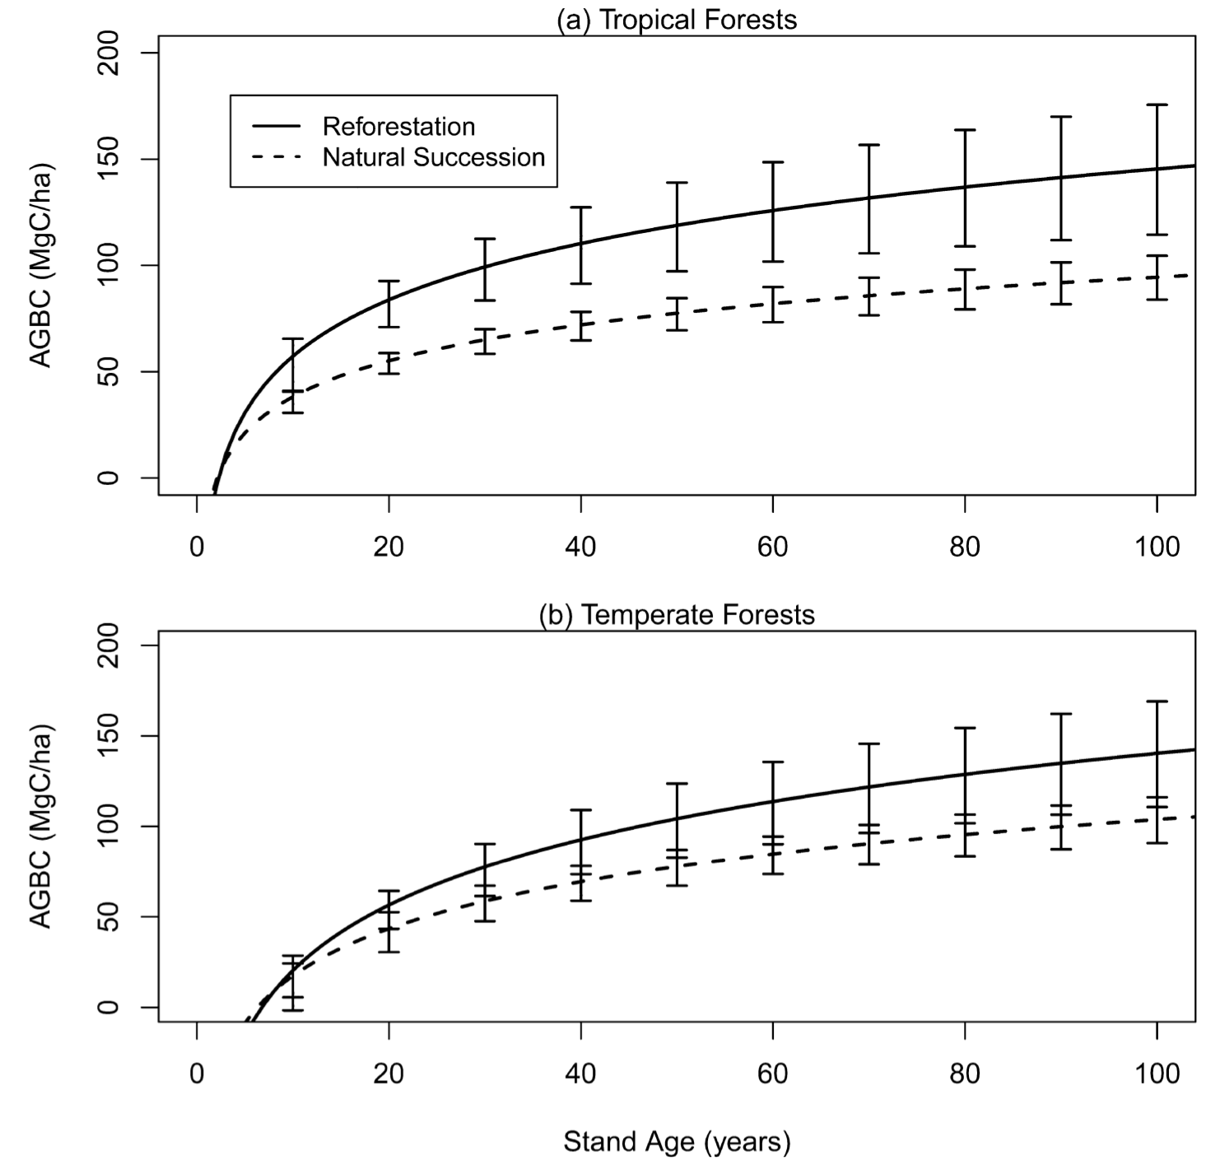
Figure 1. Dynamics of aboveground carbon storage as a function of stand age in afforestation and reforestation studies in Tropical (a) and Temperate (b) climates. Solid lines indicate active reforestation by planting tree and dashed lines indicate passive restoration based on natural succession (from Evans et al. 2015)

Large-scale afforestation and reforestation and other types of restoration of vegetation are ongoing or are being initiated in many countries (GBO4 2014). This report uses examples from Russia, China and Brazil to illustrate the climate mitigation potential of these efforts.
• Kurganova et al. (2015) estimate that passive ecosystem recovery following abandonment of agriculture on 0.6 million km² of marginal lands in Russia and Kazakhstan has led to an average sequestration of 2.3 Mg/ha/yr, and a total of 0.18 PgC/yr sequestered over the entire area. This is estimated to offset 36 to 49% of current fossil fuel emissions from these two countries.
• China has embarked on widespread forest afforestation and reforestation programs since the 1970s. This includes, but is not limited to, very large-scale programs such as Grain for Green (Fig. 2), the Three-Norths Protective Forest Program and the Natural Forest Conversion Program that focus on active restoration, but include some passive restoration. A recent estimate of carbon sequestration by all afforestation and reforestation programs is approximately 0.03 Pg C/yr, which offsets roughly 2% of the current industrial carbon emissions from China (He et al. 2015). However, this rate of sequestration has considerable potential to be increased since many of these forests have low productivity and low carbon sequestration rates that could be improved substantially through incentives for better management (Bai et al. 2015).
• The Brazilian Atlantic forest covered more than 1.5 million km² but only around 12% of the original area remains as highly fragmented natural vegetation (Oliveira et al. 2004, Ribeiro et al. 2009, GBO4 2014). This region is currently undergoing of one of the biggest forest restoration efforts in the world, primarily in the context of the Atlantic Forest Restoration Pact (AFRP; Alexander et al. 2011, Brancalion et al. 2014). This program is characterized by the use of highly diverse tree plantings (Brancalion et al. 2014). AFRP’s goal is to restore 0.15 million km² of forest by 2050 (Latawiec et al. 2015), which at 4 MgC/yr over the first thirty years of active restoration (Evans et al. 2015) would provide a carbon sequestration potential of about 0.06 PgC/yr.
• Local scale initiatives, if carried out, in many places could also potentially make substantial contributions. One example is the African Forest Landscape Restoration Initiative that was formally launched at the COP-21 in Paris in December 2016. This effort has the goals of restoring 100 million hectares of land in Africa by 2030. A very preliminary estimate is that if all national commitments were met, this would reduce cumulative greenhouse gas emissions by 1.2 GtCO₂eq over the next 10 years (World Resources Institute, http://www.wri.org), although this remains to be confirmed by more detailed analyses.

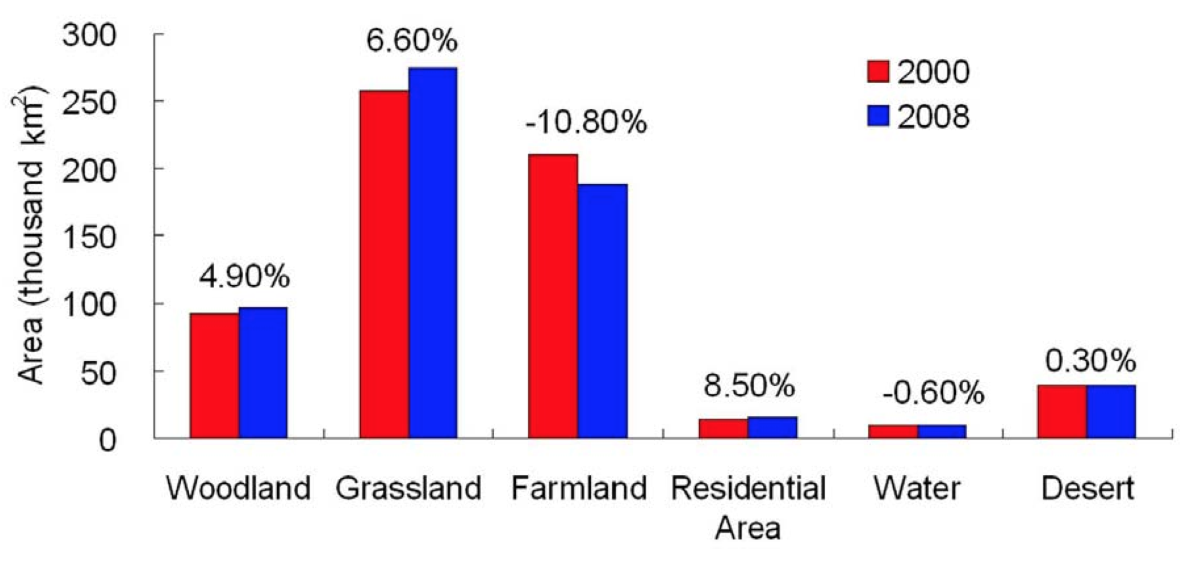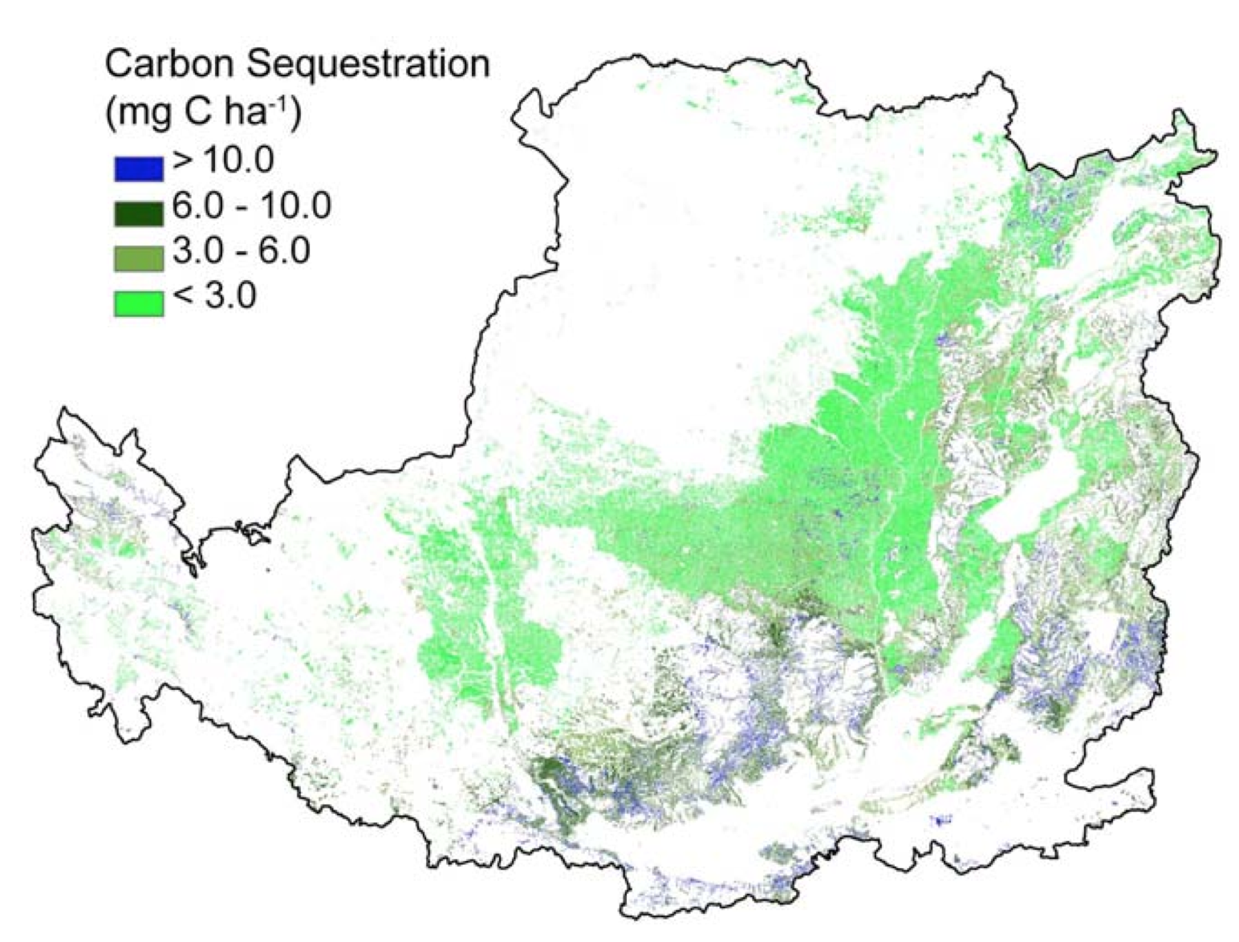

Figure 2. An example revegetation dynamics in the Loess Plateau of China in the "Grain for Green" program. The left-hand panel indicates the changes in land cover from 2000 to 2008 and the right-hand panel shows estimates of soil carbon sequestration in Mg/C/ha (from Lü et al. 2012).

3.3 Additional issues concerning protecting ecosystems and ecosystem restoration as climate mitigation options.
There are a number of important synergies that make ecosystem protection and restoration attractive options for climate mitigation. Ecosystem protection and ecosystem restoration often protect or restore biodiversity and a wide range of ecosystem services (albeit typically excluding the large scale production of food). These strong synergies lie behind the convergence of land-based mitigation incentives (e.g., REDD+), biodiversity conservation and other development goals (Turner et al. 2009, Gardner et al. 2012).

There are also a number of drawbacks to relying on ecosystem protection and restoration for climate mitigation. First, creating protected areas, reducing habitat loss and restoration in one location can lead to compensatory increases in habitat loss in others (i.e., "leakage") that can be particularly perverse if incentives for ecosystem protection are not well planned (Popp et al. 2014a, Latawiec et al. 2015). Second, biophysical and other feedbacks to climate such as the production of aerosols (see section 1) are rarely accounted for and, at regional or global scales, may reinforce or counteract the effects of reductions in greenhouse gas emissions (de Noblet et al. 2012, Naudts et al. 2016). Third, reforestation and afforestation are often done with monocultures of exotic species that may provide little benefit in terms of biodiversity and may have negative impacts on some ecosystem services, especially when fertilization and weed control are used to increase rates of carbon sequestration (Ferez et al. 2015),. Fourth, ecosystem services as perceived by some stakeholders may decline following restoration, for example discontent of water managers with declining watershed yield following reforestation in China. Fifth, the capacity reforestation and afforestation to sequester carbon diminishes rapidly with stand age (Fig. 1), and becomes relatively small after the first one to two decades. Finally, ecosystems are vulnerable to wide range of factors that can substantially degrade their capacity to mitigate climate (e.g., Forrest et al. 2015), and at global scales climate change could be a major driver of this degradation especially under high emissions scenarios (see section 2.3).

4. Contributions of sustainable agriculture and sustainable consumption to land-based mitigation (Focusing on Aichi Targets 7 and 4)

4.1 Reducing greenhouse gas emissions and increasing sequestration in agriculture
Aichi Target 7 focuses on moving towards sustainable agriculture (see Table 1), because unsustainable agriculture intensification is one of the main driving factors leading to declining biodiversity in agricultural landscapes (Flohre et al. 2011). Greenhouse gas emissions from the agricultural sector have recently surpassed emissions from deforestation and currently account for more than 11% of global warming potential from greenhouse gas emissions, leading to calls for a global effort to reduce emissions from agriculture (Tubiello et al. 2015). It has been estimated that reductions of the equivalent of 0.3 to 1.2 PgC/yr could be achieved by 2020 through measures including conservation tillage, use of biochar additions to some types of soils, improved fertilizer and water management and mitigation of non-CO₂ emissions especially methane from rice paddies and livestock (Smith et al. 2008, UNEP 2013, Lal 2004, Campbell et al. 2014, Smith 2016, Williamson 2016, UNEP/CBD/SBSTTA/19/INF/2). Some of these agricultural practices have also been shown to increase soil biodiversity (cover cropping, Peigné et al. 2009; increased diversity in agricultural rotations, van Eekeren et al. 2008; decrease in pesticide use, Pelosi et al. 2013). Many of these measures would be cost effective and compatible with the need to feed a growing global human population (Smith et al. 2008, UNEP 2013, Smith et al. 2013). There is, however, considerable uncertainty concerning the efficacy of many measures to reduce emissions from agriculture (e.g., Lorenz & Lal 2014 – biochar; Powlson et al. 2014 — conservation tillage) and to improve soil biodiversity (Pelosi et al. 2016).

Livestock, in particular ruminants, may hold the greatest potential for reductions in greenhouse gas emissions because they account for about 80% of warming potential by greenhouse emissions from the agriculture sector (Havlik et al. 2014, Persson et al. 2015). There is considerable potential for reductions in methane emissions from livestock through improved management, but the magnitude of these contributions is very uncertain (FAO 2010). It has also been estimated that livestock, especially ruminants, are the most significant cause of the decline of large carnivores due to global habitat loss (Machovina & Feeley, 2014).

One example of efforts to combine climate mitigation and biodiversity objectives is Conservation Agriculture. Conservation Agriculture combines practices, such as limited tillage, permanent plant cover and crop diversity that strive to keep soils intact, improve soil diversity, reduce soil erosion, reduce CO₂ emissions, from machinery and may improve soil carbon sequestration (Scopel et al. 2013). The change in area under Conservation Agriculture has been used as one of the primary indicators for Aichi Target 7 (GBO4 2014). Conservation agriculture practices increased substantially to reach 127 million hectares in 2011 or roughly 7% of total global cropland area (FAO 2014, GBO4 2014). However, conservation agriculture does not explicitly set limits on inputs and frequently relies on herbicide resistant GMOs and inputs of herbicides to control weeds (Scopel et al. 2013).

4.2 Effects of changing diets and reducing losses in food systems
Aichi Target 4 focuses on sustainable consumption, and although extremely broad it clearly covers sustainability of food systems. There is growing evidence that attaining a "healthy" diet (i.e., moderate meat and high in fruits and vegetable consumption) for people in all countries could have win-win-win-win effects on climate mitigation, biodiversity conservation, fertilizer and pesticide pollution, and human health (Stehfest et al. 2009, Foley et al. 2011, Powell & Lenton 2013, Smith et al. 2013, Bajzelj et al. 2014, Brunelle et al. 2014, Tilman & Clark 2014, Machovina et al. 2015; Figs. 3 & 4).

Tilman & Clark (2014) recently estimated that attaining a healthy diet for everyone — with substantial flexibility in exact nature of a "healthy" diet — could reduce global greenhouse gas emissions by the equivalent of ca. 0.3 to 0.6 PgC/yr compared to current trends, and could greatly reduce requirements to expand cropland area to feed a growing global population. Since habitat conversion to agriculture is one of the primary drivers of biodiversity loss, this reduction in pressure on land use is projected to be highly beneficial to biodiversity in natural ecosystems (GBO4 2014, Tilman & Clark 2014, Machovina et al. 2015). For example, Powell and Lenton (2013) estimated that healthy diets could reduce projected biodiversity loss from 2000 to 2050 in natural ecosystems (Fig. 4).

Healthy diets are also generally associated with greatly reduced disease (diabetes, cancer and coronary disease) and mortality from all causes compared to diets rich in red meat (Tilman & Clark 2014, Bouvard et al. 2015). In addition, about one third of food is lost in food systems due to spoilage and waste (Foley et al. 2011). Bajzelj et al. (2014) estimate processing losses to be about 0.06 PgC/yr and food waste losses of approximately 0.08 PgC/yr, highlighting the opportunity to improve food security and mitigate climate through reductions in losses in food systems. Changes in diet are essentially driven by individual choice, so progress towards healthy diets may best be achieved by concerted efforts between governments, schools, producers, retailers and consumers (Hawkes et al. 2015).

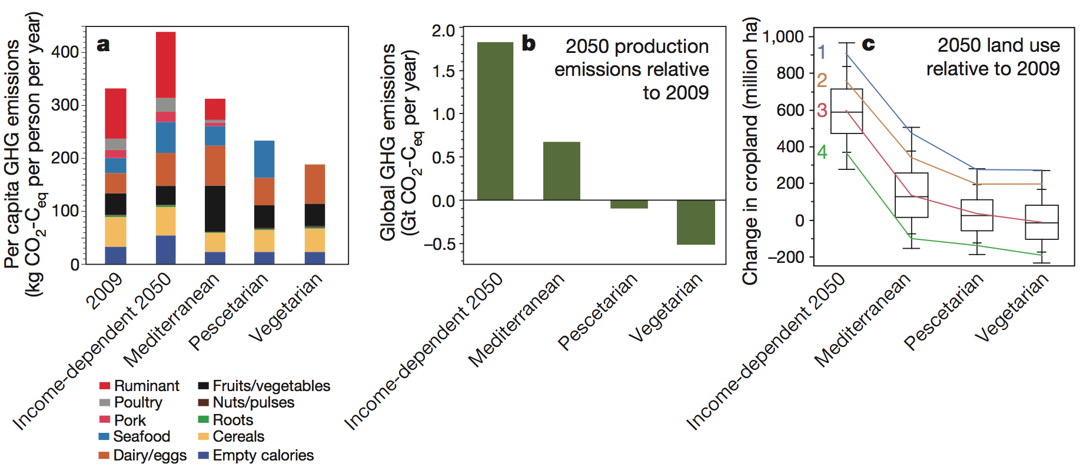

Figure 3. Effects of global convergence on four types of diets on global greenhouse gas emissions and land use for food crops by 2050. The income-dependent scenario is based on the assumption that diet preferences strongly follow income as evidenced by current trends in most countries (from Tilman and Clark 2014).

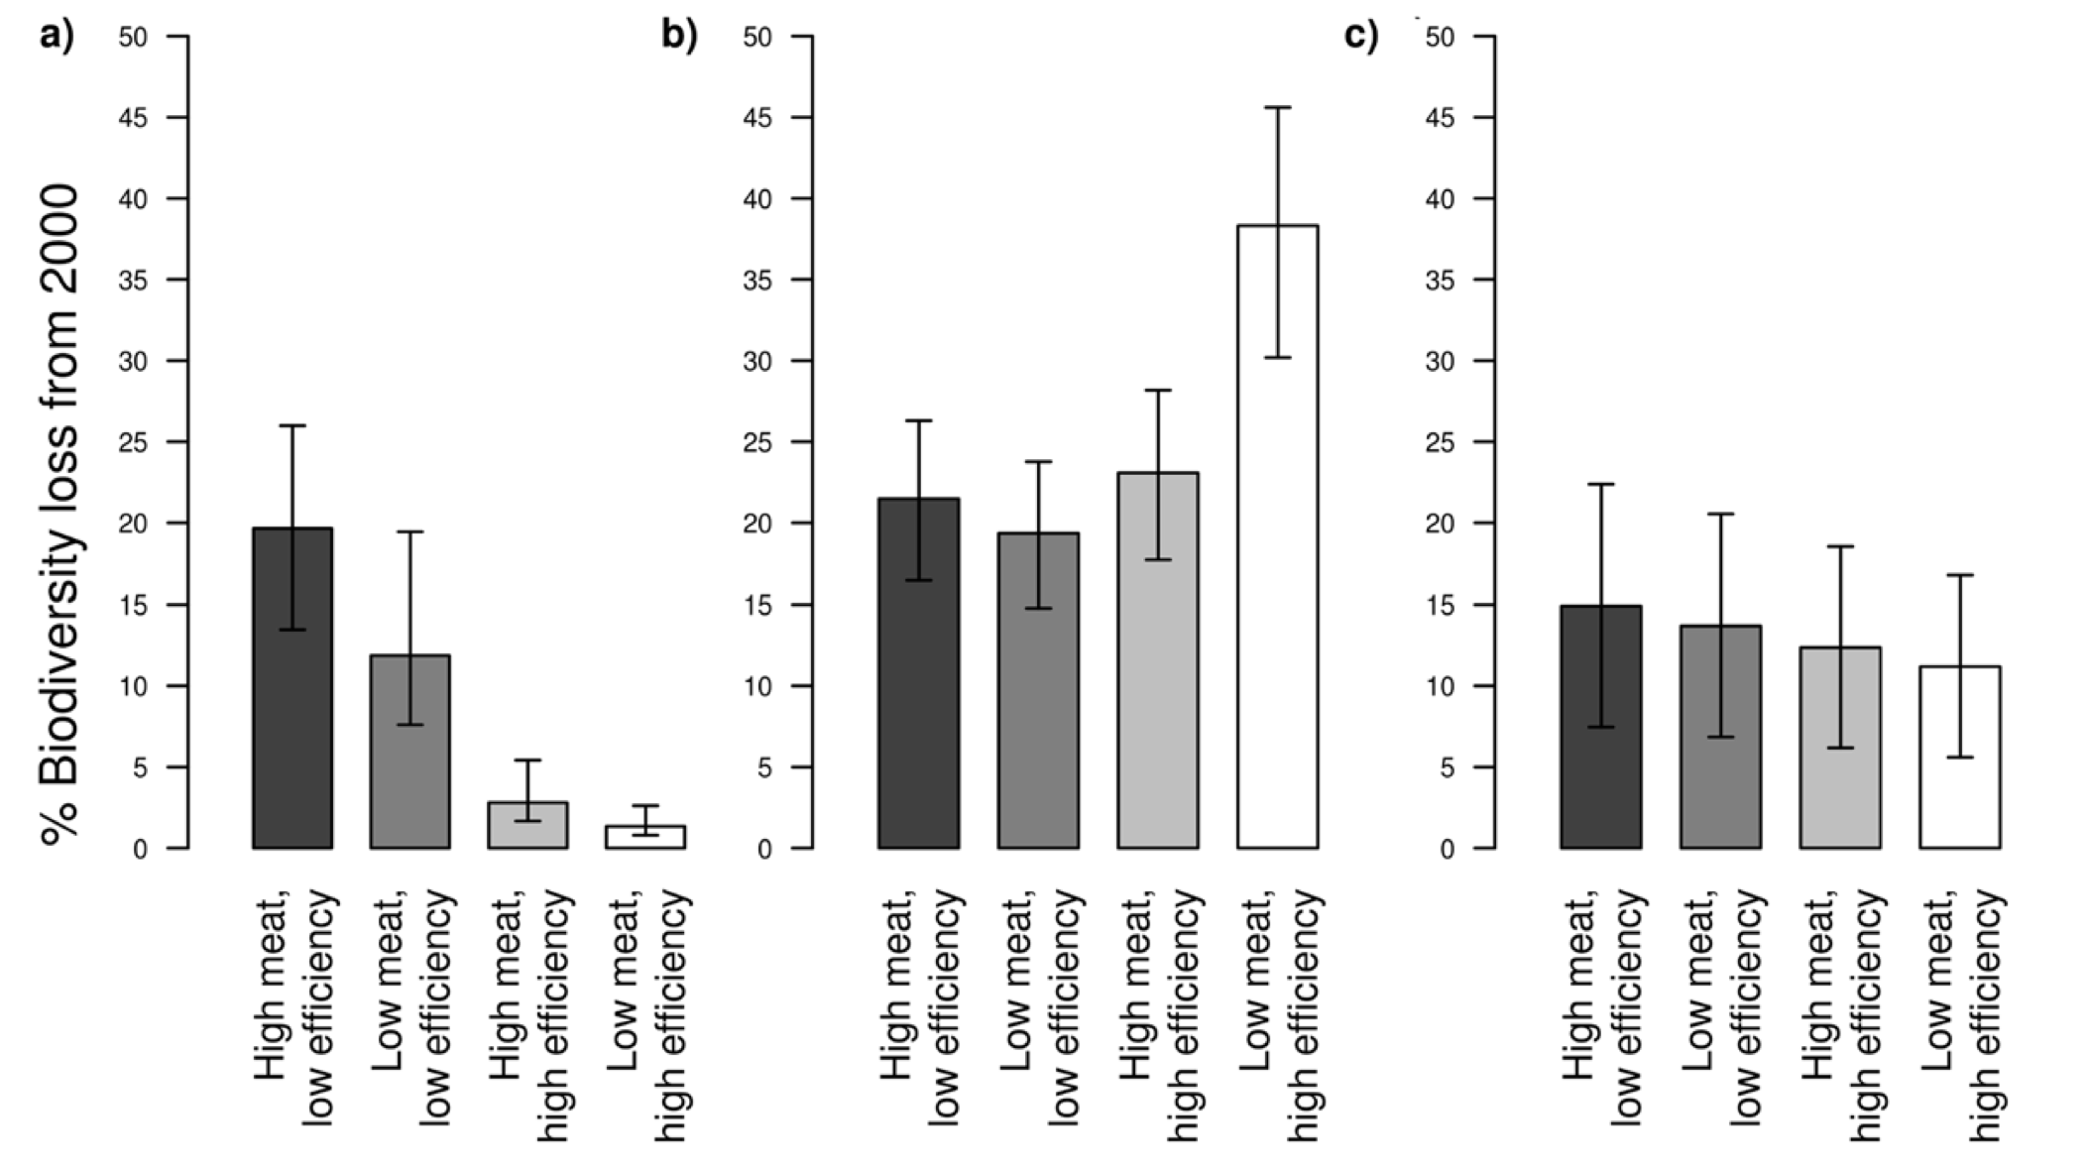
Figure 4. Biodiversity loss (in % of species loss using 2000 as a baseline) corresponding to two types of diets (high and low meat consumption) and two levels of efficiency in agricultural systems (high and low productivity per unit area) for a) land use change impacts on natural habitats, b) impacts of intensity of harvesting on croplands and c) through climate change impacts. Species-area curves were used to calculate biodiversity loss in natural areas based on changes in habitat area; species-energy relationships were used to calculate biodiversity loss on croplands (from Powell & Lenton 2013).

5. Bioenergy: boon for or bane of biodiversity
(How should bioenergy be considered when achieving Aichi Target 3?)

Bioenergy is not explicitly addressed in the Aichi Targets; however, is treated in this report because it is the primary alternative to other land-based mitigation schemes, and because most scenarios for meeting ambitious climate mitigation targets rely on massive deployment of bioenergy (IPCC WGIII 2014, Smith et al. 2016). As such, massive deployment of bioenergy could be one of the primary drivers of biodiversity loss over the next few decades (GBO4 2014, Newbold et al. 2015, see also Section 6). Bioenergy can reduced climate change impacts on biodiversity to the extent that it reduces greenhouse gas emissions (see Section 2), but is detrimental to biodiversity when it leads to habitat loss or environmental degradation. When carefully managed, and at low to modest levels of deployment, bioenergy can also provide a wide range of economic benefits and ecosystem services (Howarth & Bringzu 2009). As such, incentives such as policies or subsidies that stimulate bioenergy deployment must be carefully planned and applied in order to meet the objectives of Aichi Target 3 which focuses on eliminating incentives that are harmful to biodiversity, and on developing and applying positive incentives.

5.1 How much potential is there for bioenergy development?
Bioenergy has a wide range of sources and uses that need to be differentiated when estimating bioenergy potential and impacts of bioenergy deployment on the environment (Smith et al. 2013, Popp et al. 2014, Creutzig et al. 2015, Smith et al. 2016). Currently, most bioenergy use is in the form of traditional biomass burning (e.g., wood for cooking and heating) and "first generation" liquid biofuels from crop plants such as corn, sugarcane and soybeans. Over the next few decades, it is foreseen that a substantial fraction of bioenergy will come from more efficient sources such as industrial-scale biomass burning and "advanced biofuels" which are liquid biofuels produced from lignocellulose in wood and grasses (Popp et al. 2014b).

Creutzig et al. (2015) recently reviewed published estimates of bioenergy potential for 2050 (Fig. 5). They estimated "the sustainable technical potential as up to 100 EJ: high agreement; 100–300 EJ: medium agreement; above 300 EJ: low agreement." Most scenarios for achieving the 2°C global warming target explored in the most recent IPCC report (IPCC WGIII 2014) rely on large-scale deployment of more than 200 EJ of bioenergy, and therefore exceed many estimates of total sustainable potential (Creutzig et al. 2015).

There is high uncertainty in the land area available for dedicated bioenergy crops without creating conflicts with other land use needs such as biodiversity conservation. Estimates of the global area available for crops including bioenergy crops range from only slightly more than the land area already under cultivation to more than double the area (Fig. 6; Eitelberg et al. 2015). Differences in estimates of area available for dedicated bioenergy crops depend on many factors including changes in agricultural productivity per unit land area; the amount of land considered to be abandoned or marginal; the extent to which institutional constraints such as protect areas are accounted for; biophysical constraints such at slope, soils and temperature; etc. (van Vuuren et al. 2009, Dornburg et al. 2010, Smith et al. 2013, Popp et al. 2014b, Eitelberg et al. 2015). Medium to high estimates tend to assume that shrublands, savannas, and grasslands are "unproductive" or "marginal" and therefore suitable for conversion, even though these types of ecosystems include very important areas for biodiversity conservation (e.g., Cerrado vegetation of Brazil, Faleiro & Loyola 2013). An additional complication is that these estimates do not account for climate change impacts on the distribution of agricultural systems and natural ecosystems (IPCC WGII 2014, see Section 2).

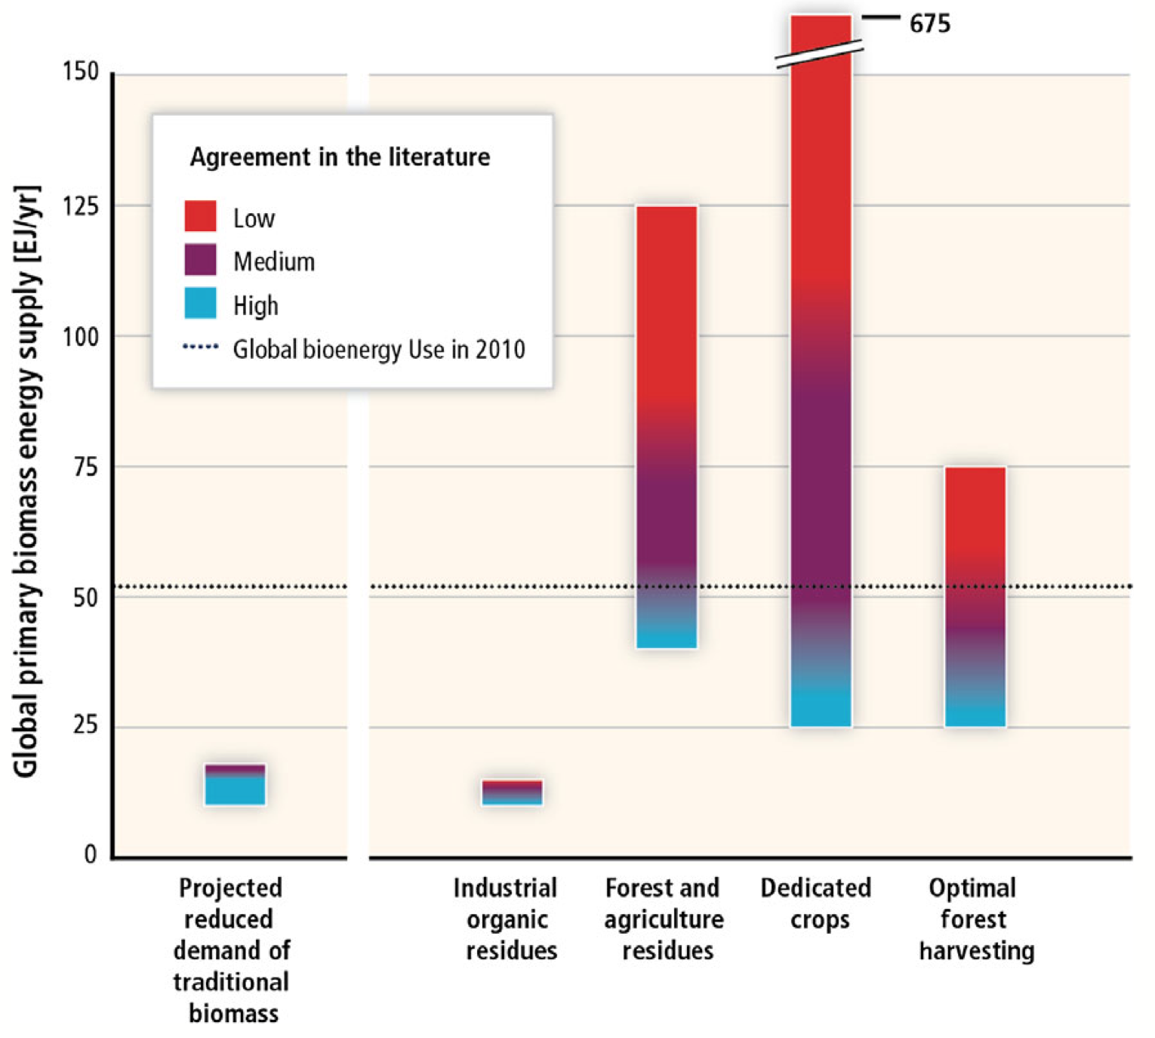
Figure 5. Sources of future biomass energy and degree of agreement in the literature concerning global bioenergy potential for 2050. These estimates depend heavily on the development of commercially viable advanced biofuels. Dotted horizontal line indicates global bioenergy use in 2010. (from Creutzig et al. 2015).

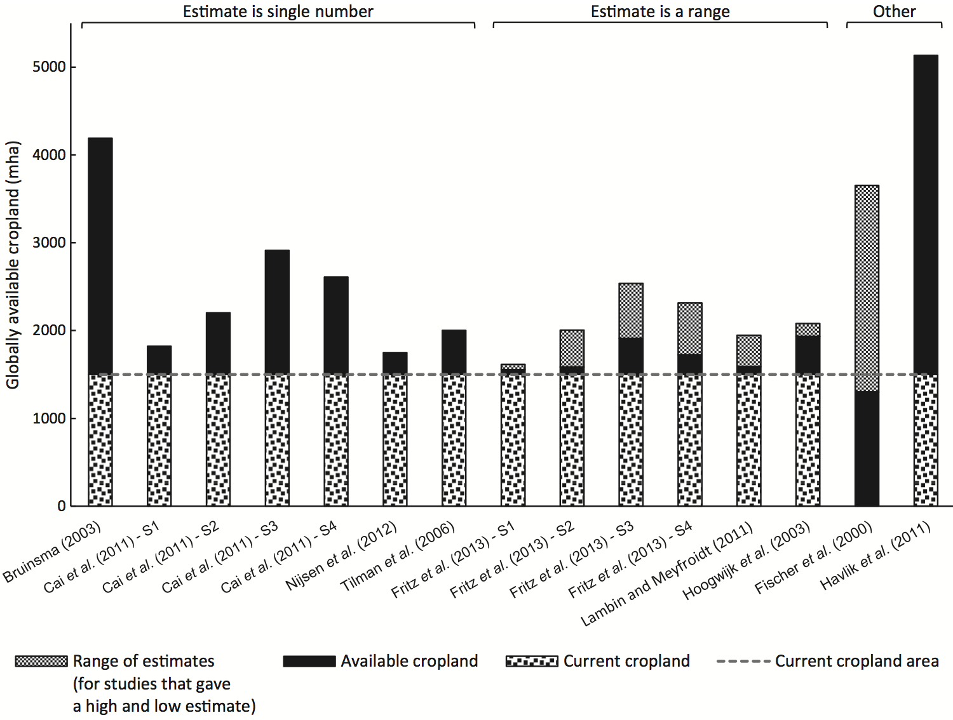

Figure 6. Estimates of land available for food crops and dedicated crops for bioenergy production at the global scale in several published studies. Stippled areas and the horizontal dashed lines indicate the current area already under cultivation (from Eitelberg et al. 2015).

5.2 Efficacy of bioenergy vs. forest recovery
Evans et al. (2015) recently analyzed a large number of studies to the efficacy of forest recovery vs. dedicated biofuel crops as a strategy for climate mitigation on abandoned agricultural land (Fig. 7). The greenhouse gas mitigation potential over 30 years is substantially higher for planting forests than most "first generation" biofuels currently in use (note that sugarcane has the highest GHG mitigation potential of all widely used biofuel sources from dedicated crops). Passive forest recovery through natural succession is also more efficient than most biofuel crops. Some dedicated crops for advanced biofuels based on lignocellouse conversion to liquid fuels may be superior to forest recovery, and when coupled with carbon capture and storage technology (CCS) these bioenergy crops could potentially have substantially greater mitigation potential per unit land area than forest recovery (Humpenöder et al. 2014).

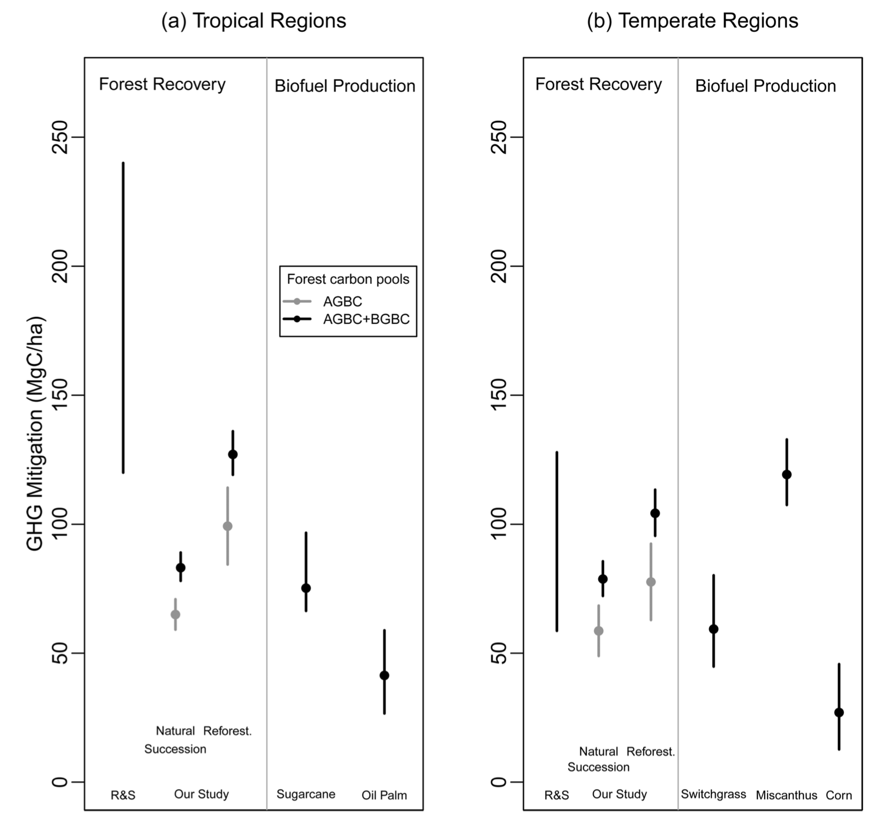

Figure 7. Comparison of estimates of greenhouse mitigation potential per hectare for afforestation and reforestation vs. dedicated biofuel crops in tropical and temperate regions. Estimates of potential from forest recovery are from Righelato & Spracklen (2007; R&S) and Evans et al. (2015, "Our study") who distinguish passive ("Natural succession") and active ("Reforest") forest recovery. Estimates from biofuels are based on life cycle analyses for "first generation" biofuels — sugarcane, oil palm and corn — and advanced biofuels that are not yet commercially viable — switchgrass and Miscanthus. (AGBC = aboveground biomass carbon; BGBC = belowground biomass carbon). Note that these estimates do not account for soil carbon sequestration.

5.3 Other environmental issues with bioenergy and their impacts on biodiversity
Bioenergy production has a wide range of impacts on the environment above and beyond habitat loss that can also pose serious problems for biodiversity (Campbell & Doswald 2009, Howarth & Bringezu 2009, Lindenmeyer et al. 2012, Smith et al. 2016). Bioenergy production from industrial organic waste and from agricultural and forest residues are generally considered to pose less problems that dedicated bioenergy crops. In addition to competing for land area, bioenergy crops require fertilizers, deplete soil nutrients and may require pesticide use and irrigation in some cases (Smith et al. 2016). For example, widespread eutrophication and "dead zones" in the Gulf of Mexico near the mouth of the Mississippi River have been greatly aggravated by large increases in nitrogen fertilizer used for corn ethanol production (Howarth & Bringezu 2009). The global scale impacts of bioenergy production on biodiversity through water use, nutrient cycles, etc., may be greater than often appreciated, but have yet to be adequately quantified global scales (GBO4 2014, UNEP/CBD/SBSTTA/19/INF/2, Popp et al. 2014, Smith et al. 2016).

5.4 The politics and economics of bioenergy
Over the recent past, some bioenergy incentives — in the form of policy targets and subsidies — have had strong direct and indirect negative impacts on biodiversity and ecosystem services, and in some cases have contributed little to climate mitigation goals when indirect effects on land use are accounted for (Searchinger et al. 2008, Howarth & Bringezu 2009, Webb & Coates 2012, Broch et al. 2013). Several studies suggest that future incentives for land-based mitigation that focus on bioenergy and do not account for all land-based sinks and sources of greenhouse gases may have large negative effects on biodiversity through habitat loss (see Section 6). Past experiences with bioenergy targets and subsidies, potential environment impacts of dedicated bioenergy crops and uncertainties associated with the commercial viability of carbon capture and storage suggest that a wide range of benefits and limits to bioenergy should be thoroughly explored before implementing incentives for large-scale deployment of dedicated bioenergy crops (Aichi Target 3).

6. Integrated insights on land-based mitigation from Integrated Assessment Models

An important limitation of the analyses in the preceding sections is that each target is considered independently. Synergies and tradeoffs between targets may strengthen or weaken the climate mitigation potential when taken as a whole. Analyses using scenarios developed with Integrated Assessment Models (IAMs) can provide important insights to these synergies and tradeoffs because they account for many of the complex interactions between various components of the land system. This section describes three sets of scenario exercises that have been analyzed for these insights.

6.1 The IPCC RCP radiative forcing and associated socio-economic scenarios
The IPCC developed four scenarios of radiative forcing — RCP2.6, 4.5, 6.0 and 8.5 — along with associated projections of climate change and scenarios of land use change. These radiative forcings and associated climate change projections form an important basis for climate negotiations, as well as for studies of climate change impacts on biodiversity, ecosystems and human well-being.

It is important to kept in mind that the socio-economic and land use scenarios initially associated with the RCP radiative forcings were developed independently by four IAM modeling teams with a focus on creating radiative forcings that could be used by climate modelers independent of socio-economic assumptions (van Vuuren et al. 2011). The underlying socio-economic assumptions from this effort and resulting land use scenarios— which we subsequently refer to as the "RCP land use scenarios" — should not be over interpreted because i) the scenarios are baseline and model dependent, ii) many constraints such as biodiversity and food security have not been taken into account explicitly and iii) the objective has always been to associate the four radiative forcings with a much broader range of underlying socio-economic scenarios referred to as the "Shared Socio-economic Pathways" (SSPs). This section explores the impacts of the four RCP radiative forcings and associated land use scenarios, while section 6.3 examines analyses associated with a much broader range of scenarios being developed in the context of the SSPs.

None of the four sets of projected climate change from the RCPs and their associated land use scenarios seem favorable for biodiversity (Figs 8 & 9). The IPCC RCP2.6 scenario is projected to lead to a reasonable probability of meeting the 2°C climate mitigation target (IPCC WGI 2013), but is associated with large land use impacts that include extensive deforestation due to land conversion for food crops and bioenergy (Fig. 9) and reductions in species diversity (Fig. 8). The IPCC RCP4.5 scenario is far more favorable in terms of land use impacts on conversion of natural systems and species diversity (Figs. 8 & 9), but is associated with a high probability of exceeding 2°C warming and therefore poses higher climate-related risks compared to the RCP2.6 scenario. This analysis does not mean that the achieving the 2°C climate warming target and mitigating land use impacts on biodiversity are incompatible. The mechanisms that underlie land use change in the RCP4.5 scenario, in particular incentives to limit carbon emissions from all sources including from land use change, are compatible with the RCP2.6 radiative forcing as is illustrated in sections 6.2 and 6.3 below. The key take-home message from the analysis of RCP scenarios is that mitigating climate change is important for protecting biodiversity, but land-based climate mitigation schemes must be carefully evaluated because the negative effects of land use change and other environmental impacts may outweigh the benefits of climate mitigation for biodiversity.

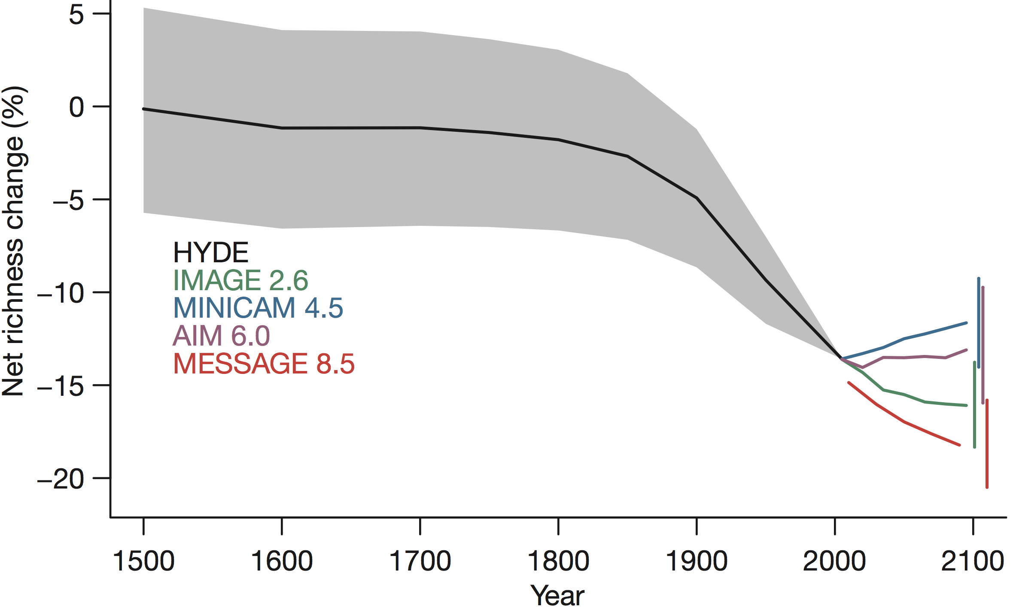
Figure 8. Impacts of the "RCP land use scenarios" (see text) on species richness (from Newbold et al. 2015). Black line and grey bounds indicates estimates of species richness based on the HYDE reconstruction of past land use. The names in color indicate the IAMs that underlie each land use scenarios and the numbers indicate the corresponding RCP radiative forcings. The 2.6 scenario is the only radiative forcing scenario that has a high probability of being compatible with the 2°C warming target (see text).

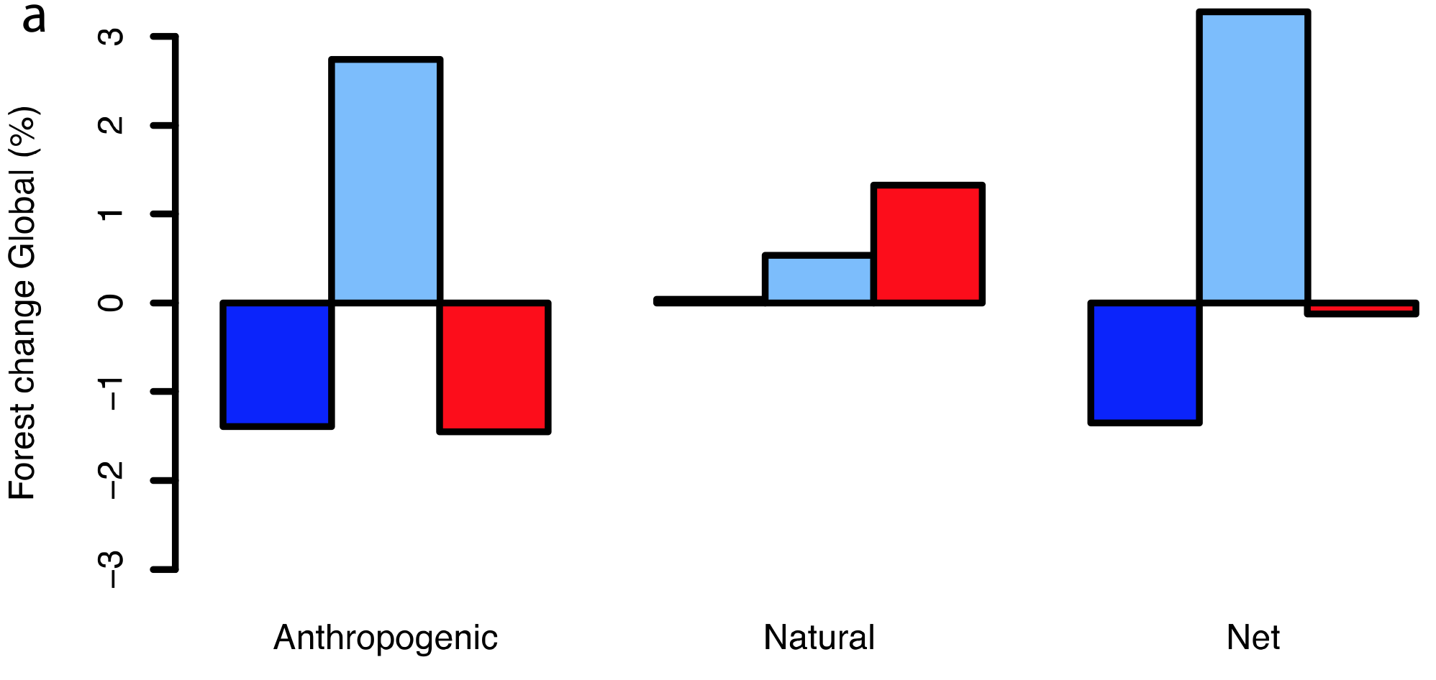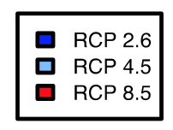
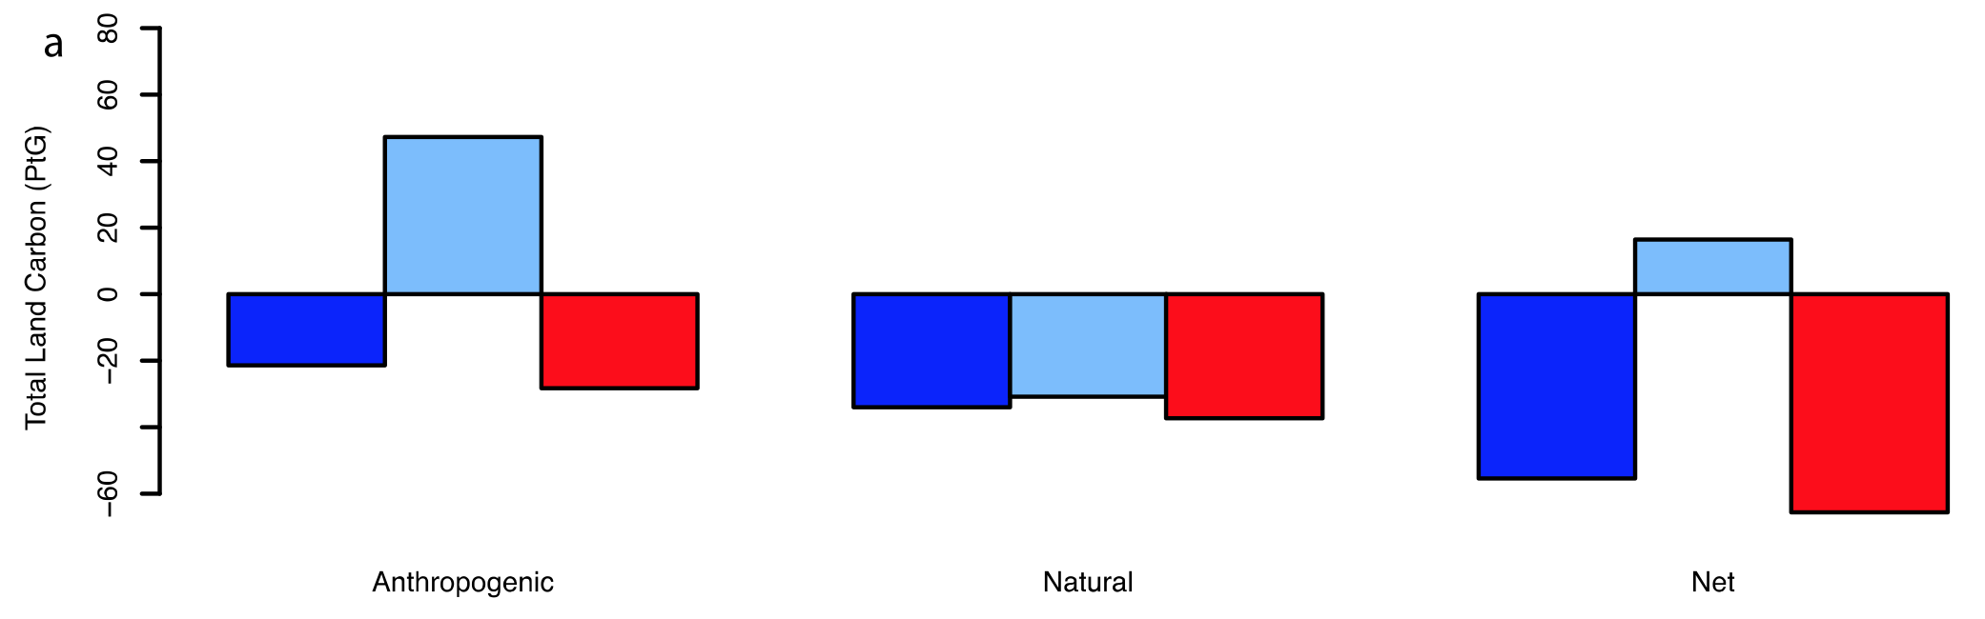
Figure 9. Changes in projected global forest cover (top panel) and changes in land carbon (lower panel) by 2100 relative to current cover for three IPCC RCP scenarios (see text). "Anthropogenic" land use is taken from the RCP land use scenarios, "Natural" changes are model-based projections of climate change induced land cover change and "Net" is the sum of anthropogenic and natural drivers (from Davies-Barnard et al. 2015).

6.2 The "Rio+20" scenarios
The "Rio+20" scenarios (PBL 2012, van Vuuren et al. 2015) were designed using the IMAGE IAM to explore the effort, synergies and trade-offs related to pathways that aim to meet several internationally agreed upon targets related to biodiversity, climate, air pollution and access to food and energy simultaneously. In terms of global warming potential these scenarios lie between the RCP2.6 and 4.5 scenarios. The scenarios were created using a “backcasting” approach, i.e. the scenarios reach the targets set for 2050 by definition. Three different pathways for achieving these targets were identified, and emphasize different sets of solution that can provide similar global outcomes. These pathways are "Global Technology" (emphasizing large scale technological responses), "Lifestyle Change" (emphasizing lifestyle changes such as dietary change and mode-shift in transport, in combination with technology) and "Decentralised Solutions" (emphasizing more local responses to sustainability problems). These three scenarios were contrasted with scenario that assumes current trends continue. The "Trend" scenario results in projected warming that lies between the RCP6.0 and 8.5 pathways.

The Rio+20 and Trend scenarios were extensively studied for biodiversity impacts in the context of the Global Biodiversity Outlook 4 (GBO4 2014). These analyses foresee improvements in several indicators of species diversity and abundance in the Rio+20 compared to the Trend scenarios (Fig. 10). Rondinini & Visconti (2015) explored the Rio+20 and Trend scenarios in more detail for European mammals (Fig. 11) and have partially separated out the climate and land use effects. This study highlights the potential to halt declines in mammal abundance, as well as the importance of interactions between land use and climate change. The key take-home message from the analysis of the Rio+20 scenarios is that it there are plausible pathways for reducing and then halting the loss of biodiversity by 2050, although all pathways involve major socio-economic transitions including increased energy efficiency, yield improvement and expansion of renewable energy, but also rely on bioenergy use to achieve climate mitigation goals.

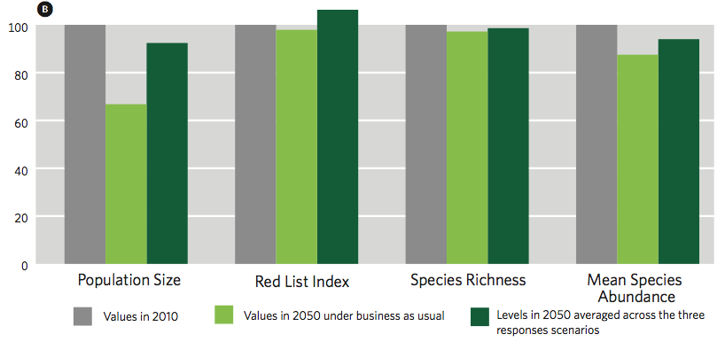
Figure 10. Changes in model-based projections of population size and Red List status of large mammals; species richness; and mean species abundance for the "Rio+20" (dark green bars; labeled "the three response scenarios") and "Trend" (light green bars; labeled "business as usual") in 2050 compared to status in 2010 (grey bars; where status in 2010 is set to 100%) (from GBO4 2014).

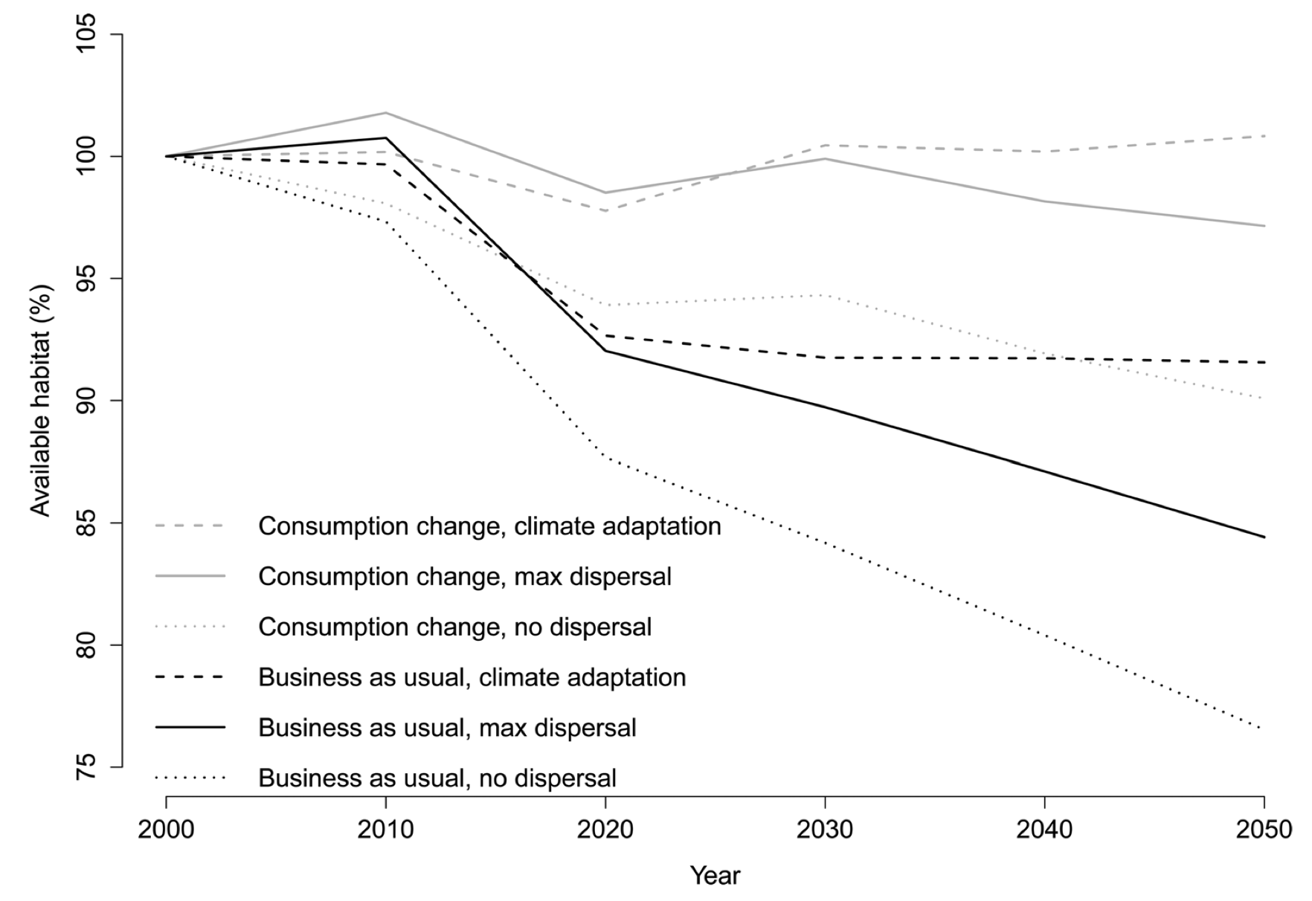
Figure 11. Changes in large mammal habitat availability in Europe using "Rio+20 Lifestyle change" (labeled "Consumption change") and "Trend" (labeled "Business as usual") scenarios. Solid lines assume that species can disperse rapidly in response to climate change, dotted lines assume no dispersal and dashed lines assume ability to adapt to climate (Rondinini & Visconti 2015).

6.3 Other analyses, including scenarios being developed in the context of the SSP effort
The SSP scenarios (see section 6.1) cover a much broader range of plausible futures than the four initial socio-economic scenarios that initially accompanied the RCP radiative forcings. First, the SSPs cover a wide range of possible developments in population and economic growth. Secondly, the SSP storylines describe – in a qualitative way – the most important trends per SSP for land-use regulation, agricultural intensification, environmental impacts of food consumption (covering low-meat versus high-meat diets, and waste), and assumptions on trade of agricultural commodities (Popp et al., in prep.). The SSP scenarios became available in late 2015 with coarse sub-global resolution. Higher resolution land-use scenarios will becoming available in 2016 following harmonization using methods developed for the RCP land use scenarios (Hurtt et al. 2011). Together, the RCPs and SSPs form a matrix of socio-economic reference and mitigation scenarios achieving the RCP forcing levels (van Vuuren et al. 2014).

Several take-home messages — with a particular focus on land-based mitigation strategies — can be drawn from recent studies of SSP-type scenarios that explore synergies and tradeoffs between climate mitigation and other sustainability criteria:
• Land-based mitigation can make large contributions to overall climate mitigation even when tradeoffs between approaches are accounted for (Rose et al. 2012, Figs. 12 & 13). The net contribution of the agriculture, forestry and other land use to cumulative climate abatement is estimated to be 20-60% until 2030, and 15-45% until 2100 (IPCC WGIII 2014), with notable uncertainty.
• Reducing emissions from deforestation and forest degradation — for example through REDD+ or carbon pricing — can be realized at relatively low costs (Kindermann et al. 2008, Overmars et al. 2014, Schmitz et al. 2015; Fig 12). As a result of low costs, much of this potential is foreseen to be used under ambitious climate policy, amounting to about a total of about 100 PgCO₂eq until 2050 (Arcidiacono-Bársony et al. 2010). After 2050, most scenarios foresee a decrease in deforestation and thus only a small additional mitigation potential (Fig. 13). Giving a price to the carbon stored in the terrestrial biosphere can be a strong incentive for reducing deforestation and increasing afforestation (Fig. 12). Until 2030, afforestation potential could amount to about 2 PgCO₂eq/yr (Smith et al. 2013, IPCC WGIII 2014, see also section 3) and on the longer term, it could even increase to about 15 PgCO₂eq/yr (Smith et al. 2013). However, the estimated reforestation and afforestation potential critically depends on crop yield increases, changes in human diets and reductions in losses in food systems to reduce pressure for land use (see also section 5).
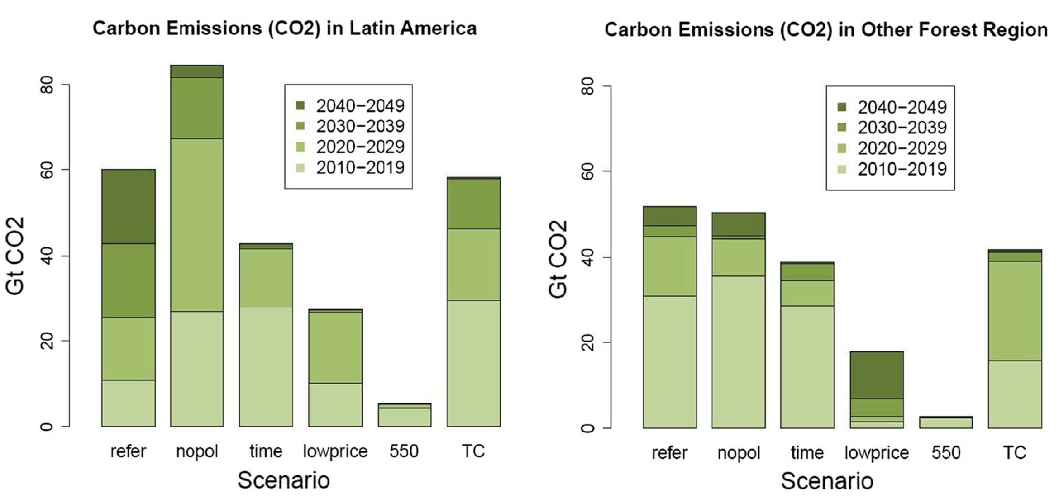
Figure 12. Policy and economic incentives and their effects on C emissions from deforestation in Latin America other regions from 2010 to 2050. Scenarios include: reference scenario (refer) = basic forest protection, business-as-usual trade; no forest policy (nopol) = basic forest protection, but with trade liberalization; increasing forest protection over time (time); low CO2 price (lowprice); CO2-price to achieve 550 ppm (550ppm); and additional investment in technology change (TC) (from Schmitz et al. 2015).

• There is a range of scenarios that are compatible with the 2°C warming target based on combinations of protection of natural systems, ecosystem restoration and bioenergy deployment (e.g., van Vuuren et al. 2009, Popp et al. 2014b, IPCC WGIII 2014). Avoided deforestation, reforestation and afforestation have clear synergies with biodiversity, but deliver comparably low and only temporary emission reductions compared to bioenergy with carbon capture and storage (BECCS). As such, BECCS plays an important role in all scenarios that achieve the 2°C global warming goal, but as highlighted in section 4 bioenergy potentially has significant tradeoffs in terms of biodiversity protection. Bioenergy production with strong land use restrictions — increased protected areas, avoided deforestation, etc. — leads to estimates of modest levels of BECCS deployment (van Vuuren et al. 2009, Popp et al. 2014a, IPCC WGIII 2014, see section 4), and these scenarios tends to reach stringent climate mitigation targets at higher costs (van Vuuren et al. 2010).

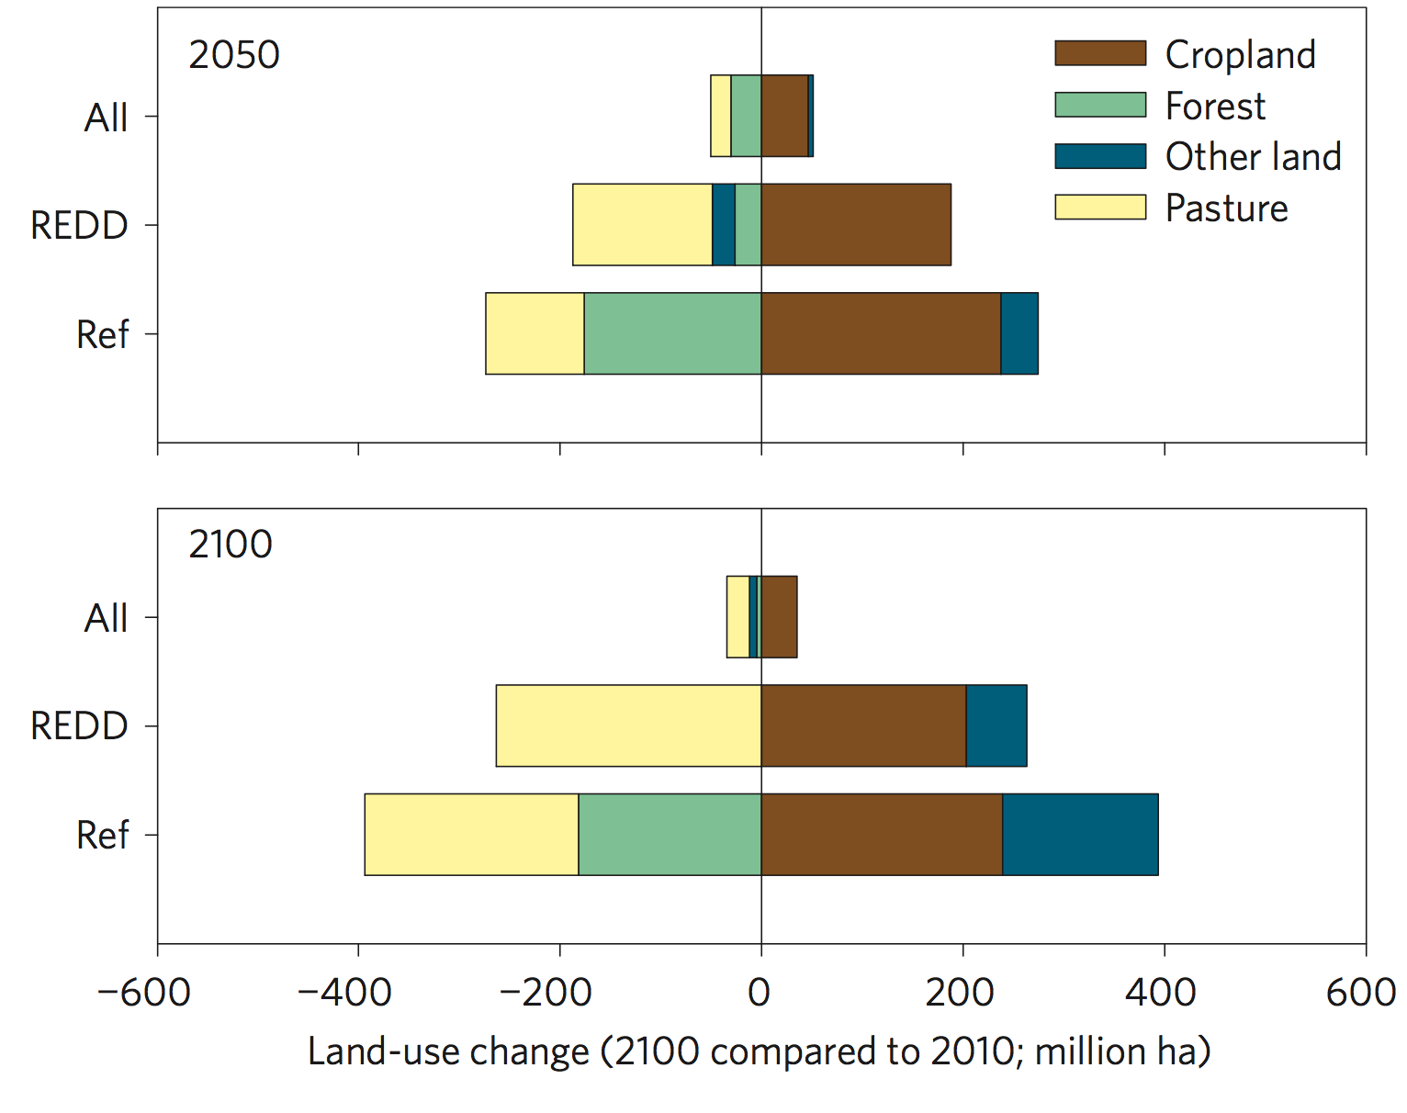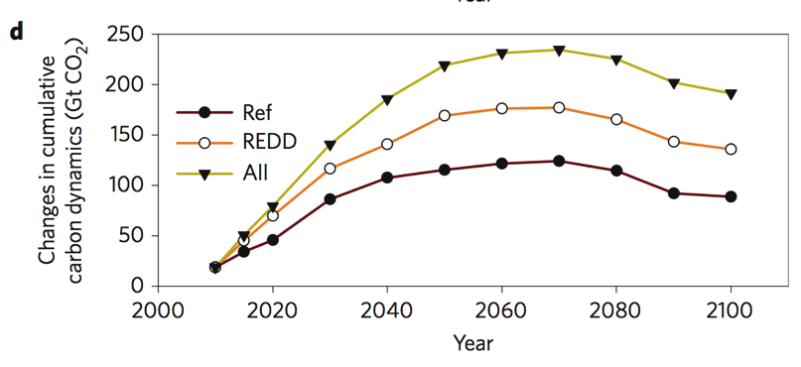

Figure 13. Carbon storage and land use for different land-based mitigation strategies. The "Ref" includes no terrestrial carbon policy; the "REDD" scenario focuses on reducing deforestation and forest degradation in the context of REDD+ initiatives and does not control non-forest leakage; and the "All" scenario assumes terrestrial carbon policy for all regions and ecosystem types (from Popp et al. 2014a).

• In implementing land-based mitigation options, policies and incentives for protecting natural systems are important, especially for bioenergy options, to avoid undesired loss of terrestrial carbon and biodiversity. More broadly, ecosystem protection, ecosystem restoration and bioenergy can all result in displacement of land use change (i.e., "leakage") if not implemented in the context of worldwide emissions reduction and carbon stock protection measures (Wise et al. 2008, van Vuuren et al. 2009, Schmitz et al. 2015, Popp et al. 2014a, Humpenöder et al. 2015).
7. References

Alexander S, et al. 2011. Opportunities and challenges for ecological restoration within REDD+. Restoration Ecology 19:683-689.
Alkama R, Cescatti A. 2016. Biophysical climate impacts of recent changes in global forest cover. Science 351:600-604.
Anderson-Teixeira KJ, DeLucia EH. 2011. The greenhouse gas value of ecosystems. Global Change Biology 17:425-438.
Arcidiacono-Bársony C, Ciais P, Viovy N, Vuichard N. 2011. REDD Mitigation. Procedia Environmental Sciences 6:50-59.
Arneth A. 2015. Uncertain future for vegetation cover. Nature 524:44-45.
Bai GX, Wang YY, Dai LM, Liu SR, Tang LN, Shao GF. 2015. Market-oriented forestry in China promotes forestland productivity. New Forests 46:1-6.
Bajzelj B, Richards KS, Allwood JM, Smith P, Dennis JS, Curmi E, Gilligan CA. 2014. Importance of food-demand management for climate mitigation. Nature Climate Change.
Bellard C, Bertlesmeier C, Leadley P, Thuiller W, Courchamp F. 2012. Impacts of climate change on the future of biodiversity. Ecology Letters 15:365-377.
Birdsey R, Pan YD. 2015. Trends in management of the world's forests and impacts on carbon stocks. Forest Ecology and Management 355:83-90.
Bouvard V, Loomis D, Guyton KZ, Grosse Y, El Ghissassi F, Benbrahim-Tallaa L, et al. 2015. Carcinogenicity of consumption of red and processed meat. The Lancet Oncology, Published online 26 October 2015;http://dx.doi.org/10.1016/S1470-2045(15)00444-1
Brancalion PHS, Cardozo IV, Camatta A, Aronson J, Rodrigues RR. 2014. Cultural ecosystem services and popular perceptions of the benefits of an ecological restoration project in the Brazilian Atlantic Forest. Restoration Ecology 22:65-71.
Broch A, Hoekman SK, Unnasch S. 2013. A review of variability in indirect land use change assessment and modeling in biofuel policy. Environmental Science & Policy 29:147-157.
Brovkin V, et al. 2013. Effect of anthropogenic land-use and land-cover changes on climate and land carbon storage in CMIP5 projections for the twenty-first century. Journal of Climate 26:6859-6881.
Brunelle T, Dumas P, Souty F. 2014. The impact of globalization on food and agriculture: The Case of the Diet Convergence. Journal of Environment & Development 23:41-65.
Busch J, et al. 2015. Reductions in emissions from deforestation from Indonesia's moratorium on new oil palm, timber, and logging concessions. Proceedings of the National Academy of Sciences of the United States of America 112:1328-1333.
Campbell JE, Lobell DB, Genova RC, Field CB. 2008. The global potential of bioenergy on abandoned agriculture lands. Environmental Science & Technology 42:5791-5794.
Campbell A and Doswald N. 2009. The impacts of biofuel production on biodiversity: a review of the current literature. UNEP-WCMC, Cambridge, UK
Campbell BM, Thornton P, Zougmoré R, van Asten P, Lipper L. 2014. Sustainable intensification: What is its role in climate smart agriculture? Current Opinion in Environmental Sustainability 8:39-43
Creutzig F, et al. 2015. Bioenergy and climate change mitigation: an assessment. Global Change Biology Bioenergy 7:916-944.
Davies-Barnard T, Valdes PJ, Singarayer JS, Wiltshire AJ, Jones CD. 2015. Quantifying the relative importance of land cover change from climate and land use in the representative concentration pathways. Global Biogeochemical Cycles 29:842-853.
Davin EL, de Noblet-Ducoudre N. 2010. Climatic impact of global-scale deforestation: radiative versus nonradiative processes. Journal of Climate 23:97-112.
Dornburg V, et al. 2010. Bioenergy revisited: Key factors in global potentials of bioenergy. Energy & Environmental Science 3:258-267.
Duarte CM, Sintes T, Marba N. 2013. Assessing the CO2 capture potential of seagrass restoration projects. Journal of Applied Ecology 50:1341-1349.
Eitelberg DA, van Vliet J, Verburg PH. 2015. A review of global potentially available cropland estimates and their consequences for model-based assessments. Global Change Biology 21:1236-1248.
Evans SG, Ramage BS, DiRocco TL, Potts MD. 2015. Greenhouse gas mitigation on marginal land: a quantitative review of the relative benefits of forest recovery versus biofuel production. Environmental Science & Technology 49:2503-2511.
Faleiro FV, Loyola RD. 2013. Socioeconomic and political trade-offs in biodiversity conservation: a case study of the Cerrado biodiversity hotspot, Brazil. Diversity and Distributions 19:977-987.
Flohre A, et al. 2011. Agricultural intensification and biodiversity partitioning in European landscapes comparing plants, carabids, and birds. Ecological Applications 21:1772-1781.
Ferez APC, Campoe OC, Mendes JCT, Stape JL. 2015. Silvicultural opportunities for increasing carbon stock in restoration of Atlantic forests in Brazil. Forest Ecology and Management 350:40-45.
Foley JA, et al. 2011. Solutions for a cultivated planet. Nature 478:337-342.
FAO - Food and Agriculture Organization. 2010. Greenhouse gas emissions from the dairy sector—a life cycle assessment. Food and Agriculture Organization, Rome.
Forrest JL, Mascia MB, Pailler S, Abidin SZ, Araujo MD, Krithivasan R, Riveros JC. 2015. Tropical deforestation and carbon emissions from protected area downgrading, downsizing, and degazettement (PADDD). Conservation Letters 8:153-161.
Gardner TA, et al. 2012. A framework for integrating biodiversity concerns into national REDD+ programmes. Biological Conservation 154:61-71.
Gattuso JP, et al. 2015. Contrasting futures for ocean and society from different anthropogenic CO2 emissions scenarios. Science 349:45-.
Gauthier S, Bernier P, Kuuluvainen T, Shvidenko AZ, Schepaschenko DG. 2015. Boreal forest health and global change. Science 349:819-822.
GBO3 - Secretariat of the Convention on Biological Diversity. 2010. Global Biodiversity Outlook 3. Montréal, 94 pages.
GBO4 - Secretariat of the Convention on Biological Diversity. 2014. Global Biodiversity Outlook 4. Montréal.
Hawkes C, Smith TG, Jewell J, Wardle J, Hammond RA, Friel S, Thow AM, Kain J. 2015. Smart food policies for obesity prevention. The Lancet 385:2410-2421.
Havlik P, et al. 2014. Climate change mitigation through livestock system transitions. Proceedings of the National Academy of Sciences of the United States of America 111:3709-3714.
He B, Miao LJ, Cui XF, Wu ZT. 2015. Carbon sequestration from China's afforestation projects. Environmental Earth Sciences 74:5491-5499.
Howarth and S. Bringezu (eds.). 2009. Biofuels: Environmental Consequences and Interactions with Changing Land Use. Proceedings of the Scientific Committee on Problems of the Environment (SCOPE) International Biofuels Project Rapid Assessment.
Houghton RA, Byers B, Nassikas AK. 2015. A role for tropical forests in stabilizing atmospheric CO2. Nature Climate Change 5:1022-1023.
Humpenoder F, Popp A, Dietrich JP, Klein D, Lotze-Campen H, Bonsch M, Bodirsky BL, Weindl I, Stevanovic M, Muller C. 2014. Investigating afforestation and bioenergy CCS as climate change mitigation strategies. Environmental Research Letters 9 (art. 064029):13.
Humpenoder F, et al. 2015. Land-use and carbon cycle responses to moderate climate change: implications for land-based mitigation? Environmental Science & Technology 49:6731-6739.
Hurtt GC, et al. 2011. Harmonization of land-use scenarios for the period 1500-2100: 600 years of global gridded annual land-use transitions, wood harvest, and resulting secondary lands. Climatic Change 109:117-161.
INPE. 2013. Projeto PRODES – monitoramento da floresta amazônica brasileira por satélite. Instituto Nacional de Pesquisas Espaciais, São Paulo. http://www.obt.inpe.br/prodes/index.php).
IPCC WGII. 2007. Climate Change 2007: Impacts, Adaptation and Vulnerability. Contribution of Working Group II to the Fourth Assessment Report of the Intergovernmental Panel on Climate Change, M.L. Parry, O.F. Canziani, J.P. Palutikof, P.J. van der Linden and C.E. Hanson, Eds., Cambridge University Press, Cambridge, UK, 23-78.
IPCC WGI. 2013.Climate Change 2013: The Physical Science Basis. Contribution of Working Group I to the Fifth Assessment Report of the Intergovernmental Panel on Climate Change [Stocker, T.F., D. Qin, G.-K. Plattner, M. Tignor, S.K. Allen, J. Boschung, A. Nauels, Y. Xia, V. Bex and P.M. Midgley (eds.)]. Cambridge University Press, Cambridge, United Kingdom and New York, NY, USA.
IPCC WGII. 2014. Climate Change 2014: Impacts, Adaptation, and Vulnerability. Part A: Global and Sectoral Aspects. Contribution of Working Group II to the Fifth Assessment Report of the Intergovernmental Panel on Climate Change [Field, C.B., V.R. Barros, D.J. Dokken, K.J. Mach, M.D. Mastrandrea, T.E. Bilir, M. Chatterjee, K.L. Ebi, Y.O. Estrada, R.C. Genova, B. Girma, E.S. Kissel, A.N. Levy, S. MacCracken, P.R. Mastrandrea, and L.L. White (eds.)]. Cambridge University Press, Cambridge, United Kingdom and New York, NY, USA, pp. 35-94.
IPCC WGIII. 2014. Climate Change 2014: Mitigation of Climate Change. Contribution of Work- ing Group III to the Fifth Assessment Report of the Intergovernmental Panel on Climate Change [Edenhofer, O., R. Pichs-Madruga, Y. Sokona, E. Farahani, S. Kadner, K. Seyboth, A. Adler, I. Baum, S. Brunner, P. Eickemeier, B. Kriemann, J. Savolainen, S. Schlömer, C. von Stechow, T. Zwickel and J.C. Minx (eds.)]. Cambridge University Press, Cambridge, United Kingdom and New York, NY, USA.
Kindermann G, Obersteiner M, Sohngen B, Sathaye J, Andrasko K, Rametsteiner E, Schlamadinger B, Wunder S, Beach R. 2008. Global cost estimates of reducing carbon emissions through avoided deforestation. Proceedings of the National Academy of Sciences of the United States of America 105:10302-10307.
Kurganova I, de Gerenyu VL, Kuzyakov Y. 2015. Large-scale carbon sequestration in post-agrogenic ecosystems in Russia and Kazakhstan. Catena 133:461-466.
Lal R. 2004. Soil carbon sequestration to mitigate climate change. Geoderma 123:1-22.
Laffoley, D., & Grimsditch, G. D. (Eds.). 2009. The management of natural coastal carbon sinks. IUCN.
Lambin EF, Meyfroidt P. 2011. Global land use change, economic globalization, and the looming land scarcity. Proceedings of the National Academy of Sciences of the United States of America 108:3465-3472.
Latawiec AE, Strassburg BBN, Brancalion PHS, Rodrigues RR, Gardner T. 2015. Creating space for large-scale restoration in tropical agricultural landscapes. Frontiers in Ecology and the Environment 13:211-218.
Leadley P, et al. 2014a. Interacting regional-scale regime shifts for biodiversity and ecosystem services. Bioscience.
Le Quéré C, Moriarty R, Andrew R, Peters G, Ciais P, Friedlingstein P, Jones S, Sitch S, Tans P, Arneth A. 2014. Global carbon budget 2014. Earth System Science Data Discussions 7:521-610.
Leite CC, Costa MH, Soares BS, Hissa LDV. 2012. Historical land use change and associated carbon emissions in Brazil from 1940 to 1995. Global Biogeochemical Cycles 26.
Lindenmayer D. B., K. B. Hulvey, R. J. Hobbs, M. Colyvan, A. Felton, H. Possingham, W. Steffen, K. Wilson, K. Youngentob, and Gibbons, P. 2012. Avoiding bio-perversity from carbon sequestration solutions. Conservation Letters 5 : 28-36
Lorenz K, Lal R. 2014. Biochar application to soil for climate change mitigation by soil organic carbon sequestration. Journal of Plant Nutrition and Soil Science 177:651-670.
Lü Y, Fu B, Feng X, Zeng Y, Liu Y, et al. 2012. A policy-driven large scale ecological restoration: quantifying ecosystem services changes in the Loess Plateau of China. PLoS ONE 7: e31782. doi:10.1371/journal.pone.0031782
Machovina, B., Feeley, K.J. 2014. Taking a bite out of biodiversity. Science 343:838.
Machovina B, Feeley KJ, Ripple WJ. 2015. Biodiversity conservation: The key is reducing meat consumption. Science of the Total Environment 536:419-431.
Millar CI, Stephenson NL. 2015. Temperate forest health in an era of emerging megadisturbance. Science 349:823-826.
Naudts K, Chen YY, McGrath MJ, Ryder J, Valade A, Otto J, Luyssaert S. 2016. Europe's forest management did not mitigate climate warming. Science 351:597-600.
Nellemann, C., Corcoran, E., Duarte, C. M., Valdés, L., De Young, C., Fonseca, L., Grimsditch, G. (Eds). 2009. Blue Carbon. A Rapid Response Assessment. United Nations Environment Programme, GRID-Arendal, www.grida.no
Newbold T, et al. 2015. Global effects of land use on local terrestrial biodiversity. Nature 520:45-.
de Noblet-Ducoudre N, et al. 2012. Determining robust impacts of land-use-induced land cover changes on surface climate over North America and Eurasia: results from the first set of LUCID experiments. Journal of Climate 25:3261-3281.
Oliveira L. et al. (2013). Large-scale expansion of agriculture in Amazonia may be a no-win scenario. Environ. Res. Letters, 8, 024021.
Overmars KP, Schulp CJE, Alkemade R, Verburg PH, Temme A, Omtzigt N, Schaminee JHJ. 2014. Developing a methodology for a species-based and spatially explicit indicator for biodiversity on agricultural land in the EU. Ecological Indicators 37:186-198.
PBL. 2012. Roads from Rio+20. Pathways to achieve global sustainability goals by 2050 (PBL - Netherlands Environmental Assessment Agency).
Peigne J, Cannavaciuolo M, Gautronneau Y, Aveline A, Giteau JL, Cluzeau D. 2009. Earthworm populations under different tillage systems in organic farming. Soil & Tillage Research 104:207-214.
Pelosi C, Toutous L, Chiron F, Dubs F, Hedde M, Muratet A, Ponge JF, Salmon S, Makowski D. 2013. Reduction of pesticide use can increase earthworm populations in wheat crops in a European temperate region. Agriculture Ecosystems & Environment 181:223-230.
Pelosi C, Pey B, Caro G, Cluzeau D, Peigne J, Bertrand M, Hedde M. 2016. Dynamics of earthworm taxonomic and functional diversity in ploughed and no-tilled cropping systems. Soil & Tillage Research 156:25-32.
Pereira HM, et al. 2010. Scenarios for global biodiversity in the 21st century. Science 330:1496-1501.
Pershing AJ, Christensen LB, Record NR, Sherwood GD, Stetson PB. 2010. The impact of whaling on the ocean carbon cycle: why bigger was better. Plos One 5:e12444.
Persson UM, Johansson DJA, Cederberg C, Hedenus F, Bryngelsson D. 2015. Climate metrics and the carbon footprint of livestock products: where's the beef? Environmental Research Letters 10 (art. 034005):8.
Poorter L, et al. 2016. Biomass resilience of Neotropical secondary forests. Nature 530:211-214.
Popp A, et al. 2014a. Land-use protection for climate change mitigation. Nature Climate Change 4:1095-1098.
Popp A, et al. 2014b. Land-use transition for bioenergy and climate stabilization: model comparison of drivers, impacts and interactions with other land use based mitigation options. Climatic Change 123:495-509.
Powell TWR, Lenton TM. 2012. Future carbon dioxide removal via biomass energy constrained by agricultural efficiency and dietary trends. Energy & Environmental Science 5:8116-8133.
Powlson DS, Stirling CM, Jat ML, Gerard BG, Palm CA, Sanchez PA, Cassman KG. 2014. Limited potential of no-till agriculture for climate change mitigation. Nature Climate Change 4:678-683.
Ribeiro, M.C., Metzger, J.P., Martensen, A.C., Ponzoni, F.J., and Hirota, M.M. (2009). The Brazilian Atlantic Forest: How much is left, and how is the remaining forest distributed? Implications for conservation. Biol. Conserv. 142, 1141–1153.
Righelato R, Spracklen DV. 2007. Carbon mitigation by biofuels or by saving and restoring forests? Science 317:902-902.
Rondinini C, Visconti P. 2015. Scenarios of large mammal loss in Europe for the 21st century. Conservation Biology 29:1028-1036.
Rose SK, Ahammad H, Eickhout B, Fisher B, Kurosawa A, Rao S, Riahi K, van Vuuren DP. 2012. Land-based mitigation in climate stabilization. Energy Economics 34:365-380.
Schmitz C, et al. 2014. Land-use change trajectories up to 2050: insights from a global agro-economic model comparison. Agricultural Economics 45:69-84.
Scopel E, et al. 2013. Conservation agriculture cropping systems in temperate and tropical conditions, performances and impacts: a review. Agronomy for Sustainable Development 33:113-130.
Searchinger T, Heimlich R, Houghton RA, Dong FX, Elobeid A, Fabiosa J, Tokgoz S, Hayes D, Yu TH. 2008. Use of US croplands for biofuels increases greenhouse gases through emissions from land-use change. Science 319:1238-1240.
Smith P, et al. 2008. Greenhouse gas mitigation in agriculture. Philosophical Transactions of the Royal Society B-Biological Sciences 363:789-813.
Smith P, Gregory PJ, van Vuuren D, Obersteiner M, Havlik P, Rounsevell M, Woods J, Stehfest E, Bellarby J. 2010. Competition for land. Philosophical Transactions of the Royal Society B-Biological Sciences 365:2941-2957.
Smith P, et al. 2013. How much land-based greenhouse gas mitigation can be achieved without compromising food security and environmental goals? Global Change Biology 19:2285-2302.
Smith P. 2016. Soil carbon sequestration and biochar as negative emission technologies. Global Change Biology 22:1315-1324.
Smith P, et al. 2016. Biophysical and economic limits to negative CO2 emissions. Nature Climate Change 6:42-50.
Stehfest E, Bouwman L, van Vuuren DP, den Elzen MGJ, Eickhout B, Kabat P. 2009. Climate benefits of changing diet. Climatic Change 95:83-102.
Soares-Filho B, Rajão R, Macedo M, Carneiro A, Costa W, Coe M, Rodrigues H, Alencar A. 2014. Cracking Brazil's forest code. Science 344:363-364.
Tilman D, Clark M. 2014. Global diets link environmental sustainability and human health. Nature 515:518-.
Trumper, K., Bertzky, M., Dickson, B., van der Heijden, G., Jenkins, M., Manning, P. June 2009. The Natural Fix? The role of ecosystems in climate mitigation. A UNEP rapid response assessment. United Nations Environment Programme, UNEPWCMC, Cambridge, UK.
Turner WR, Oppenheimer M, Wilcove DS. 2009. A force to fight global warming. Nature 462:278-279.
Tubiello FN, et al. 2015. The contribution of agriculture, forestry and other land use activities to global warming, 1990-2012. Global Change Biology 21:2655-2660.
UNEP 2013. The Emissions Gap Report 2013. United Nations Environment Programme (UNEP), Nairobi
van Eekeren N, Bommele L, Bloem J, Schouten T, Rutgers M, de Goede R, Reheul D, Brussaard L. 2008. Soil biological quality after 36 years of ley-arable cropping, permanent grassland and permanent arable cropping. Applied Soil Ecology 40:432-446.
van Vuuren DP, van Vliet J, Stehfest E. 2009. Future bio-energy potential under various natural constraints. Energy Policy 37:4220-4230.
van Vuuren DP, Stehfest E, den Elzen MGJ, van Vliet J, Isaac M. 2010. Exploring IMAGE model scenarios that keep greenhouse gas radiative forcing below 3 W/m² in 2100. Energy Economics 32:1105-1120.
van Vuuren DP, et al. 2011. The representative concentration pathways: an overview. Climatic Change 109:5-31.
van Vuuren DP, et al. 2014. A new scenario framework for Climate Change Research: scenario matrix architecture. Climatic Change 122:373-386.
van Vuuren DP, et al. 2015. Pathways to achieve a set of ambitious global sustainability objectives by 2050: Explorations using the IMAGE integrated assessment model. Technological Forecasting and Social Change 98:303-323.
Webb A., and Coates, D 2012. Biofuels and Biodiversity. Secretariat of the Convention on Biological Diversity, Montreal. Technical Series No. 65, 69 pages
Williamson P. 2016. Scrutinize CO2 removal methods. Nature 530:153-155.

* UNEP/CBD/SBSTTA/20/1/Rev.1.
Authors of this report: Paul Leadley, Rob Alkemade, Almut Arneth, Cornelia Krug, Alexander Popp, Carlo Rondinini, Elke Stehfest, Detlef van Vuuren
For reference: 1 Gigaton C (Gt C) = 1 Petagram C (Pg C) = 1000 Teragram C (Tg C) = 1000 Megatonnes (MT) = 1 Gigaton CO₂ equivalent (1 Gt CO₂eq) / 3.67.
Aichi Target 10: "By 2015, the multiple anthropogenic pressures on coral reefs, and other vulnerable ecosystems impacted by climate change or ocean acidification are minimized, so as to maintain their integrity and functioning." Note that this objective remains valid past the 2015 deadline.
Aichi Target 12: "By 2020 the extinction of known threatened species has been prevented and their conservation status, particularly of those most in decline, has been improved and sustained."
Target 4: By 2020, at the latest, Governments, business and stakeholders at all levels have taken steps to achieve or have implemented plans for sustainable production and consumption and have kept the impacts of use of natural resources well within safe ecological limits.
Aichi Target 3: By 2020, at the latest, incentives, including subsidies, harmful to biodiversity are eliminated, phased out or reformed in order to minimize or avoid negative impacts, and positive incentives for the conservation and sustainable use of biodiversity are developed and applied, consistent and in harmony with the Convention and other relevant international obligations, taking into account national socio economic conditions.
1 Exajoule (EJ) = 10¹⁸ J ≈ 2.4 million tons of oil equivalent (TOE)

