 |  | CBD
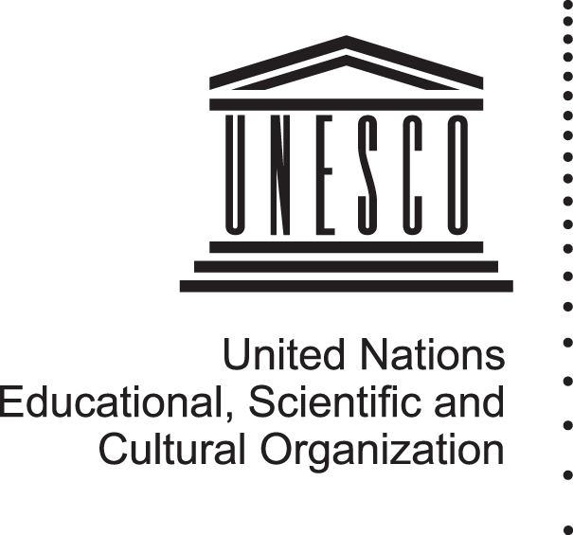   |  |  |  | Distr.  GENERAL  UNEP/CBD/DLG/JPW-BCD/1/1*  19 April 2012  ORIGINAL: ENGLISH
INFORMAL DIVERSITY LIAISON GROUP MEETING FOR THE JOINT PROGRAMME OF WORK ON BIOLOGICAL AND CULTURAL DIVERSITY OF THE CONVENTION ON BIOLOGICAL DIVERSITY AND UNESCO
First meeting
New York,
28 April – 29 April 2012

provisional agenda
1. Opening of the meeting.
2. Organizational matters.
3. Introduction to the joint programme of work on Biological and Cultural Diversity.
4. Priority focus areas for the joint programme and possible deliverables for the eleventh meeting of the Conference of the Parties.
5. Conceptual framework for and structure and content of the online platform for resources and knowledge generation and sharing: “Global Knowledge Platform on the Links between Biological and Cultural Diversity”.
6. Key messages on the links between biological and cultural diversity to be widely communicated through communication/awareness-raising campaign.
7. Consideration of the development of a diversity guide for policymakers and other practical tools.
8. Opportunities for highlighting the links between biological and cultural diversity at UNCSD (Rio+20).
9. Fund raising opportunities/strategy.
8. Other matters.
9. Adoption of the outcomes.
10. Closure of the meeting.
-----

* Reposted for technical reasons.
Including advice on potential “value-added” of the joint programme of work to global diversity work. Considering the niche that this programme may occupy to support global diversity work and the diversity community, including the development of cross-sectoral public policy.
The liaison group may also consider short (2012), medium (2013-2015) and long-term deliverables (up to 2020).
To be launched at the CBD COP-11 in October 2012 in India.

