 |  | CBD
 |  |  |  | Distr.  GENERAL  UNEP/CBD/WG8J/7/INF/2  10 May 2011  ORIGINAL: ENGLISH
AD HOC OPEN-ENDED INTER-SESSIONAL WORKING GROUP ON ARTICLE 8(j) AND RELATED PROVISIONS OF THE CONVENTION ON BIOLOGICAL DIVERSITY

Seventh meeting
Montreal, 31 October-4 November 2011

COMPILATION OF VIEWS ON TASKS 7, 10, AND 12 OF THE PROGRAMME OF WORK ON ARTICLE 8(j) AND RELATED PROVISIONS
Note by the Executive Secretary

INTRODUCTION
- As requested by the Conference of the Parties in paragraph 5(b) of decision X/43, the Executive Secretary is circulating herewith, for the consideration of participants in the seventh meeting of the Ad Hoc Open-ended Inter-Sessional Working Group on Article 8(j) and Related Provisions, a compilation of views and comments submitted to the Secretariat regarding tasks 7, 10 and 12 in the revised programme of work on Article 8(j) and related provisions, to assist the Working Group in its deliberations on the identification of minimum standards, best practices, gaps and lesson learned, which will identify further activities needed to fulfil these tasks.
- Submissions have been reproduced in the form and language in which they were provided to the Secretariat.

SUBMISSIONS

Submission from Parties
People’s Republic of China
CHINA GOVERNMENT RESPONSE TO NOTIFICATION 2011-065 & 2010-210: PROGRAMME OF WORK ON ARTICLE 8(J) AND RELATED PROVISIONS:

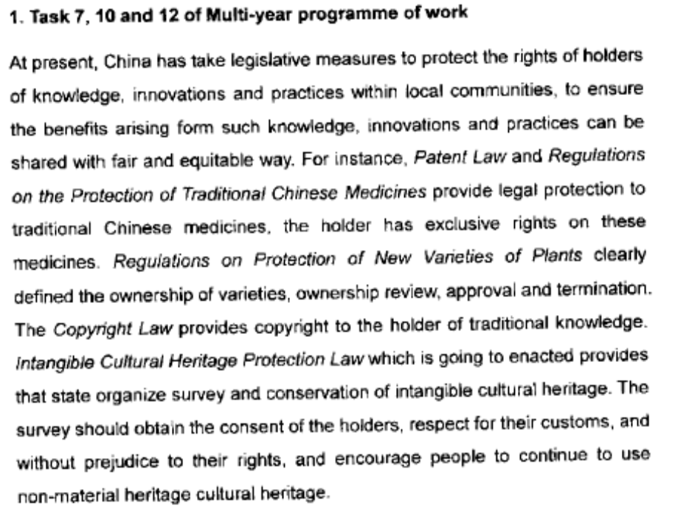
Norway
NORWEGIAN GOVERNMENT RESPONSE TO NOTIFICATION 2011-065 & 2010-210: PROGRAMME OF WORK ON ARTICLE 8(j) AND RELATED PROVISIONS:




