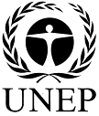 |  | CBD
 |  |  |  | Distr.  GENERAL  UNEP/CBD/WG8J/8/INF/3  18 September 2013  ENGLISH ONLY
AD HOC OPEN-ENDED INTER-SESSIONAL WORKING GROUP ON ARTICLE 8(j) AND RELATED PROVISIONS OF THE CONVENTION ON BIOLOGICAL DIVERSITY
Eighth meeting
Montreal, 7-11 October 2013

Item 3 of the provisional agenda*
Summary Report of Regional CAPACITY-BUILDING workshops for indigenous and local communitY representatives held in Preparation for the eleventh meeting of the conference of the parties to the Convention on Biological diversity
Note by the Executive Secretary
- This note provides an overview of the four regional capacity-building workshops for indigenous and local community representatives held in preparation for the eleventh meeting of the Conference of the Parties to the Convention on Biological Diversity. It is provided as a contribution for consideration by the Ad Hoc Open-ended Inter-Sessional Working Group on Article 8(j) and Related Provisions in discussions on the progress in the implementation of the programme of work on Article 8(j) and related provisions and mechanisms to promote the effective participation of indigenous and local communities in the work of the Convention.

A. BACKGROUND
- The regional capacity-building workshops for indigenous and local communities were held based on the following decisions of the Conference of the Parties on capacity-building for indigenous and local communities:
- Decision V/16, annex (programme of work on Article 8(j) and related provisions of the Convention on Biological Diversity), task 4;
- Decision VII/16 E, annex on elements of a plan of action for the retention of traditional knowledge, innovations and practices of indigenous and local communities embodying traditional lifestyles relevant for the conservation and sustainable use of biological diversity, section E, on capacity-building;
- Decision VIII/5 B, section II, on elements of a plan of action for the retention of traditional knowledge, paragraph 13;
- Decision IX/13 D, on the plan of action for the retention of traditional knowledge, in which the Parties decided that the priority for future work on the plan of action should focus on section E, on capacity-building;
- Decision IX/13 E, on participatory mechanisms, paragraph 7; and
- Decision X/40 A, on mechanisms to promote the effective participation of indigenous and local communities in the work of the Convention, in which Parties decided to encourage the Secretariat to continue its efforts to facilitate the effective implementation of decisions regarding capacity-building through workshops using a train-the-trainer methodology and extending opportunities to all regions, with a view to increasing the number of indigenous and local community representatives, particularly women, who are familiar with and participate in the work of the Convention, including its implementation at the national and local levels.
- Pursuant to the above decisions, and thanks to the generous financial support of the Governments of Spain and Japan, the multi-donor ABS Capacity Development Initiative financed by the Governments of Germany, Norway and Denmark, as well as the support of the International Union for Conservation of Nature (IUCN) through the GEF LAC project on ABS, the Secretariat of the Convention was able to organize four workshops for LAC, Asia and Africa regions.
- The objectives of the workshops were:
- Implementation of the decisions mentioned above;
- Building and strengthening the capacity of representatives of indigenous and local communities, particularly women, to effectively participate in processes of the Convention on Biological Diversity, especially those pertaining to Article 8(j) and Article 10(c) as well as the Nagoya Protocol;
- Providing preparation for the eleventh meeting of the Conference of the Parties.
- For each workshop, indigenous and local communities were invited by the Executive Secretary, through notifications, to submit their applications. The Executive Secretary informed Parties and indigenous and local communities ahead of the meetings, through official notifications, regarding the list of participants selected in consultation with partners to participate in the workshops. Some participants received funding assistance, which included the payment of their travel, accommodation, and meals. Given the interest in participating in the workshops, some participants and their organizations covered their own costs.
- The workshops were held with the collaboration of host Parties, namely:
- Government of Burundi;
- Government of Thailand;
- Government of Paraguay.
- These workshops were organized in partnership with the Indigenous Women Network on Biodiversity of the Latin American and Caribbean Region (IWNB-LAC), the Indigenous Peoples’ International Centre for Policy Research and Education (Tebtebba), the Asia Indigenous Peoples Pact (AIPP), the Indigenous Peoples of Africa Co-ordinating Committee (IPACC) and the Indigenous Information Network (IIN).
- The following organizations also contributed to the successful facilitation of the workshops:
- Unissons-nous pour la Promotion des Batwa (UNIPROBA);
- Fundación para la Promoción del Conocimiento Indígena (FPCI);
- Tekohá con los Pueblos Indígenas (Paraguay); and
- Natural Justice.

B. OVERVIEW OF THE WORKSHOPS
- Four workshops for indigenous and local communities were held in 2012 for the African, Asian, and Latin America and Caribbean regions.
- The workshops were held in:
- Bujumbura, Burundi, 9-14 June 2012 (African region);
- Chiang Mai, Thailand, 9-12 July 2012 (Asian region);
- Asunción, Paraguay, 13-16 August 2012 (Latin America and Caribbean region);
- Asunción, Paraguay, 17-18 August 2012 (Latin America and Caribbean region - workshop for trainers).
- The workshops covered the following topics:
- Introduction to the Convention on Biological Diversity, including the participation of indigenous and local communities in the work of the Convention;
- Strategy for Biodiversity 2011-2020 and the Aichi Biodiversity Targets;
- Introduction to the Nagoya Protocol on Access to Genetic Resources and the Fair and Equitable Sharing of Benefits Arising from their Utilization;
- Agenda and draft recommendation for the eleventh meeting of the Conference of the Parties to the Convention.
- In each workshop, publications on the Convention on Biological Diversity, the Nagoya Protocol, the Akwé: Kon Voluntary Guidelines, the Addis Ababa Principles and Guidelines, the Strategic Plan for Biodiversity 2011-2020 and other information on activities and programmes under the Convention related to traditional knowledge were discussed and distributed to participants. Compacts disks (CDs) were also included, containing the publications, presentations, official documents and reference materials.
- The workshops were facilitated by the members of the Secretariat responsible for the programme of work on Article 8(j), in collaboration with partners. The workshops used a participatory methodology, which included training on participation in official meetings under the Convention, preparation and use of official documents, and exchange of experience among participants.
- A total of 169 representatives of indigenous and local communities from Asia, Africa, and Latin America and the Caribbean attended the workshops (see annex below). The lists of participants are provided in the workshop reports.

C. RESULTS
- The workshop participants had the opportunity to evaluate their respective workshops. Analysis of evaluations revealed the following:
- Most of the participants said they gained more knowledge and that the knowledge is applicable to their daily activities;
- In terms of content, most participants said that the content was excellent;
- In terms of material support, the participants agreed that the materials provided were complete and highly relevant;
- Participants also made recommendations to improve future workshops including:
(i) More workshops at national and local levels to better understand the decisions of the Conference of the Parties on Article 8(j), with a special focus on the Nagoya Protocol; and
(ii) Further support for distribution of materials in communities, including in indigenous languages;
- Through this process of capacity-building with a focus on preparing for the eleventh meeting of the Conference of the Parties, indigenous and local community representatives were better prepared to present their draft recommendations and could better organize their activities in preparation for the eleventh meeting of the Conference of the Parties at local, national and international levels.
- The workshop in Bujumbura, Burundi, held from 9 to 14 June 2012, was delivered in English and French; all the participants had a working knowledge of either English or French. All in all, the participants found the workshop very useful. Many participants enjoyed the methodologies, including role-play and improvisations and believe they were excellent learning strategies for skills development, especially negotiation skills. First language of participants included Afrikaans, Babi (Kisourndi), Foulfoldé, Kimbuti, Kinyarwanda, Kirundi, Kirunizi, Kitaira, Kitembo, Maasai, Rufumbira, Rutumbia, Tamazight, and Tuger, among others.
- The workshop in Chiang Mai, Thailand, held from 9 to 12 July 2012, was delivered in English only. Most of the participants stated in their assessments that the workshop was very good; the workshop went beyond their expectations and increased their knowledge and understanding of processes and programmes under the Convention and of the Strategic Plan for Biodiversity 2011-2020. Preparation for the eleventh meeting of the Conference of the Parties helped them understand the issues that were going to be discussed and the impacts they will have on their daily work and lives. They all expressed their desire to learn more, and some stated that the fact of knowing how to deal with the issues at international level will help in finding ways to deal with them better at the local levels by replicating the lessons learnt. They were eager to know more about the Nagoya Protocol and how it opens up opportunities for indigenous peoples and local communities to protect and promote their rights. First language of participants included Bengali, Chakma, Galo, Kadazan, Karen, Khadia, K’urukh, Luhnia, Malay, Mbororo, Newazi, Oria, Palaman, Pazeh, Santali, Sinhala, Sungeri, Thami, Toraja, Vietnamese, and Wapichana, among others.
- The first workshop in Asunción, Paraguay, held from 13 to 16 August 2012, was delivered in Spanish with informal translation in English. It provided an opportunity to strengthen the capacity of representatives of indigenous and local communities, especially women, to participate effectively in the work of the Convention, particularly in matters related to Articles 8(j) and 10(c) and the Nagoya Protocol and in preparation for the eleventh meeting of the Conference of the Parties. First language of participants included Ache, Aymara, Brunka, Guarani, Guna, Inga, Ikan, Mapudungun, Nahuatl, Ngobe, Pemon, Quechua, and Wapichin, among others.
- A workshop for trainers was also held in Asunción, Paraguay, from 17 to 18 August 2012. The participants to this workshop went more deeply into the topics of the previous workshop in order to develop better tools to disseminate and share what they have learned in the workshop with their communities. These trainers understand and can work in the local languages spoken by their people and thus provide an ideal way to transmit information to the community level. First language of participants included Ache, Aymara, Brunka, Guarani, Guna, Ikan, Inga, Mapudungun, Nahuatl, Ngobe, Pemon, Quechua, and Wapichin, among others.

D. CONCLUSIONS
- The initiative for capacity-building for indigenous and local communities on Article 8(j) and access and benefit-sharing, facilitated by the Secretariat in collaboration with partners, and with financial support from the Governments of Spain and Japan, the multi-donor ABS Capacity Development Initiative financed by the Governments of Germany, Norway and Denmark, as well as the support of the International Union for Conservation of Nature (IUCN) through the GEF LAC project on ABS, allowed many representatives of indigenous and local communities, especially women, to engage and participate more actively and effectively at local, national and regional levels and in meetings of the Convention on Biological Diversity.

Annex

Workshop participants
- To participate in the workshops we received a total of 398 nominations; 133 were selected to be funded for participation.
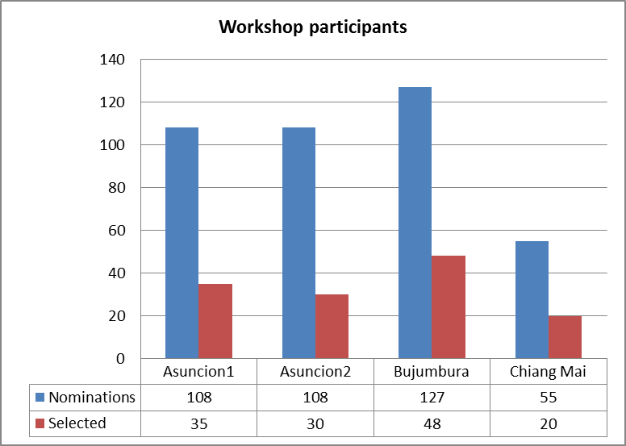
- Due to the high interest of representatives of indigenous and local communities a total of 133 were funded by the initiative and 36 through other funds.
- Nearly 60 per cent of participants were women of indigenous and local communities: a total of 99 women and 70 men.
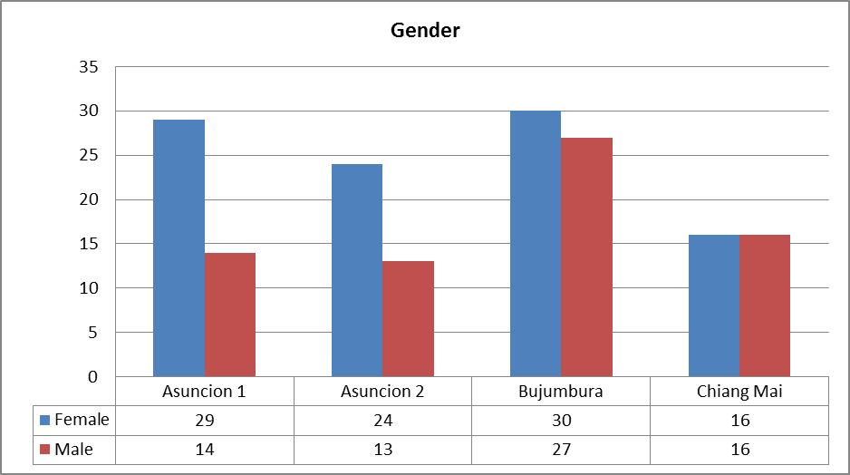
-----

* UNEP/CBD/WG8J/8/1.
GEF ABS LAC project, “Strengthening the implementation of Access to Genetic Resources and Benefit-Sharing regimes in Latin America and the Caribbean”.
See http://www.cbd.int/doc/?meeting=8J-PREPCOP11-01.
See http://www.cbd.int/doc/?meeting=8J-PREPCOP11-02.
See http://www.cbd.int/doc/?meeting=8J-PREPCOP11-03.
See http://www.cbd.int/doc/?meeting=WSILC-LAC-01.

