 |  | CBD
 |  |  |  | Distr.  GENERAL  UNEP/CBD/WG8J/8/INF/8  9 September 2013  ORIGINAL: ENGLISH AND SPANISH
AD HOC OPEN-ENDED INTER-SESSIONAL WORKING GROUP ON ARTICLE 8(j) AND RELATED PROVISIONS OF THE CONVENTION ON BIOLOGICAL DIVERSITY

Eighth meeting
Item 4(d) of the provisional agenda*
Montreal, 7-11 October 2013
COMPILATION OF VIEWS ON ELEMENTS OF SUI GENERIS SYSTEMS FOR THE PROTECTION OF TRADITIONAL KNOWLEDGE
Note by the Executive Secretary
INTRODUCTION
- As requested by the Conference of the Parties in paragraph 3 of decision XI/14 E, the Executive Secretary is circulating herewith, for the consideration of participants in the eighth meeting of the Ad Hoc Open-ended Inter-Sessional Working Group on Article 8(j) and Related Provisions, a compilation of views and comments submitted to the Secretariat on sui generis systems for the protection, preservation, and promotion and of the knowledge, innovations and practices of indigenous and local communities.
- Submissions have been reproduced in the form and languages in which they were provided.

SUBMISSIONS

A. Submissions from Parties

Australia

Indigenous Advisory Committee
The Indigenous Advisory Committee (IAC) is an expert group of Indigenous Australians who provide advice to the Australian Government’s Minister for Sustainability, Environment, Water, Population and Communities and the Australian Government Department of Sustainability, Environment, Water, Population and Communities regarding the participation of Aboriginal and Torres Strait Islander peoples in the Department’s natural resource management programs, including Caring for our Country. Committee members have extensive knowledge and experience in a wide range of land and sea management activities.

The IAC is a statutory committee that currently operates under the Environment Protection and Biodiversity Conservation Act 1999 (the EPBC Act). The IAC has a broad role advising the Minister on the wider operation of the EPBC Act, taking into account Indigenous peoples’ knowledge of land management and the conservation and sustainable use of biodiversity. The IAC has been advising the department and the Minister on issues such as: environmental and heritage regulatory reforms; Indigenous water and sea country management; Indigenous management of dugongs and sea turtles, and Indigenous consultation on the World Heritage listing of the Cape York.

The role of the IAC is to:
- advise the Minister for the Sustainability, Environment, Water, Population and Communities on:
  - the operation of the Environment Protection and Biodiversity Act 1999 (EPBC Act), taking into account the significance of Indigenous people's knowledge of the management of land and the conservation and sustainable use of biodiversity; and
  - Indigenous Protected Areas; and
- provide advice to Department of Sustainability, Environment, Water, Population and Communities on Indigenous issues as they relate to the role of the department, excluding where an existing statutory committee exists to provide such advice.

The Objects of the EPBC Act are:
- to provide for the protection of the environment, especially those aspects of the environment that are matters of national environmental significance (including listed threatened species and ecological communities; migratory species protected under international agreements; Ramsar wetlands of international importance; the Commonwealth marine environment; World Heritage properties; National Heritage places; the Great Barrier Reef Marine Park, and nuclear actions);
- to promote ecologically sustainable development through the conservation and ecologically sustainable use of natural resources;
- to promote the conservation of biodiversity;
- (ca) to provide for the protection and conservation of heritage;
- to promote a co-operative approach to the protection and management of the environment involving governments, the community, land-holders and Indigenous peoples;
- to assist in the co-operative implementation of Australia’s international environmental responsibilities; and
- to recognise the role of indigenous people in the conservation and ecologically sustainable use of Australia’s biodiversity; and
- to promote the use of indigenous peoples’ knowledge of biodiversity with the involvement of, and in co-operation with, the owners of the knowledge.

Valuation of Indigenous Participation in the Caring for our Country program
Introduced in July 2008, the Caring for our Country Program (the Program) is the Australian Governments’ flagship natural resource management initiative, which commits over $2 billion in funding over the first five years (until June 2013). The Caring for our Country supports communities, farmers, resource management groups and other land managers to protect Australia’s environment. The Program’s overarching goal is to achieve an environment that is healthy, better protected, well-managed, resilient and provides essential ecosystem services in a changing climate.

In June 2012, Urbis Pty Ltd was engaged by the Department of Sustainability, Environment, Water, Population and Communities (the department) to evaluate Indigenous participation in delivering the community skills, knowledge and engagement (CSKE) five-year outcomes of the Caring for our Country Program. The CSKE was one of six national priority areas targeted under the program. The evaluation assessed the Indigenous participation outcomes achieved to date, highlights key lessons learnt and provides the department with suggestions for the future design and delivery of natural resource management programs.

The overall finding of this evaluation is that the Caring for our Country Program effectively supported Indigenous participation in delivering the CSKE five-year outcomes. Indigenous people have significant and unique knowledge, skills and land and sea management responsibilities that contribute to achieving the Program’s cultural and natural resource management outcomes. Indigenous participation in the Caring for our Country Program reflects an Australian Government commitment to support Indigenous cultural obligations to manage land and sea country. Indigenous participation also contributes to the Council of Australian Government’s (COAG’s) commitment to Closing the Gap in Indigenous disadvantage; a commitment by all Australian governments to address the disadvantage faced by Indigenous Australians in life expectancy, child mortality, education and employment. Indigenous participation in the Caring for our Country Program is highly valued by Indigenous and non-Indigenous program and project-level stakeholders and provides wide-ranging community skills, knowledge and engagement outcomes for: Indigenous individuals, Indigenous and non-Indigenous organisations and groups, and the wider-community. The Caring for our Country Program has met or exceeded the five-year outcomes of the Program’s Indigenous-specific targets. The Working on Country Program, a ranger program that is also funded as part of this program, has also met its Indigenous employment and training targets.

Community Skills, Knowledge and Engagement (CSKE) – Traditional Ecological Knowledge
The Caring for our Country program ensured the continued use, support and reinvigoration of traditional ecological knowledge (TEK) to underpin biodiversity conservation. Since 2008, 181 projects have supported over 481 Indigenous partnerships that use TEK to deliver biodiversity conservation outcomes.

The Working on Country program met its target with over 690 Indigenous rangers employed to manage and deliver environmental outcomes over 1.5 million square kilometres of land and sea country in remote and regional Australia. In 2011-12 there were 38 new projects undertaken in partnership and a further 20 Indigenous-managed projects to record TEK and integrate this with a scientific understanding of best-practice land management and biodiversity conservation. Many of these projects also worked to control Weeds of National Significance (WoNS) in culturally significant areas; develop land and sea management plans and; integrate this knowledge with a scientific understanding of best-practice land management and biodiversity conservation.

Traditional Use of Marine Resource Agreements (TUMRA)
The Traditional Use of Marine Resources Agreement is a sui generis system for the protection, preservation and promotion of traditional knowledge, innovations and practices. It provides for on country cultural activities where intergenerational transfer of knowledge occurs. It also provides for the cultural mapping of country, including the recording of culturally significant species (plants and animals) and places of particular significance. Information typically includes use and occupancy mapping. TUMRA activities also foster and promote the use of language both in knowledge transfer, and as a component of managing country, where language names for species and places are recorded in official documents and actively promoted through sea country activities, signage, publications and other communication material. The authority over the TUMRA resides with the Traditional Owner groups, with access to different levels of knowledge agreed only by Traditional Owners - increasing the protection of their traditional knowledge.

Australian National Water Quality Management Strategy (NWQMS)
The Australian Government is working with state and territory governments to develop guidance within the Australian National Water Quality Management Strategy (NWQMS) on incorporating Indigenous cultural and spiritual values into water quality planning. This work takes into account the outcomes of a recently commissioned case study report titled Indigenous Cultural and Spiritual Values in Water Quality Planning. The guidance is being developed in response to an acknowledged gap in the NWQMS.

The aim of the case study report was to improve collective understanding of Indigenous cultural and spiritual values and to demonstrate practical ways in which these values may be considered in water quality planning and management processes. The report draws attention to positive initiatives in Australian states and territories where water managers have engaged Indigenous people in water quality planning and provides valuable lessons for future water quality management. The case studies also highlights good practice themes including that good integration of Indigenous cultural and spiritual values requires: due respect for Indigenous law, custom and traditional knowledge; early identification and engagement of the most appropriate Indigenous stakeholders and representatives; information sharing using a range of accessible formats include for example, illustrated models, booklets and stories; the integration of science and traditional knowledge; and ongoing collaboration with Indigenous stakeholders. The report also offers lessons in Indigenous engagement in water quality planning such as: the importance of cultural awareness and open communication; the importance of positive relationships between Indigenous people, farmers, government officers, conservationists, industry representatives and the scientific community and the need to include capacity building measures and employment opportunities for Indigenous participants in project design and funding considerations. For further information see: http://www.environment.gov.au/water/publications/quality/water-quality-planning-indigenous.html

Murray-Darling Basin Plan Recognition
Under the auspices of the Australian Government’s Water Act 2007, the Basin Plan 2012 is the legal instrument for the management of the Murray-Darling Basin water resources undertaken in the national interest by the Commonwealth in conjunction with the Basin States. The Basin Plan has made significant progress in the recognition of Indigenous interests in natural resource management through a powerful acknowledgement of the Traditional Owners of the Murray-Darling Basin. The Basin Plan also describes and acknowledges the concept of cultural flows and recognises the benefits that will be derived by Indigenous people from cultural flows becoming reality. The Plan places requirements on Basin States to take account of Indigenous values and uses in their water management planning and provides a role for Murray Lower Darling Rivers Indigenous Nations and Northern Basin Aboriginal Nations in the accreditation of the Basin State water resource plans. In undertaking environmental watering the Basin Plan also requires Indigenous uses and values to be taken into account. To help minimise the risk of insufficient water or water not being of a suitable quality to maintain Indigenous values the Basin Plan is to develop strategies to improve knowledge relating to the social, spiritual and cultural use of water by Indigenous people.

Murray Lower Darling Rivers Indigenous Nations and Northern Basin Aboriginal Nations
The Murray-Darling Basin Authority has supported the establishment and funds two autonomous Indigenous organisations, Murray Lower Darling Rivers Indigenous Nations (MLDRIN) and Northern Basin Aboriginal Nations (NBAN). MLDRIN and NBAN share a common aim to seek greater recognition and respect for Aboriginal knowledge, culture values and uses regarding land and water management. The MDBA has helped build the capacity of both organisations by assisting them to hold regular meetings and to set up their corporate and financial structures and communications. The intention is to reinforce their position as independent self-determining Indigenous organisations. Both these organisations are Traditional Owner based with a primary focus on culture and natural resource management; thereby providing them with the ability to provide advice which is culturally authoritative
MLDRIN was formed in 1998 and currently comprises representatives from 24 Indigenous Nations in the southern part of the Murray-Darling Basin. NBAN was formed in April 2010 and comprises representatives from 21 Aboriginal Nations in the northern part of the Basin and representatives from the New South Wales Aboriginal Land Council and South East Queensland Natural Resource Management.

MLDRIN and NBAN have contributed substantially to the development of the Basin Plan and helped design the Indigenous consultation strategy on the draft Basin Plan.
Since their establishment both MLDRIN and NBAN have been invited to participate in other natural resource management committees and are seeking alternative funding sources to further fulfil the objectives of their corporate plans.

Use-and-Occupancy Mapping
Use-and-occupancy mapping is a type of map survey that uses a rigorous, well-considered social-science methodology that has been widely implemented in Canada; it is an environmentally and politically defendable technique that will help Indigenous people document the many ways in which they currently use the land. Murray Lower Darling Rivers Indigenous Nations anticipates that there is a huge potential for use-and-occupancy mapping to assist Indigenous leaders articulate how they would like to see land and water managed to meet their future social, environmental, spiritual and economic aspirations.

The introduction of use-and-occupancy mapping to Australia has been undertaken by the Murray-Darling Basin Authority in partnership with Murray Lower Darling Rivers Indigenous Nations in a carefully considered and planned manner reflecting the Authority’s engagement principles, such as utilizing free, prior and informed consent, building capacity to engage and ensuring a respectful, inclusive approach. Several use-and-occupancy mapping projects have been completed.

Murray Lower Darling Rivers Indigenous Nations hope that use-and-occupancy mapping will help non-Indigenous people build an appreciation and understanding of Indigenous peoples’ current and vital relationship to country and consequently, assist in defining their rightful role in natural resource management leadership.

Cultural Flows Research
The term ‘cultural flows’ has been created by Aboriginal people as a way of easily encapsulating the cultural benefits that they will gain from their ownership and management of water.

The concept of ‘cultural flows’ aims to translate the complex relationship that Aboriginal people have with water resources into the normative language of water planning and management. In November 2007, Murray Lower Darling Rivers Indigenous Nations (MLDRIN) developed a definition of cultural flows known as the Echuca Declaration which has since been adopted by Northern Basin Aboriginal Nations (NBAN) and the North Australian Indigenous Land and Sea Management Alliance (NAILSMA). The short definition of cultural flows is as follows:
“Water entitlements that are legally and beneficially owned by the Indigenous Nations and are of a sufficient and adequate quantity and quality to improve the spiritual, cultural, environmental, social and economic conditions of those Indigenous Nations. This is our inherent right.”

Among the potential benefits that cultural flows could provide to Indigenous people are improved health, wellbeing and empowerment from being able to care for their Country and undertake cultural activities. Implicit in the implementation of cultural flows would be an important and respectful acknowledgement of Indigenous culture, traditional knowledge and spiritual attachment to place.

Both MLDRIN and NBAN have recognised that although the Echuca Declaration is an excellent start towards meeting their aspirations to both own and manage water to achieve cultural outcomes, it does not contain sufficient detail for the concept to be implemented or for them to advocate for substantial water allocations. They understand that they need to be able to articulate what is meant by cultural values and how they will be enhanced or protected, the volumes of water required, the timing and duration of flow events and the types of governance arrangements needed to manage their water.

The National Cultural Flows Planning and Research Committee (NCFPRC) has been established to oversee a research program ‘Incorporating Aboriginal Values into water management in Australia through identifying and quantifying Cultural Flows’. The Committee is made up of Indigenous delegates representing the North Australian Indigenous Land and Sea Alliance, Indigenous Water Advisory Committee, Murray Lower Darling Rivers Indigenous Nations and Northern Basin Aboriginal Nations. The primary outcome of the research will be a set of practical recommendations for legal and policy reform leading to the implementation of cultural flows. The research will use case studies to: identify Indigenous water values and needs; quantify water volumes to meet those requirements; conduct trial cultural flows; undertake hydrological modelling; and establish a monitoring methodology to determine socio-economic health and wellbeing outcomes. The research will also compare and contrast environmental and cultural flow outcomes and analyse governance options for future management of cultural flows by Aboriginal people. The research project has a proposed budget of $4.6million and is scheduled to be finalised in 2016.

The leadership of MLDRIN and NBAN envisage this research will, in the future, help them articulate their need for substantial allocations of water for cultural flows. Not only will this water help them meet their cultural responsibilities to care for Country, they also believe having a significant stake in the Murray-Darling Basin’s water resources will have the benefit of locking them in as prominent stakeholders and help ensure their place at water negotiation and decision making tables. Aboriginal people across Australia see a future where not only is their traditional knowledge respected but their place in society as managers and carers of their Country is assured. With this comes a more holistic and equitable approach to managing Australia’s natural resources for the benefit of all Australians.

Protection of Traditional Cultural Expressions
The Australian Government is currently developing a policy framework to respect and protect Aboriginal and Torres Strait Islander peoples’ Traditional Cultural Expressions and seeking to work across government to build understanding of its goals and impact.
Indigenous Visual Arts Industry Support
Indigenous Visual Arts Industry Support (IVAIS) provides direct funding support to Indigenous art centres and industry support and advocacy organisations. The program's overall objectives are to assist art centres to become stronger and to build a more sustainable Indigenous visual arts industry. To achieve these objectives, IVAIS funding assists organisations to:
- strengthen governance and business management practices in the industry
- provide opportunities for artists to maintain, develop and extend their professional art practice
- provide opportunities for arts workers to develop professional skills and experience

The IVAIS program is part of a coordinated Australian Government approach to develop the Indigenous visual arts sector that is outlined in the Indigenous Art Centres Strategy and Action Plan. For more information see: http://www.arts.gov.au/indigenous/IVAIS.

Indigenous Culture Support
Indigenous Culture Support (ICS) supports the maintenance and continued development of Indigenous culture at the community level. ICS funds activities that encourage culturally vibrant Indigenous communities and contribute to the cultural wellbeing of Indigenous individuals and communities. ICS funds activities that:
- maintain Indigenous culture through community involvement;
- support new forms of Indigenous cultural expression;
- increase public awareness of Indigenous culture, including through the presentation and exchange of culture; and
- support the sustainable development of community organisations involved in cultural activities.

For more information see: http://www.arts.gov.au/indigenous/ICS.

Indigenous Languages Support Program
The Australian Government’s National Indigenous Languages Support Program (ILS) is a commitment to help Aboriginal and Torres Strait Islander peoples keep their languages alive and connect to their languages and culture. The ILS supports maintenance, revival, and development of Indigenous languages, whilst supporting increase of the use of Indigenous languages in a range of fields and media as well as education. The ILS is committed to promoting Aboriginal and Torres Strait Islander wellbeing by strengthening pride in identity and culture through languages. For more information go to: http://arts.gov.au/indigenous/ils.

Review of Higher Education Access and Outcomes for Aboriginal and Torres Strait Islander People
The Australian Government has recently undertaken a Review of Higher Education Access and Outcomes for Aboriginal and Torres Strait Islander People (the Review) in Australia. One of the Terms of Reference for the Review was asked to consider was the recognition and equivalence of Indigenous knowledge in the higher education sector. The Review was led by Professor Larissa Behrendt and provided its report to the Australian Government in July 2012. The Review was tasked with, among other things, proposing a strategic framework to improve access and outcomes for Aboriginal and Torres Strait Islander people within Australian universities.

Three recommendations from the Review relate particularly to the protection of Indigenous knowledge. These are:
- Recommendation 19 - That the Australian Government continue to support the Australian Institute of Aboriginal and Torres Strait Islander Studies (AIATSIS) to digitise and thus preserve its collection for future generations and particularly for use in higher education, and encourage the development of a national approach to data digitisation working with states, territories and community groups to ensure that Indigenous knowledge be digitised appropriately and preserved.
- Recommendation 24 - That the Australian Institute of Aboriginal and Torres Strait Islander Studies (AIATSIS) provide more formal guidance to publicly funded research agencies, universities and researchers on ethical research practice. This could include, for example, information on the AIATSIS website of case studies and materials to assist Australian researchers.
- Recommendation 28 - That the Australian Government undertake a review of the Australian Institute of Aboriginal and Torres Strait Islander Studies to consider how best to maintain the Institute’s unique place in developing Aboriginal and Torres Strait Islander academic and research activities and the relationship it has with universities.

The then Minister for Tertiary Education, Senator the Hon Chris Evans launched the report on 14 September 2012 and indicated an implementation strategy relating to recommendations from the Review will be prepared. Work is currently proceeding on this strategy, which will include consideration of the review of AIATSIS. Further information from the Review can be found at http://www.innovation.gov.au/HigherEducation/IndigenousHigherEducation

Maintenance of Indigenous Language and Records Program
The Maintenance of Indigenous Languages and Records (MILR) program addresses the steady erosion and loss of Australia’s estimated 250 original Indigenous languages by providing support for the maintenance and revival of these languages. The MILR program supports a broad range of projects, including documentation and recording of Indigenous languages and the development of language resources and language databases to assist with the development and delivery of programs through language centres. It also supports greater coordination between language organisations, activities that promote Indigenous languages in the wider community and innovative projects using multimedia and new technologies. See http://www.arts.gov.au/indigenous/MILR for more information.

Indigenous Broadcasting Program
The Indigenous Broadcasting Program (IBP) supports Indigenous community radio broadcasting and provides funding support to address the broadcasting needs of Indigenous people living in remote, regional and urban areas of Australia. It supports the production and broadcasting of radio programs promoting Indigenous languages and helps to maintain a flow of information to Indigenous Australians on how to access essential services like housing, health, legal support, and education. The IBP aims to:
- support the operations of Indigenous owned and controlled community radio broadcasting services, including Remote Indigenous Broadcasting Services (RIBS);
- support the development and broadcast of programming that focuses on the promotion of local Indigenous culture and languages;
- enhance Indigenous broadcasting services by supporting national representation that serves and develops the sector's capacity;
- support broadcasting services that are able to inform and educate Indigenous Australians on accessing the range of health, legal, education and housing services available to them.

See http://www.arts.gov.au/indigenous/broadcasting for more Information.
International Heritage

The Australian Government has implemented a range of twinning arrangements under the Kokoda Initiative and Activities under the Pacific Public Sector Linkages Program. These exchanges bring together indigenous rangers and resource managers from the Western Pacific (Papua New Guinea, Solomon Islands and Vanuatu) and link them with Indigenous networks and projects in Australia, fostering knowledge sharing about land and sea scape management at the practitioner level.

Australian Support for the establishment of the Pacific Heritage Hub
Emerging from the Pacific Action Plan for the World Heritage Convention, the Hub acts as a conduit for information, brokering knowledge sharing, and linking projects within the region with donors. The Hub’s strategic plan specifically notes the importance of the Aichi Biodiversity Targets and investing in projects that support Pacific Island through supporting cultural and natural heritage institutions to implement the Strategic Plan for Biodiversity 2011-2020 noting in particular the relevance of contributing to strategic goals and targets.

Caring for our Country
Between 2008−13, the Australian Government approved over $2 billion through the Caring for our Country initiative for projects to achieve a healthier, better protected, well-managed and resilient environment in a changing climate. Farmers and Indigenous land managers have been assisted through the Sustainable farm practices priority area in pursuing innovative management practices that improve natural resource management such as soil condition, native vegetation management, agroforestry, fisheries and aquaculture and some of these draw on the use of traditional ecological knowledge. For example, the Paddocks Alight: Innovative use of burning for pasture, biodiversity and culture project aims to set up eight indigenous community fire teams to trial traditional burning with ten landholders to improve agricultural, biodiversity and cultural outcomes. The Australian Government has committed to further funding for Caring for our Country 2013−18, through the Sustainable Agriculture and Sustainable Environment streams.

Joint management arrangements of Ramsar Wetlands
A number of Ramsar sites in Australia have joint management arrangements with Indigenous communities to enable Indigenous people to contribute to the management of their lands. For example, the Millewa component of the New South Wales Central Murray Ramsar site, gazetted as a National Park, is jointly managed by the New South Wales National Parks and Wildlife Service and the Yorta Yorta Indigenous Nation. The South Australian Government and the Ngarrindjeri people have entered into the Kungun Ngarrindjeri Yunnan Agreement to protect and maintain Ngarrindjeri culture and cultural sites of the Coorong, and Lakes Alexandrina and Albert Wetland Ramsar site.

General comments
When developing a glossary, it should be kept in mind that some terms have different meanings in different national contexts and do not have a universally applicable definition (e.g. ‘traditional knowledge’ and ‘indigenous knowledge’ are similar terms in Australia but have very different meanings in other countries).

Some terms have evolved since this glossary was last considered and this should be addressed in the Secretariat’s work (e.g. “Application/use/utilization of traditional knowledge” and the definition of “utilization” in the Nagoya Protocol).

The glossary developed by the Secretariat should be consistent with the approach taken in other fora discussing ‘traditional knowledge’. The World Intellectual Property Organization has developed a glossary of relevant terms which will assist the Secretariat (see http://www.wipo.int/edocs/mdocs/tk/en/wipo_grtkf_ic_24/wipo_grtkf_ic_24_inf_7.doc ).

Bolivia

El mandato del Estado Plurinacional de Bolivia es proteger los saberes y los conocimientos ancestrales mediante el registro de la propiedad intelectual que salvaguarde los derechos intangibles de las naciones y pueblos indígena originario campesinas y las comunidades interculturales y afrobolivianas.

En ese sentido el Ministerio de Culturas y Turismo vienen desarrollando la Ley de Patrimonio Cultural, el Sistema de gestión de Sitios y el Sistema Plurinacional de Registro Patrimonio Cultural, que de manera integral tienen el objetivo establecer los parámetros marco para la gestionar del Patrimonio Cultural Material e Inmaterial, en este sentido la intersectorialidad se convierte en una necesidad de prioridad para la ejecución de políticas y planes de desarrollo nacional.

Las manifestaciones de la diversidad de culturas y en especial los pueblos indígena originario campesinos hacen el uso de variedades de especies de la biodiversidad de flora y fauna la cual merecen un especial tratamiento por la relación cultural establecida con su entorno y el uso de los recursos naturales dentro de expresiones culturales, los que significa que la normativa en proceso de consolidación debe reconocer y hacer respetar los conocimientos tradicionales dentro de las concepciones de los sistemas jurídicos locales, así los conocimientos tradicionales dentro de los sistemas que hacen a este conocimiento devienen de estructuras locales que contienen aptitudes, actitudes y prácticas rituales, religiosas, festivas, que hacen al percepción propia y contribuyen la diversidad de las concepciones de universo que hacen la interculturalidad.

Por su parte el Ministerio de Educación a través del Viceministerio de Ciencia y Tecnología, a través de la Red de Saberes y Conocimientos de los Pueblos Indígena, Originario, Campesino y Afroboliviano, en septiembre de la gestión 2012 se ha iniciado la implementación de Fichas Revalorizadas, que permiten rescatar y registrar el conocimiento tradicional de las comunidades.

El Ministerio de Salud y Deportes mediante el Viceministro de Medicina Tradicional, elaboro un anteproyecto de Ley de la Medicina Tradicional el mismo se encuentra en proceso de análisis en el Consejo Nacional de Política Económica y Social (Conapes), este anteproyecto de ley nace en respuesta al mandato de la Constitución Política del Estado, asimismo esta instancia realiza el registro de médicos tradicionales a nivel nacional, este registro incluye medicamentos tradicionales que son elaborados en laboratorios artesanales.

Asimismo, las autoridades competentes (Viceministerio de Medio Ambiente, Biodiversidad y Cambios Climáticos y de Gestión y Desarrollo Forestal, Viceministerio de Medicina Tradicional, Viceministerio de Ciencia y Tecnología y el Ministerio de Relaciones Exteriores) vienen desarrollando consultas participativas con los actores locales y pueblos indígenas a fin de identificar el mecanismo que coadyuve a proteger los conocimientos ancestrales/tradicionales que será plasmada en una Ley de Protección de Conocimientos Ancestrales/Tradicionales.

Brazil

XI/14/E, Sui Generis Systems for the protection, preservation and promotion of traditional knowledge, innovations and practices
18. As for our experiences, case studies and views regarding a broad range of sui generis systems and their mechanisms, including community protocols, policy, and administrative or legislative measures, which have contributed to respect for and protection, preservation and promotion of the wider application of traditional knowledge, please see the previous item on the implementation of Article 8(j).

19. As for regional measures that have been taken to protect traditional knowledge, innovations and practices of indigenous and local communities relevant to biological diversity held across national and international boundaries, Brazil, together with other countries in the Amazon region, has began to discuss how to address those issues under the Strategic Agenda of the Amazon Cooperation Treaty Organization. So far, a few meetings have been organized to exchange views and experiences on the different systems of protection of traditional knowledge, as well as on regulations related to access and benefit sharing.

EU and its Member States

Similarly, with regard to sui generis systems for the protection, preservation and promotion of traditional knowledge, innovations and practices, the EU and its Member States believe that synergies with other relevant international organisations, including the World Intellectual Property Organization and its Intergovernmental Committee on Intellectual Property and Genetic Resources (WIPO-IGC), should be sought, as the EU continues to regard the WIPO-IGC as the primary international forum and decision making body for any debate on the intellectual property law aspects of the protection of traditional knowledge, and complementarity should be ensured, in particular with the Nagoya Protocol to the CBD.

Finland

The Conference of Parties in Decision X/43 Multi-year programme of work on the implementation of Article 8(j) and related provisions of the Convention on Biological Diversity;

“Urges Parties, that had not yet submitted information regarding the implementation of the programme of work for Article 8(j) and related provisions, including on national participation of indigenous and local communities, to do so in consultation with indigenous and local communities, through the fourth national reports where possible, and in time for the seventh meeting of the Working Group on Article 8(j) and requested the Executive Secretary to analyse and summarize this information and make it available to the Working Group on Article 8(j) and Related Provisions at its seventh meeting.”

Finland reported on the implementation of Article 8(j) in its Fourth National Report in 2009.

Finland, Sweden and Norway have been preparing the Nordic Sámi Convention. A proposal was put forward in 2005 and negotiations since then are continuing. The proposed convention includes an article on sui generis, where states must respect the right of the Sámi People to manage their traditional knowledge and traditional cultural expressions while striving to ensure that the Sámi are able to preserve, develop and pass these on to future generations. When Sámi culture is employed commercially by persons other than the Sámi, the states must make an effort to ensure that the Sámi People have influence over such activities and gain a reasonable share of the financial revenues. Sámi culture must be protected against the use of cultural expressions that may be misleading by giving the impression of having a Sámi origin. The states must also make an effort to ensure that Sámi traditional knowledge is taken into account in decisions that concern the Sámi People. Finland feels that the proposed text is in line with the CBD concerning traditional knowledge.

UNESCO’s Convention for the Safeguarding of the Intangible Cultural Heritage entered into force in Finland on 21 May 2013. The Convention defines the intangible cultural heritage as follows:

“… the practices, representations, expressions, knowledge, skills — as well as the instruments, objects, artefacts and cultural spaces associated therewith — that communities, groups and, in some cases, individuals recognize as part of their cultural heritage. This intangible cultural heritage, transmitted from generation to generation, is constantly recreated by communities and groups in response to their environment, their interaction with nature and their history, and provides them with a sense of identity and continuity, thus promoting respect for cultural diversity and human creativity...”

According to the Convention, the intangible cultural heritage is connected primarily to:
“(a) oral traditions and expressions, including language as a vehicle of the intangible cultural heritage;
(b) performing arts;
(c) social practices, rituals and festive events;
(d) knowledge and practices concerning nature and the universe;
(e) traditional craftsmanship.”

The biodiversity-related customary law of the Sámi steers the traditional use of land and inter-community relations relating to land use, creates principles for the allocation of the areas of use, and steers the use of natural resources in a sustainable manner in keeping with the concept of justice held by the Sámi.

Duodji, a traditional Sámi handicraft, has a long tradition in the Sámi culture. Duodji embodies both making the object and the object itself, and is a part of the self-sufficient Sámi community. While usefulness is more important than decoration, also the design, shape and beauty of an item are appreciated. In making the objects, most of the raw materials — roots, tubers, birch bark, reindeer hide and antler, bones and sinew — come from nature. Metals such as tin and silver are also used.

In the Sámi culture, traditional cultural expression means joik music, Sámi handicrafts, Sámi art, the storytelling tradition and myths, literature, place names in the Sámi language and Sámi building traditions. In addition, making offerings to the Seidi, which is part of the ancient Sámi religion, is a form of cultural expression. Newer forms of cultural expression include modern Sámi music, theatre and the cinema.

Sámi traditional cultural expressions should be protected against misleading use that gives the impression that they are of Sámi origin. This is not only a question about copyright, but it is also connected to legislative measures and intellectual property rights.

Germany

Germany, through bilateral cooperation and through the multi-donor ABS Capacity Development Initiative (jointly with the EU, Norway, Denmark and the IFDD), has been supporting the development and dissemination of Biocultural Community Protocols (BCPs) in several partner countries.
BCPs are instruments that set out clear terms and conditions to the private, research, and non-profit sectors as well as government agencies for engaging with indigenous and local communities (ILCs) and accessing their local resources and traditional knowledge (TK). They are developed through culturally rooted, participatory decision-making processes within the communities and are based on communities’ customary norms, values, and laws. BCPs hold a number of functions, among others they:
- bridge the gap between the customary laws and institutions of communities on one hand, and national or international frameworks for management of natural resources - such as the CBD and its Nagoya Protocol, Reducing Emissions from Deforestation and Forest Degradation (REDD+), protected area or forest policies - on the other.
- provide clarity and a measure of legal or political certainty for users of resources and traditional knowledge (for example bioprospectors, biotrade companies or research institutes), and help to build dialogues and long-term partnerships between users and communities.
- trigger community discussions on their aspirations and enhance awareness about the communities’ values, rights and obligations regarding their resources and TK.
As such, BCPs are locally adapted sui generis systems that contribute to the protection, preservation and promotion of traditional knowledge, innovations and practices. While they first emerged in the context of ABS, it rapidly became clear that their application is much broader, and indeed BCPs can help to unify communities’ interactions with the various policy frameworks that impact their resources and TK. Germany therefore supports the development of BCPs in the context of ABS but also in other areas such as for example biotrade value chains or protected areas. For instance, German development cooperation piloted the use of BCPs in biotrade value chains in Peru, Brazil and Madagascar in partnership with the Union for Ethical Biotrade and the ABS Initiative, in collaboration with Natural Justice, supported the BCP of the Kukula Traditional Healers Association in Bushbuckridge, South Africa, which has led to a non-disclosure agreement with a local cosmetics company as well as renewed access to parts of a protected area to collect medicinal plants.

While communities have always developed protocols in written or unwritten form to manage their resources and TK and to interact with outsiders, BCPs as explicit dialogue tools on the biocultural values, rules and procedures and the rights of communities are a relatively new instrument, which is still under development. Germany is working with its partners to disseminate lessons learned from past and ongoing BCP processes, and to achieve recognition of BCPs in national policies and legislation.

Peru
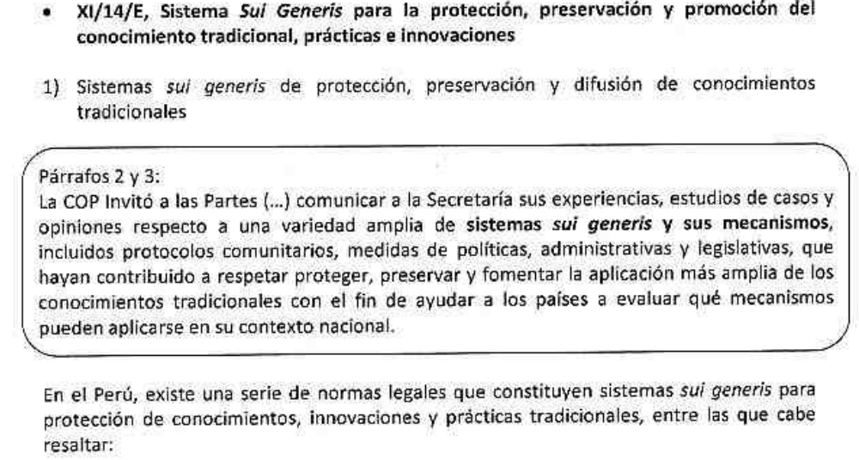

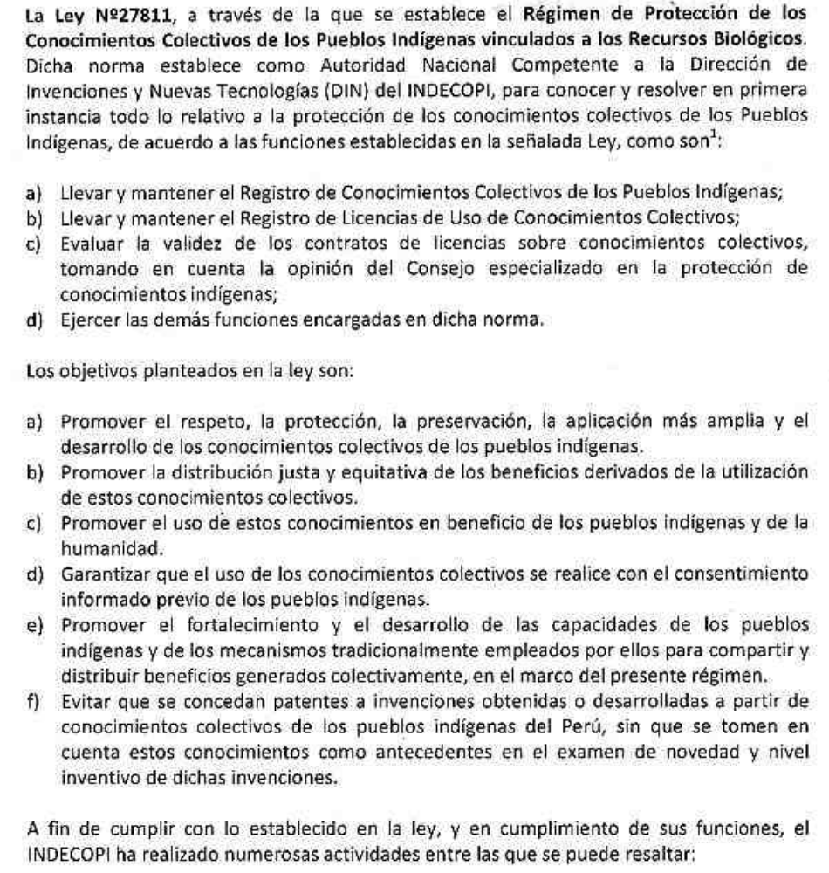

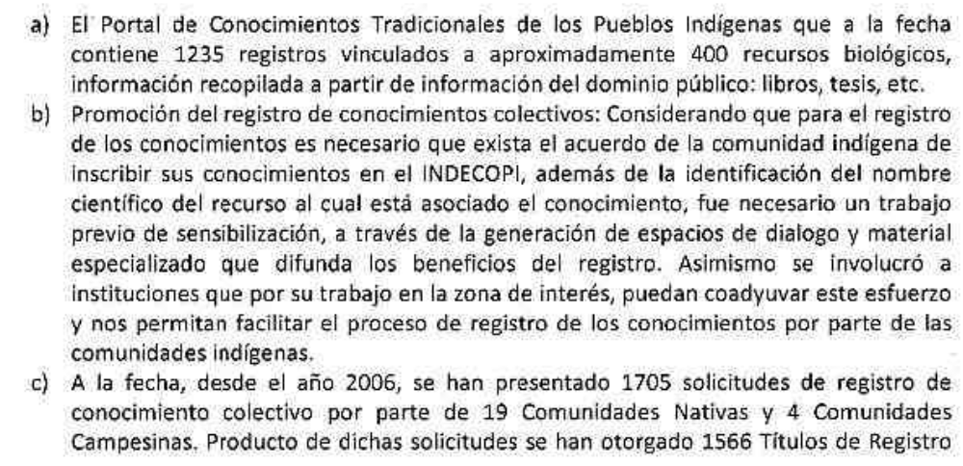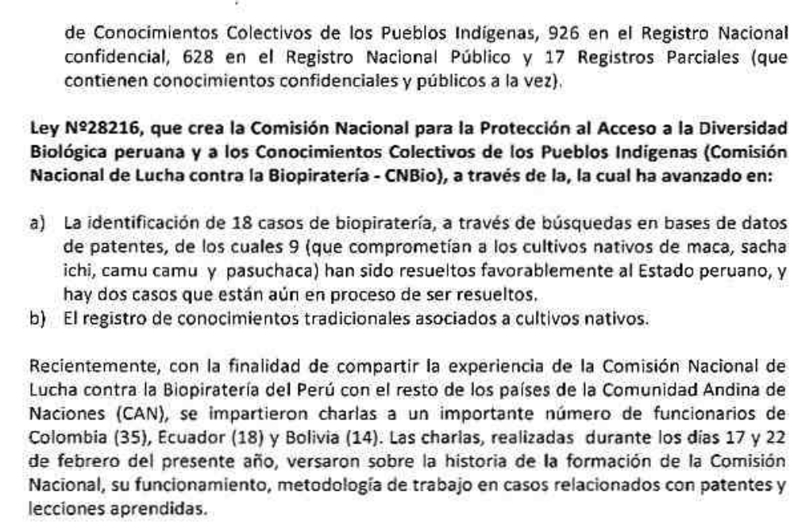
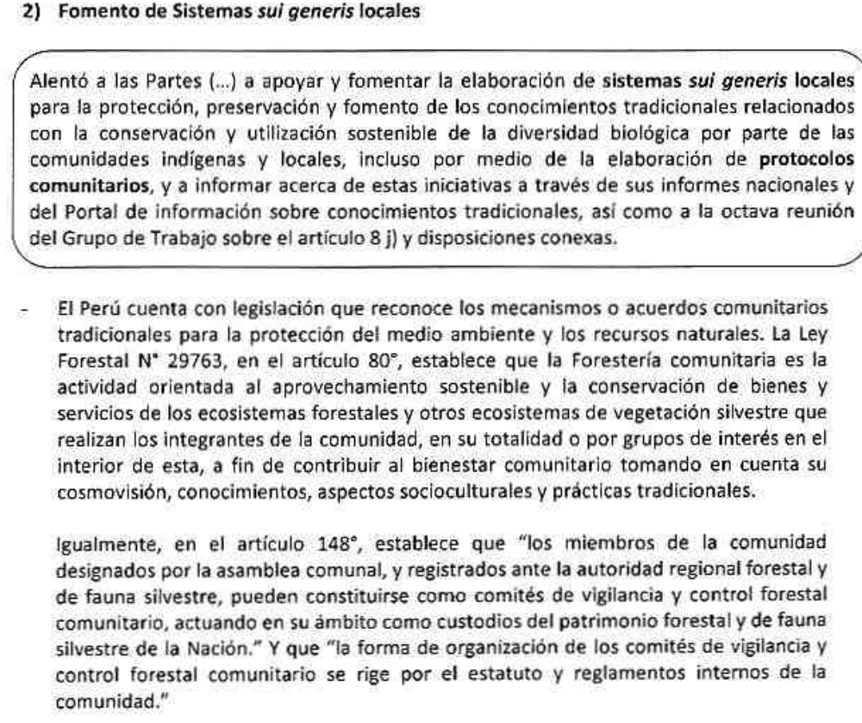
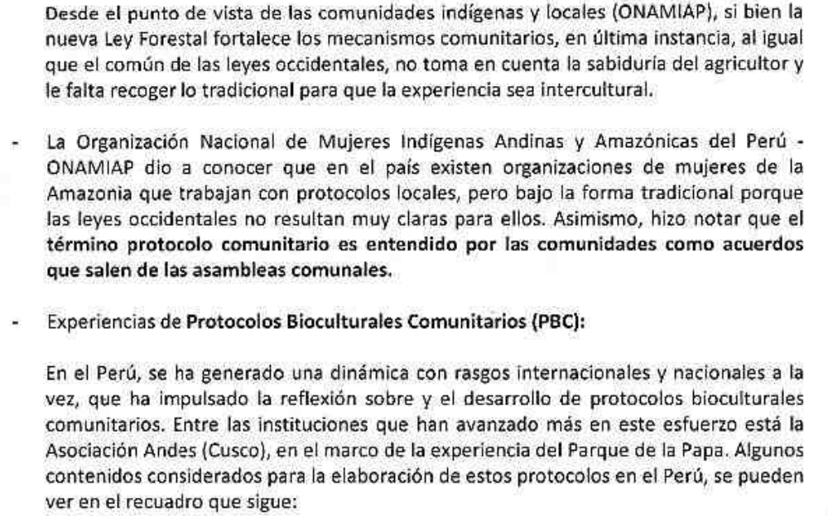
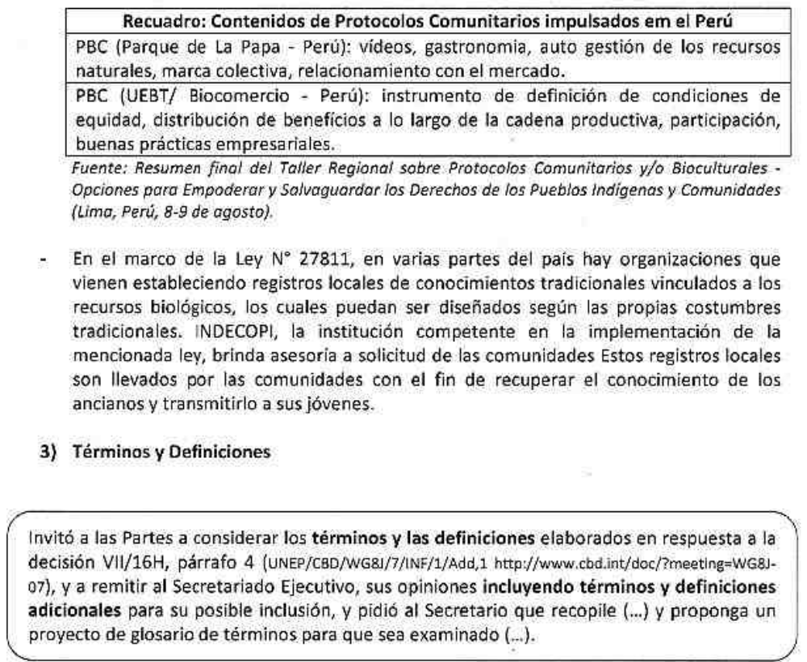
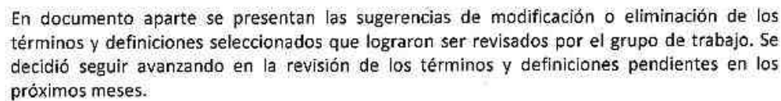

Reunión de Trabajo Multisectorial para la revisión de términos y definiciones
(Decisión XI/14/E, Sistema Sui Generis para la protección, preservación y promoción del conocimiento tradicional, prácticas e innovaciones)

Por encargo del Grupo de Trabajo de Recursos Genéticos y Conocimientos Tradicionales (GTRRGGCT) de la Comisión Nacional de Diversidad Biológica (CONADIB), el Ministerio de Cultura (MINCU) convocó a una reunión de trabajo multisectorial, con participación de representantes de organizaciones de comunidades indígenas y locales, para revisar y analizar los términos y definiciones elaborados en respuesta a la decisión VII/16H, párrafo 4 (UNEP/CBD/WG8J/7/INF/1/Add,1 http://www.cbd.int/doc/?meeting=WG8J-07).

Dicho reunión se llevó a cabo el día 19 de marzo de 2013, a la cual asistieron 6 representantes de cinco instituciones del Estado: Ministerio de Cultura – MINCU (2), Ministerio de Agricultura - MINAG (1), Ministerio del Ambiente – MINAM (1), Ministerio de Turismo – MINCETUR (1) y Comisión Nacional contra la Biopiratería - CNBio (1); así como un representante de la Confederación de Nacionalidades Amazónicas del Perú - CONAP y un representante de la ONG Sociedad Peruana de Derecho Ambiental – SPDA.

Del total de 16 términos y definiciones contenidos en el Anexo: “Conjunto de definiciones pertinentes/glosario de términos para el Artículo 8 j) y disposiciones conexas” de la Nota del Secretario Ejecutivo: “Elementos de sistemas sui generis para la protección de los conocimientos, innovaciones y prácticas tradicionales” (UNEP/CBD/WG8J/7/3, 5 de julio de 2011), preparada para la séptima reunión del Grupo de Trabajo del 8j (Montreal, 31 de octubre a 4 de noviembre de 2011), se seleccionaron y analizaron 8 de ellos.

Finalmente, el documento elaborado conteniendo el conjunto de términos revisados fue debatido y aprobado en una reunión del GTRRGGCT de la CONADIB, el día 26 de marzo de 2012, en la cual participaron 5 representantes de la Dirección General de Diversidad Biológica del MINAM (entre ellos, el Director General y la Coordinadora del área de Recursos Genéticos y Bioseguridad), 8 representantes de sectores del Estado: PRODUCE (2), MINCU (1), MINCETUR (1), INDECOPI (1), CNBio (1) y MINAG (2), y un representante de SPDA.

A continuación se presentan los comentarios y pedidos de aclaración (en rosado y celeste), así como las sugerencias de cambios (textos resaltados en gris) que fueron acordados.

CONJUNTO DE DEFINICIONES PERTINENTES / GLOSARIO DE TÉRMINOS PARA EL ARTÍCULO 8 J) Y DISPOSICIONES CONEXAS

Los siguientes proyectos de definiciones han sido cotejados con diversas fuentes, entre las que se incluyen: el Foro Permanente para las Cuestiones indígenas, OMPI, el Instituto Internacional para el Medio Ambiente y el Desarrollo, La Asociación Quechua-Aymara para la Conservación de la Naturaleza y el Desarrollo Sostenible (ANDES, PERÚ), Fundación Dobbo Yala (Panamá, Universidad de Panamá, Ecoserve (India); Centro para los Sistemas Agrícolas Indígenas (India), Centro de Investigación sobre Hierbas y Folclore (India), Centro de Política Agrícola China (CCAP, China), Instituto Meridional de Investigación de Políticas Ambientales y Agrícolas (ICIPE, Kenya), el Marco Regional de los Países Insulares del Pacífico para la Protección de los Conocimientos Tradicionales y Expresiones de Cultura, El Instituto de Investigaciones Forestales de Kenya y la legislación modelo africana para la protección de los derechos de las comunidades, agricultores y criadores y para la reglamentación del acceso a los recursos biológicos.

- Aplicación / uso / utilización de los conocimientos tradicionales: Actos de creación, el uso, la oferta para la venta, la venta o la importación con estos fines del producto tradicional protegido o, cuando la materia protegida sea un proceso, actos relacionados con el uso de los procesos así como actos de uso, oferta de venta, venta o importación con estos fines de por lo menos el producto obtenido directamente por medio del proceso tradicional.

- Prospección biológica: La investigación científica de los recursos biológicos para fines comerciales u otros fines. La prospección biológica también puede incluir investigación de los conocimientos tradicionales relacionados con los recursos biológicos.

- Herencia Biocultural: Los conocimientos, las innovaciones y prácticas de las comunidades indígenas y locales que a menudo se poseen colectivamente y están inextricablemente vinculados con los recursos tradicionales y las tierras y aguas tradicionalmente ocupadas y utilizadas por comunidades indígenas y locales, incluyendo la diversidad de genes, variedades, especies y ecosistemas; valores culturales y espirituales; y el derecho consuetudinario enmarcado en el contexto socio-ecológico de las comunidades. Al enfatizar los derechos colectivos sobre los individuales, y al abordar la diversidad biológica y la cultura en conjunto, este concepto refleja el enfoque holístico de muchas comunidades indígenas y locales. Este concepto también está vinculado al conocimiento como "patrimonio" en lugar de "propiedad", reflejando así su custodia y carácter intergeneracional.

- Expresiones Culturales Tradicionales (tangible e intangible). La manifestación física y/o inmaterial del patrimonio cultural de las comunidades indígenas y locales incluye, pero no está limitado a paisajes culturales, sitios, estructuras y restos de valor o significado arqueológico, arquitectónico, histórico, religioso, espiritual, cultural, ecológico o estético, restos humanos, narrativas orales, tales como mitos, toponimia, cuentos, apodos, chistes y expresiones artísticas tales como canciones, danzas, almacenes, historias y conocimientos gastronómicos.

- Utilización consuetudinaria de la diversidad biológica: Utilización en relación con las tradiciones locales y las normas consuetudinarias, permitiendo al mismo tiempo la innovación.

- Consentimiento fundamentado previo: El procedimiento por medio del cual los gobiernos nacionales o las comunidades indígenas y locales, de acuerdo a la legislación nacional, adecuadamente provistas de toda la información requerida, permiten o rechazan el acceso a sus recursos biológicos, los recursos genéticos contenidos en ellos, sus derivados, y conocimientos, innovaciones y prácticas tradicionales asociados. Dicho consentimiento será otorgado conforme a condiciones mutuamente convenidas de igualdad, respeto y compensación justa.

- Propietario tradicional: El grupo, clan o comunidad o pueblo o una persona que un grupo, clan o comunidad de personas reconocen como el individuo en cuya custodia o protección se depositan las expresiones de la cultura de conformidad con las normas y prácticas consuetudinarias de dicho grupo, clan o comunidad.

- Territorios tradicionales: Área que incluye tierras, aguas y espacios aéreos tradicionalmente ocupados, utilizados o a las que hayan tenido tradicionalmente acceso las comunidades indígenas y locales para sus actividades ancestrales y de subsistencia.

B. Submissions from relevant organizations
Red Indígena de Turismo de México A.C; Consejo Regional Otomí del Alto Lerma de México; Red de Mujeres Indígenas y Biodiversidad de Guatemala; Asociación IXACAVAA de Desarrollo e Información Indígena de Costa Rica; INBRAPI de Brasil; Plataforma Dominicana de Afrodescendientes y EcoHaina de Republica Dominicana.

.- XI/14/E, Sistema Sui Generis para la protección de conocimientos, innovaciones y prácticas tradicionales.

El Ministerio de Medio Ambiente de Brasil ha elaborado un anteproyecto de ley para presentarlo a consideración de la Casa Civil de la Presidencia de la Republica y posteriormente al Congreso Nacional con el objetivo de sustituir a la Medida Provisional 2.186 de 2001, pero no lo ha hecho en consulta con los Pueblos Indígenas y Comunidades Locales de Brasil. Solamente han participado de la elaboración del anteproyecto personas de la sociedad civil que hacen parte de Consejos del Gobierno, lo que no caracteriza la consulta y no representa la diversidad cultural de los Pueblos Indígenas y de las Comunidades Locales de Brasil. Esperase que el derecho a la consulta, garantizado por el Convenio 169 de la OIT sea puesto en práctica por medio de consultas presenciales, asegurada la diversidad de biomas, de lenguas y la diversidad de pueblos indígenas y comunidades locales y esperase que la amplia aprobación y participación de los pueblos indígenas y de las comunidades locales sea aseguradas y respetadas en los procesos de creación de medidas para proteger los conocimientos, innovaciones y prácticas tradicionales de los Pueblos Indígenas y de las Comunidades Locales en los niveles nacionales de las Partes, en conformidad con el Protocolo de Nagoya.
The submission is by the following peoples’ organisations, NGOs and networks (in alphabetical order): Alliance for Democratising Agricultural Research in South Asia, Alliance for Food Sovereignty in South Asia, Community Media Trust (India), Deccan Development Society (India), ICCA Consortium (Switzerland/International), League for Pastoral Peoples and Endogenous Livestock Development (Germany/ International), MELCA-Ethiopia (Ethiopia), Millet Network of India (India), Natural Justice: Lawyers for Communities and the Environment (South Africa/International), Sahjeevan (India), Southern Action on Genetic Engineering (South India)

XI/14/E: Sui Generis Systems for the protection, preservation and promotion of traditional knowledge, innovations and practices

Reporting on Experiences with Sui Generis Systems and Community Protocols

- There is a significant body of literature and resources on community protocols, including a dedicated website and a toolkit for community facilitators, edited volumes of community experiences, workshop reports from regional meetings, articles and books, and films and photo stories.

- The following experiences illustrate different elements of the process of documenting, developing and using a community protocol in a wide range of contexts. Interwoven in each experience is the intention to increase respect for and protection and maintenance of customary laws, traditional knowledge, innovations and practices, and customary uses of biodiversity and natural resources.

- Strengthening customary institutions and community organisations in Ghana: Since 2003, the Tanchara and Daffiama communities in northern Ghana have worked with the Centre for Indigenous Knowledge and Organizational Development (CIKOD) to develop a series of community organizational development tools, including institutional and resource mapping, visioning and action planning, organizational and well-being self-assessments, and institutional strengthening, to increase their capacity to ‘develop from within’. The tools have enabled customary leaders and community organisations to respond in culturally appropriate ways to an illegal gold mine and other threats to their territories, sacred groves, and important natural resources.

- Community mapping and documentation of customary ways of life in Malaysia: Nine villages have relied on the Ulu Papar valley in Sabah, Malaysia, for generations for their identity, culture, food, shelter, and medicine. In order to establish a Community Use Zone within a state park that overlaps with their customary lands, they undertook 8 years of participatory action research, including creating 3-D models, conducting livelihood assessments, recording oral histories, and producing videos and photo exhibitions. This process provided the foundations for consolidating a community protocol and engaging with government agencies to secure their customary rights and livelihoods.

- Mobilising diverse communities in response to a common threat in Kenya: When the Government of Kenya announced plans for a multi-billion dollar mega-infrastructure project in Lamu (the Lamu Port-South Sudan-Ethiopia Transport Corridor), indigenous peoples, local fishing communities, religious leaders, concerned residents, and civil society organisations joined together in solidarity. They embarked on a process of meetings, consultations, and visioning sessions before deciding not to oppose the project outright, but to call for their existing rights under international, regional and national law to be upheld in practice. Their emphasis on procedural issues such as rights to information, to participation in decisions that affect them, and to unbiased impact assessments illustrates the growing critical mass of civil society in Kenya.

- Legal empowerment of small-scale organic farmers in India: Small and marginal farmers cultivate dozens of indigenous varieties of rice in the coastal districts of Tamil Nadu, India. However, the introduction of mono-crops and high yielding varieties threaten to erode the agro-biodiversity and traditional knowledge systems that sustain it. With the support of the Centre for Indian Knowledge Systems, organic farmers’ associations have been engaging in a process of legal empowerment around relevant international laws such as the Convention on Biological Diversity and national laws such as the 2002 Biological Diversity Act, the 2001 Protection of Plant Varieties and Farmers' Rights Act, and the 2011 Food Security Bill. They have also learned about procedural rights such as the right to information, legal aid, and consumer protection for farmers.

- Advocating for livestock keepers’ rights in India: Raika and Maldhari pastoralists in Rajasthan and Gujarat (respectively) are claiming rights to customary grazing lands under India’s 2006 Forest Rights Act. Both communities developed protocols as tools to convey the importance of their breeds and ways of life to biodiversity conservation and to advocate for recognition of livestock keepers’ rights. With the support of local organisations Lokhit Pashu-Palak Sansthan and Sahjeevan as well as the League for Pastoral Peoples and Endogenous Livestock Development, the Raika and Maldhari are engaging with state government officials, national committees, and international fora to promote fair agricultural and biodiversity policies for the in situ conservation of local livestock breeds and livelihoods.

- Engaging with responsible companies to support local livelihoods in South Africa: Traditional health practitioners from two different ethnic groups in Bushbuckridge, South Africa (in the Kruger to Canyons Biosphere Region), established an Association in 2009. They developed a community protocol to address unauthorised use of traditional knowledge and overharvesting of medicinal plants by outsiders as well as lack of access to plants now confined within a state protected area. Empowered by new rights under South Africa’s 2004 Biodiversity Act and Bioprospecting, Access and Benefit Sharing Regulations and with the support of the Kruger to Canyons Biosphere Committee, the health practitioners used their community protocol to engage proactively with a local cosmetic company interested in their traditional knowledge and to establish a medicinal plants nursery.

- Many other indigenous peoples and local communities around the world have developed or are developing and using community protocols to articulate their stewardship, assert their rights, and affirm responsibilities towards their territories and ways of life, including in Peru, Colombia, Panama, Honduras, Kenya, Sri Lanka, and Pakistan. Other protocols from indigenous peoples in Canada, the USA, Australia, and New Zealand in particular have been developed specifically in response to research interests. A non-exhaustive compilation of these protocols and experiences is available at www.community-protocols.org/community-protocols.

Terms and Definitions

- In response to Decision XI/14/E, paragraph 10, regarding terms and definitions related to the sui generis agenda item, we would like to propose the additional term of “community protocols” and the explanations below for inclusion in the draft glossary of terms.

- Community protocols are increasingly referenced in international law and policy. For example, they are included in several CBD decisions (including Decisions XI/1, XI/5 and XI/14) and in the Nagoya Protocol on Access and Benefit Sharing (Articles 12(1), 12(3)(a) and 21(i)). They are referenced in Information Document 5 (“Consideration of initial elements: recognizing indigenous and local knowledge and building synergies with science”) of the first plenary of IPBES as a means to provide a framework for external stakeholders when engaging with indigenous peoples and local communities. They are also listed in the annex on tools and resources in the UN-REDD Programme Guidelines on Free, Prior and Informed Consent.

- As indicated in paragraphs 1-9 above, there is a great deal of experience, lessons learned, and literature concerning the documentation, development and use of community protocols in a wide range of contexts.

- Community protocols use participatory methods to articulate indigenous peoples’ and community-determined values, procedures, and priorities, and set out rights and responsibilities under customary, state, and international law as the basis for engaging with external actors such as governments, companies, academics, and NGOs. They can be used as catalysts for constructive and proactive responses to threats and opportunities posed by land and resource development, conservation, research, and other legal and policy frameworks.

- Every process of developing and using a community protocol is as unique and diverse as the communities who undertake them. Whilst there is no template or way to “do” a community protocol, there are lessons learned and guidance on good practices and core principles, particularly concerning facilitation of the process according to the community’s objectives, priorities, timelines, and approaches. There are also several locally adaptable methods and tools that can assist with different aspects of a community protocol process, including self-determination, endogenous development, documentation and communication, social mobilisation, legal empowerment, strategic advocacy, and reflective monitoring and evaluation. A dedicated toolkit provides initial guidance on protocol processes.

- The process of documenting, developing and using a community protocol should be endogenous, inclusive, empowering, and based primarily on the community’s own resources and diversity of knowledge, skills, and experiences. It should promote intra- and inter-community dialogue and intergenerational sharing and learning-by-doing. It should increase the community’s agency and capacity to ensure that engagements with external actors take place with honesty, transparency, respect, social and cultural sensitivity, and integrity.

- Overall, community protocols enable indigenous peoples and local communities to bridge the gap between their self-determined customary stewardship and the external regulation and management of their territories and ways of life. They can also be used to help minimize the power asymmetries that often characterise government-community relations and promote a more participatory and endogenous approach to the future governance of peoples’ and communities’ territories, natural resources, and biodiversity.

- Consultations with other indigenous peoples and local communities and their supporting organisations who have been involved in the development and use of community protocols should be undertaken before a ‘definition’ is decided in the context of the CBD to ensure any such definition is appropriately flexible and adaptable.

Inuit Circumpolar Canada

Sui Generis Systems for the Protection, preservation and promotion of traditional knowledge, innovations and practices
One consideration is to examine sui generis systems of protection under existing legislative frameworks. For example the self-government arrangement within Nunavut provides Inuit with the ability to develop their own policies and laws and legislation which provides them more management over environmental matters and which brings their own identity into the institutional processes. The Nunavut Government has developed a Qaujimajatuqangit (IQ) policy. It is a form of knowledge for understanding and explaining Nunavut. IQ embodies Inuit traditional knowledge and values and guides the government in framing decisions, policies and laws that reflect the key philosophies attitudes and practices of Nunavut majority. It goes further than contextualizing traditional knowledge of Inuit. For example the principle of Pijitsirniq means that a person with the power to make major decisions must exercise that power to serve the people to whom he or she is responsible. The principle of Avatatimik Kamattiarniq calls for nature to be treated holistically and with respect, as wildlife and habitat are interconnected and all actions have consequences for good or ill. The principle of Papattiniq is about guardianship and stewardship: wildlife belongs to nature and is not a commodity. This allows for new laws and legislation and policies to be created that reflects the social values and culture and Inuit concepts to be integrated. These new laws and policies allow for Inuit to have an expanded role in the sustainable use of Arctic biodiversity. This is an example of how the wider application of traditional knowledge is placed in the sub regional context.
-------

* UNEP/CBD/WG8J/8/1.
Shrumm, H., and H. Jonas, 2012a. Biocultural Community Protocols: A toolkit for community facilitators. Natural Justice: Cape Town. Available online in English and Spanish at: www.community-protocols.org/toolkit.
Swiderska, K., H. Shrumm, W. Hiemstra, M. Julia Oliva, K. Kohli, and H. Jonas (editors), 2012. Biodiversity and Culture: Exploring community protocols, rights and consent. IIED: London. Available in English and Spanish at: http://pubs.iied.org/14618IIED.html.
Available at: http://www.community-protocols.org/toolkit/additional-resources/publications/reports.
Available at: http://www.community-protocols.org/toolkit/additional-resources/publications/articles and http://www.community-protocols.org/toolkit/additional-resources/publications/books-booklets.
Available at: http://www.community-protocols.org/toolkit/additional-resources/films-slideshows.
Guri Yangmaadome, B., D. Banuoko Faabelangne, E. Kanchebe Derbile, W. Hiemstra, and B. Verschuuren, 2012. "Sacred Groves Versus Gold Mines: Biocultural community protocols in Ghana", pages 121-130 in Biodiversity and Culture: Exploring community protocols, rights and consent, Swiderska et al. (eds.). Available online at: http://pubs.iied.org/G03405.html.
John, T., P. John, L. Bugiad, and A. Lee Agama, 2012. "Creating the Ulu Papar Biocultural Community Protocol: Process and product in the framing of a community agreement", pages 141-150 in Biodiversity and Culture: Exploring community protocols, rights and consent, Swiderska et al. (eds.). Available online at: http://pubs.iied.org/G03407.html.
For more information, please see: www.savelamu.org.
For more information, please see: www.ciks.org.
Köhler-Rollefson, I., A. Raziq Kakar, E. Mathias, H. Singh Rathore, and J. Wanyama, 2012. “Biocultural Community Protocols: Tools for securing the assets of livestock keepers”, pages 109-121 in Biodiversity and Culture: Exploring community protocols, rights and consent, Swiderska et al. (eds.). Available online at: http://pubs.iied.org/G03404.html; please also view a photo story about the biocultural community protocol of the Maldharis of Banni: www.tinyurl.com/ccj8d2v.
Sibuye, R., M. Uys, G. Cocchiaro, and J. Lorenzen, 2012. "The Bushbuckridge BCP: Traditional health practitioners organise for ABS in South Africa", pages 101-108 in Biodiversity and Culture: Exploring community protocols, rights and consent, Swiderska et al. (eds.). Available online at: http://pubs.iied.org/G03403.html.
IPBES/1/INF/5. Available online at: http://www.ipbes.net/component/docman/doc_download/1481-ipbes-1-inf-5.html?Itemid=58.
UN-REDD Programme, 2013. Guidelines on Free, Prior and Informed Consent. FAO, UNDP and UNEP. Available online at: http://www.unredd.net/index.php?option=com_docman&task=doc_download&gid=8717&Itemid=53.
Shrumm and Jonas, 2012a.
Shrumm, H., and H. Jonas, 2012b. “Understanding and Facilitating a Biocultural Community Protocol Process”, pages 179-183 in Biodiversity and Culture: Exploring community protocols, rights and consent, Swiderska et al. (eds.). Available online at: http://pubs.iied.org/G03411.html.

