 | 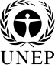 | CBD
 |  |  |  | Distr.  GENERAL  CBD/WG8J/10/INF/5  15 September 2017  ORIGINAL: ENGLISH/SPANISH
AD HOC OPEN-ENDED INTER-SESSIONAL WORKING GROUP ON ARTICLE 8(j) AND RELATED PROVISIONS OF THE CONVENTION ON BIOLOGICAL DIVERSITY

Tenth meeting
Item 9 of the provisional agenda*
Montreal, Canada, 13-16 December 2017

COMPILATION OF VIEWS ON the In-depth Dialogue on Thematic Areas and other Cross-Cutting Issues
Note by the Executive Secretary

INTRODUCTION
- As requested by the Conference of the Parties in paragraph 16 of decision XIII/19 A, the Executive Secretary is circulating herewith, for the information of participants in the tenth meeting of the Ad Hoc Open-ended Inter-sessional Working Group on Article 8(j) and Related Provisions, a compilation of views and comments submitted to the Secretariat regarding the in-depth dialogue on thematic areas and other cross-cutting issues on:
“Contribution of the traditional knowledge, innovations and practices of indigenous peoples and local communities to the implementation of the 2030 Agenda for Sustainable Development with particular emphasis on conservation and sustainable use of biodiversity”.
- Submissions were received from: Australia; Bosnia and Herzegovina; Brazil; Canada; European Union and its member States together with national contributions from Denmark (including Greenland), Finland and Sweden; Oman; Venezuela; Assembly of First Nations (AFN); Coordinadora de Organizaciones Indigenas de la Cuenca Amazonica; Great Barrier Reef Marine Park Authority of Australia; Global Forest Coalition/Community Conservation Resilience Initiative; ICCA Consortium; Red de Mujeres Indigenas sobre Biodiversidad de America Latina y el Caribe; Red de Cooperacion Amazonica and Stockholm Resilience Centre. Submissions have been reproduced in the form and languages in which they were provided to the Secretariat.
Content
A. Submission from Parties 3
Australia 3
Bosnia and Herzegovina 3
Brazil 4
Canada 5
European Union and its member States together with national contributions 5
Denmark (including Greenland) 6
Finland 6
Sweden 7
Oman 7
Venezuela 8
B. Submission from relevant organizations 8
Assembly of First Nations (AFN) 8
Coordinadora de Organizaciones Indigenas de la Cuenca Amazonica 8
Great Barrier Reef Marine Park Authority of Australia 8
Global Forest Coalition/Community Conservation Resilience Initiative 9
ICCA Consortium 11
Natural Resource Sterwarship Circle 13
Red de Mujeres Indigenas sobre Biodiversidad de America Latina y el Caribe 15
Red de Cooperacion Amazonica 16
Stockholm Resilience Centre 17

SUBMISSIONS

Submission from Parties

Australia
SUBMISSION
In terms of potential contribution to the 2030 Agenda for Sustainable Development, it is recognised that indigenous environmental management is very different from the typical Western model of optimisation and is more aligned with sustainable and adaptive management practices that look at the larger socio-ecological system. The Indigenous Weather Knowledge site reflects this, by having seasons align with changes in the environment, changing social practices and changing weather patterns.

The Bureau of Meteorology hosts the Indigenous Weather Knowledge website (http://www.bom.gov.au/iwk). The website is a formal recognition of traditional weather and climate knowledge that has been developed and passed down through countless generations by Aboriginal and Torres Strait Islander people. Through the Indigenous Weather Knowledge website, the Government of Australia, through the Bureau, is working with communities that wish to record and share valuable seasonal and environmental information and traditional knowledge.

Australia's climate and ecological zones are highly diverse and cannot be easily mapped to a rigid European-based seasonal calendar for the entire continent. The meteorological perspective of Aboriginal and Torres Strait Islander people is one of great diversity, where the names of the seasons are often dependent on localised events or resources. The ability to link events in the natural world to a cycle that predicts seasonal changes is a key factor in the successful development of Indigenous communities. These natural barometers are not uniform across the land but instead use the reaction of plants and animals to gauge what is happening in the environment.

Currently, the Indigenous Weather Knowledge site hosts information from 12 indigenous country/language areas (Tiwi, Maung, Jawoyn, Wardaman, Yanyuwa, Miriwoong, Yawuru, Walabunnba, Nyoongar, Banbai, D'harawal and Gariwerd).

Bosnia and Herzegovina
SUBMISSION
Over a long period of time, scientists are investigating a relevant knowledge regarding the biodiversity of Bosnia and Herzegovina. Among other things, certain research required the assessment of the condition and usage of traditional knowledge regarding biodiversity. The gathering of such knowledge further resulted in the preparation of scientific and expert theses, such as:
- Redžić, S. (2006): Wild edible plants and their traditional use in the human nutrition in Bosnia and Herzegovina. Ecology of Food and Food Nutrition, 45 (3): 189-232. [Indexed & Abstracted in: Science Citation Index, Science Citation Index Expanded, Current Contents - Agriculture, Biology & Environmental Sciences].
- Redžić, S. (2006): Wild edible plants and their traditional use in the human nutrition in Bosnia and Herzegovina. Ecology of Food and Food Nutrition, 45 (3): 189-232.
- Redžić, S. (2007): The Ecological Aspect of Ethnobotany and Ethnopharmacology of Population in Bosnia and Herzegovina, Coll. Antropol. 31, 3: 869-890.
- Redžić, S. (2010): Wild Medicinal Plants and Their Usage in traditional Human Therapy (Southern Bosnia and Herzegovina, W. Balkan). Journal of Medicinal Plants Research Vol. 4(11), pp. 1003-1027.
- Redžić, S., Barudanović, S., Bašić, H. (2009): Models of sustainable use of wild medical plants in W. Balkan (SE Europe). Afr. J. Trad. CAM 6 (4) Suppl.: 347-348.
- Redžić, S., Barudanović, S., Trakić, S. (2009): Comparative botanical-pharmaceutical and pharmaconosy researches of species of order Potentilla L. (P. anserinaL., P. Reptans L. and P. Palustris L.) from Bosnia and Herzegovina (Western Balkan). Planta Medica, 75: 1079-1079.
- Redžić, S., Bašić, H., Barudanović, S. (2009): Models of organic certification in herbal sector of transitional countries of Western Balkan (SE Europe). Afr. J. Trad. CAM 6 (4) Suppl.: 429-430.
- Redžić, S., Grujić-Vasić, Barudanović, S., Đug, S., Kapetanović, T., Velić, S. (2001): Ethnobotanical experiances during the war in Bosnia and Herzegovina. Proceedings of Third International Congress of Ethnobotany, Naples, 23-25.
- Šarić-Kundalić, B., Dobeš, C., Klatte-Asselmeyer V., Saukel, J. (2010): Ethnobotanical study on medicinal use of wild and cultivated plants in middle, south and west Bosnia and Herzegovina. Journal of Ethnopharmacology 131: 33-55.
The peoples of Bosnia and Herzegovina lived in harmony with its’ natural surroundings for centuries, using and guarding the native species of plants and animals, while also developing local varieties and breeds. Today, in many aspects of rural life one can recognize this relationship in so-called “traditional knowledge”. Such knowledge and skills are derived from human need for a healthy life and different suitable resources. Especially important is a traditional knowledge on the use of medicinal and edible plants, what also is recognized as a part of provisioning and cultural ecosystem services. From the other hand, this as a part of cultural heritage of our country, was rapidly lost in the post-war period due to dislocations and migrations. After the aggression on B&H, the depopulation of rural areas lead to a rapid loss of traditional knowledge, associated to market loss in terms of the profit their use could bring. Simultaneously, different pressures and forms of unsustainable use (such as overcutting trees, unsustainable hunting and the construction of a large number of hydropower facilities) are being introduced into practice, all leading to the loss of traditionally used biodiversity.
Leading cause for losing traditional knowledge is the lack of mechanism to incorporate traditional knowledge and practice in the decision making process on planning for sustainable development. On the other hand there are also no documents or strategies that will ensure conservation and promotion of ecosystem services on the basis of traditional knowledge.
For the purpose of disseminating knowledge about connections between sustainable development and conservation of the traditional knowledge, one research titled “Evaluating the state of the ecosystem services and traditional knowledge on biodiversity in the Federation of Bosnia and Herzegovina” has been carrying out.
The general goal of research is the recognition, storing and reintroduction of traditional knowledge and practice in use of Bosnia-Herzegovina's biodiversity as one of means to reach sustainable development. The research is a part of the doctoral thesis which should contribute to the sustainable return of population into the rural areas. The research would prepare a basis for a better representation, understanding and use of this knowledge type, which is gathered in Bosnia and Herzegovina over the centuries.

Brazil
SUBMISSION
Views and information on Contribution of the traditional knowledge, innovations and practices of indigenous peoples and local communities to the implementation of the 2030 Agenda for Sustainable Development with particular emphasis on conservation and sustainable use of biodiversity
The Brazilian National Policy on Territorial and Environmental Management of Indigenous Lands (PNGATI), established by the National Decree n° 7.747/2012, promotes the social inclusion of indigenous people and the participation of their organizations on the construction of public policies. This policy works by the construction of actions plans by Indigenous organizations and Brazilian Government for each 4 years. The last plan refers to the period from 2016 to 2019.
Indigenous people and traditional people are members on Brazilian CBD related councils, such as The National Biodiversity Commission (CONABIO) and The Genetic Heritage Management Council (CGen).

Canada
SUBMISSION
With more than 1.2 billion international travelers in 2016, tourism can be an important tool for the implementation of the 2030 Agenda for Sustainable Development. Tourism creates employment, promotes environmental protection and creates synergies between nations.
Indigenous tourism provides opportunities to share with travelers traditional lifestyles relevant for the conservation and sustainable use of biological diversity. It can help raise awareness of activities that respect ecosystems and share knowledge and practices that contribute to the sustainability of our natural resources.
There is consumer demand for indigenous tourism experiences that are authentic, unique, enriching and engaging. Such indigenous tourism experiences can provide a source of economic development and cultural pride in indigenous communities. They can help revitalize indigenous culture and traditions, give youth pride and opportunities, and benefit communities as well as travelers.
Regarding the 2030 Agenda for Sustainable Development, Goal # 14 “Conserve and sustainably use the oceans, seas and marine resources for sustainable development”: Fisheries and Wildlife co-management boards and committees established pursuant to Modern Treaties between Indigenous Groups and the Crown, often contain constitutionally protected responsibilities that entrench traditional knowledge in collaborative decision making and conservation planning.
Two examples include:
1) Labrador Inuit Land Claims Agreement, section 13.6.6:
The Inuit Domestic Harvest Level is an estimate of the quantity of a species or stock of Fish or Aquatic Plant in the Labrador Inuit Settlement Area needed annually by Inuit for their food, social and ceremonial purposes that is based on all relevant available information, including: any data that may be compiled on an ongoing basis by the Nunatsiavut Government using Inuit traditional knowledge;
2) Eeyou Marine Region (EMR) Land Claims Agreement, section 10.2:
The objective of Part III is to create a Wildlife management system for the EMR that: recognizes the value of Cree approaches to Wildlife management and Cree knowledge of Wildlife and Wildlife habitat and integrates those approaches with knowledge gained through scientific research.

European Union and its member States together with national contributions
SUBMISSION
In decision XIII/19 A, the Conference of the Parties decided that the topic for the in-depth dialogue at the tenth meeting of the Working Group on Article 8(j) and Related Provisions, should be: “Contribution of the traditional knowledge, innovations and practices of indigenous peoples and local communities to the implementation of the 2030 Agenda for Sustainable Development with particular emphasis on conservation and sustainable use of biodiversity”.
We fully support adopted topic of the in-depth dialogue, we need to ensure full and effective participation of the indigenous peoples and local communities in the implementation of the 2030 Agenda for Sustainable Development as IPLCs are the guardians of most of the world´s biological diversity. Further it is important, in line with decision XIII/1 regarding gap analysis, on the relationship between the Aichi Biodiversity Targets and the Sustainable Development Goals (SDGs), to include an analysis of Aichi Target 18 and advancements under 8j and 10c in relation to SDGs.
We also affirm the contribution of indigenous peoples in addressing problems such as social exclusion and poverty, loss of biological and cultural biodiversity, and climate change. Traditional knowledge systems and practices, and the holders of such knowledge, carry important insights that relate to all the Sustainable Development Goals.

Denmark (including Greenland)
“Please find experiences with the use of local and traditional knowledge under the PISUNA (Piniakkanik sumiiffinni nalunaarsuineq) project in Greenland.
"In Greenland, a central effort to contribute to the CBD Programme of Work on Article 8(j) is PISUNA and its searchable web-server database PISUNA-net. PISUNA is a community-based observing programme aimed to improve the management of resources in Greenland by establishing a process for indigenous knowledge and environmental observations to be integrated into decision-making for natural resources. The process is locally-led; Local Resource Councils, established at the community level and comprising hunters, fishers and other individuals with an interest in the environment, decide what will be observed based on the relevance for their community. Observations by the PISUNA communities primarily focus on terrestrial and marine mammals, fish, and birds, but also include abiotic factors such as sea ice cover. Every three months the observations and interpretations of each attribute are collated and discussed by the Local Resource Council, including the trend of a particular resource compared to the previous year (e.g. increasing, no change, decreasing) and the recommended management actions on the basis of the observations. Suggested management actions have included changes to hunting and fishing seasons for certain species, changes to quotas and amendments to local laws and bylaws such as imposing restrictions on fishing methods and allowable equipment. This information is submitted to the local authority to take action or to pass on to the central government, depending on the appropriate decision-making level. The observations made by the local communities are stored in a web-based application - PISUNA-net where they are publicly available and can be searched.

Finland
Finland is pleased to contribute to Notification No. 2017-006 Item 6, and provide the view on the topic of the in-depth dialogue.
In the decision XIII/19 A, the Conference of the Parties decided that the topic for the in-depth dialogue at the tenth meeting of the Working Group on Article 8(j) and Related Provisions, should
be: “Contribution of the traditional knowledge, innovations and practices of indigenous peoples and local communities to the implementation of the 2030 Agenda for Sustainable Development with particu-lar emphasis on conservation and sustainable use of biodiversity”.
Finland fully support adopted topic of the in-depth dialogue, we need to ensure full and effective participation of the indigenous peoples and local communities in the implementation of the 2030 Agenda for Sustainable Development as they are the guardians of the most of the world´s biological diversity.
We encourage all Parties to develop concrete actions that will ensure the implementation of indigenous peoples´ rights in the framework of the SDGs. We also affirm the contribution of indigenous peoples to addressing problems such as social exclusion and poverty, loss of biological and cultural biodiversity, and climate change. Finland will chair the Artic Council from May 2017 to 2019 and the participation of in-digamous peoples is crucial in addressing artic matters and biological diversity.
Traditional knowledge systems and practices, and the holders of such knowledge, carry important in-sights and knowledge that relates also to SDGs in terms of scope and content including gender issues.
Engagement of IPLCs and Sami people in the Agenda 2030 is vital for these knowledge systems and en-gagement and their contribution is vital for instance in the development of the SDG indicators.

Sweden
“Indigenous peoples and local communities live in, manage and own vast areas of land often rich in biodiversity and of significance for the generation of critical ecosystem services.
Traditional knowledge systems and practices, and the holders of such knowledge, carry important insights that relates to all the Sustainable Development Goals, in terms of scope and content, and also in ways of knowing and governing social-ecological systems during turbulent times, and articulating alternative ways forward. Engagement of IPLCs in the Agenda 2030 is vital for these knowledge contributions.
The report “The Agenda 2030 and Ecosystems” presents the main links of visibility between Aichi Targets and the SDGs, and shows that the use of traditional knowledge and practices for broader conservation and sustainable use objectives is mostly not considered, which calls for a thoroughly and systematic articulation of these links.” Further it is important to in line with decision XIII/1 regarding gap analysis, on the relationship between the Aichi Biodiversity Targets and the Sustainable Development Goals, include an analysis of Aichi Target 18 and advancements under 8j and 10c in relation to SDGs.

Oman
SUBMISSION
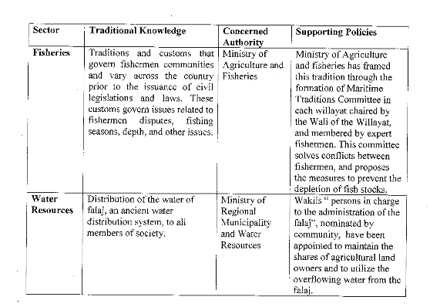

Venezuela
SUBMISSION
La DGDB actualmente ejecuta programas y proyectos de conservación de especies amenazadas (tortugas marinas, tortugas de agua dulce, caimán del Orinoco, caimán de la Costa), donde participan activamente comunidades locales y pueblos indígenas; para los cuales se proporciona el correspondiente acompañamiento técnico, legal y financiero. Esto facilita el cumplimiento del Objetivo de Desarrollo Sostenible N°15 el cual prevé en sus metas: “adoptar medidas urgentes y significativas para reducir la degradación de los hábitats naturales, detener la pérdida de la diversidad biológica y, para 2020, proteger las especies amenazadas y evitar su extinción”

Submission from relevant organizations

Assembla of First Nations (AFN)
SUBMISSION
First Nations are increasingly involved in making decisions related to land (egg, through co-management arrangements with other governments and organizations). These practices contribute to the involvement of First Nations peoples and their Traditional Knowledge in decision-making processes, which are viewed as key aspects for the conservation and sustainable use of biodiversity. This trend must be supported and expanded as Indigenous knowledge systems are validated and supported in parallel with Western knowledge systems.

Coordinadora de Organizaciones Indigenas de la Cuenca Amazonica
SUBMISSION
La contribución de los conocimientos, innovaciones y prácticas tradicionales, y sus aportes a la conservación y uso sostenible de la biodiversidad, desde los pueblos indígenas depende de un factor esencial, que tienen que ver con la estrecha relación con sus tierras y territorios, para el cual y conforme a uno de los indicadores de los ODS, el de “tierras aseguradas”, será el elemento clave para que los pueblos indígenas continúen con esa relación armónica con sus territorios y la biodiversidad.
Por tanto, tocar en el diálogo a fondo, cómo están los Estados asegurando los derechos territoriales de los pueblos indígenas en el marco de los ODS, será muy importante, para que de ella salgan recomendaciones para que se conserve y se fortalezca los conocimientos, innovaciones y prácticas tradicionales de los pueblos indígenas y comunidades locales con la conservación y uso sostenible de la biodiversidad.

Great Barrier Reef Marine Park Authority of Australia

SUBMISSION
The Land and Sea Country Partnerships Program empowers sea country managers through involvement in policy development and sponsorship opportunities. It enforces sea country management initiatives with strengthened Indigenous compliance, liaison and training. It also engages and strengthens communication with Traditional Owners through the Indigenous Reef Advisory Committee, on-country meetings, joint patrols, policy development and knowledge sharing.

Under Traditional Use of Marine Resource Agreements Traditional Owner groups:

- Develop sustainable hunting management systems
- Undertake cultural heritage activities
- Monitor the health of species and habitats
- Participate in compliance patrols and training
- Advise Reef managers on strategies to strengthen Reef protection and management

The program is supported by the Indigenous Compliance program, which runs compliance activities and trains Indigenous people to monitor and report illegal activities.

The activities under these programs contribute directly to Goal 14 of the 2030 Agenda, to ‘Conserve and sustainably use the oceans, seas and marine resources for sustainable development’. In particular, the activities protect ecosystems and build resilience (14.2) and manage excessive and illegal take (14.4).

In addition, the governance structure developed during the TUMRA process provides a clear decision making structure and mechanism for Traditional Owners to make decisions and take action to manage their sea country, contributing to aims of equality and empowerment.

The TUMRA governance structure and clear agreed boundaries attract additional investment which includes ranger programs. Ranger programs have been found to have social benefits through significant employment, self-esteem and health outcomes, in communities suffering inequality, poverty and disadvantage (See Social Return on Investment Analysis, https://www.dpmc.gov.au/sites/default/files/publications/Warddeken%20SROI.pdf). These indirect benefits contribute to Goals 1, 3, 8 and 10.

Global Forest Coalition/Community Conservation Resilience Initiative
SUBMISSION
- As adopted in Decision XIII/19 A, the topic of the in-depth dialogue to be held at the tenth meeting of the Working Group on Article 8(j) is: “Contribution of the traditional knowledge, innovations and practices of indigenous peoples and local communities to the implementation of the 2030 Agenda for Sustainable Development with particular emphasis on conservation and sustainable use of biodiversity”.

Data disaggregation and participation of indigenous peoples and local communities in reporting on the SDGs and CBD national reports

- The 16th session of the UN Permanent Forum on Indigenous Issues (PFII) is convening from 24 April to 5 May 2017 in New York. Agenda Item 9 concerns the 2030 Agenda for Sustainable Development and considers a note by the Secretariat on indigenous peoples and the 2030 Agenda (E/C.19/2017/5).

- We wish to respectfully request that a Member of the PFII be invited to the In-depth Dialogue in December to present the outcomes of the 16th session of the PFII on the 2030 Agenda and to contribute to the Dialogue more broadly.

- A consistent demand of indigenous peoples in the SDG process has been to ensure disaggregation of data by ethnicity and/or indigenous identifier in relevant indicators, and ensure the participation of indigenous peoples in monitoring the SDGs.

- Especially in the context of the CBD, we would also like to underscore the importance of data disaggregation for non-indigenous local communities who contribute to sustainable development as well as biodiversity conservation, as per Article 8(j) and related provisions.

- The template for the sixth national reports to the CBD (adopted in Decision XIII/27) includes a question specifically on contributions to the SDGs. We urge CBD Parties to ensure disaggregation of data for indigenous peoples and local communities, and women, and their full and effective participation in the reporting process, including through community-based monitoring systems.

- The UN High-Level Political Forum will discuss a set of SDGs and their interlinkages with other Goals every year, with the aim of facilitating an in-depth review of progress of all Goals. The schedule for the review of the Sustainable Development Goals is: (a) in 2017, Goals 1 (poverty), 2 (hunger), 3 (health and well-being), 5 (gender equality), 9 (industry, innovation and infrastructure) and 14 (coastal and marine ecosystems); (b) in 2018, Goals 6 (water and sanitation), 7 (energy), 11 (cities and communities), 12 (consumption and production) and 15 (terrestrial ecosystems); and (c) in 2019, Goals 4 (education), 8 (work and economic growth), 10 (inequalities), 13 (climate action) and 16 (peace, justice and institutions). Goal 17 (partnership for the goals) will be reviewed on an annual basis.

- Each year, the High Level Political Forum will also consider Voluntary National Reviews (VNRs) of a number of UN Member States. We urge Parties to the CBD to include a strong emphasis in their VNR reports on synergies with the Aichi Biodiversity Targets as well as on the contributions of indigenous peoples and local communities to the Aichi Targets and the SDGs.

- We also wish to respectfully request a presentation during the In-depth Dialogue on the status of indigenous peoples and local communities (including women) in the HLPF and VNR process, for example, assessing the number of VNRs that included any reference to their contributions to the SDGs and identifying ways to improve the participation of indigenous peoples and local communities (including women) in the VNR process.

The Chennai Guidance for the Integration of Biodiversity and Poverty Eradication

- Decision XII/5 and the Chennai Guidance for the Integration of Biodiversity and Poverty Eradication (the Annex to Decision XII/5) arguably amount to the strongest recognition of ICCAs in the CBD. The Chennai Guidance acknowledges that many ‘poor’ communities have traditionally been very effective at conserving nature and biodiversity, including through ICCAs (preamble). Of particular importance, it underscores the need to appropriately recognise ICCAs and traditional knowledge and conservation practices as the basis for local biodiversity conservation plans and in turn identified such plans as the basis for achieving Sustainable Development Goals (Section 3/B, para (b)).

- The notion of ‘appropriate’ recognition of ICCAs responds directly to CBD Technical Series No. 64 on recognition of ICCAs (including a series of country case studies). The ICCA Consortium produced this volume in collaboration with several partners, including the CBD Secretariat and a number of CBD Parties, which was launched at COP11 by the former CBD Executive Secretary Braulio de Souza Dias during a colloquium on the role of ICCAs in achieving the Aichi Targets (13 October 2012). CBD Technical Series No. 64 is of direct relevance to the Chennai Guidance, and we encourage the CBD Secretariat and Parties to consider its recommendations in implementing Decision XII/5 and the Chennai Guidance.

- A selection of good practices and recommendations was included in the 31 August 2016 joint submission by the Global Forest Coalition (GFC) and members and partners of the Community Conservation Resilience Initiative (CCRI) in response to the notification requesting information on the contribution of biodiversity for poverty eradication and sustainable development (Decision XII/5).

- We acknowledge the 2016 note by the Executive Secretary on “Mainstreaming and the integration of biodiversity across relevant sectors, and further implications of the 2030 Agenda for Sustainable Development and of other relevant international processes for the future work of the Convention” (UNEP/CBD/COP/13/10), which contains a section on “Follow-up to the Chennai Guidance for the Integration of Biodiversity and Poverty Eradication”. This section refers to submissions from a number of Parties and other organisations, including GFC and CCRI.

- Further information is needed about implementation of the Chennai Guidance, especially in light of efforts to implement SDGs 1 and 2, inter alia, and from the perspective of indigenous peoples and local communities themselves.

- Towards this, we wish to respectfully request a presentation during the In-depth Dialogue on the Chennai Guidance and experiences and recommendations relating to its implementation, including experiences with appropriately recognizing and supporting ICCAs.

ICCA Consortium
SUBMISSION
- As adopted in Decision XIII/19 A, the topic of the in-depth dialogue to be held at the tenth meeting of the Working Group on Article 8(j) is: “Contribution of the traditional knowledge, innovations and practices of indigenous peoples and local communities to the implementation of the 2030 Agenda for Sustainable Development with particular emphasis on conservation and sustainable use of biodiversity”.

Policy brief on ICCAs and the SDGs

- We would like to inform the CBD Secretariat and Parties that the ICCA Consortium is currently preparing a policy brief and series of case studies on the contributions of ICCAs to the Sustainable Development Goals (SDGs). This builds on our 2014 policy brief on the contributions of ICCAs to the Strategic Plan and Aichi Biodiversity Targets, which was launched at COP12 by the former CBD Executive Secretary Braulio de Souza Dias during the UNESCO-SCBD programme on Linking Biological and Cultural Diversity (11-12 October 2014).

- The policy brief and case studies will address all 17 SDGs. We aim to include the following for each Goal:
- A description of the root causes of the issue addressed by the Goal (e.g. over-fishing for Goal 14);
- A critique of mainstream approaches to achieving the Goal (e.g. top-down poverty eradication schemes for Goal 1) and how they affect ICCAs; and
- A description of how ICCAs and supporting organisations provide alternative approaches to addressing the core issue and sustainable development more broadly; and
- Policy recommendations for appropriately recognising and supporting ICCAs in the context of the SDGs.

- We aim to publish an online version featuring the six Goals to be considered at the UN High Level Political Forum in July 2017 and a full version in time for the CBD meetings in December 2017. We are also planning to host additional case studies online to highlight the diversity of ICCAs contributing to sustainable development from an indigenous and community perspective.

- We would welcome discussion with the CBD Secretariat about collaborating with the ICCA Consortium to co-publish and disseminate the case studies and policy brief, including in light of paras. 38 and 67 of Decision XIII/22 (‘Framework for a communication strategy’).

- In terms of the tenth meeting of the Working Group on Article 8(j), we wish to respectfully request that a representative of the ICCA Consortium be granted the opportunity to present the key findings of the case studies and policy brief during the In-depth Dialogue in Montreal.

The Chennai Guidance for the Integration of Biodiversity and Poverty Eradication

- Decision XII/5 and the Chennai Guidance for the Integration of Biodiversity and Poverty Eradication (the Annex to Decision XII/5) arguably amount to the strongest recognition of ICCAs in the CBD. The Chennai Guidance acknowledges that many ‘poor’ communities have traditionally been very effective at conserving nature and biodiversity, including through ICCAs (preamble). Of particular importance, it underscores the need to appropriately recognise ICCAs and traditional knowledge and conservation practices as the basis for local biodiversity conservation plans and in turn identified such plans as the basis for achieving Sustainable Development Goals (Section 3/B, para (b)).

- The notion of ‘appropriate’ recognition of ICCAs responds directly to CBD Technical Series No. 64 on recognition of ICCAs (including a series of country case studies). The ICCA Consortium produced this volume in collaboration with several partners, including the CBD Secretariat and a number of CBD Parties, which was launched at COP11 by the former CBD Executive Secretary Braulio de Souza Dias during a colloquium on the role of ICCAs in achieving the Aichi Targets (13 October 2012). CBD Technical Series No. 64 is of direct relevance to the Chennai Guidance, as ICCAs are referenced several times therein. We would encourage the CBD Secretariat and Parties to consider its recommendations in implementing Decision XII/5 and the Chennai Guidance.

- A selection of good practices and recommendations was included in the 31 August 2016 joint submission by the Global Forest Coalition (GFC) and members and partners of the Community Conservation Resilience Initiative (CCRI) in response to the notification requesting information on the contribution of biodiversity for poverty eradication and sustainable development (Decision XII/5).

- We acknowledge the 2016 note by the Executive Secretary on “Mainstreaming and the integration of biodiversity across relevant sectors, and further implications of the 2030 Agenda for Sustainable Development and of other relevant international processes for the future work of the Convention” (UNEP/CBD/COP/13/10), which contains a section on “Follow-up to the Chennai Guidance for the Integration of Biodiversity and Poverty Eradication”. This section refers to submissions from a number of Parties and other organisations, including GFC and CCRI.

- Further information is needed about implementation of the Chennai Guidance, especially in light of efforts to implement SDGs 1 and 2, inter alia, and from the perspective of indigenous peoples and local communities themselves.

- Towards this, we wish to respectfully request a presentation during the In-depth Dialogue on the Chennai Guidance and experiences and recommendations relating to its implementation, including experiences with appropriately recognising and supporting ICCAs.

Natural Resource Sterwarship Circle
SUBMISSION
Pech indigenous from Honduras: Ancestral knowledge of tree essence production leads to recover participation rights of land use governance

Documented by Christine Woda
Contact: cwoda@web.de
Consultant of the Natural Resources Stewardship Circle

The Pech are an indigenous group from Honduras, composed today by 5,300 people. The Pech call themselves “sons of the forest”, as they depend directly on the forest which provides the goods of daily life. In ancient times, the Pech lived a semi-nomadic way, ranging the woods of a big territory in eastern Honduras. In the 19th Century, they got settled by the Catholic Church and are living today in 12 widespread located communities, with little access to land. In 1962, the Pech lost one of their only two land titles due to mestizo settlements promoted by the Honduran Government, and were forced to withdraw and to settle again in more remote areas. Nevertheless, the mestizo colonists were following, and the Pech are constantly threated by cattle risers who destroy their ancient forests for pasture. The numerously complaints of land conflicts and forest destruction are not attendant by the Honduran Government. In 1988, the Federation of Pech Tribes of Honduras – FETRIPH was founded, composed by the Pech community councils, with the objective to defend the rights of the Pech.

Since ancestral times, the Pech are producing a tree balsam for medicinal use and for incenses – known as Liquidambar or Styrax. In pre-colombian times, Liquidambar was also produced by Aztec and Mayan people. When discovering the Americas, the European colonists were fascinated by the rich fragrance of Liquidambar, which became a basic ingredient of the perfume industry. Only the Pech from Honduras have been provided Liquidambar during centuries to the European market, transforming Honduras to the only source of Liquidambar worldwide. Approximately 75 years ago, mestizo colonists in Honduras copied the knowledge of the Pech and entered into the production. Due to their mercantile skills, they quickly became leader of the production, and today mestizo producers provide 85% of total Liquidambar volume. The trade on national and international level got concentrated in hands of mestizos, while the Pech producers got marginalized and abused by getting payed very low.

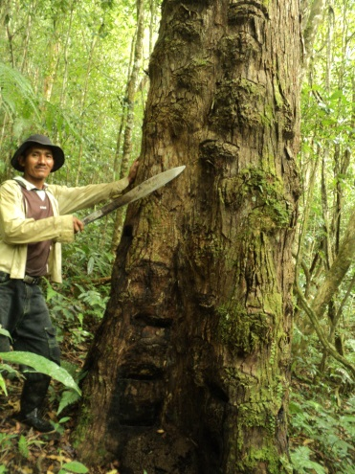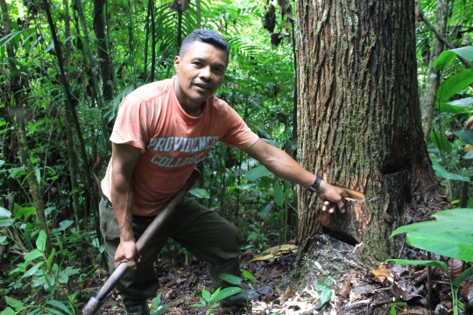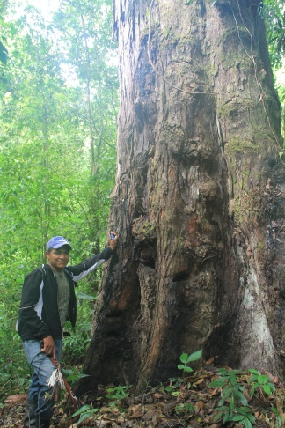

Liquidambar trees under production.

In 2011 disturbances on the international market called attention of the perfume industry. The need of action became apparent, to tackle the abuse of indigenous rights and to rescue the Liquidambar value chain. The Natural Resources Stewardship Council, together with the German Cooperation GIZ initiated the creation of a standard to specific criteria and indicators of a sustainable Liquidambar production. The standard is based on the traditional knowledge of Pech people and was elaborated together with the Pech producers group “APARFSS” of El Carbon Mountain. The complying of the standard is open for every Liquidambar producer in Honduras. Nevertheless, the Pech are showing the highest degree of performance of sustainable production. Accordingly, various companies from the international market demand especially Liquidambar from Pech producers. The income obtained by the producers raised from 7 to 14 US $ per kilo of Liquidambar, and the producer organization APARFFS additionally gets a prime of 14 US $/kg to cover administration costs, invest in good forest management and community help. Since 2012, APARFFS has sold 8 tons of Liquidambar under the NRSC sustainability standard.

The fame of being the guardian of the forests and the carrier of ancestral knowledge of Liquidambar production has not only leaded to a plus of monetary income for the Pech, but also to more attention paid by the Honduran government and their departments. In 2012, although the Carbon Mountain is place of two indigenous Pech communities with registered land titles, the Forest Administration ICF was going to declare the area as a National Park – without consulting the indigenous people. Encouraged by recognition of original Liquidambar production by the international market, the Pech federation FETRIPH stopped the process and insisted to realize a free, prior and informed consent according to indigenous rights. In the following process, the Pech people voted to create an Anthropological Pech and Forest Reserve instead of the National Park. Meanwhile, two municipalities declared the ancestral Liquidambar production of the Pech people as cultural heritage.

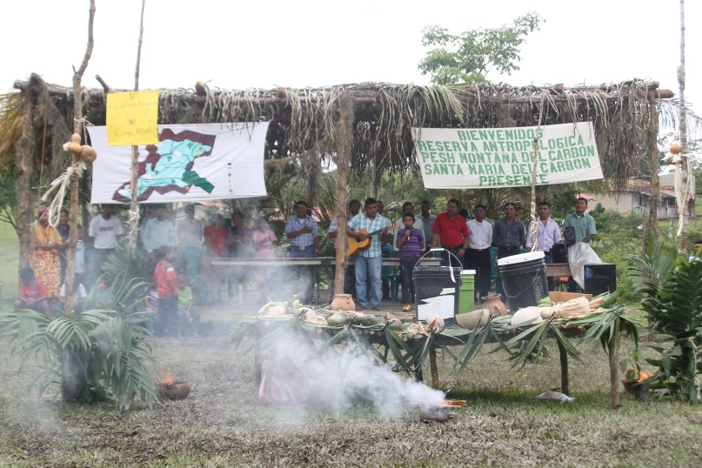

Free, prior and informed consent about the protected area, organized by the FETRIPH.

In 2014, the Honduras Congress finally declared the creation of the “Anthropological Pech and Forest Reserve The Carbon Mountain”, covering an area of 34,000 hectare. Beside of presenting the ancestral area of Liquidambar production of Pech people, the area takes part of the Mesoamerican eco-corridor, and is habitat of endangered species as Jaguar, Tapir and macaws. The watershed provides water for agriculture and households of two towns with 60.000 habitants and 27 rural communities, as well as for a hydro-electric plant.

In 2016, the FETRIPH signed with the forest administration ICF an agreement to administrate the protected reserve. The Pech are the first indigenous group who has requested the declaration of a protected area, without insisting to get the territory land rights (land titling). The Carbon Mountain is habited mainly by mestizo communities, whereas the Pech people are the minority with just two communities. The Pech do except the presence of mestizo communities, but insist in their participation rights of the land use governance of their ancient territory. FETRIPH now got more scope of action on political level to make visible the problematic of forest destruction, loss of habitat and lack of governance in field within the ancestral Pech territory.

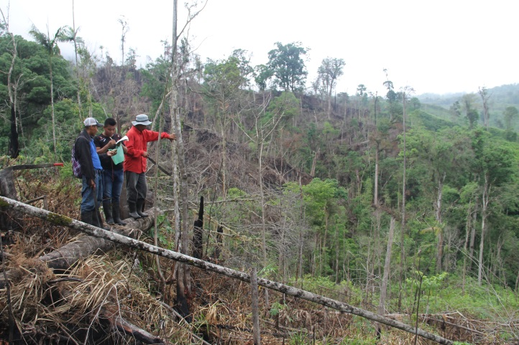

Forest destruction goes on: Pech people documenting an illegal forest cut for cattle breeding.

The Pech people have passed through a unique process to recuperate their identity and participation rights of land use governance of their ancestral territory. From a marginalized production of Liquidambar, they got recognized by national authorities and on international market to be the carrier of ancestral knowledge and examples of good forest management and preservation. Within this process, the Pech community councils got encouraged, as well as their political representation, the FETRIPH. FETRIPH was given by the Honduran Government the faculty to administrate the protected area El Carbon Mountain”, without being the land owner of the territory. This is a complete innovative process, where for first time in Central America an indigenous group gets the governance rights for an area, where mestizo communities are present. Those mestizo communities from now on have to accept the authority of indigenous governance, comprised in sustainable land and forest use. This pilot project has great potential to be repeated along Latin America.

Red de Mujeres Indigenas sobre Biodiversidad de America Latina y el Caribe
SUBMISSION
Respecto de este tema, desde la perspectiva y el ámbito de trabajo de la RMIB-LAC, consideramos importante la inclusión del tema sobre el enfoque de género y en particular de la mujer indígena con respecto al objetivo 15 de los Objetivos de Desarrollo Sostenible relacionado con “Promover el uso sostenible de los ecosistemas terrestres, luchar contra la desertificación, detener e invertir la degradación de las tierras y frenar la pérdida de la diversidad biológica”, y en ella, dar nuestra perspectiva, reflejo de la realidad y propuesta de plan de acciones para el cumplimiento de sus metas e indicadores, para la conservación de la biodiversidad y los conocimientos tradicionales asociados.

Finalmente, como RMIB-LAC, vemos la ocasión propicia para que en este espacio de diálogo se dé una oportunidad para que, en ella se brinde una panorámica del cumplimiento de los Objetivos de Desarrollo Sostenible, desde la perspectiva de las mujeres indígenas.

Red de Cooperacion Amazonica
SUBMISSION
Venezuela y el Gobierno de la Republica Bolivariana de Venezuela, en base a solicitudes de Pueblos Indigenas y Comunidades Locales entre otros, decreto la creacion del Parque Nacional Caura , la segunda Area protegida mas grande del mundo , y el area protegida en bosque tropical mas grande, además se solicito sea nombrado Parque Indigena y Popular esto ultimo hace referencia a comunidades locales ,habitantes del area geográfica. Destacamos que es la primera vez que un gobierno crea una area protegida con estas características y a solicitud de pueblos indígenas y comunidades locales .
Destacamos que la forma de gobierno instituida en la Republica Bolivarina de Venezuela es la democracia participativa y protagonica lo cual significa que todos los ciudadanos deben tomar parte en la formulación ,ejecución y control de las decisiones y de los actos de gobierno, y en este caso se crea una Area Protegida bajo la nueva constitución de la república del año 1999 y con las características arriba señaladas lo cual se corresponde con la agenda 2030.
Por otra parte ,sugerimos que el dialogo esté orientado a proporcionar aportes en la dirección de mayor integración de las Metas de Aichi con los Objetivos de Desarrollo Sostenible y la Agenda 2030, especialmente las metas 1, 14 y 15.

Stockholm Resilience Centre
SUBMISSION
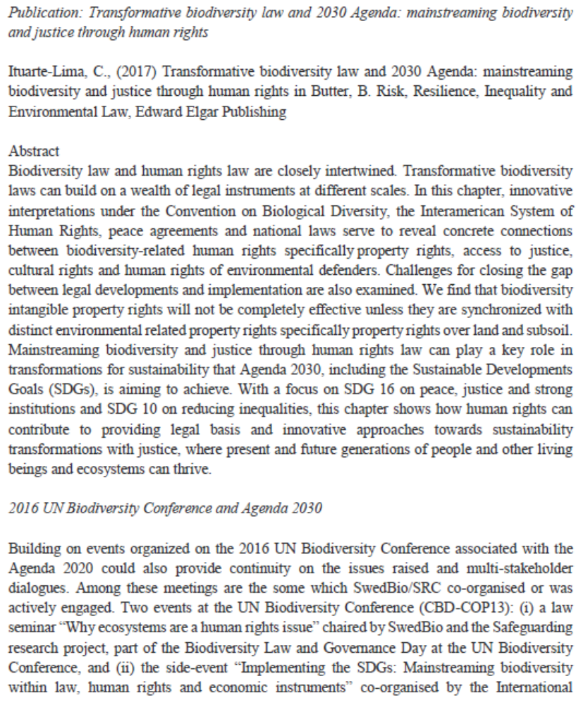
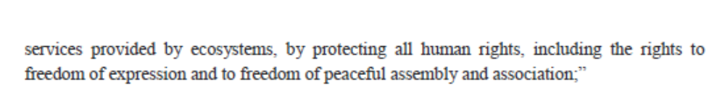
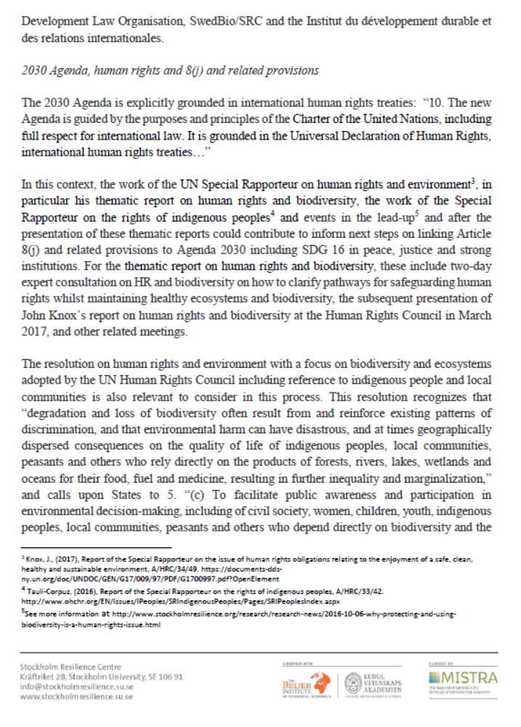
__________

* CBD/WG8J/10/1.
See report at: https://www.cbd.int/doc/pa/icca-day-report-en.pdf.
Kothari and Neumann (2014).
See: https://www.cbd.int/traditional/documents/diversity-final-10oct.pdf.
Para. 38 underscores the importance of “increase[ing] work with indigenous peoples and local communities to communicate their role in the conservation and sustainable use of biodiversity, and to show how their activities contribute to the implementation of the Convention on Biological Diversity and other biodiversity-related conventions”. Para. 67 identifies indigenous peoples and local communities as “a key group for the Convention as custodians of traditional knowledge related to the conservation and sustainable use of biodiversity. Their role is to demonstrate: (a) Contributions of traditional knowledge to the conservation and sustainable use of biodiversity at the national and global level; (b) Contribution to the implementation of the Strategic Plan for Biodiversity 2011-2020.”
See report at: https://www.cbd.int/doc/pa/icca-day-report-en.pdf.

