 |  | CBD
 |  |  | Distr.  GENERAL  UNEP/CBD/WGRI/5/INF/17/Add.1  9 June 2014  ENGLISH ONLY

AD HOC OPEN-ENDED WORKING GROUP ON REVIEW OF IMPLEMENTATION OF THE CONVENTION
Fifth meeting
Montreal, 16-20 June 2014

Item 9 of the provisional agenda*

Guidance on mainstreaming gender into work UNDER the Convention on Biological Diversity

Note by the Executive Secretary
- The eleventh meeting of the Conference of the Parties to the Convention on Biological Diversity adopted decision XI/9, “progress report on gender mainstreaming”. Through this decision, Parties requested the Executive Secretary to provide guidance for mainstreaming gender into all programmes of work under the Convention.
- Furthermore, the Gender Plan of Action presented in UNEP/CBD/COP/9/INF/12/Rev.1 identified the need for guidelines on integrating gender equality into poverty eradication with particular attention to the root causes of inequality between women and men. Accordingly, the implementation plan for the Gender Plan of Action calls for the development of “how to” tools for gender mainstreaming, including, inter alia, guidelines.
- In response to the above, the Executive Secretary has prepared draft guidance on mainstreaming gender into work under the Convention on Biological Diversity, presented in annex to the present document, UNEP/CBD/WGRI/5/INF/17/Add.1. This guidance is intended to complement the “Guidelines for Mainstreaming Gender into National Biodiversity Strategies and Action Plans” published as CBD Technical Series No. 49.
- This draft is being presented for the consideration of the fifth meeting of the Ad Hoc Open-ended Working Group on the Review of Implementation of the Convention (WGRI 5) in order to facilitate a broad peer review process. The Working Group is invited to consider the draft annexed below and present any recommendations for revision to the Executive Secretary. Individual Parties and organizations are also invited to provide their comments to the Executive Secretary, with the intention that a final guidance note will be prepared for consideration by the twelfth meeting of the Conference of the Parties (COP 12).

Annex

DRAFT
Guidance on Mainstreaming gender into work UNDER the Convention on Biological Diversity
This document has been prepared in order to provide Parties, relevant organizations and interested individuals with a range of options to support the enhanced mainstreaming of gender under the Convention on Biological Diversity (CBD). It is intended to complement the “Guidelines for Mainstreaming Gender into National Biodiversity Strategies and Action Plans” published as CBD Technical Series No. 49. The actions suggested in this document are relevant to all programmes of work and cross-cutting issues under the Convention.
The document combines general discussions on gender mainstreaming and its relevance to the Convention with specific examples and suggested activities. Examples are drawn from across programmes of work as a demonstration of the relevance of gender mainstreaming to different ecosystems and approaches under the Convention.
Overall, the document provides an overview of gender mainstreaming and biodiversity, an exploration of the benefits of gender mainstreaming under the Convention on Biological Diversity for both gender issues and biodiversity conservation and sustainable use and benefit-sharing, and guidance on steps that can be taken to enhance gender mainstreaming throughout biodiversity planning and implementation of the Convention.
Following a brief introduction presented below, the first section provides an overview of gender and its importance to the broader goals, objectives and mechanisms of the Convention. The second section focuses on mainstreaming gender within national implementation of the Convention.
Given that each circumstance is different, users of this guidance document are invited to select those activities that are of relevance for them. Further details on each activity can be found in the list of resources while illustrative case studies are available throughout the guide.

INTRODUCTION
Based on the definition of gender mainstreaming in box 1 below, the desired outcome of gender mainstreaming is equality. Gender equality does not necessarily imply that women and men will become the same but rather means that an individual’s rights, responsibilities and opportunities will not depend on whether they are born male or female.
Box 1: Defining gender mainstreaming
The process of assessing the implications for women and men of any planned action, including legislation, policies or programmes, in all areas and at all levels. It is a strategy for making women’s as well as men’s concerns and experiences an integral dimension of the design, implementation, monitoring and evaluation of policies and programmes in all political, economic and societal spheres so that women and men benefit equally and inequality is not perpetuated. The ultimate goal is to achieve gender equality.
Source: United Nations Economic and Social Council Agreed Conclusions, 1997/2
Gender mainstreaming is an important cross-cutting issue within the Convention on Biological Diversity and is included in a number of strategies, programmes of work and decisions by the Parties to the Convention. Examples of gender mainstreaming under the Convention, including promoting the participation and engagement of women, include the following:
Text of the Convention – thirteenth preambular paragraph
Recognizes the vital role that women play in the conservation and sustainable use of biological diversity and affirms the need for the full participation of women at all levels of policymaking and implementation for biological diversity conservation.
Decisions on gender mainstreaming – decisions IX/24, X/19 and XI/9
Call for the mainstreaming of gender considerations into national and, where appropriate, regional, biodiversity strategies and action plans, national biodiversity targets, funding and implementation of the programmes of work.
CBD Gender Plan of Action – decision IX/24
Defines the role that the CBD Secretariat will play in stimulating and facilitating efforts, both in-house and with partners at the national, regional and global levels, to overcome constraints and take advantage of opportunities to promote gender equality and equity.
Programme of work for the implementation of Article 8(j) – Task 4(e)
Calls for the promotion of gender-specific ways in which to document and preserve women’s knowledge of biodiversity.
Strategic Plan for Biodiversity 2011-2020 – Goal D
“Enhance the benefits to all from biodiversity and ecosystem services”.
Aichi Biodiversity Target – Target 14
“By 2020, ecosystems that provide essential services, including services related to water, and contribute to health, livelihoods and well-being, are restored and safeguarded, taking into account the needs of women, indigenous and local communities, and the poor and vulnerable”.
Finally, the Convention has prepared a Technical Series publication and a module on mainstreaming gender into national biodiversity strategies and action plans (NBSAPs). These provide a useful framework for linking gender mainstreaming to national biodiversity planning processes.
In addition to being recognized in the Convention on Biological Diversity, gender commitments are addressed under the other two Rio conventions (the United Nations Convention to Combat Desertification and the United Nations Framework Convention on Climate Change). As such, gender mainstreaming provides an opportunity for enhanced synergies among the Rio conventions. This opportunity is further elaborated in the publication of the Joint Liaison Group of the Rio conventions (JLG) entitled “The Rio Conventions – Action on Gender”.
Furthermore, the framework for gender mainstreaming has been set in many countries through the implementation of international agreements, including, among others, the Universal Declaration on Human Rights, the Convention on the Elimination of All Forms of Discrimination against Women (CEDAW), the Beijing Platform for Action, the United Nations Declaration on the Rights of Indigenous Peoples, Security Council decisions, the Millennium Development Goals (MDGs) and the Rio+20 outcome document. Understanding and mobilizing these frameworks can support the implementation of gender mainstreaming under the Convention while facilitating the realization of efficiencies and avoiding overlap in efforts.

1. UNDERSTANDING GENDER–BIODIVERSITY LINKS
Understanding gender roles is recognized as being important to implementation of the Convention on Biological Diversity because of the differing roles and knowledge between men and women in the conservation and sustainable use of biodiversity (for example, see box 2 below).
Box 2: Gender differences in coastal communities
When considering the management of marine biodiversity, men and women typically play different roles. Taking the example of fishing, catching fish tends to be dominated by males whereas women tend to play a more significant role in processing and selling fish products. When women do participate in fishing, the species targeted are generally different from those caught by male counterparts. This difference is most marked in developing countries.
Source: Wildlife Conservation Society. A Gender Perspective on Securing Livelihoods and Nutrition in Fish-dependent Coastal Communities
According to the Food and Agriculture Organization of the United Nations (FAO), gender roles are socially constructed, learned and influenced by class, age, caste, ethnicity and religion. Gender roles are also dynamic, changing over time, and differ both within and between cultures. Gender issues are also grounded in the social, political and economic environment and, as such, are closely tied to the implementation of any actions impacting livelihoods, land use and natural resource management.
The following section introduces the key elements of gender mainstreaming and discusses the role that gender plays in decision-making on and use of biodiversity. The section also considers the links between gender and the Strategic Plan for Biodiversity 2011-2020 and its Aichi Biodiversity Targets.

1.1. Understanding gender mainstreaming
Having a common understanding of gender mainstreaming is important when planning and implementing supportive actions. It is not uncommon for gender mainstreaming to be confused with equal participation and representation between men and women; however, gender mainstreaming goes far beyond this.
In reality, achieving gender equality involves actions at all stages of implementation of the Convention, from awareness through to reporting, as outlined in table 1 below.
Table 1: Elements of gender mainstreaming
Criteria | Desired outcomes
Awareness | Steps are in place to increase the awareness of gender mainstreaming issues and benefits
Participation | Processes are in place to ensure or encourage the meaningful participation of women in decision-making and policy development
Assessment | Initial assessments or screening are conducted to identify gender mainstreaming needs and opportunities and establish a baseline with regards to gender issues and initial conditions
Strategy | Relevant strategies and action plans are gender-sensitive, promote gender equality, and engage both women and men
Reporting | A monitoring and evaluation system is in place to assess the implementation of gender mainstreaming actions, and results are reported
Suggested actions
In order to improve the understanding and awareness of gender among those responsible for the Convention, two key steps are suggested:
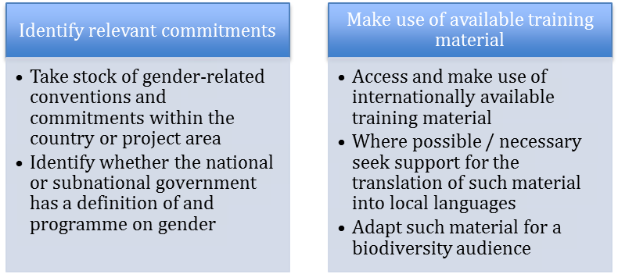
Resources
UNICEF - Gender Equality, UN Coherence and You:
http://www.unicef.org/gender/training/content/scoIndex.html.
UN Women – Community of Practice on Gender Training:
http://gtcop.unwomen.org/index.php?option=com_content&view=article&id=8&lang=en.
UNESCO – Gender Equality eLearning Programme: http://www.unesco.org/new/index.php?id=34592.

1.2. How gender influences biodiversity management and decision-making
The roles of men and women in the management of biodiversity, and the division of decision-making responsibility, vary between countries and cultures, as outlined in figure 1 below. However, in most circumstances there are gender-based differences, usually tied to secondary issues such as the participation of men and women in different economic sectors, land tenure and use rights, legal protection and status, and cultural norms.
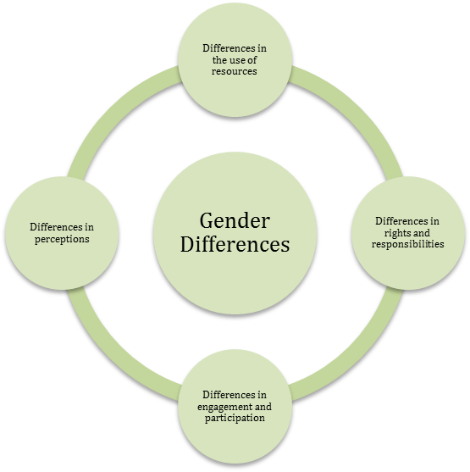
Figure 1. Elements of gender differences in biodiversity conservation and sustainable use.
When it comes to implementation of the Convention, these differences also impact perceptions of risk and vulnerability and benefits both with regards to biodiversity loss and when considering the impacts of biodiversity conservation and sustainable use measures.
Perceptions of benefits: Understanding gender differences in how biodiversity is perceived and managed can be critical to the success of implementation of the Convention. As illustrated in the example presented in box 3, below ensuring that both men and women realize the benefits from biodiversity conservation and sustainable use can impact the long-term sustainability of action.
Box 3: Gender perceptions of benefits from conservation
A study on gender differences in attitudes in Myanmar revealed that women are far less likely to support protected areas compared to men. This difference remains even when socioeconomic variables are removed and can largely be attributed to differences in the perception of benefits and disadvantages from protected areas between women and men.
Source: T.D. Allendorf and K. Allendorf, “Gender and Attitudes toward Protected Areas in Myanmar,” Society & Natural Resources, vol. 26, no. 8, pp. 962–976, 2013.
Perceptions of risk and vulnerability: Given gender differences in the use of biodiversity resources, it follows that there are also gender differences in exposure to risk and vulnerability to biodiversity loss and changes in access to and management of biodiversity resources (see box 4 below). As a result it is important to identify whether and how actions implemented under the framework of the Convention on Biological Diversity impact women and men, including their use of and reliance upon biodiversity resources.
Box 4: Gender perceptions of risks from conservation
Fifteen states in India adopted forest protection resolutions that restricted firewood collection within the programme for Joint Forest Management. As a result, women had to walk an average of 10 kilometres to gather firewood in non-restricted areas. Failing to adhere to restrictions resulted in severe penalties (public flagellation) with women accounting for 90% of the people punished
Source: IUCN Factsheet - Protected Areas: Gender makes the difference http://www.frameweb.org/adl/en-US/2337/file/234/WCC_Gender_Fact_Sheet_on_Protected_Areas.pdf
Suggested actions
One of the most effective ways to understand gender differences in biodiversity management and decision-making is through a gender analysis. A gender analysis can establish the baseline with regards to gender differences and expose where there is gender inequality. Overall a gender analysis should answer the following questions:
- What are the different roles played by women and men in biodiversity use and management?
- Are there gender differences in access to and rights over biodiversity resources?
- Do women and men have different priorities for biodiversity conservation and sustainable use and the sharing of benefits?
- How will actions under the Strategic Plan for Biodiversity 2011-2020 affect women and men?
- How will actions under the Strategic Plan for Biodiversity 2011-2020 benefit women and men?
- Do national targets for the achievement of the Aichi Biodiversity Targets adequately reflect gender issues?
- How are women and men currently represented in biodiversity decision-making?
- Is there any gender-specific legislation that the project must conform to?
The process of answering these questions can be included in any stocktaking or analysis related to the implementation of the Strategic Plan for Biodiversity 2011-2020 or the development of national targets under the Aichi Biodiversity Targets. In general, however, a gender analysis should consist of the steps outlined below.
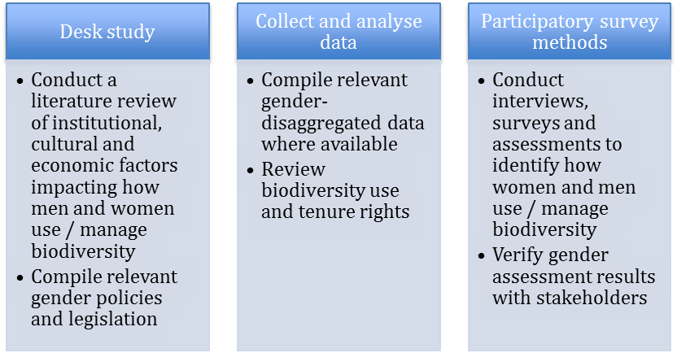
Resources
Food and Agriculture Organization of the United Nations (FAO), International Labour Organization (ILO), United Nations Development Programme (UNDP) - The Socio-economic and Gender Analysis (SEAGA): http://www.fao.org/gender/seaga/en/ .
World Bank - Gender and Development: A Training Tool:
http://info.worldbank.org/etools/docs/library/192862/Module2/Module2-index.html.
Canadian International Development Agency (CIDA) - Gender Analysis as a Tool:
http://www.acdi-cida.gc.ca/acdi-cida/acdi-cida.nsf/eng/EMA-218123616-NN9#a3.
United States Agency for International Development (USAID) - Tips for Conducting a Gender Analysis at the Activity or Project Level:http://transition.usaid.gov/policy/ads/200/201sae.pdf.
About Fishermen, Fisherwomen, Oceans and Tides: A Gender Perspective in Marine-Coastal Zones: https://portals.iucn.org/library/sites/library/files/documents/2000-042-En.pdf.
Diversity makes the difference: Actions to guarantee gender equity in the application of the Convention on Biological Diversity, at http://www.generoyambiente.org.
Participatory Appraisal from a Gender Equity Perspective (PAGEP): https://portals.iucn.org/library/efiles/edocs/modulo2-En.pdf.

1.3. Gender mainstreaming and the Strategic Plan for Biodiversity 2011-2020
Gender mainstreaming can have direct and indirect impacts on the implementation of the Strategic Plan for Biodiversity 2011-2020, including:
- Supporting the identification of drivers of loss;
- Identifying locally-appropriate approaches to biodiversity conservation and sustainable use;
- Enhancing stakeholder participation;
- Improving equity of tenure and use rights; and
- Ensuring consistency with the human rights based approach to development.
In addition to the above, when examining the benefits of gender mainstreaming for national biodiversity strategies and action plans (NBSAPs) – key instruments for the translation of the Strategic Plan for Biodiversity 2011-2020 into national action – the following “value added” considerations were identified:
- Highlights the decisive sociopolitical, economic and cultural aspects of conservation;
- Increases efficiency;
- Ensures the incorporation of important knowledge, skills and experiences;
- Enhances sustainability;
- Improves credibility and accountability;
- Contributes to fighting poverty;
- Guarantees compliance with human rights standards;
- Promotes social justice;
- Prevents increasing gender inequality.
With regards to the text of the Strategic Plan for Biodiversity 2011-2020, women are identified as a specific stakeholder group to be engaged in partnerships for implementation. Ensuring that the engagement of women is effective will, however, require significant awareness raising and capacity-building in addition to the design of mechanisms to facilitate participation.
An example of how this was accomplished in the case of reducing emissions from deforestation and forest degradation in developing countries is presented in box 5 below. In addition, the engagement of women is discussed in more detail in section 2.1 below.
In addition to recognizing women as a stakeholder group, the Strategic Plan for Biodiversity 2011-2020 calls for capacity-building on gender mainstreaming to be supported. This is intended to facilitate the greater inclusion of a gender perspective in implementation of the Convention as well as gender equality in the achievement of the Convention’s three objectives.
Box 5: Engaging women as a stakeholder group - Mexico’s REDD+ programme
Mexico’s national REDD+ policy includes gender through the following steps:
- Strengthen institutional capacities for communication and identify permanent spaces for social communication and feedback
- Include alternative means for communicating with different audiences efficiently
- Ensure the participation of women in the design and implementation of safeguards, respecting community customs
- Analyse and evaluate the specific needs of indigenous peoples and women and their ways of accessing information, expressing and resolving conflicts
- Promote compliance with legislation to promote equal opportunities for women and groups of specific attention.
- Strengthen the capacities of women for the management of timber and non-timber resources
Source: Estrategia Nacional para REDD+. Borrador. Julio 2013
Suggested actions
The United Nations Environment Programme (UNEP) has developed a gender checklist to ensure that gender is considered in the design, implementation and assessment of UNEP-funded projects. Adapting the checklist to the Strategic Plan for Biodiversity 2011-2020 can provide a gender framework under which actions to support the effective engagement of women can be assured:
- How can the Strategic Plan advance the role of women in environmental decision-making?
- What specific ways can be proposed for encouraging and enabling women and men to participate and benefit equally from implementation of the Strategic Plan?
- Are there categories of women and/or men likely to be disadvantaged by implementation of the Strategic Plan? If so, what remedial measures can be taken?
- Are there opportunities under the Strategic Plan to increase women’s ability to take charge of their own lives, and to take collective action to solve environmental problems?
Resources
United Nations Environment Programme (UNEP) – Gender Plan of Action:
http://www.unep.org/roa/amcen/Projects_Programme/climate_change/PreCop15/Proceedings/Gender%20strategies/Unep%20Gender%20Plan%20of%20Action_5_Feb07.pdf.

1.4. Gender mainstreaming and the Aichi Biodiversity Targets
In addition to strengthening implementation of the Strategic Plan, it is important to understand the links between gender mainstreaming and related goals and targets.
Gender considerations are relevant for all of the Aichi Biodiversity Targets, especially, Target 4 on the engagement of stakeholders in sustainable production and consumption, Target 6 on the sustainable management of aquatic biodiversity, Target 7 on the sustainable management of agriculture, aquaculture and forestry, and Target 13 on the genetic diversity of cultivated and valuable plants and animals.
Furthermore, women are specifically identified as a stakeholder group under Target 14 on the maintenance of ecosystem services. Additional details are provided in table 2 below as well as in the document, “Report on an Updated Gender Plan of Action to 2020 and Progress in Gender Mainstreaming, Monitoring and Evaluation and Indicators” submitted to the Ad Hoc Open-ended Working Group on Review of Implementation of the Convention (UNEP/CBD/WGRI/5/7).
Table 2: Gender and the Aichi Biodiversity Targets
 | Target | Importance of gender
1 | By 2020, at the latest, people are aware of the values of biodiversity and the steps they can take to conserve and use it sustainably. | The values placed on biodiversity and its uses typically differ by gender, with men often responsible for extractive uses while women often use biodiversity for non-market purposes
2 | By 2020, at the latest, biodiversity values have been integrated into national and local development and poverty reduction strategies and planning processes and are being incorporated into national accounting, as appropriate, and reporting systems. | Promotes consistency with ongoing work on gender-responsive budgeting
3 | By 2020, at the latest, incentives, including subsidies, harmful to biodiversity are eliminated, phased out or reformed in order to minimize or avoid negative impacts, and positive incentives for the conservation and sustainable use of biodiversity are developed and applied, consistent and in harmony with the Convention and other relevant international obligations, taking into account national socio-economic conditions. | There are gender-related differences in economic participation and opportunity, education, health and political empowerment
4 | By 2020, at the latest, Governments, business and stakeholders at all levels have taken steps to achieve or have implemented plans for sustainable production and consumption and have kept the impacts of use of natural resources well within safe ecological limits. | There is a gender gap concerning assets and access for many biodiversity-based livelihoods, including land, livestock, labour, education, extension and financial services, and technology
5 | By 2020, the rate of loss of all natural habitats, including forests, is at least halved and where feasible brought close to zero, and degradation and fragmentation is significantly reduced. | Pressure on natural habitats often differ by gender
6 | By 2020 all fish and invertebrate stocks and aquatic plants are managed and harvested sustainably, legally and applying ecosystem based approaches, so that overfishing is avoided, recovery plans and measures are in place for all depleted species, fisheries have no significant adverse impacts on threatened species and vulnerable ecosystems and the impacts of fisheries on stocks, species and ecosystems are within safe ecological limits. | Women represent about 47% of the fisheries workforce and there are often gender differences in harvesting and production patterns of fish
7 | By 2020 areas under agriculture, aquaculture and forestry are managed sustainably, ensuring conservation of biodiversity. | More than 40% of economically active women are engaged in agriculture, with the percentage well above 50% in developing countries
8 | By 2020, pollution, including from excess nutrients, has been brought to levels that are not detrimental to ecosystem function and biodiversity. | There are gender differences in exposure to pollution and risks from negative impacts
9 | By 2020, invasive alien species and pathways are identified and prioritized, priority species are controlled or eradicated, and measures are in place to manage pathways to prevent their introduction and establishment. | Gender mainstreaming is expected to enhance the effectiveness of invasive alien species prevention and management
10 | By 2015, the multiple anthropogenic pressures on coral reefs, and other vulnerable ecosystems impacted by climate change or ocean acidification are minimized, so as to maintain their integrity and functioning. | Women represent about 47% of the fisheries workforce and there are often gender differences in harvesting and production patterns of fish
11 | By 2020, at least 17 per cent of terrestrial and inland water, and 10 per cent of coastal and marine areas, especially areas of particular importance for biodiversity and ecosystem services, are conserved through effectively and equitably managed, ecologically representative and well connected systems of protected areas and other effective area-based conservation measures, and integrated into the wider landscapes and seascapes. | The values placed on biodiversity and its uses typically differ by gender, with men often responsible for extractive uses while women often use biodiversity for non-market purposes
12 | By 2020 the extinction of known threatened species has been prevented and their conservation status, particularly of those most in decline, has been improved and sustained. | The values placed on biodiversity and its uses typically differ by gender, with men often responsible for extractive uses while women often use biodiversity for non-market purposes
13 | By 2020, the genetic diversity of cultivated plants and farmed and domesticated animals and of wild relatives, including other socio-economically as well as culturally valuable species, is maintained, and strategies have been developed and implemented for minimizing genetic erosion and safeguarding their genetic diversity. | There are gender differences in the species cultivated and maintained, typically tied to use
14 | By 2020, ecosystems that provide essential services, including services related to water, and contribute to health, livelihoods and well-being, are restored and safeguarded, taking into account the needs of women, indigenous and local communities, and the poor and vulnerable. | There are gender differences in exposure to disturbances and reliance upon natural resources
15 | By 2020, ecosystem resilience and the contribution of biodiversity to carbon stocks has been enhanced, through conservation and restoration, including restoration of at least 15 per cent of degraded ecosystems, thereby contributing to climate change mitigation and adaptation and to combating desertification. | Gender mainstreaming is expected to enhance the effectiveness of climate change mitigation and adaptation
16 | By 2015, the Nagoya Protocol on Access to Genetic Resources and the Fair and Equitable Sharing of Benefits Arising from their Utilization is in force and operational, consistent with national legislation. | Gender differences in tenure and use rights can impact access to benefits and payments
17 | By 2015 each Party has developed, adopted as a policy instrument, and has commenced implementing an effective, participatory and updated national biodiversity strategy and action plan. | Both women and men are important stakeholders to be engaged in national planning
18 | By 2020, the traditional knowledge, innovations and practices of indigenous and local communities relevant for the conservation and sustainable use of biodiversity, and their customary use of biological resources, are respected, subject to national legislation and relevant international obligations, and fully integrated and reflected in the implementation of the Convention with the full and effective participation of indigenous and local communities, at all relevant levels. | Gender differences are culture specific and are often tied to traditional knowledge and practices
19 | By 2020, knowledge, the science base and technologies relating to biodiversity, its values, functioning, status and trends, and the consequences of its loss, are improved, widely shared and transferred, and applied. | There are gender differences in the development and transfer of technologies
20 | By 2020, at the latest, the mobilization of financial resources for effectively implementing the Strategic Plan for Biodiversity 2011-2020 from all sources, and in accordance with the consolidated and agreed process in the Strategy for Resource Mobilization, should increase substantially from the current levels. This target will be subject to changes contingent to resource needs assessments to be developed and reported by Parties. | Can contribute to ongoing work on gender-responsive budgeting
Having a global understanding of the links between gender and the achievement of the Aichi Biodiversity Targets is important for building political will and justifying the allocation of sufficient staff and financial resources. However, measures to attain the Aichi Biodiversity Targets will be implemented and monitored at national level. Details on mainstreaming gender into national indicators are presented in section 2.2 below.

2. STEPS TO ENHANCE GENDER MAINSTREAMING IN IMPLEMENTATION OF THE CONVENTION ON BIOLOGICAL DIVERSITY
While it is important to ensure that gender is considered in the implementation of the Convention on Biological Diversity and the Strategic Plan for Biodiversity 2011-2020 with its Aichi Biodiversity Targets, implementation happens at the national and subnational level. Guidance is presented below on mainstreaming gender within national biodiversity strategies and action plans, national indicators, and national reports to the Convention.

2.1. Mainstreaming gender within national biodiversity strategies and action plans
Extensive guidance on mainstreaming gender within national biodiversity strategies and action plans (NBSAPs) is available through CBD Technical Series 49 – Guidelines for Mainstreaming Gender into National Biodiversity Strategies and Action Plans (NBSAPs). A brief overview is presented below.
The Technical Series publication provides guidance for mainstreaming gender into national biodiversity strategies and national action plans respectively, although there are a number of commonalities.
Actions to ensure gender considerations include the following:
- Engage ministries / organizations responsible for women or gender;
- Provide tailored gender training to relevant staff and ensure that staff are supported by gender experts;
- Provide capacity-building for women and women’s organizations to enhance the effectiveness of participation;
- Ensure that sufficient staff time and financial resources are made available for gender mainstreaming;
- Use gender-sensitive language;
- Implement participatory methods that include women and women’s organizations (recognizing that women are not a homogenous group);
- Include gender mainstreaming in monitoring and reporting;
- Ensure gender equality in human resources elements of strategy development and implementation of the action plan (hiring, pay, etc.).
Actions specific to the development of biodiversity strategies include:
- Ensure that the organizations involved in strategy development have a gender strategy or policy;
- Require that staff involved in strategy development report on gender aspects of their work;
- Conduct a gender analysis (see section 1.2);
- Include gender as a cross-cutting priority, guiding principle or objective within the strategy;
- Consider the revision of discriminatory legislation or policies;
- Emphasize the national and local socioeconomic context of the Strategic Plan for Biodiversity 2011-2020.
Actions specific to the development and implementation of biodiversity action plans include:
- Emphasize the promotion of gender equality by including it as a criterion in the assessment of the priority level of an activity;
- Base priority assessments on gender-disaggregated data;
- Establish a gender expert list to support the implementation of gender mainstreaming;
- Consider including “gender” in activity titles where appropriate;
- Allow for sufficient time for participatory methods that capture the views and experiences of both men and women.
With regards to implementation, given the wide variation in national circumstances, it is suggested that countries pick and choose from the guidance presented in Technical Series 49. An example of one approach to gender mainstreaming in environmental policies is presented in box 6 below.
Box 6: Gender checklist - Nigeria
In 2011, the Ministry of the Environment of Nigeria developed a Gender Mainstreaming Toolkit for National Environmental Policy and Processes. The toolkit outlines steps and strategies for gender mainstreaming, provides a checklist for mainstreaming gender into projects, programmes and policies, and presents methods and tools for gathering and using data for gender mainstreaming. The main aim of the toolkit is to identify gaps and opportunities for a stronger response by the Ministry of Environment to gender equality issues, and provide a guide for complete gender audit.
Source: Gender Mainstreaming Toolkit for National Environmental Policy and Processes. Ministry of Environment, Nigeria.
Suggested actions
Mainstreaming gender into NBSAPs is highly dependent upon national circumstances; however, in general, the process should consider and engage women and men in all stages in order to reflect the different elements of gender:
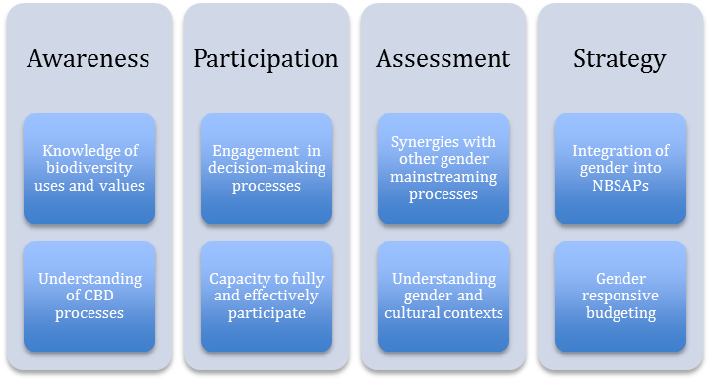
Resources
CBD Technical Series 49. Guidelines for Mainstreaming Gender into National Biodiversity Strategies and Action Plans: http://www.cbd.int/doc/publications/cbd-ts-49-en.pdf.
Center for International Forestry Research (CIFOR) - Proposal Development Guidelines for Integrating Gender: http://www.cifor.org/online-library/browse/view-publication/publication/4155.html.

2.2. Mainstreaming gender in national indicators
Developing gender-sensitive national indicators for the Aichi Biodiversity Targets can facilitate the assessment of changing relationships between men and women over time. Gender-sensitive indicators can help ensure that inequalities are reduced, or at least not exacerbated, and that men and women have equal opportunities to participate in and benefit from biodiversity conservation and sustainable use and benefit-sharing.
Ensuring that national indicators are gender-sensitive requires an assessment of empowerment and equality depending on the purpose of the actions being measured. If actions are intended to build capacity among stakeholders or promote stakeholder engagement, empowerment is the key gender issue to examine. If, however, an action is intended to result in an outcome for biodiversity conservation and sustainable use, then it is important to measure gender equality in terms of the impacts of such actions on people and communities.
Such indicators can be either qualitative or quantitative in nature depending on the purpose, availability of data and resources available. Examples of each indicator type are presented in table 3 below.
Table 3: Examples of quantitative and qualitative indicators
Quantitative indicators | Qualitative indicators
Participation of women and men in CBD processes (nationally and intergovernmentally) | Consideration of the different roles of men and women in the use and management of biodiversity
Number of training / toolkits / guidance on gender mainstreaming | Assurance of gender-equitable natural resource tenure and use rights
Percentage of proceeds from access and benefit-sharing agreements for women | Mechanisms in place for gender-equitable benefit-sharing from biodiversity conservation and sustainable use
Distribution of funding for biodiversity conservation and sustainable use projects between women and men | Appropriate inclusion of gender in NBSAPs and CBD national reports
Support is available for the development of gender-sensitive indicators through the Biodiversity Indicator Partnership (BIP). In particular, BIP has been exploring how possible indicators could be disaggregated by gender and, in doing so has identified a set of indicators for which feasibility should be examined further (see box 7 below). These include indicators on:
- Awareness of biodiversity values,
- Biodiversity for food and medicine, and
- Ecosystem service delivery trends at important sites for biodiversity.
However, the BIP has no suggestions on gender-disaggregated data for any of the Aichi Biodiversity Targets under Strategic Goal B, on reducing the direct pressures on biodiversity and promote sustainable use, or Strategic Goal E, on enhancing implementation through participatory planning, knowledge management and capacity-building.
Box 7: Gender in Aichi Biodiversity Target 1
In order to evaluate how gender-disaggregated data could be used to assess the achievement of the Aichi Biodiversity Targets, the Biodiversity Indicators Partnership, through the Biodiversity Barometer recorded gender differences in the number of survey respondents who could correctly define biodiversity. This looks, in particular, at Aichi Biodiversity Target 1: By 2020, at the latest, people are aware of the values of biodiversity and the steps they can take to conserve and use it sustainably.
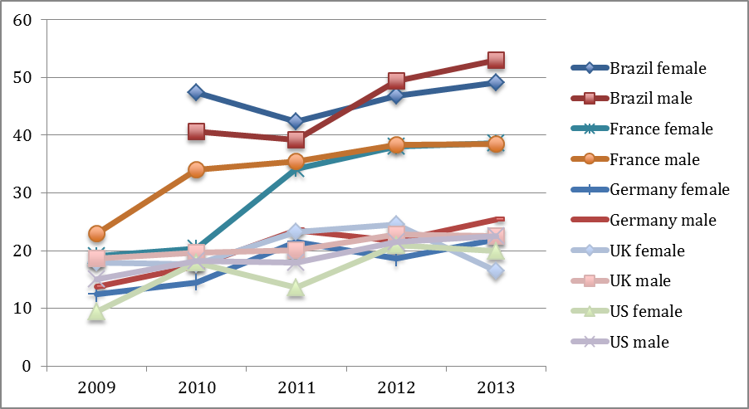
Source: Biodiversity Barometer. UNEP-WCMC, 2014
As an additional guide, the Food and Agriculture Organization of the United Nations (FAO) developed a ten-step process to ensure that indicators are gender-sensitive. The list can be summarized as follows:
- Ensure that indicators are people-focused and differentiate between men and women;
- Include the existing roles and responsibilities of men and women in the description of each indicator;
- Ensure that indicator descriptions define how activities are expected to address the different needs and priorities of men and women;
- Consider indicators on how men and women will be involved in activities;
- Assess the immediate impact of actions as well as the longer-term outcomes for men and women;
- Involve men and women and organizations with a gender mandate in the design of indicators;
- Ensure that gender roles and responsibilities, and particularly the needs and priorities of women, have been carefully considered and addressed through well-designed indicators;
- Measure the participation of women and men at each stage of indicator development;
- Ensure that indicators assess outcomes for women and men after three to five years;
- Plan and allocate budget for the gender-disaggregation of data.
Suggested actions
Countries, based on national circumstances and capacities, drive the development of national indicators. However, there are two key steps to be considered. The first is the use of gender-disaggregated data in the assessment of indicators – this is discussed in more detail in section 2.3 below. The second is the targeted consideration of gender issues in those Aichi Biodiversity Targets for which gender differences are particularly relevant. These include:
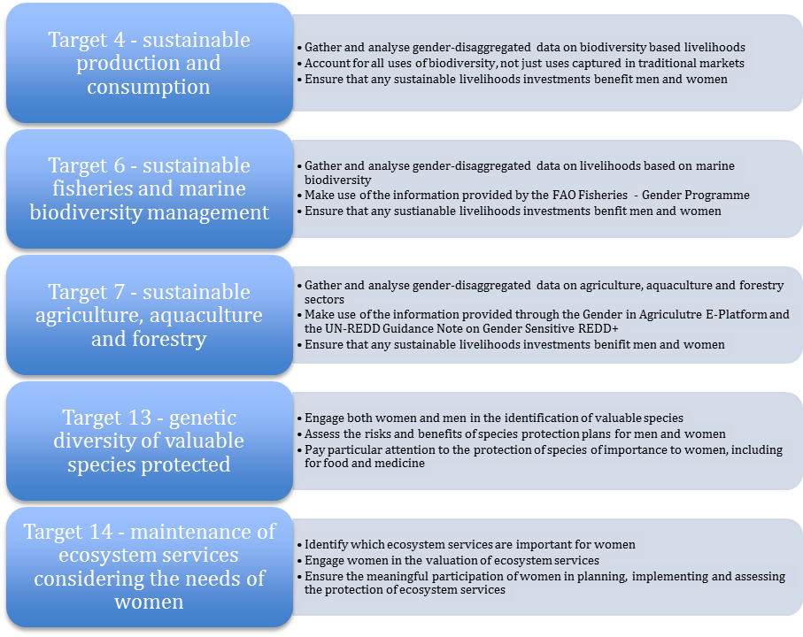
Resources
Agriculture
Food and Agriculture Organization of the United Nations (FAO) - Gender and Land Rights Database:
http://www.fao.org/gender/landrights/en/.
Food and Agriculture Organization of the United Nations (FAO) - Governing Land for Women and Men: http://www.fao.org/docrep/017/i3114e/i3114e.pdf.
Forests
Center for International Forestry Research (CIFOR) – Forests and Gender programme:
http://www.cifor.org/gender/home.html.
Food and Agriculture Organization of the United Nations (FAO) - Gender Analysis and Forestry Training Package: http://foris.fao.org/static/pdf/gender/tr-e01/tr-e01.0.pdf.
World Bank – Gender and Forestry
http://siteresources.worldbank.org/INTGENAGRLIVSOUBOOK/Resources/Module15.pdf
Ecosystem services
Global Gender and Climate Alliance - Database on Gender Publications:
http://www.gender-climate.org/Publications/.
UN Development Programme (UNDP) – Resource Guide: Mainstreaming Gender in Water Management
http://www.undp.org/content/undp/en/home/librarypage/environment-energy/water_governance/resource-guide-mainstreaming-gender-in-water-management.html.
UN Development Programme (UNDP) – Measuring Democratic Governance, A framework for selecting pro-poor and gender sensitive indicators:
http://arabstates.undp.org/content/rbas/en/home/presscenter/events/2012/November/regional_governance_week/_jcr_content/centerparsys/download_12/file.res/Measuring%20Democratic%20Governance_English%20Paper.pdf.

2.3. Mainstreaming gender in national reports
The guidelines for the fifth national reports to the Convention include a section on progress towards the 2015 and 2020 Aichi Biodiversity Targets and contributions to the relevant 2015 Targets of the Millennium Development Goals. Given the discussion above on the links between gender mainstreaming and the Aichi Biodiversity Target, as well as Millennium Development Goal 3 – promote gender equality and empower women, it follows that gender should be included in national reports.
Furthermore, the guidelines for the fifth national reports call for the engagement of stakeholders. As mentioned in previous sections, women are important stakeholders although it should be acknowledged that women are not a homogenous group and, as such, the views of a small group cannot be assumed to be the views of all women.
Engaging women in the national reports process requires capacity-building and awareness raising on national report objectives, processes, and findings, opportunities for all stakeholders to participate, including, if appropriate, women-only consultations, and reporting back on findings and conclusions from the reports.
Including gender-disaggregated data in national reports to the Convention can assist with identifying priorities for implementation and monitoring outcomes in a manner that addresses gender and promotes empowerment and equity.
Gender-disaggregated data are essential as they (1) highlight the different conditions of women and men, including changes over time; (2) allow the impacts of national strategies on women and men to be identified and tracked; (3) enable options to be developed that are effective and beneficial for both women and men; (4) allow resources to be allocated in a fairer way for both women and men; and (5) support gender-responsive evaluation and monitoring. An example is presented in box 8 below.
Box 8: Gender assessment – Ecuador, Ghana and India
The Centre of Public Policy (CPP) at the Indian Institute of Management in Bangalore (IIMB) developed the Gender Asset Gap Project. Although not specific to biodiversity, the project collects individual-level data disaggregated by gender. Data are available at the national level for Ecuador and Ghana and at the state level in Karnataka, India.
The project also holds workshops on collecting and using gender-disaggregated data and develops policy briefs and technical reports on topics such as strengthening women’s property rights and gender constraints in farming.
Source: http://genderassetgap.org
In general, gender-disaggregated data fall into two broad categories:
- Data gathered for general use: these are data that governments collect as part of broader census or sector assessments and can include indicators such as employment by sector, income by sector, percentage of land titles, percentage of resource use rights, number of government officials, etc.; and
- Biodiversity-specific data: these are data gathered as part of a CBD or related process such as NBSAP development or revision, and can include indicators such as biodiversity knowledge, types and sustainability of use of biodiversity, contribution to threats to biodiversity, benefits from investments in biodiversity, etc.
Gender-disaggregated data are, however, limited, especially in developing countries. Some information is available in centralized databases as outlined in table 4 below.

Table 4: Sources of gender-disaggregated data
Tool | Description | Link
World Bank Little Data Book on Gender | Gender-disaggregated data from 200 countries on demography, education, health, labour force, political participation, and the Millennium Development Goals | http://data.worldbank.org/products/data-books/little-data-book-on-gender
World Bank Gender Equality Data and Statistics | Gender-disaggregated data on economic structures and access to resources, education, health and related services, public life and decision-making, and human rights of women and girl children. | http://datatopics.worldbank.org/gender/
FAO Gender and Land Rights Database | Gender-disaggregated data on property and use rights, customary law, international agreements, and the participation of relevant organizations | http://www.fao.org/gender/landrights/home/en/
United Nations Economic Commission for Europe (UNECE) gender statistics | Gender-disaggregated data on countries in the UNECE region on demographics, work and the economy, education, public life and decision-making, health and mortality, crime and violence, science and information and communication technology, work-life balance, and forest sector employment | http://www.unece.org/stats/gender.html
IUCN Environment and Gender Index | Gender-disaggregated data on participation in international meetings, and on women in decision-making positions in environment ministries. | http://environmentgenderindex.org/
Suggested actions
Although the availability of gender-disaggregated data is limited in most countries, including gender in national reports can be accomplished through the development of key indicators that can be assessed through commonly employed data collection techniques such as surveys, community mapping, and participatory rural appraisals.
Such methodologies are often best employed at the project level and, as such, it is important to establish an overall strategy for monitoring and reporting on gender mainstreaming which can then be applied to an entire portfolio of projects. An example of a methodology that can be applied to the establishment of a gender monitoring and reporting framework is presented below.
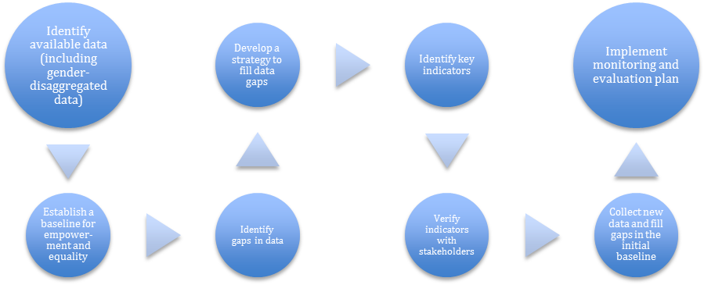
Resources
Food and Agriculture Organization of the United Nations (FAO) – Gender-Disaggregated Data for Agriculture and Rural Development: http://www.fao.org/docrep/012/al210e/al210e00.pdf.
World Bank – Successful Cases of Gathering Sex-Disaggregated and Gender Relevant Data by the World Bank and its Clients:
http://web.worldbank.org/WBSITE/EXTERNAL/EXTOED/GENDEREXT/0,,contentMDK:22442653~pagePK:64829573~piPK:64829550~theSitePK:6701813,00.html.
International Union for Conservation of Nature (IUCN) – Environment and Gender Index: http://environmentgenderindex.org.
-----

* UNEP/CBD/WGRI/5/1.
http://www.cbd.int/doc/publications/cbd-ts-49-en.pdf, http://www.cbd.int/doc/training/nbsap/b9-train-gender-en.pdf.
http://unfccc.int/resource/docs/publications/roi_20_gender_brochure.pdf.
FAO, Socio-Economic and Gender Analysis (SEAGA) Macro Level Handbook. 2003.
CBD decision X/2, http://www.cbd.int/decision/cop/?id=12268.
http://www.unep.org/PDF/Women/ChapterSix.pdf.
http://reports.weforum.org/global-gender-gap-report-2013/.
http://www.fao.org/gender/gender-home/gender-why/key-facts/en/.
www.wcs.org/genderfisheries.
Food and Agriculture Organization of the United Nations (FAO).
http://www.ncbi.nlm.nih.gov/pmc/articles/PMC2831913/.
http://www.eiar.gov.et/IAS-Publications/Gender%20and%20Invasive%20Report%20new.pdf.
www.wcs.org/genderfisheries.
UN-REDD. Guidance Note on Gender Sensitive REDD+.
http://sustainabledevelopment.un.org/content/documents/1299un-women.pdf.
Sasvari, A., Aguilar, L., Khan, M., Schmitt, F. (2010). Guidelines for Mainstreaming Gender into National Biodiversity Strategies and Action Plans. Gland, Switzerland: IUCN. viii + 97 pp. http://www.cbd.int/doc/publications/cbd-ts-49-en.pdf.
http://www.fao.org/sd/2001/pe0602a_en.htm.
http://www.fao.org/gender/gender-home/gender-programme/genderfisheries/en/; http://www.genderinag.org; http://www.undp.org/content/undp/en/home/librarypage/womens-empowerment/guidance-note-gender-sensitive-redd-/.

